Group 11

The Household Power Management System:

“Smart Interior Monitoring Plug”

(S.I.M.P.)

Jose-Valentin Sera-Josef (EE)

Anthony Perez (CpE)

Edin Durgutovic (EE)

Austin Raynor (CpE)

**Table of Contents**

1. Project Description 1

2. Project Specifications and Constraints 2

2.1 Specifications 2

2.1.1 General 2

2.1.2 Hardware 2

2.1.3 Wireless Connectivity 2

2.1.4 iOS App/UI 2

2.1.5 Autonomous Management 3

2.2 Constraints 3

2.2.1 General 3

2.2.2 Hardware 3

2.2.3 Software 3

3. Block Diagrams 4

3.1 Software Block Diagram (Figure 1) 4

3.2 Hardware Block Diagram (Figure 2) 5

3.3 Linear Circuit Rough Draft (Figure 3) 5

3.4 Design Sketches 6

3.4.1 S.I.M.P. Block Sketch (Figure 4) 6

3.4.2 S.I.M.P. Wall Outlet Fixture Sketch (Figure 5) 6

3.4.3 S.I.M.P. Extension Cord Brick Sketch (Figure 6) 6

4. Project Budget 7

4.1 Project Budget Breakdown (Table 1) 7

5. Project Milestones 8

5.1 Senior Design 1 Estimated Milestone Dates (Table 2) 8

5.2 Senior Design 2 Estimated Milestone Dates (Table 3) 8

6. House of Quality Chart 9

7. Plan of Demonstration 9

**1. Project Description**

The goal of our Smart Interior Monitoring Plug (SIMP) will be to provide both digital and physical support in the home to help achieve these aims. It will physically consist of several SIMP units plugged into the walls that are connected to each other over wifi, each ranging in size from an AC to USB wall adapter, to the size of a 5 port surge protector. All the SIMPs will be monitoring the power usage of the devices plugged into them and sending the information to an online server where it will be saved. The data can then be accessed through a webpage to see the power usage over time and the smart digital assistant of the system “SIMPY” can provide analytics to the user in the form of cost analysis, change in power usage for the month, as well as other functions to help the user learn more about their households power usage and offer solutions to reduce power usage while maintaining quality of life.

Through the use of the webpage users will also be able to set schedules for their appliances that are connected to SIMPs as well as enable parental controls. Parental control for the SIMPs would require a PIN or password to be entered from the SIMP webpage to allow an appliance connected to the SIMP in question to be activated either until the device is turned off or for a set amount of time at which point power to the device will be shut off. In the event a device connected to a SIMP is considered a “high-priority device” (ex. CPAP, medicine pump, life support or other medical monitors) it can be exempt from a SIMPs schedule even if another device is sharing a SIMP. If a non-high priority device is still being used close to the SIMPs scheduled off period, the mobile app will send a push notification to the users email or phone number to warn them power will be shut off soon and to give them the option to extend that SIMPs time being active with the entry of the Parental Control PIN.

**2. Project Specifications and Constraints**

2.1 Specifications

2.1.1 General

* The SIMP is to be no larger than 4.5” x 2.75” x 3”
* SIMP’s are to be compatible with the standard North American household receptacle (120V ~ 15A)
* SIMP’s will operate via connected DC Power (Not Battery Operated)

2.1.2 Hardware

* LED Wireless Status Indicator
* Push Button for Wireless Connectivity
* Custom PCB
* PCB Antenna
* Processor Unit
* Toggle Switch

2.1.3 Wireless Connectivity

* SIMP’s will be capable of IEEE 802.11 Wireless Standards for connecting with 2.4GHz Wireless Networks
* SIMP’s will be capable of communicating with other SIMP devices connected to the same 2.4GHz Wireless Network

2.1.4 iOS App / UI

* Back-End Database will contain metric data being drawn from the SIMP, including:
  + Voltage
  + Amperage
  + Wattage
* Dashboard displaying daily usage metrics and cost-saving analysis
* User Functions:
  + See and Manage SIMP’s
  + Turning a SIMP ON/OFF
  + Scheduling SIMP Usage
  + Enable/Disable Autonomous Management (Machine Learned Control)

2.1.5 Autonomous Management

* Processing Unit will use Machine Learning to Optimize Power Drawn from SIMP’s and disrupt electrical output as necessary
* All Machine Learning will be written in Python
* SIMP’s on the network may be excluded from Autonomous Management if they serve a critical function (e.g.,Breathing Machines, Alarms, etc.)

2.2 Constraints

2.2.1 General

* Finance - We are all committed to a $500 limit in manufacturing any prototypes, whereby each member is responsible for $125 of the Project’s Budget
* Time – We have a limited amount of time to engineer, prototype and present our final design. Also, all team members have jobs throughout the week, making scheduling for meetings and engineering hours more difficult to coordinate between the 4 of us

2.2.2 Hardware

* Heat – Too much generated by the consumption and passage of power may prove damaging to any circuitry within the SIMP
* Size – An excessively large design will be a deterrent for household use
* Supplies – With the aftermath of the COVID-19 pandemic, shortages in chipsets and micro components will prove detrimental in our timetable for completing this project. PCB prototyping will need to be done with confidence, otherwise we risk not getting a working board in time to present our project
* Load – Seeing how the SIMP will be drawing power and acting as an extension for any device plugged into it, we want to make sure the connected circuit isn’t overloaded from too much power being drawn

2.2.3 Software

* Language – The bulk of the code written will be in C, Python and JS
* Database – The database will need to be large enough to train our Machine Learning algorithm for power optimization
* Expertise – Majority of our members are well-versed in Back-End Programming, thus, time and study will be required to create an engaging and attractive UI

**3. Block Diagrams**

3.1 Software Block Diagram

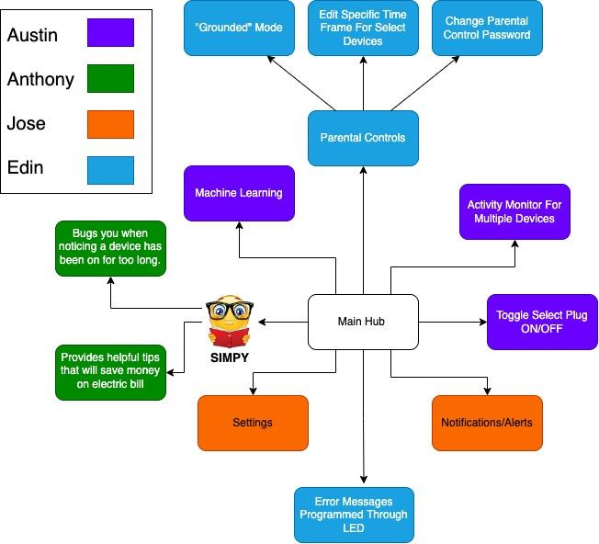

*Figure 1: Software Block Diagram*

3.2 Hardware Block Diagram

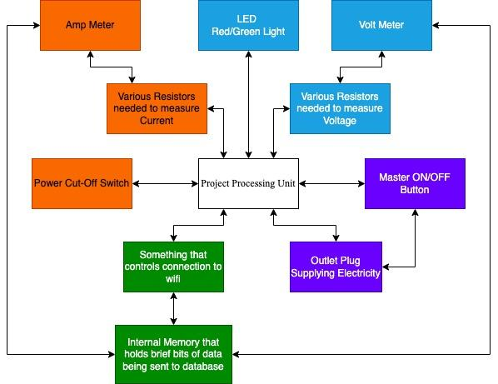

*Figure 2: Hardware Block Diagram*

3.3 Rough Draft of Linear Circuit

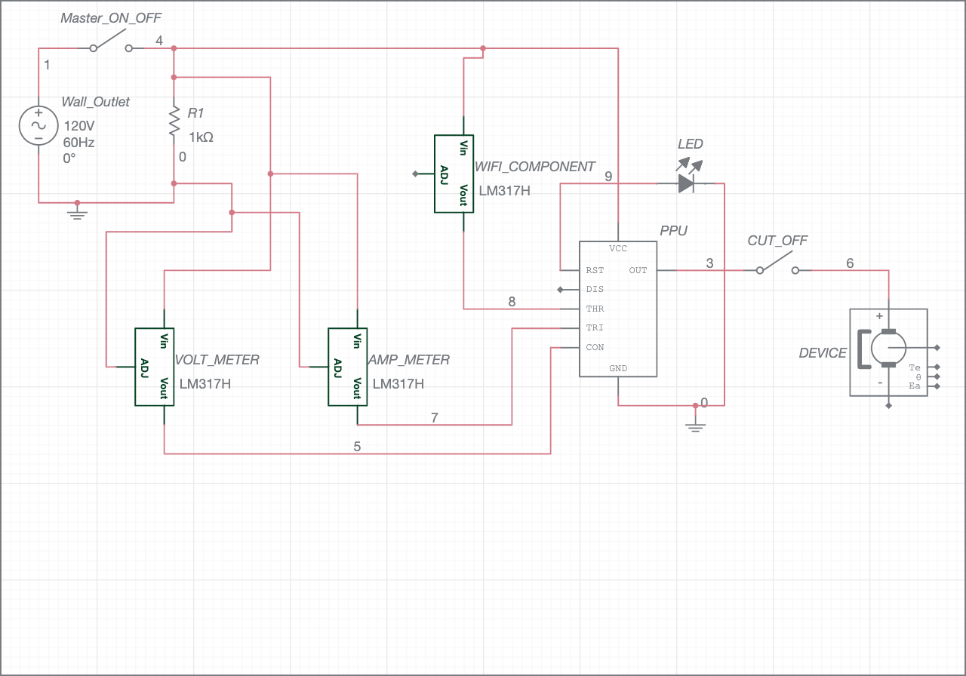

*Figure 3: Rough Draft of Linear Circuit*

***Please do keep in mind that none of the components being shown are actual components being used, as seen by both the Amp Meter and Voltage Meter being displayed as LM317H’s, or the Processing Unit being displayed as a 555 Timer. They are merely place-holders in spots for the actual components due to Multisim Live’s inventory of only the most basic linear circuit components.

3.4 Design Sketch

3.4.1 S.I.M.P. Block Sketch

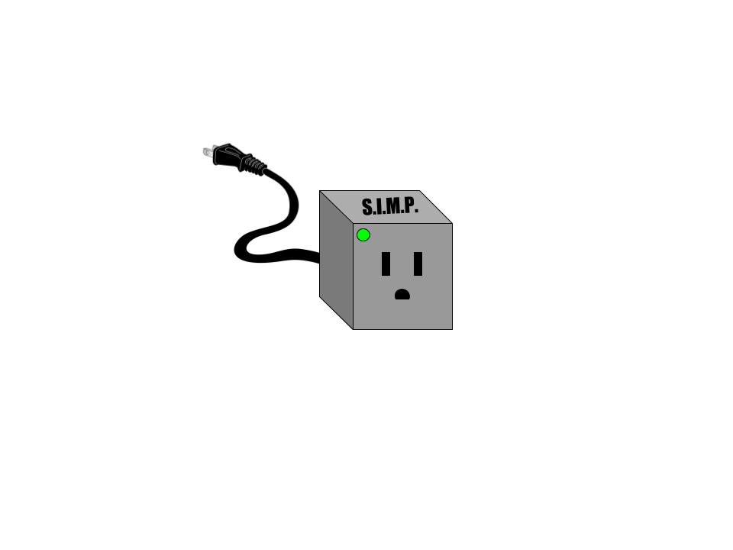

*Figure 4: S.I.M.P. Block Sketch*

Alterations could be made in the future regarding how many female sockets could be implemented to the block.

3.4.2 S.I.M.P. Wall Outlet Fixture Sketch

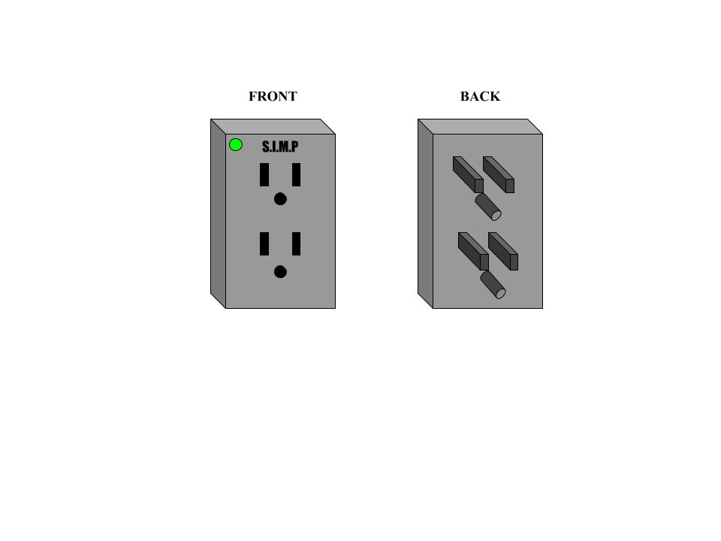

*Figure 5: S.I.M.P. Wall Outlet Fixture Sketch*

Alterations could be made in the future regarding how many male plugs would be needed for power or rigidity and how many female sockets could be implemented without costing the final product an increase in size.

3.4.3 S.I.M.P. Extension Cord Brick Sketch

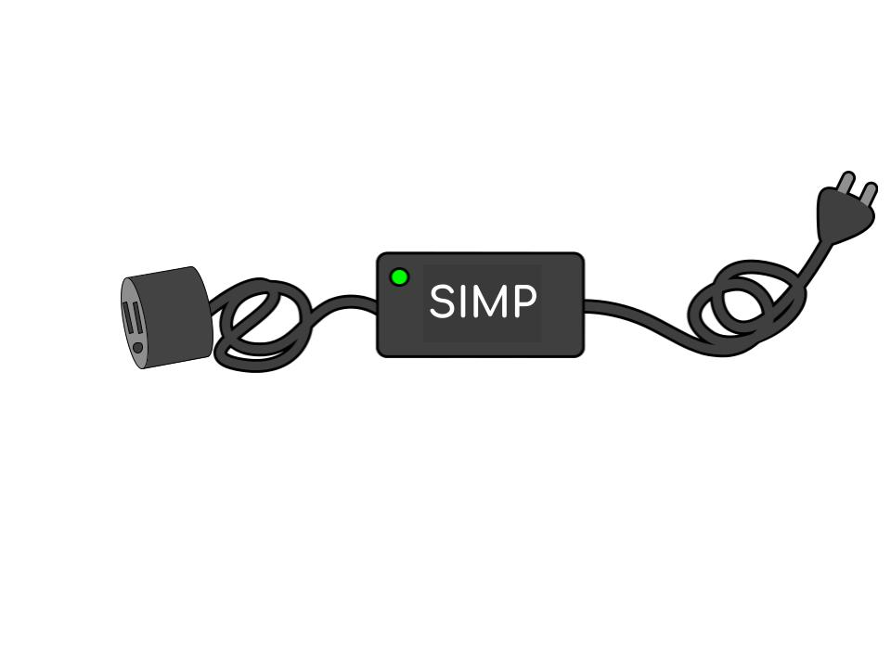

*Figure 6: S.I.M.P. Extension Cord Brick Sketch*

**4. Project Budget**

There is no sponsor yet as of writing this paper, as we will be funding the project ourselves. The table below shows an estimated budget of all the parts necessary to create our project. The prices may be overestimated to account for possible problems or price changes that may occur during the semester.

4.1 Project Budget Breakdown

| Hardware | Cost | Quantity |
| --- | --- | --- |
| Project Processor | $50 | 1 |
| Relay Switch | $20 | 1 |
| Voltmeter | $20 | 1 |
| Ammeter | $20 | 1 |
| Buttons | $10 | 2 |
| Resistors | $10 | Over 10 |
| WiFi Module | $20 | 1 |
| NEMA 5-15 Plug | $20 | 1-2 |
| Printed Circuit Boards | $30 | 1 |
| Total Budget | $200 |  |

*Table 1:Project Budget Breakdown*

**5. Project Milestones**

5.1 Senior Design 1 Estimated Milestone Dates

| Milestones | Dates |
| --- | --- |
| Divide and Conquer, Version 1.0 | June 2nd |
| Divide and Conquer, Version 2.0 | June 17th |
| Standards Assignment | June 24th |
| 60 Page Documentation Draft | July 8th |
| 100 Page Report | July 22nd |
| Final Document | August 2nd |

*Table 2: Senior Design 1 Estimated Milestone Dates*

5.2 Senior Design 2 Estimated Milestone Dates

| Milestones | Dates |
| --- | --- |
| Ordering Prototypes of Design to Test | August |
| Testing and Fixing Design Flaws | September |
| Redesigning Hardware and Software | October |
| Finalizing Projects Software and Enclosing | November |
| Presenting our Project | December |

*Table 3: Senior Design 2 Estimated Milestone Dates*

**6. House of Quality**

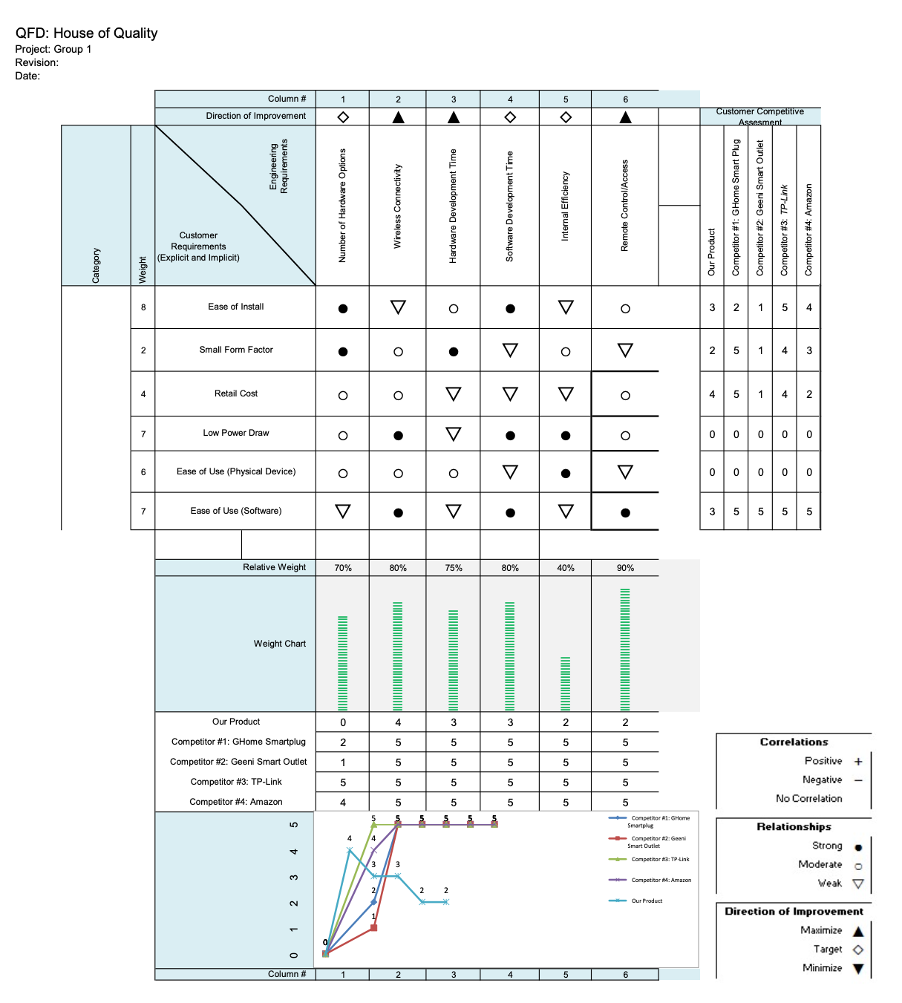

*Figure 7: House of Quality Chart*

**7. Plan of Demonstration**

For our demonstration at the end of Senior Design 2, we plan on showcasing 3 main features of the device:

* Live power reading along with a chart of daily power usage of the device.
* Ability to turn the device on and off from the app/website.
* Digital assistant SIMPY sending notifications and advice on power usage.