

Group 11

The Household Power Management System:

“Smart Interior Monitoring Plug”

(S.I.M.P.)

Jose-Valentin Sera-Josef (EE)
Anthony Perez (CpE)

Edin Durgutovic (EE)

Austin Raynor (CpE)

Table of Contents:
1. Executive Summary 1
2. Project Description 2
2.1 Motivation 2
2.2 Goal 2
2.3 Related Work 3
2.3.1 “Mini Smart Plug, Wi-Fi Outlet Socket” sold by GHome Smart 3
2.3.2 “Smart Wi-Fi Duplex Tamper Resistant Outlet” sold by Geeni 4
2.3.3 “Amazon Smart Plug” sold by Amazon 4
2.3.4 “Kasa Smart Wi-Fi Plug Mini” sold by TP-Link 5
2.4 Engineering Specifications 7
2.5 Block Diagram(s) 8
2.5.1 Software Diagram 9
2.5.2 Hardware Diagram 9
2.5.3 Hardware Flowchart 11
2.5.4 House of Quality Chart 12
3. Research & Part Selection 13
3.1 Technology Comparison 13
3.1.1 Bluetooth vs. Wi-Fi vs. Zigbee 14
3.1.2 NEMA 5 vs. NEMA 14 15
3.1.3 Electromechanical Relay vs. Solid State Relay 17
3.1.4 Shunt Resistors vs. Magnetic Sensors 18
3.2 Part Selection 20
3.2.1 Coding Software Selection 20
3.2.2 Web Server Selection 22
3.2.3 Hardware Selection 24
3.2.3.1 Microcontrollers 25
3.2.3.2 Shunt Resistors 28
3.2.3.3 Ammeters 29
3.2.3.4 Outlets 30
3.2.3.5 Plugs 34
3.2.3.6 Switches and Buttons 36
3.2.3.7 Relays 38
4. Design Constraints and Standards 42
4.1 Design Constraints 43
4.1.1 Economic and Time Constraints 43
4.1.2 Ethical, Health, and Safety Constraints 44
4.1.3 Environmental and Manufacturing Constraints 44
4.1.4 Wireless Constraints 45
4.1.5 Programming Constraints 45
4.2 Design Standards 46
4.2.1 NEMA Power Standards (Outlet Standards) 47
4.2.2 IEEE 802.11 Standards (Wireless Connectivity) 47
4.2.3 UL 94,111 Standard (Flammability of Plastics/Multi-Outlet) 48
4.2.4 IPC Standards (General PCB Layouts) 49
4.2.5 ISO/IEC 50001/29119 Standard (Development in IT) 51
5. Design 52
5.1 Hardware 52
5.2 Schematic(s) 52
5.2.1 Voltage Measurement 53
5.2.2 Ammeter Rough Draft 53
5.2.4 High Voltage AC to Low Voltage DC MicroUSB 56
5.2.5 Final Schematic 60
5.3 Breadboard Testing 63
5.3.1 Outlet-to-Outlet Power 63
5.3.2 Ammeter 66
5.3.3 Wi-Fi Connection 70
5.3.4 Green/Red LED 71
5.3.5 Voltage Divider 74
5.3.6 Powering Arduino Through MicroUSB 79
5.3.7 Safely Cutting Off Power 81
5.3.8 Sending and Receiving Data to and from Hub 82
5.3.9 Soldering of “VUSB” Pin 83
5.4 Software 84
5.4.1 SIMP 84
5.4.2 Web (Front-End) 85
5.4.3 Database and Web APIs (Back-End) 85
5.4.4 Machine Learning 87
5.4.5 Controls 87
5.4.5 Payload 88
5.5 Software Components/Flow Charts 88
5.5.1 Initial Setup/Wi-Fi Connection 89
5.5.2 Parental/Main Controls 89
5.5.3 SIMPY 91
5.5.4 Activity Monitor 92
5.6 Interface 95
5.6.1 Software/Website Example 95
5.6.2 Physical Switch 96
5.6.3 LED(s) 96
5.7 Design Sketch 97
5.7.1 SIMP Wall Outlet Fixture Sketch 98
5.7.2 SIMP Block 98
5.7.3 SIMP Extension Cord Brick 99
6. Overall Integration 101
6.1 Hardware Setup and Operation 101
6.2 Software Setup and Operation 101
6.2.1 SIMP’s Frontend 102
6.2.2 SIMP’s Backend 105
6.3 System Testing 106
6.3.1 SIMP’s Ability to Handle a Load 107
6.3.2 SIMP’s Ability to Connect to the Network 107
6.3.3 App’s Ability to Communicate with the SIMP 107
6.3.4 App’s Ability to Interact via UI 108
7. Administration 109
7.1 Administration Table 111
7.2 Project Milestones/Budgeting 112
7.2.1 Senior Design 1 Estimated Milestone Dates 112
7.2.2 Senior Design 2 Estimated Milestone Dates 113
7.3 Project Budget 114
7.3.1 Breadboard Testing Budget 114
7.3.2 Approximated/Allotted Budget 115
8. Conclusion 117
Appendix A: Related Works/Product Links 118
Appendix B: Data Sheets/ References 120

Figures:
Figure 1: “Mini Smart Plug” by GHome Smart 4
Figure 2: “Smart Outlet” by Geeni 5
Figure 3: “Amazon Smart Plug” by Amazon 6
Figure 4: “Kasa Smart Plug Mini” by TP-Link 7
Figure 5: “Sense Home Energy Monitor” by Sense 7
Figure 6: Software Block Diagram 11
Figure 7: Hardware Block Diagram 12
Figure 8: Hardware Flowchart 13
Figure 9: House of Quality Chart 14
Figure 10: NEMA 5 & 14 Plugs 18
Figure 11: Electromechanical Relay vs. Solid State Relay 19
Figure 12: Shunt resistor 21
Figure 13: AWS Amplify Logo 25
Figure 14: DigitalOcean Logo 25
Figure 15: Heroku Logo 26
Figure 16: Arduino Portenta X8 27
Figure 17: Arduino MKR Wi-Fi 1010 28
Figure 18: Arduino Nano 33 IoT 29
Figure 19: Hall Effect Ammeter 32
Figure 20: Decora 15 Amp Residential Grade Self Grounding Duplex Outlet 33
Figure 21: X Series 20 Amp 125-Volt Tamper Resistant USB Duplex 34
Figure 22 : Leviton 20 Amp Commercial Grade Duplex Outlet 35
Figure 23: Leviton 15 Amp 125-Volt Double Pole 3-Wire Grounding Plug 36
Figure 24: Leviton 515PV-OR 15 Amp, 125 Volt, Grounding Plug 37
Figure 25: GRS-4011-0146,GRS-4021B-0000,GRL-4011-0000 Rocker Switches 38
Figure 26: Pushbutton Switch SPST-NC Standard Panel Mount 39
Figure 27: TWTADE 2PCS AC SSR Single Phase Solid State Relay ssr-25da 41
Figure 28: AQA221VL by Panasonic Electronic Works 42
Figure 29: Voltage Measurement Rough Draft 55
Figure 30: Amp Measurement Rough Draft 56
Figure 31: Voltage Divider Equation 56
Figure 32: Voltage Divider Simulation #1 56
Figure 33: Voltage Divider Simulation #2 57
Figure 34: Voltage Divider Simulation #3 57
Figure 35: WEBENCH® POWER DESIGNER Home Page 58
Figure 36: Final Two AC/DC Schematic Characteristics 59
Figure 37: UCC28740 AC/DC Schematic 60
Figure 38: UCC28740-Q1 AC/DC Schematic 61
Figure 39: Final Schematic Rough Draft 63
Figure 40: Voltage Divider Calculator 65
Figure 41: Outlet-to-Outlet Power Schematic 66
Figure 42: Outlet-to-Outlet Power #1 66
Figure 43: Outlet-to-Outlet Power #2 67
Figure 44: Outlet-to-Outlet Power #3 67
Figure 45: ACS712 Hall Effect Current Sensor 69
Figure 46: Ammeter Breadboard Test Circuit Diagram 69
Figure 47: Ammeter Breadboard Test Circuit 70
Figure 48: Function Generator 10 Vpp 60 Hz 70
Figure 49: DC Power Supply Supplying 5V 71
Figure 50: Ammeter Output Voltage 71
Figure 51: Arduino Nano 33 IOT 72
Figure 52: Output of the Arduino Scanning for Local WiFi Networks 72
Figure 53: Output of the Arduino’s Connectivity Test 73
Figure 54: LED Breadboard Test Circuit Diagram 74
Figure 55: LED Breadboard Test with Switch in “OFF” Position 74
Figure 56: LED Breadboard Test with Switch in “ON” Position 75
Figure 57: Arduino Blinking LED Sample Code 75
Figure 58: Voltage Divider #1 Circuit Diagram 76
Figure 59: Voltage Divider #1 Breadboard 76
Figure 60: Function Generator 1 Vpp 60 Hz 77
Figure 61: Voltage Divider #1 Output Voltage 77
Figure 62: Voltage Divider #2 Circuit Diagram 78
Figure 63: Voltage Divider #2 Breadboard 78
Figure 64: Voltage Divider #2 Output Voltage 79
Figure 65: Function Generator 10 Vpp 60 Hz 79
Figure 66: Voltage Divider #2 Output Voltage After 10 Vpp Input Voltage 80
Figure 67: MicroUSB Split Into Four Wires 81
Figure 68: DC Power Supply Supplying 5V 82
Figure 69: 5V DC Powering MicroUSB OFF 82
Figure 70: 5V DC Powering MicroUSB ON 83
Figure 71: Read API function 84
Figure 72: Create API function 85
Figure 73: The solder and connected VUSB jumper pads 86
Figure 74: “SIMP” UML Diagram 88
Figure 75: Payload 90
Figure 76: Initial Setup Flow Chart 91
Figure 77: Parental/Main Controls Flow Chart 92
Figure 78: SIMPY Flow Chart 94
Figure 79: Apple Screen Time #1 95
Figure 80: Apple Screen Time #2 95
Figure 81: Apple Screen Time #3 96
Figure 82: Potential Activity Monitor Sketch 98
Figure 83: S.I.M.P. Wall Outlet Fixture Sketch 100
Figure 84: S.I.M.P. Block Sketch 101
Figure 85: S.I.M.P. Extension Cord Brick Sketch 102
Figure 86: SIMP Login Page 105
Figure 87: TPLink Kasa Smart Plug Sample Data Chart 106
Figure 88: SIMP Sample User Dashboard 107
Figure 89: GET API Requests 108
Figure 90: POST API Requests 109

Tables:
Table 1: Related Works 9
Table 2: SIMP Specifications Table 10
Table 3: Bluetooth vs. Wi-Fi vs. Zigbee 17
Table 4: NEMA 5 vs NEMA 14 19
Table 5: Electromechanical Relay vs. Solid State Relay (in General) 20
Table 6: Shunt Resistors vs. Magnetic Sensors 22
Table 7: Software Selection 23
Table 8: Web Hosting Options (Pros/Cons) 26
Table 9: Microcontroller Comparisons 30
Table 10: Shunt Resistors Components 31
Table 11: Ammeters 32
Table 12: Decora 15 Amp Outlet Specifications 33
Table 13: X Series 20 Amp 125-Volt Duplex Specifications 34
Table 14: 20 Amp Commercial Grade Duplex Outlet 35
Table 15: Outlet part comparison 36
Table 16: Leviton 15 Amp 125-Volt Double Pole 3-Wire Grounding Plug 37
Table 17: Leviton Grounding Plug Comparison Chart 38
Table 18: Rocker Switches Comparison 39
Table 19: Pushbutton Switch SPST-NC Standard Panel Mount 40
Table 20: TWTADE 2PCS AC SSR Single Phase Solid State Relay ssr-25da 41
Table 21: AQA221VL by Panasonic Electronic Works 42
Table 22: Relay Component Comparison 43
Table 23: Tiny Ammeter vs Breadboard-Friendly Ammeter 68
Table 24: Software 90
Table 25: Software Components 96
Table 26: LED Message Code Directory 99
Table 27: SIMP Design Sketch Comparison 103
Table 28: System Testing 111
Table 29: Project Responsibility Table 115
Table 30: Senior Design 1 Estimated Milestone Dates 116
Table 31: Senior Design 2 Estimated Milestone Dates 117
Table 32: Breadboard Testing Budget Breakdown 118
Table 33: Approximated/Allotted Budget Breakdown 119

1. Executive Summary

All around the world, we as innovators push the boundaries of what is known, aiming to seek out new and practical solutions to our modern everyday problems. The simplest of tools and innovations, such as the wheel or the nail, came from an unconscious need for humans to solve a persistent task within their means. It wasn’t until time and research passed on that one invention led to another invention, thus ultimately leading to modern day appliances and simple electronics that became basic necessities in our everyday life - such as light from a lightbulb, or ventilation from an air duct. Nowadays, we have the privilege of modern technology and advances in STEM that have enabled engineers the capability to let their creative minds wander and begin to produce products that most users never thought they would need. The first electronic doorbell was invented in 1831. It was not until 2012 that the world finally had the idea to attach a camera to the doorbell and grant an end user access to seeing a live video feed from that same basic doorbell that once served a basic solitary purpose. Now, brands such as Ring, Nest and Netgear dominate the doorbell market and continue to enhance once thought of non-pertinent necessities with Smart capabilities. One of those many simple electronics that were once thought of as being completed in its entirety was the general home electrical outlet, also known as a NEMA 5.

At first glance a consumer may think that any additional features to be added to an outlet would be solutionism at its worst, because they perceive their outlet to serve a solitary purpose -that is, providing power to a connected device. But when we come to understand the role of an outlet we can begin to devise ways of incorporating Smart technologies in an effort to make them as intelligent and efficient as possible. What most consumers recognize by now is that advancements in technology means additional devices in their home; additional devices in a consumer's home means additional power necessary to power each individual device; additional power drawn from a consumer's home electricity will eventually inflate their electric bill - at what rate ultimately depends on the consumer. It's this simple problem, the issue of home power consumption in a world moving in the direction of automation and technology, that we aim to tackle and mitigate with our version of a Smart monitoring plug.

The Smart Interior Monitoring Plug (SIMP) is able to provide both digital and physical support in the home to help monitor the power usage of the different devices plugged into it within a home or office. The monitored home layout will physically consist of one or several SIMP units plugged into the walls that are connected over Wi-Fi to a web server - each unit being no larger than a NEMA 5 plug/receptacle.. All the SIMPs will be monitoring the power usage of the devices plugged into them and sending the information to an online server where it is saved. The data can then be accessed through a webpage to see the power usage consumed and costs spent over time. Some form of a smart digital assistant, “SIMPY” will aim to provide analytics to the user in the form of cost analysis, change in power usage for the month, as well as other basic functions to help the user learn more about their households power usage and offer solutions to reduce power usage while maintaining their basic quality of life.

Research and notes taken on related works helped us in deciding what features of the device would need to be incorporated to, not only stay competitive with similar products, but to separate our product above the rest with unique features. The related works also gave us ideas as to what engineering specifications we should prioritize and which are not as important to be demonstrated when the time comes for our final presentation of our project.

Through the use of the webpage users will also be able to set schedules for their appliances that are connected to SIMPs as well as enable parental controls. Parental control for the SIMPs would require a PIN or password to be entered from the SIMP webpage to allow an appliance connected to the SIMP in question to be activated either until the device is turned off or for a set amount of time at which point power to the device will be shut off. In the event a device connected to a SIMP is considered a “high-priority device” (ex. CPAP, medicine pump, life support or other medical monitors) it can be exempt from a SIMPs schedule even if another device is sharing a SIMP. If a non-high priority device is still being used close to the SIMPs scheduled off period, the mobile app will send a push notification to the users email or phone number to warn them power will be shut off soon and to give them the option to extend that SIMPs time being active with the entry of the Parental Control PIN.

A smart monitoring plug is not a new invention. A decent number of companies, some well known, some not so much, have made their attempt at producing a Smart plug tailored to their likings Several of the members involved in this project own some of these Smart Plugs. It’s because of this outside perspective that we as both a consumer and an engineer have the capability to build and program a version of the SIMP to not only do what most other companies plug’s will do, but also make up for them in added content and features where competitors products fall short. Such is the reason for the genesis of this design.

2. Project Description

In this section, we will be highlighting our first ideas and motivations for this project, as well as our overall goal that we have set for ourselves to consider this project complete when finally presenting it. In this section are also some descriptive works that we found comparable to our idea of the final product, as well as some in depth compare-and contrast-type descriptions. Finally we have agreed on a table of engineering specifications we plan to have the final product follow and have highlighted those that we plan on demonstrating in our final presentation.

2.1 Motivation

Our motivation behind the SIMP was caused by hearing about the never-ending struggle that is lowering the electric bill in one’s household. It’s a difficult topic to tackle and has many ways to achieve a solution. While some will just live with the air conditioning being a degree higher or not using hot water as much it doesn’t necessarily get to the root of the problem of what in your house is consuming the most power. To get the answers you would usually have to call your electricity provider to send a specialist who can give you suggestions on what are the heaviest loads but those are always in the moment and don’t pick up on trends in the household over time which we hope to alleviate with our device. While there are devices on the market that are able to help monitor your total power usage straight from the breaker panel most don’t give device specific readouts and give most homeowners worries as they need a certified electrician to install it or possibly injure or kill themselves in the name of saving money. This is what had us all decided on the more simple plug design to allow the user to just plug the SIMP into the wall in between their devices to monitor their energy output without the complicated and expensive install. On a slightly different note, we have heard countless complaints from relatives who are parents about how “kids these days are spending too much time on their devices that separate them from the real world around them” while simultaneously soaking up dollars out of their parents wallets through the electrical outlets in their rooms. All members of Group 11 have fallen victim to procrastination or laziness due to excessive use of electronics in the past few years. As a result, we were motivated to include characteristics in the SIMP that help the consumer and their children “disconnect”, both figuratively and literally, from those devices which, in turn, saves electricity and money on their electric bill.

2.2 Goal

Our goal behind the SIMP device was simple; create a device that saves the average home-owner money on their electric bill without having complicated installation (such as getting into a breaker box or taking apart and reinstalling a wall outlet) that might be off-putting to the layman or require calling an electrician for said installation. As previously mentioned, we also set out with a secondary goal of disconnecting the household from their electronics, even if for an hour or two a day, while suggesting alternatives to the abyss that is electronic devices. Something as simple as blocking electricity to a device that has been on for too long and receiving a notification on your phone that says “let’s stretch those legs and go for a walk” every day or so could potentially help improve the consumer’s health both mentally and physically.

2.3 Related Work

As to be expected, there are already products similar to the one we hope to create, with some having more features and efficiency due to the sheer size of their engineering workforce and the time they were able to spend on research and development. Below are a few products we found comparable to our ideal final product:

2.3.1 “Mini Smart Plug, Wi-Fi Outlet Socket” sold by GHome Smart

This smart plug (shown in Figure 1) boasts features that we plan on including in our SIMP, such as Wi-Fi-connectivity, scheduling, and control from practically anywhere through the use of an app, or in our case, a website. It does however boast features that we won’t have in our SIMP device, either due to time constraints or complexity, like Google Home compatibility, Alexa compatibility or hands-free voice control, control over a group of multiple smart plugs in the house and small physical dimensions that make it easy to leave one socket of the outlet functioning as a normal socket.

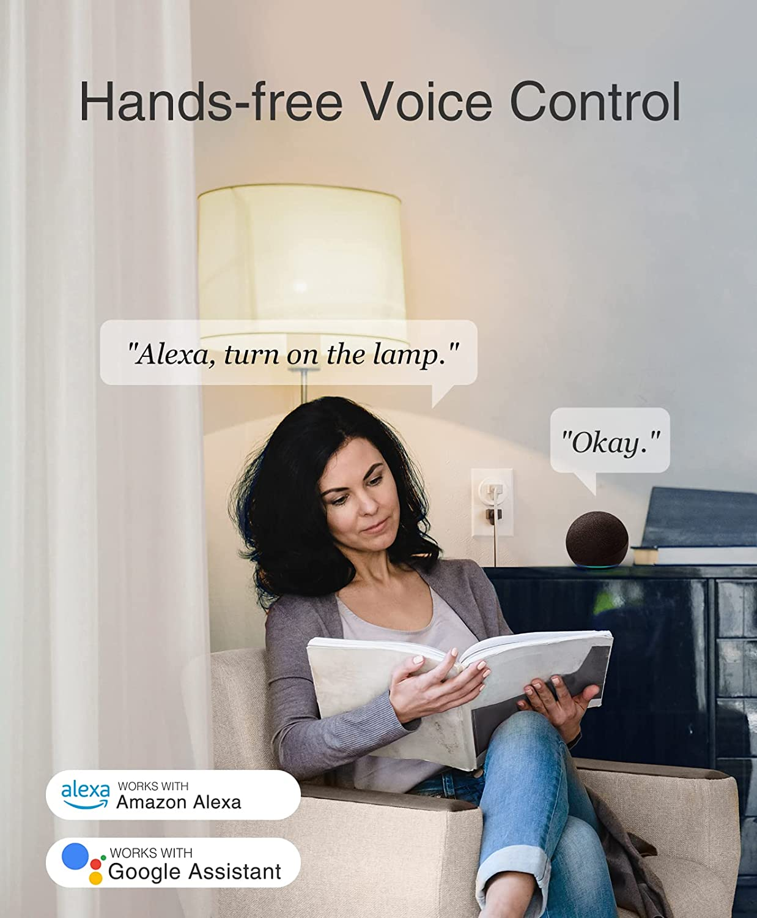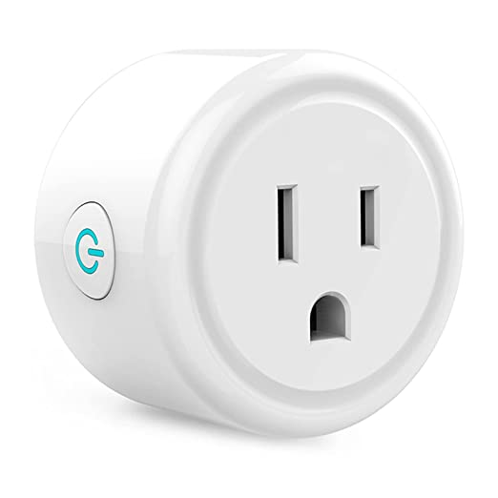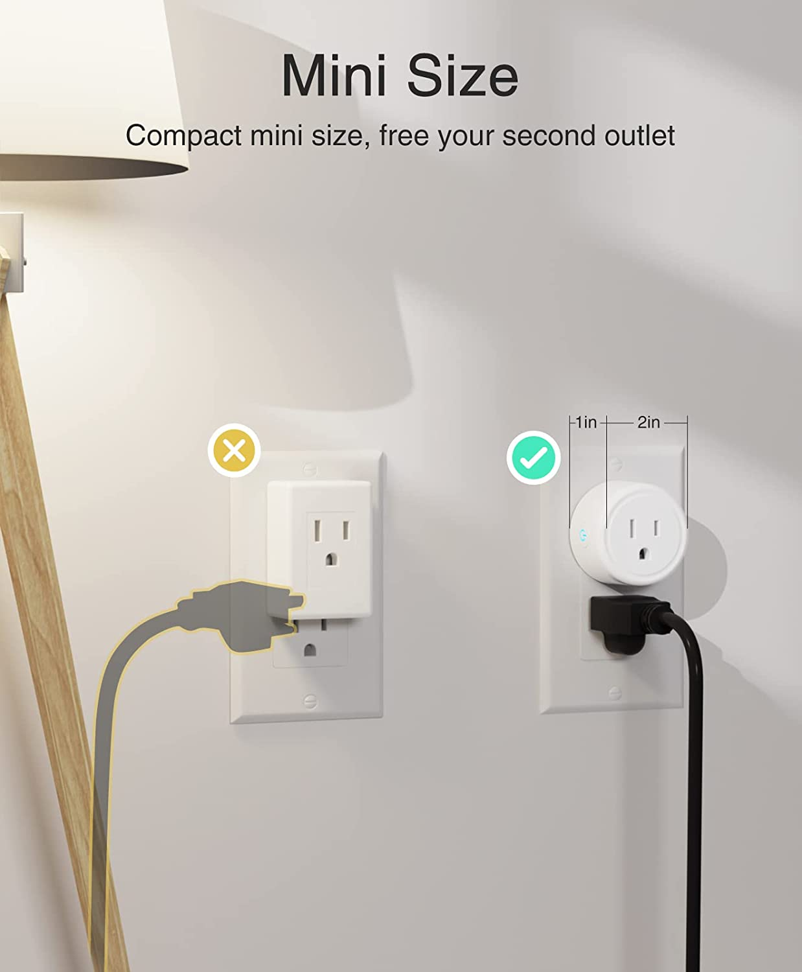
Figure 1: “Mini Smart Plug” by GHome Smart

Although the scheduling aspect of this device may be similar to what we plan on implementing, we intend to take it one step further with machine learning that takes the schedules the user inputs and the readings of power used on certain devices over time and learns to cut power off to those devices when it understands that the user will most likely not be using it based on power usage algorithms. We also intend on differentiating ourselves by having “SIMPY”, the personal SIMP assistant, who will give tips and advice on power usage in the form of notifications to the main user interface hub. Though this product is filled with more features and is smaller than what we expect our final product to be, our approach on “disconnecting” is the main difference between the devices out now and the SIMP. In searching, we were unable to find any sort of smart electrical plug that will notify the user when a device has been on far too long and suggests to take a break and stretch or go outside or completely cut power to said device and essentially force the user to take a break.

2.3.2 “Smart Wi-Fi Duplex Tamper Resistant Outlet” sold by Geeni

This smart outlet (shown in Figure 2) carries the same “control from anywhere” capabilities and the same Alexa and Google compatibility as the smart plug sold by GHome, but with the added benefit of being a direct replacement to the electrical wall outlet. This provides an uninterrupted sleek look that is unnoticeable to the untrained eye. It also benefits with the inability to be removed by a child who doesn’t enjoy their electrical devices being controlled by their parents.

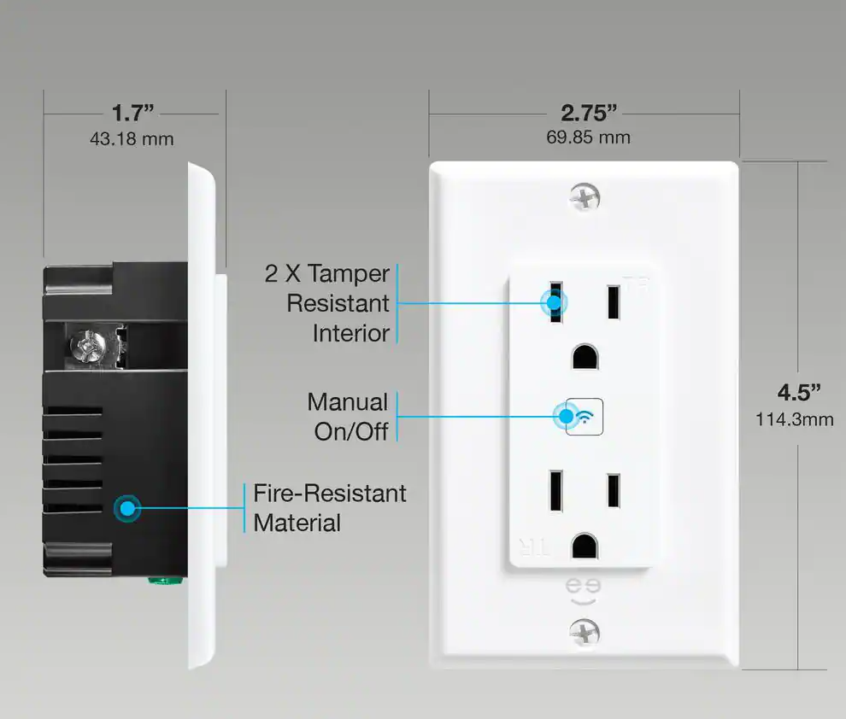
Figure 2: “Smart Outlet” by Geeni

With said benefits, also come downsides. Being a direct replacement to an electrical outlet would be a more complex installation that might discourage the consumer who is hesitant to work with electrical wires. We agreed to stay away from the idea of a complete electrical outlet replacement to keep our goal of simple installation from being tarnished. With the complete replacement also comes the difficulty of wanting to move the hardware from one room to the next. Suppose you want to use the hardware that lets you control the TV in your bedroom to now control the microwave in the kitchen. With a smart plug, you could simply unplug it from the bedroom and plug it into the kitchen. Though, with a direct replacement smart outlet, you would have 3 choices; 1.) Set aside time to uninstall both outlets and switch them for each other; 2.) Find the money to buy more smart outlets and spend a few more minutes uninstalling the existing outlets to then install the new ones; or 3.) Plug your microwave into the bedroom smart outlet and wake your significant other up every time you’d like to enjoy some late-night pizza rolls.

2.3.3 “Amazon Smart Plug” sold by Amazon

Amazon would not be the second biggest (right behind Walmart) retail company known to man if it did not have its own version of a smart plug. It seems like Amazon has its own version of just about every product someone can think of and a smart outlet plug is no exception. It is no surprise that this smart plug has Alexa compatibility, coupled with scheduled on/off switching for the device and a simplistic design that only takes up space of one outlet. A big selling point is the user-interface, which is done all through the Alexa app. Since a good percentage of consumers already have installed and are familiar with the app, it gains the extra point of attraction not having to install a separate app and take up extra space on one’s smartphone. Like the previous smart plug mentioned, its sleek, smaller design allows for use of the outlet above or below it as a normal everyday outlet.

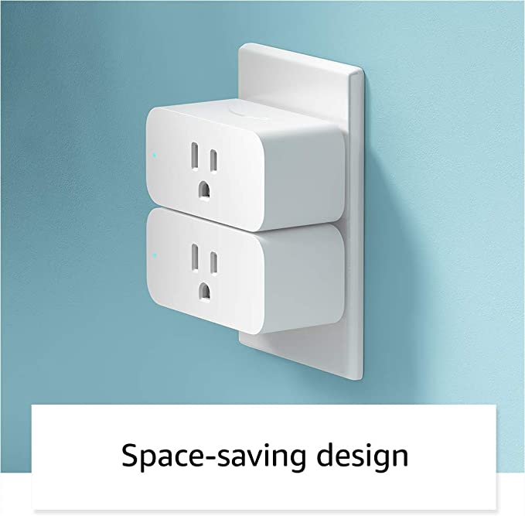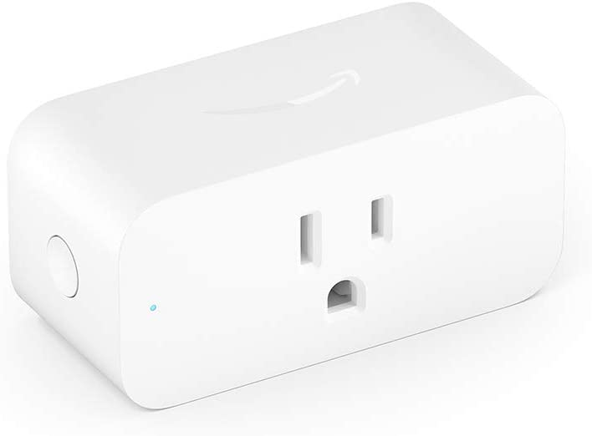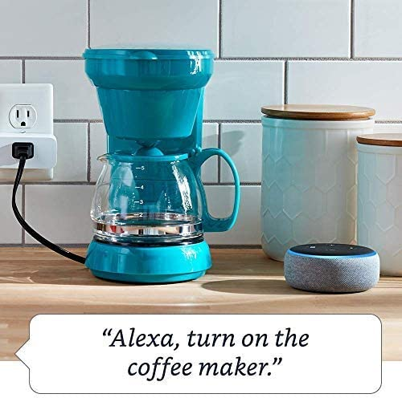
Figure 3: “Amazon Smart Plug” by Amazon

As mentioned true for the previous smart plug, the features on this device focus more on the “away from home” or “too lazy to get off the couch” controls of the device. This smart plug stands as a nice competitor to our SIMP, but lacks the strive for power saving and disconnecting that the SIMP will provide. The ease of use for this device through voice control will not hold a candle to the money the user would save on their electricity bill due to our SIMP. Nor will it compete with the fresh air and serenity the user will be sure to find after SIMPY takes charge, both figuratively and literally, of their household devices and appliances.

2.3.4 “Kasa Smart Wi-Fi Plug Mini” sold by TP-Link

Our last related work comes to us from the bright minds at TP-Link. This smart plug serves as the middle-man between the GHome Smart smart plug and the Amazon smart plug, with a price point equal to half the price of Amazon’s and double the price of GHome Smart. The same can be said for how well-known TP-Link is, as a company; not as popular as Amazon, but still known enough to be sold in electronic retail stores like BestBuy and Target, unlike GHome Smart which after numerous searches, only seems to be sold on Amazon. This plug has all the same features as the smart plugs previously mentioned; Alexa, Google Home, away-from-home controls, device power-scheduling, etc.
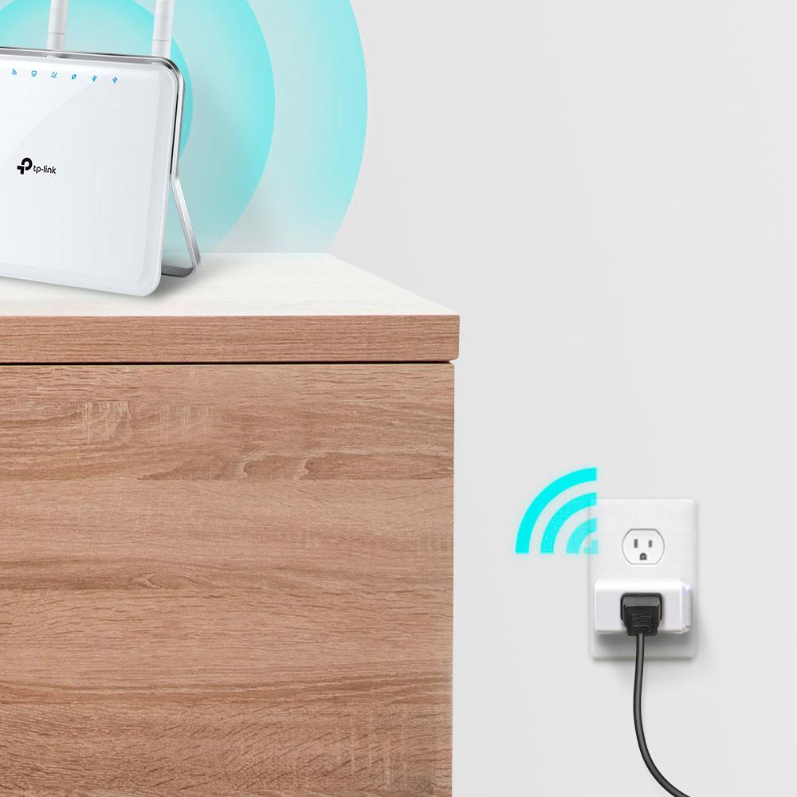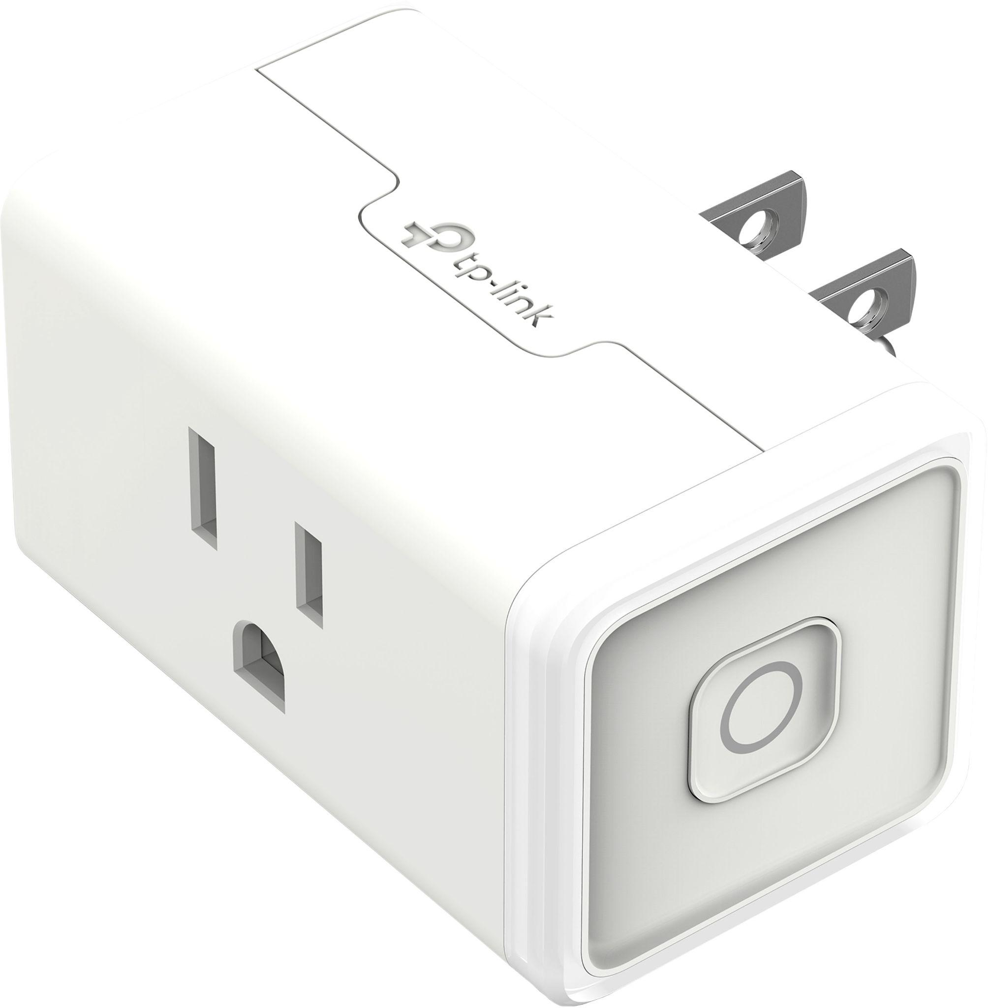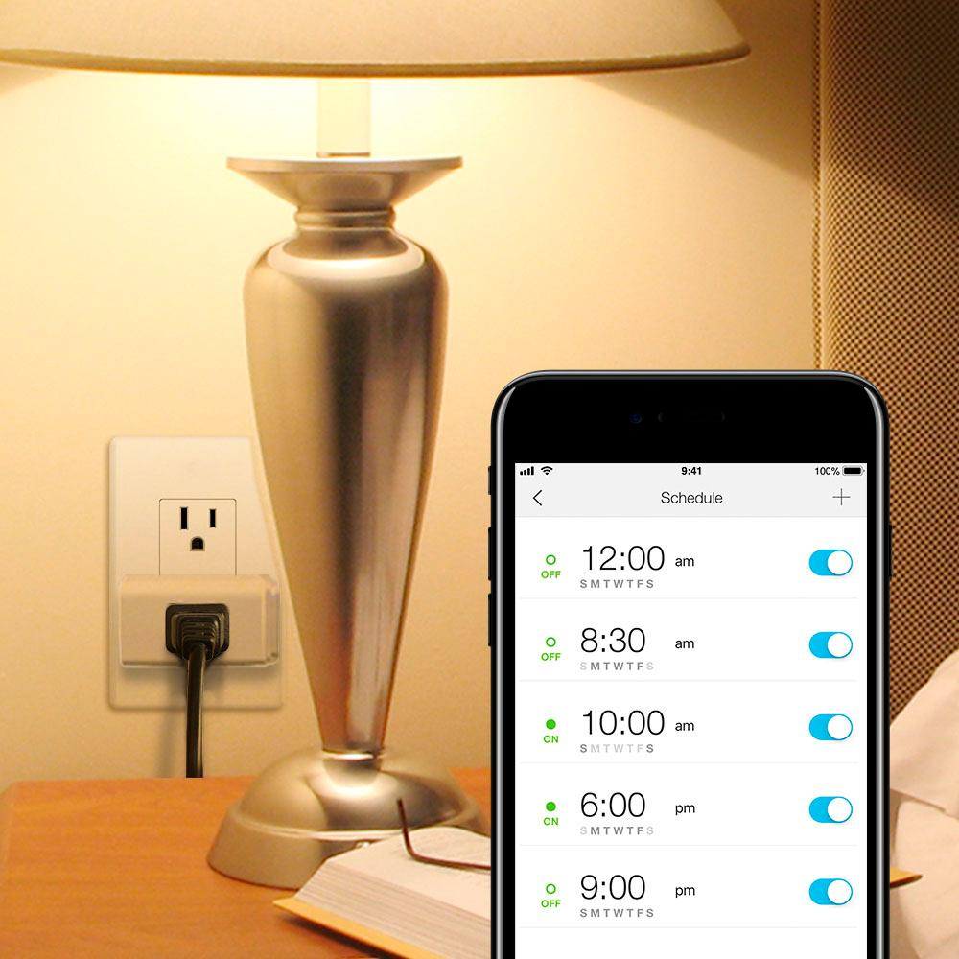
Figure 4: “Kasa Smart Plug Mini” by TP-Link

This product, and all previous products, achieves its purpose that it was meant to achieve, which is giving the user the ability to control certain devices in their home through an app on their phone. Though there are many replicas of the same device with more features than we plan on having for the SIMP, not one of them has set out to do what the SIMP will do. While control of your devices from anywhere is nice, the SIMP plans on using your need to save money on your electric bill to take device control one step further. No device, previously shown, had the ability to detect a lack of activity from the device it was powering and disconnect power to it to save electricity. We believe that this will truly be one of the first devices of its kind; with the constant push for newer technology that keeps our eyes glued to our screens and away from real life, a device that forces you to take a break every now and then through control of your devices has yet to be mass produced, as far as our research shows.

2.3.5 “Sense Home Energy Monitor” sold by Sense
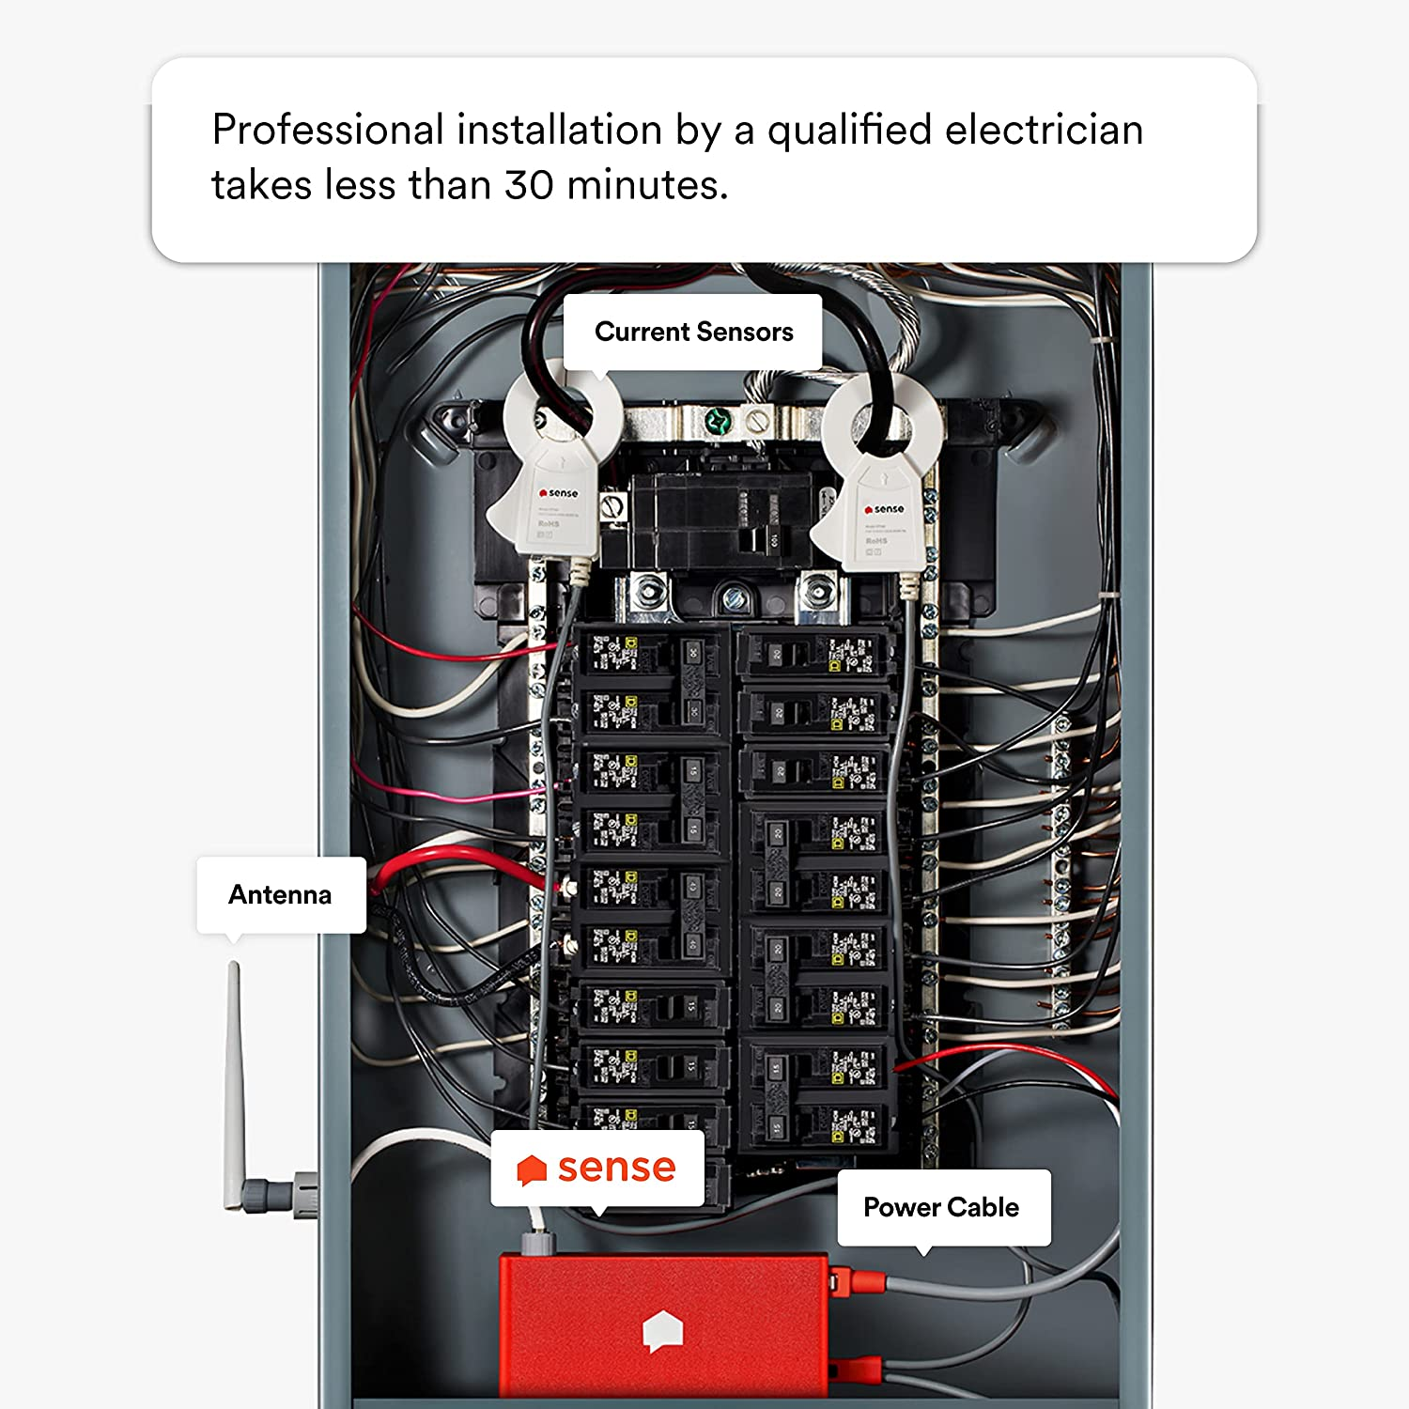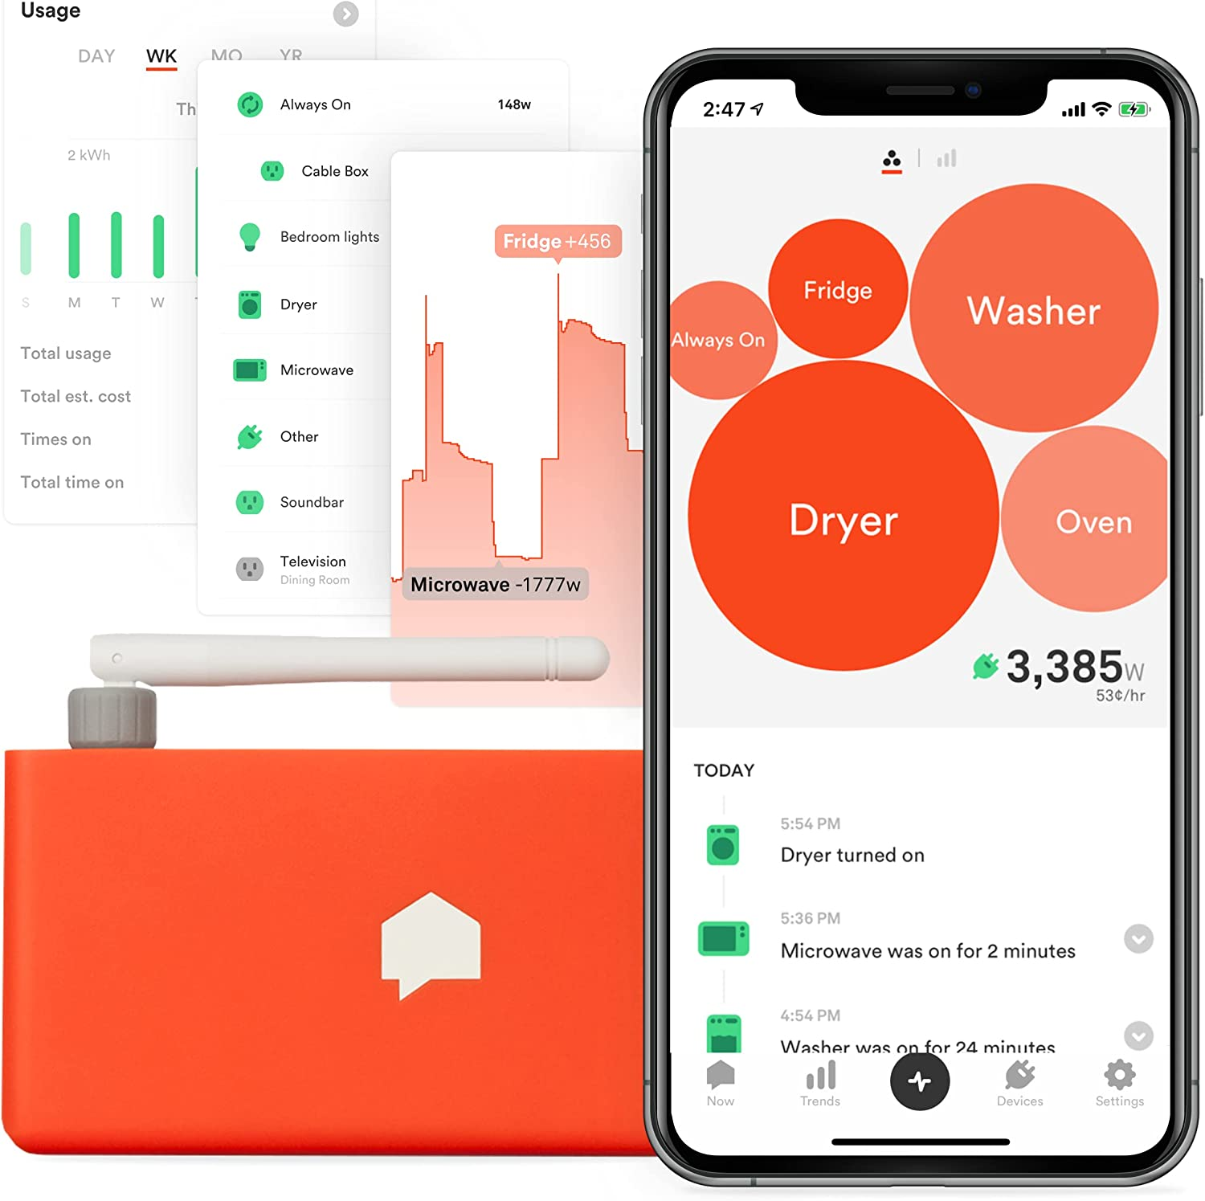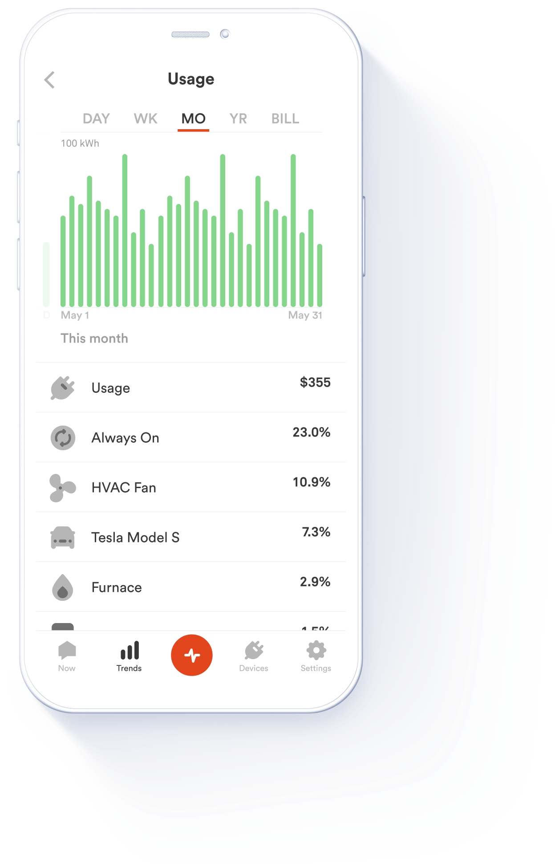
Figure 5: “Sense Home Energy Monitor” by Sense

This product is a bit of an odd-ball of the related products in our list but does accomplish the same task as the others but in a different way. The sense uses current transformer clamps around you mains coming in from the electric company to measure the current without invading the system via a man-in-the-middle solution. The device get’s voltage readouts from a breaker off of your panel to both measure the voltage across the two sides of the panel and to power the device itself. Now the question you may be wondering is how is it able to identify individual devices just by knowing the total power output? And the answer is through Data Disaggregation and Machine learning. Data Disaggregation can best be explained with an analogy, Imagine you are at a bar where there are lots of conversations going on in the background while to someone not paying attention it can be seen as background noise that is not discernible but with a keen ear you might be able to focus on a conversation if you try to tune other frequencies out.

This is how the Sense is able to differentiate devices on the grid without having separate devices once it’s picks up the devices power over time signature it uses machine learning to cross reference it with data obtained from their own testing and current users identifications to give you a device name with a confidence level attached to it. Usually this value is spot on with a 80% pickup rate for most common household appliances but does struggle with smaller appliances that consume less than 100 watts. For this reason the company recommends you buy a separate smart plug for those devices to get more accurate readings from the device itself which adds more cost the user for the sake of more accuracy in knowing what devices take up the most power.

The biggest let down of this devices is it’s requirement to be installed by a certified electrician. While it will only take them 30 minutes to setup they will charge you for the installation and it’s usually not a pretty costs to add on top of the $300 that the device costs upfront without installation. While you may have an electrician that can do it for free or do it yourself it’s not something recommended as it can be a fire hazard, and could even kill you if you are not careful which no one should have to worry about when trying to save money on energy costs. While this device is definitely a suitable product, its high costs, minimum control features, and difficult installation requirements makes it a worthy subject to look into and improve upon especially with giving users more functionality as well as taking some inspiration from their software design to give a full user experience.

Below is a table giving a generalized summary of our related works section above. It can be observed that three of the four related works (GHome Smart, Amazon TP-Link) don’t have much to separate themselves from each other besides their user interface and price point. The main outlier of the four related works seems to be the smart wall outlet replacement, due to its difficulty in installation and expertise required to properly install it, unlike the others who are simple “plug-and-done” devices. It can also be observed that where each of the related works have Alexa and Google Home software built into them, they lack the personal assistant, SIMPY, software we plan to implement. In a way, SIMPY is our greatest strength we have over the competition. While the rest have Alexa and Google Home, which is very unlikely to be used naturally, SIMPY will be around 24/7 to push the user closer and closer towards their desired electricity bill, as well as desired separation from electronics, if applicable.

 | GHome Smart | Geeni | Amazon | TP-Link | Sense | S.I.M.P.
Size/Weight | 2 x 2 x 1.1 inches;  1.6 ounces | 1.7 x 2.75 x 4.5 inches | 3.2 x 1.5 x 2.2 inches;  3.1 ounces | 2.4 x 1.5 x 1.6 inches; 6.4 ounces | 5.4 x 2.6 x 1.26 inches; 7.75 ounces | 5 x 5 x 3 inches;  8 ounces (Estimate)
Alexa & Google Home | ✅ | ✅ | ✅ | ✅ | ✅ | ❌
Scheduling | ✅ | ✅ | ✅ | ✅ | ❌ | ✅
Away-  From-Home Controls | ✅ | ✅ | ✅ | ✅ | ❌ | ✅
SIMPY | ❌ | ❌ | ❌ | ❌ | ❌ | ✅
Easy Installation | ✅ | ❌ | ✅ | ✅ | ❌ | ✅
Price/  Quantity | $7.99/1 | $39.99/2 | $24.99/1 | $17.99/1 | $299.99 | ~$60.00**
Table 1: Related Works

**The price of the SIMP can fluctuate depending on the packaging of components used as it will be cheaper to buy components in bulk or more expensive to buy components as single pieces**

2.4 Engineering Specifications

Below is our previously mentioned table of engineering specifications that we plan to have demonstrable by the end of our project when the final touches have been placed. The specifications that are shown to be highlighted green are the three specific specifications that we plan to demonstrate in the timely manner we are given to present our final product.

 | Key Engineering Specifications:
Dimensions | The enclosure of the SIMP is to be no larger than 5 x 5 x 3 inches.
Plug Style | The SIMP should be compatible and operate via a standard NEMA 5-15R (120V~15A).
Male Plug | The SIMP will consist of no more than 1 standard NEMA 5-15P.
Female Plug(s) | The SIMP will consist of no more than 2 standard NEMA 5-15R.
Data Reporting | The SIMP will collect and report data via a 2.4GHz Wireless Network Connection every 15 seconds.
Platform | The SIMP UI will consist of a low cost web-based platform.
Daily/Weekly Report | The SIMP UI will summate Power Consumption Costs (either per kWh or per U.S. Dollar) per SIMP Device and report them to the end user in the form of a table/chart every 24 hours and every 7 days.
Main Controls | The SIMP UI will enable a user to control the power output within 10 seconds from the web interface.
Dashboard | The SIMP UI will contain a dashboard indicating pertinent information such as Device Schedules, Device State, and Activity Metrics.
“High-Priority” Warning | The SIMP UI will warn the user of any “high-priority” devices suddenly losing power or loss of power draw within 10 seconds of said power loss.
Table 2: SIMP Specifications Table

2.5 Block Diagram(s)

Below are block diagrams showing a basic layout of the hardware and software components of the SIMP device, color-coded to show which member of Group 11 will be responsible for which component of said software or hardware. These help to distribute the workload between the members while also not putting people outside their discipline.

2.5.1 Software Diagram

Due to the lack of experience (relative to their Computer Engineering group members) with various coding softwares, Edin and Jose have elected to help write code that will be written in C or C++ for the microcontroller. Their experience in classes like Computer Organization and Engineering Analysis and Computation will allow them to download programs into the microcontroller(s) without an extensive amount of help needed from their CpE counterparts. Austin and Anthony will be developing the more complicated side of the software that has to do with work on the main server hub, with coding languages like Python, PHP, and JavaScript.

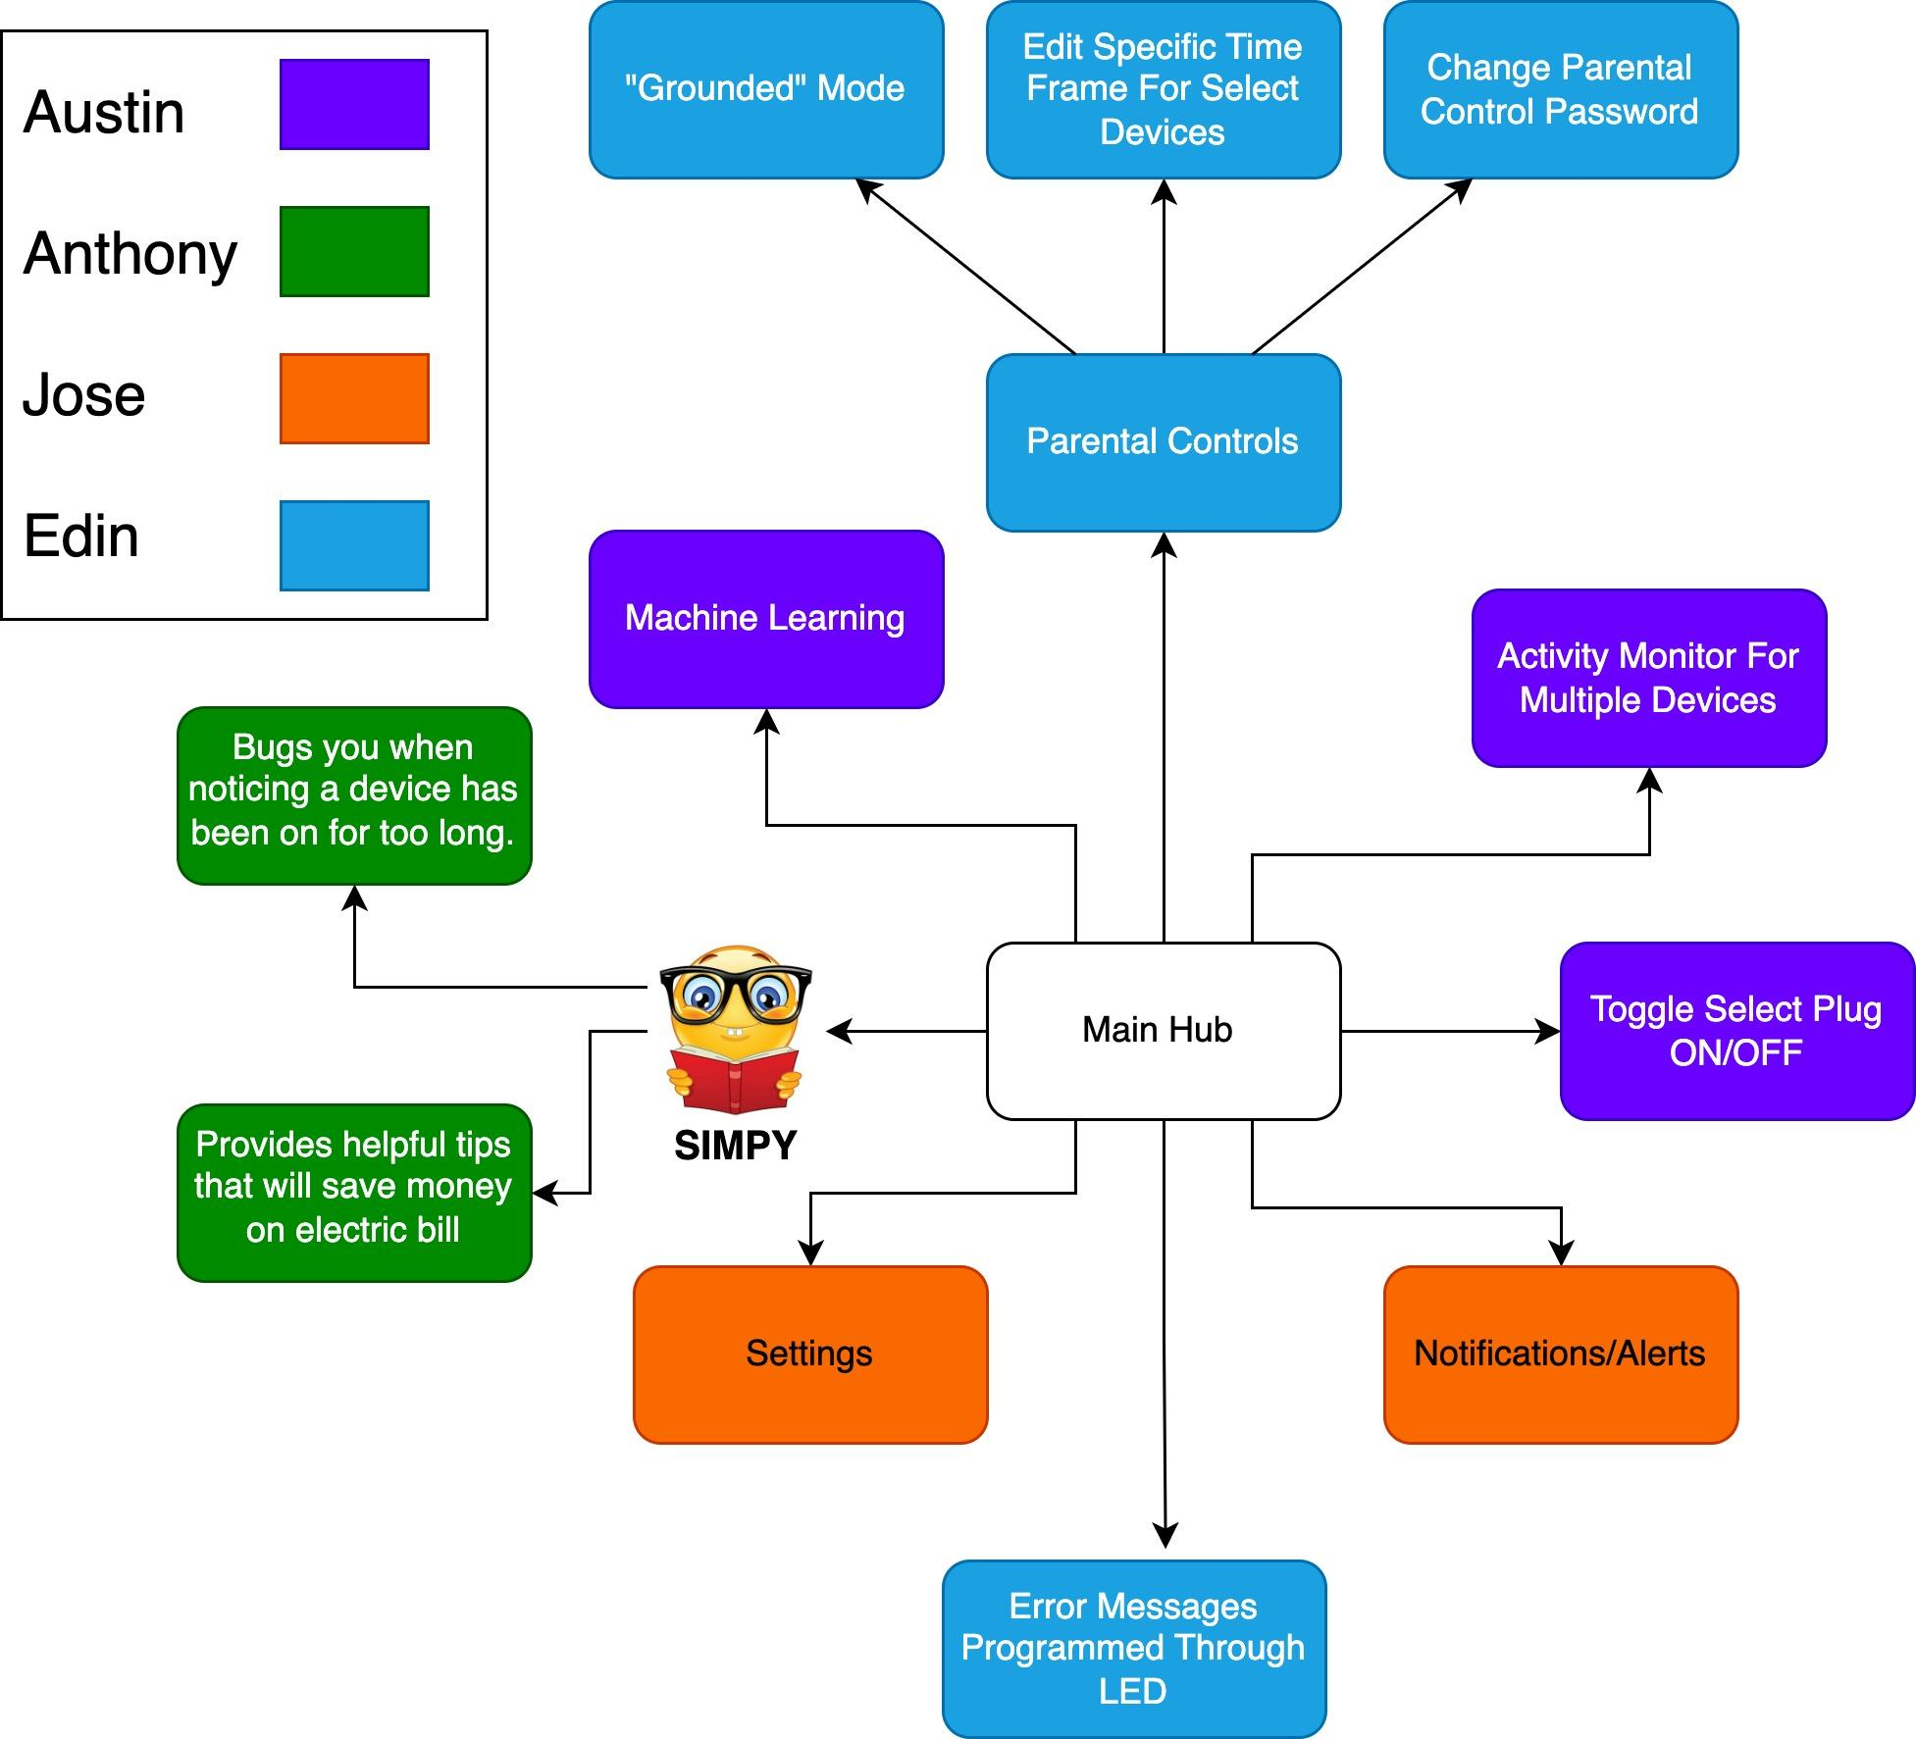
Figure 6: Software Block Diagram

2.5.2 Hardware Diagram

As the more complicated software will be mainly handled by our Computer Engineering group members, the opposite will be true for our hardware. This means that the majority of research in physical parts and breadboard testing will be done by Jose and Edin, while Austin and Anthony will be handling what physical hardware components they are most confident with, with help from their Electrical Engineering group members, if need be.

After the microcontroller or component with Wi-Fi capabilities is properly set up and confirmed to work as we wish, our CpEs will take charge in its function of making sure our SIMPis able to connect to the internet. As to be expected, the area of hardware that may prove to be the most challenging; the voltmeter(s) and ammeter(s) circuit research and development, will be carried out by Jose and Edin. Other sections of hardware have been scattered amongst group members who volunteered their expertise on the subject.

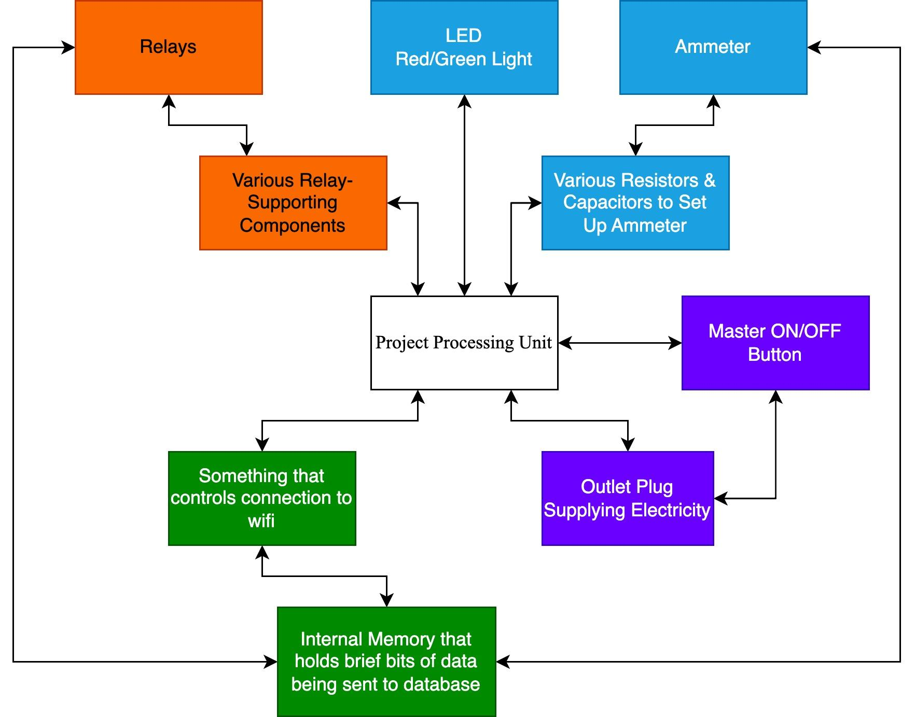
Figure 7: Hardware Block Diagram

2.5.3 Hardware Flowchart

Below is a simplified diagram showing the plan for connecting various hardware to their counterparts. Considering that most of the communication and data exchange will be done between the microcontroller and Wi-Fi module, there is not much hardware
Keep in mind that, although the flowchart shows “Appliances”, our focus is on devices that use plugs that resemble everyday electrical wall outlets, not appliances that use different outlet plugs like washing machines, convection ovens, refrigerators, etc.

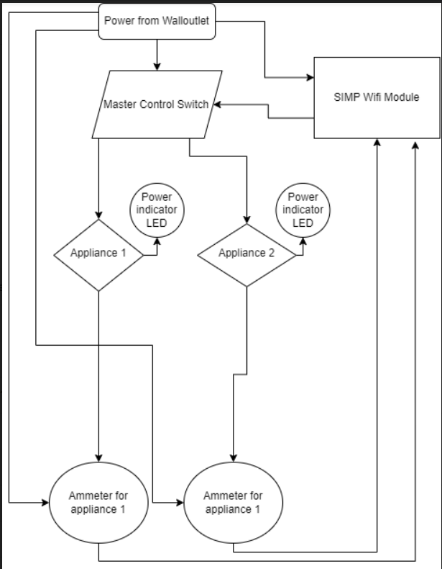
Figure 8: Hardware Flowchart

2.5.4 House of Quality Chart

The following chart simulates comparisons between our product, the Smart Interior Monitoring Plug (SIMP), and several industry giants that have their own version and implementation of a Smart Plug. Categories we aimed to compare our product against others were in the realm of general Ease of Use, the Size of the Unit, as well as the Cost comparison (Post-Production). Most of the comparisons made at this time were according to where we thought the SIMP would be towards the end of the project. In comparison to most, our SIMP did rank lower due to a lack of extensive Research and Development. Given enough time,, we would more than likely be able to make a more space/energy efficient product that, when manufactured in bulk, would generally cost less than most.

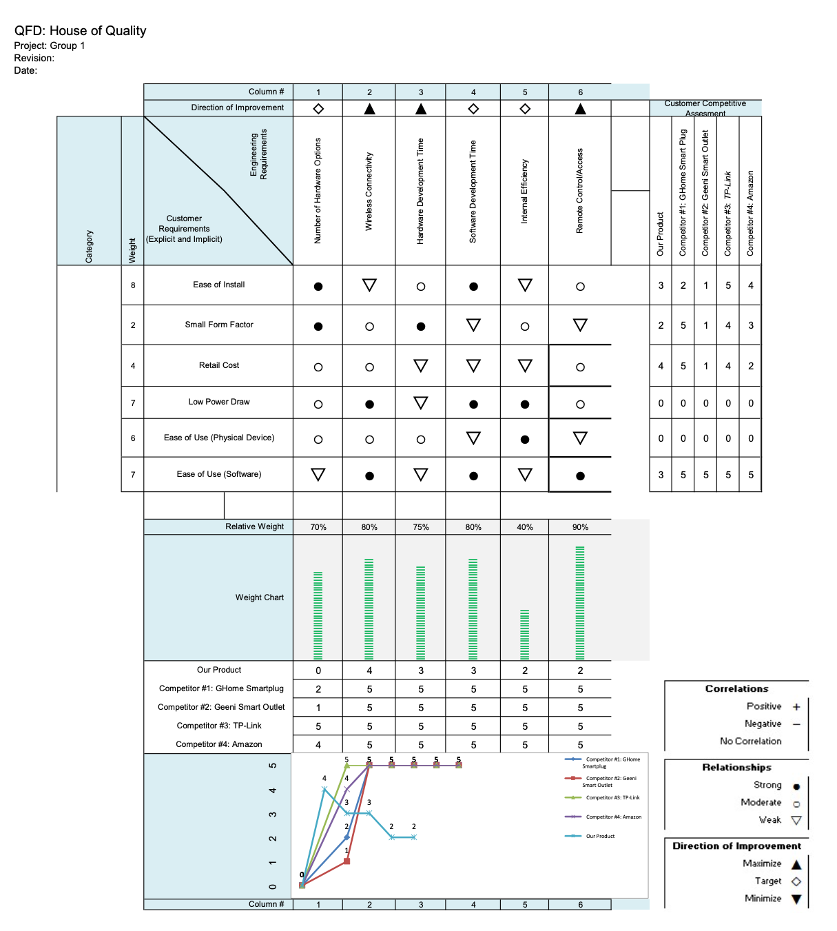
Figure 9: House of Quality Chart

3. Research & Part Selection

When collaborating to design any new project or idea, those involved in the genesis of said creation generally have some understanding of what's necessary to bring their idea to fruition. Some individuals rely on prior knowledge, whereas others rely on the expertise of their team members to compensate for their own lack of understanding in any general aspect of the project. In an effort to build upon our individual understanding of the concepts and components involved in our design, we must research and understand the intricacies about what goes into making an educated decision on one component over another.

Researching, within any project, not only builds upon what is known going into the project, but also opens up a doorway to explore several different avenues of development that otherwise would never have been sought out. Take for example, as we will explore in Section 3.1.3, the comparison of the Electromechanical Relay and the Solid State Relay. Both relays serve the same purpose, that is to open and close an electronic circuit by means of an electromagnetic switch, but do so in different ways. Thoroughly researching both components tell us in simple terms that though electromechanical relays were more common at one point in time, nowadays, Solid State Relays are generally more reliable, less expensive and more efficient than their counterparts. Had we gone forward with the understanding that because Electromechanical Relays were more common at one point in time that SS Relays were, we would have made a general bad implementation decision in our circuit design that could have otherwise been avoided.

From this example, we can come to realize that though researching topics and components may take away from the physical production of our end product, in the long run, we may actually save time and money. Preemptively researching the hardware, understanding the components, and realizing how each component integrates with one another all goes into developing our skills and capabilities as engineers.

3.1 Technology Comparison

This section will include comparisons to competing technologies we will be implementing into our designs. These will include communication protocols, microprocessors, sensor types, outlets, software languages. The comparisons are to help understand our decision making process and take all options into consideration to make the best product we can that stays true to our goals and beliefs with the project.

3.1.1 Bluetooth vs. Wi-Fi vs. Zigbee

With an IoT device comes a way of communicating with the user and the internet to submit data. The two leading communications standards are Bluetooth and Wi-Fi, both providing similar functionality with some key differences that help in different ways, but also at times that can be useful for the same project.

Bluetooth is a fast and secure way to connect to another device to transfer smaller objects such as photos, music, documents, and controlling devices in your home like plugs, switches, speakers, and lights. With this functionality, you are not connecting your device to the internet - keeping it safe from outside usage but also limiting it to be within your house and sometimes closer, being that Bluetooth’s range can be limited with realistic distances of approximately 20ft. Sending information via bluetooth would also require the software to upload data via your device and send it to the cloud server - meaning that whenever bluetooth is off, or you have disconnected from your SIMP, no data can be uploaded, causing a hole of missing data or having the device store data until the user can reconnect to the device to later upload said missing data. Both of these ideas are not practical which is why they are not the optimal choice to move forward with.

Wi-Fi is another form of radio communication, providing the capability for your home router to connect to the internet directly without the user intervening - allowing for remote access to your smart plug just in case you forgot to turn off your lamp (or electric kettle). Wi-Fi also allows data to be transmitted constantly to the server so there are no missing packets of data - given that the signal and router are always operational. The distance via Wi-Fi is also of greater range and usually able to connect from 80-100ft away with most people being far closer than that. Typically, this system is almost perfect but does have some issues, one being with security - which is something that will have to be closely considered as this device can be connected to critical devices. If a hacker were capable of ascertaining credentials to permit access, it could be catastrophic to a user's home electronics. Therefore, we will have to implement special security protocols for which may require the user to have a separate password for remote access (which in hindsight is more secure). Another issue we face is connecting the device to the Wi-Fi when it is first set up. This would require the device to obtain the Wi-Fi password manually (via hardcoding) or use WPS in order to recognize and connect to the Wi-Fi which, in most cases, can become quite cumbersome and maybe impossible depending on their router situation. This can be solved with the use of Bluetooth as a medium for adding the user's password quickly via a cellular device when first setting up the device and then forgetting the client's device afterwards as it is no longer needed.

Zigbee is another form of radio communications whose main appeal is low cost and low power over a wireless personal area network. They are used mostly in wireless control for mesh networks, and battery powered devices. It operates in the same radio bands as WiFi does, typically 2.4 GHz but can be as low as 868 MHz with a lower data rate. Its data rates are really low because of its trade offs of low power and cost. Another issue with this design is that Zigbee that it requires a hub to send data to the internet, while this is an option we can explore especially in high scaling fields such as commercial properties or large houses, it doesn’t serve a purpose for most single family homes who may not want to monitor everything in their home when they are only curious about certain devices.

The range of zigbee as well does pose an issue in typical housing environments with electronic devices as well as walls that make penetration difficult, it does alleviate this issue by being able to connect to other zigbee devices to create a mesh network between themselves but this only works if the user already has these devices. If this were the user’s first Zigbee devices they would need to have the hub nearby which can prove to be difficult in some scenarios for people.

 | Bluetooth | Wi-Fi | Zigbee
Range | Up to 50 ft | Up to 100 ft | Up to 30 ft
Bandwidth | Low (2 Mbps) | High (450 Mbps) | Very Low (250Kbps)
Power Consumption | Low | High | Very Low
Latency | Medium (50-100ms) | Medium (80-150ms) | Medium  (50-100ms)
Table 3: Bluetooth vs. Wi-Fi vs. Zigbee

3.1.2 NEMA 5 vs. NEMA 14

North America has several types of plugs used for a variety of applications - the two most popular of which being NEMA 5 and NEMA 14. Both plug types have very different use cases, but can provide useful information to users of each category. Each plug has its own sets of features we can include into the design to help the users with devices that we may typically see plugged into them. We may create two versions of the device to satisfy both types of outlets as they prove to be useful in both aspects.

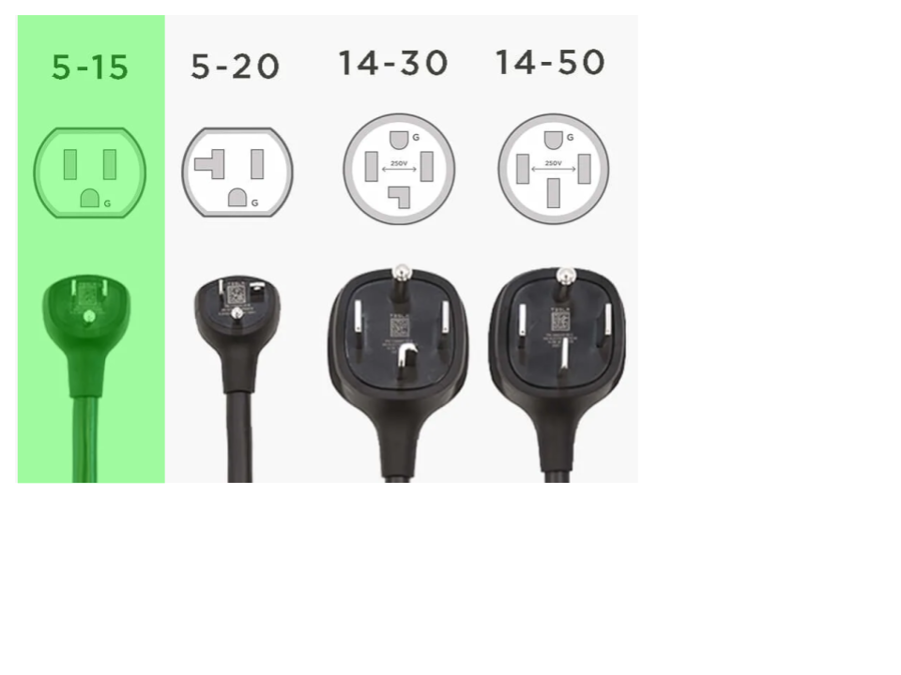
Figure 10: NEMA 5 & 14 Plugs

The NEMA 5 outlet is the standard North American 120V outlet that you see in most residential and commercial settings. These outlets will typically be rated for up to 15A and power most smaller devices in your home such as lamps, phone chargers, coffee machines, and computers. This can prove beneficial in the implementation of our SIMP to be useful for users who may want to know how much their gaming desktops cost them each night, or for parents who want to limit their child's usage of certain products, or to create a cost-analysis for BitCoin miners who want to ensure their gain outweighs their loss. Typically though, most of these devices do not take up the majority of your electricity bill, as they are mostly low wattage devices that stay on for less than 4 hours a day with few being much more than that.

The NEMA 14 outlet is a popular outlet for North America when related to appliances and electric vehicle charging - which is becoming more popular by the year. Generally, NEMA 14 outlets will be rated for up to 50A of power, hence why they are some of the most power hungry devices in your home. These usage metrics can be very useful for the user to see in both a monetary perspective as well as via smart notification. Imagine a user attaching a SIMP module to their oven or dryer. The user can have the SIMP intelligently sense when the dryer or oven is done, once power for their heating elements has been shut off, notifying the user from anywhere in their home or even remotely. The SIMP can also work especially well with ovens for those who may forget to turn off their bake settings.

When the SIMP detects the oven to be on for more than 1 hour, which is typically longer than most baking times for most, it can auto shutdown the outlet to prevent any potential hazards from incurring upon the consumer. One of the issues we face with NEMA 14’s is the process of measuring 240V with high current values going through our plug causing the products size to increase - this because they require thicker wires rated for a higher amperage. This same issue can cause some electrical interference as there will be a large induced current in the cable which can leak into other components giving us inaccurate readings or hardware malfunctions.
 | NEMA 5 | NEMA 14
Voltage Rating | 125V AC | 125/250V AC
Amperage Rating | Up to 50 amps | Up to 60 amps
Poles | 2 | 3
Applications | Common Household Electronics and Small Appliances | Large Appliances, Electric Vehicle Chargers, and Generators.
Table 4: NEMA 5 vs NEMA 14

3.1.3 Electromechanical Relay vs. Solid State Relay

The Relay is an electrical component that allows a microcontroller to allow interruption of current flow for high voltage and current devices. This can be useful in shutting off your oven, your dryer, or your typical household devices such as coffee machines and toaster ovens. Relays will typically come in two popular makes that have both their own strengths and their weaknesses: Electromechanical Relay and Solid State Relay.

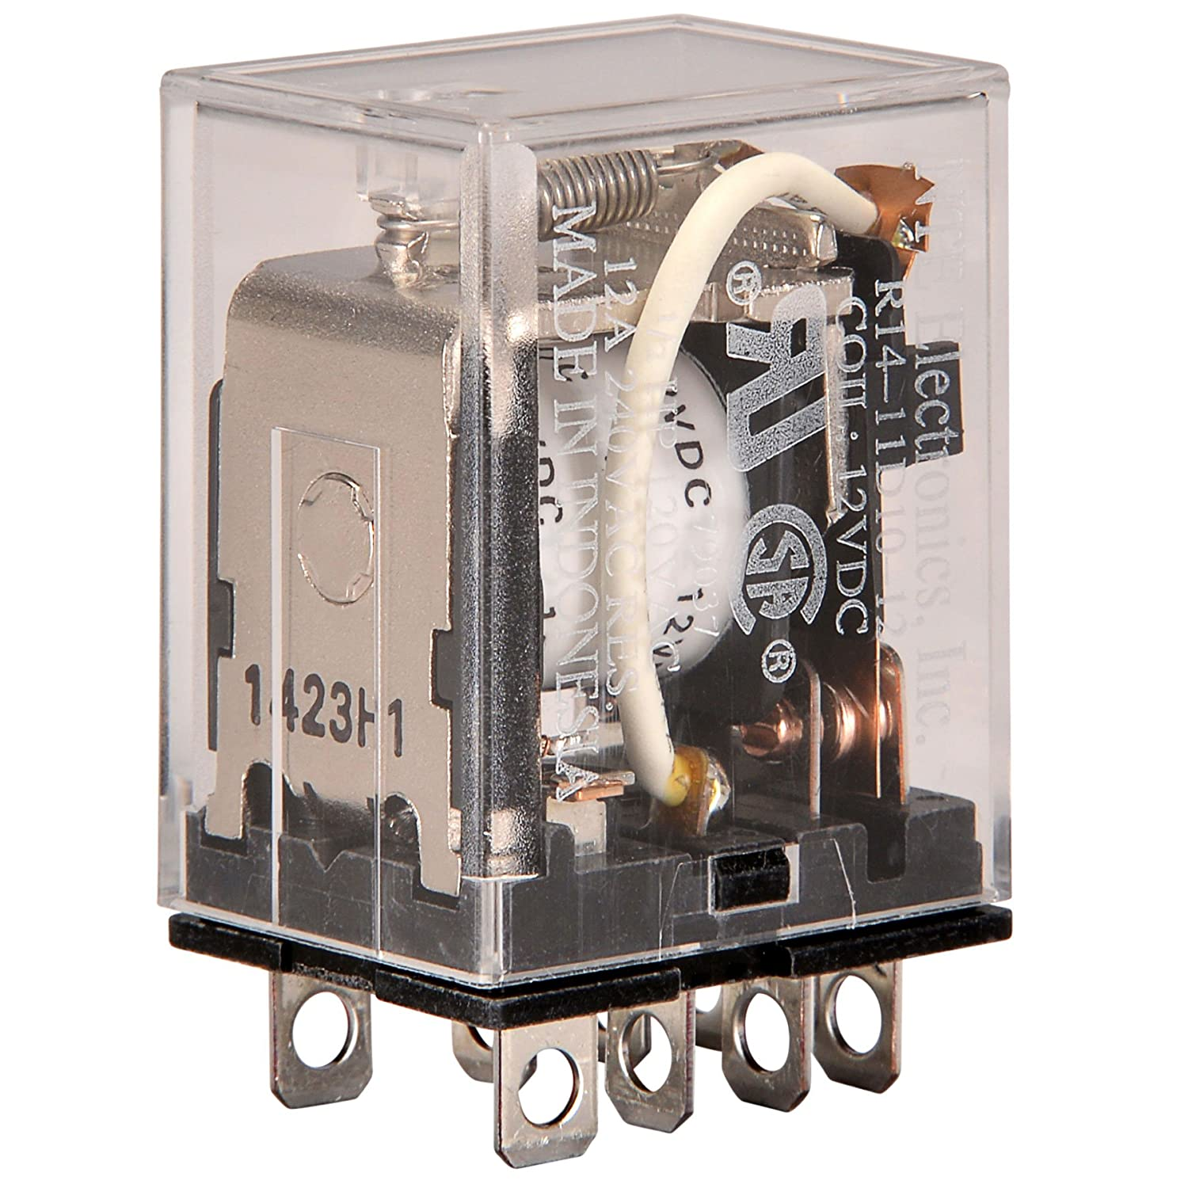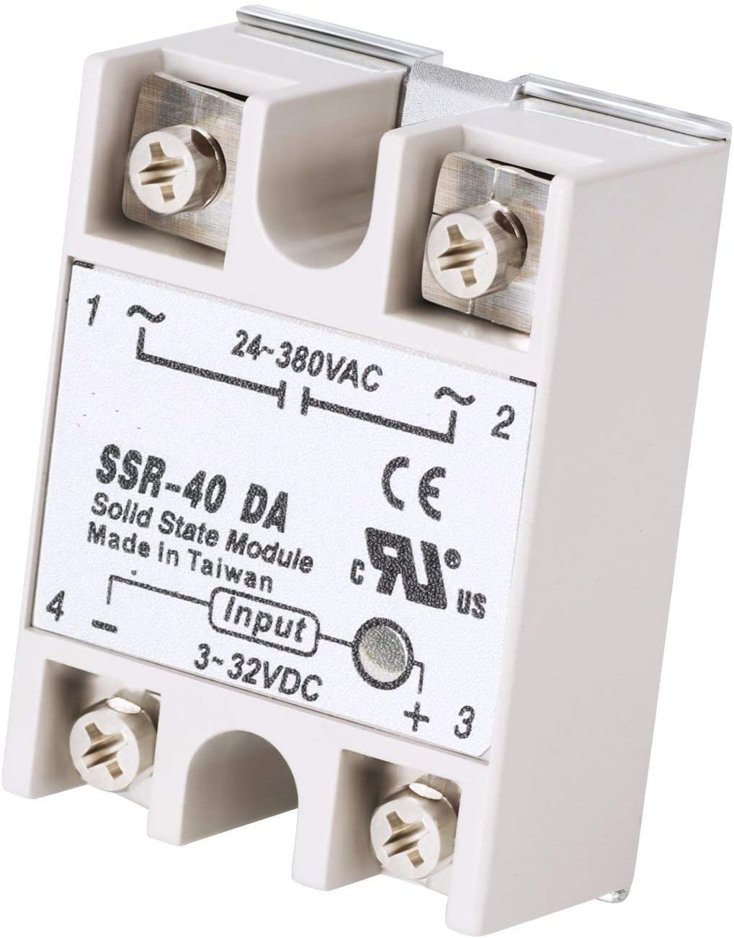
Figure 11: Electromechanical Relay vs. Solid State Relay

The Electromechanical Relay uses electromagnetic inductions to physically move an electrical contact to break or complete the output circuit. The Electromagnetic allows for both DC and AC voltage to be used without any changes made to it, thus making it a versatile relay. Its simplistic design allows for a cheaper price and for higher current rated models over some Solid State Relays as well. It typically has a lower residual voltage in the relay along with no leakage current because of the physical separation of the connections. The downsides to the switch outweigh the pros by a fair margin. The mechanical switching of the relay gives it a shorter lifespan, noisy switching, and contact bouncing which can cause your device to flicker on and off for a brief period and cause some issues in critical devices. Another huge downside is that with higher current loads it can produce electrical arcs that can pose a hazard to the switch. With all these factors in mind, our option was clear as the Solid State Relay alleviates many of the said concerns.

The Solid State Relay uses semiconductors as a switching device in the relay and as such does not have any moving parts inside of it breaking or completing the circuit. The Solid State Relay provides a smaller overall package size, no moving parts or strain, no noise when switching, lower power input requirements to be used with microcontrollers 3.3V, longer life cycles, and very fast response times. Although, with these great benefits, there are some drawbacks with them. Solid State Relays tend to leak some current through the system - which in smaller outputs could have the device turn on or have a phantom state from the small current it gets through it. This is not an issue as much in our case though since we are working with higher current applications. The device may require a heatsink due to its semiconductor components switching the higher current, which causes them to heat up considerably. This can force our final product to incorporate some means of airflow through the device to keep any internal components within safe operating temperatures.

 | Electromechanical Relay | Solid State Relay
Footprint | Large | Small
Efficiency Level | Low; Inefficient due to moving parts | High; Very Efficient
Cost | $10-$30 | $10-$20
Durability | Don’t last very long due to metal contacts physically wearing after each switch. | Up to 50-100 times longer than Electromechanical Relays
Table 5: Electromechanical Relay vs. Solid State Relay (in General)

3.1.4 Shunt Resistors vs. Magnetic Sensors

In order to read power coming from the wall we need a device to read the current. These come in two different forms that provide some useful benefits from either side. The two devices are Shunt Resistors and Magnetic Sensors.

Shunt Resistors calculate current by passing voltage over a known resistor value; these have to be measured from an isolated circuit that includes either an amp or ADC. Shunt Resistors are typically used in small current systems to get accurate results while also not having much heat generation from the shunt resistor. The issue we have is that the larger the current the larger the resistor value and more heat will be generated from the shunt resistor as more current passes through it. With the amperages we expected the system to be seeing could have caused a potential fire hazard or require serious cooling in order to maintain equilibrium. For this reason, shunt resistors were not an ideal candidate for our project and are better for smaller scales.
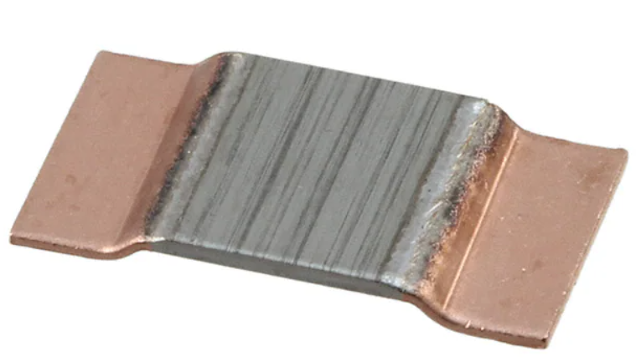
Figure 12: Shunt resistor

Magnetic Sensors are non-invasive ways of measuring current from a wire by using a hall effect sensor to measure the magnetic field around the wire which is induced by the current. There are differing types of magnetic sensors including cored and coreless. The difference between these two is that a magnetic core is integrated into the sensor. This was to help get accurate readings of the magnetic field generated by the current and funnel it into the hall effect sensor so as to not allow for inaccurate readings. The only issue with this core is that it takes up a lot of space, especially in larger current models which can have cores larger than a calculator, this issue is solved with the help of coreless current sensors. Coreless current sensors provide the same functionality and advantages as cored sensors but remove the extra space taken up by the magnetic core. They do this by running the current through a PCB trace really close to the Hall effect sensor which allows it to only pick up the magnetic field from the trace allowing for accurate results much like the magnetic cored variant but with a smaller footprint. With this in mind, we would like to use the coreless magnetic sensors as it brings all the benefits that we want while not bringing any baggage with them. We could also find a way to fit a cored version into our design but it would not be nearly as ideal especially if we want to keep a smaller footprint overall with our plug.

 | Shunt Resistors | Magnetic Sensors
Price | Same | Same
Accuracy | >99.5% with calibration | >98% with calibration
Noise | Very low | High
Power Dissipation | Low | Very Low
Table 6: Shunt Resistors vs. Magnetic Sensors

3.2 Part Selection

With each set of ideas formulated, the next step is picking the right tools and parts that will help the group finish every goal of the project without sacrificing too many resources. This means compiling lists of multiple products that do roughly the same task and choosing the most efficient product in terms of goals achieved, time spent, and money spent. Below are tables providing insight on parts and tools we found might be useful to us in the future, with descriptions as to why they might be helpful to us, along with price comparisons and pros and cons they might have that may push us towards using it or discourage us from using it.

3.2.1 Coding Software Selection

Given the general purpose of a task, it is the responsibility of a Software Engineer to pick the right programming language and/or software required to develop their project in the most efficient and easy to understand way. Choosing another programming language outside the scope of a general task may be doable in most cases but not without difficulty and generally more work to perform the same functionality. Take for example the creation of a program that will establish an ssh connection to a remote terminal, perform a basic function, and terminate the program. Doing this in the C programming language is possible but would not only require the use of many variables to contain certain aspects of the remote session, but also require the creation of many hard to understand functions that will have to serve difficult to discern functions within your program. This once simple idea of opening and closing an SSH session, in C programming, starts to become a daunting task that will require much more effort. Now, if the Software engineer took a moment to realize that a python library exists to serve such a function (Paramiko, Netmiko, and Napalm for those interested), they could have initially developed their script entirely within a Python IDE and feasibly served the purpose of their task. This shift in mindset all goes back to the Software Engineers ability to apprehend the problem and move forward with a programming language that would most efficiently and most accurately complete that task.
Below is a table dictating the many software languages we can plan to code in throughout the duration of this project. Programming will include Front-End and Back-End development to ensure all systems store info and communicate as expected between the SIMP device and the SIMPs User Interface. For the development of the User Interface, the primary coding language we will be programming in is Javascript, due to its flexibility in configuring both Front-End and Back-End scripts and being easily understood by any general web-hosting application. For the development of the SIMP, interactions between how the device responds to user inputs will be hardcoded into the microcontroller (in our case an Arduino) via C++ and Code Composer Studio - post import of basic Arduino libraries. See the table below:

Software Language | Use(s) | Role | Reason for Use(s)
C++ & Code Composer Studio | Hardware coding/ MCU coding.  Simple coding, e.g. variable names, unit conversions, function calls, etc. | Used in our SIMP plug to measure sensor data and send it to our main web server. | Easier and more familiar language for group members who have relatively less experience in multiple coding software.
JavaScript | Frontend and Backend development with the help of a MERN stack, hosting a server to collect data and analyze. | Full stack web server, light machine learning,  data analysis, chart visualization | Fairly known to the CpEs because of use in previous courses designing a MERN stack project with.
Python | Machine Learning, Frontend and Backend development, analyzing large amounts of data quickly. | Full stack web server, machine learning, data analysis, chart visualization | Very simple yet powerful, with lots of libraries to help with any task, and lots of documentation, Machine Learning is easier to apply on this platform.
Table 7: Software Selection

Software Language | Use(s) | Role | Reason for Use(s)
PHP | Very easy language and GUI allows for API Development/ | Back end APIs, Database transportations, filtering database | Separates stack flow, limited functionality with supported CRUD operations only.
Table 7: Software Selection (cont)

3.2.2 Web Server Selection

As we aim to understand and discern the primary differences between each of these web hosting options, it took time and consideration to select the option that not only fits well with what we aim to accomplish, but also be feasible enough to navigate so the software engineers in our group are not stuck learning an entirely new system. Taking into consideration the ease of applicability, the ease of understanding, and the overall cost to host our application, our team has decided to move forward with using Heroku as our primary web hosting option for the duration of this project. AWS Amplify, though well renowned for its versatility and overall applicability in the industry of software development, would take some time to learn how to navigate and is generally much more expensive than most of the web hosting options we have seen thus far. With their pay as you go web hosting option, we are charged $0.01 per build minute, $0.023 per GB stored per month, and $0.15 per GB served. Overtime with the accumulation of data necessary to be stored by the SIMP, and taking into account the builds we’ll be pushing during our development phase, we can see costs sky rocket anywhere between $300-$500 in total. Digital Ocean was also a potential option but just had a learning curve to understanding how deployment of the containers worked and eventually connecting the entire application to work with DigitalOcean seemed like a chore for those with less experience in the Web Hosting service. Eventually, we decided on Heroku as our primary Web Hosting application because members of our team were familiar with how to navigate and use Heroku (from prior engagements throughout their journey in UCF) and because many of the feature included in the free tier aligned with what we aimed to accomplish when planning to publish our web application to a web hosting service. The table below outlines some of the primary pros and cons between each of the Web Hosting Services described throughout 3.2.2:

AWS Amplify:

AWS (Amazon Web Services) is a cloud-computing platform hosted and developed by Amazon. The platform enables a consumer the ability to establish cloud solutions in Front-End Web and Mobile app development, Security, Networking, Machine Learning, Database Management, and the list goes on. Within each product line of AWS is a diverse suite of sub-platforms that specialize in key functionalities geared to enhancing whatever feature or implementation a developer plans to implement in his/her production environment.

Figure 13: AWS Amplify Logo

AWS Amplify is an Amazon platform/product that provides all the tools and features necessary to build and host both our web app and mobile apps. Amplify Studio (a tool within Amazon Amplify) enables a developer the ability to setup their applications back-end, import UI components, and deploy general app management permissions to all members involved. Amplify Hosting (another tool within Amazon Amplify) gives those involved the ability to fully host and deploy their web/mobile app. Other AWS tools can be integrated within Amplify Hosting depending on their intended use within your application.

Digital Ocean:

DigitalOcean is another cloud-computing platform that provides solutions relating to Web Hosting, Mobile Apps, Gaming Development, VPN, SaaS, Big Data and the list goes on. Featured products of Digital Ocean includes:

- Droplets - Create a set of scalable and modifiable virtual cloud machines
- Kubernetes - Scale and Manage Kubernetes clusters
- App Platform - Build, Deploy and Manage Web Apps
- Functions - Create and Deploy Serverless Computing Solutions
- Databases - Structural Back-End Databasing and Maintenance


Figure 14: DigitalOcean Logo

DigitalOcean’s web hosting is well known for its ease of deployment, affordable pricing, and overall performance. Its advanced developer tools and speed are what make it attractive to most developers, but can become a lot to bear if a non-experienced developer is taking a look for the first time at the advanced UI.

Heroku:
Heroku is a cloud platform that enables an organization the ability to build, deliver, monitor and scale both web and mobile apps. Similar to both AWS and DigitalOcean, Heroku enables a developer with all the tools they will need to design and publish their app but doesn’t already provide all the extra integrations and features seen from its competitors' platforms. In general, the Heroku platform will readily support code written in Node, Ruby, Java, PHP, Python, Go, Scala and Clojure.


Figure 15: Heroku Logo

Most junior developers (including those involved in the development of the SIMP) typically create their very first Full-Stack Project using Heroku as their primary Web Server. As opposed to its competition, Heroku is overall easier to integrate and scale but known to lack in performance.

Hosts | Pros | Cons
AWS Amplify | AWS brings the whole suite of applications from the database to the frontend with its multiple services making it ideal for an all-in-one solution. | The team has not worked with this in the past so it will bring some learning curve in order to get it functioning the way we want it to.
Digital Ocean | Simple solution for hosting full-stack applications of any type whether we decide to go with one language or another. | With it being a virtual machine its performance is not the best and doesn’t provide the hardware to do any machine learning without paying a hefty price per month.
Heroku | Great solution for a MERN stack, a stack we are familiar with using already. Also has plug-ins to allow for the analysis of data. | Performance can be slow at times with large amounts of data to process but may be solvable with optimized data.
Table 8: Web Hosting Options (Pros/Cons)

3.2.3 Hardware Selection

When selecting the microcontroller for the SIMP system we have to take into consideration the amount of power that will be going through the system to avoid damage to the microcontroller as well as how the information gathered by the microcontroller will be sent to the web server. To serve the second consideration all the microcontrollers we decided to look at are boards that are meant to have “Internet of Things” capability meaning they are already capable of connecting to a wireless network which relieves our team the task of designing an antenna/receiver for the board so we can dedicate more time to other parts of the project. To further refine our search we looked for boards with integrated input/output pins, in an effort to avoid having to develop or purchase input pins for the board as well as risking damage to the board during integration.

3.2.3.1 Microcontrollers
The microcontroller is used in the SIMP system as a means to collect information about the power usage from the appliances plugged into the SIMP and then sending the information to the web server for post processing and translation into a more legible form for the user to understand. When looking at the microcontrollers, we needed to not only look at their physical size, but also the operating voltages of the devices’ input/output pins since we will need to tune our measurement devices to never input a voltage that is too close to the maximum voltage in order to avoid damage to the microcontroller. In addition to safety of the device as well as the user, the output voltage pins are important so that we can power several components from the input/output pins rather than having them all be tied to a singular or a few voltage output pins the microcontroller may have.

Arduino Portenta X8:

The Arduino Portenta X8 meets and exceeds the qualifications we need for the SIMP system, to the point where it may actually be overkill for what we plan to design. It has an extremely small form factor at 66mm x 25mm with two high-density connectors on the board allowing for double the input and output capabilities of boards that are larger.
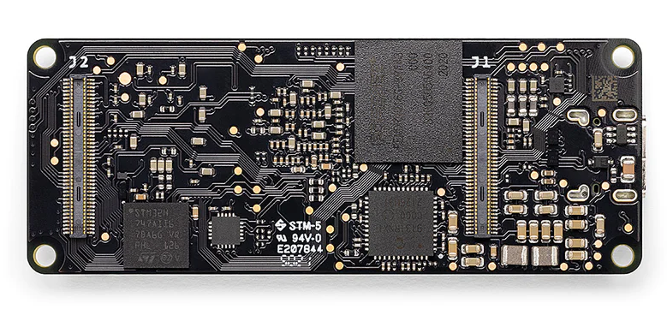
Figure 16: Arduino Portenta X8

The Portenta also has industry-grade hardware and software security which for our applications would prove to be very useful. However, with all these features and security, it makes this board the most expensive option we had found in our search and our project does not actually require all the input/output capabilities of this board so their capabilities would be wasted. The Portenta X8 comes readily available with the following:

- 1.8 GHz M4 CPU (400MHz)
- 2GB DDR4 DRAM
- 16GB eMMC
- 2.4GHz/5GHz 802.11 b/g/n Wi-Fi 4
- Bluetooth 4.1

With the higher than average level of processing capabilities, and the abundance of storage and RAM, the Portenta X8 is a powerhouse microcontroller that, while usable, would have much higher specifications than what would be required for us to build the SIMP module. Even though this MCU has higher than average specs, the board itself is heavily reliant on the use of a breakout board to actually interface and manipulate some of the standard IO options that would typically come pre-installed on any other generic Microcontroller Unit.

Arduino MKR Wi-Fi 1010:

The Arduino MKR Wi-Fi 1010 has the small form factor our team is looking for as well as the Wi-Fi capabilities. An added bonus to this is that it operates with a low-power main processor as well as an onboard battery that is charged via the USB connector, meaning the overall SIMP system shouldn’t draw too much power away from the output thus not affecting the performance of the devices being monitored by the SIMP. The MKR is also compatible with several cloud-based web services such as AWS, Azure, and Google Firebase, making it very versatile giving our team several options when designing the software components of the SIMP system.

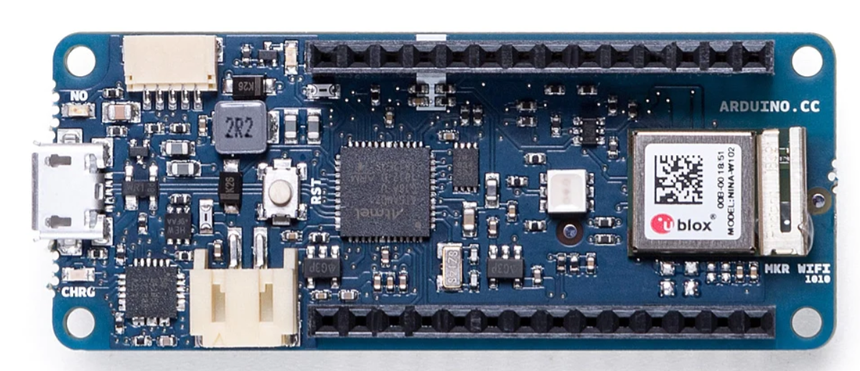
Figure 17: Arduino MKR Wi-Fi 1010

With a more modest number of both analog and digital I/O connections than the Portenta, it comes at a more modest price point, making it much more accessible for our team and none of the board’s capabilities would be put to waste. All these factors make a strong argument for this board to be the final choice for our design.

The Arduino MKR Wi-Fi 1010 comes readily available with the following:

- 256KB CPU Flash Memory
- 32KB SRAM
- Wi-Fi 2.4GHz 802.11b/g/n
- Bluetooth v4.2
- 1024mAh Li-Po Single Cell Battery
- ATECC508 Crypto Chip

The Arduino MKR Wi-Fi 1010 is overall simpler and more economic in terms of the basic function it serves and the intended implementation for engineers and general hobbyists alike. The capability to run on a single cell battery sets the MKR Wi-Fi 1010 apart from your average less-expensive MCU’s, but still lacks general power and scalability should more components be integrated with it. Because of the general specifications and use-cases of this particular MCU, our team sees some potential in eventually developing the SIMP around it's simple to navigate architecture.

Arduino Nano 33 IoT:

The second contender for the team's board of choice was the Arduino Nano 33 IoT (Internet of Things). This board is the smallest and cheapest board we have seen in our hardware selection process. It is functionally the same as the MKR but lacks the incorporation of an onboard battery and Bluetooth capabilities, therefore, we decided to have the SIMP rely solely on the power coming from the outlet and not use the Bluetooth we would have an even smaller form factor for the overall system.

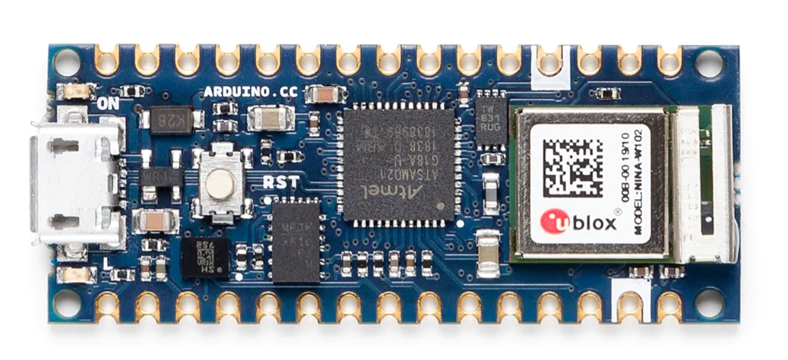
Figure 18: Arduino Nano 33 IoT

The Arduino Nano 33 IoT comes readily available with:
- 256KB CPU Flash Memory
- Wi-Fi 2.4GHz 802.11b/g/n
- Bluetooth v4.2
- ATECC 608A Crypto Chip

The primary drawback when attempting to use this board in production is the inoperability of pushing 5V to any peripherals that may be attached. Trying to do so will likely cause whatever lies within that desired to pin to simply not work and potentially create chaos and confusion amongst those who are attempting to figure out where the fault in electronic design may be. Arduino makes it very clear in their spec sheets that the board will only support handling 3.3V to individual IO’s. Attempting to use this board in that fashion would cause a lot of limitations in what can be measured and perhaps end up non-responsive when the load exceeds the capabilities of the device. The operation of this board was then supported by other components such as the 5V AC/DC converter for power to components that needed 5V to run and the use of NPN transistors to step up the voltage coming out of the Nano for when control signals need to be generated.

Microcontroller Name | Arduino Portenta X8 | Arduino Nano 33 IoT | Arduino MKR Wi-Fi 1010 | Texas Instruments MSP430 Launchpad
Price | $239.00 | $22.10 | $35.40 | $20.00
Dimensions (mm) | 66 x 25 | 18 x 45 | 61.5 x25 | 76 x 50
Input Voltage(V) | 5 | 5(USB-C)  4.5-21 | 5 | 5(USB)  3.3
Operating Voltage(V) | 3.3 / 5 | 3.3 | 3.3 | 1.8-3.6
GPIO pins | 7 | 26 | 26 | 83
RAM | 2 GB | 32 KB | 32KB | NA
Flash Memory(GB) | 16 GB | 256 KB | 256 KB | 128KB  (FRAM)
Connectivity | Bluetooth,WiFi | Bluetooth,WiFi | WiFi | USB
Table 9: Microcontroller Comparisons

3.2.3.2 Shunt Resistors

Shunt resistors are a specific type of resistors that have an extremely low resistance, in the range of less than one milliohm. These resistors are typically used in parallel with ammeters for protection from high current and with the correct instrument scaling will not impact the ammeters accuracy. We had originally looked at these resistors and thought to use them in conjunction with a voltmeter so that we could useΩ’s law to calculate the current, but then through researched learned that some ammeters were exactly this set up so we had decided to look at the preassembled shunt ammeters. These shunt resistors could still be used in order to protect the system power surges by acting as shorts to ground if the power gets too high.

Part Name | High-Power Ultra-Low-Ohmic Shunt Resistors  (PSR400ITQFD0L30) | High-Power Ultra-Low-Ohmic Shunt Resistors  (PSR400ITQFH1L00)
Price | $1.45 | $1.45/unit
Size(mm) | 10.0 X 5.2 | 6.3 X 3.05
Maximum Power (W) | 15 | 15
Table 10: Shunt Resistors Components
We realized throughout the design process that we would no longer need any sort of shunt resistor.

3.2.3.3 Ammeters

Ammeters are circuit components that are usually in series with a load and measure the current being drawn by the load, usually by outputting a voltage signal that is a scaled down version of the current going through the ammeter. There are several different types of ammeters, otherwise known as current sensors, and each type uses different methods to measure the current.

MCS1803GS-10-Z and TMCS1108A3UQDR(Hall Effect Current Sensors)

These two current sensors make use of the hall effect in order to measure the current being passed through them. The Hall Effect is the production of a voltage across a conductor when a current passes through it and an applied magnetic field is perpendicular to the direction of the current. The supplied VCC to the components can be used to tune the sensitivity or “resolution” of the measured current such that the higher the the VCC the higher the sensitivity of the sensor and in that sense creating a more accurate sensor.

With both of these components needing 5V to be powered and the maximum power our choice of microcontroller can create is 3.3V we employed the same 5V AC/DC converter that is powering the microcontroller to also power the sensors so that they can run at their peak accuracy and precision.
Part Name | MCS1803GS-10-Z  (hall effect current sensor) | TMCS1108A3UQDR  (hall effect current sensor) | SSA-100  (shunt current sensor)
Price | $4.60 | $2.94 | $81.41
Size(mm) | 5.0 x 6.2 | 4.9 x 3.9 | 83.8 x 19.1
Minimum-Maximum Vin | -0.1 to 6 | -120 to 120 | 3.0 to 5.5
Minimum-Maximum Vout(V) | -0.1 to 6 | -0.3 to 6.3 | -1.25 to 1.25
Minimum-Maximum Input Current | -10 to 10 | -2.25 to 23.5 | -200 to 200
Table 11: Ammeters

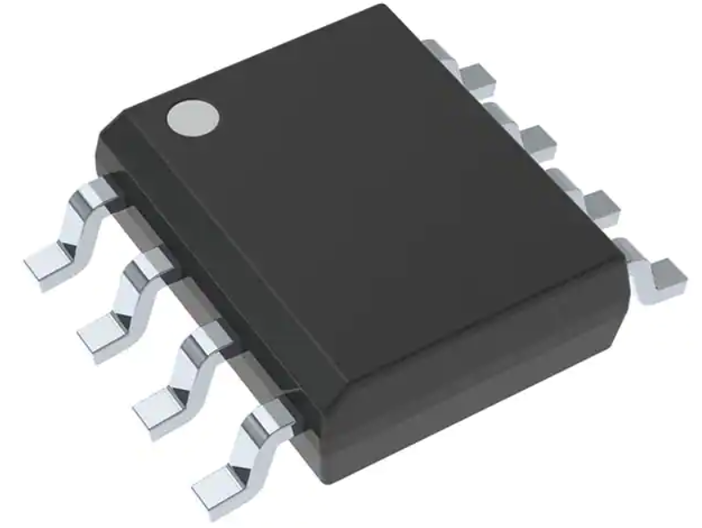
Figure 19: Hall Effect Ammeter

Throughout the design process, we decided to use an ACS712-5A module for its simplicity as well as ease of access through Amazon.

3.2.3.4 Outlets

The outlets we are looking at in this section are the ones that the user’s appliances will be plugged into. The characteristics we are looking at with these outlets is their maximum amperage rating and their size. We are aiming for as small of a system as possible for our final product so starting in the prototype stages with as small of parts as we can is how we are ensuring that we are achieving this aim. Counteracting this aim however is the desire for our system to be able to support as wide of a range of appliances as possible, ranging from desk lamps to hopefully a desktop PC, this means that we have to look also have to balance the smaller size of the outlets with how much power they can safely pass to the load that is plugged into it.

Decora 15 Amp Residential Grade Self Grounding Duplex Outlet

When selecting these possible outlets for the SIMP system we looked at its small shallow depth outlets since they are meant to give homeowners the most room in the wiring box during installation and this directly goes in line with our project's aim for a small size unit while still having two plugs. The plug is also self grounding so in case of a short or wire tampering with the outlet it should protect the devices plugged into SIMP from any damage. The plug includes 2 separate terminals for each outlet which we can use to monitor both outlets separately as well as control separately, this feature would be useful for multiple use cases in which you want to monitor two devices from the same outlet.

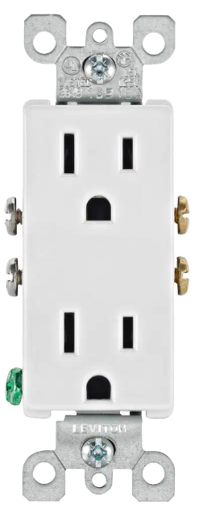
Figure 20: Decora 15 Amp Residential Grade Self Grounding Duplex Outlet

Specifications:
Dimensions | 1.063” x 1.625” x 4.25”
Socket Type | NEMA 5-15R, 2P and 3W
Rating | 15A / 125V
Grounding | Self-Grounding
Price | $2.67
Table 12: Decora 15 Amp Outlet Specifications
X Series 20 Amp 125-Volt Tamper Resistant USB A/A 4.8 Amp Duplex Decorator Outlet Back Wire Clamps

Another possible candidate for the SIMP system is the above model. It has a higher maximum amperage than the previous option as well as two USB power outlets which would mean if we used this for the final system design it could support up to 4 devices from one outlet with power monitoring. We are hesitant for this choice though, since the addition of two extra devices effectively doubles the number of components we would need for each unit as well as needing twice the theoretical room which would be counteractive to one of our project’s aims of having a smaller form factor. This unit also does not come with the self grounding so we would have to implement some form of grounding in the unit and this would be a danger to both the team and the end user.

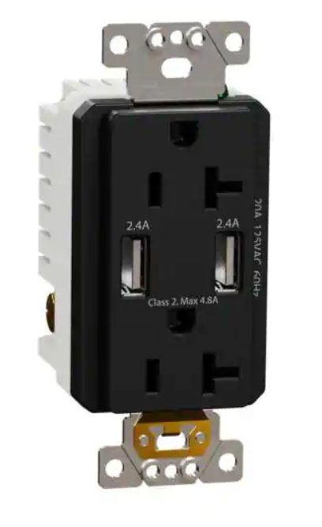
Figure 21: X Series 20 Amp 125-Volt Tamper Resistant USB A/A 4.8 Amp Duplex Decorator Outlet Back Wire Clamps

Specifications:
Dimensions | 4.06” x 1.73” x 1.73”
Socket Type | NEMA 5-20R, 2P and 3W
NEMA Rating | 20A / 125V
USB Rating | 2.4A
Grounding | Self-Grounding
Price | $40.00
Table 13: X Series 20 Amp 125-Volt Duplex Specifications
Leviton 20 Amp Commercial Grade Duplex Outlet

While slightly more expensive and barebones than some previous models, we looked at those specific characteristics that could work to our team’s benefit. The other models come with anti-tamper plastic casings that we would have to remove whereas this model has no such casing and separate wire contacts for each individual outlet that would make development and prototyping easier on us. For example, with the exposed contacts we will have a more direct way of attaching relays to control if power is going to a singular outlet or not. This outlet has a higher amperage rating when compared to the model of a similar price point, making our system more applicable to different household devices that would require more current than the 15A outlet could supply.

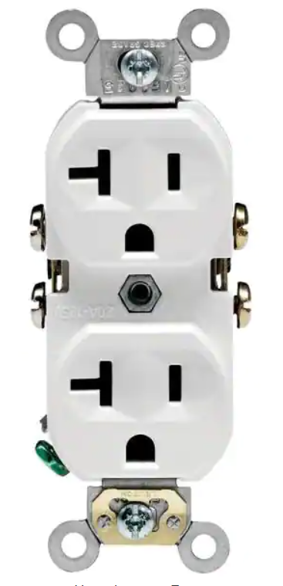
Figure 22 : Leviton 20 Amp Commercial Grade Duplex Outlet

Specifications:
Dimensions | 4.122” x 1.875” x 1.375”
Socket Type | NEMA 5-20R, 2P and 3W
NEMA Rating | 20A / 125V
Grounding | Self-Grounding
Price | $3.64
Table 14: 20 Amp Commercial Grade Duplex Outlet
Name | Decora 15 Amp Residential Grade Self Grounding Duplex Outlet | X Series 20 Amp 125-Volt Tamper Resistant USB A/A 4.8 Amp Duplex Decorator Outlet Back Wire Clamps | Leviton 20 Amp Commercial Grade Duplex Outlet
Dimensions | 1.063” x 1.625” x 4.25” | 4.06” x 1.73” x 1.73” | 4.122” x 1.875” x 1.375”
Socket Type | NEMA 5-15R, 2P and 3W | NEMA 5-20R, 2P and 3W | NEMA 5-20R, 2P and 3W
NEMA Rating | 15A / 125V | 20A / 125V | 20A / 125V
Grounding | Self-Grounding | Self-Grounding | Self-Grounding
Price | $2.67 | $40.00 | $3.64
Table 15: Outlet part comparison

After weighing the pricing, sizing, and availability of these outlets, our final design utilizes the Decora 15 Amp outlet, clipping the connecting strip between outlets to isolate one from the other such that the operation of one outlet does not impede the other.

3.2.3.5 Plugs

The components we discuss in this section will be the plug that connects the SIMP system to the house AC power. An important consideration to take with this component is to make sure the amount of amperage it draws from the house is the same or less than the maximum current rating of the outlet that we choose as well. If the plug draws more current than the outlet can handle then there is the chance it can lead to damage to the SIMP system or worse, harm to the user.

Leviton 15 Amp 125-Volt Double Pole 3-Wire Grounding Plug

The purpose of these plugs is to act as the connector to the wall outlet to provide the 120VAC to our circuit in order to monitor our power usage as well as cut power off to the outlet as well. For this reason we would need a plug that is able to support the 15 amps that will be provided from most household outlets in a bedroom or living room. This design offers a very slim and simple design for us to interface with, as well as maintaining with, our slim form factor.
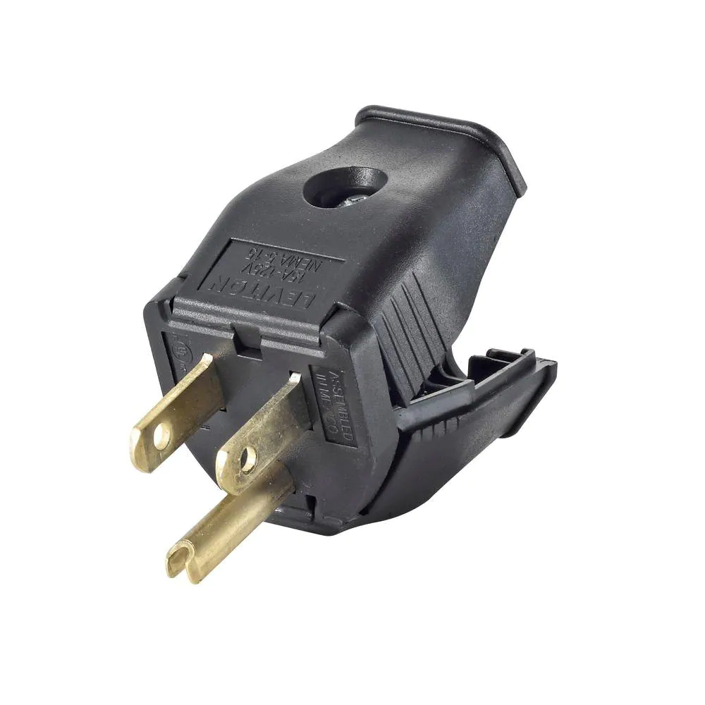
Figure 23: Leviton 15 Amp 125-Volt Double Pole 3-Wire Grounding Plug
From the specifications below, we can observe that the Leviton 15 Amp 125-Volt plug is capable of serving our most general power accessibility purposes from the directly provided power to our SIMP, but, we must also take into consideration the overall size of this plug and how it will impact our design. The dimensions of this plug are, generally, the size we are constrained to due to the necessity to draw from a typical NEMA outlet which requires a hot pin, cold pin, and a grounding pin.

Specifications:
Dimensions | 1.5” x 1.5” x 1.5”
Socket Type | NEMA 5-15P
NEMA Rating | 15A / 125V
Grounding | Self-Grounding
Price | $3.64
Table 16: Leviton 15 Amp 125-Volt Double Pole 3-Wire Grounding Plug

Leviton 515PV-OR 15 Amp, 125 Volt, Grounding Plug

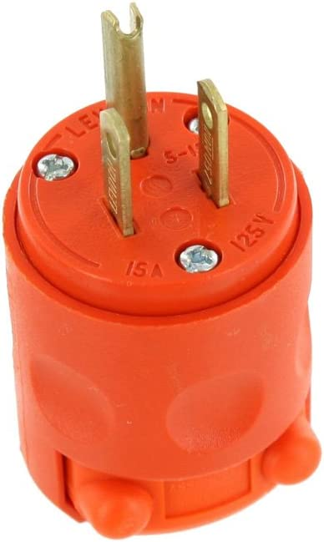
Figure 24: Leviton 515PV-OR 15 Amp, 125 Volt, Grounding Plug
While this a cheaper and flashier design, this product provides the same amperage and voltage rating as the other while still providing a simplistic design. The big upside to this one is that it provides a sturdier connection to the wall into our outlet allowing us to have all our components stick out while not stressing the outlet inside the wall or the plug as bad as a thinner design. The downside of this plug is the bulk of the entire plug, this goes against our goal of making this a slim design. We could try to slim down the design by modifying the PVC housing but that would run the risk of creating a spark gap between the connection if there isn’t enough insulation between the poles as well as a fire hazard if that spark happens.

Name: | Leviton 15 Amp 125-Volt Double Pole 3-Wire Grounding Plug | Leviton 515PV-OR 15 Amp, 125 Volt, Grounding Plug
Dimensions | 1.5” x 1.5” x 1.5” | 1.3”x1.94”x1.54”
Socket Type | NEMA 5-15P | NEMA 5-15P
NEMA Rating | 15A / 125V | 15A/125V
Grounding | Self-Grounding | Grounding
Price | $3.64 | $4.47
Table 17: Leviton Grounding Plug Comparison Chart

Throughout the design process we decided the easiest route with male socket plugs would be to buy an extension cord and use the wires cut from the female end of the cord to power our devices and PCB.

3.2.3.6 Switches and Buttons

The purpose of the switches in the SIMP system is to give the user’s an option to shut off power to devices such as in the event of an emergency or just for convenience if they cannot get to the webpage to remotely turn off the devices. The size of the switches across the board are close enough in that the only major criteria for them is if they can sustain the current of whatever device they are plugged into without damage or risk of injury to the user. Other defining features we could make our conclusions on would be if the switch is backlit or not for use in dark rooms. We chose the rocker switch style since this style of switch is ubiquitous with surge protectors for their ease of use.

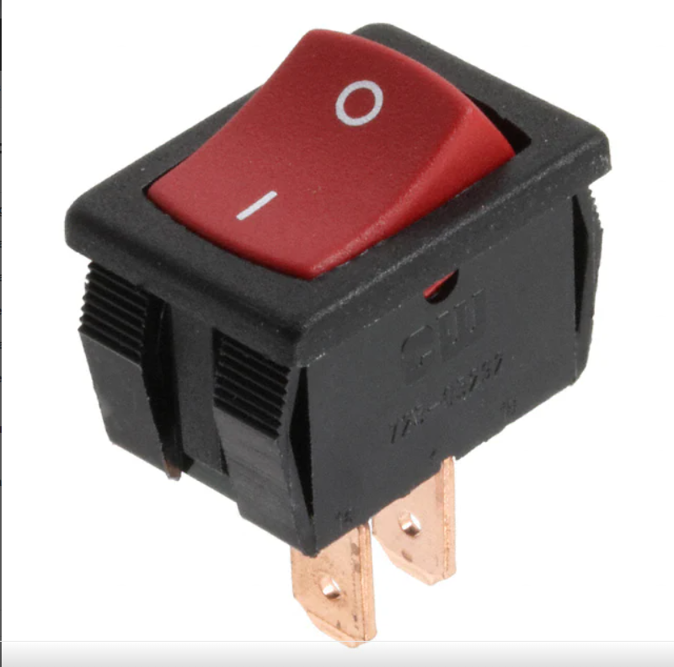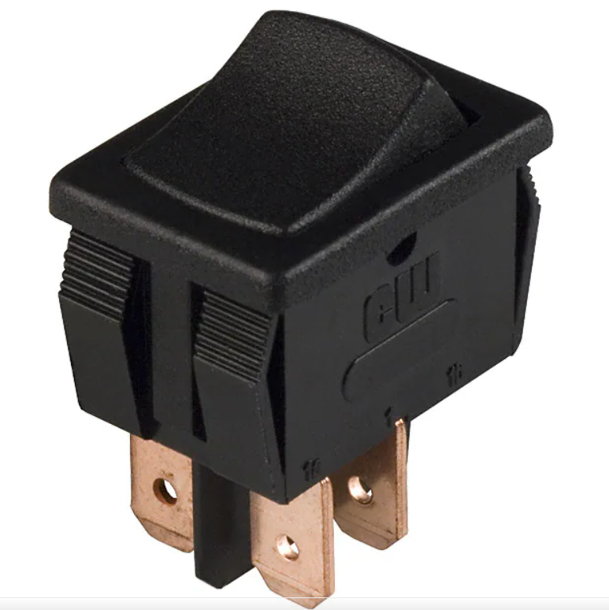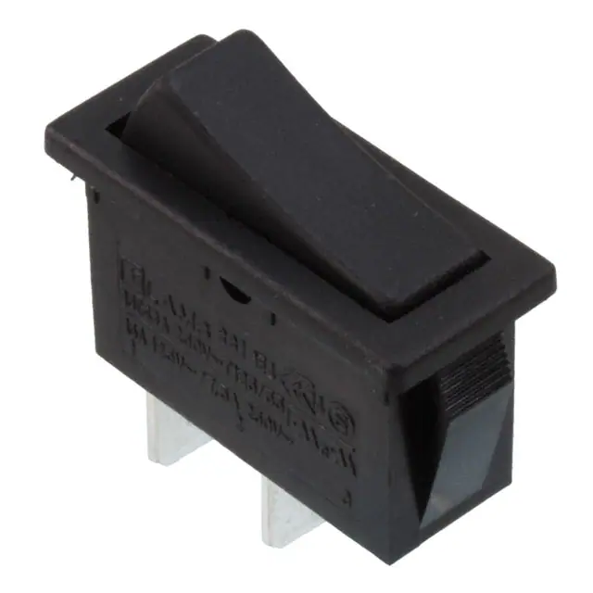
Figure 25: GRS-4011-0146,GRS-4021B-0000,RB141C1100 Rocker Switches, respectively
Part Name | GRS-4011-0146  (Rocker switch) | GRS-4021B-0000  (Rocker Switch) | RB141C1100
Price | $0.91 | $1.04 | $1.12
Dimensions (Millimeters) | 15 x 21 x 12 | 15 x 21 x 12 | 14 x 32 x 27
Maximum Current  (Amperes) | 13 | 13 | 15
Maximum Voltage  (Voltage) | 250 | 125 | 125
Table 18: Rocker Switches Comparison

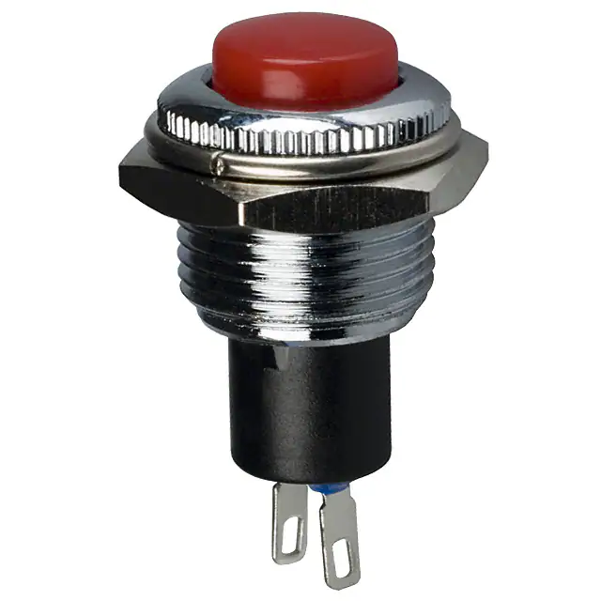
Figure 26: Pushbutton Switch SPST-NC Standard Panel Mount

As we look to compare and determine the best components necessary to build the SIMP, we put careful consideration into whether or not we should use a rocker switch or, as seen in the figure above, a pushbutton switch. The switch above is characterized as a Single-Pole Single-Throw Normally-Closed Pushbutton Switch. Such a switch has an initially closed circuit state while there is not any current being applied. Once voltage is applied to the relay’s coil, the switch will then go into an open position and disconnect the load from any power being delivered to it. Such a behavior has several favorable advantages in our system, that being the ability to deliver power to our system in an uninterrupted state and therefore not impose any unwanted disruptions without our doing so. Once an action to disrupt power is taken via the pushbutton, all system loads will be halted until having been released by the user. Some form of this reset will be key in the event that manipulation of any internal relays is no longer accessible via any deliverable UI.

Take for instance the event where the SIMP is plugged into an outlet, and plugged into the SIMP is an end user's home modem/router. Metrics will be drawn as normal, statistics will be calculated as normal, and all user functionality will continue to enact as normal - including disrupting power being delivered via the SIMP. This poses a problem being that the SIMP is no longer accessible through the primary method of access, i.e WiFi. To counteract such an event, we would have some method of resetting the internal relays so they may revert back to their normal ON states and once again re-enable output to any directly connected loads- which in this example is the modem/router. The table below describes a list of general specifications pertaining to the SPST-NC Push Button Switch seen in the prior figure:

Specifications:
Dimensions | 17mm x 14mm (Height x Diameter)
Circuit Type | SPST-NC
NEMA Rating | 3A / 120V
Grounding | Self-Grounding
Price | $3.97
Table 19: Pushbutton Switch SPST-NC Standard Panel Mount

3.2.3.7 Relays

The use of the relays in the SIMP system is to control the flow of power from the wall to the outlets on the device. While the switches themselves have the same purpose, the use of the relays is to implement the scheduling aspect of the SIMP system. The relays we have looked at require a voltage across their terminals in order to block current flow across the output terminals. When selecting the parts we want to use we have to take the same size characteristic comparison we’ve been using for all the other components, we want to look for a small enough relay such that we can keep our unit as small as possible while still maintaining performance. Another important aspect is the operating input voltage the relay takes. We need the relay to be able to operate with the maximum voltage our microcontroller can output from it’s input/output pins so that all we have to do for the code on the microcontroller is set the pin to high so that we can deactivate power to the appliance and then set the pin to low to reactive power to the appliance.

TWTADE 2PCS SSR-25 DA 25A 3-32V DC / 24-380V AC SSR Single Phase Solid State Relay ssr-25da:
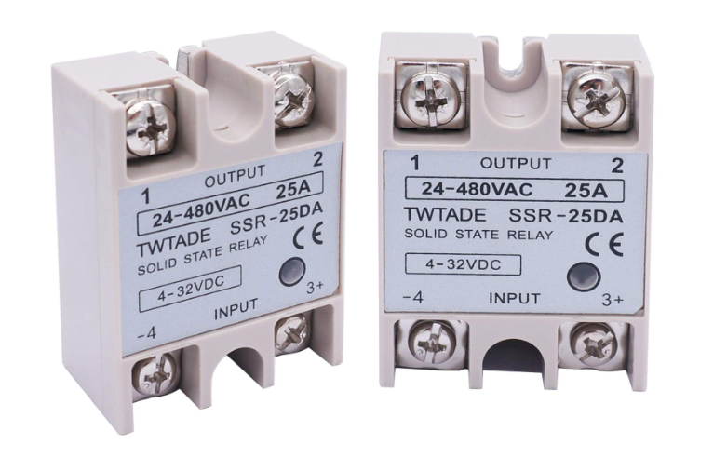

Figure 27: TWTADE 2PCS AC SSR Single Phase Solid State Relay ssr-25da

The purpose of the relay in the SIMP system is to be able to shut off power and to return power to the outlets with devices plugged into them. This is not only in an effort to allow remote control of devices connected to the SIMP but also to allow the SIMP to have a set ON/OFF schedule that the users can set from the webpage. The activation of the relay requires a DC voltage across its input terminals which we will source from the arduino’s digital output pins that we can set to the appropriate voltage. The only drawback to this choice of relay switch is its large size which will greatly impact how we design the rest of the SIMP system since it is the largest component we have in our selection.

Specifications:
Dimensions | 2.4” x 1.8” x 0.9”
Input Voltage | 3V - 32V
Output Voltage | 24V - 380V
Output Current | 25A (≤ 50%)
Working Voltage | 250V
Max Switching Current | 40A
Price | $14.88
Table 20: TWTADE 2PCS AC SSR Single Phase Solid State Relay ssr-25da

AQA221VL by Panasonic Electronic Works
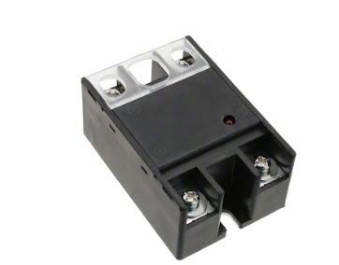
Figure 28: AQA221VL by Panasonic Electronic Works

A more expensive option than the other relay we looked at but that is because this relay has a smaller form factor than the previous relay we looked at which is inline with one of aims of having as small of a device as possible. In addition to its more compact form, it comes in more discrete current rating packages, meaning we won’t be wasting resources with relays that can handle more current than our outlets can output.

A drawback to this relay choice however is that its control voltage ranges from 4V to 32V which is higher than most power output options on the microcontrollers we are considering for use with this project, without modifications to the boards at the very least. This problem can be solved however by soldering one of the pins directly to the Vusb line which would create a pin that outputs 5V.

Specifications
Dimensions | 1.575” x 2.283” x 1.004”
Input Voltage | 4V-32V
Output Voltage | 75V-250V (Vrms)
Output Current | 15A,25A,40A
Working Voltage | 75V-250V
Max Switching Current
Price | $22.67
Table 21: AQA221VL by Panasonic Electronic Works
Part Name | TWTADE 2PCS SSR-25 DA 25A 3-32V DC / 24-380V AC SSR Single Phase Solid State Relay ssr-25da | AQA221VL by Panasonic Electronic Works
Dimensions | 2.4” x 1.8” x 0.9” | 1.575” x 2.283” x 1.004”
Input Voltage | 3V - 32V | 4V-32V
Output Voltage | 24V - 380V | 75V-250V (Vrms)
Output Current | 25A (≤ 50%) | 15A,25A,40A
Working Voltage | 250V | 75V-250V
Max Switching Current | 40A
Price | $14.88 | $22.67
Table 22: Relay Component Comparison

Further research into relays we found a much more compact model that was already documented being used with Arduino boards of similar functional capacity to our Arduino Nano 33 IoT in the SRD-05VDC-SL-C relay. First testing was done with pre-built modules which responded well to the levels of voltage the Arduino Nano could produce. In order to show sufficient PCB design for our project we then rebuilt the modules directly into our final PCB design and with final testing they still operated as expected.

4. Design Constraints and Standards

The production of any project, whether we realize it or not, does not come without the dependability of industry standards and general constraints. We, as engineers, heavily rely on the stipulations defined by various manufacturers and industry giants so we may design a product that adheres to any design norms that goes into using any particular pieces/components for our project. A constraint is any “design decision imposed by the environment or a stakeholder that impacts or limits the design” (Ford, 2008, pg. 39, para. 2). Thus, any existing component we choose to incorporate into our design will generally have some form of a constraint that it will impose on the overall product. Take for example the usage of an Arduino Nano 33 IoT Microcontroller as a means of controlling and operating our device. There are multiple benefits to using this device, such as: Smaller Footprint, General Processing Speeds and Wireless Capabilities. But, those same components we deem to be benefits of the device are also what constrain it.

Because of the small footprint of the device, we are limited in the number of Analog-Digital pins on the board itself. Thus, we are incapable of implementing such large scale schematics without the incorporation of multiple components in addition to said microcontroller. The processing speed, though capable of serving its purpose in most general projects, will be limited in the event that we require the performance of a process that requires more than what the Arduino Nano 33 IoT Microcontroller is capable of. In terms of wireless connectivity, the Arduino Nano is capable of sending and receiving transmissions via a 2.4GHz Network but, even with this added benefit, leaves the microcontroller open for the constraint of solely being capable of transmitting via a 2.4GHz network and not via a 5GHz network. We understand the reasoning behind why these components are used but, as a result, we must also understand the selected components limitations and thus plan to build our project, whichever it may be, with these constraints in mind.

A standard is “an established way of doing things that ensure interoperability” (Ford, 2008, pg. 39, para. 4). We abide by standards so that whenever an attempt at altering or enhancing a system component is made, the person making these changes are aware of what specifications are involved and what each individual component is capable of doing. Deviating from general standards created by those such as IEEE, ANSI, and IPC is by no means illegal, but makes it significantly more difficult to achieve the same goal in an effort to reinvent the wheel - so to speak. In general, the constraints used by the Arduino Nano 33 IoT are what confine an engineer to a specific set of parameters, whereas the standards actually lay the groundwork for how individual components will need to operate. The wireless capabilities of the Arduino Nano 33 IoT are defined by IEEE’s 802.11 wireless standards. As a result any attempt to connect to the microcontroller via any means of wireless connectivity will require the same understanding of communication, that is, communication via the same wireless frequencies and general protocols.

Failure to adhere to the same wireless communication standards will inevitably result in a failure to communicate with the device and ultimately a failure for the device to communicate to anything else. The following sections outline several standards and constraints that we will be incorporating or need to understand in the development of our SIMP project.

4.1 Design Constraints

Designing a product from scratch comes with various constraints that may deter the time -table of completing our project, or simply stop us from overall moving forward with a specific characteristic. We recognize many of these constraints and how they will affect our design, thus we will plan to work around them with our end goal in mind. Listed below are constraints pertaining to the design and implementation of SIMPY:

4.1.1 Economic and Time Constraints

Engineering a new technology in itself requires not only the intuition to understand what pieces go together, but also the proper planning and coordination between those involved to complete the design in a timely manner. Formulating an idea of what function the SIMP will perform gives us a means of estimating the cost to each member of the team to be approximately $125 each - Budgeting the design in parts and labor to be around $500. As we’ve budgeted for this amount strictly off speculation, we are unaware if, in our testing and development, whether or not additional capital will be required to fund our project.

As capital funding proves arduous in itself, time of completion will also play a vital role in how we approach what is bought and when parts should be purchased. With the impact of the COVID-19 pandemic to the manufacturing industry, much of the production of microchips and raw materials is delayed indefinitely due to lack of labor in foreign countries. Because of this, we will need to strategically plan to order parts (e.g. Processors, Antennas, PCB’s) in advance to mitigate any halts that may arise in production.

Each team member carries their own talent in the development of this project, thus, coordination in scheduling will be key in presenting a satisfactory design. Lack of coordination in scheduling between all members involved will cause discord in our time-table for completing this project, as well as create last minute urgencies in trying to get simple aspects of our project completed in an apt amount of time.

4.1.2 Ethical, Health, and Safety Constraints

The intent of the SIMP is to provide a consumer with the capability to monitor and better manage the power being drawn within their home circuit. Seeing how this device will be regulating power and access to consumer equipment, we realize the need to ensure the safe transmission of electricity between the utility provider and our device. Safety is key in cutting any form of electricity, thus, we will need to ensure that regular switching of our internal circuit will not overload a consumer's device - nor disrupt or cause hazardous conditions to the incoming utility power.

We also realize the necessity to ensure the security of our device from any forms of intrusive personnel. The SIMP not only monitors but also grants admin rights to the device itself, therefore, should some foreign entity attempt to hijack the connection or hack an end user's account, the safety and security of our consumers will be put at great risk. Some layer of security will need to be implemented to guarantee a secure session between our consumers and the SIMP they will be utilizing.

4.1.3 Environmental and Manufacturing Constraints

The overall design of this product needs to not only serve the original function it's intended to carry out, but do so in such a way that it will not be disruptive to our consumers' daily lives. We will need to take into account the realistic placement of this product and general concerns that will require addressing once in the hands of the consumer.

The SIMP will require some form of accessibility to a power outlet , therefore, the footprint left by the SIMP will need to be minimally larger in scale than the outlet itself. Engineering a product that will substantially outscale the power outlet will likely be deemed undesirable by the general population and prove unfavorable to consumers when picking their preferred monitoring solution.

With the design layout of the SIMP’s circuitry and PCB components still to be determined, it will be necessary to consider extraneous factors of development such as heat and optimal airflow. Depending on the number of components used to realize our engineered design, we may need to space out circuitry to accommodate the optimal threshold of heat. A large amount of devices attempting to draw a current through the SIMP will result in an acute spike of heat. Non-dissipated heat over a large amount of time will result in the degradation of components, or even worse, potentially hazardous environmental conditions such as arcing or electrical fires.

With heat being a variable factor in the longevity of our device, we must also consider the wattage being funneled from the utilities power through the SIMP and into our customers' multiple connected devices. In general, the average North American power outlet is rated for anywhere between 15 to 20 Amps. If a load seen by the SIMP exceeds the amperage pull rated by the home electrical circuit, it will result in a trip at the circuit breaker and potentially be a fire hazard if too many devices attempt to draw energy at the same time. As a result, the SIMP will need to have some form of Safe-Guarding to ensure the safe transmission of power between multiple devices while also having the capability to disrupt the flow of power before endangering the life-safety of those who entrust the device in their home.

4.1.4 Wireless Constraints

We realize as well that depending on our method of connection between the SIMP and our UI (User Interface), the placement of the device will need to be altered. Given a connection via Infrared (similar to our TV Remotes), a direct line of sight will need to be initiated between our device and whatever transceiver of sorts will be receiving the signal. Given a connection via Bluetooth, we will require a dedicated bluetooth chip within our device, as well as the constraint of being unable to place the device any further than 30’ (approx. 10 meters) away. Any further than 10’ and we will run the risk of a dropped connection between the user and the system UI.

Given a connection via a 2.4Ghz wireless network, we obtain the benefit of low-frequency transmissions over a further distance (enabling the connection of our device to better traverse physical in-home obstacles such as walls and furniture), but become more susceptible to channel interference due to the saturation of devices transmitting on the same wireless channels. Given a connection via a 5GHz wireless network, we obtain the benefit of faster network speeds (transmitting at higher frequencies), but become more susceptible to signal blocking via in-home fixtures and come at an additional cost (as most general electronics don’t come readily prepared with a 5GHz NIC (Network Interface Card).

Because the intended method of communication with our device will be via an 802.11n 2.4GHz wireless connection, the area of coverage will need to be within the bounds of our home network's wireless antenna’s area of coverage. The SIMP will also need to be capable of caching the credentials necessary to establish a call back upon the clients wireless network.

4.1.5 Programming Constraints

One of the major programming constraints in this project will be dictated by our members' knowledge of the programming languages we plan to be using. Being that many different components will be used to create a well thought out engineering design, we will need to carefully strategize what programming language we’ll be using to ensure ease of legibility and promote overall functionality of our systems.

There will be two major programming components to this project - programming of Device Functions and programming of the SIMP UI (User Interface). The primary Device will be some form of a Microcontroller (e.g. Arduino, TI MSP,etc.), therefore the working language will likely be C++. With this in mind, we must be wary of what we use to comprise our functions and classes - pointers take a large amount of memory in C++; using multiple pointers will quickly allocate any excess memory and could potentially result in a c program that is too large to buffer.

When we move on to establish Machine Learning there will be several aspects to consider. We will require a large dataset to train our RNN (Recursive Neural Network). Many datasets currently contain device names and usage data for thousands of devices over extended periods of times. Not having a large enough dataset to train our data will result in a flawed RNN that would likely perform scheduling actions outside of typically learned/suggested times of day. Using a dataset pertinent to the data metrics we are planning to survey will also be necessary to accurately predict a timing schedule of each individual SIMP. We’ll also need to ensure that the processor we plan on using to run our Machine Learning is capable of computing all the information gathered from our database and performing the next best course of actions as a result. Not having a strong enough processor to handle the datastream will likely force the processor to crash and dump the payload being received each time from our database. With that being said, the processor must also be capable of handling code in a decent amount of time so as not to slow up any other processes in our device's general workflow. A slow processor incapable of resolving code fast enough will likely stall at difficult to compute processes, and potentially force us to litter throughout our code wait() commands so our program doesn’t accidentally error out (from No Response).

As many of us come from different backgrounds in education, another major programming constraint will be each team member's level of expertise in the programming languages we will be coding in. A lack of foundation in Python, HTML, Javascript or C will inevitably result in a loss of time (due to fewer members working on a specific aspect), or lead to unforeseen bugs from attempting to make changes to major components.

4.2 Design Standards

With the development of any new product or design, there is a specified list of standards engineers are mandated to abide by depending on what characteristics they will be incorporating into their project. Failure to abide by standards laid out by each independent organization could lead to a failure in trademark applicability (e.g Safety, workability, etc.) and likely cause distributors to avoid selling your product. It is because of the standards created and implemented by countless organizations that we are able to design a product that adheres to most components by which they will be integrated with. Listed below are several standards relating to the implementation and design of SIMPY.

4.2.1 NEMA Power Standards (Outlet Standards)

NEMA (National Electrical Manufacturers Association) is the organization responsible for establishing the standards used in the manufacturing of medical imaging and electrical equipment. Standards range from protection of electronic enclosures and motors to various types of AC (Alternating Current) Plugs and magnetic wirings.

As we plan to integrate the SIMP with a standard North American household outlet, we are required to acknowledge and specify the exact standard outlet we will be making this outlet accustomed to. In accordance with “NEMA’s Configuration for Straight Blade Plugs and Receptacles,” the SIMP will be capable of properly channeling power and interfacing via a 2-Pole 3-Wire Grounding 125V~15A Plug (Model 5-15P). The targeted NEMA rating of our device will be NEMA-1 (Defined by NEMA as an enclosure typically best suited for indoor use. It can protect humans from electric shock as a result of contact with live electrical parts and can also be protected from light falling debris, like dirt). Several other NEMA ratings such as NEMA-2 (Defined by NEMA as an enclosure similar to NEMA-1 but protected against light dripping or splashed water) and NEMA-13 (Defined by NEMA as an enclosure that can protect against splashing water, rust, circulating dust, falling dirt, spraying oil, and coolants) would be highly ambitious given the time frame, but would be preferred with simple alterations needing to be made and tested with our final product.

Ultimately, NEMA standards would benefit any manufacturer or engineer's final design - capable of improving on main safety points and communication between a firm and their consumer knowing they are using a trusted product.

4.2.2 IEEE 802.11 Standards (Wireless Connectivity)

IEEE (Institute of Electrical and Electronics Engineers) is an organization “dedicated to advancing technology for the benefit of humanity.” The organization is responsible for the bulk of international standards used in Information Technology, Power-Generation, and Telecommunications. IEEE also published nearly ⅓ of technical literature published throughout the world in Computer Science, Electronics, and Electrical Engineering. As the leading organization in many of the standards relating to networking and design, it would not be hard to believe that many of the standards we use throughout our development will utilize IEEE standards (whether we are aware of it or not).

At the forefront of our wireless connectivity is IEEE’s 802.11 wireless standard. This standard highlights the protocols necessary to establish proper communication between a device's MAC (Media Access Control) and wireless network products via Wi-Fi (Wireless Fidelity). Each standard of 802.11 correlates with its own indication of specified frequency spectrums to establish wireless connectivity between two distinct devices. 802.11 standards begin at 802.11a, “b”, “g”, “n”, “ac” and all throughout the years to the more recently (yet less widely known) 802.11ax and now “be.”

802.11a was a wireless standard capable of operating at the 5GHz band, with a maximum data rate of 54Mb/s. Operating at this wireless standard meant the fafsterr transmission of data, but came with the risk of greater signal interference as there was a probability of interference with signals attempting to pass through walls (or solid objects in general). 802.11b was a wireless standard capable of operating at the 2.4GHz band, with a maximum data rate of 11Mb/s. Because most devices were capable of securing and maintaining a connection via a(n) 802.11b wireless network (plus not being as susceptible to interference as 802.11a wireless networks), most people used these networks as their primary networks. 802.11g was formulated in June 2003 and was capable of operating at the 2.4GHz band and a maximum data rate of 54Mb/s. As the demand for better connectivity juxtaposed to higher data rates became higher sought out through the general population, 802.11g became known as the more widely accepted standard of the three. As time moved on, IEEE implemented possibly the most renowned of all 802.11, that is 802.11 - capable of operating on BOTH the 2.4GHz and 5GHz bands and supporting a data rate between 54Mb/s and 600Mb/s.

This wireless standard became widely accepted and used throughout the world because all developing technologies now enabled users the opportunity to connect to whichever wireless band of their choosing - depending on whatever frequency or band their device may prefer or support. Most technologies today now support many of the more modern wireless standards accompanying each amendment in Wi-Fi version (e.g 802.11ac for Wi-Fi 5, 802.11ax for Wi-Fi 6, etc.), but most products in development need only be required to communicate with something as simple as an 802.11n network - seeing how most modern wireless standards are backwards compatible. With this in mind, we intend to make the SIMP 802.11n capable of communicating to and from a wireless network via a 2.4GHz Wireless Network.

4.2.3 UL 94,111 Standard (Flammability of Plastics/Multi-Outlet)

UL (Underwriters’ Laboratories) is an organization that certifies components after having gone through a thorough test and evaluation period. Once a component goes through the evaluation process, components are recognized as being “UL Compliant” - meaning that the component successfully complies with UL’s published and nationally recognized safety standards. ANSI (American National Standards Institute) is the accrediting entity of a product's recognition of being and becoming UL compliant.With over 1500 UL standards, standards can range from Lithium Batteries (UL 1642) and Commercial Batteries (UL 2054) to Temporary Lighting Strings (UL 1088) and Direct Plug Nightlights (UL 1786). With the development of the SIMP, the main UL standards we will need to keep in mind are UL 94, and UL 111.

UL 94 (Safety of Flammability of Plastic Materials for Parts in Devices and Appliances Testing) is a standard that specifies the components flammability and likelihood to spread or extinguish upon being ignited. There are several classifications that can be assigned to a plastic depending on the flame-retardance of said plastic: HB, V-2, V-1, V-0, 5VB. and 5VA (with HB being the least flame-retardant and 5VA being the most). The main reason we’ll need to recognize a higher classification of flame-retardant plastic meeting UL 94 standards is because the enclosure of the SIMP itself will be made from plastic. With multiple loads of electricity potentially being passed through to a client's device, there's always the risk of overheating the components of our PCB/Microcontroller and can potentially cause a spark to ignite. If this hazard ever became apparent, we would want to ensure that the flame is isolated to the interior of the SIMP itself, incapable of spreading outside the interior of the SIMP and igniting any potential flamants.

UL 111 (Multi-Outlet Assemblies) covers the requirements involved in the production of any Multi-Outlet assembly. Assemblies generally include a raceway connecting each individual plug and abide by a set standards including:

- Permanently wired circuit branches not exceeding 1 kV
- DC Circuit Frequency between 50-400 Hz
- UL 1363 (Standard for Relocatable Power Taps)
- UL 962A (Standard for Furniture Power Distribution Units)

The standard (UL 111) also provides optional power channel and enclosure options that may me permissible in the production of a multi-outlet system including:

- Channels created for additional Power/Control/Power Limited Circuits
- Channels created for communication wiring of multimedia inputs (Audio, Video)
- Non-metallic Enclosures/Raceways/Fittings

It's good that we recognize the do’s and don’ts involved in prototyping an electrical outlet so we may avoid any potential hazardous situations. Not complying or taking into account guidelines stipulated in UL 111 can lead to failed products or even lawsuits by weary consumers.

4.2.4 IPC Standards (General PCB Layouts)

The IPC (Institute of Printed Circuits) is the association responsible for standardizing most assembly and production requirements of general electronic equipment. The IPC is accredited by ANSI (American National Standards Institute) and has well over 300 active industry standards upheld throughout the world - covering just about every aspect in the production of any electronic.

Standards published by IPC generally include:

- General Documents
- Design Specifications
- Material Specifications
- Performance and Inspection Documents
- Flex Assembly and Materials Standards

From these general standards, the ones that would most closely be tied to the design and implementation of the SIMP would be IPC-2615 (Printed Boards Dimensions and Tolerances), IPC-2612 (Sectional Requirements for Electronic Diagramming Documentation), and IPC-2221 (Generic Standard of Printed Board Design).

IPC-2615 (Printed Boards Dimensions and Tolerances) is an IPC standard covering general dimensioning and tolerancing of electronic packaging. The standard speaks in detail of how to go about fundamentally profiling, positioning, and orienting your PCB according to its geometric footprint. The standard also illustrates for an engineer multiple forms of PCB layouts that would come approved by IPC standards, depending on the type of project being designed.

IPC-2612 (Sectional Requirements for Electronic Diagramming Documentation) is the IPC standard outlining the requirements for documentation of electronic diagrams that define the interconnectivity between various electronic components. Within the documentation, we understand the consistency of schematics, logical attributes and naming conventions that would be recognized by anyone attempting to understand the circuitry. In the event of an inspection, all information pertaining to designs, hardware realization and software realization will be readily available to any persons or auditors.

IPC-2221 (Generic Standard of Printed Board Design) is an IPC standard stipulating the quality of printed boards that would be expected before becoming recognized as an IPC approved PCB module. All PCB modules must adhere and to the general requirements outlined in the standard, including but not limited to:

- Design
- Component Mounting
- Interconnections

IPC-2221 falls under the IPC-2220-FAM (Generic Standard of Printed Board Design Family) because there are multiple subsets of PCB standards depending on the type of board an engineer would be designing for their project. Of the board types there are IPC-2222 (Rigid), (Flex), (MCM-L) and (HDI) - (i.e Multi-Chip Module and High-Density Interconnect). Thus, when opting to design, for example, a Rigid PCB, not only would you follow and outline the standards listed in ICL-2221, but you’d also refer to the standards outlined alongside IPC-2222 (Rigid). Without IPC-2221, we’d have no set way of how to go about designing a board around specified board clearances, insulation requirements, and potential high-voltage design requirements.Within our design, we will need to recognize the industry standards that go along with developing and producing our PCB and ensure that if we were to go about mass producing it, it adheres to the many requirements outlined in the IPC-2220 Series.

4.2.5 ISO/IEC 50001/29119 Standard (Development in IT)

ISO (International Organization for Standardization) is the organization fundamentally responsible for creating and publishing over 24,000 standards relating to the technical and non-technical fields of:

- Quality Management
- Environmental Management
- Health and Safety
- Energy Management
- Food Safety
- IT Security

ISO 50001 is a standard framework highlighting the requirements necessary to accomplish goals in Energy Management such as using data to better understand and make decisions pertaining to energy use and measuring energy consumption results as necessary in developing a new product design. Understanding many of the strategies and ideas outlined in ISO 50001, we can better integrate energy-saving tips that may be prompted and further implemented by our in-app energy-saving icon SIMPY.

ISO/IEC 29119 (Software Testing Standard) is an internationally recognized standard that goes over the general understanding of how to test a software design. It goes into detail about all the unit testing that needs to be performed before acknowledging the program to be complete post-production. Recognizing these Software Testing Standards is important so we have a better understanding of what may or may not be working throughout our code. Failure to properly unit test and meet industry standards would mean not only a state of non-compliance but also a potential risk should your code fail an audit or a general penetration test.

5. Design

In this section we will discuss our design for the SIMP in terms of Hardware and Software. We will also include Breadboard testing that will be conducted throughout the semester to conclude that our hardware can communicate with the software and work together to provide the correct outcomes. These designs are all speculations as we do not have all of the parts and know-how they interact with each other. This can cause some changes in the Hardware design and maybe even the Software design as we may need to add or drop new features to make up for changes in the Hardware.

5.1 Hardware

The physical components of the SIMP system would have to be able to both reliably measure the current being drawn by the appliance plugged into it as well as transmit the measured current to the online server so it can be relayed to the end user via the web page. These are however only the technical requirements of the system, the system has to be physically as small as possible without sacrificing performance capabilities. In order to achieve both of these aims when selecting hardware, we had to pay attention to both the price points and physical sizes of the components and microcontrollers. Further considerations we have had to take when choosing our hardware for the project are their nominal operating ranges, making sure they would be able to handle the high AC voltage coming out the wall outlets as well as being able to handle the highest current that a household appliance can be normally expected to draw from a Type-B outlet plug in the US.

We spent a generous amount of time researching which parts are best suited for our project, in terms of reliability, cost, and efficiency. This would be achieved by researching ratings from previous users on the seller’s websites, watching observational videos that show examples of the component being used and testing the limits of its use, reading up on the details of the specifications sheets of the hardware, observing the overall reputation of the company that sells the component, etc.

5.2 Schematic(s)

Before breadboard testing can be done, ideas must be turned into schematic drawings to save us the stress, time-loss, component failure, and trial & error of having to think of every schematic possible and every possible outcome in the limited time we have in the lab. All our ideas were discussed, with certain ones being deemed too dangerous to test or needing more research done, and some being realized as unnecessary or too extravagant. Those that have been researched already were drawn up using a circuit schematic designer, while the ideas that needed to be proven before a breadboard could be introduced were put through simulation(s). Please note that these schematics are rough drafts simply designed to show ideas and are by no means final.

5.2.1 Voltage Measurement

Figure 7 below shows the initial design of the SIMP’s measuring system using a voltmeter in parallel with a low resistance shunt resistor. The thinking behind this design is to measure the voltage across the shunt resistor and use the output of the voltage meter and the known value of the resistor to calculate the current going through the resistor. With the load and the resistor in parallel with the voltmeter in series, we can say with confidence that the same current going through the resistor is the same current going through the load, and in our application the load is the appliance plugged into the SIMP. The advantage of this design is it gives the engineers more modularity in the design so if we need to test out different manufacturers or components we could have. This design was abandoned as further research found that this method was just an overcomplicated and oversized version of ammeters on the market that were proven to have higher accuracy with the teams assembly capabilities.

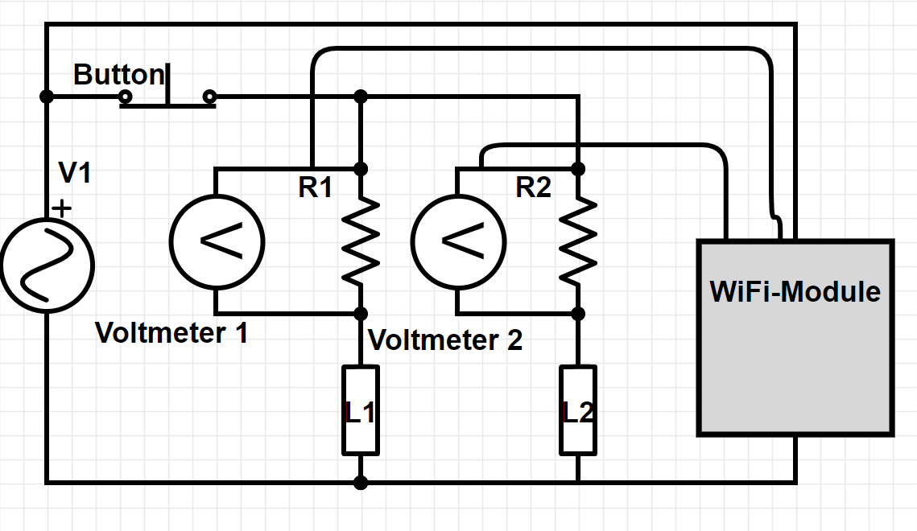
Figure 29: Voltage Measurement Rough Draft

5.2.2 Ammeter Rough Draft

Figure 30 shows the potential design of the SIMP using a current sensing component over a voltage sensor in parallel with a shunt resistor. This design creates a simpler circuit topography thus lending itself to a smaller form factor for the system itself. This approach also allows us to test different sensing techniques so that we can try to find the one that best fits our needs. Some ammeter components on the market are in fact the previous voltmeter design, using a shunt in parallel with a voltage sensing component all in one unit. Other current sensing components use the hall effect to measure the current in the wire by using the magnetic fields produced by the current.

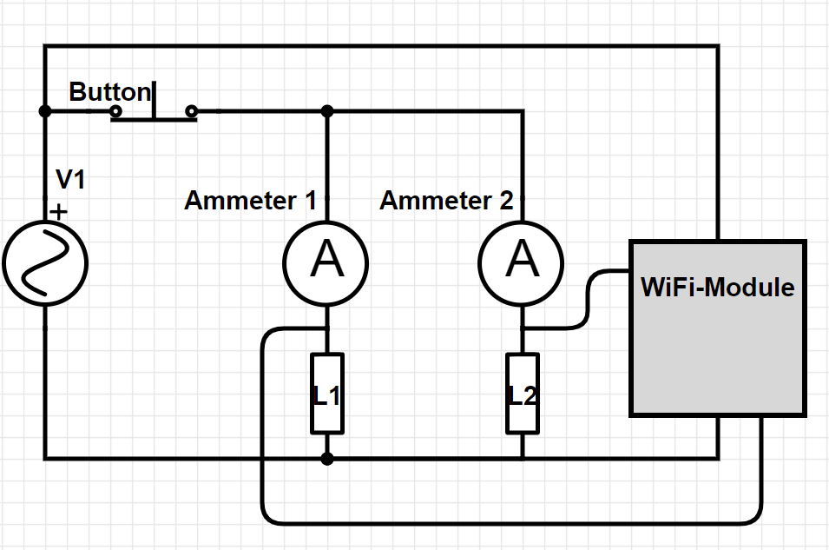
Figure 30: Amp Measurement Rough Draft
This method proved to be the most space saving and accurate method the team could find and easily implemented so it was applied in the final design of the SIMP system.

5.2.3 Voltage Divider Idea for Voltage Measurement

As stated in section 5.2.6, an idea was hatched as a way to minimize size of voltmeters/ammeters and to minimize risk to our processing unit in terms of excessive voltages using a voltage divider to read high amounts of voltage. We simulated this using Multisim Live, after doing the calculations to find the ratio needed between Resistor 1 and Resistor 2. The following calculations show the ratio needed:

$V_{out}=V_{in}\frac{R_{2}}{(R_{1}+R_{2})} → For \frac{V_{out}}{V_{in}}=0.10 → R_{1}=(9×R_{2})$

Figure 31: Voltage Divider Equation

We began the simulation with 10k-90kΩ resistors:
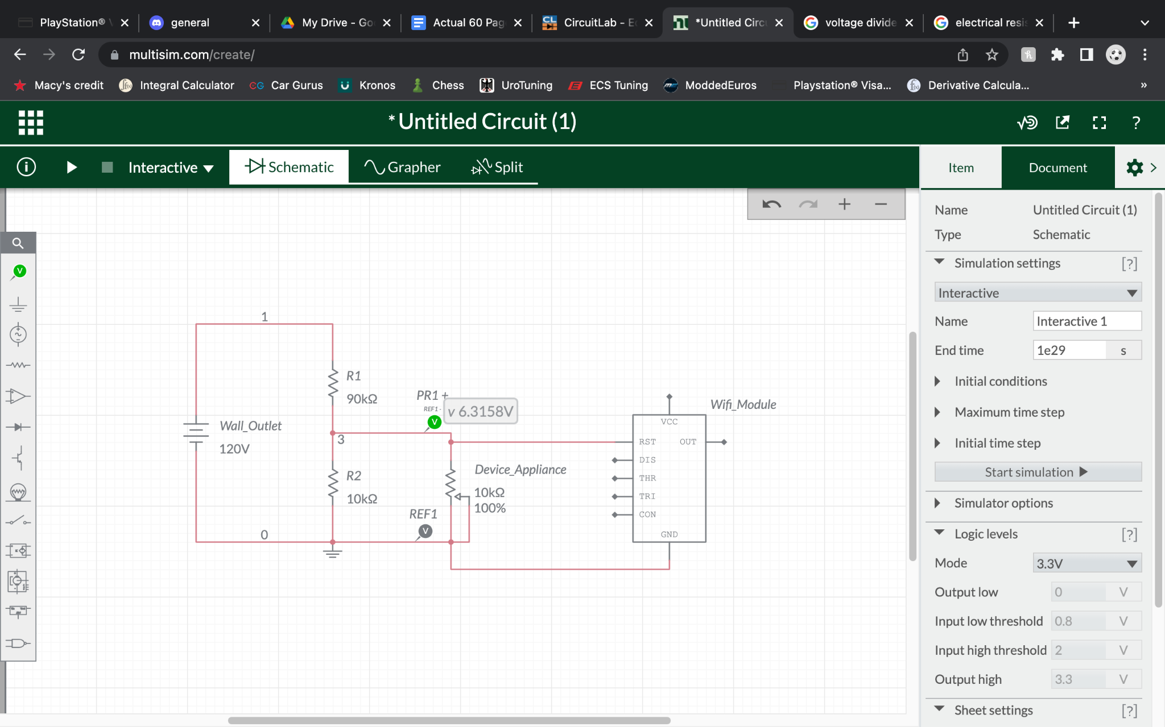
Figure 32: Voltage Divider Simulation #1
After noticing the voltage being read was not the voltage we wanted, we lowered the values of the main resistors while keeping the same ratio to achieve a higher accuracy while keeping cost down. This was able to give us a closer reading of the voltage we wanted, but not close enough:
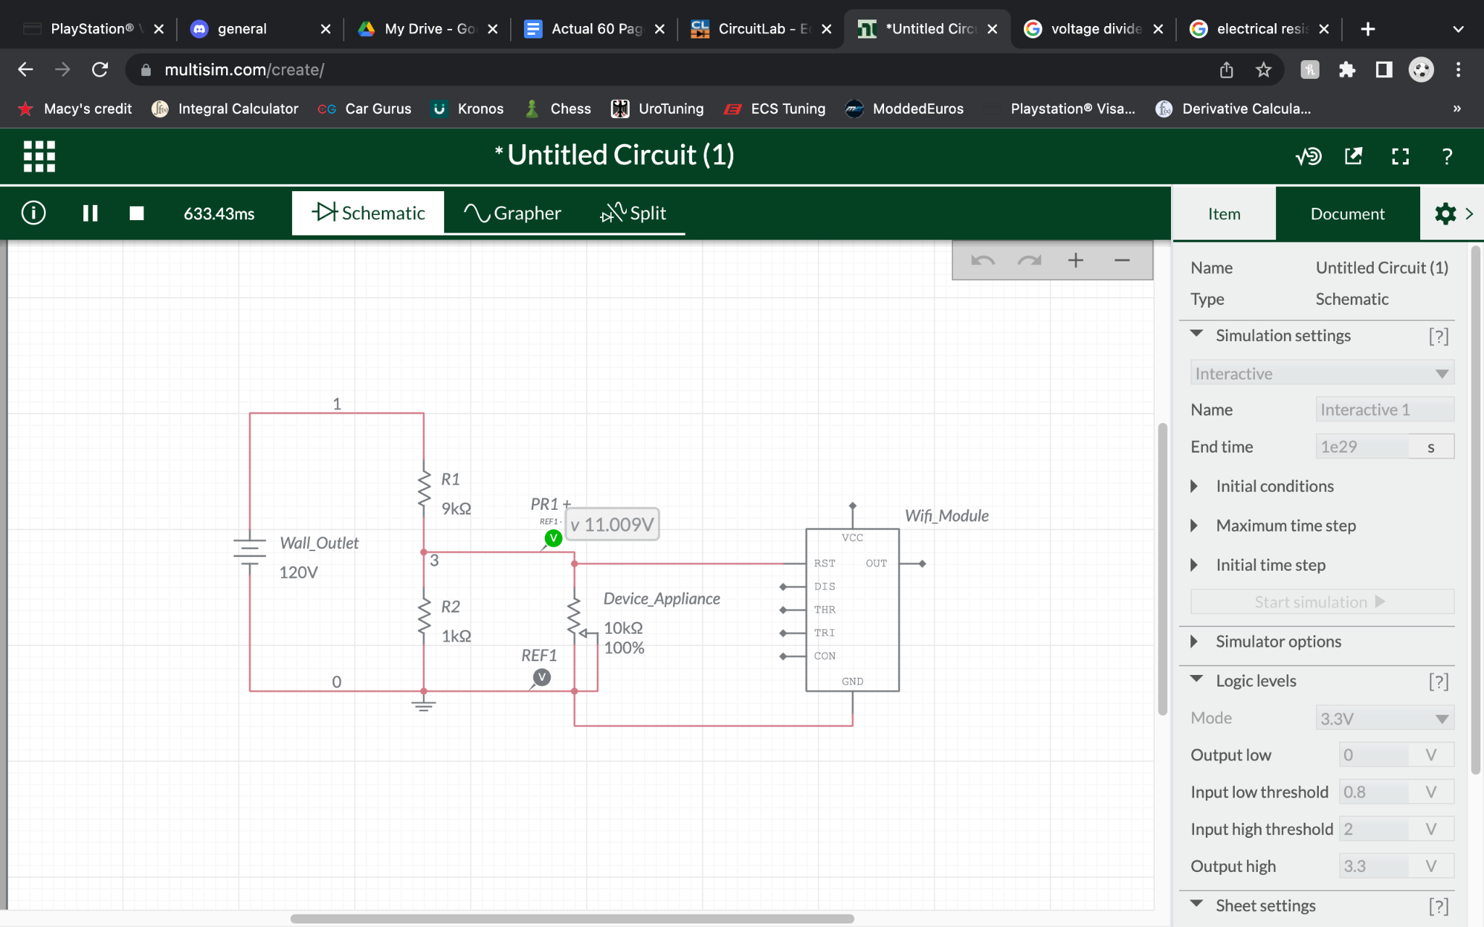
Figure 33: Voltage Divider Simulation #2

With the final simulation, we were able to deduce that the voltage that would be read by the voltmeter would be dependent on the total resistance of the device that is being plugged into the SIMP. This means that, if we plan to use the voltage divider idea to its full extent, we will have to incorporate a set of adjustable resistors (potentiometers) that will adapt to the resistance of the device while keeping the same ratio for a maximum achievable voltage reading. This is shown in the figure below as the adjustable resistors being connected to the Processing Unit through pins that it would control. The maximum values of these resistors will be anywhere from 1kΩ to 200kΩ depending on the device(s) we plan on plugging into the SIMP when it comes time for demonstration.
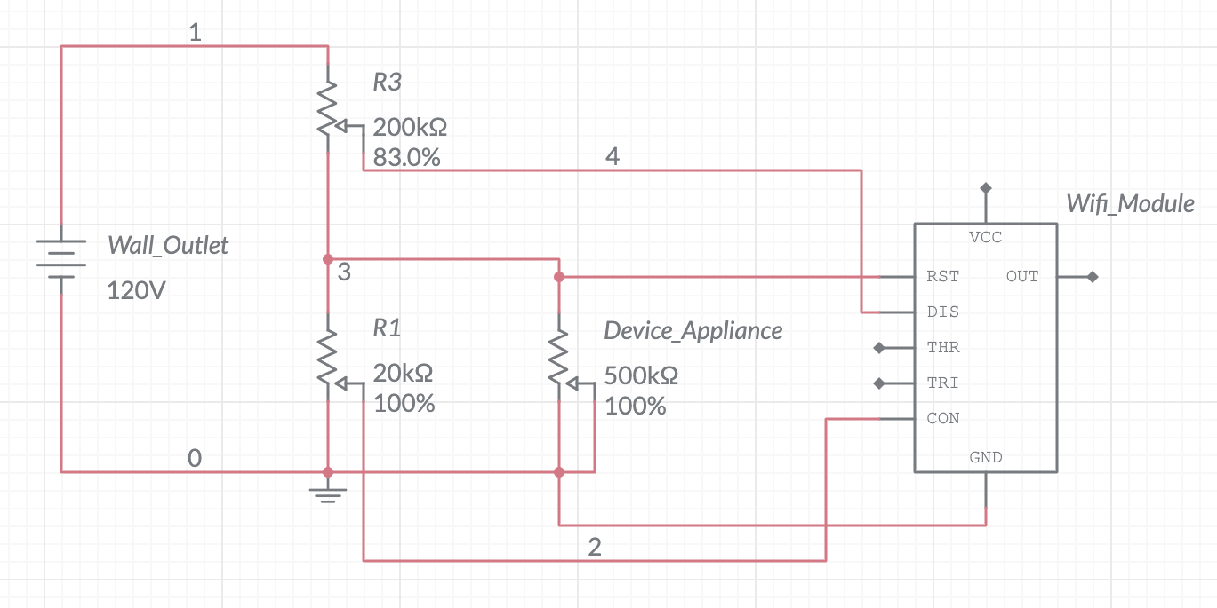
Figure 34: Voltage Divider Simulation #3

***Please note that these schematics are rough drafts designed to show ideas and are by no means final. Also note that, due to Multisim Live’s limited inventory of only the most basic of linear circuit components, our Wi-Fi Module/Processing Unit is displayed as an ideal 555 Timer. This is merely a placeholder that we used to show our Processing Unit as a linear circuit component with many pins. No attention should be given to the names or functions of said pins on the 555 Timer.***
Given the challenges of having adaptive potentiometers in the system which we would likely have to develop ourselves and needing to have a list of all the possible resistances of different loads for the SIMP we abandoned this methodology.

5.2.4 High Voltage AC to Low Voltage DC MicroUSB

The main drawback of working with PCB components for an interior home outlet monitor is the difference in voltages, which can be detrimental and harmful to the small parts that are designed to run off much smaller parameters. Since we do not plan on adding any sort of battery slot to our SIMP, both for size constraints and simplicity’s sake, the entirety of our system will have to be powered by the wall outlet it is plugged into. This brought up the discussion of how we plan on powering our Arduino Nano 33, which uses a 5V microUSB to power itself and to connect to a computer via USB to download code from a computer.

Thankfully, Texas Instruments takes all the hassle out of researching and will provide anyone with multiple schematics of circuits that will allow for conversion of any AC voltage that has a 50 Hz or 60 Hz frequency into a DC power supply with desired output voltage and current. This is done through WEBENCH® POWER DESIGNER. Below you will find our input we filled into the provided blank boxes of the homepage, including minimum input voltage (RMS), maximum input voltage (RMS), frequency, output voltage, and maximum output current. After a few moments, we were given a list of 118 different schematics that would help us draw power from a 125-250V AC outlet and use that power to keep our Arduino running consistently on 5V as long as our SIMP was plugged in.

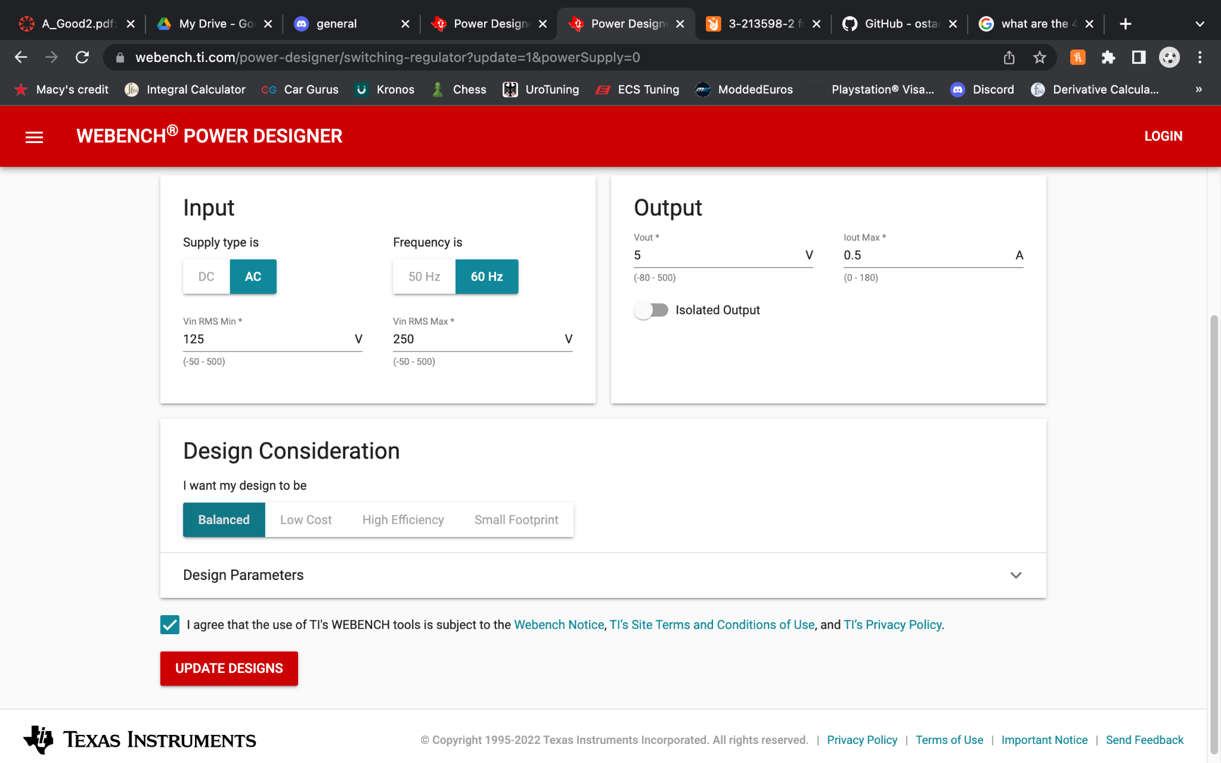
Figure 35: WEBENCH® POWER DESIGNER Home Page
With 118 possible schematics to choose from, there was quite a bit of narrowing-down we had to do. These schematics varied in characteristics like efficiency, footprint size, bill of materials (BOM for short) cost, bill of materials count, etc. Our most important characteristics to us, in order, were footprint size, efficiency, BOM cost and BOM count. Since the footprint sizes for all 116 schematics were labeled “NA”, we decided to neglect the footprint size, as we assumed the actual footprint size would most likely be determined when we rearrange the schematic onto a PCB to our liking. With footprint sizes unavailable, we wanted our efficiency to be the highest possible. Moving the provided efficiency slider to its maximum range, more than 85% efficiency, narrowed the list down to just three schematics. The list of the remaining three schematics remained unchanged after moving the BOM cost slider down to its lowest possible range (without completely removing the three remaining schematics, that is), which was less than $9.40. Finally, the BOM count slider was move to its lowest possible range, that would not wipe out the list entirely, of less than 30 parts combined. This left us with two final schematics with identical characteristics, as shown below.

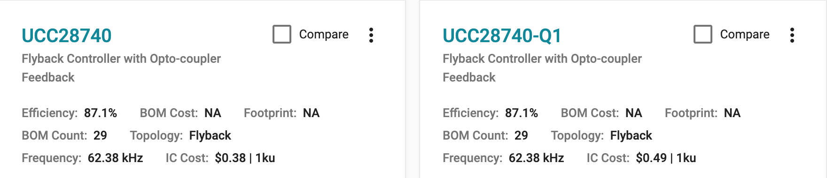
Figure 36: Final Two AC/DC Schematic Characteristics

To make matters of choosing even more difficult, the schematic designs are exactly identical, with the only difference between them being the integrated circuit they each use. One uses a TI UCC28740 while the other uses what seems to be a newer version of the same integrated circuit, a TI UCC28740-Q1. There was hope that the UCC28740 would be larger, as it is shown in the schematic, which would make our choice easy. But according to the data sheets of both integrated circuits, they are identical in size as well. Figures of the UCC28740 and UCC28740-Q1 schematics are shown below, respectively.

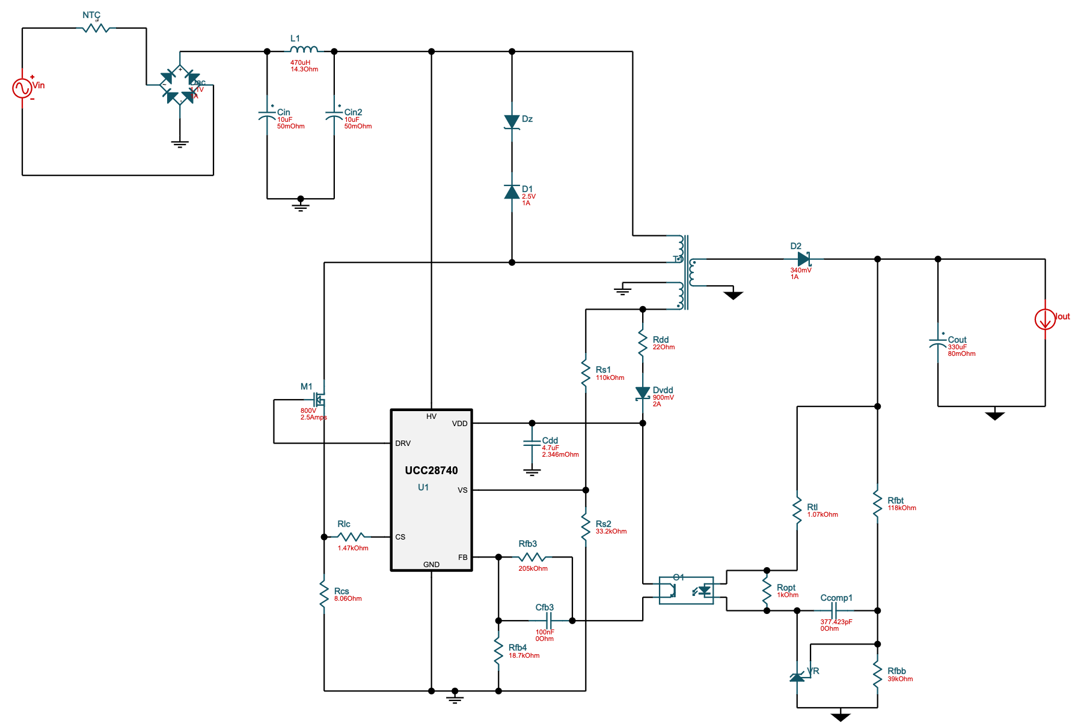
Figure 37: UCC28740 AC/DC Schematic

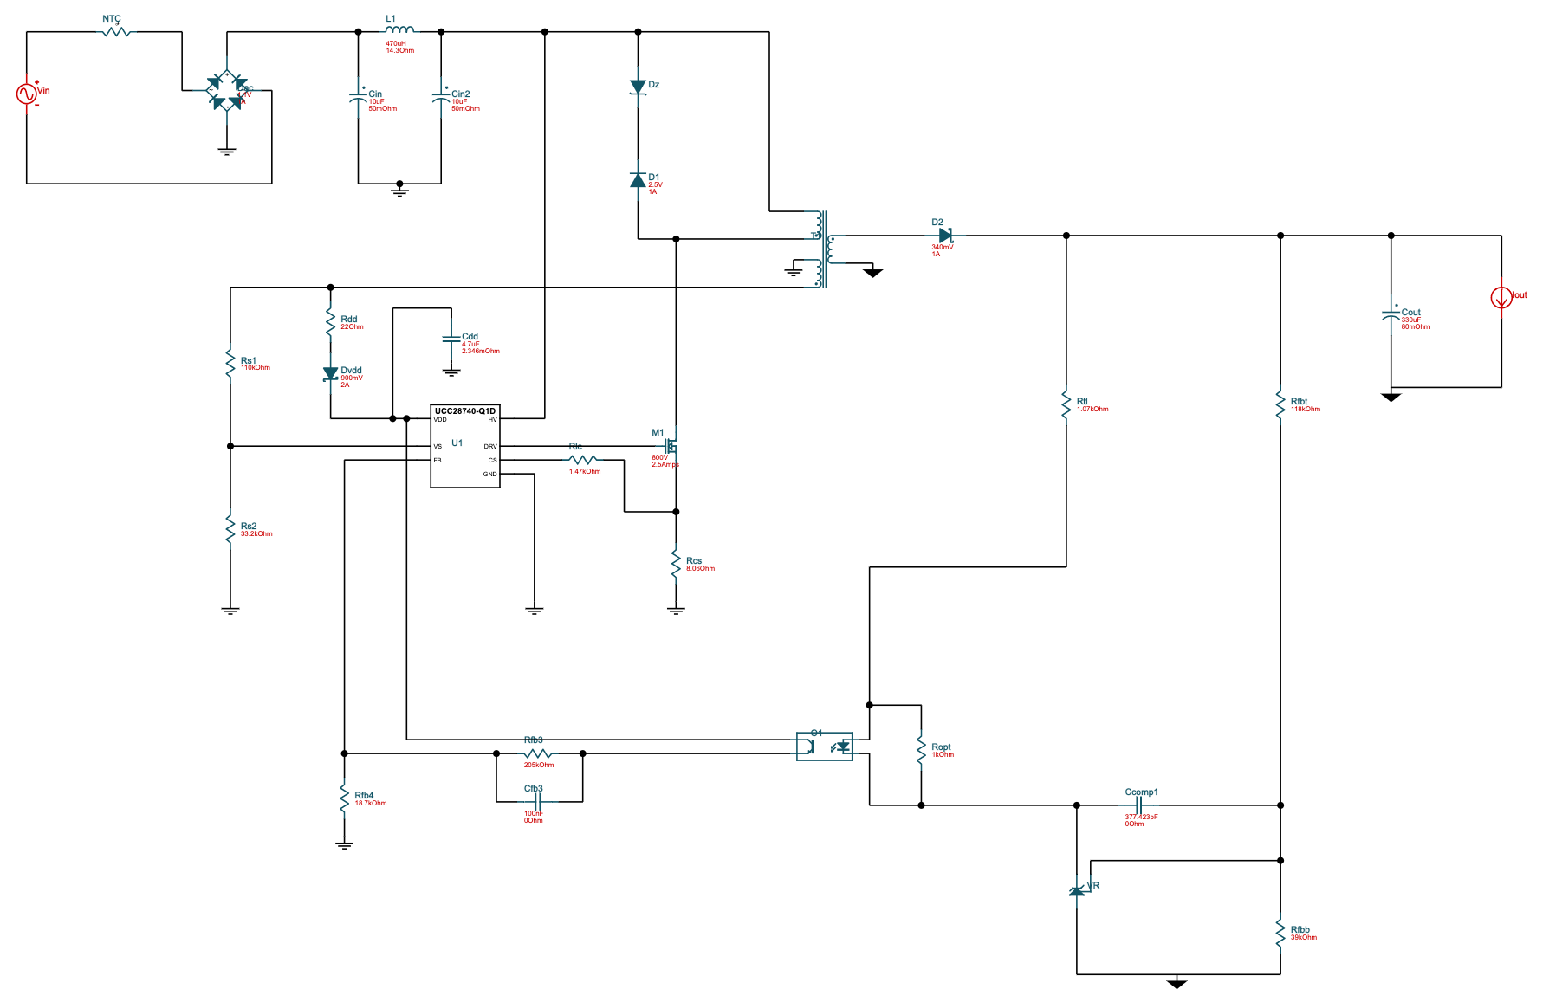
Figure 38: UCC28740-Q1 AC/DC Schematic

After looking to add either of these integrated circuits to our existing EAGLE schematic, only one of them had both an available footprint and an available symbol. For the sake of not falling into any confusion or tedious work-arounds in the future, we decided to choose the option that had the available footprint and symbol, which was the normal UCC28740.

5.2.5 Final Schematic

Below, taking up the entirety of page 56, is a rough draft of our final schematic that will be eventually turned into a PCB board and machine-made to ensure as much efficiency in final product dimensions as possible. Updates will be added to this rough draft as more testing is done as we are prepared for some components to not perform to the level we expect them to. From first glance, a reader will notice that the bulk of the final schematic is taken up by our 120V-AC-to-5V-DC power converter discussed in section 5.2.4. This section of our final schematic was made to replicate the schematic given to us by TI WEBENCH to the best of our ability and with the limited footprints and symbols we were able to find through EAGLE or SnapEDA (link found in Appendix B). Certain symbols in our schematic are the result of failure to find an exact footprint of the component recommended to us by TI WEBENCH.

For example, the box labeled “O1” in either of the AC/DC schematics above (shown as a box with a transistor on one side and an LED on the opposite side) was the most difficult to find, as there was no component name, as well as no datasheet provided to us by TI WEBENCH when looking in the Bill of Materials. To make matters worse, not a single group member had ever seen a linear circuit component like it. After a generous amount of time, we were able to find a datasheet of the part through renesas.com (link in Appendix B), and identify the component as a “photocoupler”. Because there was so little to find about this exact part online, there was no luck in finding any sort of footprint or symbol of it we could download and use in our EAGLE schematic. The photocoupler found in our EAGLE schematic is, instead, the result of searching EAGLE’s libraries for “photocoupler” and choosing the symbol that most resembled the one in our TI WEBENCH schematics.

The MOSFETs labeled “M1” in either of the schematics above were also impossible to find a footprint for online. As a result, our MOSFET labeled with value “800V 2.5 Amps” below is one we found in EAGLE’s libraries that we thought most resembled the one shown in the schematics above. Though not the exact part, we feel that as long as we have connected the ports of the MOSFET the same as the schematics TI WEBENCH provided and labeled it with the correct circuit characteristics, our final schematic is just as effective as if we found the footprint for the exact part number.

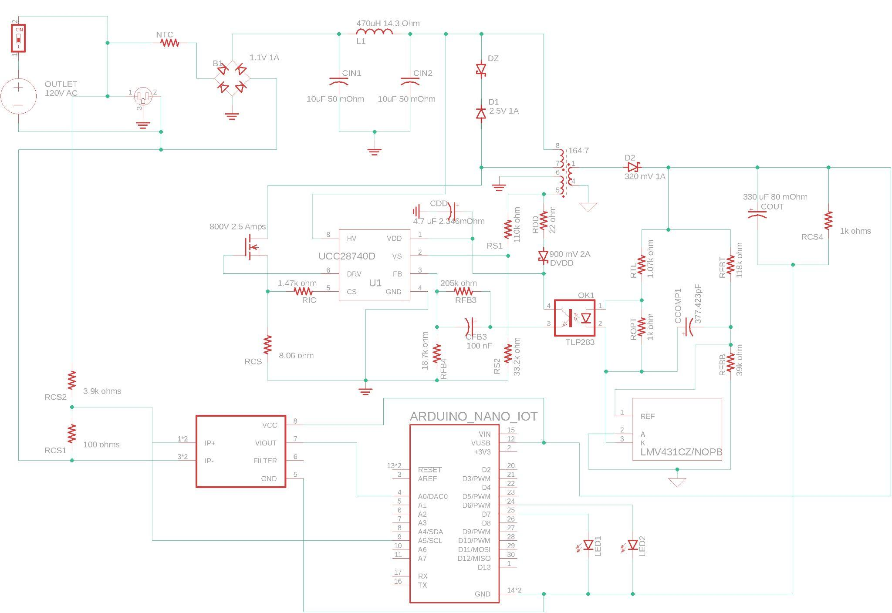
Figure 39: Final Schematic Rough Draft
The outlet that is part of the home interior is shown in the schematic as the independent voltage source that is connected in series with a switch, which together are connected in parallel with the outlet that we plan to be the “face” of the SIMP device. The switch was also found in EAGLE’s libraries and is not likely to be used in our final product, but we thought it crucial to show how the switch will be the main driver in deciding whether or not the entire circuit is receiving power from the wall outlet. It is also shown that the outlet, or “face” of the SIMP is not the deciding factor of the rest of the circuit being powered. We need it connected in parallel so that the SIMP is on, able to send and receive data, whether or not a secondary device is plugged into it.

Finally, the Arduino pins are somewhat confusing when observing the schematic at face value, but can be explained. The microUSB port not being included in the EAGLE footprint we downloaded from SnapEDA is where most of the confusion stems from. It is understandable that the footprint does not include a microUSB port, because for most scenarios, it is only used to write and download code into the Arduino, and never used in final schematics. Though when someone finally decides to use the microUSB port as a form of powering the Arduino even when it is finished coding, trouble may arise when designing the schematic. In our final schematic, for the sake of simplicity, we have shown the Arduino’s “VUSB” pin being connected to the DC end of our AC/DC converter, with the Arduino’s “GND” pin being connected to the ground of said converter. In reality, the “VUSB” pin will be its own separate pin, soldered so it receives 5V from the microUSB allowing it to provide DC power to any circuit components with a required Vcc of 5V. The soldering we did to the “VUSB” pin to achieve this will be explained in section 5.2.9. As well as the “VUSB” pin being soldered in reality, the DC-end of the AC/DC converter will be connected to the red and black wires of a shortened microUSB cable that will be plugged into the microUSB port of the Arduino.

We plan to have the LEDs entirely dependent on the Arduino, and have shown that by pinning one end of each of them to a desired digital output pin, with the other end of each pinned to the “GND” pin of the Arduino. This will allow us the extra precaution for the LEDs, since the Arduino will never be able to produce a power so high that it would damage the LEDs, which are crucial to the schematic, as they are the main form of physical communication between the SIMP device and the user besides the notifications that the user. For more details about the communication methods we plan on implementing via the LEDs, see section 5.6.3.

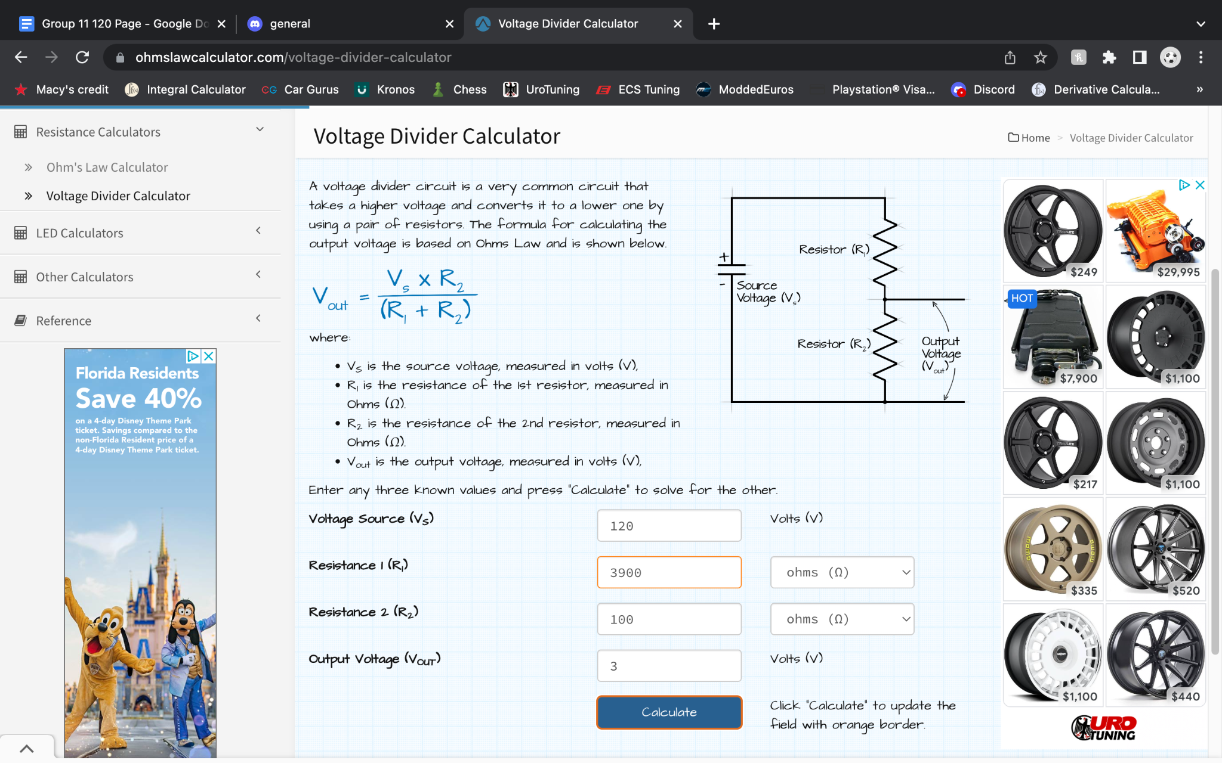
Figure 40: Voltage Divider Calculator

5.2.6 Final Schematic & PCB

After ditching the idea of a separate PCB for our AC/DC converter and buying one instead, our final schematic turned out to be less complex and require less components. Below is a figure of our true final schematic, consisting of terminal blocks, relays, LEDs, current sensors, pin headers for our microcontroller to slot into and an AC/DC converter.

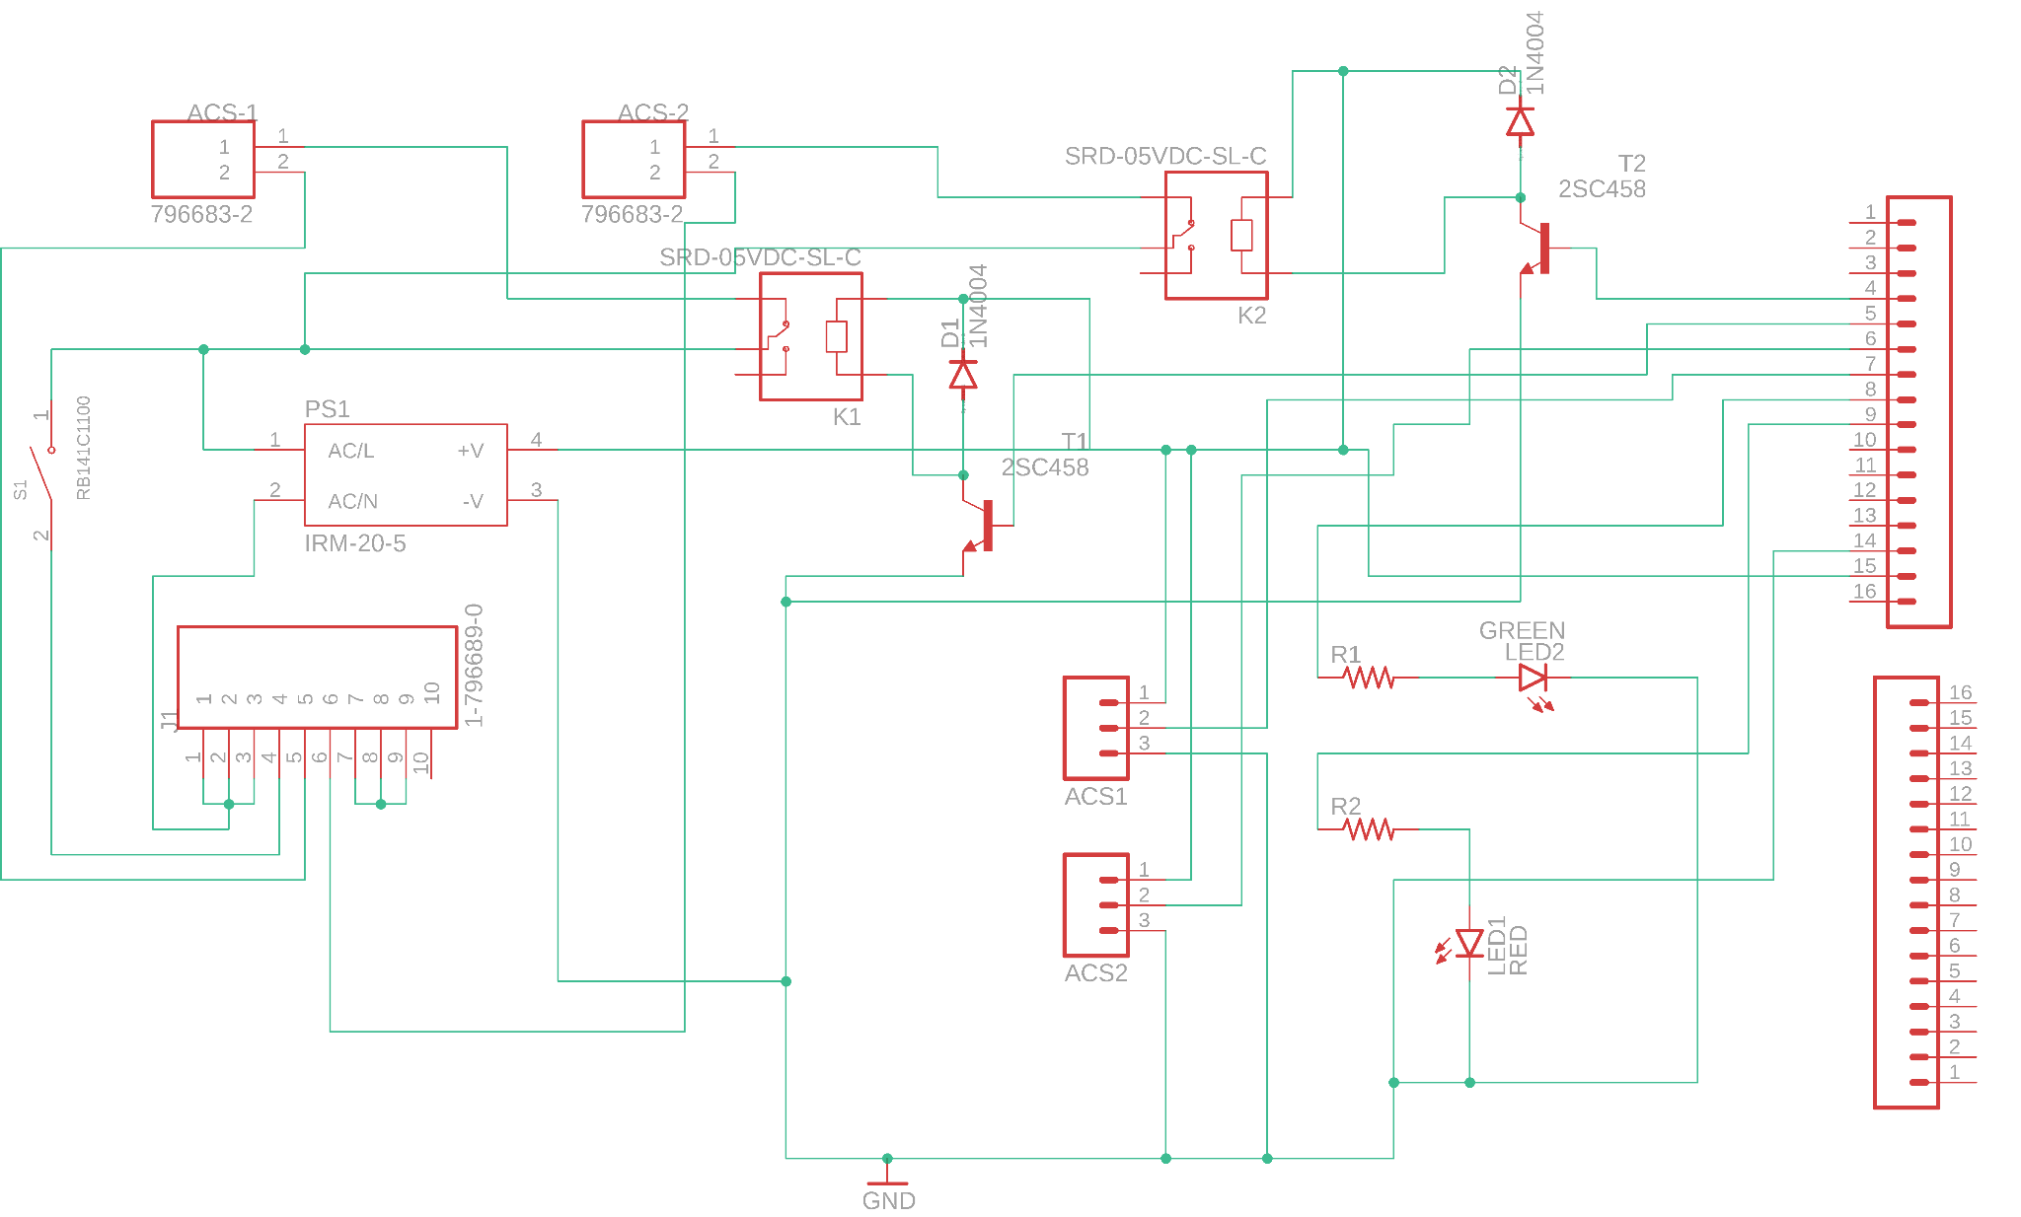
Figure 40: Final Schematic
This final schematic allowed us to create our final PCB for the project, shown below.

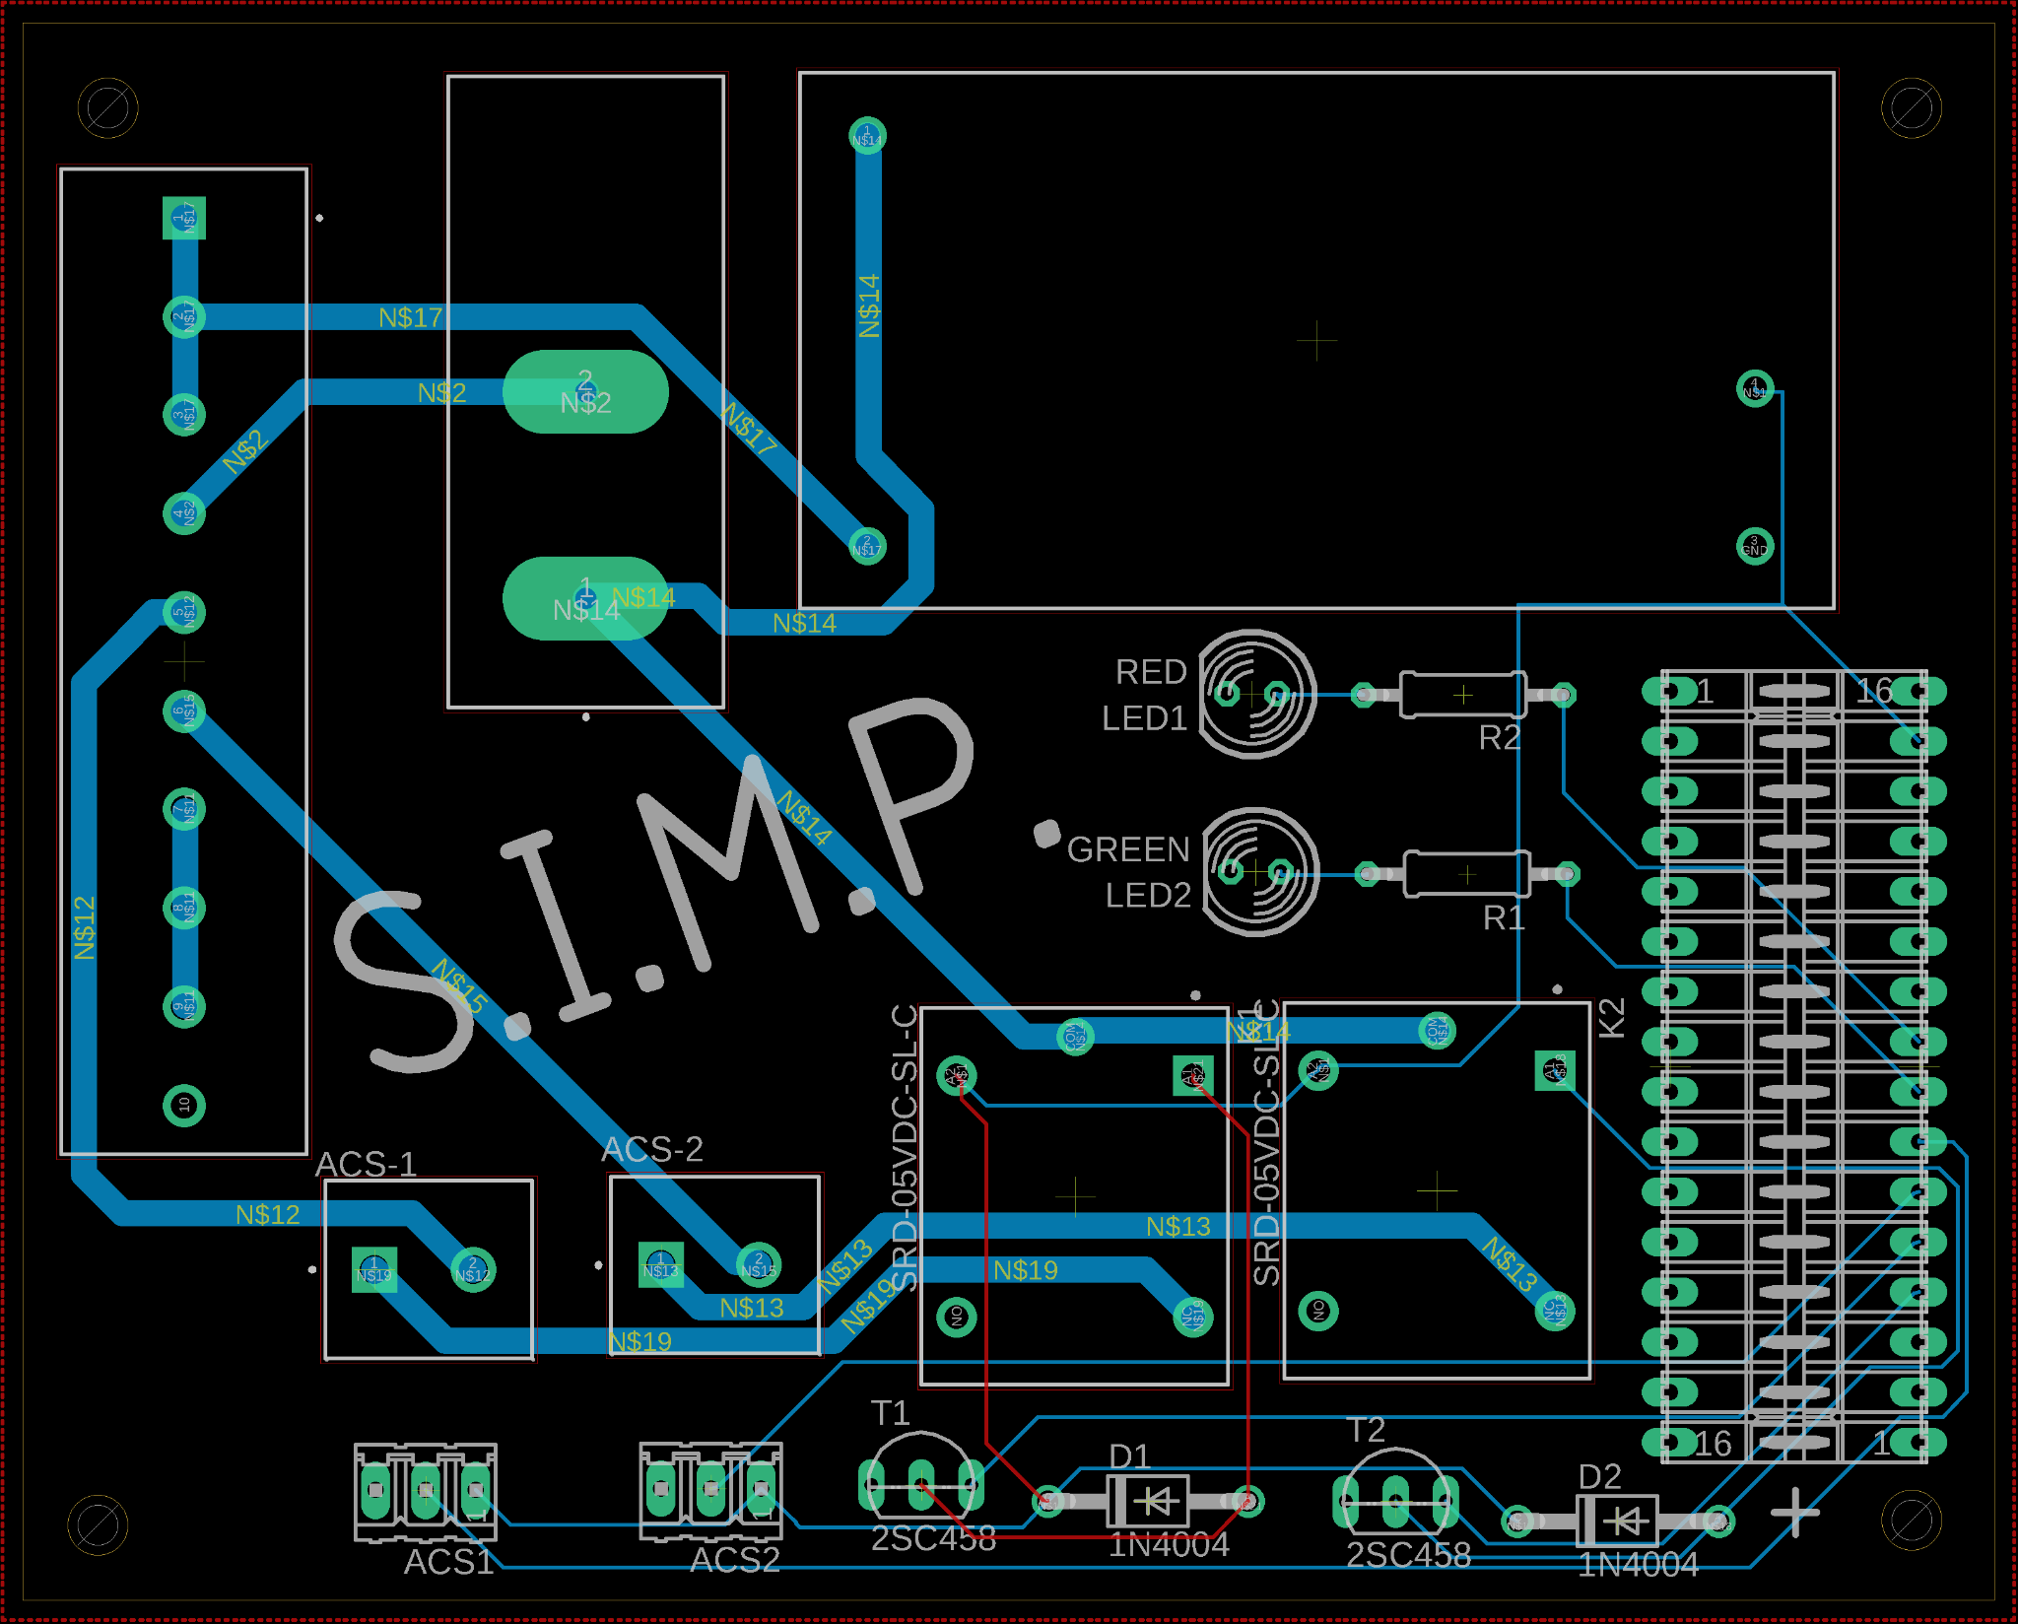
Figure 40: Final PCB

5.3 Breadboard Testing

Our hardware testing consisted of several phases, starting at a breadboard level with the constituent parts of the whole system being constructed individually. For the power measuring system we will use lower voltage power sources for safety purposes and more control over the amount of power going into the system to avoid part damage. We will first start with the power coming out of a computer USB 2.0 port which runs at a known 5V DC with a maximum current of 500mA, after which we incrementally increase the voltage going into the system using a function generator. The final round of breadboard testing consisted of the full 120V at 60 hz of a US household outlet.

5.3.1 Outlet-to-Outlet Power

Due to our decision to use a duplex outlet as our middle-man between the device that is being powered and the actual wall outlet the SIMP will be plugged into, our first breadboard test did not actually include a breadboard. Instead, it included a wire with a male plug at one end, attached (via wire caps) to a separate wire that we previously attached (via duplex pins and screws) to the duplex outlet, essentially making a short extension cable with a duplex at the end of it. We then plugged a lamp that usually runs off electricity from a wall outlet into our duplex and plugged our extension cable into the wall outlet and flicked the switch of the lamp. The following are figures included to help the reader understand the test further.

The figures include:
- A simplified schematic of the test
- A picture of the test before being plugged in to show the lamp off and dependent on power coming from the outlet
- A picture taken of the outlet to show it being properly wired to the male electrical plug via duplex pins and screws
- A picture taken once the male electrical plug was connected to a female wall outlet, showing the lamp light does turn on as it usually would if there weren’t an extra plug between it and the wall outlet.
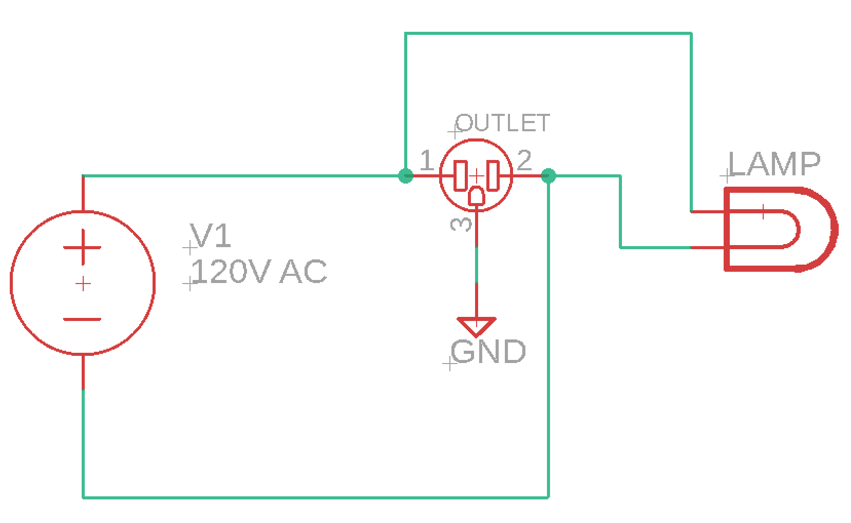
Figure 41: Outlet-to-Outlet Power Schematic

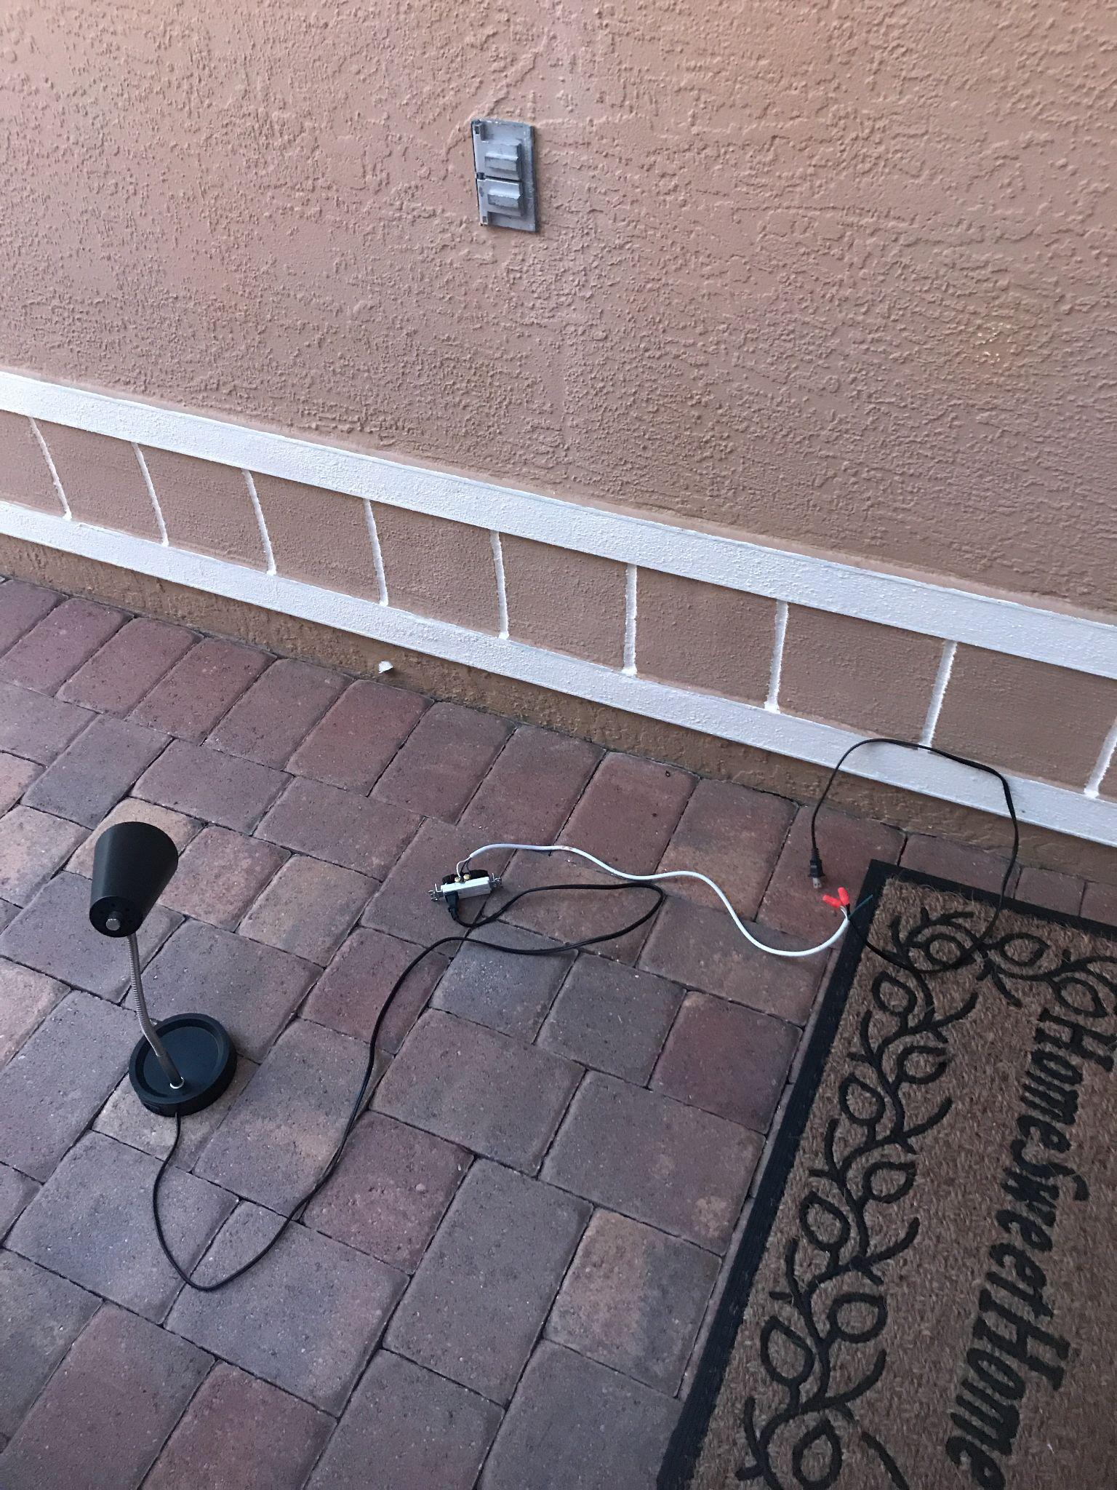
Figure 42: Outlet-to-Outlet Power #1
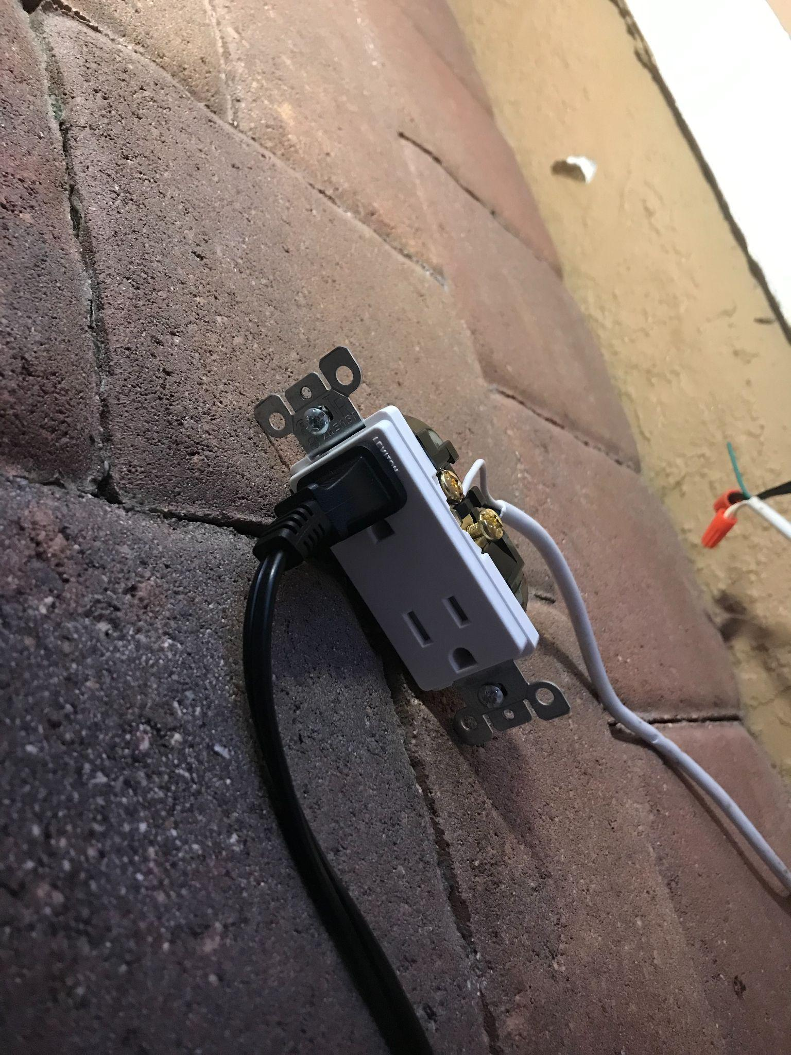
Figure 43: Outlet-to-Outlet Power #2

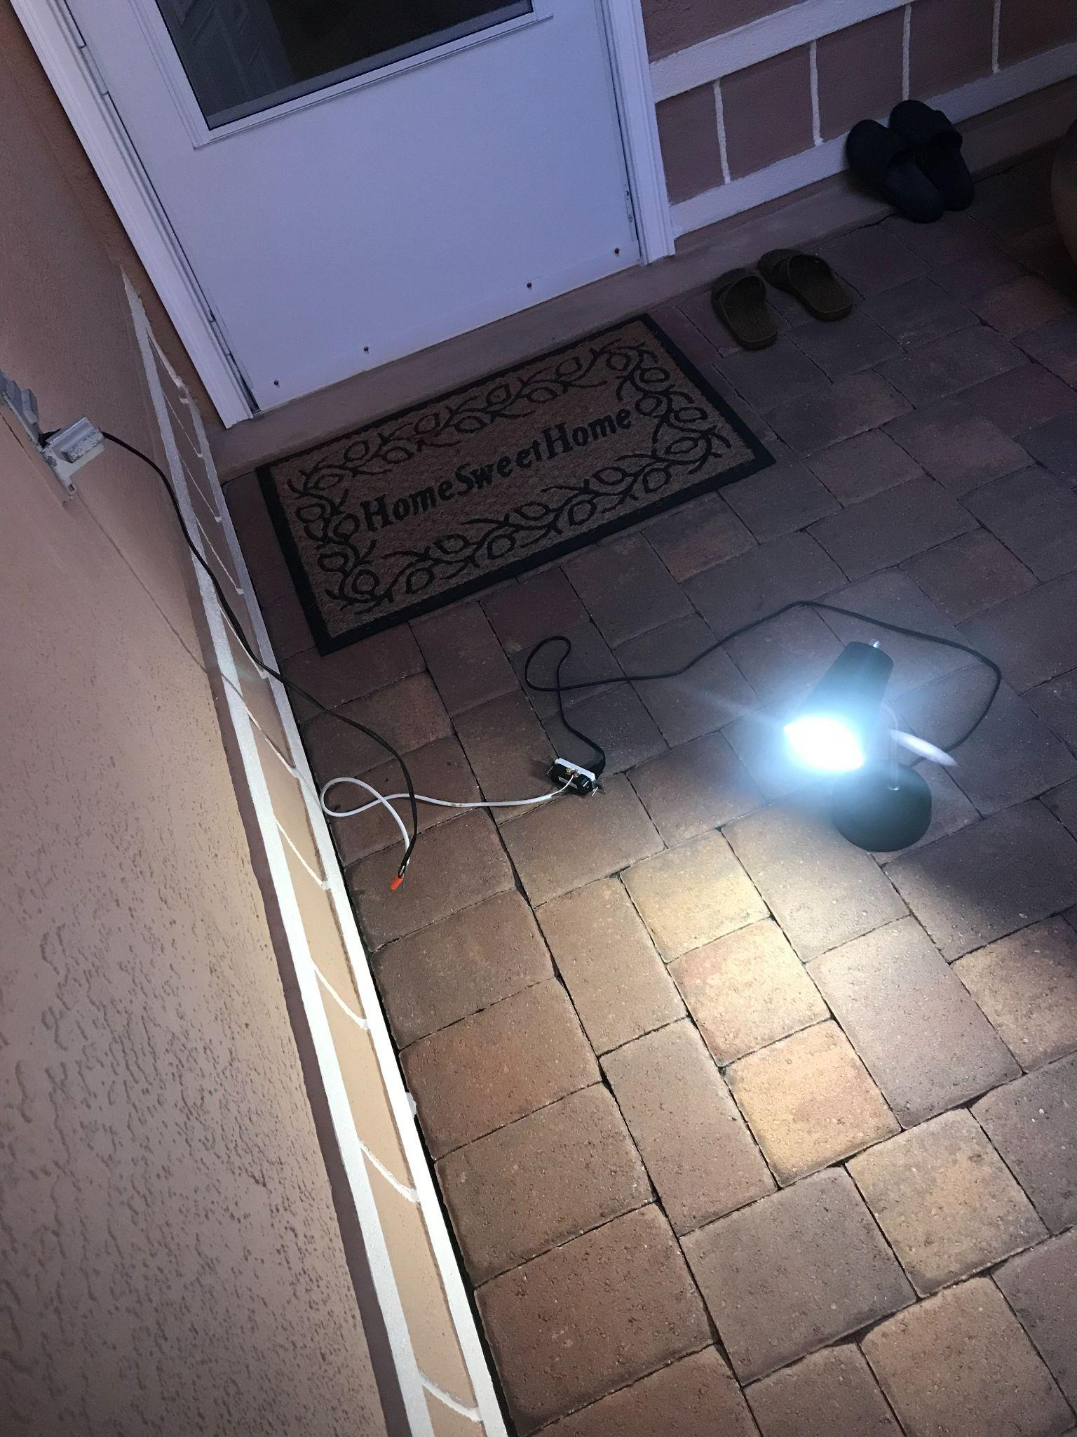
Figure 44: Outlet-to-Outlet Power #3

As expected, the lamp turned on without hesitation. This test was done first because of its simplicity as well as its importance in the following steps in breadboard testing. The idea is that this linear circuit would theoretically be connected in parallel to the other linear circuits of the breadboard in the future. Due to the severity and danger of AC electricity, great care was taken in the combining of electric cords, with all combining done before any electricity was introduced. Extra precautions were also made when the test was ready to run, such as using an outlet that was on the exterior of the house rather than inside the house. A good distance was kept from the duplex outlet on the ground, with a fire extinguisher handy, since the wiring was metal where the wire meets the screws technically exposed for the “middle-man” duplex plug.

5.3.2 Ammeter

Arguably the most important breadboard test done on an actual breadboard for this project was the testing of the ammeter we plan on using to read voltage and power and have it sent to the arduino to interpret. Our first mistake came with purchasing ammeters that were very small and were meant to be purchased on a PCB where it would be soldered by a machine. After numerous sessions of trying to solder and two of the five hall effect ammeters ending up with broken pins, we decided to rethink the ammeter sizing, just for breadboard testing’s sake. We went with a hall effect ammeter that came connected and soldered to a miniature PCB and had pins available for the wires we would use in breadboard testing. Below is a table comparing the hall effect ammeters we could not use due to soldering (middle column) and the ones purchased for breadboard testing (right column).

Part Name | MCS1803GS-10-Z  (hall effect current sensor) | ACS712 Hall Effect Current Sensor Module
Price | $4.60 | $11.99
Size (mm) | 5.0 x 6.2 | 11.7 x 31 x 13
Minimum-Maximum Vin | -0.1 to 6 | -0.1 to 8
Minimum-Maximum Vout(V) | -0.1 to 6 | -0.1 to 8
Minimum-Maximum Input Current | -10 to 10 | -30 to 30
Table 23: Tiny Ammeter vs Breadboard-Friendly Ammeter

As we can see the performance of the PCB mounted ammeter while having a wider input range, it’s output range is very similar to the range our desired ammeter will have so as long as we test the new ammeter within the same ranges of the original we can say with confidence that the results would be similar.
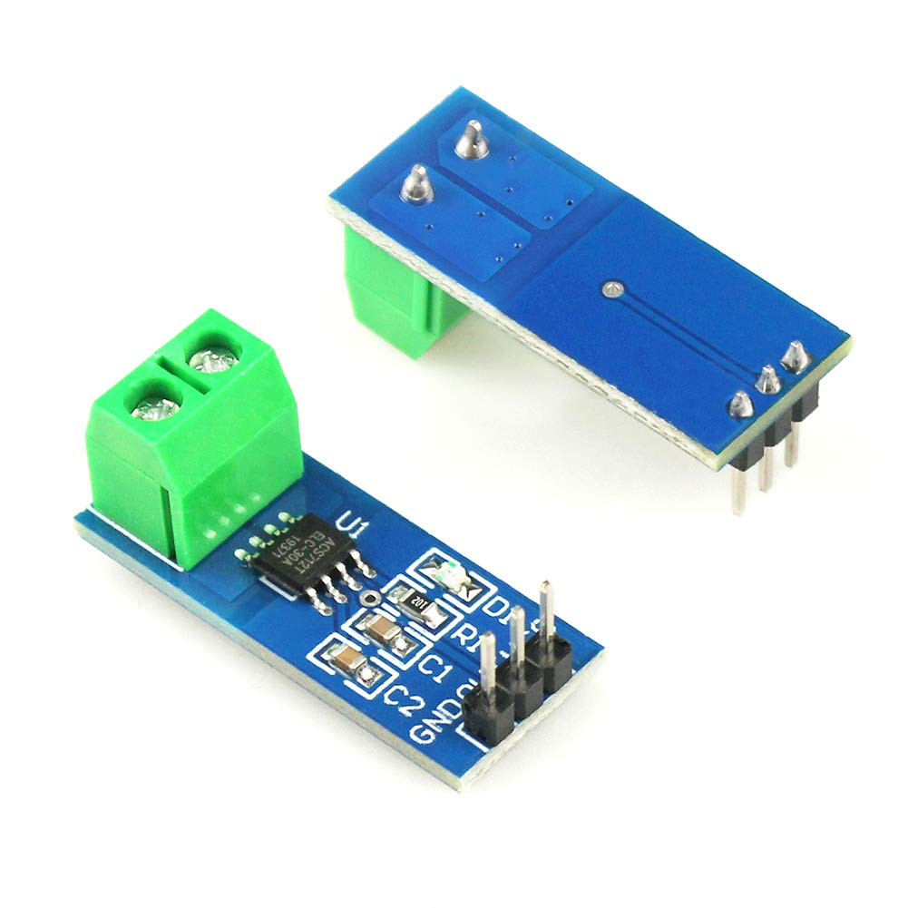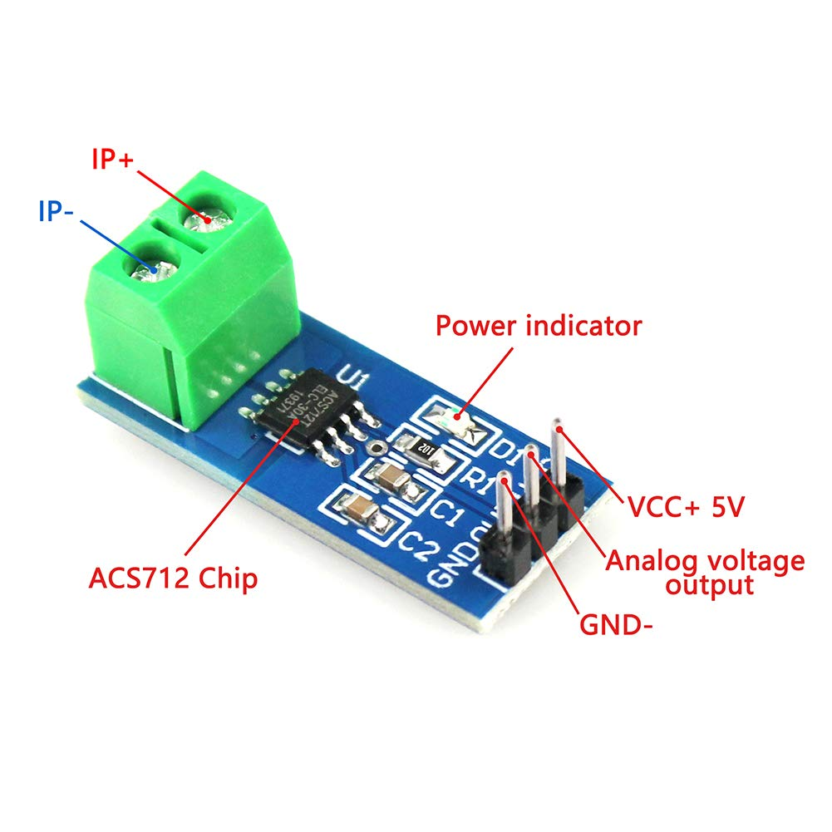
Figure 45: ACS712 Hall Effect Current Sensor

With the newly purchased ammeter(s), we began the breadboard test with the creation of a real-time version of the simplified schematic below. The circuit consisted of a Tektronix AFG3022B Function Generator, a Keithley 2230-30-1 DC Power Supply, one 100Ω resistor, one ACS712 Hall Effect Current Sensor, a breadboard, and an assortment of wires. The DC power supply was set to 5 V and connected to the Vcc pin of the current sensor module which illuminated its power indicator to show it was powered. The following figures below show, respectively:

- The schematic, which the breadboard test is based on.
- The actual breadboard circuit created in the Senior Design Lab.
- The function generator is set to its corresponding 10 Vpp and 60 Hz sinusoidal wave.
- The DC power supply is set to its corresponding 5 V.

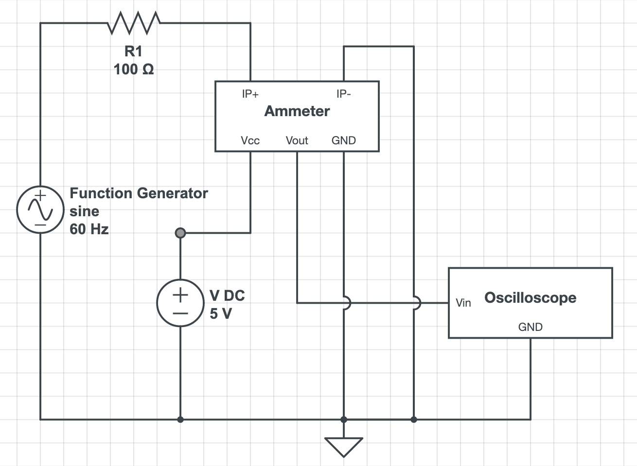
Figure 46: Ammeter Breadboard Test Circuit Diagram

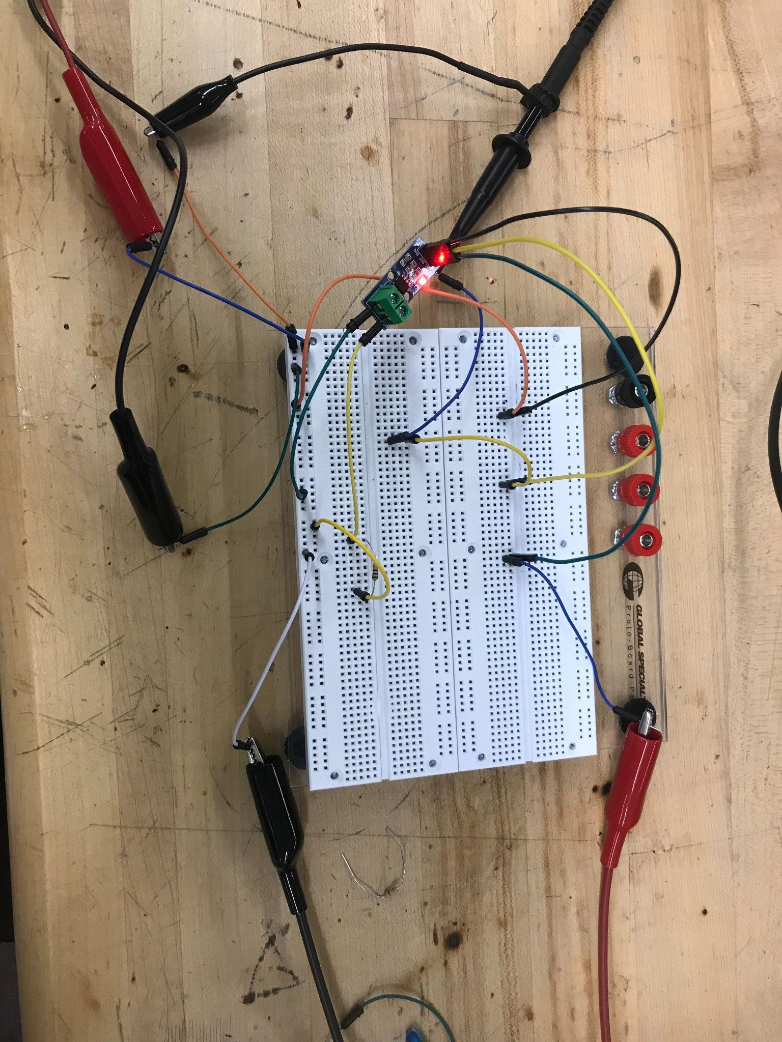
Figure 47: Ammeter Breadboard Test Circuit

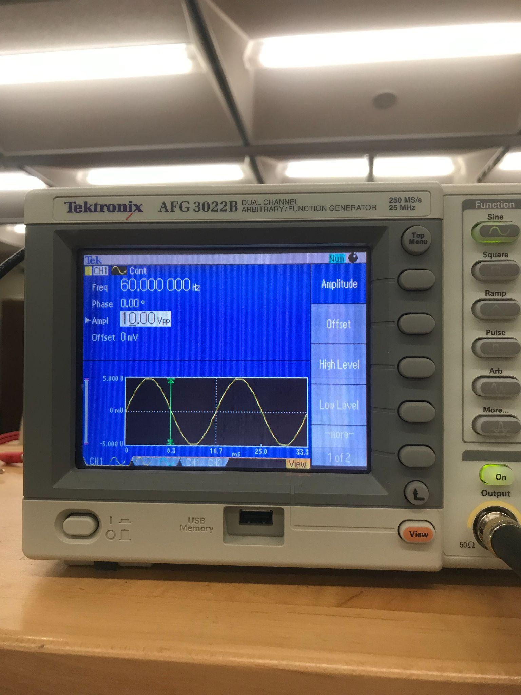
Figure 48: Function Generator 10 Vpp 60 Hz
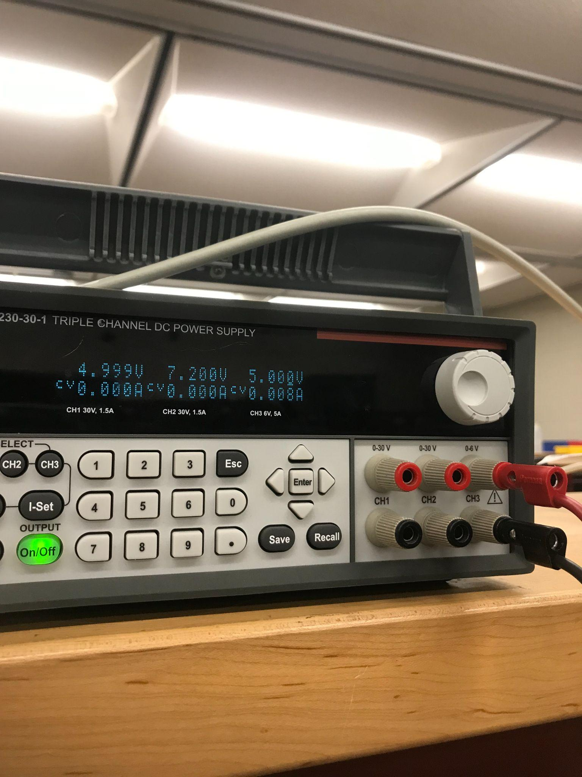
Figure 49: DC Power Supply Supplying 5V

From the circuit we created, we observed a voltage reading which we would then feed into a coding software algorithm in which we convert the sinusoidal voltage wave into the wave for current. We would do this by using the datasheet of the ammeter to determine the ratio between voltage shown and what that voltage means in the form of current (e.g. 60 milli-Volts per 1 Ampere). Because ammeters this small usually end up outputting waves that are read in milli-Volts, future testing with inductors and capacitors implement will have to be done to cancel out any noise the SIMP might experience while being plugged in for increased accuracy.

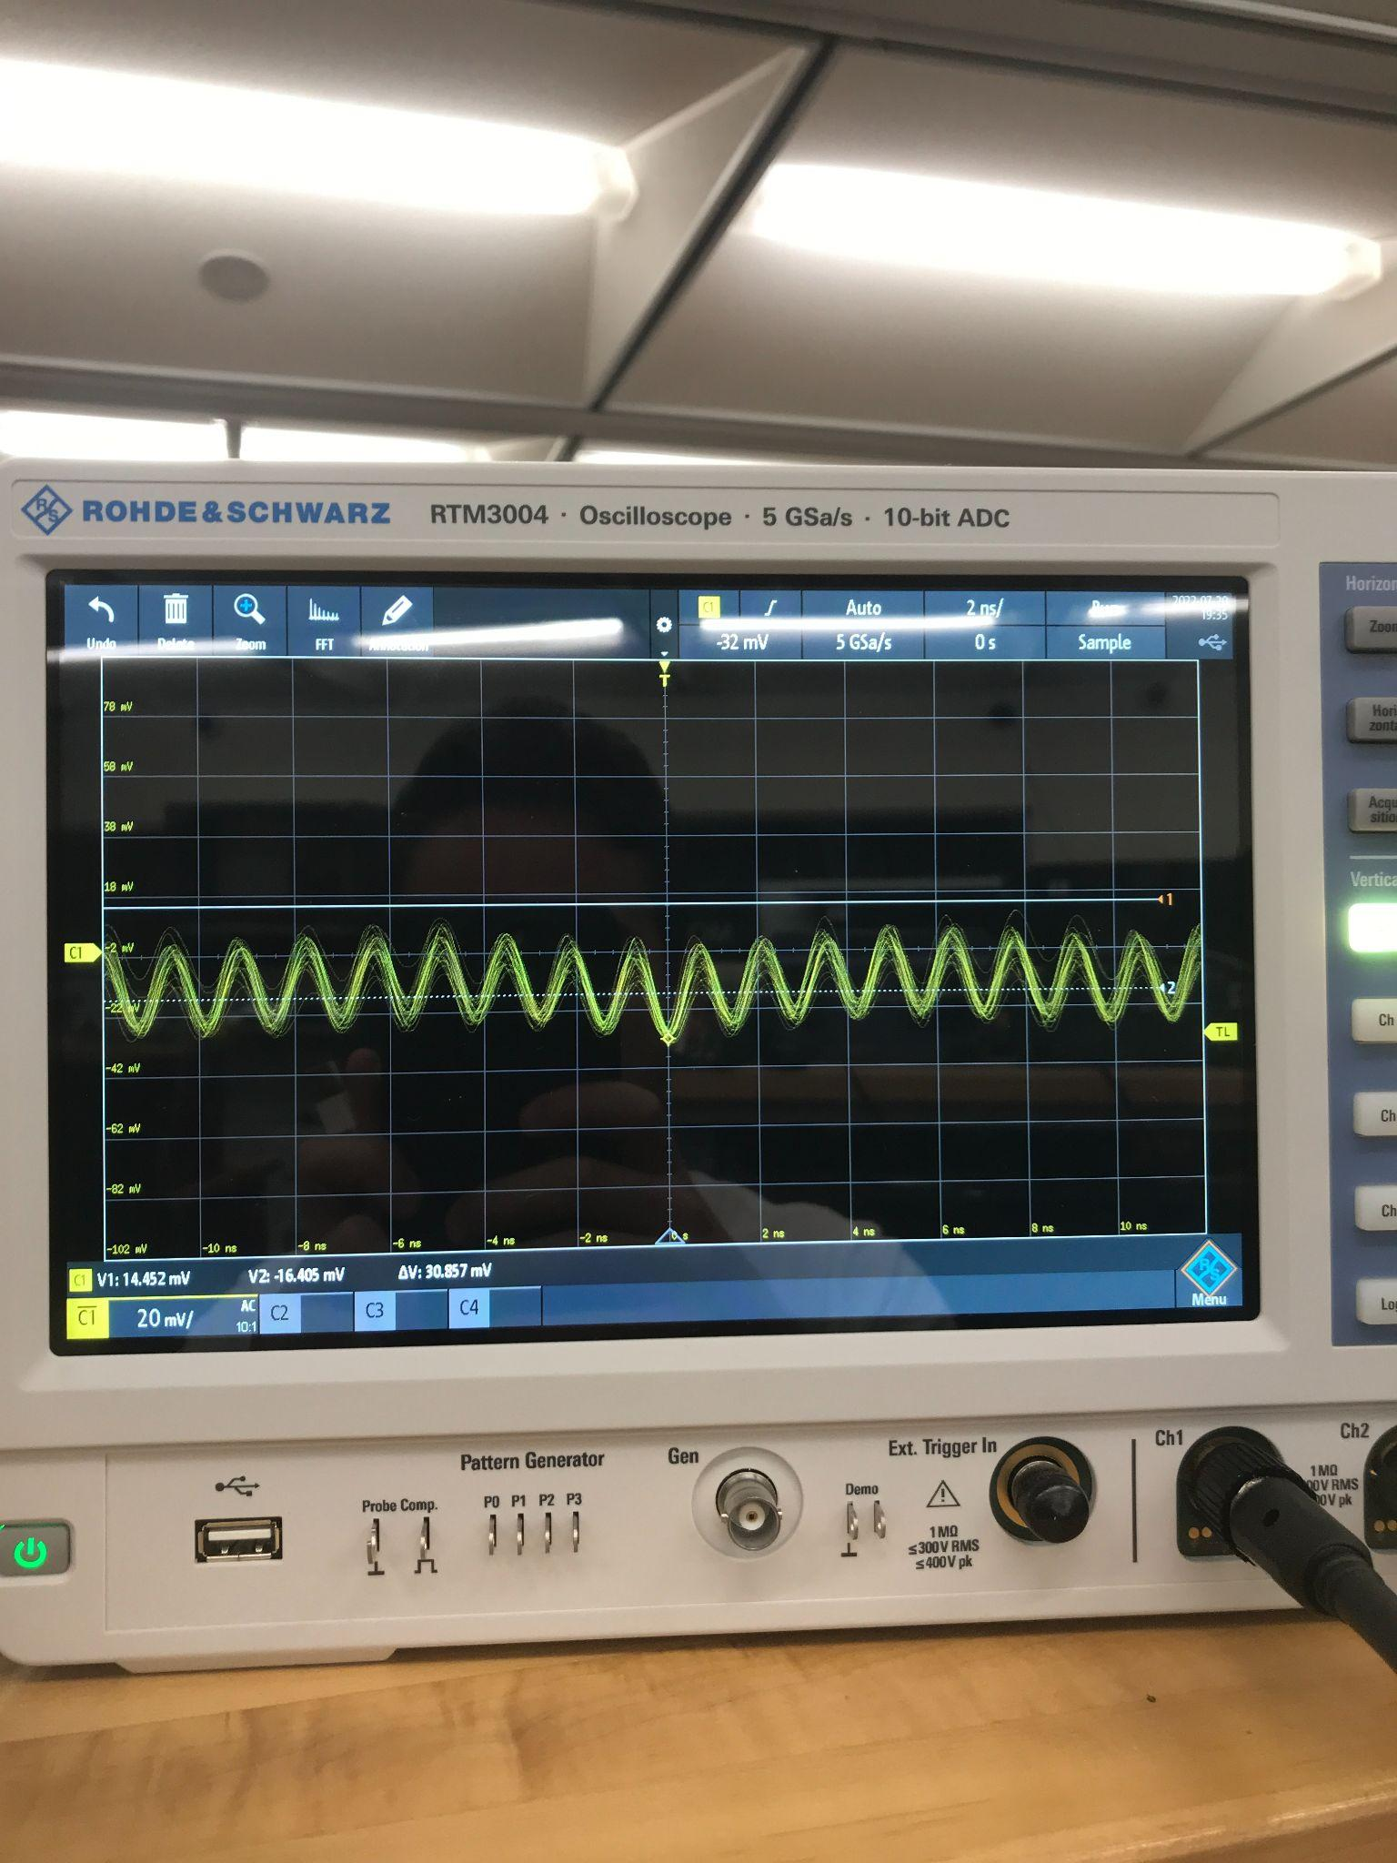
Figure 50: Ammeter Output Voltage

5.3.3 Wi-Fi Connection

To test the WiFi functionality of the microcontroller we purchased, we looked at the example codes that come with the Arduino libraries for the WiFi module on the microcontroller. The first test consisted of checking the microcontrollers onboard WiFi module by having it search for the local WiFi networks. This functionality is imperative to the SIMP working in order for the data that it is collecting to be sent to the web server.

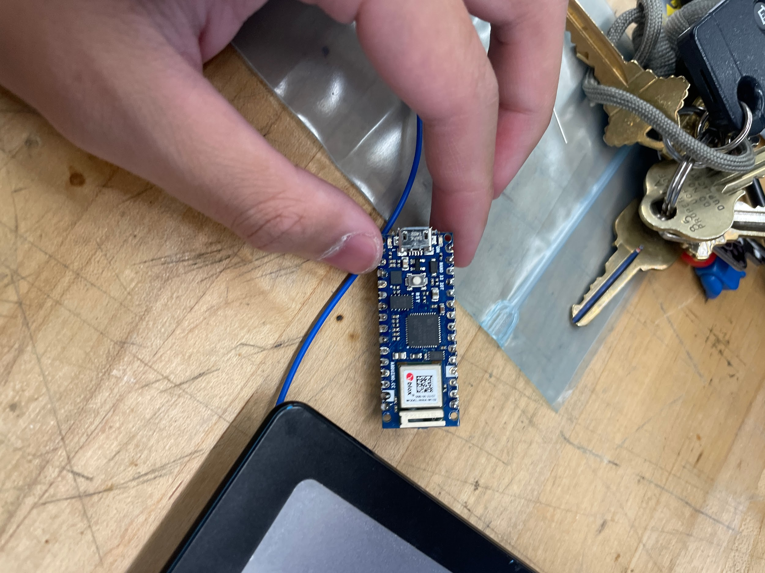
Figure 51: Arduino Nano 33 IOT

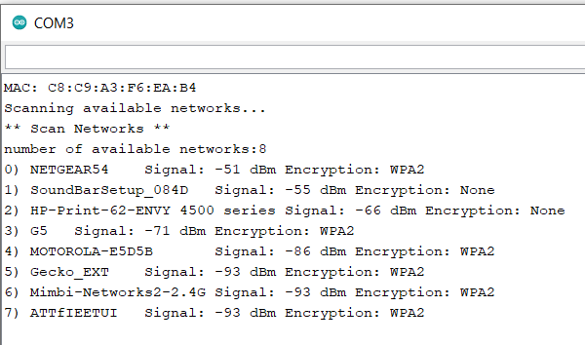
Figure 52: Output of the Arduino Scanning for Local WiFi Networks

Above is the output of the Arduino Nano’s local wireless network scan. As we can see it is able to detect the local networks nearby and the test network “NETGEAR54” is the strongest signal the Arduino is detecting which makes sense since it was the closest wireless access point to the controller.

The next WiFi-connection test we did was to see if the controller can now connect to the WiFi networks the user directs it to. Again using the libraries built-in example codes we gave the Arduino the correct credentials to connect to the test network and assuming we used the code correctly and the WiFi module works properly, the output should show both that the board is connected to the WiFi, as well as the IP address of the network.

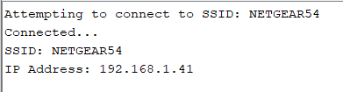
Figure 53: Output of the Arduino’s Connectivity Test

For privacy purposes, we have removed the IP address of the test network, but the above figure does show that the controller has successfully connected to the test network. The conclusion of both of these tests means that our microcontroller can be used to send the data we need over WiFi to the web server for the SIMP system.

5.3.4 Green/Red LED

The LED(s) we plan to implement will be simple enough to test, but making sure its 3-4 light-toggling settings work as they should should not be neglected. The LED will be the device's only form of communication with the user for immediate things like Wi-Fi network searching for initial setup, error messages, warning of plans to shut power off, and notifying the user to check the Hub for a more detailed version of notifications the LED cannot portray on its own. The breadboard circuit consisted of the Arduino Nano IOT, being powered through microUSB, an ON/OFF switch, and a green LED. Below are a figures showing, the schematic for the breadboard test of the arduino and LED, a picture taken with the switch in its “OFF” position, and a picture taken with the switch in its “ON” position, respectively.
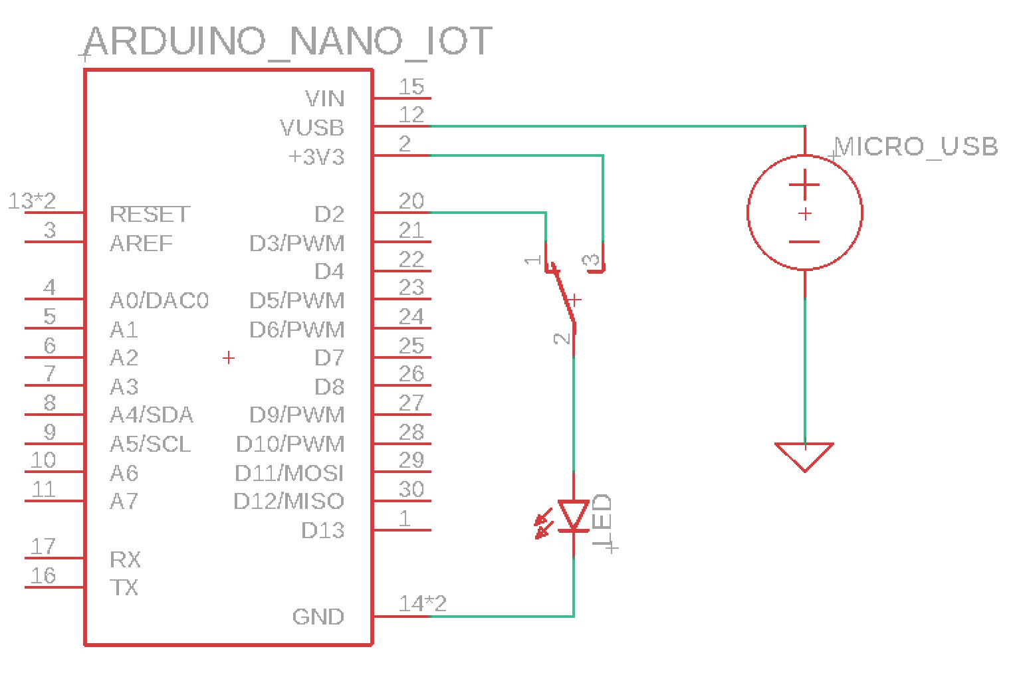
Figure 54: LED Breadboard Test Circuit Diagram

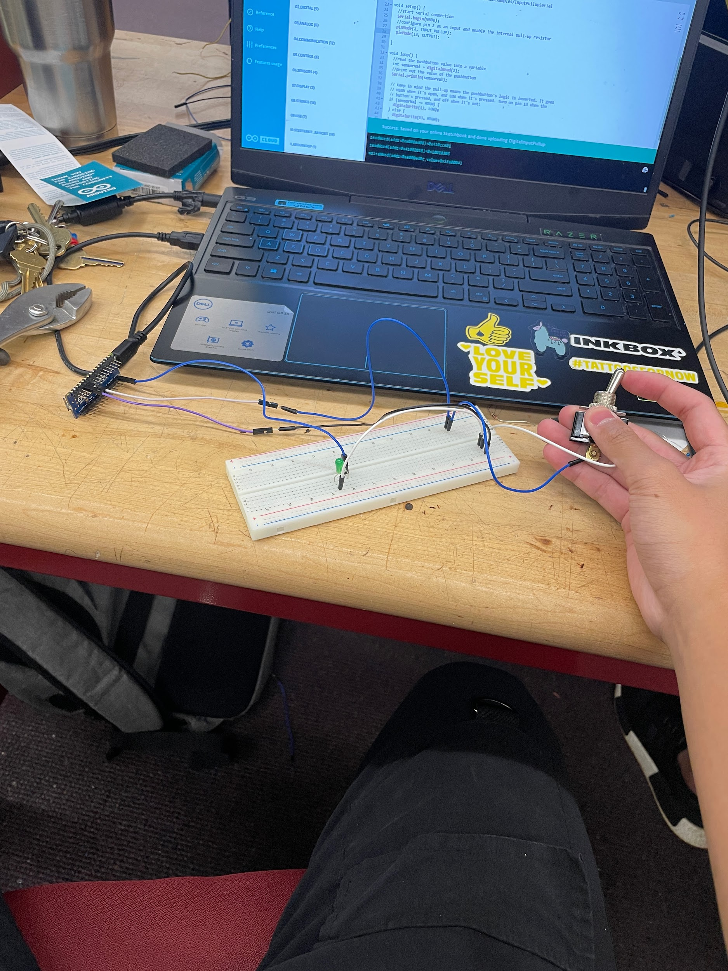
Figure 55: LED Breadboard Test with Switch in “OFF” Position

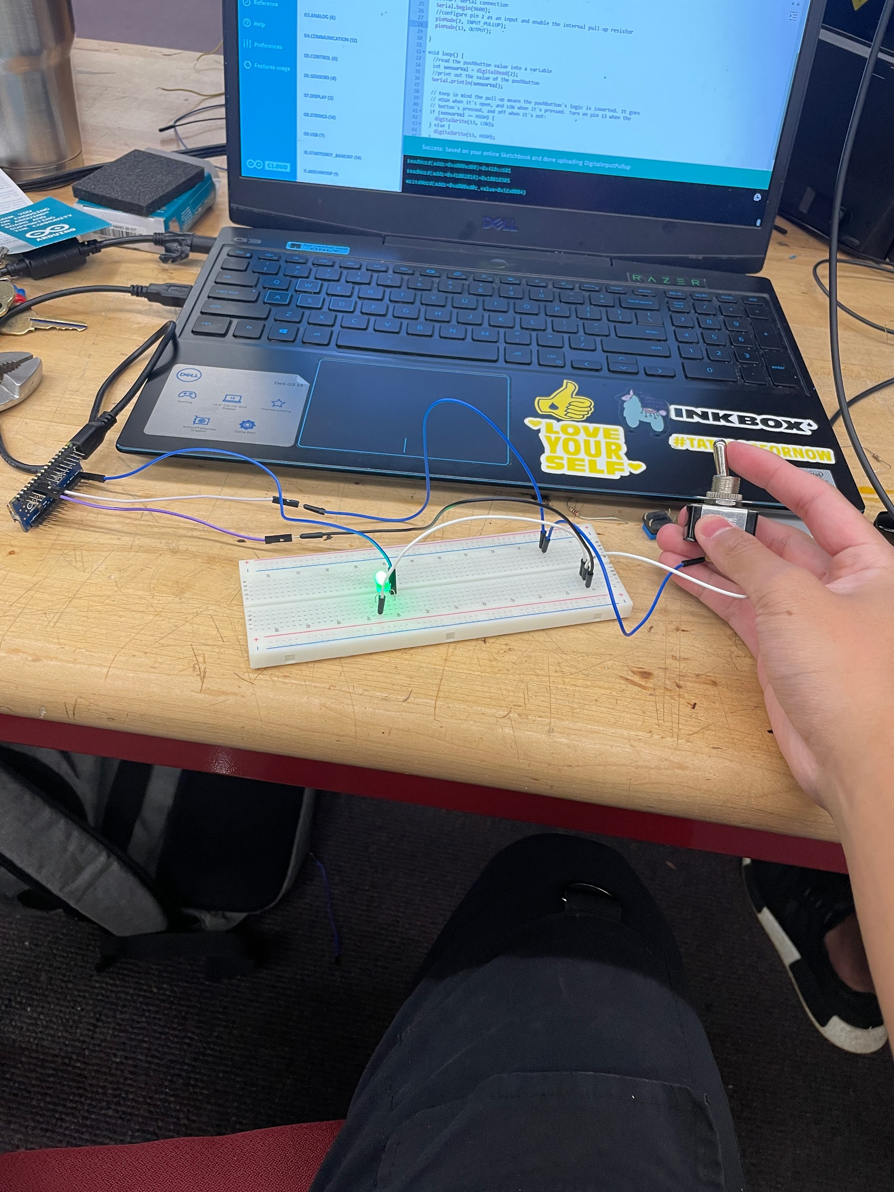
Figure 56: LED Breadboard Test with Switch in “ON” Position

Through simple testing, we were able to have the Arduino Nano supply a voltage to the LED to make it light up. The switch would choose whether the LED would be powered by the constant 3.3V pin or the pin that is configurable. With that pin, we were able to achieve a test of a blinking LED using a sample code off the Arduino website (shown below), varying the frequency in the code to observe varying frequency in the blinking of the light. We plan to use 1-2 pins of the arduino that would supply voltages to our LEDs with varying frequencies in order to communicate to the user.

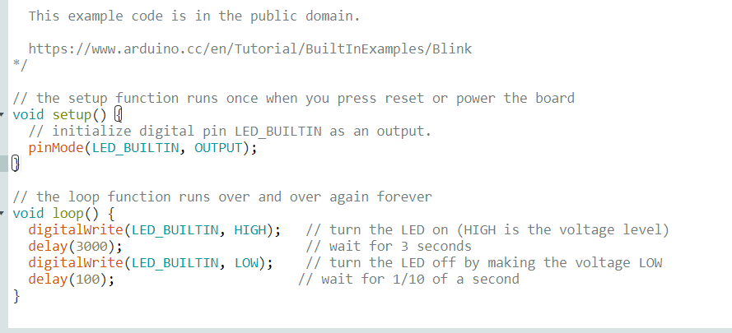
Figure 57: Arduino Blinking LED Sample Code

5.3.5 Voltage Divider

Because it would be too much of a size constraint, the idea of fitting a complete volt ammeter that would be able to read up to 120 V and 15 A in the SIMP is somewhat of a lost idea. The group has formulated the idea of having a much smaller volt ammeter reading the voltage from a voltage divider circuit that would divide the outlet voltage by a factor of 10.

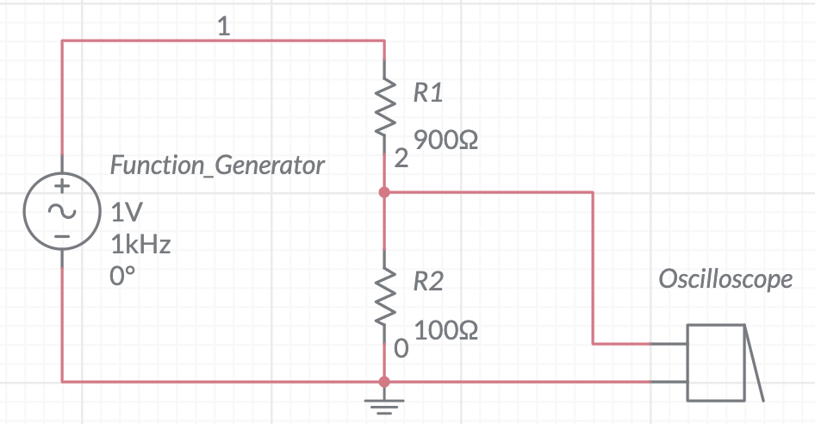
Figure 58: Voltage Divider #1 Circuit Diagram

Then, in the code of our microcontroller, we would write a conversion function that takes the divided voltage and multiplies it by 10, and gives the final product as the voltage that can be read being sent to the device that is plugged into the SIMP. We would of course planned to breadboard to test this theory and work our way up to being able to read up to 120 V from the wall outlet.
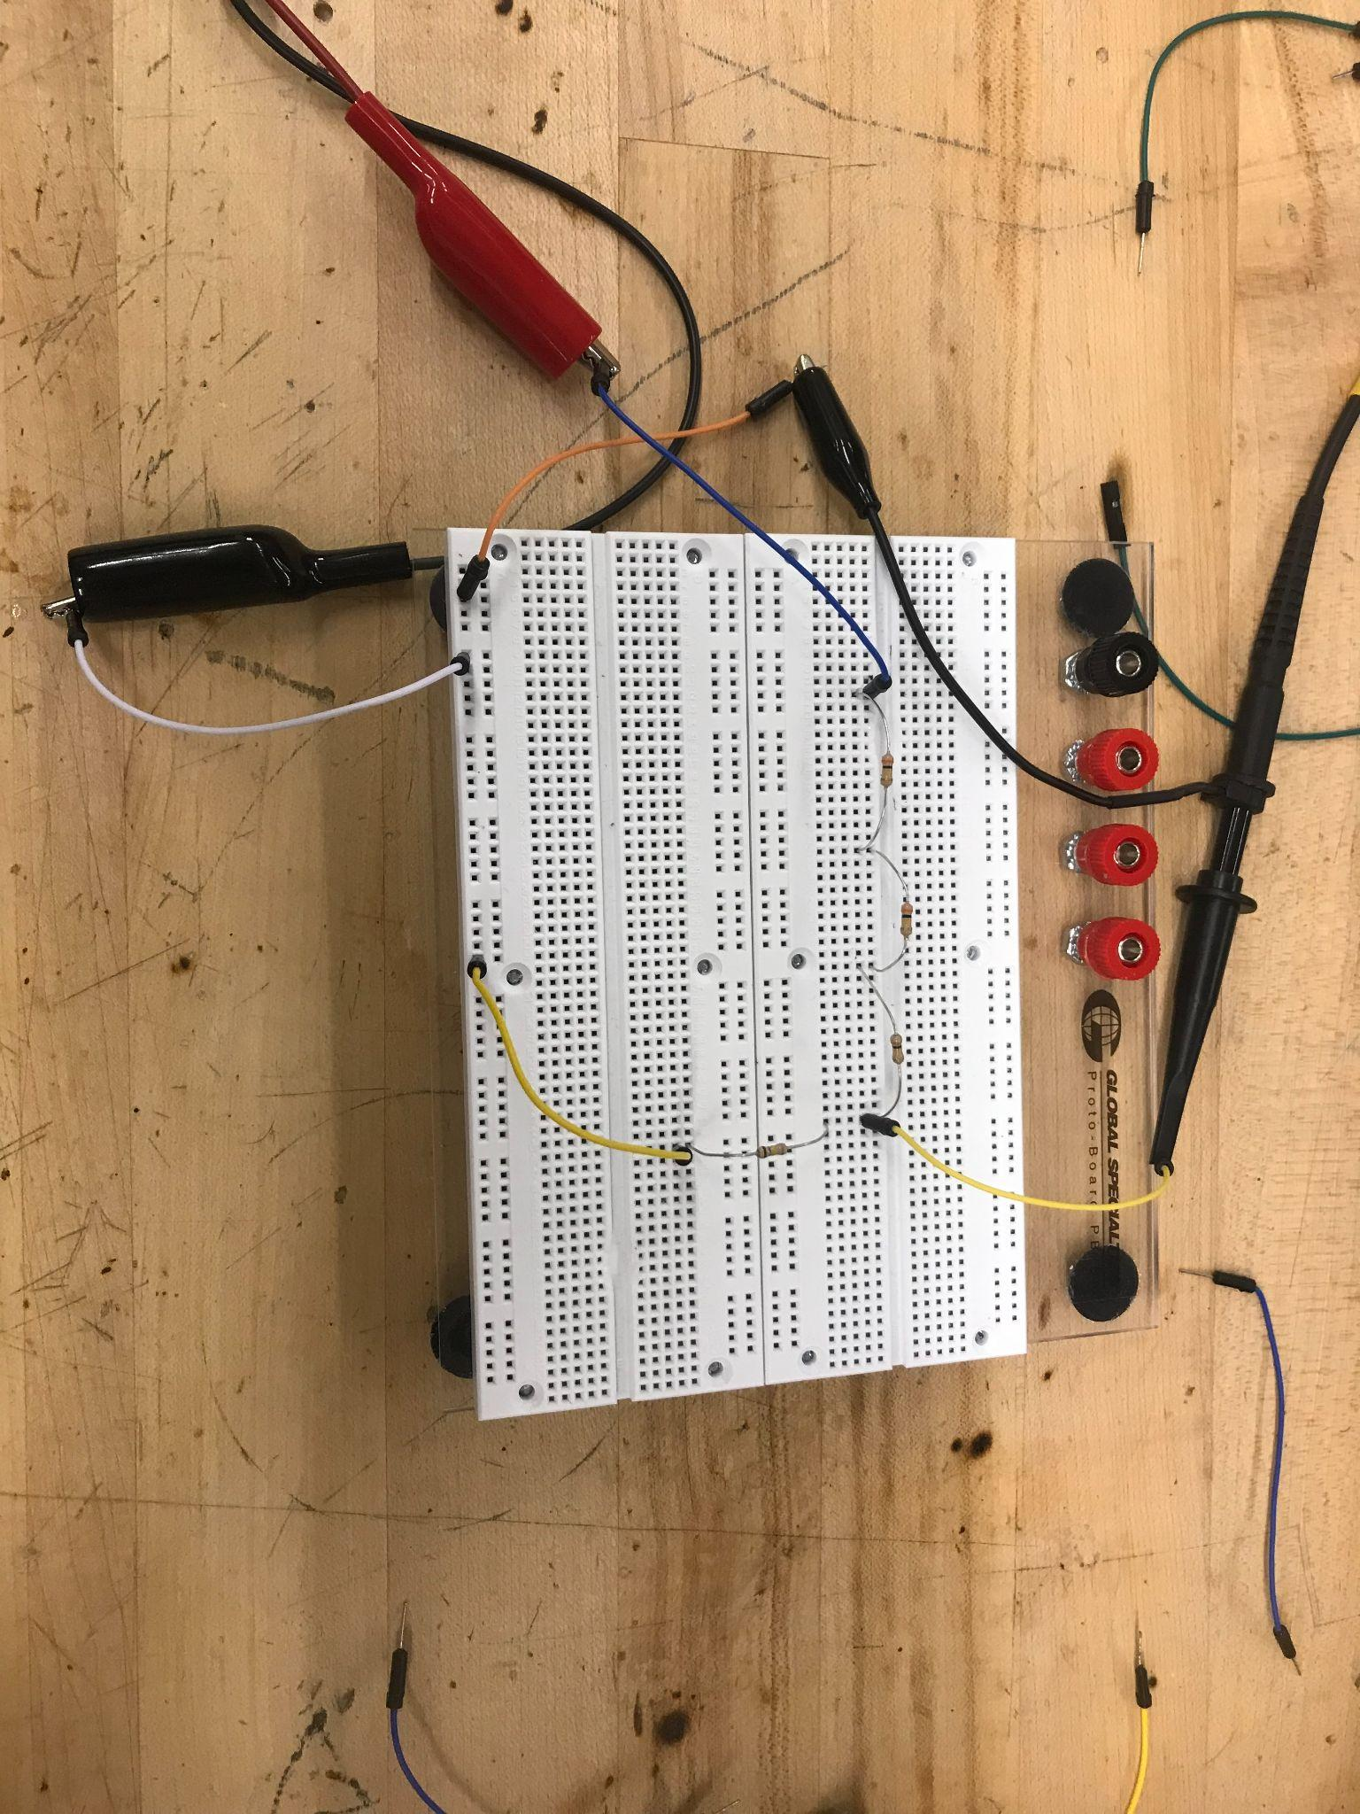
Figure 59: Voltage Divider #1 Breadboard
To show that we would indeed experience a shrinking factor of 10, we returned to the Senior Design Lab and quickly created our own 1:10 voltage divider. We did so by combining three 300Ω resistors in series to be used as the 900Ω resistance for R1 and one 100Ω resistor for R2, with the load of the oscilloscope as the resistive load of the circuit.

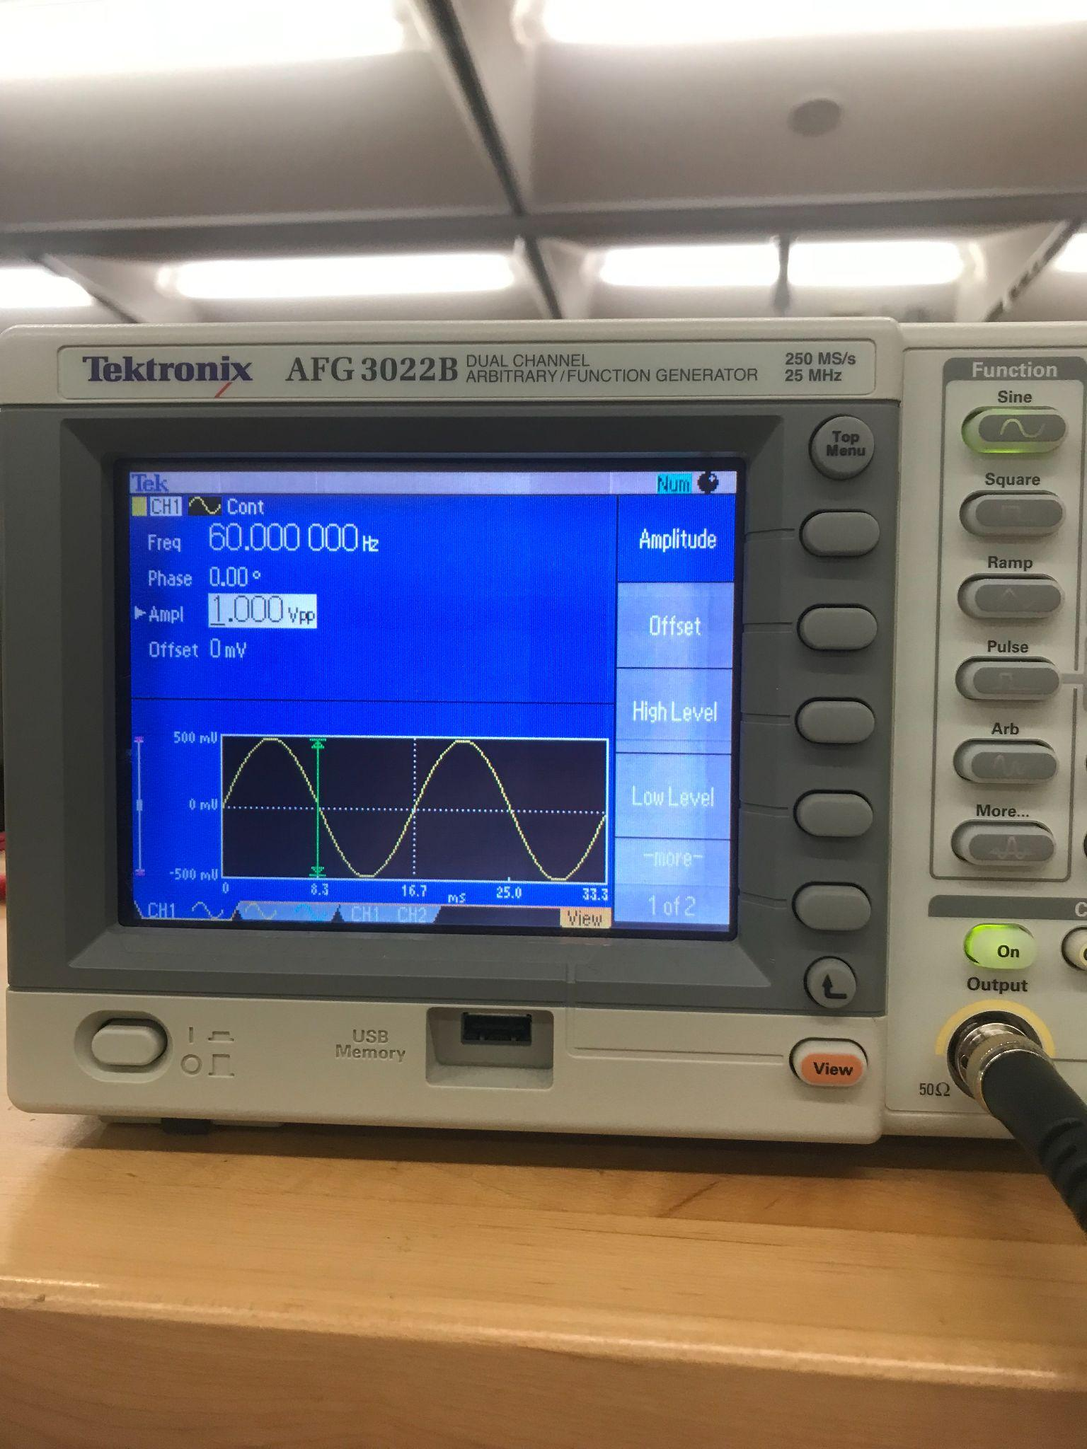
Figure 60: Function Generator 1 Vpp 60 Hz

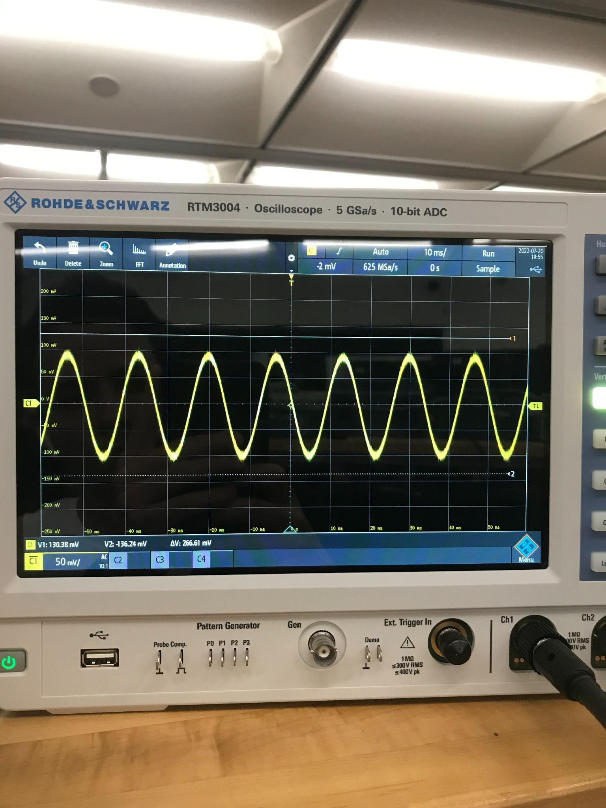
Figure 61: Voltage Divider #1 Output Voltage

With the waveform we observed of a 100 mV peak-to-peak sinusoidal wave, we were able to confirm the ratio between the resistors we discussed in section 5.2.3 did in fact deliver a shrinking ration of 1:10. The next step was to identify if it would be worth it to purchase resistors with higher values of resistance in any case like noise interference or accuracy.

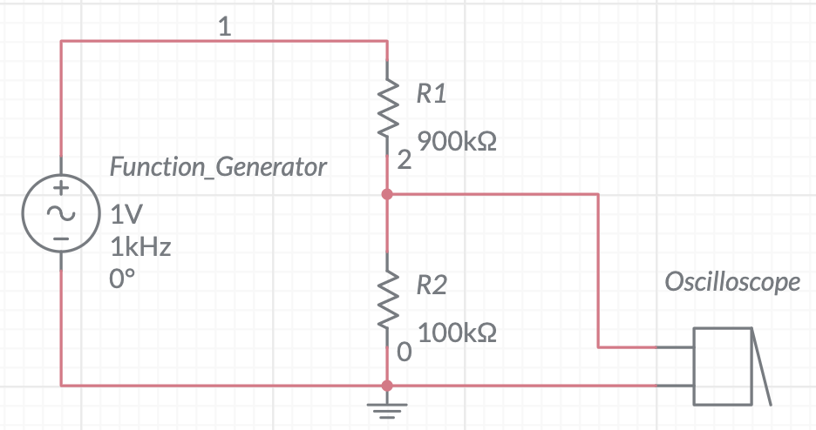
Figure 62: Voltage Divider #2 Circuit Diagram

To test this, we set up the same voltage divider circuit, instead this time with three 300kΩ resistors, in series, to be used as 900kΩ for R1 and one 100kΩ resistor for R2. We kept the same exact input waveform as before (1 Vpp at 60 Hz) and ran the circuit through the oscilloscope to observe the difference, if any. Below are figures showing the circuit diagram of the revised voltage divider in the lab, the physical circuit and the oscilloscope reading we observed, respectively.

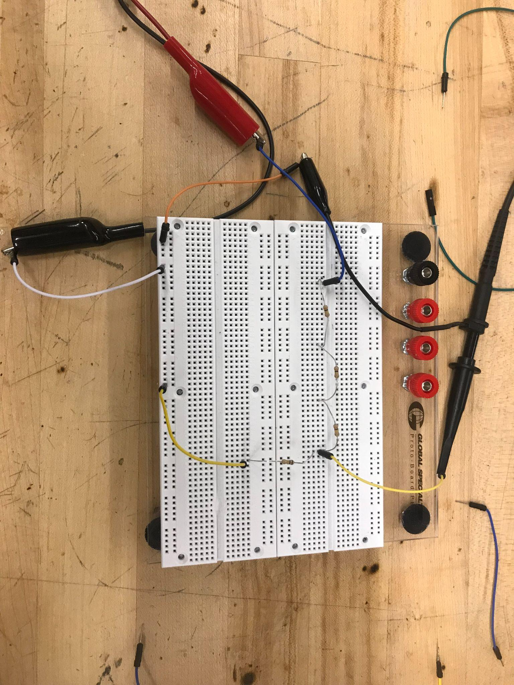
Figure 63: Voltage Divider #2 Breadboard

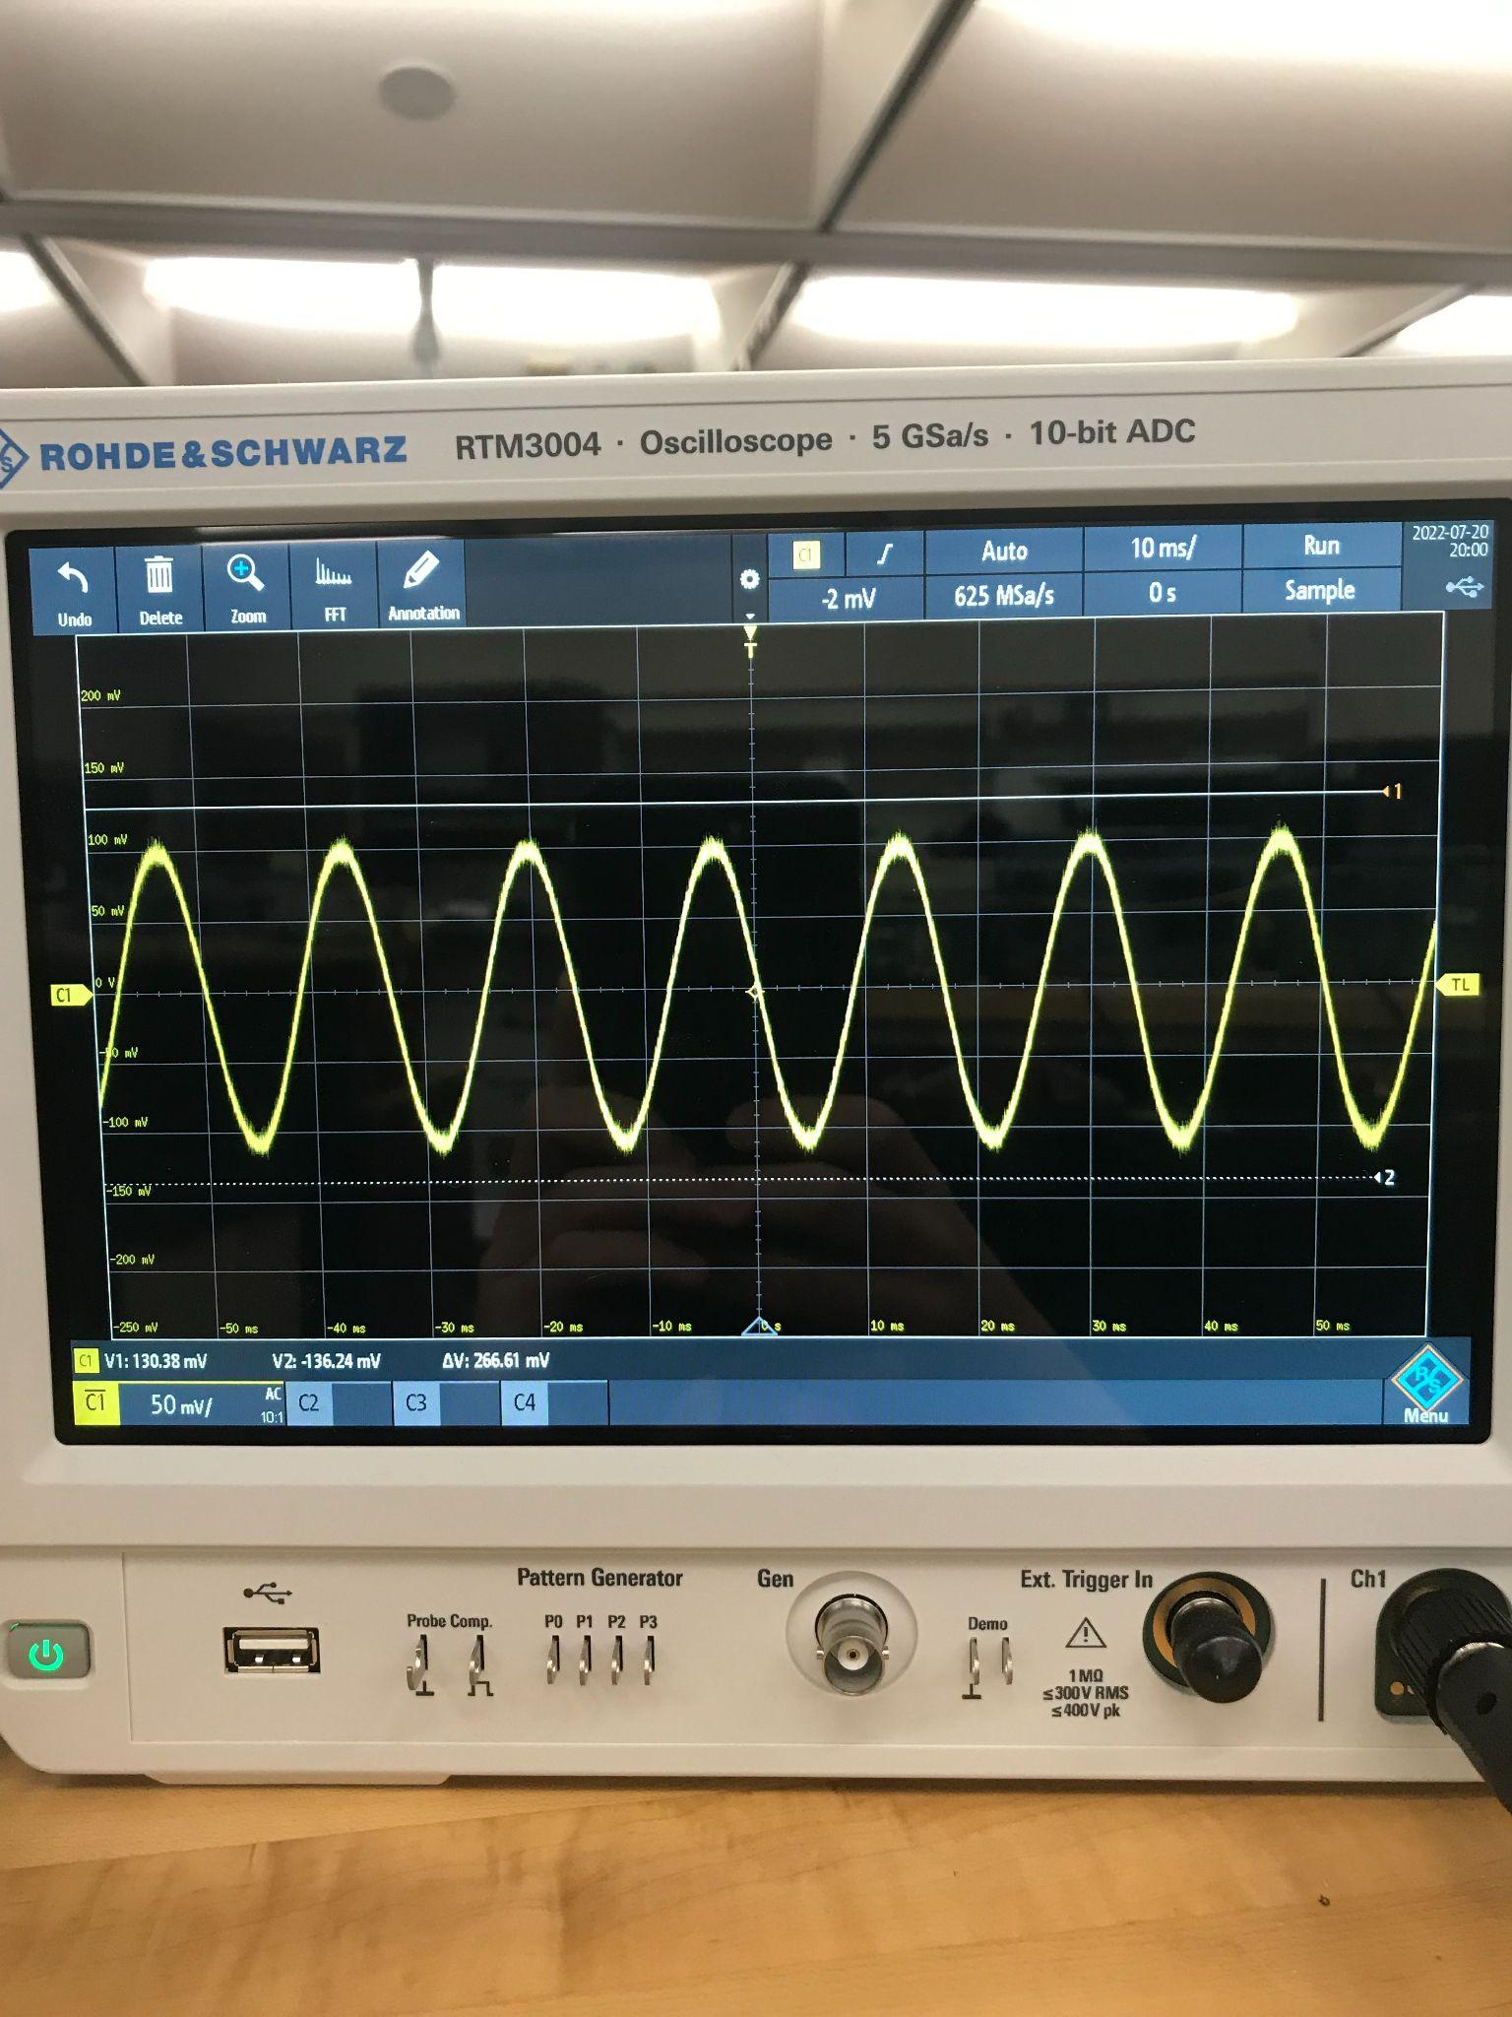
Figure 64: Voltage Divider #2 Output Voltage

From our observations, we were able to conclude that as long as the ratio between the resistors was met, the value of the resistors, whether it be 900Ω or 900kΩ, did not change the output waveform.

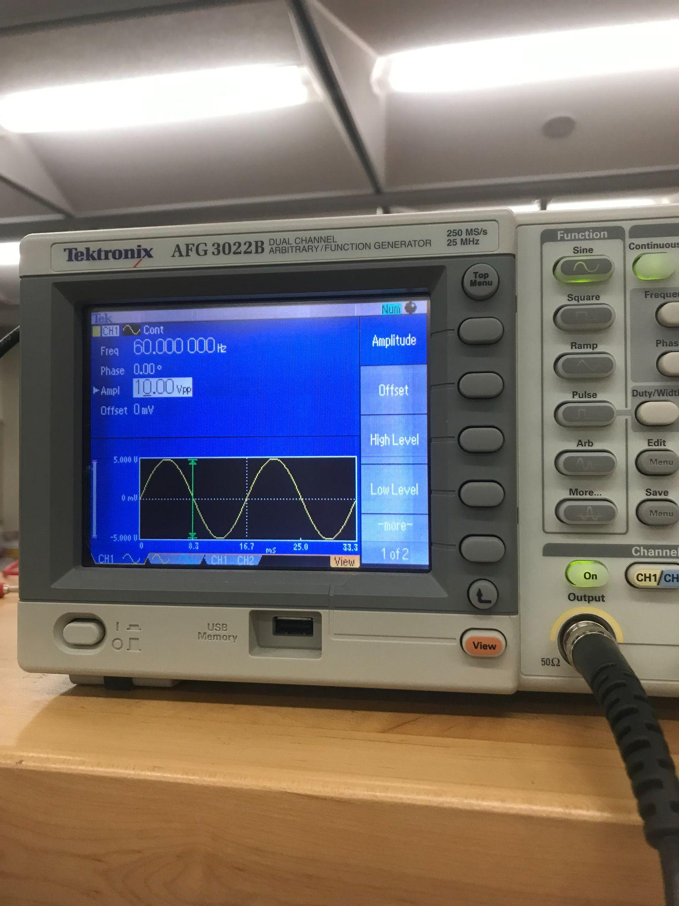
Figure 65: Function Generator 10 Vpp 60 Hz
The final step was to observe if there were any difference in noise when the input voltage was increased to 10 Vpp, as shown in the figure above. Less observable noise would help us determine that a lower ratio between the voltage-divider voltages (around 10:1) would be more accurate in the future than a higher ratio (around 40:1). The argument of a higher ratio was brought up by group members to help save the components from the risk of being overloaded with too much voltage. With a maximum input voltage of 120 Vpp, our voltmeter would need to be able to read up to about 12 Vpp if our voltage divider ratio was only 10:1, but, as shown in the oscilloscope figure below, there is less chance of noise entering the output signal if we keep the output voltage in a sort of “sweet-spot”. We will need to adjust this ratio accordingly, based on the maximum input voltage our microcontroller can read and send without risk of harm to the components.

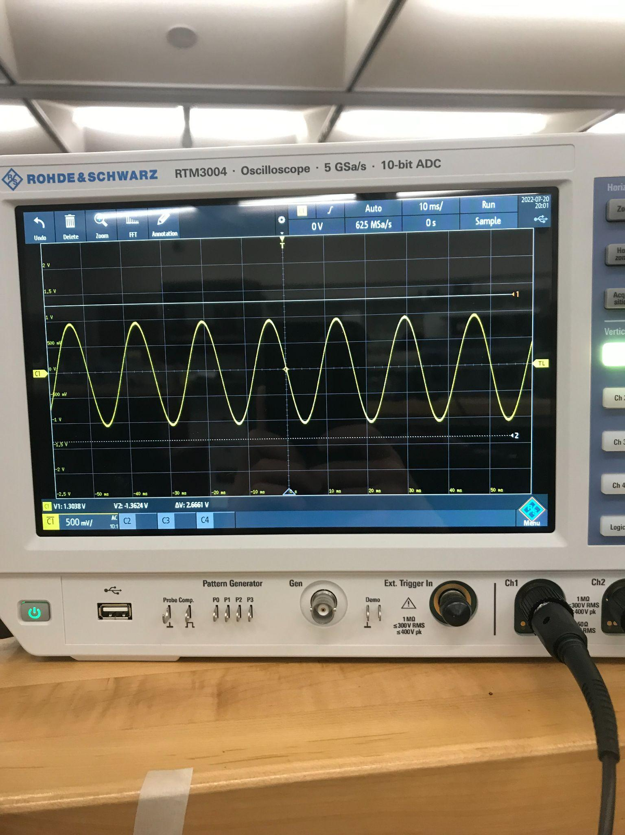
Figure 66: Voltage Divider #2 Output Voltage After 10 Vpp Input Voltage

5.3.6 Powering Arduino Through MicroUSB

We will need to ensure that we can power our arduino through a microUSB that is connected to a DC power source at the end of a microUSB-to-USB cable. To do so, a group member used wire cutters to cut the USB end of the cable off and strip the main wire that holds the smaller wires together (shown below). This exposed a green wire, white wire, red wire and a black wire. With the insides of the microUSB cable now showing, a simple search on the internet pointed out that the white and green color wires are used to send and receive information, while the red and black color wires are used for power. In our case, we would only be using the red and black color wires once our Arduino has all our written code saved to it.
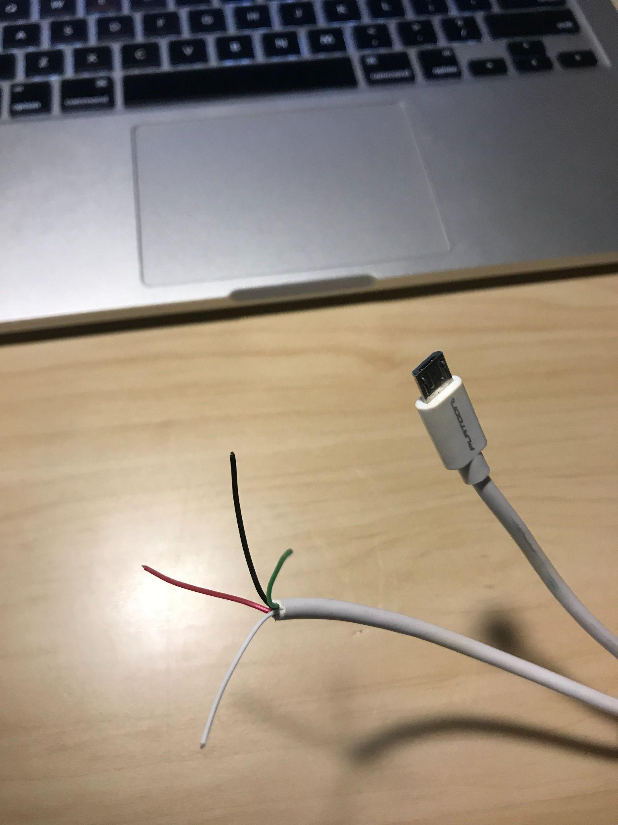
Figure 67: MicroUSB Split Into Four Wires

Once again, we returned to the Senior Design Lab in an attempt to test our theory. We began by setting our DC power supply to 5V and stripped and clamped the wires to the microUDB accordingly. Once the male-plug end of the microUSB was plugged into the Arduino, we turned on the output of the 5V DC power and witnessed the LED of the Arduino (responsible for letting the user know the Arduino is being powered properly) turn bright green as we intended. Below are a few pictures taken of our Senior Design Lab visit, including the DC power supply settings, the test with the DC power supply off and the rest with the DC power supply on to show dependence on the 5V DC power.

Figure 68: DC Power Supply Supplying 5V

As shown in the figure above we set channel 3 of the DC power supply to 5V and there is a current being drawn which means power is going into the Arduino and this is confirmed in the following figures.

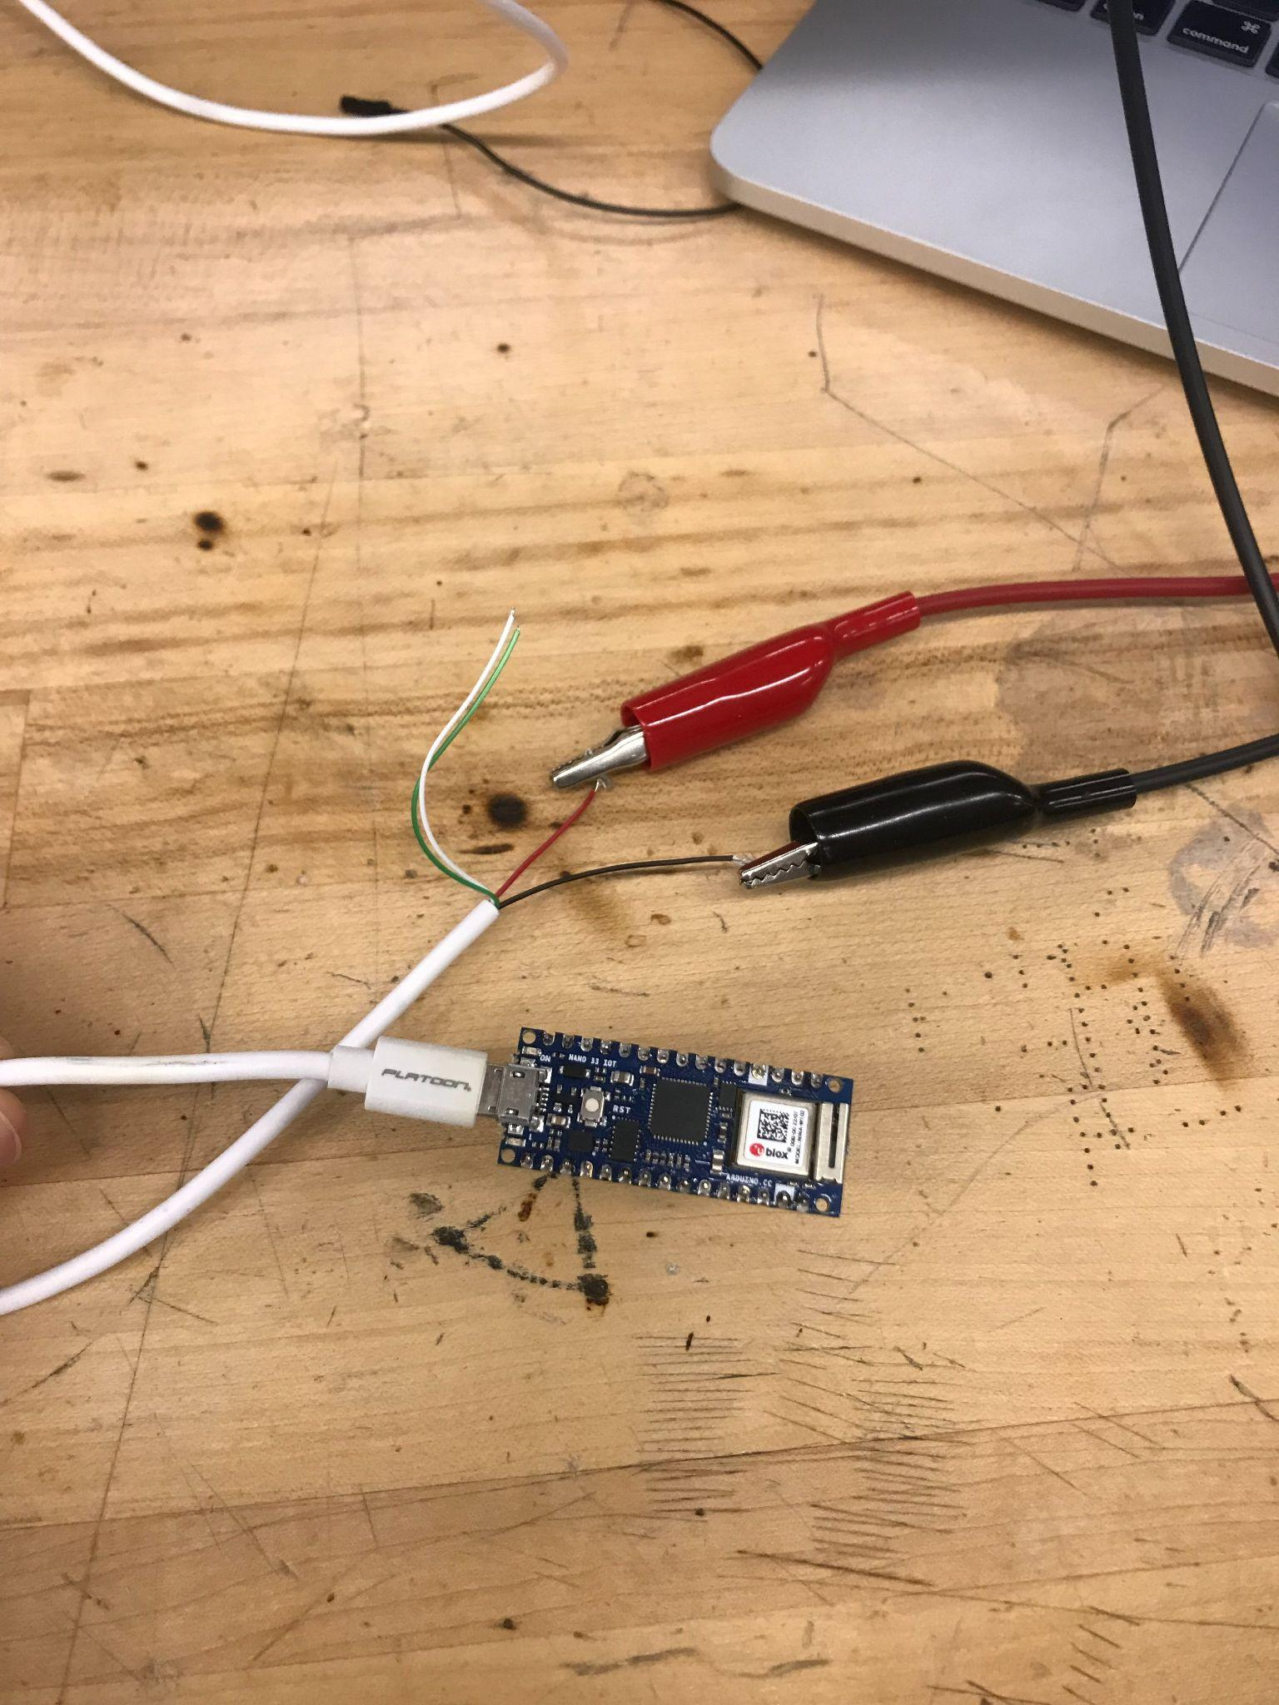
Figure 69: 5V DC Powering MicroUSB OFF

The previous figure shows the arduino in the off state before we applied the 5V from the DC power source to it, we are sure it is off since the power indicator LED on the board is currently off and that LED is permanently set to always to on if there is power and no form of code can override it.
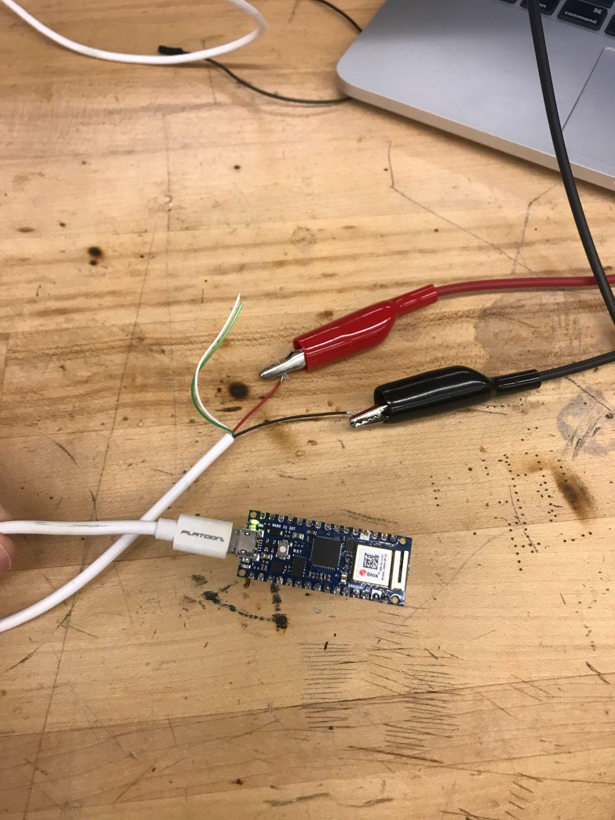
Figure 70: 5V DC Powering MicroUSB ON

We considered this breadboard test completed and successful since as shown above, the power indicator LED is lit when we activate the DC power source meaning we had successfully powered the board from a source other than a computer.

As expected, we were able to power our Arduino Nano 33 through a DC power supply, which we hope will come from our AC/DC power converter when it comes time to create a PCB for our final design. It is also worth mentioning that the source we found on microUSB cables was correct in advising that the green and white color wires from the microUSB do nothing for providing power and instead are used to relay data to and from the device the microUSB is plugged into. The next steps after this test would be to rectify the AC power coming from the wall, rectifying it to DC and then using our voltage divider to make sure that only 5V goes into the micro usb port on the arduino.

Further design in the future saw us use a 120V AC to 5V DC converter to power our microcontroller as well as other components on our PCB. The idea of powering the Arduino Nano 33 IoT was discarded after this step in our design.

5.3.7 Safely Cutting Off Power

We needed to test how abrupt we could introduce power and cut off power to the entire device without causing damage to components. We would also need to test software like the toggle ON/OFF switch and SIMPY’s abrupt “disconnect” feature on the hardware to make sure it could handle multiple ONs and OFFs without damage to circuit components. These sort of tests were done during our Senior Design 2 semester with multiple switching of power on and off through the relays as well as through the master switch to make sure there was no sense of danger or damage during further testing and demonstration videos.

5.3.8 Sending and Receiving Data to and from Hub

We need to confirm that we are able to consistently send and receive data from our Hub in order for our Arduino to communicate with the Hub appropriately. In order to do this we use ARC (Advanced REST Client) a program that is able to send API requests and receive them in a way that we can visually debug and confirm. We tested this with our Specific Amount Read function and our Create function which are the most important for our project. The code for these API requests is shown in section 6.2.1 which explains how the function works. These tests were done with multiple values inputted with the create function to test scenarios of accidental inputs through the arduino or mismatching of data types. The read function was tested with multiple values to gauge the time it takes to receive the table of values depending on the amount of data points requested.

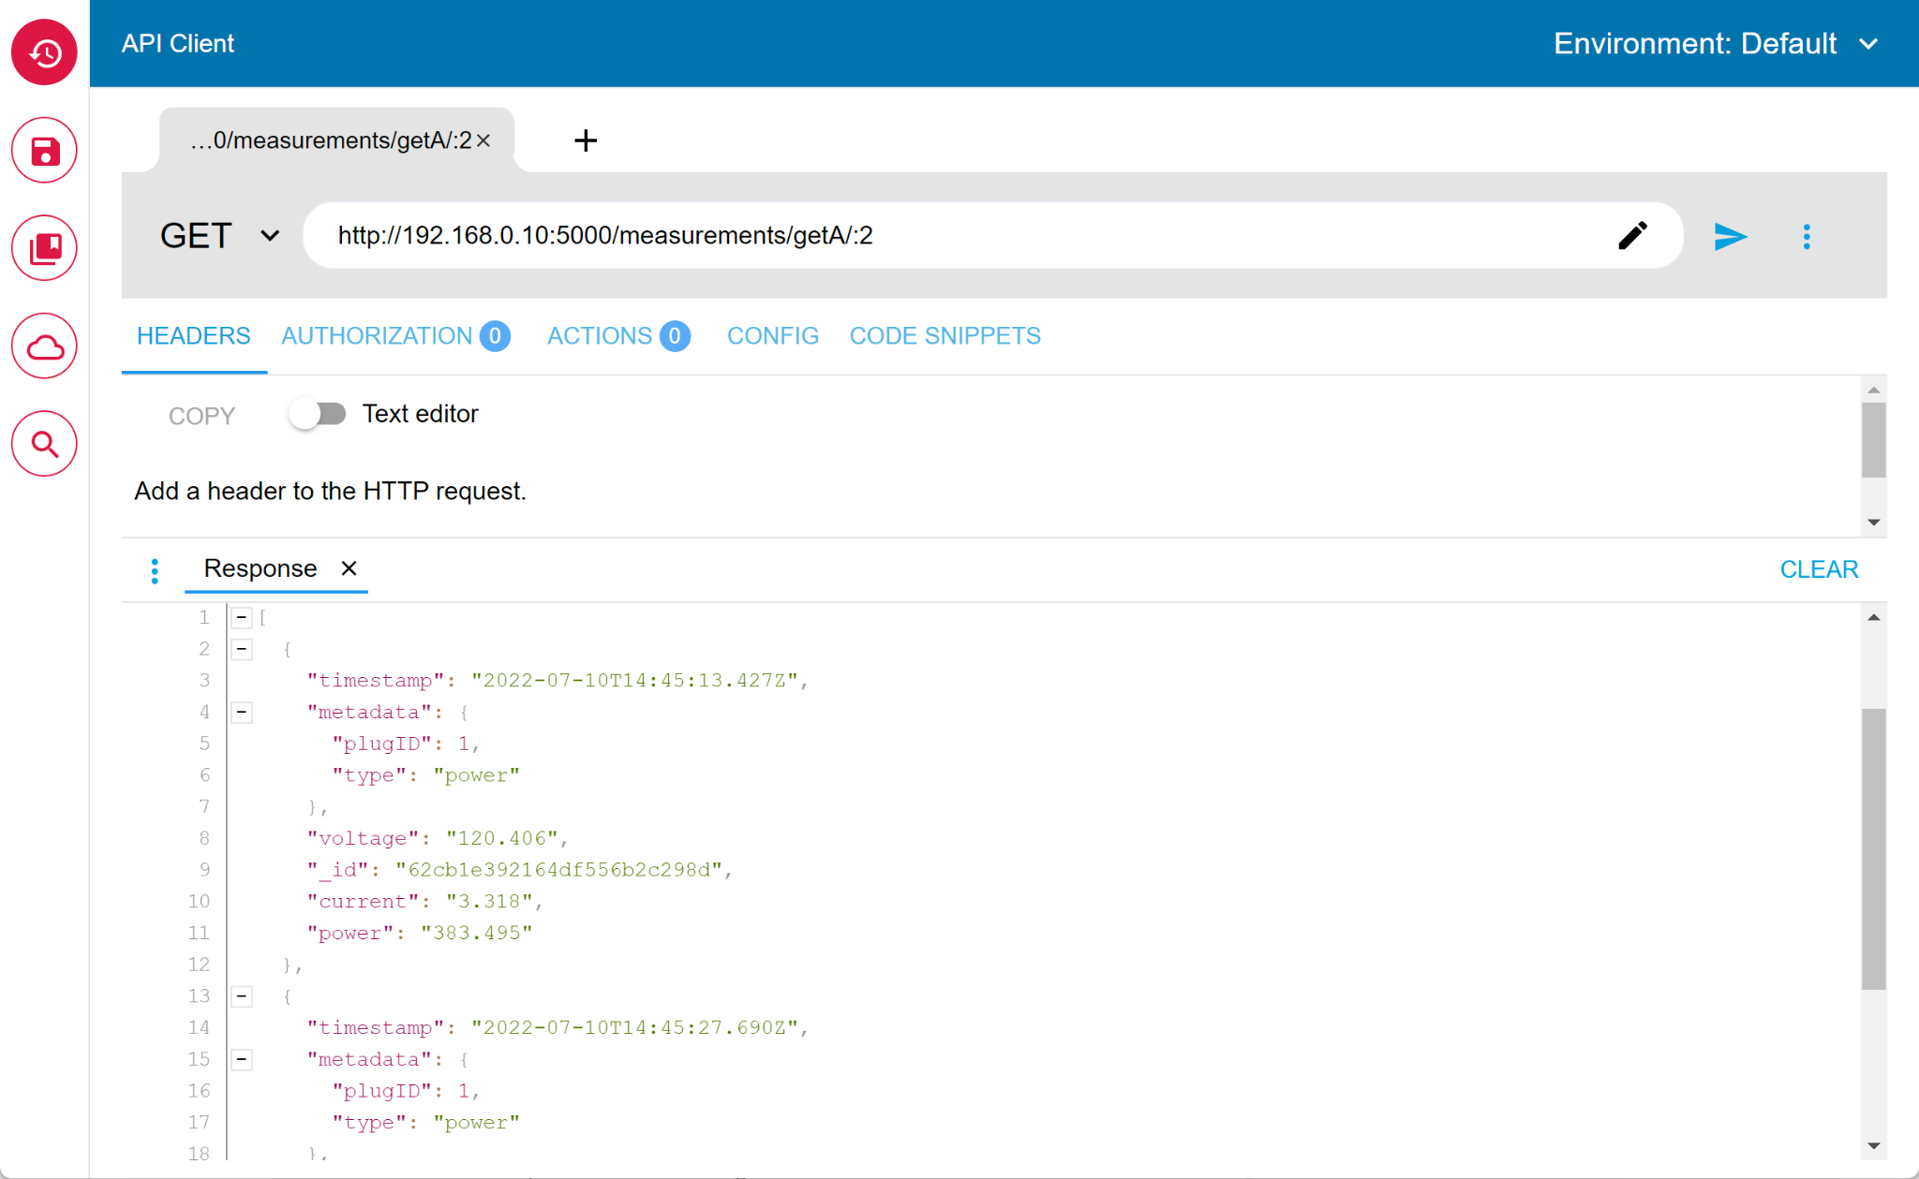
Figure 71: Read API function
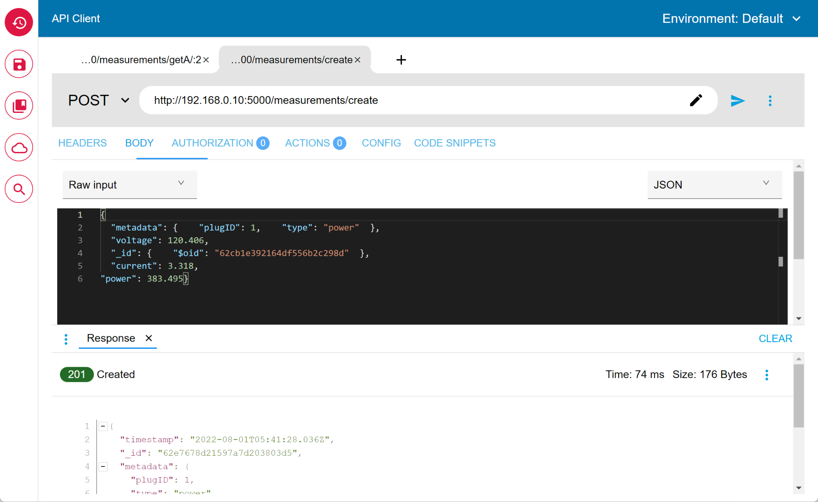
Figure 72: Create API function

A variety of tests will be done in an attempt to perfect the data that is being communicated from the device to the Hub that displays information on the website. Though this is mainly a coding/software test, we could find ourselves not being able to communicate between the Hub and the SIMP as a lack of hardware effectiveness. This “breadboard” test would need to be done during our Senior Design 2 semester, when we have code written for our web server hub where we will send and store all of our data.

5.3.9 Soldering of “VUSB” Pin

The Voltage Common Collector of many of the ammeters and voltmeters is set to 5V which is higher than the 3.3V output pin the Arduino Nano 33 IoT can output, but thankfully the designers of the boards thought ahead about this dilemma and include two jumper pads on the board. These jumper pads are important since one side connects to the VUSB line coming in from the microusb port which delivers 5V and the other pad is connected to an output pin on the board. With the board as it is when it comes out of the box, the 5V pin is unconnected to anything and can not even be used as an input pin. In order to utilize the pin, the jumper pads have to be connected somehow, either with some wire or in our case, we connected the pads by soldering them together via dripping the solder onto the board until it made a connection between the pads. Once the pads were connected we checked to make sure the connection was secure by using a multimeter to measure the voltage between the pin and the ground pin on the Arduino and it read around 5V with some fluctuations with moving the probes due to our hand jitter. We took this reading to mean that we had successfully activated the 5V pin.

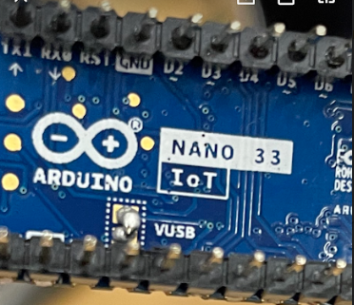
Figure 73: The solder and connected VUSB jumper pads

5.4 Software

The Software is what is responsible for taking the measurements from our sensors and displaying them to the user in a way that can help them better understand their energy consumption habits and how to change them. With the software, we are going to be communicating through different languages between our web server and our device on-site which brings with it some difficulties that can be solved through common back-end APIs that help merge the two platforms so they can communicate without any issues or communication errors.

Once the data is taken on the web server it is stored in the database for archiving and analysis, this allows the user to see their usage over larger periods of time to detect trends themselves or for us to as well. Once this data is stored we can analyze it for patterns of usage and categorize it. Once this is established, we can recommend the user certain strategies to lower their always-on power usage or less usage of certain appliances.

5.4.1 SIMP

Once we have the hardware to measure out current and voltage we need the software to interpret that data and package it to be sent to the server for analysis. This can all be done using the C++ language with the help of REST API library calls that will be the transportation for our payloads. We will also be able to use C++ to implement the shut-off of our switches on the hardware for parental controls and scheduling. We are also able to do some small analysis of the measurements on the device itself that can help with not recording outlier values and give a smoother reading that shows a more accurate value. With this in mind, we would most likely be posting data at a slower rate most likely in the 5-10 second range. While the device should be capable of reading once a second or even multiple times a second, in reality, most people only need the average readings of a device in a real world application. We could have the device send packets every 5 seconds containing the last 5 seconds of recorded data instead to have more samples on the database for more accurate readings but it’s something we have to think about when dealing with our database size as well as processing time when trying to filter so much data.

5.4.2 Web (Front-End)

Once the data is sent off the SIMP, we begin to process it on the main web server where it will be implemented in either Javascript or Python and will sort the data - as well as send it off to the Database for storage and larger analysis later on. This is going to be the largest part of the software design as all the features we have listed will have to go through here as an intermediary to properly have each function work as expected. We will be implementing a simple and informational dashboard (Home Page) for the user to get the most out of their energy uses with items such as Current Usage, Today’s Cost ($), and Power Switches (to quickly turn off devices actively connected to the SIMP). From there, we will have multiple pages to choose from that can help the user in differing ways. The analytic page (Charts Page) will be a dashboard with various data analytics including usage per device, charts to look at data from the past 30 days and compare results/charts from previous months. The insight page (Invest Page?) will suggest changes to the user’s schedule, and time device used to save money and power. This page will also show their money accumulated every month in savings from lower bills and money deficit when the user ends up using more. Another thing we aim to implement is notifications to the user via Email, Text, or right through the web client. These notifications would include a customizable amount of things the user would want to be notified for such as daily use, hourly usage, wrong code input on parental control, device status (Online/Offline), and money spent on power daily or monthly, and more. This could also be achieved with a Newsletter type of email that we generate monthly to the user to show their energy usage in simpler terms that can help them to realize how much they actually spend on electricity daily and how to improve it.

5.4.3 Database and Web APIs (Back-End)

The Data will be stored here for a specific amount of time, most likely 30 days of data for the user to look at in history with a possibility of keeping up to a year of data to help compare to last year's energy usage and new devices possibly added since. The Database structure we will be using is MongoDB which should give us the ease of filtering and finding results fast for the user while being simple for us to interact with. Within MongoDB, we can specify data to be stored in a Time-Series Database. With Time-Series, data points will be taken at a designated point in time (e.g 1 sec., 5 sec., etc) and output to our dataset in the form of an aggregate. Because of this, exporting of data in the form of a graph will be faster and generally minimize storage use of any preset limits defined by our hosting application.
Web APIs will be used to get data from the SIMP as well as send signals to the SIMP to turn off a device. These will be implemented using JavaScript and more specifically ExpressJS for the APIs. We will be mostly using POST and GET API requests on the device to send the JSON payload of the measurements to the database for storage and analysis, switch the device's relays on or off, and configure the status LED on board the SIMP. We may also add some APIs for additional info that may benefit the user like average daily weather for each day the device is monitoring to see correlations to weather and energy use.

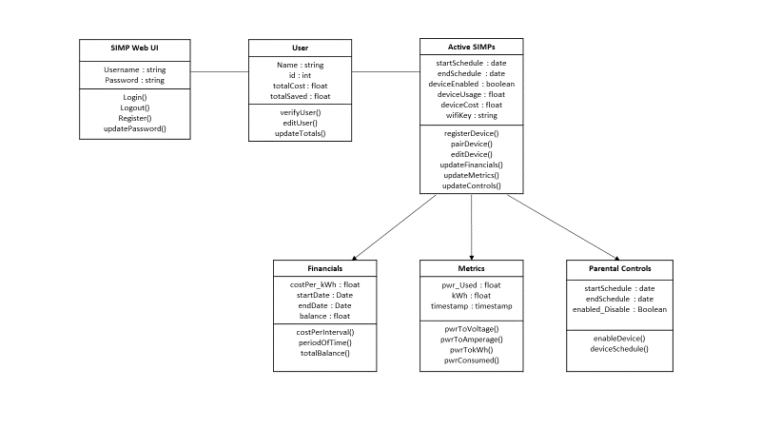
Figure 74: “SIMP” UML Diagram

The UML (Unified Modeling Language) diagram is a class-oriented high-level view of what will make up the functions and characteristics of each component in our database. The diagram gives a broad overview of the general structure and behaviors as they pertain to each aspect of the database. From the diagram above, we can observe the general flow to be as follows:

- User Registers/Logs into Account
- User sees information pertaining to Cost Metrics and Wattage Usage
- User adds a SIMP (Name, Scheduling, Pairing)
  - SIMP Collects Financial Data
  - SIMP Collects Metrics Data
  - SIMP Schedules and Enables Parental Controls

Adhering to and following this general UML Diagram will make for not only a more structured code layout, but for a better understanding of how everything works should any other developer come behind us and try to make sense of what has been completed thus far.

5.4.4 Machine Learning

Machine Learning will be responsible for identifying user devices with a confidence value assigned to it to help identify certain items that may be power-hungry or something that can be powered off when not in use to save money. For this, we will be using TensorFlow as it is a great library for machine learning algorithms. We will most likely be using a convolutional neural network as our algorithm and feed it data that we have either collected online or have personally curated ourselves to help the algorithm correctly predict a device based on certain key values such as power, time of day used, duration of product power-on state, and power pattern. With these values, the algorithm should hopefully be able to guess a large portion of devices in the user's household.

This will require a lot of time to both curate datasets as well as train the model to accurately predict the device connected and currently on. Some of the issues we may face when trying to tackle this challenge is knowing the differences between two similar power draw devices if they were turned on at close enough times. To alleviate this we may use the default name of the plug as the guess for which device in the house turned on. If this was all on one plug we would have to consider power deaggregation which is a very complex algorithm that we don’t want to bring into the scope of this project as that implementation could take as long as the whole project itself with all the complicated variables involved.

5.4.5 Controls

The controls will be responsible for turning off individual outlets of the simp remotely or on a schedule depending on the user's setup for each outlet. Once the user pushes the switch on our web interface, the server sends out a GET request to the Arduino which then triggers the code to send a signal to the relay causing the circuit to toggle power. This API can also be implemented for other features including parental controls, and scheduled switching.

Software Component | Role | Coding Language/Software
SIMP Microcontroller | Measurement | C/C++
Web Application | User Interface | HTTP/JavaScript
Database and Web APIs | Storage and Transport | SQL/PHP/Python
Machine Learning | Analysis | Python
Table 24: Software

5.4.5 Payload
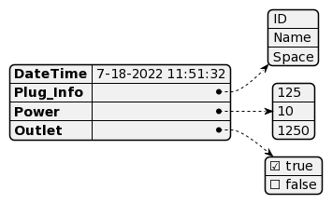
Figure 75: Payload

The Payload is going to be the basis of communication between the database and the SIMP. The Payload structure we will be using is JSON, JavaScript Object Notation, because of its integration with our Javascript web stack as well as its support through our arduino as well through libraries. This structure will provide us the information we want while also giving us the option to scale our information after the fact thanks to mongoDB’s document based storage. These Payloads will carry crucial information such as Date/Time, Voltage, Amperage, Power, and On/Off States of the outlets. The SIMP will have the ability to serialize its own JSON Payloads for sending sensor data to the server and database as well as deserialize JSON Payloads that are sent from the server to turn on and off the outlets remotely.

5.5 Software Components/Flow Charts

Below is a rough draft list of ideal detailed software components we plan to implement assuming we are able to achieve the maximum amount of testing possible in the time we are given. For added clarity, these software components are displayed as flow chart diagrams.

5.5.1 Initial Setup/Wi-Fi Connection

Upon initial startup of the SIMP, a green LED built into the SIMP will illuminate to let the user know it is ready to begin setting up. The user, having already installed the app or opened the website we plan to make for the SIMP, will be shown a device attempting to connect to their Wi-Fi router named something along the lines of “SIMP_397”. Knowing this is the SIMP they had just recently plugged in, the user would take control of the SIMP through the website or app and input their Wi-Fi password through their smartphone or computer keyboard, allowing the SIMP to connect to the internet, and thus completing the Wi-Fi Connectivity section of the startup.

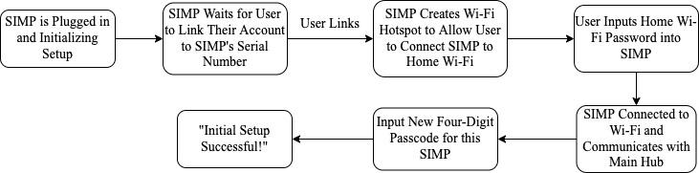
Figure 76: Initial Setup Flow Chart

The next startup section would be the initial passcode set for that specified SIMP. This would be immediately prompted after the Wi-Fi setup with a message explaining a four-digit passcode must be made for simplicity in future access and to minimize the risk of hackers or others within the household gaining access to control of the SIMP.

5.5.2 Parental/Main Controls

Upon opening the parental/main controls section of the main hub, the user will be given three main options or subsections; the option to set or edit the scheduling for the SIMP, the ability to set or change the four-digit passcode, and the ability to control the main ON/OFF power switch to the device that is plugged into the SIMP.

The scheduling subsection will start with a prompt to input the four-digit passcode that was previously set when setting up the SIMP’s initial startup. After successfully inputting the correct passcode, the user will be prompted to choose which SIMP it would like to set the scheduling for, assuming the user has more than one SIMP linked to their account. Finally, the user will be prompted to choose one of two scheduling options. The first of which allows the user to set a start time and an end time on specific days that they would like the SIMP to allow power to the device. The second of which allows the user to set a certain amount of time, in fifteen-minute increments via a scroll-wheel-type of button layout, that they would like the SIMP to allow power to the device per day.

The next subsection allows the user to change their four-digit passcode that allows access to the SIMP account, in the event that the user is worried the current passcode has been compromised by another household member or even a hacker. Opening this component of the software will prompt the user with inputting the current passcode before allowing any changes to it to be made. After inputting the correct current password, the user will be prompted to input a new four-digit passcode. After the user inputs their new passcode, a notification will be sent to the screen that confirms a passcode change.

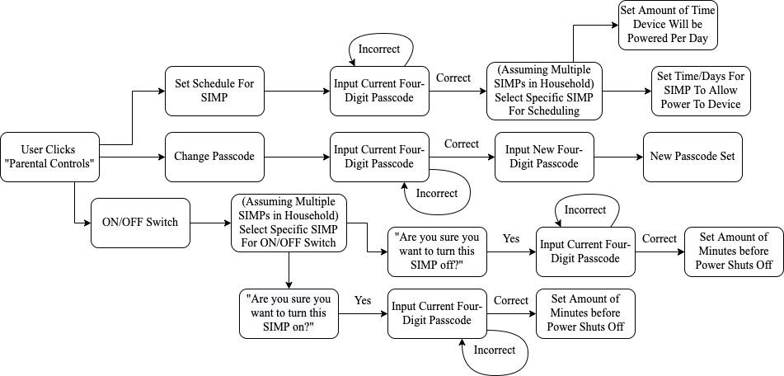
Figure 77: Parental/Main Controls Flow Chart

The final subsection will be the control station for the Master ON/OFF switch. Selecting this subsection will prompt the user with a list of SIMPs linked to the user’s account, where the user will choose which SIMP they’d like to power on or off. If the selected SIMP is on (or off), a question of “Are you sure you would like to turn this SIMP off (or on)?” will be prompted with “Yes” or “No” being the only answers. Answering “Yes” will bring up yet another four-digit passcode prompt. Inputting the correct passcode will allow the user to set a timer before the SIMP restricts power to the device from any amount of minute between one and twenty. This will trigger the warning display on the physical SIMP in which the red and green LEDs alternate to let the user of the device know that they have a limited amount of time before the SIMP cuts off electricity to their device.

This serves as a helpful warning to the secondary user to allow them to save whatever progress they need to save or properly shut down the device before it is abruptly disconnected from power with the potential to lose progress in whatever video game they’re playing or whatever project they might be working on. After the device is shut off, the parent is free to enter the child’s room and say, “Consider yourself grounded,” and leave the room laughing hysterically to themselves.

5.5.3 SIMPY

Probably the most intricate and timely section of our software will be SIMPY; the smart digital assistant provided to the user through owning a SIMP. We plan to have the bulk of SIMPY’s software be notifications that are sent to the user through the main website or hub or app. These notifications will consist of reminders, warnings, tips, etc.

The tips would be SIMPY telling the user different ways they could change their electronics usage to better themselves or save them money on their electricity bill over time. If we have extra time, we could go as far as introducing the efficiency of newer models of appliances and notifying them that something like a newer water heater or washing machine (in these hypothetical situations, the appliances don’t use alternative outlets or plugs) would be more efficient and save them money over time.

When a user first opens the software that controls SIMPY, a prompt will ask the user to set how strict they would like SIMPY to be in terms of power savings from a scale of zero to four. This will vary the number of notifications the user will receive, with “zero” being very lenient and allowing the user to live blissfully and not a single notification from SIMPY, other than that the device has been turned on. “Four”, on the other hand, would be as annoying as possible for those who want to save the maximum amount on their electricity bill. Examples of how the notifications from SIMPY might look are provided in the diagram below:

Shown in the diagram below are some examples of limits SIMPY would add on top of the scheduling software already placed by the user. This part of the software will be void unless the user gives SIMPY access to controlling the ON/OFF functions of the SIMP that cuts off power to the device. Giving SIMPY permission to cut off power to the device will be the best solution for someone who needs to go from spending five hours a day on a device to four down to three and eventually to the minimum amount possible over time. We plan to have him set a schedule that helps the user minimize their electronic usage over a smooth period of weeks.

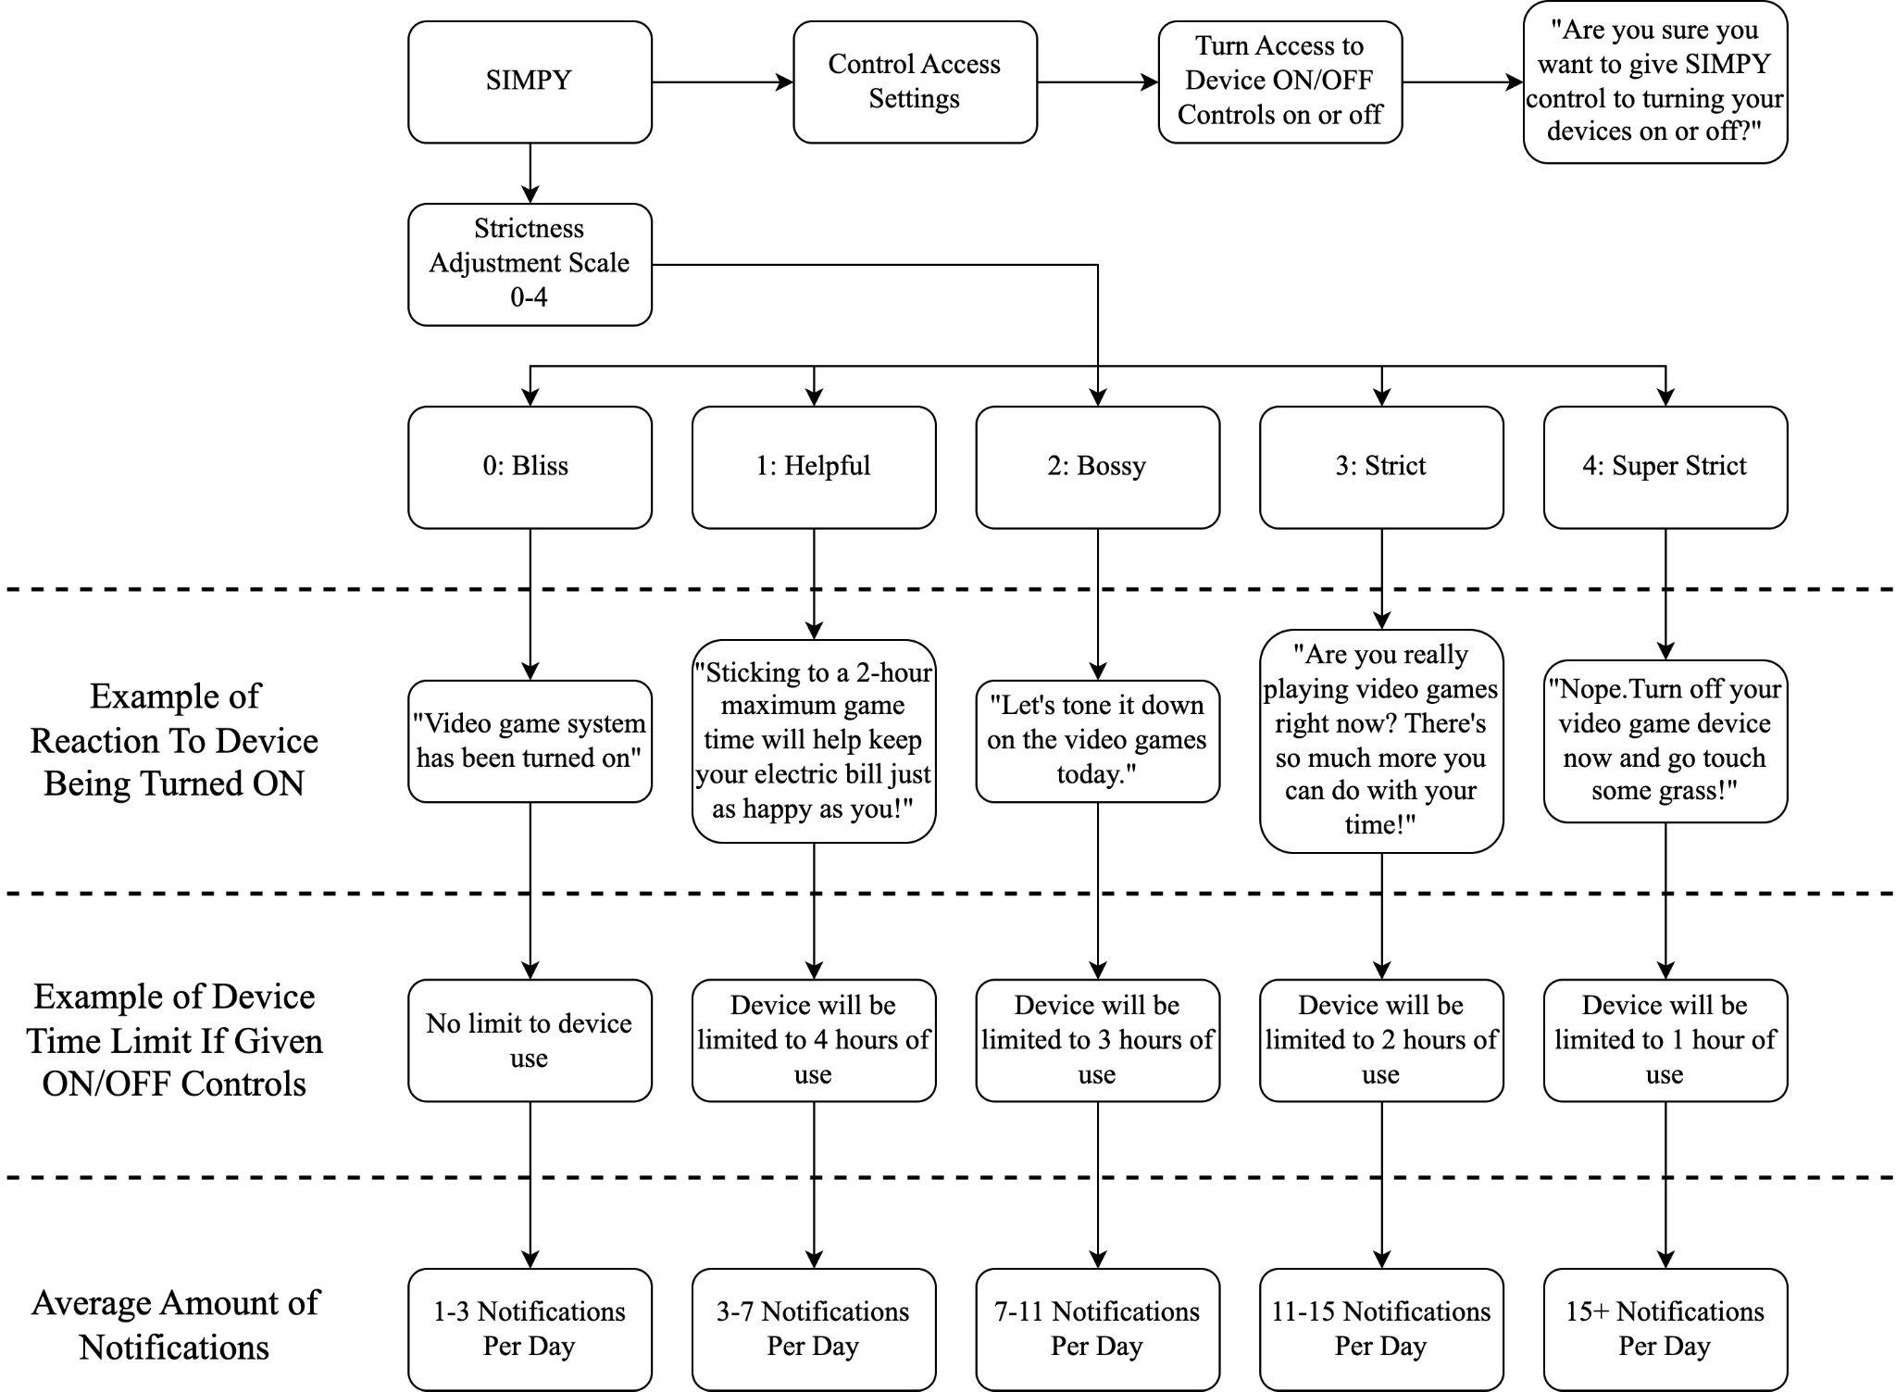
Figure 78: SIMPY Flow Chart

The final characteristic of SIMPY that changes with the adjustment of how strict he will be is the number of notifications per day the user will receive that pertain to tips or reminders. Though this may be adjusted depending on what we observe in our testing, we plan on having the user(s) receive anywhere from one to twenty notifications per day depending on how strict they set the adjustment scale.

We were unable to implement SIMPY into our final demonstration as we found ourselves short on time and therefore included SIMPY in our list of stretch goals.

5.5.4 Activity Monitor

The Activity Monitor section of the software will either be integrated into the home screen of the UI as a list of SIMPs. Each section in the list (assuming multiple SIMPs are active within the household) will contain the name of the SIMP device, the live power draw being measured by that specific SIMP, and how much power has been drawn by the device the SIMP is plugged into throughout the entire day. We plan to have it resemble the same look and integration as the Screen Time software found on Apple products (shown below). Instead of the y-axis being the time the device has spent powered on, it will be a measure of how much power had been used in the time frame indents of the x-axis.

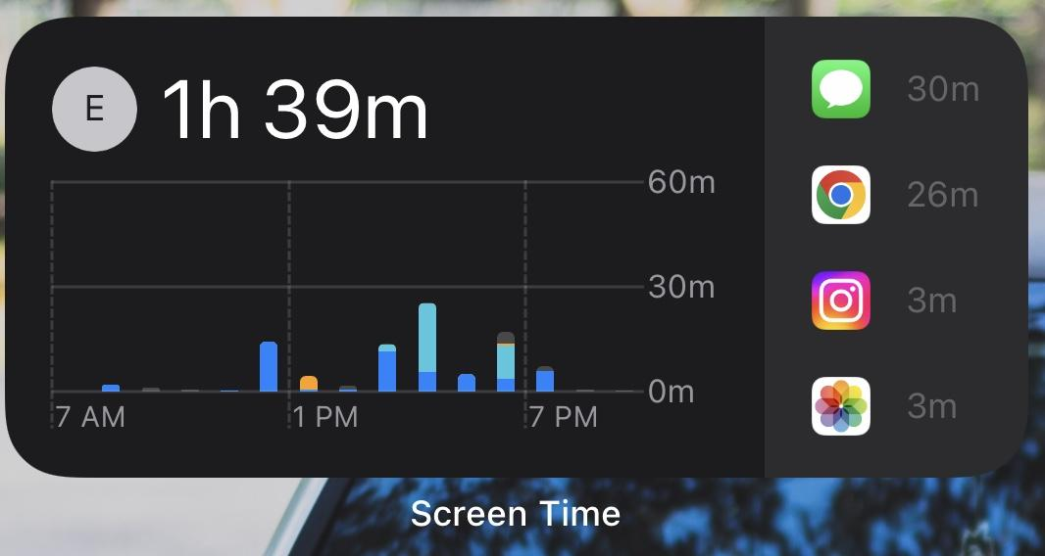
Figure 79: Apple Screen Time #1

Opening the Activity Monitor further will show a more in-depth version of the software on the main hub. With inspiration again drawn from Apple’s Screen Time software, we plan to have it be a bar graph that adds the total power used from each device that is plugged into a SIMP in the household, splitting each piece of each bar into colors that pertain to specific devices. This will help the user realize which device(s) is used more frequently than others once they notice how much larger certain colors of the bar graph are than others.
We also plan to add the ability to toggle between the days of the week to give the user the ability to compare power usage on a day-to-day basis, as well as the average power used per day of that week to further push the user to save electricity by noticing that they were able to use less power some days and have over exceeded their average power usage on other days.

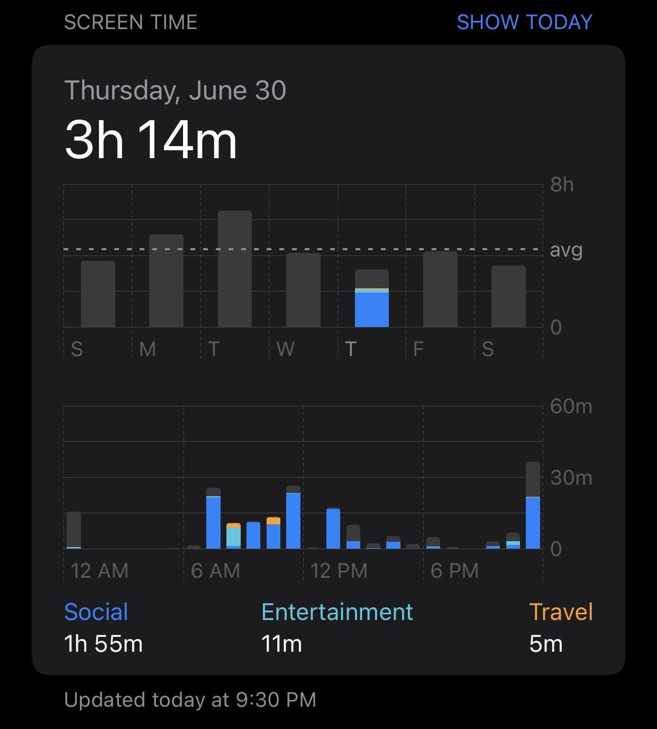
Figure 80: Apple Screen Time #2

If we find ourselves with extra time, a section can be added to the Activity Monitor that allows the user to compare their current week of power usage to previous weeks. Apple also gives this option in their Screen Time software (shown below). We could go as far as writing a program in the software that would convert the power used into dollars than using the difference between two different weeks, it could emphasize the savings in money. This would prove to the user that the longer they have had their SIMP or the more strict they allow SIMPY to be with their devices, the more money they can and will save on their electricity bill.
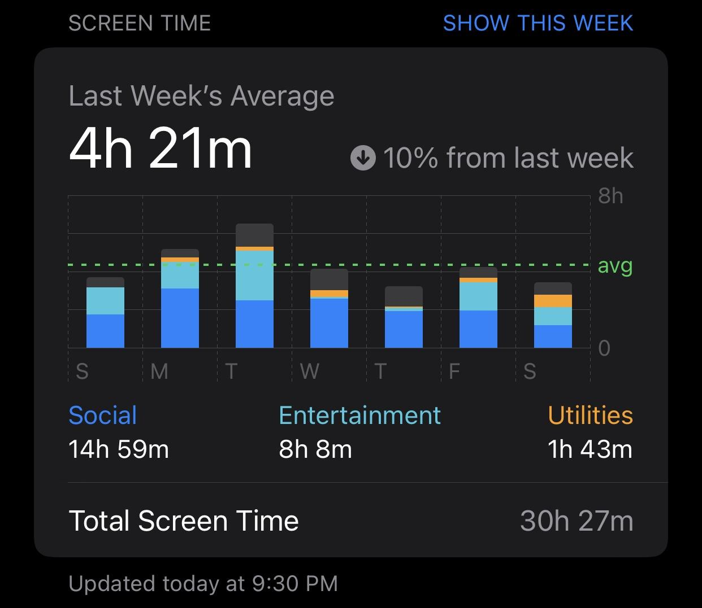
Figure 81: Apple Screen Time #3

Although not exactly 100% correct, due to the fact that the SIMP does not know what the user does after SIMPY tells them to go outside and touch the grass, we could also compare the weeks and have SIMPY send a notification with something along the lines of “you’ve spent three and a half hours less this week on your Xbox than last week, do you feel more energetic and social?”. This can help show the user that during weeks off their devices not only are they saving money but also giving themselves more chances to socialize and be more proactive.

Software Component | Role
Initial Setup | Supports the user in connecting the SIMP to the Hub via Wi-Fi with step-by-step tutorial-like directions and lets the user set up their initial four-digit security PIN.
Table 25: Software Components

Software Component | Role
Parental/Main Controls | - Allows the user to set a new four-digit security PIN.  - Allows setting up schedules for
- Allows setting up schedules for the electrical device to receive and stop receiving electricity, either based on time limits or based on specific time frames.
- Allows the user to shut power to the electrical device off with a timer.
SIMPY | - Choose whether or not to give SIMPY access to the ability to turn the device off.  - Choose the level of strictness you would like SIMPY to treat the user with when it comes to how long they should use the device and how persistent he will be with notifications to get the user off their device.
Activity Monitor | - Shows the user power consumption readings in the form of charts that can be viewed in time-spans of 24-hours, weeks, or even months.  - Shows multiple devices’ power consumption stacked onto eachother in each graph.
Table 25: Software Components (cont.)

5.6 Interface

The Interface is how users will interact with their SIMP, this can include everything from the front-end web design to the hardware buttons on the plug itself. These all hold an important role as we want to give the user the power to visualize their power usage but also not complicate the user with a barrage of graphs and numbers. To do this we need to think on more simpler terms and get people's attention in a way they can recognize … Money.

5.6.1 Software/Website Example

Though the software interface has been mentioned numerous times throughout this report, it is important to have an idea of what the user will actually see and be interacting with. Below is an example of what our main hub/server will look like when the user logs onto the website. From this main page, the user can navigate through all the software previously mentioned in our software components section of the report. The hypothetical landing page below provides an example of what daily use metrics delivered by the SIMP can report to the end-users dashboard including Total Wattage Use, Total Costs, Total Saved, and Individual Consumption of each device.
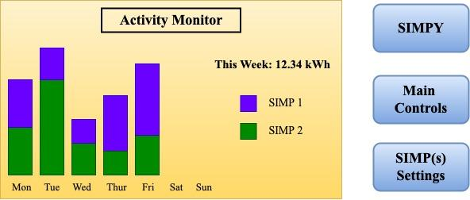
Figure 82: Potential Activity Monitor Sketch

5.6.2 Physical Switch

On the off chance that the software of a production device is stuck in an endless loop or is not working the way it should, there must always be a failsafe in the form of a physical on/off button or reset button. We plan on implementing this idea in our SIMP to allow the device the ability to reset without going into the software or opening the device or unplugging it from the power of the wall outlet. Our reset/on/off button will need to be small enough that it will not add to the overall physical dimensions of the SIMP but will need to be large enough that it can still be found by the user from a quick glance. We also want to deter any idea of using a button that is so small that it would require a tool like a needle that might result in the user accidentally making contact with the electrical outlet and shocking themselves.

5.6.3 LED(s)

The LED(s) on the physical SIMP will be the only line of communication between the SIMP and the user other than the notifications that are sent to the main server hub. We plan on using a single LED that can be made to flash at different rates and is more than one color of light in order to maximize its usefulness. The thought between group members was that if there were more colors and frequencies that the LED could flash on and off at, there would be less stress on the code to have to communicate through a series of single-colored flashes like morse code. Since each outlet will be operating independent of the other there will be one LED for each outlet so that different messages for each outlet can be displayed at once. We could have gone the route of having several LED’s for each different message, but this not only would have increased the size of the overall system to include the wiring of several more components, but also would occupy several of the already limited input/output pins on the microcontroller that could be devoted to what we deemed as more important components such as input pins to receive the ammeter and voltmeter measurements or to be used a control signals for the relays when power to certain devices is scheduled to be shut off. Below is a table of some ideas we’ve conceived for how the SIMP would communicate with the user:

Message Being Delivered | LED Color(s) | Frequency
“Initial Setup; Ready To  Pair To Wi-Fi” | Green | 2 Hz ON/OFF
“Setup Finished & Running” | Green | ON; No Frequency
“10 Minutes Before SIMP Cuts Power To Device; Save Your Progress” | Red/Green | 1 Hz RED/GREEN
“5 Minutes Before SIMP Cuts Power To Device; Save Your Progress” | Red/Green | 2 Hz RED/GREEN
“1 Minute Before SIMP Cuts Power To Device; Save Your Progress” | Red/Green | 4 Hz RED/GREEN
“Error Detected; Check Server Hub For Detailed Message” | Red | ON; No Frequency
“Notification from SIMPY” | Green | Two 8-Hz Flashes Per Second
Table 26: LED Message Code Directory

Like SIMPY, our messaging protocol through the LEDs were put aside in order for us to have a viable device and software for demonstration due to time constraints.

5.7 Design Sketch

A product's design is one of the main reasons as to why any consumer will purchase one product over another. The design of a product has to not only be tailored to a target audience, but also fit within a set of constraints specified by a manufacturer or an engineer. Coming up with ideas of what the SIMP should look like did not come without its own challenges. At face value, we have the liberty to design our product to go as big as we desire, but in retrospect, the typical consumer needs their smart plug to be space efficient and provide adequate flexibility in the event that it's used in hard to reach places.

The problem with most Smart Plugs today is the following: The more functionality a Smart Plug provides, the bigger the enclosure of the plug must be. The bigger the enclosure of the Smart Plug, the less convenient it is to seamlessly incorporate it into someone's corporate setting/home. Its this design challenge we must keep in mind when drafting sketches of what our SIMP will look like post-conception - A product large enough to adequately fit all the components required to operate normally, as well as small enough that it does not inhibit the space requirements most consumers lack in their hard to reach places (where a SIMP may be used). Sections 5.7.1, 5.7.2, and 5.7.3 outline some general sketches of how we can go about designing the enclosure of the SIMP but do not necessarily reflect on what the final product will definitely be.

5.7.1 SIMP Wall Outlet Fixture Sketch

Below (Figure 18) is our first of three sketch ideas we drew up for our SIMP. The idea was to keep the look of a regular wall outlet with only slightly bigger dimensions in hopes of keeping the product looking sleek. We also wish to have the weight of the SIMP kept low enough that the wall outlet could hold it up with ease just from the male outlet ports protruding from the back of the SIMP being plugged in. Our goal is to keep the distance between the front of the SIMP and the wall outlet as small as possible without sacrificing any functionality. The previously mentioned reset button would be on the bottom of this particular design sketch. Since this is a design sketch and is in no way final, alterations could be made in the future regarding how many male plugs would be needed for power or rigidity, as well as how many female sockets could be implemented without costing the final product an increase in size.
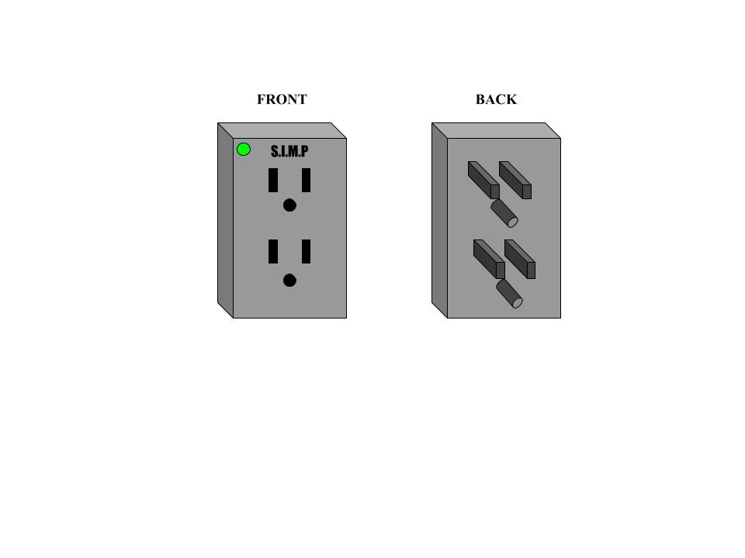
Figure 83: S.I.M.P. Wall Outlet Fixture Sketch

5.7.2 SIMP Block

Below (Figure 19) is our second sketch idea. This design was thought up as a safety net with the fear that the physical dimensions that we planned for are exceeded, due either to component dimensions or PCB design dimensions. Our thought behind this safety net was that it would be easier to hide a box that resembles that of a power-surge box than to 1.) have the entirety of the box look as if it is sticking out of the wall of the user’s room and 2.) hope and pray that the outlet would hold that box without any chance of it disconnecting on its own due to weight limits. The reset button, in this particular design, would be on the opposite side of the female electric outlet port of the SIMP. Because this is indeed a rough sketch, alterations could be made in the future regarding how many female sockets could be implemented to the block (two instead of one).
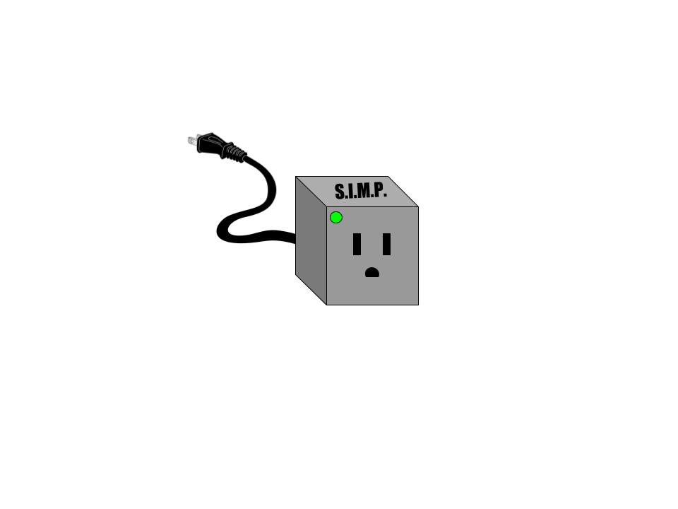
Figure 84: S.I.M.P. Block Sketch

5.7.3 SIMP Extension Cord Brick

And because no idea can have too many safety nets for design, we thought of a third sketch, shown below (Figure 20). This design sketch was thought to be, by the group members, the most pleasing to the naked eye, as it resembles something the average person is all too familiar with; a charging brick for a laptop.
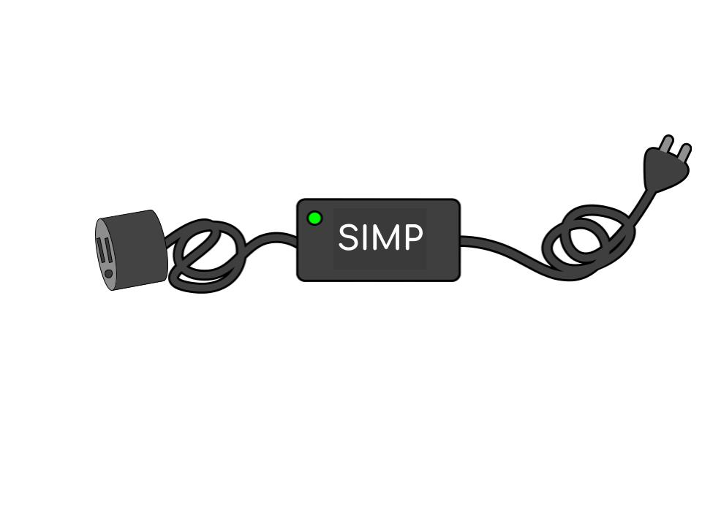
Figure 85: S.I.M.P. Extension Cord Brick Sketch

The advantage of this design over the others would be the obvious length and the fact that it could act as an extension cord as well as keep the functionality of a SIMP from the designs above. The only downside to this design would be the limit on female electrical outlet ports. This could be alleviated by incorporating multiple female outlets similar to a 6 port power strip the only issue with this would be implementing a power rail system for all the ports to share power off of to keep the design slim and not awkwardly shaped.

Sketch Name | Size | # of Male Plugs | # of Female Plugs | Probability of Being Final Product
Wall Outlet Fixture | 5 x 5 x 3 inches | 2 | 2 | 60%
Block | 6 x 6 x 6 inches  + Length of Electrical Cord | 1 | 2 | 35%
Extension Cord Brick | 5 x 5 x 3 inches  + Length of Electrical Cord | 1 | 1 | 5%
Table 27: SIMP Design Sketch Comparison

Due to complications with the wall outlet fixture attempts, we fell back on our safety-net of the SIMP block, which consisted of a block that had a cord protruding from it that would be plugged into the wall. This allowed us to simply place the final design on the ground instead of having to find a way to suspend the complete design and all of its weight onto a single male electrical plug.

6. Overall Integration

Any design or project implementation does not come without many milestones and mishaps prior to its realization. It's only through the efforts of rigorous research and testing that engineers are able to manufacture something from scratch that will work reliably post conception and into its daily use. In the development of the SIMP, we realize that multiple components will need to be selected with the intent to seamlessly integrate them with one another, and ensure that no bugs or quirks trickle down to the end product as a result. In the following sections, we will describe how we plan to go about integrating hardware components with key functionalities, as well as ensuring the appropriate manipulation of the SIMPs core utilities via an interactive and responsive User Interface. We will also go on to explain how general components of our product will plan to be tested and enhanced via a series of general system tests and operations. Doing so will guide us and ultimately produce a product capable of all the general functionalities described in our specification and constraints.

6.1 Hardware Setup and Operation

Once the SIMP is constructed, the physical setup for the system should be as easy as any other smart outlet out on the market. All the user will have to do is plug the SIMP into any outlet and start the pairing process using the WPS button to connect the device to their router and subsequently the internet. Once the device is connected to the internet the user can find their device on their local network and link it to their account, they can start controlling the device and reading power usage. If the user wants to not allow power to a certain outlet without having to access the webpage they could set the switch by the outlet in question to the “off” position in which the LED by the outlet will turn red, indicating power has in fact turned off for the outlet. If there ever is an error with the user’s SIMP they can look at the LEDs on the device to see what error codes light up to help solve the solution faster, this would include Network issues, Power issues, Hardware Issues, and Overcurrent Protection. Another LED indicator would be for the parental controls which will blink the LEDS in rapid succession in order to indicate that the outlet is going to turn off soon and they should safely power down anything that is currently being used before it will be abruptly shut off. While the LED is going off a Sound can emanate from the switch to indicate to the user that the switch has lost power or is about to turn off for parental controls in the case that the SIMP is behind a wall and the LED can not be seen.

6.2 Software Setup and Operation

As we aim to develop key system functionalities and an easy to interpret User Interface, we will need to start formulating and understanding how much of the back-end and front-end processes will work. Database processes and API’s (Application Programming Interface) will be necessary to store user data and interact with front-end applications. HTML and scripts will be necessary for updating front-end applications and calling upon the back-end for pertinent data as necessary. In section 6.2, we will go on to describe how we anticipate much of the front-end to perform from the user side experience as well as how database management and general back-end processes will be situated - as well as how much the back-end of the SIMP project has been developed up unto the completion of this engineering report.

6.2.1 SIMP’s Frontend

Once the SIMP is powered from the Outlet the setup process can begin, the LED can begin to blink in a specific pattern to show that it’s ready to pair. This is when the user will download the Application to pair the device to their account and their Wi-Fi network. Once installed it will prompt the user to create an account to access their devices after setup either in-home or remotely, they will be asked for an E-Mail, Username, and Password to be stored in our database. Once registered, the application will ask to connect to the SIMP via Bluetooth as a fast safe means of entering their Wi-Fi Network info to be stored on the SIMP for re-connects whenever the device loses power or the network is down. Once the user enters their Wi-Fi network it will prompt the user to disconnect to the SIMP and redirect them to the Device Setup page with their new plug showing current readings and Custom prompts to identify the plug to the user. These will help the user identify which of their plugs is costing them the most power if they have multiple or just know their device's actual power draw.

Once this has been finished they will be redirected to the Dashboard to get a full view of their current data from multiple switches. If they want to set up parental controls or scheduling they can go to another page which will allow them to set up a parental code for the account, as well as scheduling or time limits for the switches power on time. This will let the parents keep their kids from staying on their systems for too long, or have lights out after 8PM. With the parental code their child can still access the account to view how much time they have left in the day but are not allowed to change any of those time limits or schedules. This helps kids plan out accordingly how they want to spend their day with the limited time they have.

To begin establishing at least some general basis by which to design our web-application around, we have started by creating the most basic form of a login page. To do so, we created simple headers, encapsulated the majority of our general div components in css and output our preliminary general web design to the chrome web application. The username and password fields within the login page will be used to collect information pertinent to user identification and be used to call back to our MongoDB and search for an identical match before moving forward to that registered users dashboard containing all their stored information and devices. Below the “Login” button is a href assignment linked to the description “Sign Up.” Clicking the “Sign Up” reference will alter the Login page to enable a new user the ability to input their personal information and register with a dedicated link. Upon verifying the registration link, the user will now be set up to login to their dashboard like normal and a SIMP device as anticipated. Logging into the dashboard should also display many user metrics pertaining to their SIMP as well as provide some form of an interactive graph for the user to better understand the consumption of power and currency relating to any one (or all) device pertaining to the user's account.

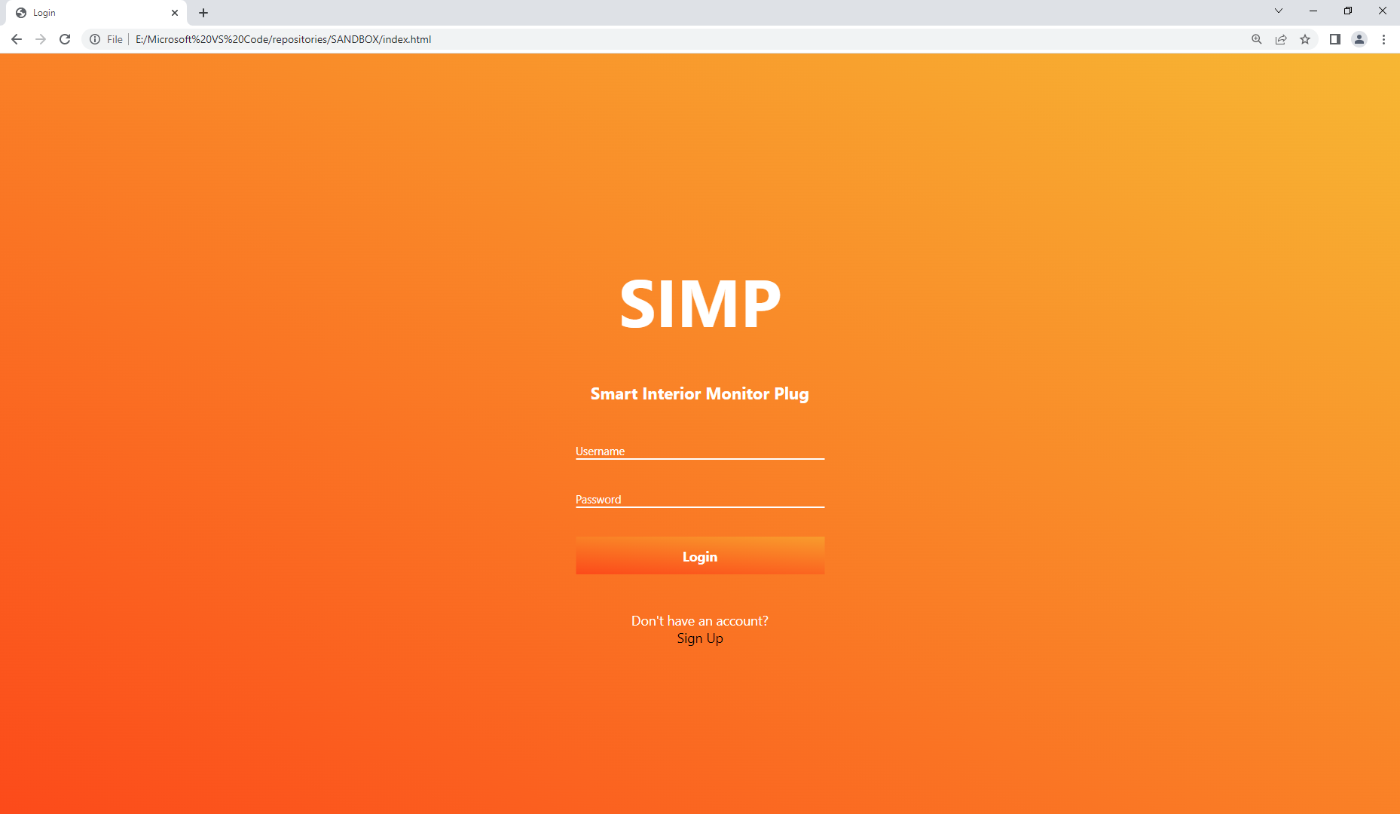
Figure 86: SIMP Login Page

The chart below is an example of what the user will see upon logging into their dashboard. The information used to populate the data points necessary to build this chart was done so by reverse engineering a Smart Plug built by TPLink and importing each individual measurement taken at a 5 second interval into our chart. The chart shows the values of the Power (Watt), Voltage (V), and Current (Ampere) all over a time period. The voltage is staying constant around 120 Volts while the current changes over time with usage. It’s hard to see the current changing in this graph due to the scaling of all 3 the values but it does change with a variance of around 0.2 Amps. Doing this provided us with a general layout by which we can design our chart before actually waiting on the final production of our SIMP to begin our most basic front-end programming of scripts and functionalities.

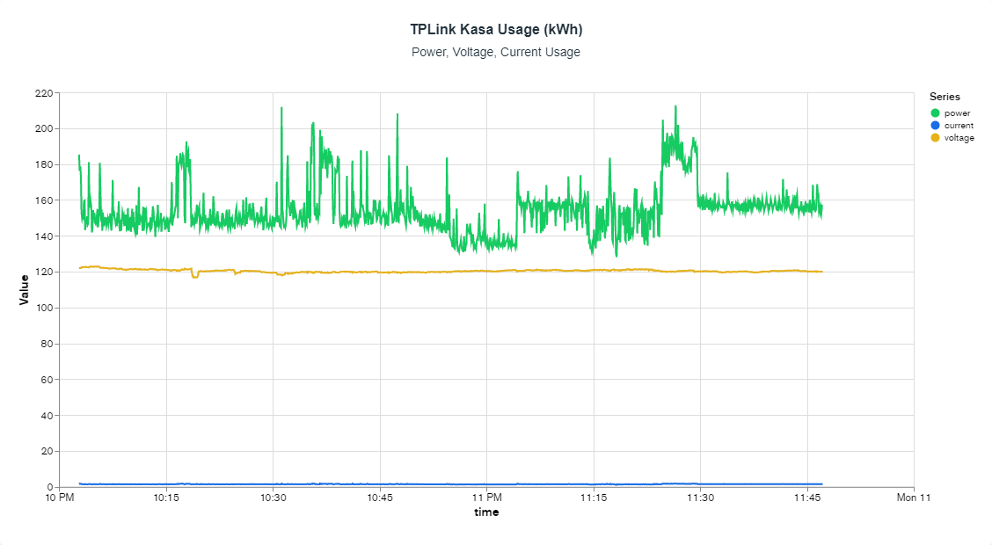
Figure 87: TPLink Kasa Smart Plug Sample Data Chart

The figure below is a preliminary mock-up of how we anticipate a users dashboard to look upon logging into the SIMP Web Application. The most basic display will contain some general form of Total Costs and Total Wattage used this month - or whatever set interval pre-determined by the end user. The dashboard will also contain some form of a chart (as seen in the last figure) that will tabulate and equate usage metrics being pumped into the SIMP’s database from individual SIMP’s or overall coming from each device. There will be an option to import a new SIMP device, where the user will interact with their device to enable it network access and eventually link itself to a customer account via the SIMP UI, and, upon adding devices, the user will be able to see all their currently added devices and perform device-specific functions simply by clicking the device - such as turning the device on or off, or creating a schedule by which the device should adhere to.

As time progresses, we anticipate making alterations to the general mock-up and where/how specific items are placed on the web page. Our team will look to add more features and better design components as time permits and according to the input of those we plan to test our product with. Not only do we want to create a device that serves the purpose of device manipulation, but also create an engaging experience for any customer or stakeholder of our product when they eventually plan to do so. Creating an interactive web page that is both conducive to what we are doing, as well as simple to navigate for any end user, is at the core of any front-end designer's list of goals when outlining and creating their web/mobile application. Not putting in adequate timing and preparation in the planning phase will not only cost major setbacks in time but also lead to loss in funding and revenue from loss of clientele and the general addition of labor hours required by our front-end software engineers.

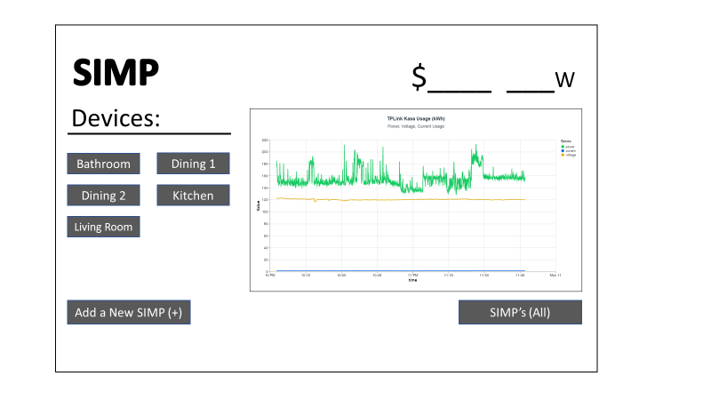
Figure 88: SIMP Sample User Dashboard

6.2.2 SIMP’s Backend

The backend is what will communicate with the frontend interface and the database to display and record data that is being stored on MongoDB. For the APIs we used Express.js to create the REST API calls for the SIMP and Web Server to communicate to the Database. In order to know what the requests are creating and reading we had to develop a schema for the payloads to follow as well as connect the API to the database, the schema is responsible for giving a description of the database structure along with pointing the api to the right collection within the database. Once we have a schema we can then make CRUD (Create, Read, Update, and Delete) API operations.

The read is the easiest of the operations as it only requires a simple GET request to be sent to the server and it will then send all of the values from the database. This API is the basis of all our data analysis and data visualization as we want to visualize all the data points from a given user. This is not as ideal though in certain scenarios as with enough data points the database could be big enough in size to cause slowdowns, for this we have another GET request that can request a specific amount of recent data points which can help speed up the users frontend experience. The code below shows the GET API request done in Javascript using Express.js, our current library for creating API requests easily.
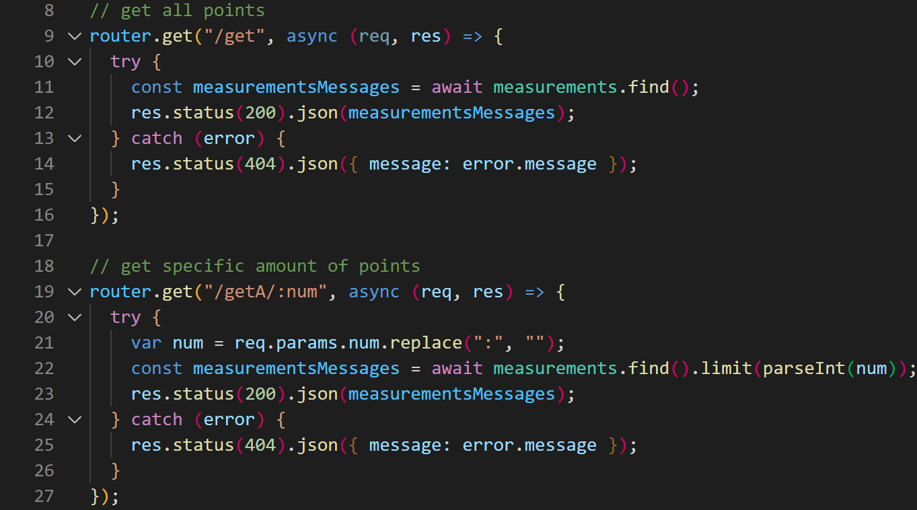
Figure 89: GET API Requests

One of the most important API requests for our project is the create API that takes a JSON payload and sends it into the database to be stored. The POST request takes in the payload sent from the SIMP and separates it into components that will be stored in certain columns of the database similar to an excel spreadsheet, once they are separated it then parses the information from each of the columns and adds it into the column of the database. If there is information missing that is required such as power, time, or device id, the program will not accept the payload as it’s not validated to be stored in the database which can cause errors down the line. This API request only creates one entry into the database at the time which in our case is fine but in some cases could be inefficient when large amounts of data are being sent in a single payload. We could explore this option in the future to get more datapoints without needing to send multiple packets a second, this approach would require the arduino to store the values every second then after a given amount of time send the one payload with multiple records in it with the database being able to separate each recording into its appropriate spot on the timeseries collection. The code show in the figure below for the create API request was created in Javascipt using Express.js like the last API request while it is not self explanatory, it is somewhat easy to follow along with what this paragraph has explained. In the future we plan to
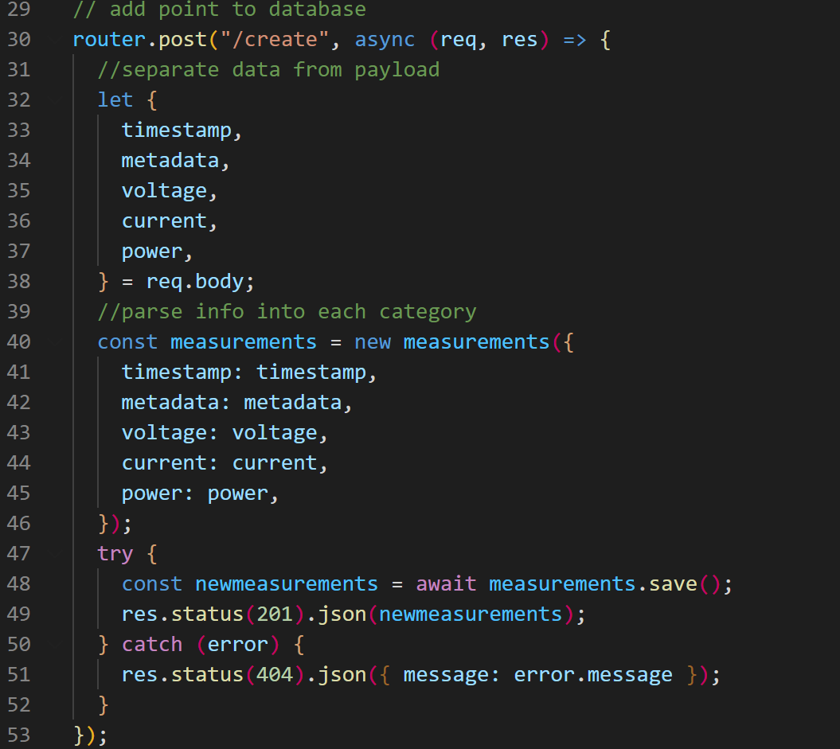
Figure 90: POST API Requests

6.3 System Testing

With the development of any new product or design comes the necessity to adequately test individual components and the product as a whole before recognizing it as ready for production. With the development of our SIMP module, we recognize the need to ensure testing is done within these major areas:

- SIMP’s Ability to Handle a Load
- SIMP’s Ability to Connect to the Network
- App’s Ability to Communicate with the SIMP
- App’s Ability to Interface via UI

6.3.1 SIMP’s Ability to Handle a Load

Once we’ve completed designing our PCB, integrated our MCU and brought everything together in a 3D-Printed enclosure, we can begin to test the stability of our components internal circuitry and verify that no hazardous mishaps occur when running of 120V AC Power. We can begin by verifying each receptacle end of the SIMP is producing the same amount of AC Voltage via standard multimeter. If a receptacle does not appear to produce any voltage, there may be a short or an open circuit somewhere in the internal wiring and would require further investigation. If the voltage being produced appears to be lower (or higher) than expected, it would be safe to assume that somewhere in the design of our PCB there was a miscalculation in the routing of power and as a result will require a rework on our current schematics.

The same ideology would apply in the event where multiple devices are inserted into both receptacles and one or both receptacles are seeing drops in their output voltage. These drops can become hazardous and lead to potentially damaging a consumer's device.

6.3.2 SIMP’s Ability to Connect to the Network

Upon verifying that the SIMP is working as a stand-alone extension plug, we would need to verify whether or not the device is capable of securing a connection to our home's wireless network. To do this, we would already have programmed the SIMP to secure a wireless connection via bluetooth to our home network. We would attempt to connect to the device via bluetooth, alter any network configuration settings as necessary and move forward with enabling the device a secured connection. If for some reason we weren’t able to access the device via bluetooth, we would need to verify that the device is made discoverable for a specified interval of time - one that grants a standard user the ability to figure out the base connection to get started. If after securing the bluetooth connection the device is still unable to connect, we will need to verify that the device is attempting to connect to a 2.4GHz or 5GHz wireless network accordingly - seeing how most less expensive MCU’s supporting Wi-Fi will typically only connect to a 2.4GHz network.

6.3.3 App’s Ability to Communicate with the SIMP

After the device is connected to the network, we will need to verify that it is linked to some form of wireless interfacing and that we are able to send and receive commands as generally expected. To test this, we would have already established some form of a web UI and already done to some extent Unit Testing of the site to minimize the hindrance of bugs in our system. So, we’d attempt to log into our Web app, attempt to add the SIMP module to our profile, and attempt to rename or specify the SIMP’s intended purpose depending on the location of where it has been installed. If when attempting to add the SIMP to our account it does not appear, there may be 1 of several issues including but not limited too: Errors in programming, SIMP is not on, SIMP is not discoverable on the network, UI not displaying information correctly, Back-End and Front-End are not properly hooked up, etc. This aspect in troubleshooting will likely be the most time-consuming portion of our system testing if proper measures were not taken ahead of time to verify that no single component further up the chain is not causing any issues.

6.3.4 App’s Ability to Interact via UI

Finally, we should be able to interface with the SIMP via the UI. All the basic functions and details of a SIMP should be posted to the user's profile upon adding the SIMP and the user should have the ability to see metric charts, enable parental controls, and edit information of the SIMP as they deem pertinent. To test this aspect of the final design, we would need to verify that the SIMP is in fact receiving communication from the web server and is capable of making physical changes to the MCU ensuring all instructions adhere to what has been posted. In the event that an instruction is sent to the SIMP and was not followed through by the said SIMP, there again could be 1 of many problems that may be causing this lapse in communication: The device could be off, the user could be editing the wrong device, there could be errors in coding etc. All this being said, there’s no easy way of verifying where in our Full-Stack project will there be a problem point once we push everything into a production state. All that can be done is an effort to recognize what exactly is the problem, isolate where that problem is appearing from, and attempt to rectify it before any potential clients or consumers find out.

 | Summary
SIMP’s Ability to Handle a Load | SIMP will be tested to handle more than 120V 15A by a safety factor of 1.1
SIMP’s Ability to Connect to the Network | SIMP will be tested to connect to a network in varying locations and environments.
App’s Ability to Communicate with the SIMP | SIMP will be tested to handle a requests a second in case of finer sampling
App’s Ability to Interface via UI | SIMP UI will be tested by using tools such as unit testing,
Table 28: System Testing

7. Administration

It is important that we have a list of goals to achieve and a timeframe that we would like those goals to be achieved. It is even more important that to achieve those goals, each group member understands their priorities and responsibilities that will keep them working consistently and efficiently without the need to be given tasks by their group members or group leader.

The assignment of tasks was both delegated and given voluntarily depending on the individual's ability to accomplish and seek out that task to its completion. Many of the programming heavy tasks such as developing the website and the generations of the back-end APIs were generally delegated to those with a strong background in Full-Stack development - i.e the Computer Engineers. Many of the circuit design and breadboard testing tasks were generally delegated to those with a strong background of electrical circuits and designs. We separated the bulk of the project tasks in this way so that all the major components of our project are completed timely and reliably at the point of submission. In the event that a member should fall short in the completion of their tasks or begin to fall behind, we as a group made it very clear how important it is to seek out help. Lack of communication between group progress can not be bad for general progress of the project but can ultimately lead to an unfinished design and result in the entire team's failure. As such, our group will plan to meet regularly to voice our individual progress and, at least from the software development side, tackle many of the issues via an Agile approach - i.e Design, Develop, Test, Deploy and Review individual components of our project and then eventually bring them together as a whole. Laying some foundation by which we plan to tackle each and every difficult task within this project will be the key to accomplishing each individual's tasks within the time-table arranged by our Senior Design Coordinators.

Below is a list of our group members, with each group member having written a short summary of their responsibilities and priorities for the project.

Austin

Austin will be responsible for the development of the web server and APIs for the SIMP to communicate with and store the data received from it. He will also be developing the collection of multiple SIMPs in a single household to allow the user to have more than one device monitored. He will be developing the main on and off switch for devices attached to the SIMP to give smart plug functionality for scheduling and parental controls. Austin will also be helping in multiple areas of the software process to alleviate any stresses any other teammates may have while trying to design certain features of the SIMP. With this in mind, he will be available as much as he can to help with any of the processes going on with the software and how they need to integrate with the other languages, hardware, and features that we will support.

Anthony

Anthony will be responsible for designing and developing (alongside Austin) various components involved in establishing the website such as the database, the front-end, simple API functions, and ensuring all members of our team are able to interface with the same prototype design - possibly involving Github, Docker, DigitalOcean, etc. He will also be responsible for ensuring the SIMP is capable of interfacing with a Web Server and allows for the proper sending and receiving of POST/GET requests as necessary. He will also plan to be involved in the Unit Testing of various API calls developed by the Software Engineering team and ensure no flaws, detrimental to the final design, are causing any unforeseen issues with the SIMP module.

Jose

Jose was responsible for the part selection and breadboard testing with the assistance of Edin. Jose was also responsible for the design of the power monitoring component and the emergency power shut off system of the SIMPs hardware design as well as assembly and testing of SIMP prototypes with help from the rest of the group for safety. For the software design Jose was responsible for the creation of the functions for the Arduino that connect to the webserver and apply the users’ input commands to the Arduino, such as turning on or off appliances plugged in or the flashing of the LEDs as warning lights.

Edin

Edin will be responsible for part selection of linear circuit hardware and breadboard testing alongside Jose. He will also be responsible for less advanced C-coding that pertains to the hardware of the device and functions like safely cutting off power between the SIMP and the device that is plugged into it. He will also help coding functions like the parental controls we plan to implement into the software with things like the ability to set or reset a password and setting schedules for the SIMP to provide power. As part of a group vote, Edin was elected the “Project Lead” of Group 11. As a result, he is also responsible for daily check-ins with each group member, keeping each group member on task and making sure the group is ahead of time with each coming checkpoint of project completion.

7.1 Administration Table

Below is a generalized yet in-depth, table showing the level of responsibility each group member is trusted with for each particular component of the project. The table characterizes each generalized aspect of what it would take to build this project and displays the team members' applicability to ensure that role/aspect of our project is fulfilled throughout the course of this design. Generally speaking, the role of programming and software design is given to the responsibility of the CpE (Computer Engineering) majors in our group. Their past experience in generalized programming and full-stack development will highlight many of the key programming aspects that will be necessary to build and deploy this project by the time of its completion.

As a result, it only makes sense that Software Design and Software Implementation is assigned to both Anthony and Austin to take the lead and both Jose and Edin will provide backup as needed. For anything pertaining to circuit design and overall component testing, it would make sense that those more suited to those roles, i.e the EE (Electrical Engineer) majors would take the lead. As a result, Hardware Component Testing and Breadboard Testing were primarily handled by the likes of both Jose and Edin and both Anthony and Austin will provide support where needed. RnD (Research and Development) is a general role where no one member has more control over the other. We assign the tasks of research to those who prefer to seek out the best components and equipment to incorporate into our design; every other team member is expected to assist and provide feedback to improve the overall understanding of the topic for the group.

Thus, it’s assumed that Jose (EE) would be the primary in handling research regarding electrical hardware - i.e Relays, Switches, Resistors, etc. Austin (CpE) will be the primary in handling research regarding the microcontroller and WiFi components (if applicable). The final project component pertinent to this project is the role of project leader, or Leadership. Ensuring this role was assigned to someone who was gonna keep tabs on the project milestones and take care of administrative issues was vital to making sure that we complete our project by the end of our term. As a result, we elected Edin as project leader seeing how he has had prior experience in project leadership from prior courses and was comfortable taking on the role for our team. These project responsibilities are what we as a team need to guarantee an appointed member takes responsibility for and can continue to oversee that specific project component through to the end of this project. It clears up any confusion for which member is in charge of a specific role and better allows for separation of duties between all members involved. See the table below:

Project Component | Responsibility Level
 | Austin | Anthony | Jose | Edin
Hardware Research (Electrical) | Secondary | Tertiary | Primary | Tertiary
Hardware Research (Computer/Wi-Fi) | Primary | Secondary | Secondary | Tertiary
Hardware Component Testing | Tertiary | Tertiary | Primary | Secondary
Breadboard Testing | Secondary | Secondary | Primary | Primary
Software Design | Primary | Primary | Secondary | Secondary
Software Implementation | Primary | Primary | Secondary | Secondary
Leadership | Secondary | Secondary | Secondary | Primary
Table 29: Project Responsibility Table

7.2 Project Milestones/Budgeting

Because an idea is only as good as the planning that goes behind it, milestone dates were thought up to keep the project on task as well as constantly moving in the right direction. Without milestones and dates set for when we need certain project components or documents turned in, we would be split into different tasks with no roadmap and ideas of procrastination would start to form. To counteract those thoughts of procrastinating and relaxing, we created tables of milestones with tasks to be completed paired with the dates we’d like to have them completed by.

7.2.1 Senior Design 1 Estimated Milestone Dates

During our Senior Design 1 semester, we plan to focus mainly on the written documents as well as the quizzes on engineering standards, with some focus for breadboard testing towards the end. Though each written assignment's due date is shown below, we, as a group, agreed to have all written information turned into our google document two days before the due-date. This allowed a thorough look through the document to fix any issues with the table of contents due to writing added between sections that already have titles. An earlier due-date for the group also allows each member of the group to read through the entirety of the document themselves and provide feedback they may have not been able to provide due to focus turned elsewhere on their part.

Milestones | Dates
Divide and Conquer, Version 1.0 | June 2nd
Divide and Conquer, Version 2.0 | June 17th
Standards Assignment | June 24th
60 Page Documentation Draft | July 8th
Beginning of Breadboard Testing | July 22nd
100 Page Report | July 22nd
End of Initial Circuit Breadboard Test | July 28th
Final Document (120 Pages) | August 2nd
Table 30: Senior Design 1 Estimated Milestone Dates

7.2.2 Senior Design 2 Estimated Milestone Dates

During our Senior Design 2 semester, the focus is taken away from written documents and set solely on testing and developing a prototype that eventually becomes a final product. Once our breadboard testing is finished and we have found a way to connect all the linear circuits of each component of the project we need, we will combine them into one main breadboard and make sure it works as expected. While that is happening, we will also be creating the web server that will hold all of the data and notifications for the product. When those components are done, a PCB will be designed using a software such as EAGLE to allow a maximum space-efficiency to be reached and have a working PCB with only software left to be perfected. A few days will also be taken towards the end of the semester in preparation for the presentation of the project because what good is a product that has a fumbling presentation. A table of each milestone for the Senior Design 2 semester is shown below:

Milestones | Dates
Ordering Prototypes of Design to Test | August 10th
Initial Web Server Creating | August 15th
Testing and Fixing Design Flaws | September 10th
Redesigning Hardware and Software | October 10th
Finalizing Projects Software and Enclosing | November 10th
Practicing Presentation of Project | November 30th
Presenting Our Project | December (Presentation Week)
Table 31: Senior Design 2 Estimated Milestone Dates

7.3 Project Budget

We were funding the project ourselves, as there was no sponsor yet as of writing this document. The table below shows an estimated budget of all the parts necessary to create our project. The prices may be overestimated to account for possible problems or price changes that may occur during the semester.

7.3.1 Breadboard Testing Budget

Below is a table showing the circuit components along with other items that were used in breadboard testing. You’ll notice that some items or components are marked with a cost-per-unit of zero dollars. This simply means that the item(s) was already owned by one or multiple group member(s), either through past purchase of breadboard starter-kits or through items that they themselves owned before the Senior Design 1 semester began, or through items provided to us in the Senior Design Lab. This budget is a current total value of parts purchased as of this paper's submission, this value will change in time as we progress further into the Semester and Senior Design 2 for future testing.

Component | Quantity | Cost/Unit
Levinton Decora 15 Amp Tamper Resistant Duplex Outlet, White | 1 | $3.22/1
WayinTop 2pcs ACS712 Hall Effect Current Sensor Module 30A Range ACS712 Module | 1 | $11.99/2
Breadboard(s) | 1 | $0
Resistors | 10 < X < 20 | $0
Breadboard Wires | X>20 | $0
LED(s) | 1 | $0
Lamp | 1 | $0
USB-to-MicroUSB Cable | 1 | $0
Total Budget |  | $15.21
Table 32: Breadboard Testing Budget Breakdown

7.3.2 Approximated/Allotted Budget

Below, you will find a list of budgets that we’ve allotted to certain parts or components of the project. These are estimates on how much we plan to spend on each component and are by no means actual prices we have paid for parts. The quantities are written as ideal situations and are subject to change as testing components may break, melt, burst, etc. The costs of some of these are also subject to change as lack of inventory in one component may force us to buy our second option for that component which may cost more or less than our ideal part.

Hardware | Cost | Quantity
Project Processor | $50 | 1
Relay Switch | $20 | 1
Voltmeter | $20 | 1
Ammeter | $20 | 1
Buttons | $10 | 2
Resistors/Capacitors/Inductors | $15 | 10+
WiFi Module | $20 | 1
NEMA 5-15 Plugs (Male) | $5 | 1-2
NEMA 5-15 Plug (Female) | $5 | 1
Printed Circuit Boards | $30 | 1
Total Budget | ~$200
Maximum Budget | $400
Table 33: Approximated/Allotted Budget Breakdown

7.3.2 Finalized Budget

Item | Price (Total)
First Ammeters and Voltmeters | $12.77
5V Relay Module | $5.86
2x20 Pin Headers | $9.57
AC Voltage Sensors | $15.96
AC Voltage Sensors Return | -$15.96
Solder | $7.44
2nd 5V Relay Module | $5.86
3.3V Relay Modules | $9.57
De-solder wick | $10.64
5A Current Sensors | $7.99
Red & Green LEDs | $5.31
5V Naked Relays | $8.51
2 POS Terminal Blocks | $5.99
Female Pin Headers | $6.49
First PCB | $28.00
“Final” PCB | $30.00
Actual Final PCB | $30.00
2nd Set of 5A Current Sensors | $7.23
Diodes & Transistors | $12.23
Unobtrusive ammeter x2 | $24($12/unit)
Extension Plug | $12.22
Arduino Nano 33 IoT | $25.84
Grand Total | $265.52

8. Conclusion

With all the components and ideas we plan to add to this relatively small device, in the allotted time that we are given, we were sure to have our work cut out for us. We have our prior assignments like our “Divide and Conquer” to help us in staying on track with our milestones for the project and what dates we must have them completed by. To make sure we stay within the margin of error in execution, we planned to have our work turned into the group ahead of schedule in a constant manner to allow other group members their own chance to add constructive input and improvements.

In the months of Fall 2022, a jumpstart of further breadboard testing and software development were crucial. To keep the workflow consistent and focused, we had broken down our ideas, research and testing into individual and two-person group assignments. While Edin and Jose used their research to develop a reliable physical schematic, Austin and Anthony would be creating the software layout for the main hub of the SIMP’s data and user interface. Though these could not be done without one being done before the other, it would be irresponsible for the CpE’s to wait on the hardware to be finished to begin writing the code, or vice versa with the EE’s waiting on the software being complete to start working on breadboard testing. After about two week’s worth of both breadboard testing and software development (with constant check-ups to make sure everyone is on task), our plan was to consolidate what we have, with the idea that about 70% of the work that requires expertise from our specific fields of study would be complete. Once we are brought together again as an entire group, it will be a fall semester of trial, error, success, stress tests and more trials. When we were at the milestone where we have a complete hardware device and main software for the SIMP is complete, all that was left was to perfect it to the best of our ability and timeframe, and to maybe add features and ideas into the software that we can implement with any extra time we find ourselves with.

With the wave of smart-plug devices in the market, our finalized SIMP won’t be able to hold a candle to the rest in terms of features. This statement would prove to be redundant, as the ideas that we planned to implement into the SIMP are sure to separate it from being classified as something as basic as a plug that will turn on and off with your voice or from the tap of an app on your phone. The focus on minimizing the user’s electricity bill and pushing them to disconnect from electronics is our main goal for this household power management plug. Who knows, with the ever-expanding world of electronics and gaming devices that make us forget that the real world exists, the SIMP may be the device that triggers a revolution in electronic use.

Appendix A: Related Works/Product Links

“Mini Smart Plug, Wi-Fi Outlet Socket” sold by GHome Smart:
https://www.amazon.com/Smart-Compatible-Control-Function-Required/dp/B09LXPK5XM/ref=asc_df_B09LXPK5XM/?tag=hyprod-20&linkCode=df0&hvadid=563671128400&hvpos=&hvnetw=g&hvrand=1386515982259665033&hvpone=&hvptwo=&hvqmt=&hvdev=c&hvdvcmdl=&hvlocint=&hvlocphy=9011814&hvtargid=pla-1624414956847&psc=1

“Smart Wi-Fi Duplex Tamper Resistant Outlet” sold by Geeni:
https://www.homedepot.com/p/Geeni-Smart-Wi-Fi-Duplex-Tamper-Resistant-Outlet-No-Hub-Required-Works-with-Alexa-and-Google-Assistant-White-2-Pack-GN-WW215-199/314290556?source=shoppingads&locale=en-US&&mtc=SHOPPING-CM-CML-GGL-D27-027_002_WIRING_DEVIC-NA-NA-NA-SMART-2997116-NA-NA-NA-NBR-NA-NA-NEW-PL3&cm_mmc=SHOPPING-CM-CML-GGL-D27-027_002_WIRING_DEVIC-NA-NA-NA-SMART-2997116-NA-NA-NA-NBR-NA-NA-NEW-PL3-71700000093390730-58700007789602690-92700070740571004&gclid=Cj0KCQjwwJuVBhCAARIsAOPwGARVZ7fbijY2RTHRgcc_CMe51wydEVGm5tjPNfRxMm4PtZhrnzTV1HEaAnhKEALw_wcB&gclsrc=aw.ds

“Amazon Smart Plug” sold by Amazon:
https://www.amazon.com/Amazon-smart-plug-works-with-Alexa/dp/B089DR29T6/ref=asc_df_B089DR29T6/?tag=hyprod-20&linkCode=df0&hvadid=507647825193&hvpos=&hvnetw=g&hvrand=14898392487411914575&hvpone=&hvptwo=&hvqmt=&hvdev=c&hvdvcmdl=&hvlocint=&hvlocphy=9011814&hvtargid=pla-1317070124772&th=1

“Kasa Smart Wi-Fi Plug Mini with Homekit” sold by TP-Link:
https://www.bestbuy.com/site/tp-link-kasa-smart-Wi-Fi-plug-mini-with-homekit-white/6472520.p?skuId=6472520&ref=212&loc=1&ds_rl=1268652&gclid=Cj0KCQjw2MWVBhCQARIsAIjbwoNqznNhF5lJBwiu5Qj4TrNNskXJw3Am8ik0b5XayICs7f7u7VaFVjgaAmFzEALw_wcB&gclsrc=aw.ds

Portenta X8 sold by Arduino:
https://store-usa.arduino.cc/products/portenta-x8?selectedStore=us

MKR1000 Wi-Fi with Headers Mounted sold by Arduino:
https://store-usa.arduino.cc/collections/iot/products/arduino-mkr1000-Wi-Fi-with-headers-mounted

MKR1000 Wi-Fi:
https://store-usa.arduino.cc/collections/iot/products/arduino-mkr-Wi-Fi-1010

Portenta H7 Lite sold by Arduino:
https://store-usa.arduino.cc/products/portenta-h7-lite-connected?selectedStore=us

Nano 33 IoT sold by Arduino:
https://store-usa.arduino.cc/products/arduino-nano-33-iot

5mm Diode Bulbs sold by EBOOT:
https://www.amazon.com/eBoot-Pieces-Emitting-Diodes-Assorted/dp/B06XPV4CSH/ref=asc_df_B06XPV4CSH/?tag=hyprod-20&linkCode=df0&hvadid=167146990738&hvpos=&hvnetw=g&hvrand=877805474323013814&hvpone=&hvptwo=&hvqmt=&hvdev=c&hvdvcmdl=&hvlocint=&hvlocphy=9011814&hvtargid=pla-369941417757&th=1

PSR400ITQFD0L30 sold by Rohm Semiconductor:
https://www.digikey.com/short/7v7vfnb4

PSR400ITQFH1L00 sold by Rohm Semiconductor
https://www.digikey.com/short/vp4vz2c0

MCS1803GS-10-Z sold by Monolithic Power Systems inc
https://www.digikey.com/short/3wwr0w5v

TMCS1108A3UQDR sold by Texas Instruments
https://www.digikey.com/short/fmj3r43v

TLE2425CDR sold by Texas Instruments
https://www.digikey.com/short/5pddb25c

SSA-100 sold by SSA-100
https://www.digikey.com/short/dhj3r74n

Tesla Charging Adapters sold by Tesla
https://shop.tesla.com/product/gen-2-nema-adapters

WayinTop 2pcs ACS712 Hall Effect Current Sensor Module 30A Range ACS712 Module + 2pcs Voltage Sensor Module DC0-25V Voltage Tester Terminal Sensor for Arduino:
https://www.amazon.com/dp/B08BZKPSFY?psc=1&ref=ppx_yo2ov_dt_b_product_details

Normally-Closed Relay Switches
https://www.electroschematics.com/normally-closed-relay-switch/

Normally-Open Relay Switches
https://www.electroschematics.com/normally-open-relay-switch/

Appendix B: Data Sheets/ References

UCC28740 Data Sheet:
https://www.ti.com/lit/ds/symlink/ucc28740.pdf?ts=1658803374018

UCC28740-Q1 Data Sheet:
https://www.ti.com/lit/ds/symlink/ucc28740-q1.pdf?ts=1658803412098

Guide to USB Cables:
https://uk.rs-online.com/web/generalDisplay.html?id=ideas-and-advice/usb-cable-guide#:~:text=%E2%80%9CIf%20you%20were%20to%20open,known%20as%20the%20ground%20wire

SnapEDA:
https://www.snapeda.com/search/?q=microcontroller&search-type=parts

Photocoupler Datasheet:
https://www.renesas.com/us/en/document/dst/ps2811-1-ps2811-4-data-sheet

Voltage Divider Calculator:
https://ohmslawcalculator.com/voltage-divider-calculator

