Autonomous Sanitation Robot

Shawn Manohar (EE), Rishi Patel (EE), Abel Assefa (EE) and Allan McCormick (CPE).)

Dept. of Electrical Engineering and Computer Science, University of Central Florida, Orlando, Florida, 32816-2450

***Abstract* — This paper aims to show the design overview and the implementation of the autonomous sanitation robot. The robot utilizes a microcontroller and a raspberry pi in tandem to help realize and achieve many of the deliverables being asked of it. The microcontroller helps with the spraying interface of the robot along with the detection interface that is achieved by the different sensors. The sensors involved are a color sensor, ultrasonic sensor, and a liquid level sensor. The main objective of the raspberry Pi focuses on movement of the robot. Together these two will communicate at certain scenarios to meet all the constraints of the robot. The autonomous sanitation robot’s main purpose and goal is to sanitize target areas accurately and consistently in each environment while properly discerning any environmental factors that may impose its operations.**

***Index Terms —* Autonomous, Communication, iRobot, Sensor**

1. *Introduction*

With the way things are now people are more concerned than ever about cleanliness. This recent COVID-19 pandemic has shown everyone how easy it is to spread germs in an environment. This has changed the mindset of everyone, even after this pandemic is over people will be more health conscious than ever, being more mindful of the area they are in and thinking more about how often they should wash their hands. With areas of the highest foot traffic being hallways, we need to maintain the cleanliness of hallways the most, although many people do not spend excessive time in hallways everyone must use them.

With these given factors we created the Autonomous Sanitation Robot. This is a self-driving robot that will help people such as building managers ensure that high traffic areas like hallways and lobbies are always sanitized and clean. By replacing the human with a robot, we have decreased the amount of time a given area would be dirty. This is possible with having the robot constantly patrolling an area and cleaning said area all day. Unlike with a user doing this task the robot would be designated to a specific area to patrol and keep clean.

This robot is light enough for the average user to carry, can discern a dirty area from a clean one, is able to autonomously seek out dirty areas, and will also notify the user if there needs to be a refill to the disinfectant solution.

The closest product that would compete with the Autonomous Sanitation Robot would be the household Roomba. The major difference would be that this robot does not vacuum or mop floors. This robot also does not “randomly” clean such as a Roomba, the robot will essentially autonomously “patrol” an area and if it recognizes a dirty area, it will then clean this area and continue its “patrol.” This allows the robot to cut down on unnecessary sanitation. Utilizing ultrasonic sensors along with a color camera the robot will be able to autonomously search out dirty areas in places such as hallways and proceed to disinfect these areas until clean.

1. *Design Overview*

The robot consists of a robotic chassis called the iRobot that has two motors utilized for movement, a color sensor to recognize dirty areas to clean, ultrasonic sensors to detect the environment and avoid users and obstacles, and a motorized sprayer with a reservoir to house the sanitation fluid. The robot would patrol areas such as hallways using the motors and sensors, and then the camera would recognize a dirty area and the command would be sent from the color sensor to the microcontroller to begin spraying. While spraying the microcontroller also monitors any potential users that may be approaching the robot. If a user enters within 40 cm of the robot it will shut off spraying to avoid spraying in the vicinity of a user.

The robot will have three main deliverables that it will display.

* 1. The robot spraying system will be triggered by a relay that will spraying for every 15 seconds
  2. The robot will determine if an object or person is within <40 cm and the marked color is green, this will then produce a beep to alert users of spraying.
  3. The robot will determine if there is less than <10% of the solution and this will also emit different a sound for 5 seconds and shut down

The image below shows the blow diagram breakdown of the physical and software implementations of this project.

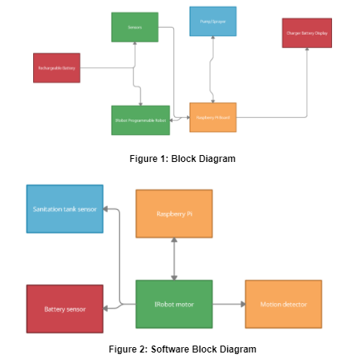

1. *Components*

The autonomous sanitation robot is a breakup of many subsystems of components working together to achieve the set deliverables.

*1. MSP430FR6989 Microcontroller and Raspberry Pi*

When it comes to the brains of the iRobot, where the spraying, refilling detection system and environmental detection are all controlled by a powerful microcontroller. We are using the MSP430FR6989 microcontroller that is embedded within the system so it can interact with all the different deliverables that we have setup throughout the iRobot.

The MSP430 family, provided by Texas Instruments, is one of the most popular designs for a microcontroller that allows for a wide pin layout and several A/C interactions. It has a low cost, high availability, and large serial programmability.

The specifications of this microcontroller lead us to make the decision that it would be best for our needs. The MSP430FR6989 has a 12-bit SAR ADC and 128KB of nonvolatile memory that’s incorporated in the housing of the microcontroller. It has 81 GPIO pins that allows for a deep load and has several internal and external interrupt capabilities. Within the MSP430FR6989 there is a crystal clock frequency of 16 MHz that can be used for an internal timer or an external counter in the microcontroller. Also, the microcontroller has 16KB of RAM associated within it.

Next working in tandem with the MSP430 is the Raspberry Pi. The Raspberry Pi serves as the bridge between the two brains of the iRobot and acts as the spinal-cord of the whole system. The Raspberry Pi will be computing the directions that will communicate to each of the Microcontrollers. The focus of the raspberry pi is to establish proper movement with the iRobot which is the chassis of our robot and will be discussed more in a later section.

The specific Raspberry Pi model used in this project is the

Raspberry Pi 3 Model B+. The Raspberry Pi 3 Model B+ has an input power of 5 Volts DC and it draws a 2.5 A via some USB connector. The input power can also be achieved through a 5 V DC GPIO header or using a POE which is Power over Ethernet. The board has 4 USB 2.0 ports and has an extended 40-pin GPIO header. Lastly the board has video and sound capability with a 1 f\full size HDMI, a MIPI DSI display port, A MIPI CSI camera port, and a 4-pole stereo output composite video port. This board provided the best performance and output at it’s given price. It met the needs we required to control the robot’s movement and was priced well within our budget.

*2. TCS3200 Color Sensor*

This is a color detector sensor that comes equipped with the TAOS TCS3200 RGB sensor chip and 4 white LEDs. The RGB chip has a vast range of detecting visible colors and has many applications from sorting by color, color matching, ambient light sensing, and calibrations. This is done through the many photodetectors on the sensor itself that allows it to take in all the different visible colors and properly sort and identify them. This sensor also contains an internal oscillator that produces a square wave which has a frequency that is proportional to the intensity of a color that is chosen. This is how it reads a specific color and blocks out all other colors.

This sensor operates at a DC voltage of 2.7 Volts to 5.5 Volts, with high performances with increased voltage until the maximum value. This sensor works heavily with frequency throughout its components. There is a High-Resolution Conversion that takes the light intensity and converts it to frequency. There is also a programmable color and full-scale output frequency that is supported by this sensor. This is mainly done through 4 switches; S0, S1,S2,S3, that deal with the output frequency and photodiode.

The table below shows how the pair of switches works in tandem to control an aspect of the color sensor. S0, and S1 deal with the output frequency and S2, and S3 deal with the type of color being measured. Using the information in the tables below the sensor can be set up as specified for any given color.

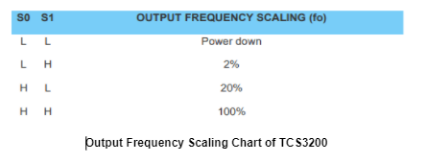

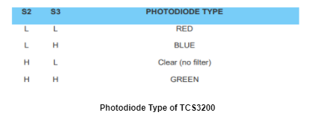

*3. HC - SR04*

The HC - SR04 has a working voltage of 5 DC volts, and a working current of 15 mA. The range of the sensor has a minimum of 2 cm and a maximum of 4 m, and the measuring angle of the sensor is at a 15-degree cone radius. Lastly the dimension of the sensors are length 45 mm, width 20 mm, and height 15 mm. This sensor provides excellent range in sensing as well as great and manageable power consumption.

The sensor has 4 pins the: Power, Signal, and ground. The signal pin is represented by two pins: the trigger and echo pin; these two pins communicate with one another to deliver and receive messages. The trigger pin and an echo pin which work off each other with a timing scheme.

The image below shows the timing diagram in action as a 10-microsecond pulse is sent to start the ranging which will send an 8-cycle burst of ultrasound at 40 kHz and raise the echo. The range is defined as the time interval between the sending trigger and the receiving echo. The ranging can be calculated with multiple different formulas based on the units of measurement desired. For units of centimeters the formula is the microsecond pulse divided by 58 and for inches the formula is the same, but instead of 58 the number is 148.

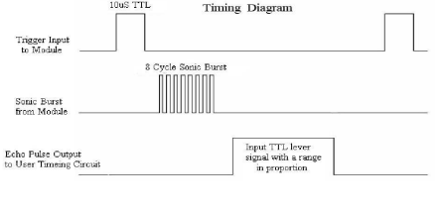

*4. Optomax Digital Liquid Level Sensor*

The Optomax digital is a liquid level switch that contains a sensor that has an infrared LED and a photo transistor. The infrared sensor measures the amount of liquid when submerged in the liquid. When the sensor is in the liquid the light leaves from the infrared LED and the photo transistor turns off. During this state the sensor detects the amount of or lack of liquid inside and reports that. It is very versatile and is not affected by ambient lights or any kind of foam or bubbles that may be confused for actual liquid.

This sensor has a working voltage of 4.5 VDC and 15.4 VDC, and a current consumption of 2.5mA. The source current also has a current consumption of 100 mA. The operating temperature is set to be at -25 C to +80 C, with a storing temperature of -30 to +85. This sensor has listed many features that makes it a very versatile sensor. This sensor has a reverse polarity protection as well as the widespread voltage range. The sensor is also compatible and microcontroller friendly at both logic levels of 3.3 and 5 V. This device is also a solid state which entails that it is fully enclosed, and no parts are moving around which may cause unreliability.

*5. PetraTools Automatic Battery Sprayer and KY-019 relay*

This sprayer is powered by two AA batteries housed in the sprayer head, the included reservoir has a fluid capacity of 32 ounces or 909 ml. The tube extends 9.5 inches or 42 cm into the reservoir. The exterior tub that connects the spray head to the reservoir is 36 inches or 91.5 cm long. The spray head does have adjustments to go from a mist to a full stream. The mist spray flow is 6 ounces/minute, and the full stream flow is 8 ounces/minute or 170 ml/minute and 227 ml/minute, respectively. The pump operates on 3-volt power with a pump speed of 4200 rpm. This product weighs approximately 15.8 oz or 448 g unloaded and 48.8 oz or 1.27 kg with a full load of solution.

The sprayer works in tandem with another component which is the KY - 019 5 Volt relay. This relay acts as a switch that responds to a signal received from the Arduino, it has an integrated LED that indicates if the signal is high or low. On the DC side of the board there are 3 pins for signal, power and ground. On the AC side there are 3 contacts, NC (Normally Closed), Common and NO (Normally Open). The working voltage range for this relay is 5 VDC - 12 VDC

The image below shows the disassembled sprayer head. The sprayer is motorized, and the activation method is a trigger switch. Utilizing the trigger switch we modified the spray head and removed the trigger altogether and used the switch contacts to initialize the spray head. Wires were then connected to the switches contacts and connected to the relay. Once this was achieved the relay is now controlling the triggering of the sprayer as the relay goes from high to low.

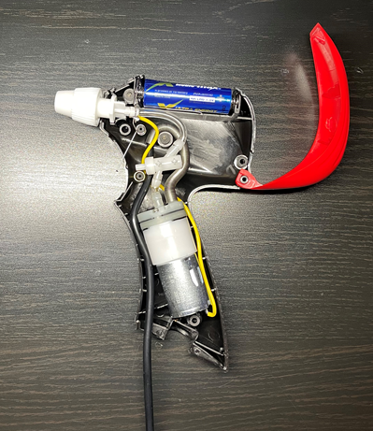

*6. JBL Speaker*

We wanted a Speaker that would be able to signal to oncoming pedestrians that the iRobot system is going to spray its solution. We decided to go with the JBL Micro Wireless | Ultra-portable Bluetooth speaker with bass port that can connect with the Pi’s 3.5mm audio jack

1. *Standards and Constraints*

*Standards:*

The major components in this project that need to be voluntarily and technically regulated are:

* Motors
* Batteries
* Circuit Board Electronics and Wiring
* Disinfectant Sprayer and Tank

A motor in any device such as a car must be thoroughly inspected for a lot of reasons. A motor of a small rc-car is just as important because it could lead to the harm of the user if it was made defectively.

When ordering or designing a PCB, it is expected that the creation process needs to be monitored closely. The IPC has a standard for the safe and reliable creation of PCB’s. Some of the most important standards created by IPC are listed below.

IPC-2581: Anyone that designs a PCB that will then be sent to a manufacturer adheres to the standard of submitting data to the manufacturer so that the product can be made correctly every time.

IPC-6012B: Sets the standard for the quality of the structure, soldering, and layout design for PCBs.

IPC J-STD-001: A standard that can be followed to use materials and processes to create the best soldering connections for a board.

Specifically, these IPC standards listed were utilized by our team. These standards kept us from making too many mistakes in designing our PCB before having it sent to be created. The PCB is used in our Autonomous Sanitation Robot on top of the chassis to control all aspects related to spraying the disinfectant.

IEEE and ANSI have standards for the use of lithium and rechargeable batteries. IEEE 1625-2008 covers our rechargeable battery inside our iRobot Chassis. It is a voluntary standard that covers all levels from the quality of the battery to the reliability when it is in use. ANSI C18.2M covers specifications and safety standards related to batteries. This standard gives producers the knowledge that all producers making batteries will be able to create very similar products that are safe and effective. This allows for reduced costs and high expectations for consumers because they know that whatever and whoever they buy a product from that contains a battery, that it should be reliable, safe, and of high quality. ANSI lists standards for every possible scenario when it comes to batteries including vibration stress to thermal temperature misuse.

*Constraints*:

Constraints can come from the physical ability of what is possible to the financial limitations. Each constraint listed below will lead to the overall analysis of what must be done to complete the project. These constraints are realistic and not outlandish for the real purpose of finishing the project.

*Financial and Time:*

Financial constraints are an important factor to the overall quality of the project. It is very important to research all parts beforehand while weighing a cost analysis for each part to determine if it is worth it. After researching and investigating, a project's bill of materials and parts list is necessary to manage the budget within the group. Time constraints are also an important factor because the project cannot have an unlimited time span just like it can’t have an unlimited budget. Our project was designed not to have parts that are extremely expensive and an assembly that is so complicated it would take years.

For the autonomous sanitation robot, our budget split between the four of us was 700. We had this budget set based on what we believed was our bill of materials. Our iRobot chassis and custom PCB board accounted for a large portion of the budget. The custom PCB board was the most cost heavy component in our budget. With any changes it required a whole new board to be ordered which ended up costing time and money.

*Environmental Constraints:*

In modern day society, environmental concerns are at all-time highs. As technologies get more advanced and products keep getting consumed, environmental pollution is becoming staggering because of improperly discarding electronics like cellphones. These problems have been leading to the cause of global warming and climate change. Solutions have been posed by governments and companies to start recycling a lot and control emissions with standards that require products to have certain restrictions on how they affect the planet. The US EPA is a government agency that is made to protect the environment by tagging restrictions on products that for example burn fossil fuels.

Our Autonomous Sanitation Robot contains motors, batteries, and rechargeable batteries. Our robot does not output any emissions directly regarding nitrogen dioxide. The environmental concerns that can come from our project are related to properly recycling the batteries and motors after the assignment is complete. Motors can be recycled easier than batteries. The electrical wiring and circuit boards used throughout the robot will be implemented correctly so it doesn’t cause any problems. The circuits and wires throughout the robot will also be addressed by being properly recycled and should not be hazardous to the environment.

Finally, our robot will be spraying disinfectant chemicals that can also affect the environment in a negative way. Headlines have been made that the overuse of disinfectants from Covid-19 might be hurting Urban Wildlife. To minimize this, we chose a disinfectant liquid that is environmentally conscious.

1. S*ubsystem Integration & Software Design*

*First Subsystem*

The first subsystem is the iRobot, TCS 3200 Color Sensor and the Raspberry Pi 3 Model B+. Looking at the iRobot and taking a deeper look into its design we will see how it works and how it will interact with the Color sensor and the Raspberry Pi.

The iRobot has seven pins associated with its design. The iRobot does not have many pins by design as most of the modification and readings come from the use of the open interface. However, these pins are crucial in how we used the iRobot and helped in troubleshooting issues that arouse while doing this project. Pins 1 and 2 are standard unregulated power and specifically the Roomba’s battery. Pins 6 and 7 have a very similar functionality with these pins dedicated to the ground of the Roomba’s battery. Pins 3,4, and 5 are very interesting and key applications associated with it. Pin 5 is the port that deals with the Baud rate, and the iRobot has a default baud rate at 115200, but if a processor cannot support this level there is a way to force a switch to 19200. Lastly the last two are associated with the TTL level communication set at 0 – 5 volts with 3 being RXD which is associated to the serial input and 4 being TXD which is the serial output

The RXD and TXD uses 0 – 5 Volt logic which is different from the serial port used. A solution to this is to use a level shifting device to match the differing logic levels. Fortunately, the iRobot Create USB cable has level shifting capability thus no need to construct a voltage level shifter. This level shifter allows this robot to also be able to communicate with boards of the same logic level such as the raspberry pi. The flowchart below illustrates the pin out of the iRobot explained here.

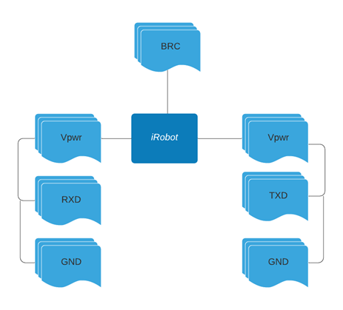

The next part of this subsystem is the combination of the Raspberry Pi 3 Model B+ and the TCS3200 Color Sensor. The Color sensor has an 8x8 array of photodiodes which is covered with either a red, green, or blue filter which ultimately detects what kind of color that the sensor will read. The setup is then placed by utilizing the general-purpose input/output of the raspberry Pi. There are 40 of these pins that can be utilized in any way, and the Color sensor will be connected to these pins to begin working with the board. The wiring will go to S0, S1,S2,S3 as these are the switches that will determine the output frequency and which photodiode type will be reflected which essentially means which color will be read by the sensor.

*Second Subsystem*

This subsystem focuses on our spraying process. The PentraTools Automatic Battery sprayer was chosen as the ideal sprayer for this application. The most important part about this sprayer is that it is motorized, and the activation method is a trigger switch. Utilizing the trigger switch we modified the sprayer head and removed the trigger altogether and only used the switch contacts to initialize the spray head.

The way we initialize the spray head is to connect wires to each of the contacts to a relay. The relay shown below is connected to the microcontroller and awaits a signal from the microcontroller to turn on the sprayer. When the relay receives its signal, it completes the circuit for the spray head thus initializing the sprayer. To turn off the spray the same is done. A signal is sent to the relay, and this causes the circuit to open causing the sprayer to turn off.

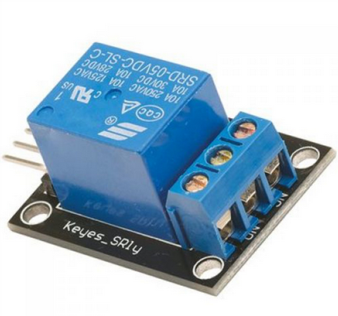

The image below also shows the disassembled sprayer head and the trigger mechanism. One end of the battery is connected to the pump while the other end of the battery is connected to the protruding wire, as can be seen in the figure below. The golden coil seen in the figure is connected to the other terminal on the pump. When the trigger is squeezed the wire contacts the golden coil, thus completing the circuit and activating the sprayer.

To activate the sprayer without the need to squeeze the trigger every time we hardwired it to the mainboard. This means that we took a wire and connected the two contacts of the sprayer to the relay, and this acts as our switch. When the relay receives power, it will close the switch allowing the circuit for the sprayer to complete which will cause the sprayer head to activate.

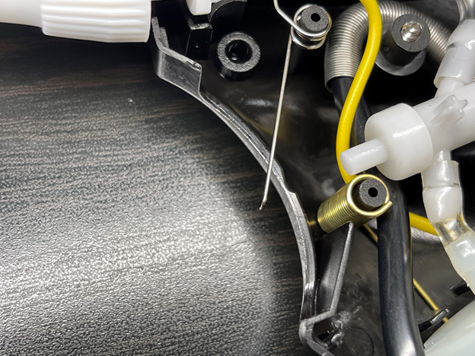

*Software design:*

We used Microsoft Visual Basic Studio to implement our software. This IDE was used specifically for C that was loaded from the computer’s USB ports to the serial cable that plugs into the Roomba. The Raspberry PI also was installed with the Roomba that will be coded to instruct it how it moves. This minicomputer communicates with the disinfectant payload housed above the Roomba.

The Raspberry Pi is responsible for using all the sensors together to create this cohesive system. The disinfectant bottle has a sensor that is monitored by the microcontroller. The Raspberry Pi will be working in conjunction with the camera that detects colors and with the ultrasonic sensor. These values will be addressed by alerting the switches and pins and alerting users using the speaker.

The language of choice was determined to be C based on how much experience we had using the language compared to others. We would have to learn Python before experimenting with our autonomous robot and even though Python is known to be very easy to learn, we felt more comfortable with C..

1. *PCB Design*

First before we could print and manufacture the PCB, we needed to first design the board in software. There are multiple PCB software’s that were available for us to use and design the custom board that we desire. Some software environments include EagleCAD, Altium, KiCAD and OrCAD. Out of all these software environments, EagleCAD is a free software that we all have access to and is the software all of us as a group are most familiar with. Altium, KiCAD and OrCAD are much more complicated and require paid licensees that we did not have access to. With access to any of these software environments we were able to go from drawings to schematics and then to analysis and manufacturing. The only difference with the paid software environments is they have a more extensive library that can be used by drawing up a schematic for the PCB and can be entered into a PCB simulation via PCB editor. This can allow for quality control on the PCB to make sure it works properly for what you want it to do and makes sure the schematic design shows the three different layers of the PCB. The model, symbol and footprint make up the three different layers of the PCB schematic design.

Once we decided on EagleCAD, we began our design process. Our goal was to create a board with our chip which was selected to be a MSP430FR6989 as well as have an integrated power source to power all our other peripheral components. A 6 Volt battery pack was selected which meant we needed two convertors to bring the voltages from 6 V - 5 V and from 6 V - 3.3 V. The 5 volts was going to all our sensors and the 3.3 volts was going to the MSP chip. With all that the image below shows our final schematic and board design.

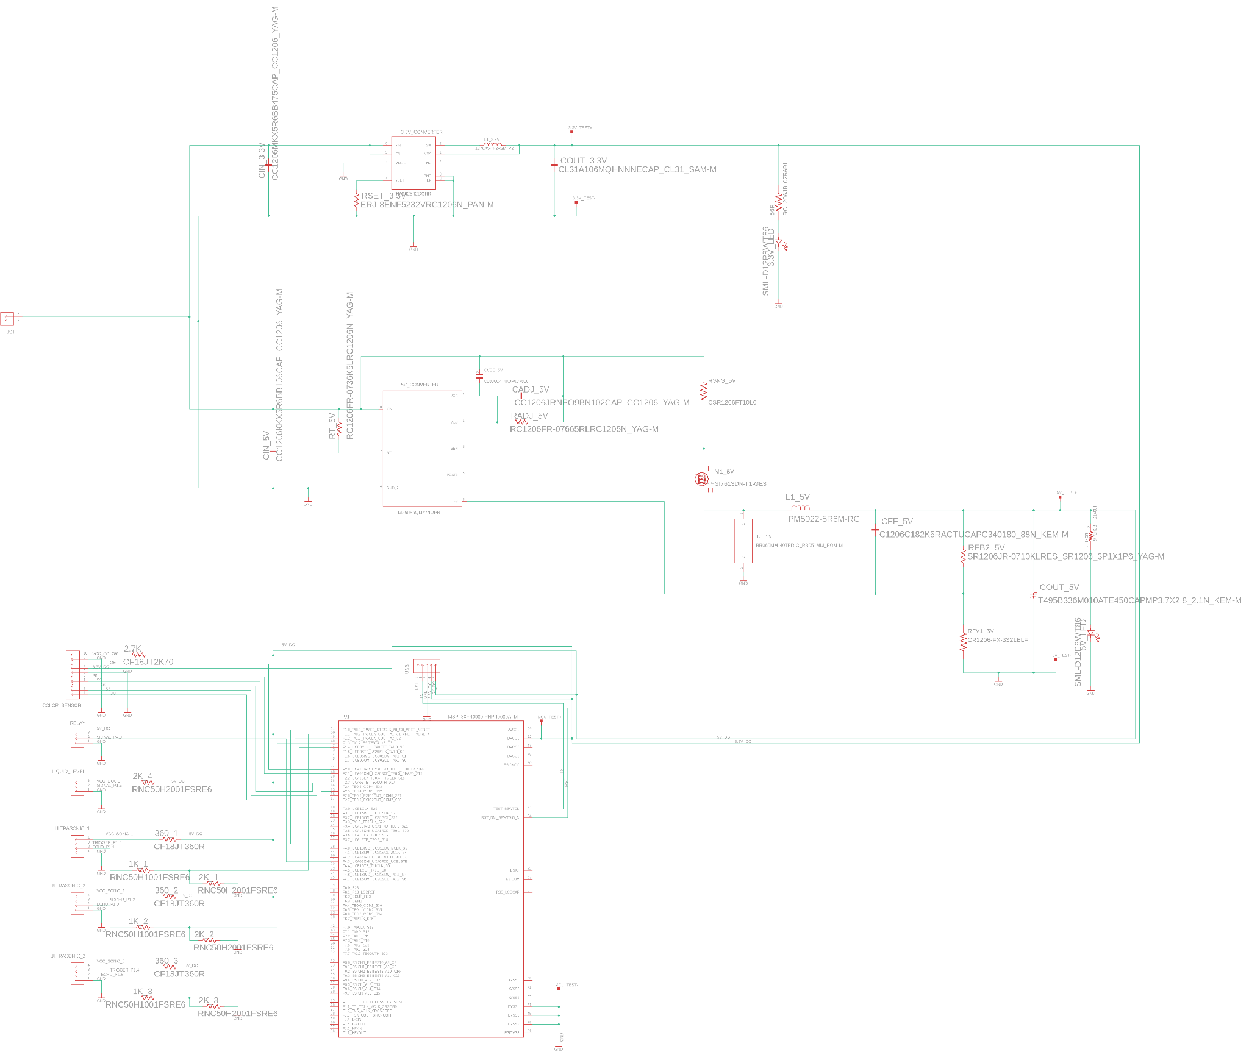

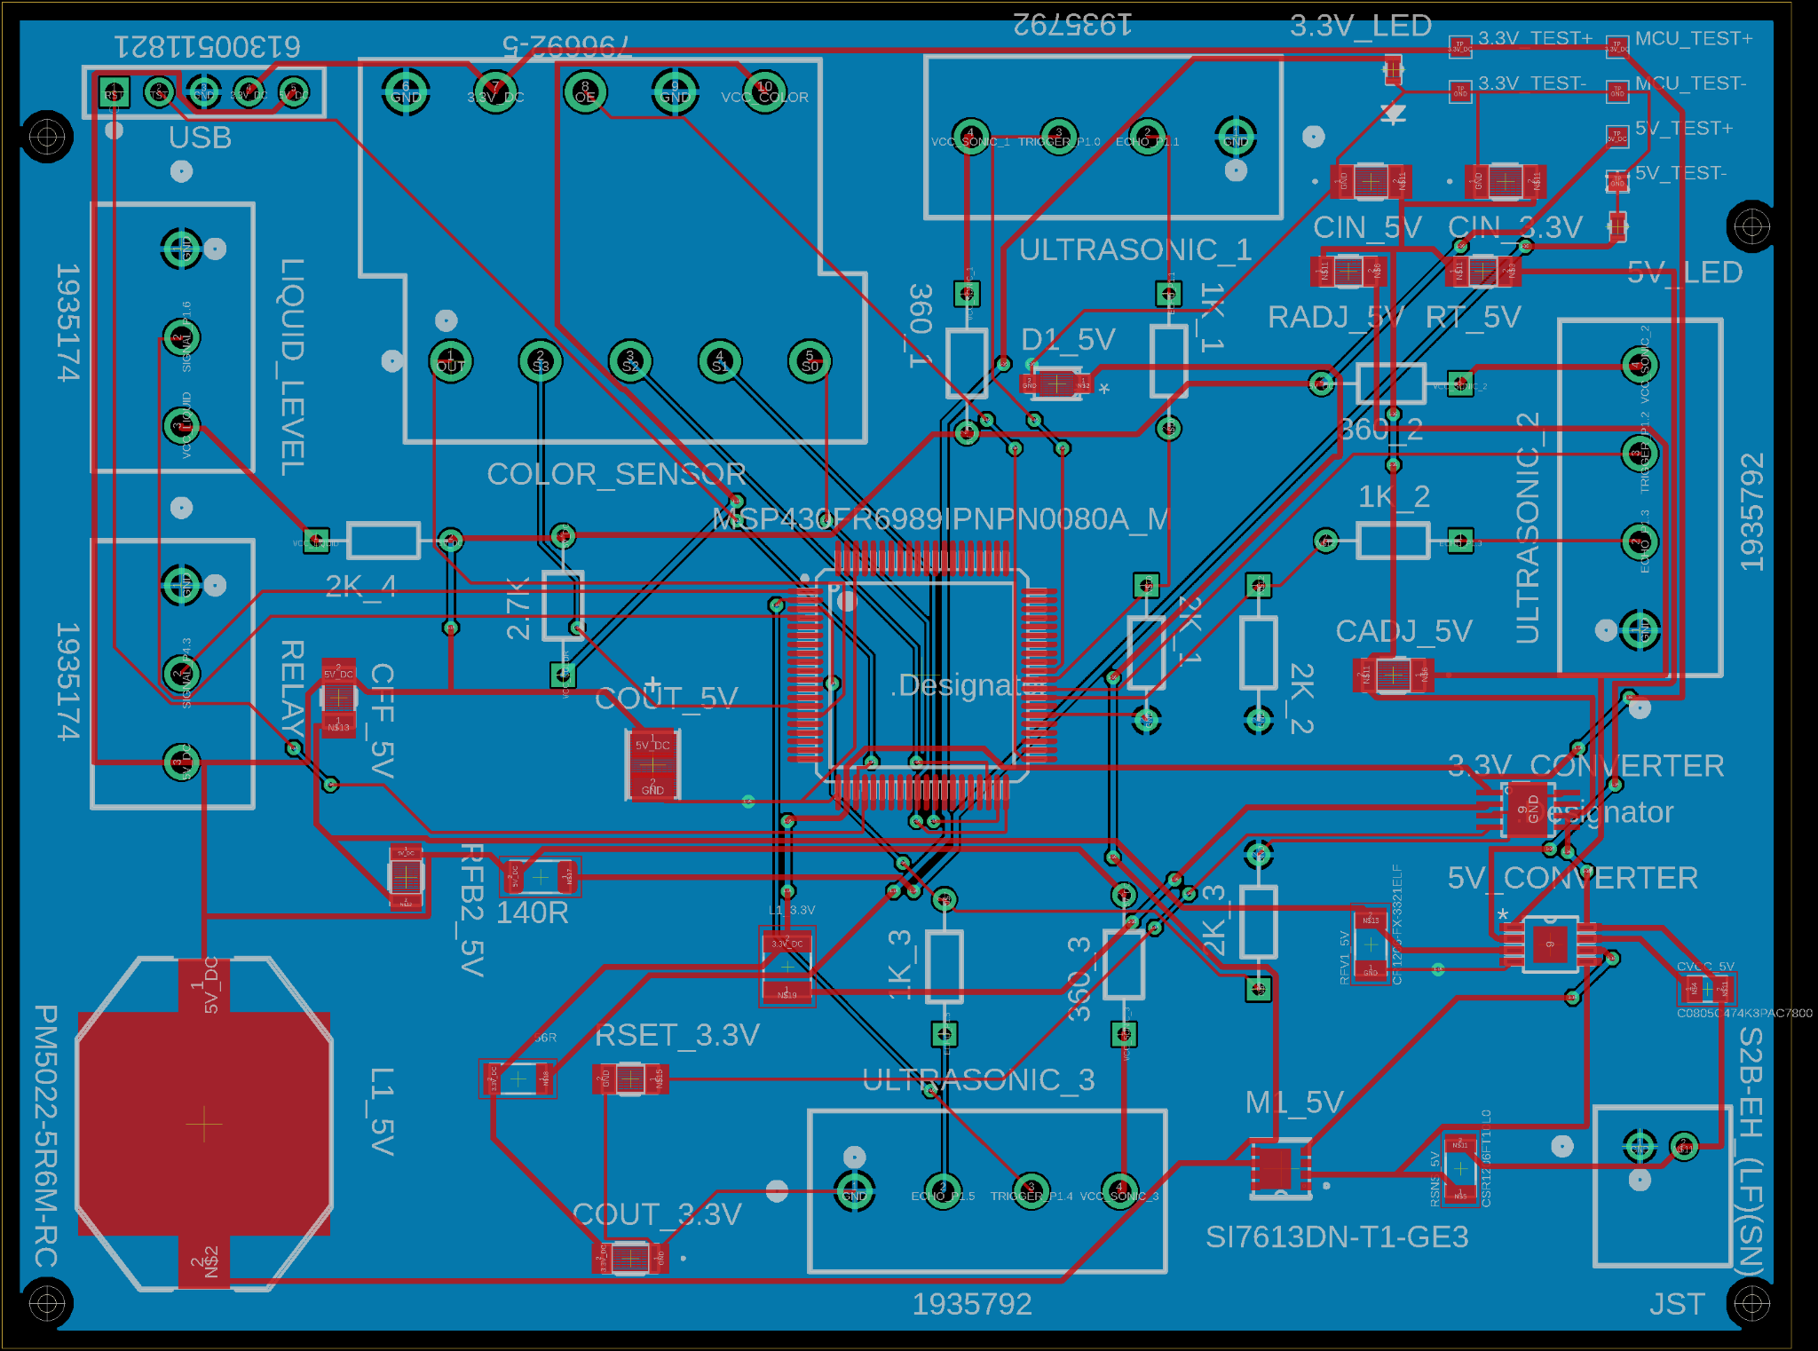

The first image of our overall schematic shows the two convertors and our MCU connected to the headers. We utilized screw down headers to extend out our sensors so that it can reach outside the edges of our robot. The converters were created with the specifications of TI’s webench. This tool allows input power parameters to be entered and it gives out circuit topologies and convertors that can achieve the desired goal. The designs rank from efficiency, price, and small footprint sizing. One challenge here that was propelled by covid was that many converters were not readily available, so the best rated and effective converters were not accessible.

Lastly with the board design it shows the routing of all the lines and where everything is set to go to. One other key component is the blue square around the board design. This represents the grounding plane which we constructed. For an earlier PCB design, we had no grounding plane and because of that we did not have any power working on our board due to a lack of proper grounding. With this final design we ensured a proper grounding plane was placed to avoid any issues of not grounded components.

1. *Conclusion*

Throughout this paper we as group 9 have demonstrated and detailed our autonomous sanitation robot. Starting with our introduction and design summary we detailed all the ideas, motivation, and deliverables of our robot there. Following that we broke down all the components and modules used in our project. Each component was selected after thoroughly comparing many similar products in its field and market. Each component plays a necessary and integral part in our project as if one is not working to its specific nature than many other dependent systems fails because of this

Following this was a breakdown in the standards that need to be followed when dealing with this project. There are many standards that expand upon many fields. Along with standards are some constraints that were imposed upon a project of this nature. There were many constraints, but the two biggest ones associated with the autonomous sanitation robot were the financial and Time as well as the environmental. Following this there was a breakdown of the subsystems and how the individual pieces of this project work together along with the software’s design. Finally, there was the PCB design section where there was the highlighted understanding and struggles that came with designing the final PCB board implementation for the autonomous sanitation robot.

In all, the autonomous sanitation robot is a product that is extremely useful and prominent given the times we are in and will continue to be moving forward. It has a great positive impact on society and a project that can be innovated upon to create newer applications to help associate society.

1. *Biography*

**Abel Assefa** is currently a senior at the University of Central Florida and will be graduating with a Bachelor of Science in Electrical Engineering in December 2021.

**Shawn Manohar** is currently a senior at the University of Central Florida and will be graduating with a Bachelor of Science in Electrical Engineering in December 2021.

**Rishi Patel** is currently a senior at the University of Central Florida and will be graduating with a Bachelor of Science in Electrical Engineering in December 2021.

**Allan McCormick** is currently a senior at the University of Central Florida and will be graduating with a Bachelor of Science in Computer Engineering in December 2021.

1. *References*

[1] Embedded School. “Different types of Microcontroller Programming used in Embedded Systems.” Types of Microcontroller, https://embeddedschool.in/different-types-of-microcontroller-programming-used-in-embedded-systems/. Accessed 2 8 2021.

[2] MCL PCB. “Guide to IPC Standards for PCBs.” PIC Standards for Printed Circuit Boards,

https://www.mclpcb.com/blog/ipc-standards-for-pcbs/.

[3]Geeks for Geeks. “The complete History of Java Programming Language.” The complete History of Java Programming Language, https://www.geeksforgeeks.org/the-complete-history-of-java-programming-language/.