**Sign Language Display**

**The University of Central Florida**

***College of Optics & Photonics***

***College of Engineering & Computer Sciences***

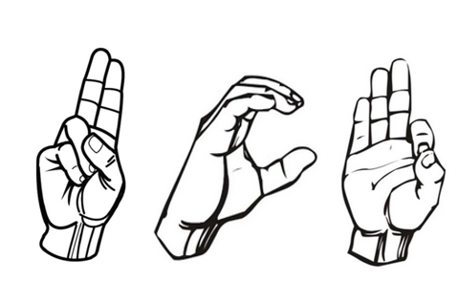

**Initial Project Documentation**

**Senior Design I**

**Dr. Lei Wei**

**GROUP 3**

Keonni Adams - PSE

Lens Kongolo - EE

Miguel Cordero – CPE

Olamijide Kayode- CPE

Table of Contents

1. Project Narrative Description ……………………………………………………… 3
   1. Project Description and Goals …………………………………………. 3
   2. Project Motivation ……………………………………………………... 3
   3. Project Function ……………………………………………………….. 4
2. Requirements Specifications ………………………………………………………. 5
3. House of Quality …………………………………………………………………... 7
4. Project Block Diagram …………………………………………………………….. 8
5. Project Budget and Financing ……………………………………………………… 9
6. Project Milestones …………………………………………………………………. 10
7. Project Considerations ………….………………….………………………………. 11
8. References …………………………………………………………………………. 12
9. **Project Narrative Description**

**Project Description and Goals:**

The purpose of this project is to create a connection between deaf people speaking sign language and others who do not. There exists several translation devices and service for most known languages, our goal is to create a device which can be used for translating sign languages. We plan on creating a wearable glove which will be used to sign the alphabet using a combination of flex sensors, force sensors, an accelerometer, and software (most likely using AI) to create a device which will translate the American Sign Language alphabet to visual letters. The implementation of photonics would be incorporated into our design by building a projector from the ground up. For the projector, different light sources are being investigated to create the image needed to be displayed and are mostly interested in using a blue laser as the light source.

The goal for this project is to create a mechanism which translates sign language swiftly and correctly. The margin of error required for the project needs to be minimal with a 95% level of accuracy. The reason for such percentage is because the device could be further implemented to accommodate the translation of different types of sign languages, although this would not be accomplished during the completion of the project due to various factors like costs and time.

Another goal for this project is to ensure the device is energy efficient and cost effective. Energy efficiency is very important, as the glove is designed to be powered by a battery source, the source needs to last for a few hours to allow for the translation of the language. If this is not possible, then the glove loses its efficiency and value. As for efficiency in terms of the projector, it must be very efficient because the projector needs to connect automatically to the gloves to gather the information needed to display to the viewer or user. To do so, the consumption of energy needs to be taken into consideration, as users do not want to utilize equipment that consumes a lot of energy and is not cost effective. There is a personal reason for the device to be cost effective because we are funding this project on our own without sponsorship. There is also a practical reason which goes back to us wanting to create a marketable device, and production price is always a strong factor. Our final goal is to create a glove that is comfortable to wear and when used, allows for a clear and seamless translation from the glove to the projector.

**Project Motivation**

The motivation for this project began with the discussion of various project ideas. The ideas revolved around the idea of helping people in one form or another. After various considerations and thoughts, the discussion of the deaf community came to mind. One of the team members came up with the idea of learning of rare and important skill which is sign language. It did not take long before the realization we have all come across a situation where we tried to communicate with someone of a different language and how difficult it was to get information across. Then did the thought of how hard it must be for someone speaking sign language to be in those type of uncomfortable situations. We originally wanted to build a project which would translate speech to sign language and display that to an LED board. But this seemed too simple and unchallenging. This idea was not also a good enough project for the photonics member in our team, as it did not incorporate the requirement needed from her department. After further discussion we came across projects that created a glove which could be used to translate live sign language to text. We researched this and concluded on making our own version of this project. Our team also wanted to make this a big display, for anyone to be able to read, this way the person speaking (in sign language) could talk to an individual or a large group. We hope to create a device that represents the deaf community, to give them a platform for their voice to be heard.

**Project Function**

The function of our project will be live physical sign language being translated to text and then displayed for all to see through a team-built projector. The glove should be made of strong and durable material to hold the electrical components without tearing or falling apart. The glove also needs to be comfortable and flexible in order to allow an easy maneuver of the user’s hands when they are making the hand gestures. The plan for our project is to use a mixture of sensors combined with AI software to accurately capture the sign language letters. Flex sensors will be used to determine which fingers are being bent and to what degree. These sensors will have varying resistance depending on how they are bent, and this input will be used to help determine which letter is being signed. We hope to also implement the use of an Accelerometer, gyroscope, or both. This implementation will even more accurately help determine which letter is being signed as it will record any movement that the hand makes while wearing the glove. The accelerometer will be more used for large gesture or if the whole hand is twisted or moved to another position. Since the flex sensors will learn finger movements, we do not plan on using the accelerometer to determine fingers movement.

We are also looking into force sensors to help distinguish more letters, some letters in sign language are very similar and have small differences. Force sensors send input when the sensor is pressed, and if we accurately place these in touch hotspots then our results can be more accurate. All of these components will be connected to a PCB which we plan on having installed directly on the glove. The PCB will carry most of the electrical components which will receive the inputs. Our project device should take the movements and finger placements as our input, this input will then be translated by software in our MCU into text. The text will then be displayed through our projector device. Both the glove and the projector will communicate via Bluetooth to have a wireless connection. The concept is someone who owns the glove can connect to one of our compatible projectors to display the sign they made. If time permits, we would also like to update our projection device to have a speech to sign language functionality, this way the deaf party can use the glove to speak and then translate, and the other party can translate a spoken language and then have the sign language equivalent projected.

1. **Requirements and Specifications**

**Requirements**

This project requires having a glove as the input to be connected wirelessly to a microcontroller which connects to a projector that would display the desired output. The glove is required to have an accelerometer and seven flex sensors. The accelerator is needed to accurately measure the hand’s movement. Five flex sensors would be on each finger to detect motion and the two other sensors would be for tilting and rotating. These sensors would detect precise signals from the hand’s movement while avoiding any distortion. The detected signal would then be processed by a microcontroller on the glove. The glove’s microcontroller would transmit the processed data via a Bluetooth or Wi-fi module to the projector’s microcontroller which is going to process the data received through a built-in software (Python). When the data is processed by the microcontroller, it would be able to send the information via HDMI to the projector to display the correct output. Our team chose to build an LCD projector that would consist of three colors red, green and blue (RGB). The RGB LCD would be combined by a light source through a prism and a filter to get a colorful image that can be viewed on the clear projected screen. This display setup will utilize back projection, which means that the images produced would be inverted. The projector lens requires to have a short focal length to project a clear image on a screen that will be within 5 feet from the lens, for that reason a short throw lens will be incorporated. The light source within the projector is a blue laser that should produce an image that is luminous enough to view under the circumstance of standard ambient room lighting.

**Specifications**

**Glove**

* **Premium leather resistance:**
  + **Large**
  + **Comfortability**
  + **Flexibility**
  + **Thickness**
* **Power source:**
  + **Battery:**
    - **Input 3.3 to 5V**
    - **Lithium ion**
    - **2 to 3 hours duration**
  + **USB port:** 
    - **Input** **100 to 120V**
* **Accelerator:**
  + **3-axis sensing**
  + **3 mm × 3 mm × 1.45 mm LFCSP**
  + **Single-supply operation: 1.8 V to 3.6 V**
  + **RoHS/WEEE and lead-free compliant**
* **Flex Sensor:**
  + **Flat Resistance: 10K Ohms**
  + Resistance Tolerance: ±30%
  + **Bend Resistance Range: 60K to 110K Ohms**
  + **Power Rating: 0.50 Watts continuous. 1-Watt Peak**
* **MCU:**
  + **Low power**
  + **Advance sensing**
  + **RAM up to 256KB**
  + **Wi-Fi network processor**
* **Bluetooth Module:**
  + **3.5 x 2.4 x0.2 inches**
  + **3.5g**
  + **Input voltage 3.6 to 6V**
  + 2.4 GHz with RF communication

**Projector**

* Projector size: 15 x 12 x 8 inches
* Projection size: 15-16 inches
* Projector connection:
  + MCU:
    - Wi-Fi/Bluetooth
    - 2 USB 3.0 ports; 2 USB 2.0 ports
    - 2 × micro-HDMI ports (up to 4kp60 supported)
    - Broadcom BCM2711, Quad core Cortex-A72 (ARM v8) 64-bit SoC @ 1.5GHz and Gigabit Ethernet
    - Operating temperature: 0 – 50 degrees C ambient
* Power supply:
  + 100 to 240 VAC ±10%
  + 1.8 to 0.8 A
* Display Resolution: 1280 × 800 pixels
* Projection distance: 3-8 feet between the projector and the screen.
* Projector Light Source:
  + Blue Laser diode:
    - Normal Light Source mode:100 - 120V (173W)
    - Quiet or Extended Light Source mode: 118W
    - Wavelength: 440 to 460 nm
    - Light source life: Up to about 20,000 hours
* Short Throw Lens
  + Throw ratio = 0.38:1
  + F = 1.51 to 1.92
  + Focal length: 18.2 to 28.4 mm

1. **House of Quality**

Below in figure 1 is an engineering development tool named the House of Quality (HOQ). This tool incorporated both engineering and consumer tradeoffs which is useful in market considerations throughout the products system life cycle. This tool can be used in different phases of development; this HOQ was focused on requirement specifications for the initial phase of development. The axis of this tool incorporates the engineering requirements (Horizontal) and the consumer requirements (vertical). The plus and minus signs show each categories’ correlation to the product that would contribute a positive output in the perspective of each axis. The up and down arrows also show the correlations of each of the intersected categories.

*Figure 1: HOQ*

1. **Project Block Diagram**

*Figure 2: Block Diagram*

1. **Project Budget and Financing**

The project being worked on by group three will be financed by the students involved. The team will be splitting the total cost equally amongst each other. The current maxiwe have a maximum budget of $1000 amongst all four of us. We hope to not exceed that budget and will look for cost effective parts to stay within budget. We will not however comprise quality parts for lower cost, our main goal is to have a project that works correctly. Most of the materials needed for our project can be found on amazon or other sites at relatively low prices. The table below breaks down the main materials we know we will need from the start and includes a miscellaneous section to account for unexpected cost and materials. We understand that cost might be higher or lower when final design is complete. We are also ordering a few extra units for any components which may be faulty or burn out. Our goal is to build a cost-effective device.

|  |  |  |  |
| --- | --- | --- | --- |
| **Item** | **Retailer** | **Qty** | **Cost** |
| MCU 1 (For projector) | Amazon | 1 | $120.00 |
| MCU 2 (For Glove) | Texas Instrument | 2 | $3.48 |
| Flex sensors | Adafruit | 10 | $11.66 |
| Force sensors | SparkFun | 2 | $6.95 |
| Bluetooth Module | Amazon | 2 | $9.88 |
| Gloves | Grainger | 2 | $8.34 |
| Accelerometer | Adafruit | 1 | $11.95 |
| PCB | Pcbbuy | 5 | $26.0 |
| Projector Light Source  (Blue Laser Diode) | Amazon | 2 | $18.95 |
| Projector Lenses  (Biconvex Lens) | Surplusshed | 3 | $10.00 |
| Miscellaneous | Other |  | ~150.00 (may or may not be used, but can help account for unexpected shipping cost, or having to reorder any part) |
| **Estimated Total** | Various |  | $529.87 |

*Table 1: BOM*

1. **Project Milestones:**

In project management, activities need to be completed at a timely manner. The image below is a snapshot of this project and its list of tasks with a timescale, and individuals in the team responsible for the completion of the project.

*Table 2: Milestones*



1. **Project Considerations**

Fully Identifying and understanding what a project entails is paramount to deciding what project needs to be chosen. Gathering requirements by evaluating and prioritizing factors can be done via a decision matrix. This is needed as the decision to do this project must be based on several criteria. With cost and time being the most important factors. For this matrix, a rating scale for each criterion is established:

Other factors taken into consideration are Sponsorship, Experience/Familiarity with the project, Social Value, Motivation and Educational Role.

A rating between 1 to 9 was chosen, with 1 being the worst, 5 being moderate and 9 the best. After careful considerations, the Sign Language Display was chosen as the lead project for the group.

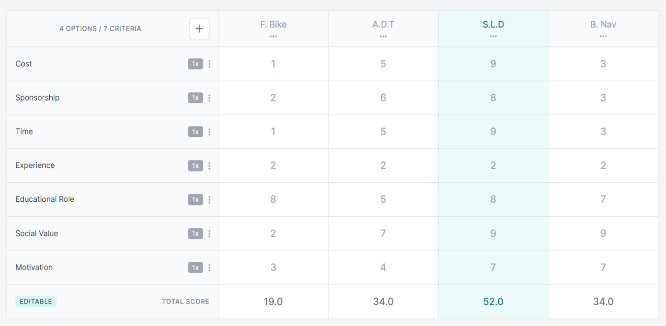

Figure 3: *Decision Matrix*

1. **References**

Decision Matrix Design:

<https://app.ruminate.io/d/Op5MPeEX7vkFtNvTHVdiOw>

Raspberry pi 4 Specification:

<https://www.raspberrypi.org/products/raspberry-pi-4-model-b/specifications/>

LED, Jderies-3030, Specification:

<https://cree-led.com/media/documents/data-sheet-JSeries-3030.pdf>

Choosing the right accelerometer:

https://learn.sparkfun.com/tutorials/accelerometer-basics/all

Hardware components

https://www.ijariit.com/manuscripts/v5i2/V5I2-1407.pdf