**ASL Motion to Text Projection**

Keoni Adams, Lens Kongolo, Miguel Cordero, and Olamijide Kayode

Dept. of Electrical Engineering, Computer Science, and Photonics Engineering, University of Central Florida, Orlando, FL, 32816-2450

***Abstract –* The goal of the American Sign Language Motion to Text projection is to design and create a device which will be useful in the teaching/displaying of sign language as it is being done. The group hopes to accomplish this by design a two-part project including a glove with data capturing sensors and a low energy LED projector to display the sign language to text translation. The glove will be designed with flex sensors, force sensors, and an accelerometer to produce strong datasets. In order to achieve sign language to text translation the group will use machine learning algorithms to receive data and make a prediction. This prediction is what will be transmitted to the projector and then displayed. The goal of the projector is to be an integrated light device which will work directly with the glove. The group envisions this being used in classroom settings, small group learning, and with advancement in technology being able to be used as a bridge for communication.**

***Index Terms –* Microcontrollers, Machine Learning, Lenses, Sensors, Printed Circuit Board**

I. INTRODUCTION

American Sign Language Motion to Text Projection is a project which will use a worn glove to translate sign language in real-time and then display it for a large group/crowd. The overall design of the project can be broken down into three areas of work. First there is the hardware involved with the glove, the glove will have sensors affixed to it which will be used to create data. The sensors include five flex sensors for each finger, one force sensors, and a gyroscope/accelerometer. These sensors will then be all connected to a PCB which will house the microcontroller unit which is necessary to gather data. There will also be a Bluetooth module connected the PCB and a wireless power source in order to create a wireless device.

The second area of work is the software which is necessary to translate the raw data from the sensor into a gestured letter. For this project the group chose to implement machine learning algorithms and software. The third area of work is the output device, which will be designed as low-powered light projector using a combination of mirrors and lenses to project the translated output.

The project objective is to design a complete device which comes ready to be used in a learning/classroom environment. The group has always envisioned it as a traveling classroom to help teach ASL and create awareness towards the Deaf community. For this project the goal is to be able to translate the ASL alphabet gestures to the corresponding letters. The future goal of this project is to be able to do words and sentences.

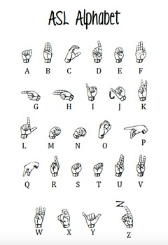

Fig. 1. The asl alphabet which ASL motion to text projection will translate from live gestures to projected text

This device is not designed to be a way for a deaf person to speak to someone, but rather a way to make learning ASL more interactive and readily available for everyone. The group considered this to be a device to help the deaf communicate, but past research has shown that devices like these will not make communication easier with the current sensing technology, but in-fact can make it more difficult for a deaf person to communicate [1]. If there is ever further advancement in sensing technology which can learn to interpret body language/facial features this can be applied together to one day be used as a communication device. For this reason we see our project as a learning device.

II. GLOVE DESIGN

The design for the glove includes five flex sensors, one force sensors, and an accelerometer/gyroscope component. These sensors are all connected to a PCB and their data values are received by an MCU. There is also a Bluetooth module connected to the PCB which will be used to transmit the data values to the PC being used for translation, this will be the projects wireless communication aspect.

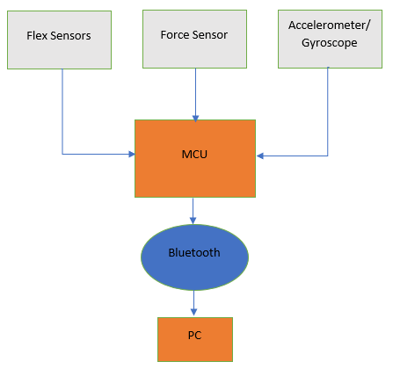

Fig. 2. Overall Diagram of the glove design which shows how sensors communicate with MCU which then uses Bluetooth to wirelessly transmit data.

*A. Flex Sensors*

ASL gestures involve different position and bending of the fingers for different letters/words. The group needed to find a way to translate this into data which would vary depending on the bend of the fingers. A few technologies were considered from using light sensitive resistors, potentiometers, conductive sheets, and flex sensors. The group decided to use Spectra Symbol flex sensors because it is a reliable device which has been used in large scale projects like the Nintendo glove for instance. Datasheets and circuit examples were also available for these flex sensors making them the best choice for our project to achieve optimal results. Most of the other technology would need to be designed as well and could cause issues due to overall time constraint of the project. These flex sensors were available in two sizes, being 2.2in and 4.5in, for this project the group chose the 4.5in sensors because most fingers are longer than 2.2in. There was a flex sensor from bendlabs available but these were significantly more expensive per sensor and would blow the budget. These sensors however would possibly produce more sensitive bend detection.

The way the Spectra Symbol flex sensors gather data is by varying resistance as the sensor is bent. For these flex sensors the resistance ranges from 60K-110K ohms. The change in resistance then changes the output voltage according to ohms law. The change in output voltage is the data which will be collected from the flex sensor to represent a change in bend. Different bend angles will have different voltages, resulting in a finger bending simulation. These values ranged from 2.2V to 4.4V on average, being the more the bend the lower the voltage value. During testing the group made observations for different bend angles to determine if the sensors were working properly. For this project the design required five flex sensors to create data for each finger.

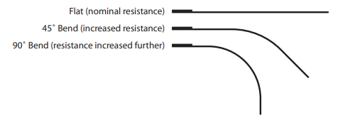

Fig. 3. Expectation for how the change in bend angle should affect the change in resistance.

*B. Force Sensors*

In ASL there are a few letter gestures which cannot be distinguished by the bending of fingers alone when looked through a data perspective, the letters U and V for example. In order to help build stronger datasets the group decided to add a type of sensor which could detect a change in touch/force. The concept would be that adding areas where touch data is gathered would help distinguish more gesture for some will have touch contact in certain area while others won’t.

The group researched load cells, strain gauges, and force sensitive resistors. While each of those technologies would work in theory, the most useful for this project design was the force sensitive resistor. Primarily because FSR are able to detect even the small change in force and are thin and flexible. Being that the glove for this project would be worn and performing several different gestures, the lightweight and flexibility of FSR were essential. The group ordered the Interlink Electronic Force Sensitive Resistor Sensor. The group decided to only implement one but were open to using more if prediction accuracy was low.

When not being touched or applied force the force sensor outputs a very small value ranging from 60-200. Once pressure is applied the sensor output jumps significantly, with light touch creating values in the 2000’s, with a high of 4095 depending on gravity of the force being applied.

*C. Accelerometer/Gyroscope*

Accelerometers and Gyroscope are essential for designs which require to detect change in movement and also change in orientation. For this project including and accelerometer or gyroscope would help in first create better predictions for the gestures being used in this project; secondly allow for future implementation of this project to predict words or phrases. The tilt function of the accelerometer is mainly used to detect the change in activity of the hands in order to achieve a low-power consumption during the short duration of dynamic accelerations. The accelerometer detects an event based on a trigger of event anytime there’s a change in the tilting of the hands.

As for the gyroscope, it is used to measure the rotation of the hands along the axis and produces a positive going digital output for counterclockwise rotation via the process of applying a defined angular velocity. The gyroscope is quite sensitive, and values detected change very little over time and temperature.

We had planned on using the ADXL377 at first, but we couldn’t find the library required for it to run in conjunction with our MCU, so we chose the SparkFun 6 Degrees of Freedom Breakout-LSM6DO (Qwicc) because of the one specific feature that the LSM6DSOX board did not have. This was the Qwicc 4-pin connector with a 1mm pitch which helped reduce soldering time and space on the PCB, as well as providing a polarized connection, thus preventing the ability to hooking the gyroscope/accelerometer wrongly. This breakout board is a protégé of the LSM6DOXTR and uses the same I2C serial interface with the same standard connections, GND, VCC (3.3V), SDA and SCL. The voltage range for operation is between 1.7 and 3.6V and works in both low-power and high-performance mode. Although we needed the breakout board for its rotational and tilt function, it allows for detection of other applications other than motion or tilt. Such examples include shocks, temperature and taps/steps.

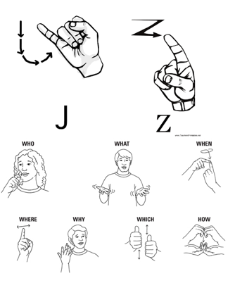

Fig. 4. Example of J and Z requiring motion (which this project will need to be able to predict) and some phrases which also require motion

*D. Microcontroller*

All the sensors for this project would require a processing unit to receive the data being created by them, and also send the data out to the machine learning model. A microcontroller was the obvious choice to accomplish this. The microcontroller’s main purpose in this project would be the first test each component and verify they are sending the expected output. The microcontroller would receive the data values from the five flex sensors, force sensor, and accelerometer and gyroscope simultaneously. The microcontroller is also responsible for connecting to a wireless communication device (*Bluetooth discussed in section E) and transmitting the data values to a PC.

For this project the group chose to work with the msp430 MCU considering that several of the team had worked with this MCU in the msp430fr6989 development board for previous coursework. The team had a total of 4 development boards on hand allowing for immediate testing and prototyping when ordered parts arrived. Also, this allowed for a smooth transition from prototyping with breadboard to final product with PCB.

There were a few MCU’s considered for this project. Initially the group wanted to use the CC2652RSIP MCU because it had integrated Bluetooth low energy. Using this would eliminate the extra Bluetooth component. However, there were not enough readily available documents and datasheets for this MCU, being why the group went with their second choice, being the msp430.

*E. Wireless Communication*

ASL motion to text projection project is expected to implement wireless communication across the design. The goal is to create wireless communication between the glove and the PC doing the prediction and between the PC and the projector. The group decided this was very important because of the popularity of wireless devices.

There were several forms of wireless communication considered for the project, including WIFI, Bluetooth, and infrared. WIFI and Bluetooth were the most desirable for the project, but the group ultimately decided on Bluetooth because it provided sufficient security, worked at enough of a distance required for project specifications. Bluetooth was also very desirable because the group initially planned on using an MCU with integrated Bluetooth. Even though the projects final design used a different MCU the group was able to find the HC-06 Bluetooth module readily available. The Bluetooth module would be connected to the PCB on the glove and send data received by the MCU to the PC.

Wireless communication is also being implemented from the PC to the projector. WIFI communication is used for this portion and is discussed later.

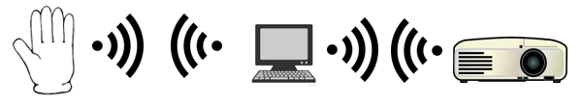

Fig. 5. Expectation for glove communication with PC and PC communication with Projector.

*E. Power Source*

Three power sources were implemented to accommodate for each instances the board can and would be used. The PCB can be powered on via a DC jack, two AA 3.7V batteries and via the eZ-FET emulator from already existing launchpad or MSP-FET.

For the DC Jack, a minimum of 6V and maximum of 12V is needed to power on the PCB and was our last resort after numerous time and effort was wasted on the research and design of customized power supply circuit with a minimum input voltage of 3-5V. We tried using the TI WeBench Power Designer tool to create our power supply circuit, but the integrated chips needed for the designs to work were not readily available on the TI’s website. We reached out to a TI representative, but their response time was not the fastest, so we opted to use the AMS117 5V and 3.3V regulator instead, and it was readily available to buy from the Amazon website.

Fig. 6. Schematic of the Power Source for the PCB.

These regulators require a minimum of 6V to power the PCB and other components. Hence the use of the second source of power, the two 3.7V AA batteries. This was chosen as it was the lightest, and most compact battery that could fit on a battery holder which is housed in the PCB, hence making our whole glove compatible and giving the PCB the ability to be an all-in-one package not requiring any form of external connections to power on. The 2 AA batteries when combined provide 7.4V which is within the input range and provide a capacity of 3000mAh, at 1000mA consumption rate, the PCB would last for about 3hrs before its need to recharge. The third source as explained earlier in the PCB design section is via a microcontroller or FET/JTAG emulator which feeds 5V or 3.3V directly from pin headers assigned to the TI Launchpad’s emulator found on its datasheet. When the PCB is powered on via the emulator it bypasses the need for a minimum current of 6V but instead supplies 5V to power up the MCU, Bluetooth devices, gyroscope, and sensors, if using the 3.3V from the emulator some devices requiring a minimum of 5V wouldn’t turn on.

*F. Printed Circuit Board*

The board was fabricated with a common grade Flame Retardant woven glass reinforced epoxy resin, it was designed with 2 layers (top and bottom) to allow for easy crossover of the traces, and wiring.

The board was designed without an eZ-FET emulation due to the cost of materials and design. After multiple research it was identified that the board could be powered on via an existing emulation tool, and in this case the MSPFR4306989 and MSPFET430UI were used in sending the data from the computer to the PCB board. This was specifically chosen to be designed this way designed this way to allow the PCB to utilize the best functionality technology there is for easy debugging and communication with the PC via EnergyTrace++ Technology. The MCU in the board has a non-volatile memory, and wouldn’t require data to be sent every time the PCB is plugged in, hence again, the nonrequirement for the design of the eZ-FET emulator, especially since the PCB would be mounted on the glove, and the user might be far away from the PC.

The minimum footprint used for each component was 0805mm2 to accommodate for easy SMT assembly and soldering to the planes of the board. Multiple GND, 5V and 3V3 pins were incorporated in the board for easy accommodation of other parts that can be implemented to the board, e.g. Bluetooth Module, Gyroscope/ Accelerometer, and other components like a USB to Serial Adapter if trying to communicate with another PCB. The overall dimension chosen for the PCB was about 2.5” x 2.5” to enable it to fit perfectly and comfortably on the back of the hand when the glove is worn.

III. SOFTWARE

For the ASL motion to text projection project software is a very important portion of the design. There are three main areas of software for this project, first being the embedded software to program the electrical components which will be used for data. Secondly, this project implements machine learning which needs to be programmed and trained with a large dataset. The third area is the creating of an API which will be able to use the machine learning model with real time data and make a prediction, this will also be used to display the predicted letter for the gesture.

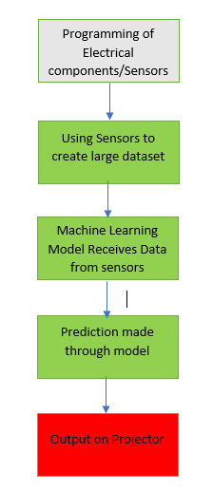

Fig. 7. Block Diagram of Overall Software for ASL motion to text projection

*A. Embedded Software*

For the PCB to communicate with the PC and other components required for the glove, a program had to be written. We decided to go with the use of a Energia over the traditional software integrated IDE by TI, as it was easy to modify the sketches and configure the pins and variants needed for our PCB to work. Energia is an open-source platform start supports easy prototyping of electronics. The code written to get the data registered by both the flex sensors and force sensors, as well as the gyroscope was easily implemented in Energia.

A serial communication between the PC and the board was established via USB at a baud rate of 9600, and the analog readings of the input values generated by these sensors were gotten. These readings were mainly the voltage values of the sensors and the rotational and gravitational axis of the gyroscope/accelerometer. The readings would be needed as raw data for the machine learning to take place for it to generate the right values for the letters to be projected. The values are finally transferred via the Bluetooth module through the backchannel UART (TXD and RXD) via a different serial/COM port to the terminal where the machine learning algorithm takes place.

*B. Machine Learning*

Machine learning is a very important part of the overall software design of this project. The group decided they did not want to hardcode values for the letters for two reasons, first it would be very time consuming to find all the possible values a gesture could have (a bend of the finger will create similar values, but they will be off by a few decimal values, hardly ever exact), secondly machine learning allows for a device which can learn a large library of possible outputs. The goal for the machine learning model is to use a large dataset representing the 26 alphabetical letters and learn which values may represent a certain letter. The machine will take a portion of this data to train on, and then the remaining portion to test its accuracy. When a model results large accuracy numbers it is considered to be well trained.

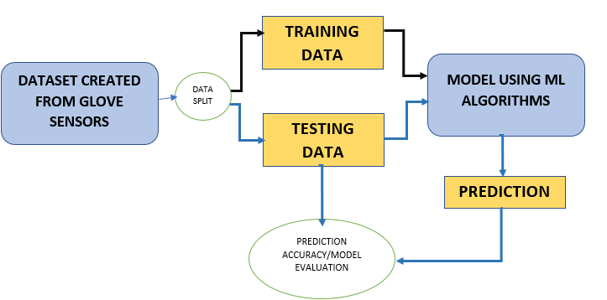

Fig. 8. Block Diagram of how machine learning is expected to work in the ASL motion to text projection project.

There were several options the for the group when it came to machine learning algorithms. For the data being provided and the output expected the project required a classification algorithm. The group considered neural networks, naïve bayes, support vector machine, and random forest algorithms. The final decision came down to accuracy and necessary computation power. The group decided to use SVM for the project, because it met the needs with not as much computation power as neural networks. SVM works by finding an optimal hyperplane which can separate the data points into classes. SVM can be used for both regression and classification problems.

What makes SVM useful as well is that even though it natively does binary classification, there are ways to make it work for multi-class classification, while still achieving high accuracy scores. SVM also uses kernels which is useful because not all data is linear, this allows for more complex datasets to still receive high accuracy prediction. In this project the linear kernel provided the best accuracy, after testing all of the others as well.

In order to achieve multi-class classification with SVM the program can implement either one vs one (ovo) or one vs rest (ovr). Depending on the type of data and complexity of it, these different implementations will vary the accuracy score. In ovo each one class is compared to one at a time, and then the prediction is made. So, there will be a larger number of comparisons. In ovr there will be one class compared to the rest of the data, essentially less comparisons. The project needs were best met with ovo method [2].

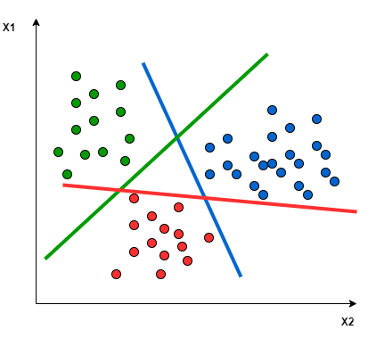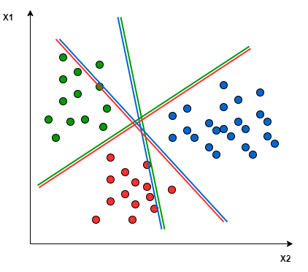

Fig. 9. On the left on vs one, and on the right one vs rest.

The machine learning algorithm SVM uses supervised learning because the model is fed input data and expected output data. Creation of the dataset was a very important step in the project. The dataset would include data from all flex sensors, the force sensors, and x, y, z values from both the accelerometer and gyroscope. The dataset also needed to be large enough that the ML model could be properly trained and tested. Since the team would be working with 26 possible outputs each member worked on creating a portion of the dataset. The process involved gesturing the specific letter and receiving the values via Tera Term. This data was then cleaned and organized, and each associated with the specific letter using a number. For example, the letter A would be represented by 1, B by 2, and Z by 26. Once enough data values were collected per letter the team moved onto the next one. Everything would be stored in excel file which could be easily converted into a .CSV file for our model to read from.

Many programming languages are used for different machine learning and AI projects, finding the right one for this specific project and team was very important. From early on the team considered Java, Python, and C#. These languages have all been used for machine learning and have libraries and resources available online. The team ultimately decided to work on the machine learning in python because of its extensive libraries AI/ML, its ease of use and user-friendly syntax, and because python is the language mostly associated with any AI project. Anaconda and Jupyter notebook were used for writing the machine learning software for this project. Jupyter notebooks is very user friendly and included libraries which were very useful to visualize data and results.

*C. User Interface*

For this project the team wanted to show how the data that is being received and what prediction is expected for the projector to display. The group decided the best way to do this was using Python flask. Using flask would allow for simple web app development while also creating an API for the machine learning model the group created [3]. Our flask web application works by running an introduction page welcoming the user and inviting them to make a prediction. There will be a button which when pressed takes the user to the prediction page. In this page there will be a box holding the data values received and another box with the prediction made by the machine learning model.

The group decide to use a PC as the main system which would be running the user interface and making the prediction from the data received from the glove. We considered using a phone application but found it to be more convenient with testing and debugging using a web application. With flask it was easy to setup a port to receive the data being sent by the Bluetooth connection between the PC and glove.

The user interface is very simple because it is not the main output display for the project. The projector will be displaying the predicted letter so it can be seen by a larger audience.

IV. PROJECTOR

The projector that we have created utilizes short distance back projection. The reason for this type of projection is so that it can be used in a variety of spaces. If there is a power cord and a small table, it can easily be set up for use.

The projector consists of an LED that is behind and directed toward the LCD screen that is placed at the focal point of a lens that has a diameter and focal length of 5mm. The distance between the lens and the LCD would be the biggest factor in how large the projector would be, which is why a lens with such a short focal length was chosen. The then collimated image would be reflected in the path of two 30:70 R/T beam splitters and a mirror that would split the image into three identical images. The reflected images would then be directed toward three concave mirrors who also have a diameter and focal length of 50 mm. The concave mirrors then create the final magnified images on a trifold screen that is placed directly in front of it.

We initially wanted to use a small LCD with no backlight which is commonly used in projectors. Even though these are easy to find, there is no documentation for them, rendering them useless for this project. We decided to use a large LCD, we weren’t able to completely remove the backlight, but we were able to detach it and cover it. This change didn’t allow for a fully closed projector, therefore affecting the projectors projection strength. Even with these challenges, we were stable able to project onto the desired surface with enough clarity. Future improvement would be the figure out how to use the initial LCD allowing for a closed projector, allowing the light source to work better.

V. CONCLUSION

ASL motion to text projection project is looking to create an interactive way to bring the teaching of ASL to any place. The team was motivated by their shared desire to learn ASL and create more awareness for the deaf community. The project hopes to use a sensor embedded glove to make gestures which will be then translated to projected text via a light, energy-efficient, LED projector. Machine learning is necessary for the project translation. First the sensor values are too sensitive for hard-coding and they vary by the slightest change in bend. Second in future application of a project as this one there are too many words to hardcode them, machine learning allows the machine to learn and make prediction based off provided data. The team decided to use a projector for the output to show their knowledge with working with photonic systems, including LED’s, mirrors, lenses, beam splitters, etc.

Together every aspect of this project brings a ASL classroom to any location it is needed. Allowing for a traveling classroom if one will. The team sees ASL motion to text projection project as a starting point for a teaching/communication device, which one day can have more advance and complex features.

V. BIOGRAPHY

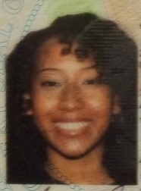**Keonni Adams**

**Photonics and Optics Engineering**

Keonni is a Photonics and Optics engineering student and will be graduating with a bachelor’s in science. She plans on pursuing developmental engineering for the Air Force or Space Force after completing her bachelor’s degree in Fall 2021. She has always enjoyed her lab courses that incorporated optics and laser technology and she hopes to carry that experience into weapon and space technology in the future.

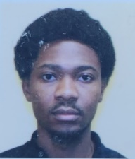**Lens Kongolo Ngoie**

**Electrical Engineering**

Lens is an international student at the University of Central Florida graduating with a bachelor’s in electrical engineering, born in 1993 in the Democratic Republic of the Congo. As a teenager, Lens enjoyed working in electrical projects in his country alongside reputed electricians in his city. Lens gained a passion for the electrical field; therefore, he decided to deepen his knowledge of the field. Lens took several classes in Electrical Engineering, which is his major, with a focus on power and renewable energy track. He enjoys designing and solving electrical circuits. Lens plans to work with clean energy companies after he gets his bachelor’s degree. One of Lens’s biggest ambitions is to bring back to his city, on a small scale, then to his country the knowledge he acquired to provide power even to the neglected areas so he can influence and motivate his generation and the generations to come to work together so that the country can have the most stable power it has never had in the past. He is hopeful for what he will bring to his family and community back home.

**Olamijide Kayode**

**Computer Engineering**

Kayode is studying at UCF’s College of Engineering and Computer Science to earn a Bachelor’s in Computer Engineering. He currently works at United Parcel Services in the Systems Engineering department as a supervisor. Although he has multiple years of managerial experience, he hopes to start a career in hardware engineering or electrical field after graduation. Kayode has a diverse skill set and is well versed with different programming languages both for software and hardware development, he is also experienced with embedded systems and in charge of ensuring the photonics, electrical and the software development parts of the project are in correlation with one another and can yield a seamless outcome.

\

**Miguel Cordero**

**Computer Engineering**

Miguel will be graduating with a bachelor’s in computer engineering. He has always enjoyed courses that involved programming and software. He hopes to start a career in software programming after graduation but is open to start in any Computer Engineering position after graduation. Miguel is currently in pursuit of a career to start applying his skills learned in university and also to learn on the field skills. Miguel is in charge of the machine learning software research and development. He has taken a course that worked with machine learning and has some experience with python. Miguel knows the software development for this project will be a challenge, but he believes it will be exciting and help with his career pursuit. Miguel will also help program the devices and sensors we will be using and is open to help in anything electrical. Miguel said he believes the biggest obstacle for him will be developing a well-trained machine learning model and has asked the group to be open to helping with concepts and ideas.

Acknowledgements

We would like to acknowledge Quality Manufacturing Services, for their PCB services and help mounting our PCB.

We would like to acknowledge amazon, adafruit, and sparkfun for providing supplies, fast shipping, and excellent customer service.

References

[1] M. Erard, "Why Sign-Language Gloves Don't Help Deaf People," *The Atlantic,* 09 November 2017.

[2] Pupale, Rushikesh. “Support Vector Machines(Svm) - an Overview.” Medium, Towards Data Science, 11 Feb. 2019, https://towardsdatascience.com/https-medium-com-pupalerushikesh-svm-f4b42800e989.

[3] “What Is Flask Python.” *What Is Flask Python - Python Tutorial*, https://pythonbasics.org/what-is-flask-python/.