**UCF Senior Design 1**

*UV Water Purification and In-line Monitoring with Spectroscopy*

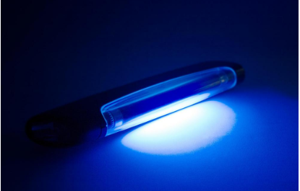

*Initial Project Document and Group Identification*

*Divide and Conquer*

**Group 5**

Kendra Kordack Photonic Engineering

Bradley Blackburn Electrical Engineering

Grant Cooper Electrical Engineering

Lucas Heredia Computer Engineering

**Project Narrative**

Having access to clean water and food are the very basic requirements for human life. Nonetheless, having a steady and reliable supply of them is a requirement for the development and maintenance of any civilization. The earliest evidence of humans filtering water is present in Sanskrit writings dating back to 2000 B.C. Back then water was filtered by exposing it to the sun, or by boiling it with fire, or by filtering using sand. Making sure the water was clean, was the most effective form of maintaining good health for its citizens and even today that is still true. Proper water cleaning is one of the most effective ways of preventing diseases.

Water filtering technology exists for a couple thousands of years, the demand for this technology exists for more than that. But even today in many places around the world, United States included, people don’t have access to safe or clean drinking water. Unclean water can carry bacteria, viruses, and many harmful pollutants. Most places use filtration systems to clean water, which are impossible to install in certain places, leaving people with little to no access to clean drinking water. Many people cannot afford this, and, in some places, there isn’t even a way to install a filtration system. On the other hand, chlorine systems can also be very expensive and using your own chlorine tablets can be tricky and lead to drinking harmful water. UV treatment can be more effective on certain bacteria that grows in water than any other water cleaning system. UV cleaning can also be inexpensive, using low powered UV LEDs or a UV light bulb. With the recent pandemic and fear of bacteria and virus infections and many other illness’s spreading, the inspiration to make a UV water cleaning system with in-line monitoring was unmatched.

After the water has been treated how do you make sure it’s clean? Most water testing methods are expensive, required trained persona, and can add chemicals back into the water. To deliver high speed and noninvasive water testing, Raman spectroscopy would be the best candidate for the system. Spectroscopy has been tested and shown that it needs minimum sample preparation, is non-contact, as well as, a good test for finding chemicals and microbial contaminants in water.

The system being built will have two filters and a UV treatment chamber. The first filter will be a sediment filter, which will filter out dirt, dust, and large particles. The second filter will be a carbon filter, the carbon filter will remove chlorine, taste, and odor. Finally, the water will be treating with UV light that will remove bacteria and scramble DNA of pathogens, no longer allowing them to reproduce. The Raman Spectroscopy will then be used to evaluate the water quality, showing if there are any microorganisms, inorganic and organic chemicals, for example, arsenic, cyanide, benzene, etc.

This product is similar in function to other water filters like LifeStraw. But those portable water filters do not work well filtering chlorine and heavy metals, hence will be able to work better by proving higher quality water. In addition, being powered by a solar panel, the system becomes very versatile. It is perfect to be used outdoors on hiking, fishing, hunting and other outdoor adventures. But it could also be used inside house where people may wish an additional high-quality water filtering system.

The system will also be reliable and intuitive to use. It will require very little maintenance, if any, and it will last many years filtering thousands and thousands of gallons over the years and the costumers will always be confident that the water is indeed clean.



**Specifications**



* Power source and Converter
  + The system shall feature a solar panel
  + The system shall not need to be charged using a standard wall outlet
  + Conversion from solar energy to electrical
  + Battery should last 8 hours once it is fully charged
  + On its first use the system should be able to gather enough power from the solar panel to turn itself ON in under 2 minutes.
* Microcontroller
  + The microcontroller must be able to handle the data from the spectrometer, and interface to it the display without lagging.
  + Must have enough data store spectroscopy data
* Water analysis
  + The system should use Raman Spectroscopy in order analyse the water
  + The water cleaned by the system must pass the environmental protection agency (EPA) standard
  + System should determine if Cryptosporidium is under acceptable levels
* Water cleaning
  + System shall feature sedimentary filter to remove particles up to 50 microns
  + System shall feature an activated carbon filter for 5 micron filtration and oder removal
  + UV source (lamp or LEDs) with wavelengths ranging from 185nm-254nm
  + Safety precautions in place to contain harmful UV light
* Water pump
  + Pump must be able have a psi rating of 60 psi in order to drive water through the filtration system
  + Must be powered by 12V DC
* Final water analysis
  + System must measure chloride levels in the water
  + System must measure mercury levels in the water
  + System must measure lead levels in the water
  + System must measure fluoride levels in the water
  + Determining what was removed from the water
  + Determine if water is safe to drink
  + Determine if water is not safe to drink
  + Determine if water can be cleaned
* Interface / Display
  + Small display mounted in the body of the filter prompting the user
  + Simple intuitive interface
  + Users should be able to learn how to use the interface without prior knowledge in under 5 minutes.
  + Display must show water chloride levels using a bar graph.
  + Display must show water mercury levels using a bar graph
  + Display must show water Lead levels using a bar graph
  + Display must show water Fluoride levels using a bar graph
  + Display must show water Lead levels using a bar graph
  + Display must show if some part of the system has a defect
  + Display must show that the water is coronavirus safe
* Price / Cost
  + The cost of all the parts plus the assembly shouldn’t exceed 600 dollars
* Dimension/ Weight
  + The system should be encapsulate in a case in shape of a cuboid or a cube
  + The system height should be under 75 cm
  + The system width should be under 75 cm
  + The system depth should be under 30 cm
  + Weight less than 10 kg
* System
  + The system should be able to process 1 Liter of water at a time
  + The whole cleaning process shouldn’t exceed 5 minutes
* Reliability
  + Should work for 2 years on average without requiring any maintenance
  + Should still be functioning if dropped from a height of 1.5 meters on a hard surface.
  + Should not be damaged if wet or soaked
* Extras
  + Should be easy to wash if contaminated

**Block Diagram:**



**Block Status: As of 5/27/20**

Currently we are in the researching stage of each block. Once proper research is collected, we will move into the design phase. No blocks have been purchased.

**Possible Design:**

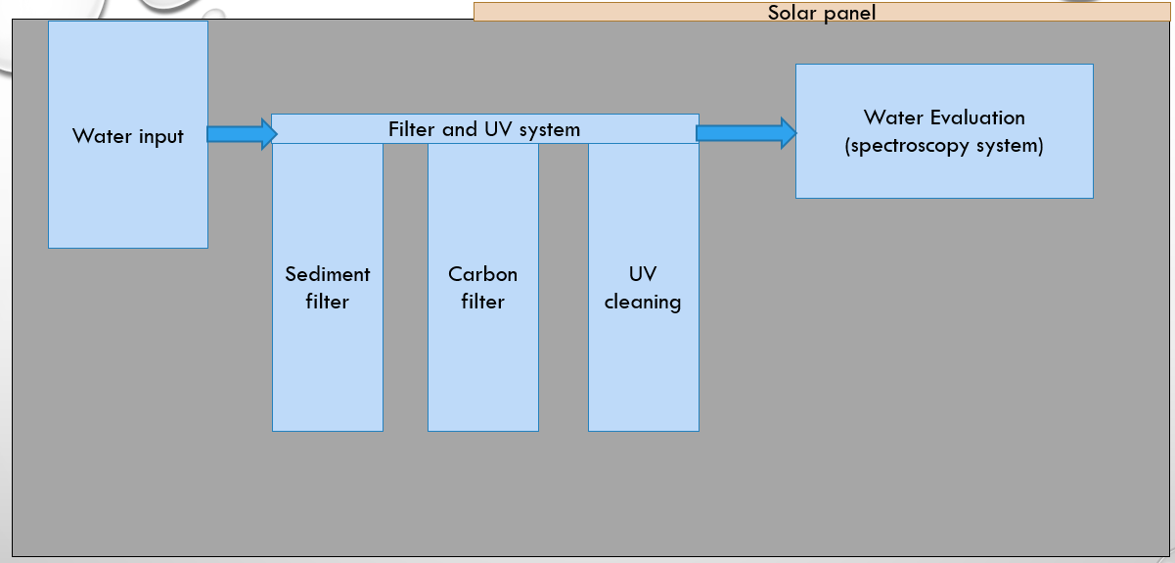

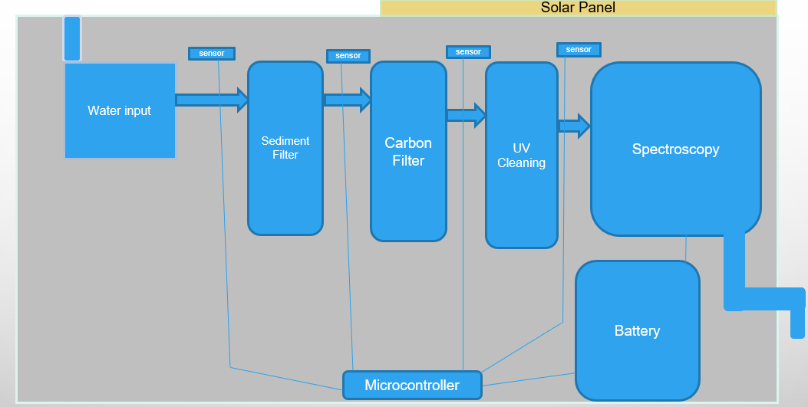

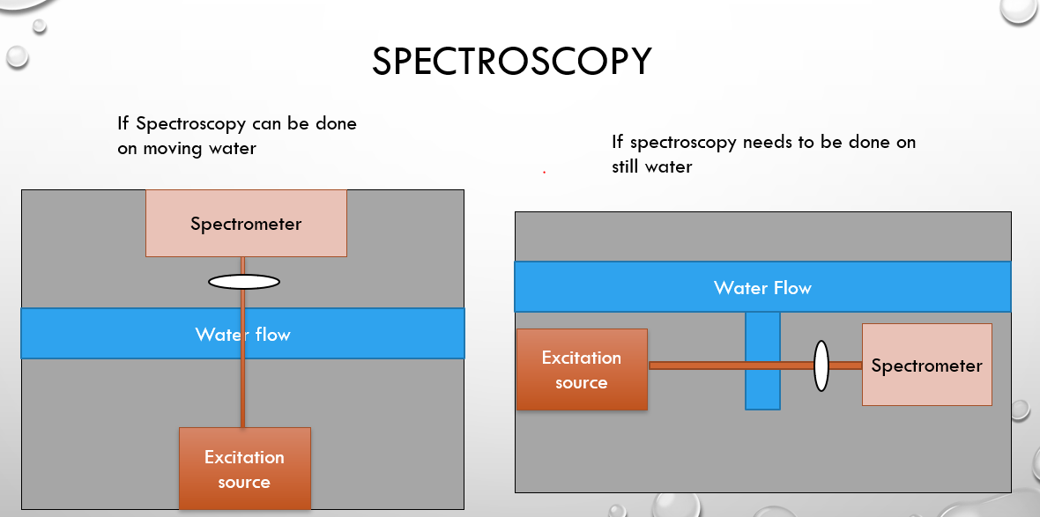

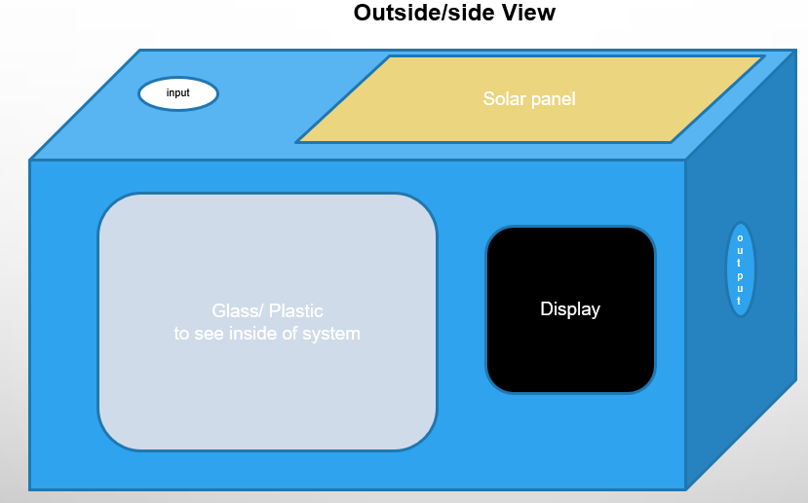

**Initial Project Milestones**



|  |  |  |  |  |  |
| --- | --- | --- | --- | --- | --- |
|  | Task | Start | End | Status | Responsibility |
| Senior Design I | | | | | |
| 1 | **Ideas** | 5/4/2020 | 5/20/2020 | Completed | Group 5 |
| 2 | **Project Selection and Role Assignments** | 5/13/2020 | 5/20/2020 | Completed | Group 5 |
|  | **Project Report** |  |  |  |  |
| 3 | Initial Document: Divide and Conquer | 5/20/2020 | 5/29/2020 |  |  |
| 4 | Table of Contents | 5/29/2020 | 6/5/2020 |  |  |
| 5 | First Draft | 5/29/2020 | 6/22/2020 |  |  |
| 6 | Final Document | 5/29/2020 | 7/16/2020 |  |  |
|  | **Research, Documentation, & Design** |  |  |  |  |
| 7 | Spectroscopy/water monitoring research | 5/20/2020 |  |  | Kendra |
| 8 | UV water cleaning source research | 5/20/2020 |  |  | Kendra |
| 9 | UV water cleaning chamber design | 5/25/2020 |  |  | Group 5 |
| 10 | Spectroscopy monitoring design | 5/25/2020 |  |  |  |
| 11 | Automated system design/research |  |  |  | Lucas |
| 12 | Spectroscopy interface research/design |  |  |  |  |
| 13 | Type of Filter Research | 5/25/2020 |  |  |  |
| 14 | Microcontroller | 5/25/2020 |  |  |  |
| 15 | LCD Display | 5/25/2020 |  |  |  |
| 16 | Final Design | 5/25/2020 |  |  |  |
| 17 | **Order and Test Parts** |  |  |  |  |
| Senior Design II | | | | | |
| 18 | **Build Prototype** |  |  |  |  |
| 19 | **Testing and Redesign** |  |  |  |  |
| 20 | **Finalize Prototype** |  |  |  |  |
| 21 | **Peer Presentation** |  |  |  |  |
| 22 | **Final Report** |  |  |  |  |
| 23 | **Final Presentation** |  |  |  |  |

**The Engineering-Marketing Tradeoff Matrix**



|  |  |  |  |  |  |  |  |  |  |
| --- | --- | --- | --- | --- | --- | --- | --- | --- | --- |
| **Marketing Requirements** | Engineering Requirements | | | | | | | |  |
|  | | **Cost** | **Weight** | **Dimensions** | **Battery Life** | **ScannedClean Water** | **User Interface** | **Solar Power System** |
| **-** | **-** | **-** | **+** | **+** | **+** | **+** |
| **User Friendly** | **+** | ↓ | ↑ | ↑ | ↑ | ↑↑ | ↑↑ | ↑ |
| **Low Cost** | **-** | ↑↑ |  |  | ↓ | ↓ | ↓ | ↓ |
| **Portability** | **-** | ↓ | ↑↑ | ↑↑ |  |  |  | ↓ |
| **Maintenance** | **-** | ↓ |  |  | ↑ |  |  |  |
| **Durability** | **-** | ↓ | ↑ | ↑ |  |  |  | ↓ |
| **Install Time** | **-** |  | ↓ | ↓ |  |  |  |  |
|  | | **< $400** | **< 10 kg** | **< 2999 in3** | **> 8 hrs** | **Free of Specific Contaminents** | **< 1 week** | **Off  Grid Operation** |

**Budget**



We are currently in contact with Ocean Insights for certain parts of the system, but we will be paying out of pocket for some of this project. No parts have been purchased, and some are still currently being researched for the best price and quality.

|  |  |  |  |  |  |  |
| --- | --- | --- | --- | --- | --- | --- |
| UV Water Cleaning Systems Parts List | | | | | | |
|  | **Part Number** | **Description** | **Vendor** | **Price Per Unit** | **Amount** | **Total estimated price** |
| 1 |  | Sediment Water Filter | iSpring | 40$ |  |  |
| 2 |  | Carbon Water Filter |  |  |  |  |
| 3 |  | UV light |  | ~40-60$ |  |  |
| 4 |  | Spectrometer | Ocean Insights |  |  | Loaned |
| 5 |  | Water pump |  |  |  |  |
| 6 |  | Piping |  | 2$ |  |  |
| 7 |  | Microcontroller | Texas Instruments | 15.86$ |  |  |
| 8 |  | Display |  | 6.76$ |  |  |
| 9 |  | Solar Panel |  |  |  |  |
| 10 |  | Battery |  |  |  |  |
| 11 |  | Dual Laser Excitation System | Ocean Insights |  |  | Loaned |
| 12 |  |  |  |  |  |  |

**Conclusion:**

This system will provide portable clean water with both filters and a UV cleaning system. The solar power makes this a feasible system for places with no clean drinking water and no places to install entire filtration systems. This system will also not use any harmful chemicals or chemicals in general to clean and test the water, making it less work and cutting out potential chemical contamination. The water quality evaluation system in this will also be fast then most water quality evaluations, where they must take a sample of the water to a second location. The LCD display will provide an easy to read version of what the spectroscopy evaluation shows.

**Citation/References:**

* Spectroscopy Systems

<https://www.oceaninsight.com/products/spectrometers/raman/qepro-raman-series/>

* Spectroscopy for water quality

[Li-2014-Raman-spectroscopy-for-in-line-wate.pdf](https://cdn.discordapp.com/attachments/713126345605120044/714893563929821255/Li-2014-Raman-spectroscopy-for-in-line-wate.pdf)

https://www.epa.gov/cwa-404/clean-water-laws-regulations-and-executive-orders-related-section-404

* UV water Cleaning

<https://www.freedrinkingwater.com/whole-house/water-filter-knowledge-base/how-does-ultraviolet-water-purification-work.htm>

<https://www.water-research.net/index.php/water-treatment/water-disinfection/uv-disinfection>

* Water Purification

<https://culligandenver.com/blog/what-doesnt-reverse-osmosis-remove/>

https://www.epa.gov/sites/production/files/2018-03/documents/dwtable2018.pdf

* Filters

<https://www.healthline.com/health/home/water-filter-pitcher#pitcher-filters-101>

<https://h2odoctors.com/reverse-osmosis-v-carbon-filtration/>

<https://metrowaterfilter.com/faq/sediment-filter-different-carbon-filter/>

* Water Flow

<https://www.watertreatmentguide.com/ultraviolet_systems.htm>