



Robot Basketball

**Divide & Conquer** - Senior Design I, Group 9, Summer 2019

Brandon Gross • Electrical Engineering

Suvrat Jain • Computer Engineering

Cory Ricondo • Computer Engineering

Mathew Schneider • Computer Engineering

# Project Narrative:

## Motivation

Entertainment is an essential part of life in the City of Orlando. Amusement parks, arcades, sports, movies and television retire us of our tiredness and fulfill our lives with optimism and sheer excitement. The Robot Basketball game project is chosen to create dynamic, interactive entertainment for everyone to enjoy.

This is proposed in the spirit of Robocup challenge; Robocup is a standardized soccer-based robotic competition with a variety of leagues. In general, robots compete against one another utilizing complex algorithms developed by engineers. In the case of Robot Basketball, two human players can compete against one another by controlling the robot to move and shoot the basketball. However, due to perception and coordination problems that come from remotely operating robots, the players may need some assistance to maximize amusement. This introduces a complex engineering challenge that involves some level of machine intelligence to achieve high control fidelity.

The team proposes this project as a foundation for learning a wide variety of skills including Robotics, Computer Vision, Machine Learning, PCB Design, Bluetooth communication, Game and App development, and real-time control.

## Goals and Objectives

The overall goal in this project is to create an arcade-style entertainment system that is both robust and intelligent. The product should be able to fit on typical foldable tables and should be playable by at least one, but preferably two people. The system should be designed modularly such that different subsystems can be designed, tested, and created independently without disassembling the entire system. The system should incorporate both high level software and low-level hardware interfacing. The robot should be low cost such that multiple robots can be created. The robot should be capable of collecting and launching the ball into a scale hoop with high accuracy and precision. The robot should be quick to traverse the court to increase mid-game activity. The system should assist the user by performing calculations to increase shot accuracy. The arena should display information to the user including game type, score, and debugging information. The final product should be engaging and attractive.

# Requirement/Specifications:

|  |
| --- |
| The project shall… |
| 1. Cost no more than $1000 |
| 1. Contain two high-level subsystems capable of communication: Arena and Robot |
| 1. Allow a human-player to control the robot-subsystem to drive and launch a ball |
| 1. Be transportable in a standard-sized sedan |
| 1. Take efforts to ensure safety of both human players and subsystems |

|  |
| --- |
| The Arena shall… |
| 1. Be no larger than 2 meters length, 2 meters width, and 1.5 meters height |
| 1. Weigh no more than 75 lbs total |
| 1. Cost no more than $500 |
| 1. Contain at least 1 rubber ball that is no smaller than 1.5” diameter |
| 1. Contain at least 1 basketball hoop no smaller than 1.5” diameter |
| 1. Have flat ground with scale basketball court markings |
| 1. Contain a display of at least 17 inches with 720p Resolution capable of playing sounds |
| 1. Communicate with the robot subsystem with Bluetooth technology at a rate of at least 50Hz |
| 1. Support a camera for top-down view of the court |
| 1. Support an Embedded Controller capable of running a traditional Operating System |
| 1. Be powered by a standard US 120V wall outlet |
| 1. Convert voltage from 120V AC to 12V DC |
| 1. Convert voltage from 12V DC to 9V and 5V DC |
| 1. Support at least two gamepads |
| 1. Support vision-based position tracking of the ball and robots in the court with update rate of at least 60 Hz |

|  |
| --- |
| The Robot(s) shall… |
| 1. Cost no more than $300 |
| 1. Weigh no more than 8 lbs |
| 1. Communicate with the arena subsystem with Bluetooth technology at a rate of at least 50Hz |
| 1. Be capable of holonomic locomotion |
| 1. Contain at least 3 Drive motors |
| 1. Contain a single motor for launching mechanism |
| 1. Contain a launching mechanism capable of launching a 1.5” diameter rubber ball |
| 1. Contain an intake mechanism for acquiring a 1.5” diameter rubber ball from ground level |
| 1. Traverse in one direction at minimum .3 m/s |
| 1. Be powered by a 12V battery |
| 1. Convert voltage from 12V DC to 9V DC and 5V DC |
| 1. Support an embedded controller capable of processing controls for a minimum 5 motors |

# Block Diagrams:

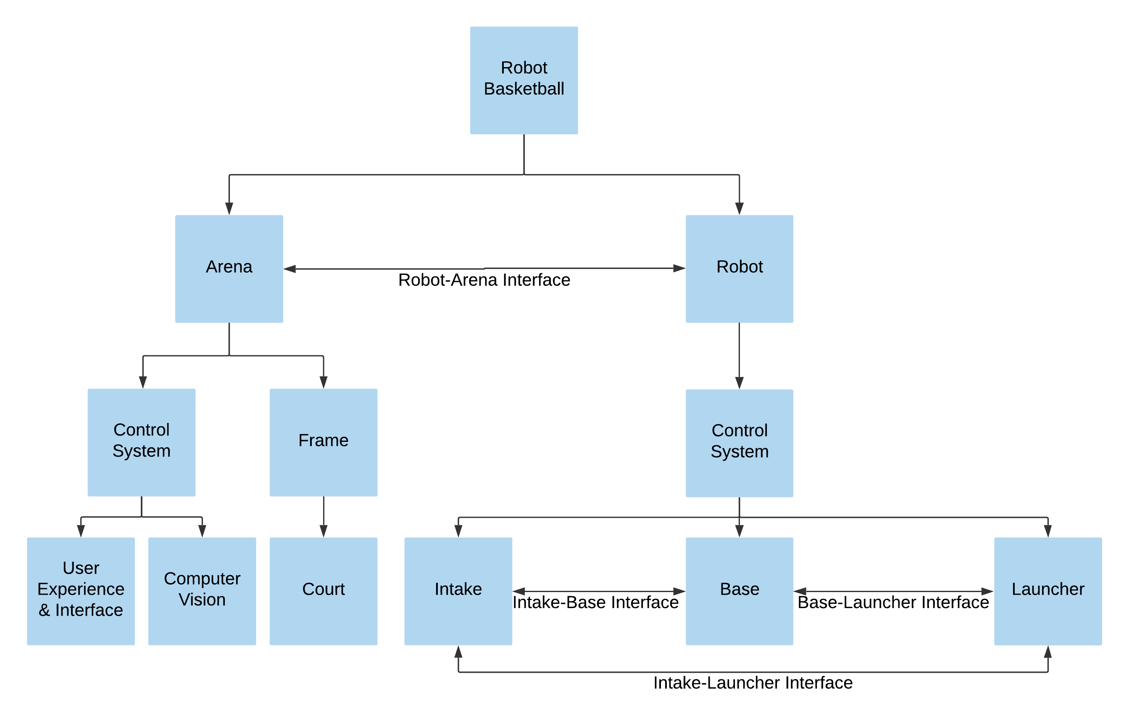

Figure 1 System Hierarchy and Interface Identification

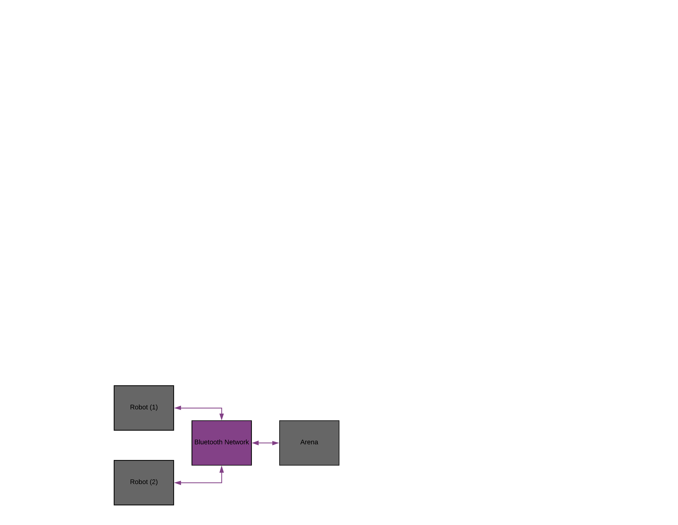

Figure 2 System Communication Diagram

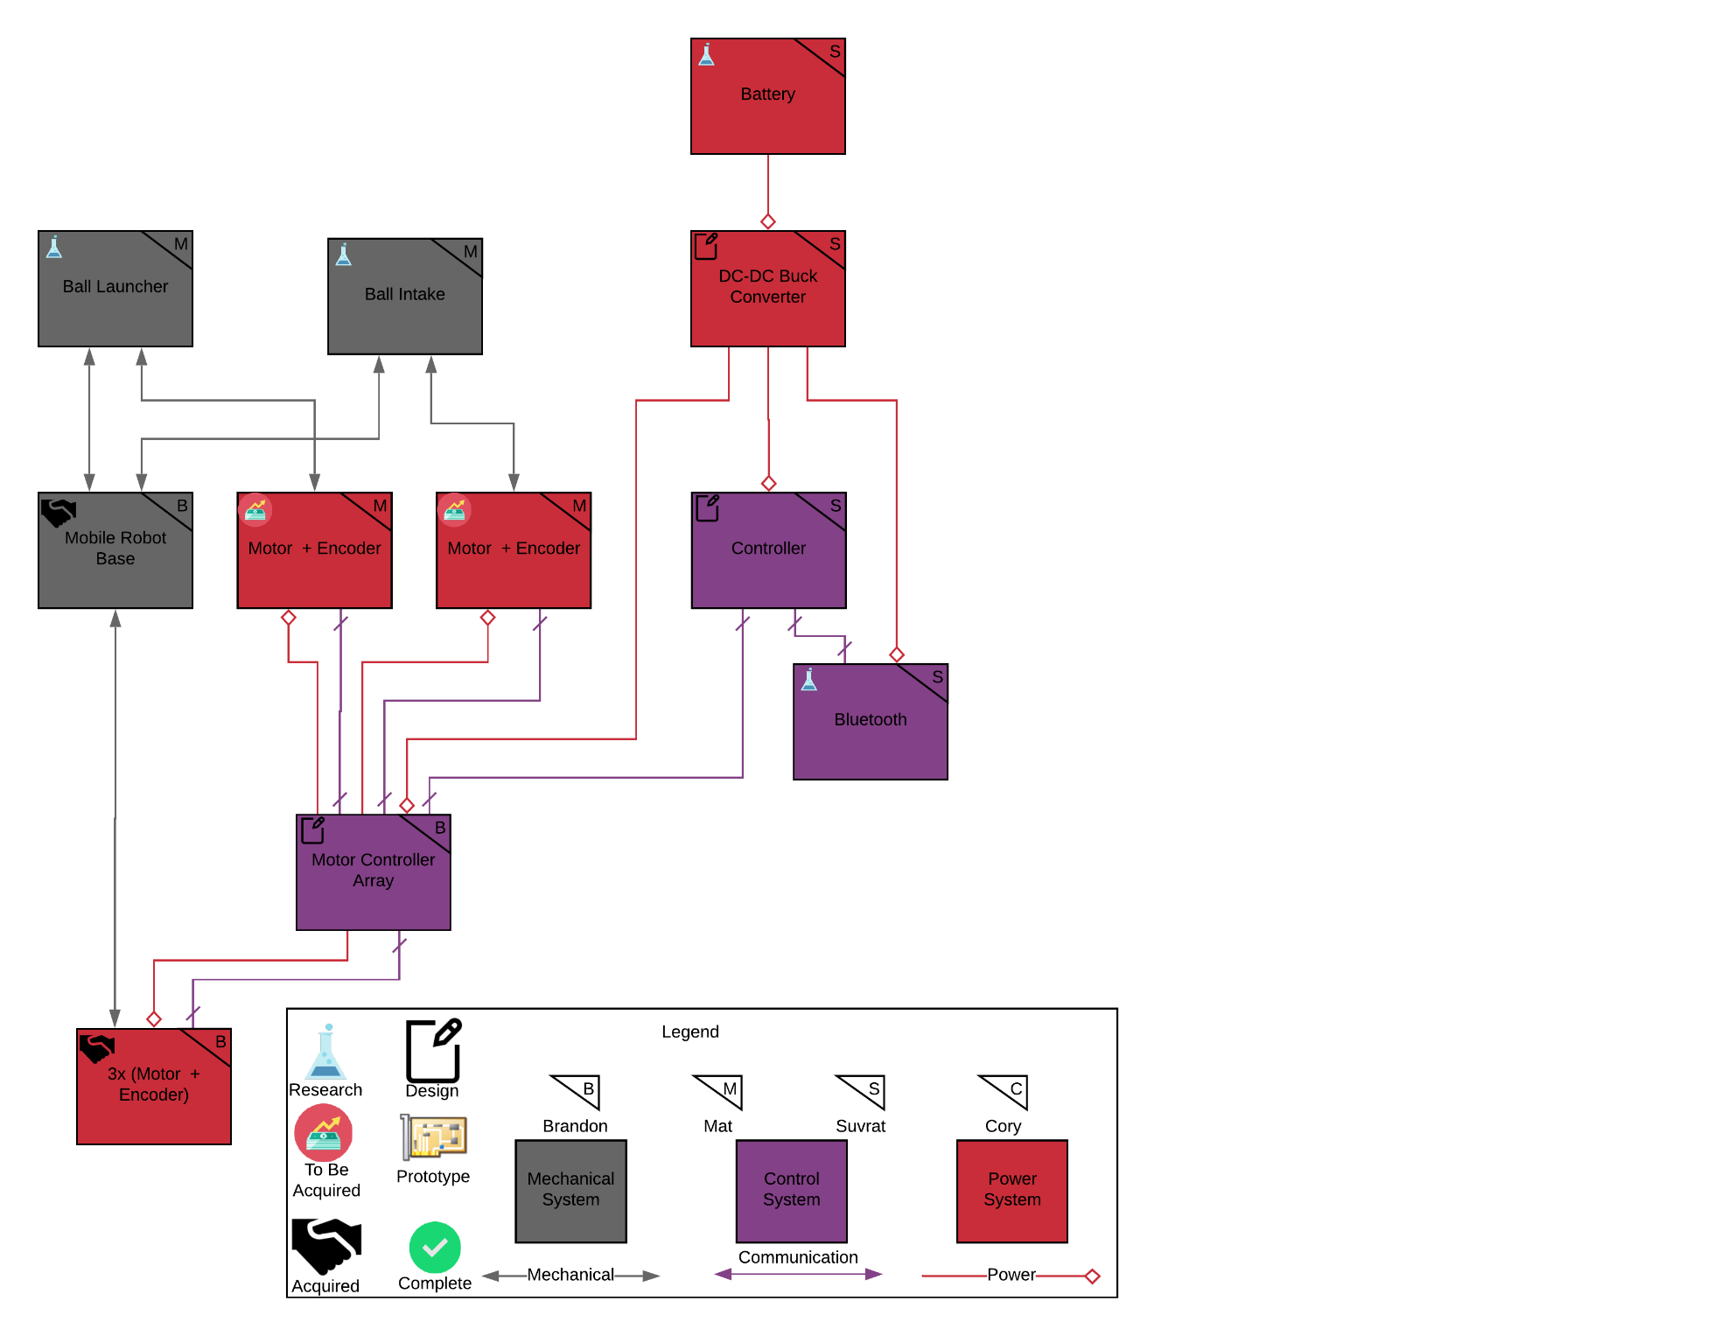

Figure 3 Robot Subsystem Power & Signal Diagram

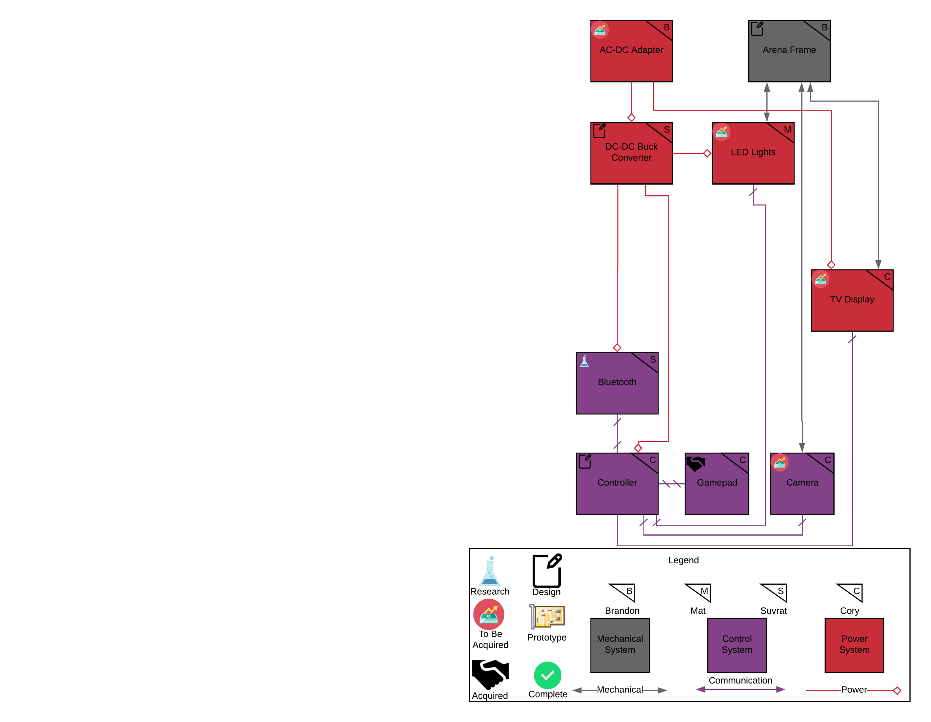

Figure 4 Arena Subsystem Power & Signal Diagram

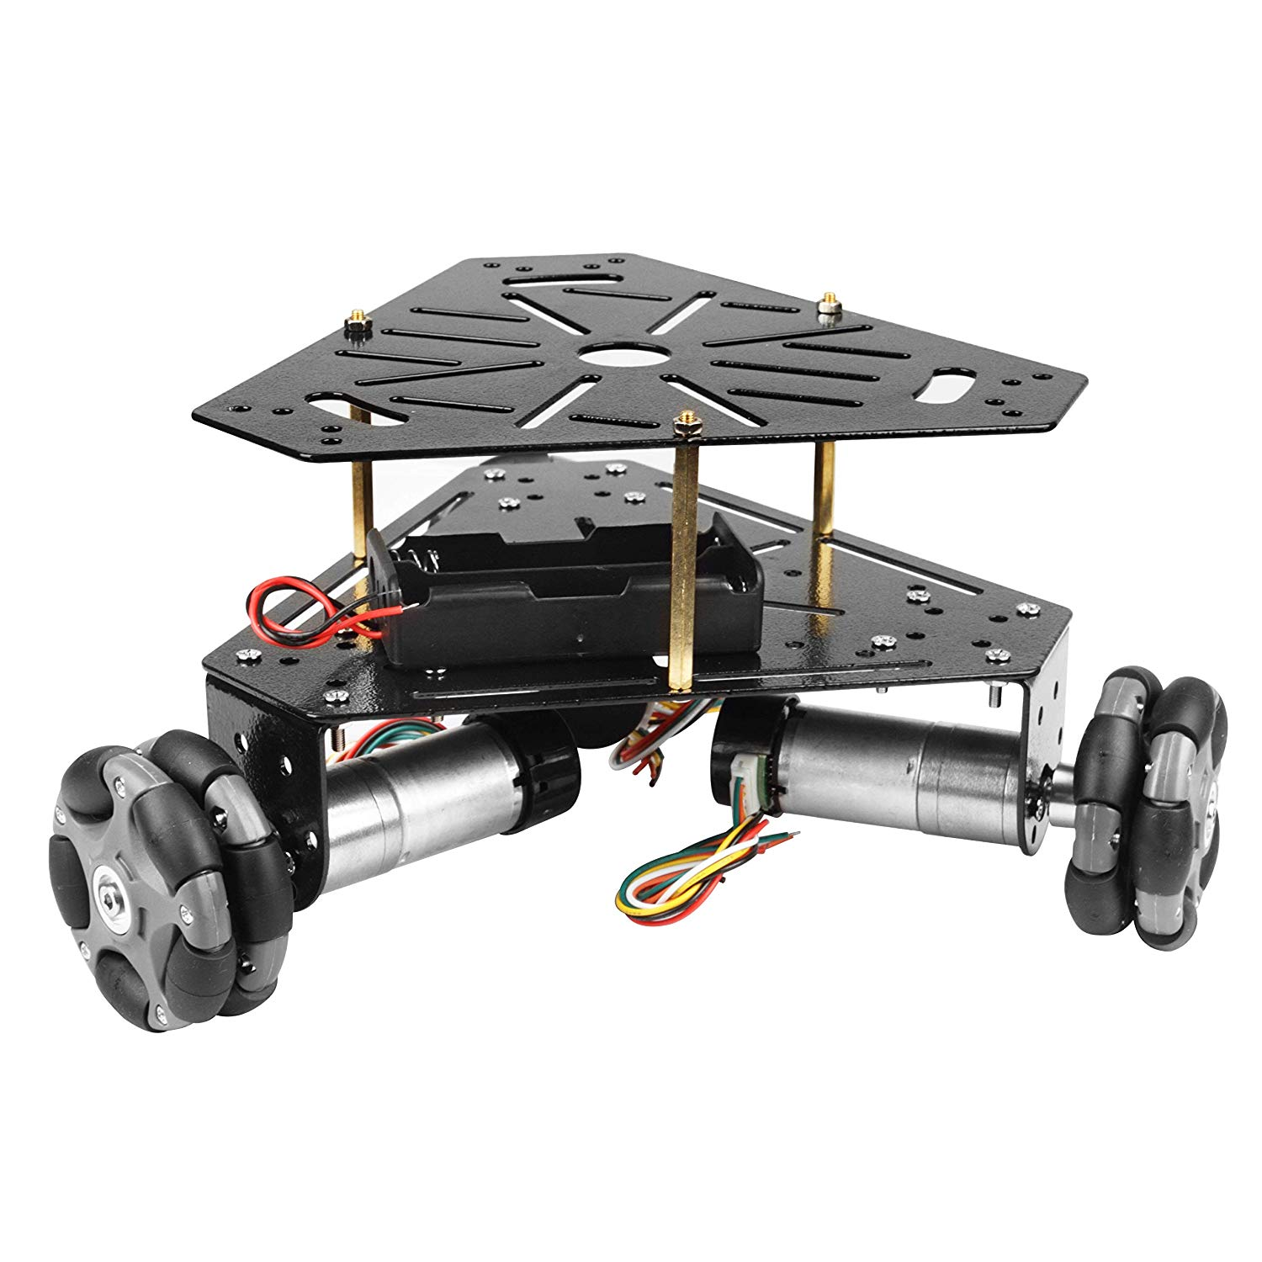

Figure 5 Example Omni-wheel base from Heneng on Amazon.com [<https://www.amazon.com/gp/product/B07LGT93BZ/ref=ppx_yo_dt_b_asin_image_o02_s00?ie=UTF8&psc=1>]

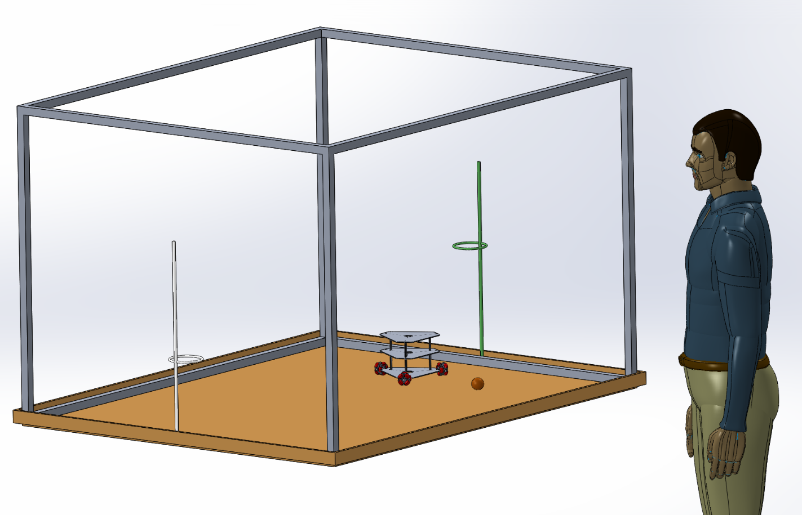

Figure 6 SOLIDWORKS Image of proposed scale Arena, Robot, and Ball

# Budget:

## Robot

|  |  |  |  |
| --- | --- | --- | --- |
| Item | Price (USD) | Quantity | Subtotal (USD) |
| Launching Hardware | $ 20.00 | 1 | $ 20.00 |
| Drive Hardware | $ 30.00 | 1 | $ 30.00 |
| Intake Hardware | $ 20.00 | 1 | $ 20.00 |
| Intake Motor | $ 15.00 | 1 | $ 15.00 |
| Drive Motor | $ 20.00 | 3 | $ 60.00 |
| Launch Motor | $ 20.00 | 1 | $ 20.00 |
| Controller | $ 20.00 | 1 | $ 20.00 |
| Battery | $ 30.00 | 1 | $ 30.00 |
| PCB | $ 20.00 | 1 | $ 20.00 |
| Bluetooth Module | $ 10.00 | 1 | $ 10.00 |
| Voltage Converter | $ 15.00 | 1 | $ 15.00 |
| 5x Motor Controller | $ 13.00 | 1 | $ 13.00 |
|  |  |  |  |
| Total |  |  | $ 273.00 |

## Arena

|  |  |  |  |
| --- | --- | --- | --- |
| Item | Price (USD) | Quantity | Subtotal (USD) |
| Frame Hardware | $ 100.00 | 1 | $ 100.00 |
| Camera | $ 40.00 | 1 | $ 20.00 |
| Controller | $ 100.00 | 1 | $ 100.00 |
| Power Supply (AC-DC) | $ 20.00 | 1 | $ 20.00 |
| PCB | $ 20.00 | 1 | $ 20.00 |
| Bluetooth Module | $ 10.00 | 1 | $ 10.00 |
| Ball | $ 5.00 | 1 | $ 5.00 |
| Court Hardware | $ 25.00 | 1 | $ 25.00 |
| Voltage Converter | $ 15.00 | 1 | $ 15.00 |
| LEDs | $ 25.00 | 1 | $ 25.00 |
| Gamepad | $ 25.00 | 2 | $ 50.00 |
| TV Display | $ 70.00 | 1 | $ 70.00 |
|  |  |  |  |
| Total |  |  | $ 460.00 |

Project Total for 1 Robot: $733, Project total for 2 Robots: ~$1000

# Timeline:

Our group has a room in HEC reserved every Tuesday and Thursday from 12pm-1:30pm for design meetings. These operate as SCRUM stand-up meetings in our AGILE based development process. Due to the modularity and subsystem breakdown of the project, the majority of components and software development can be completed in parallel to other tasks. The block diagrams in figures 3 & 4 indicate proposed task delegation mostly broken down by subsystem. Some tasks across subsystems are very similar, and thus are combined under a single owner in order to reduce duplicate work (Bluetooth in Robot & Arena, for example).

Robot, Arena, Critical

## Senior Design I

|  |  |  |
| --- | --- | --- |
| Week # | Date | Milestone / Activity |
| 2 | 5-23 | Base is delivered. Included motors are tested. |
| 3 | 5-27 | Determine Arena scale & if Mobile base is sufficient |
| 3 | 5-28 | Camera decided. |
| 3 | 6-1 | Senior Design Bootcamp. Intake decided & Intake design start. |
| 4 | 6-8 | Launcher decided & Launcher design start. Frame material decided. |
| 5 | 6-15 | Decide on hoop, other materials and Bluetooth. |
| 6 | 6-16↔6-22 | Gather materials for prototypes |
| 6 | 6-22 | Launcher design done. Build Prototype arena. |
| 7 | 6-29 | Intake design done. Arena design done. Computer Vision done. |
| 8 | 7-6 | PCB designs complete. Robot design done. |
| 8↔12 | 7-1↔7-28 | Test subsystems & redesign. |
| 12 | 7-28 | Final paper complete. |

## Senior Design II

|  |  |  |
| --- | --- | --- |
| Week # | Date | Milestone / Activity |
| 1 | 8-30 | Begin Arena. Begin Robot(s). |
| 2 | 9-6 | Arena built (minus PCB) |
| 3 | 9-13 | First Iteration of PCBs Arrive |
| 5 | 9-27 | Robot(s) built. Arena PCB Complete |
| 6 | 10-4 | Robot-Arena Interface Complete |
| 7 | 10-11 | Test final subsystems |
| 8 | 10-18 | Test system Integrations |
| 9 | 10-25 | Test completed system |
| 10↔15 | 11-1↔12-6 | Revise, test, & maintain |