Aqua Sentinel 3000 - Personalized Pool Monitoring System

Anna Baranova, Brian Bisplinghoff, Minh Nguyen, Zachary Schwartz

Dept. of Electrical Engineering and Computer Science, University of Central Florida, Orlando, Florida, 32816-2450

***Abstract* — Our main goal is to design a product that will detect when a child has gone into the pool and alert the parents through the use of a mobile application. Currently there isn’t a smart sensor like this system that is available in the market. We want to design the software in a way that will make the product very reliable and efficient. Moreover, it will be important to use technologies and products that can operate with relatively low power consumption.**

### ***Index Terms* — IP networks, Microcontrollers, Object oriented programming, Solar panels, Temperature sensors, Video Surveillance.**

I. INTRODUCTION

The system consists of three main organizational units, the main unit that will sit by the pool and monitor the pool, the band that will be placed on the children to send out a signal when the child enters the pool, and the phone app which will act as the parent interface with the device. The main unit will be powered by solar panels to increase the environmental sustainability of the system but will require the unit to be in direct sunlight. Due to being close to the water, the housing being waterproof is of utmost importance, with a good portion of the research being dedicated to ways to ensure the functioning of the system in a wet environment. Similarly, the bands will need to be waterproof to function if the child falls into the pool, so similar research is done into materials that can be used. For the actual logic of the system, it was determined due to the high processing requirements of the video streaming, a Raspberry Pi Zero will be used as the main logic unit of the device. The mobile application will run on Android.

Although there are some alternatives on the market, our project aims to remedy some gaps in available implementations. By combining the general architecture with a mobile application, we give parents a convenient monitoring device that they already carry with them all the time. This prevents the awkwardness of a separate device being necessary simply to monitor the pool. Our design also capitalizes on the fact that a majority of pools are outside by employing solar energy to power the system. Along with these innovations, the project seeks to be affordable in production so that it reaches the widest audience possible. It also must feature the utmost safety and reliability due to the dangerous nature of children's’ lives being at stake.

II. SYSTEM DESIGN

The device will use the wrist bands around the children's’ arms to detect if one of the children has fallen into the pool. It will then analyze this in the microprocessor and send out a signal to the parent as well as activating the video camera. It sets off both alarms to alert anyone nearby that the child is in danger. At the same time, the system will also send a wireless signal to the phone application and alert it that there is possibly a child in danger. This way if the parents are either inside the house or the child is with someone else they will be notified if the child has fallen into the pool immediately. The camera will also be enabled and live feed will stream to the phone app. This stream can also be turned on at will if the user desires.

Due to the remote nature of having the main unit by the pool, battery power will be needed to power the device. This power should be able to sustain itself for a reasonable amount of time and should alert the user when it is getting low well ahead of time. The video feed should remain off when not in use and the microcontroller should be in a low power setting in order to conserve power. Solar power should be the primary means of recharging the power supply as the device will already be outside. This would be very useful for uncovered pools but may cause issues for some pools with overhead covers.

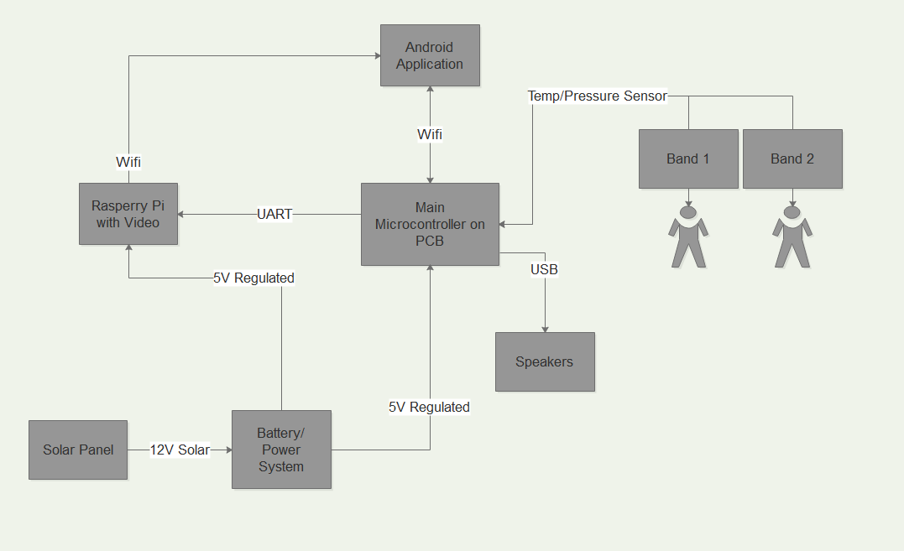

# Fig.1.High Level System Block Diagram

*A. Microcontroller*

ATmega328 is one of the more popular on the market currently due to its general purpose nature and its inclusion in the Arduino Uno development board. Unlike TI’s microcontrollers, the ATmega features a harvard architecture which means separation of program and data memory. It features 1 MIPS per MHz throughput with 32 kB of flash program memory, 2 kB of data RAM, and 1kB of data ROM. In comparison to the MSP430 line, the ATmega sports stronger computing power. It also sports 23 GPIO pins, which should be more than enough for the project. For serial communications, it features 2 SPI modules, 1 USART module, and 1 I2C module, enough for most necessary communication. (few sentences about where we using it).

*B. Solar Panel*

Solar energy is one of the most used clean energy on the market. Solar energy is versatile in such that it can be placed anywhere around the pool and doesn’t have to be lock into a power outlet. In this project the solar panel will be placed outside due to this especially in Florida using solar energy will be a lot cheaper where plenty of sunlight rays shine everyday allowing the system to easily harness this energy. Using a power outlet is wasteful and in today’s markets less demanding than solar. Also if there is a thunderstorm and the power is lost they system will not be able to run which happens regularly in Florida. Wind energy need to have more wind and some pools have windscreen to block wind and this will not be as convenient as solar energy. A solar panel system will be used to run the Raspberry pi video streaming in this system and main central unit in this project. The solar panel system will also have a backup battery to store it for days that are cloudy or on days that there isn’t as an abundant amount of sunlight.

# *C. Raspberry Pi*

Aqua Sentinel 3000 has build in video camera to video stream a pool area into mobile device through Android application. Due to constraints imposed by the need for sending video feed to our mobile application, a standard microcontroller may not contain enough processing power to get the job done. For this reason, the team has decided to investigate into the possibility of adapting a SoC (System on Chip) unit for use as a stand in for a more traditional microcontroller. And as a result Raspberry PI Zero model was chosen for the project. RaspiCam is the only camera module that is compatible with this board, without further improvements and it is most likely the most efficient for the price as well. Camera module RaspiCam is compact and is capable of taking full HD 1080p photo and video.

# *D. Sensor*

The main goal of our project is to send signal when an object drowns in a pool. In more concrete case, Aqua Sentinel 3000 should recognize two scenarios: if a child already in the pool and start drowning, and when a child enters pool water without parents/guardian knowledge. The sensor should capture both of these cases, send signal to alarm system in main device and send warning to a mobile device. For the wearable device temperature sensor was considered. DS18B20 sensor was chosen. Sensor is digital, compact, and accurate. Temperature range is from -55°C up to +125°C. Sensor works great with any microcontroller using a single digital pin, multiple sensors can be connected to the same pin.

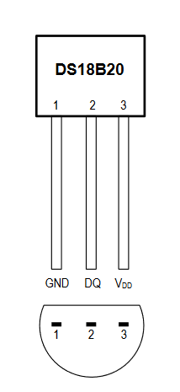Fig.2. Temperature Sensor DS18B20

# *E. Battery*

There will be days where the weather will not permit for the solar panels to receive sunlights and there are days where the solar panels received nothing but sunlights. In order to regulate the extra energy and save it for a non sunny day a backup battery will be implemented. Lead-acid batteries are the cheapest type of batteries and the most commonly used in clean energy. We decided to implement it in our design since the price is important and the fact of using battery more as a storage and backup power supply.

# *F. Wireless Communication*

Wi-Fi technology is designed to connect electronic devices in a wireless local area network (WLAN). Devices that are within the WLAN or devices that are connected to the internet can exchange data or connect to the Internet at a data rate of 54 Mbit/s or more. This technology is based on the IEEE 802.11 standards operating in the 2.4 GHz (IEEE 802.11b/g/n) and 5 GHz (IEEE 802.11a/n/ac unlicensed bands available worldwide). Wi-fi will need to be used in order for the mobile application to communicate with the main PCB and the Raspberry Pi. There is no alternative to Wi-Fi that we could use to successfully implement the video streaming feature.

# III. SYSTEM HARDWARE

This section details the design of the hardware for the project, including the broad system design, implementation details for the main unit and its connections to the wifi module, the speakers, the raspberry pi with the camera unit, and the power supply.

*A. Raspberry Pi and RaspiCam module*

The lower cost option offered by adafruit, the zero sports a Broadcom BCM2835 single core processor clocked at 1GHz with 512MB of RAM. It provides enough overall processing power, with the main constraint being the video streaming. Note that this processor also uses the ARM architecture if some obscure assembly tasking is needed. This pi requires an input voltage ranging between 5.25 and 4.75V, though this voltage is decreased to 3.3V by a voltage regulator built into the pi. Because of this, there may be a way to reduce the input voltage to lower the power consumption if this is deemed necessary based on the power system specifications. This pi has a current draw between 180 - 200 mA while under normal operating conditions and 65-100mA when idle.

# *B. Battery*

The battery is a deep-cycle flooded battery the most common battery used battery for solar panels. The model we used is ExpertPo. It is a 12 volt battery that is cheap and can handle the deep-cycle that a solar panel discharge. Battery enclosed in the high impact case made up of a non-conductive ABS Plastic, has a strong resistance to shock and heat. The acid inside is absorbed between the plates and thereby immobilized by a fiberglass mat.

# *C. Voltage regulator*

The regulator we used is called DROK Micro LED DC-DC.

Voltage regulator is meant to control a constant voltage so other system like. The diode is used to make sure the system keeps and maintain a constant dc voltage and make sure it won’t change into ac. The resistors are used to drop the voltage to the amount that is needed. Lastly the capacitor is used to filter out the noise in the regulator.

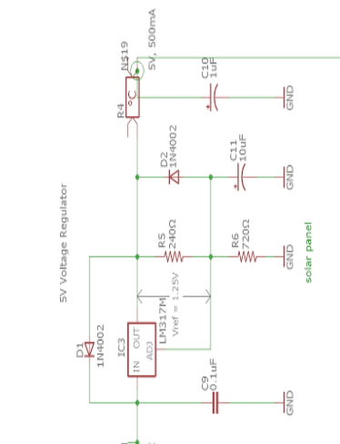Fig.3. Voltage Regulator Schematic

# *D. Sensor*

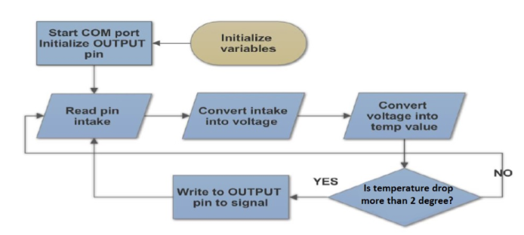Sensor is located on the wearable device, secondary PCB and communicates with main PCB through wifi module located to receive signal on the main PCB and to send signal on the secondary PCB. Temperature Sensor DS18B20 core functionality is its direct-to-digital temperature sensor. The DS18B20 uses a strict 1-Wire communication protocol to ensure data integrity. Several signal types are defined by this protocol: reset pulse, presence pulse, write 0, write 1, read 0, and read 1. DS18B20 provides 9-bit to 12-bit Celsius temperature measurements. Can measure temperatures from -55° C to +125°C, and its accuracy ±0.5°C from -10°C to +85°C. All further calculation to trigger signal produced in main PCB processor.

Fig. 4. Temperature Sensor FlowChart

*E. Wireless Module*

The ESP8266-1 was chosen as the wireless module for use in the project. It is a low cost module making it very efficient. It is a complete SoC with a TCP/IP stack already implemented. It comes preprogrammed with AT commands, but can also be manually programmed as it features its own microprocessor. It has 2 GPIO pins that can be utilized as any other GPIO pin, but are also used in flashing the chip. The RX and TX lines are dedicated serial communications and generally the way that another microcontroller would interact with the chip. There is also a significant amount of community

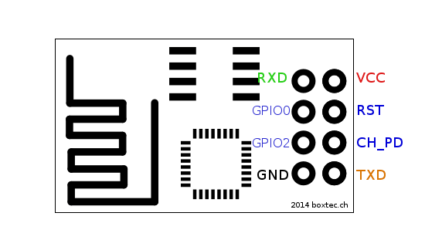Fig. 5. Pin Layout ESP8266-1

support for this chip due to its popularity in the IoT community.

*F. Speaker*

After many considerations, a piezoelectric speaker was chosen for our project. This speaker operates using the a piezoelectric actuator that generates sound through the piezoelectric effect. This causes a buildup of electric charge to be converted to mechanical movement. This in turn generates sound through the vibrations of the plate. This was chosen over a more traditional speaker functioning off of inductive principles due to concerns about the magnetism causing issues with communications in the system.

A close up of a sign

Description generated with very high confidence

Fig.6. Speaker FlowChart

IV. SOFTWARE DESIGN

*A. ATmega328*

The ATmega328 was programmed in the C language using the arduino IDE to facilitate the process. The microcontroller begins with a significant startup process where it configures both wifi modules. It does this by sending AT commands that configures one of them to purely server mode and one of them to both server and client mode so that it can send a signal to the mobile application. After this it loops checking if there is a message present in either module. If one exists for the mobile application it either starts the video streaming or toggles the alarm, depending on which message was sent. If a message from the band is received, it compares it to the last received temperature value. If the value is to different, it sets off the alarm and sends a A screenshot of a cell phone

Description generated with very high confidencesignal to the mobile app.

Fig.7. Pin Layout Atmega 3208

*B. Wifi Modules*

For programing the ESP 8266 there are two options. The chips come preprogrammed with AT commands which can be used by sending strings with the associated commands. This was done for the two modules linked with the ATmega328 since it alleviates the issues related to having to flash software onto them. For the wearable, since the wifi module is the sole chip, it had to be flashed with separate code. This was accomplished using an open source library that is compatible with the arduino IDE to facilitate programming.

The first wifi unit is configured to communicate with the android application. It waits for a signal either to start the video stream or toggle the alarm, and upon receiving a string that determines what it will do, it takes that action. Currently this only works if the phone and the network are connected to the same network but given more time could be expanded to work from anywhere. The second wifi unit that is also hooked up to the ATmega listens for a connection from the wifi module located on the band. It then receives data about the temperature level every three seconds and if there is too large of a drop between subsequent levels, it sends a push notification to the android application. The wifi module on the band simply attempts to connect and upon successful connection transfers temperature data input to one of its GPIO pins to the main board.

V. HOUSING

Research was made on encapsulation of electronics submerged in water. To protect secondary PCB rubber silicone was chosen. Smooth-on Dragon Skin Silicone Rubber, by Smooth-on, Inc. was chosen as it delivers skin effect, skin safe, flexible, easy to work with and not too costly. PCB of wearable device was fully submerged into liquid silicone to cover it completely, then an opening was made to give temperature sensor access to air to enable sensing capability.

A picture containing screenshot

Description generated with high confidence

Fig.8. Conceptual Housing for Wearable Device

For the main device PCB 3D printing of housing was chosen. Housing covers main PCB, Raspberry Pi Zero with RaspiCam module, and power battery. Free 3D printer, MakerBot Replicator 2, in the public library near main UCF campus was used and did not cost us nothing. The design was made with AutoDesk AutoCAD software.

To hold Solar Panel, the stand was made of light metal panels purchased at one of the local hardware stores.

VI. ADMINISTRATIVE

In order to design a product that could be used to prevent children from drowning and alert parents, we researched few of the possible technologies and parts we could use. Moreover, we found that the best way to design our project would be to have a band that attaches to the child, a base communication unit on the outside of the pool, and a mobile application. This documentation briefly explained the technologies that we used for our project. Throughout the research process we analyzed the pros and cons of different devices and technologies. We had proposed the budget of the project at the beginning of the Senior Design I and tried to hold the spending accordingly. Senior Design II was fully related to project implementation, testing components as one unit, PCB design and housing.

VI. ANDROID APPLICATION

*A. Android Application*

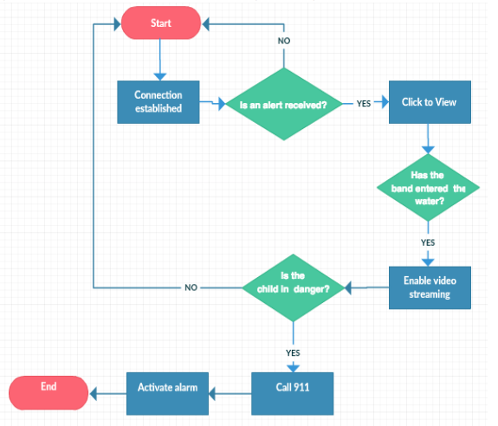Our mobile application is responsible for displaying alerts from the PCB and the stream from the Raspberry Pi, as well as activating and disabling the alarm. The mobile application will have a basic menu with three tabs: connection, video, alarm. The connection page is where the user will enter the IP address so that the mobile application can communicate to the Raspberry Pi and pcb. After entering the IP address, a message will be displayed alerting the user whether there is a successful connection or if an error occurred. The video page is where the user will navigate to in order to activate and view the stream from the Raspberry Pi. The alarm page is where the user will be able to send a signal to the pcb to activate and disable the alarm. The last main feature of the mobile application is notifications. When the band that the child is wearing enters the pool, the pcb will be triggered and send a notification to the mobile application. It was important Fig. 9. FlowChart of Mobile Application

to design the mobile application so that it was organized and very easy to use. Having a menu with each feature on a separate page makes it easy for the user to set up a connection, activate/disable the video stream, and activate/disable the alarm.

*B. Video Streaming*

In order to effectively display video from the Raspberry Pi on the mobile application, we looked into many different methods. We chose to continuously take still pictures from the Raspberry Pi and have them displayed on the mobile application with only a short delay. This process involved downloading several packages and files from libraries on the Raspberry Pi. Once MJPG-Streamer was downloaded and configured on the Raspberry Pi, we created a simple code that would handle the camera configuration and startup so that the stream would easily be produced and efficiently sent over to the mobile application. The video streaming is configured in a way that once the Raspberry Pi is booted up, the user can activate the video stream from the mobile application at any time. The still pictures will be taken at that point and continuously sent over the same network. Using MJPG stream was the best solution for the streaming because it allows the user to easily see the pool area from the phone without much delay and also while not being as resource intensive.

A screenshot of a cell phone

Description generated with high confidence

Fig.10. Video Streaming Flowchart

VII. PCB

The PCB is the main part of this system. The PCB will be the one that connect all the power, sensor, microcontroller, speaker, Wi-Fi and video streaming camera. The PCB is spilt into two different systems. The first system will be the main unit which will control all the function like video streaming, speaker and signal processing. The second PCB will be the senor that will relay the signal when the wearer falls into the water.

VIII. PCB DESING

*A. Eagle Cad*

The first step to design the PCB for the system is to understand what the system needs to have. After understanding what is needed in this system a design is needed with a cad program. Eagle cad is the most commonly used program. It has the most open source libraries and plenty of tutorials to help better design and debug the systems. For example if there is too many wires cross-talking with each other the program will give an alert and shows option to fix this cross talk. Eagle Cad also has both schematic designs along with board design. This is helpful as the board can get a little bit confusing and the schematic doesn’t have a broad picture of what the board will be. For examples it doesn’t shows the side of the components or the crosstalk of the wires. Lastly many fabrication companies also work their system around Eagle Cad.

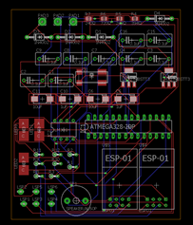

Fig.11 PCB Design

*B. Fabrication*

After the PCB is design a company is then select to create the board. The company that was selected, OSH Park, has the multiple option they help speed the making of this PCB board. The first option is for express fabrication. By paying a bit more money the productions time almost in cut in half. They also have a friendly user interface that is quick and easy. Lastly they supply three copies of the PCB. This greatly helps if there is a mistake when assembling the components.

*C. Components Assembly*

The last step of the PCB design is to assemble all the parts together. This can be done by a machine which will cost more or by soldering which will take more time. Our group has some experience soldering so we decided to save the money and solder the component on instead. Some difficult with self-soldering is that sometimes the components is really small which can be frustrating to do.

IV. BIOGRAPHY

**Brian Bisplinghoff** is currentlya computer engineering senior at the University of Central Florida. His interests include any flavor of programming as well as data science. He currently interns at Lockheed Martin and plans to continue his career there upon graduation. His primary focus on the project was the embedded programming for the ATmega as well as the wifi modules.

**Minh Nguyen** is currently a electrical engineering major in his senior year at University of Central Florida. His interests include mostly microelectronic such as mems devices, semiconductor and sensors. He hopes to find a job in this field but is open and interested in all electrical engineering field. His primary focus on this project was the power system and the PCB design.

**Zachary Schwartz** is currently a computer engineering senior at the University of Central Florida. His interests include embedded programming and networks. After graduating, he plans to get a job working on embedded systems. His primary focus on this project was designing the android application and setting up the video streaming.

**Anna Baranova** is currently a computer engineering senior at the University of Central Florida. Her interests include software programming, video processing and embedded programming. She plans to get an engineering related job after graduation and continue education towards master degree in the short future. Her primary focus on this project was designing housing for embeddeded electronics and programming camera module.

ACKNOWLEDGEMENT

Our group would like to express thanks of gratitude to University of Central Florida, Electrical Engineering and Computer Science department for giving us all resources to learn, experience and research the engineering field towards our prospective degree. Secondly, we would like to say thank you to all faculty of the department of Electrical Engineering and Computer Science who lectured classes, helped us in the laboratories, and answered questions during office hours. Lastly, we would like to thank with gratitude professors Amro Awad, Karin Whiting and Gerald Hensel who agreed to review our final Senior Design project Aqua Sentinel – 3000.

REFERENCES

[1] "ESP8266 Tutorial: Programming the Onboard GPIO Pins | DIY Hacking." <https://diyhacking.com/esp8266-gpio/>. Accessed 17 Nov. 2017.

[2] https://datasheets.maximintegrated.com/en/ds/DS18B20.pdf