**Smart Umbrella**

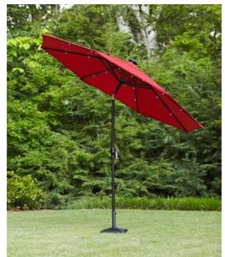

**Name: Major:**

|  |  |
| --- | --- |
| Eugene McDonald | Electrical Engineer |
| Derek Workman | Electrical Engineer |
| Nicholas Van Nice | Computer Engineer |

**Project Description:**

We want to create a portable patio umbrella that may be used when going to family events, such as the beach or camping. This umbrella will be powered with rechargeable batteries, and will have solar panels to keep these batteries charged. To maximize shade efficiency it will include multiple sensors that will relay information to the circuit that we create. We plan on implementing 3 separate sensors. One sensor will be placed or worn by the user to mark the spot where the user would like the sun to be blocked. A second sensor will locate the position of the sun and also relay information to the circuit to help with the positioning of the umbrella for maximum shading. The third sensor will relay information for when the sun is no longer charging the batteries, so that the umbrella will return to the upright position and initiate the LEDs. The circuitry will then communicate with 2 motors, one that rotates 360 degrees near the base of the umbrella and a second motor that will rotate the top of the umbrella 90 degrees (-45 to 45) to best maximize shade for the attended user.

The Smart Umbrella will also have USB ports to allow users to charge phones, so people can enjoy cell phone use in outside environments and not have to worry about batter consumption. We will also include LED lights on the umbrella for applications used when the sun isn’t present. The LEDs will have multiple modes. The first mode will be just a general lighting that will be initiated by the sensor when the umbrella returns to its upright position. A second mode will be brighter and can be used for reading and an entertainment mode that will have different lighting colors that blink in pattern. This mode will also cause the umbrella to dance.

All electronic equipment used will need to be waterproofed as well. We will need to design and build a small table on the pole where we can place the batteries charger and any other circuitry.

Added Features under consideration

1. Added Speakers (music capabilities)
2. Synchronized LED lights that will play with the music

**Requirement Specifications:**

|  |  |  |
| --- | --- | --- |
| **Spec #** | **Spec Name** | **Spec Description** |
| 1 | Design Costs | Costs below 600 |
| 2 | Weather Proofing | All electronic components will be weather protected |
| 3 | Power Consumption | Under 25 Watts |
| 4 | Lightweight | Under 10 Ibs |
| 5 | Battery Life | Over 5 hours |

**Project Design Picture**

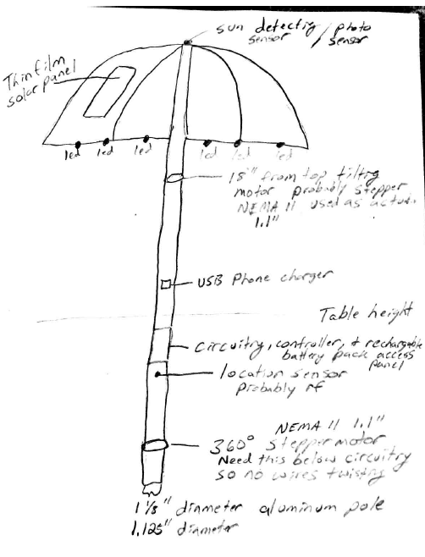

**Project Block Diagram**

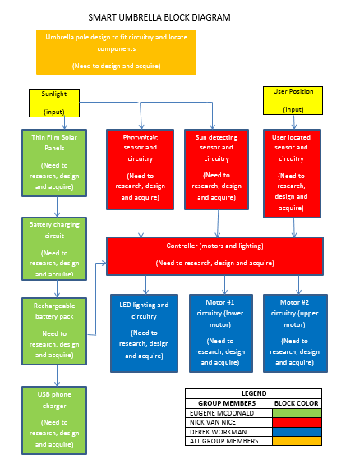

**Project Budget (Estimated)**

|  |  |
| --- | --- |
| **Item** | **Cost (dollars)** |
| Motor 1 | 20-30 |
| Motor 2 | 35-50 |
| Control Unit | 60-100 |
| LEDs | 15-30 |
| Batteries | 30-40 |
| Umbrella | 30-60 |
| Circuitry | 40-60 |
| Sensors | 100 |
| Pole Mods | 100 |
| Solar Panels | 80 |
| **Max Total:** | 650 |

***Designing and fabricating all parts

**Project Milestone**

Summer –

1. 1-3 Weeks – Research
2. 3-6 Weeks – Design/Schematics/Final Parts List
3. 6-10 Weeks – Test Requirements/ Begin Prototyping

Fall –

1. 1st Week – Parts Ordered/Pre- Fabrication
2. 2-3 Week – Pre-Fabrication Umbrella
3. 3-5 Week – Pre-Fabrication Motors
4. 4-6 Week – Pre-Fabrication Sensors
5. 6-8 Week – Pre-Fabrication Lights
6. 8-10 Week – Pre-Fabrication Communications
7. 10-13 Week – Fabrication/Testing