Smart Umbrella
Eugene McDonald, Derek Workman, and Nicholas Van Nice

Dept. of Electrical Engineering and Computer Science, University of Central Florida, Orlando, Florida, 32816-2450 U.S.A.

Abstract — The purpose of this project is to design and realize a portable solar tracking umbrella. This project consists of several subsystems that work together to achieve the overall goal. The umbrella will use solar cells for energy collection purpose, then by way of a maximum power point tracker, charge an onboard battery. The umbrella will use two motors, and four light depended resistors to keep the umbrella facing the sun during the daytime. During nighttime the umbrella will use LEDs to provide light to the users. An entertainment mode will cause the umbrella to spin and create unique lighting patterns.

Index Terms — Adaptive algorithms, battery charging, maximum power point trackers, microcontroller, permanent magnet motors, photovoltaic cells, solar power generation.

I. Introduction
The project, as described, is a solar tracking umbrella that utilizes many different components to create a unique product. Three of the major goals of this project are to be environmentally friendly, portable, and energy efficient. In order to achieve these goals, it was decided that solar panels would be used as the primary power supply. In order to make better use of this solar energy, a storage device was also required. To make the system more energy efficient, this project will need to use an efficient regulator to ensure the solar panels unregulated voltage gets regulated to the correct charging voltage of the battery. Ordinarily, an umbrella needs to be physically moved in order to keep it facing the sun. This project will make use of motors in order to keep the umbrella facing the sun. It will do this by employing multiple sensors to make sure that the umbrella top can track the sun at any point in the day. This has two major effects that are beneficial for this project. The first is ensuring that the top of the umbrella is facing the sun. This will maximize the energy collection of the solar panels. Secondly, since this movement is done without the need of outside operators the system is completely autonomous. When the system is no longer able to track the sun after it is not visible, the system will return to the upright position and turn on a lighting system for the user of this product. As an added effect to make this product more unique, this project will feature an entertainment mode that will make the umbrella do different effects for the user’s entertainment.

II. System Components
This project is made of several subsystems that are best described in their own respective sections. Each of the subsystems has been either been chosen or designed for the appropriate fit to the overall system. Following is each subsystem described from a technical view point.

A. Microcontroller

The microcontroller is the brains of this system. It controls all the other subsystems of this project. Given that this project has many complex components the Atmel ATmega 2560 is the processing chip chosen to control this project. The 2560 has 54 digital I/O pins, 15 of those are pulse width modulation pins, as well as 16 analog input pins. It has 256 KB of flash memory for code, which is needed for some of the complex functions needed to run. It runs at a 16 MHz clock speed, so it is fast enough to keep up with changes that effect this project. For the prototyping the Arduino Mega 2560 is used in conjunction with Arduino IDE for programming. This proves to be a powerful tool as libraries can be used to help make controlling certain subsystems easier.

B. Solar Panels

The solar panels are the only means of input power for use in this project. They were chosen because they are the most efficient form of an environmentally friendly means of power generation that could be used on an umbrella. Typical solar panels already assembled proved to be too bulky for use on top of the umbrella. Instead, for this project, it was decided to create solar panels from individual thin film solar cells. The solar cells chosen for this project are the SoloPower Copper Indium Gallium Selenide (CIGS) cells that are rated at 1.25 W per cell. These cells will provide 0.5V at 2.5amps. By combining 28 of these cells in series, a 35 watt solar panel will be built. They are very light weight and flexible cells that will work well with the project. This will help make the umbrella more portable. Since the cells are raw solar cells, an encapsulation was created to protect them from the elements and to prevent damage to the cells thus decreasing their efficiency. This was done by means Gorilla’s heavy duty packaging tape. By placing the solar cells between two pieces of packaging tape, a heavy duty, lightweight barrier seals and protect the solar cells. These raw solar cells also required tabbing. The solar cells are mounted on a thin flexible stainless steel backing. This made tabbing very difficult due to the solder not sticking well to the stainless steel surface. To fix this issue a copper tape with conductive glue was used for tabbing the solar cells and this tape created a surface to solder wires to each cell. This provides a perfect solution to the problem of a lightweight solar panel for this project.

C. Maximum Power Point Tracking (MPPT)

To maximize the efficiency of the system a MPPT synchronous switching regulator was created in this project. This increases the efficiency by up to 40% and allows the use of smaller solar panels which reduces total weight of the umbrella. Because of the variability of the solar panels voltage supply due to multiple conditions such as cloud cover, shading, or just indirect sunlight rays, the MPPT requires multiple sensors to input data into the microcontroller. The microcontroller then regulates the PWM to the MOSFET driver which controls the upper and lower MOSFETS regulating the output voltage. The first sensor was a simple voltage divider that provides constant analog data to the microcontroller for the input voltage from the solar panel. A current sensor was also needed at the solar panel to be able to calculate the power inputted into the system. The current sensor chosen in this project was Allegro’s ACS712 Hall effect-based linear current sensor IC. The ACS712 produces an analog voltage output based on the amount of current flowing through the IC. The last sensor is used at the output to maintain the regulated voltage. This is also a simple voltage divider.
For the MPPT, multiple MOSFET drivers were tested. International Rectifier’s IR2104 MOSFET driver was chosen in the final design mainly due to the packaging which came in a DIP8 style which made prototyping easier. This IC also requires very little power consumption of 130mA to operate.
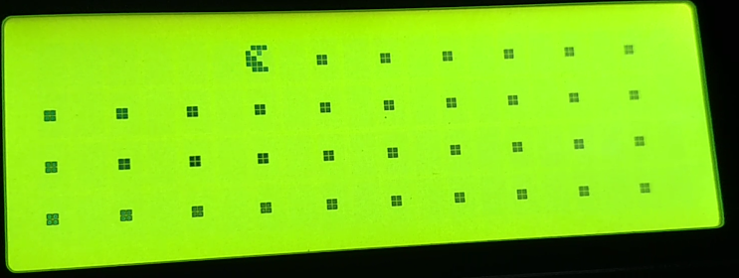
The MOSFETS chosen for the MPPT were Texas Instrument’s CSD18503KCS Power MOSFET. These were chosen because of the low Drain-to-Source On-Resistance of 3.6 milliohms at a Gate-to-Source voltage of 5V. Other reasons these were chosen were the low threshold voltage of 1.9V and the high maximum Drain-to-Source voltage of 40V.
The inductor used to regulate the current output of the switching regulator is Bourne’s 100uH 5505-RC. This inductor was chosen for the low DCR of 61 milliohms with maximum amperage of 4.5A. This is well within the maximum amperage that is expected to be generated by the solar panels. The capacitor chosen to regulate the output voltage was Panasonic’s 560uF Aluminum Electrolytic Capacitors. These capacitors have a low impedance of 350 milliohms. A fast switching diode UF4003 is used in series with the capacitor to reduce the risk of current building during MOSFET switching. It allows a path for the current to flow thus decreasing the risk of burning components during normal operation. A small RC snubber circuit in parallel with the 100uH inductor will help in reducing voltage ripple in the output voltage.
To isolate the battery from feeding back into the solar panels possibly causing damage to the panels, an isolation MOSFET is used. This MOSFET is opened only when the MOSFET driver high side is activated thus creating efficient feedback isolation between the solar panels and the battery. Below in Fig. 1 is the schematic of the MPPT.

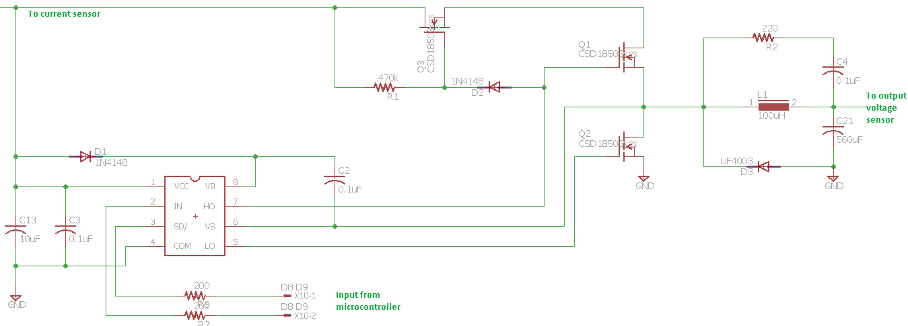
Fig. 1. MPPT circuit Schematic

Because an enclosure was needed to house the battery pack and the circuitry needed for this project, an LCD screen will be added to the front of the enclosure that will display the inputs and outputs from the MPPT. It will display the solar panel’s voltage, current, and total power. It will also display the output voltage from the MPPT and the duty cycle of the MOSFET driver needed to maintain a regulated output voltage. Figure 2 shows the LCD screen lit up with the entertainment mode display of Pac-man.

Fig. 2. LCD screen showing entertainment mode
D. Battery and Battery Charging

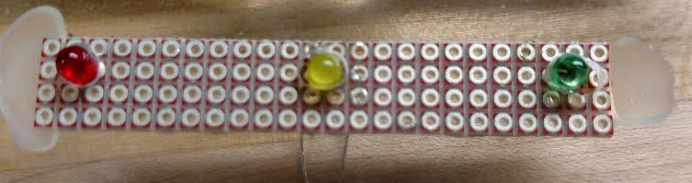
One of the goals of this project was to maintain normal operating conditions for 4 hours when the solar panels were unable to produce power. To do this a high capacity storage unit was needed. For the project, Tenergy’s Li-ION 7.4V 5200Ahr battery pack was chosen. This battery pack was chosen for a variety of reasons. It is rechargeable with no memory effects. It is the lightest weight of any other types of battery technologies, only weighing 0.5 pounds. Li-ION battery packs are durable and can be used in any position so storing and transporting the umbrella will not be an issue. It is small sized at 2.83 (l) x 2.76 (w) x 0.79 (h) inches. Li-ION has a very small self-discharge rate. This was important because this product may be stored for many months before being used again.
The only downside to LI-ION technology is the complicated charging characteristics needed to safely charge the battery pack. Abuse of these charging characteristics can cause the pack to explode which could hurt consumers or damage the product. To minimize these risks and to provide the proper charging characteristics, Texas Instrument’s BQ24123 Single Switch Mode Li-Ion Charge Management IC was utilized. This circuit schematic is shown in Fig 3.
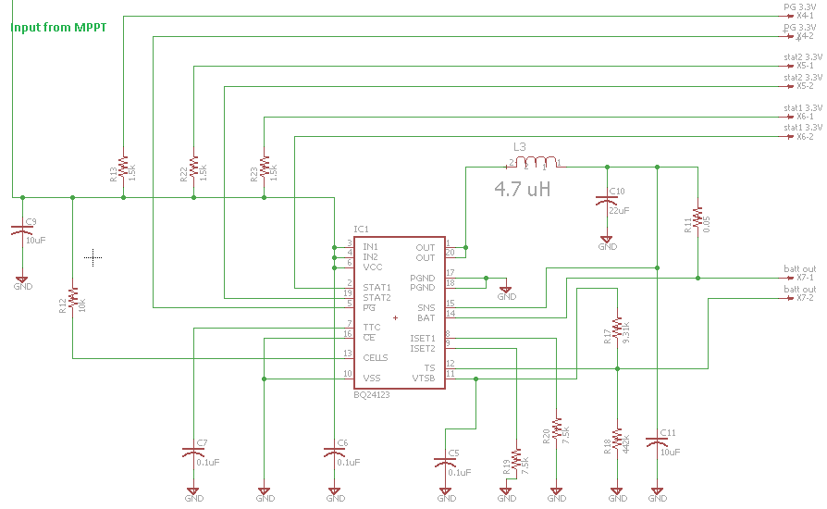

Fig. 3. BQ24123 circuit schematic

The main reasons that this IC was chosen for the battery charging was that it was capable of being used as a standalone unit. The BQ24123 also has a three stage charging profile to safely and accurately charge 2 cell Li-ION battery packs. The first phase is a precharge phase to slowly trickle charge the battery if it is at a very low voltage. The second phase is the current regulation phase which charges the battery pack at a max of 2A to quickly charge the battery. The last phase is the Voltage regulation phase which slowly raises the voltage to the max battery pack voltage of 8.4V. This IC also has three LED indicator lights which will be placed in the cover of the umbrella’s enclosure for easy battery charging status viewing by the user. These three LED are picture below in Fig 4.

Fig. 4. BQ24123 status LED’s. Red – Proper input voltage detected. Yellow – Battery charging status. Green – Battery fully charged status

E. 5 Volt Switching Regulator and USB charging Port

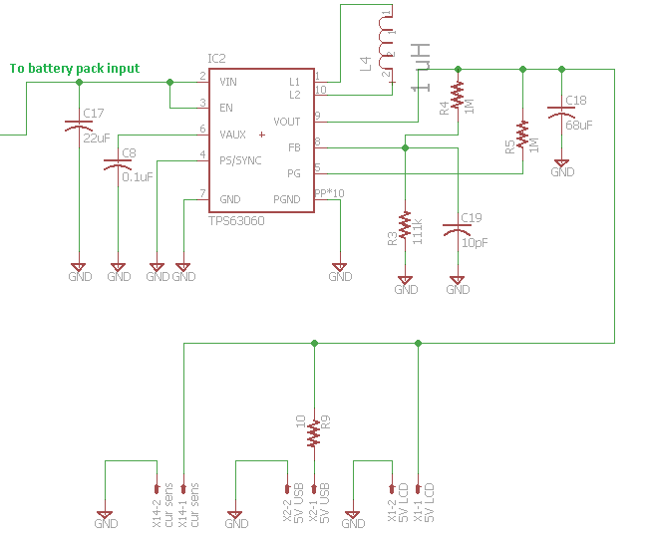
Multiple components could not be powered directly from the battery or solar panels. A 5V switching regulator was needed to run the microcontroller, the LCD screen, the ACS712 current sensor, and the USB dedicated charging port. Texas Instrument’s TPS63060 single inductor buck-boost converter was chosen for this. The schematic of this circuit is shown below in Fig. 5.
Fig. 5. TPS63060 circuit schematic

The main reason for choosing this IC was the 96% efficiency and the max allowable current of 1.8A which is well above our projected use. This max current was needed mainly for the USB phone charging port, though this charging port will be restricted to 0.5A charging capability. To keep this part of the project simple, 5V will be supplied to the USB for charging phones that can utilize simple charging capabilities. This charger will not be able to charge Samsung’s Galaxy or Apple’s line of phones, but will be able to be updated in future versions to include the charging of these types of phones.

F. Sun Tracking

One of the goals of this project was to produce a unique sun tracking solar panel. The umbrella will be designed to track the sun autonomously with no user interaction. This will be accomplished by using two motors in the pole design and using sensors to collect data. This will serve two purposes. The first is to maximize the solar panels ability to collect direct sunlight by pointing the top of the umbrella directly at the sun. This will allow more solar panels to be able to collect the direct rays thus increasing their efficiency. The second reason that the top of the umbrella will track the sun is to maximize the shading potential of the umbrella, as this is the reason behind using an umbrella in the first place. A push button switch in the enclosure will be used to activate the sun tracking ability of the umbrella. The umbrella will be set to the default of standing straight and lighting the LEDs incorporated in the top of the umbrella. By pressing the push button the microcontroller will automatically begin tracking the sun’s path. Because of the slow movement of the sun in the sky, readings and adjustments will only be taken in 30 minute increments. Another push of the button will return the umbrella to the original default position. Also if the sun’s intensity becomes too weak to charge the batteries due to cloud cover or nightfall the umbrella will be returned to its default position. This was done so that the umbrella could be used for any possible situation that the user could need. An on/off switch in the enclosure will allow the user the option of just having a standing umbrella with no lighting if that is desired.
Tracking the sun’s position in the sky will be achieved by using multiple sensors on the top of the umbrella. These sensors are simply Light Dependent Resistors (LDR’s) set in a plus shaped mounting at the top peak of the umbrella. By aligning the number 1 LDR with the hinge in the pole, rotating the umbrella to the desired spot will ensure that the umbrella will tilt towards the sun. This 360 degree ability to rotate will be possible with the use of a 19:1 planetary geared NEMA 14 stepper motor 14HS13-0804S-PG19. This motor is capable of providing 400 oz/in of torque. This highly efficient controllable stepper motor will be controlled by using a motor controller ROB-12859. The motor controller allows the motor to be controlled by the microcontroller while providing sufficient power from the Li-ION batteries. Initial testing shows a power draw of 0.7A at 7.4V. The motor controller also allows for the use of a sleep mode to increase efficiency of the project. This sleep mode allows the motor to be turned off while it is not being used.
The number 2, 3, and 4 LDR’s will regulate the degree of tilt in the umbrella. Preset tilt angles of 10, 20, and 30 degrees will allow the umbrella to tilt to the most efficient point. This action will be capable by adding a second NEMA 14 stepper motor 14HS17-0504S. This second motor will also be controlled by a second motor controller ROB-12779. This stepper motor will be used as an actuator to increase the amount of torque capable to allow a smaller more efficient motor to be used. This will also allow the motor to be placed in a sleep mode so that power does not have to be maintained thus increasing efficiency of the project. The tilt motor draws approximately 0.5A at 7.4V and provides 32 oz/in of torque.

G. Lighting And Entertainment Mode

Lighting was important in this project to allow the user to remain outside on a cloudy day or at night. To allow sufficient lighting, 24 high intensity cool white LEDs, model number YSL-R547W2C-A13, were added to the project design. This allowed 4 LED’s to be placed on each of the 6 steel splines of the umbrella. To allow the LED’s to be programmed individually and maintain a constant current to each individual LED, so that all of the LED’s were always the same intensity, a LED lighting controller was used. The 1429 lighting controller allows an SPI connection between the LED controller and the microcontroller. This allows the ability to manipulate a single LED. This ability was important to the project to allow for an entertainment mode.
The entertainment mode is activated by a push button switch on the enclosure. This mode will rotate the umbrella in a constant 360 degree pattern, provide 5 different lighting patterns, and light up the LCD screen where Pac-Man will be eating pellets across the screen. The 5 different lighting patterns will provide variety so that each press of the entertainment mode switch will provide a different lighting pattern. The entertainment mode will run for 15 seconds each time the button is pressed so that the battery life can be reserved. This was a fun way to show the programmability of the LED’s, the LCD screen, and the motors.

III. Prototype build
Multiple aspects needed to be considered when actually building and mounting the components on the final prototype. The next few sections will address the issues that arose and the prototype build and how these issues were solved. A big part of these issues were from the structural build of the umbrella itself.

A. Solar Panel Mounting

Since the Umbrella is comprised of fabric a heavy-duty spray adhesive was needed to mount the 28 solar cells. To allow for a 2A output current 18 gauge wiring was used to run the solar cells in series and to carry the current to the enclosure. The solar cells are located close to the 6 steel splines of the umbrella top to allow the umbrella to still be folded up for easy storing or transporting.

B. Motors

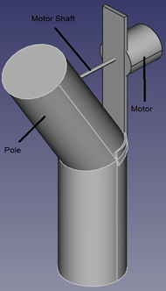
This part of the project was probably the most difficult part. Multiple motors were tested to verify that the most efficient solution was chosen. The umbrella has a round 1 ¼” steel pole. To insure that the umbrella could properly track the sun it needed to be able to spin 360 degrees and tilt at a 30 degree angle. To allow the umbrella to still be folded for storage or transporting the top motor had to be installed 3’ from the top of the umbrella. To decrease the torque on the motor a hinge was installed at 3’6”. This also only allows the umbrella top to tilt in one direction and to allow the umbrella to return to its original position when returning to the upright position. A heavy duty bracket was needed on the exterior of the pole to properly mount the motor. Figure 6 shows the model design of this motor. Also to increase the torque capability of the motor it was designed to act like an actuator. This was achieved by connecting the motor shaft to a 10-24 threaded rod using a flexible shaft coupler which reduces the radial force on the motor shaft. A 10-24 coupler inside the pole connected to a pin inserted through the pole which allows the coupler the ability to rotate which also decreases the radial force on the motor shaft. This was the biggest concern to allow for longevity of the motor use.

Fig. 6. Top Motor Build

The axial force on the shaft was not as big an issue as this was much larger and well within our calculated forces. Designing the motor in this fashion also allowed for the use of sleep mode so that a holding torque was not needed to maintain the position of the umbrella. This dramatically increases the efficiency of the total project.
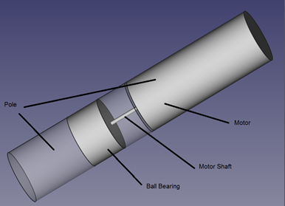
The second motor was the more difficult though the concept was easier. Since the umbrella broke apart with the top part inserting into the base, this was used to create the separation in the pole needed to be able to rotate it 360 degrees easily. A simple ball thrust bearing was installed inside the pole for the top of the umbrella to rest on. This decreased the axial load on the motor to nearly zero allowing for maximum motor life. The bottom motor could not be used as an actuator so the torque produced by the motor had to be able to handle the rotation. The motor with the shaft was much bigger than the diameter of the pole and required a special enclosure to be added to house this motor. The motor shaft was then connected to a fixed shaft attached to the bottom of the pole. The model of this design is shown in Fig. 7. This allows the shaft to remain fixed and the motor to rotate the top portion of the umbrella. Welding this box in the middle of the pole was not possible due to the temperatures of the welder burning holes through the thin steel. A heavy duty steel brace was used to connect and support the weight of the top of the umbrella.

Fig. 7. Bottom Motor Build

C. LED

The 24 LED’s were mounted using a hot glue gun. First each spot was isolated by applying a heavy duty electrical tape so that there was no contact between the steel umbrella splines and the contacts of the LED’s themselves. Then lead wires were soldered to each LED and then ran to the LED controller which is placed at the top of the umbrella pole. This allows the umbrella to still fold and only requires that 6 wires need to run down to the enclosure instead of 54 wires. This helps decrease the total weight of the project and the added wiring inside the enclosure.

D. PCB

Two PCB’s were created in this project. The fine folks at Osh Park, where the PCB’s were made, did a remarkable job. Since no one in the group had any experience with Eagle software or with designing and populating a PCB, this became a challenge. Populating the board took a fair bit of time and patience mainly due to the QFN packaging of the BQ24123 and TPS63060 IC chips.
The first PCB is the MPPT, BQ24123, and the TPS63060. Each individual IC is separated to insure that no issues arose in the testing. The board layout is pictured below in Fig. 8. This allowed for individual IC testing which definitely helped in the testing phase.
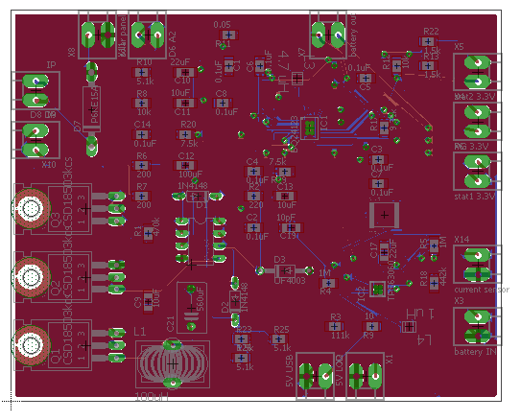
Fig. 8. PCB 1 – MPPT, BQ24123, and TPS63060PCB Board

The second PCB created in this project was the Arduino 2560 microcontroller. A bit of research went into the design of this PCB. This PCB is shown below in Fig. 9. To increase efficiency and maintain a smaller board size a barebones configuration was adopted which allowed the Fig. 9. PCB 2 – ATMEGA2560-16AU PCB Board.

maximum number of inputs and outputs available. This became more difficult than initially anticipated, because of the need to install a bootloader and the project coding onto the 2560-16AU chip.

E. Enclosure

The enclosure that was built for the project was made from Plexiglas so that all components can be visible. It allows people to easily see all of the circuitry and components needed to create this umbrella. Building the enclosure also allowed a smaller lighter weight design. The enclosure dimensions are 6 (l) x 4 (w) x 3 (h) inches. The sides and back of the enclosure were hot glued to create a stable box. Inserts were added at the front of the enclosure so that the front can be easily removed with 4 screws. The enclosure will house the two PCB’s, the battery, the two motor controls, the USB port, an on/off switch for the battery, and multiple push button switches.

IV. Testing
Testing the project was extremely important as there are multiple subsystems that needed to be integrated to create the final product. Initially testing was done on each subsystem individually. Then all the systems were integrated and a final testing was done to verify that the umbrella would run as advertised.

A. Solar Panel Testing

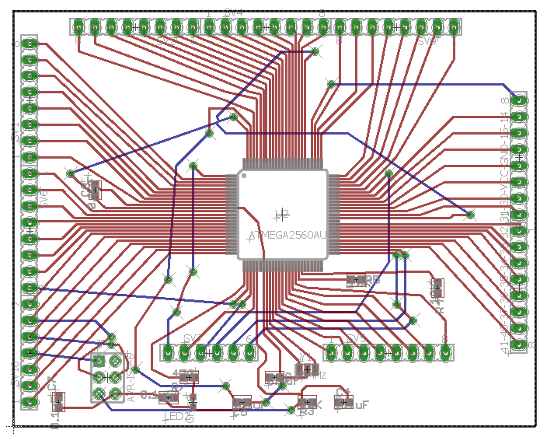
Testing the solar panels after they were installed on the umbrella was fairly easy to do. First, testing was done in direct sunlight with the umbrella standing straight. Then testing with the umbrella tilted toward the sun. More readings were also taken when cloud cover occurred. These readings gave an open voltage range of between 11V to 15V. Fig. 10 shows an example of the difference between the solar panels not fully facing the sun and the panels actually tilted towards the sun.
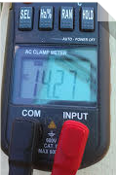
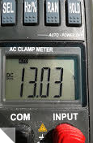

Fig. 10. Left – Open voltage reading standing straight. Right – Open voltage reading tilted 30 degrees.
The solar panels were then fully loaded to find the operating voltage of the panels. Because of the efficiency of the system, the operating voltage was consistently 1.5V less than the open voltage readings. This shows that tilting the umbrella increases the voltage output from the solar panels significantly. This test verifies that sun tracking creates more efficiency in our design. Tilting the umbrella adds a greater power output from the same sized solar panels.

B. MPPT and Battery Charging PCB Testing

Testing of the MPPT and the Li-ION battery charging IC was initially done in the laboratory using a regulated voltage supply. Fig. 11 pictures an oscilloscope reading to show the regulated voltage, shown in light blue, being supplied to the battery during the charging phase of the BQ24123 battery charging IC. Varying the input voltage, shown in dark blue, on the voltage supply to replicate the varying voltage of the solar panels resulted in a regulated constant output voltage of 8.4V. This voltage has a low ripple around 800 mV in amplitude under the conditions described above. This ripple voltage was initially nearly twice this voltage. Adding a simple RC snubber circuit in parallel with the 100 uH inductor cut the ripple voltage in half. This created a more stable voltage output from the MPPT.
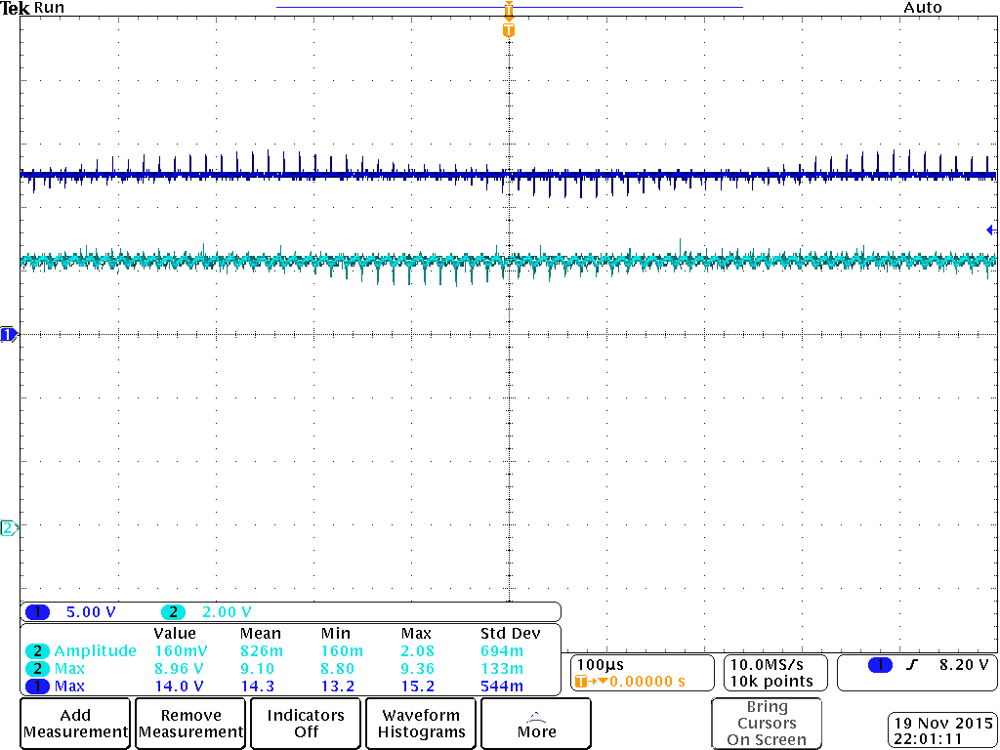
Fig. 11. Dark Blue – Input voltage 13V. Light blue – MPPT output voltage

The LCD screen also helps in the testing of the MPPT by showing the PWM of the MOSFET driver to show that it is changing and correctly switching the MOSFETS to regulate the output voltage. A load was then added to the circuit resulting in a 2A draw from the voltage supply. This was done by engaging both motors and the LED’s to guarantee that the components could handle a load that is double the max load intended to be used during normal operating conditions. Temperature readings were then taken using a multimeter to verify that there was no issue with overheating.

C. Sun Tracking Testing

Testing the sun tracking abilities of the umbrella involves a visual test leaving the umbrella in one location all day long and taking a time delay set of pictures to show that the umbrella is indeed following the sun. Since the readings and adjustments are taken every 30 minutes, this test was very time consuming. Because of the limitations on the length of this document, this set of pictures will be displayed in our presentation. Testing to verify that the push button switch will begin and leave the sun tracking mode and return to the default mode, has also been verified using a visual testing method.

D. Entertainment Mode Testing

Testing of the entertainment will also be a visual test. Verifying the length of run time and testing the variation of lighting modes will be as simple as pushing a button and watching to verify that the multiple modes are running correctly. A visual inspection was also used to verify that the LCD screen properly lit and displayed Pac-man eating pellets.

E. Final Testing

The final testing involves integrating all of the subsystems into the final product. This test verifies that all of the systems are working correctly together. This test involves the normal operating conditions that the umbrella will be subjected to. Battery testing is crucial in this test because of the goal to verify that the umbrella can run for 4 hours when solar panels are not charging the battery. This test will also involve the charging length to fully charge the battery to its maximum value. It will also make sure that all switching is correctly executed.

V. Conclusion
The main goals of this project were to create a lightweight, transportable, and unique senior design capstone project. By doing extensive research the group was able to realize these goals by creating a unique sun tracking solar panel application that serves a needed purpose. Separating this project into multiple subsystems allowed the design and testing to be done in smaller chunks. Choosing a microcontroller that was capable of integrating these subsystems was key to the success of the project. Choosing solar panels as the source for the battery charging allowed the umbrella to be used as a patio umbrella application and any other application where the user may need a sun tracking umbrella. It made the umbrella portable with no need to plug in to an external power supply. By adding a battery pack and battery charging capabilities for power storage, this also made the umbrella usable for multiple applications. Adding motors and motor controllers added a highly accurate means of sun tracking which increases the efficiency of the total system using data from the LDR's. Lighting was also added into the system to allow the user to use this umbrella at any time of the day or night. A simple dedicated USB 2.0 charging port allows the user to stay connected while enjoying the peaceful outdoors. Creating peripherals like the LCD screen and battery charging status LED's gives the user easy visuals to the status of the system showing useful information.

This project also shows the group's design capabilities utilizing the tools taught through UCF's engineering program. This project expanded the group's engineering toolbox by forcing the group to learn new real world applications. Learning Eagle cad software and learning how to design and create PCB's will be an added benefit in future careers. Testing and troubleshooting real world design issues as a group also creates another invaluable skill set that can be used throughout the group's future career. The manipulating of the multiple deadlines, meetings, reports, and the need to achieve success in the prototyping of the project has given this group a small “taste” of the career that we have chosen.

VI. Biographies


Eugene M McDonald is a 40 year old Electrical Engineering student. Eugene has an extensive work history that includes most recently 14 years’ experience as a lead electrician for a local electrical company. In this capacity, Eugene has increased his “skill set” to include electrical system design and installation, bidding, sales, customer service, material handling and multiple project coordination. Eugene hopes to use his education and past experiences in a career as a power Engineer incorporating smart grid technologies to increase efficiencies in the electrical utility marketplace.

Derek A Workman is a 29 year old student obtaining his Bachelors of Science in Electrical Engineering. Prior to going for this degree, he has always showed interest in electronics. Coding programs, repairing computers and fixing other various electrical devices were his normal pastimes. Derek hopes the knowledge he gained at the University of Central Florida will be put to use in power engineering. Derek has interest in working at military contractors and power generation companies. He has also showed interest in staying at University of Central Florida and obtaining another degree in Computer Engineering.


Nicholas Van Nice is a 29 year old Computer Engineering student. He inspires to work in the defense industry as a digital design engineer, specializing in firmware development. He served 4 years in the United States Navy and hopes to continue serving the United States military through his education and expertise.

References

[1] Electronics, Power. "Buck Converter Design Demystified", accessed 7/4/2015, http://powerelectronics.com/dc-dc-converters/buck-converter-design-demystified
[2] Informative, Energy. "Best thin film solar panels-
Amorphous, Cadmium Telluride, or CIGS?", accessed
6/21/2015,http://energyinformative.org/best-thin-film-solar-
panels-amorphous-cadmium-telluride-cigs/
[3] Network, EDN. "A simple guide to selecting power
MOSFETS", accessed 7/3/2015, http://www.edn.com
/design/ components- and- packaging/ 4341997/A- simple-
guide-to-selecting-power-MOSFETS
[4] Semiconductor, On. "AND9135 - LC Selection Guide for
the DC-DC Synchronous Buck Converter", accessed
7/3/2015, http://www.onsemi.com/pub_link/Collateral/
AND9135-D.PDF
[5] Omega."INTRODUCTION TO STEP MOTORS" accessed
07/13/2015, https://www.omega.com/auto/pdf/REF_IntroSt
ep Motors.pdf
[6] Adafruit. "All about Stepper Motors" accessed 07/14/2015,
https://learn.adafruit.com/downloads/pdf/all-about-stepper-
motors.pdf
[7] Microchip, "Practical Guide to Implementing Solar Panel
MPPT Algorithms" accessed 7/14/15 http://ww1.microchip.
com/downloads/en/AppNotes/00001521A.pdf
[8] Suntracker, "How I built a motorized sun tracker for my
solar panels" accessed 7/15/15, http://www.mdpub.com/
suntracker/

