**Wearable PPG Biometric Tracking System**

**Divide and Conquer 2.0**

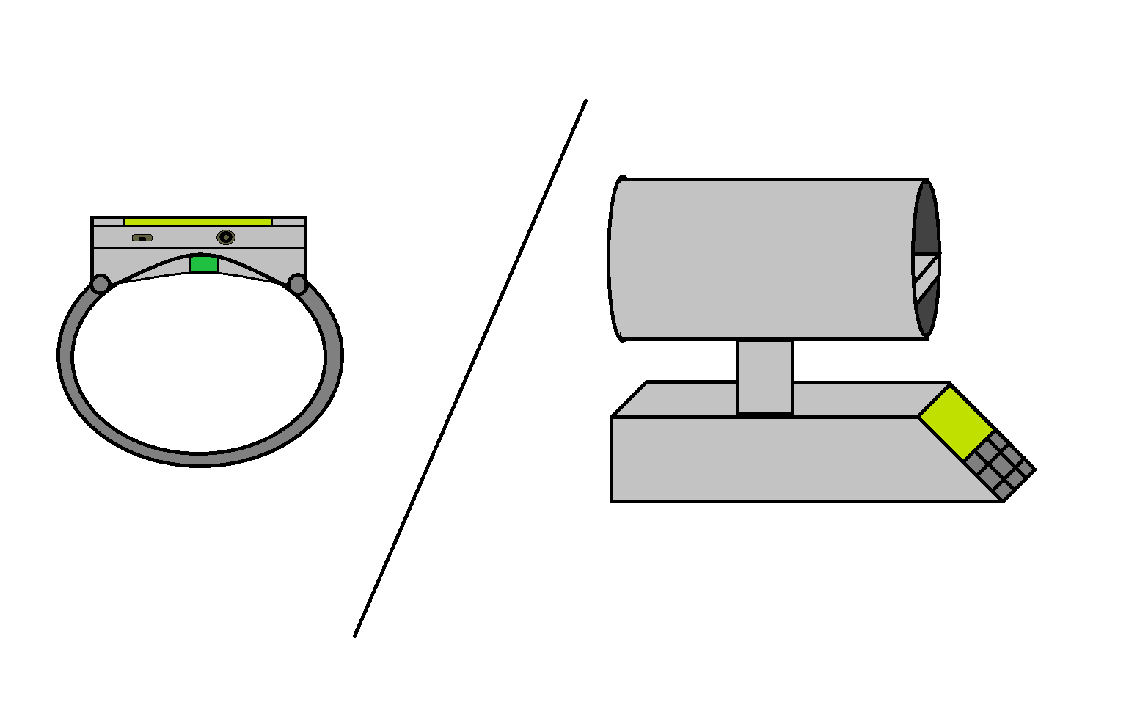

**Group 2**

**Tyrone Morales**

**Christopher Bormey**

**Scott Perryman**

**Cody Showers**

PSE

EE

EE/CpE

CpE

**University of Central Florida**

**Department of Engineering and Computer Science**

Senior Design 1

EEL4914 Spring 2022

Dr. Lei Wei, Dr. Samuel Richie, and Dr. Aravinda Kar

**Divide and Conquer 2.0**

Table of Contents

**1.1 Introduction** **1**

**1.2 Motivation** **1**

**1.3 Goals and Objectives** **1**

**1.4 Function of Project** **3**

**2.0 Engineering Requirement Specifications** **3**

**2.1 General Project Specifications** **3**

**2.2 Photonics Specifications** **4**

**2.3 Signal Analysis Specification** **5**

**2.4 Physical/Power Specifications** **6**

**2.5 Software Specifications** **6**

**2.6 Biometric Measurement Specifications** **6**

**2.7 House of Quality** **8**

**3.0 Prototype Representations** **9**

**3.1 High Level Overview Diagram** **9**

**3.2 Hardware Layout Block Diagram** **9**

**3.3 Signal Analysis Block Diagram** **10**

**3.4 Pre-Signal Analysis Block Diagram** **11**

**3.5 Application Data Receipt Workflow** **11**

**4.0 Signal Processing** **12**

**4.1 Features** **12**

**4.2 Heart Rate** **13**

**4.3 Heart Rate Variation** **15**

**5 Budget and Financing** **15**

**6 Project Milestones** **17**

**6.1 Senior Design 1 Milestones** **17**

**6.2 Senior Design 2 Milestones** **18**

**References** **19**

# 

# **1.1 Introduction**

Mindful monitoring of one’s cardiovascular health is a useful habit to establish in the modern day as cardiovascular disease (CVD) is the leading cause of death worldwide. Identifying an individual’s personal cardiovascular biometrics, such as heart rate, is a good approach towards analyzing their risk for CVD, as well as monitoring progress towards better cardiovascular endurance. Obtaining accurate heart rate measurements have, for the most part, been conducted via the use of multiple ECG probes which measure the heart’s electrical activity. While the ECG method stands as a current standard of medicine, in recent years there has been a renewed interest of PPG methods.

Photoplethysmography (PPG) is a technology which measures the blood flow volume changes of an individual from a single area via the illumination and subsequent detection of scattered light from microvascular tissue. The reflected light is modulated via the blood flow variation to create a signal that is mainly shaped by the pulse rate and pulse pressure. PPG devices have attracted recent attention in the academic field of biomedical engineering due to the possible biometric information embedded in the acquired signal, as well as the attention of fitness companies due to their inexpensive and easy-to-use implementations.

# **1.2 Motivation**

The motivation for this experiment is to explore the current state of PPG devices for personal health monitoring. Over the last 7 years, the number of scholarly articles and patents filed for PPG-related devices has grown significantly due to their promise for accessible health monitoring. This growth can be attributed to advances in sensor-related research and algorithm-based techniques for mitigating sources of inaccuracies and extracting critical biometrics for personal health, such as blood pressure and blood glucose. Given the ongoing research with respect to the accuracy of blood pressure measurements, our project will be constructed with the motivation of attempting to reach the current state of the art for educational purposes and should not be mistaken as a commercially ready device with respect to advanced biometric measurements.

# **1.3 Goals and Objectives**

Our group’s basic design goals are to design and construct a non-invasive biometric monitoring device via the processing of optical bio-signals. The proposed device will be able to interface wirelessly with a personal device via a health monitoring application that will store biometrics for an extended period. The principal biometrics that are to be collected for the basic design goals are the following: Heart rate, Heart Rate Variability (HRV), Blood oxygenation concentration (SpO2), and Skin temperature. The advanced design goals of our project include: improvements in the accuracy of the principal biometrics collected (such that they meet the accuracy standards), using an accelerometer to halt readings when they would be unreliable, and having the device be non-contact, and as well as the collection of additional biometrics such as blood pressure, blood glucose, and skin resistivity. Stretch goals for the project design include a motion-robust signal processing, such that movement of the region of interest (ROI) does not render the processed biometrics full with errors, a rechargeable battery that lasts more than an hour, as well as that the secondary biometrics collected closely approach the set standards of accuracy. The classification of the two final goals in the stretch category is due to the fact that these goals have only recently been achieved in the last two years in academic settings with reasonable funding.

Our group’s current objectives are related to the design and market-research of the necessary modules for the construction and function of the device. We aim to design an optical sensing module that allows for the collection of the PPG and skin temperature signal in such a manner that further biometric extraction is not limited by the initial signal acquisition. We aim to design a signal conditioning module which will filter, amplify, and convert the collected signals to be ready for biometric extraction. We aim to design and utilize digital algorithms to extract the biometrics information embedded in the collected signals. We aim to design a wireless communication module for the transmission of the processed biometrics data to a personal device for convenient monitoring. We aim to design a PCB layout that will be able to integrate all the necessary modules into a relatively compact manner.

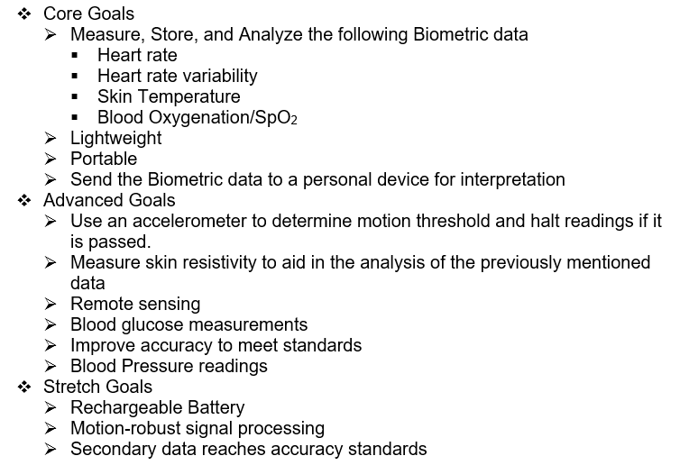

# **1.4 Function of Project**

The function of the project is to provide individuals who use the device with an easy and convenient method for monitoring important biometrics. The information gathered from the device will be formatted and stored in such a manner that it can be used to understand the current cardiovascular health status. The information gathered will be stored for a given time period such that an individual can compare their current status to prior status as means to identify progress or concern.

# **2.0 Engineering Requirement Specifications**

These requirement specifications are the metrics by which we are planning to accomplish the desired results of the project and measure their success. We have broken these requirements into a few categories. The categories are as follows, general, photonics, signal analysis, physical power, and application specifications.

# **2.1 General Project Specifications**

General project specifications refer to broad requirements of the project that may not cleanly fit into a specific category but may be essential to the design. These specifications can be found in the table below (Table 2.1)

| Number | Description | Magnitude | Units |
| --- | --- | --- | --- |
| 1 | The device shall have multiple modes of operation: Off, ON: Stand-by, ON: Data Acquisition, ON: Data Transmission & Presentation. | 4 | Modes |
| 2 | Device shall produce predictions for the following biometrics: Heart Rate, Heart Rate Variability, Blood Oxygenation, Temperature. | 4 | Biometrics |
| 3 | The device size should be compact for the contact design (WxLxH) | ~8x4x4 | cm |
| 4 | The device size should be compact for the non-contact design (WxLxH) | ~18x24x30 | cm |

**Table 2.1: General Specifications**

# **2.2 Photonics Specifications**

Photonics Specifications refers to the requirements of the hardware relating specifically to the photonics modules required for the device’s operation. These specification can be observed in the table below (Table 2.2)

| Number | Description | Magnitude | Unit |
| --- | --- | --- | --- |
| 1 | The wavelength range of the illumination source should be in the VI spectrum to IR spectrum. | 500 - 1000 | nm |
| 2 | Photodetector(s) should have a high responsivity at the selected wavelengths of the illumination source(s). | >0.65 | A/W |
| 3 | The emission spectrum of the illumination source should not vary from it’s characteristic wavelength by more than 15 nm | <15 | nm |
| 4 | The detection module must be designed such that ambient light only comprises less than 5% of detected light. | 5% | W |

**Table 2.2: Photonic Specifications**

# 

# **2.3 Signal Analysis Specification**

Signal Analysis specifications refers to the specific metrics of the performance and application of signal analysis in the system. These specifications can be seen in the table below (Table 2.3)

| Number | Description | Magnitude | Unit |
| --- | --- | --- | --- |
| 1 | A/D converter shall sample at a rate of at least 100Hz. | 100 | Hz |
| 2 | Signal to noise ratio shall be at least 30dB. | 30 | dB |
| 3 | Hardware latency should be less than .5 second <TBR> | 0.5 | s |
| 4 | This process shall produce an estimation of heart rate, heart rate variability, blood pressure, blood oxygen content, and temperature no less than once every second when in data transmission and presentation mode. | 1 | s |
| 5 | The bias of the distribution of any of the biometric predictions on any single user should not be more than 5% away from the true value. | 5 | % |
| 6 | The variance of the distribution of any of the biometric predictions on any single user should be less than 5. <TBD> | 5 | Unit^2 |

**Table 2.3 Signal Analysis Specifications**

# **2.4 Physical/Power Specifications**

Physical/Power specifications refers to the overall physical design of the device in the system and the power requirements of the external device. These specifications can be seen in the table below (Table 2.4)

| Number | Requirement | Magnitude | Unit |
| --- | --- | --- | --- |
| 1 | Compact PCB that can fit on the wrist | 2000 | mm2 |
| 2 | Enough battery life to withstand a presentation and testing | 3600 | s |
| 3 | Low Power Consumption | <200 | mA |
| 4 | Light weight | <500 | g |

**Table 2.4 Physical/Power Specifications**

# **2.5 Software Specifications**

This section refers to the requirements of the design related to the transmission and the application’s ability to receive, display, and store the data for the system. The software system will be responsible for displaying the measurements and will be constrained by these measurements. The specifications can be seen in the table below (Table 2.5).

| Number | Description | Magnitude | Unit |
| --- | --- | --- | --- |
| 1 | Transmission range | 3 | ft |
| 2 | Data Transmission Rate | 1 | Mbps |
| 3 | Store User Data Long Term | 365 | day |

**Table 2.5: Software Specifications**

# **2.6 Biometric Measurement Specifications**

This tool is intended to provide an inexpensive tool for the purposes of education rather than a diagnostic tool. To that end we can make some reasonable assumptions about the ranges of the metrics we are trying to measure. Anything outside of these ranges will not be considered when designing the display of the application or notifications inside the application. Minimums and maximums of the metrics are included in Table 2.6

Heart rate refers to the number of times a heart pumps blood during a fixed period. In this case the standard is measured in beats per minute. Although a low resting heart rate can be an indicator of cardiovascular fitness and strength, too low can be detrimental to health or even mean death.

Heart rate variability refers to the difference in time between beats of heart. Although the rate of a heart beat may be fixed, this is an average which can have a variable interval between. This metric is identified by the difference in timing between beats during a fixed period. This measurement is most accurate over long periods however, an estimation can be made by a much smaller window.

Skin Temperature refers to the amount of heat emitted by the skin of the user. This can be affected by the environment and go beyond reasonable health ranges. Operation of this device will assume that skin temperature does not go below freezing or above a temperature where fever would likely induce brain damage. Either of these cases would go beyond reasonable bounds for a tool like this one and medical attention should be sought immediately.

Arterial Oxygen Saturation refers to the percentage of oxygen concentration in the bloodstream. A healthy oxygenation level will approach 100% but excess will escape the blood into the environment. Below 95% often users should be seeking medical attention but this does not represent a good lower bound of the reading. Oxygenation can vary due to a number of factors but cannot possibly be lower than 0%.

| Number | Description | Magnitude | Unit |
| --- | --- | --- | --- |
| 1 | Heart Rate Min | 0 | bpm |
| 2 | Heart Rate Max | 600 | bpm |
| 3 | Heart Rate Variability Min | 0 | ms |
| 4 | Heart Rate Variability Max | 1000 | ms |
| 5 | Skin Temperature Min | 0 | C |
| 6 | Skin Temperature Max | 60 | C |
| 7 | Arterial Oxygen Saturation(SaO2) Min | 0 | % |
| 8 | Arterial Oxygen Saturation(SaO2) Max | 100 | % |

**Table 2.6: Biometric Measurement Specifications**

# **2.7 House of Quality**

The house of quality below (Table 2.7) shows the sacrifice of parameters in developing this device. By using this form of analysis we plan to optimize the balance between the customer’s and engineering requirements.

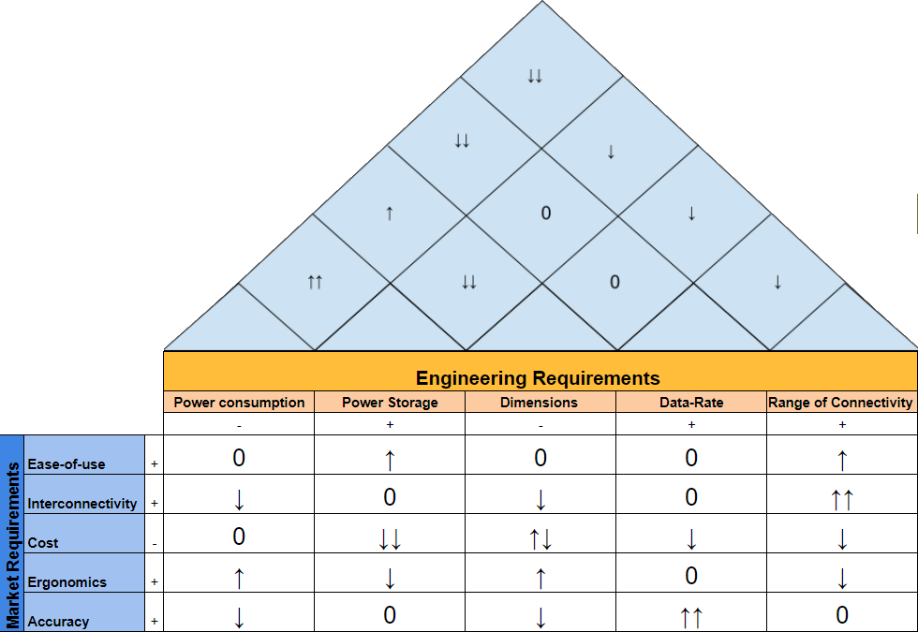

**Figure 2.7: House of Quality**

# 

| Legend |  |
| --- | --- |
| + | Positive Polarity |
| - | Negative Polarity |
| ↑ | Positive Correlation |
| ↑↑ | Strong Positive Correlation |
| ↓ | Negative Correlation |
| ↓↓ | Strong Positive Correlation |
| 0 | Neutral Correlation |
| ↑↓ | Complicated/Nonlinear Correlation |

# 

# **3.0 Prototype Representations**

This chapter will express the system at different levels of abstraction. Generally this chapter moves from high to low with a couple exceptions. Some sections express specific functions such as signal processing, dataflow, etc.

# **3.1 High Level Overview Diagram**

The planned system will incorporate the function of a designed device that uses LEDs and sensors to gather biometric data. It will then analyze the information gathered and use a communication protocol to push the results to another device for display and storage. The various components will be completed by each of the members of the team. Each member of the team will be responsible for the completion of at least one of these components from an administrative perspective but any or all of the team may end up working on any given component. Responsibility for each is labeled in the figure below (Figure 3.1).

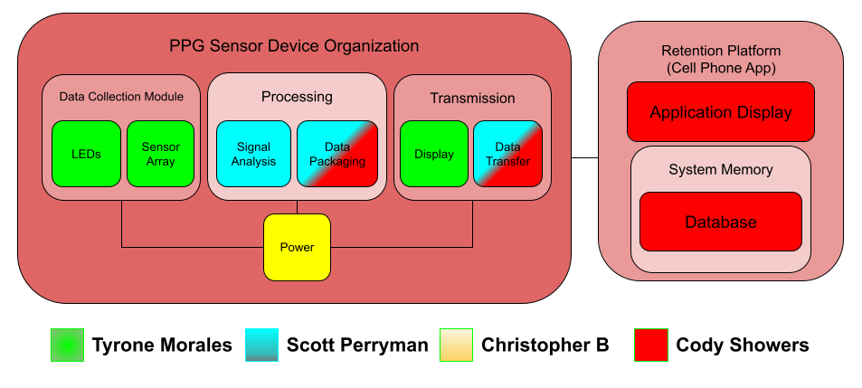

**Figure 3.1: High Level Overview**

# 

# 

# **3.2 Hardware Layout Block Diagram**

Currently every component of this block diagram is in the research stage, wherein no parts have been definitively chosen. We are yet to decide what combination of parts would deliver the portability, power consumption, and low cost qualities we are looking for. Figure 3.2 below gives a general overview of the flow of information from different hardware components, and their interaction with the outside environment.

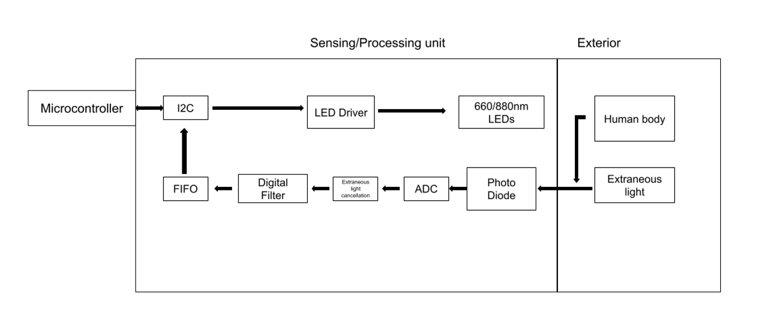

**Figure 3.2: Hardware Layout**

# 

# **3.3 Signal Analysis Block Diagram**

Below is a basic diagram (Figure 3.3) of the signal processing system. The system starts with an incoming analog current signal from the photodiode sensor array. With the use of a transimpedance amplifier, we can convert the current signal to a voltage signal. From there we are going to do some basic signal preprocessing which will use several layers of active and passive filters to remove unneeded frequency components from the analog signal. The A/D converter coupled with a flip-flop array will allow us to convert the preprocessed analog signal to a digital signal with our desired sample frequency and resolution. Using several feature extraction techniques we can then predict and output the user’s biometrics.

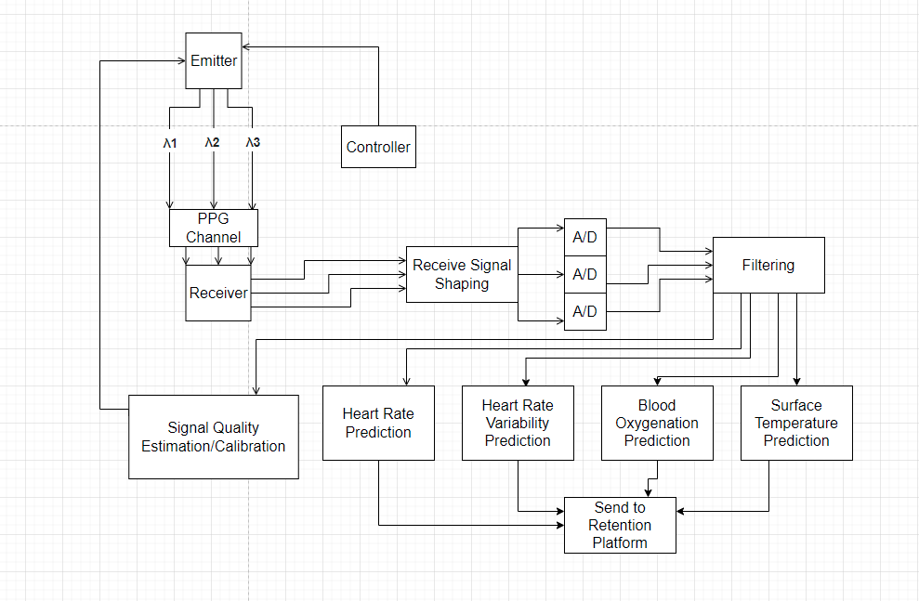

**Figure 3.3: Signal Processing System**

# **3.4 Pre-Signal Analysis Block Diagram**

The device will have a pre-signal analysis block to ensure that the PPG signal going into the biometric extraction process is of adequate quality. Common sources of inaccuracies in readings are often the result of motion of region of interest (ROI) during signal acquisition and/or inadequate illumination for darker skin tones due to stronger absorption from larger melanin concentrations. The diagram below (Figure 3.4) will provide feedback to the system and user such that these issues can be addressed before entering the primary signal analysis stage.

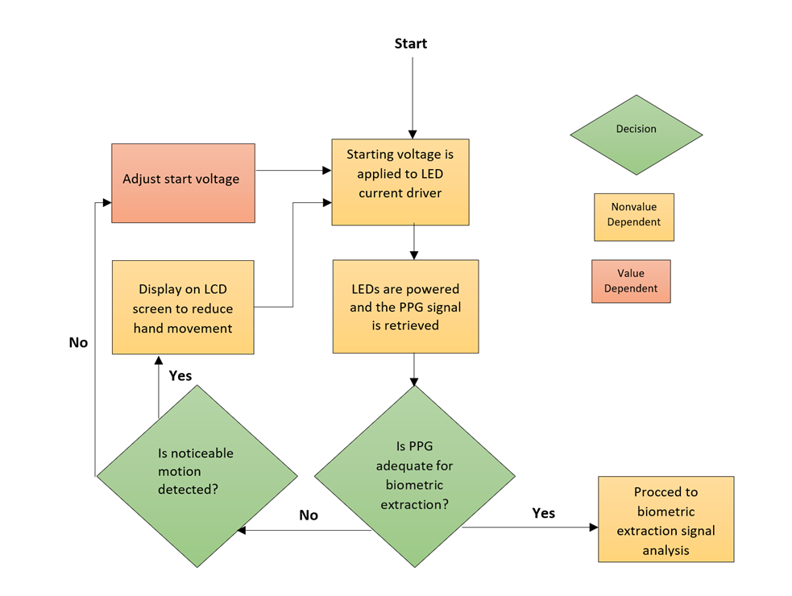

**Figure 3.4: Pre-Signal Analysis Loop**

# **3.5 Application Data Receipt Workflow**

The application will reside on a smart device ready to receive the signal from the designed device. As modeled below in Figure 3.5, the application will await data input from the device. Once received the application will be responsible to check to see if data transferred is valid. Upon a failed check data must be retransmitted. If the check passes, the results would then be decoded and displayed in the application. Meta-data would need to be wrapped into the data received from the device to store in the application database. Upon the storage step the application would reset and return to the awaiting data state.

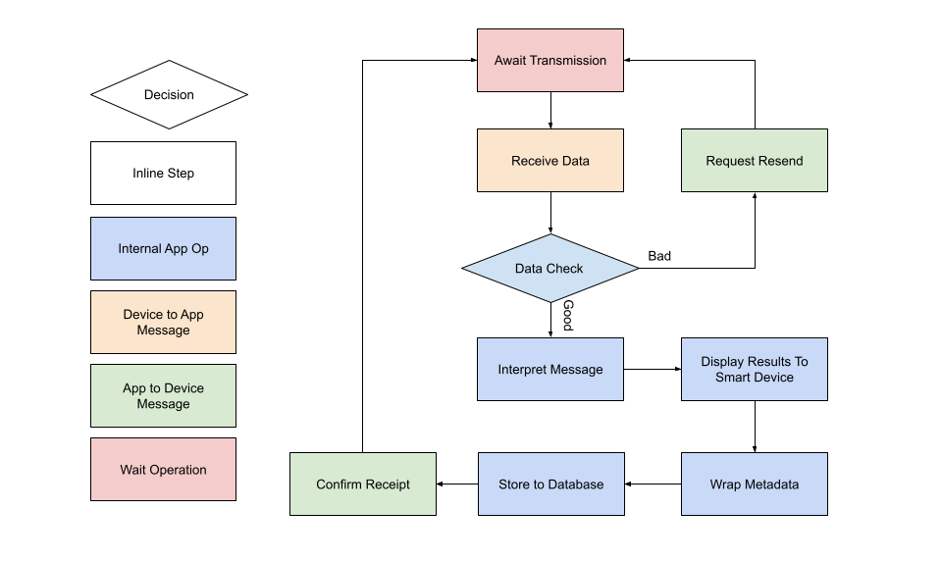

**Figure 3.5: Application Data Flow**

# 

# **4.0 Signal Processing**

The signal processing required to extract the certain biometric features from the PPG signal will require some time-domain analysis. In this section we will briefly cover some techniques for identifying the necessary features of the PPG which are necessary to derive blood flow information necessary for average heart-rate and HRV.

# **4.1 Features**

**Peak Detection-**

One of the most important features we will be looking for is the signal’s peaks. By taking a look at the sample PPG signal you will see there are two local maximums per heart rate period. We specify that we want to locate the highest valued maximum to maintain consistency. Below is a high level description of the algorithm used to identify the sample number and time at which this peak occurs.

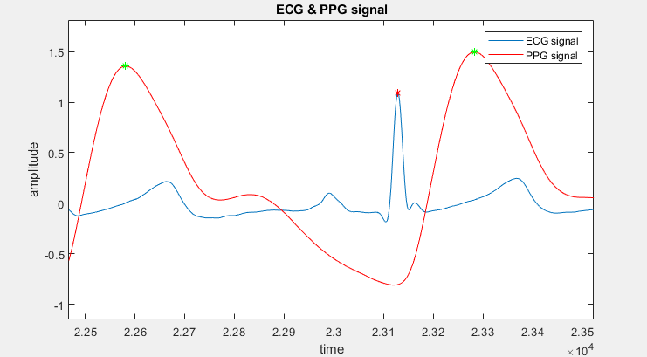

**Figure 4.1: Peak detection of bio-sigals**

To tackle the problem of peak detection algorithmically we must identify the characteristics of the peak we are looking to detect. To explain these algorithms we are going to use the example PPG signal sampled at 1kHz given in figure 4.1.

Identifiers:

* Is a local Maximum
* Is the highest valued point in the cycle.

Algorithm-

If (PPG(n) > PPG(n-1) && PPG(n) > PPG(n+1))

PPG(n) is a local maximum.

If (PPG(n) > PPG(x)) for all x | n-T0/2<x<n+T0/2 && x,n are integers

PPG(n) is the maximum point in the cycle

If both of the statements above are true, than n is the sample number of this peak and n*Ts is the time of this peak.

# **4.2 Heart Rate**

**Instantaneous Heart Rate-**

From the peak detection algorithm we can identify repetition in the incoming PPG signal. This cycle will have the same frequency as the heartbeat as the subject of the sensor. So, the difference in sample number multiplied by the sample period will be a good approximation to the period of a heart beat cycle.



**Figure 4.2**

Example-

$n= 2.26*10^{4} , n_{2}= 2.33*10^{4}, T_{s}= 1/1kHz = .001 seconds$

$n_{2}-n_{1}= 700$

$700*.001s = .7s$

$60/0.7 = 85.71BPM$

**Average Heart Rate-**

By detecting multiple instantaneous heart rates in series we are able to make an estimation for the average heart rate. This is important to note since not only will this parameter be reported to the user, but will also be used to estimate heart rate variation.

Definition -

Assume k is a set of instantaneous heart rate estimations.

$Mean heart rate = \sum_{x}^{k}{}x/|k|$

# 

# **4.3 Heart Rate Variation**

To maintain consistency we decided to repurpose the definition of variance in probability theory. Meaning heart variance is equal to the variance of the distribution of instantaneous heart rate predictions. Furthermore, the square root of HRV is equal to 1 standard deviation.

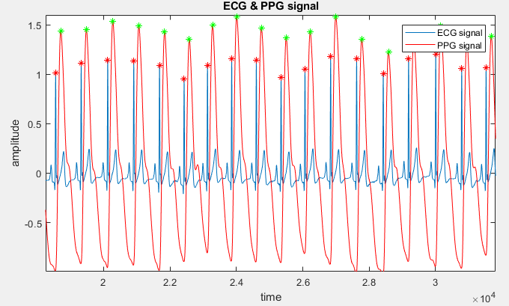

**Figure 4.3**

Heart Rate Variability-

Assume that K is a set of instantaneous heart rate estimations.

$HRV = \sum_{x}^{k}{}(x- mean HR)^{2}/|k|$

Example-

K = {60, 70, 85}

Mean Heart rate = 71.66

$=[({60-71.66)}^{2}+(70-71.66)^{2}+(85-71.66)^{2}]/3$

$=[135.955+2.7556+177.955]/3$

$HRV=105.555 = σ^{2}$

# 

# **5 Budget and Financing**

As of the creation of the divide and conquer 2.0 document, this project will be financed entirely by the project group members. When creating a wearable device, cutting edge technology that is smaller than a common wristwatch is not feasible on a budget made with four students in mind, therefore we have chosen components that are light and affordable at the expense of not being smaller than market competitors. The team has agreed upon a maximum budget of $300 per person, with the aim to make this project under $150 per person. Current budget estimates are tentative, as we have not finished the process of deliberating what parts we will be using in our first prototype. As of now, the high end of the budget estimate would target reaching all of our goals, including the stretch goals. To implement just the core features and perhaps some advanced features, we aim to keep the budget at the aforementioned $150 per person. Decisions on what type of battery and power delivery system we use moderately affect our budget and convenience of the device. Currently, our high end estimate for the budget lies in the $300 per person range, with complications potentially raising this to $400 or more.

| **Item** | **Cost Per Item** | **Quantity** | **Total cost** |
| --- | --- | --- | --- |
| Microcontroller | $30.00 | 1 | $30.00 |
| Wrist wearable Housing | $75.00 | 1 | $75.00 |
| Photo Diode | $1.38 | 3 | $4.14 |
| Battery | $10.00 | 1 | $10.00 |
| PCB Printing | $15.00 | 3 | $45.00 |
| BLE Module | $4.00 | 1 | $4.00 |
| 660 nm LED | $2.50 | 3 | $7.50 |
| 880 nm LED | $0.66 | 3 | $1.98 |
| ADC | $2.66 | 5 | $13.30 |
| FIFO memory | $10.00 | 3 | $30.00 |
| IR sensor | $3.30 | 3 | $9.90 |
| *Total (Approx)* |  |  | $230.82 |

**Table 5.1: Cost of Components**

# 

# 

# **6 Project Milestones**

This chapter is a listing of the intended milestones throughout the project from start until conclusion. It is broken up by in which class the prospective milestone will be reached.

# **6.1 Senior Design 1 Milestones**

| **Week #** | **Dates** | **Milestone** |
| --- | --- | --- |
| 1 | 1/10/2022 – 1/14/2022 | Form a group and formulate ideas |
| 2 | 1/17/2022 - 1/22/2022 | First group meeting |
| 3 | 1/24/2022 – 1/28/2022 | Meet bootcamp objectives and start on D&C V1.0 |
| 4 | 1/31/2022 – 2/4/2022 | Finalize D&C V1.0 |
| 5 | 2/7/2022 – 2/11/2022 | D&C V1.0 meeting  Work on D&C V2.0 |
| 6 | 2/14/2022 – 2/18/2022 | D&C V2.0 submission |
| 7 | 2/21/2022 – 2/25/2022 | Begin work on 60 page paper |
| 8 | 2/28/2022 – 3/04/2022 | 30/60 pages |
| 9 | 3/07/2022 – 3/11/2022 | 40/60 pages |
| 10 | 3/14/2022 – 3/18/2022 | 50/60 pages |
| 11 | 3/21/2022 – 3/25/2022 | 60/60 pages, Assignment due |
| 12 | 3/28/2022 – 4/01/2022 | Finalize research and design, achieve 80 pages |
| 13 | 4/04/2022 – 4/11/2022 | 100 pages due |
| 14 | 4/18/2022 – 4/22/2022 | Refine paper, finish last 20 pages |
| 15 | 4/25/2022 – 4/29/2022 | Submit final report 120 pages  Order PCBs |

**Table 6.1: SD1 Milestones**

# **6.2 Senior Design 2 Milestones**

| **Week #** | **Dates** | **Milestone** |
| --- | --- | --- |
| 1 | 5/16/2022 – 5/20/2022 | Update meeting, order missing parts |
| 2-3 | 5/23/2022 – 6/03/2022 | Test sensor and data processing |
| 4-6 | 6/06/2022 – 6/24/2022 | Get App/UI finished |
| 7-10 | 6/27/2022 – 7/22/2022 | Finish prototyping/make final changes |
| 11 | 7/25/2022 – 7/29/2022 | Deliver presentation |
| 12 | 8/01/2022 – 8/05/2022 | Final report |

**Table 6.2: SD2 Milestones**

# **References**

[1] Castenda, D., et al. (2018). "A review on wearable photoplethysmography sensors and their potential future application in health care." Int J Biosens Bioelectron. **4**(4): 195-202.

[2] Elgendi, M. (2012). "On the analysis of fingertip photoplethysmogram signals." Curr Cardiol Rev. **8**(1): 14-25.

[3] Fine, J., et al. (2021). "Sources of inaccuracy in photoplethysmography for continuous cardiovascular monitoring." Biosensors **11**(126).

[4] Ghamari, M., et al. (2016). "Design and prototyping of a wristband-type wireless photoplethysmographic device for heart rate variability signal analysis." Conf Proc IEEE Eng Med Biol Soc.: 4967-4970.

[5] Organization, W. H. "Cardiovascular diseases." Retrieved 1/30/2022, 2022, from <https://www.who.int/health-topics/cardiovascular-diseases>.

[6] Saha, S. "PPG-Signal-Processing." from <https://github.com/ShoumikSaha/PPG-Signal-Processing>.