Project: Camera Motion Rig

Group 26

Chisom Ikejiani – Computer Engineering

Andre Samaroo – Computer Engineering

Michael Serignese – Computer Engineering

Narrative Overview

Motion control rigs are basically robotic cameramen. They control the camera’s movements and even the camera settings. These systems allow you to execute difficult camera shots with the ease of programming the movements. This also allows us to take camera shots from difficult places and remotely.

The tall tripod-mounted action camera is meant to act as a sports camera that can rapidly pan, tilt, and zoom (also called a PTZ camera), rapidly responding via the user interface in order to capture fast-paced events from a vantage point that allows effective coverage of a large sports arena. The implementation we looked at was designed by Qwikcut. It is rather pricey for a system that does not quite meet a desirable maintenance schedule, where three cables for power, audio, and video appear to be grafted onto the camera system in such a way that they often fail. Additionally, the waterproofing for the system is lackluster and may cause failure on an incident of rain, a detrimental feature for a camera system that is meant to capture events often held outdoors. Therefore, the goal of this project is to offer a new design and implementation of the product that is lower cost, more tightly integrated, has superior waterproofing, and requires less maintenance than the initial design.

The camera will output audio and video data to a workstation computer that will be responsible for recording to disk, livestreaming the audio-video media content in real time, and issuing commands to the camera via the user interface of a game controller. The inputs of power and commands to the camera as well as the media output from it will flow over an ethernet cable capable of conducting the signal and wattage necessary for the device.

The camera will be controlled via a game controller, using two joysticks and at least four buttons to control pan, tilt, and zoom, starting and stopping the recording or livestream, increasing or decreasing the brightness of the video stream, and finally powering on and off the device. If there are additional interfaces on the controller that remain unused, the goal for these features is to reserve them to attain maximum control over the camera through the controller, and only deferring to the workstation computer as a secondary control mechanism.

Since this is an action camera, the responsiveness of the device both in terms of software control features and also in mechanical agility are paramount. The controller-camera logical connection, in tandem with the pan-tilt motor agility, must be bridged in such a way that commands transmitted via the user interface of the controller reach the camera

As a stretch goal, we would like to automate the control rig in some way. We thought that a computer vision based tracker would be best. The camera will lock onto a subject in frame and then basically follow that person until the feature is turned off. This leads to another stretch goal of making the game controller communicate with the workstation wirelessly to allow for the person to control the camera remotely.

Requirements Specifications

**Tripod-1**

The tripod must be sturdy enough to provide mechanically stable video in wind gusts of 10 miles per hour.

**Housing-1**

The device housing must be waterproof in moderate rain, at 0.10 inches of rain per hour.

**Video-1**

The camera system must be capable of sampling 1080p at 30 frames per second, with a delay of less than one second for the samples to arrive.

**Audio-1**

The audio system must be able to sample audio in the following formats, or an equivalent format that offers comparable quality parameters: WAV (44.1kHz, 16 bit), MP3 (320Kbps), or OPUS (128 Kbps). The samples must not be delayed longer than 1 second to arrive.

**Mount-1**

The mounting connectors between the tripod, motor mounts, and camera system must be able to withstand minor force of 5 ft-lbs without being damaged.

**Controller-1**

The controller must be able to connect to a workstation computer via USB2 or newer, and control the camera via the joysticks and buttons on the device.

**Controller-2**

The controller must be able to pan, tilt, zoom, and otherwise control the camera on the full range of the device’s capabilities, initiating the commands from the controller in under 1 second.

**Workstation-1**The workstation software must transmit the commands received from the controller in less than 0.5 seconds.

**Workstation-2**The workstation software must process packets received from the camera system to prevent a packet backlog of over 1000 packets from forming.

House of Quality

The house of quality, in Diagram 1, illustrates the tradeoffs between the marketing and engineering requirements. By comparing the tradeoffs between the two requirements we are able find what can be accomplished conceptually before actually physically building the project.

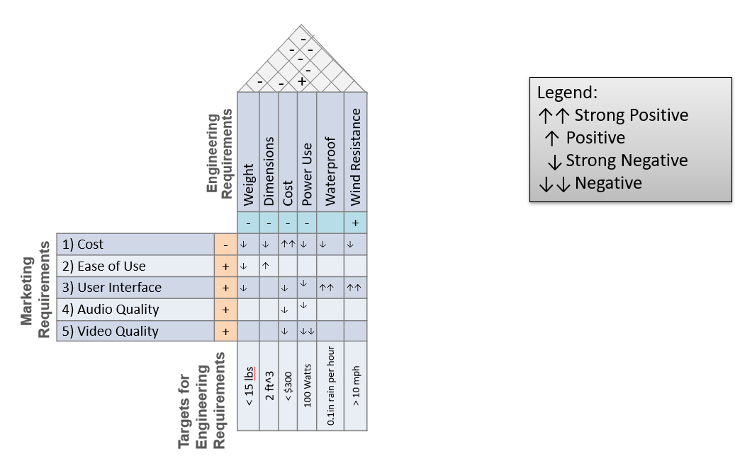

Diagram 1: House of Quality Diagram

Software Flowchart

In diagram 2, the general overview of the software flow is awaiting commands from the workstation. The device awaits a power-on signal, and then listens for input related to powering off, audio and video sampling, PTZ actions for the motor, and responds to them appropriately.

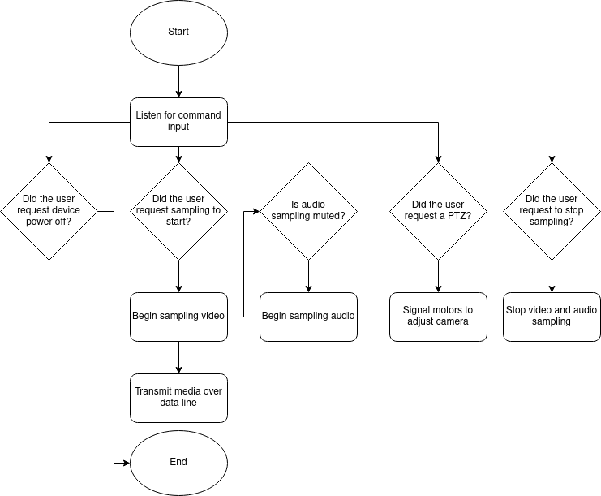

Diagram 2: Software Flowchart

Block Diagram

The hardware block diagram in diagram 3 illustrates the physical connections between subsystems in the device. The capture device is the controlling system for the audio-video subsystems, as well as directing the motor to the appropriate angles in order to frame the shot correctly and quickly. Any commands and media data are transmitted over the power-data line, where commands are brought in from the controller, and where the media is written to disk. The mount and tripod support the capture system, the weight of the cables connecting the workstation, capture device, and motor, providing stability and the altitude for media capture.

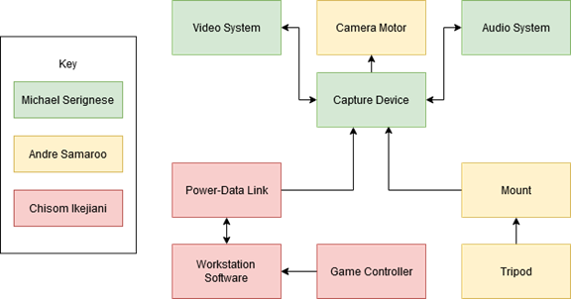

Diagram 3: Hardware Block Diagram

Budget

The budget shown in Table 1 displays options for both ready made products and parts for systems we would build ourselves. There are three major categories for the products. There are the parts for the camera, parts for the controller, and parts for the mount. The computer workstation will just be the user’s computer with a user interface. A good option for a bought camera is an IP surveillance camera since they already work with power over ethernet (PoE). If we choose a camera option without PoE capability, it will be necessary to build an adapter. This can be integrated into the control unit for the motors. If we decide to buy a controller it may not have the right ports. To build a controller, we just need a control unit, two joysticks, and buttons if necessary. The mount is supposed to connect the motion rig to the tripod so we may opt to 3D print the parts to suit our needs.

|  |  |  |
| --- | --- | --- |
| Item | Quantity | Price |
| Camera | 1 | $40 |
| Microphone (if not built in) | 1 | TBD |
| Power-data link | 1 | $30 |
| ethernet cable(25 ft) | 1 | $9 |
| ethernet microcontroller |  | $23 |
| Game controller | 1 | $50 |
| control board/ microcontroller | 1 | $23 |
| joystick/4 way switch | 2 | $8 |
| USB connection cable(10 ft) | 1 | $8 |
| Mount | 1 | TBD |
| 3D printed parts ? |  |  |
| Motor | 2 | $28 |
|  |  |  |
| Total | -- | ~$219 |

Table 1: Budget

Initial Project Milestones

Table 2 outlines our milestone goals week by week. A majority of the first semester is spent on documentation and developing an initial prototype and writing the proper documentation. The second semester is about building the prototype, analyzing the initial results, and developing an improved system.

|  |  |
| --- | --- |
| Senior Design 1 | |
| Week | Milestone |
| 1 | Form teams |
| 2 | Brainstorm ideas |
| 3 | **DC1** |
| 4 | Investigate project idea |
| 5 | **DC2** |
| 6 | Investigate weather-proofing |
| 7 | Draft parts requirements |
| 8 | Finalize parts requirements |
| 9 | **Assignment on standards** |
| 10 | Order parts and set up development software |
| 11 | Begin assembly and experiment with control software |
| 12 | **60 page draft** |
| 13 | Test camera motor and implement mount |
| 14 | **100 page draft** |
| 15 | **Final draft** |
| 16 | **Final submission** |
|  |  |
| Senior Design 2 | |
| 1 | Software plan |
| 2 | Implement workstation software |
| 3 | Implement controller software and data exchange protocol |
| 4 | Implement video subsystem |
| 5 | Implement audio subsystem |
| 6 | Final revision, assembly, and testing of prototype 1 |
| 7 | Revise software for workstation, controller, and data link |
| 8 | Revise mechanical stability, weatherproofing, and software for audio-video |
| 9 | Final comments and accessory ideas |
| 10 | Final revision, assembly, and testing of prototype 2 |
| 11 | Assess and Report |
| 12 | Final draft |

Table 2: Milestones

Sources:

Documentation from Qwikcut about requirements:

<https://webcourses.ucf.edu/courses/1370771/files/folder/potentialprojects?preview=84393337>

Motion rig examples:

<https://www.mrmoco.com/motion-control/>

PoE explanation:

<https://www.veracityglobal.com/resources/articles-and-white-papers/poe-explained-part-2.aspx>

video:

<https://www.youtube.com/watch?v=EUMIdhZXRWY>

PoE cam info:

<https://reolink.com/poe-ip-cameras-buying-guide/>

PoE cam option:

<https://www.amazon.com/Security-Ethernet-Surveillance-Waterproof-Infrared/dp/B07KSWNDXV>

<https://www.cctvcameraworld.com/ip-cameras-with-audio.html>

<https://www.bhphotovideo.com/c/products/Network-Cameras/ci/16665/N/3880127377?sort=PRICE_LOW_TO_HIGH>

PoE cam with audio:

<https://amcrest.com/prohd-5mp-outdoor-security-ip-turret-poe-camera-2-8mm-lens-103-fov-ip67-weatherproof-white-ip5m-t1179ew-28mm.html>

Ethernet cable:

<https://www.bestbuy.com/site/best-buy-essentials-25-cat-6-ethernet-cable-blue/6435184.p?skuId=6435184>

Motors:

<https://www.amazon.com/LMioEtool-Torque-Reversible-Electric-Geared/dp/B07NLGL8K1/ref=sr_1_111?dchild=1&keywords=12V+DC+motor+controller+forward+reverse&qid=1612980724&sr=8-111>

Ethernet microcontroller options:

[https://www.microchip.com/en-us/products/high-speed-networking-and-video/ethernet/ethernet-mcus-and-mpus#](https://www.microchip.com/en-us/products/high-speed-networking-and-video/ethernet/ethernet-mcus-and-mpus)

USB cable:

<https://www.amazon.com/Cable-Matters-Male-Black-Feet/dp/B00HSS9KJY/ref=sr_1_5?dchild=1&keywords=Male+To+Male+Usb+Cable&qid=1612981553&sr=8-5>

joystick:

<https://www.amazon.com/arduino-joystick/s?k=arduino+joystick>

Arduino control board:

<https://store.arduino.cc/usa/arduino-uno-rev3>