**University of Central Florida**

Spring 2020 Group 3

Department of Electrical & Computer Engineering

**Divide and Conquer V2**

Authors:

Pedro A. Alvarez Fernandez Photonic Science and Engineering

John Haynes Electrical Engineering

Ilina Sunkara Photonic Science and Engineering

Taylor Whitton Computer Engineering



**Sponsored by: Air Force Research Labs**

**Table of Contents**

Executive Summary (1-2 pages)

Project Description (10 pages)

Motivation

Goal

Related Work

Engineering Specification

Block Diagram

Research and Part Selection Comparison

Technology Comparison (10-15 pages)

Part Selection (30-45 pages)

Design Constraints and Standards (10-15 pages)

Design

Hardware (15-20 pages)

Breadboard Testing

Overall Schematic

Software (10-20 pages)

Flowchart

Interface

Overall Integration (10-15 pages for

PCB Design Overall Integration through

System Testing System Testing)

Administration (5-10 pages)

Conclusion (2-3 pages)(end page count)

Appendix

**Project Description**

Passive ranging, or imaging, is a non-destructive way of studying a field/target by only collecting information given by scene. Active systems can be more accurate and controlled than passive systems, but they involve illuminating the scene first. In the realm of defense, active ranging systems can pose risks and dangers to devices that utilize them. The use of a passive ranging device can allow targets to be sensed and monitored without alerting any nearby sensors. This is common when wanting to scan an aircraft covertly or detecting unexpected threats. A common passive ranging technique is the use of stereo vision, similar to how the human eye functions. By using two cameras, a depth map can be constructed, and range can be estimated. By using computer logic, an object can be identified, and range tracked. Since visual cameras can see exactly as we do, object identification can be achieved using machine learning and computer vision.

There is a limit to how much visual cameras can identify, especially under poor illumination or weather conditions. This can be overcome with the use of an infrared (IR) camera, which can detect heat/thermal radiations that are emitted from targets. In the long-wave infrared, these cameras can see in the dark and through tougher weather conditions than in visible. In addition, the maintenance needed for IR cameras is minimal. One disadvantage of the use of IR cameras is that the object being detected must be in motion. Furthermore, there is no reason that both visual and IR cameras should not be implemented in conjunction. IR cameras can also be used for identifying animals in the wilderness, automating inspections (food, automobiles, electronics, welding etc.), monitoring conditions (fires, waste, combustibles), and detecting gases.

The goal of this project is to create a device that can track and range a moving target, with the use of visible and infrared cameras. The goal is to determine range estimates passively, without using any emission, and to be able to track a target. The Air force Research Labs (AFRL) is sponsoring the project with some equipment and mentorship. The main application of this project would be in defense systems. This device should be able to collect temperature vs time measurements, identify targets of interest, see through fog/rain, predict target movement and course, and possibly classify targets. The device will be built on an optical table but can be condensed into a housing if time permits. Considering the AFRL is loaning us the infrared camera, and I will be able to borrow equipment from a CREOL research lab, the project will be relatively low-cost. The results of the camera will be displayed on a touchscreen which will be our main interface. Being able to process and analyze the images from the camera will take a strong processing computer that will give estimates at a decent speed. The device should be easy to use at the press of a button.

The algorithms used with the images should be able to process the input data and determine ranging data based on both the IR and stereo camera images. The stereo camera images would primarily utilize the depth that can be found by using the cameras in conjunction. The IR camera would primarily be able to determine data when an object is moving towards or away from the camera.

We will be using either an FPGA or a raspberry pi 4. If we use the FPGA approach, then we would be able to get a more efficient hardware design going, though this would cost more. We would also need to design an FPGA board and the computer vision part. Connecting that up with the other parts of the system would be easy as long as the design is well thought out. With the raspberry pi 4, we could get a cheap set up going, but we may have to adapt some connections to get the set up to work. There are also some background things happening as well as not being as efficient as going with an FPGA designed specifically for this purpose.

**Engineering requirements**

As seen below, **table 1** outlines some engineering specifications and requirements. Where applicable, there are quantitative goals. Highlighted are 3 specifications that the system should be able to demonstrate

|  |  |
| --- | --- |
| Range estimation accuracy | ±5% of true value |
| Range estimation speed | 10/s |
| Background/Target differentiation | 2 s |
| Time of arrival estimation (velocity) | ±5% of true value |
| Disparity image | 15 FPS (480p<) |
| Object motion tracking | - |
| Temperature sensitivity | ±5°C or ±5% of reading |
| IR Field of View | 45°(H) × 37°(V) |
| IR Resolution | 1.31 mrad |

**Table 1.** Engineering requirements and specifications for the ranger.

**House of quality**

In **table 2a-b** a tradeoff between marketing and engineering requirements can be visualized with arrows corresponding to positive and negative correlations between the variables.

|  |  |  |  |  |  |  |  |  |  |  |  |
| --- | --- | --- | --- | --- | --- | --- | --- | --- | --- | --- | --- |
|  |  |  | **Engineering Requirements** | | | | | | | | |
|  |  |  | +/- | Speed | Accuracy | Size | Cost | Power Usage | Image Quality | Sensitivity | Engineering Time |
| Marketing Requirements | +/- | |  | + | + | - | + | - | + | + | - |
| **1** | Low Cost | - | ↓↓ | ↓↓ | ↓↓ |  |  | ↓↓ | ↓↓ |  |
| **2** | Practicality | + |  |  | ↓↓ |  | ↓↓ |  |  |  |
| **3** | Reliability | + |  | ↑↑ |  |  |  | ↑↑ | ↑↑ | ↑ |
| **4** | Installation time | - |  |  | ↓ | ↓ |  |  |  |  |
| **5** | Durability | + |  |  | ↓ | ↑↑ |  |  |  | ↓ |
| **6** | Accessibility | + |  |  | ↓ |  | ↓ |  | ↑ |  |
| **7** | Customizability | + |  |  |  | ↓ |  |  |  | ↓ |
| **8** | User Experience | + | ↑↑ | ↑↑ |  |  | ↓ | ↑ |  |  |
|  | Targets |  | 10 Hz | >95% | 2x2x2 ft | <$10k | ~30 Watts | 15 fps, 480p | +/-5% | 1 week |

**Table 2a.** A table displaying how the marketing and engineering requirements relate and trade off each other. This is called a house of quality.

|  |  |
| --- | --- |
| **Legend** | |
| + | Positive Polarity |
| - | Negative Polarity |
| ↑ | Positive correlation |
| ↑↑ | Strong positive correlation |
| ↓ | Negative correlation |
| ↓↓ | Strong negative correlation |

**Table 2b.** Legends for the House of quality.

**Project Diagrams**

On **figure 1** below, a block diagram outlining the project is shown, with colors based on the primary group member in charge of the given block. On **figure 2,** a similar diagram is shown for the general software flow; this is unrelated to group member work distribution.

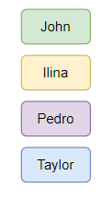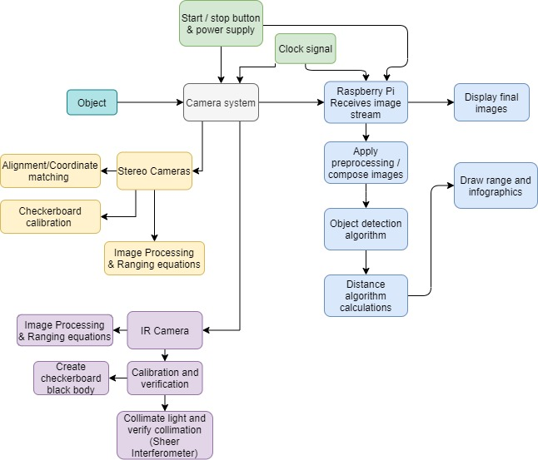

**Figure 1.** Overall system block diagram and work distribution.

**Software Diagram (general)**

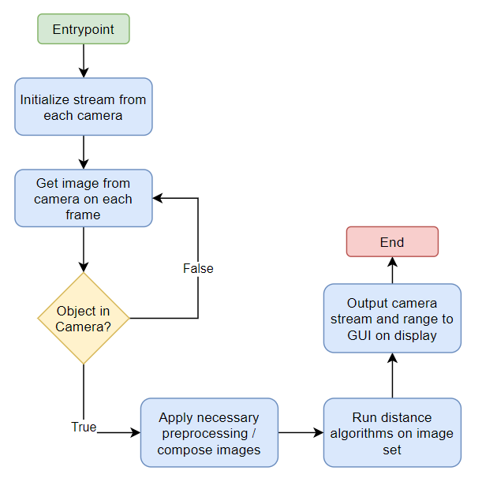

**Figure 2.** Software diagram: colors unrelated to work distribution.

**Budget and Financing**

Below, in **table 3**, an outline of the estimated budget for the entire project is given, with some part loaned by the AFRL.

|  |  |  |  |
| --- | --- | --- | --- |
| **Item Number** | **Item Type** | **Model** | **Price** |
| 1 | IR Camera | FLIR A65 w/ 25 mm lens | $8494.69 |
| 2 | Stereo Camera Set | IMX219 | $48.95 |
| 3 | Microcontroller | CanaKit Raspberry Pi 4 8GB Starter Kit - 8GB RAM | $119.99 |
| 4 | Touch Display | 7inch HDMI LCD (H) 1024x600 IPS | $61.79 |
| 5 | 12V Power Source | - | $10.00 |
| 6 | Jumper cables and breadboard | - | $20.00 |
| 7 | PCB Fabrication | - | $50.00 |
| 8 | FPGA | - | TBD |
| 9 | Misc Electrical Components (resistors, capacitors, etc) | - | $50.00 |
| **Total** | - | - | $9055.42 |

**Table 3.** Outline of estimated budget for the project.

**Milestones**

Below, in **table 4a-b**, the milestones/deliverables are outlined in order of due date and responsibilities/status is indicated.

|  |  |  |  |  |  |
| --- | --- | --- | --- | --- | --- |
| Number | Task | Start | End | Status | Responsible |
| **Senior Design 1** | | | | | |
| 1 | Ideas | x | x | Completed | Group 3 |
| 2 | Project Selection | x | x | Completed | Group 3 |
| 3 | Role Assignment | x | x | Completed | Group 3 |
| **Project Report** | | | | | |
| 4 | Divide and Conquer 1.0 | 1/22/21 | 1/29/21 | Completed | Group 3 |
| 5 | Divide and Conquer 2.0 | 1/29/21 | 2/12/21 | Completed | Group 3 |
| 6 | 60 Page Draft | 2/12/21 | 4/2/21 | In Progress | Group 3 |
| 7 | 100 Page Draft | 4/2/21 | 4/16/21 | In Progress | Group 3 |
| 8 | Final Document | 4/16/21 | 4/27/21 | In Progress | Group 3 |
| **Documentation and Design Investigation (preliminary)** | | | | | |
| 9 | IR Camera | 2/15 | 2/19 | In Progress | Pedro A. |
| 10 | Visual Camera | 2/15 | 2/19 | In Progress | Ilina S. |
| 11 | FPGA choice | 2/15 | 2/19 | In Progress | John H. |
| 12 | Computer vision library/algorithm | 2/15 | 2/19 | In Progress | Taylor W. |
| 13 | Calibration process | 2/22 | 2/26 | In Progress | Pedro A. |
| 14 | FPGA board specifics | 2/22 | 3/5 | In Progress | John H. |
| 15 | Image Processing | 2/22 | 2/26 | In Progress | Ilina S. |
| 16 | Raspberry Pi | 2/22 | 2/26 | In Progress | Taylor W. |
| 17 | Hardware design | 3/8 | 3/12 |  | John H. |

**Table 4a.** Milestones for Senior design 1 Spring 2021.

|  |  |  |  |  |  |
| --- | --- | --- | --- | --- | --- |
| **Senior Design 2** | | | | | |
| 19 | Build Prototype | 5/17/21 | TBD |  | Group 3 |
| 20 | Test & Redesign | TBD | TBD |  | Group 3 |
| 21 | Finalize | TBD | TBD |  | Group 3 |
| 22 | Peer Presentation | TBD | TBD |  | Group 3 |
| 23 | Final Report | TBD | TBD |  | Group 3 |
| 24 | Final Presentation | TBD | TBD |  | Group 3 |

**Table 4b.** Milestones for Senior design 2 Summer 2021.