Initial Project Document and Group Identification

Divide and Conquer

Group #2:Find All User’s ‘X’ (FAUX)

Small tracker item with a paired mobile app that allows you to locate a lost item if the tracker is attached to the lost object.



Department of Electrical Engineering and Computer Science

University of Central Florida

Dr. Samuel Richie

Senior Design I

|  |  |
| --- | --- |
| **Group Member** | **Major** |
| Amish Kanji | Computer Engineering |
| Joshua Radicchi | Electrical Engineering |
| Joel Gardyasz | Computer Engineering |

**----------------------------------------------------------------------------------------------------------------------------**

**Project Narrative**

**----------------------------------------------------------------------------------------------------------------------------**

On average we spend six minutes every morning looking for our phone, wallet, and keys. These are precious minutes that we are wasting, especially in the morning when we are usually late and trying to get to work or school on time. In fact, for everything else that we lose we spend 55 minutes a day (that is twelve days out of the year!). With our new tracker you will never waste those precious minutes searching for something important that you lost.

Along with losing valuable items within your own residence, you are always at risk to losing items when in public areas. Today, items such as a wallet and keys are required in everyday use. If either of these items are misplaced, there could be serious repercussions that follow. Strangers who find either of these could potentially steal your car, max out your credit cards and take any money you had in the wallet. Losing these items causes a state of panic in almost everyone due to the shear importance of these items in society today.

The goal of our project is to create an efficient way to find misplaced items, whether it be laying under a table or in the pocket of a thief. We have the idea of designing a tracking object, shape yet to be decided, with a mobile app to go along with it that can be connected through either Bluetooth or Wifi. These two items paired together will allow people to track where they misplaced their item. The tracking object will be attached to the desired object, whether it be on your keychain or within a pocket in your wallet for example, and the mobile app will be synced to the tracking object which will result with finding the misplaced item.

There are similar items out there on the market right now such as the one that we are describing. The most popular of these is called Tile. This device is paired to your phone through Bluetooth and tracks it wherever it goes, so if you misplace it you would be able to find it. You would be able to open up the app on your phone and track where your lost item is. Also if you lose your phone you can press on the actual Tile and it will make your phone ring even if your phone is on silent. This item is also limited; it does not include the ability to charge it or change the battery, it also does not have any external lighting so that you would be able to find your lost item in the dark.

We want to expand on the features from the products that are in the market currently. We could explore other options for battery use as well as see if there are advantages to using Bluetooth or Wifi. We would require the project to be low cost and easy to use in order to meet the needs of all demographics. A major feature we need to focus on is ensuring the object is lightweight because the item must be easy to carry on your desired items so minimizing the weight would be the most efficient way of achieving this requirement. We also need to consider the range that the tracker and your mobile app can be apart for them to be able to communicate with each other.

**----------------------------------------------------------------------------------------------------------------------------**

**Project Specifications**

**----------------------------------------------------------------------------------------------------------------------------**

|  |  |
| --- | --- |
| **Required ID** | **Requirement Description** |
| FAUX-01 | The location of the object will be found by using a smartphone or tablet. |
| FAUX-02 | The tracking device required us to use either GPS or Bluetooth low energy; If we use Bluetooth low energy we will use iOS. |
| FAUX-03 | The tracking device will be of portable size and weight. |
| FAUX-04 | The tracker will be water resilient, and be able to withstand fall damage. |
| FAUX-05 | The tracker will be powered by a battery that will last at least six months. |
| FAUX-06 | The tracker will respond to the user’s commands sent from an iOS device. |
| FAUX-07 | The tracker will respond to the user's commands within 7 seconds. |
| FAUX-08 | Your smartphone will respond to the tracker if need be. |
| FAUX-09 | The software will be developed in Java/ Javascript for an iOS device |
| FAUX-10 | The tracker will produce sounds and light up when prompted. |
| FAUX-11 | The batteries in the tracker will be easy to replace. |
| FAUX-12 | The tracker will work well up to forty feet. |

**----------------------------------------------------------------------------------------------------------------------------**

**Project Budgeting**

**----------------------------------------------------------------------------------------------------------------------------**

|  |  |  |  |
| --- | --- | --- | --- |
| **Part** | **Cost Per Unit** | **Quantity** | **Total Cost** |
| iOS Device | *Free | 1 | $0.00 |
| Microcontroller | $50.00 | 1 | $50.00 |
| Casing (3D printed) | $30.00 | 1 | $30.00 |
| LEDs | $0.06 | 50 | $3.00 |
| Speaker | $15.00 | 1 | $15.00 |
| iBeacon Device | $100.00 | 1 | $100.00 |
| Wires | *Free | 2 feet | $0.00 |
| Coin Battery | $2.50 | 2 | $5.00 |
| Misc. Supplies/Tools | $50.00 | NA | $50.00 |
| Total Cost |  |  | $253.00 |

*A team member already owns this component.

**----------------------------------------------------------------------------------------------------------------------------**

**Block Diagram**

**----------------------------------------------------------------------------------------------------------------------------**

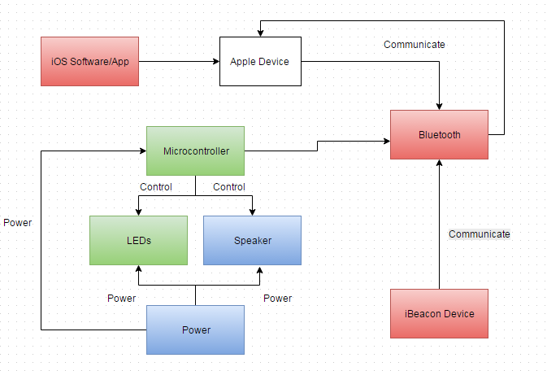

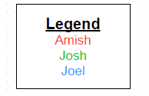

**----------------------------------------------------------------------------------------------------------------------------**

**Project Milestones**

**----------------------------------------------------------------------------------------------------------------------------**

|  |  |
| --- | --- |
| **Description** | **Weeks** |
| **Senior Design I** |  |
| Project introduction | Week 1 |
| Group formation | Week 2 |
| Initial proposal | Week 3 |
| Research Bluetooth | Week 4 - Week 5 |
| Research iBeacon Device | Week 4 - Week 5 |
| Research Microcontroller | Week 4 - Week 5 |
| Begin design paper and continue research | Week 6 - Week 8 |
| Spring Break | Week 9 |
| Design models and continue design paper | Week 10 - Week 12 |
| Finalize paper and begin ordering parts | Week 13 - 16 |
| Summer Break |  |
| **Senior Design II** |  |
| Regroup after Summer break, and discuss plans/ go over inventory | Week 1 |
| Design and test app | Week 2 - Week 4 |
| Prototype Microcontroller and iBeacon device | Week 5 - Week 8 |
| Test and Debug system. Begin final documents | Week 9 - Week 11 |
| Final presentation/ Evaluation | Week 12 |