W.E.A.R. - Wireless Energy Autonomous Robot

Blake Emerton, Trent Smith, Dimitri Wilks, W. Oliver Laleau

Dept. of Electrical Engineering and Computer Science, University of Central Florida, Orlando, Florida, 32816-2450

***Abstract* – The Wireless Energy Autonomous Robot, or W.E.A.R., is an original Electrical and Computer engineering project which shows a solution to help eliminate the need for electric vehicles to stop and charge. This autonomous robot follows a line using computer vision and can alert when there is an object in its path. Induction coils are mounted under the test track along the line where they will transmit energy wirelessly to a receiver mounted on the bottom of the robot.**

***Index Terms* - Wireless Charging, Computer Vision, Wireless Communication, Motor Driver, Oscillator, Charge Controller.**

I. INTRODUCTION

The purpose of W.E.A.R. is to use the knowledge that we have accumulated during our time at the University of Central Florida to create a multi-dimensional project. We wanted to incorporate our interests along with current industry trends. There is currently a huge interest in electric vehicles and Tesla is evidence of this. The only drawback to electric vehicles is that they cannot travel long distances without having to stop and recharge. A solution to this problem could be inductively charging during motion.

This led us to the idea of a wireless energy autonomous robot. It navigates around a track which will provide it with wireless energy. The robot is equipped with a camera unit which will handle the line detection and send the corresponding data to an STM32F427 microcontroller. This microcontroller will then send signals to the robot motors to navigate around the track. The robot also has an HC-SR04 ultrasonic sensor to help it avoid a collision with a stopped object in its path. The wireless energy is provided by induction coils placed at specific intervals underneath the track. There is a receiving unit on the robot to continuously top off the battery and greatly extend its range.



Fig. 1 - High Level Design

II. TRANSMITTER

A. Oscillator Circuit

In the designs we used the XKT-335, an integrated circuit that contains an oscillator circuit for wireless energy transfer. This IC uses CMOS technology which allows for higher accuracy and stability. The circuit is fairly simple and can oscillate large amounts of power but dissipates low heat. This circuit uses nMOSFET’s and pMOSFET’s for complementary-symmetric purposes. It contains high noise immunity and low static power consumption. When the power is applied to the V+ pin, currents starts to flow through both side of the primary and the drains of the MOSFET’s. While high voltage is on the gates will cause the nMOSFET to conduct and the pMOSFET to not conduct. Since the MOSFET’s aren’t exactly alike one there will be a delay in the one turning on faster than the other. One MOSFET will receive more current, while the other will receive the left over current on its primary gate side which switches them on and off. Since the connections are in a CMOS type the current gets reduced, which will regulate the amount of current flow in the system and also keep heat generation down. In connection with this IC, is an inductor coil and capacitors which forms the LC tank for sinusoidal oscillation. The capacitor allows the current to not spike in the system and the current to rise and fall causing the oscillation. Since it’s a CMOS process no heat sink is needed while oscillating 60 watts. The relationship is given by Eq. 1:

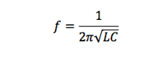

The schematic (See Fig. 2) shows the oscillator circuit. Too much gate current can cause damage so the 47KΩ resistors limit the current that charges the gates. The 9kΩ resistors are used to pull the gates down to ground so the MOSFETs will prevent from latching. The 6V Zener diodes prevent the gate voltage from exceeding 6volts and help maintain constant amplitude in the oscillations. When the voltage on the opposite leg of the LC tank is grounded, the BYV27 diodes pull the gates down to ground. These diodes are also capable of handling high operating current and also fast switching of the circuit. Finally, to improve the overall performance of the circuit, we charge the gates with VCC and discharge them via the LC tank circuit using the ultrafast diodes.

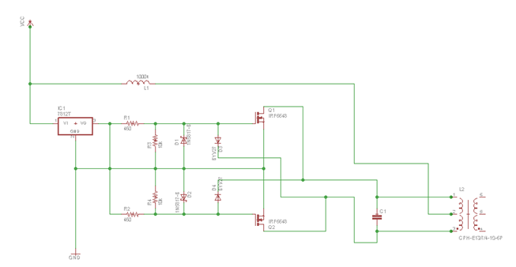

Fig. 2 - Oscillator Schematic

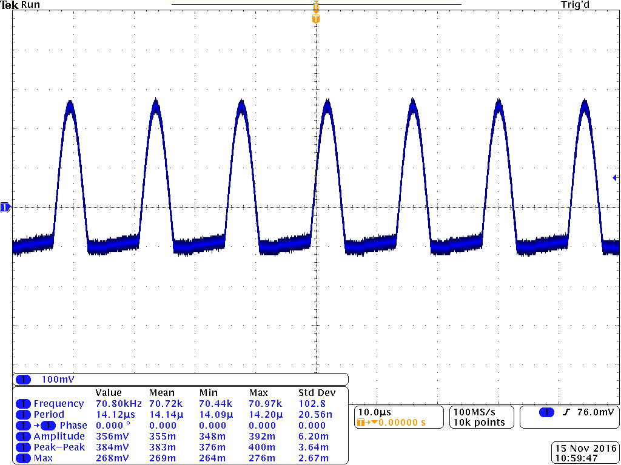

Fig. 3 - Oscillator waveform

B. Transmitting and Receiving Coils

After a few debates we decided to go with a flat spiral design for both the transmitting and receiving coils. This design helped save space and helps since there is about 3 inches of ground clearance. The receiving coil and transmitting coil are the same size, but we will be setting up multiple transmitter coils to compensate for misalignment. The transmitting coil and receiving consists of 10 turns. The coils came pre wounded and the inductance was determined using the LCR-816 tester in the senior design lab which gave us 33uH. So in order to get optimum power transfer between the transmitting coil and the receiving coil, the tank circuit of both coils must be tuned to the same frequency. Our resonant frequency is designed to be 70 kHz (See Fig. 6). The two main coils used for this design are 18 American Wire Gauge (AWG) enameled copper magnetic wires. The magnetic copper wire is the most commonly used coil. Compared to other coils, magnetic copper coil is tough and capable of tighter windings and it can handle high temperatures. Although the coils wire is small in diameter, its meets our constraints for the amount of current we will be pushing through the wire. Due to the regulations in the IC, chances of harmonics and affects to the coils Q-factor will be less unlikely. This means less distortion or unwanted behavior in the coils performance. Since our application uses a relatively high voltage frequency we won’t need high inductance for our system. Fig. 4 shows an example of the flat coil design:

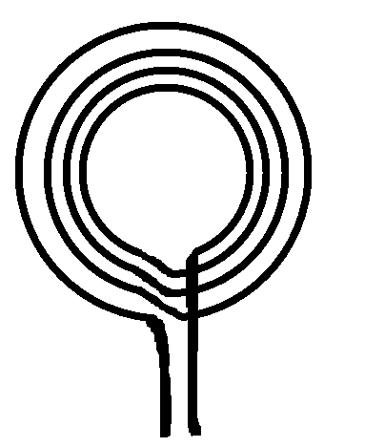

Fig. 4 - Coil Design

Fig. Flat coil design; this example of the shape of the coil and its windings we will be using

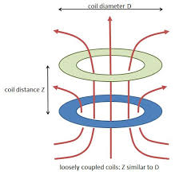

Fig. 5 - Induction

III. RECEIVER

The Receiver will gather the incoming signal from the transmitter. This signal will then be used to charge the lithium polymer battery. The lithium polymer battery has to be charged in a specific way to help prevent overcharging. This special method includes only two phases, the first being a constant current phase to continually charge the circuit and the second is the constant voltage phase.

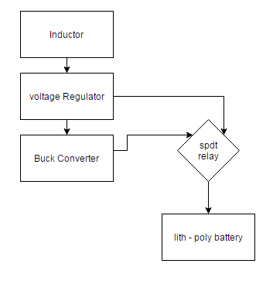

Fig. 6 - Wireless High Level

A. Buck Converter and Charge Controller

The T316 IC is a current rectifier integrated with a buck converter, which is the main component to our receiver circuit. The T316 contains a current rectifier to convert AC current into DC current. The rectifier allows current to flow in one direction, which means the current can be used to power different components or charged the battery for the robot car. The current coming in from the receiver coils is about 200mA. This current then travels into buck converter for a DC to DC conversion. The integrate buck converter has similar characteristics of the LM27313 Switcher Power Convertor. This means that the incoming voltage of about 8V will be stepped down while ultimately stepping the current up to be more useful for our constraints in charging the battery of the robot. The following (Eq. 2) was used to help find the correct resistor loads for our buck converter. The robot battery charges between anywhere between 400mA and 500mA. So the buck converter steps the current up to about 600mA to be used for the battery. Since we are transferring power over a distance, we tend to lose energy the further the transmitting and receiver coils are apart. The table (See Fig. 8) shows the variations in distance to how much current is being captured at the output to going into the charger controller. We used the Adafruit PowerBoost 1000c that contains a charge controller and boost converter. The charge controller regulates the voltage and current going into the battery. It detects whether the battery is full which than turns off the charging. If this is a safety component to help prolong battery life or damage. The Adafruit PowerfBoost 1000c also allows controls the way the battery usage of the system. So for instance, if the battery is fully charged than the the IC will stop the charging of battery and let the system run off of the wireless charging current independently. But if the wireless charging current isn’t sufficient enough to power the robot car system, then it will switch so the battery will compensate for the power needed.



|  |  |  |
| --- | --- | --- |
| Distance (millimeters) | Voltage (Volts) | Current (Amps) |
| 1mm | 5V | 600mA |
| 2mm | 5V | 450mA |
| 3mm | 5V | 360mA |
| 4mm | 5V | 310mA |
| 5mm | 5V | 240mA |
| 6mm | 5V | 210mA |
| 7mm | 5V | 162mA |

Table 1 - Table of Transmitter to Receiver Output Current

B. Peak Detector

The Peak Detector is used to change from AC to DC. With the peak detector, it is a full wave rectifier with a 10 uF capacitor attached.

C. Relay

The relay is what controls the switching between the voltage regulator and the buck converter. When a specific voltage threshold is reached, the relay will switch between the voltage regulator and the buck converter. Since the output is only one source and the input is two sources, we decided that the SPDT relay would be the best fit for the job.

IV. ROBOT HARDWARE

In order to have a more efficient charging, a 5 volts output will be expected from the receiver. This voltage will be used to power all of the hardware components that are being used for the project. Low power consumption is what is considered for all of the material on the robot.

A. Track

The track is made from a 0.08” acrylic sheet that has dimensions of 32” x 44”. We chose acrylic because it is strong while still being thin enough to decrease the wireless energy transmitting distance. It is also clear, so the transmitters mounted under the track will be clearly visible. On the track tape is applied in a pattern that can demonstrate the robots ability to navigate autonomously.

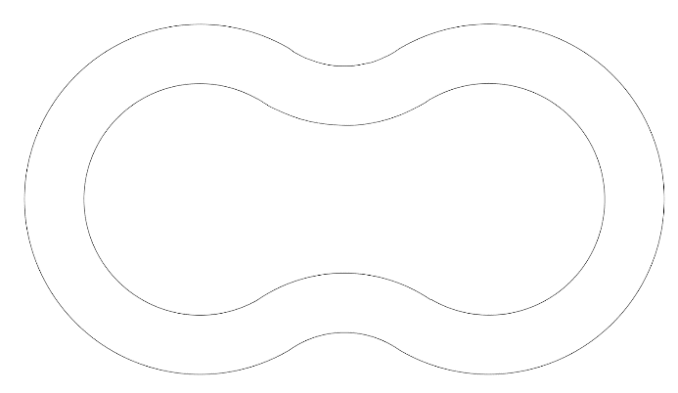

Fig. 6 - Possible track configuration

B. Battery

Lithium-ion batteries were designed to prevent the safety issues that can be created by a lithium metal. The essential feature of the Lithium ion battery is that at no stage in the charge-discharge cycle should there be any Lithium metal present. Rather, Lithium ions are intercalated into the positive electrode in the discharged state and into the negative electrode in the charged state and move from one to the other across the electrolyte.

There are certain limitation problems concerning the battery that we have to solve to ensure a smooth power distribution:

1) Due to safety hazard, a lithium polymer battery needs to be charge with a specific current and a specific voltage.

2) The battery needs to be able to recharge and power the components simultaneously

The battery outputs 3.7 volts which isn’t enough to power all the components.

C. Charge Controller

For a charging that is safe and efficient, a charge controller can be used. It will receive 5 volts from the receiver and it will step it down to 4.2 volts to charge the battery. It contains a MCP73871 which is a device that is capable of providing constant current and a constant voltage using a charge algorithm that fits the requirement a the 3.7 volt lithium polymer battery. Next, the battery’s output voltage should be stepped up from 3.7 volts to 5.2 volts using the charge controller’s boost converter. It uses a TPS61090 DC to DC boost control chip to serve that function. The charge controller allows the battery to be directly connected to it while simultaneously charging it but also using its power to distributed to the other components. The charge controller being used is the PowerBoost 1000 charger. It is made to be powered with any 3.7 volt lithium polymer battery and outputs a 5.2 volts.

D. Motor Driver

The L298N is the H-bridge driver that is being used to control the DC motors. It is an integrated monolithic circuit in a 15 -lead Multiwatt and PowerSO20 packages. It is a full bridge driver capable of sustaining high voltages, high currents. It is also capable of allowing standard TTL logic (transistor-transistor logic) levels and drive inductive loads such as DC motors and stepping motors. The L298N will be contained in a motor driver to facilitate commands from microprocessor to the robot.

The motor driver being used is the DROK L298n V3. It provides a peak current of 2A and is capable of controlling 4 DC motors. It will be connected to the microprocessor’s PWM channels which can be used to set the speed of the robot. It will receive the 5.2 volts from the charge controller and use it to provide the necessary amount of current needed for the motors while powering the microprocessors.

E. OpenMV

The OpenMV cam is a small and low powered and highly capable machine vision module. It’s functionality for line tracking and color detection is what is going to be used for this project. It requires a 3.7 volt input and a 140 mA current to operate. It is also equipped with a STM32F427VGT6 cortex m4f MCU which allows it to behave like a microprocessor. It can communicate with another microcontroller via SPI, I2C or Async serial.

The OpenMV cam will receive data from its sensor. It utilizes an ov7725 image sensor in order to detect what is in the environment. Then it will follow an algorithm allowing it to send commands to the motor driver through the connected PWM pins. When the motor driver gets these commands it will send the instructed current to adjust the speed for the DC motors. A PCB will be made that is based off of the OpenMV cam, but with more pins and overall functionality.

F. WiPy

To allow data to be transferred wirelessly to a monitor in order to visualize data from the OpenMV cam. It is a wireless MicroPython board and has a ultra-low power consumption of generally less than 1mA to a maximum of 14mA.

V. PCB

The PCB design for the board will consist of adding three new PWM pins and three new filters. The filters will consist of ferrite beads of 180 ohms at 100MHz. The ferrite beads will reduce noise going into each added channel and they are optimal for low power consumption. The new PWM pins will allow the motor driver to send signal to all four DC motors. The next figure is the eagle board design for the PCB:

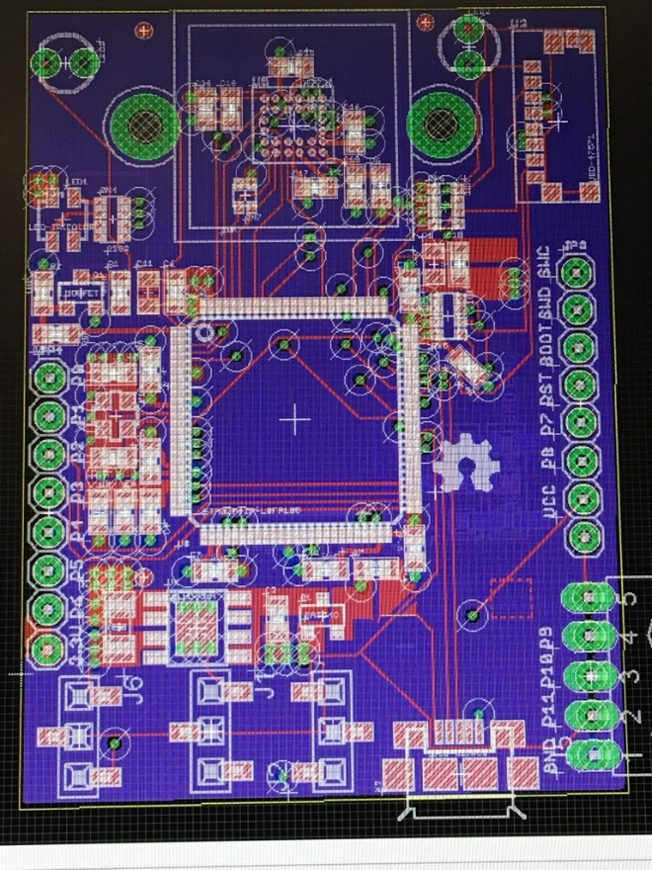

Fig. 7 – STM32F427 PCB

VI. SOFTWARE

One of the project’s goals is to keep the power usage at a minimum. Because of this, all software necessary for the robot to move autonomously is run on the STM32F427 MCU, which is the main MCU. The firmware is modified from the OpenMV firmware in order to enable the extra pulse width modulation (PWM) pins. The main MCU is programmed using MicroPython and is recognized as removable storage, so any python editor can be used to modify the startup program. We mostly used the OpenMV IDE during prototyping and later PyCharm. The main MCU takes in the camera data and then sends PWM and enable signals to the motor driver as well as using PWM to control the ultrasonic sensor. The WiPy is also a MicroPython microcontroller and its main function is to read the battery data and create a wireless access point with the CC3200. It can then be accessed by any device to monitor the battery levels.

A. MicroPython

MicroPython was released in 2013 and is a full implementation of Python 3 for microcontrollers. Previously, Python was not able to run on microcontrollers because it is very memory intensive. MicroPython fixes these issues. The example of MicroPython below shows an algorithm for calculating a Mandelbrot set.

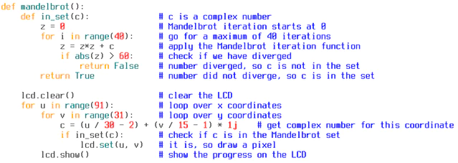

Fig. 8 - MicroPython Example

B. Computer Vision

The computer vision is made up of line detection and tracking. The camera takes in a frame and stores it in its flash memory. This frame is then checked for any connected pixel regions that satisfy certain thresholds in the L*a*b* color space. From these connected pixel regions, three regions of interest (ROI) are created with the lowest holding the most weight and the highest holding the least weight. This is shown in the following image. Each ROI has x, y, z, and h values and is bound by a rectangle. The center of each rectangle is then used to determine a deflection angle between -50 and 50 degrees.

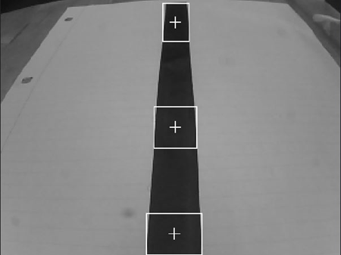

Fig. 9 - Regions of Interest

ComputerVision.png

Fig. 10 - Software Block Diagram

C. Ultrasonic Detection

The HC-SR04 ultrasonic sensor operates by emitting a sound wave that is greater than human hearing which is above 20 kHz. The distance is then measured using the formula:

L = C X T

Where L is the distance measured, C is the ultrasonic spreading velocity, and T is half the value of the time required to transmit and receive a signal.

For our application, if the sensor detects an object on the track that is less than a threshold L value, then the robot will stop completely until it is safe to continue along its path. Both the trig and echo pin are set to LOW when the robot is initialized. A high level pulse is sent to the trig pin and a timer is started once a rising edge is detected by the echo output. The timer is stopped at the falling edge of the echo and this time is 2T in the above equation. The figure below demonstrates this.

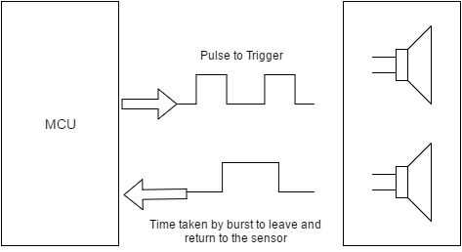

Fig. 11 - HC-SR04 Operation

D. Motor Control

Motor control is achieved using two L298N dual H bridge motor drivers. The 140 motors were tested to work reliably down to 70% PWM signal. When the robot is initialized the PWM is set to 80%. The front wheels of the robot do not steer, so in order to have the robot turn the two left wheels and two right wheels operate at the same speeds respectively. The deflection angle calculated from the ROIs is then converted to degrees and divided by three to give a turn value. This will ensure that the PWM signal does not drop below 70%.

The L298N motor driver receives three input values from the MCU per motor: Input A, input B, and enable. One input pin is set to HIGH and the other is set to LOW. This determines the direction the motor will spin. The enable pin is controls the speed of the motor using a PWM signal. Since the turn value will either be positive or negative based on which side of the line the robot is on, it is either subtracted or added to the current PWM values. If the deflection angle changed too rapidly then the wheel direction is reversed on one side until safe operation can continue. This is accomplished by changing the input values.

E. Wireless Monitoring

The WiPy is used as an access point in order to remotely monitor the battery voltage levels without requiring the robot to stop. The IP address will be 192.168.1.1 and you must log in to the WiPy using WPA2 encryption. The 3.7V battery voltage is sent through a voltage divider in order to meet the maximum requirement of 1.4V. The values can then be monitored to observe the wireless energy charging the battery.

VII. CONCLUSION

To conclude W.E.A.R has been a final test of the fundamentals we have obtain through our time at the University of Central Florida. This project has help each one of us learn our strengths and weakness and how to learn to work and communicate with each other. We learned how to get sponsorship, and creating a budget. We faced learning new programs and software to complete a desired task. This project allowed us to actively use various resources, like professors, books and the internet. We then combined these resources with our own knowledge and experience to successfully complete our Senior Design project.

VIII. ACKNOWLEDGEMENT

The W.E.A.R team would like to acknowledge the assistance and guidance of Dr. Samuel Richie and Dr. Lei Wei. We would also like to acknowledge the help of David Douglas for equipment assistance and the innovation lab for its resources. We are happy to thank UCF for giving us this opportunity to use our knowledge, creativity and practical engineering ability and make something out of it.

IX. THE TEAM



Blake Emerton - is graduating with a BS in Computer Engineering from UCF and is currently a remote intern with Quartus Engineering in San Diego, CA. He has accepted a full time position at Quartus starting January 2017 as a Software Engineer with a focus in mobile application development.



Dimitri Wilks – Will obtain his BS in Electrical Engineering in Fall 2016 from UCF. Dimitri is currently working as an intern at Interplan LLC as an electrical design engineer and plans to continue his career in the Power Generation Industry or Engineering Consulting. He later plans to work towards a Master’s degree in Business and Project Management.

Trent Smith - A senior Electrical Engineering student at UCF, he will be starting a working career after graduation and will be looking to start his own business.

 Wilson Olivier Laleau - A senior student of Electrical Engineering at UCF. He is going to pursue a working career in the electrical engineer profession of any specialization and continue studies for master degree.

X. REFERENCES

[1] Wilson, Tracy V.. "How Wireless Power Works" 12 January 2007. HowStuffWorks.com. <http://electronics.howstuffworks.com/everyday- tech/wireless-power.htm> 12 November 2016.

[2] Texas Instruments Incorporated. (1999-2013) LM27313 Datasheet. <http://www.ti.com/lit/ds/symlink/lm2596.pdf>

12 November 2016.

[3] Ada, Lady. "Adafruit Powerboost 1000 Basic." Adafruit. N.p., 30 July 2014. Web.

12 November 2016.

[4] George, Damien “MicroPython Documentation”

< <http://docs.micropython.org/en/latest/pyboard/>>

28 August 2016