**W.E.A.R**

**(Wireless Energy Autonomous Robot)**

Group Name : L

Trent Smith - Electrical engineering

Wilson Laleau - Electrical Engineering

Blake Emerton - Computer Engineering

Dimitri Wilks - Electrical Engineering

**Project Narrative**

Electricity is becoming one of the more essential source of energies as more and more objects are being evolved to electric. In order to make the process easier, engineers are working on new ways to transmit energy wirelessly yet, this technology has been limited to powering static object. But, this project focuses on charging a moving robot wirelessly. The design will include a system capable of producing wireless signals to transmit energy over a small distance. The system will be consisted of an autonomous robot which will guide itself along a track and avoid any objects on the course.

Another motivation for this project comes from the need for extended range on electric vehicles. This is a miniaturized version that could incite the possibility of the use of autonomous electric vehicles in the future capable of being charged while moving.

**Requirements**

The robot will use a camera in order to view its environment using image processing and, it will guide itself along the track using sensors to detect the presence of any object to avoid them. As for the wireless energy, the use of radio waves seems like the best option available. To accomplish this, a transmitter will be used to produce small induced currents that will be running past a bandpass filter. As a result, any other frequencies will be neglected and, that it will not cause any other disturbances with any other component and/or circuit. This is simulated in the figure below.

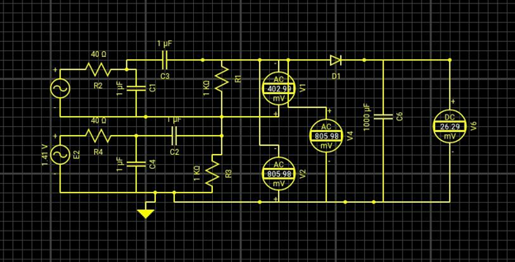

(For the circuit above, a unity gain and transformer need to be added.)

However, there is a loss of energy from the voltage in the diode, so taking in large voltages is the best thing that can be done to minimize the lost of energy. Also, the loss of energy from the traveling within the medium is given by the Inverse-Square Law. This is compensated for by sending out a larger signal such that it is able to compensate for the loss of energy or able to amplify the circuit using a transformer to get the desired voltage.

One of the main concerns is that the induction being set off by the EMP will likely cause induced currents in another circuit, so to prevent this a temperature sensor will be implemented which will turn on or off when a foreign metal object is detected.

**Specifications:**

* Electronic Receiver
* Transmit Coil
* Receiver Coil
* Electronic Receiver(Robot car)
* Autonomous Camera System
* Track (for Robot)
* Addition- Solar Panel

**Constraints**

Some constraints will be the use of the transceiver to meet the desired voltage needed for the receiver such that it can produce normal results and how much wireless energy can be sent over to the robot, the loss of energy that will occur from whatever power source we decide due to eddy current, and the energy loss per distance.

When dealing with high frequencies creating the magnetic field, there’s possibility that an induction of eddy currents can form in metal materials and cause heat or small induced currents. To prevent this a thermal detection system will need to be implemented to protect the hardware and ourselves.

Transmitter:

In order to transfer the power to the robot wirelessly, we must build a transmitter circuit that will convert direct current power source into alternating current, so that it will pass through the transmitter coils. The transmitter circuit will consist of resistors, transistors, inductors, capacitors, zener diodes and switches. This circuit will be connected to transmitter coils, where the current will be induced and create the magnetic field. The magnetic field carries the current to the receiving transmitter to be generated and apply power into the robotic system. To accomplish this the resonant frequency of the transmitter needs to be matched closely with the resonant frequency of the receiver circuit.

Robot:

To be able to adjust the weight, a strain gauge will be inputted. However, if the strain gauge input exceeds the max voltage the IC is able to take, then a scale needs to be applied. To scale the voltage down, a voltage divider will be best. With this it will adjust the amount of wireless energy that may be needed to power the servo motors. One of the main issues that will be faced with this is the amount of wireless energy that we need to be able to get to power the servos.

**Milestones:**

Spring 2016

1. Research and Development
2. Circuit Design
3. Begin Electrical Prototyping
4. Begin Software Prototyping
5. Obtain Parts
6. Design Paper

Fall 2016

1. Assemble Robot
2. Begin Programming for Mapping and Object Tracking
3. Start making Wireless Power Circuit
4. Assemble Robot Track
5. Finish Prototype
6. Test Prototype
7. Make Necessary Changes to Hardware and Software
8. Win

**Block Diagrams:**

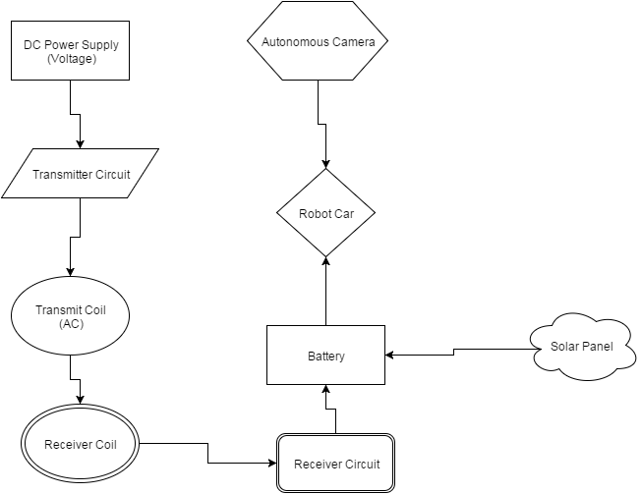

**Wireless Energy Block Diagram:**

**Trent Smith**

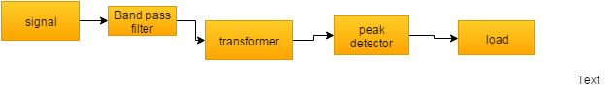

**Transmitter**

**Dimitri Wilks**

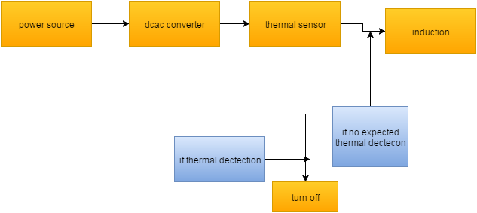

**Robot Hardware Block Diagram:**

**Wilson Laleau**

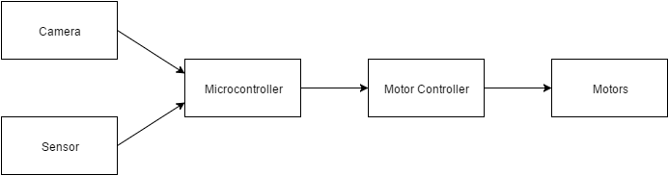

**Software Block Diagram:**

**Blake Emerton**

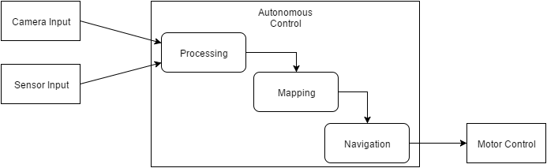

**Materials & Budget**

|  |  |
| --- | --- |
| material | Cost |
| Resistors | .14 per type |
| Capacitors | .15 per each |
| Transformer | $13.81 |
| servos | 3.50 |
| inductors | 3.43 per each |
| Integrated Circuit | $5.00 |
| Ir sensors  ir recievers | $2.00 each  $2.00 each |
| Camera | $50.00 |
| Plywood | $3.57 |
| Plexiglass | $20.00 |
| Robot Platform | 70.00 |
| Total | $240.00-$300.00 |

|  |  |  |
| --- | --- | --- |
| Sources  Corporation, Linear Technology. *Application Note 138 – Wireless Power User Guide* (n.d.): n. pag. Linear Technolo, Oct. 2013. Web. 25 Jan. 2016. | | |
| *Robotshop*. Robotshop Inc, 14 Sept. 2015. Web. 29 Jan. 2016. |  |  |

URLs

<http://cds.linear.com/docs/en/application-note/AN138fc.pdf>

<http://www.robotshop.com/en/smart-car-chassis-4wd.html>