

Stand Alone Solar Entertainment
Group 7
Hugh Hackler – Electrical Engineer
Daniel Graves – Electrical Engineer
Devin Hobby – Electrical Engineer
Mark Boutwell – Computer Engineer
EEL 4915 Senior Design 2 – Fall 2016

Table of Contents
- Executive Summary 1
- Project Description 2
  - Motivation and Goals 2
  - Objectives 3
  - Requirements Specifications 4
    - Hardware Specifications 4
    - Software Specifications 4
- Research related to Project Definition 5
  - Reference Projects / Products 5
    - Solar Powered Speakers 5
  - Pertinent Technology 6
    - Solar Cells 6
      - Monocrystalline Silicon 6
      - Thin Film Solar Cell 7
      - Polycrystalline Solar Cells 7
    - Peltier Plates 8
      - Physics 8
    - Audio Amplifiers 9
      - Figures of Merit 12
      - Classes 14
      - BJT vs. Op Amp 16
    - Remote Connectivity 17
      - Wi-Fi 17
      - Bluetooth 17
3.2.5 Energy Storage 18
3.2.6 Charge Controller 19
3.2.6.1 MPPT Controller 21 3.2.6.2 PWM Controller 22
  - Architecture / Diagrams 23
    - Power Input 23
      - MTTP tracking 24
      - Charge storage 24
    - Microcontroller 25
    - Amplifier 26
    - Cooling 28
    - LED Lighting 29
  - Software Development Environments 31
    - Mobile Application 21
    - Embedded Microcontroller Environment 32
- Standards & Design Constraints 33
  - Safety Standards 33
  - Reliability Standards 33
  - Communication Standards 34
  - Programming Language Standards 34
  - Connector Standards 35
    - USB standards 35
  - Battery Standards 35
  - Amplifier Standards 36
  - Design impact 36
  - Economic / Time management Constraints 37
4.10 Social Constraints 38
4.11 Health / Safety Constraints 38
4.12 Feasibility 39
- Hardware and Software Design 40
  - Block Diagrams 40
    - Control System 40
    - Power System 41
    - Charge Controller 42
  - Electrical Hardware 44
    - MPPT Charge Controller 44
    - Power Input 44
    - Amplifier Design 48
5.2.3.1 Crossover Design 52
5.2.3.2 Filter Design 54
    - LED Matrix 63
    - LED Controller Program 65
    - Cooling Stations 67
    - Charging Stations 69
    - PCB 70
    - Complete Schematic 71
5.2.9.1 Complete Charge controller schematic 71
5.2.9.2 Complete Audio schematic 72
5.2.9.3 Cooling schematic 73
5.2.9.4 Regulator schematic 74
5.2.9.5 Charge Controller Revisions 75
  - Embedded Hardware 76
    - Microcontroller Hardware 76
    - Microcontroller Program 88
  - Mobile Application 80
- Project Prototype Construction and Coding 84
  - PCB Assembly 85
  - PCB construction 86
  - Coding Plan 87
6.3.1 MPPT Code 88
  - Project Construction
- Project Prototype Testing 95
  - Hardware Test Environment 96
  - Hardware Specific Testing 97
    - Battery and Controller Testing 97
    - Voltage Regulation 102
    - Cooling Testing 104
    - Amplifier Test 105
    - Filter Testing 108
    - LED Test 109
    - Microcontroller and Programming Board Testing 111
    - MCP4725 12-Bit DAC Testing 114
  - Software Test Environment 115
7.3.1 Android Studio Application Testing 115
  - Software Specific Testing 117
- Operation 120
8.0.1 Charging cooler 120
8.0.2 Cooling system 120
8.0.3 Audio system 120
8.0.4 LED modes 120
8.0.5 Charging station 121
  - Device Setup 122
  - Application Usage 123
9.0 Administrative Content 125
9.1 Milestone Discussion 125
9.2 Budget and Finances 128
9.2.1 Project costs 128
9.3 Parts List 129
Appendices 132
Appendix A – References 132

1.0 Executive Summary
The idea for this project was to implement mobile seamless entertainment. We wanted to create an all-in-one package that could replace multiple devices. The concept is for an all in one system that will provide beverage cooling, while also functioning as an ultimate entertainment center. Carrying a cooler make is a typical activity in Florida and makes a day at the beach or by the pool that much more enjoyable, while many also opt for bringing some form of entertainment from home wherever they decide to go. At the beginning of the development of our project every member of this group was in agreement of how essential a cooler to carry water is during summers in Florida. Portability is a key feature of this device as the cooler will be lightweight with the simplicity of easily controlling its components from your smartphone. Our device is designed to integrate key technologies to enjoy the outdoors into a small, affordable, and portable package to be versatile for our customers’ needs’.
Overall our goal of this project was to mobilize entertainment easily, efficiently, and at an affordable price. The cooler will be mainly solar powered with as the idea of running the project off of solar as much as possible was essential to our group. In order to keep our project versatile, the system we are designing will allow for a solar input and also a plug in AC input. This feature will allow for the system to be charged even if solar power is unavailable, for example during a cloudy day or even rain. Inputs will be connected to a charge controller which will help protect the battery when it is fully charged. The controller is setup to cut power from the source once the battery is fully charged, thus further preventing damage or overcharging to our battery. A microcontroller will be used to control and mitigate the various technologies together, while also giving feedback on the system to the users’ smartphone display. Cooling technology will be constructed using Peltier plates that will be designed to efficiently cool a standard can of beverage while also removing wasteful heat to maintain the integrity of the cooling space. An amplifier will be designed to take input from a wireless smartphone or tablet via Bluetooth and provide clear high fidelity sound via two channels; a bass and treble channel. Key features of our amplifier design are low harmonic distortion, low noise introduction, and high fidelity. Various classes of amplifier will be considered with power consumption being one of the most important aspects; as our system will have a limited amount of power.
We foresee customers that will be interested in this product as young, active, and with a love of the outdoors with familiar comforts from home. In addition, families going on camping or fishing trips could also benefit and would be interested in our product. Use of this product is not limited to the beach, as many people in Florida own pools or live on lakes and would benefit from this product at such an event. Florida is known for having a nearly year round summer with hot weather and random rain showers that anyone who has lived in Florida most of their lives can agree with. Our product would make summer and the outdoors in Florida that much more enjoyable while also giving customers’ familiar amenities’ they’d rather not leave home without during summer.

2.0 Project Description
Sections to follow will not only describe the reason for choosing this project but also the planning required, the objectives of this project, and the decisions involved with choosing specifications required to be met at the end of our project.

2.1 Motivation and Goals
The main motivation behind this project is to be able to provide portable entertainment. People enjoy listening to music no matter the location. All of our group members currently attend school in central Florida. We all understand that summers in Florida are brutal. In most situations you need a cooler with you when going outdoors. This allows you the comfort of being at home while enjoying the outdoors. Most coolers only have the function of keeping items cold such as beverages and food. A typical trip to the beach includes a cooler, a Bluetooth speaker, and maybe a portable phone charger. Our goal was to combine all the necessities of enjoying a day in the Florida heat into a single item.
We came up with this idea while trying to think of a portable entertainment center. We initially couldn’t come up with perfect body to house the center. We came across a couple cooler designs that sparked our interest. It seemed that they had all of our goals encompassed in a cooler. Also being that there were multiple designs it let us to believe that there was a market for these coolers. As we continued to research these designs we solidified that this was the project we would like to work on.
As a group we decided that solar power was a major goal. We wanted this to be as environmentally friendly as possible. As we move on in the world the natural resources we have been using will run dry. That is why it was important to us as a group to use as much renewable energy as possible. All while still understanding that it is not always available and that the cooler needs to be able to be charged at any point in time.
One of the main goals we were trying to cover is weatherproofing the electronics. The cooler is going to be used in environments that aren’t exactly electronics friendly. Especially in Florida where it could rain at any moment during the summer. We also wanted the integrity of the cooler to remain. Some of the electronic parts we are using produce heat. We decided the best way to combatant that was to house all electronics in a sealed case. This allows the casing to keep heat the unwanted heat in and keep water out.
At the age we live in now it has become imperative to produce a seamless product. The consumer is looking for something that is easily controlled. We decided that creating an app that controls the entire systems was the perfect. Most people own smartphones and are familiar with apps and how to use them. Our app is going to make our project that much more seamless. The user will be able to open that app and control many different functions in the system. The app will also be able to display power efficiency received from the solar panels and battery life of the battery bank.
Another main focus is to provide a high quality sound system. The primary focus on the cooler is the speaker and amplifier. This is the standout entertainment portion of the cooler. Music is enjoyed by all people and we want to deliver a product has a great sound.

2.2 Objectives
The main objective of our group is to design a cooler that reaches our expectations. We have a solid idea on how we want the cooler to turn out. Reaching these objectives is imperative to us. We have three electrical engineers and one computer engineer in our group. We have evenly distributed the workload pairing an engineer with each of their strong points. As we realize the group is going to have to remain flexible and possibly leave their comfort zone to finish this project. We have laid out a plan and a schedule when we want certain tasks to be complete.
Two members of the group will be working on the power system for the cooler. We will achieve our goals in the by creating a cooler that can run mainly off of stored solar power. We will be using a 200W solar panel that supplies 12V with a maximum of 3.86A. When using solar panel we also must make use of a charge controller. The main purpose of the charge controller is to monitor the solar input such that it doesn’t damage the battery. We will make two separate charge controllers for each of the inputs. Also we must deliver the goal of being able to display solar panel efficiency. We will achieve this goal by use of two sensors. We will install a current and voltage sensor before the input to the charge controller. This will allow us to monitor the power output of the solar panel. Lastly we will use multiple regulators to step down the voltage for the various parts of the system that require lower voltages.
One of our members is designing the amplifier circuitry that will drive our speakers. This circuit will achieve our goals such that it will deliver enough power to drive two 75W speaker. The circuit will filter the bass and treble to different speakers to deliver a clean sound. It will also consist of a common emitter amplifier that feeds into a buffer and finally out of a common collector. This will allow us to achieve the correct input resistance, output resistance, and gain. This part of the project will provide the quality sound needed for the entertainment center. One of our primary goals for our project was to provide quality entertainment. The amplifier circuit is a crucial part to our design.
The other member of our group is handling the app development and the microcontroller. The microcontroller is going to be used to communication between all parts of our system. It will be used to read the input from the current and voltage sensors to display the power efficiency from the solar panels. It will also read input from the Peltier plate cooling system to ensure that it stays above a specified temperature. It will also read the sensor for the battery voltage and allow the user to see what the battery life of the system is at. The LED strip will be controlled by the microcontroller as well. This will give the user multiple options of LED ambiance for the particular moods. The microcontroller will also handle communication with the app via Bluetooth; routing the audio signal from the phone to the amplifier, sending sensor data, and handling control requests. The app will display various information on the state of the system, including battery level, temperature, and volume and will be designed so that it is easily navigated by any user. The app will also allow you to control some parts of the system such as the LED modes and the target temperature. This provides the seamless portion of our entertainment center. The control to the whole system is at the touch of the user's fingertips

2.3 Requirements Specifications
The following list shows the specifications and requirements we chose for our project, the specifications listed below must be must to consider this project completed.

2.3.1 Hardware Specifications
- A total system power consumption of less than 500W
- Solar and AC wall outlet power options
- Subwoofer, midrange driver, and tweeter
- Multiple mode LED
- Drink cooling station
- 3-port USB charging station
- Charge controller for battery protection
- Interchangeable battery source not internal
- Power efficiency feedback
- Weather proofed casing for electronics
- On/off Switches to cut power to certain subsystems
- Automatic low power mode if battery life is <25%

2.3.2 Software Specifications
- Mobile Application interface for system control to work in Android environment
- Communicate wirelessly via Bluetooth to system
- Battery charge display
- Power efficiency display
5) Display rate of battery charge from solar panels

3.0 Research Related to Project Description
In the sections to follow, we will include technology we found pertinent to our project design, some examples of industry products we found, as well as examples of projects similar to this. We will discuss the solar powered speakers that have saturated the market and our reasoning for choosing a project that does more than just play music, we will discuss the type of amplifier technology options available to use and the reasoning for choosing a specific class. In addition, sections on the solar technology will be presented to provide a basic overview of the technology we will use. Next we will discuss Peltier plates and the application for cooling that we intend to use in this project.

3.1 Reference Products/ Projects

3.1.1 Solar Powered Speakers
There are a plethora of solar powered speakers on the market, however many of these products are somewhat expensive. Standards features include Bluetooth connectivity to a mobile device, a rechargeable battery that is either charged by AC power, DC solar powered, or a combination of both. A typical solar powered speaker can cost upwards of $100 and only put out a few watts of power. In order to achieve our goal for this project we are looking for much more power output from our amplifier. High fidelity portable speakers are the most expensive category of portable wireless speakers, and they typically the most expensive. However, when most consumers listen to music the quality of the sound is one of the most important factors. There is an existing project on instructables.com involving a DIY solar boom box. However, this project does not make not make use of a charge controller to regulate the amount of current drawn from the battery; in order to make our system as efficient as possible we have opted to make use of a MPPT charge controller. In addition, this reference project uses an existing amplifier, with minimal sound quality. For this design we have opted to design our amplifier circuit from scratch with high fidelity, low noise and low distortion as the major goals of our design.
A quick search of a browser like Google will show the large variety of solar powered speakers, or mobile speakers designed to playback music from a smartphone. There are also a large amount of do it yourself projects that many hobbyists online have created. We also found solar powered coolers that enable the user to charge their smartphone, while keeping drinks cool. However, we were unable to find any existing product either do it yourself or professional that offers cooling technology in conjunction with solar power and audio playback. The depth and scope of this product will be much deeper than some of the projects we have found online. We have opted to design and use a charge controller and also design our amplifier; many projects online use fully assembly professional amplifiers or parts not designed for that intended use.

3.2 Pertinent Technology

3.2.1 Solar Cells
A photovoltaic cell converts light emitted by the sun into an electrical current. Most solar cells make use a semiconductor metals in their design. The sun emits photons which collide with the atoms of the semiconductor. These collisions allow the free electrons in the semiconductor to be expelled from the atom. Now that the electrons are free of the atoms the goal is to direct the current in a certain direction. A usual solar cell has three layers. This top layer is an n-type semiconductor. The middle layer is a PN junction. While the third layer is a p-type semiconductor. The PN junction creates an electric field which is used to direct the current in a desired direction. This is achieved by the fact that electrons will flow in the opposite direction as the electric field. There are two other layers to consider with a solar cell. The electrical contact layers, one for positive and one for negative, are necessary. These layers allow the current to flow to a load.

3.2.1.1 Monocrystalline Silicon Solar Cells
Monocrystalline solar cells are one of the oldest solar cell technologies. They are nearly the most efficient and dependable solar cell on the market. Each solar module is made from a single crystal of silicon. An advantage of monocrystalline solar cells is their durability. This was one of the first solar cell technologies and is still used today. This proves that even with the discovery of other technologies that this cell is still relevant. Another major advantage to using the monocrystalline solar cell is their efficiency. Some of these cells boast as much as 24.2% efficiency which blows most solar cell efficiency out of the water. A disadvantage to monocrystalline modules is the initial cost of the cells. It is more expensive and time consuming to produce pure silicon crystals. This means that the final product will be more expensive.
.
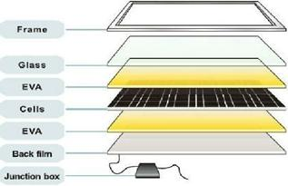
Figure 1 shows the layers of a monocrystalline solar module

3.2.1.1 Thin Film Solar Cells
Thin film solar cells are a fairly newer technology compared to the monocrystalline. It is made by stacking thin layers of photovoltaic material on to glass, plastic or metal. Thin film technology can have layers as thin as a few nanometers up to tens of micrometers. This is much thinner than any other technology on the market today. In turn thin solar cells are cheaper to make, they weigh less, and have less drag. A useful application for this style of solar cell is building solar integration. Where these solar cells could be laminated to the windows of a building. As this technology is newer it is definitely not as efficient as the other solar technologies, but it is maturing as a technology. As it matures the efficiency has been improving.
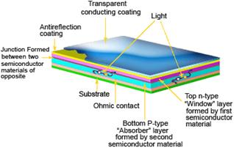
Figure 2 Thin layer photovoltaic cells structure

3.2.1.1 Polycrystalline Solar Cells
Polycrystalline solar cells are made up of multiple silicon crystals known as crystallites. This solar technology is slightly less efficient than the monocrystalline, but it is cheaper to fabricate. These solar cells are so popular because they are in the middle of the market. They are nearly as efficient as monocrystalline and definitely more efficient than thin film technology. Instead of being crystallized the molten silicon is poured into a cast. The silicon is poured into a ceramic crucible and formed into an ingot. Then wafers are cut from this ingot. As the silicon is cooling a certain desired cell structure is intruded allowing the silicon the form in that specific structure. This allows to make these solar cells with a smaller amount of silicon
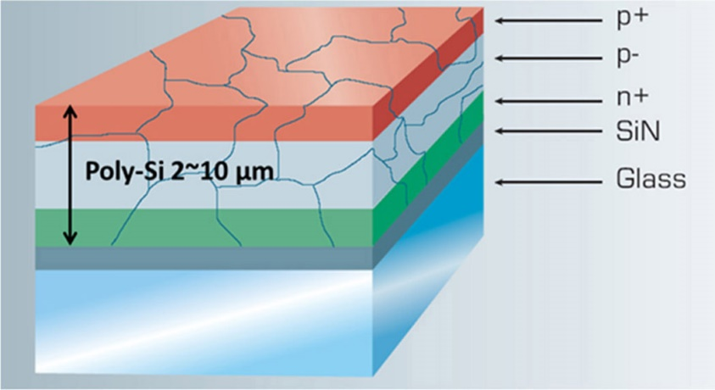
Figure 3 Polycrystalline Cell Structure

3.2.2 Peltier Plates
Peltier thermoelectric plates use a matrix of opposite polarity transistors pressed between two ceramic plates. Acting as a heat pump, the peltier will create opposite temperature poles with the difference in temperature depending on the applied power. If the “hot side” of the peltier plate can be cooled then the “cold side” will become ΔT cooler. Although considered fairly inefficient, the peltier plate has many advantages: low spatial consumption, simple DC configuration, and solid state cooling/heating. Using the peltier plate in conjunction with heat-sinks will allow rapid heat transfer for either heating or cooling. Other cooling methods are generally not solid state and implement a coolant subjected to varying pressures and passed through radiators. Although this can be effective for reaching low temperatures the infrastructure and power consumption is not feasible for this portable solution. Peltier plates provide enough cooling to accomplish the task and will greatly simplify and shrink this portion of the system.

3.2.2.1 Physics
The cooling system will allow customers to place drinks of varying sizes into stations in which heat will be extracted from the beverage. Using peltier thermoelectric plates the “cold side” will be attached to a heat-sink which will be in contact with the beverage. As power is applied to the system the heat from the “cold side” will be drawn to the “hot side.” A fan will blow ambient air through channels which will pass over heat-sinks connected to the “hot side” of the peltier plates. The peltier unit creates a ΔT between the two sides of the plate. The ambient air will extract the heat from the heat-sinks allowing the “hot side” to decrease in temperature, therefore causing the ΔT to shift lower, which will cause the “cold side” to drop or maintain a cold temperature. The hot air that passes the heat-sinks will be expelled back into the ambient air outside of the cooler so warm air is not introduced into the cooler. To ensure the drink is not frozen (which could cause a soda can to explode and damage the system) the temperature will be measured and power can either applied or removed to/from individual cooling stations. Three stations are implemented into the system with two peltier plates on opposite sides.

3.2.3 Audio Amplifiers

Amplifiers are common place in our modern electronics age; they vary from a few watts to hundreds or even thousands of watts. Audio power amplifiers or audio amplifiers are electronic devices that amplify low power signals (mainly composed of frequencies between 20 Hz- 20 KHz; which is the range of audible frequencies for the human ear) to a level that is strong enough to drive a loudspeaker. The electrical signals of the amplifier are in turn transduced into acoustical signals which are audible to a listener. Thus the main job of an audio amplifier is to provide relatively high voltage and high current. There are a few key design parameters to consider when starting an amplifier design: frequency response, gain, noise, distortion, and output power to name just a few. All of the listed parameters are interdependent; typically, an increase in gain will lead to increases in noise and distortion while negative feedback reduces gain, it also reduces distortion. In addition, a few less basic topics such as damping factor, dynamic headroom, slew rate, output current, and minimum load impedance will be considered as they can be very useful in amplifier design.

Frequency response is a measure of the output spectrum of a system in response to an input. Measures of both magnitude and phase of the output as a function of frequency are included in the frequency response of a system and is often used to characterize the dynamics of the system. The objective of an audio system is to accurately reproduce the input signal with no distortion. A system that reproduces the desired input signal with no attenuation in any frequency band is considered to have a “flat” response. Typical inputs for an audio system include electronic amplifiers, microphones, and loudspeakers. For example, in high fidelity audio an amplifier requires a frequency response of at least 20 Hz – 20 KHz, with a tight tolerance of ±0.1 dB in mid-range frequencies around 1 KHz. An important measurement in frequency response is bandwidth and in order to determine the bandwidth of a system the 3 dB down point (from nominal 0 dB) is usually specified.

Gain is a measure of the ability of an amplifier to increase the power (or amplitude) of a signal from the input to the output of the system. Defined as a ratio of signal amplitude at the output port to the amplitude at the input port, it is often expressed using the logarithmic decibel (dB). Gain greater than one (0 dB) is the defining property of an active circuit. Gain can be an ambiguous term; as it can refer to voltage gain, current gain, or power gain. For our application of an audio amplifier we will refer to either voltage gain or current gain. We will refer to the gain for frequencies in the passband (operating frequency range) of our equipment as gain will vary with frequency.

Noise is any undesired or random fluctuation in an electronic circuit. Noise can vary greatly, and there are many sources for noise generated in electronic devices: thermal noise, shot noise, manufacturing quality, and even defects in semiconductors. A measure used in engineering that compares the levels of desired signal to the level of background noise is signal-to-noise-ratio (SNR). Defined as the ratio of signal power to noise power; it is also expressed in decibels (dB). For example of ratio higher than 1:1 (greater than 0 dB) indicates there is more signal than noise.

Distortion is any alteration of the original signal; it is distinguished from noise in that distortion is an unwanted alteration due to the equipment in the circuit. Although it cannot at all times be eliminated, engineers strive to minimize it at all costs. In some applications such as for electric guitar, distortion is actually desirable, but for this project distortion in our system is undesirable. There are many forms of distortion such as amplitude, harmonic, frequency response, and phase distortion. Amplitude distortion (also known as clipping in signal processing) occurs in a system when the output amplitude is not a linear function of the input amplitude. Harmonic distortion adds overtones which are whole number multiples of a sound wave’s frequency. In audio systems the same nonlinearities that give rise to amplitude distortion also give rise to harmonics (overtones) added to the system. Harmonic distortion can be expressed in terms of individual components in decibels, or as the root mean square of all harmonic components. A measurement of harmonic distortion present is defined as the ratio of the sum of powers of all harmonic components to the power of the fundamental frequency is known as total harmonic distortion (THD). Expressed as a percentage it is used to characterize the linearity of an audio system. Another measurement is THD+N which is total harmonic distortion plus noise, it is much more common and like the THD measurement it is a ratio of RMS amplitudes. Typically, THD+N is measured by inputting a sine wave, notch filtering the output, and comparing the ratio between the output signal both with and without the sine wave. Another important type of distortion in amplifier design is crossover distortion, it is caused by the switch between devices driving a load; often a transistor. Most commonly it is found in complementary “push-pull” amplifier designs; include class B and class AB amplifiers however it is often seen in other types of circuits. The term crossover is used to describe the switching from the upper transistor to the lower transistor and vice versa. Frequency response distortions can occur when a system has a non-flat frequency response; it occurs when different frequencies are amplified by different amounts. In audio this is usually causes by room acoustics, poor unreliable loudspeakers and microphones, and even long cables in combination with frequency dependent speaker impedance. Lastly phase distortion is a change in the shape of a waveform and can occur when the phase shift introduced is not directly proportional to the frequency.

In order to design an amplifier a general idea of rated output power should be known. Typically, maximum output power is quoted for a load ranging from 16 Ω to 4 Ω. The lower the impedance of the load the more power will need to be delivered. Known as continuous average sine wave power the power rating for amplifiers is often described in terms of Watts _{RMS}.

Another concept we must touch on when designing an audio amplifier is negative feedback. Simply put, negative feedback occurs when some function of the output is fed back into the input of the system. Typically, negative feedback is employed to reduce fluctuations in the output, and thus leading to greater stability. Unlike positive feedback which tends to lead to more instability via exponential growth. Negative feedback tends to result in a settling to equilibrium, however there are advantages and disadvantages to negative feedback. Negative feedback in amplifiers can lead to oscillations so the type of feedback and amount should be carefully selected to weigh benefits to disadvantages and optimize the benefits. Developed by Harry Nyquist, the Nyquist stability criterion is used to identify stable feedback systems in amplifiers. Advantages of negative feedback include increases in gain stability, linearity, frequency response and greatly reduces sensitivity to variations in manufacturing or environmental. Disadvantages of negative feedback include instability if not designed correctly, and gain decreases.

Since performance specifications for audio amplifiers can have almost no limit, as already stated a few extra concepts are quite useful that we would like to touch upon. We’ve already touched upon the idea of a flat frequency response as being desirable to avoid tonal coloration, but a flat response may not always be obtained when driving a real world load. Since input impedance of loudspeakers can vary as a function of frequency, and output impedance of amplifiers are nonzero and thus there is a voltage divider that is formed by amplifier output impedance and the loudspeaker input impedance. The output impedance in series with actual output impedance gives rise to a Thevenin equivalent circuit. Damping factor of an amplifier is a way of expressing the output impedance of the amplifier; ideally they should act like voltage sources with zero output impedance, but in the real world they have finite output impedance. Technically a loudspeaker is a mechanically resonant system; with the damping of the loudspeaker done by the low output impedance of the amplifier via the loudspeaker’s resistance of the voice coil and electromotive force; thus amplifiers with higher output impedances will provide less damping of loudspeakers. When considering a loudspeaker, the effect of damping and output impedance on frequency response cannot be underestimated considering the large impedance variations in loudspeakers.

Sine waves unlike music have no impulses and are not dynamic. Music however has power peaks that may often be many times its average power. Dynamic headroom of an amplifier refers to the fact that it can usually put out a greater short-term burst of power than on a continuous basis. Primarily caused by voltage regulation and power supply sag, power supply voltages will remain high and near no-load values for a small period of time during heavy loading conditions due to the energy storage in capacitor reservoirs, but under long term conditions, the voltage will sag and thus less maximum power will be delivered. Usually it’s recommended to have at least twenty to forty percent more power available when needed for peaks, however a large amount of dynamic headroom usually comes in conjunction with a sloppy power supply.

Slew rate is a measure of how fast the output voltage can change under large-signal conditions, and if often an indicator of how well the amplifier can respond to high transient content. Measured in volts per microsecond, larger power amplifiers should have a larger slew rate; since voltages swings will be larger. Next we must discuss output current as it can have a very strong effect on the sonic quality of an amplifier. Complex reactive louds can demand much larger currents than the rated resistive loads often used for testing. Also many loudspeakers have impedances that may dip below their rated impedance levels, this can lead to a high current demand. Lastly we have to discuss the minimum load impedances as it is the specification of minimum output impedance that is safe for the amplifier to drive. Variations in speaker impedance can drive current demand very high as often loudspeakers are designed with little regard for what it takes to drive them. This is just a brief overview of the design concepts we used in order to design the amplifier for our project, we will discuss each concept in much more depth when describing the design process, we took.

3.2.3.1 Figures of Merit

In order to accurately characterize the properties and performance of our amplifier design we will use figures of merit. Given as a list of specifications, figures of merit are important to determine whether the amplifier is suitable for our intended use. Below is a list of figures of merit we will focus on in our design:
- Gain

When designing our amplifier, we primarily focused on voltage gain. Current gain for transistors is dependent upon the DC current gain (β) and can vary due to manufacturing and environmental conditions. DC current gain is taken into account during the design process for each individual transistor.

Voltage Gain

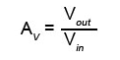

- Bandwidth

Bandwidth represents the band of frequencies the amplifier is most effective at amplifying, it is effectively the difference between frequency limits of the amplifier and is also known as the -3 dB bandwidth. This means that f₁ and f₂ from the figure below represent where the output has fallen -3 dB from its peak value.

Bandwidth (BW) = f_{H} - f_{L}

- Frequency Response

Used to show the exact values of output gain and that gain changes as a function of frequency. Generally, Bode plots display this information by graphing magnitude or gain on a vertical scale and frequency on a horizontal scale. Typically drawn in a linear scale that is divided into decimal divisions, Bode plots are considered semi-logarithmic graphs; as the x-axis is logarithmic and the y-axis is linear.

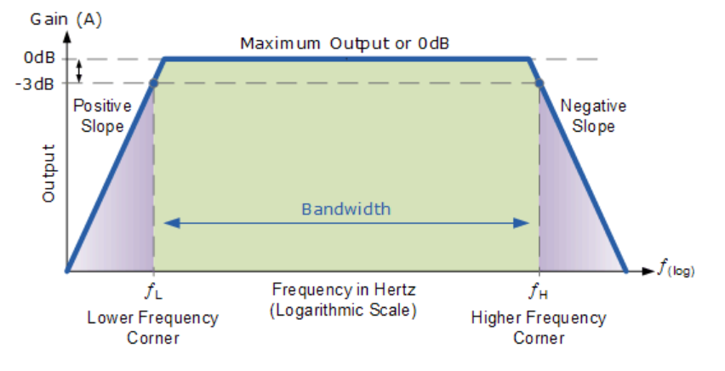

Figure 4 Frequency response of an audio amplifier

- Efficiency

A measure of how much the power supply is applied to the amplifier’s output. Each class has their own efficiencies and the more efficient the amplifier the cooler they will run without the use of cooling fans. Efficiency can be determined first by calculating the power input:

P = V * I

Next the output power must be calculated:

P = V² / R

Finally the efficiency can be calculated:

η = Output Power / Input Power

- Noise

A measure of how much noise the amplification process introduces. Each

transistor has a metric known as the noise figure or noise factor; which is a comparison between the output SNR and thermal noise of the input signal.

- Total Harmonic Distortion (THD)

A measure of harmonic distortions present which is used to characterize the linearity of an audio system. Most commonly defined as the ratio of RMS amplitude of a set of high harmonics divided by the RMS amplitude of the fundamental frequency. Typically THD is expressed in a percent form or in dB relative to the fundamental.

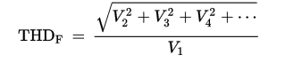

However, THD is a non-standardized specification that can vary widely between manufactures and thus is not easily comparable.

A much more common measurement is THD+N which includes noise, it is much more comparable between devices. It is also a ratio of RMS amplitudes
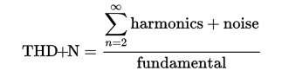
Throughout our design process we will expand upon these formulas and also calculate harmonics and noise in order to determine what our systems THD+N percentage is and if it matches the standards for high fidelity.

3.2.3.2 Classes

Entire papers could be written on the various classes of amplifiers that have been designed and continue to be engineered. Classes or classifications of amplifiers depend on the conduction angle, or the portion of the input signal during which the transistor is conducting. For simplification, we will focus primarily on the most common classes; give the advantages and disadvantages and discuss how each weighted into our decision to pick a class of amplifier.
- Class A

These are the most common types of amplifiers and typically use a common emitter configuration. Using a switching transistor that is always biased “ON” it conducts one complete cycle (360°) of the input single and thus produces minimum distortion and the output with maximum amplitude. Since the transistor is biased always on there is no crossover or switch-off distortion to the output signal. This class of amplifiers is known for quality audio with very low distortion as noted. The disadvantages of this class of amplifiers is the power efficiency is very low typically less than 30%, and generally delivers small power outputs and large drains on a power supply. Another disadvantage is that the same load current is passed in the amplifier even when on input signal is applied and thus large heat sinks are needed for the output transistors. These two factors alone are enough to eliminate a class A amplifier from our selection.

- Class B

This class of amplifiers is an improvement on the previous class in that it uses complementary transistors known as a push-pull configuration. A push-pull configuration uses two “complementary” transistors that are matched but separate type; one NPN and the other PNP. Both receive the same input signal with equal magnitude but opposite phase, which results in one transistor amplifying half of the signal (180°) while the other transistor amplifies the other half of the input signal before the two halves of the signal are put back together at the output. One major advantage of a push-pull configuration is that it raises the power efficiency to about 70%. Another advantages is that since no current flows with no input signal, no power is dissipated at the output transistors thus requiring much less dissipation of heat. However, a major disadvantage known commonly to plague this class is a phenomena known as crossover distortion. Since a transistor requires about 0.7 volts to begin conducting, this class uses output transistors that are not always “ON” and thus a part of the output signal can fall below this voltage threshold and consequently will not reproduced correctly during conduction transition between one transistor and the other. Even perfectly matched transistors will not start/stop conducting at exactly the zero crossover point. One of the major considerations for this project, however the sound quality from this class of amplifier is much lower than class A amplifiers thus we decided to look into another class which is a further improvement.

- Class AB

Technically not a separate class, but a combination of the previous two classes. Currently one of the most common types of audio amplifier designs, the class AB amplifier is a variation in the class B amplifier except that both transistors conduct during the same time thus eliminating crossover point in the output waveform. Each transistor will conduct slightly more than the half cycle of the input waveform like class B amplifiers but still much less than the full cycle conduction of class A amplifiers. An advantage is the two transistors have a small bias voltage which is typically provided by diodes or resistors, we can overcome the crossover distortion and maintain linearity and high efficiency; typically about 50 to 60%. Advantages of this class far outweigh the disadvantages, in fact very few disadvantages for this class could be found. One thing to note is that this class will use more transistors and components thus raising cost and design time significantly.

- Class D

This class of amplifiers function slightly different than the previous class in that they operate as electronic switches instead of a linear gain devices like other amplifiers. Using a train of constant amplitude pulses, the active devices switch rapidly back and forth from full conduction and no conduction. Using a conversion of analog signals to pulses by means of pulse width modulation (PWM), or other methods. Output waveforms are converted back into analog signals after amplification by low pass filter networks. Despite much more complexity involved in the design process this class of amplifiers have much reduced power dissipation, reduced cost and size, and high efficiency; typically about 90%. The increased complexity of this class is one of the major reasons it was not considered in our design; one of our major constraints is time and we decided designing a class D amplifier would take more time than we had available. Otherwise, the advantages of this class for our application included low-power and portable applications; both of which are integral to this project.

3.2.3.3 BJT vs. Op Amp

Inevitably in the design process, a point will come where the type of technology used must be considered. Since each type of technology is readily available, the sheer variation of designs was daunting and knowing the advantages of one device over the other in regards to our application definitely helped narrow down our list of choices.

Bipolar Junction Transistor (BJT) |  | Operational Amplifier (Op-Amp)
Pros | Cons | Pros | Cons
High Speeds due to low input capacitance | Higher Power Consumption | High Input impedance | Higher Cost
Input-output relationship | Lower Gain | Low Output Impedance | Complexity
Higher Linearity  (High fidelity) | Low input impedance | Higher Gain | Cost
Higher output currents | More variation in manufacturing | Less variation in manufacturing | Requires clean power supply
Lower output impedance | Higher Instability | Less Instability | Higher noise
Differential BJT amp is heart of op amp | More components | Less components | Input-Output isolation

Table 1 – Comparison of BJT and Operational Amplifier Technology

3.2.4 Remote Connectivity
In order to communicate with our device we have opted to develop a mobile application based on the Android OS. Several options exist for us to achieve this goal: Wi-Fi, and Bluetooth. Since efficiency is one of the major goals of our project we will have to pay attention to the power consumption involved with our connection. After some research the idle power consumption for each connection was found to be negligible so active power consumption is include below with some specifications that have been placed into a table for convenience.

Connection | Power Consumption | Range | Security | Interference | Bandwidth
Wi-Fi | 750 mW | 32-95 meters | WPA2 | Minimal at 2.4 GHz | 54 Mb/s
Bluetooth | 100 mW | 10 meters | CRC | Minimal at 2.4 GHz | 1 Mb/s
Table 2 - Connectivity Specifications Comparison

3.2.4.1 Wi-Fi
Wi-Fi frequency ranges are about 2.4 GHz and 5 GHz. The obvious benefit from a 2.4 GHz protocol comes with its longer wavelength enabling it to pass around objects slightly better than a shorter wavelength of 5 GHz. However, there is much more interference with routers and even cell phones using the 2.4 GHz system; since it is much more common and widespread.

There are several disadvantages to using Wi-Fi protocol over Bluetooth, the first is that it requires the use of a local area network, via the use of a router or a mobile hotspot. In addition to requiring a network setup Wi-Fi uses significantly more power than Bluetooth. However, there are many advantages to using Wi-Fi over Bluetooth, the obvious being the extended range and ability to be accessible from pretty much anywhere since Wi-Fi is found almost everywhere today. In consideration of power consumption Wi-Fi is certainly not the option we want to use.

3.2.4.2 Bluetooth
Bluetooth has been around for many years now and with ample resources online available to us we have decided based on power consumption, accessibility, and convenience to choose a Bluetooth communication protocol for this project. Like many other products on the market, Bluetooth is the preferred method of communication from a mobile device. In addition, our goals for this project include the ability to stream music from a mobile device and seeing how most people when they go outdoors carry a mobile phone and portable speaker; Bluetooth was the obvious choice.

3.2.5 Energy Storage
When it comes to charge storage we really took time to consider our options. We need a battery that is lightweight, has a high energy density, and is as environmentally friendly as possible. We researched a few battery chemistries to compare and decide which a good fit was. The first chemistry we came across was NiCad. Nickel Cadmium batteries have been used since the 1950’s. These batteries have relatively low energy density, but have a very fast charging rate. They also are relatively cheap compared to other chemistries. They also contain toxic metals that are not environmentally friendly. The next battery chemistry we considered was Nickel-Metal Hydride. This battery has a higher energy density compared to that of the NiCad battery. The tradeoff comes with the longevity of the battery. Also this battery chemistry doesn’t have any toxic materials that would be environmentally unfriendly. Typical applications for this chemistry are for cell phones and laptops. We decided that neither of these battery chemistries perfectly fit our design. The first is too environmentally unfriendly and the second we felt wouldn’t be enough power storage for our design. We then did some research on the lead acid battery which also wasn’t what we needed. This battery has a great storage, but the charge time is significantly larger than any of the other choices. Also lead acid batteries are typically used when weight is of no concern. We have narrowed our battery selection down to two different chemistries, Lithium Ion and Lithium Ion Polymer. After comparing the various batteries, we found that a NiMH fit out project well. We chose to place 10 D cell 10,000mAh D cell batteries in series. Each cell has a rating of 10,000 mA hours and 1.2V. Placing these batteries in series we can achieve the 12 volts desired for our system.

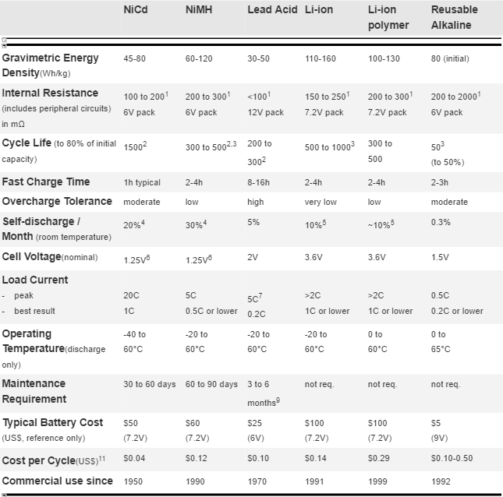
Figure 5 Battery Technology Specifications

3.2.6 Charge Controller
A charge controller is necessary in most power systems that include a battery. The main goal of a charge controller is to protect the life of the battery. Most rechargeable batteries are fragile to overvoltage and overcurrent. If you over charge a battery it can shorten the life of the battery or even damage it. There are two major types of charge controllers on the market today. The first is MPPT controller and the second is a PWM controller. Each of these controllers are useful in their own respects. The PWM controller is useful in a situation where the source voltage is similar to the battery voltage. While a PWM controller allows for a wide variety of input voltages no matter the battery voltage. The MPPT is definitely more efficient than a PWM controller in most application, but it is also more expensive than the PWM controller. When it came to our application we decided that we wanted to build a controller instead of buying one. After researching designs we came across a MPPT controller in www.instructables.com. The design didn’t exactly fit our specs but we have modified it.
The basics of any MPPT charge controller lie in two main parts, a PWM, or Pulse Width Modulator, and a buck converter. The PWM is discussed later in further detail but is essentially used to regulate voltages coming into the system. If the battery is rated at 12 V and the solar panel is outputting (on a very sunny day) 40 V the battery could be damaged, but a PWM can change that. The PWM will change the 40 V dc off and on at a rapid pace, with a signal that looks like a step function. Depending on the voltage the duty cycle, or the ratio of time on to time off, will change. A low voltage would result in a high duty cycle, which may just look like a DC constant, and a high voltage would merit a low duty cycle, which might look like blips on the oscilloscope. This regulates the Power to the battery, which leads to the buck converter.
The buck converter uses an inductor, capacitor, and diode to work. When a 50% duty cycle signal comes in, on and off equal amounts of time, the on state will charge the inductor and capacitor and power will flow into the battery, and not to the diode which connects to ground. After a period of time on, the PWM will switch off, so there will be no voltage coming directly from the solar panel. During this time the capacitor will discharge and the inductor will continue to push current through the diode and into the battery. The power received from these components will decrease over time but the switching speed will not allow for there to be a null period. Instead, the voltage output of the system will look like a saw-tooth with the voltage rising steadily as the PWM is on, and lowering steadily as the PWM is off. The MPPT is more efficient because of this aspect; the battery will continue to be charged even during ‘off’ periods of the PWM. If the PWM duty cycle is 50%, that means the battery is receiving power 50% of the time more than without the buck converter. The following equations show how we calculated the correct values for our inductor and capacitor.

$L= \frac{Vout*(Vin-Vout)}{∆I_{L}*Fs*Vin}$ $Cout\left(min\right)= \frac{∆I_{L}}{8*Fs*∆Vout}$ $∆I_{l}= \frac{\left(Vin\left(max\right)-Vout\right)*D}{Fs*L}$
Equation (1) Equation (2) Equation (3)

Calculating the inductor value we assumed the inductor ripple current (∆il) is 20% to 40% of the maximum output current. We inputted our values from our system and calculated we needed an inductor that was 100.7uH. Then we plugged this value into the inductor ripple current equation (3). We calculated that our inductor ripple current was 1.158A. The final calculation was equation (2) to calculate the correct output capacitor. We calculated that we needed a capacitor of 220uF. The charge controller also makes use of an Arduino Nano. The Nano allows for control of the system. It makes decisions and either supplies or cuts off power. The Nano controls a network of MOSFETs that act as switches between the battery and the source. The last part of the charge controller design has three sensors. Two are voltage sensors that are voltage dividers and one current sensor (INA219). These sensors feedback analog input to the Arduino Nano. We need the voltage sensor to measure the battery and solar voltage. The maximum voltage for our system is 68 volts. The maximum battery voltage is around 14 volts. The Nano can only read values between 0 and 5. Dividing each of the maximum voltage values by 5 we can scale the voltage between 0 and 5. Then inside the MPPT code we can reverse that action to receive the actual solar panel voltage and battery voltage.

3.2.6.1 MPPT controller
MPPT stand for maximum power point tracking. This means that the controller adjusts itself to always be receiving the maximum power output of your solar panel. The controller uses sensors to compute the power output of the PV panel. It also uses a sensor to compute the voltage of the battery. The controller compares these two values. It then decides what the best value of power the solar panel can put out to charge the battery. The advantage of using a MPPT controller vs a PWM is that the solar panel voltage doesn’t need to match the battery voltage. The PWM steps the voltage of the solar panel down and converts this voltage drop into a current gain. When charging a battery the current flowing into the battery is what you want. Also you want to make sure that the voltage of the voltage being applied is slightly higher than the voltage of the battery. Most MPPT designs now are microprocessor controlled. The microprocessor takes the input from the sensors and make the necessary adjustments. In a typical MPPT the microprocessor can send a PWM signal to a gate driver. This allows the driver to send a signal to the MOSFET that is acting as a switch to allow current flow from the source. When the MOSFET is on allowing the current to flow it then runs through a DC-DC converter. The DC-DC converter takes in the solar panel DC values and converts it to a voltage slightly larger than the battery voltage. The figure below shows a typical maximum power point of a typical solar cell.
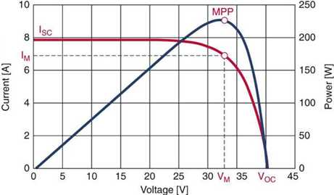
Figure 6 Graph of current and power versus voltage for a typical solar cell, showing the maximum power point and the cell’s current curve
3.2.6.2 PWM Charge Controller
A PWM controller uses pulse width modulation to send pulses to the battery to charge it. It monitors the battery level to determine the proper pulse width and duty cycle to apply to the battery. The main advantage of a PWM controller to most other controllers on the market is cost. They are significantly cheaper than MPPT controllers and are just as effective. A major disadvantage to the PWM controller is that it will not effectively draw the full power from the panel. It drops the voltage down from the solar panel to match the battery, but it does nothing with the extra current. For example if you have a panel rated at 24V and 5A and your battery is 12V. The controller will output 12V, but still be at the 5A. This means that you have lost half of the power that could be outputted by your panel. This PWM controller is only really effective when the battery voltage slightly less than the solar panel rated voltage. As you can see in the figure below the PWM controller is much less efficient. It extracts nearly 25W less out of the solar panel than the MPPT design.
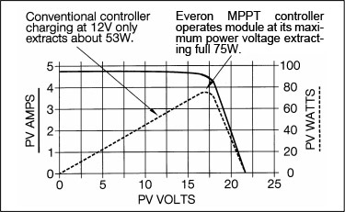
Figure 7 PWM efficiency

3.3 Architecture / Diagrams

3.3.1 Power Inputs (Solar Module)
The two power inputs that our design are a solar panel and a 120V AC plug. The AC source will use a standard three prong adapter that will fit most wall outlets. The voltage needs to be converted from AC to DC and also stepped down to 12V. We will first incorporate a transformer to step down the voltage from 120V to 12V. Once the voltage is stepped down it feeds through a bridge rectifier made up of four diodes. The signal is then filtered to limit the ripple voltage put off by the rectifier. Then finally the signal is fed through a 12V regulator to accurately maintain approximately a 12V DC signal. The following block diagram shows the system we will use for our AC source.

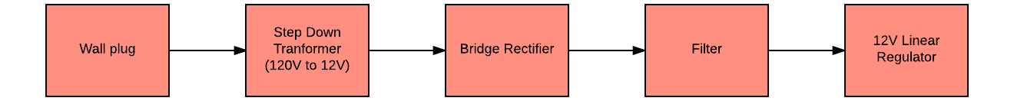
Figure 8 Block Diagram of AC power supply

The solar power supply will takes input from the panel and outputs a regulated 12V DC voltage. This is easily accomplished because the solar panel already outputs a DC voltage. There is no need to step down the voltage or rectify it. The block diagram below shows the solar input.

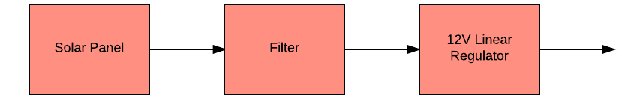
Figure 9 Solar input block diagram

3.3.3.1 MPPT Tracking

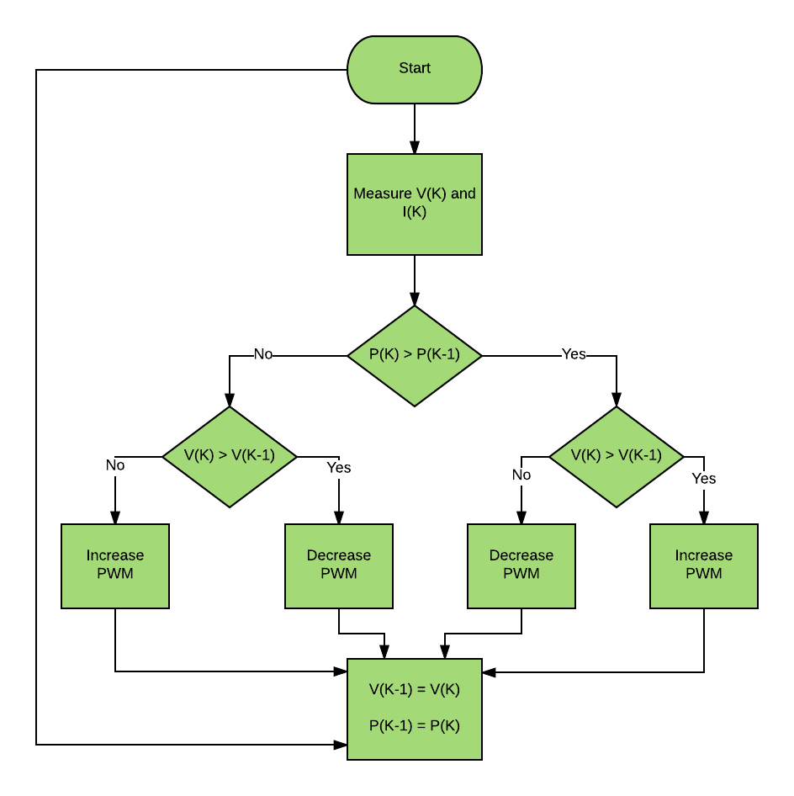
Figure 10 MPPT Code Flowchart

3.3.3.2 Charge Storage
Our design makes use of an MPPT to monitor the battery level. This is useful when it comes to preserving the life of the battery. The charge controller monitors the voltage and current of the battery and of the solar input. The input voltage from the solar panel can vary due to power drawn from the panel. The MPPT will drop the voltage down to meet the battery voltage, and converts the loss in voltage to current. The MPPT makes use of the Arduino. The Arduino is used to provide feedback. The Arduino takes analog inputs. The input can then be processed and then display the results on an LCD. The charge controller will feed intro a battery bank of 10 NiMH batteries. Each battery cell is operating at 1.2V and has a 10,000mAh capacity. The battery cells will be connected in series so that we can produce a 12V battery at 10,000mAh. This battery bank will store all the energy captured by the solar panel or from the wall outlet. This battery bank will supply power to all of the subsystems of our design. Most of the subsystems run on voltages lower than that of the battery bank. The battery bank will feed into a network of regulators that will step down the voltages to appropriate levels for each of the subsystems.

3.3.2 Microcontroller
The microcontroller is the interface between the mobile application and the rest of the system, communicating with or controlling all of the other components and has many roles to play. The first job of the microcontroller is to communicate with the mobile application through the Bluetooth™ module. It will then have to convert the digital audio from the application to an analog audio signal that the audio amplifier will be able to use. The microcontroller will also have to receive commands from the mobile application to update the LED controller settings. Lastly, the microcontroller will have to read data from various sensors including: a temperature sensor found in the cooler, a power sensor attached to the Solar panel to aid the user in finding the best angle and position of the panel, and a sensor for reading the battery level.

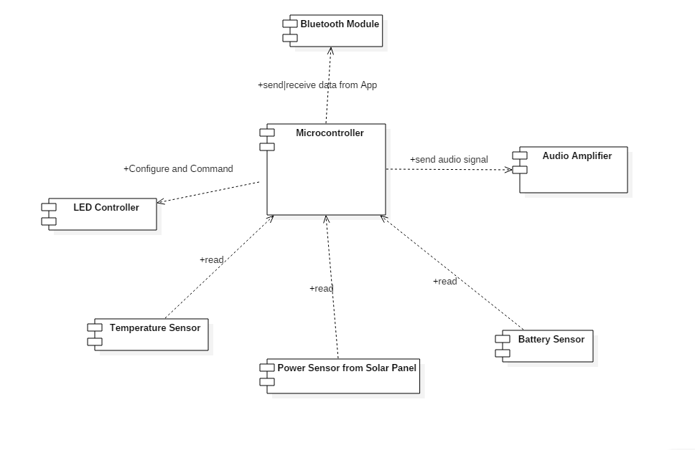
Figure 11 Microcontroller responsibilities

For Communicating with the mobile application, the microcontroller will have to interface with a Bluetooth™ module. This is usually done over a UART (universal asynchronous receiver/transmitter) or USART (Universal Synchronous/Asynchronous Receiver/Transmitter) serial interface device. Most microcontrollers will have at least one of the UART devices. We will have to make sure the microcontroller is capable of handling the high amount of bandwidth from a high quality audio source. We will also have to make sure the microcontroller has enough memory to store a queue for the audio packets.
Converting the digital audio files to an analog audio signal for the amplifier can be a little tricky. Many microcontrollers do have analog output that uses PWM (Pulse Width Modulation) to create the analog signal, however these are usually limited to 8 bits or 256 discrete values for the output. This can cause the quality of the audio output to be significantly lower. One method to get past that is to use an external DAC (Digital to Analog Converter) with a higher bit PWM that can create a more accurate analog signal. Another method is, if the microcontroller can support it, is to combine multiple PWM output pins from the microcontroller into one, affectively turning the 8 bit PWM into a 16 bit or 24 bit PWM signal.

The LED controller will most likely be controlled via an I²C (Inter-Integrated Circuit) connection or possibly another UART connection. Most microcontrollers only have one UART device, and while it is possible to connect multiple UART connections to one UART device on the microcontroller, it would be much more difficult and the connections cannot be communicating simultaneously. Using an I²C bus to communicate between the microcontroller and the LED controller would be the better option, so we would have to make sure the microcontroller and the LED controller support I²C.

As for reading from the multiple sensors of the system, the sensors will most likely output an analog signal. If we use sensors with somewhat more complex data, they might use the I²C protocol, in which case we would have to make sure there is an I²C bus on the microcontroller. An analog signal would not be able to send as high a number of possible values as I²C, however it would be much simpler to implement. Also, the sensor readings do not have to be extremely precise, so the analog sensors should be sufficient. For each loop cycle, all of the sensors will be read and combined into a packet to send to the mobile application over Bluetooth™.

For achieving the above responsibilities, the microcontroller must have the following requirements. At least one UART or USART connection for communicating with the Bluetooth™ module. Enough memory for storing an audio packet queue; 16kb or more should be enough. Either an internal or external DAC with at least a 12 bit PWM for outputting the audio signal to the amplifier. An I²C bus for communicating with the LED controller. Enough analog input pins for the sensors (3). And finally, it needs to be fast enough to handle a high quality audio source.

3.3.3 Amplifier
For our design, we decided to stick with a class AB “push-pull” complementary pair amplifier. The reason for this decision was in order to maintain high fidelity as one of our major design goals, while also keeping in mind our power needs and the efficiency of the amplifier. This class of amplifiers is the most common type of amplifier on the market right now and provides high fidelity while also meeting our minimum of 50% power efficiency. Operating as a Class AB amplifier has the advantages of removing crossover distortion via a small bias voltage consisting of resistors while still maintaining efficiency and linearity; both imperative specifications for this amplifier to meet.
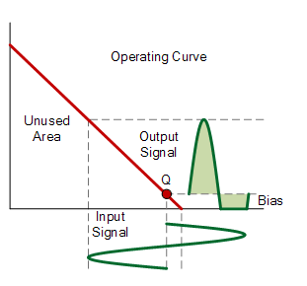
Figure 12 Class AB amplifier operation

Below the design architecture of the amplifier is shown.

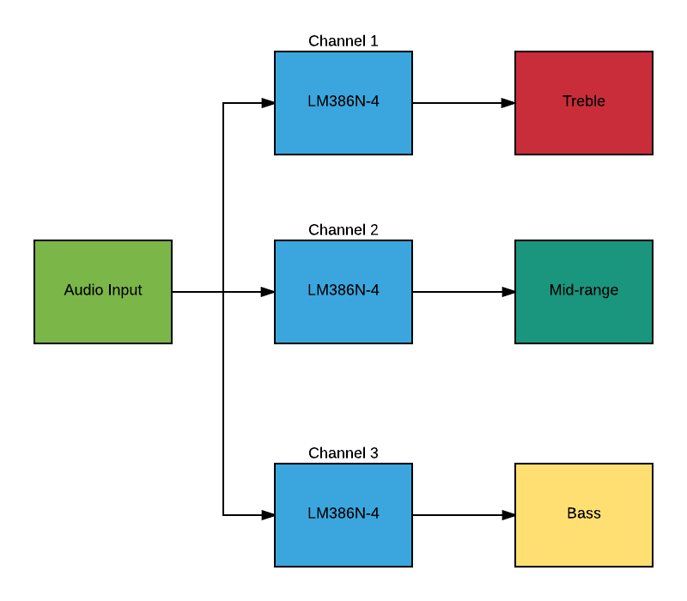
Figure 13 Amplifier design flowchart
Our design will take input from the microcontroller, output to a set of speakers and receive its power from the battery charged by the solar system. Below a flowchart has been included for the audio system.
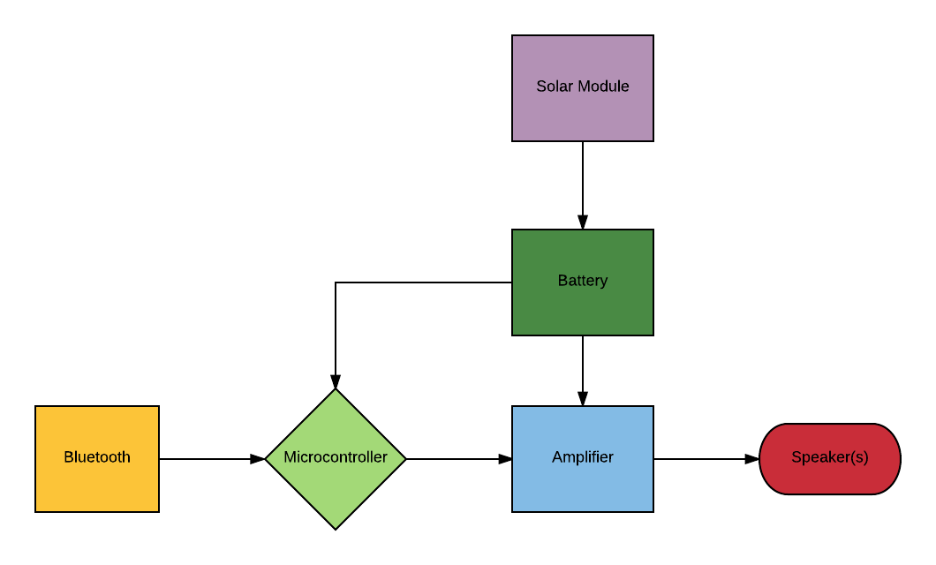
Figure 14 Flowchart of Audio System
3.3.4 Cooling
The cooling system for our project is designed to cool a standard beverage compartment while using cooling fans to remove heat. The microcontroller will receive power from the battery charged via the solar module and mitigate the cooling functionality of our design. A temperature sensor input into the microcontroller to give the user an accurate temperature reading and ensure the drink compartment maintains an acceptable temperature to keep drinks cool. Peltier plates will be used to create a compartment in which a standard beverage can will be inserted and then rapidly cooled. Heat sinks and cooling fans will ensure heat is removed quickly and efficiently. A relay will be used to separate the high power consumption of the Peltier plates and the low power Arduino. This will permit Arduino controlled switching in a high power situation that would either destroy the Arduino or supply too little power for cooling.
Peltier Plate
Battery
Cooling Fan
Microcontroller

Temperature Sensor

Figure 15 Cooling system design flowchart
3.3.5 LED Lighting
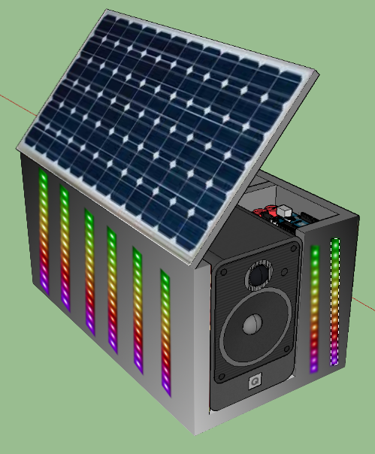
Figure 16 LED Display Design

The size of the cooler will be around 20 in x 35 in x 22 in, the size of a standard cooler. To get a nice look without using an impractical amount of LEDs, we decided to have 6 LED strips each on the long sides and 2 to 4 LED strips on the other two sides. There will not be any LEDs on the top or on the bottom of the cooler. Using 10-inch height for each of the LED strips, we will need 15 ft. of LEDs or about 300 LEDs for 60 LEDs per meter strips.

The LEDs will be individually addressable RGB LEDs, giving us full control over their color and intensity. Because controlling these many LEDs will require a rather large amount of processing power, they will be controlled by a separate microcontroller so that the main microcontroller can focus on the Bluetooth communication and audio processing. Most LED strips use the I2C bus for input, so the LED microcontroller will need to support it. The LEDs will be fully customizable by the user. The user will be able to select from several different color schemes or create their own. The microcontroller will also be capable of taking the audio signal and control the LEDs to create an audio visualizer, changing the LEDs to match the audio.

The LED microcontroller will also need to communicate with the main microcontroller. The main microcontroller handles communication the user interface, so in order to change the color scheme of the LEDs, the LED microcontroller will have to receive somewhat complex commands from the main microcontroller. It will need to select from a few different modes such as strobe, blinking, mixed, or audio visualizer. It will also need to receive the several color values for each mode. To make things simpler for the user, each theme and color combination will have a max of three different colors. This also simplifies to the commands sent to the LED microcontroller a bit. Because of the color values, there are only two options for sending the commands, using the I2C bus or multiple analog pins. If we went with the analog pins, we would need to use 10 PWM output pins on the main microcontroller and 10 analog input pins on the LED microcontroller. Nine pins are needed for the 3 different RGB color values and one pin for the mode select. This is a rather large number of analog output pins for most microcontrollers, but there are many that do support it. The I2C bus is the most likely method to use for sending the commands, since both microcontrollers will need to support it for using the other devices in the system anyway. However, since there will be many LEDs that will most likely be using the I2C bus and the Bluetooth module will probably be using the I2C bus, we will have to make sure we do not oversaturate and slow down either bus.

Because we will need to be addressing about 300 RGB LEDs on the I2C bus, the LED microcontroller will have to support that many addresses. Most hobbyist microcontrollers do not have anywhere near this much, such as the ATmega 328 on the Arduino UNO which only has around 120 addresses available on its I2C bus. There are a few ways we can work around this. The first is to stack multiple microcontrollers in either a pyramid configuration where the top microcontroller is the one communicating with the main system microcontroller or each microcontroller communicates with the main microcontroller separately and controls different sections of the LED display. This adds more hardware complexity and cost but gives us the ability to change each RGB LED individually allowing much more control over the display. Another option is to group multiple LEDs together and address the group as one, reducing the overall number of LEDs that the microcontroller sees. This keeps us from having to use more than one microcontroller for the display, but each group of LEDs will have the same color.

3.4 Software Development Environments
3.4.1 Mobile Application
The mobile application will be developed solely for Android™ devices due to an unavailability of testing devices for other operating systems. We will be using the Android SDK in conjunction an Integrated Development Environment (IDE) called Android Studio™ that was developed by Google specifically for developing applications for the Android operating system. The Android SDK includes several tools for developing Android applications, one of the most important ones for us being the Android Debug Bridge (ADB); which, as the name implies, allows us to debug the application that we develop as well as install our app onto the phone.

The alternative IDE we could use to develop the android application is Intellij IDEA by JetBrains. Google’s Android Studio is actually built using an older version of Intellij as its core. Both IDEs have similar functionality, however Android Studio has much more support from the development community and Android itself. This is why we chose this IDE over Intellij.

Because the Android operating system is built around a Java Virtual Machine, the main language for Android application development is Java. This is also the only language that Android Studio and the Android APIs support. So, this is the programming language that we will be using to program the mobile application. Android does give you the ability to write code in c using the Android NDK, however this is only for external native libraries; which is not needed by our application.

The Android API libraries have many useful libraries that will help speed up the process of the application development. This includes an easy to use library for interfacing with Bluetooth devices like ours. This will make communicating with our Bluetooth module much simpler.

3.4.2 Embedded Microcontroller Environment
The microcontroller we will be using will be an AVR ATMEGA 328P chip. Because this is the same chip used in the popular Arduino prototype boards. We will be using the same IDE as the Arduino boards, or the Arduino IDE. Since we are not using the pre made development boards, we will have to use an external programming board to program the microcontroller. In our case, we will be using an Arduino UNO to program the microcontroller. The microcontroller also requires an external oscillator for programming. To use the Android IDE with the ATMEGA we will also need to flash the Arduino Bootloader onto the microcontroller.
The principal programming language for the Arduino IDE is C/C++. The Arduino IDE also includes several useful libraries for our needs including serial communication, pin I/O, and I²C communication. And because we are using the same microcontroller as most of the other Arduino boards, we can make use of the thousands of publicly available programs and guides already out there for Arduino boards. The Arduino IDE makes it easy to compile and send our program to the ATMEGA microcontroller.
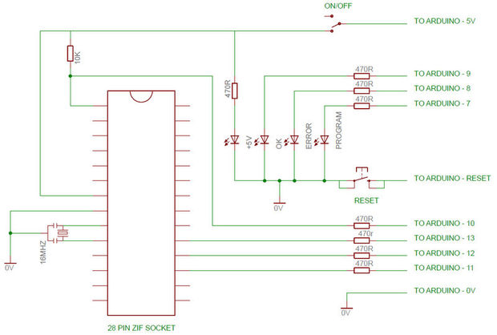
Figure 17 ATmega 328p Programmer Board Reference Design

The above figure shows the design for programming the ATmega 328p using the ISP programmer code provided by Arduino. The Arduino programmer communicates with the ATmega 328p using the Serial Peripheral Interface (SPI) bus. Once the Arduino ISP program is uploaded to the Arduino Uno, the Arduino software is then able to detect and communicate with the new ATmega 328p microcontroller. The external 16 MHz oscillator in the programmer design is necessary only once the Arduino bootloader has been flashed onto the new microcontroller. So, when we first connect the microcontroller to the Arduino Uno, we need to disconnect the oscillator and then burn the new bootloader, which the Arduino software makes very simple. The Arduino bootloader has two advantages over the default provided bootloader on the microcontroller. The first is that it lets you program using the Arduino libraries. The other is that it configures the microcontroller to run at a much faster 16 MHz over the 1 MHz default clock rate. This is a huge increase in performance that is necessary for this project.

4.0 Standards & Design Constraints
Standards have probably the greatest effect on how new technologies in the United States of America spread. Standards are formed in order to simplify product development while also ensuring safety during the development and intended use of such products. Another advantage of standards is greater compatibility between devices which in turn fuels cost reduction and decreases in development times. There are many standards that will be utilized in our project including safety, reliability, communication, programming, connector, and battery standards. Many of which will be pre-established by organizations such as the IEEE, ANSI, and UL while some others will be project specific.

4.1 Safety Standards
Safety is always a top concern when working with electrical parts and below the table will list safety standards which are relevant to our project. While our project will not use any hazardous or carcinogenic materials we must consider how we will control power dissipation in the form of heat and how to properly keep our internal components from overheating and function properly.
Standard | Description
IEC 61508 | Functional safety of electronic and programmable safety-related systems.
NFPA 70 | National Electrical Code specifies safe electrical designs, installation, and inspection to protect people and property from potential electrical hazards.
UL 50 | Requirement to provide a degree of protection to personnel from contact with enclosed equipment.
UL 62109-1 | Safety of power converters used in PV systems.
Table 3 Safety Standards

4.2 Reliability Standards
Below is a list of reliability standards that we found relevant to our project. Since one of the main purposes of any project design is to be reliable, one of our major reliability factors will be using a solar panel. Knowing the characteristics of the solar cells we use will greatly increase our ability to utilize them properly and maximize performance and in turn reliability.
Standard | Description
UL 61215 | Requirements for testing crystalline silicon photovoltaic modules in order to determine capability to withstand exposure to the elements.
UL 62108 | Requirements for testing concentrator photovoltaic modules to determine the capability to withstand exposure to the elements.
Table 4 Reliability Standards
4.3 Communication Standards
There are two possible communication protocols we plan to use for this project; below the table will list the standards we found for Bluetooth and Wi-Fi.
Standard | Description
IEEE 802.11b | Wireless networking specifications up to 11 Mbits/sec and using the 2.4 GHz band (Wi-Fi)
IEEE 802.15.1 | Defines access control for wireless medium and specifications for wireless personal area networks (Bluetooth)
Table 5 Communication Standards
4.4 Programming Language Standards
Programming language standards used for this project are followed mainly from the ISO/IEC 9899:2011 standardizations.
For our mobile application developed in Java, we will be using the code conventions outlined in “Code Conventions for the Java TM Programming Language” April 1999 [TODO: reference]. These code conventions give us a standard for coding styles that make our code easier to read and follow for other developers. For our embedded programs written for the microcontroller and the LED microcontroller, both written in C/C++, we will be following the conventions outlined in Google C++ Style Guide due to familiarity with the style and ease of use.

4.5 Connector Standards
4.5.1 USB standards
Below are the relevant standards for the USB connection.
Standard | Description
UL 6703 | Outline of connectors used in Photovoltaic Systems
ANSI C119.6-2011 | Standard for electrical connectors used in systems rated 600 V or less.
USB Battery Charging 1.2 Compliance | Critical standard in establishing proper way to charge batteries from a USB port.
Table 6 Connector Standards
4.6 Battery Standards
Below are the relevant standards for general battery use.
Standard | Description
ANSI C18.2M | Portable Rechargeable Cells and Battery guidelines
IEEE 937-2007 | Recommended practice for installation and maintenance of lead-acid batteries for photovoltaic systems.
IEEE 1013-2007 | Recommended practice for sizing lead-acid batteries for stand-alone photovoltaic systems.
IEEE 1361-2014 | Guidelines for selecting, charging, testing, and evaluating lead-acid batteries used in stand-alone photovoltaic systems
IEEE 1526-2003 | Practices for testing performance of stand-alone photovoltaic systems
Table 7 Battery Standards

4.7 Amplifier Standards
In addition we must also talk about standards for audio amplifiers. Below is the table of standards relevant to audio amplifiers.
Standard | Description
CEA 2006 | Industry standard for products with amplifiers, allows consumers to make apples-to-apples comparison between power ratings.
Amplifier Rule CFR 16 Part 432 | Requirement for audio power and distortion ratings for entertainment equipment to be measured in a defined manner and given as RMS.
ANSI/CEA 2006 B | Testing and measurement methods for mobile audio amplifiers.
IEC 60268-3:2013 | Applies to analogue amplifiers, specifies characteristics which should be included in specifications of amplifiers and corresponding methods of measurement.
Table 8 Amplifier Standards

4.8 Design Impact
We have compiled a list of how we will implement the standards listed above and how these will in turn help make our project safer to the user.
- Products compliant with the NFPA 70 standard will ensure that the electronics will not introduce hazardous conditions that could become a fire hazard.

- When considering our enclosure the UL 50 standards will ensure that users are protected from incident upon coming into contact with the electronics enclosure.

- Standard connecters from the UL 62109-1 will be considered when selecting charge controller, and other power hardware within the solar system.

- Both UL 61215 & UL 62108 will be considered when selecting which photovoltaic technology we will use for the project; these standards will ensure reliable power is delivered to our system.

- UL 6703 will be used to choose compliant connectors for use in the solar system; including connectors from module to charge controller, to battery, and finally to PCB.

- Wi-Fi & Bluetooth standards will be used in order to determine which connectivity protocol is best for our project.

- Battery Charging compliance 1.2 will be used to ensure the USB charger operates in accordance.

- Battery standards listed above will be used to select the appropriate battery, sizing the battery, charging, and eventually testing to ensure performance.

- CEA 2006 will ensure our amplifiers power rating is compliant and able to be used in comparison with other power ratings from various other products on the market. IEC 60268-3 will ensure our amplifier meets specified characteristics with methods of measurement.

10.) Amplifier Rule CFR 16 part 432 will ensure that our power and distortion ratings are given as RMS values in order to be compliant with other products on the market.

11.) Testing and measurement methods for the audio amplifier will follow ANSI/CEA 2006 B standards.

4.9 Economic / Time Management Constraints
After researching multiple designs that are already in the market. There are few that come close to comparing to our design. Most designs are not solar powered, and the ones that are solar powered are not designed to run the whole system. Our design gives the consumer the choice of plugging the cooler into the wall or setting up the solar panel to receive clean energy. There are not any designs that we found making use of the peltier plate cooling station. Most coolers researched included only speakers, Bluetooth connectivity, and USB charging stations. A cooler with these features ranges anywhere between $200 and $400. Our proposed price of $900 will be split equally among the four members of our group. This price could be lower by the end of the project.
The time restraints for this project are spread from the summer to the fall semester. That gives us a total of 28 weeks to have a report and deliver the product. As a group we have the summer semester (12 weeks) to complete the report for our design. We have split the workload evenly and have been reporting to each other on our progress. Also to stay on task we have created a timeline to which we will be able to complete all tasks. We have been using the timeline as a checklist allowing us to keep track of what we have accomplished, and also what still needs to be accomplished. In addition we must design the charge controller and amplifier, which is an additional time constraint; all of which we plan to have done by our set timelines.
When the times comes to begin construction of our design we will have 16 weeks to complete the tasks. Before this timeline begins we will have all of our parts tested and schematics drawn for each subsystem of our design. These 16 weeks will be dedicated to constructing our PCB and building the prototype. We have allotted ourselves enough time to build the prototype and troubleshoot it. We will incorporate the same style of timeline checklist to remain on time.
Currently we do not have any sponsorship for this project, and all expenses will be paid by the members in this team. Electronic component prices are cheap and will not be much of an issue, however solar cells will be the largest expense that we must take into consideration.
In order to counteract this expense, we are planning to rent a solar panel or set of panels from the UCF electrical/computer engineering department. This will dramatically lower the cost per team member on this project. While not nearly as high of an expense as the solar module, our choice of enclosure and the cooling station hardware of the enclosure will be an additional expensive. In order to lower our costs for this hardware we have opted to scrap components such as heat sinks, cooling fans, and other parts from old electronics if they are applicable to our application.

4.10 Social Constraints
Social constrains upon the project are minimal due to the non-invasive design. Since the device has the ability to operate entirely off of renewable solar energy there can be little argument made in the way of waste. Also, efficiency is considered at each end every step as to not exceed a large power draw. No by-product is produced and no fuel is required to run the device.
The speaker system embedded into the cooler and the ambient light feature could be considered a nuisance if used in public places where such ambiance is not socially acceptable. This however, is up to the discretion of the user and due to the portable nature of the device, more suitable areas can easily be accessed with minimal effort.
4.11 Health / Safety Constraints
There are inherent risks that must be taken into consideration for this project. In this section we will describe, analyze, and discuss our solutions with these risks. One of the most important things for this project was for us to produce a product that had no waste and did not continue to draw upon fossil fuels for power. Every member in this group lives in Central Florida and we all have to deal with increasing temperatures year round due to global warming, not only do fossil fuels continue to pollute the environment but the cost to use these fossil fuels continues to rise. This project will not produce any harmful waste or fumes, as the entirety of the power drawn in from renewable sunlight.
Therefore any health risks associated with this device can be limited to the use of batteries for storing charges, and the health risks associated with electrical equipment. Safety and health risks associated to the user should be taken very seriously and our goal is to adhere to the set of standards we found online established by industry professionals once we begin to assemble our hardware. In addition, the parts we use must adhere to the same set of standards to ensure the requirements for this project are met. These standards will ensure our product functions reliably, safely, and with no health risks for the user(s).

4.12 Feasibility
This project is considered feasible yet challenging in our minds. The idea of the cooler is easy but implementing it with all of our features is challenging. Any solar project is challenging because it is impossible to fully predict. The amount of sunlight available isn't predictable nor controllable. Also being able to adequately charge the battery while protecting it from over voltage or current will be a design hurtle itself. Our design also implements speakers that produce quality sound at a range of amplitudes and over an appropriate distance from the system. One of our members is well versed in writing and creating quality applications for Android, which will help us tremendously as app control is a very important goal for this project. We have yet to find on the market a product that offers exactly what we plan to; most products offer one or two features, maybe more but no product exists that can cool drinks via solar power, while also streaming wireless music from a mobile device all contained in a portable housing that can easily be transported from a tailgating event to the beach. At the beginning of our design selection process, the idea of feasibility was very important to our group. After brainstorming a set of ideas, we even discussed whether each idea was feasible within our time frame and if not we inevitably had to choose another idea.

5.0 Hardware and Software Design
The sections below will outline the design of this project in detailed sections and then follow with the prototype construction and testing in subsequent chapters.
5.1 Block Diagrams

5.1.1 Control System

Figure 1 below shows the control system for our project. The legend can be found below to show the different aspects of the project each member will be working on. As a group we understand that this will probably change, and we are prepared to fill in work wherever it is needed in production. Our system is controlled by an app that can be easily downloaded on any android device. The app communicates with a microcontroller via Bluetooth. This allows the app to receive feedback from system performance and control power to the system. We are making use of two Arduino microcontrollers. We are using the Arduino Nano with an ATMEGA 328. This is used to receive feedback from the solar panel and battery. Also it is used to control a PWM signal sent to the charge controller circuitry. The other controller makes use of the ATMEGA 328 chip. This controller communicates the feedback from the charge controller to the app. It also controls and powers the LED strip. The MCU will also receive feedback from the cooling station. Then it will make a decision whether it needs to cut or supply power to the peltier plates. The MCU also communicates with the audio signal. It will receive the signal via Bluetooth and will sample it and recreate a signal to send to the amplifier circuitry.

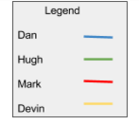
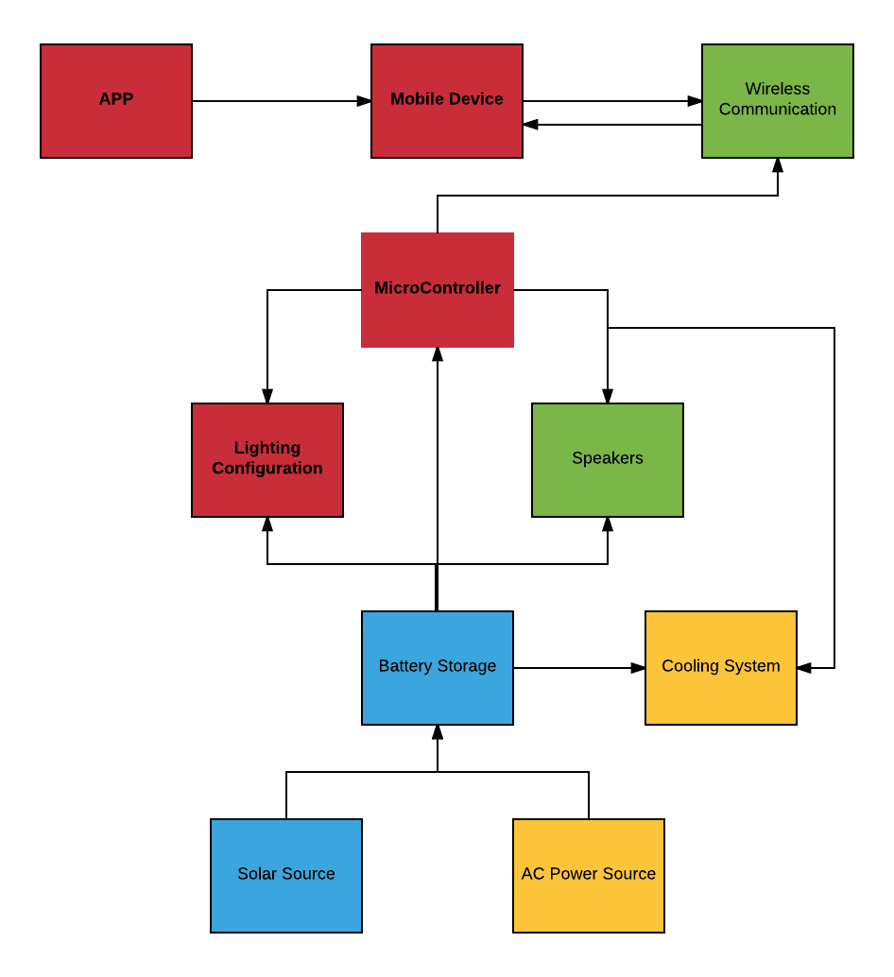
Figure 18 Control System

5.1.2 Power System
The power system begins with two sources. The first source being a solar panel and the second being an AC wall outlet. The system will take whatever input is available at the time of charging. The sources are then run into a charge controller. The duty of the charge controller is to monitor the battery level in the charging process. The controller will allow the source to charge that battery until a certain point. When the battery is fully charged the controller will cut the power sources off. We are using a 12V solar panel and also approximately a 12V battery bank. This battery bank will supply power to the various portions of the system. The power system will require multiple DC-DC converters. This is due to various components in the system running at lower voltages than our battery bank supplies.
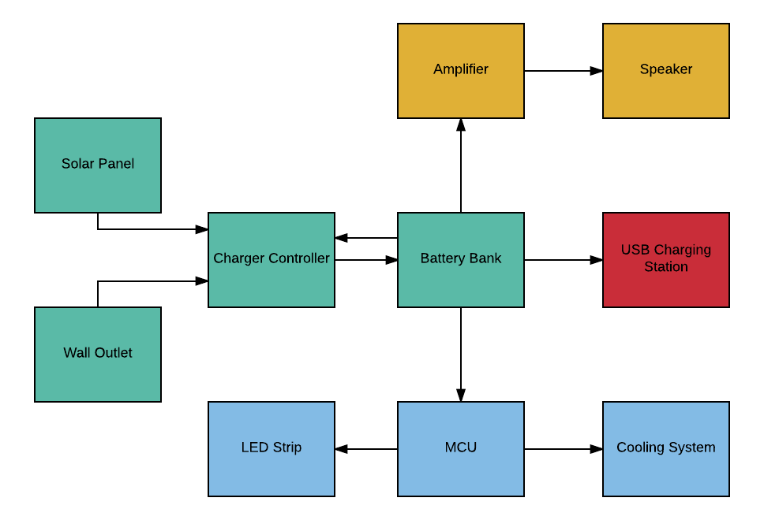
Figure 19 Overview of Power System

5.1.3 Charge Controller
The charge controller is designed to charge the battery and maintain the longevity of battery life. The charge controller can be broken down into three major sections. The first section is the sensors. There is a sensor that reads the solar panel voltage, a sensor that reads the solar panel current output, and a sensor that reads the battery voltage. The information recorded from the sensors is fed to an Arduino Nano. The Nano then can convert the given information and make decisions. The next stage of the charge controller is the MOSFET network. This network is used as a switch to either connect or disconnect the battery from the source. If the battery is fully charged the MOSFET network should be off and not allowing current flow from the solar panel to the battery. The heart of the MOSFET network is the MOSFET driver which is controlled by the Nano. The Nano decides whether or not the driver needs to be turned on or off judging by the information it receives from the sensors. The final stage of the charge controller is the DC-DC buck converter. This is the stage the steps down the voltage of the source to match the battery voltage. It also converts that loss in voltage to a boost in current. This allows more maximum efficiency of our charge controller. The battery is connected to the output of the buck converter. The block diagram below shows how the charge controller should operate.
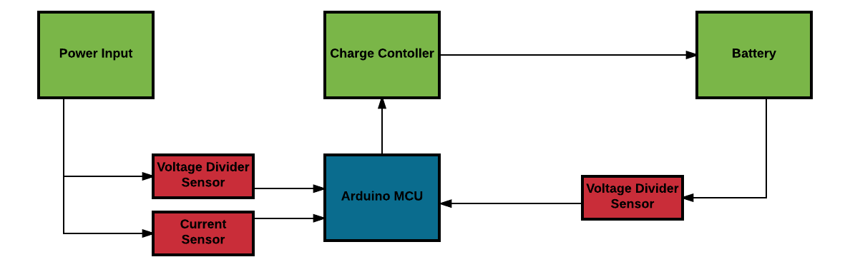
Figure 20 Battery storage control system block diagram

5.2 Electrical Hardware
5.2.1 MPPT Charge Controller
The charge controller is a crucial part of the system as it collects power, manages energy, and protects the circuitry. The charge controller is designed as a maximum power point device, meaning that little power is wasted as would take place in other designs. This requires an understanding of multiple system factors. The solar panel’s output voltage will fluctuate (according to the level of light received) both below and well above the 12 volts at which the battery is rated. Assuming the battery is not fully charged, a voltage under 12 volts would simply provide a slow charge to the battery. An Overvoltage (> 14 V) could potentially damage the battery and equipment connected to it, so a buck converter is used. The advantage of a buck converter over pulse width modulator is that voltage is stepped down while current is stepped up. Therefore the power supplied to the battery is retained without causing any overvoltage that could harm the battery and the surrounding technology.
The battery bank will feed into a network of linear regulators. These regulators will drop the voltages to desired level for each of the subsystems. The battery capacity for our bank is 10Ah at 12 volts. Multiplying this we can produce 120 watt-hours. We state that our system is rated for three hours of continuous use. This means that our battery can supply 80 watts of power for each hour. The op amps in the amplifier are designed to be powered with 12V, and the amplifier itself doesn’t draw much current. The MCU require 5V and a small amount of current. The three systems that require a large amount of current are the cooling station, the LED strips, and charging station. The USB run at 5V so connected three of these in parallel we can use a 5V regulator for that. A phone charging can pull around .9A. This gives you 4.5 watts of power per USB port for a total of 13.5 watts for the whole charging station. The LED strip can draw anywhere from .5 - 1 amps and operates at 5V. This will require around 2.5 to 5 watts. The cooling station operates at 12 volts and can draw up to 1.5A just for one peltier plate. This will require around 18 watts for one plate. The whole cooling station including fans will pull around 25 Watts. Assuming that all systems are running at once the total power draw will be around 80 watts per hour.

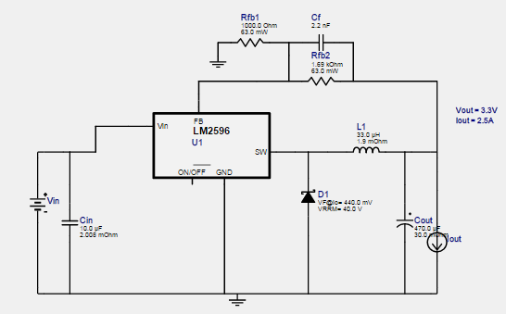
Figure 21 Buck converter used in MPPT charge controller
After a certain time the battery will fully charge and further charging could be dangerous, even if there is more power available to be provided. This is the purpose of the charge controller, to measure the voltage of the battery, and decide when to apply or remove power to it. Using an Arduino Nano to determine the voltage (along with other specifications), a layer of protection is implemented. The Arduino can be programmed to allow power to pass from the solar panel, through the buck converter and into the battery, if the battery is in need of charging. When fully charged, the Arduino Nano can divert power to a dummy load, or any other system. Levels of charging can be programmed into the Arduino creating a hysteresis window of voltage levels that would specify when to charge and when not to.
Various other component can be implemented to ensure the safety and continual operation of the device. A fuse, to protect from voltages too high for the buck converter to handle. Linear regulators to ensure the Arduino Nano does not become over powered. Diodes to ensure voltage does not drain from the battery to the solar panel. The Arduino Nano can also be used in conjunction with an LCD screen so users can actively see the input and output levels from both the solar panel and the battery, which can be used to determine efficiency. LEDs can quickly provide feedback on power levels so users know how full the battery is and when the battery is being charged.
The brains behind operation of the charge controller is in the dynamic communication between the Arduino and the MOSFET driver. The point of the MOSFET driver is to provide power to the gates of the MOSFETs in such a way that the PWM is created allowing current to flow from the solar panel to the battery. The driver has two outputs that alternate which MOSFET will be on or off. The crucial part is the input into the driver, which will determine how the MOSFETs change. The drive has two inputs, IN and SD. IN is the signal which will be a step function at a predetermined frequency and duty cycle derived by the Arduino. This will go into the driver and alternate the MOSFET network according to the step function. The SD stands for Shut Down, and will completely turn of the MOSFET that feeds current to the battery regardless of the signal provided to IN.
The Arduino produces the signals output to IN and SD. Each are determined by a voltage divider, and will change the signal given upon certain conditions. SD is a simple signal and is derived from a voltage divider on the battery. Signal SD determines when to shut down power to the battery, which is desired when the battery is considered full. The voltage divider will be able to tell the Arduino the voltage of the battery and from there the Arduino will send a signal LOW to the MOSFET driver. This indicates to the driver not to power the gate terminal of the MOSFETs regardless of IN. If the battery voltage is low, indicating that it needs to be charged, the Arduino will produce a signal HIGH. When SD is HIGH, the signal IN is allowed to take effect. The signal IN is determined by a voltage divider on the solar panel, and directly correlates to the duty cycle output by the MOSFET driver. If the solar panel were to operate at a voltage lower than that of the battery the duty cycle would be 100% and the MOSFETs would constantly allow current to flow into the battery. Once the voltage begins to surpass the voltage of the battery, the duty cycle drops. This is to protect the battery from harm, through over-voltage or current. The higher the voltage of the solar panel the less time the MOSFETs will spend time open connecting the battery. Although this sounds wasteful, the buck converter manages to save that high voltage by converting it into current used to charge the battery so the level of waste is decreased.
The charge controller also accepts 120 VAC from a US wall outlet used to charge and power the system in situations when an outlet is available. In this case, the operation of the charge controller will be the same except that the voltage will be stepped down with a transformer and then rectified into a steady DC voltage. Allowing both AC input and DC solar input into the system allows for both indoor and outdoor uses.

5.2.2 Power Input
The two power inputs to our system include a solar panel and a 120VAC wall outlet. The wall outlet requires a few extra parts to be able to supply power for our project. It requires 4 diodes, a step down transformer, and a couple capacitors. The diodes are used to rectify the waveform from a sinusoid to practically a DC value. The transformer steps down the voltage to a desired level through electromagnetic induction. Finally the DC signals is filtered to diminish the ripple voltage effect. This allows for a cleaner approximately DC output.
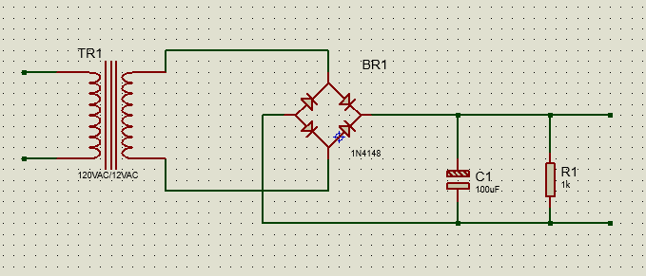
Figure 22 120VAC to 12VDC
The solar input doesn’t require the same hardware. It already produces a DC voltage and is not necessary to be converted. The solar panel will pass through three separate circuits. The first is a basic voltage divider circuit. This will allow the voltage to be stepped down and measured by the Arduino. The open circuit voltage for the solar panel we are using is 68V. The Arduino I/O pins can only handle about 5V. Using the equation (1) below the relationship between R1 and R2 is R2 = R1/13.605. We will also use another voltage divider to feedback our battery voltage to the Nano. The maximum output voltage for the battery is approximately 14V. Dividing the 14V/5 we get that we need a ratio of R2 = R1/2.8.

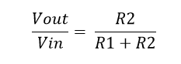
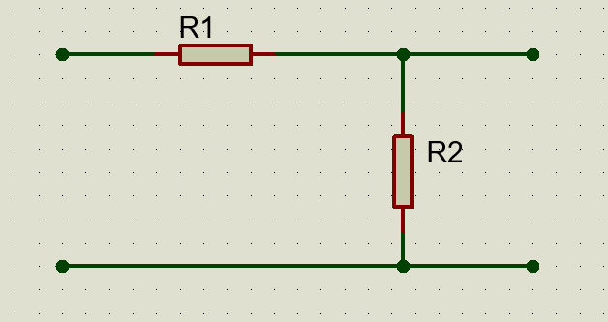
Figure 23 Voltage Divider Sensor for Solar Panel
The solar panel will also need to be fed through a current sensor. The short circuit current for the solar module we are using is 3.86A. After researching some options the INA169 analog DC current sensor module fits our project well. It is rated to sense a maximum current of 5 amperes and a voltage of 75V. The board measures the DC current draw and has an analog output pin. It makes this a perfect option for our current feedback to the Arduino.
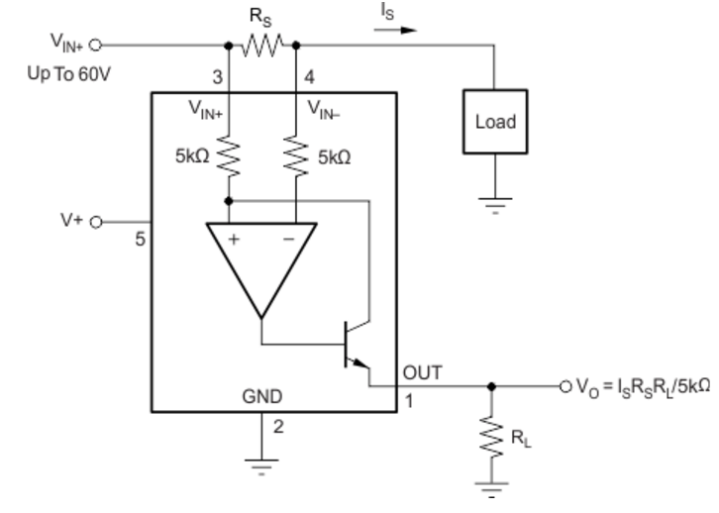
Figure 24 Current Sensor Circuit

The output voltage can be calculated by the by the following equation above. It is dependent on the current Is, Load resistor RL, and the source resistor Rs. Once the output voltage is calculated the current can be calculated but dividing by the load resistor.

5.2.3 Amplifier Design
The amplifier is a very integral part of this project as it is the primary form of entertainment, and the most important aspect of a portable speaker system for our customers. Our amplifier is designed to take input from the users smart phone or mobile device via Bluetooth communication protocol and playback music with relatively no noise introduction or distortion, and high fidelity over a variety of amplitudes. Integral to this design is high fidelity audio and in order to accomplish this we have decided to choose a class AB amplifier due to high efficiency ratings. Another incredibly important aspect for our design was minimal power drain as we are limited on the amount of power we can access since solar panel output can drastically change due to weather or even shading conditions. This is another reason we decided to choose this class of amplifier as they meet the minimum power efficiency specifications for this project. One of the most important aspects of high fidelity is linearity; or the ability of the amplifier to reproduce the input signal characteristics with large enough gain to drive a speaker load. Distortions and noise are all non-linearity’s that affect sound quality; this was another important aspect in deciding which class of amplifier to choose. In order to minimize distortions and noises introduced at the output and input of our amplifier decoupling capacitors were used to limit noise. With these issues in mind and having the advantages of high linearity, high fidelity audio, low component cost thanks to operational amplifiers the class AB amplifier was the ideal solution to our design goals for this project.
After considering the options and weighting them versus the specifications listed for this project the amplifier chosen is the Texas Instruments LM386N-4 operational amplifier. It is a single channel mono class AB amplifier packaged in an 8 pin DIP IC chip and is designed for use with low-voltage consumer electronics which makes it ideal for running on a battery supply. Operational amplifiers have far surpassed transistor amplifiers due to higher gain and smaller size; both of which were important factors in deciding to choose this chip. The LM386N-4 utilizes an emitter follower buffer in the input stage which provides approximately unity voltage gain but the added benefit of current gain; thus increasing the overall power of the signal. Like many operational amplifiers the heart of the input stage is the differential amplifier; which takes the difference between two input signals V₁ and V₂ and makes the output proportional to that difference. Biasing is provided by current mirrors which provide a stable current for biasing internal transistors. In order to stabilize the input stage a feedback resistor provides a form of negative feedback. The second stage of the amplifier is a common emitter amplifier which provides voltage gain; biasing for the voltage stage is provide by an additional current mirror. Lastly, the output stage is a Sziklai connected push-pull complementary class AB transistor pair. Similar to a Darlington arrangement, the Sziklai pair has one NPN and one PNP transistor, which acts like a single transistor with a very high current gain beta (β). An advantage over the Darlington pair is that the base turn on voltage (V_{BE}) is about half the value of the Darlington’s at about 0.6 V.
In order for the design of the LM386 to be more versatile, there are two pins which provide for gain control; pins 1 and 8. If connected via a 1kΩ resistor the gain will be set at 20, however if a capacitor is placed in series with these two pins the gain will be set at 200, additionally placing a resistor in series with a capacitor between pins 1 and 8 enables the gain to be set from any value between 20 and 200. For this design a 10kΩ potentiometer has been chosen for both gain and volume control. Although there are subtle differences between volume and gain controls, it would be pertinent to mention them. Gain is defined as the amplification of input potential and is a characteristic of the amplifier, while volume only lets you adjust the range of amplification which is set as a function of the gain. Below the pin layout for the LM386 has been given; the main pins that have yet to be mentioned are pins 2 and 3, the audio signal inputs, and pin 5 the output audio signal.
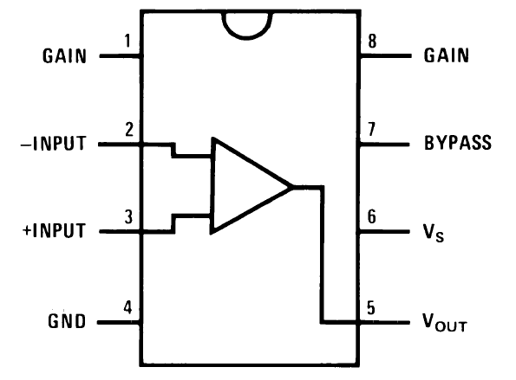
Figure 25 LM386 IC chip Pin Layout
In order to minimize noise between the power supply a 100 µF and 0.1 µF capacitors are placed in between the positive and negative power supplies to decouple the power supply. Since the power supply typically has some ripple and noise the coupling capacitors will block any DC voltage present from the source. Low frequencies will be filtered by the 100 µF capacitor and high frequency noise with the 0.1 µF capacitor. In addition a 0.1 µF capacitor is placed in between pins 4 and 6 to further decouple the power supply and the chip, while a 10kΩ resistor between pin 7 and ground will be utilized to decouple the audio input. Below the circuit diagram for a 1-channel mono amplifier is shown using Multisim for the design schematic.
Pins | Gain (A_{V}) | Gain(dB)
Pin 8 open | 20 | 26.02
10 µF from pin 1 to 8 | 200 | 46.02
Table 9 Gain configuration for LM386N-4
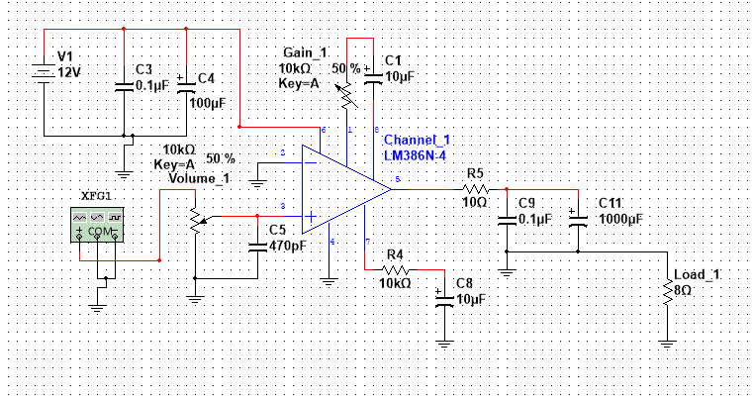
Figure 26 Single channel 1 W mono class AB amplifier
A single channel of sound perceived to come from a single position is known as monaural or monophonic sound production. Mono can include a single loudspeaker, or multiple loudspeakers fed identical signals; the result is a perception of one-channel sound which “images” a sonic space in between the loudspeakers. For this project we wanted at least three channels; mainly due to the fact that in our modern society everyone who listens to music does so in stereo or with more than two channels known as surround sound, also three channels allows for separation of low, mid, and high range frequencies which is integral in high fidelity audio systems. Stereophonic sound is achieved with at least two independent audio channels configured with two or more loudspeakers to create the impression of sound coming from multiple directions more akin to “natural hearing”. Most loudspeakers are incapable of reproducing the entire audible spectrum of frequencies from 20 Hz – 20 kHz with acceptable amplitude and absence of distortion. Many high fidelity audio systems on the market employ a class of electronic filter known as an audio crossover; in which multiple loudspeakers are catered to different frequency bands.

5.2.3.1 Crossover Design
Crossovers enable frequency separation and enable the designer to send separate bands to the loudspeakers that were optimized for a specific audio frequency band. Crossovers can come in two different forms; passive and active. Passive crossovers incorporate equalization networks that will compensate for changes in impedance as frequency varies, which is an inherent in virtually any loudspeaker system. However, passive crossovers are typically bulky and are a source of power loss and are widely only chosen for their low cost. Passive components can be utilized to construct a filter circuit before the amplifier, which is known as a passive line-level crossover. For this project our main goal is high fidelity sound while also reducing power loss and thus an active crossover has many advantages over the latter and suites our project specifications much better. Active crossovers distinguish themselves in that they provide filtering of specific audio bands before amplification in addition to the fact that they operate at levels suited to the amplifier inputs instead of passive crossovers which operate at the amplifier’s output; with high current and possibly high voltage. Although active crossovers are typically slightly more expensive and complex and advantages far outweigh passive crossovers; reduction in power output, and a frequency response that is independent of the dynamic changes in a drivers electrical characteristics are just a few pertinent to our design specifications for this project. Below a typical active crossover is shown, a design of an active crossover will be to come.
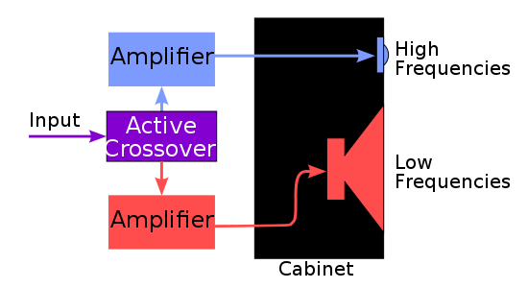
Figure 27 Typical active crossover
Typical crossovers for stereophonic sound will separate an audio signal into high, mid, and low range frequencies. Each band of frequencies will then be sent to the drivers; tweeters, woofers, and subwoofers respectively. Circuit topology of the crossover was designed as the standard parallel configuration which is the most common by far. Since each filter section is in parallel they do not interact which makes the design of the three-way crossovers much easier as each section can be considered separately and component tolerance variations are isolated.

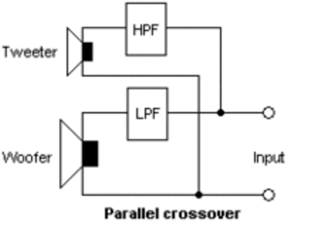
Figure 28 Parallel crossover configuration
High fidelity sound uses more than one driver so a crossover is required in order to ensure that each driver only receives a signal it is intended to reproduce; avoiding sending a low frequency signal to a tweeter design for high frequency signals, thus limiting damage to drivers. Typical high fidelity configurations include a loudspeaker driver with a broad frequency range, a subwoofer for low frequency signals, and a high frequency driver that compensates for the main drivers’ frequency roll off. For this project we would like a set of drivers, one for high frequency signals and another for low frequency signals. Having the ability separate audio frequency bands will allow the flexibility to choose specialized drivers for each range of frequencies which will make it possible to achieve lower distortion and better reproduction of the source material thus leading to high quality.
For this design a crossover the employs the use of a high pass, low pass, and band pass filter will be used. A low pass filter will be utilized to stop midrange or high frequency signals from being sent to the bass driver, band pass filter will stop bass or treble signals from going to the midrange driver, and the high pass filter will prevent low frequency signals from being sent to the high frequency driver. In order to design an audio system that utilizes multiple loudspeakers in stereo format a second channel had to be designed. Since the LM386N-4 is a single channel 1W operational amplifier, each channel will need a single chip along with the external components. Since each channel will be independent and the design of an active crossover has been selected, it will be inserted before the amplifier in between the audio input coming from the microcontroller.

5.2.3.2 Filter Design
In order to accurately design the crossover to separate low, mid, and high range frequencies we must know the frequency response of high fidelity tweeters and woofers. Our goal with the crossover is to maintain flat frequency response across each band of frequencies and avoid any abrupt stop in any band; each filter should roll off the edge of its band at a certain rate and having one band fade out as the next band fades in.
Audio frequencies can be split into seven distinct frequency bands ranging from 20 Hz to 20 kHz; those bands are sub-bass, bass, low midrange, midrange, upper midrange, and presence & brilliance. Sub bass is the first audio band and includes the lowest useable frequencies from 20 to 60 Hz. Sub bass range is known for its deep bass which is felt rather than heard most of the time, giving a sense of power. This audio band will remain relatively untouched with no equalization boost. Bass frequencies range from 60 to 250 Hz and determines how fat or thin a sound is. A subwoofer is used to accurately reproduce bass signals; a low pass filter will ensure only low frequencies reach the subwoofer. Low midrange contains low order harmonics and range from 250 to 500 Hz, and is typically viewed as the bass presence range and boosting signals around 300 Hz will add clarity to bass. Midrange audio frequencies range from 500 Hz to 2 kHz which includes the human voice and caution must be taken into account when boosting this band since the ear is particularly sensitive to the frequency coverage and sound of the human voice and excess output may cause tinny sound and lead to ear fatigue. Upper midrange goes from 2 to 4 kHz, and is responsible for adding presence into audio. Presence ranges from 4 kHz to 6 kHz and is the range at which most stereos center their treble control on, it is responsible for clarity and definition in a sound system. Lastly, brilliance ranges from 6 kHz to 20 kHz which is composed primarily of harmonics responsible for sparkle and air in sound.
Knowing the range of audio frequencies will enable design of the filter networks in the crossover to be completed with relative ease. Subwoofers are the driver used only for low frequency audio signals typically below about 200 Hz. This will be the cut-off for the low pass filter and using the equation below, we can calculate the value of resistance and capacitance RC given a specific cut-off frequency for each audio band. A typical active low pass filter is also shown below along with the frequency response of a low-pass filter and phase response.

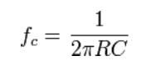
Figure 29 Calculating RC value
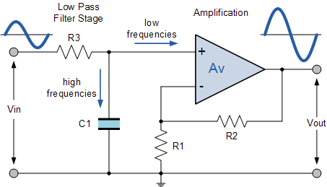
Figure 30 Typical active low pass filter operation
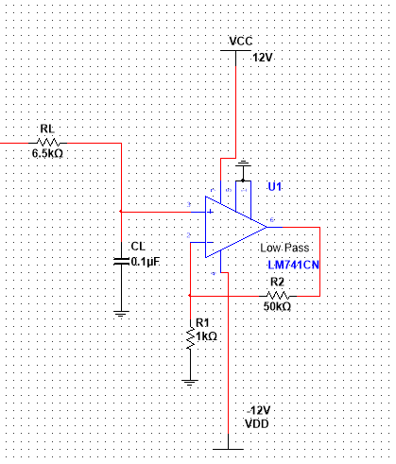
Figure 31 Active low pass design schematic
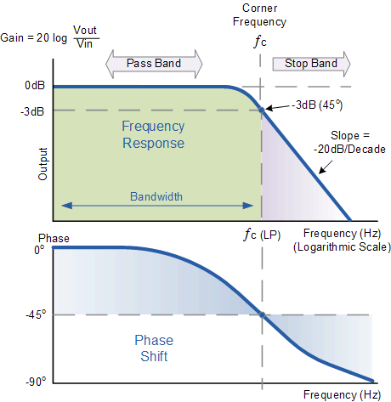
Figure 32 Low pass filter response
The low pass filter is designed to pass frequencies below about 250 Hz and attenuate at a rate of -20 dB/decade. An active low pass filter network includes an op amp with a DC gain of about 50 as a pre amplifier section before reaching the subwoofer.
Mid-range drivers are responsible for reproducing middle frequencies. A filter design to allow only a band to pass; in particular the mid-range frequencies is known as a band-pass filter or a band notch filter. Frequencies in a certain range are allowed to pass while frequencies outside that range are rejected or attenuated, known as the pass and stop band respectively. In the figure below, the frequency response for a band-pass filter is shown; F_{L} stands for the lower cut-off frequency while F_{H} stands for the high cut-off frequency. Bandwidth is the range of frequencies in a particular band when transmitting signals and is often used in conjunction with passband bandwidth; the difference between F_{H} and F_{L}.
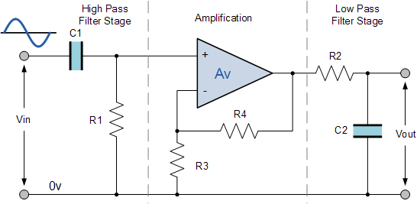
Figure 33 Active band pass filter

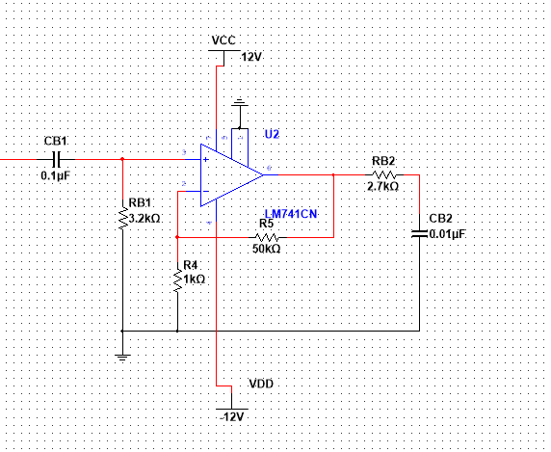
Figure 34 Active Band pass filter design schematic

The band pass filter is designed to pass frequencies between 500 Hz and 6 kHz and attenuate frequencies below and above those cutoffs. A high pass network inputs into an amplifier with a DC gain of about 50 before a low pass network then completes the band pass filter output.

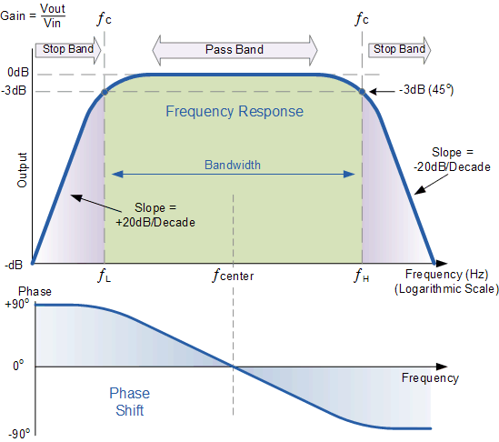
Figure 35 Band pass filter response

Tweeters are the drivers responsible for delivering high frequency signals mainly from about 2 kHz to 20 kHz. When designing an audio system it is very important to make sure no low frequency signals reach the tweeters as it would inevitably lead to their destruction and in order to design a system in which only high frequency signals reach the tweeter a high-pass filter will be utilized. Designed to attenuate frequencies lower than the cut-off it will be used in this project to protect tweeters from damage and separate the upper midrange, presence, and brilliance frequency bands. An active high pass filter is shown below along with the frequency and phase response.
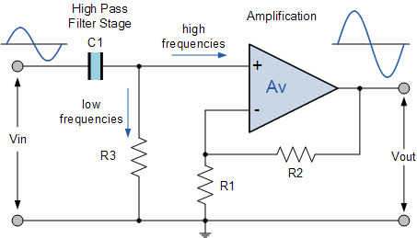
Figure 36 Active high pass filter

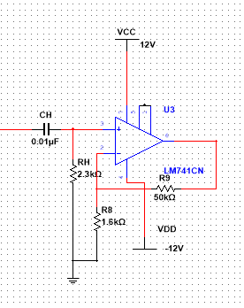
Figure 37 Active high pass filter design schematic
The high pass filter is designed to pass only frequencies above the cutoff of 7 kHz and attenuate at a rate of -20 dB/decade any frequencies lower.
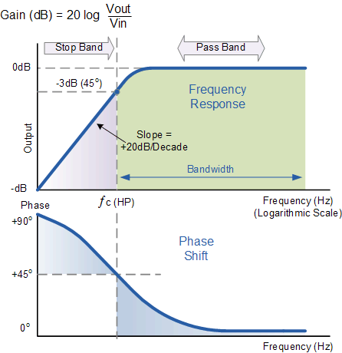
Figure 38 High pass frequency response
For the design of the active crossover filter network the general purpose LM741 operational amplifier was chosen. It can handle a maximum voltage of 18 V, making it perfect for our application with a power supply at 12 V. Along with this 8 pin package and some external components such a resistors and capacitors our active filter crossover network will be placed in between the audio input from the microcontroller and the amplifier section of the audio system. Shown below is an overview of the crossover network once completed and together the crossover system and filter system will make a complete stereo audio system in which the user can control from their phone.

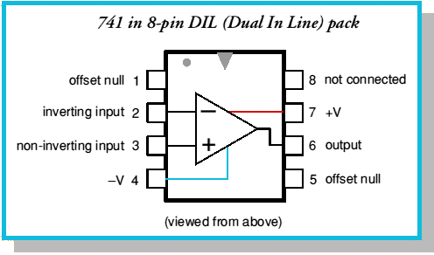
Figure 39 – LM741 operational amplifier

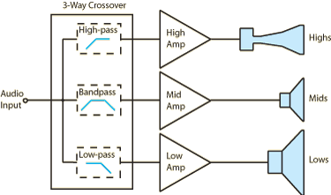
Figure 40 – Complete crossover system

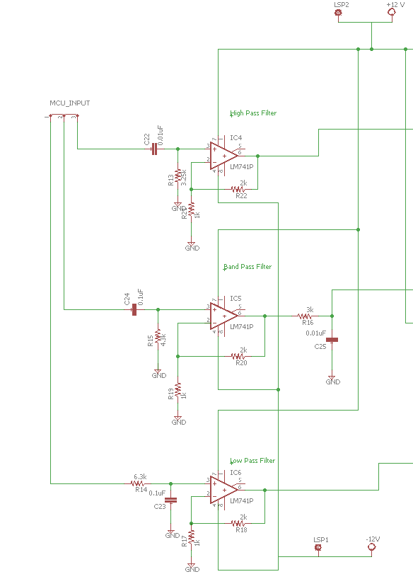
Figure 41 Complete three-way crossover design schematic

After comparison between the LM741 & LF351 operational amplifier for our filter design we decided to go with the LF351 as it had a much higher input impedance (10 TΩ) and had a much lower THD factor (0.02%) even though it uses about 170 mW more power and costs about $0.69 more; these disadvantages were negligible when compared to the benefits of this chip.

5.2.4 LED Matrix
The LED matrix will surround the device and be entirely controlled by the microcontroller. A power supply will provide the necessary power to the array. The matrix can be configured through the mobile app in communication with the Bluetooth module.
For the LED display on the cooler, we went a strip of SMD5050 RGB LEDs with WS2811 controllers from Alitove. It is a 5-meter roll with 60 LEDs/m for a total of 300 individually addressable RGB LEDs. The WS2811 controllers are widely used with the microcontroller we chose and already has great libraries for interfacing with the controller. For the microcontroller, we went with the same microcontroller IC as the main microcontroller, a single ATmega 328P. This allows us to simplify development by only requiring one development environment and programming board and also reduce costs by buying the microcontroller IC in bulk.
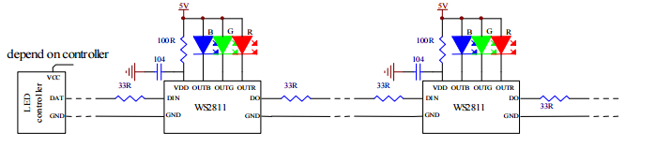
Figure 42 WS2811 LED Controllers

The WS2811 LED controller outputs to three separate LEDs, one for each of the three primary colors. These three LEDs are grouped into individual pixels which can be controlled to display any possible color. Each LED in each pixel requires 8 bits of data to set the color for a total of 24 bits per pixel. The data for each 24-bit pixel is sent sequentially over a single digital pin followed by a reset code. The WS2811 controllers are synchronous, so all of the LEDs will reset at the same time.

The WS2811 controller has two modes for speed. In high speed mode, the shortest cycle for the control bits is 0.25 µs. This means that in order to run the WS2811 controller in High Speed mode, the LED microcontroller will need to run at least at 4 MHz. The ATmega 328p will be run at a 16 MHz frequency, so it won’t have any issue with the high speed mode. In this mode, the time to send one bit takes 1.25 µs and the reset code takes 50 µs. This totals to 425 µs to send a full cycle of data to all 300 pixels in the LED strip. We will be using a refresh rate of 30 frames per second for the LED strip. This leaves us with almost 33 ms each loop to handle the processing for other parts of the program. This is more than enough time to handle the audio visualization processing, which is the longest part of the program for the LED microcontroller.

One large benefit of using the WS2811 LED controllers is that instead of using an I2C interface it uses a single digital pin for input. This allows us to individually control all 300 LEDs without requiring multiple microcontrollers. The WS2811 LED controls also are compatible with a great Arduino library called FastLED to control each LED, significantly simplifying the program development.
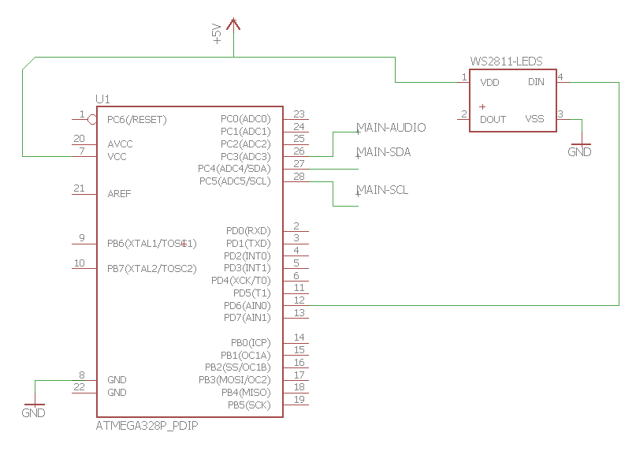
Figure 43 LED Controller Schematic

The hardware for the LED system is rather simple thanks to the WS2811 controller. The ATmega 328p only needs to use one digital pin to send data to the LEDs. Both the LEDs and the microcontroller require 5V, so they will be sharing the same +5V power rail. The LED microcontroller then connects to the main system microcontroller through the two pins for the I2C bus and one analog pin to receive the audio output of the main system microcontroller. The LEDs require 3-6 volts to operate with the optimal voltage at 5V and each LED consumes around 60 mA for a total power draw of 90 W for the entire roll.

5.2.5 LED Controller Program
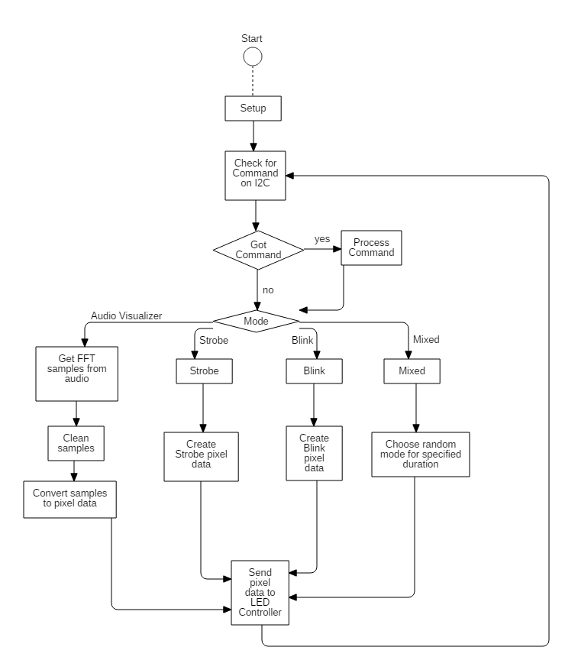
Figure 44 LED Controller Flow Chart

While the hardware for the LED display and controller are simple, the program for the controller is much more complex. Once every loop, which will be in 33 ms intervals since we will be running at a refresh rate of 30 times per second, the controller will check the I²C bus for any incoming requests from the main system microcontroller. These requests will be contained in 80 bit packets. Three colors of 24 bits each, 8 bits per RGB channel, and 8 bits for the mode select. If one of these packets, it is processed and saved as settings in the program. One of these settings is the mode, of which there are currently four planned.

For the Audio Visualizer mode, it will need to convert the analog audio signal to multiple frequency levels and then to pixel data that it can send to the LEDs. Thankfully, there is a great Arduino library for using Fast-Fourier Transform on analog signals like this that is compatible with our microcontroller. Using the standard analogRead() in the main loop and analyzing the signal myself would be far too slow to provide useful data. The FFT library from Adafruit taps into a special mode of the Analog-to-Digital converter called free mode, automatically collecting analog samples at a specified sample rate and converting the samples into frequency spectrum using a Fast-Fourier Transform. The microcontroller then has to convert the complex frequency spectrum data into a graph representation and its color values and send them off to the LED controllers.

For the other modes, the microcontroller will be generating random patterns based on the time and mode. For instance, when the system is in Blink mode, the microcontroller will need to create a random alternating color pattern using the time as the seed. If the system is in mixed mode, it will randomly select from the other modes and set it as the current mode temporarily.

Figure 45 RGB bit order

When generating the color patterns based on the mode, the LED microcontroller will need to generate 24-bit color values in the order shown above for each of the 300 pixels on the LED strip. This totals to 7.2 kb of data being transmitted in order over one of the digital pins on the microcontroller followed by some delay of at least 50 µs. The code to send the color data to the WS2811 controllers will be placed at either the start or end the loop, so that the audio, commands, and pattern processing will naturally provide a delay long enough so that we do not have to waste processing time.

5.2.6 Cooling Stations
Three cooling station will be equipped in the device for cooling drinks. Each cooling station will have a cylindrical center designed to expand for various drink sizes. The cylinders will be constructed to curve around the beverage on one side and have a flat portion on the opposite side. The flat portion will be bonded with a peltier thermoelectric plate using thermal adhesive. As current passes through the peltier unit heat is drawn from one side of the plate to the other. The heat will be extracted from the cylinder and eventually the drink, cooling the beverage. On the opposite face of the peltier plate heat begins to build up. Bonded with more thermal adhesive, a heat-sink is attached to dissipate heat. The heat-sink will be covered in an air tube where a fan will pass ambient air across the warming heat-sink and away from the cooler. Maintaining the temperature of the “hot” side of the peltier is crucial to the cooling as the unit can only maintain a temperature difference of 67 °C.
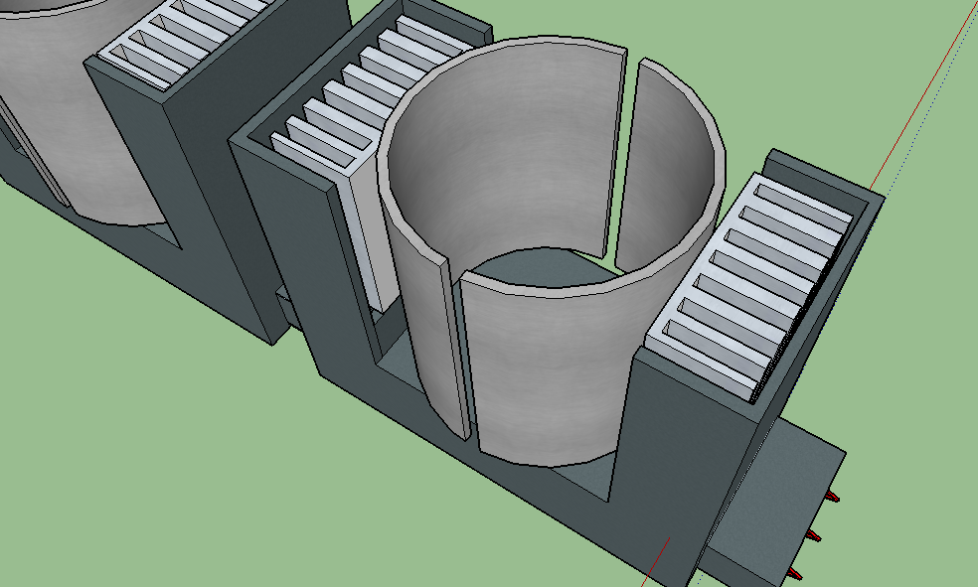
Figure 46 Cooling station design and layout
Various component are added to the construction of the cooling station in order to improve control and reliability. Due to the inefficient nature of thermoelectric plates the device will primarily be used when supplied by a steady AC wall connection. LEDs will indicate active cooling and manual switches are available to remove power without using the mobile application. Temperature sensors will display the temperature of the cooling cylinders within the app, so the users can actively see the cooling process. The temperature sensor will communicate with the Arduino microcontroller which will communicate with the Bluetooth module.
The warm heat sinks will be surrounded by an encasing that will channel ambient outside air across the heat sinks and back out. The encasing in is necessary so heat is not introduced into the body of the cooler, only into the surrounding environment. The encasing will also provide a direct channel of air so heat can be removed from the heat sinks.
Using the Arduino as a controller can work as a power supply, logic gate, and many other functions if the required power is not too high. The power drawn from the cooling system is significantly higher than Arduino is capable of providing. This requires there to be an alternate power source separate from the Arduino yet still controlled by it. The solution is a relay, with 5 V DC switching so the Arduino can switch the power supply on or off but still be disconnected from that power itself. Using a normal open (NO) single pole single throw (SPST) relay would require the Arduino to supply a steady signal high to connect the switch to supply power. Even though the cooling system is designed to be used when a steady stream of power is supplied to the system, it would be inefficient to have a relay that requires the constant high voltage signal to maintain a constant power supply so a latching relay will be implemented instead.
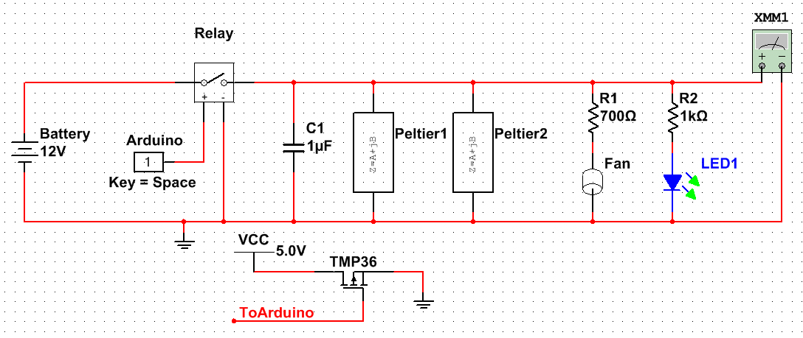
Figure 47 Cooling station circuit design schematic
The temperature sensors, TMP36s, require 5 V across two inputs and a third for the output signal. The output of the TMP36 is a voltage, which changes ±5 mV for every change in degree Celsius (± ºC). These sensors will be connected to one of the Arduino’s analog pins. The Arduino will read the voltage and using calculations seen in the code that will determine the temperature. This temperature will then be sent to the mobile app so customers can actively see the temperatures at which their drink is cooling. The temperature will also be used to determine if a drink becomes too cold. To avoid freezing any beverages, the temperature also makes sure the sensor does not read below 0 ºC for over two minutes. If the temperature does drop below 0 ºC for more than two minutes the Arduino will switch off the power to the Peltier plates for one minute and then re-apply power to the system. Below is an example output of the temperature dropping as the power is applied to a Peltier plate with the TMP36 reading the temperature of the “cold” side.
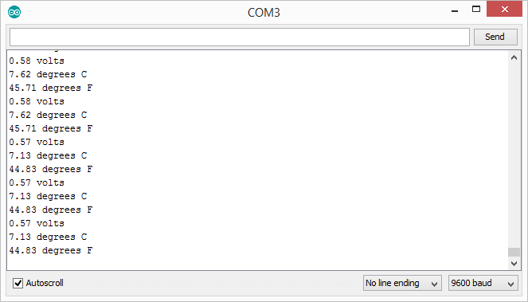
Figure 48 Cooling station serial port output upon cooling
The main concern with the cooling stations is power consumption. The fan used to cool the heat sinks, the LED, the latch relay, and the Arduino consume little energy compared to the Peltier units. The user has the option to use this feature at any time, whether or not a stead AC power connection is available or not. But if the device is running off solar power, particularly with a low power panel, using the cooling system will quickly drain the battery. The units can be used individually so not all need to be running, but regardless, the cooling system is recommended to be used mainly in conjunction with an AC power source.

5.2.7 Charging Station
The charging station is going to consist of three USB3.0 ports. This will need to be powered by the battery bank. The USB3.0 port requires 5V and outputs around 150mA. A particular phone can draw as much as 6 times as much current to charge. That means with three of these in parallel we will have to supply approximately .9A to each of the USB ports. This means that that battery must produce 2.7A to the charging station. Although there may not be three phones plugged in we are testing the design for the maximum power that could be drawn. The schematic below shows the layout of three USB ports. The power supplied by the battery will be run thought a 5V regulator to match the required 5V of the USB port. We have also talked about possible adding a current amplifier before this stage to allow for quicker charging of phone. This part of the project draws a significant amount of current.
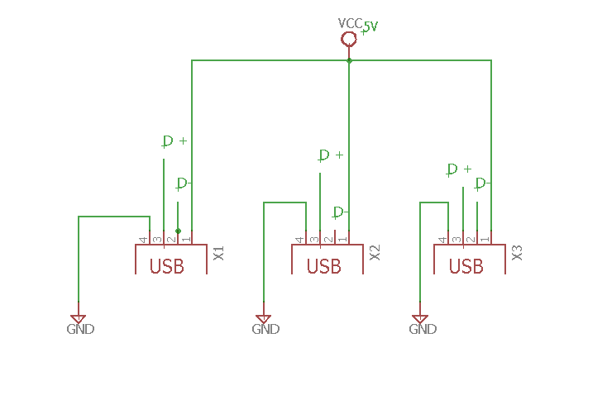
Figure 49 USB Schematic

5.2.8 PCB
Once we have our entire schematic complete in Eagle we can create a PCB schematic. In the eagle software you can go to file and then select switch to board. Eagle then creates an empty board design window with all of your components. Then by moving all the components into the legal area you can start designing the layout of the PCB. A good check once you have placed your parts is to check the major signals. It is better if these signals are in straight short lines as opposed to zig zagging all throughout the board. The most important signal to have straight is the ground signal. You can also use the RATSNEST function which will re-compute the air wires. The next step is to load your specific design rules. Once you load the design rules it will change your board specific to the rules you dictated. After this happens you need to make sure it is correct or else you’ll need to go back and change the design rules. Once the board is looking good the auto route. This function will auto route all the possible traces. Once this is complete we need to check and make sure that all routers are connected. If a few are new we need to manually route these lines. Once all traces are placed correctly it is time to place the power planes. These planes are large areas of copper that carry an actual signal. These usually consist of power and ground. Once the power planes are place the PCB design is basically done. At this point the last thing to do is clean up the design and triple check all the traces and components are correct. Once the design is created you can send the cad file out to a third party to create your board.

5.2.9 Complete Schematic
Shown below are the figures for the final schematics for each part of this project.

5.2.9.1 Complete Charge Controller Schematic
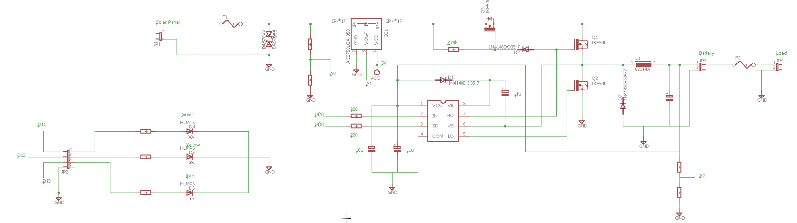
Figure 50 Charge Controller Schematic

5.2.9.2 Audio Schematic
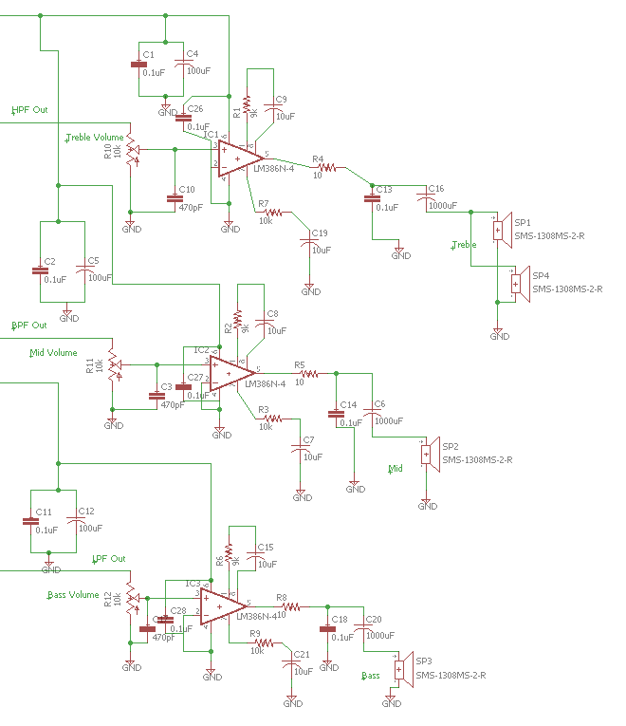
Figure 51 Three-way audio amplifier network schematic

5.2.9.3 Cooling Schematic
Figure 52 Cooling system schematic

5.2.9.4 Regulator Schematic
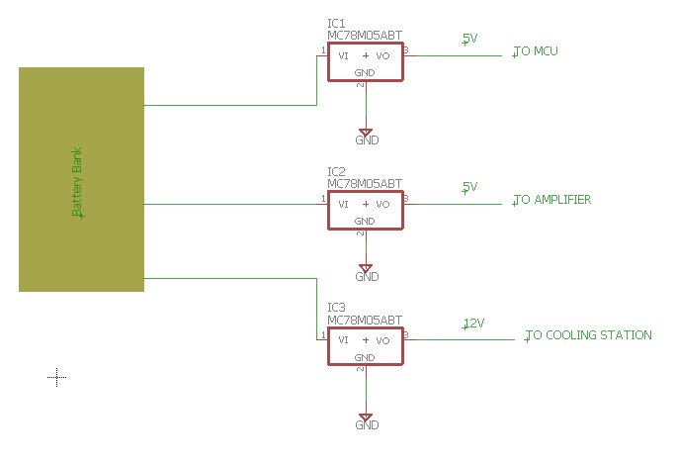
Figure 53 Regulator Schematic
5.2.9.5 Charge Controller Revisions
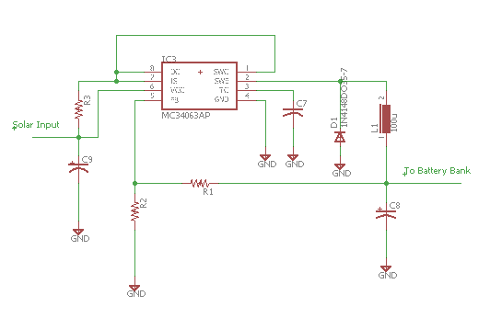
Figure 54 Buck Converter Circuit
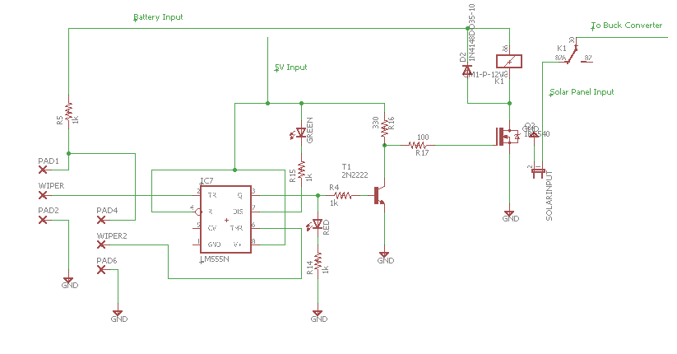
Figure 55 Overvoltage Protection Circuit

5.3 Embedded Hardware
5.3.1 Microcontroller Hardware
Various signals will need to be collected, processed, and manipulated. The microcontroller will effectively accomplish these tasks. Signals received from the Bluetooth module will provide information to the microcontroller which will decipher the signal and execute the appropriate action. The signal could be a song streaming which will need to be directed to the amplifier, or a button press to switch on/off the cooling stations. Various configurations of lights will be controlled by varying signals received from the mobile app. In addition there will be feedback signals from the cooling station to ensure drinks are not frozen, and feedback on battery levels to notify users on the level of charge remaining.
To satisfy the requirements outlined in section 3.3.2, we have chosen to use the AVR ATMEGA 328P microcontroller. Although there were cheaper options that satisfy our needs, we decided to go with the 328P for several reasons. The most significant reason was that the 328P is the same microcontroller used in the popular Arduino prototype development boards that has widespread support and documentation. Because this is the same microcontroller, we can flash the Arduino bootloader onto it and make it compatible with the Arduino IDE simplifying the programming process significantly. This made the ATMEGA 328P the best choice due to our familiarity with the Arduino development boards.

ATMEGA 328P Specifications Comparison
Specification | Required | ATMEGA 328P
UART/USART | >=1 (either) | USART
Memory | >=16KB | 32KB
Speed | 15 MHz | 20MHz
I/O pins | >3 | 23
I²C bus | >=1 | 1
DAC | 12 bit PWM | 8bit PWM (6 channels)
Table 9 Microcontroller Specifications Comparison

As shown in the above table, the ATMEGA 328P exceeds all of our needed requirements except for the 12 bit PWM DAC. Like most microcontrollers, the PWM analog output is limited to just 8 bit. This means that we must use an external 12bit DAC. We chose to go with the Microchip MCP4725 12 bit DAC. This DAC some useful features, however the primary reason for this choice was due to the low price point as well as the DAC’s compatibility with the ATMEGA microcontroller. This DAC takes a I²C input, which the ATMEGA 328P has. The DAC will be hooked in parallel with the LED controller input on the I²C bus. Because we will not be communicating with the LED controller very often, having both of them on the I²C bus should not have much of a performance impact.

One issue that could arise from using this microcontroller, is that the even though the memory size meets our requirements, it is still somewhat low for our needs. Using 12 bit audio at the standard sample rate of 44.1 kHz would fill up all of the available memory on the ATmega with just 56 ms of audio. This severely limits the available memory for storing program code and all of the other operations of the microcontroller. This also makes the system susceptible to any lag in the Bluetooth packets.

If we do end up needing more memory, there are several ways we can fix the issue. One method would be to connect an external flash memory storage IC or an SD card to the microcontroller. This adds complexity to both the hardware and software of the microcontroller as well as increases the cost, however it would be the simplest method to implement that won’t degrade the audio quality.

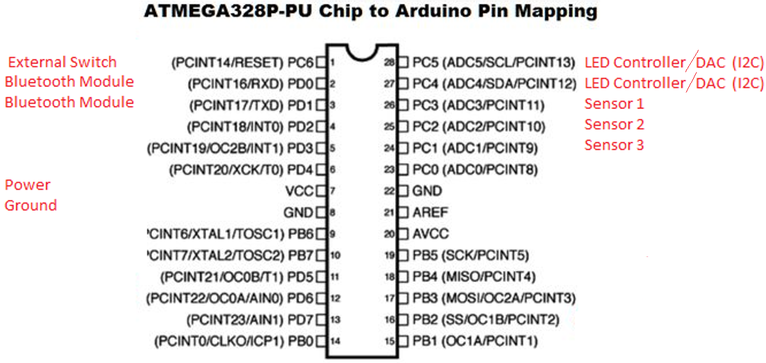
Figure 56 Microcontroller Pin Mapping to Our System

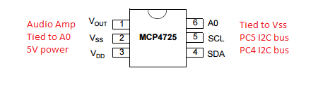
Figure 57 DAC for Audio Output
The above diagrams shows the mapping of the pin connections for our system. On the ATMEGA 328P, an external switch located inside the cooler is mapped to the reset pin. The Bluetooth module is connected to the Rx and Tx UART pins. The LED controller is connected to the SCL and SDA pins for the I²C bus. The sensors are connected to three of the analog input pins. And the Audio DAC is also connected to the I²C bus.
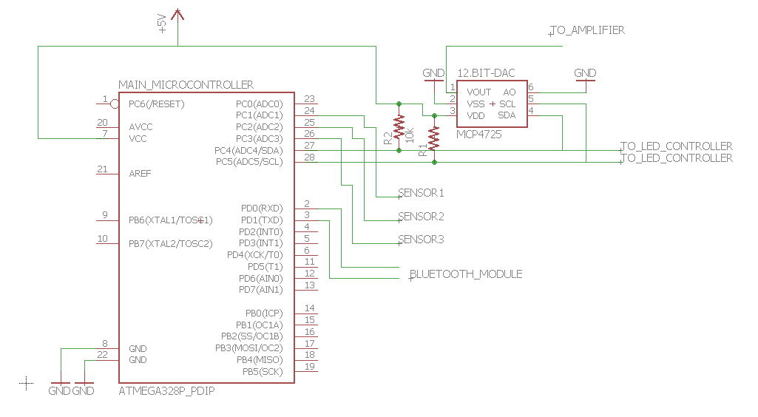
Figure 58 Main Microcontroller Schematic

5.3.2 Microcontroller Program
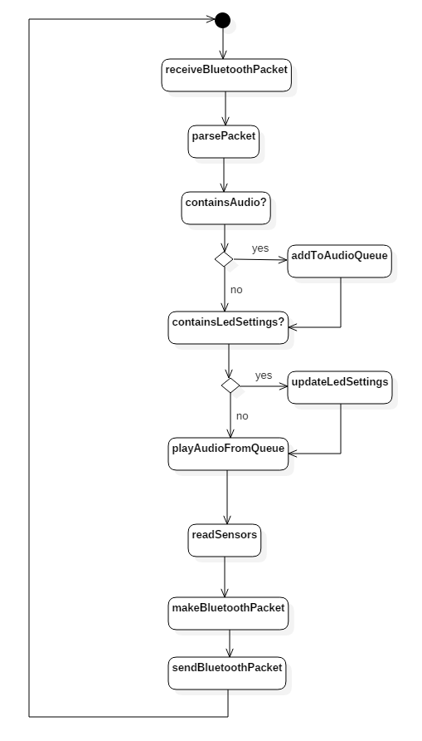
Figure 59 Microcontroller Program Flowchart
The program for the microcontroller has three main jobs. It needs to process the Bluetooth packets for both receiving and sending. It needs to send audio to the amplifier through the digital-analog converter. And finally, it needs to receive data from 3 external sensors.
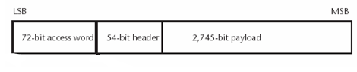
Figure 60 Bluetooth Packet
Due to the large amount of data in the Bluetooth packets, the processing for these packets will be somewhat complex. The received packets from the phone will contain two pieces of information. It will contain any audio that the phone wants to playback and it will have setting changes for the LED controller such as the mode and up to three different RGB color values for the color combination and theme. The LED settings component of the packet will be set at 80 bits, 8 bits for the mode and 24 for each of the three different colors. These 80 bits will be at the front of the packet payload and the rest of the 2,665 bits in the payload will be consist entirely of audio data. Using 12-bit audio at 44.1 kHz, this is enough for roughly 5ms of audio in each packet.
Once we get the digital audio data from the packet, we need to store the data into a queue or buffer. Because of the limited memory capacity in the ATmega 328p microcontroller, we are also very limited in the amount we can store in this queue. In order to avoid running out of memory used by all of the microcontroller operations and storing the program code, it would be best to only store 3 to 4 packet’s worth of audio data in the buffer or about 10,660 bits. This leaves about 21 kB of memory for the rest of the system.
Finally, the microcontroller needs to read data from all three external sensors. The three external sensors are a temperature sensor from inside the cooler, a battery level sensor on the battery, and a power sensor on the solar panel output. All three of these sensors will have an analog output, so they will be connected to three analog input pins on the microcontroller. The built-in Analog-Digital converter has an output of 10-bit values, giving us a range of 1,024 possible values, which is more than enough for these sensor readings. These sensor readings will then be packaged into a response Bluetooth packet and sent to the phone through the Bluetooth module.

5.4 Mobile Application
The mobile application will be developed for the Android operating system, supporting versions greater than 4.4.2 KitKat. The applications role is to provide a user interface to control the device as well as provide sensor readings from the device including the temperature in the cooler, the power output of the solar panel, and the current battery level. The application is also responsible for intercepting the audio of the phone and sending it to the device
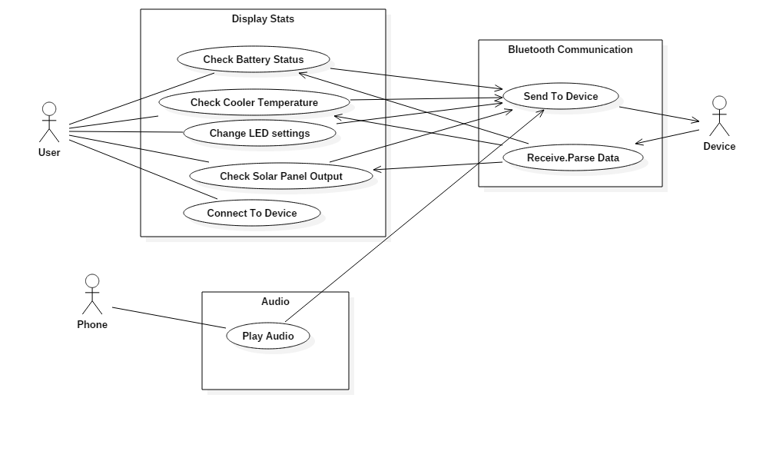
Figure 61 Use Case Diagram
The above use case diagram illustrates the responsibilities of the mobile application. The user interface of the application will have an Android Activity with a single window to display all of the sensor data and have a drop down menu to select between the different LED modes. The application will have an Android Service class that runs in the background to intercept the audio and send it out to the Bluetooth device.
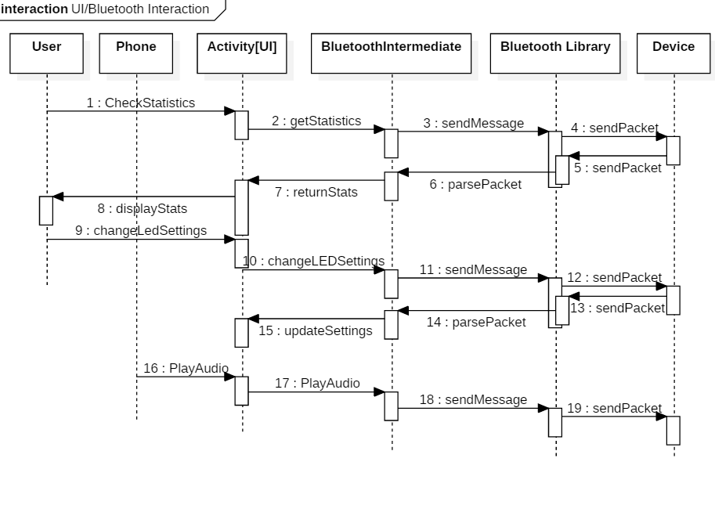Figure 62 Sequence Diagram for Application
The sequence diagram shows an overview of how requests will be moved through the application to the device and back. When the phone requests to play audio, the user loads the Activity with the stats, or the user requests a change in the LED settings, a call will be made to the Bluetooth Intermediate class which abstracts out the base Bluetooth library API calls. The Bluetooth Intermediate class will handle the messy low level API calls and parsing, creating ready to use objects for the Activity and Service to use with the right information. The Bluetooth Library API is provided by Android and contains all of the necessary methods to communicate with Bluetooth devices.

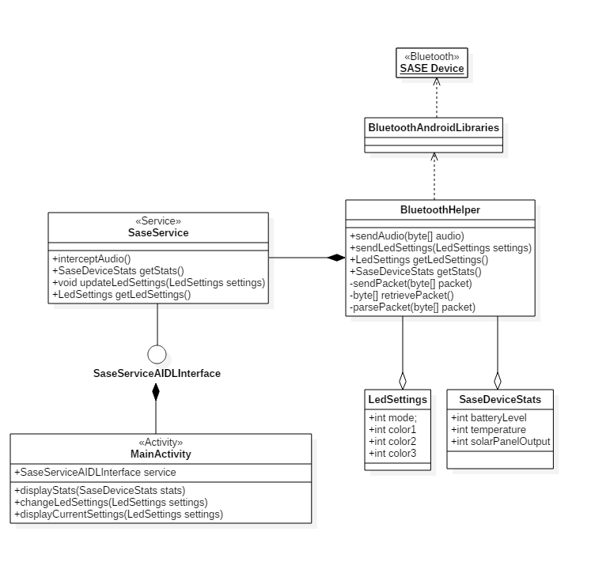
Figure 63 Mobile Application Class Diagram

The above class diagram gives a more defined view of each component of the mobile application. The MainActivity class is an Android Activity that provides the user interaction and controls for the device. It is connected to the SaseService, an Android background service, through an Android Interface Description Language (AIDL) interface called SaseServiceAIDLInterface. AIDL is the primary method for Inter Process Communication (IPC) for handling passing java objects. We have two transfer objects for passing information between the classes, LedSettings and SaseDeviceStats. As their name implies, LedSettings contain any configuration options that the Led controller might have. Currently, we are aiming to support at least three different preconfigured modes (i.e. Strobing, Sliding, Audio Visualizaion) and three different slots for different colors. The SaseDeviceStats class holds all of the sensor data retrieved from the device.
The SaseService class has two responsibilities. The first is to pass any requests or commands from the MainActivity class to the BluetoothHelper class. The second is to intercept all audio from the phone and to pass it as well to the BluetoothHelper. The service will hold a double buffered byte array queue that stores the audio from the phone as it comes in. At the first available chance, when the Bluetooth device is not busy, the audio in the queue will be sent. The BluetoothHelper class packages all current commands, requests, and audio into a single Bluetooth packet. The class then sends the packet to the Bluetooth device using the Android Bluetooth Library.
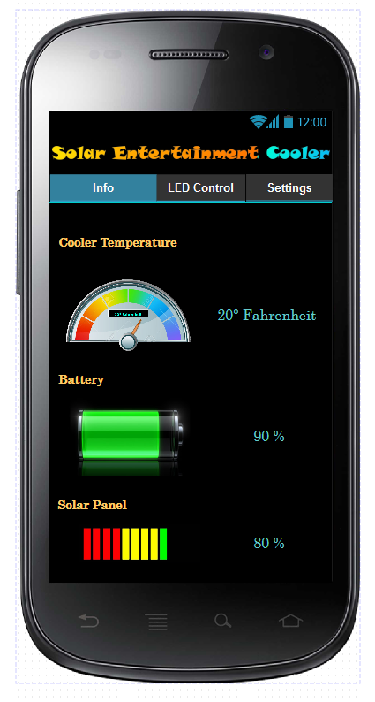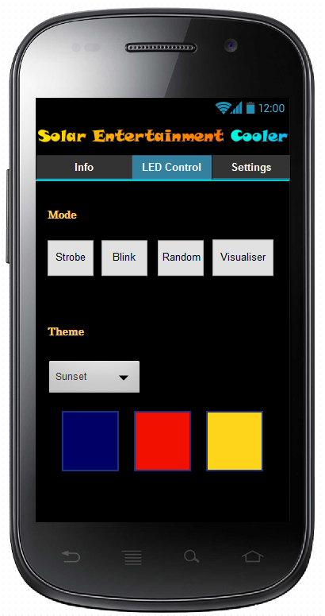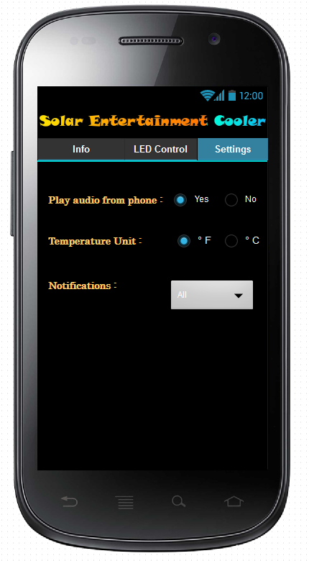
Figure 64 Android Application User Interface
The graphical user interface of the application will consist of three different pages. An info page displaying all of the sensor data from the cooler such as the cooler temperature and battery level. There is an LED Control page that lets users set the Mode and Color scheme. The final page allows the user to change settings for the application such as whether or not to intercept the audio from the phone and play it back on the cooler, the temperature unit to display on the Info page, and which notifications you want to receive.

6.0 Project Prototype Construction
Configurations and test bring the project to the point of prototyping. Each group member has tested their parts ensuring that the requirement specifications have been met and that the schematics work. These test where on breadboards, to allow for quick changes to be made, errors to be corrected and measurements to be easily viewed. Naturally, after test and configuration takes place prototyping becomes a reality. Construction of a prototype begin with Eagle CAD schematics of each system which are them combined into one schematic. This master schematic will contain all the electronics that drive the system. Implementation of the schematic onto a PCB which will then determine the modifications needed to be made to the cooler.
The modifications include, ensuring the PCB will take up little room in the cooler, ensuring the embedded electronics are protected from water or food, applying the lights, cooling stations and sound systems. A connection will need to be made to each part and wires for communication and power and will run a discrete path to each system. Some modifications include fixing the lights to the exterior, and applying a diffuser to mask the LEDS and to create a glowing effect. Then securing a cooling station to the inside wall of the cooler and creating conduits for airflow. Also, embedding speakers into the cooler so the audio can project outwards into environment but still maintaining visual concealment. Next we must secure and protect the battery and then attach the solar panel to power and charge the system. The prototype will resemble the product consumers will see as much as possible to allow for more tests to be made and proof of concept.
Assembling the product will require purchasing a cooler on the market, and modifying various aspects. The chosen cooler will need to have space to fit all the electronics, PCB, speakers, and battery while still leaving space enough for storing drinks, food, and other general items suitable for coolers. There will have to be electrical conduits that will contain wires from the solar panel and to each individual strip of LEDs, power to the cooling system, and send the signal to the speakers. There will also be holes drilled for airflow, and space removed to place the speakers. Although alterations will be made, the cooler should retain a professional look and feel. There should also be no worry of breaking the device due to fragility. Ideally the cooler should not be any less robust than a standard cooler since the design is for portability. For this reason, wheels and handles are also a necessity as the electronics will add weight, in addition to whatever else may also be store in the cooler.

6.1 PCB Assembly
PCBs are the next step after breadboard testing is complete and each circuit design has been finalized. The PCB design allows the circuit layout to be organized and to maximize space used. Each component can be place in an organized manner without adding space to the entire design. Ample consideration must be given to the layout to ensure that is efficient. A layout could cause to many crossing leads causing a board to use more layers to the board. Also, some leads could interfere with others, causing a level of capacitance for example. So arranging the components so there are shorter, less complex navigations, and less interweaving leads can have a significant advantage. Another concern is the power across each lead. The power drawn by the cooling system could potentially burn the board if the leads are too small, and not able to handle a high level of amperage. The final consideration to be made is how the PCB will be placed within the cooler itself, and real estate on the board can be used for rigging to secure the PCB to the wall of the cooler.

Below is the considered organization for the PCB, which takes into concern the issues above. The cooler has systems that are fairly isolated and generally interact solely with the main Arduino driven by the code.
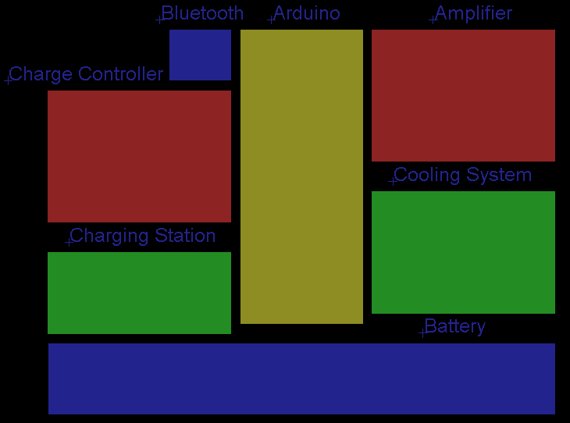
Figure 65 PCB layout organization design

Careful care will need to be taken to guarantee that each piece is measured and will fit exactly into the PCB. Also that there is no accidental physical piece that could touch or short with another. When ordered, the pieces will be tested individually, then soldered to the PCB, and then retested. This rigorous testing will aid in the prevention of potential issues that could result in hours of troubleshooting in order to determine the problem. The final step is to fasten the PCB in place and do final test to ensure operation in its intended environment of operation.
6.2 PCB Construction
In order to prevent any noise from the power supply from entering into our filter and amplifier network we have opted to create two PCB boards; one for the power system and the second for the MCU controllers and audio filter/ amplifier network. Using EAGLE CAD software, the designs were finalized and ordered from the PCB vendor PCB WAY. For about $56 we were able to order each board in quantities of five; which were received in approximately one week. The power system board contains the linear regulators, charge controller, and buck converter which will charge the battery from the solar panel and provide the +12 V, -12V, +5V, and +3.3 V power rails. The power board measures in at about 30 mm x 70 mm and with a thickness of 2mm. Below is the final PCB schematic for the power systems.

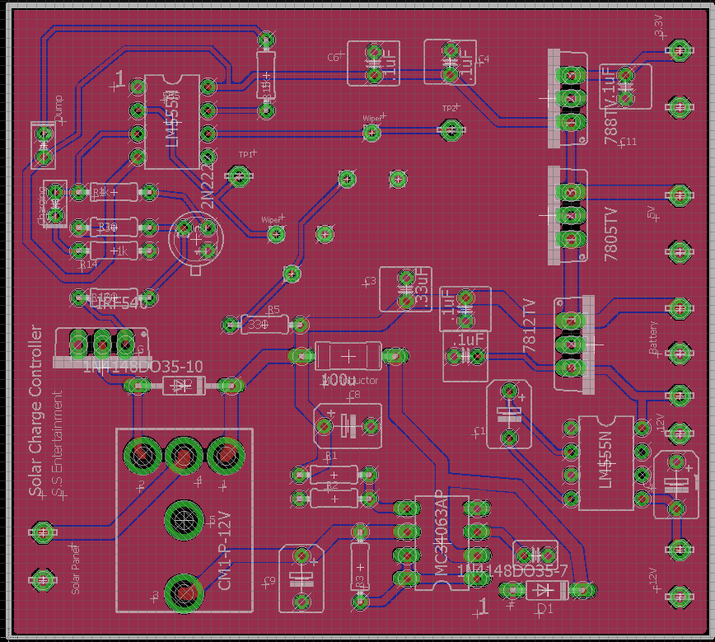
Figure 66 Power systems PCB

Next the MCU controller board and audio filter/ amplifier network were designed and placed onto a secondary board with solder pads in which we could easily solder connecting wires from the power board. The MCU controller and audio PCB measured in at about 57mm x 46mm with two layers and a thickness of 1.6mm. Below the final PCB design for the MCU controllers and audio is shown.

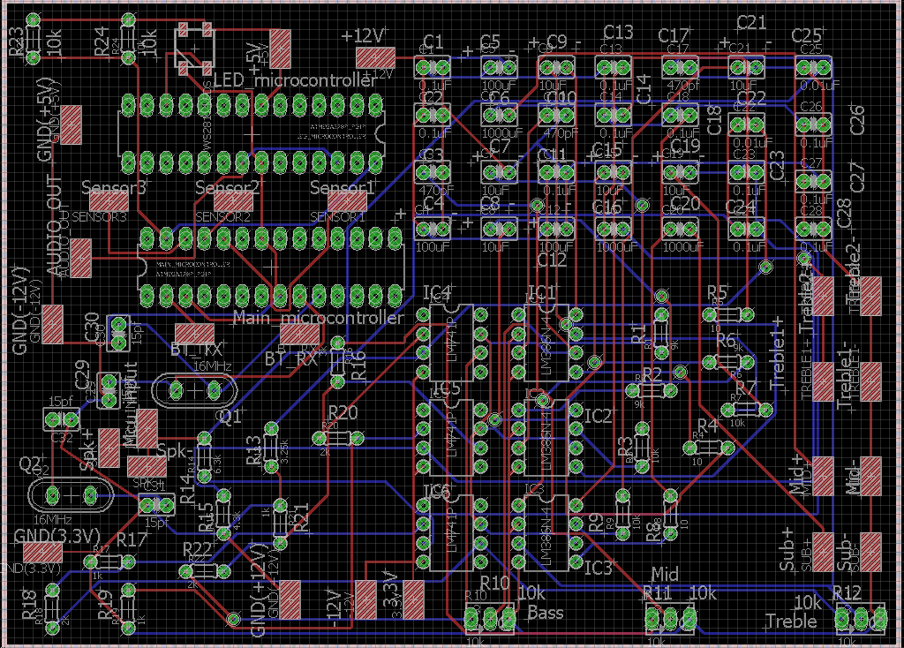
Figure 67 MCU and audio filter / amplification network PCB

Included on the board above are solder pads for the speaker connections to each channel as well as an input pad from the MCU for audio input and the input to the RN-52 Bluetooth chip. Audio will be transmitted to the Bluetooth chip and then sampled by the MCU in order to provide digital sampling data for the FFT library included in the Arduino that we utilized for the LED graphic visualizer. Also included are three potentiometers that are can be utilized by the consumer to “tune” the music coming out of the speakers; a pot will control bass, mid, and treble volume respectively.

During testing of the PCB for the MCU and audio system, we found that certain pins on the MCU & LED controller weren’t routed correctly and would not work as designed. Without having time to order a new PCB for the MCU we opted to create a small proto board which would contain only the MCU & LED controllers; however, everything functioned as designed with the audio system.

6.3 Coding Plan
6.3.1 MPPT Code
The heart of our MPPT charge controller is our MPPT algorithm. We need to write an optimized code that can drive the signal though the hardware. The code can be broken into a few functions. Once all the libraries used are attached the variables must be defined. The program reads analog inputs and converts then to a number between 0 and 5. These values need to be converted back to the original values. Once the values have returned we can do computations with the values we have received from the sensors.
The program should have a few functions handy. There are two signals that are sent out of the Arduino. One is a PWM in which the duty cycle varies dependent on the solar panel power and voltage output, and a signal that is either logic high or logic low to enable or disable the MOSFET driver. The program needs a function that can set the duty cycle and output a PWM. The battery has multiple stage of charging. We are also going to write a function to determine the battery level and output the results to LED indicators. The loop will compare the power and voltage output of the solar panel. Then it should decide if the duty cycle of the PWM signal needs to be increased or decreased. This loop should continue for the entire time there is power to the Arduino. The following diagram shows the flow of our program. Depending on the day and what our solar input is the algorithm should quickly and efficiently reach the MPP. Due to constant change in the solar input the algorithm is the most important part to this design. If the code is not running properly than the hardware will not be operating properly. We are taking our time in testing this code and ensuring it is doing exactly what we need at all steps of the charging process.
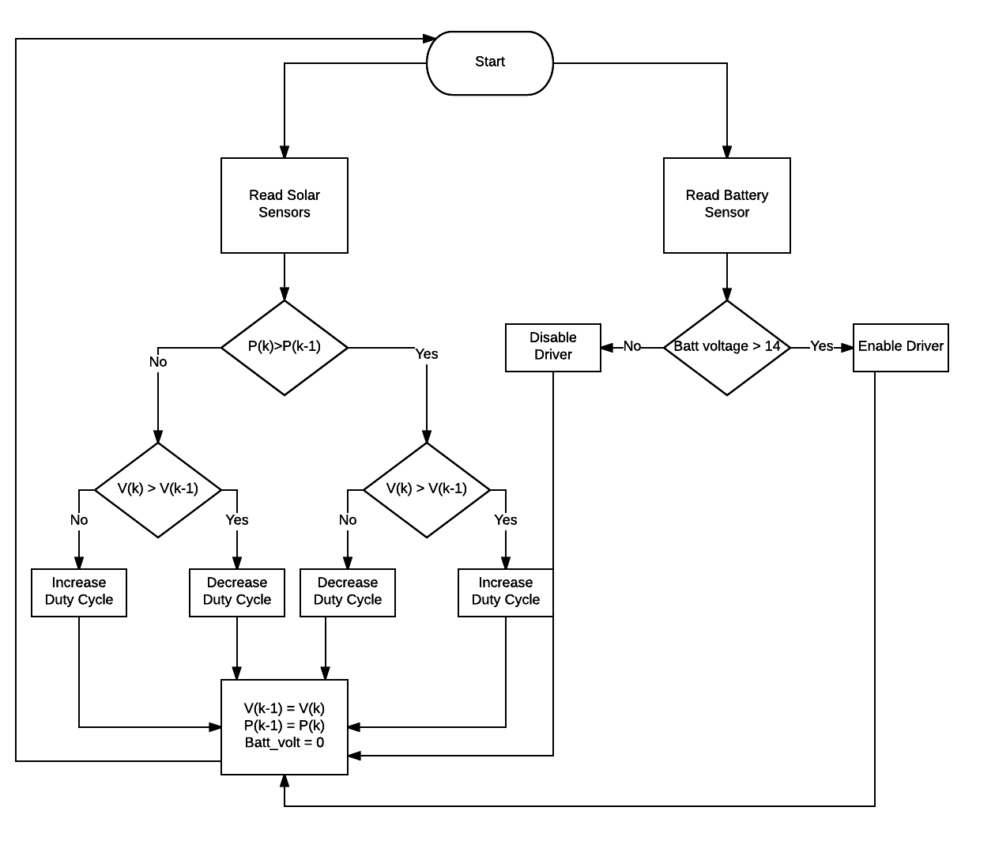
Figure 68 MPPT Code Plan

6.4 Project Construction
After the designs for each system has been finalized and the PCB’s ordered and assembled it is time for us to construct our project prototype for our demonstration and presentation at the end of the semester. A cooler was found with wheels and handles from Walmart for about $19.99 that matched the specifications we were looking for. First we had to modify the cooler body so we could mount the bass, mid-range, and two tweeters for the audio system in addition to mounting the LED strips along the outside of the cooler. Our original design was to mount the LED strips vertically along the outside of the cooler but we quickly noticed it would involve over 300 LED’s and the power consumption would be more than we wanted. Thus we opted to just mount a single strip of LEDs on the outside lip of the cooler; although not nearly as many LEDs as we had planned originally we were very pleased with the overall effect and look. We also had to modify the design for the solar panel; originally we wanted to find a panel or series of panels in which we could just cover the top of the cooler without adding more weight or a bulky panel that would need to be carried. Upon further research we soon realized we would not be able to find a panel that size with the power requirements we would need. Thus a 150 W panel was lent to us by the ECE department at UCF and was used for the duration of this project. Next the cooling stations were constructed using aluminum sheets to construct a cooling channel in which a fan could be mounted in order to push hot air out of the cooler and leave behind only cold air used for cooling a standard size soda can. A heat exhaust port was drilled into the side of the cooler body that would vent hot air way from the cooling stations and out of the cooler body. Volume controls and input jacks were added to one side of the cooler in addition to the AC transformer connecting wire, USB inputs for charging, and an audio input jack. In addition, a pair of connectors were installed on the outside of the cooler with which the consumer could connect their own solar panel or the panel with which we have tested with. While the PCB boards were mounted into two pieces of wood installed in the inside of the cooler, each with slots that each board could slide down into; the addition of screw holes in the PCBs would’ve made mounting much easier. Below some photos of the completed project construction are shown.

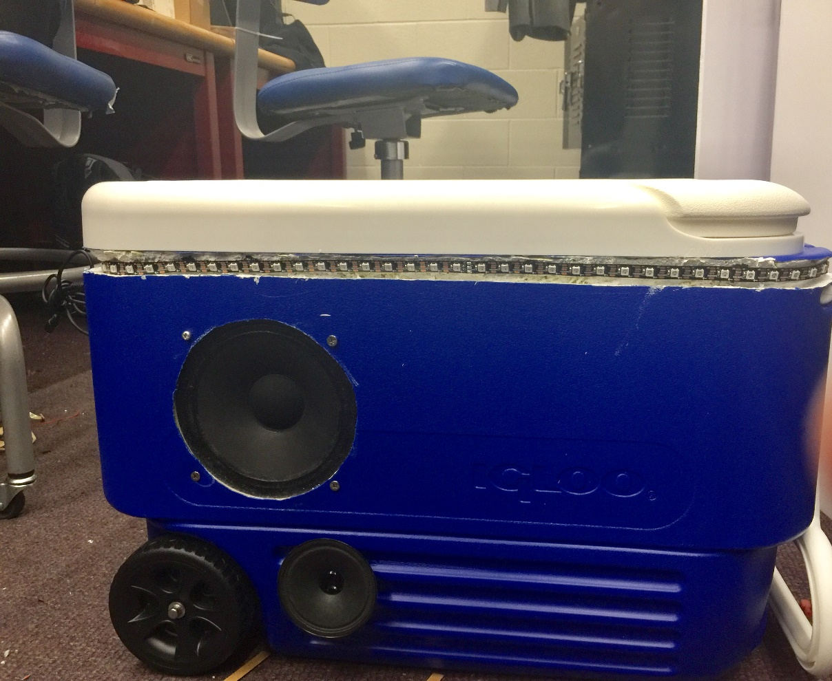
Figure 69 Completed cooler design

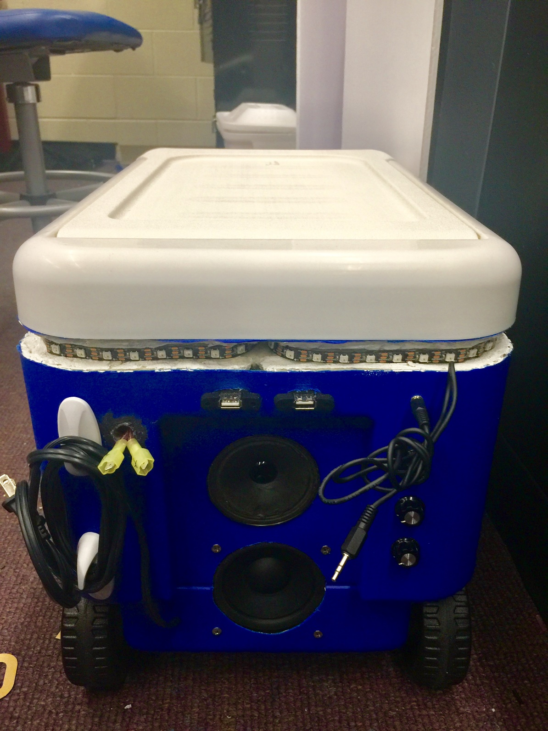
Figure 70 Cooler connections

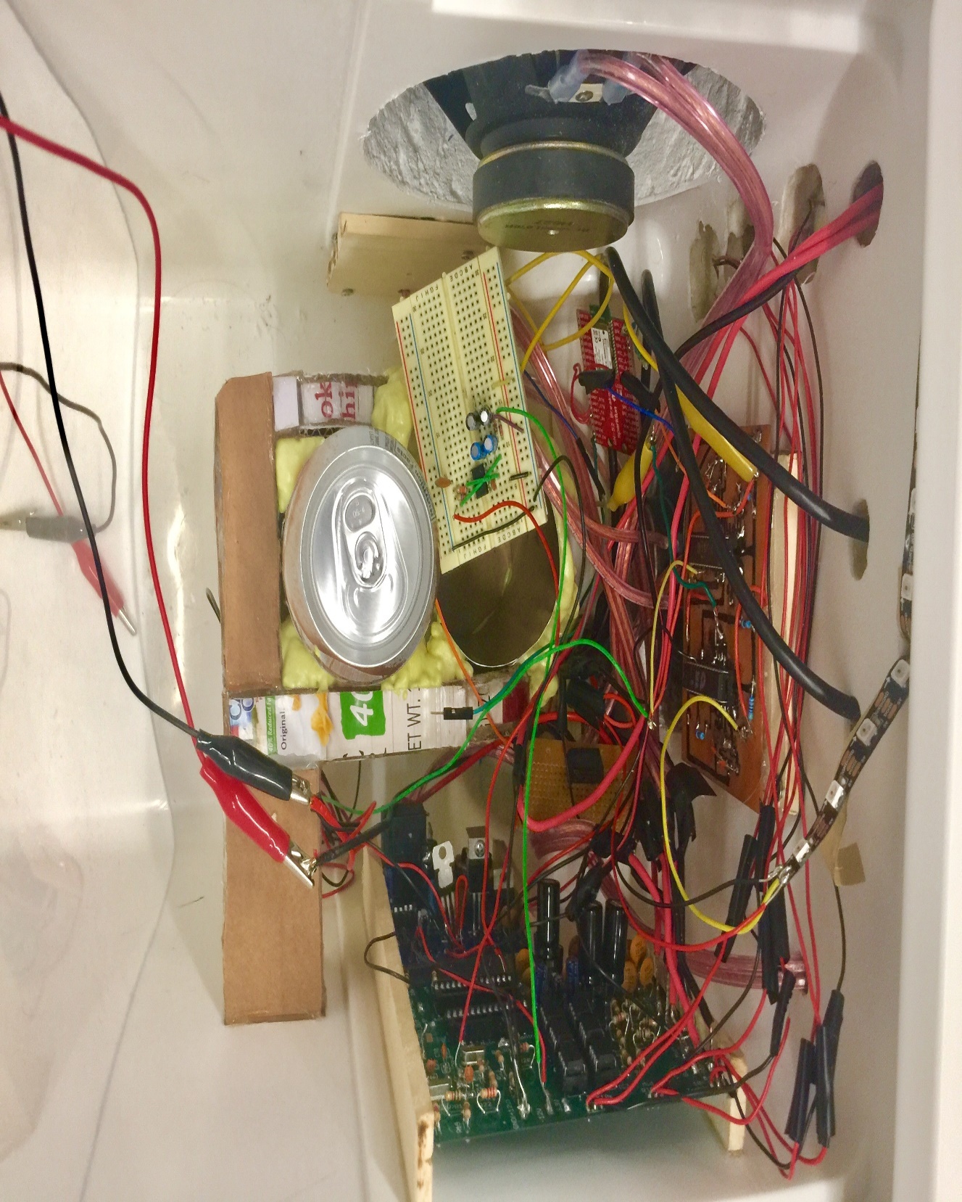
Figure 71 Components mounted inside cooler

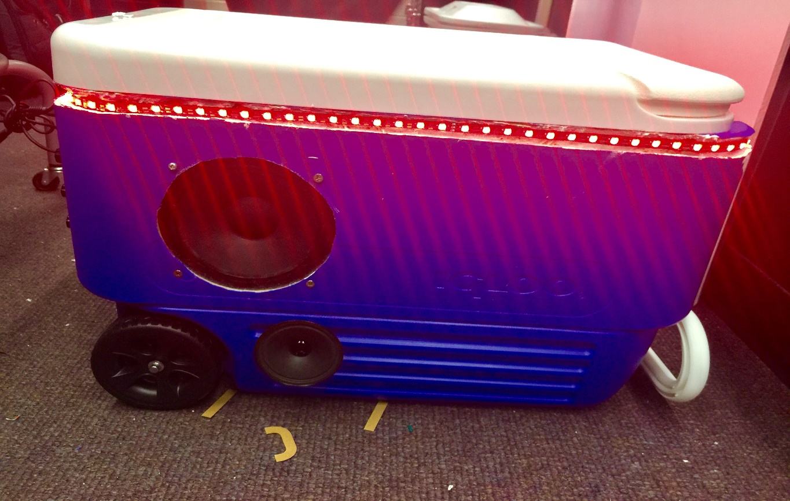
Figure 72 LED testing on final product

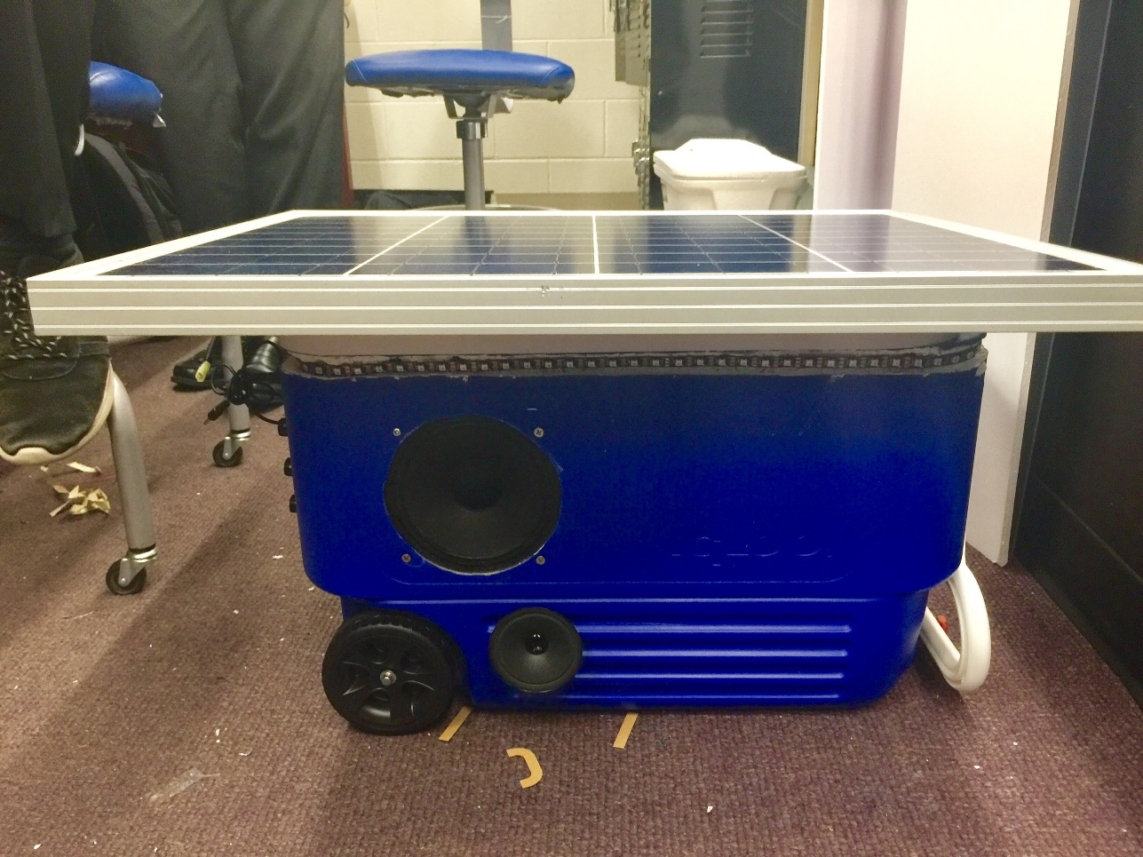
Figure 73 Solar Panel placement on cooler
7.0 Project Prototype Testing
The prototype testing for this project will be conducted in the senior design lab. We started by testing individual parts using basic circuits to ensure the part is operating correctly. Once we have all of the parts tested we began to start building each system of our design. We broke the charge controller testing into three parts. We tested the sensors, the DC-DC converter, and the MOSFET driver. We checked to make sure we were getting the correct readings from the sensors and also that our MOSFET network was switching correctly. Once we figured out the MOSFET switching frequency we could calculate parts for our buck converter. We tested the buck converter and received the proper waveform.
The next system we tested was the amplifier. We built the system on a breadboard. The amplifier circuit is three channels, each using an op amp. We started by building each channel independently and then checked the oscilloscope at each stage ensuring that we were receiving the correct signals. Next the three channels needed to connect all three speakers to make sure that was working. Next the crossover will be designed to ensure only certain bands of frequencies reach specific drivers. Our design makes use of three audio channels; bass, mid-range, and treble. We also need to filter the signal in the crossover to ensure protection of our drivers before an audio signal from a mobile phone is outputted through the speakers.
We then needed to test our LED strip. We bought an LED strip that is 5 meters in length. We first tested this system by ensuring the LEDs were working. We ran the simple blink test and noticed that it was working. The next step is to start writing code for the Arduino that can operate the LEDs in all modes. Once we have the code optimized we then need to make sure we can control the modes with the app. Once these tests are completed our LED system is operating correctly and we can move on.
We then need to test the cooling station. The cooling station will be drawing a significant amount of power. The other concern of this system is heat management. As the peltier plate cools on one side the other side produces a significant amount of heat. We are going to make use of heatsinks and fans. The heatsink will suppress the heat to a certain extent while the fan is used to direct the heat into a channel that will push the heat out of the cooler. We are going to test this with the use of a few temperature sensors. One of the sensors will read the temperature of the beverage holder to make sure it won’t freeze any drinks. Another sensor can be used to monitor the temperature in the cooler to make sure the heat isn’t escaping into the cooler. Once this is testing on the breadboard we can construct the final design for cooler and retest it to make sure it is working properly.
The next systems we need to test is the charging station. We are going two buy three USB ports than can be put in the breadboard. We are then going to test the charge time for charging a single phone. We also need to test the power draw from the three ports. We are going to test the power draw from one port in use, two ports in use, and finally when all ports are in use. We also need to record the impact this system has on the total battery life. We can calculate this by multiplying the current draw by the voltage input and multiple it by the time it takes to charge the battery in hours. This will give us the power in Watt hours. This information will allow us to calculate how much of the batteries energy will be used to power the charging station.
The last test is to connect all of these systems. We can easily connect the systems from their various breadboard setups. Then we need to test the entire power draw of the systems. We need to record the current draw from each of the systems and calculate how that will affect our batteries lifetime. From this we can calculate approximately how long our battery will be able to supply the system. In our specs we declared three hours of continuous use. If our battery is not capable of driving the whole system for three hours we will need to make necessary adjustments.

7.1 Hardware Testing Environment
We decided that the testing environment needed to simulate all environments the cooler would be in. We first thought we needed to simulate the possible environments for charging the cooler. We came up with the following environments.

- Facing East (solar)
- Facing West (solar)
- Facing North (solar)
- Facing South (solar)
- Inside (wall outlet)
- Outside (wall outlet)

We figured these cases would cover most of the possible environments the cooler would be charged in. In each case we will set a time and record the amount of energy that is produced. This will allow us to inform the user of the optimal charging position for the solar panel and the wall outlet. Once these tests have been conducted we can hooked up our charge controller and battery bank and test the charging time for the optimal conditions.

In most cases a cooler is used when you leave the house or are outside by your pool. We also though it would be good to test the power usage of our system in different environments. We want to simulate two environments. One where the cooler is to be used poolside at a residence and the other where the cooler is used elsewhere such as a concert or sporting event. In both cases we can record the power usage and record the information. This allows the user to know the different lengths of battery life. When we are testing the cooler we will be testing it at maximum power draw. This means we will be testing with all features of the system running at once. Once we get accurate values for the battery usage we can conclude the best environment for the cooler.

7.2 Hardware Specific Testing
The hardware needs to be tested before we can start testing in different environments. The first environment we will be testing in is the senior design lab. We will conduct breadboard experiments of all of the systems independently. Once the hardware is tested and working we can start recording data for our cooler.

7.2.1 Battery and Controller Testing
In testing the battery charge controller we need to make sure the battery is adequately protected. Also that the battery can receive a charge in a reasonable amount of time. Starting with the solar panel working down to the battery. Each input and output will determine the accuracy, efficiency, and safety of the charge controller. There is special care and precaution needed in this area because there are potential dangers that could be caused if not careful. Beginning with the voltage dividers, of which there are two, a test would ensue to ensure their accuracy. These voltage dividers are fed into the Arduino which will use those values to make decisions. The Arduino can read any voltage between 0 and 5 volts so the maximum voltage of our solar panel, 68 volts, will need to equal no more than 5 volts. Our maximum possible voltage from our solar panel is 68V. Therefore, a voltage divider circuit that divides the input by 13.6 volts is required. Using the voltage divider equation resistor values of 2.2k and 29k were picked. Using the same equation for calculating the batter sensor resistors, the chosen values of 1k and 1.2k were derived. This is a simple calculation but resistors are never perfect, so calibration in the code will need to be adjusted according to the exact voltage divider ratios. Once these ratios are determined the Arduino is added to the test. Depending on the voltage received from the voltage divider the Arduino will need to determine a duty cycle that will appear to the batter as 14 VDC. So as the voltage rises, the duty cycle should decrease in such a manner that will retain the desired voltage. Secondly, the voltage divider on the battery will tell the Arduino when 14 V has been reached, meaning the battery is now full. If the voltage is above the 14 the shutdown signal becomes LOW and vice versa.
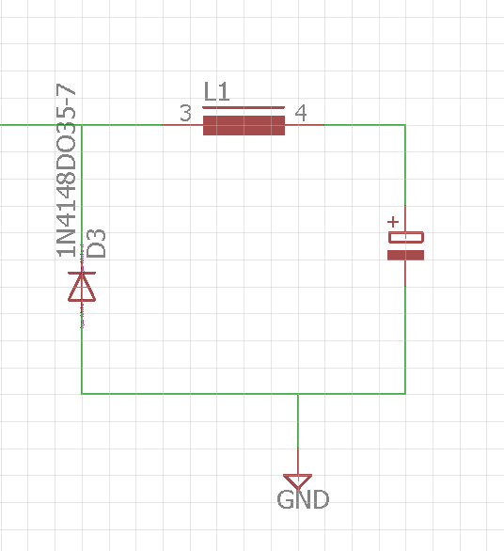
Figure 74 Schematic of Buck Converter
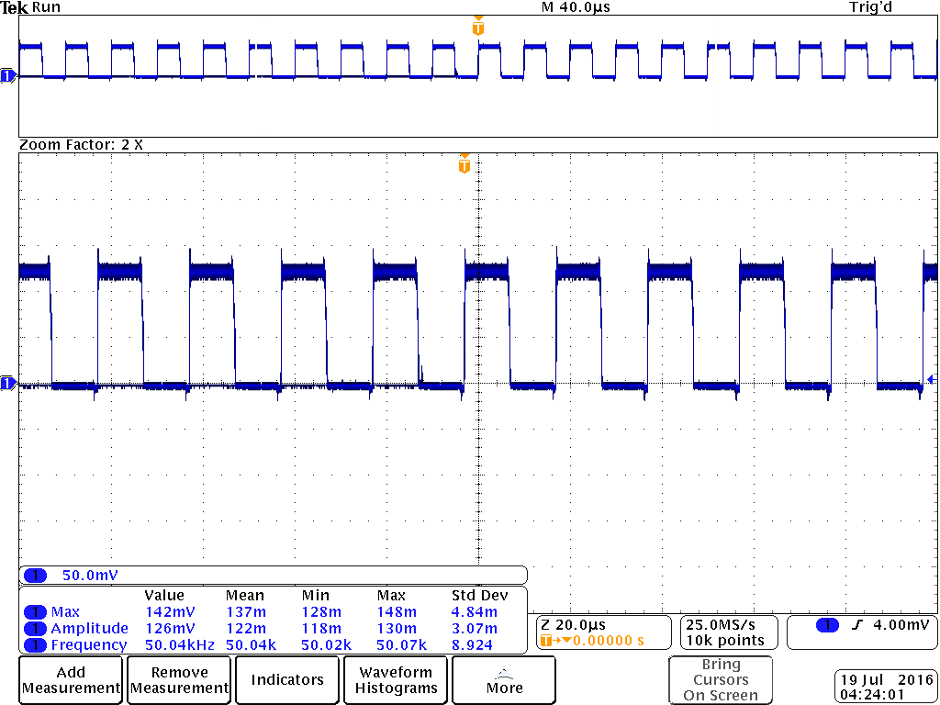
Figure 75 Oscilloscope output of Buck Converter at 50 % duty cycle
The next subsystem that we tested was the switching system. This system included the MOSFET driver and the three MOSFETs controlling the switching. The IR2104 MOSFET driver has 8 pins. The pinout for our application can be seen in the figure below. The driver is used drive the three MOSFETS into different states. There are two control signals that the driver sends out. High output (HO) is sent when the source needs to supply power to the battery. The low output (LO) is used when the battery needs to be disconnected from the source. The driver also takes two pulse width modulated inputs from the Nano. The Nano either sends a signal to the VIN terminal or the SD terminal. The SD terminal is used to shut down the driver which enables the LO signal.
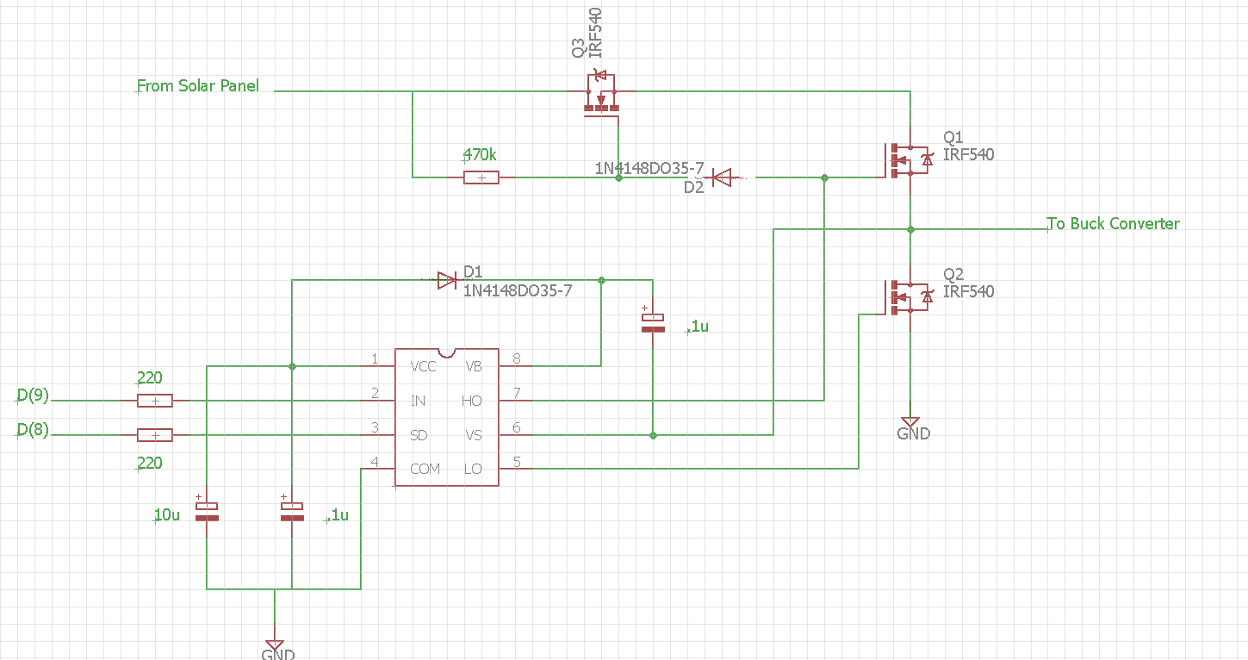
Figure 76 Schematic of Switching Network
In the network above the driver in the bottom left corner controls the three MOSFETS. The driver has two modes, it is either on or shutdown. This is controlled by the SD signal. If SD is logic high the driver will be on, and if the SD signal is logic low it will be turned off. The IN signal is a PWM signal coming from the Nano. The Nano decides the duty cycle and sends the signal. The driver then either selects the HO or LO signal depending on the signal from the Nano. If the HO signal is send from the driver Q1 and Q3 will be on and current will flow to the buck converter. If the LO signal is sent then Q2 will be on and all current will flow to the ground. These are the signals that will allow us to supply or cut power from the source to the battery.
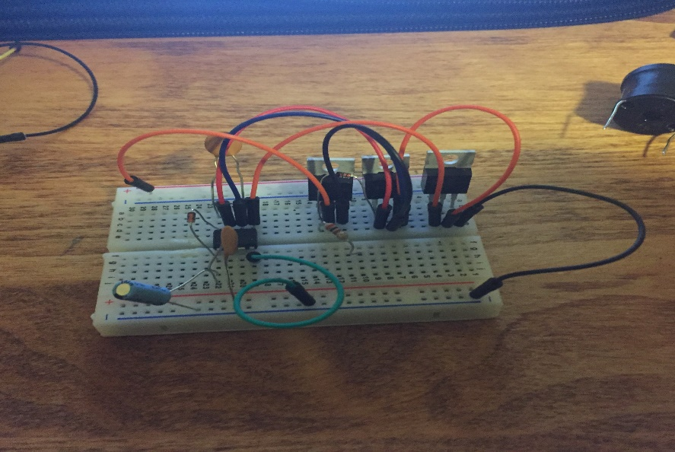
Figure 77 Breadboard of MOSFET network
The last subsystem we tested were the sensors. The input from the solar panel or wall outlet is first run through a current sensor and a voltage sensor. The values are analog inputs to the Arduino Nano. We applied various DC inputs to this system and read the values on the serial port of the Arduino. The Arduino can only measure values between 0 and 5 volts. Our maximum possible voltage from our solar panel is 68V. We need a voltage divider circuit that divides the input by 13.6 volts. Using the voltage divider equation we picked resistor values of 2.2k and 29k. We used the same equation for calculating our batter sensor resistors. We chose values of 1k and 1.2k. We wrote a simple code for the Nano to test our sensors. The code for testing can be found below as well as a picture of the breadboard setup and the output on the serial port of the Arduino IDE.

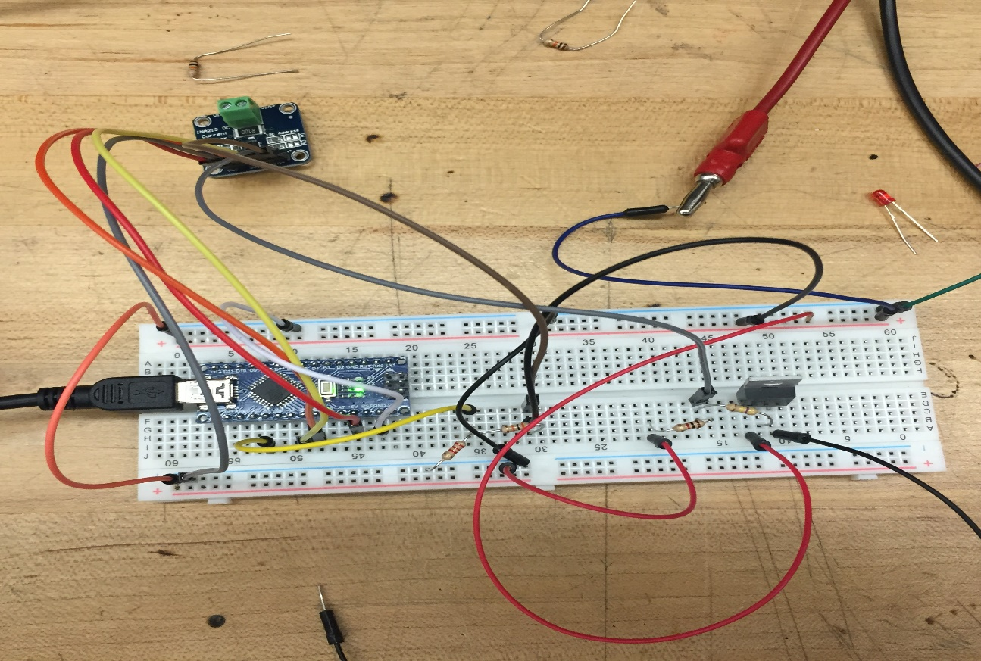
Figure 78 Breadboard of Source Sensors
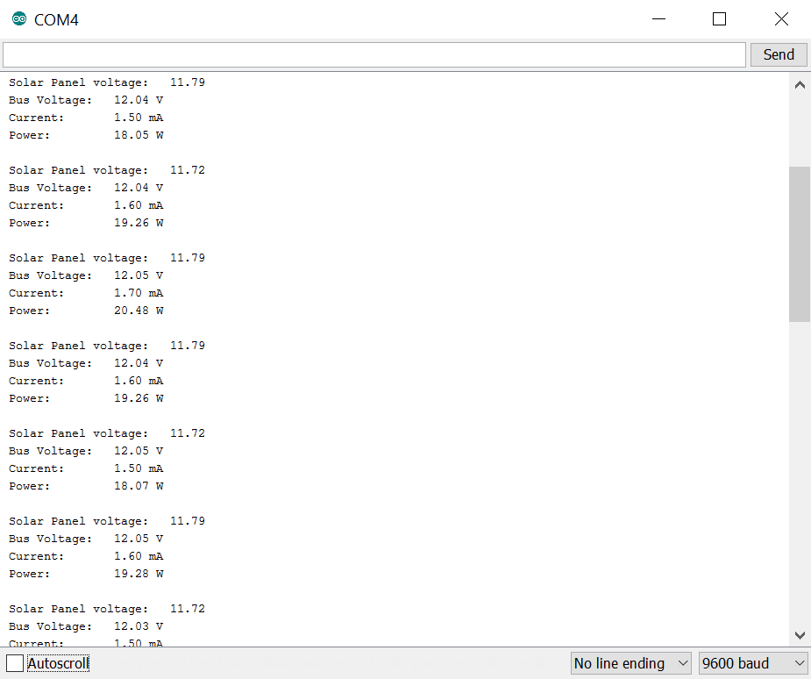
Figure 79 Serial Port Output of Sensor Test

The final test is to connect all the subsystems of the charge controller. We need to test this systems for both power inputs and record the length of charge. Also we need to make sure the controller is working properly. This can be tested by draining that battery completely and then charge the battery bank. We can check the LED indicators along with several voltages and currents corresponding to each stage of charging. Once all of these values have been tested and seem to be working properly our charge controller is complete.

7.2.2 Voltage Regulation
The battery bank needs to supply power to our entire system. Most of the subsystems are running at a voltage that is different than our battery. Our battery will be providing 12V and this needs to power our MCU, the amplifier, the charging station, and the cooling station. The cooling station is the only subsystem that is also running on 12V. The rest of the subsystems are designed to have a 5V input. We can test this by connecting the battery bank and placing the four linear regulators in parallel. This allows the battery to supply 12V to each of the regulators. We then need to test the output of each regulator ensuring that it is outputting the correct voltage. After the voltage is confirmed we can connect the various subsystems to our battery bank without damaging any of the devices.
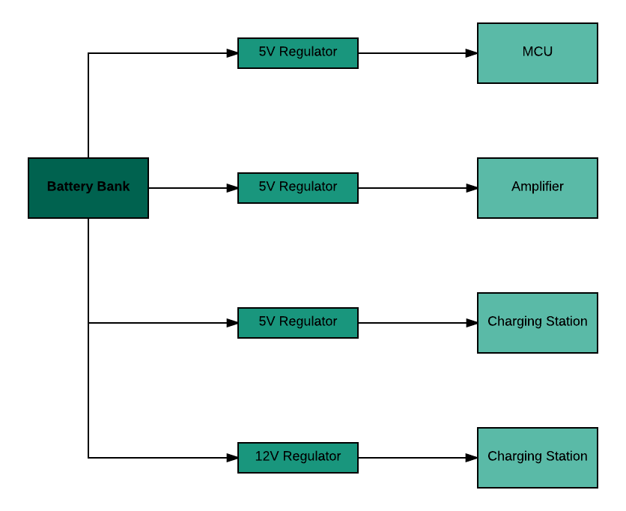
Figure 80 Voltage Regulation system

7.2.3 Cooling Testing
Testing the cooling system requires various components and procedures. The first test was to ensure that the temperature sensor accurately reads the correct values and is calibrated correctly. This required testing using the Arduino NANO, the TMP36 sensor, and a thermometer. The temperature readout from the Arduino then was compared with the temperature of the thermometer in various ambient temperatures to ensure accuracy.

Following the TMP36 test, the Peltier could then be tested using digital reading of the temperatures obtained. Connecting the Peltier to a DC 6 V power source the plate drew 1.7 A or 10.2 W. With a small heat sink glued to the hot side using thermal adhesive, and having the cold side exposed temperatures of 42 ºF were measured. A fan blew on the heat sink connected to the hot side of the plate to dissipate heat using 1.8 W of power. The heat sink used was extracted from a laptop and is smaller than would be used in the actual design. With the larger heat sink a more voltage across the Peltier cooler temperatures could be achieved.

A large concern is that the airflow will need to effectively extract heat from the heat sinks in order to allow the Peltier to cool properly. A corridor made to fit the heat sinks allows air to pass through the flanges of the heat sink and push the heat elsewhere. Testing the corridor involves crafting a path for the air to follow and measuring the rate of flow in the separate corridors to confirm that air is evenly distributed. By measuring the temperatures of the cold sides of Peltier plates, if the power supply is uniform, one Peltier would be colder than the other if more air is dissipating heat from the hot side of that plate.

The relay test was accomplished using LEDs, one that would flash when the latching relay is to switch and the other to show the state of the relay (on or off). The relay is used as a disconnect from the high current draw of the cooling system and the logic from the Arduino. The purpose is to have the ability to turn off and on the cooling stations contingent upon input from the app, to prevent freezing, or overheating. The test included the temperature sensor TMP36 which would measure the cold side of the Peltier. The switching LED blinks when the temperature drops below 50 ºF (for the test only) and should blink again after 2 minute to indicate another switch. The switching LED should also blink if the temperature rises above 80 ºF because this would mean the hot side will be dangerously hot at this point. The status LED should switch on or off at each blink of the switching LED to indicate the status of on or off of the relay.

The mobile app will need to display the temperature accurately and also allow the user to manually control the ON/OFF status of the cooling station. The previous testing setup will be used with the indication lights to determine the status of the relay and station. The app will communicate with the Bluetooth module and the Arduino to determine switching. The user will switch on the cooling station through the app, then view the drop in temperature. When the temperature drops below 50 ºF the cooling station will automatically turn off for two minute before turning on again. The user should try to turn off the module and see the LEDs correspond correctly to the inputs provided.

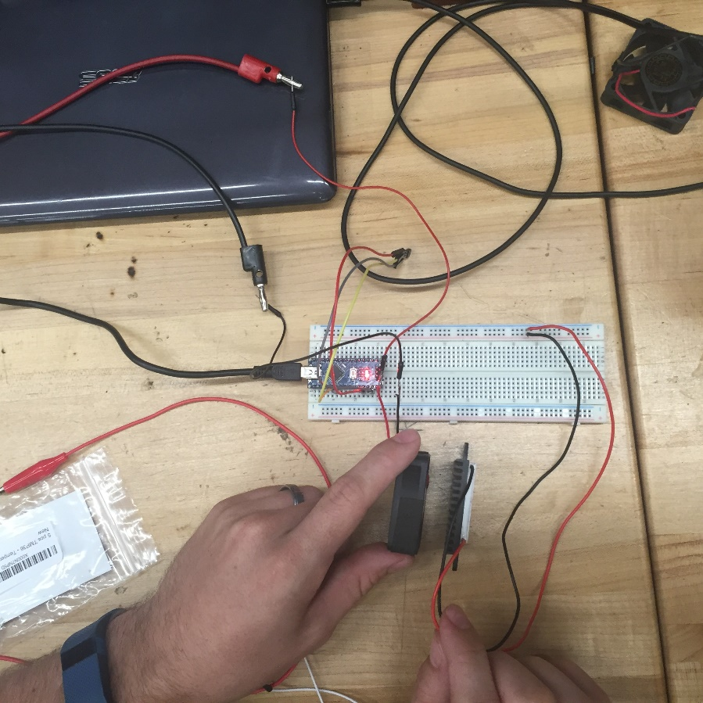
Figure 81 Breadboard of Peltier Test

7.2.5 Amplifier Testing
Testing of the amplifier was done to ensure the signal at the input of the amplifier was amplified accurately without distortion and noise at the output. Using a 12 V power supply, the amplifier was fed from a mobile device using a hacked headphone plug. Two channels were tested using a set of speakers with an output coming directly from the headphone cable. Each channel uses about 1 W of power with a 12 V source drawing about 0.56 mA of current per channel. A complete three channel amplifier will only draw about 2 mA of power, well within our specifications for low power consumption. Using a function generator, a signal of 2.5 V_{peak} at 5 kHz was inputted into the amplifier. Using an oscilloscope the figure below was generated showing the input signal in navy and the output signal in turquoise.

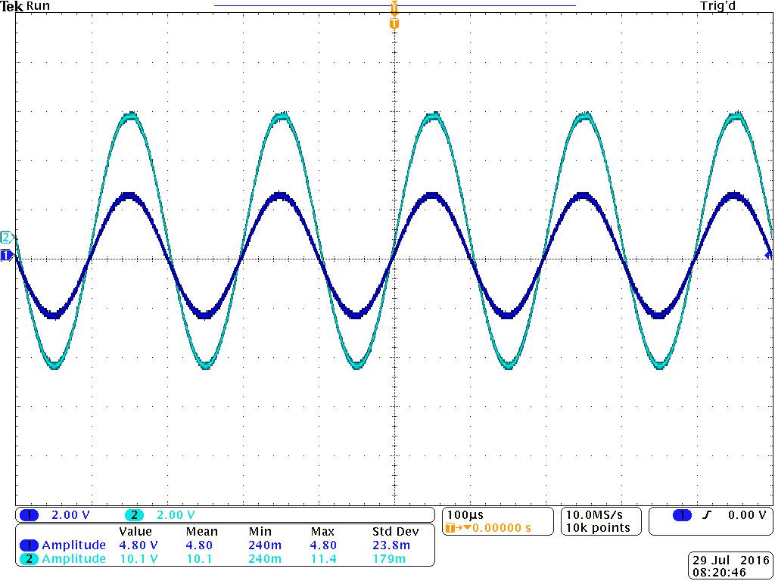
Figure 82 Amplifier signal test

A successful output signal was displayed with no distortion and noise, however any more amplitude and the signal will clip on positive and negative cycles. Next the amplifier circuit was built on a breadboard and tested to make sure all parts function as designed. Shown below is the breadboard test and the hacked phone cable used to input audio into the amplifier circuit from a smartphone device. A standard 1.8 mm headphone plug was split into three separate wires; red (channel 1), white (channel 2), and ground. A set of alligator clips easily connect to each wire and then into the volume potentiometer in each amplifier circuit. Speakers used were taken from an old set of Bose speakers, one of which was found to be blown out. These tweeters were only able to accurately reproduce upper mid-range to high frequencies.

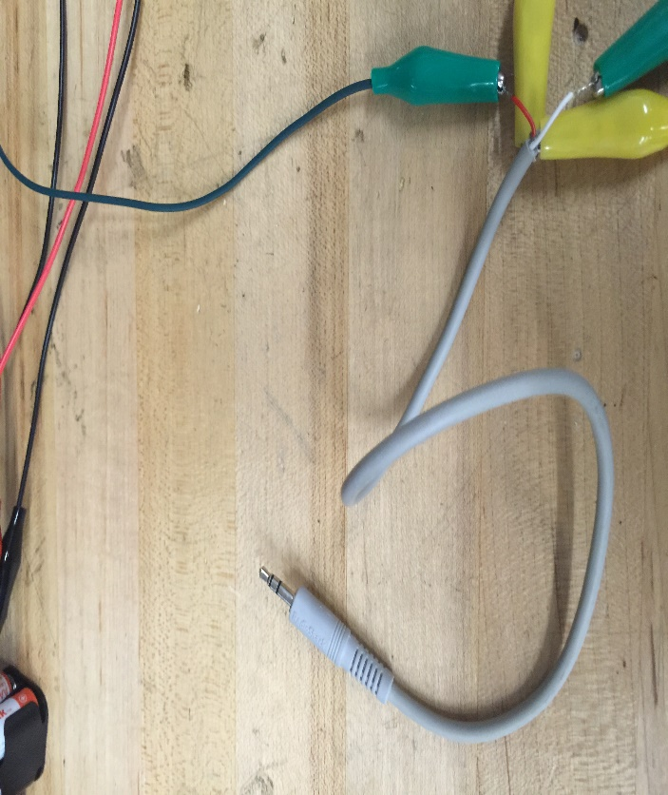
Figure 83 Hacked headphone cable for audio input

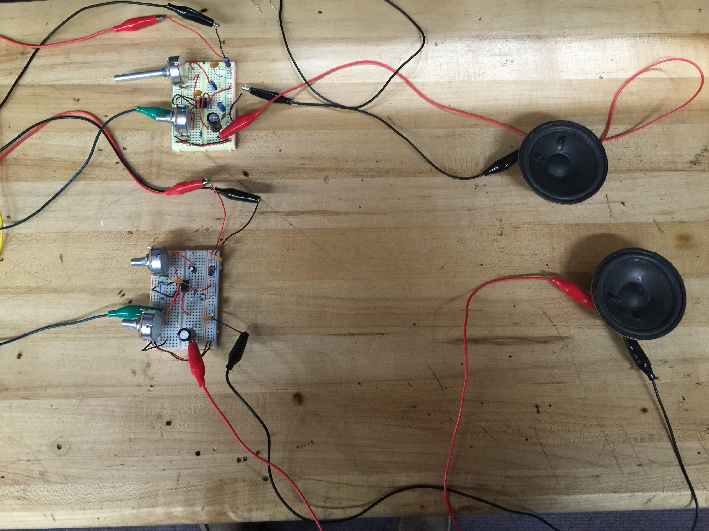
Figure 84 Two channel amplifier testing

Using the headphone cable a signal from left channel was sent into amplifier while a signal from the right channel was sent into the other amplifier, each circuit has its own loudspeaker output. Control of the signal is done via the volume and gain pots for each amplifier, gain will be set at a nominal value for the final product as the volume will be controlled via a smartphone.

7.2.5 Filter Test
Filter testing was done to ensure frequency separation was being done as designed by each filter channel. Testing was done in the senior design laboratory on the campus of the University of Central Florida using a signal generator and oscilloscope. This testing was done to compare the plots of each filter circuit to those obtained during simulation in MultiSim. Below each filter frequency response is shown for each filter channel.

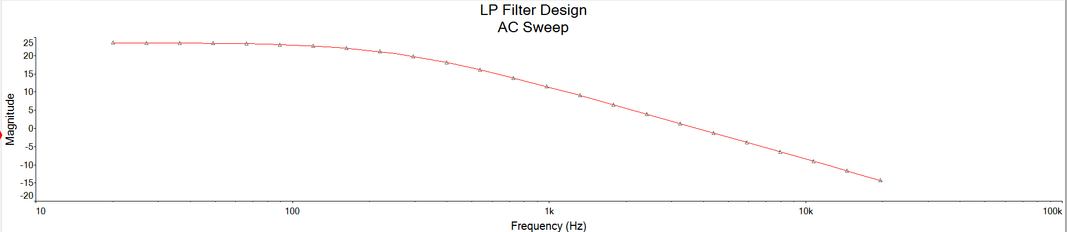
Figure 85 Low Pass filter frequency response

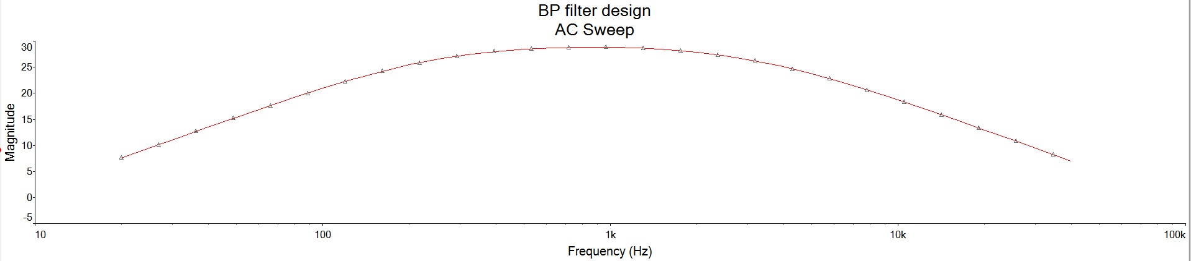
Figure 86 Band Pass filter frequency response

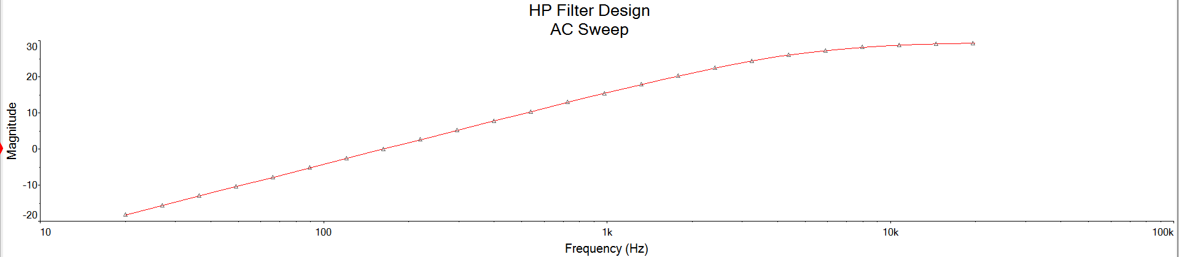
Figure 87 High Pass filter frequency response
7.2.6 LED Test
To test the 300 WS2812B LED strip, we connected the strip to a power supply set at 5V. The signal wire was connected to an Arduino Uno prototype board to the digital output pin 6 with a 470-ohm resistor.
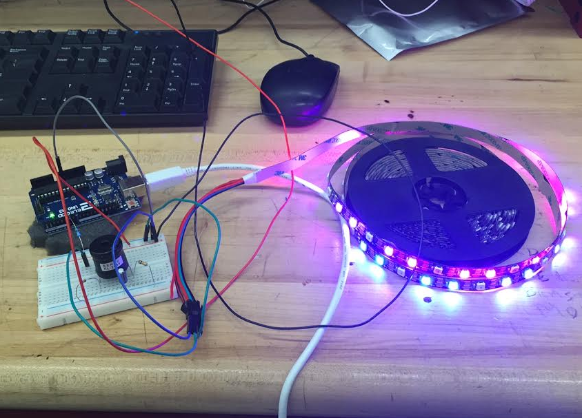
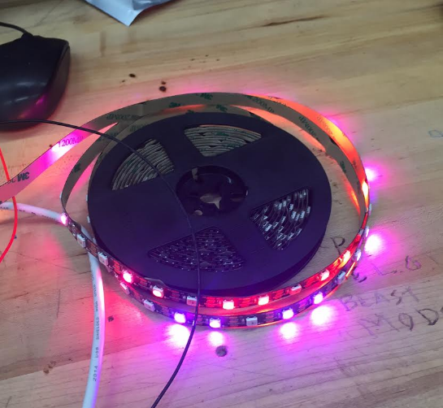
Figure 88 WS2812B LED Strip Test

We tested a couple different ways. The first way we used the sample Arduino code to blink an LED. The LED strip runs at 5V so we used a resistor out of a digital pin on the Arduino and connected the LED strip across the resistor and ground. We confirmed that the LEDs blinked correctly. Next we tested that we could change the brightness of each flash and the time between flashes the LED strip.

The initial test was run using example code published on the manufacturer’s website. It used the Adafruit Neopixel led library for communicating with the WS2811 controllers on the LEDs and alternated the pixel’s colors in set patterns. We confirmed that the LEDs blinked correctly. Next we tested that we could change the brightness of each flash and the time between flashes the LED strip. With the first few tests, only a small section of LEDs was lighting up and responding to the signal from the microcontroller.

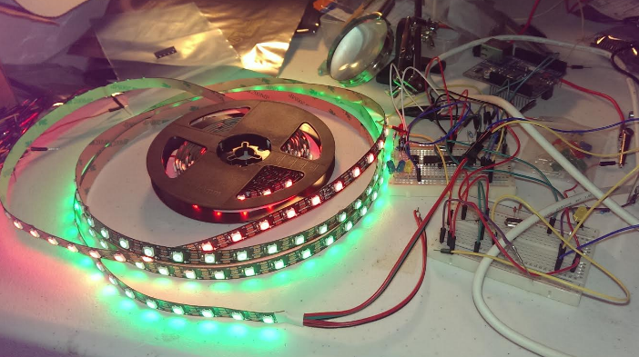
Figure 89 WS2812B LED Strip Test 2 (All LEDs lit)

After some testing, we found that the issue with the not all of the LEDs lighting up was due to a bug in the example program that limited the number of LEDs to 60. Correcting the bug and setting the number of LEDs in the program to 300, or all of the LEDs on the strip, fixed the issue and all of the LEDs lit up and responded to the microcontroller signal properly. The power draw of the strip when all of the LEDs were lit up at full power was 71 Watts, each LED drawing around 60 mA. The microcontroller controlling the LEDs was drawing 86mA. Both the LED strip and microcontroller were operating at 5V.

We confirmed that the LED strip is working correctly. Now we can start to develop the code four our 5 modes of operation. Once we have the code complete we can test the LED strip in the same fashion. Once we have confirmed that we can operate in all 5 modes with the control of the app we can add the LEDs in a pattern on the cooler. The last and final test of the LED system is to test the system once installed on the cooler. If that is working correctly

7.2.6 Microcontroller and Programming Board Testing

This is the programming board meant to allow the Arduino Uno to act as a programmer to flash code to the blank ATmega 328p microcontroller IC. The design for the programmer board is a slightly modified version of the reference design for programming this specific microcontroller. It has several LEDs for debugging purposes, such as power, when the Arduino Uno is sending code to the microcontroller, error, and successful completion. The Arduino Uno and the microcontroller communicate over the digital pins 11 through 13. With the programmer board setup, we used the Arduino software to flash the bootloader on the new microcontroller to the Arduino bootloader.

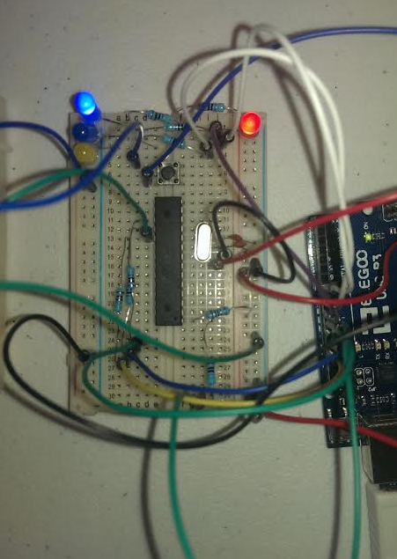
Figure 90 ATmega 328p Programming board

After burning the bootloader to the blank microcontroller, we added a 16 MHz oscillator crystal to the programmer board to allow the timing to work properly. To use the Arduino Uno as a programmer, we uploaded the ArduinoISP program to it and changed the programmer in the software. We then did a test to upload a very simple LED blink program to the new microcontroller via the programmer board.

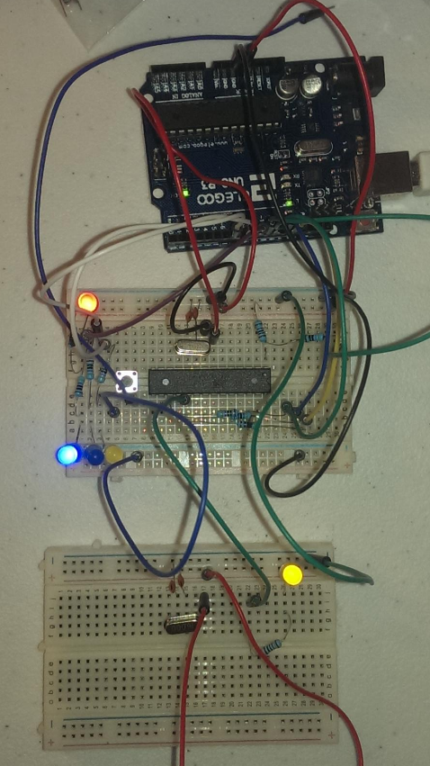
Figure 91 Blink Test Program on New Microcontroller

After some trial and error and moving some wires, the blink program was finally uploaded to the new microcontroller. The yellow LED in the bottom breadboard in the above picture is the LED set to blink entirely controlled by the new microcontroller. The debugging LEDs on the programming board were also working successfully, flashing yellow while uploading the code and flashing blue when it successfully completed. The error LED flashed when the code could not upload due to wires in the wrong place.

7.2.7 MCP4725 12-Bit DAC Testing

This DAC is used to convert the digital audio data from the Bluetooth packet to an analog output signal to the audio amplifier. Because this component came was in Cut-Tape packaging instead of DIP and the component is incredibly small. This was a difficult component to test due to the soldering required. After much effort, we were able to solder 6 longer pins onto this small IC. We then connected it to the microcontroller via the I²C bus and ran a simple write, read-back test program to see if the DAC outputs correct values. We connected the output of the DAC to an analog input on the microcontroller.

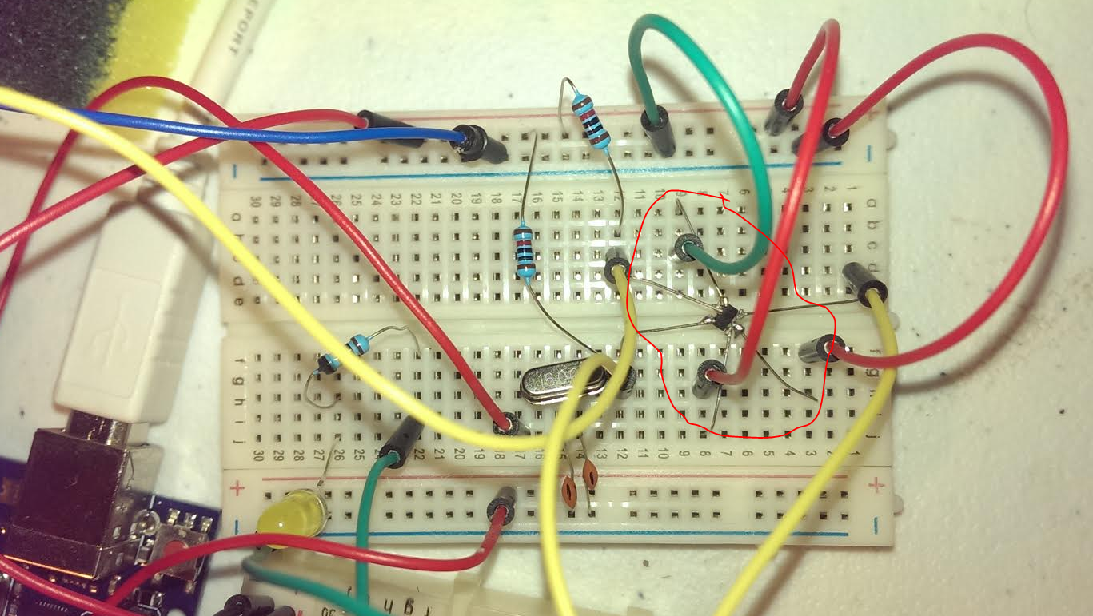
Figure 92 DAC Write-Back Test. (DAC outlined in red)

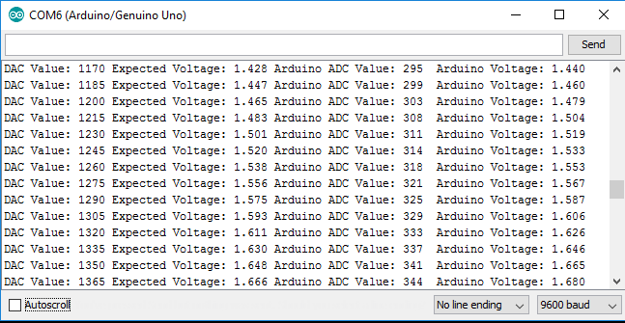
Figure 93 DAC Write-Back Test Output

The test was able to run successfully. Each loop incremented the value by the smallest possible increment which was about 15 units. The output voltage was very close to the expected voltage on most of the tests, with an average error of less than 1%. Because the onboard ADC of the microcontroller is 10 bit while the DAC is 12 bit, the error should be even less when the output is connected directly to the audio amplifier. The difference between the DAC and ADC is also causing the discrepancy between the two integer values.

7.3 Software Test Environment
7.3.1 Android Studio Application Testing
Android Studio is the Development Environment for developing the Android application. The Android application is the user interface to the rest of the cooler, allowing the user to read the sensor data, select LED mode and colors, and play the audio from phone.

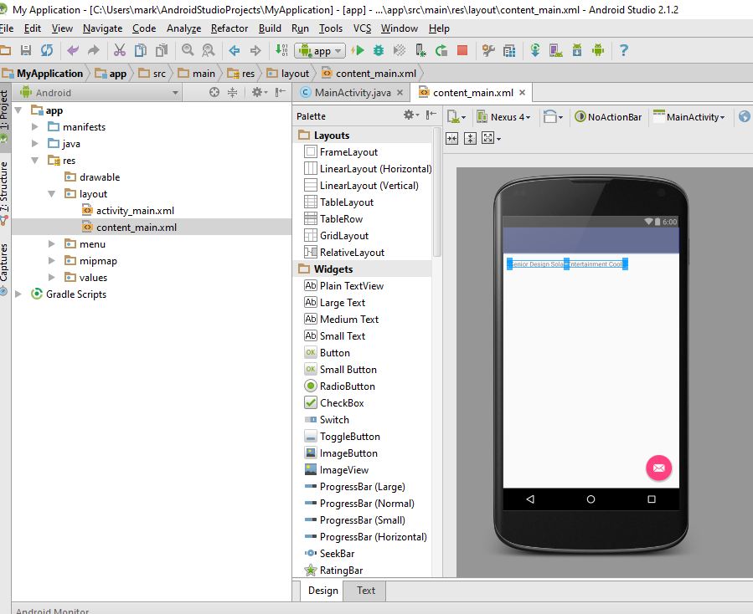
Figure 94 Android Studio in action

We did quick tests to make sure that we can get the Android Studio software and Android SDK running properly. We made a very small test application consisting of a basic Activity class with some pop up text. The application APK was then pushed to an Android device and launched.
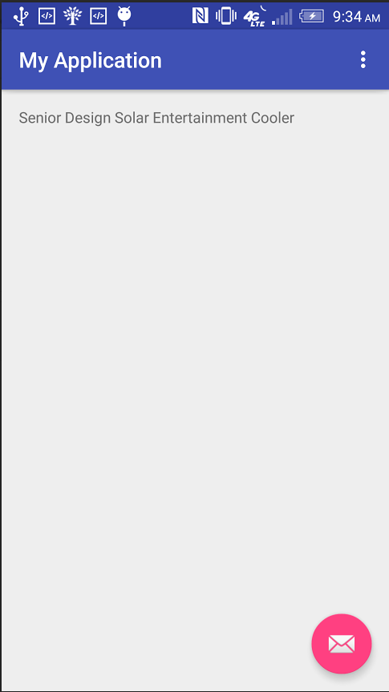
Figure 95 Test Application Running on Phone

After changing some developer options on the Android device, the test application ran perfectly and displayed the text properly.

7.4 Software Specific Testing
7.4.1 MPPT Software Testing
The MPPT design makes use of an Arduino Nano. This microcontroller is used to make decision to either allow or disallow current flow through the MOSFETS. There are three analog inputs to the Nano including: solar voltage, solar current, and battery voltage. The Nano uses the battery voltage to determine which stage of charging the battery is in. The Nano uses the solar voltage and current to decide which state the MOSFETS should be in, and to also set the duty cycle of the PWM. The duty cycle of the PWM should change with the changing power input from the solar panel. Testing this we used the following circuit.
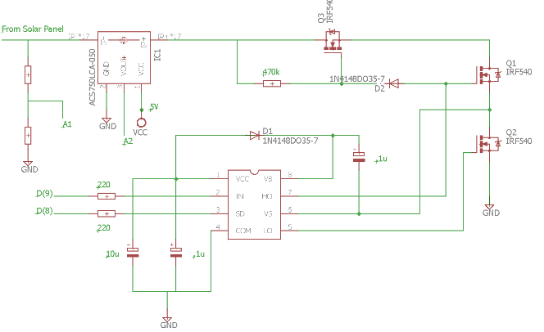
Figure 96 MPPT Coding test

After we confirmed the circuit was built correctly we wanted to test that the duty cycle would change dependent on the solar input. We wrote a test code that read the values of solar voltage, solar current and battery voltage. We printed the results to the serial port to confirm that the Arduino was reading the correct values. The next test was to vary the solar voltage and measure the PWM signal that came out of the Nano. In the MPPT flow chart for our code we first check to see if the power measured is greater than the previous iteration. If it is then we check if the voltage is greater than the previous iteration. If the voltage is greater than the PWM should increase, and if the voltage is less the PWM should decrease. If the power less than the previous iteration and the voltage is greater the PWM should decrease. If the power is less and the voltage is less than the previous iteration the PWM should increase. The test code we implemented checked the solar voltage and solar current. As we changed the solar voltage we noticed that the output PWM of the Nano was operating correctly. The following tables shows various inputs used and the corresponding PWM signal outputted by the Nano. Since we were using a DC power supply the solar current didn’t change much, so for this example we will just assume it as one value. We started at the assumption that the solar voltage = 20V and the solar current was equal to 500mA and the duty cycle was 50%. We also set a delta duty cycle to increment by that is equal to 20%. We made it this large just to be able to easily see the difference. The figure below the table is a picture of the breadboard set up for this test.

Solar Power dependent PWM Test
Solar Current | Solar Voltage | PWM Output
500mA | 25V | 70%
500mA | 18V | 90%
500mA | 20V | 70%
500mA | 22V | 50%
500mA | 20V | 70%
Table 10 Results of MPPT Code Test
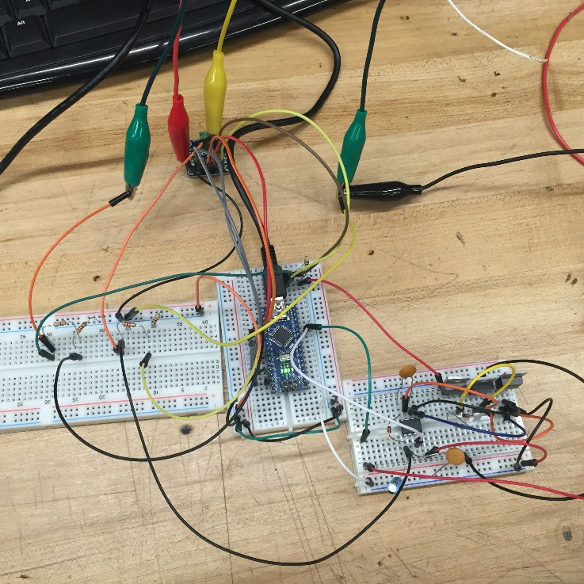
Figure 97 Breadboard of MPPT Code Test

8.0 Operation
Now that you’ve received the cooler it is time to get acquainted with the product. The following sections below show you how to operate your cooler and make use of all of its features.

8.0.1 Charging Your Cooler
This cooler has been designed to charge in two ways. You can charge the cooler with a solar panel or you can simply plug the cooler into a standard wall outlet. The cooler comes equipped with a charge controller that will monitor the battery during charging. This will ensure the longest lifetime for the rechargeable batteries and optimal charging speed for both sources. When it comes to the wall outlet it is as simple as plugging the cooler into the wall outlet. The solar source is slightly more complicated being that you have to connect the solar panel to the charge controller. We have installed header screws for easy connection. All this is required is a flathead screw driver. You must make sure to check the polarity of the solar panel wires to the correct corresponding terminals on the charge controller. The charge controller comes with LED indicator lights to let you know when your cooler is charged and ready for use. The red LED indicates the battery life is low, the yellow LED indicates that the battery is in bulk charging stage, and the green LED indicates when the cooler is ready for use.

8.0.2 Cooling Station
The state of the art cooling station is the perfect feature for a hot summer day. When enjoying your cooler in a hot environment it allows you to cool up to two beverages. The cooling station will allow for beverages of any size. It is controlled so that your beverage will remain cold but won’t get too cold and freeze. Through the mobile phone application, the cooling station can be turned off and on and a temperature sensor provides accurate temperatures while the device is in use.

8.0.3 Audio System
The audio system will be completely controlled with your phone. The systems is controlled using Bluetooth communication. Once your phone is connected via Bluetooth you can play music directly from your phone. Our system is designed to connect to any device that has Bluetooth capability. Our sound system is created and tested to produce a clean sound. We have built a three channel system that separates the bass, mid, and treble and allows for a pleasurable listening experience at high and low volumes. The audio system is designed to run for 4 hours of continuous use. In addition an auxiliary audio plug is located on the outside of the cooler to provide a quick connection if Bluetooth is not available or the customer desires to conserve their mobile phones battery life.

8.0.4 LED Modes
The cooler comes with a built in LED matrix to allows for the perfect ambiance. The cooler comes equipped with five LED modes to pick from. The modes are strobe, blink, mixed, audio visualizer, and off. You can easily open the mobile app and change the LED mode for whichever environment you wish to create. The audio visualizer samples the audio signal and converts these sample to show through the LEDs. Through the use of an FFT library the audio signal is sampled digitally for the visualizer. This allows for an ambiance that simulates the music you are listening to. The LED portion of the cooler can also be cut off from power using the app. Depending on your battery life you can decided whether or not you would like the LEDs be on or off.

8.0.5 Charging station
The charging station has been designed to allow for up to two phones to be plugged in and charging. While this is not the ideal conditions for the system it is possible. The more phones you have plugged in the faster the battery will discharge. The charging station is equipped with the USB 3.0 ports. This style of port is compatible for most USB phone chargers. The charging station requires a good amount of power to charge the three ports all at once. There will be an option in the app to disconnect the power to the USB charging section of the cooler. This allows you to check the battery level and decide whether you still want to power the charging station.

8.1 Device Setup
The setup for the cooler is fairly simple and straight forward. The only tricky part to the cooler is connection and disconnecting the solar panel for charging. It is recommended that a complete solar charge is acquired before the cooler is taken out for a camping trip or day at the beach. Without a full solar charge, there would be no AC outlets to charge the battery and the cooler might not last a full day. With ideal weather conditions the solar panel would be able to charge the battery fully in approximately 2-3 hours.

For the mobile application, we will only be supporting Android phones with Android 4.4.2 KitKat or greater. On the final product, a user will simply install the application onto their phones or tablets by going to the Google Play Store on their device, searching for the Stand-alone Solar Entertainment app, and clicking install. However, for development and users of the prototype, they will receive an APK with the application packaged inside. To install using the APK, the user will need to download the Android SDK on their computer and connect their device to their computer over USB. The user will need to turn on Android debugging in their phone’s settings. With the phone connected to the computer, navigate to the Android SDK folder, open command prompt or terminal in that folder and type in “adb install [APK file]”. The application will then be installed and should appear in the app drawer on the phone.

8.2 Application Usage
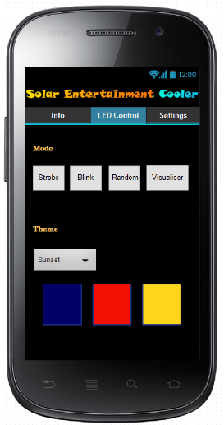
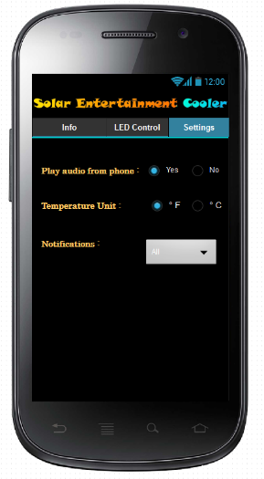
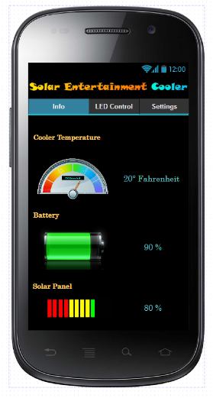
Select Tab

Cooler playback phone audio

Select Tab

Select Tab

Change LED Mode

Change Color Theme

Select Tab

Changes Temperature Display unit

Cooler Temperature Display

Cooler Battery Level

Select Notifications you want to receive

Solar Panel Output Level

Settings tab

LED Control tab

Info Tab

Figure 98 Application User Interface Usage Overview

In order to connect to the cooler and send audio, the user must run the application from the app launcher at least once. This will activate the background service that will connect to the cooler whenever it comes into range. Once launched, the application will continuously check the Bluetooth connections on the phone for the cooler. Once it has found the cooler and established a connection. The user is brought to the info tab. From this view, the user will be able to check the status of the cooler including the temperature inside the cooler unit, the remaining battery power, and the amount of energy the solar panel is receiving.

On the top of the window, the user can change the current tab. In the LED Control tab, the user is able to change the LED mode and theme. Changing the mode will affect the pattern that the LEDs on the cooler will follow. Strobe sets each LED strip to have a falling water drop effect at random intervals by having one fully lit pixel on each strip move downwards with a trail decreasing in brightness. The Blink mode sets the LEDs to alternate between the three different colors at random intervals. Random mode will randomly select from the three other modes to activate for five seconds and then chose a different mode. The visualizer mode connects the LEDs to audio allowing them beat along with the music.

The settings tab lets users change options specific to the application. The first option is to set whether or not the application should send audio to the cooler. If the user choses “Yes”, the background service will automatically intercept all audio coming from the phone and sends it to the cooler when in range. Otherwise, the device will not automatically connect to the cooler, however the user may still connect to the cooler and control the LEDs when the application is open. The second option determines whether the temperature display on the info tab will display the temperature in Fahrenheit or Celsius. The default value is Fahrenheit. The last option is for notifications. The application will send out notifications when the cooler is in range and has been connected, if the battery in the cooler is getting low, when the temperature has reached the set temperature, or the solar panel is not outputting any power. Changing the notification setting will allow the user to select which of these notifications they want to receive and which ones they want to turn off.

9.0 Administrative Content
In this section we would like to share some of the planning and organizing that as a group was done in preparation to design, built and test this project.

9.1 Milestone Discussion
As a group we sat down and set a plan to have the paper done on time. We thought the best method was to create a milestone table. The table lays out a schedule to have pages done on a specific date. The tables below show the milestone tables by months.

June 2016
Section | Date
Chapter 1
Executive Summary | 6/1/16
Chapter 2 Project Description
Motivations and Goals | 6/1/16
Objectives | 6/2/16
Requirement Specification | 6/2/16
Hardware Specs | 6/2/16
Software Specs | 6/2/16
Chapter 3 Research
Reference Projects/Products | 6/3/16
Solar Powered Speakers | 6/3/16
Solar Cells | 6/6/16
Photovoltaic Technology Consideration | 6/6/16
Peltier Plates/physics | 6/6/16
Figures of Merit (audio amplifier) | 6/8/16
Classes (audio amplifier) | 6/8/16
BJT vs MOSFET (audio amplifier) | 6/8/16
Wi-Fi | 6/10/16
Bluetooth | 6/10/16
Energy Storage | 6/10/16
Charge Controller | 6/10/16
MPPT Controller | 6/13/16
PWM Controller | 6/13/16
Architecture / Diagrams | 6/13/16
Power Input | 6/13/16
MPPT | 6/15/16
Charge Storage | 6/15/16
Microcontroller | 6/17/16
Amplifier | 6/17/16
Cooling | 6/17/16

June 2016 (continued)
Section | Date
Chapter 3 (continued)
Microcontroller | 6/20/16
Amplifier | 6/20/16
Cooling | 6/22/16
Mobile Applications | 6/22/16
Embedded Microcontroller Environment | 6/22/16
Chapter 4 Standards & Design Constraints
Safety Standards | 6/24/16
Reliability Standards | 6/24/16
Communication Standards | 6/24/16
Communication Standards | 6/27/16
Programming Language Standards | 6/27/16
USB Standards | 6/29/16
Battery Standards | 6/29/16
Amplifier Standards | 6/29/16
Design Impact | 6/30/16
Economic / Time Management Constraints | 6/30/16
Social Constraints | 6/30/16
Health / Safety Constraints | 6/30/16
Feasibility | 6/30/16
Table 11 June 2016 milestones

July 2016
Section | Date
Chapter 5 Hardware and Software Design
Control System (block diagram) | 7/1/16
Power System (block diagram) | 7/1/16
Charge Controller (block diagram) | 7/1/16
MPPT Charge Controller (Hardware) | 7/4/16
Power Input (Hardware) | 7/4/16
Amplifier (Hardware) | 7/4/16
LED Matrix (Hardware) | 7/5/16
Cooling Station (Hardware) | 7/5/16
PCB | 7/7/16
Complete Schematic | 7/7/16
Microcontroller (Hardware) | 7/11/16
Microcontroller Program | 7/11/16
Android API | 7/11/16
Chapter 6 Project Prototype Construction
Parts Invoice | 7/13/116
PCB Assembly | 7/13/16
Coding Plan | 7/15/16
Chapter 7 Project Prototype Testing
Hardware Test Environment | 7/18/16
Battery Controller Testing | 7/18/16
Voltage Regulation | 7/18/16
Cooling Test | 7/20/16
Amplifier Test | 7/20/16
LED Test | 7/20/16
Software Test Environment | 7/22/16
Chapter 8 Operation
Device Setup | 7/22/16
Application Usage | 7/22/16
Chapter 9
Milestones | 7/25/16
Budget and Finances | 7/25/16
Appendices | 7/26/16
Table 12 June 2016 milestones

Fall 2016
Function | Date
PCB Design
Design PCB | 10/15/16
Order PCB | 10/31/16
Presentation
CDR draft | 10/18/16
CDR presentation | 10/23/16
Conference Paper | 11/18/16
Final Presentation | 11/30/16
Mid Term Demo | 11/3/16
Project Prototype Construction
Construction (mounting & testing) | 10/31/16-11/29/16
Table 13 Fall 2016 Milestones

9.2 Budget and Finances
9.2.1 Project Costs
As a group we have kept track of the current cost up to this point. We have decided the split the total cost four way. We have not received any funding for this project so the money will be coming out of our pockets. We have an excel sheet that we have shared on google sheet. Each member can add their parts and the cost and at the end of the project we can square up. The table below shows the estimated cost breakdown for our project at the time of senior design 1. During senior design 2 our designs changed considerably so we felt it necessary to include a budget for each semester. This cost was determined if we had to purchase all of the parts for our project
Estimated Project Budget SD1
Quantity | Item | Estimated Cost
2 | Batteries | $54
2 | Voltage Regulation Components | $50
1 | Wireless Modules | $50
1 | Electrical Components | $100
1 | PCBs | $350
1 | Cooler | $20
1 | Structuring Components: Wood, Screws... | $25
5 | LED Strips | $125
2 | Microcontrollers | $60
5 | Thermoelectric Peltier Plates | $40
1 | Bluetooth Module | $30
2 | Speakers | $60
 | Total Estimated Costs | $621
Table 14 Estimated Project Cost
Actual Project Budget SD2
Quantity | Item | Estimated Cost
10 | Batteries | $54.99
10 | Voltage Regulation Components | $49.99
1 | Bluetooth Modules | $39.95
 | Assorted Capacitors, Resistors, and Inductors | $17.98
1 | PCBs | $56
1 | Cooler | $19.99
1 | Structuring Components: Wood, Screws... | $30
1 | LED Strips | $25.99
2 | Microcontrollers | $21.39
11 | Thermoelectric Peltier Plates + Heat sinks + Fans | $56.00
2 | Speakers | $0
 | Electrical Components | $50
 | Total Estimated Costs | $389.95
Table 15 Actual Budget
9.3 Parts List
-IRF640 MOSFET (3)
-INA219 Current Sensor
-IR2104 MOSFET driver
-Assorted capacitors inductors and resistors
-Arduino Nano
-Assorted voltage regulators
-Voltage regulator heatsinks
-10kΩ audio pots (3)

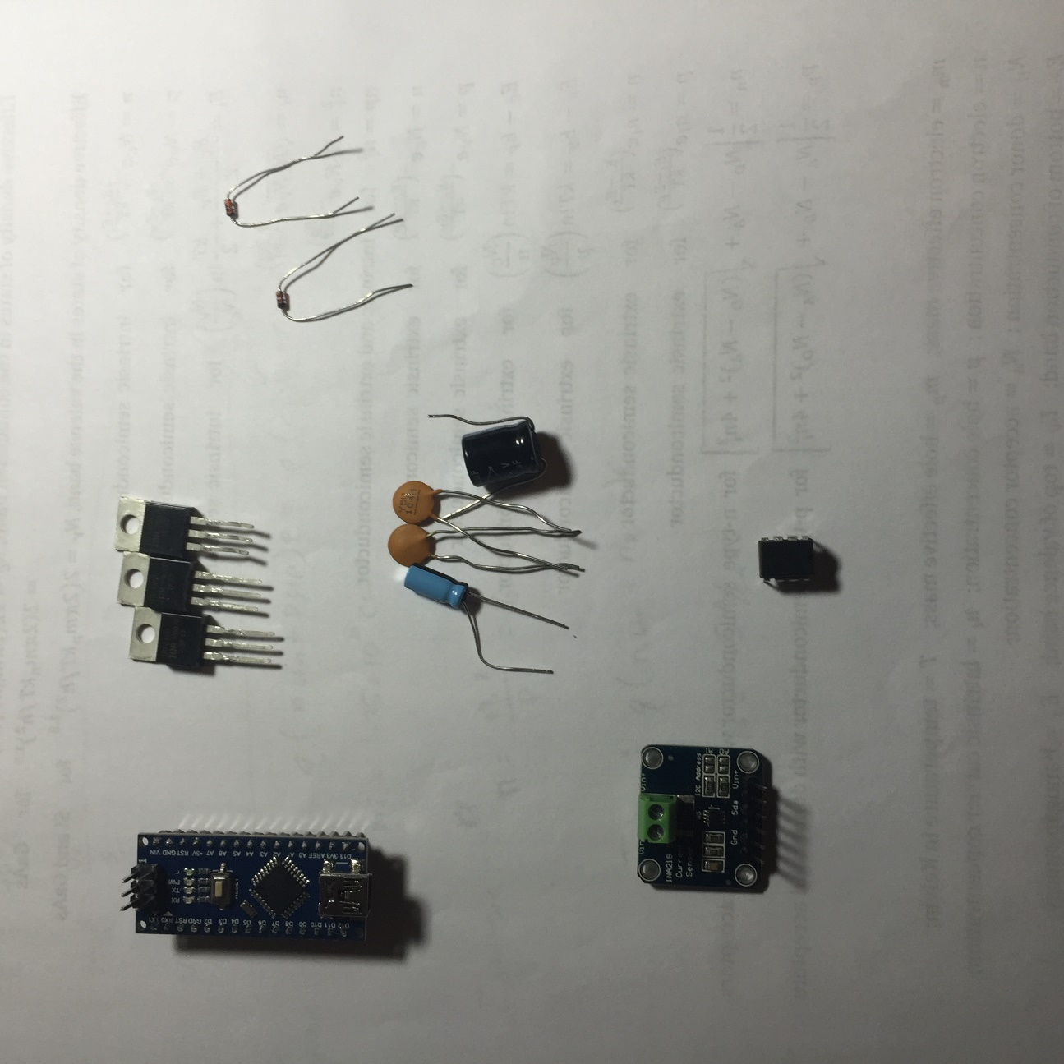

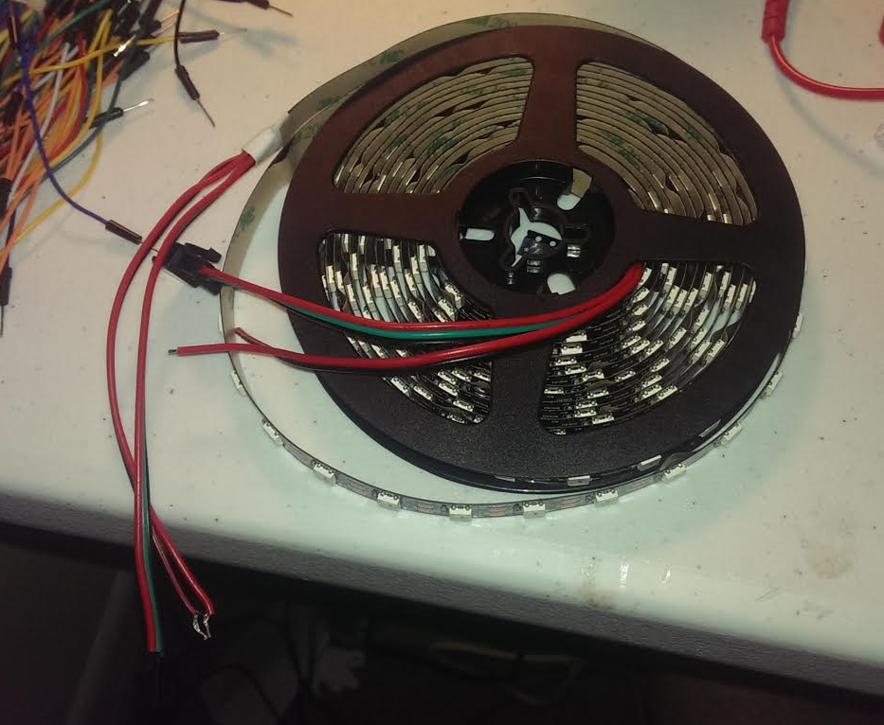
300 LED Strip 5 meter (1)
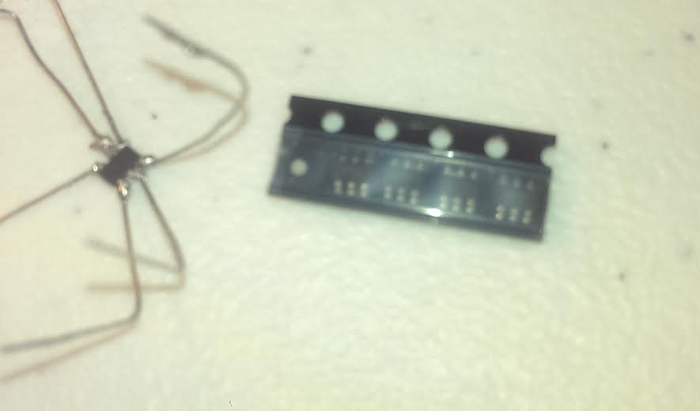
MCP 4725 12-bit DAC (5)
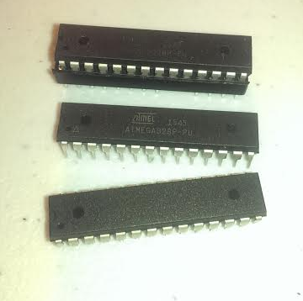
ATmega 328p microcontroller (3)
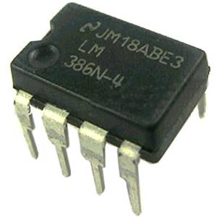
TI LM386N-4 (3)

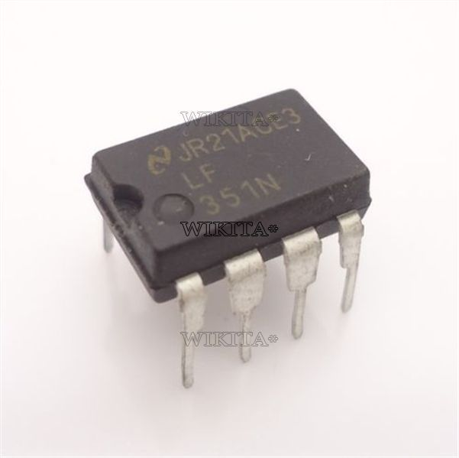
LF 351 (3)

Appendices
References

[1] | C. Design, "http://batteryuniversity.com/learn/archive/whats_the_best_battery," 2016. [Online].
[2] | Y. Tassew, 13th February 2013. [Online]. Available: http://www.mathworks.com/matlabcentral/fileexchange/40300-backward-forward-sweep-method-for-radial-distribution-system.
[3] | N. A. W. a. Solar, 2016. [Online]. Available: https://www.solar-electric.com/mppt-solar-charge-controllers.html/.
[4] | C. Cooper, Penton, 2016. [Online]. Available: http://electronicdesign.com/power/fundamentals-buck-converter-efficiency.
[5] | deba168, 29 07 2016. [Online]. Available: http://www.instructables.com/id/ARDUINO-SOLAR-CHARGE-CONTROLLER-Version-30/.
[6] | T. Instruments, "INA169 Data Sheet," Nov 2005. [Online]. Available: https://cdn-shop.adafruit.com/datasheets/ina169.pdf.
[7] | "Analog Devices "Low Voltage Temperature Sensors TMP35/TMP37"," Datasheet, 2008, D00337-08/08(E).
[8] | CUI Inc, "Peltier Application Note," 12 July 2016. [Online]. Available: http://www.cui.com/catalog/resource/peltier-app-note.pdf.
[9] | B. Cordell, Designing Audio Power Amplifiers, Mcgraw Hill, 2011.
[10] | "electronics tutorials," [Online]. Available: http://www.electronics-tutorials.ws/. [Accessed 2016].
[11] | "Maxim Integrated," 2016. [Online]. Available: https://www.maximintegrated.com/en/design/techdocs/tutorials/index.mvp/id/36/c/Audio%20Circuits#c36.
[12] | Texas Instruments, "LM386 low voltage audio power amplifier," 2000.
[13] | Texas Instruments, "LM741 general purpose amplifier," 2000.
[14] | JBL Professional, Sound System Design Reference Manual, JBL, 1999.
[15] | J. Eargle, HandBook of Recording Engineering, 2003: Springer.
[16] | J. E. a. C. Foreman, Audio Engineering for sound reinforcement, Hal Leonard Corporation, 2002.

