**Kitty-Bot**



Stephen Barth

Bryen Buie

Carlos Garzon

Trenton Williams

**1.0 Introduction**

The purpose of this document is to introduce the initial concept of the project by our group for Senior Design 1 (EEL 4914) undergraduate course at the University of Central Florida (UCF) during the Summer 2016 semester. For the course, we, Electrical and Computer Engineering students of the University of Central must join together in teams to conceptualize, design, and finally, build a system or device that displays the engineering knowledge and skills we have gained. Our group has decided to work on a project that would not only challenge us, but also be useful and fun. The project will be a robotic device whose primary function is to interact and play with cats. Cats are often times curious and playful creatures. Their interactions with the robot would be entertaining for both the cats and their owners.

**2.0 Project and Group Information**

* **Project Name: Kitty-Bot**
* **Group 5 Members:**
  + **Stephen Barth**
    - **Electrical Engineering**
  + **Bryen Buie**
    - **Computer Engineering**
  + **Carlos Garzon**
    - **Computer Engineering**
  + **Trenton Williams**
    - **Electrical Engineering**

**3.0** **Project Description**

**3.1 Objectives**

The robot, affectionately dubbed “Kitty-Bot”, will function as an advanced robotic toy for cats. Since the primary target for the robot is cats, it will be designed with this animal in mind. The robot will need to be durable enough to withstand rough contact from the animal. Sensitive components such as microcontrollers, printed circuit boards (PCB), and wiring will need to be housed in durable compartments. Kitty-Bot may potentially be turned over while a cat is playing with it. If this happens, Kitty-Bot will be able to set itself upright again.

**3.2 Goals**

The project will seek to meet the following base requirements:

* Robot should be durable enough to withstand potential damage from an animal; specifically, it should not break due to a cat’s scratching or biting.
* Robot should have 360-degree maneuverability both in the clockwise and counterclockwise direction.
* Robot should be able to turn itself upright if knocked over by the cat.
* Robot should be no larger than 60 cm in length and 30 cm in width.
* Robot should be able to sense physical objects and obstacles and make decisions based off of those objects.
* Robot should move based on input data and internal logic in a way that inspires the animal’s playful instinct. The cat should want to play with the robot!

While these goals are the minimum we seek to meet, we plan to design Kitty-Bot in a way that achieves core functionality first which can be added upon later modularly.

**4.0 Block Diagram and Flowchart**

**4.1 Group Member Colors**

Below we provide visual representation of the colors representing team member work distribution for future reference.

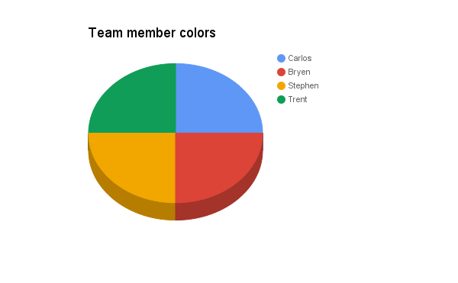

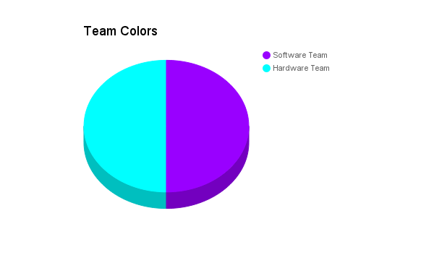

Our four group members are additionally split up into two teams, a Software team and a Hardware team.

**Software Team: Carlos Garzon & Bryen Buie**

**Hardware Team: Stephen Barth & Trenton Williams**

**4.1 Flowchart**

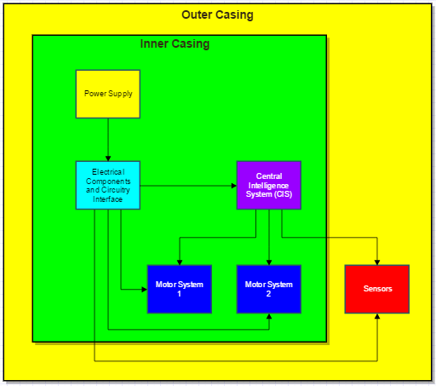

Above is a diagrammatic representation that illustrates the sequence of operations to be performed in our system with the logical end of a fully autonomous Kitty-Bot.Work was distributed according to the previously mentioned color coordination system.

**4.2 Illustration**

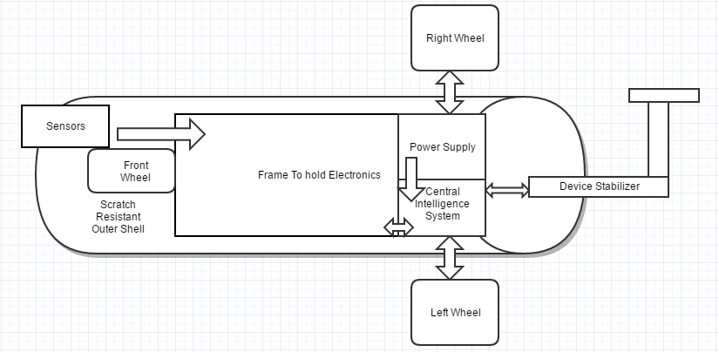

**Block Status**

Frame to hold Electronics: Design - block is currently being designed

Front wheel: Design - block is currently being designed

Sensors: Design - block is currently being designed

Central Intelligence System: Design - block is currently being designed

Power Supply: Design - block is currently being designed

Motor System: Design - block is currently being designed

The entire system should be controlled by what we call the **Central Intelligence System (CIS)**. The Central Intelligence System should receive input from the Motor System and Sensors. Both of these should help the Robot make decisions that will inspire the cat's’ playful nature. In our group discussions we came to an initial design decision that excludes more than two **Motor Control Systems**. We believe we can achieve desired mobility with this design. Also, if possible, we want to limit ourselves to at most two microcontrollers. Where we want to add complexity is in the intelligence and decision making of the system. We want to add as many sensor devices as needed in order for the Robot to make intelligent decisions.

**5.0 Estimated Cost**

As stated in the goals, this project’s costs should be low ($100-200). These prices are based on potential components found online.

|  |  |
| --- | --- |
| **Part** | **Cost** |
| PCB | $50 |
| Microcontroller | $20 |
| Casing | $20 |
| Camera | $50 |
| Proximity Sensors | $24 |
| Power supply components | $20 |
| Chassi to hold system | $10 |
| Wheels | $20 |
| **Total** | **$214** |

**5.1 Market Tradeoff Matrix**

↑↑ = Strong positive correlation ↑ = positive correlation

↓↓ = Strong negative correlation ↓ = negative correlation

|  |  |  |  |  |  |  |
| --- | --- | --- | --- | --- | --- | --- |
|  | **Engineering Requirements** | Output Power | Efficiency | Casing | Sensors | Cost |
| **Marketing Requirements** |  |  |  |  |  |  |
| Low Power |  | ↑↑ | ↑ |  |  | ↓↓ |
| Durable |  |  |  | ↑↑ | ↓ | ↓ |
| Cost |  |  |  | ↓ | ↓ | ↑↑ |

**6.0 Project Milestone**

Senior Design I:

* Week of May 30 - Decide on Initial Project Idea
* Week of June 06 - Research sensors, microcontrollers, motors and other electronic parts.
* Week of June 13 - Design protective circuits & power supply (Hardware Team)
* Week of June 20 - Design protective casing/outer shell (Hardware Team)
* Week of June 27 - Design, simulate, & capture schematics (Software Team)
* Week of July 11 - Research and design algorithms (Software Team)
* Week of July 18 - Final Report
* Week of July 25 - Final Report
* Week of August 01 - Continue modifying and improving algorithm (Software Team)
* Week of August 08 - Continue modifying and improving algorithm (Software Team)

Senior Design II:

* Week of August 15 - Purchase hardware components (Hardware Team)
* Week of August 22 - Build chassis, connect motors (Hardware Team)
* Week of August 29 - Build pcb and other protective circuits (Hardware Team)
* Week of Sept 05 - Build protective casing and outer shell components (Hardware Team)
* Week of Sept 12 - Build power supply (Hardware Team)
* Week of Sept 19 - Interface components and test for proper connectivity (Software Team)
* Week of Sept 26 - Test sensors, collect and graph data (Software Team)
* Week of Oct 03 - Test and modify algorithm (Software Team)
* Week of Oct 10 - Test and modify algorithm (Software Team)
* Week of Oct 17 - Test and modify algorithm (Software Team)
* Week of Oct 24 - Build test area for kitten to play in.
* Week of Oct 31 - Test durability of play area and device with kitten
* Week of Nov 7 - Reinforce outer shell and play area if any weak spots are discovered (Hardware Team)
* Week of Nov 14 - Make sure the project meets expectations and is working as intended
* Week of Nov 21 - Make sure the project meets expectations and is working as intended
* Week of Nov 28 - Dec 5 - Improve and fix any problems or issues before presentation