**UCF Senior Design 1**

VFLTTS

(Vest Free Laser Tag and Texas Star)



Department of Electrical Engineering and Computer Science

University of Central Florida

Lei Wei/ Samuel Richie

Divide and Conquer

**Group 22**

Chace Arrington Computer Engineer [chacearrington@knights.ucf.edu](mailto:chacearrington@knights.ucf.edu)

Reneau Augusma Computer Engineer [raugusma@knights.ucf.edu](mailto:raugusma@knights.ucf.edu)

James Gossett Electrical Engineer [james.gossett@knights.ucf.edu](mailto:james.gossett@knights.ucf.edu)

**Project Summary**

Laser tag has been around for quite a while and is a hobby or outing activity enjoyed by many to this day. Recently NERF developed a way to make the game much more compact by integrating the receiver, usually located in a vest, and building it into the gun.

Laser tag was invented in 1982 by George Carter III. It was inspired by movies like Star Trek and Star Wars. After George Carter finished designing and building the blasters, sensors, and arenas, the first game was played in 1984. It wasn’t until 1986 that laser blasters were available on the open market. Blasters contain an emitter of collimated infra-red beams of light that is highly directional. The sensors are infra-red receivers that absorb the light and use optical filters to detect the signal. These blasters use infrared rather than real lasers for a few reasons: even cheap lasers can still cause eye damage, infrared emitters and receivers are cheaper, and lasers may cause distractions in game. Especially since games are often played in dark environments. At the end of laser tag games, you get a stat sheet with how you did, and who shot you. This is possible due to the fact that each gun emits a specific beam of infrared light, which can be differentiated by the sensor.

The Nerf blaster has a single shot, IR burst, with each pull of the trigger and registers hits with lights and sounds. It also has a status bar for health and ammo capacity. While the blaster has unlimited ammo, there is a reload button for when your magazine runs out. Nerfs blaster also has two different game modes, team deathmatch, or free for all. (Figure 2)

For our laser tag part of the blaster, we have been looking into adding a few different “game modes”, to increase the capabilities of the blaster. One of which being a health based game mode, where every player has a set amount of health, with their blaster turning red once they run out. Another option would be keeping score, counting how many times a player has been “shot”. There will be a toggle switch for selecting game modes, or switch to target shooting. (Figure 1)

The blaster additionally would have more functionality than what NERF offers currently. Such as taking the reload feature a step further by allowing the user to select from variable maximum “magazine” sizes such as a six shot mode for a revolver-like experience, and a magazine size more reflective of modern firearms. We are planning on implementing multiple features of the Nerf blaster: health and ammo status, reload button, different game modes, team selector, lights or sounds to visual or audible feedback.

To take this cheap access to laser tag to the next level there must be more than one kind of activity that can be done with it. Enter the Texas Star, a challenging target long enjoyed by shooting enthusiasts that is mounted on a swinging base holds a number of plates that fall off as they are hit causing the target to swing erratically as more are removed. The real version of this target is quite expensive with even lower end models costing around $300, but with the low cost and wide availability of electronics in the present day there is an untapped potential for a simulation of this for a low cost. (Figure 3)

The Texas Star target would work by having a simple PCB in each plate that’s only functions would be detecting the laser from the gun, signaling that it has detected the laser, and then releasing itself from the Star via an electromagnet. This would put it ahead of what is currently offered as the target for laser guns are more of an afterthought, whereas this device would simulate the physical aspects and size of what it is modeled after.

These plates will be affixed to the arms of the main body via 5 volt electromagnets with a holding force of 5.5 lbs. This means that the magnets will be able to support 1 pound, and this should be more than enough for our minimal electronic components and 3D printed plate. As a form of redundancy each plate will also be equipped with LEDs that will light up when a plate has been hit. This redundancy feature allows us to account for two points of failure that can exist in our system that are parallels to the same in the real-world target. The first point of failure comes about if the electromagnet does not release when struck leaving the plate on the target, and the actual texas star sometimes does this if you are using a lower power round and hit the plate at a non-optimal spot. The second point of failure is the opposite, plates flying off due to too much force being produced by the swinging of the star and overriding the holding force of the connection. The LED hit confirmation also mirrors a real-world factor of using this target such that in using a real Texas Star one can see if the plate was struck by checking for the impact of the bullet on the plate.

**Project Goals**

* Create Working Laser emitter/receiver on blaster
* Create laser blaster with variable “magazine” sizes
* Have a functioning game mode selector
* Display player health and ammo capacity on the blaster
* Create working receiver for Texas Star target
* Create a mechanism on Texas Star Target that allows for plates to be dropped

**Specifications**

* Texas Star Target
  + Five targets Mounted on swinging base 3 feet across and holds plates that can fall off as they are hit by Laser Gun
  + Plates of the Texas Star Target are attached by Five respective electromagnets
  + Receives emitted Laser transmitted from Gun
  + Star Target stands 4 foot tall
* Laser Gun
  + Emits Laser from Gun that will be aimed at Texas Star Target
  + Receives emitted Laser that allows Gun to be self contained
  + Each laser Gun fires a single-shot IR beam up to 200 FEET (60.96 METERS)
  + Reload feature that allows the user to choose a maximum “magazine” size from 15-17 shots as well as a minimum magazine size of 1 shot

**Block Diagram**

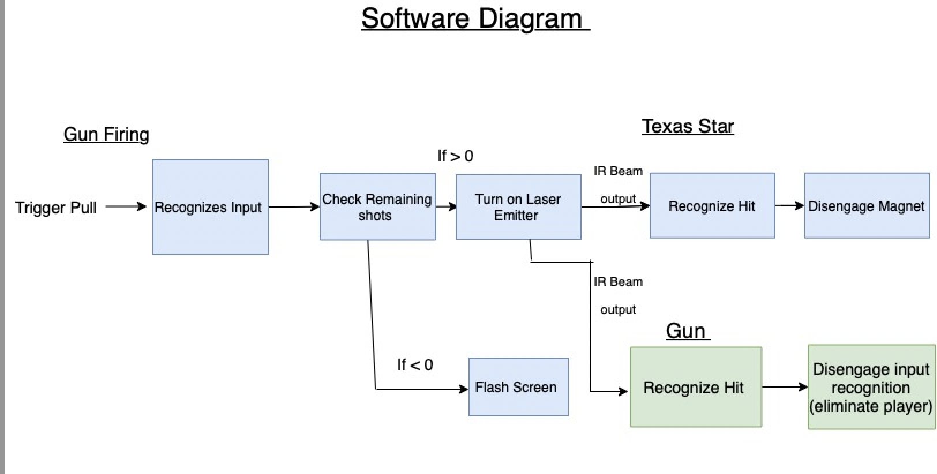

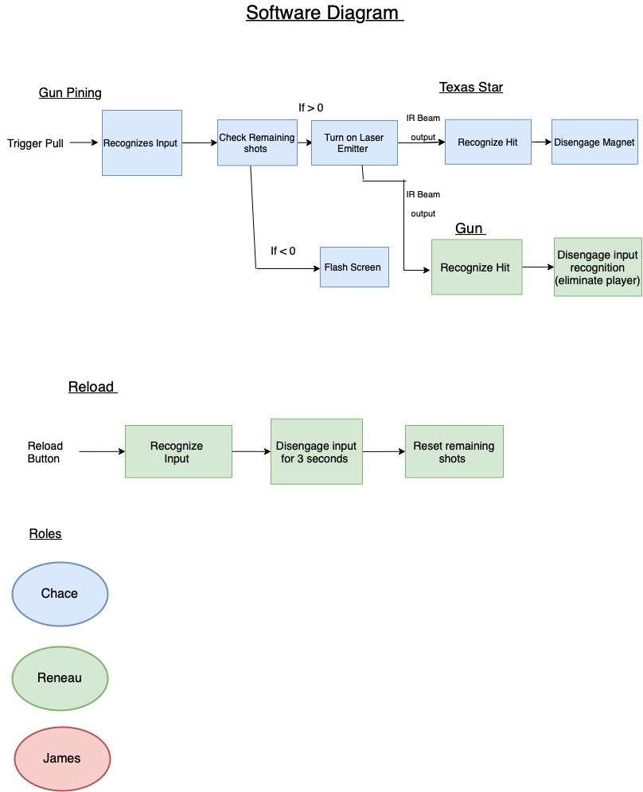







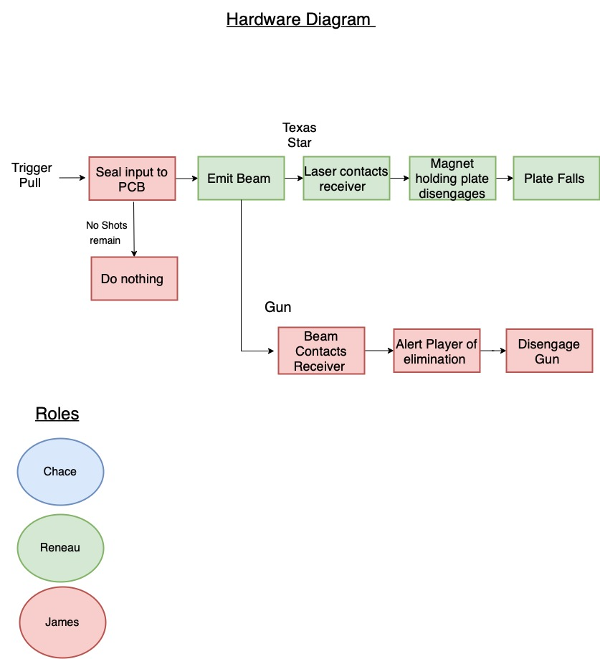







**Project Budget:**

|  | **Part** | **Description** | **Unit Price** | **Amount** | **Total Price** |
| --- | --- | --- | --- | --- | --- |
| Parts required for laser guns: | Nerf Laser OPS | Nefs Laser Tag gun for reference of what parts to get | 21 | 1 | 21 |
|  | Infrared Sensor | To sensor IR signals | 2 | 3 | 6 |
|  | Infrared Emitter | To emit IR signals | 2 | 3 | 6 |
|  | Misc | Buttons, switches, resistors, etc | 20 | 1 | 20 |
|  | Battery pack | Power the guns | 6 | 3 | 18 |
|  | Body of Gun | Find or create model/ 3D print | 10 | 3 | 30 |
|  | PCB | Control power delivery | 20 | 3 | 60 |
|  | Micro-controller | Controls all other aspects of the laser gun | 20 | 3 | 60 |
|  | LED's | Pack of 25 various colors | 5 | 1 | 5 |
| Part required for Texas Star: | 2"x4"x96" | Target Stand | 4.25 | 4 | 17 |
|  | 1" bearing | Pillow Block Ball Bearing | 2 | 11 | 22 |
|  | 1" bolt | Mounts star to bearing | 3 | 1 | 3 |
|  | 3/8" bolt | Mounts bearing to frame | 0.33 | 4 | 1.32 |
|  | LED's | Pack of 25 various colors | 5 | 1 | 5 |
|  | PCB | Detects hits | 10 | 5 | 50 |
|  | Infrared Sensor | To sensor IR signals | 2 | 5 | 10 |
|  | Electromagnets | Affix and detach plates from star | 5 | 5 | 25 |
|  | Misc | Buttons, switches, resistors, etc | 20 | 1 | 20 |
|  |  |  |  | Grand Total: | 379.32 |

**Project Milestones:**



| **Number** | **Task** | **Start** | **End** | **Status** | **Responsible** |
| --- | --- | --- | --- | --- | --- |
| **Senior Design 1** |  |  |  |  |  |
| 1 | **Ideas** | 8/23/2022 | 9/1/2022 | Complete | Group |
| 2 | **Project Selection and Role Assignment** | 9/5/2022 | 9/9/2022 | Complete | Group |
|  | **Project Record** |  |  |  |  |
| 3 | Initial Divide and Conquer | 9/9/2022 | 9/16/2022 | In Progress | Group |
| 4 | Final Document | 9/16/2022 | 9/30/2022 | In Progress | Group |
|  | **Engineering Analysis, Documentation, Design** |  |  |  |  |
| 5 | IR emitter and receiver for Laser Guns | 9/16/2022 | 11/4/2022 | Researching | James |
| 6 | IR receiver for Texas Star | 9/16/2022 | 11/4/2022 | Researching | James |
| 7 | Design PCB for power delivery | 9/16/2022 | 11/4/2022 | Researching | James |
| 8 | Write code for hit detection | 9/16/2022 | 11/4/2022 | Researching | Chace |
| 9 | Write code for reload | 9/16/2022 | 11/4/2022 | Researching | Reneau |
| 10 | Write code for ammo capacity | 9/16/2022 | 11/4/2022 | Researching | Reneau |
| 11 | Write code for Health bar | 9/16/2022 | 11/4/2022 | Researching | Reneau |
| 12 | Write code for laser tag or target shooting mode | 9/16/2022 | 11/4/2022 | Researching | Reneau |
| 13 | Mechanism to drop plates once hit is detected | 9/16/2022 | 11/4/2022 | Researching | Chace |
| 14 | Design Gun model/ layout | 9/16/2022 | 11/4/2022 | Researching | Chace |
| 15 | Design Texas Star | 9/16/2022 | 11/4/2022 | Researching | Chace |

**Project Milestones (continued):**



|  | **60 Page Senior Design Draft** | 9/30/2022 | 11/4/2022 | In Progress | Group |
| --- | --- | --- | --- | --- | --- |
| 16 | Cover Page and Summary | 9/30/2022 | 10/14/2022 | In Progress | Group |
| 17 | Technical objectives, goals, specifications | 9/30/2022 | 10/14/2022 | In Progress | Group |
| 18 | Research and investigation | 9/30/2022 | 10/21/2022 | In Progress | Group |
| 19 | Design overview | 9/30/2022 | 10/21/2022 | In Progress | Group |
| 20 | Explicit Design | 9/30/2022 | 10/28/2022 | In Progress | Group |
| 21 | Project Summary and Conclusion | 9/30/2022 | 10/28/2022 | In Progress | Group |
| 22 | Appendices | 9/30/2022 | 10/28/2022 | In Progress | Group |
|  | **100 Page Report Submission** | 9/30/2022 | 11/18/2022 | In Progress | Group |
| 23 | Finalize Cover Page and Summary | 11/4/2022 | 11/11/2022 | In Progress | Group |
| 24 | Finalize Technical objectives/ Goals | 11/4/2022 | 11/11/2022 | In Progress | Group |
| 25 | Finalize Design overview | 11/4/2022 | 11/11/2022 | In Progress | Group |
| 26 | Finalize Project Summary and Conclusion | 11/4/2022 | 11/18/2022 | In Progress | Group |
| 27 | Finalize Appendices | 11/4/2022 | 11/18/2022 | In Progress | Group |
| 28 | **Final Document** | 9/30/2022 | 12/6/2022 | In Progress | Group |
| 29 | **Order and Test Parts** | 11/1/2022 | 12/6/2022 | Research | Group |
| **Senior Design 2** |  |  |  |  |  |
| 30 | **Built Prototype** | 1/9/2023 | 1/13/2023 |  |  |
| 31 | **Test and Redesign** | TBA | TBA |  | Group |
| 32 | **Finalize Prototype** | TBA | TBA |  | Group |
| 33 | **Peer Presentation** | TBA | TBA |  | Group |
| 34 | **Final Report** | TBA | TBA |  | Group |
| 35 | **Final Presentation** | TBA | TBA |  | Group |

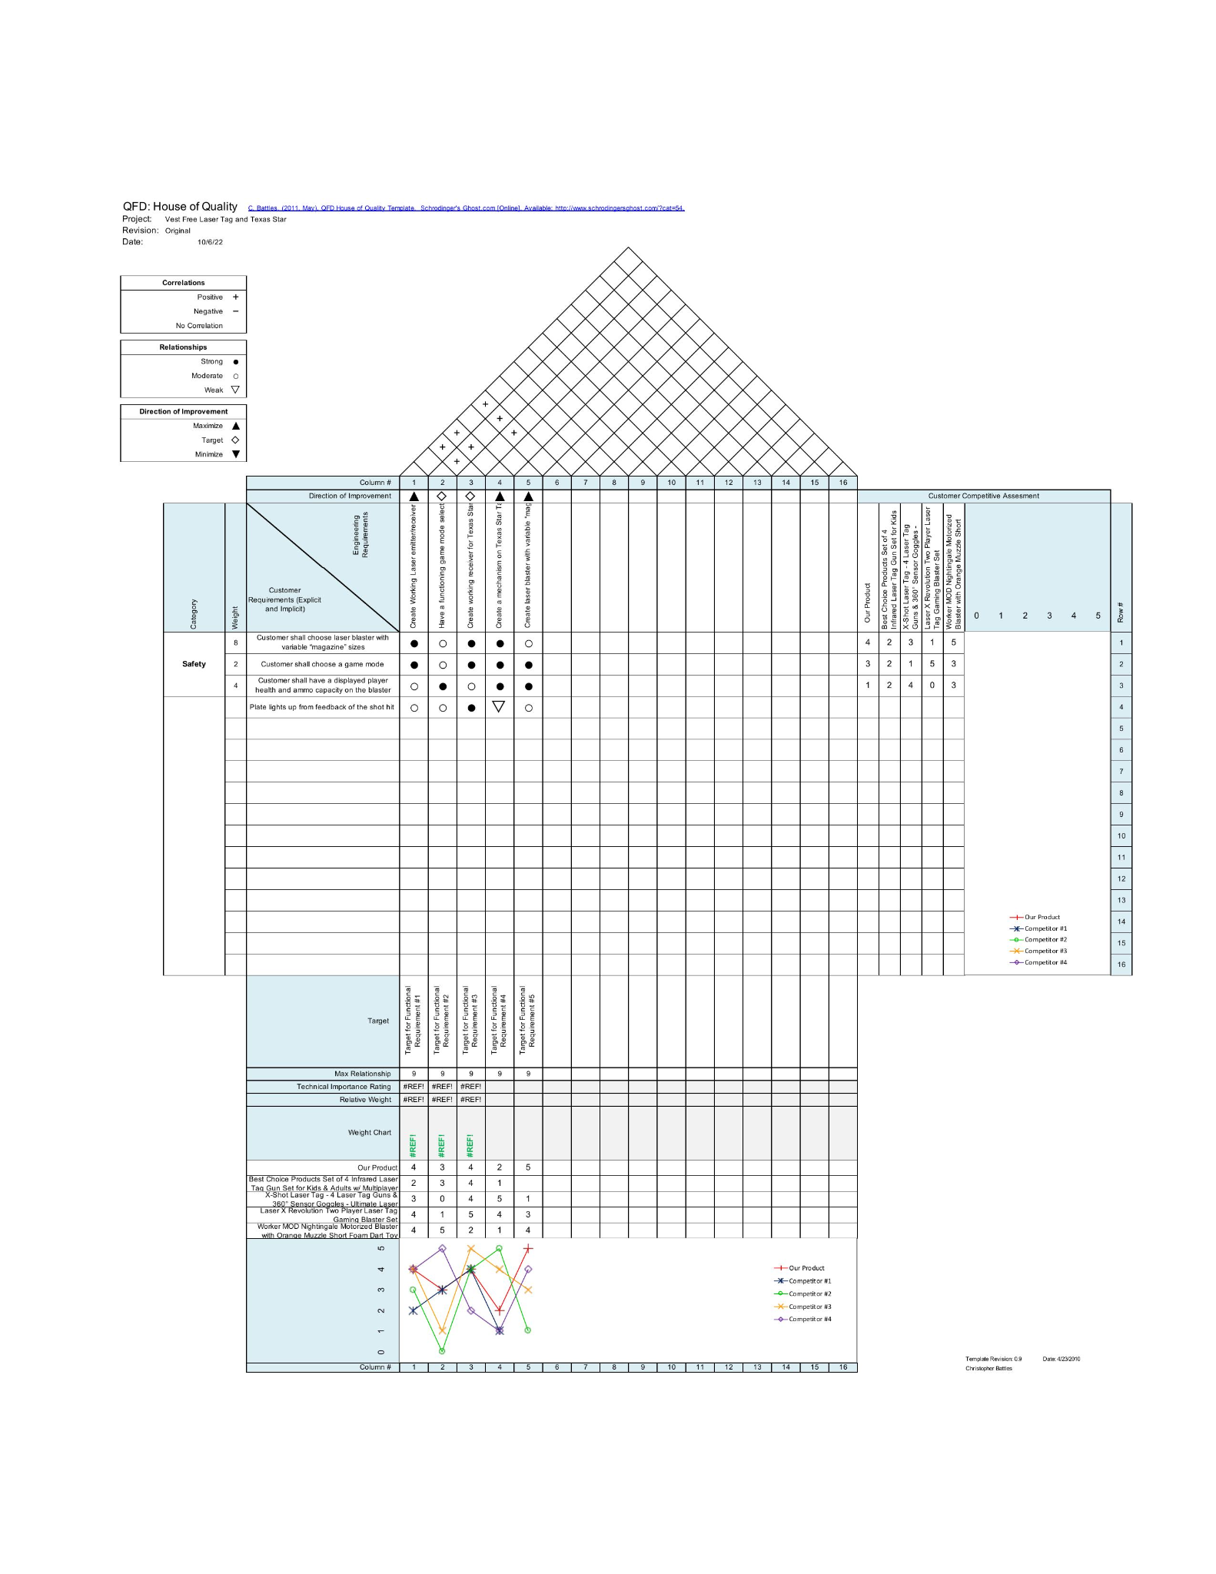

**Conclusion:**

While this project is neither innovative or life changing technology we thought it to be a good example of the value of entertainment and consumer electronics. This project seeks to create a product that expands upon existing technology to provide a new experience to people who enjoy laser tag and firearm simulation. With all this information our technology should be able to be both reproduced and expanded upon, just as we have used the original technology. With our final product we hope to create a fun and easy to use product that will be enjoyable to all.

**Citation/Researching:**

* Nerf Laser Ops:

<https://nerf.hasbro.com/en-us/laser-ops-pro>

* Texas Star:

<https://magnumtarget.com/products/reactive/ar500-portable-texas-star-no-weld-reactive-steel-shooting-target-8in-paddles/>

* How Laser Tag Blasters Work:

<https://interestingengineering.com/innovation/how-do-laser-tag-guns-work>

* How electromagnets work:

<https://flexbooks.ck12.org/cbook/ck-12-middle-school-physical-science-flexbook-2.0/section/22.4/primary/lesson/electromagnet-ms-ps/>