**Divide and Conquer 2.0**

**October 7, 2022**

Self-Sustaining Hydroponic Greenhouse

**with Photovoltaic Power and Optical Sensing**

**University of Central Florida**

**Department of Electrical Engineering and Computer Science**

Dr. Lei Wei

**College of Optics and Photonics**

Dr. Aravinda Kar

**Group 5 - Fall 2022**

Britany Forbes

Kaleb Morgan

Connor DiMatteo

George Kiriazes

Electrical Engineering

Computer Engineering

Optics and Photonics

Optics and Photonics

**Table of Contents**

Self-Sustaining Hydroponic Greenhouse i

1.0 Project Narrative iii

1.1 Problem Statement 1

1.2 Motivation 1

1.3 Function 1

1.4 Previous Project Inspirations 1

1.5 Goals and Objectives 2

2.0 Requirements Specifications 3

2.1 Power 3

2.2 Microcontroller 3

2.3 Hydroponic System 3

2.4 Sensors 4

2.5 Constraints 4

2.6 House of Quality 5

3.0 Block Diagrams 5

3.1 Overview 5

3.2 Photovoltaic System (Research) – George; Connor 6

3.3 Rainwater Collection System (Research) - George; Connor 7

3.4 Nutrient System (Research) - George; Connor; Kaleb; Brittany 7

3.5 Hydroponic System (Research)-George; Connor; Kaleb; Brittany 8

3.6 Control System (Research) - Kaleb; Britany 8

4.0 Estimated Budget 9

5.0 Project Milestones 10

5.1 Senior Design 1 10

5.2 Senior Design 2 10

6.0 Research 11

6.1 Relevant Technologies 11

6.1.1 Microcontroller 11

6.1.1.1 Features 11

6.1.1.2 Comparisons 11

6.1.2 Wireless Data Communication 12

6.1.2.1 Wi-Fi 12

6.1.2.2 Bluetooth 13

6.1.2.3 Comparisons 14

6.1.2.4 TCP/IP 14

6.1.3 Wi-Fi Module 14

6.1.3.1 Features 14

6.1.3.2 Comparisons 15

6.2 Optical & Photonic Considerations for Greenhouse System 16

6.2.1 Photovoltaic Panels 16

6.2.2 Ultraviolet Water Purification 18

6.2.3 Spectroscopy Water Analysis 18

6.2.4 Multispectral Sensor Leaf Nitrogen Reporter 18

Work Cited 20

1.0 Project Narrative

1.1 Problem Statement

Over the last forty years, municipalities across the state have undergone rapid development because of the rapid influx of residents that has more than doubled the population of Florida. The steady growth of the state has resulted in unchecked urban sprawl, sudden gentrification, and diminished access to fresh organic foods. As these problems become more prevalent, city residents are faced with rising prices that make living a happy, healthy lifestyle unaffordable for an average family. While concerns grow, localities are falling behind on implementing sustainable agricultural initiatives, such as community gardens, to combat these issues. Failures to implement community gardens as a potential solution can be attributed to three main concerns: lack of knowledge, resources, and people.

1.2 Motivation

The motivation behind this project is derived directly from the problem statement. We are seeking to overcome the three main concerns hindering community gardens to combat the larger issues of food insecurity, sustainable agriculture, and diminished quality of life. Having identified the aforementioned issues in the nearby city of Oviedo, we intend to develop a self-sufficient hydroponic greenhouse requiring minimal human contributions with affordable fixed costs and low variable costs. We will make this a smart, self-monitoring system so that we can effectively eliminate the potential lack of knowledge, resources, or people that may inhibit the implementation of these initiatives.

1.3 Function

Our greenhouse will be an entirely self-contained system with many sub-systems involved in ensuring it has all the resources necessary to continue operation. The primary function of the greenhouse is to house three independent hydroponic systems, each growing a different crop using the nutrient film technique for growth. The second function of the greenhouse is to collect and divert rainwater into a purification reservoir to be distributed to each of the plant systems with the proper nutrient concentrations specified for each plant. The third function of the greenhouse is to utilize photovoltaic cells to capture solar energy and provide power for the systems. Upon completion, this self-sufficient greenhouse will function as a source of affordable organic produce for the community as well as an educational tool for residents on the benefits of sustainable agriculture.

1.4 Previous Project Inspirations

We have identified several former projects that we plan to expand upon to enhance their features, efficiency, and size. The two projects we are taking inspiration from for our hydroponic systems are the “[Automated Home Hydroponics System](https://www.ece.ucf.edu/seniordesign/su2020fa2020/g19/gallery.html)” from Group E in Fall 202 and the “[Pocket ‘Ponics](https://www.ece.ucf.edu/seniordesign/fa2019sp2020/g28/index.html)” in Fall 2019. For the rainwater collection system and photovoltaic system, we are taking inspiration from the “[UV Water Analysis System](https://www.ece.ucf.edu/seniordesign/su2020fa2020/g05/index.html)” from Group 5 in Fall 2020 and the “[Solar Powered Water Filtration System](https://www.ece.ucf.edu/seniordesign/fa2019sp2020/g24/)” from Group 24 in Fall 2019. Each of these projects provide essential knowledge necessary to developing the numerous sub-systems we intend to include in our greenhouse. For a detailed analysis of the projects, review “6.1 Related Projects and Products”.

1.5 Goals and Objectives

|  |  |
| --- | --- |
| Hydroponic System | |
| Goal | Objective 1.0 |
| Grow many plants of the same species according to a specific plant profile | Program plant profiles |
| Automate the water and nutrient pumps according to profile |
| Build a cascading housing |
| Monitor the pH-balance, nutrient concentration, and cycles |
| Construction of each system is affordable | Materials should be individually affordable and accessible |
| Materials should be easy to work with |
| Create a compact system | System should utilize vertical space in compact horizontal space |
| Rainwater Collection System | |
| Goal | Objective 2.0 |
| Use spectroscopy to analyze water quality | Integrate a spectrophotometer to detect contaminants |
| Implement a UV purifier inside the reservoir |
| Automatically pump water and nutrients into hydroponic systems | Pump water into the hydroponic systems as needed |
| Sensors trigger pH balancing when water pH breaks range |
| Sensors trigger nutrient pumps to maintain NPK ratio of water |
| Photovoltaic System | |
| Goal | Objective 3.0 |
| Generate power for the system | Optimize solar collection of panels outside the greenhouse |
| Include power channels to all electronic devices |
| Store excess power | Channel surplus power into a battery |
| Greenhouse | |
| Goal | Objective 4.0 |
| Ensure connectivity between all internal systems for automation | Develop a LAN network for monitoring and system control |
| Internal sensors connect to microcontroller to create mesh |
| Scale independent system sizes within housing |
|  |  |
|  | Core |
|  | Advanced |
|  | Stretch |

**Table 1.5.1** Goals and objectives for the “Self-Sustaining Hydroponic Greenhouse with Photovoltaic Power and Optical Sensing”

2.0 Requirements Specifications



**Table 2.0.1** Specifications for the hydroponic system, rainwater collection system, photovoltaic system, and the greenhouse broken up into objectives

2.1 Power

* Clean Energy: The greenhouse should be able to sustain itself using only energy it collects from the connected solar panels.
* Energy Storage: There must be a constant, reliable source of energy for the pumps and sensors. Surplus energy should be stored efficiently for later use (ex. night).
* Voltage Regulation: PCB should regulate the incoming and outgoing voltage according to the needs of individual systems and sensors.

2.2 Microcontroller

* Low Power: The microcontroller should be able to function at low power to reduce electric usage.
* Data Collection: Must be able to quickly collect and store sensor data.
* Communication: Microcontroller must be compatible with chosen local network connection.

2.3 Hydroponic System

* Materials: Beds should be made of affordable, durable PVC material.
* Size: The system (bed, water, and nutrients) should be large enough to hold the various plants and vegetables but also compact enough to optimize space.

2.4 Sensors

* Low Power: The sensor playground should process and interpret data while consuming minimal electricity.
* Accuracy: Sensors should report accurate data to the microcontroller with high accuracy and minimal error.
* Maintenance: The sensor mesh will operate through extended periods of time without the need for support.
* Size: The sensors must be of a scale small enough to be housed within the sub-systems.
* Compatibility: Each sensor must be compatible with the microcontroller to ensure they are properly integrated within the mesh network.

|  |  |  |
| --- | --- | --- |
| **Component** | **Parameter** | **Specification** |
| Solar Panels | Power | 100 Watts **≤** P < 300 Watts |
| Battery | Time | ≈ 12-hour battery life |
| UV Water Purifier | Effectiveness | 99% Efficiency on viruses, bacteria and protozoa |

**Table 2.4.1** Specifications for the solar panels, battery, and UV water purifier

2.5 Constraints

* Cost: This is the largest constraint. Minimizing cost without losing quality will be very important.
* Time: Project must be accomplished in given time (~20 weeks)
* Energy: If this project is to run entirely on solar energy, limiting power usage is a large priority.

2.6 House of Quality



Figure 2.6.1 House of Quality

3.0 Block Diagrams

3.1 Overview

1. Greenhouse: Houses the plants and other systems.
2. Hydroponic System: Maintains supply of nutrients to plants.
3. Control System: Monitors all the sensors and provides and determines the actions taken. Provides users access to the greenhouse data and settings via an interface.
4. Rainwater Collection System: Provides purified water to the plants in the greenhouse.
5. Nutrient System: Provides specific nutrients to the plants in the greenhouse.
6. Photovoltaic System: Provides electricity to the greenhouse.

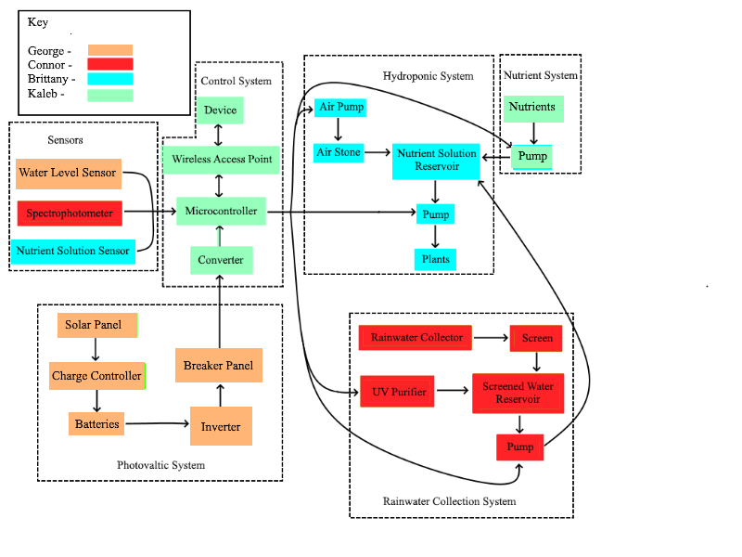

**Figure 3.1.1** Hardware Block Diagram

3.2 Photovoltaic System (Research) – George; Connor

1. Solar Panel: Converts sunlight into DC electricity.
2. Charge Controller: Limits the rate at which electric current is added to or drawn from batteries.
3. Batteries: Store the electricity.
4. Inverter: Converts DC electricity to AC electricity.
5. Breaker Panel: Switches to control the flow of electricity.

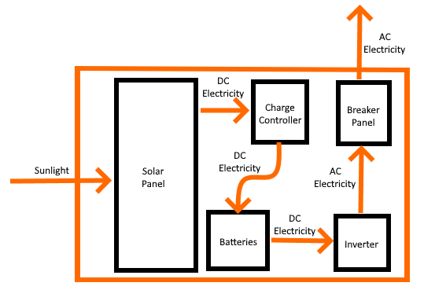

**Figure 3.2.1** Photovoltaic System

3.3 Rainwater Collection System (Research) - George; Connor

1. Screening: Remove objects from the water.
2. Initial Reservoir: Stores the rainwater after it has been screened.
3. Spectrophotometer: Monitors the level of water contaminants.
4. UV Purification: Purifies the water using UV light.
5. Purified Water Reservoir: Stores purified water.
6. Pump: Moves the purified water from the reservoir to the greenhouse.

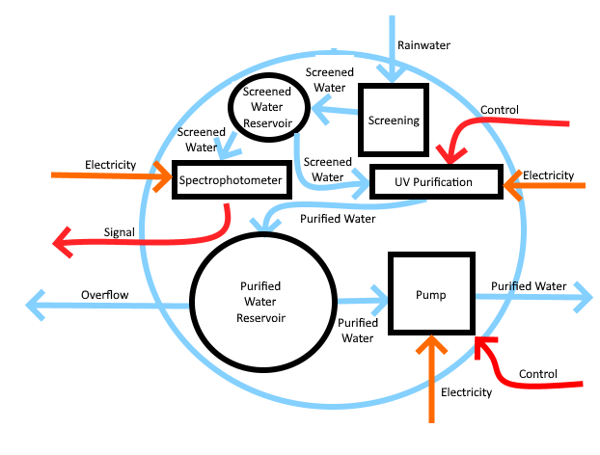

**Figure 3.3.1** Rainwater Collection System

3.4 Nutrient System (Research) - George; Connor; Kaleb; Brittany

1. Phosphorus Reservoir: Stores phosphorus.
2. Nitrogen Reservoir: Stores nitrogen.
3. Potassium Reservoir: Stores potassium.
4. Calcium Reservoir: Stores calcium.
5. Magnesium Reservoir: Stores magnesium.
6. Pump: Moves the nutrients to the greenhouse

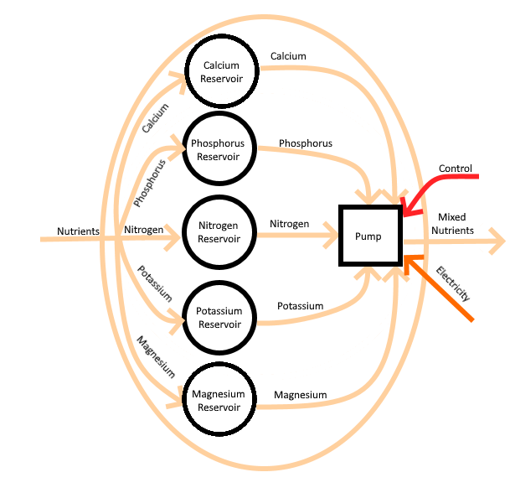

**Figure 3.4.1** Nutrient System

3.5 Hydroponic System (Research)-George; Connor; Kaleb; Brittany

1. Air Pump: Moves air to the air stone.
2. Air Stone: Diffuses air into the water.
3. Nutrient Solution Reservoir: Stores the nutrient solution for plants.
4. EC or TDS Meter/Spectrophotometer: Measure the concentrations of the nutrient solution reservoir
5. Pump: Moves the nutrient solution to the plants.
6. Plants: Grow and make food.

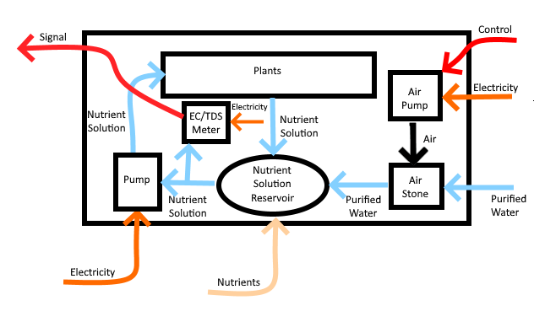

**Figure 3.5.1** Hydroponic System

3.6 Control System (Research) - Kaleb; Britany

1. Controller: Takes in signals from sensors and tells the system what to do. Sends and receives data from Local Area Network.
2. Local Area Network: Facilitates communication between devices within a small range.
3. Device: Examine data from the greenhouse and make changes to the settings.

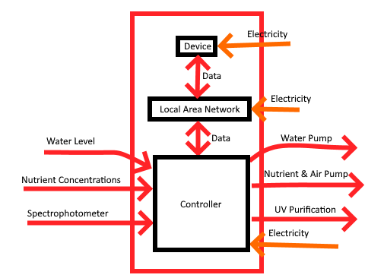

**Figure 3.6.1** Control System

4.0 Estimated Budget

|  |  |
| --- | --- |
| **Part** | **Estimated Cost ($)** |
| Spectrophotometer | 1500 |
| Green House | 800 |
| Photovoltaic system | 500 |
| Nutrient Film Technique (Hydroponic) | 300 |
| UV water purification | 150 |
| Flow meter | 100 |
| Water pump | 60 |
| Nutrient dispenser | 60 |
| Nutrients | 35 |
| Microcontroller and PCB | 30 |
| Reservoirs | 30 |
| LED growth lighting | 15 |
| Humidity sensor | 15 |
| Screening (Water) | 5 |
| Seeds/starters | 20 |
| Miscellaneous / Emergency | 300 |
| Total | 3920 |

**Table 4.0.1** Estimated budget for overall project span

This budget is proposed for the design and construction of a Self-Sustaining Hydroponic Greenhouse. When drafting the initial budget estimate, we estimated the major components based on the current average price of the different units. The components are itemized in the budget. Most of our funding will be from sponsors. The remaining funding will be provided by project team members. A contingency of $300 was included in the budget; this will be in case of emergencies, unplanned minor expenses and possible instrument repair or replacement.

5.0 Project Milestones

5.1 Senior Design 1

|  |  |  |
| --- | --- | --- |
| **Number** | **Milestone** | **Completion Week** |
| 1 | Initial Product Documentation (Divide and Conquer 1.0) | 4 |
| 2 | Search for potential sponsor | 4 |
| 3 | Meet with advisor to confirm project idea | 5 |
| 4 | Research systems and create initial designs | 5 |
| 5 | Revised Product Documentation (Divide and Conquer 2.0) | 6 |
| 6 | Confirm design of power management system | 6 |
| 7 | Create PCB initial design | 7 |
| 8 | Update system designs (software, water retrieval, nutrient delivery) | 7 |
| 9 | Prototype spectrophotometer | 8 |
| 10 | Prototype nutrient delivery and pump system (software and hardware) | 9 |
| 11 | Finalize PCB design | 10 |
| 12 | Purchase components and PCB | 10 |
| 13 | Finalize 60 Page Draft | 11 |
| 14 | Finalize 100 Page Draft | 13 |
| 15 | Complete Final Report | 16 |

**Table 5.1.1** Project milestones for Senior Design 1

5.2 Senior Design 2

|  |  |  |
| --- | --- | --- |
| **Number** | **Milestone** | **Completion Week** |
| 1 | Construct housing and hydroponic bed | 1 |
| 2 | Begin Integration | 2 |
| 3 | Complete nutrient selection software and interface | 3 |
| 4 | Complete integration | 4 |
| 5 | Begin Testing | 6 |
| 6 | Complete Testing | 8 |
| 7 | Deliver Product | 9 |

**Table 5.2.1** Project milestones for Senior Design 2

6.0 Research

6.1 Relevant Technologies

This section discusses the different technologies that will be used. A further understanding of the individual components that make up the system is important for understanding the system as a whole.

6.1.1 Microcontroller

Microcontrollers consist of memory, programmable I/O peripherals, and one or more processors. A large benefit of using a microcontroller is that it reduces the size and cost of designs compared to designs that implement each device separately. Microcontrollers lie at the center of embedded applications and serve to automate specified tasks. Their ability to collect data from the outside world makes them a prime candidate for internet of things edge devices. There are many microcontrollers to choose from with the more familiar ones being the MSP430 microcontrollers provided by Texas Instruments.

6.1.1.1 Features

The microcontrollers include Non-volatile memory (Flash or FRAM) and volatile memory (RAM or SRAM) ranging from 0 KB to 512 KB and 0.125 KB to 66 KB, respectively. “The device features a powerful 16-bit RISC CPU, 16-bit registers, and constant generators that contribute to maximum code efficiency.” [2] The CPUs have frequencies of 4 MHz on the low end to 25 MHz on the high end with the ability to reduce these speeds. Lowering the speed of the CPU reduces power consumption which the MSP430 microcontrollers make use of through their low-power modes. Five of these power-saving modes are included, each of which disables their own configuration of CPU and peripherals to meet the needs of the program. Some of the peripherals included in the MSP430 microcontrollers are USCI, timers, ADCs, GPIOs and BOR to name a few.

Beginning development with these microcontrollers is simple with options that are affordable. Texas Instruments provides an ez-FET debug probe on most of their development kits which cost around $10 and can interface to most MSP430 microcontrollers. These powerful tools use JTAG and SBW to program and debug the microcontrollers via a USB connection to a computer. Texas Instruments also provides an integrated development environment, Code Composer Studio, that has tools useful for developing and debugging Texas Intruments's microcontrollers.

6.1.1.2 Comparisons

The microcontroller's three main tasks are to receive data from the sensors, communicate with the necessary pumps and purifier, and to communicate with the Wi-Fi module. When selecting a microcontroller, we must select one that can not only implement these tasks but stays within our design specifications and constraints. The characteristics that determined our selection are broken down.

* Power Consumption: Running off solar power requires us to limit our power usage throughout our design. We must look for an option that has low power consumption to ease the strain on our system.
* Peripherals: The Wi-Fi module will use UART to communicate with the microcontroller so our selection must include at least one of these protocols. Analog-to-digital converters are also necessary as some of our sensors will be providing analog signals. Having an excess of GPIO pins would also help to implement the water level sensor as well as any new sensors.
* Memory: We intend to store and access data of many sizes so it would be beneficial to use a microcontroller with ample memory. Having a small amount of random-access-memory especially may require extra steps when programming which would be better off avoided.
* Cost: With a limited budget we must conserve funds wherever we can. Luckily, there are many low-cost microcontroller options to choose from.
* Debugging and Programming: Being able to debug and reprogram the microcontroller quickly will increase the speed of development. Understanding how to program the microcontroller will also help.

|  |  |  |  |
| --- | --- | --- | --- |
|  | [MSP430G2553](https://www.ti.com/product/MSP430G2553) | [MSP430F5257](https://www.ti.com/product/MSP430F5257) | [MSP430FR6989](https://www.ti.com/product/MSP430FR6989) |
| Feature | Microcontroller | Microcontroller | Microcontroller |
| Non-volatile memory | 16 KB | 128 KB | 128 KB |
| Random access memory | 0.5 KB | 16 KB | 2 KB |
| GPIO pins | 24 | 53 | 83 |
| UART | 1 | 4 | 2 |
| I2C | 1 | 4 | 2 |
| SPI | 2 | 8 | 4 |
| Power Consumption | .5uA - 230uA | 1.3uA - 290uA | 0.35uA - 100uA |
| Cost | $0.95 | $2.39 | $4.17 |

**Table 6.1.1** Microcontroller comparison between the MSP430G2553, MSP430F5257, and the MSP430FR6989

6.1.2 Wireless Data Communication

Wireless data communication allows data to be transferred between devices without the need for a physical medium. Radio waves are by far the most common for use in wireless technology and can provide variable distances from a few meters to millions of kilometers. There are many different communication technologies differing in coverage range and performance. Some common examples are Wi-Fi, GSM, and Bluetooth.

6.1.2.1 Wi-Fi

Wi-Fi “is a family of wireless network protocols, based on the IEEE 802.11 family of standards, which are commonly used for local area networking of devices and Internet access, allowing nearby digital devices to exchange data by radio waves.” [3] The frequency ranges provided by the 802.11 standard for use in Wi-Fi communications are 900 MHz, 2.4 GHz, 3.6 GHz, 4.9 GHz, 5 GHz, 6 GHz, and 60 GHz bands. These bands are further divided into channels which are regulated by countries individually. As the frequency is increased you can expect to see higher throughput. The opposite applies for the range of communication. As the frequency increases, the range decreases. Common frequency ranges include the 2.4 GHz and 5 GHz bands along with some common protocols being 802.11b/g/n and 802.11ac/n, respectively. Differences in protocol include supported bands, bandwidth, modulation, and maximum data rate. The diagram below shows some of these differences for select protocols.

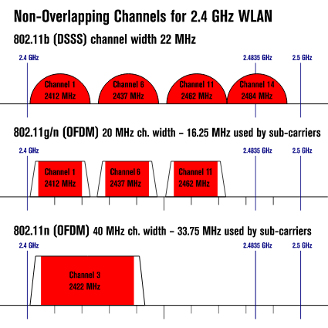

**Figure 6.1.1** North America Wireless LAN Channels in 2.4 GHz band

6.1.2.2 Bluetooth

“Bluetooth is a short-range wireless technology standard that is used for exchanging data between fixed and mobile devices over short distances and building personal area networks (PANs).” [14] Bluetooth was originally standardized by IEEE as IEEE 802.15.1 but has since switched hands and is now overseen by the Bluetooth Special Interest Group (SIG). Bluetooth operates in the range of 2.402 GHz to 2.48 GHz in the ISM bands. Bluetooth is divided into 79 designated channels each with a bandwidth of 1 MHz. There are many variations of Bluetooth, one being Bluetooth Low Energy (BLE) which reduces cost and power consumption considerably while keeping a similar distance for communication. BLE uses the same ISM bands as Bluetooth but is instead divided into 40 channels with 2 MHz bandwidth.

6.1.2.3 Comparisons

When looking at the two technologies some of the main characteristics taken into consideration are broken down below:

* Range: We need to be able to establish and maintain a connection within and close to the greenhouse.
* Power Consumption: Running off solar power requires us to limit our power usage throughout our design. We must look for an option that has low power consumption to ease the strain on our system. Typically, Wi-Fi is seen as using much more power than Bluetooth. This depends on the setup and optimizations.
* Throughput: Having high throughput is useful for handling inputs quickly. Even though we will not be sending or receiving substantial amounts of data, having a high throughput would be beneficial to the speed of the system.
* Cost: With a limited budget we must conserve funds wherever we can. Depending on how each technology is implemented, there are options for each that are relatively cheap.

|  |  |  |
| --- | --- | --- |
|  | Wi-Fi | Bluetooth |
| Range | 9.1 m – 70 m | 10 m – 100 m |
| Power Consumption | .0231 mW - 1.16 W | .01 mW – 100 mW |
| Throughput | 2 Mbps – 10 Gbps | 732.2 Kbps – 50 Mbps |
| Cost | < $5 | < $5 |

**Table 6.1.2** comparison of Wi-Fi versus Bluetooth

6.1.2.4 TCP/IP

To make sense of wireless communication over a network you need to have a common form of communication. The Internet Engineering Task Force (IETF) provides standards for the internet and similar computer networks. The internet protocol suite (TCP/IP) is a set of communication protocols based on the IETF technical standards. “The Internet protocol suite provides end-to-end data communication specifying how data should be packetized, addressed, transmitted, routed, and received.” [6] This set of protocols sits on top of the wireless data communication protocols completing the communication network and is the most widely used set of protocols for internet and local network communications.

6.1.3 Wi-Fi Module

A Wi-Fi module is connected to a device to provide access to a WLAN. There are many options when looking for a Wi-Fi module like those provided by Texas Instruments and Espressif Systems.

6.1.3.1 Features

A Wi-Fi module supports IEEE 802.11 standards and typically comes with a complete TCP/IP protocol stack. A Wi-Fi module can act as either a client, access point, or both client and access point. In client mode, the module intends to connect to a WLAN. In access point mode, the module intends to set up an access point for other devices to connect to the WLAN. Typical frequency bands for the modules are 2.4 GHz and 5 GHz. Wi-Fi modules contain a microcontroller with a highly integrated Wi-Fi system on chip (SoC). These MCUs come with peripherals such as UART, SPI and GPIO to allow for communication in embedded systems. The MCUs on these modules integrate on-chip “antenna switches, RF balun, power amplifier, low noise receives amplifier, filters and power management modules.” [7] Modules provided by Texas Instruments and Espressif Systems also come with several low-power modes in order to increase power efficiency.

6.1.3.2 Comparisons

The main task of the Wi-Fi module is to facilitate communication between the off-chip microcontroller and the user’s device. The module needs to use IEEE 802.11 standards and implement the TCP/IP protocol stack. When selecting a Wi-Fi module, we must select one that can not only implement these tasks but stays within our design specifications and constraints. The characteristics that determined our selection of a module are broken down below.

* Power Consumption: Running off solar power requires us to limit our power usage throughout our design. We must look for an option that has low power consumption to ease the strain on our system.
* Peripherals: The Wi-Fi module needs to communicate with the off-chip MCU. The communication protocols used by our off-chip MCU include UART, SPI, and I2C. The Wi-Fi module must implement at least one of these protocols.
* Throughput: Having high throughput is useful for handling inputs quickly. Even though we will not be sending or receiving substantial amounts of data, having a high throughput would be beneficial to the speed of the system.
* Cost: With a limited budget we must conserve funds wherever we can. Luckily, there are many low-cost Wi-Fi module options to choose from.

|  |  |  |  |
| --- | --- | --- | --- |
|  | [CC3100MODR11MAMOBR](https://www.mouser.com/ProductDetail/Texas-Instruments/CC3100MODR11MAMOBR?qs=9ZbiF7sZ4j3pil3tOhRYCA%3D%3D) | [ESP-WROOM-02D-N2](https://www.mouser.com/ProductDetail/Espressif-Systems/ESP-WROOM-02D-N2?qs=Li%252BoUPsLEnvhNeppmJQCiA%3D%3D) | [ESP32-C3-MINI-1-N4](https://www.mouser.com/ProductDetail/Espressif-Systems/ESP32-C3-MINI-1-N4?qs=stqOd1AaK7%252B%2FpH3qqyGehA%3D%3D) |
| Feature | Wi-Fi | Wi-Fi | Wi-Fi |
| Throughput | 16 Mbps / 13 Mbps | 72.2 Mbps | 150 Mbps |
| Power Consumption | 7uA - 272mA | 20uA - 170mA | 5uA - 350mA |
| Op. Temperature | -20C ~ 70C | -40C ~ 85C | -40C ~ 85C |
| UART | 1 | 1 | 1 |
| SPI | 1 | 1 | 1 |
| I2C | 0 | 1 | 1 |
| Programming Method/IDE | C/Code Composer Studio | C/Energia | C/Energia |
| Cost | $16.78 | $3.00 | $1.88 |

**Table 6.1.3** Comparison of different Wi-Fi modules.

6.2 Optical & Photonic Considerations for Greenhouse System

An important emphasis of our project is the photonic aspects of the self-sufficient plant growing process. The major photonic pieces for the greenhouse are the photovoltaic panels, multispectral sensor leaf nitrogen reporter sensor, spectroscopy water analysis process, and the ultraviolet water purification process. These optical aspects will be done by Connor and George. The integration into the control system will be focused on by Brittany and Kaleb.

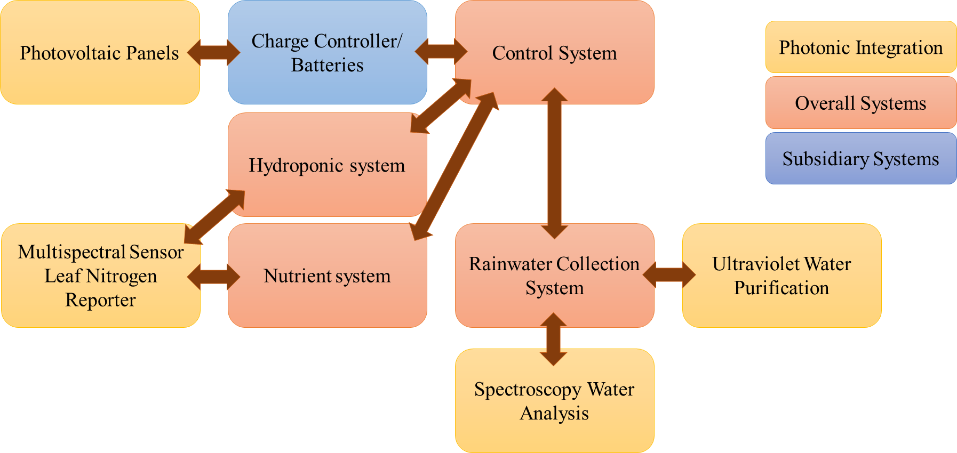

**Figure 6.2.1** Photonic integration into overall greenhouse system

6.2.1 Photovoltaic Panels

For the use of a self-sufficient system, a solar array that would be able to supply power to the greenhouse environment 24 hours a day would be ideal. Though possible to have a solar system provide enough power to run 24 hours a day, it would come as no surprise that such a system would require a much larger solar array which in turn would also require a much higher budget being designated to the energy collection system. To compromise on this specification a lower operation time of 8 hours a day was set for the full system to always have the required power needed. Smaller systems would be operational for longer while larger ones are limited in operation time to preserve the system. To figure out what photovoltaic device would be ideal for us, a deeper look is required into what is available.

Recently photovoltaic units have been subject to massive growth in the solar panel industry. This is a result in the rising demand for solar due to lower costs and federal tax credits aiding for lots of consumers, who in result, decide to integrate solar into their daily lives. With an independent system containing only solar panels and batteries you can expect between 12 and 24 volts to be achieved allowing for great off the grid uses.

When looking at the variety of solar energy options, there are different types of photovoltaic cells for different applications. Even though better options exist for solar energy, price point is one of the main factors when choosing which solar option to choose from. The main types of solar cell technology that are used are made up of polycrystalline silicon cells, thin-film solar cells, and monocrystalline silicon cells. Thin-film solar cell technologies are still being developed so this option would be less considered in our selection process.

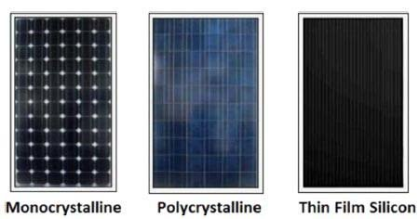

**Figure 6.2.2** Different silicon technologies. From left to right: monocrystalline silicon solar cell, polycrystalline silicon solar cell, thin-film silicon solar cell [9]

Monocrystalline silicon cells where the first breakthrough for solar technology. To create the wafers for the solar panel a silicon crystal is placed in molten silicon. This is then extracted from the molten silicon. The resulting silicon structure is formed into a wafer that will be used for a solar cell. The Monocrystalline silicon cell structure is one of the most efficient forms for solar technology because of the high purity silicon in the final silicon wafers.[10] This structure results in a long lifetime for the solar cell, high efficiency, high output, and thermal resilience. All these factors allow for an efficiency rate of over 20%. However, these cells usually are more expensive to produce resulting in a large cost for consumers. Polycrystalline silicon structures came shortly after the monocrystalline silicon structures. The polycrystalline cells start similarly to the monocrystalline with a silicon crystal. The crystal is dropped into molten silicon but not removed like in a monocrystalline cell. This is left to cool which results in rigid crystal structures within the cells. This process is much faster and cheaper than that of a monocrystalline silicon cell. These quicker and cheaper processes result in a lower lifespan and a max efficiency of only 15%.[11] Polycrystalline silicon cells are a likely consideration for future design development due to its price point being within our budget for the overall greenhouse system.

6.2.2 Ultraviolet Water Purification

Ultraviolet light is attractive for filtering water due to its great germicidal properties. Since we desire a system with full control of most aspects of what the plants in the system receive, a purification and filtering step is wanted to help remove any unwanted aspects from the water that may reach the plants. Plants can be affected by many different impurities found in rainwater including chemicals, heavy metals, and other impurities that could affect the efficiency of plant growth. By filtering rainwater to remove most chemicals and heavy metals and by using ultraviolet to remove any other microorganisms, we can take almost complete control over the nutrients and water that the plant will receive. Ultraviolet-C is the wavelength most used for germicidal properties which consists of the range between 100 nm and 280 nm. In a on the grid system, you could easily go about avoiding microorganisms and heavy metals by using distilled water. Since our goal is to have an off grid self-sufficient system, we must be able to produce as close to distilled water as we can to be able to give the plants the best chance possible at success. By using purified water, plants can grow faster and stronger than just using rain or tap water.

6.2.3 Spectroscopy Water Analysis

To measure and confirm that the proper quantities of nutrients are being fed into the hydroponic system a spectrophotometer is planned to be used to measure the different nutrient-specific parameters such as potassium, calcium, and magnesium to verify that proper quantities are what a specified plant requires is being achieved. A spectrophotometer will also allow for pH levels to be measured to also make sure each parameter is set correctly for a plant and allow for adjustment to provide proper nutrient levels to the selected plant. Spectrophotometers are also capable of telling us the measurements of stable water isotopic composition as well as nitrogen solutes and hydrological information. [15] This process will ensure an increase in food production without raising the need for a higher consumption of water resulting in higher yields per gallon of rainwater.

6.2.4 Multispectral Sensor Leaf Nitrogen Reporter

Knowing what is going into the hydroponic system is a great way to make sure that you are providing everything the plant needs in the form of nutrients; however, it’s important to be able to know the actual nutrient status of the plant. Using a plants leaf nitrogen level can be a critical indicator which will tell us a lot about the nutrient information and thus the overall plants health. Many different forms of nitrogen are sensitive to the near-infrared and visible wavelength regions. There are many different methods to collect this information however the most practical is a non-invasive visible and near-infrared sensor to measure. Using the reflectance of around 550nm wavelength you can deduce many different nitrogen treatments for a plant.[12]

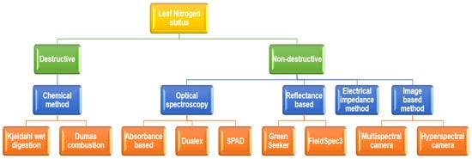  
**Figure 6.2.3** “Destructive and non-destructive methods used for estimating leaf nitrogen status.”[12]

As seen in the figure above there are many different methods of optical imagery to determine the nitrogen status. Most of the less intrusive methods consist of a system to measure the reflectance or absorbance of the coloration of a leaf. This information is critical to represent the chlorophyll found in a plant. Using this indirect indication of the photosynthetic processes you can determine the plants overall health and vitality. Most of the options available to consumers to measure this information are expensive and hard to integrate into an overall mesh sensor network. However, options exist to build this crucial plant monitoring system at a low price point with high efficiency that is also capable of being directly integrated into an overall controlled and monitored network.

Work Cited

1. *Charge controller - Wikipedia*, https://en.wikipedia.org/wiki/Charge_controller.
2. *MSP430G2553 data sheet, product information and support | TI.com*, <https://www.ti.com/product/MSP430G2553>.
3. “Wi-Fi.” *Wikipedia*, Wikimedia Foundation, 2 Oct. 2022,

<https://en.wikipedia.org/wiki/Wi-Fi>.

1. “ESP8266.” *Wikipedia*, Wikimedia Foundation, 7 Sept. 2022,

<https://en.wikipedia.org/wiki/ESP8266>.

1. “IEEE 802.11.” *Wikipedia*, Wikimedia Foundation, 5 Oct. 2022,

<https://en.wikipedia.org/wiki/IEEE_802.11>.

1. “Internet protocol suite.” *Wikipedia,* Wikimedia Foundation, 29 Sept. 2022,

<https://en.wikipedia.org/wiki/Internet_protocol_suite>

1. *Wireless LAN - Wikipedia*, <https://en.wikipedia.org/wiki/Wireless_LAN>.
2. *Internet protocol suite Wikipedia*,

<https://en.wikipedia.org/wiki/Internet_protocol_suite>.

1. Nayan, Faysal & Ullah, S.M.Safayet & Saif, S.. (2016). *Comparative analysis of PV module efficiency for different types of silicon materials considering the effects of environmental parameters.* 1-6. 10.1109/CEEICT.2016.7873089.
2. Lenardic, D. (2015, December 23). *Photovoltaics - Historical Development.*

<http://www.pvresources.com/en/introduction/history.php#:%7E:text=The%20first%20silicon%20monocrystalline%20solar,materials%20for%20solar%20cell%20production>

1. *Types of Solar Panels (2020)* - GreenMatch. (2020, March 10).

<https://www.greenmatch.co.uk/blog/2015/09/types-of-solar-panels>

1. *Low-Cost Multispectral Sensor Array for Determining Leaf Nitrogen Status,* Nitrogen2020, 1(1), 67-80; <https://doi.org/10.3390/nitrogen1010007>
2. “GSM.” *Wikipedia,* Wikimedia Foundation, 8 Oct. 2022,

<https://en.wikipedia.org/wiki/GSM>

1. “Bluetooth.” *Wikipedia,* Wikimedia Foundation, 5 Oct. 2022

<https://en.wikipedia.org/wiki/Bluetooth>

1. *Set Up of an Automatic Water Quality Sampling System in Irrigation Agriculture*, Sensors 2014, 14(1), 212-228; <https://doi.org/10.3390/s140100212>