# Self-Sustaining Hydroponic Greenhouse with Photovoltaic Power and Optical Sensing

Connor DiMatteo, Kaleb Morgan, and George Kiriazes

### Dept. of Electrical and Computer Engineering College of Optics and Photonics

### University of Central Florida, Orlando, Florida, 32816-2450

### *Abstract* — Access to sustainable community gardens has grown in need as communities are affected by urban sprawl, gentrification, and food insecurity. This paper explores the application of compact hydroponic greenhouses for increasing access to healthy, organic food in municipalities. It discusses the design and methodology used to ensure cost and maintenance are minimized while the yield and accessibility are maximized. This is accomplished by collecting rainwater, generating solar power, encoding system profiles, sensing impurities, and filtering contaminants, and automating the deposition of nutrients, pH, and water.

### *Index Terms* — Filtration, Horticulture, Hydroponics, Local Area Networks, Raman Spectroscopy, Solar Energy

### I. Introduction

Agriculture has played a central role in people’s livelihoods as far back as the first humans. As the world continues to advance, grow, and evolve, individual’s access to sustainable agriculture has continued to diminish resulting in increased food insecurity across the globe. This problem is especially prevalent in lower-income regions with high levels of poverty amongst residents. While many potential solutions exist to solve this problem, the implementation of community gardens in localities presents an opportunity for problem solving at the individual level. Community gardens serve as an excellent source of affordable locally produced organic foods, but they have the added benefit of serving as an educational centerpiece in communities to teach community members how to cultivate their own food. However, there are three major inhibitors to the establishment of community gardens: resources, knowledge, and people.

The self-sustaining hydroponic greenhouse with photovoltaic power and optical sensing is intended to reduce or all-together eliminate the problems that inhibit the implementation of community gardens. By generating its own power, collecting its own water, and employing hydroponic methods, it substantially reduces the need for resources from local governments. Utilizing numerous sensors and pumps, the system can automate itself to ensure pH and nutrient levels are balanced for optimal growth by encoding it with specific profiles that are unique to each plant. This further reduces the need for a dedicated group of people to maintain the greenhouse, making maintenance necessary only for initial planting, solution refills, and plant harvests. Making the system completely controllable using a cellphone, individuals would no longer be required to have the technical knowledge to maintain the system such as balancing solutions, surveying plants, and adjusting cycles.

### II. System Overview

The system takes a cross-functional approach to horticulture and utilizes nuanced engineering to improve its overall appearance and efficiency. This system has multiple subsystems that are integrated together to create seamless automation of plant growth. Here, the subsystems are discussed in detail for their function, design, and implementation.

*A. Rainwater Collection*

An integral part of the greenhouse is the rainwater collection system, acting as the sole water supply once the garden is made active. If the control system is the brain of the system, this system acts as the lungs. Since rainwater in Florida is produced in such abundance, an early determination was made to create a system to harness this water for use in the NFT structure. The greenhouse provided the perfect opportunity to channel rainwater into a reservoir, allowing us to collect water from 48 square feet of space using simple gutters and tubing. The rainwater system features a central reservoir, filtration unit, portable in-line Raman spectrometer, solenoid valve manifold, and sub-reservoirs designated for each specific hydroponic structure.

As rainfall occurs, the rain is channeled into a central reservoir comprised of three 45-gallon trash cans connected underground at their base by PVC pipe. This allows the cans to fill and empty at an equal rate so the water is distributed evenly across the three cans. We use a single water level sensor placed low on one of the cans to receive a rough baseline estimate of how much water remains in the central reservoir. We also only use a single pump to pump water from the three cans using this underground connection.

The central reservoir pump is only triggered by the water level sensors of the three subsystem reservoirs. Each sub-reservoir includes two 45-gallon trash cans connected to each other underground at their base, a water level sensor, an EC/TDS sensor, a pH sensor, and a pump. One can acts as the input can which receives water from the central reservoir, doses of nutrient and pH solution from the deposition system, and the recycled water from the NFT system. The other can acts as the sensing and output can which pumps water from the sub-reservoir to the NFT system and triggers the central reservoir as well as the deposition system. Because one can acts as an input and the other acts as an output, it naturally circulates the water between the two cans to distribute the deposited solutions throughout the water system.

When the water level sensor reads low, the system will automatically trigger the solenoid associated with that system as well as the central reservoir pump to pump water from the central reservoir to the specific system. The water pumps from the central reservoir through a 6-stage water filter that features an ultraviolet sterilizing stage. This means the filter will remove major particulates, microorganisms, and micro contaminants before sending the water to the solenoid manifold. Once the sub-reservoir is filled, the EC/TDS and pH sensors will begin reading to balance the nutrient and pH concentration in the water. This triggers the nutrient and pH deposition system to begin pumping solution into the sub-reservoir. The path the water will take through the rainwater collection system is depicted in Figure 1.

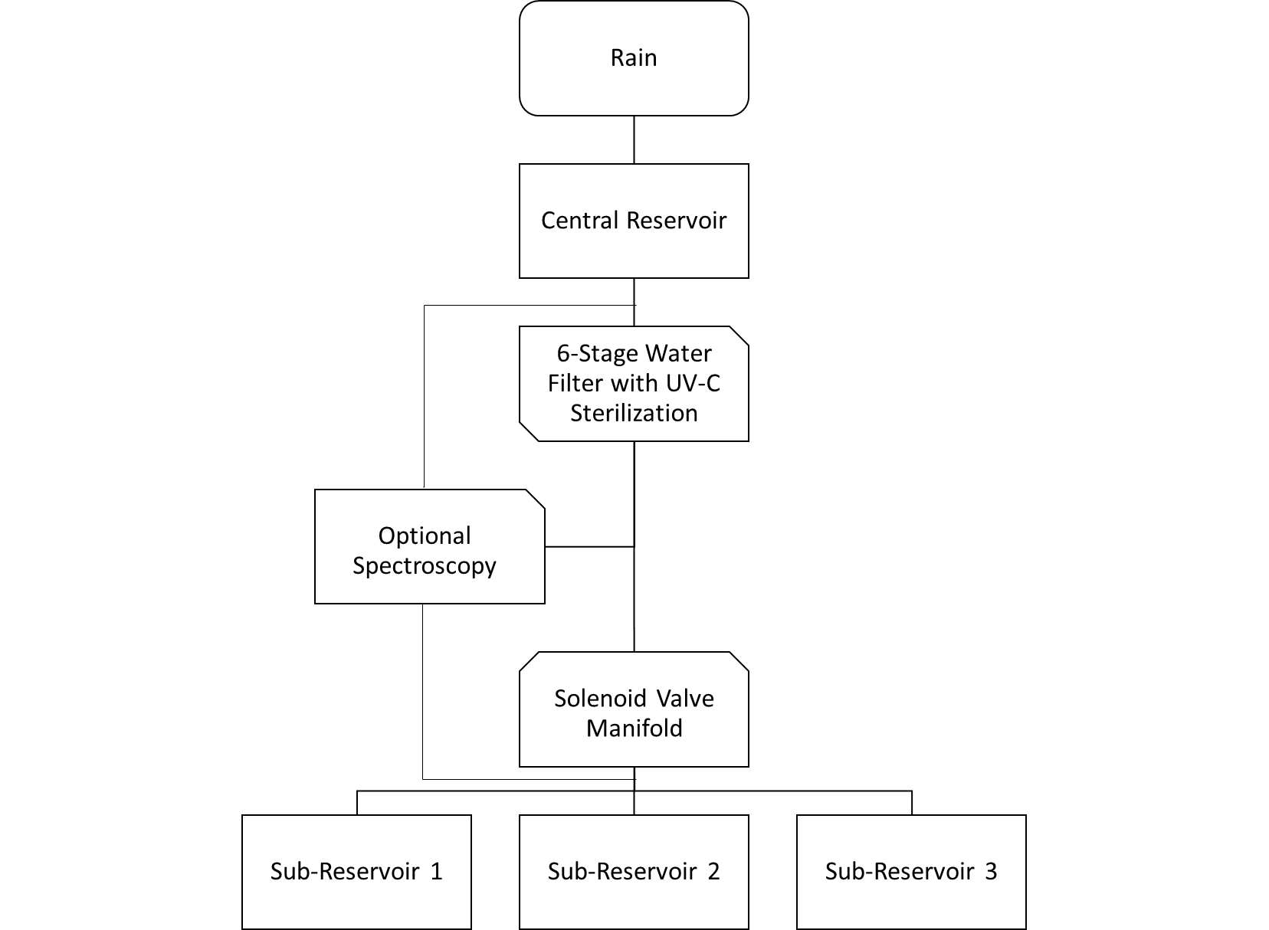

Fig. 1. Depiction of the flow of water through the rainwater collection system excluding inputs and outputs to different subsystems.

One of the major features of this project is the ability to use a Raman spectrometer to analyze the water content through any of the vinyl tubing in the entire system. This was accomplished by 3-D printing a small housing for the lens assembly that has a slotted sampling port in the center to slide the vinyl tubing into or out of the assembly. This allows a user to insert or remove the Raman spectrometer anywhere vinyl tubing exists in the system. To note, the spectrometer is a non-integral part of the system; it does not have any triggering functions. It is solely to allow a user to inspect the water quality anywhere in the system in the event they may need to make adjustments for system irregularities. This system is powered by a USB cable plugged into a laptop computer, and the analysis is conducted using OceanView, software provided by Ocean Insight. The spectrometer itself is an early model developed at Ocean Insight, and the laser source is a 785 nm wavelength laser that was also produced at the company.

*B. Photovoltaic Power*

Arguably the most important resource for our system is electrical power. Since this is a smart greenhouse, there are numerous sensors, pumps, and control boards that require power for operation. The utilization of photovoltaic power generation was selected for this system due to its renewable and sustainable nature. The greenhouse is intended to be usable and developable “off-grid” without access to standard municipal resources such as power and water. Solar energy presents an excellent solution to this problem because it is in abundance in Florida as well as the potential for mobility in the placement of solar panels.

The project overall required a large amount of power if each of the components were in use at the same time. Currently, this would never be the case due to systematic triggering from the software for the system, but to increase the efficiency and speed of the system’s functions, this could potentially be altered in the future. Therefore, two 100-watt monocrystalline solar panels were selected for their high efficiency, low cost, and portability. The panels charge a large 12-volt car battery using a solar charge controller. They are secured to a wooden mounting bracket that is outside of the main body of the greenhouse. There are some components in the greenhouse that required an AC power source, so a DC to AC power inverter was included in the power system as well.

*C. Hydroponic Nutrient Film Technique*

The main body of this project is the nutrient film technique hydroponic system. Of the many hydroponic methods, this method was selected for several reasons. Maintenance and automation were two of the biggest considerations. Unlike other hydroponic techniques like ebb and flow and deep-water culture, NFT systems typically require less maintenance due to the constant movement of the water through the system. The natural flow of water helps to keep the growth channels clear of buildup which reduces how much maintenance will have to be performed on the system in the long term. Automation also becomes easier using NFT systems because the pump cycle is constant while the dosing cycle is kept at a minimum. This means that we only need to trigger our sensors periodically to analyze the water as opposed to constant analysis, conserving power and increasing the lifetime of the electronics.

The hydroponic structure itself is relatively simple. It is a two-tier structure with two growth trays per level. Water is pumped in from the system sub-reservoir into the top of the structure, and it is split by a tee connector into the two growth channels. From there, the water is gravity fed through the top tier of plants before being channeled to the second level of plants. It is collected and recycled using only gravity back into the input can of the sub-reservoir to complete the water cycle. Each growth tray holds 9 plants for a total of 36 plants per hydroponic system. Originally, the structure was intended to hold 54 plants per system with either a three tier or three tray model, but for this pilot system, we opted to reduce the number of plants to improve our testing plan. The system currently only has a single functioning NFT system due to budget constraints; however, following the completion of this proof of concept, more money will be awarded to the project for completion of the greenhouse. This will allow the remaining reservoirs and structures to be built for use in the greenhouse.

*D. Nutrient and pH Deposition*

Plants would not be able to grow without the proper deposition of nutrients and pH balancers into the water, so an automatic deposition system was implemented to further negate the needs for a person to do it. Each NFT system will have its own deposition system featuring three storage containers. These containers store nutrient solution pH up solution, and pH down solution respectively. Previously, it was mentioned that there are two water sensors in the sub-reservoirs, an EC/TDS and a pH sensor.

These sensors rest vertically on a buoy in the output can of the sub-reservoir to check the electro-conductivity and pH levels of the water after dosing. By measuring these values at the top of the water in the output cannister, we are able to measure the distribution of the levels over time between the two cans due to the natural circulation of the water from the input and output structure of the reservoir. These sensors are set to trigger periodically when the deposition system is not active, and they read the values in intervals during the deposition activity. In this way, the system allows itself to take time to circulate the water before continuing the dosing process. In turn, this increases the amount of time it takes to completely balance the water levels because circulation time must be accounted for by the system. The deposition is accomplished using a peristaltic pump to have finely tuned control over the amount of solution that is put into the reservoirs. A water level sensor is integrated into the nutrient and pH storage containers to notify a user when they are low simply by looking at the control site using the local area network.

This system is also triggered each time the central water reservoir refills one of the sub-reservoirs to ensure the solutions are not diluted by the addition of more water into the system. Each NFT system has its own nutrient and pH deposition system. Every plant exhibits different preferences for pH ranges and nutrient ratios, so this allows a user to be selective about the kind of nutrients and pH solutions that are used in each NFT system.

*E. Greenhouse Control and Network*

The brain of the greenhouse consists of our control board featuring 2 microcontrollers as well as various peripherals. The main microcontroller, the MSP430FR2476, performs all of the operations required for the greenhouse. The main microcontroller is interrupt driven utilizing several timers and a number of different interrupts including ADC, UART and I2C. This microcontroller communicates with all of the sensors and pumps discussed previously as well as the secondary microcontroller, the ESP8266.

The secondary microcontroller is not necessary for the greenhouse to operate however it allows users to modify the greenhouse’s operation. This microcontroller establishes a local area network providing wireless communication over Wi-Fi with a user’s device. The ESP8266 also serves an HTML website which can be accessed via the user’s device using web browsers such as Google Chrome. This site acts as a user interface allowing users to examine and update sensor readings, as well as create, read, update, and delete plant profiles.

Plant profiles contain information regarding specific plants. The data includes minimum TDS and pH levels, maximum pH level, system number, and plant name. Modifying the system number enables or disables the plant profile for a given hydroponic system. For example, in a 3 hydroponic systems configuration, setting the system number to 3 will set the plant profile for system 3 to active. Setting the system number to anything outside of the range (1-3) will disable the plant profile. Only one plant profile at a time can be active for each hydroponic system. Changing the minimum TDS or pH range allows us to control when the nutrients and pH pumps will be run. If the sensors detect a level that is outside of our specified parameters, pumps are activated providing necessary solutions to shift the levels.

A simple solution to managing levels is used for each of our hydroponic systems. When an undesired level is detected, pumps are activated for a constant period. After some time, sensors are checked again, and the cycle repeats until proper values are returned.

### III. System Concept

This system is intended to be equipped with all the sensors it needs to be able to make its own decisions and make adjustments for itself when needed. A proof of concept for this design is accomplished in this project by showcasing the simple decisions that this greenhouse would make for a single system. To better understand the simple interactions of the system, a flowchart can be used to depict this process.

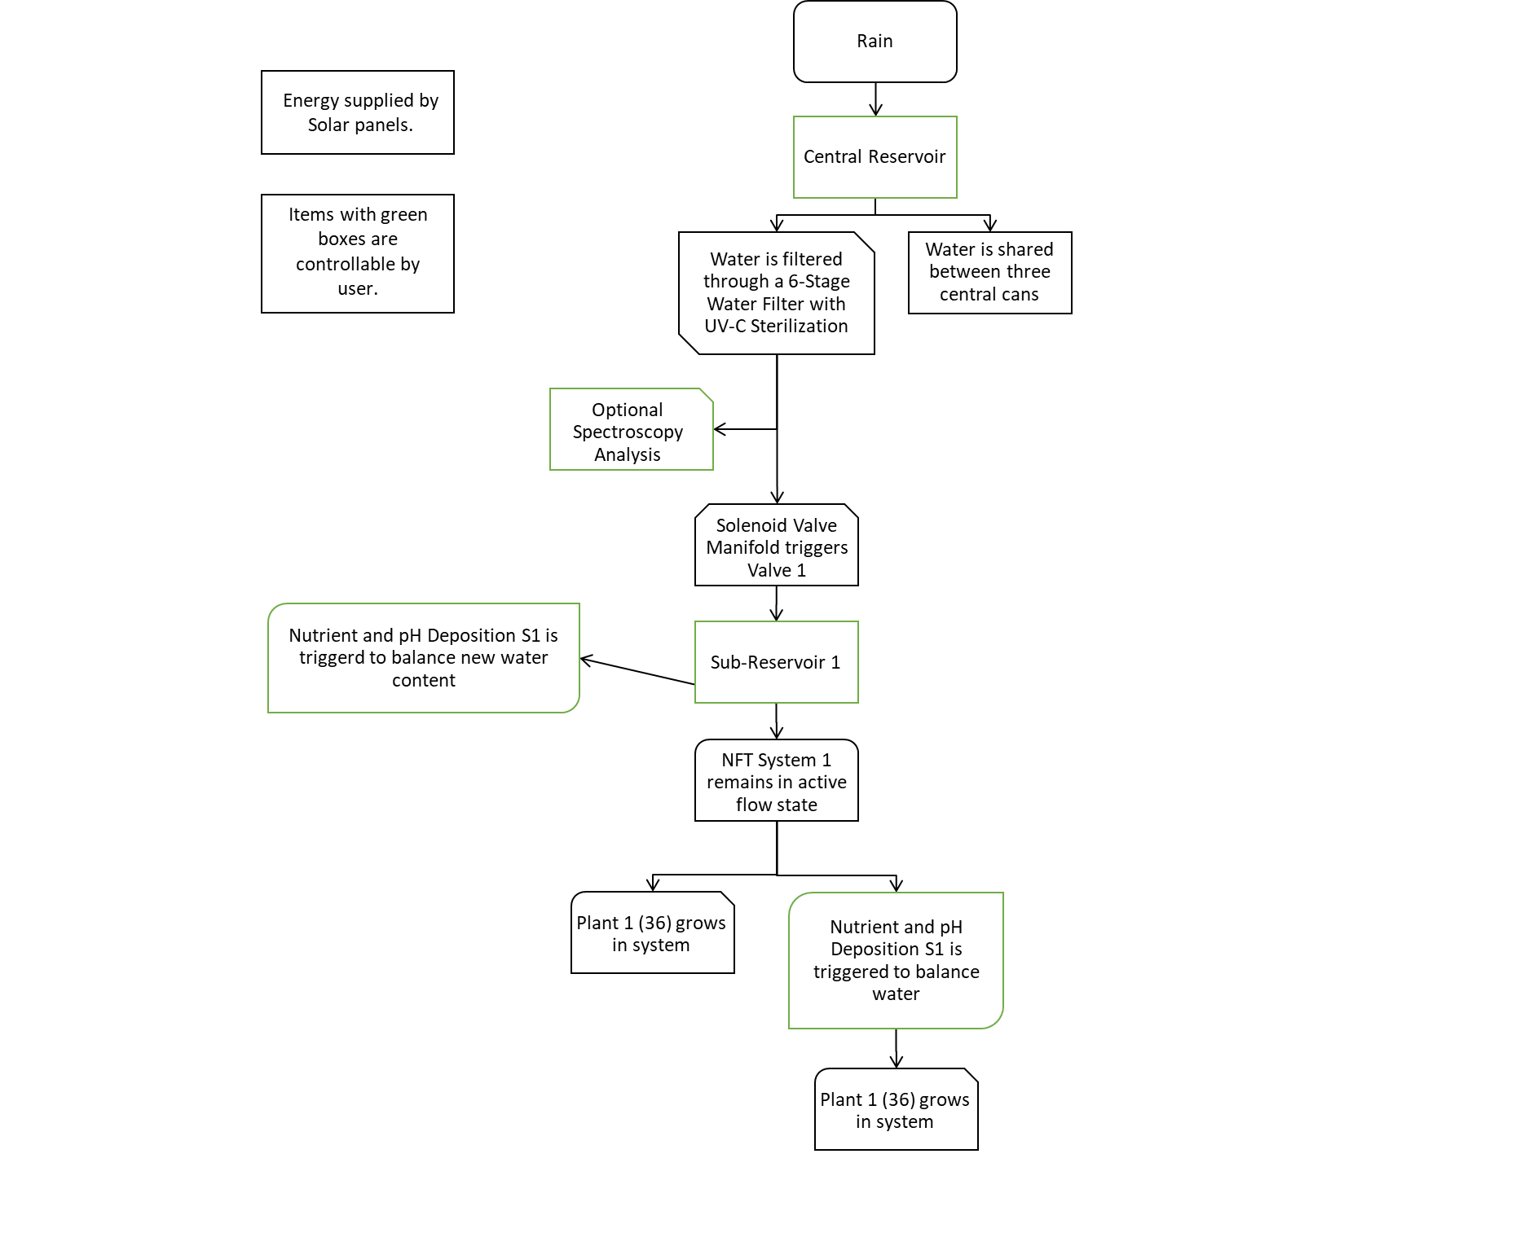

Is NFT System 1’s water level low?

Yes

Is NFT System 1’s water balanced properly?

Yes

No

No

Fig. 2. Flowchart demonstrating a simplified decision matrix used by a single NFT system to trigger other subsystems to balance the relevant water data for the specific system.

Though the system is intended to automate itself, it allows the user to independently control any of the system’s functionality, and it provides the user with simple options to alter the functions of the subsystems. Because a greenhouse should be a dynamic system that can produce a wide variety of plants, users can create and modify plant profiles that set the value ranges necessary for the plant to thrive. These plant profiles can then be selected for a specific system to reset its parameters to align with the new settings. The primary limitation of the system is that it does not employ the use of a drip irrigation technique that could deposit individual solutions to each plant. This means that each NFT system will be best suited for a single species of plant, but users could choose to plant crops with similar pH tolerance and NPK ratios within a single structure with a high success rate of growth.

No

The whole system has numerous interaction events between the various subsystems based on the feedback generated by the sensors.

### IV. Hardware Detail

This greenhouse hosts a variety of electrical and optical components intended for use in future greenhouse systems developed in municipalities as well as to satisfy the requirements set forth by the senior design curriculum.

*A. Electrical Components*

Looking back at the photovoltaic system we are provided with a 12V battery to power our greenhouse. Battery voltages can lie within a range of values, typically 10.5V ~ 14.4V. To mitigate the risks of burning up components a 12V DC regulator is added to our system to stabilize the voltages we receive from the battery. This 12V regulator is used in-line with the battery to power almost every component in the greenhouse.

Moving on to the PCB, this device hosts several components. For starters this system includes several pull-down resistors which prevent our liquid level sensors from providing a floating signal. Without these resistors, readings from our sensors would be unreliable. In addition, the PCB has voltage dividing resistors for all the analog input signals. These resistors provide us with a voltage that is easier to work with when performing analog to digital conversions from our pH sensors. Three capacitors can be seen at our voltage converter with the sole purpose of removing any AC noise from our power supply. Moving on from the more basic hardware components, we have two eight to one multiplexers, greatly reducing the number of pins required by the microcontroller for liquid level sensing. Without the use of multiplexers in our design we would require two pins for each liquid level sensor whereas the two-multiplexer configuration allows us to read 13 different liquid levels using three output pins and two output pins. The figure below shows this multiplexer configuration.

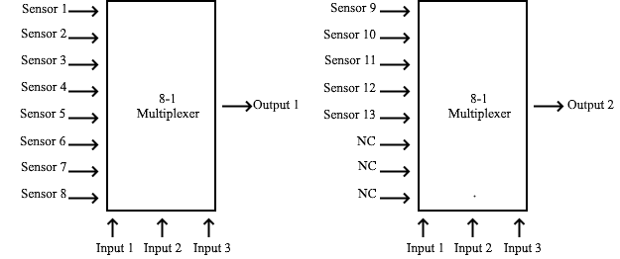

Fig. 3. Multiplexer configuration for liquid level sensing. Using 3 selection line inputs to control two eight to one multiplexers we can reduce the number of pins necessary for liquid level sensing.

Two seven output Darlington transistor arrays are used to provide controlled power to the pumps in our greenhouse. These output lines are capable of outputting up to 500mA of current to a given load and run at a specified 12V. For loads greater than 500mA, two or more output lines are connected to reach our required amperage. The PCB contains two microcontrollers with functionality as mentioned previously. The 48-pin MSP430FR2476, and the ESP8266. The ESP8266 comes in a module denoted as the ESP-01S. This module limits the number of pins available from the ESP8266 but provides appropriate functionality for wireless communication. It is also important to note that this module works in conjunction with two tactile buttons necessary for resetting the device and putting it into programming mode.

For each hydroponic system three peristaltic pumps and one water pump are used. In addition to these pumps, one solenoid and a higher output water pump is used for the overall system. All these devices operate at a regulated 12V and are connected to the Darlington transistor arrays allowing us to control when they are being activated.

Each hydroponic system also has a number of sensors, four liquid level sensors, one pH sensor, and one TDS sensor. The overall system also requires an extra liquid level sensor for our rainwater reservoir. These sensors operate at 3.3V suitable for use with our microcontroller.

*B. Optical Components*

Our optical system is comprised of 3 main components; UV-C for water filtration, photovoltaic panels for independent energy harvesting, and a Raman spectrometer to analyze shifts in wavelengths to detect water impurities throughout the system. Photovoltaics were covered in detail in a previous section leaving UV-C and Raman spectrometry to be covered in detail.

Ultraviolet light is attractive for filtering water due to its great germicidal properties. Since we desired a system with full control of most aspects of what the plants in the system receive, a purification and filtering step was used to help remove any unwanted aspects from the water that may reach the plants. Plants can be affected by many different impurities found in rainwater including chemicals, heavy metals, and other impurities that could alter the efficiency of plant growth. By filtering rainwater to remove most chemicals and heavy metals and by using ultraviolet to remove any other microorganisms, we can take almost complete control over the nutrients and water that the plant receives. Ultraviolet-C is the wavelength most used for germicidal properties which consists of the range between 100 nm and 280 nm. After our carbon-based filters, we used a stainless-steel cylinder with quarter inch tubing input and outputs for water to run through. A quartz tube was placed inside the housing to allow UV wavelengths to pass through into the water without making direct contact with our electronics. Inside the tube our UV-C bulb was placed attached to an AC 110V outlet that was powered by our 12v DC to 110V AC converter.

For our system we used Raman spectrometry to analyze the water running through the system. There are two techniques used in Raman spectroscopy, being stokes and anti-stokes Raman spectroscopy. For our system we used Stokes Raman spectrometry. When looking at Stokes Raman spectroscopy photons from the excitation source collide with molecules which result in some of the energy from the photons transferring to the molecule. This loss in expected energy can be measured which results in seeing a wavelength shift, known as a Stokes shift. When performing spectrometry of a sample to get the most beneficial reading a proper optical setup must be put in place to be able to have accurate reading. This involves selecting proper lenses as well as filters and coatings to be able to remove unwanted light with as little optical loss as possible.

Fig. 4. Graphic depiction of lens system to be translated to physical components for the use of water analysis through Raman spectrometry.

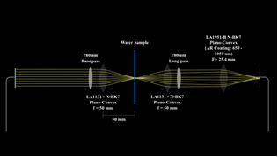

To translate our lens design into a physical system, initially we placed our lenses and filters on an optical table attached to lens posts and translation stages to further align our system to optimize the optical system. After performing these initial optical setups for our system, we later translated the system to a much cleaner 3D printed housing for our lenses and filter to be placed in. This not only made our system much more compact but also completely portable. Originally, we used a long pass and bandpass filter to properly pass our 785nm light though the system to allow for background light to be properly filtered out. After shifting our optical system into the 3D printed housing these filters became obsolete since the system was completely isolated from outside light sources. These filters were substituted with neutral density filters to reduce the intensity of our laser module. The 3D print was comprised of a black tube with slots for out lenses to perch and two ports on either side of the lens system. These ports were later fitted with a Newport SMA bulkhead and FC/PC bulkhead to properly interact with our fibers. The fibers we used were an FC/PC to FC/PC multimode fiber to connect our 785nm excitation source laser module and a SMA to SMA multimode fiber to connect to the Ocean Insights Raman spectrometer. This Raman spectrometer allows for the analysis of our water sample through the OceanView software provided by Ocean Insights.

### V. Software Detail

Software was developed for our greenhouse for both the MSP430FR2476 and the ESP8266. Both microcontrollers require separate off-board programmers to upload our programs. Both microcontrollers are also programmed using different IDEs. The MSP430FR2476 was programmed using code composer studio whereas the ESP8266 was done through Arduino IDE.

The MSP430 microcontroller required 3 separate programs. Two of these programs are used for calibrating the pH and TDS sensors as they do not come preconfigured. These sensors use the point-slope formula to determine accurate sensor readings and therefore require calibration at two separate levels. The pH sensor utilizes ADC making it difficult to calibrate the TDS sensor at the same time as it utilizes I2C. For this reason, two separate but similar programs were developed. To further explain how these programs operate we will look at the point slope formula.



Fig. 5. Point slope formula. Given two points, x1 and x2, we are able to calculate the slope, m given that we know the output at these two points. The value of b is given by reading output in open air, the point where you would expect a zero output to be read.

These two programs aim to configure this point slope formula for use in the greenhouse system program of the MSP430FR2476.

Diving into the MSP430FR2476 software, we went for a modular interrupt driven approach. This means that we were able to use the low-power features of the MSP430 microcontroller as well as ease the strain on programming.

Timer’s control much of our system and produce interrupts at specified intervals defined at the start of our code. These include sensor check timers, pump enable timers, and timeout timers. Sensors are checked at 15-minute intervals. It is imperative to let your solution mix before attempting to mitigate levels within your water solution. Water is circulated through our hydroponic systems and after some testing, we have found that the solution has been mixed after 10 minutes. Setting our timers to 15-minutes provides us with some extra padding for error. Peristaltic pumps within each hydroponic system as well as the overall system pump and solenoid are enabled sequentially when a value out of range is read from the corresponding sensors. These pumps and solenoids have separate defined times at the start of the code which remain active. It was necessary to configure our pump enable timer accordingly. When reading sensor values or performing other system tasks a timeout timer was used to provide some interrupt driven delay. Especially in the case of the TDS sensor, we were required to wait up to 600ms for some operations to occur.

Other forms of interrupts used include UART, I2C, and ADC. UART interrupts occur when MSP430FR2476 receives or can send data. This interrupt is important for communication with the ESP8266 microcontroller. ADC interrupts are made of use when dealing with the pH sensor. This sensor can trigger an interrupt when the ADC interrupt is enabled and has an analog signal available. The last interrupt, I2C, is useful when communicating with the TDS sensor. This interrupt is triggered when it is enabled and has received data from the TDS sensor, or.

VI. User Interface

Beginning

VII. Conclusion

Although

### Acknowledgement

The authors wish to acknowledge the assistance and support of the Oviedo Historical Society, City of Oviedo, and Ocean Insight.

Further acknowledgement and thanks are offered to Drs. Aravinda Kar and Lei Wei for their instruction and oversight throughout the Senior Design curriculum.

The authors offer their sincere thanks and gratitude to Drs. Issa Batarseh, Rodrigo Amezcua Correa, Suboh Suboh, and Mrs. Jacqueline Sullivan for offering their time and expertise in the evaluation of this project.

Finally, the authors wish to acknowledge and thank their friends, families, and professors for their unwavering support and unfettered belief in the pursuit of this project’s fabrication. This project may never have transcended the design phase if not for their encouragement.

### Biography

**Connor DiMatteo** is a 23-year-old Photonic Sciences and Engineering student with concurrent minors in Physics, Mathematics, and Prelaw. Connor is very passionate about sustainability and hopes this project will be the first step in improving sustainable initiatives in his hometown of Oviedo. He plans to work for a defense contractor to continue to explore the field of engineering in a cross-functional environment.

**George Kiriazes** is a 21-year-old Photonic Sciences and Engineering student. George has worked with many interdisciplinary groups throughout his college career during internships with Townes Institute Science and Technology Experimentation Facility, UCF’s wave propagation research group, and the NASA Glenn quantum communication space communications and navigation group.



**Kaleb Morgan** is a 24-year-old Computer Engineering student. Kaleb has been working with computers and electronics for several years developing both software and hardware solutions to outstanding problems. Kaleb currently works with a small team of engineers at Regal Marine automating tasks for the boating industry.

### References

[1]

