



Direct Absorbance Bilirubin Spectrometer (DABS)

Bernardin Dezius, CpE

Juan Gonzalez, EE

Kevin Kuzius, EE

Kevin Landau, PSE

Andrea Wetteland, PSE

Group 4

Fall 2019

EEL4914

*Department of Electrical and Computer Engineering*

*And*

*The College of Optics and Photonics*

Contents

1 Project Description 1

1.1 Project Motivation 2

1.2 Goals and Objectives 2

1.3 Functionality 3

1.4 Requirement Specifications 4

1.4.1 Dimensions 4

2 Executive Summary 5

2.1.1 Cost 6

2.1.2 Safety. 7

2.1.3 Dependency 7

2.1.4 Optical Source 7

2.1.5 Sample Input (Cuvette) 8

2.1.6 Power 8

2.2 Overall View of Design 8

3 Research and Background Information 11

3.1 Existing Similar Projects and Products 11

3.1.1 Consumer Products 11

3.1.2 Project Design Considerations 13

3.1.2.1 Type of Bilirubinometer 13

3.1.2.2 Light Source 13

3.1.2.3 Sample Input 14

3.1.3 Existing issues 14

3.2 Relevant Technologies 15

3.2.1 Optical Methods of Bilirubin Analysis 15

3.2.1.1 Optical Method Summary 17

3.2.2 Electrical Components 17

3.2.2.1 ADC 18

3.2.2.2 DC-to-DC Converter 18

3.2.2.3 Amplifier 19

3.2.3 Battery and Charging 20

3.2.3.1 Relevant Battery Systems 20

3.2.3.2 Relevant Charging Technologies 26

3.2.4 Cooling System 29

3.2.4.1 Thermoelectric Cooler 29

3.2.4.2 Cooling Fan 30

3.2.5 Code Composer Studio 31

3.2.6 Touchscreen user Interface 32

3.2.6.1 Comparison: 33

3.2.7 Serial Communication Protocols 34

3.2.7.1 SPI 34

3.2.7.1.1 Major Pros and cons 36

3.2.7.2 . I2C 36

3.2.7.2.1 Major Pros and Cons 37

3.2.7.3 UART 37

3.2.7.3.1 Major Pros and Cons 38

3.2.7.4 USB 38

3.2.7.4.1 Major Pros and Cons 39

3.2.7.5 Summary 40

3.3 Strategic Component and Part Selections 40

3.3.1 Optical Source 40

3.3.2 Sample Input 44

3.3.2.1 Cuvette 48

3.3.3 Photodetector 49

3.3.4 Transimpedance Amplifier 57

3.3.4.1 Introduction to the TIA 57

3.3.4.2 Designing the Transimpedance Amplifier 58

3.3.4.3 Complete Transimpedance Amplifier Package 62

3.3.4.4 Conclusion 62

3.3.5 Microcontroller 62

3.3.5.1 Key Features of Potential Microcontroller 63

3.3.5.2 Input and Output (I/O) 65

3.3.5.3 Communication Protocols 67

3.3.5.4 Microcontroller Operating Conditions 70

3.3.5.5 Choosing the Microcontroller 72

3.3.6 Touchscreen Display 73

3.3.7 Printed Circuit Board 75

3.3.8 Battery Charging Initial Schematic 75

3.3.9 Power Source 77

3.4 Parts Selection Summary 77

3.5 Software Tools 79

3.5.1 Communication 79

4 Related Standards and Realistic Design Constraints 81

4.1 Standards 81

4.1.1 Sample 81

4.1.2 Light Source Standards 81

4.1.3 Battery Standards 81

4.1.4 Health, Safety, and Ethical Standards 83

4.2 Realistic Design Constraints 83

4.2.1 Economic 83

4.2.2 Light Source 84

4.2.3 Sample Constraint 84

4.2.4 Optical Filters Constraint 84

4.2.5 Time Constraints 84

4.2.6 Testing Constraints 85

5 Project Hardware and Software Design Details 86

5.1 Microcontroller System 86

5.2 Optical Subsystem 87

5.3 Software Design 89

5.3.1 Autodesk EAGLE: PCB Design Software 89

5.3.2 Use Case Diagram 91

5.3.3 Startup and Bootup Process 92

5.3.4 Graphical Display 93

5.3.5 Touch interface 94

5.3.6 Optical Sensor Algorithm 94

5.3.7 Cooling System 95

5.3.7.1 General Temperature Test Plan 96

5.3.8 Low-power mode 97

5.4 Housing Design 98

5.5 Integrated Schematics 105

5.5.1 DC to DC Converter 106

5.5.2 Amplifier Circuit 109

5.5.3 DC Power Circuit 110

6 Project Prototype Construction and Coding 112

6.1 PCB Vendor and Assembly 112

6.2 Final Coding Plan 114

7 Project Prototype and Testing Plan 116

7.1 Hardware Test Environment 117

7.1.1 Optics Test Environment 117

7.1.2 Electrical Components Test Environment 119

7.2 Hardware Specific Testing 120

7.2.1 DC Power 120

7.2.2 Charging 122

7.2.3 Temperature Sensor 123

7.2.4 Cooling System 124

7.2.5 Microcontroller 125

7.2.6 LED Source 125

7.2.6.1 Characterization Testing 125

7.2.6.2 Green Diode 126

7.2.6.3 Drive Current 126

7.2.6.4 Power vs Time 126

7.2.6.4.2 Blue LED Diode 128

7.2.6.5 Integration Testing 130

7.2.6.5.1 Light Source vs Cuvette 130

7.2.6.5.2 Light Source vs Photodiode 130

7.2.6.5.3 Light Source vs Power Source 130

7.2.6.5.4 Light Source vs Microcontroller 131

7.2.6.6 Light Source Testing Schedule and Equipment 131

7.2.7 Sample Input 132

7.2.7.1 Preparation and Characterization 132

7.2.7.2 Calibration and Integration Testing 133

7.2.8 Photodetector 134

7.2.8.1 Characterization Testing 134

7.2.8.2 Dark Current 134

7.2.8.3 Photogenerated Current 135

7.2.8.4 Photodiode vs Cuvette and Samples 136

7.2.8.5 Photodiode vs Integration Testing 138

7.2.9 Transimpedance Amplifier 138

7.2.10 Touchscreen 138

7.2.10.1 Touch Response Output Voltage Range 138

7.2.10.2 Input Current Range 139

7.2.10.2.1 Active Mode 139

7.2.10.2.2 Low-Power mode 140

7.3 Software Test Environment 140

7.4 Software Specific Testing 140

7.4.1 Display/SPI Communication 141

7.4.1.1 SPI Communication/Driver 141

7.4.1.2 Graphical Driver 142

7.4.1.3 Graphics Library 143

7.4.2 Touch Response/Coordination 144

7.4.3 Low-power mode 145

7.4.3.1 Screen off and back on 145

7.4.3.2 Touch response wake up 145

7.4.3.3 Sleep timer 146

7.4.3.4 Sleep mode - Simulated button 147

8 Project Operation 148

8.1 General Information 148

8.2 Safety Considerations 149

8.3 Device Calibration 149

8.4 Using the Spectrometer 149

9 Administrative Content 151

9.1 Milestone Discussion 151

9.2 Budget and Finance Discussion 153

9.3 Stretch goals 155

10 References 156

11 Appendix A: Datasheets 160

12 Appendix B: Permissions 161

List of Figures

Figure 1. The absorbance spectra of bilirubin and hemoglobin. 1

Figure 2. Enclosure measurement constraints. 4

Figure 3. Simple block diagram on the overall design functionality. 9

Figure 4. Philips Bilichek with disposable tips and phototherapy patches. 12

Figure 5. EasyBil (Left) and UNISTAT (Right). 13

Figure 6. The absorbance spectra for bilirubin and hemoglobin [1]. 15

Figure 7. ADC settings and configuration. 18

Figure 8. Design for a buck converter. 19

Figure 9. Volts vs time when charging a lithium-ion battery. 26

Figure 10. Configuration of charging circuit using the MCP7381. 27

Figure 11. Configuration using the MCP73213. . 28

Figure 12. Schematic Diagram of the Peltier Effect. 30

Figure 13. Illustration of a p-i-n semiconductor laser diode. 41

Figure 14. Spectra from a Green LED. 42

Figure 15. Vendor wavelength emissions, voltage and current specifications. 44

Figure 16. Absorption spectra of curcumin. 45

Figure 17. Absorption spectra of bilirubin. 46

Figure 18. Absorbance of betalain at various pH balances. 47

Figure 19. Cuvettes prepared with betalains (left) and curcumin (right). 49

Figure 20. Spectral responses of photodiodes. 56

Figure 21. Transimpedance amplifier (From DigiKey ArticleLibrary) 58

Figure 22. DC Analysis (From Texas Instruments) 59

Figure 23 AC analysis (from Texas Instruments) 60

Figure 24 Circuit diagram for OPA170 61

Figure 25. Battery charging circuit for the Li-Ion battery [18]. 76

Figure 26. Setup of the optical subsystem. 88

Figure 27. Derivation for new optical path length. 88

Figure 28. EAGLE Schematic OpAmp Design Example. 89

Figure 29. ERC Error Display 90

Figure 30. DRC Error Report. 91

Figure 31. Use case diagram of system’s operation. 92

Figure 32. Flowchart of Bootup/Startup process 93

Figure 33. Flowchart of touch response interface 94

Figure 34. Flowchart of optical sensing process 95

Figure 35. Flowchart of Low-power mode process 97

Figure 36. 3D printers available in the CREOL senior design lab 99

Figure 37. Black Delrin Plastic 101

Figure 38. Black Acrylic Plastic 102

Figure 39. First draft of base design for project to present to machine shop instructor for initial design constraints. 103

Figure 40. Preliminary concept design for the project housing 104

Figure 41. Buck Converter with an output of 3.3 Volts. 107

Figure 42. Efficiency of the TPS62743 buck converter. 108

Figure 43. Buck-boost converter circuit to provide 3.7 volts to the laser. 109

Figure 44 Transimpedance Amplifier Schematic Design 109

Figure 45. DC Power Circuit. 111

Figure 46 - Examples of User Interface menus 115

Figure 47. Connection of the main battery to a 2.1KΩ load. 121

Figure 48. Charging IC for the Li-polymer battery. 122

Figure 49. Connection of LM35 to the microcontroller. 123

Figure 50. Simple configuration of the fan connection to microcontroller. 125

Figure 51. Green Diode Power vs Time test table. 126

Figure 52. Green laser diode Power vs Time graph 127

Figure 53. Emission spectra of green laser diode. 128

Figure 54. Emission Spectra of blue LED. 129

Figure 55. Known concentrations used to establish molar extinction coefficients. 133

Figure 56 Test Circuit for Photodiode - Reverse Bias Operation 134

Figure 57. Display being reset using command over SPI. 142

Figure 58. Displaying text data along with shape objects sent to the display. 143

Figure 59. Calibration of screen for touchscreen. 144

Figure 60. Side-by-side of PWM = 0 testing. 145

Figure 61. Process for ADC interrupt of touch signals. 146

Figure 62. Milestone timeline calendar. 152

List of Tables

Table 1. Estimated budget for project. 6

Table 2. Advantages and disadvantages of popular battery chemistries. 21

Table 3. Key features of the MCP73213 and MCP73821. 29

Table 4. SPI pros and cons. 36

Table 5. I2C pros and cons. 37

Table 6. UART pros and cons. 38

Table 7. USB pros and cons. 39

Table 8. Communication Spec Comparisons 40

Table 9. Specs for green light source. 43

Table 10. Absorption table for bilirubin, hemoglobin, betalain, and curcumin. 48

Table 11. Comparison of photodiodes. 55

Table 12 OPAMP Design Goals 60

Table 13. OPA857 Key Design Features. 62

Table 14 Project Pin Planning 67

Table 15. Advantages and Disadvantages to the SPI and I2C. 68

Table 16 Advantages and Disadvantages to the UART and USB 69

Table 17 MSP430 Operating Conditions 70

Table 18 MSP432 Operating Parameters 71

Table 19 Arduino Due Operating Parameters 72

Table 20. Component Summary. 78

Table 21. Safety specifications for lasers. 82

Table 22 Tentative Testing Schedule 131

Table 23 Light Source Testing Equipment and Status 132

Table 24. Dark Current of photodiodes. 135

Table 25. 532 nm Laser Diode measurements. 135

Table 26. 460 nm LED measurements. 136

Table 27. 532 nm Laser Diode measurements at mW. 136

Table 28. 460 nm LED measurements at mW. 137

Table 29. Project milestones. 151

Table 30. Bill of Materials Optical and TIA 153

Table 31 Bill of Materials Power and Miscellanous Components 154

Table 32. Bill of Materials MCU, Display, PCB and Temp Control 154

# Project Description

Nearly 60% of all newborn infants have jaundice due to a build-up of bilirubin. Most instances can be treated with direct sunlight and are non-threatening, but in concentrations over 24 mg/dL, more serious and permanent damage can be sustained if treatment such as phototherapy is not given.

In Figure 1, the absorbance spectra of bilirubin (in orange) is interfered by the absorbance of hemoglobin (in green), but a second measurement of hemoglobin at 540 nm will determine the amount the 460 nm measurement will be corrected.

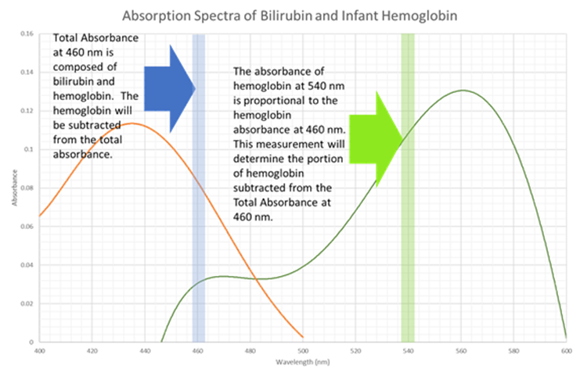

Figure 1. The absorbance spectra of bilirubin and hemoglobin.

The Direct Absorbance Bilirubin Spectrometer (DABS) is a low-cost, in-home device meant for new parents to determine if the bilirubin concentrations are non-threatening or if they necessitate hospital treatment. DABS will determine the bilirubin concentration using two absorbance measurements at two wavelengths. In neonates, bilirubin absorbs light at 460 nm. No other substances present in blood at this age absorb light at this wavelength, besides hemoglobin. Hemoglobin also absorbs light at 460 nm and has an absorbance peak at 540 nm. The ratio of hemoglobin at both wavelengths in full-term infants is constant enough so that an accurate bilirubin reading can be obtained by subtracting hemoglobin absorbance from the 460 nm absorbance measurement relative to the hemoglobin absorbance measurement at 540 nm

DABS will determine the concentrations of hemoglobin and bilirubin at these two wavelengths by illuminating a blank sample with two light sources, one at 532 nm and one at 450 nm, and recording this initial intensity. A blood sample or proxy will then be illuminated and the transmitted intensity at each wavelength will be recorded. The absorbance at each wavelength will be determined using the Beer Lambert Law equation,A=-log(I0/I). Absorbance at 460 nm due to bilirubin will be determined by subtracting Ahemoglobin(460 nm) determined by its ratio to Ahemoglobin(532 nm). The concentration of bilirubin in the sample with be determined by the Beer’s Law equation A=e*l*c, with e being the inherent absorbance coefficient of bilirubin at 460 nm, l being the pathlength the light travels through the sample, and c being the concentration in mol/L. The molar weight of bilirubin will be used to convert the concentration in mg/dL. This final recommendation and, if it is higher than 15 mmol/dL, a recommendation to seek medical attention will be displayed for the user.

## Project Motivation

Neonatal hyperbilirubinemia, or jaundice, is a common condition in newborns wherein elevated concentrations of bilirubin causes yellow discoloration of the skin and eye whites.  Bilirubin is the product of hemoglobin being broken down. When the neonate liver is incapable of processing the bilirubin because of increased production, decreased excretion, or other impaired mechanic, an excess concentration can occur.  Levels resulting in visible discoloration occur in almost 60% of all neonates. At higher levels (308 μmol/L), the bilirubin is toxic to the neonate brain, and encephalopathy or brain damage (kernicterus) can occur without treatment. For less extreme cases, sunlight exposure is sufficient to aid the neonate in processing bilirubin.  Phototherapy treatment is successful in treating hyperbilirubinemia in most extreme cases, therefore the key issues timely diagnosis and treatment.

Bilirubin concentration levels usually rise to dangerous levels 3-4 days after birth.  Unfortunately, many infants and mothers are discharged from hospitals 2 days after birth, so hyperbilirubinemia is often not detected until the first pediatric checkup, often 5-7 days after birth.  Due to the commonality of neonatal jaundice, many parents noticing the yellow discoloration in infants are advised by doulas and internet searches not to worry, or to just keep the baby near a window to provide sunlight exposure.  This means more serious cases of hyperbilirubinemia can go undiagnosed for days. This project aims to allow new parents to test neonate bilirubin concentrations from home, offering peace of mind for mild cases, and earlier detection for more severe cases.

## Goals and Objectives

The Direct Absorbance Bilirubin Spectrometer (DABS) will make it possible to get an accurate bilirubin concentration from the home.  The goal is to measure 100% of samples with 90% or greater accuracy. Greater sample accuracy is not necessary, as the purpose is to alert parents as to whether the infant should be taken to the hospital for more accurate testing.  For our device to have the value of in-home convenience, the device must have a simple interface that a person with a non-scientific background can operate. Most persons with a non-medical background will not be comfortable withdrawing large amounts of blood from a newborn, so the required sample size must be small enough to be obtained with a pinprick.  The device must also be smaller than a breadbox and lightweight, for ease of use and to reduce the burden of shipping costs to the user. Because a major purpose of the device is to offer early detection by a few days, it would not make sense for parents to purchase a device after they already suspect elevated bilirubin levels. The device must be affordable, so that it is not prohibitive for most parents to preemptively purchase or borrow a device before birth.

## Functionality

Bilirubin is a yellowish-orange and absorbs light at 440 nm. Hemoglobin also absorbs light at 440 nm but absorbs light at 528 nm in equal measure. DABS will shine sources of light, at around 550 nm, through a cuvette and use a photodiode array to measure the transmitted intensity of the wavelength. The absorbance of each wavelength will be calculated with Beer’s law. By using a clean control sample as a reference sample, the resulting relative change in current detected by the photodiode through the bilirubin sample and corresponding circuit will provide a bilirubin concentration.

One of the most common techniques to measure bilirubin concentration in serum or plasma is the “Diazo” method. This method involves using various diazo dyes in the presence of an accelerating agent into a coupling reaction to have conjugated bilirubin which is water soluble. The results of this method are limited by sample hemolysis as well as the concentration of hemoglobin and bilirubin in the sample.

Direct spectrophotometric and diazo methods are only effective to measure bilirubin in neonates younger than 2 to 3 weeks old since other pigments such as carotenoid start to develop and absorb at 454 nm. Once the neonates’ age is past the 2 to 3 weeks mark another method known as HPLC or High-Performance Liquid Chromatography can be performed. This chemical method is not subject to interference from hemoglobin or lipemia, but it is very labor intensive and impractical for routine use.

## Requirement Specifications

### Dimensions

The dimensions of the final working product will have the following specifications: no more than 13 x 8 x 5’’ cubic inches. Figure 2. demonstrates the dimensions specified but does not show the finished enclosure of the final product, just a representation of the dimensions. All the components selected, and testing will be done inside the specified measurement.

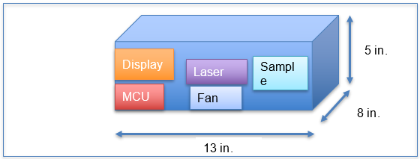

Figure 2. Enclosure measurement constraints.

# Executive Summary

A common diagnostic checkup performed on newborn infants is a bilirubin level check. This test is commonly performed on newborns since their livers are often not capable of processing bilirubin within the first few weeks of life. Bilirubin is a yellowish substance in blood that forms after red blood cells are broken down that then gets filtered through the liver, gallbladder, and finally digestive tract before being excreted. Neonatal hyperbilirubinemia is a common condition amongst neonates where approximately 60% experience levels resulting in yellowish discoloration of the skin and eyes. Most cases are not severe and are easily remedied with exposure to sunlight to aid the neonate in processing bilirubin. For more extreme cases, the excess concentration of bilirubin is toxic to the neonate brain and may cause brain damage which may cause impairments such as cerebral palsy, visual and hearing loss if not treated in a timely manner.

Most newborn infants and their mothers are discharged early from hospitals under the pretense that the infant is healthy and if neonatal hyperbilirubinemia was not predicted at the time it is often not diagnosed until a following checkup. Since neonatal jaundice is so commonplace, parents of neonates who notice discoloration in their infants are advised not to worry and expose the infant to sunlight, but this means many more serious cases may go undiagnosed for days. This may lead to an increase in incidences of brain damage amongst neonates who develop jaundice.

There are several methods that can be used for measuring bilirubin concentration, but this project will focus on a proof of concept utilizing a monochromatic direct absorbance spectrophotometer to analyze a sample for its corresponding bilirubin concentration. The aim of this project is to show a proof of concept design that should be affordable to the common consumer and simple to use, such that parents can monitor their infant at home after being discharged from the hospital if they desire. The runtime for the analysis of this design should be quick and the results should be easily interpreted without the need for medical or technical knowledge which would alert the user if the sample has healthy or dangerous levels of bilirubin.

The spectrophotometer will be composed of 2 unique monochromatic light sources, 2 photodetectors for each corresponding wavelength, a cuvette holder, at least 2 cuvettes where one holds a reference sample and the other holds the test sample, and a display for the interface with the user as well as displaying the results with the recommended action. The 2 wavelengths that are going to be targeted are 550 nm where hemoglobin has an absorption peak and then 460 nm where bilirubin and hemoglobin have high absorption peaks. Using the 550 nm laser diode source will give a specific reading which will be used as a reference sample to zero out the absorption of hemoglobin when the 460 nm light source is used, resulting in only reading the absorption due to our target compound that is bilirubin.

Since this project has no sponsors and the members of the team are all college students, the budget and accessibility to bio-organic compounds for testing are the largest constraints of the process thus far. Bilirubin is difficult to measure on its own since it is unstable and thus is usually paired with specific Diazo reagents to form azobilirubin for accurate measurements. The kits for the Diazo agents and proxy bilirubin are expensive so for the primary tests we will be using turmeric to mimic the absorption spectra of bilirubin and benzolain (beetroot powder) to mimic the effects of hemoglobin. This should provide a proof of concept for the rapid prototype ensuring that this design would indeed satisfy all the requirement specifications set. If all the testing goes well then as the deign matures further into completion a kit will be purchased to perform the analysis on the azobilirubin and proxy blood.

### Cost

The overall estimated budget for procuring equipment desired for this project is detailed in Table 1. Component selection will be determined based on the budget specified for that specific component and additional funding will be required if the component is crucial in the execution of the final design.

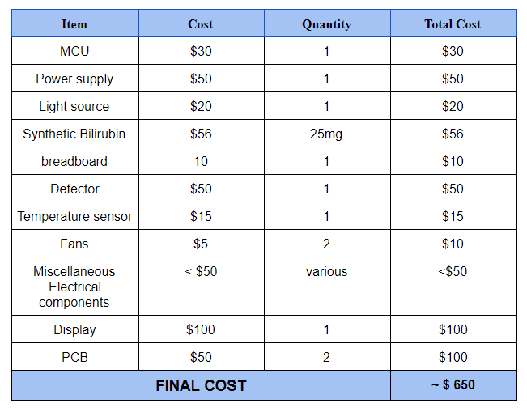

Table 1. Estimated budget for project.

### Safety.

The project device and all selected components should:

* pose no risk to the end user or cause bodily harm.
* Components like electrical connections, battery charging, and the encloser for all components should not add any potential risk to the environment.
* All electrical and optical components will be enclosed in a housing so there are no exposed electronics or optical beams reducing all risks of potential injury

### Dependency

The overall design shall output accurate data with at least 90% accuracy. The device will be calculating very delicate health-related data and should be reporting accurate data analysis done by the chosen microcontroller. Not only is the microcontroller calculating the data but also reporting the analysis to the end user and notifying them of actions to be taken based on the results

### Optical Source

Sources must have significant output bandwidth at 460nm and 550 nm. Because of the potentially high extinguishing coefficients in blood, each light source should be 10 – 50 mW at the specified wavelengths so there is a high signal to noise ratio. The intensity can be attenuated as needed with an ND filter.

An accurate reading will be based on a ratio of the initial intensity and the transmitted intensity. In both measurements, the incident beam must have the same intensity. Some diodes and LEDs have increased intensity after lasing continuously for more than a couple seconds. While these intensity increases can be accounted for, the increase must be deterministic.

To meet the overall power consumption requirements for the project, the two diodes should each not consume more than 5 V to operate.

The relationship between the absorbance at green and the absorbance at blue will only be deterministic if the absorbance reading is at a specific wavelength. (Narrow bandpass filters are another option to limit the light that reaches the photodiode to a specific wavelength, but they can be expensive.) DABs will control the wavelength by sending beams with very narrow spectra. Ideally, the full-width-half-max (FWHM) for each beam’s wavelength spectra will be under 3nm.

### Sample Input (Cuvette)

The cuvette must provide a calibrated optical path length and allow for transmission for our two wavelengths in the visible range. The transmission percentages must be equal for both wavelengths and have less than 2% error, as accurate measurements are dependent on the two transmitted intensities relative to each other. As the devise is ostensibly to be used by persons with non-medical skillsets and the serum is to be taken from infants under three weeks, it is important that the required sample should be no more than 3mL.

### Power

To ensure the project design is able to function properly with the main power source, the following specifications have been placed on the power system:

* Low Voltage – DC voltage supplied by a chosen battery chemistry will not exceed 12 volts.
* Stable Voltage – Voltage throughout the entire system must not fluctuate. more than 0.5 V after the device has turned on.
* Size – DC to DC converters will be limited to 100 mm x 100 mm.
* Cost – The cost of the main power source must not exceed $50.
* USB (Option) – The end user must be given a second option to power the device when the main power source has been drained and cannot operate until fully charged.

## Overall View of Design

The block diagram in Figure 3. shows a simplified description on how the overall design functionality of our project will work and how each component will interact with each other. Figure 3. also shows the block status along with a legend specifying each individual’s responsibility in this project.

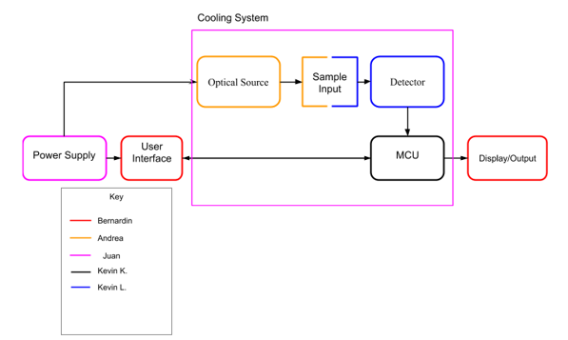

Figure 3. Simple block diagram on the overall design functionality.

Figure 3. also shows the block status along with a legend specifying each individual’s responsibility in this project. With that said, each block will operate as follows to some extent:

* **Power Supply** – The main power source will supply power to all the components which are optical source, user interface, MCU, and cooling system.
* **User Interface** -The touch screen user interface will provide users to navigate through the settings to test or read the results from a test.
* **Optical Source** – Will have a laser that goes through a sample input and be detected a photodetector.
* **Sample Input** – The sample Input will contain the sample of choice to be tested. We wish to prove the ability of this device to determine the bilirubin concentration in a blood sample, but due to IRB restrictions we will using a proxy with similar absorption spectra.
* **MCU** – The microcontroller chosen will do the calculations and analysis from the input of the photodetector. The MCU will also turn on the cooling system and vice versa.
* **Cooling System** – The cooling system will cool the laser and other electrical components including the MCU. To include a temperature sensor to read the temp inside the enclosure and a system of fans to cycle air through, to help regulate the temperature.
* **Detector** – The detector will be a photodetector taken an specific wavelength and converting it to a current source for analysis
* **Amplifier** – once the detector picks has a current reading, it needs to be converted to a usable output voltage. The output voltage will be able to be detected by the microcontroller, and thus be able to start the calculations to determine the concentration of bilirubin in the sample.
* **Display/Output** – The results of the MCU will be displayed to the end user on the chosen display. The display will also serve as the user interface, to guide the user through calibration and sample measurements.

# Research and Background Information

Like all designs, a good amount of research is essential in developing and implementing a successful project. High quality research produces unacquired knowledge to the team that is applicable to the design and serves as a guidance when deciding on critical components. There are similar products, materials, hardware designs, etc., that are out in the current market that have the same objective goal or functionality as the project goal of this design.

Many come with advantages and disadvantages and choosing a critical component requires a deep exploration in the availability and reliability of said component in achieving the desired outcome of this project.

## Existing Similar Projects and Products

### Consumer Products

There are many spectrophotometers currently in the market for a wide range of applications ranging from medical diagnosis to chemical analysis of substances. Spectrophotometers that are primarily used for bilirubin measurements can be broken down into 2 groups:

* Transcutaneous measurements
* Bench-top

Transcutaneous methods for bilirubinometry is a relatively new method of measurement compared to bench-top and traditional chemical blood laboratory analysis. A transcutaneous measurement is a measurement taken across the skin instead of intravenous methods that require a needle to prick the skin and draw some blood to be analyzed. Traditionally newborn infants are pricked by a heel stick or venous puncture to draw blood for analyzation, but this causes pain and discomfort to the infants and anxiety for the parents (ncbi – PMC2435331). This discomfort to the infant as well as modern health care norms where infants are discharged from hospitals earlier and with fewer routine tests, brought about the transcutaneous method of measurement.

The transcutaneous devices are noninvasive and direct a white light source into the skin of the newborn, usually on the head, to measure the reflected intensity of specific wavelengths. This measurement must then be subtracted by the known spectral properties of interfering components in the skin to determine an accurate bilirubin measurement. Initially these types of devices face difficulties in taking accurate measurements after the newborn had undergone phototherapy and failed to have accurate results on neonates with darker pigmentation. Measurements taken by these devices are known as transcutaneous bilirubin or TcB compared to conventional measurements that take a blood sample which are known as total serum bilirubin or TSB. These challenges have been tackled throughout the years and now there are several bilirubinometers that claim to have a strong correlation with measurements taken by HPLC on most cases.

There are many companies starting to make bilirubinometers such as BiliCare by Natus and BiliProbe by AVI Healthcare, but the most well-known transcutaneous bilirubinometer that is accepted by professionals is BiliChek by Philips.

The Image below was taken from Philips BiliChek webpage [32].

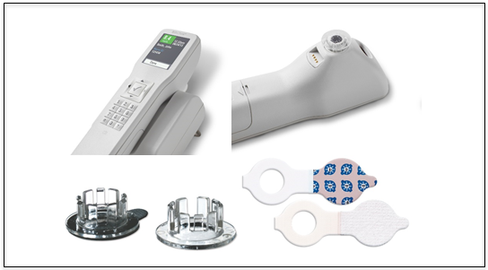

Figure 4. Philips Bilichek with disposable tips and phototherapy patches.

The Philips Bilichek has been clinically proven to be accurate with a strong correlation to HPLC with no pain, trauma, or risk of infection associated with drawing blood in patients of gestational age 27 to 42 weeks and postnatal age of 0 to 20 days (accessmedical). This device should only be used by properly trained personnel and can be used for pre, during, and post phototherapy with the use of the phototherapy patch shown in the figure above. Overall the BiliChek system is an efficient and helpful tool with a price point at around $6000.

The bench-top bilirubinometers are used to analyze the blood and find the total serum bilirubin (TSB) which is the medical standard for testing bilirubin. They are usually a spectrometer with two wavelengths in a box housing with a few buttons and a display screen. It needs to have a cuvette or capillary tube holder so the cuvette or capillary tube will always be placed in the same location and keep the device optically aligned. These devices require a blood sample and usually some pre analyzation work to separate the red blood cells from the serum so that an accurate measure of bilirubin is possible, but this can be avoided by using two wavelengths to illuminate the sample.

Two popular bench-top bilirubinometers are the EasyBil by Micro Lab Instruments and the UNISTAT bilirubinometer by Reichert. The EasyBil is an Indian model that uses capillary tubes, LED light sources, and uses centrifuged whole blood as its sample type. It has a cost of approximately $1700 when converted from Indian Rupees to USD. UNISTAT is an American model that uses disposable cuvettes and a dichroic mirror to separate the beam towards a 460 nm and 550 nm filter respectively. UNISTAT collects the output from the photodetectors at each wavelength and the difference between the readings is used to calculate the total serum bilirubin. Since this is the applied method used in UNISTAT, that means that this device is not affected by hemolyzed samples (reichertai). This makes the UNISTAT device easier to operate than the EasyBil since the blood does not need to be put into a centrifuge to separate the red blood cells. The UNISTAT device has a market price value around $9,700 [31].

Image on the left was taken from microlab-india.com website and the image on the right was taken from opticsplanet.com [31]. (*No reply when email sent for permission*).

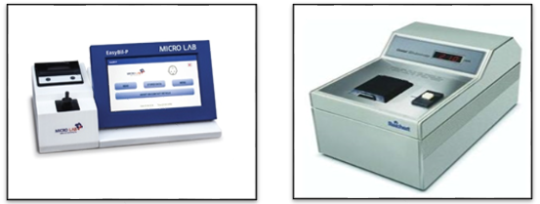

Figure 5. EasyBil (Left) and UNISTAT (Right).

### Project Design Considerations

#### Type of Bilirubinometer

The DABS design is modeled after the bench-top bilirubinometers such as the previously mentioned UNISTAT. After much research into common spectrophotometric designs for bilirubinometers, our preliminary design conception is a dual source direct spectrophotometer that will analyze blood samples at 460 nm and 550 nm. We are trying to design a product that will be easy to use at a low cost, with the parents of neonates as our intended audience.

#### Light Source

One of the original design requirements was ease of use. This came into conflict with ease of building and testing when considering which optical method to use in our approach. The diazo method could be performed with one wavelength and testing could be performed with synthetic bilirubin. As research progressed, the reagent kit and synthetic bilirubin standards required intensive preparation and restricted testing to limited shelf-lives (as short at 5 days for bilirubin standards). This encouraged us to consider the ease and cost of testing in our design considerations. The spectrophotometric method requires more optical components to take measurements at multiple wavelengths, but the additional components can be tested much more rigorously and for less money that the diazo reagent kits and synthetic bilirubin. Spatially, the additional light source and photodetector do not add significant volume to compromise the size requirement.

The other consideration for the optical system will be whether to take measurements from each laser diode and corresponding photodetector separately or simultaneously. Band-pass optical filters, 450 - 470 nm, and 510 - 560 nm placed before each light source should limit light intensity from being measured in the photodiode.

#### Sample Input

When designing the layout of the spectrometer, there must be a place for a user to place and remove a cuvette into the light path. The cuvette dimensions are 12.5 x 12.5 x 45mm. The system will be enclosed, so a hole must be made for the cuvette to fit into, or a compartment of the system must made able to open and close easily with one hand so that it is accessible to a user holding the cuvette. Smudges can affect the accuracy of the transmission readings, so the design must allow for the easy insertion and retrieval that allows a user to avoid touching either of the polished sides through which light is transmitted.

### Existing issues

In most quantitative spectrophotometric measurements, a key obstacle is interference from other substances that absorb or fluoresce at the same wavelength as the object of measurement. Hemoglobin also absorbs light at 460 nm and must be mathematically removed from quantitative measurements of bilirubin. Between 14 – 20 days of age, neonates begin producing carotenoids which also absorb light at 460 nm. These carotenoids cannot be reliably measured and subtracted by direct absorbance methods, and bilirubin measurements taken in neonates over 2 weeks can only be taken by altering the bilirubin so that it absorbs or fluoresces at a different wavelength.

## Relevant Technologies

### Optical Methods of Bilirubin Analysis

There are multiple methods for measuring bilirubin that include diazo, spectrophotometric, enzymatic, adding fluorescent probes, high-pressure liquid chromatography (HPLC), and transcutaneous. Each method was researched by our group, and its viability for our project determined with regard to how well potential designs would fall within our skill sets, the robustness of possible designs, as well as the price and time for execution.

Spectrophotometric measurement of bilirubin is a measure of the absorbance of bilirubin, at 460 nm, but requires calculations to account for hemoglobin absorbance. In neonates, hemoglobin is the only other substance in the blood that absorbs 460 nm light. The hemoglobin absorbance spectrum also has a strong absorption at 580 nm with no interference from other substances.

The principle of a spectrophotometric reading of bilirubin is to take readings at both 460 nm and 580 nm, and to subtract the absorbance due to hemoglobin from the total absorbance measured at 460 nm. As depicted in Figure 6, the absorbance coefficients of hemoglobin differs at 460 nm and 580 nm, and the absorbance coefficient This is accounted for using the equation Abili (mg/100 ml)= 50*A455 – 119*A575 [5]. This method was our first consideration for the project.

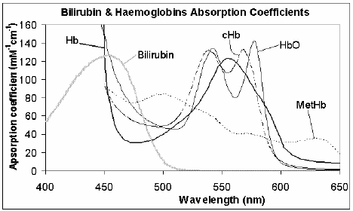

Figure 6. The absorbance spectra for bilirubin and hemoglobin.

The above figure depicts the absorbance spectra of bilirubin shown with a peak absorbance at 454 nm. (Permission for image use requested and received from Dr. Mark McEwan.) The hemoglobin (Hb) wavelength is shown with a solid line to have absorbance in the 450-600 nm range. Hemoglobin can be broken into subcomponents (cHb, HbO, MetHb) with different spectra once they have bonded with oxygen, but for neonates carried to term (38-42 weeks), the absorbance at 550 nm can reliably indicate the relative contribution of hemoglobin at 454 nm.

The Jendrassik-Goff diazo method is the most commonly used method for determining bilirubin in clinical settings. While the peak absorbance wavelength for bilirubin is 460 nm, the diazo method mixes the blood serum with reagents including sodium nitrate. The nitrate bonds with the bilirubin molecules creating azobilirubin. The azobilirubin absorbs at 550 nm.

The absorbance of the bilirubin is measured by first setting a spectrometer to zero with intensity from a blank sample with blood serum and reagents with no sodium nitrate (forming no azobilirubin). This subtracts absorbance due to hemoglobin. The intensity at 550 nm is then taken with the sample with the azobilirubin is then measured. The absorbance is then converted to a mol/L value based on the reagent concentration values specified by the specific reagent kit. Caffeine is often used as a catalyst to facilitate the azobilirubin formation. Typical reagent ingredients in an assay kit by DiaSys Diagnostic Systems include caffeine as a stimulant for the reaction. 200 µL of human serum and Reagents 1, 3, and 4 are added to both the blank and the sample, while Reagent 2 is added only to the sample.

Enzymatic methods involve a catalyst derived from a fungus called Myrothecium that changes bilirubin so that it no longer absorbs at 425 nm, and the change in absorption at 425 nm gives results comparable to the Jendrassik & Goff diazo method [6]. However, the procurement and handling of the enzyme, which required specific pH and temperature conditions to change the bilirubin, was beyond the technical scope of our team [7]. Furthermore, the absorbance at 425 nm made it a less attractive candidate, as the decrease in absorbance at that wavelength would be very minute [8] and photodiodes sensitive at that wavelength were considerably more costly.

The fluorescent probe method bonds a fluorophore to the bilirubin so that when it is excited at 487 nm, it fluoresces at 520 nm. While these were ideal wavelengths to work with, the method of bonding the fluorophore to the bilirubin involves the enzymatic catalyst to alter the bilirubin before adding a solution where it would react with the marker [8]. Again, the level of chemistry skills was determined to be beyond the scope of this project.

HPLC is a method of diluting a sample into a solvent, often helium or nitrogen, which is then brought to high pressure and run through a chromatographic tube. This method allows for the separation of substances that allows them to be measured in extremely low concentrations, as low as parts per trillion. This is a widely used method in clinical and industrial applications that require extremely detailed substance analyses, but it is costly. The mechanical logistics of this method were beyond the scope of the spectrometer proposed by our group.

Transcutaneous measurement tools are widely commercially available. While each operates slightly differently, the common working principle is that light is projected into a neonate skin, often at the forehead, and the reflected light is measured. This method cannot resolve carotenoid concentrations that develop in infants 2-3 weeks of age, and the intended subject age (as specified by Philips Bilichek) is under 20 days. Differences in neonate bone density, skull thickness, and skin melanin result in less accuracy, and multiple studies have recommended that they only be used for screening and not for diagnostic purposes.

#### Optical Method Summary

It was important that method employed by DABS employ the areas of study for every member of the team. Another contributor to the decision was that the method be the most straight-forward to ensure the robustness of the design and the reliability of the device. The latter motivation initially led us to using the Jendrassik-Grof diazo method, as it was possible to achieve with only one light source and it resolved interference from hemoglobin by zeroing it out as a reference. Considerable time researching synthetic bilirubin that would react the same to the diazo agents as bilirubin, beginning at $56 per 25 g. Diazo kits that required one wavelength began at $256. Bilirubin standards for calibration were available for $189 and only lasted 4 days refrigerated at 8 degrees. These factors led to the ultimate decision that the diazo method would be too costly to perform stringent testing, and too much of the required skills (chemistry) lay outside the expertise of the DABS team.

The final decision was to base the DABS project on the spectrophotometric method. The two light sources, sample input, and detection scheme left enough necessary open-ended design for the two photonics engineering team members, and the power system, user interface, and programming required equal parts open-ended design from the two electrical engineering and the one computer engineering teammates. This method left us open to seek more affordable proxies for blood, as a proof of concept only required that the solutions have comparable absorbance spectra.

### Electrical Components

In the current market, there is a lot of electronic components or discrete devices that are used to affect electrons in various ways to produce a desire output for a specific application. For example, analog to digital converters or ADC, are used to convert an analog signal to a digital signal for analysis or other applications. Other electronic components include amplifiers, voltage regulators, DC to DC converters, and many more.

#### ADC

For our project, several of these electrical components will be utilized for the execution of various processes. An ADC component will be necessary to take the input of a temperature sensor, which will be a continuous sign wave, and convert it to a digital signal for the microcontroller to read. Figure 7, shows how an ADC will produce a digital signal for our microcontroller to read and do analysis.

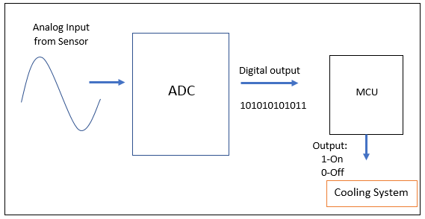

Figure 7. ADC settings and configuration.

The microcontroller will either have this feature or not depending on the chosen controller. Either way, the ADC will be critical in providing accurate measurements for the microcontroller. Many microcontrollers from reputable companies like Texas Instruments have such feature that can be benefited from.

#### DC-to-DC Converter

Another electrical component that is relevant to our project is the DC to DC converter. The DC/DC converter converts ta source of direct current or DC from one voltage level to another voltage level [29]. The converter is used in many applications including portable devices and personal devices. There are many types of converters in the market today and each have their advantages and disadvantages in different applications. A converter will become useful when a voltage needs to be stepped down/up or regulate for the operation of several peripherals selected throughout the design of this project.

Two familiar converters relevant to this project are the boost converter and the buck converter. The boost converter will increase the input voltage to the desired output voltage and the buck converter will step down the input voltage for low powered peripherals. This two are chosen over other converters as they are efficient and inexpensive. Unfortunately, they do come will some disadvantages, like higher noise than the linear regulators.

One general topology of the buck converter is shown below. Another disadvantage of these converters is the complexity of the design when trying to achieve greater efficiency. With greater efficiency, the design becomes more complex as shown in Figure 8. [3]

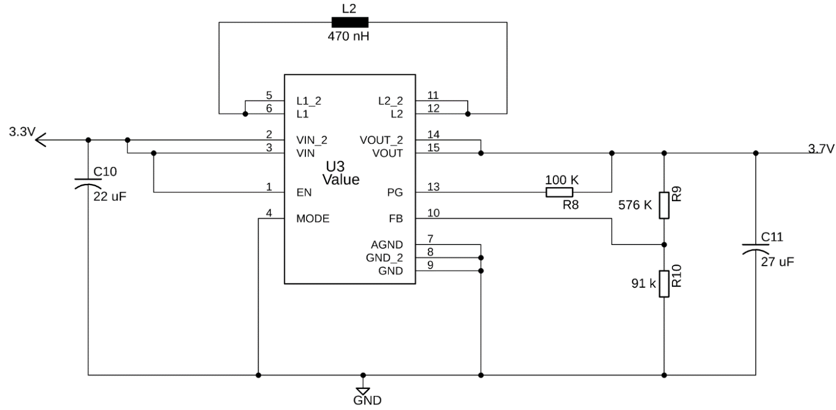

Figure 8. Design for a buck converter.

Since Texas Instruments has a tool for creating such complexities, the tool will be useful when creating the desired buck converter or boost converter for our design. Not only does this tool designs the converter, it also shows the details in cost, efficiency and BOM.

#### Amplifier

Another relevant technology in the electrical components is the amplifier. The amplifier is able to amplify a signal by a gain factor depending on the chosen feedback resistors and capacitors. There are many types of amplifiers currently in the market. The four basic types are the current amplifier, voltage amplifier, transconductance amplifier, and transimpedance amplifier. Their functionality is summarized below.

* **Current Amplifier** – Multiplies the current input by a certain gain factor to produce the desired output current.
* **Voltage Amplifier** – Amplifies the input voltage, by multiplying by voltage gain factor, to produce the desired output voltage.
* **Transconductance Amplifier** – Amplifies an input voltage, by the appropriate conductance gain factor, to receive the desired output current.
* **Tranimpedance Amplifier** – Amplifies an input current (usually from a photodiode) to produce the desired output current.

There are many more types of amplifiers like the operational amplifier or a transistor amplifier but the one of interest is the transimpedance amplifier.

The reason why this amplifier is preferred is because the output voltage will change based on the input current coming from a photodetector that is acting in photovoltaic mode.

### Battery and Charging

#### Relevant Battery Systems

There are many types of batteries with different chemistries out in the market today with each holding their advantages and disadvantages. With three main characteristics of a battery, that is, chemistry, voltage, and capacity or specific energy, deciding on the right battery type to provide sufficient power to the device will be critical.

Since the required specification requires the device to last more than one hour of continuous usage, the battery will need to have a high mA rating while providing enough voltage to operate the electrical components chosen for the project.

There are two types of batteries to choose from: primary batteries, which are non-rechargeable and secondary batteries, which are rechargeable. There are also advantages and disadvantages when deciding on the type of battery to implement on the project. The main object in deciding main power source of our device is to offer a reliable, safe, and a long-lasting battery for individuals utilizing DABS during critical testing procedures.

The project goal for batteries is to have a reliable, environmentally safe, and high nominal voltage output to give DABS the capacity to function as intended at critical moments when necessary.

Advantages of a primary battery over a secondary battery include battery life (Up to 10 years), higher specific energy or capacity, and longer storage times [1].

Primary batteries can play an important role in different applications of use and can be recycled becoming environmentally friendly since most batteries contain toxic chemicals that need to be disposed of appropriately.

|  |  |  |
| --- | --- | --- |
| Battery Chemistry | Advantages | Disadvantages |
| Lead Acid | * Low maintenance requirement * Thermally stable for safety * Low cost * Midrange temperature performance | * Higher charging time * Low specific energy * High toxicity (Battery must be disposed of appropriately) * Low nominal cell voltage * Low cycle life |
| Nickel-Cadmium | * Midrange specific energy * High life cycle * Low charge time (Around 1 – 2 hours) * Thermally stable * Moderate cost | * Very high toxicity * Low nominal cell voltage (For our project) * High self-discharge * Maintenance required every 90 days when in full use |
| Nickel-Metal-Hydride | * Medium specific energy * Low toxicity * Low overcharge tolerance * Low internal resistance * Wide temperature range | * Requires double the time than NiCd to charge (Around 2 – 4 hours) * Half the life cycle than NiCd * Maintenance required very 90 days or so * High self-discharge |
| Lithium Ion | * High life cycle count * Low charging time (Around 1 to 2 hours) * Maintenance-free * Low toxicity * High specific energy * High nominal cell voltage * High coulombic efficiency * Low self-discharge per month | * Cost is higher than other battery systems * Requires protection circuitry for thermal runaway in situations where the battery is stressed. |

Table 2. Advantages and disadvantages of popular battery chemistries.

Primary batteries are not able to be recharged, the user of a common household device would have to replace the battery with a new battery once the old battery is fully discharged or depleted. This brings a disadvantage to the usage of a primary battery as the main power source for our device since the user would have to manually replace the depleted battery. This disadvantage alone becomes an issue when critical testing requirements need to be initialized in order to detect abnormal symptoms in newborns.

Secondary batteries can be advantages in certain applications and cost-efficient over the long term; for example, in high drain applications or high utilization of applications.

Although secondary batteries are cost-efficient, it will eventually rival the cost of primary batteries;but there is another alternative to supplying power to the device which will be discussed later in the sections that follow.

Since these batteries are charged inexpensively, their overall life cycle expectancy diminishes. Also, worth mentioning that secondary batteries have additional chemistries, that usually makes them less stable than primary batteries, and need a special Integrated chip to recharge them correctly and efficiently as to avoid any additional problematic issues that may arise during the recharging phase. Special containment and disposal also need consideration when dealing with rechargeable batteries.

The table above outlines the major characteristics of four commonly used rechargeable battery systems found in secondary batteries. The advantages and disadvantages between them which will determine the optimal solution to supplying our device with enough voltage and current to perform critical tests efficiently and effectively without interruption.

The method of charging and regulating these different battery chemistries is not highlighted but only the characteristics of each. The desired battery chemistry and the way it is charged securely and proficiently will be discussed in later sections of this document and cost considerations will be considered when deciding with what battery is the best choice for this project.

The most prevailing secondary batteries in the market currently are lead acid, Nickel-Cadmium (NiCd), Nickel-Metal-Hydride (NiMH, and Lithium-ion or Lithium Polymer; which . Table 3. lists the advantages and disadvantages of Lead Acid.

Lead Acid has an advantage as it has a low maintenance requirement than the other two types of batteries but with it comes a low specific energy and limited cycle count. It also has a low nominal cell voltage which is not desired for our specific project. The goal is to use minimal battery cells as to not increase the heaviness of the device. With the specification highlighted in the beginning, a higher nominal voltage is necessary. The greatest disadvantage to this type of battery is that it is toxic when the battery is fully dead and cannot continue to recharge and act as a power source.

This situates the end users to handle toxic batteries in the act of disposing them appropriately. This becomes a safety issue that is not desirable in this project. This type of battery also requires around 8 to 16 hours of charging time which does not fit the project goal when it comes to charging time [1].

The use of this type of chemistry is appropriate for personnel carriers, wheelchairs, golf cars, emergency lighting, uninterruptible power supply (UPS), and car batteries. Lead acid batteries are ideal for providing large volume of current when needed, making them reliable when high performance is required.

The specification requirement specified initially requires a power source that allows users to use DABS for a continuous use of one hour. This battery achieves that goal, but it is not ideal regarding safety, charging time, and power required.

One advantage that sticks out for NiCd is the charge time; having around one to two hours of charge time is promising when it comes to having DABS fully functional in terms of using the device in environments where no power outlets are in the premise. NiCd also comes with a high life cycle expectancy making it ideal for long lasting reliable secondary batteries, which is preferred since the troublesome of replacing batteries in our device is not desirable.

Although Nickel Cadmium has its advantages in charge time and life cycle, it also has disadvantages that are not desirable. NiCd also has very high toxicity rating making it environmental unsafe for end users when handling discharged batteries.

This battery chemistry offers low nominal voltage, which can be increase if the single cell batteries are combined together in series, but this adds some drawbacks in the weight added to the device and is not recommended when transporting DABS since it will not be designed to withstand fall impact damage.

NiCd is used in applications where long service life, large discharge current and durability in extreme temperatures are required [1]. While the ultra-fast charging is exceptionally beneficial, this chemistry type is not suited for our application. NiCd is mainly used for power tools, devices involved in the medical field, aviation and uninterruptible power supplies.

Nickel-cadmium-hydride does have a replacement, however, and that is Nickel-metal-hydride or NiMH. This battery chemistry offers low toxicity levels making it safer when handling depleted batteries. It also offers high specific energy than NiCd, but it comes with some disadvantages as well. Table 3 also highlights the advantages and disadvantages of NiMH chemistry. Some characteristics of NiMH are similar to that of NiCd, so the advantages and disadvantages are similar with little differences.

Nickel-metal-hydride differs from NiCd in toxic levels with NiMH being environmentally safe in toxic levels and having low overcharge tolerance making it supplementary safe for users to charge the battery without having any harmful damaging occurring in the battery that could possible harm the user. Other differences are the service life NiMH provide; it has half the life cycle than Nickel-cadmium. NiMH also have a high self-discharge rate than NiCd, which causes the battery chemistry to have a low life cycle. These negatives compared to NiCd make NiMH an undesired

Typical applications for the use of NiMH include industrial applications, medical instruments, and hybrid cars [1]. With toxic levels being high, this negative brings issues in safety in charging this type of chemistry battery and is not desired for one of the project objective goal not listed in the initial sections

The last battery researched and analyzed for the use of the project is Lithium-Ion batteries. This type of chemistry replaces lead and nickel-based batteries but needs insightful consideration in circuitry protection when designing a circuit to include this battery type to be the main power source for our device.

The schematic diagram for the main power source that will be providing power to each component will be discussed in later sections. Lithium-ion batteries are more expenisive than the other battery chemistries but do come with a high cycle count and low maintenance requirement.

A certain type of lithium-based battery was taken into consideration and will almost certainly be utilized in the build of the prototype, is the lithium-polymer battery. This type of chemistry differs from other battery chemistries in the type of electrolyte used, specifically gelled electrolyte [1].

Adding gelled electrolyte to the modern lithium polymer allows the battery to be conductive at room temperature. A main difference between standard Lithium-ion batteries and Lithium-polymer batteries are the cells and how they are packaged. Li-polymer systems are mainly packed in a flexible foil-type enclosure making weigh 20 percent less than a standard Li-ion classic hard shell [1].

Since lithium-polymer foil type enclosure can be manufactured into any shape, they can be fitted into modern phones and tablets. A specification requirement initially specified in the beginning of this document specified that the device should weigh no more than 50 pounds. Having a lithium polymer battery cable of delivering the required power and reduce the amount of weight added is a desirable component when deciding the battery chemistry to use.

According to Battery University’s website, both lithium ion and lithium polymer are exactly the same with the use of identical cathode and anode material utilized and both have similar amounts of electrolyte. Since lithium polymer batteries are identical to other lithium ion systems, the charge and discharge characteristics are identical and do not require special circuitry considerations when dealing with the charging of the battery.

The advantages of lithium-ion based systems outnumber the number the disadvantages of this system. There are other characteristics that not mentioned but these are the most significant features or characteristics that stood out from researching this battery system.

As mentioned before, a desired characteristic that our battery system should have is a low toxic trait and high nominal cell voltage to provide power to our device. This battery system has just that, but it does come with a slightly higher cost than the other batteries. This battery also has high coulombic efficiency or faradaic efficiency which is able to charge at an efficiently whenever the user decides to charge the lithium ion battery.

This type of battery is also maintenance free meaning the user of our device does not need any additional care of this battery type system. This makes the lithium ion battery an ideal type to utilize in this project.

The main component that will substantially drain the battery voltage will most likely be the laser being chosen, but the laser will not be in continuous use, so this is not an issue that needs be a concern, but further testing and analysis of this statement will be described in later sections in detail.

This battery is also able to be charged in just a couple of hours either in 1 or 2 hours depending on the charging rate the charging circuit is designed. This design will be described in detail and at what rate of chagrining is chosen to provide a safe and efficient charging environment for the user and the battery.

Overcharging the battery is not desirable and will be precautionary circuit design will be implemented as to avoid such situation. Since this battery requires some type of protection circuity for thermal runaway, special considerations are considered when the battery is being used. Testing and stress analysis of this issue will be performed and described in detail of the results in later sections.

While lithium ion type battery or lithium polymer meets every desired requirement for this project and will be chosen as the main power source for every component utilized, some detail analysis and testing will be performed to conclude and verify any open issues concerned with these type of chemistry when charging is being performed.

The method of charging of this battery and precautions taken will be discussed in the hardware design details. The next section will discuss the approach to charging our chosen battery type system.

#### Relevant Charging Technologies

Charging circuits exist in the market to safely charge battery systems when the battery is depleted and cannot supply power, but cautionary measures need to be considered to prevent overcharging. Overcharging a battery can have serious consequences. For example, after a battery has fully charged, the battery will be stressed causing the battery to progressively heat up which will cause a battery’s life cycle to deteriorate or in worse cases inflate and cause a hazardous environment [1].

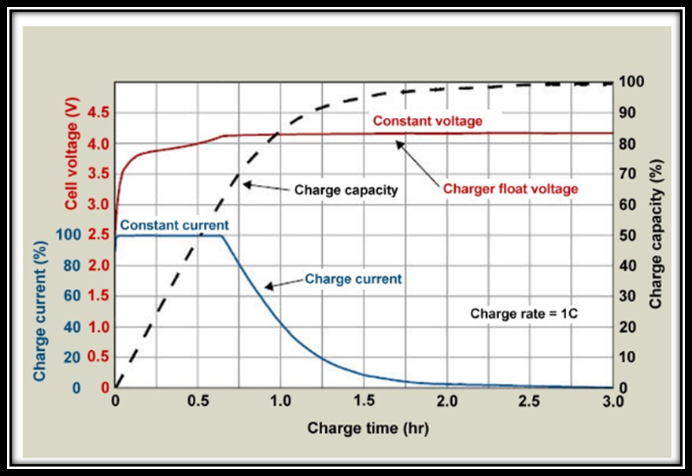

Figure 9. Volts vs time when charging a lithium-ion battery.

(Figure 9 was reprinted with the prermission of Battery University).

This issue of overcharging is resolved by designated operating voltages to the chosen battery system. According to Battery University’s website, charging lithium-ion based batteries are much simpler and straight forward than charging other battery systems. The way a lithium ion battery system is charged is shown in Figure 9 [1]. This information is invaluable when choosing the charging circuit to charge our chosen battery system.

From the figure above, as long the charging rate of the charging circuit is 0.5C from the rated ampere of the battery and with designated operating voltages, environmental concerns of overcharging a battery will not be a safety concern for users. Voltage and current limitations will be considered when the microchip designed to charge secondary batteries is chosen for this project.

The microchip in charge of charging the secondary batter will be limited to the rated voltage of the secondary battery. For example, if a secondary battery of 4.2 volts is chosen, the microchip will output a voltage of 4.2 volts at .5C, where C is the measure of the rate at which the battery will discharge relative to its maximum capacity.

The existing product design and components will take a max input voltage of around 4.2 to 5 volts and draw no more than 70 mA. Two existing microchips that can achieve recharging batteries successfully are the Texas Instrument MCP73231/2 and MCP73213.

There are more sophisticated circuit chargers and microchips, but these two microchips are suitable for the charging of secondary batteries. The two selected battery management controllers were chosen for several reasons; the MCP3831/2 was selected for the low voltage options that it offers making it suitable for low powered components.

The MCP73213 was selected for offered mid-range voltage options making it a second choice if more voltage or current is required for the functionality of each component selected for this project. These two microchips are easily modifiable on the computer aided design (CAD) EAGLE; along with the battery.

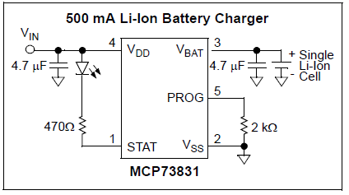

Figure 10. Configuration of charging circuit using the MCP7381.

Datasheets for both Figure 10 and Figure 11 are located in Appendix A.

They are designed specifically for charging batteries at around 10 volts and below and our project design will not go over that voltage range based on the specifications of the design.

Figure 10 and Figure 11 show the two microchips and their typical configuration with a lithium polymer-based battery cell.

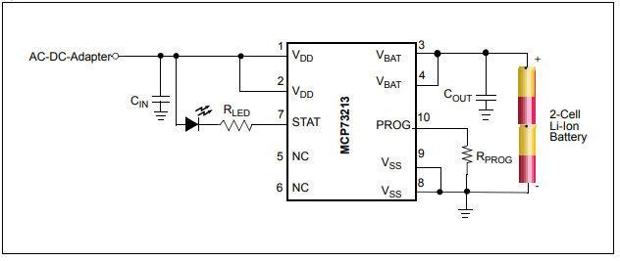

Figure 11. Configuration using the MCP73213. .

The MCP73831 is suitable for charging batteries capable of outputting a nominal voltage of 4.50 volts. The MCP73213 is suitable for a 2-cell battery capable of output a voltage up to 8.8 volts and programable fast charge current up to 1100 mA.

Table 3 shows the key features between the two TI battery charge management controllers. Each controller is programmable for fast charging and is easily replaced on Eagle if any adjustments need to be made. Datasheets can be found in Appendix A.

Typical applications for the MCP73831 are used for cellular telephones, digital cameras, MP3 players, USB chargers, Bluetooth headsets and most importantly lithium-Ion/Lithium polymer battery chargers. This microchip controller is ideal for small battery-based systems with a voltage range of 4.5 V to 4.2 V.

For this project, all of the components that will be chosen will be low-powered or ultra-low-powered components capable of functioning at low voltage and current. After testing is conducted for each component in our design, the controller responsible for charging our secondary battery will be chosen.

Both microchips are capable of charging secondary batteries and with buck converters or voltage regulators for each component, any design modifications will have low impact to the project execution.

### Cooling System

There are many cooling systems or techniques for electronics like heat sinks, thermoelectric coolers (TEC), forced air systems, heat pipes, and fans. All electronic devices and circuity generate some kind of excess heat and thus require a thermal management unit to improve reliability and prevent undesirable failure of components.

|  |  |
| --- | --- |
| MCP73821 | * Four voltage regulation options:   4.2 V, 4.35V, 4.4V, 4.5V   * Programmable charge current of 15 mA to 500 mA * Thermal regulation (Crucial for environmental safety of users) * Reverse discharge protection (Crucial for lithium-ion batteries) * Automatic power-down * Temperature range of -40°C to 85°C |
| MCP73213 | * Four voltage regulation options: 8.2V, 8.4V, 8.7V, 8.8V * 13 V input overvoltage protection * Programmable charge current of 130 mA to 1100 mA * Automatic End-of-Charge Control * Thermal regulation (Crucial for lithium-ion batteries) * Temperature range of -40°C to 85°C |

Table 3. Key features of the MCP73213 and MCP73821.

One of the main components that requires heat management for operation is the laser diode. According to the specifications of the operating temperature, it’s operating temperature is around 10°C to about 40°C ( 50°F ~ 104°F). Initially when it is used it will be of no concern, but when the laser diode is required to be used several times, it will need to be cooled down for operation.

Given that there is an abundant of options to achieve desired temperatures, the two possible choices that are suitable for this project are thermoelectric cooler and fans. There are benefits to both options and both are used in a wide variety of applications such as computers or aerospace and defense technologies.

#### Thermoelectric Cooler

Thermoelectric coolers operate based on the Peltier Effect. Figure 12 shows a diagram of the Peltier Effect [11].

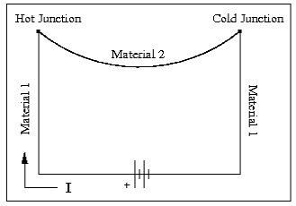

Figure 12. Schematic Diagram of the Peltier Effect.

The Peltier Effect is mainly used for cooling but can also be used for heating or control of temperature [11]. When the current flows through the junctions of the two different metals, heat is removed at one junction or connection and cooling occurs. The heat deposited from one connection becomes extremely hot and requires some sort of radiator to dissipate the heat. If the heat of hot junction of TEC is not properly dissipated, the TEC will begin to fuse together and will not function properly. This is not desirable as it creates a safety issue for the user and product.

One of the main disadvantages of using a TEC is the it has a poor power efficiency. This negative will drain the main battery supply if it is not at high capacity capable of supporting TEC operation. Not only the TEC have a poor power efficiency, it has a high cost depending on the cooling capacity.

#### Cooling Fan

Another alternative to providing a good airflow inside the enclose are the very common fans, specifically mini cooling fans. Cooling fans are widely used today for reducing the temperature in computers, laptops, or even yourself. More importantly, the cooling fans reduce the chance of electrical components from operational failure.

There are many advantages when using a small cooling fan that include:

* Low cost.
* Small size.
* Low weight and easy installment.
* Better low-load efficiencies.

The mini fans do however come with some disadvantages; for example, the controlling of temperature is not precise and will produce a small amount of noise when operating at full load. The noise problem will not be an issue as these fans will only run for a short amount of time to cool down the laser.

Since there is a variety of cooling fans out in the market, a suitable fan for this project for would be one of low voltage operation (around 3 to 5 Volts) and a small size since there is a constraint on size.

### Code Composer Studio

Code Composer Studio one of the recommended IDE’s available to program and flash Texas Instruments’ microcontrollers, boards, and development kits. The benefit of this IDE is that is developed by Texas Instruments and it has high compatibly with all their microcontrollers as well as examples for those controllers. The software is also compatible over all major Operating Systems, which allows for portability and adaption whenever an arbitrary member in a group working in Code Composer Studio needs to make changes on any machine type of machine at their current disposal.

Code Composer Studio has many more other amenities that are due to it being produced by Texas Instruments. One of those features is that it has multiple libraries embedded within it which help users learn how to operate a large number of the Texas Instrument models and boards. Some of these libraries also include examples that are useful to getting started on a new model/board or library.

CCS’s other features relates to the programmability and compatibility between a model using the same piece of code. Switching between models can be a simple as changing the model configuration settings for the current project. This would often require the project be coded in an abstract manner, but CCS still takes a large part in cross-platform combability out of the way. And all these features are in addition to the traditional features that come with a typical IDE, such as error-checking while coding as well as easy access to compilation.

One of the best, and very highly useful, features of Code Composer Studio is its portability across all the major Operating System machines. Aside from the versatility gained with this flexibility, in terms of programmability, it also gives the freedom to build and flash your code without the worry of compatibility between your device and your machine.

There were other options for IDE’s and programming Texas Instrument devices such as Energia, EnergyTrace, and GCC – Open Source Compiler for MSP Microcontrollers, to name a few. It is worth noting that Energia is another popular option that is used in programming embedded devices due to its ease and simplistic interfacing. It was designed for anyone of any programming background to build and produce a functioning embedded software application and was created in order to bring the popular Arduino framework to Texas Instruments’ MSP430 series. It has expanded to TM4C, C2000, CC23xx, and CC13xx [19]. The use of the Arduinio comes with the tradeoff that you don’t get full control of the board because it used an API to communicate to and from the board.

All the compatible IDE’s for any given device are listed on each device’s product page on Texas Instruments’ website. They all have their advances and versatilities, along with the fundamental functionality needed to work on the respective device. The choice of which IDE will be used will come down to major aspects like user familiarity and experience, ease, and versatility, to name a few.

### Touchscreen user Interface

The touchscreen display is a great means of both interacting with a user, and receiving input from said user, all in one module. It is a very compact option for any project that uses an display and needs user interaction. With touchscreen capabilities there is no need of a separate module for user interaction, such as the usual alternatives for user interfaces. Those alternatives being keypad inputs, like keyboards and number pads, as well as cursor interfaces, like mouses or touchpads. Touchscreens are more compact options that the stated, typical alternatives because those alternatives usually require occupying surface area space for the module in addition to the space needed for the display.

With regards to visual appeal, the graphics of the display gives a more advanced experience than an simple segment LCD display, since the touchscreen display is typically a pixel display, of which are more versatile in the kinds of graphics that can be illustrated, as compared to segment LCD displays. Pixel displays also offer the ability to add a wide variety of colors on the screen as opposed to segment displays that can only do two colors. The pixel display’s color capabilities even further the gap between the appeal of the two displays.

Additionally, more and more utilizes in the commercial space also switching to touch-capabilities so it would be wise for projects with the compatibility to follow the trend to do so, in order to stay up with the times.

There are two basic options when it comes to touchscreen modules, resistive and capacitive touch. As the names suggest they are implemented upon concept of resistance and capacity. Resistive touch uses two contact layers placed on top of one another and spaced apart by a insulator medium in order to detect touch. Once pressure is applied to the top layer it makes contact with the lower layer and changes the current reading of the lower layer and due to the change and resistance cause by the touching of the two layers.

Since this method depends on pressure and mechanical forces it can requires considerable amount of force from the user in order to activate. Although this means that it’s sensitivity will result in being somewhat low, this configuration also comes with the capability of activating the touchscreen using means besides a bare finger. For instance, gloves, stylus, lead pencil, etc [20].

Capacitive touch operates in a slightly more sophisticated fashion. It uses properties humans naturally have. The properties have an effect on capacitors in contact with it. Specifically, dielectric properties and conductive properties. Since the strength of a capacitor is affected by the dielectric insulator between the two charged plates, altering that dielectric can have a noticeable change in the capacitor. In regards to contact by a human’s finger, the change in the dielectric is about a multiple of 80, compared to air. This increase in insulation increases the capacitance of in the area around where this finger touches the screen [22].

The conductive property also has an increasing effect on capacitance. Since the human body is conductive, as shown by our ability shock ourselves, we can as a second conductive plate. So, when touching the capacitor of a capacitive touchscreen it is as if we as in parallel to it, therefore increasing the capacitance in that area [22].

These different physical characters that compose these different kinds of screens directly affect the capabilities and functions they achieve. Capacitive touchscreens have the ability to achieve multi-touch functionalities due to being able to detection multiple changing in capacitance. Which is a functionality that resistive screens can not obtain. Yet, resistive screens have the ability to operate with contact from object besides a human finger since it uses premises of mechanical pressure in order to operate.

#### Comparison

When it comes to the touch response aspect of a touchscreen display, there is the possibility of using an API that does some, or all, of the processing from anything detected touch of the screen, or the is the possibility of directly interacting with the touch analog signals from the display.

|  |  |
| --- | --- |
| Resistive | Capacitive |
| * Non multi-touch | * Multi-touch |
| * Usable with gloves | * Unusable with most gloves |
| * Stylus compatible | * Stylus incompatible |
| * Less sensitive to touch | * Sensitive to touch |
| * Less expensive | * More expensive |
| * Lacking in display quality | * Responsiveness can vary per implementation in various products |

Although all displays have the analog layer, the lack of existence of an API seems to depend on popularity of the display and/or its family, and/or the popularity of an individual board to a compatible screen. The API simply takes the tedious and low-level programming out of the task, but it is not always necessary in order to use the module.

There is typically the option of programming directly using the analog signals. That simply involves converting and processing the signal within one’s code in order to obtain the touch response capabilities. This is also a workaround option in a situation where an API for a touchscreen display is available for a model family of a board or microcontroller one may be using, but to implement it would require editing a generic driver for the family. The user has the option to decide against assimilating the said driver and choice to work directly with the ports and pins responsible taking in the touch signals if, for example, configuring the driver would take more time, research, and other resource than deemed necessary.

When it comes to the visual displaying of graph on the touchscreen, that is taken care of by a serial communication interface. Touch displays come in a variety of data serial communication protocols, including three common protocols that are also taught in the UCF Cp.E. curriculum, SPI, I2C, and UART. The variety allows for flexibility on projects that may be constrained by the type of communication or ports they may have at their disposal for the display.

### Serial Communication Protocols

Data transfer and communication is an essential part of computer technology. It allows the ability to add features to a system by simply appending peripheral modules with said feature(s) to the system. Through this process the system would then essentially have these features innately. Thanks to communication, the system would simply need to make requests to the added peripheral(s), which would then complete the implementation and return the results of said feature(s).

There are many different types of serial data communication protocols. Although parallel communication protocols also exist it will not be focused on. The only significant difference between serial and parallel protocol is the same tradeoff between the two in most applications. Which is, trading space for speed, respectively. Serial communication is defined by the transferring of data, bit-by-bit.

For the purposes of this project the serial communication is intended to be used for communicating with the LCD display used to user graphical interfacing. Commands and information must be able to be sent to the display module in order for it to display what we require for any given situation. Serial communication is the simplest way for us to send data from the microcontroller to any connected modules or peripherials that require the data.

#### SPI

Serial communication is used widely in embedded systems. So much so that even though many of them have official standards there are a number of them, that do not, such as the Serial Peripheral Interface (SPI). SPI is a protocol that uses the idea of giving everyone a turn. It involves a single head that determines whose turn it is to communicate which is indicated over a dedicated chip-select line per peripheral.

Aside from the input and output lines that is necessary for all form of serial communication, this protocol also has clock line in order to sync the head with the other cells. This protocol is found in many different applications and modules but some aspects of it, such as the official names for the data lines, are not standardized. However, this protocol can still be widely used because of its simple design and premise.

There are multiple advantages to the SPI protocol. One of which being that data can be sent without interruption, compared to I2C or UART, which sends data in packets. SPI also has a very simple premise. Once a peripheral’s chipset is activated it should expect data until the chipset is deactivated.

Lastly, since there is no overhead for things such as confirmations or starting and stopping data transmission this protocol sends data faster than other protocol with such overheads. But this advantage also starts the list of its disadvantages. Due to the this protocol’s simplicity and the cause of its speed there is no means of acknowledgement of data sent. Hence, data can be lost without the sender being aware of it (Smith).

Another downside is that its simplicity comes at the cost of space. It generally requires at least 4 lines, and that number increases per additional peripheral device. The number of needed ports can also be affected by the number of lines, since each peripheral could need its own chipset line.

We would likely use the SPI protocol for communication where the data transfer line is relatively short and speed is needed or desired. This would be the ideal set up since the short travel distance would decrease the possible of data loss, which is important with the lack of acknowledgment in this protocol. The display is perfect place for this setup since the distance is expected to be short and the user would receive a more responsive experience.

SPI does have different implications that can allow it to make up for some of its disadvantages, such as daisy-chaining. These methods essentially adjust the tradeoffs of the communication protocol and can be helpful in projects where there is the flexibility to adjust tradeoffs based on their priority/importance to the constraints of the project.

In the case of daisy-chaining, direct communication is given up in exchange for only needing one chip-select line. This configuration may be useful to use in the case where there aren’t enough pins to give each individual module to receive their own line. In the optimal situation, the time delay associated with this configuration is insignificant.

##### Major Pros and cons

|  |  |
| --- | --- |
| Pros | Cons |
| Continuous streaming of data | Comparatively high number of wires |
| Simple and direct architecture | No acknowledgment of transfer completed |
| Comparatively high transfer rate | Lacks error checking |
| Data can be sent and retrained simultaneously | Can only have one master |

Table 4. SPI pros and cons.

#### I2C

The Inter-Integrated Circuit protocol, or I2C, is another popular, and simple, serial communication protocol. This system utilizes the data bus architecture and it requires mapping each individual peripheral on the data bus to its own specific address (I2C Info – I2C Bus, Interface and Protocol, n.d.). The entire setup only requires two wires (Figure_I2C-A).

One line for data transfer and another for synchronization with a clock. In this protocol both lines are pulled to some voltage *Vdd* (Figure_I2C-B). The essential gist of this transfer process is the receiver and transmitter should respond and acknowledge the completion or failure of a transmission, and since these are two mutually exclusive results only one acknowledgement bit is needed.

The advantages of this protocol include its small size requirements with it being only 2 pins and staying that low. As compared to the SPI protocol which requires at least 4 pins normally and increases per peripheral added. This exists variants of SPI where one could bring the total number of minimum lines down to three, but they still come with drawbacks (Smith). For example, the lines would still increase per peripheral, and the other downsides that come with it as mentioned above. Another major comparison to SPI is that I2C can guarantee the succession of transmission, whereas it is impossible for SPI to know definitely that its transmission was successful.

A considerably important disadvantage is that this protocol comes with the overhead of needing a start and stop signal for data transfer as well as overhead for acknowledgements. This added with the fact that it can only send data 8 bits at a time puts a significant on the throughput rate of transmitted data.

##### Major Pros and Cons

|  |  |
| --- | --- |
| Pros | Cons |
| Two wires needed | Slower than SPI |
| Multi-master/slave compatible | Overhead in data |
| Simpler hardware | Packets limited to 8 bits |
| Widely used | More complicated than SPI |
| Easy to add modules | Only one can transmit at a time |
|  | Lacks error checking |

Table 5. I2C pros and cons.

#### UART

Another two-pin protocol UART, or the Universal Asynchronous Receiver/Transmitter. It reduces the required pins down to a transmitting and a receiving line, Tx and Rx, respectively. The data passed into Tx and exiting Rx coming from a parallel bus. The parallel data is converted into serial format to be passed to the recipient’s Rx pin. Once it is received by Rx it is converted back into parallel data. UART is another protocol that comes with a start and stop condition like I2C. And accordingly, just like I2C, this accounts for some overhead in the transmission. This protocol also has an optional parity bit that would account for an extra bit of overhead. This parity bit is how UART checks for errors in the data transmission. It signifies whether to data has even or odd number of 1’s so it is capable of catching errors a single bit error in each transmission.

It is important to point UART’s lack of a clock. One might wonder how data can be sent without synchronization between the sender and recipient. This is possible through the implementation of a Baud rate. A Baud rate is a measurement of bits per second. Similar to a clock frequency, this baud rate is how a master and its peripheral synchronize. If a master and its peripheral have a baud rate within ten percent of one another data can be sent and received as if synchronized by a clock.

Like I2C, UART is very compact with its two-pin architecture, which is always beneficial when one is constrained by space or available pins. UART also has the added benefit of having error-checking capabilities. Something that neither of the communication protocol mentioned early possess. Another property that UART has that the other two lack is that it is well documented. SPI especially lacks this property, with even the names of each port not being standardized.

There are a few downsides to this protocol. One of which being that it relies heavily on both sides of the connection having prior information about the either. For instance, the baud rate of both of them have to be close enough together that reliable connection is possible. But there is a wide spectrum of baud rates, from 110 to 921600 (Serial Baud Rates Supported By NI-VISA, 2019) so for both sides to randomly be using the same rate is unlikely. In order to reliably synchronize rates prior information is needed on at least one side.

Another way this protocol can be viewed as needing prior information in order to achieve proper connection and transmission is in the fact that prior compatibility is needed in order to use UART. Both SPI and I2C can be easily implemented on non-master devices that do not intrinsically have those functionalities. But with UART it is not that simple because of the Baud rate. The UART protocol also lacks the ability to have multiple masters or slave systems since there is no way to differentiate senders and receivers.

##### Major Pros and Cons

|  |  |
| --- | --- |
| Pros | Cons |
| 2 wires needed | Multi-masters/slaves unsupported |
| Error checking | Success dependent upon baud rate being configured within 10% of one another |
| Flexible packet length | Packet length limited at 9 bits |
| No clock needed | Slow speed |
| Well documented |  |

Table 6. UART pros and cons.

#### USB

Perhaps the most well-known and widely used serial communication protocol currently is USB, or Universal Serial Bus. This port is found an most computers and laptops as well as other personal devices and electronics in some variation, such as phones, development boards, smart devices, etc.

The pins description for the USB serial protocol is noticeably different from the other protocols mentioned prior. The lines are labeled as VCC, D-, D+, and GND (Peacock, USB in a NutShell, 2018). Transmission of bits is done using two states of D+ and D- called J state and K state. These two states are always the inverse polarity of one another (i.e. when J state has D- = high & D+ = low $⇒$ K state has D- = low & D+ = high).

Signal-ending was a common method throughout all of the previously mentioned protocols. And although this method is simple, direct, and more beneficial with size constraints, it is very vulnerable to noise and distortion while sending data. This is due to the fact that the longer a wire is the more susceptible it is to interference from its environment (Paonessa), making it far less reliable at longer ranges. Although differential signaling comes at the cost of more space/lines needed, as well as an internal circuit to computer the comparison, it comes at the advantage of having far more reliable transmission since the subtraction between the two signals will cancel out noise since both lines would receive identical interference along the data route.

A huge benefit in using USB communication is the added distance between the master and the peripheral devices compared to the other protocols. Due to the noise and interference issues of the single-ended signaling that those other protocols possess, data lines must be kept short in order to have reliable transmissions. This protocol also comes with error checking as well as other add features that the other protocol lacks. Many these features come from the structure of the USB already mentioned.

But these advantages of USB come with a steep tradeoff. The system is far more sophisticated that the other methods mentioned previously, making it more difficult to implement on a device that does not innately have USB functionalities. As compared to SPI or I2C that simply need free pins lines to transmit data.

USB could be a very useful protocol to use because of how widely used it is. It can currently be seen in many aspects of our everyday lives in many different applications and through many different mediums. Due to this, information on various implementations that would satisfy our needs through various points in the project can be expected to be far easier to obtain than the other protocol that lack even a true standard. And unlike the other protocol that would likely only be used for display data transfer, USB’s widespread utilization make it such that implementing any number of additional features that are USB compatible has a much more probable and obtainable level of actualization.

##### Major Pros and Cons

|  |  |
| --- | --- |
| Pros | Cons |
| Easy to use  Versatile  Widely used  Low cost  Wide range of speeds | Limited performance |

Table 7. USB pros and cons.

#### Summary

Spec. Comparisons:

|  |  |  |  |  |
| --- | --- | --- | --- | --- |
|  | SPI | I2C | UART | USB (Peacock, 2018) |
| Top  Transfer Speeds | 10MHz | Standard: 100kHz  Full speed: 400kHz  High speed: 3.2MHz  (Speed) | 115200 baud $≈$ 110kHz | Low speed: 1.5Mhz  Full speed: 12MHz  High speed: 480MHz |
| Data Packet size | Unlimited | 8 bits | 5-8 bits | 8 bits |
| Min. # of wires | 4 | 2 | 2 | 4 |
| Error checking | No | No | Yes | Yes |
| Max # of masters | 1 | Unlimited | 1 | 1 |
| Max # of slaves | # of CS lines | 2n  (n = address bit length) | 1 | 127 |

Table 8. Communication Spec Comparisons

## Strategic Component and Part Selections

### Optical Source

The crux of our calculations depends on reading changes in the intensity of light on two specific wavelengths. The accuracy of the measurements is dependent upon how narrow of a spectral bandwidth we sample in the two specified ranges. Photodiodes respond to specific wavelength ranges and filters can be placed before the photodiodes to limit intensities from other wavelengths from contributing to the measurement, but one of the most effective ways of limiting intensities from outside our desired spectral bandwidth ranges is to control the bandwidth of the light being transmitted from the source. Although white light is cheap, readily available, and contains light in our desired visible ranges, it does not offer the same accuracy and efficiency as laser diodes or LEDs.

Lasers produce near-monochromatic light output. The principle is that electrons are stimulated from a lower energy state to a higher energy state. When the electron returns to the lower state, it loses the energy in the form of a photon. This is called spontaneous emission, and it occurs randomly, with no applied energy, and the light output from spontaneous emissions is near zero. When the system is excited by incoming photons, electrons in the higher state are forced down to the lower state, emitting other photons of the same energy. This is referred to as stimulated emission.

Lasing is achieved when there are more electrons in the higher state than in the lower state, achieving “population inversion”. This is achieved by “pumping” the system with a light source and using reflective surfaces to provide a cavity that passes the photons back and forth through the medium. All of the photons have the same wavelength, proportional to the energy between the upper energy level and the lower energy level. The relationship between the photon energy and the wavelength is given by the equation E=hc/ λ. A laser needs three basic components to achieve lasing: a gain medium, a resonator cavity, and a pump.

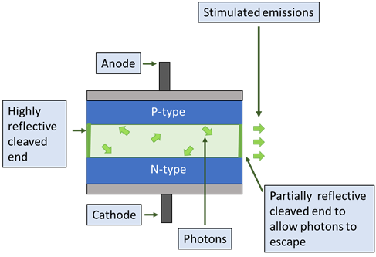

Figure 13. Illustration of a p-i-n semiconductor laser diode.

A laser diode is the smallest forms of a laser, made up of a double-heterostructure p-i-n semiconductor. The doped ends of the semiconductor chip confine the electron-hole recombination to the center region with specified energy difference, and the cleaved ends of the semiconductor create the resonator cavity. Figure (13) shows the structure of a laser diode, including the cleaved ends that serve as the high reflection (HR) and output coupler (OC) ends to form a resonator cavity. When the diode is forward-biased, electrons and holes are guided into the inner region, stimulating population inversion and photon generation. The more current that is applied, the more electrons are pushed to the higher state, and the greater the stimulated emissions when the electrons generate protons. With little current, the emission spectra are largely composed of spontaneous emissions, forming a broader spectrum, but the threshold current or higher is applied, the monochromatic stimulated emissions dominate the output.

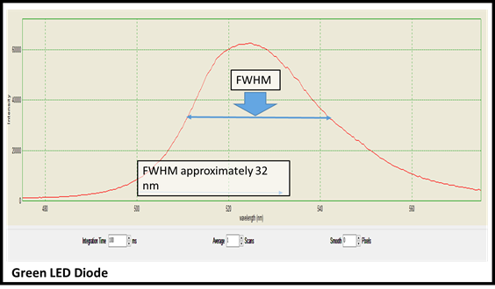

Figure 14. Spectra from a Green LED.

One of the light sources DABS requires is a green light source near 550 nm to measure hemoglobin absorption. The first source tested was a green LED as it was cheap ($.10) and already available to us. The green LED was from Co Rode and required 3 V. To avoid an expensive optical filter, it required a narrow spectral bandwidth in the 530-550 nm range, so the absorbance of hemoglobin (betalains) could be determined at a specific wavelength, allowing us to extrapolate the absorbance due to hemoglobin (betalain) at the blue wavelength A spectral analaysis using an Ocean Opticas spectrometer was performed. The results are depicted in the chart above. The green LED did not provide a sufficiently narrow spectral analysis for our purposes. The next option was to purchase a 532 nm laser diode. Fortunately, relatively high-powered green laser pointers are cheap and readily available. They are composed of a diode that emits 808 nm photons, which stimulates the semiconductor diode to emit 532 nm green light. We have purchased a 50 mW laser diode for $16.95 that meets the needs for our readings. The table bleow gives all the specifications for this diode. This diode emits light from 522 nm – 542 nm, which is sufficient for our use.

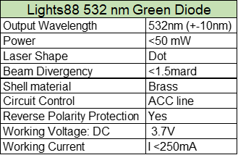

Table 9. Specs for green light source.

The other light source required to take measurements near 460 nm is a blue source. Blue laser diodes are much more expensive, as the semiconductor materials with the high energy bandgap needed to generate photons with wavelengths of 460 nm are more expensive. A 450 nm laser diode with a 50 mW output was found on Thorlabs (PN PL450B) and Egismos (PN D4-7-450-50) for $75 and $80, respectively. Both have similar power requirements as the green diode, but the price led us to explore less expensive options than laser diodes.

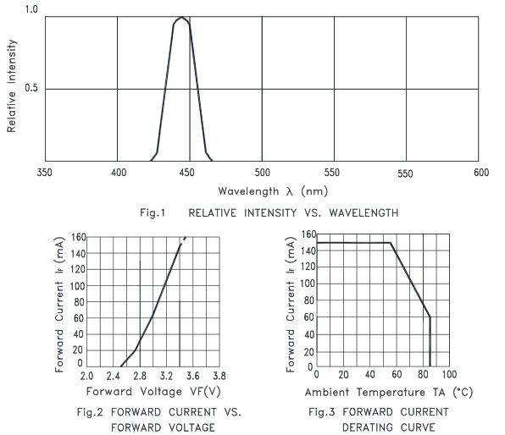

Figure 15. Vendor wavelength emissions, voltage and current specifications.

LEDs are also p-i-n semiconductors, but unlike laser diodes, they do not require pumping nor a resonator cavity. The emissions are based on the electron-hole recombination in the active region due to a forward bias, but the photons are not amplified through a resonator cavity. LEDs are highly efficient, though the output linewidth is broader than laser diodes. However, blue LEDs are available at a small fraction of the price as laser diodes, and we found multiple blue LED light sources sufficient for our purposes. The blue LED from Mouser (PN 720-GDPSLR3113A1817) costs $0.65 and requires 5.6 V to operate. The input operating voltage was a bit high for our design, and an LED with lower operating voltage was considered. The $0.68 LED from Lite-On optoelectronics was ultimately chosen due its efficiency, a 3.0 V required forward bias for normal operation, and its output in our wavelength range, depicted in Figure ().

### Sample Input

Due to IRB restrictions for research using human samples, including whole and partial blood serum, testing of the DABS spectrophotometer will rely on proxy samples. Synthetic bilirubin, which has the same absorbance spectra as bilirubin as well as reacts with sodium nitrate to form azobilirubin in the same quantities as real bilirubin, is commercially available. Synthetic bilirubin is necessary to perform analysis using the diazo method, but by itself would be unsuitable for testing using the spectrophotometric method as it does not account for the hemoglobin interference, which is a primary function of the proof of concept.

Other readily available blood substitutes were researched based on their optical absorbance properties. To perform calculations using the Beer-Lambert law, the absorbance properties to be approximated are the molar absorbance coefficient epsilon, the concentration the substance must be mixed, and its absorbance rate at wavelength near 460 nm and 540 nm.

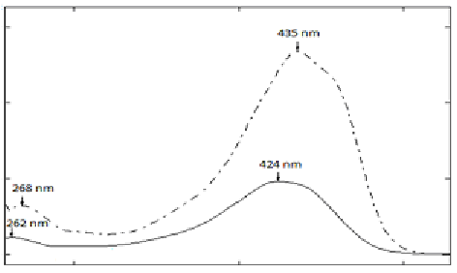

Figure 16. Absorption spectra of curcumin.

The above figure depicts the absorption spectra of curcumin (tumeric) in a methanol solution is shown by the dotted line. The peak absorption at 435 nm and extinguishing at close to 500 nm cuts a similar profile to that of bilirubin. We will create our own absorption spectra with our samples to measure the molar extinction coefficients, as the concentrations and absorbance could differ depending on the preparation method and the solvents. (Permission to use this image was requested from Dr. Md. Saiedur Rahaman. No reply has yet been received.)

Bilirubin concentrations in jaundiced neonates are around 175 µmol/L. The substance has a maximum absorbance around 460 nm, and has a molar absorbance coefficient in whole blood serum around 53,846 cm-1/M. A readily available organic pigment that also absorbs at this wavelength is curcumin [Majhi]. Curcumin is a compound found in turmeric root. It has a deep yellow color similar to bilirubin. Figure 16 depicts the absorption spectra of curcumin to be compared to the spectra of bilirubin depicted in Figure 17. While curcumin is not easily soluble in water, the powdered root can be diluted into methanol. The molar absorbance coefficient at 432 nm in a methanol mixture of 2 µmol/L was found to be 51,818 cm-1/M [Majhi]. With this information, we will prepare a concentration of curcumin and methanol to mimic the absorption of bilirubin.



Figure 17. Absorption spectra of bilirubin.

The above figure depicts the the absorption spectra of bilirubin. The maximum absorption peak is at 454 nm. While the maximum absorbance peak is 19 nm lower in the curcumin-methanol mixture, there is still a significant absorbance at 454 nm, and both extinguish shortly after 500 nm, leaving for an unfettered reading of respective hemoglobin and betalains absorbance at 540 nm. (Permission for use of this image was requested from Dr. Junzhong Li. No reply.)

Hemoglobin concentrations in the whole blood serum differs depending on the extent it has bonded with oxygen, but the absorbance at 460 nm and at 550 nm is nearly identical with or without oxygen-bonding. In term neonates, the concentration is 15-21 g/dL, or .1551 mmol/L [7]. The molar absorbance coefficient at 550 nm is 53,412 cm-1/M, and 23,388 cm-1/M at 460 nm [Prahl]. Betalains are a red-violet pigmented compounds related to carotenoids found in plants including amaranth and red beetroot. Betalain can be divided into betaxanthin, which is yellow in color and has an absorption maximum at 450 nm, and betacyanin, which is magenta in color and has an absorption maximum at 430 nm [8]. The total spectra of betalain is depicted in Figure 18 and can be compared to the absorbance of hemoglobin. (Permission for the use of Figure 17 requested from. Permission for use of figure 18 requested from Dr. Corneliu Oprea. No reply has yet been received.) The optical absorption properties of betalains have been well-documented due to their use as an organic pigment; the absorption at 460 nm is .729 and .925 at 550 nm [9].

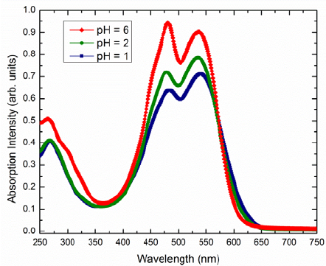

Figure 18. Absorbance of betalain at various pH balances.

Table 10 shows all of the documented and expected values of bilirubin, hemoglobin, betalain, and curcumin. For inexact molar extinction coefficients, proxy absorbance values can be obtained using the other form of the Beer-Lambert Law, A=-log(I0/I). This table will inform our approximate concentrations for our testing samples, and proxy standards will be developed by measuring the incident and transmitted intensities of light of our two wavelengths.

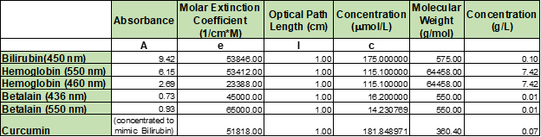

Table 10. Absorption table for bilirubin, hemoglobin, betalain, and curcumin.

#### Cuvette

A cuvette is a container for a sample in a spectrometer. Cuvettes specifically manufactured for spectrophotometric use are commercially available and come in a variety of sizes, materials, and with different coatings to allow for different types of light penetration. They can be made up of quartz, glass, sapphire, and plastics. Plastic cuvettes are built to be disposable and cost less than one dollar a piece. The downside of disposable plastic cuvettes is that the percentage of light transmitted at a given wavelength is not tightly tolerance, which means the accuracy of the reading is compromised.

Even the smallest scratches in the cuvette can cause divergence of the light and affect the reading of transmitted intensity. For this reason, sapphire cuvettes, which are incredibly resistant to surface scratches, are an ideal quality cuvette. They can also transmit a large range of wavelengths, from 250 nm to 5000 nm. However, the cost over $1500 and because our two transmission wavelengths are in the visible range, sapphire glass was not a feasible or sensible choice.

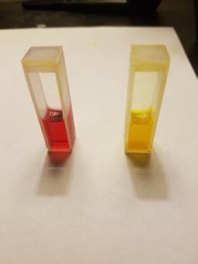

Figure 19. Cuvettes prepared with betalains (left) and curcumin (right).

Cuvettes prepared with betalains (left) and curcumin (right) are photographed in the above figure. The above samples were prepared for spectral analyses by soaking beet in methanol for 5 minutes and extracting 2 mL to the cuvette, and the curcumin sample was prepared as the bilirubin proxy by adding 1 g turmeric powder to 30 mL of methanol and extracting 2 mL to the cuvette. The proxy blood will include a concentration containing both, and DABS will determine the concentration of the curcumin.

The standard path length for spectrophotometric cuvettes is 10 mm, with a minimum sample volume of 1.5 mL to fill. The path length must be calibrated as it is a key input in calculating absorbance via the Beer-Lambert law. This standard size fits within our requirements, and we were able to find optical glass cuvettes without paying any upcharge for custom sizing or coating. The cuvettes ultimately chosen for the DABS project were a four-piece set of optical glass cuvettes from Adealink, 12.5 x 12.5 x 45mm with a cell capacity of 1.5-3.5 mL. The light transmission error is guaranteed to be less than 0.5%.

### Photodetector

Before a detection measurement can be taken, the light from the source must usually pass through a monochromator such as a diffraction grating to separate the wavelengths. The diffraction grating will break up the light source into all the wavelengths that make up the original source which, when paired with a wavelength selector, either a narrow slit or optical filter, allows the sample to be illuminated by single wavelengths at a time. This gives a more accurate absorption spectra of the sample by giving more control to the system to focus on illuminating the sample with the desired broadband or corresponding peak absorption wavelength.

Since the goal of the DABS project is to detect concentration levels of bilirubin which is a known chemical substance that has a well-defined absorption spectrum, we have decided to use 2 monochromatic laser diodes at 460 nm and 550 nm respectively instead of using a rotating diffraction grating or prism to separate a broadband light source into its corresponding wavelengths. This effectively eliminates the need for a diffraction grating in the optical setup since there are predefined target wavelengths that need to illuminate the sample instead of having a broadband source.

Photodetectors work on the principle of the photoelectric effect where electrons or other free carriers are emitted when electromagnetic radiation or light hits a material. As light hits the photodetector, electron-hole pairs are formed, and the incident light gets converted into a current that is filtered into a receiver circuit where it can be amplified. There are several types of photodetectors available including photodiodes, phototransistors, photoresistors, photocells, CCD cameras and many more. Each type of photodetector has its corresponding characteristics which would be more beneficial depending on its intended use, but all photodetectors have a few fundamental characteristics which are wavelength range, responsivity, quantum efficiency, dynamic range, size or area, noise, and linearity.

Wavelength Range

One of the most critical characteristics of a photodetector is the operating range of wavelengths over which the device can produce an electrical current from the incident optical power onto the device. The range of wavelengths the photodiode can operate under is determined by the materials used in the semiconductor and their respective bandgap energy. Equation below shows the relationship between the bandgap energy and the corresponding maximum wavelength that the semiconductor can absorb (new ref 40).



In the equation above h is Planck’s constant, c is the speed of light, Eg is the energy is eV, and q is the charge constant which when multiplied by Eg will convert the energy into Joules. Silicon semiconductors used for photodiodes work in the visible range which includes our 2 target wavelengths of 460 nm and 550 nm.

Responsivity

According to Opteks, responsivity describes the ratio of generated current produced by an optical power incident on the material in units of amps per watt (A/W). The actual value of R is dependent on wavelength, thickness of the detector, temperature and the absorption coefficient of the material.

Quantum Efficiency

The quantum efficiency describes the fraction of incident photons that contribute to the photocurrent. It is directly related to the responsivity and photodiodes tend to have a high quantum efficiency, but it varies with wavelength which can be calculated by the following equation. A higher quantum efficiency would yield a better detector for the targeted wavelength.

Dynamic Range

The range of wavelengths over which the photodetector can detect optical power. For some photodetectors such as photodiodes, the dynamic range is large especially when paired with electrical amplifiers.

Size or Area of Photodiode

The dimensions of the active area in the detector can influence the performance characteristics. Smaller active areas for the photodiode result in faster speeds and higher resolution in wavelength at the expense of less sensitivity due to a smaller area to collect light and increasing the minimum optical power needed to provide a measurement. Larger areas increase sensitivity since there is a larger area for photon collection which is especially useful for large beam diameters or dimly lit applications.

Noise

In general photodiodes are a very accessible piece of electro-optic equipment that is relatively cheap, rugged, stable and has a relatively short lead time for customization and ordering when compared to some of the other options available. Phototransistors are also very sensitive and cheap as well as having a built-in internal gain, but their frequency bandwidth and linearity are relatively limited. Photodiodes tend to have a great dynamic range, high sensitivity, are small, lightweight and has the best linear response among the photodetectors (ref). Due to these factors as well as having difficulty finding phototransistors in the 460 nm range, the type of photodetector chosen for this design are photodiodes.

Photodiodes can be further broken down into subcategories known as PN photodiodes, PIN photodiodes, avalanche photodiode and Schottky photodiodes. The following sections below will provide the characteristics of each of the photodiode types and their advantages and disadvantages. The project goal for detectors is to have each corresponding detector be robust, stable and have high sensitivity. It should have the capability to detect small changes in light intensity to accurately calculate the change in light intensity after it has been absorbed by the sample.

PN and PIN Photodiodes

A PN photodiode is a solid-state detector using a p-n junction semiconductor device that converts light energy to generate electrical current. The contact between the surfaces of the positively doped material (p-type) with the negatively

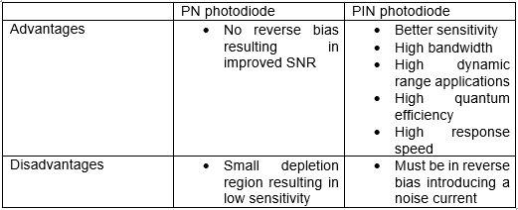

doped material (n-type) causes a depletion region where charge carriers can shift around. The depletion region causes electrons to drift towards the p-type while holes drift towards the n-type creating an electric field that will only allow current to flow in one direction. By putting the photodiode under reverse bias, the depletion zone will expand increasing the potential difference across the junction.

PIN photodiodes are very similar to PN photodiodes but have an undoped intrinsic material sandwiched between the positively doped and negatively doped materials. By having an intrinsic material in the middle, there is an even greater depletion region allowing for higher reverse voltages to be tolerated. The larger depletion region allows for more light photons to be collected and converted into electrical current.

Avalanche Photodiodes

Avalanche photodiodes share similar characteristics with PN and PIN photodiodes where photon absorption generates electron-hole pairs, but it also uses a process known as impact ionization to significantly increase the magnitude of the photocurrent. It is structured with a highly negatively doped substance on top (n+ type), a positively doped substance underneath (p type) the n+ type, an intrinsic substance that is lightly doped between the p type and the following strongly positively doped substance (p+ type). Impact ionization is the process that causes an avalanche breakdown effect and can only undergo this process under high potential differences that create a strong electric field. This amplifies the signal received due to its high current-gain product (ref).

|  |  |
| --- | --- |
| Advantages | * Highly sensitive and can detect weak signals * Large gain |
| Disadvantages | * Non-linear output * High level of noise * Much higher operating voltages required |

Schottky Photodiodes

|  |  |
| --- | --- |
| Advantages | * Provide capabilities of high speed and long wavelength detection * Lower forward drop bias * Can operate at high frequencies * Good for focal plane array use |
| Disadvantages | * Can not withstand high reverse voltage without break down |

In a Schottky diode a metal replaces the p-type semiconductor which causes the

semiconductor to require less of a forward voltage drop than PN diodes. These

devices can switch on and off much quicker than the PN counterparts and produce less noise which is highly useful in high-speed switches (ref).

Based on the research depicted above on the types of photodiodes available the one that we have chosen for the DABS project is a PN photodiode. The PN photodiode can meet the required specification of a low-cost photosensitive detector that can quickly read the absorption intensity changes associated with this project. Furthermore, we can specifically find photodiodes with a spectral range and sensitivity centered around each of the two target wavelengths associated with bilirubin and hemoglobin.

There is a plethora of options when it comes to buying photodiodes, but after careful consideration on the available options on the market that matched the project’s budget and time constraint, we narrowed it down to 3 photodiodes. The photodiode for DABS needs to have a dynamic range that includes 440 nm and 550 nm with high linearity and sensitivity. It also needs to have a good sound-to-noise ratio (SNR). The following 3 photodiodes have dynamic ranges that encompass our desired wavelengths with peak sensitivities around 550 nm while still maintaining a high sensitivity around 460 nm allowing us to use the detector under each of the laser diode sources.

1. SFH 2430 – DIL SMT Ambient Light Sensor [33]

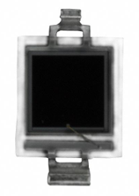

1. BPW21R – Vishay Semiconductors [33]

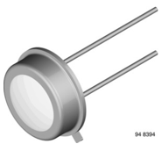

1. VEMD5510C – Vishay Semiconductors [33]

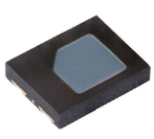

They also share larger active surface areas than other options on the market resulting in better light collection and sensitivity which is the most important factor for our photodetector in this project. The larger surface area would result in slower response speeds but the delay in speed is not significant enough to impact the data that will be collected, and the higher sensitivity will allow the photodiode to detect more finite changes in the optical power.

The SFH 2430 detector has applications for ambient light sensing and health monitoring. The VEMD5510C is a surface-mount device that has high speed and sensitivity with low capacitance. The datasheet shows it has applications in wearables, heart rate monitoring, and ambient light sensing. The BPW21R is a planar silicon PN photodiode designed for high precision linear applications. The following table shows a side by side comparison of key characteristics of the 3 photodiodes.

|  |  |  |  |
| --- | --- | --- | --- |
|  | SFH 2430 | VEMD5510C | BPW21R |
| Spectral Range | 400 nm – 900 nm | 440 nm – 700 nm | 420 nm – 675 nm |
| Wavelength of Peak Sensitivity | 570 nm | 550 nm | 565 nm |
| Breakdown Voltage | 6 V | 20 V | 10 V |
| Power Dissipation | 150 mW | 215 mW | 300 mw |
| Reverse Dark Current | Typical 0.1 nA max 5 nA | Typical 2 nA max 10 nA | Typical 2 nA max 30 nA |
| Sensitivity | 6.3 nA/lx | - | 9 nA/lx |

Table 11. Comparison of photodiodes.

Table 11 shows the relative spectral responses for each of the 3 photodiodes depicting the dynamic range of the device as well as the efficiency for the photodiode to collect light at the varying wavelengths. All 3 of these photodiodes are promising and fit the needs of our project and so we will begin prototype testing each one to see which of them work best for our needs.

To receive any relevant information from the photodetectors there must be a reference sample to calibrate the measurement before analyzing the test sample in question. Bilirubin has an absorption peak at 440 nm while hemoglobin has high absorption peaks at both 440 nm and 528 nm absorbing equally on each wavelength. By having 2 light sources the true absorbance of bilirubin can be calculated after using Beer-Lambert law. To do this the absorbance measured at 528 nm needs to be subtracted from the measured absorbance at 440 nm. There will have to be several different readings, one for the reference sample without bilirubin to calibrate the device and then the 2 measurements with each light source to find the relative absorbance at each of those relative wavelengths.

Beer-Lambert law is commonly used in spectrophotometry to analyze concentration of samples. This law relates the absorption or attenuation of light to the property of the material through which the light is traveling (chem.lib). The absorbance of the material is dependent on the ratio of the incident and transmitted intensities. After the absorbance is known, the concentration of the substance in question can be calculated if the molar absorptivity of the substance and the length of the cuvette is known. The following equations show the relationship between these parameters

 

and how the process can be calculated mathematically.

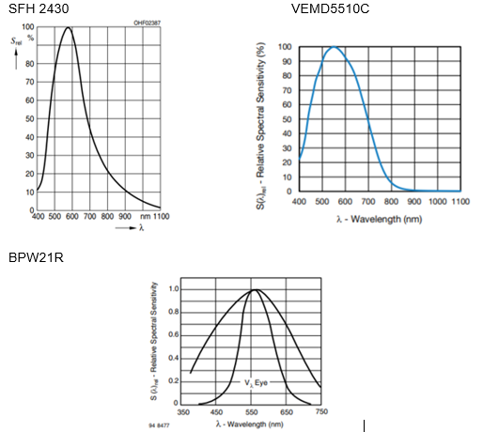

Figure 20. Spectral responses of photodiodes.

To make accurate measurements using Beer-Lambert law it is crucial to have not only a reference sample before taking the final measurement of the test sample, but also for the sample to be in a reasonably concentrated solution. If the test sample is in a strongly concentrated solution, there will be a large amount of absorption. On the other hand, if it is mixed in a very dilute solution the absorbance will be very low. For this exact reason there need to be a reference sample that does not contain the test sample for accurate comparisons to be made. The same holds true for the container size and shape which should be constant throughout the measurements. Once all these parameters are met, the readings from the photodetector are significant and can be passed on to be calculated using Beer-Lambert’s law.

### Transimpedance Amplifier

#### Introduction to the TIA

For this section we will briefly describe the need for a transimpedance amplifier. According to a Digi-Key ArticleLibrary [35] on designing stable transimpedance amplifiers, one of the common applications of these circuits is in medical systems. This medical systems category, while relatively broad, is the perfect category to describe the DABS system we are designing. As mentioned in the executive summary, we intend for this system to allow new parents to obtain an accurate bilirubin concentration at home.

Since DABS will measure the bilirubin concentration, using direct absorbance (i.e., measuring the absorbance of light), we need a circuit that will can link light to a meaningful voltage value. This is the sole purpose of the photodiode and transimpedance amplifier that will be incorporated into DABS, Figure 21 provides a generic illustration of this concept [35].

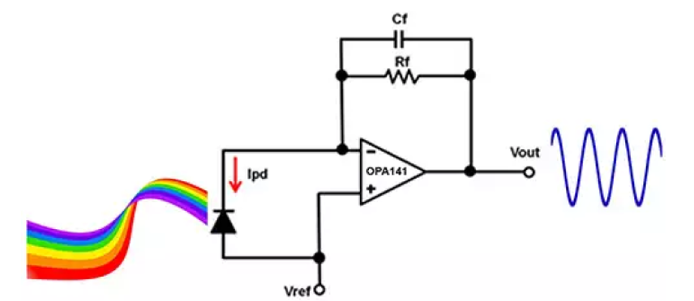

Figure 21. Transimpedance amplifier (From DigiKey ArticleLibrary)

Figure 21 will provide, for us, the basic overall design guidance for our transimpedance amplifier, to be fine tuned to our specific applications. Pending the results from testing of the

#### Designing the Transimpedance Amplifier

When designing a transimpedance amplifier, we must consider a variety of factors, that will help narrow the technology selection. Texas Instruments’ *Analog Engineer’s Circuit Cookbook: Amplifiers* provides 3 major design notes when for selecting an operational amplifier model [36]. First, when selecting an operational amplifier model, it is suggested that we use either a JFET or CMOS device with low bias current, thus avoiding increase DC error. Second, in order to avoid non-linearity errors, we should operate the amplifier within its linear output voltage swing (found within specific op amp datasheet). Third, we may need to add a bias voltage, on the non-inverting input, in order to set output voltage under 0 A input currents.

The first op amp under consideration, will be the TL084. The first reason this op amp was chosen was because it is used in most of the labs accompanying UCF’s electrical engineering curricula. Since we have experience using this type of op amp, it may serve well to set up our initial test conditions. The TL084 is a JFET-input operational amplifier and has an output swing voltage of ±13.5 V (fits with the power supply specifications). One drawback to using this model, is that we will have to design the rest of the transimpedance amplifier. Information this devices was found in the TL084 Datasheet.

There are a few major characteristics that we must consider if we decide to use design a transimpedance amplifier around an existing operational amplifier. First, thing we must consider is the phase margin, which is directly related to the step response overshoot and quality factor, of the amplifier [34]. We

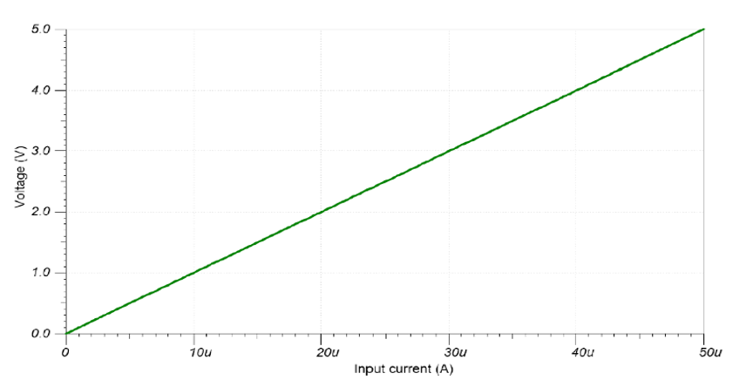

Figure 22. DC Analysis (From Texas Instruments)

must then add two feedback components, a resistor and capacitor, to fine tune the phase margin. To design these feedback components, we will need to used the following items from an op amp datasheet: Voutmax, Voutmin, gain-bandwidth product, and max input current.

Fortunately, to serve as a good test control design, Texas Instruments’ *Analog*

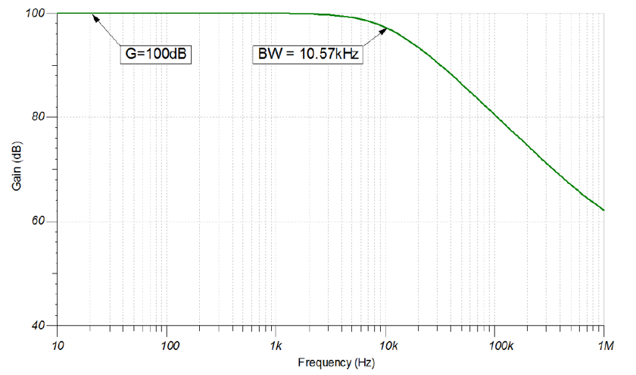

Figure 23. AC analysis (from Texas Instruments)

*Engineer’s Circuit Cookbook: Amplifiers* provides description an additional op amp

model, and how to use it to design the transimpedance amplifier.

|  |  |  |  |
| --- | --- | --- | --- |
| Parameter | Values |  |  |
|  | Minimum | Maximum | Units |
| Input Characteristics | 0 | 5.00E-05 | Amps |
| Output Characteristics | 0 | 5 | Volts |
| Bandwidth | -- | 10000 | Hertz |
| Supply - Vcc | -- | 15 | Volts |
| Supply - Vee | -- | -15 | Volts |

Table 12. OPAMP Design Goals

We will consider, in more detail, the OPA170 model, shown in the circuit cookbook. We can use the DC and AC simulation results, provided by TI for the OPA179, as a guide when performing the hardware testing. Figures 22 and Figure 23 shows us the expected DC simulation results and AC simulations results (respectively) [36]. Upon circuit simulation and initial hardware testing, we wish to mimic these results. The circuit feedback characteristics will need to be tweaked to ensure the correct gain is to be obtained from the transimpedance amplifier.

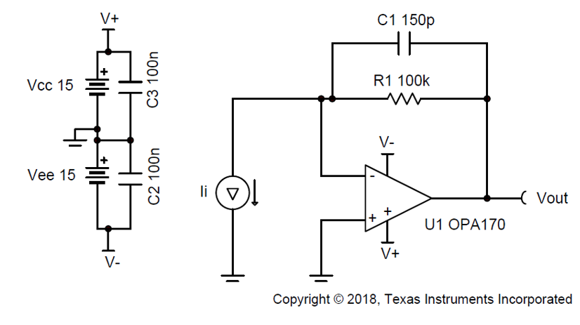

Figure 24. Circuit diagram for OPA170

As we can see, the input current is linearly proportional to the output current. Also, we see, from the AC analysis, that this op amp will provide very stable gain up until about 10KHz.

The transimpedance amplifier designed using the OPA170, meets the design goals given by Table 12 (adapted from the TI Circuit Cookbook) [36].

These design goals are used to define the components we discussed above: the feedback components (i.e., the feedback capacitor and gain resistor) as well as the gain bandwidth. Figure 24 shows a complete design example using the OPA170, image provided by Texas Instruments.

If we choose to use the OPA170, this figure, along with the *Analog Engineer’s Circuit Cookbook: Amplifiers*, will serve to guide our design and testing.

#### Complete Transimpedance Amplifier Package

|  |  |  |  |
| --- | --- | --- | --- |
| Feature | Value |  | Units |
| Supply Voltage | 2.7 | 3.6 | Volts |
| Current Draw |  | 23.4 | mAmps |
| Temperature Range | -40 | 85 | Celsius |
| Swing Voltage | 0.6 | 1.9 | Volts |
| Maximum Gain | -- | 100 | kΩ |
| Bandwidth | -- | 120 | MHz |

One transimpedance amplifier package, manufactured by TI, that may work very well for the DABS is the OPA857 Ultralow-Noise, Wideband, Selectable-Feedback

Table 13. OPA857 Key Design Features.

Resistance Transimpedance Amplifier [TI.com]. According to the applications section, on the datasheet, this TIA is suitable for optical amplifiers, photodiode monitoring, and high-speed I/V conversions, which intuitively make it a great fit for the DABS. Table 13 summarizes some of the important features of the OPA857.

#### Conclusion

Based on this technology review, and the resources available, we can make an initial selection on operational amplifier to use for the transimpedance amplifier in the DABS. From this preliminary review, the operational amplifier of choice will be the Texas Instruments OPA170. If we run into issues during testing, or face other constraints, we may be able to use one of TIs complete transimpedance amplifier, such as the OPA857 [datasheet].

### Microcontroller

The microcontroller will be used to interface with and/or control the different portions of this project, including the power supply, light source, temperature sensor, fan, user interface, and display. Thus, we will have a wide range of necessary functions to help us compare and make the final selection of a microcontroller.

The microcontroller will bear the brunt of the calculations and overall system integrations. All the different subsystems are dependent upon the microcontroller being programmed to run smoothly and properly communicate and instruct them on what to do and when. This section will cover a variety of features and operating conditions of a microcontroller that will be used to pick the best option.

#### Key Features of Potential Microcontroller

This section will provide a brief overview of a selection of microcontrollers that could potentially be used for this design project. We will include some of the key features that may assist in narrowing down to the microcontroller to be used for this design.

MSP430FR6989

The MSP430FR6989 was chosen as an option because it is the device, that the ECE Department uses, for the Embedded System’s lecture and laboratory. This device is listed as the first choice, because of the familiarity with the microcontroller and coding environment.

This microcontroller uses a CPU with a 16-bit RISC architecture, with the benefit that most operations can be performed simply using register operations. There are also, an available, seven low power modes, which in conjunction with the architecture make this device very power efficient to achieve extended battery life. For convenience (i.e, reduced instruction execution time) there are 16 integrated registers that provide register-to-register operations in only one cycle of the clock. The CPU controls all peripherals via data, address, and control buses and can manage the peripherals using simple instructions.This information was adapted from the technical documents provided by TI to include the Microcontroller datasheet and the Chip Data sheet for the MSP430FR6989.

Some of the major features of the MSP430FR6989:

* Up to 83 configurable I/O pins (shown in the MSP430 Pinout Figure below)
* A high-performance Analog-to-Digital Converter, with 12-bit precision
* 5 available timers
* Comparator
* eUSCI_A modules capable of supporting UART, SPI and IrDA
* eUSCI_B modules that support I2C and SPI
* Hardware multiplier
* Compatible with LCD display (all pins support capacitive touch)

MSP432P4111

This microcontroller is an essentially an extension of the MSP430 family of microcontrollers. This means, that it performs essentially the same functions but has more advanced (or extended) features. The idea of including this microcontroller was to possibly work with an Arm Cortex CPU.

The specific CPU that the MSP432P4111 utilizes is an Arm 32-bit Cortex-M4F CPU, which is a high-perfomance processor implemented in a low-cost system. This processor is able to accomplish a variety of system requirements including: low memory implementation, low power consumption, and reduced pin count . While meeting these system requirements, the Arm Cortex-M4 is still able to maintain exceptional computing power and response to interrupts Similar to the MSP430 family, the MSP432 family offers a variety of ultra-low-power operating modes, drawing as low as 22 nA and up to 100 µA. This information about the general information of the MSP432P4111 was provided and adapted from the MSP432 Family Data sheet (SLASEA0B).

Some important features (adapted from the , to help narrow selection, include:

* Up to 84 configurable GPIO pins (shown in the MSP432 Figure below) supporting a variety of I/O features including ultra-low-leakage, up to 48 with interrupt/wake up capability, up to 24 allowing port mapping, and 8 that support glitch filtering
* SAR analog-to-digital converter, providing 16-bit precision and up to 24 input channels
* Up to four 16-bit timers (with capture, compare, and pulse width modulation capabilities)
* Two 32-bit timers (capable of generating interrupts)
* Two analog comparators
* Up to four eUSCI_A modules that support SPI, UART, and IrDA
* Up to four eUSCI_B modules that support I2C and SPI
* All pins, of ports P1 to P10 and PJ, support capacitive touch

Arduino Due

The Arduino Due board will be compared to the others, because it is supported by an open source network and utilizes an Arm Cortex processor. Specifically, the Arduino Due is based on an Atmel SAM3X8E Arm Cortex-M3 CPU. The relevant information here was adapted from the general overview section, on Arduino’s websit for the Arduino Due microcontroller []

Some of the major features of the Arduino Due board are:

* 66 I/O pins (54 digital and 12 analog, shown in schematic figure below)
* 8 serial communication pins
* 12 pins capable of PWM
* Supports SPI and UART communications
* 2 DACs that provide analog outputs with 12-bit resolution

Summary

The pinout diagrams will be useful when constructing the PCB and beginning to program the chosen microcontroller. The availability of pins will be one of the strongest determining factors in the choice of microcontroller. In addition, the major features of each microcontroller can be used as a plan to determine which pins will be necessary. Once the project requirements are set in place these two items will be able to be utilized in making the final selection of microcontroller package.

#### Input and Output (I/O)

Project Specific Pin Needs

Table 14 shows the preliminary plan for the individual subsystem interface with the microcontroller. This is the beginning plan to show the pins that will be needed for each part of the design. From this table we have an idea of the pins that will be utilized on the microcontroller that we use in the design of DABS.

MSP430FR6989

According to TI’s Descriptions and Parametrics for this microcontroller, all P1, P10, and PJ pins [37] are multifunction input and output pins, shown in the MSP430 figure in the previous section. Each port, P1-P9 and PJ contains eight I/O lines. Port P10 only supports 3 I/O lines, this information is found in the data sheet. All the pins, on P1-P10 and PJ, have the inherent ability to support capacitive touch capability, which will be useful in integrating the LCD display.

In order to handle analog I/O, the MSP430 utilizes two additional peripherals, the 12-bit Analog-to-Digital converter and a 16-Channel Analog Comparator. The ADC module, on chip, is the ADC12_B, which is used to convert an analog input to the corresponding 12-bit digital representation. This module will allows us to use up to 32 channels for analog input and take advantage of 32 digital result storage registers. Working in conjunction with the ADC is the Analog Comparator, corresponding to module Comparator_E. Comparator_E’s main functions include monitoring external analog signals, precision slope analog-to-digital conversions, and battery voltage supervision.

MSP432P4111

As mentioned above, in the features, the MSP4324111 provides up to 84 total I/O pins. These pins are configurable and allow both digital and analog functionality.

There are up to 10 8-bit I/O ports on this microcontroller that support many functions. Some of these functions include:

* The ability to program all I/O bits separately
* Wake-up capabilities from low power modes on ports P1 to P6
* Pullup or pulldown on all ports
* Any combination of input, output, or interrupt possible
* Ports P1 to P6 also support interrupt capability (edge-selectable)
* Glitch filtering on certain digital I/Os

The glitch filtering allows the microcontroller to stabilize the interrupt and wake-up capabilities through the use of an analog filter, which suppresses unintentional interrupts or wake-ups . This microcontroller also has the ability to handle analog I/Os. According to the MSP432P4111 datasheet, analog capabilities are handled by an ADC module, capable of 16-bit precision via the Successive Approximation Register (SAR) core. Two of the major analog functions supported are battery monitoring and temperature sesnsin. The MSP432 microcontrollers also use a comparator to perform precision slope analog-to-digital conversions, and does so through the use of two Comparator_E modules. This information was researched and adapted using the MSP432P4111 datasheet.

Arduino Due

As previously mentioned, the Arduino Due provides 54 digital pins, however, these are dedicated digital pins and are not programmable [38]. Each of these pins operate at 3.3 Volts, provides either 3 or 15 mA source current, and may receive 6 or 9 mA sink current. Some of these pins have specified functions such as: serial transmission and reception, pulse width modulation, SPI communication, CAN communication protocol, and TWI communication.

Instead of requiring and ADC and comparator to handle analog functions, the Arduino Due has 12 analog inputs. The analog inputs provide 12 bits of resolution, which can be changed with an Arduino function call. Again, these inputs only support up to 3.3 Volts, and may damage the chip if higher voltage is applied. There are also two pins that provide analog outputs, also with 12 bits of precision.

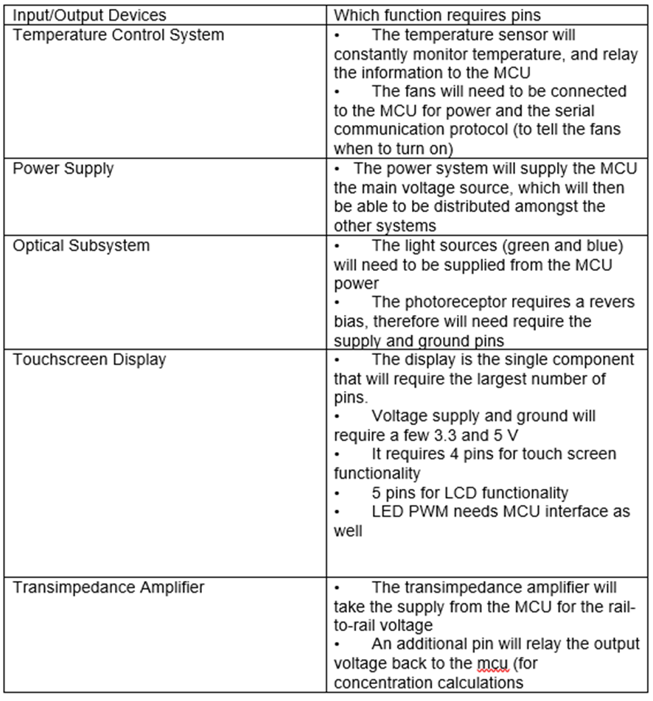

Table 14 Project Pin Planning

#### Communication Protocols

The modules offered by the MSP430FR6989 include: UART mode using eUSCI_A, two SPI modes using eUSCI_A and eUSCI_B, and I2C mode (at 100kbaud) using eUSCI_B. This information was adapted from TI.com’s product information section for the MSP430FR6989 microcontroller [37]

The MSP432P4111 also accomplishes serial communication through the use of eUSCI modules. There are up to four eUSCI_A that support UART (automatic baud detection), IrDA encode and decode, and SPI (max 16 Mbps). There are also up to four eUSCI_B modules that support SPI (max 16 Mbps) and I2C (multiple-slave addressing).

|  |  |
| --- | --- |
| Communication Method | Advantages and Disadvantages |
| SPI | Advantages |
| Serial Peripheral Interface | • High transfer speed (up to 10MHz) |
|  | • Does not limit data transfer based on packet size |
|  |  |
|  | Disadvantages |
|  | • Does not provide error checking |
|  | • No acknowledgement of data sent |
|  | • Requires more space than I2C and UART, proportional to the number of connected peripherals |
| I2C | Advantages |
| Inter-Integrated Communication | • Requires a minimum of two wires for connection of all peripherals (Serial Data Bus and Serial Clock Bus) |
|  | • Provides clock synchronization |
|  | • Acknowledgement of completion/failure provided |
|  |  |
|  | Disadvantages |
|  | • Does not provide error checking |
|  | • Data transfer limited by packet size (8 bits) |
|  | • Requires start/stop signal, adding to transmission overhead |
|  |  |

Table 15. Advantages and Disadvantages to the SPI and I2C.

The Atmel chip on the Arduino Due provides a variety of communication methods. For the purposes of this analysis, only serial communication methods will be considered. The atmel data sheet provides the necessary information to successfully complete this analysis of communication methods. First, the SPI communication protocol will require four pins on the Atmel chip. These pins include Master Out Slave In (MOSI), Master In Slave Out (MOSI), Serial Clock (SPCK), and Slave Select (NSSS).

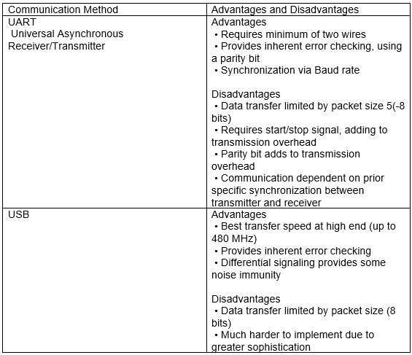

Table 16 Advantages and Disadvantages to the UART and USB

The Atmel CPU also supports Two-wire interfaces, which is compatibly with the I2C standard, however, it does not use a start byte or provide slope control and filtering. Finally, the Atmel chip supports both Universal Asynchronous Receiver/Transmitter (UART) and Universal Synchronous Asynchronous Receiver/Transmitter (USART).

In order to summarize the section on serial communication protocols, 3.2.9 Tables 15 and 16 will compare the advantages and disadvantages of the protocols previously discussed. These advantages and disadvantages will then be used in the analysis when determining the correct microcontroller and communication combination. The table uses the previously cited information, provided in section 3.2.9, any additional information will be marked with new citations.

#### Microcontroller Operating Conditions

|  |  |  |  |  |  |
| --- | --- | --- | --- | --- | --- |
| Important Operating Parameters | Minimum Value | Maximum Value | Tolerance | Units | Notes |
| 1) Absolute Maximums | | | | | |
| Voltage applied at pins | -0.3 | 4.1 | ±0.3 | V | n/a |
| Voltage at any pin | -- | 4.1 | -- | V | n/a |
| Diode Current | -- | ±2 | -- | mA | n/a |
| 2) Recommended Conditions | | | | | |
| Vcc (Supply Voltage) | 1.8 | 3.6 | -- | V | -- |
| TA (Ambient Temperature Range) | -40 | 85 | -- | C | 25 ± 5 ˚C for DABS |
| fSYSTEM (Max MCLK Speed) | 0 | 8 |  | MHz | no FRAM wait sites |
|  | 0 | 16 |  |  | with FRAM wait sites |
| fACLK |  | 50 |  | kHz | Adjust with divisn |
| fSMCLK |  | 16 |  | MHz |
| 3) Memory Capacity | | | | | |
| FRAM | -- | 127 | n/a | KB |  |
| RAM | -- | 2 | n/a | KB |  |
| ROM | -- | 256 | n/a | B |  |

Table 17 MSP430 Operating Conditions

In order to help select a suitable microcontroller, we will utilize a comparison of some important operating conditions. This section will analyze the respective data sheets and pull out information that will help in the selection of the appropriate microcontroller for this project. The parameters to be considered include: operating temperature range, voltage and current supplies, system clocks and clock speeds, and the memory capacity of the individual microcontrollers. These parameters provide a quick tool to analyze which microcontroller will be most suitable to the design of DABS.

|  |  |  |  |  |  |
| --- | --- | --- | --- | --- | --- |
| Important Operating Parameters | Minimum Value | Maximum Value | Tolerance | Units | Notes |
| 1) Absolute Maximums | | | | | |
| Voltage applied at supply | -0.3 | 4.17 | ±0.3 | V | -0.3 to Vcc + 0.3 |
| Voltage at any pin | -- | 4.17 | -- | V | -- |
| Diode Current | -- | ±2 | -- | MA | -- |
| 2) Recommended Conditions | | | | | |
| Vcc (Supply Voltage pins) | 1.71 | 3.7 |  | V |  |
| TA (Ambient Temperature Range) | -40 | 85 |  | C |  |
| fSMCLK | 0 | 48 |  | MHz |  |
| 3) Memory Capacity | | | | | |
| Flash (main memory) | 2048 | | KB | |  |
| Flash (info memory) | 32 | | KB | |  |
| SRAM | 256 | | KB | | 8KB of backup memory |
| ROM | 32 | | KB | | with peripheral driver libraries |

Table 18 MSP432 Operating Parameters

|  |  |  |  |  |  |
| --- | --- | --- | --- | --- | --- |
| Important Operating Parameters | Minimum Value | Maximum Value | Recommended | Units | Notes |
| Voltage and Current Supplys | | | | | |
| Operating Voltage |  |  | 3.3 | V |  |
| Input Voltage | 6 | 16 | 7 to 12 | V | to prevent over heating |
| DC Current (all I/O) |  | 130 |  | mA |  |
| DC Current @ 3.3V pin |  | 800 |  | mA |  |
| DC Current @ 5V pin |  | 800 |  | mA |  |
| Clock system and Memory | | | | | |
| Clock Speed | 84 | | MHz | |  |
| SRAM | 96 | | KB | | split into two banks: 64KB and 32KB |
| Flash Memeory | 512 | | KB | |  |

Table 19 Arduino Due Operating Parameters

#### Choosing the Microcontroller

By analyzing some of the important electrical and operating conditions provided in the tables above, we can begin to select the characteristics important to this project. After selection and testing of the appropriate components and parts, the project specific operating conditions will be able to be determined. The necessary operating conditions are to be summarized in the table below.

Through the analysis of the topics covered on the strategic component and part selections we can make an informed decision on the microcontroller to use. An additional parameter to consider is previous experience using a microcontroller. For the electrical and computer engineers, we are required to take a course on embedded systems, which currently uses the MSP430FR6989 development board and booster pack. This course gave us prior experience developing and testing code. This prior experience, in itself, makes a strong argument to use the MSP430 series microcontrollers.

Similar to the MSP430 series is the MSP432P4111, which provides some overall improvements to the 430 series. The MSP432 series is also controlled with an ARM cortex processor. The ARM cortex was intriguing because it would allow the computer engineer to learn a new skill. This processor is also commonly seen in industry applications (due to its adherence to military standards). The MSP432 family provides a larger memory capacity and higher clocks speeds. These applications are important but may not differ enough to weight the selection towared the MSP432.

The major draw of the Arduino series is that it is relatively easy to use. Arduino has number open source forums, that provide help on almost any function that we would need to incorporate. This seems to be a plus but it provides no challenge to the programming team.

Based on this quick analysis and the needs of this project we will, for now choose the MSP430 series microcontroller. This does not automatically rule out the MSP432 series because it can be programmed in a very similar fashion. Due to the prior experience with the MSP430 series and the project time constraints, this microcontroller makes the most sense to use. The familiarity with the MSP430 will be conducive to writing the necessary codes and algorithms in a timely manor. Getting the MCU programmed as quick as possible will allow us to finalized testing and prototypes of DABS, which will be important for the modifications that may be needed to finalize a working product.

### Touchscreen Display

The part selection for the display does not even begin with comparing touchscreen parts. It begins with the decision to constrain the display to touchscreen. This decision was made due to helping keep inline with the objective of developing this device to be compact. With keeping the user graphical interfacing and user response interfacing within the same unit we are able to save on space. As opposed to a keypad/keyboard which would take up far more space. Although, the idea of using a trackpad interface instead did come up. And although it does occupy less space than a keypad, a touchscreen still more versatile for anything that might occur during the implementation and building of the project so it is the better choice.

Once the decision to stay with touchscreen displays has been set, next to start comparing the major general differences between them. The broadest place to start is likely with the differentiation between resistive and capacitive touchscreens. Since the choice between these two options can affect core features later on, such as multi-touch and sensitivity, this is a great place to begin.

With the resistive screen mechanism, not every touch is going to be recognized, which makes the device harder to use. The capacitive touchscreens ability to pick up on most, if not all contact, makes it a better choice for reliability and ease. Although it is only capable of picking up on human touch that is not a concern here sense the intended and practical use is with human touch.

Along with the touch sensitivity, the capability to run multi-touch functionality is an added benefit of using a capacitive touchscreen. This feature allows for the possibility of more advanced operations in future development.

The next parameter to pay attention to is the interfacing to the touchscreen. As previously mentioned, there is the choice between analog or API driven interfacing. The decision on which is best for the project is dependent upon other parameters of the project, such as availability to analog pins, levels of compatibility between a microcontroller and a given display, memory constraints, etc. For this project the major concerns were general purpose input/output pin availability, along with availability to serial communication pins, and also whether there are APIs that were pre-compatible with microcontrollers that fit our specifications.

It was projected that multiple aspects and features of this project will require the use of analog pins, therefore further limiting the availability of said pins beyond the total number of analog pins from the microcontroller. Accordingly, the touchscreen that was chosen needed to require a low number of pins.

In regard to the serial communication interfacing, it was decided to go against the direction of an API due to the fact that analog-controlled interfacing would give much more control over the device, if needed in future development. Furthermore, there were no APIs that were innately compatible with most of the microcontrollers being researched. And the route of configuring the API would have required more time and effort than deemed necessary.

But the serial communication is still a factor when interacting and setting the graphics of the screen. Of the options between SPI, I2C, UART, and USB mentioned before, there was the capability to move forward with the first three options since they were features that existed on most microcontrollers that fit under the design specifications and constraints.

Taking all the mentioned parameters into account, the *Kentec QVGA Display BoosterPack* was selected for the touch response and display interface for this project. This touch display is designed using capacitive touch and uses SPI communication to design and draw graphics onto the display. It also uses analog signals to read touch responses from the screen, as well as have documentation on compatibility with Texas Instrument’s MSP430 microcontroller family.

Although all the factors mentioned above played a role in the final deliberation of the touchscreen but many of them were after thoughts. The main constraint that affected the choice of the screen was the deliberation over the microcontroller used and, subsequently, the compatible displays for said screen. The microcontroller was under dispute due to concerns over cost-effectiveness, availability, and learnability.

In order to get a working prototype for proof of concept completed within our milestone we had to use something that was readily available and would still be viable when completing the final project. Due to this restriction our microcontroller was chosen. The result of that chose left us with a restricted pool of viable choses in touchscreen display modules. A pool consisting only of the *Kentec QVGA Display BoosterPack*. Due to this, many of the touchscreen parameters are forced onto the project and its capabilities became a constraint as to what features we are able to implement. And accordingly act as constraints for part selection of other components.

### Printed Circuit Board

The printed circuit board (PCB) must be able to fit within the chosen parameters of the DABS enclosure box. The preliminary design of the enclosure has a base of 10 inches by seven inches which provides a lot of area for the board and other components. The design challenge that arises here, is that the optical subsystem will require its own sub-enclosure to ensure that will block out all incident light, other that the laser sources. The location of the optical subsystem will leave a relative “L” shaped space to work the PCB design around.

There are thus two options to designing the overall PCB. First, we can try to design the entire PCB in one piece. This would theoretically allow us to fit the PCB in around the optical system. We would be able to create the anticipated floorplan of the DABS box and measure the space around the optics, where the PCB would fit. Then, the dimensions around the optics system could be used to create a board design, in EAGLE, that would fit in the space around the optical system. There is another design dilemma that must be considered with the PCB, the placement of the power source because the laser and photoreceptor both need supply but are on opposite sides of the enclosure.

Another option for the PCB design would be to break it down into smaller modules that could be placed in such a way as to fit in the available space. This should allow for strategic placement of the power supplys circuit to easily reach both sides of the system. This modular design will also present a design dilemma, in that we will need to design a system to connect the different subsystems.

The final consideration, for the PCB design, is the component size selections. When choosing components, such as resistors and capacitors, we need to take into account the overall size for soldering purposes. We desire to choose parts that are small enough to condense the overall size ot the design, but components that are not too small to solder by hand.

### Battery Charging Initial Schematic

The charging circuit for the lithium polymer battery is crucial in voltage regulation for stable charging. The battery will be charged at 4.2 Volts and at a 500mA rating using the MCP73831 from Texas Instruments. The final PCB design will include the circuit responsible for supplying power to the microcontroller and other peripherals. The initial schematic outline is shown in the figure below.

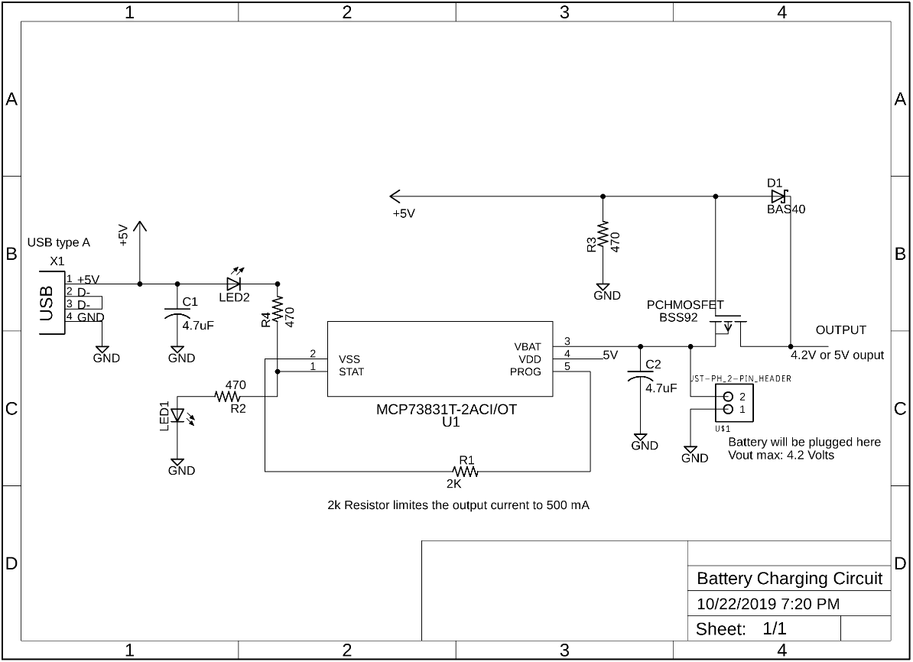

Figure 25. Battery charging circuit for the Li-Ion battery [18].

From the figure, there are two options when supplying power to the main board. One option is supplying power from the Li-Ion polymer battery itself. The second option is from a USB Type-A input, which is rated to supply 5 to 6 Volts. The second option allows the device to be utilized while the battery is charging. This way it allows users to utilize the device and perform tests using external power.

The components in the initial schematic in the figure above, the components that will be selected for the implementation of the charging circuit are the following:

* 4 Resistors
* 2 Capacitors
* 1 Inductor
* 2 LEDs
* Texas Instrument MCP73831
* USB female connector
* 1 JST/PH 2 pin header
* 1 Schottky diode
* 1 P-channel MOSFET

The values to these components will vary and the final schematic diagram will include the values for each component. These components and additional parts will be procured using Digi-Key website. Digi-Key is the fourth largest electronic component distributor in North America and a broad-line distributor capable of supply our component selection in a timely manner.

There are other websites to procure components, but familiarity of this company is one reason why it was chosen as the main distributor for some of the components. Texas Instrument parts will be of course procured from TI website.

### Power Source

The main power source will be a lithium polymer-based battery capable of outputting a voltage of 4.2 Volts when fully charged and supply a current at 1200 mAh (can be upgraded in case this one is not sufficient). The battery system will be able to be recharged using USB Type-A connection to an external power source either from a wall outlet using a USB adapter or any computer system that has a USB connection. The battery will be full charged under two to three hours are specified in the specification requirements.

The configuration shown in the schematic for the charging circuit allows the device to be power by an external power source as well. The second power source, which will be optional, is an external power source via USB connection. So, two power source options will be available for the functionality of the device.

## Parts Selection Summary

The main components selected are shown in the following table. This includes the power supply system, optical system, and temperature control systems.

|  |  |
| --- | --- |
| 532 nm 50 mW laser diode |  |
| 460 nm 5 mm LED |  |
| BPW21R Photodetector |  |
| 12.5 x 12.5 x 45mm glass cuvette, 1cm OPL |  |
| Lithium polymer battery |  |
| DC Brushless Cooling Fan x 2 |  |

Table 20. Component Summary.

## Software Tools

For the software coding of the project there were individual tools used such as IDE’s and compilers, but their separate tools are needed in order for the team members to communicate and coordinate efficiently. These tools help to get everyone on the same page and pace while keeping us accountable for one another in a simplistic and convenient manner, when meeting in person is not possible.

### Communication

Communication is a core aspect to the progression of a project. Everyone must to be to communicate and collaborate at any given time in order to maximize the progress efficiency of the project at any given step.

**Whatsapp** Whatsapp was chosen for general communication. This a simple and reliable means of communication that can be used from a mobile device or a PC. It uses one’s mobile number to create an account that can be accessed from any device when needed. Its major feature consists of message and calling communication. Those calls can be either voice or video with the option to switch between the two during a call. Additionally, there is the voice message feature where voice recordings can be sent as the phone of communication that combine calls and messaging. This tool uses one’s mobile device’s contact list to connect to other users, so it acts as an alternative to using SMS or calling minutes. All communication done on this tool is encrypted by default which adds a level of security. There is also the ability to share documents files, links, and media files, which also are protected by the encryption security. And the tool also organizes these shared materials so that they are in one place to be found again later. Each of these features exist with one-on-one communication as well as group communication. One can create a group from individuals that reside in the group creator’s contact list and once created everyone in this group can communicate together in the same chat and are able to contact one another even some group member may not have the contact information of another member.

**Discord** Discord was chosen as a second form of group communication. This tool was developed with the motivation to allow gamers to play with their friend, and the premise corresponds well with group conferencing purposes. Discord can be used on mobile devices as well as PC. Users have the option to call and message one another as a group. A key feature of this platform is having the ability to call as a group in real time, in a simple manner. Different groups and sub-groups can be made to serve specific purposes or out specific topics. The sub-topics are created directly within the main topic and operate on a similar premise to a HAM radio. I.e. within a group a user can create a sub-group called a channel. All other users in the group can then have to abilty to switch to this created channel, and while in the channel all communication received will come from here. Essentially a user has the option to switch between any created channel and this main channel of the group. These channels can ideally have a specific topic related to the main topic of the group.

**Google Drive** Google Drive’s platform provides a place for cloud-sharing and documentation collaboration. Items can be shared using a compiled link or linking Google accounts to the item. For our project it was used for initial documentation purposes that allowed for brain-storming and integration of ideas. Google Drive provides a centralized platform to documenting that can be accessed from multiple accounts and devices at one time. These items can be edited and updated by anyone given access to it and these changes will be spread to everyone else with access. It innately connects to Google’s documentation software which is useful for quick and simplistic editing. These software also share some compatibility with Microsoft software of the same field which allows for exportation between the two to some compacity.

**OneDrive** OneDrive is a tool that can be utilized by much of Microsoft’s software. It provides cloud-sharing and document collaboration, not only online but also on each host. All editing that is down on the local Microsoft Word application is constantly updated to its cloud counterpart. This allow for seamless collaboration and consistent formatting for every user linked to the document. It also organizes shared and un-shared items so they are easy to find and differentiate. Additionally, through their parentship with UCF, all student receive 1TB of cloud data which essentially give a remote location for us to upload as much data as we may require.

# Related Standards and Realistic Design Constraints

## Standards

The DABS project must comply with all standards associated with the project. These standards will ensure that the design has repeatability and conforms with all legal constraints that may arise in response to the nature of the project. There are several standards and constraints ranging from technical standards of the components to the health, safety, and ethics standards associated with drawing baby blood. It is not feasible, nor are we going to be conducting any work that would fall under human testing, but we must still follow the corresponding standards and guidelines. We are going to avoid using actual infant blood and instead buy proxy blood to verify our results.

### Sample

Bilirubin standards are commercially available and contain preparations of bilirubin suspended in chloroform in known concentrations. These standards are used for the calibration of spectrophotometers, and are prepared to have the same molar absorptivity coefficients of 70,300 (plus or minus 280) for azobilirubin at 560 nm with an optical path length 1 cm, and at 49,100 (plus or minus 690) for bilirubin in serum at 460 nm with an optical path length of 1 cm [7]. The standard optical path length for a cuvette is 1 cm.

### Light Source Standards

The International Electrotechnical Commission (IEC) has established safety classifications for lasers, as shown in Table 21. Both laser diodes to be used in this project are in the visible light spectrum with power outage under 50mW. While the project is under construction, the laser diodes are considered Class 3R and can cause retinal damage if viewed directly into the beam or magnified by optical components like a telescope. When testing, we will take care to not put our face down to eye-level with the laser when it is lasing. Protective eyewear should not be necessary so long as cautious laser-protocol are followed. The direct beams will not be exposed in the finished product and will pose no safety risks.

### Battery Standards

For battery standards, there exist several standards that go into detail about specifications on portable rechargeable batteries in general, the storage of batteries, and even the safety of testing lithium-Ion batteries. Those standards are described as follows:

**ANSI C18.2M** – This standard provides a general standard for the interchangeability of rechargeable battery products between different manufactures minimizing any confusion for producers or consumers. It also defines standard performance tests and guidance to end users, consumers, manufactures and designers [13].

**UL 1642** – This standard covers the safety of testing lithium-ion batteries either it be rechargeable or non-rechargeable. The requirements in this standard are intended to reduce risk of fire or explosion and reduce the risk of injury due to that fire or explosion when lithium-Ion batteries are used in a product [14].

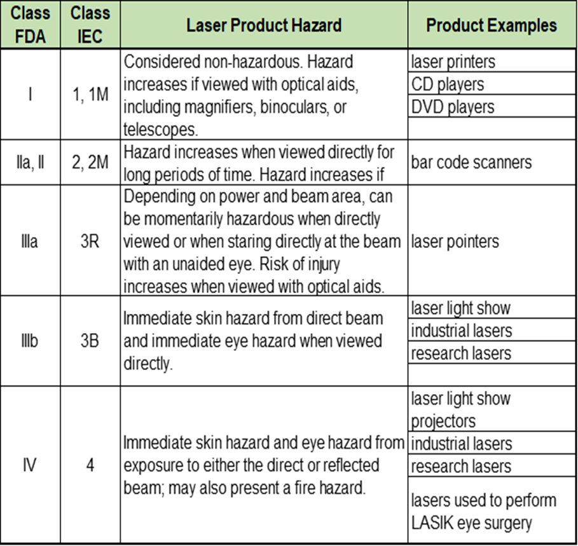

Table 21. Safety specifications for lasers.

**BS EN 61960-3:2017** – This International Standard specifies performance and safety tests for secondary lithium cells and batteries for portable applications. It gives users several requirements for secondary lithium single cells to provide consumers or purchasers with a set of criteria to estimate the performance and safety of various secondary lithium-ion cells [15].

**BS EN 61429:1997, IEC 61429:1995** – This standard covers the details of recycling and disposing batteries with the international recycling symbol [16].

**UL 2054** - This standard specifies the safety requirements for household and commercial batteries. Requirements cover batteries for general use, reduction in risks, and secondary batteries for use as power sources in products [17].

### Health, Safety, and Ethical Standards

Due to the nature of this project that deals with infant blood, there are a set of rules and standards that dictate how samples can be obtained. It is not ethical to go around drawing blood from newborn infants without having the proper training and equipment to draw and store the blood. According to the Human Research Protection Office, there are several considerations that qualify research for review and must abide by the code set under the CFR 21 [40]. This code dictates what humans under the specific conditions are viable to have blood extracted by a professional who understands how to do the operation. It also breaks down the frequency and amount of blood that can be drawn from people as well as how to properly contain, transport, and the time constraint associated with blood.

CFR 21 is the Code of Federal Regulations Title 21 that deals with Food and Drug administration in the biologics subchapter explaining how to handle human blood [39]. We must comply with all the federal regulations and since blood needs to be stored around 1 to 6 degree Celsius and we do not have the necessary equipment, we decided to work with beetroot powder and turmeric first to have a proof of concept. Working with these products is completely safe and does not have special storing requirements, so it is great for testing and providing a proof of concept as it has similar absorption spectra to the hemoglobin and bilirubin we want to measure. We would only acquire the proxy blood samples after we have confirmed that the project is in working conditions and the proof of concept has been met.

## Realistic Design Constraints

### Economic

As DABS enters its design phase, practical issues of cost, time, and physics will form obstacles that will influence our final design. One of the most dominating constraints will be price. This project is self-funded, and our funds are limited. Furthermore, there are other spectrophotometric devices commercially available, and if part costs greatly exceed those, then our project loses practical utility.

### Light Source

The 532 nm laser diode specifies that it cannot run continuously for over 5 seconds due to overheating. One of the constraints of our spectrometer will be to collect intensity measurements in four or less seconds. The photoresponsivity of our photodiodes will accommodate this constraint without problem.

### Sample Constraint

Our device will be calibrated to compute the concentrations of the proxy samples that we have proposed to testing. These proxy solutions have similar absorbance spectra, but the absorbance rates will be different. Therefore, the computation would need to be altered in order to give accurate concentration readings on real human blood serum.

The standard cuvettes chosen for this device require a 1.5 – 3 mL sample readings. This would equate to at least 30 drops of blood from an infant. This is a large amount of blood for non-medical persons to extract from an infant under two weeks of age with a lancer typically used by diabetes patients. Cost is a constraint for this demonstration. If DABS goes into commercial production, custom micro-cuvettes can be ordered with a millimeter pathlength, so only 1-3 drops (.2mL) would be required to perform a bilirubin analysis.

### Optical Filters Constraint

Even the smallest and most affordable optical filters start at $70. Our design will therefore minimize the need for quality optical filters by only emitting narrow ranges of wavelengths. We will be using lower cost colored filters designed for filtering light for photography applications. The packaging design must be enclosed, and it will need to shelter outside light from entering the system and skewing the detection measurements.

### Time Constraints

A major factor that affects every aspect of the design is the time constraint. Along with making sure that the design is completed and implemented by the end of Senior Design 2, it must also be taken into the account the amount of available time that each team member will have to allocation to the progression of the project in a timely manner. Each feature of the project will require time for research, acquisition, and proof of concept. Along with that, attention must be kept with the time it would take to complete prototyping and acquire the PCB for testing of the final design before it must be presented. This is all while managing other senior level classes as well as work and extracurricular time allocation. Components such as the PCB need to be completed as soon as possible with contingency plans in place to make sure that if any modifications are made to the PCB or if we need to redesign the PCB we have enough time to get the new order in to perform the proper testing and complete the overall project in time. Obtaining the PCB is one of the most crucial steps in the design, as it will allow the project to be integrated and tested for each component that was selected and verify that the components are working as expected and can be integrated efficiently.

Any ideas to add additional features to the project must take into account these time constraints and fit into the general milestones before it is deemed a viable option. Ample consideration into the amount of time the testing and integration must be accounted for to ensure any additional features that may be added can be realistically incorporated. This also includes considering that when a feature is added because it is working standalone, it must then be integrated into the overall design which would need to be retested to ensure that all the other components are still functioning after the integration. Time management is going to be one of the key factors to delegate work to each group member and meet the project deadlines to complete the project by the deadline set in senior design 2.

### Testing Constraints

Testing equipment and resources are limited to what is available to the team members and at UCF. Therefore, any testing ideas must be in a form that is readily available to us. This will affect how our accurate of reading we can obtain such as not having the necessary testing equipment to test surface mount devices. The accuracy of the measurements will only be as accurate as the testing devices provided or available to the group in the senior design labs. Also, due to our economic constraint ample testing of the bilirubin blood is not possible which can affect the thoroughness of our testing. We will be able to obtain a viable substitute to prove the concept but since it is only a substitute there is an area of uncertainty.

# Project Hardware and Software Design Details

## Microcontroller System

The chosen microcontroller will be responsible for integrating all the different systems, working in conjunction to make DABS a functional device. The final schematic is not yet finalized but will be implemented and designed over the semester break.

The microcontroller will need to interface with the power supply. First of all, the battery and charging circuit will supply the power to the microcontroller, which will then be responsible for distributing the supply voltages to the different components. We may also need to incorporate voltage regulation circuits, dependent on the supply needs of each component.

For the optical subsystem, the microcontroller will be responsible for the supply voltage as well as a timing system to turn the lasers on and off. The voltage supply must feed the two lasers, blue and green. The photodetector also requires a voltage supply but in a negative bias to run the photodiode properly. In order to minimize the time necessary to run the laser, and therefore the power consumed, we will set up a timing delay. This delay is intended to only let the laser run for enough time to shine through the sample and illuminate the photodiode. We will make this delay into a loop such that we can get multiple readings to ensure the accuracy of the results.

The thermal control subsystem is extremely dependent upon the proper function of the microcontroller. First, the temperature sensor must maintain communication with the microcontroller to report the ambient temperature within the enclosure. This is important because we only want the fans to turn on if the temperature inside the box rises above our defined upper threshold. Another task required of the microcontroller is to send a signal to the fans when they need to turn on and then send another signal to shut them off when the system has detected sufficient cooling. The motivation for only using the fans within a certain threshold is again to reduce the overall power consumption and try to prolong the battery life as long as possible.

The LCD touchscreen display will communicate with the microcontroller as well. This will be a very important feature, because it will guide the potential user through the process of testing the blood sample. As established above, the screen will require about 11 of the pins on the microcontroller. These pins are for the power supply and the quardinate controls on the touchscreen capability.

The interface with the transimpedance amplifier is limited to the voltage supply, for the amplifier to power on, and to receive the output voltage. This output voltage will be used by the microcontroller to calculate the overall concentration of bilirubin in the blood sample.

In order to test these individual systems, we will make use of breadboards to test the individual hardware. This method will prove useful for us to verify the preliminary designs. We can easily interface the microcontroller with a breadboard and test each subsystem individually. This individual testing procedure should allow us to verify the initial designs. Once the initial designs are tweaked and perfected, we can start the process of running tests on multiples systems at the same time, concluding with a complete system test. We will use this complete system test to make any adjustments to the PCB designs to try to minimize extra cost, if we need to reorder the boards after redesigns.

## Optical Subsystem

The optical subsystem will reside in its own light-containment compartment and comprise of the two light sources, a cuvette, and a photodiode. The light-containment compartment will sit inside the outer DABS structure and will be fabricated earlier to support testing of the optical components. In addition to cut out holes for all of the wiring for the optical components to run through, an insert must be made to support the insertion of the cuvette. The outer dimensions of the cuvettes are 12.5 x 12.5 x 45mm.

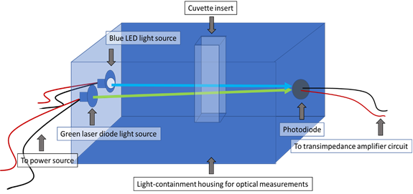

Figure 26. Setup of the optical subsystem.

The opening for the cuvette must be large enough to easily insert and remove the cuvette, but not so large as to allow outside light into the system. One possible solution will be to carve out notches on either side for fingers to grasp the non-transmitting sides of the cuvette, and to attach a lid for the notches and the cuvette top to block light.

The above figure shows the proposed schematic for the optical subsystem. The two beam paths will go through the sample in the cuvette and the transmitted signal will be received by the photodiode. (This diagram is not to scale.)

The green laser diode and the blue LED will both be stationary, and both need to point directly at the photodiode. The photodiode surface is small, and the two diodes will need to be angled slight towards the center towards the photodiode. This will slightly elongate the optical path length the beam travels through the cuvette, which is a constant value critical to the concentration measurements. The modified optical pathlength will be accounted for by determining the angle the light beams will be traveling through the cuvette, as illustrated in the following figure.

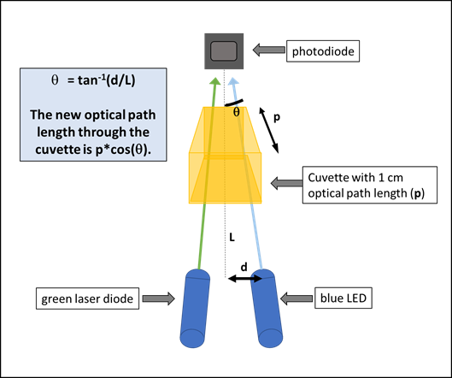

Figure 27. Derivation for new optical path length.

The updated pathlength through the cuvette will be derived using the lateral displacement (x-translation) of the diodes from the photodiode. The change is due to the small angle of the two light sources towards the central photodiode will be modified to account for slanted path of the beam.

## Software Design

Once the preliminary parts have been chosen and the constraints have been attended is when the software designs begin to be developed. Although the majority of the software is done by our Computer Engineer team member, portions of the design are delegated to other members who were assigned to focus on certain subdivisions of the project.

### Autodesk EAGLE: PCB Design Software

This information presented was adapted from the Autodesk webpage on EAGLE. Eagle falls under the software scope of electronic design automation and is generally a subscription-based service. We chose this design environment because a limited, free, version of the software can be obtained by university students. This software package is generally easy to navigate and there is plenty of documentation and guides provided by Autodesk. For the remainder of this section, all descriptions will be about the academic version of this software.

The main purpose of using EAGLE is to serve as the environment to design and test our PCB, before having the design turned into a physical board for hardware testing. There are 3 major aspects of EAGLE, that we will utilize for the PCB design: the schematic editor, PCB layout editor, and the PCB libraries.

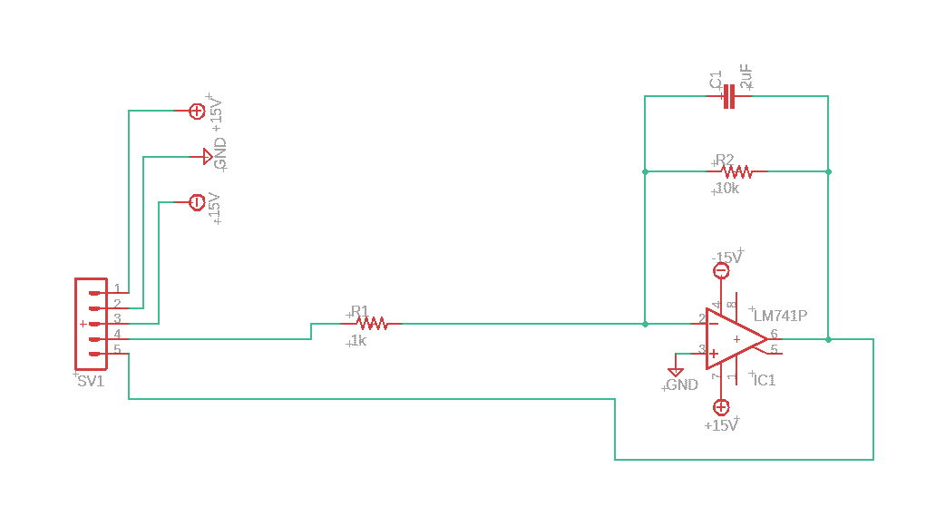

Figure 28. EAGLE Schematic OpAmp Design Example.

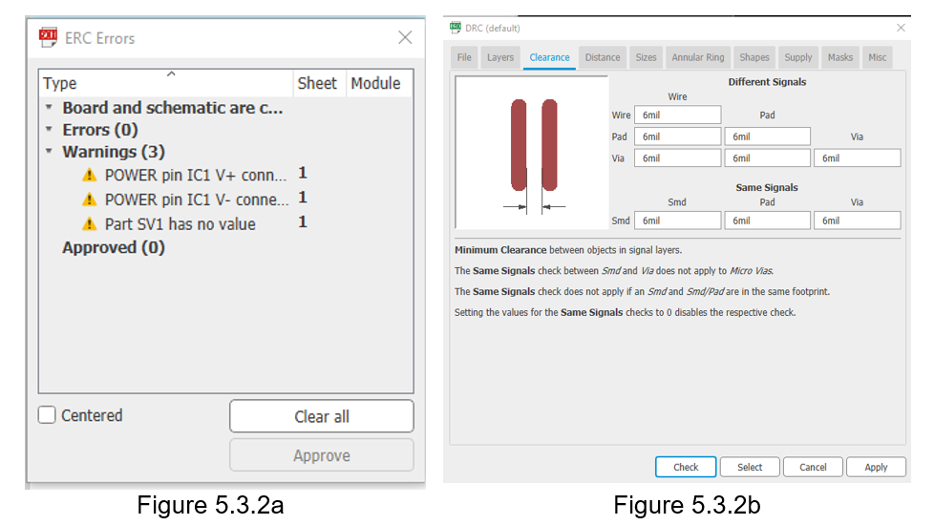

Figure 29. ERC Error Display

The first major component is the schematic editor, in which we can construct and test the schematics of each subsystem. Figure 28 shows an example of the schematic design environment for the design of an amplifier circuit. Within the schematic editor, there are a host of useful tools, that provide preliminary design testing and validation. First, EAGLE offers a SPICE simulator package that would allow us to conveniently validate the designs before attempting build and test the physical hardware. The schematic editor is designed to be modular. This modular design makes the drag-and-drop user interface very easy to navigate. Figure 29 shows the implementation of another useful tool provided by EAGLE’s schematic editor, the electronic rule checking (ERC). The ERC provides an additional layer of schematic validation, based on a complete set of electronic rule checks (defined by the software). If you click on the warnings provided by the ERC, EAGLE will pinpoint the exact locations of each error.

The next layer of EAGLE we will be using is the PCB layout editor. EAGLE provides a simple and easy to use interface when designing a PCB layout. This PCB layout editor shows us the footprint of each component and allows us to lay the traces, that will be the wires connecting the pieces on the physical board. Once the board

components are placed and routed, the design rule checking (DRC) can be used to customize the rules and constraints governing the final PCB design, the types of guidance given by the DRC is shown in figure 30.

Finally, Eagle provides a large variety of PCB content libraries. Within these libraries, we can find almost all the parts and components needed to design the board. If EAGLE lacks a component that we need, there is a process that allows us to create a library, along with the footprint, for the device or component that we need.



Figure 30. DRC Error Report.

Once the design is complete, EAGLE makes it easy to create a bill of materials and select components directly from the manufactures. This bill of material provides a couple of important pieces of information (among others): the quantity and price of the component or device.

Once the PCB design is complete, using the EAGLE design studio, we will be able to download and print the board file.

### Use Case Diagram

This Use Case Diagram depicts how a user would operate and interact with the DABS system as well as its current capabilities and features.

Figure 31. Use case diagram of system’s operation.

### Startup and Bootup Process

The Bootup and Startup process will run once the device is first powered on. The system will start by initializing all pins and analog-to-digital converters needed for the touchscreen display followed by printing on the screen and to the user that the device is currently booting up. Next is the initialization of all other modules of the device (i.e. the temperature sensor, optical sensor, and touch capabilities), which will each require input/output pins as well as analog-to-digital conversion pins. Once all modules complete their initialization the screen will display a menu for the user to interface to the system through touchscreen capabilities.

Figure 32. Flowchart of Bootup/Startup process

### Graphical Display

The display will be used to interact with the user(s) to display information as well as instruct for the retrieval of information from the user. The display will be operated and interacted with solely through a graphics library API that comes compatible with our microcontroller and the display. The API communicates over SPI using the 3-pin configuration. The display will illustrate instructions needed to operate the device and well as touch areas that run the different functions of the device. Most functions will have its own specific display to illustrate to the user. It will also illustrate when the delays of the operations. The library will communication between the two through the SPI protocol.

### Touch interface

The touch response of this system will come from the display and shall be retrieved through an interrupt. The interrupt will receive the response as an analog signal to be converted by the microcontroller. Once converted it shall be run through a scaling algorithm in order to pinpoint the X and Y positioning on the display. After this information is processed and associated to a point on the screen, it shall be associated with the operation field that encloses the area accordingly, if one exists at that moment. The touch response will also be setup to remain active while the system in in low-power mode and shall be the trigger to awaken the system.

Figure 33. Flowchart of touch response interface

### Optical Sensor Algorithm

The optical sensing will be done as an analog reading taken from an optical circuit. The circuit becomes active by means of a high voltage signal sent from the microcontroller. Once the supply signal is sent the system will wait until the analog signal is retrieved from the optical circuit. That signal is then converted into a value can be compared. The comparison will be between an ideal sample and a test sample from the user. Once that retrieval and conversion process is done for both the ideal and test sample, followed by the comparison, an output response will be sent to the display. The response will illustrate the results of those sample reading and will also display information about next steps if the results return a negative reading.

Figure 34. Flowchart of optical sensing process

### Cooling System

The cooling system process is going to be based on a reactive system with a restrictive active interval. The temperature sensing circuit will be sending out a constant signal, but the microcontroller will be listening to the line only for the duration right before and after the optical sensor reading is active or intermittently while the fan is running. If the response of the temperature sensing circuit surpasses the threshold of safe operation a signal will be sent to the fan to commence cooling down the system. The fan will be kept running until the system receives a reading from the temperature sensing circuit that the temperature as decreased comfortably back into normal operation bounds. While the fan is on a timer will be used to recheck the temperature after specific duration until a satisfactory value is achieved.

#### General Temperature Test Plan

All electrical components will dissipate heat during continued use. Using the thermal information section, of the individual device datasheets, the total heat dissipated could be calculated using the thermal resistance and the power applied to these components. Dependent upon the time the system is left running, the temperature inside the box has the potential to continue to rise. To help prevent the system from overheating, a fan will be used to help maintain the ambient temperature, at 25⁰C within the DABS enclosure. This temperature is commonly used as a stand in for “room temperature” and falls well within the operating conditions of the device components. We will thus need to write a control code, telling the microcontroller when to supply power to the fan and when to cut that power.

The device may not be left running for significantly long periods of time, but we will need to apply a tolerance level to the temperature we wish to maintain. The tolerance will serve as a control for when the fan needs to turn on, as well as when it should shut off. In order to keep this control relatively simple, and improve the ability to prove it works, will we be using a temperature range of 25⁰C ± 8%. These values will be hardcoded so that they stay constant throughout testing. Thus, the three hardcoded values that will serve as the main fan control will be:

* tolerance = 2 (25⁰C ± 8%)
* upper_threshold = 25 + tolerance
* lower_threshold = 25 – tolerance

The tolerance level was chosen, based mostly on simplicity and the idea that, with a small temperature increase needed, we will be more likely to utilize the fan during operation of the DABS. The control will be set up such the test is initialized to pass, meaning that the initial state of the fan will be off. Once the temperature increases 2⁰C, the test will fail, which will change the state of the fan to be on. Now, the fan will continue to run until the temperature within the encloser hits the lower threshold, at which point the test will again pass and the fan can shut off.

The temperature sensor will be used to continually monitor the ambient temperature within the enclosure. This data will work in conjunction with the microcontroller to determine when to turn the fan on or off. The following pseudocode will help visualize this process.

Overview of Fan Control Code

1. Test is initialized to pass, before any temperature data is processed
   1. Initial test state = pass
   2. Initial fan status = off
2. If ( received temperature <= upper_threshold && >= lower_threshold)
   1. The test state will continue to be pass
   2. The fan will remain off
3. Else If ( received tempereature > upper_threshold)
   1. The test will fail
   2. This means the fan must be turned on
   3. The fan will remain on as long as the test state = fail
4. Else (temperature < lower_threshold while the fan is on)
   1. The test passes
   2. The fan must be shut off
5. Once the fan shuts off, the above control loop will continue to monitor the temperature and switch the fan on or off depending upon the defined thresholds.

This serves as an initial outline for the temperature control subsystem and will probably need to be modified in order to come up with a workable code. We will continue to build off this foundation to and expand this pseudocode into a real code that will be run by our microcontroller.

### Low-power mode

The low-power mode turns off most of the functionalities of the system except touch response since that will be what wakes up the system.

Figure 35. Flowchart of Low-power mode process

The system will entire this mode after a certain period of inactively from the touch screen or if the option is selected from the screen.

Since most of the system is actively initiation (i.e. optical and temperature sensing), those will simply stay in their inactive state while in low-power mode. The only system that operates passively is the display due to the fact that it directly gets power from the battery supply. So, the low-power state for the display is achieved by manipulating its internal backlight circuit’s PWM. By setting the value to zero the backlight of the LCD display will power off, and due to the touch response having a separate power source it will remained unaffected and active.

The device will then be configured to stay in this state until the touch response interrupt receives a signal. Once the interrupt is thrown the system to return the PWM signal back to the display and it will display an illustration that full operation has returned in some way, with the intent being that it is obvious to the user. Also, the process is set up such that the initial touch to exit low-power mode does nothing else but reactivate the system. Hence, touching the screen in this state does not activate any function that may be associated with their area contacted.

## Housing Design

The housing for the DABS project needs to be no larger than 10” x 8” x 8” and weigh less than 15 pounds including all the equipment that will be shielded inside. The housing needs to isolate the components inside from all light that does not pertain to project, mainly ambient light from the room where the device will be run. It should have a sleek professional look that makes the device have an appearance of a well thought out and complete product instead of a project that looks like it is a work in progress.

There should be no exposed wiring or hazardous materials protruding from the device making it a safe device to operate. The housing needs to keep all the optical and core electrical components inside but accommodate for an external display screen that will be the interface for the user to operate. The housing must also have a hatch that opens to allow for the user to place the cuvette with the reference sample and then replace it with a cuvette with the test sample. It should be visibly obvious where the cuvette should go since there will be a cuvette holder. There also needs to be a side panel or some mechanism to get to the optical and electrical components inside for testing and repair purposes. The housing should be sturdy enough to withstand bumps or small drops without cracking or breaking, while holding all the components inside in place. The size of the housing will most likely be smaller than the initial design constraints, since we will reduce the dimensions of the housing to be just large enough to hold all the components effectively.

There are many different types of materials that can be used for the housing as almost any visibly opaque material would be effective at blocking out ambient light at the wavelengths chosen for the project. There are many different materials readily available to buy that fit the initial requirements of the housing, but the way we will narrow down the material used is by looking at the material’s properties such as durability, tensile strength, flexural modulus, ease of machinability and cost. The tensile strength and flexural modulus will signify if the material has a good tendency to resist bending or breaking which is ideal. The housing needs to be as durable as possible since the idea is that one completed DABS product should be able to perform multiple tests and last a relatively long time, at least a year of operation without any defects.

The largest factors in deciding what sort of material will be used for the exterior housing will be cost and machinability. The cost of the housing should not push the total cost of the project over the budget and the material chosen needs to have high machinability so that it is easy to manipulate and produce a custom build that will not take an excessive amount of time to fabricate.

One option for manufacturing the housing is to 3D print it. There is a 3D printer that is available for use in the senior design lab with the appropriate 3D printing software. To properly use the 3D printer the design schematics for the product need to be accurately drawn with the corresponding measurements. There is a free online 3D printing software known as Tinker CAD from the Auto CAD family that is easy to use where we can design any parts that need to be printed.

Usually 3D printing is a slow process and is restricted on the type of material available for printing. This means it is not ideal to print the entire housing using the 3D printer which will require a long time to print, but smaller components such as the slots for the light sources, if we decide not to buy optical stands, the cuvette holder, and the slot for the photodetector can all be manufactured using the 3D printer. To properly use the 3D printer, it must be calibrated before use to ensure that it will print the object desired with the appropriate dimensions accurately. These dimensions include the height, width, length and thickness of the object that is designed to create an accurate finished product. The feed speed and thickness of the material used for printing is also an important factor when producing the desired object as an increase in speed and thickness usually result in less precise edges and corners when printing but faster print speeds. It is essential to find the appropriate speed and thickness of each layer printed to have a printed product that is structurally sound and precise.

There are 2 main methods, other than 3D printing, that are available to the group for machining the material we decide to use, either the lathe machine or the mill machine. The lathe machine has a stationary cutter while the actual piece that is meant to be cut is rotating making it extremely efficient and useful for creating cylindrical objects. The mill machine performs in the opposite method, where the part that will be cut is stationary and the cutting piece is rotating. This makes the milling machine more effective for complex designs of objects. We will most likely be using the milling machine in the machine shop at CREOL to create our housing since we only need to machine one device and the milling machine can make more complex cuts than the lathe. The milling machine has many features that determine what type of drill bit and component are most effective for the type of job that will be performed and the most important factors are the material that will be cut and what type of cut is going to be made.

The milling machine must operate at an rpm that is going to be able to shave of the material that will be cut while not operating at too high of an rpm for very materials that will cause the drill bit to break. In general, the harder the material such as stainless steel, the lower the rpm and feed rate the milling machine must operate at. This means that materials such as stainless steel that seem like a very durable, reliable material to use for a project may not be the best option to use if time and cost are limited. The machining process of the stainless steel would be very slow increasing the cost of producing a part made of stainless steel. The direction in which the rotation of the drill bit is spinning in relation to the direction in which the bit will be introduced into the material is also important. If the cutting edge is ‘scooping’ off material or for example the bit is spinning clockwise and will be introduce from the right side, then this is known as up milling while the opposite is known as climb milling. This is very important because you should know where the material is going to exit from the flute and the finish of the cut will be different. Usually climb milling is the better option as it leaves a better finish on the cut since it introduces the thickest part of the cut first and thins out at the end of the blade, but sometimes up milling or conventional milling is the better option to start a cut since it can remove the skin of the material easier. On very hard surfaces like stainless steel, climb milling will place a lot of pressure and backlash from the blades on the surface of the material and can break the drill bit. For this reason, it is important to note what material we will be dealing with and how to properly cut the material for a nice clean finish.

Due to these factors the housing will most likely be made from plastics such as acrylic or Delrin that bridge the gap between metals and plastics. These plastics are extremely durable, lightweight, as well as having high tensile strength and toughness. They are also very easy to machine, allowing us to fabricate a prototype piece relatively easily and rapidly for testing before creating a final design. The machine shop already has some leftover acrylic and Delrin scraps that we may use to machine our housing, but they are also not expensive to purchase sheets online. The plastics can be easily cut by up milling or climb milling and will most likely have the best finish by introducing an up milling cut first then finishing it with a climb milling cut.

The walls of the housing should be quick and easy to make the only issue is creating the locations for the bolts or screws and washers to hold the piece together. The holes need to be strategically placed to spread the load on the walls evenly, so they do not bend or snap on impact. The most difficult part of the outer design will be creating a secure hole for the display to fit into and a door or hatch that can be opened and secured shut for the cuvettes with the samples to be placed into. The hatch will need to have a locking mechanism for when the device is under operation so there is no light from outside that can interfere with the readings and be built in such a manner that it is durable for repeated movements during multiple tests. There also needs to be a wall that serves as a panel that will allow us to test the components once they are inside in case something goes wrong.

The schematics of the housing will be drawn by hand depicting all the measurements associated with the outer shell as well as the dimensions for the hatch and display screen that needs to be incorporated. There will be another sketch of the design portraying the layout of the base of the housing that should have a section to hold the PCB and other electronics in place, in a secure location that will shield the electrical components from outside damages.

The sketch of the base of the housing will also have the location of the optical stands or holders that will hold each of the 2 light sources, the cuvette holder, and the photodetector. All these measurements should be drawn to scale and precisely marked, so that the appropriate pieces can be manufactured precisely and accurately. Once the measurements are all drawn correctly on paper, they will be transferred to a 3D printing software for the pieces that will need to be printed or handed to the individual in charge of machining the housing using the milling machine. It is critical for the schematic of the base design to be easily legible and depict all the accurate positions and locations of where the optical components will be. This will allow the user of the milling machine, who is the machinist in charge of the CREOL machine lab, to accurately reproduce the design and meet the given specifications.

An accurate schematic is essential because once the design is manufactured, the components will not be able to move from their respective locations and all the corresponding calculations and measurements will be using the dimensions provided in the schematic. The laser diode and LED as well as the cuvette and photodetector need to be secured in place and have some vibrational resistance so the alignment of the optical set up is not altered causing inaccurate readings.

The exact dimensions of the cuvette holder on the base will provide the dimensions for the hatch on the cap of the housing so that everything can align itself in the proper manner. This is especially important when considering the optical alignment of the laser diode and LED with the cuvette and ultimately the photodiode to ensure that as much of the beam from each source reaches the sensitive area of the photodiode. The calculation for Beer Lambert’s law which is the formula used to calculate the concentration of bilirubin in the sample is dependent on the optical path length of the cuvette so the dimensions are also critical in this regard since this underlying principle is what will drive the readings from the photodiode to be processed and projected onto the display screen.

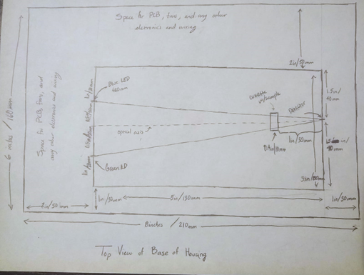

Figure 39. First draft of base design for project to present to machine shop instructor for initial design constraints.

The first draft depicted above was used to present the general idea of the conceptual design for the base of the project to the professor working in the machine workshop in CREOL. The dimensions and locations of the components were strategically selected after conducting some research, but the dimensions are not set in stone yet and can be modified as needed. This draft was presented to the machine shop professor to verify that the design is realistically feasible and get some feedback as to how long it may take to machine this design as well as the availability and durability of materials that can be used to complete the design.

Overall, the feedback was positive, telling us that the design looks like a good first draft that can be easily manufactured with the leftover acrylic he has available in the lab. In his professional expertise working with machines and designing various designs for multiple projects, he confirmed that the base of the design should not take very long to machine once all the final dimensions have been established. The stability of the base is very important as it will hold all the major components and the idea is to have a raised platform for the PCB and other electrical equipment to decrease the risk of damage to any internal components.

The design also accounts for the light containment chamber that will hold the optical equipment inside the outer shell of the housing and preparations with the professor from the CREOL machine shop have been made. The preparations include providing slits or optical holders for the 2 light sources as well as the cuvette insert holder and the detection stand, where all these components should be stationary at specific distances, allowing a small amount of space for modifications in testing for each component until the final design is established.

The housing look will be based off existing models of table-top bilirubinometers such as the UNISTAT bilirubinometer. The measurements for the design will be updated as the spectrometer is being built so that actual accurate measurements of distances and sizes of objects can be considered for the spacing needed inside the housing. Although the final design will be based off existing models it will have to get a unique look and finish displaying the work and will contain the University of Central Florida logo to display the work done by the group members.

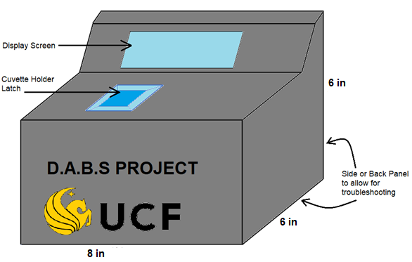

Figure 40. Preliminary concept design for the project housing

The conceptual design of the outer housing was also presented to the professor at the machine shop so that he had as much information as possible about the projected idea for the housing. One of the biggest concerns before bringing in the design to the professor was creating the latch for the cuvette holder that would be able to be incorporated into the design and be sturdy enough to be repeatably opened and closed. This was quickly dismissed by the professor once the situation was explained, as he presented a quick and effective way to add a plastic hinged door that will be very sturdy to act as the latch for the cuvette holder.

The base of the housing will incorporate rubber feet so that the product is not shifting or sliding around the table as well as increased resistance to external vibrations from the surroundings of where it is placed. The walls of the housing will be joined using industrial glues and a series of screws creating a strong foundation throughout the design.

The display screen will need to have an opening just large enough to display it and have enough space to place an outer frame around the display on the inside of the housing so the display can be bolted in place from the inside without having any exposed screws. This will keep the design looking sleek and professional. The professor at the machine shop lab also confirmed that the acrylic can be flame finished after the design is complete to give the design a clean, professional look.

The housing should look sleek and professional, giving the impression of a completed product instead of a lab experiment. The actual design of the housing might change slightly after learning different techniques or methods advised for designing the housing are given by the professor in charge of the machine shop in CREOL. The last process that will be done for the housing is providing a coat of paint and finishing on the exterior of the housing. The polished finish and paint will provide the image of a finished product that looks ready to be presented and represents the groups work and place of study.

## Integrated Schematics

Schematics are essential to designing, building, and representing an overall detailed layout of an electric circuit board. Our printed circuit board vendor will require schematics in order to execution our required PCB.

The main schematics required to be implemented in the project protype will have all the detail information and detail description on how it will function and why it a certain value for an electrical component was chosen. Most of the integrated circuits will come with a datasheet. The datasheet section is located in Appendix A.

The datasheets attached give more detail and guidance in selecting certain values for resistors or capacitors. The values for certain components will be chosen based on the datasheet recommended component values in order to achieve a desired output or a functionality of the circuit. All the transistors, resistors, capacitors, and integrated chips will be shown in the schematics with their chosen values.

A group consensus will also be made in deciding the printed circuit board vendor. The vendor will have to be reliable, reputable, and able to deliver the PCB in a timely manner. There are many vendors in the United States or other countries that can manufacture and assemble a circuit board, so considerable research of a vendor will be discussed in later sections highlighted a specific vendor that meets the requirements.

The detailed schematics will show how the DC-to-DC converters will be utilized for voltage regulation for some components like the laser or microcontroller or how an amplifier circuit schematic will show how the output of a photodetector will be amplified to a measurable voltage or current for a digital input on the microcontroller. The MCU schematic will show all the connections that will be integrated to other components. This will be the main schematic as it will have mostly all the connections on the board.

The last schematic that will be designed is the DC Power Circuit. The schematic for this design will show how the user will be able to charge the main battery system while still being able to operate the device via USB connection to an external power source. The selected integrated circuit’s datasheet will be used to design the power input schematic as this is critical to supplying sufficient power and not cause any hazards that will cause bodily or environmental harm to the end user or others.

### DC to DC Converter

In order for the low-powered microcontroller to function properly, a voltage input of 3.3 volts is required as specified the MCU datasheet in Appendix A. A buck converter will be designed with the guidance of the software tool WEBENCH from Texas Instrument.

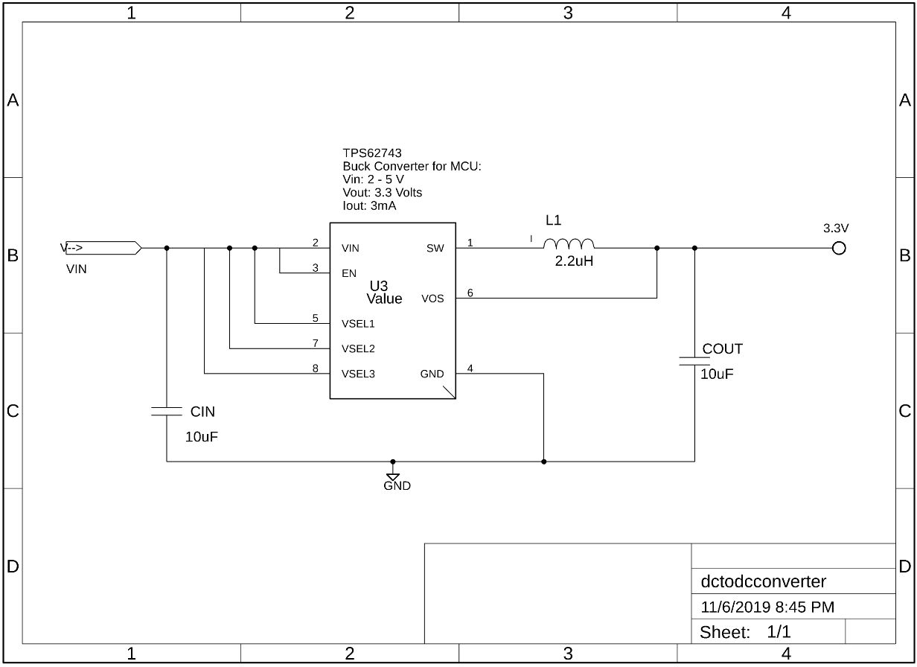

Figure 41. Buck Converter with an output of 3.3 Volts.

A buck converter was chosen over a linear voltage regulatory because of its high-power efficiency characteristics (See Figure 41) compared to the linear voltage regulator which dissipates more heat than the buck converter. The electronic chip chosen for this design is the TPS62743 from TI.

The above schematic shows an initial design of the buck converter producing an output voltage of 3.3 volts for the MCU. The input voltage of this circuit will either be 4.2 volts from the lithium-polymer battery when fully charged or 5 volts from an external power source using USB connection.

The maximum input voltage this chip can take is 6 volts, so the USB connection will need be verified that it only outputs below 6 volts. This circuit will also supply the cooling fans which is rated to function at 3.3 volts and 200 mA. This circuit is able to supply up to 300 mA of current and will be sufficient for fans and MCU.

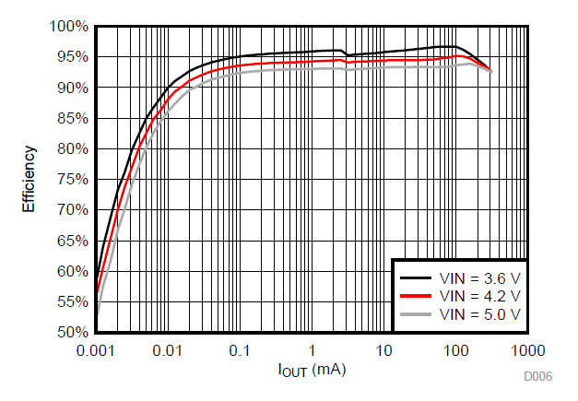

Figure 42. Efficiency of the TPS62743 buck converter.

For the laser to be operational, a voltage of 3.7 volts and a current less than 250 mA is required for initial start-up. A buck boost converter topology will be implemented in the design stage to keep the voltage at 3.7 volts. One chip that can provide a stable output voltage specified is the TPS63806 for Texas Instruments. (See Appendix A-4 for datasheet information). This chip can take an input voltage from 1.3 to 5.5 volts and give an output voltage of 3.7 volts when designed with the correct configuration.

The configuration below is the recommended values and implementation of the TPS63806 to provide the desired output voltage and current. The schematic diagram has not yet been finalized but a general idea is given on how the circuit will be designed on the PCB.

The main input voltage will be either from the battery system or the USB connection. This buck-boost converter also has a high efficiency rating and was chosen to be implemented in the design process.

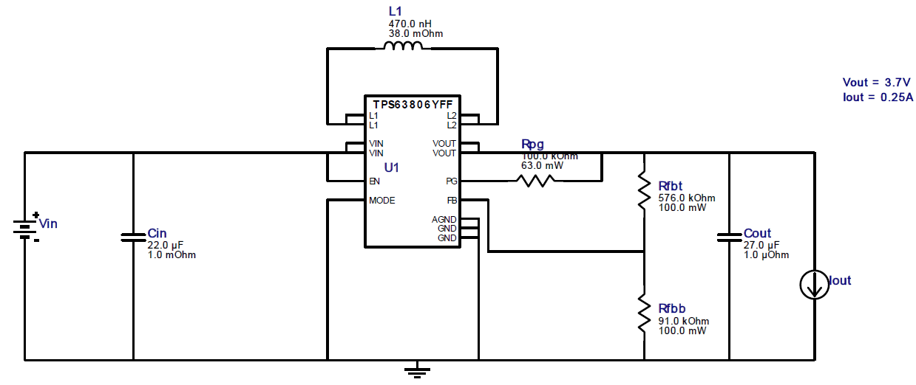

Figure 43. Buck-boost converter circuit to provide 3.7 volts to the laser.

### Amplifier Circuit

The amplifier circuit was designed with the help of TI’s Circuit Cookbook for Amplifiers [36]. The initial choice for operational amplifier, was the OPA170, but may be changed after initial hardware design and testing. The current supply will come from the photodiode output, after the light source passes through the sample.

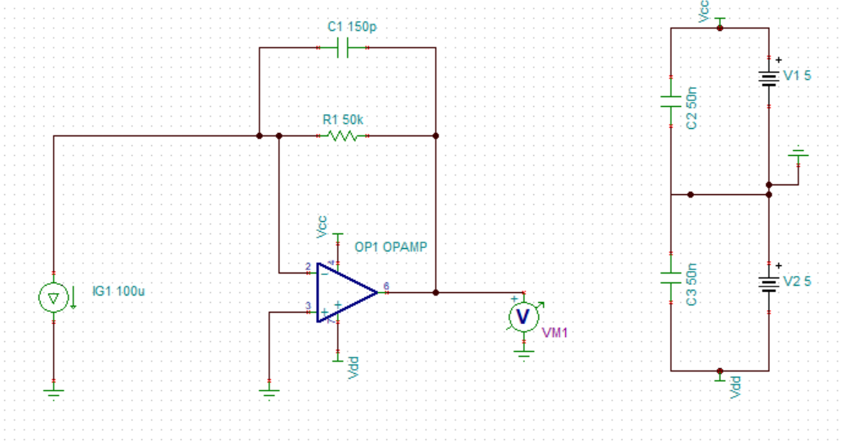

Figure 44 Transimpedance Amplifier Schematic Design

The transimpedance amplifier will play an important role in the functionality of the the DABS project. We need to use a transimpedane amplifier circuit in order to convert a current source into a voltage value. This voltage value can then be used by the microcontroller. The microcontroller should be programmed, using the Beer-Lambert Law, to be able to convert the detected voltage value into the bilirubin concentration. This concentration value can then be sent to the display.

### DC Power Circuit

For the power circuit, carefully design considerations were taken. One main source will supply the components with power, however, as mentioned in previous sections, the user will have the option to power the device using an external power source via USB type connection to the board. This will allow the battery system to charge while the user is still operating the device.

The figure below shows an initial design implemented on a schematic using EAGLE software. From the schematic, a USB connector will be soldered on the PCB for a USB connection for optional power input. The main chip that will charge the battery will be the MCP73821 from TI.

This chip was chosen for the reliability and safety of charging the main battery system at 4.2 volts and a programmable charge current rate of 500 mA. The range of supply voltage to this chip is from 3.75 to 6 volts max which is safe operation since most USB type connections are rated at 5 volts.

The design also has 2-pin JST-XH connector that will be solder on the PCB as well. This will allow the battery to simply connect to the board and be secured tightly and not have a loose connection. The battery can also be replaced if the battery can no longer be functional.

The schematic also includes a Schottky diode that connects between USB output to the drain pin on the P-Ch MOSFET. The diode is there to prevent any leakage current from the device.

A P-Ch MOSFET is used to open the circuit from battery to a DC-DC converter or a buck booster whenever there is power coming from the USB connection. When there is no power from an external power source, the P-Ch MOSFET will close the switch between source and drain and allow current to flow to the electrical components.

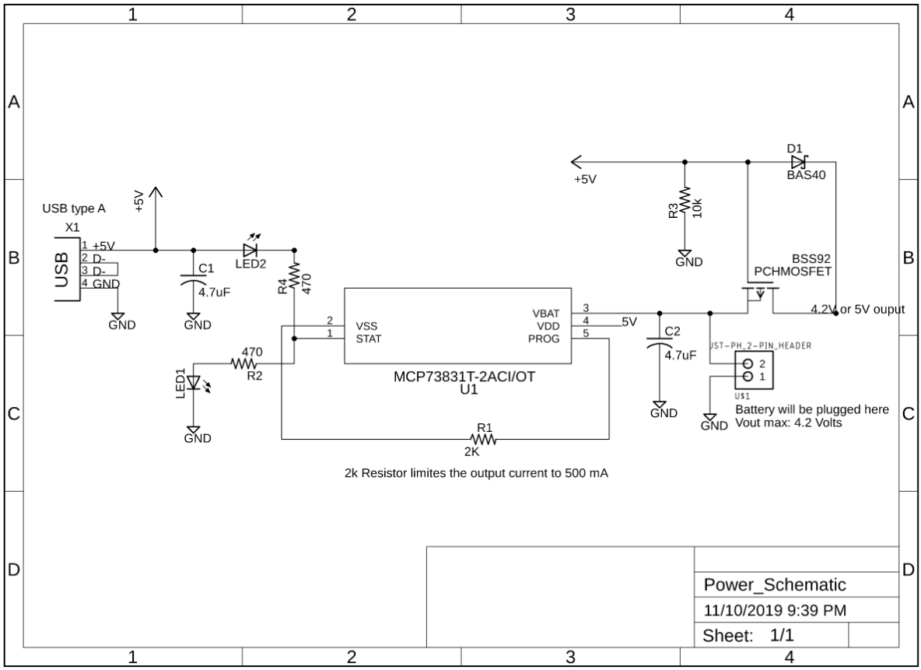

Figure 45. DC Power Circuit.

Additionally, there are two LEDs to indicate when the battery is charging and when it is fully charged at 4.2 volts. The resistors and capacitors show in the schematic will also be utilized with their given values listed below:

Resistors :

* 2 x 470 Ohm
* 1 x 10 kOhm
* 1 x 2 kOhm

Capacitors:

* 2 x 4.7 uF

Both the resistors and capacitors surface mount packages will be 0805 (0.08 x 0.05 x 0.018). This will sufficient when soldering all the components. The LEDS will be the same size of the resistors and capacitors. The Schottky diode and MOSFET will be vary depending on the availability of the transistor of the chosen vendor of the components. All components selected will be procured through Digi-Key website.

# Project Prototype Construction and Coding

At this stage of the project’s design production, a prototype has not yet been developed or implemented on the CAD software EAGLE. However, some schematics have been designed but not yet produced a final printed circuit board or PCB with all the integrated schematics for each electrical component, pins, and the microcontroller.

A general idea for how the entire system will function accurately with various circuits on the PCB is known. First the laser will have to be connected to digital pins on the selected MCU. The PCB will have several analog and digital I/O pins connected to the microcontroller chip. These pins will connect to other peripherals like the cooling system or fans, interface with touchscreen, the photodetector, and the main power source. Pins on the PCB will also serve an interface between the controller for onboard emulation for programming and debugging.

The major design implementation will be the microcontroller as it will be the “brains’ of the operation and special design considerations will be taken to ensure a fully functional system.

Secondly, several buck boosters and buck converters will be utilized and implemented in the design to supply several components with the proper voltage and current. Other circuits like the amplifier, RC circuits for noise filtration, and battery charging circuits will also be implemented into the design.

The initial schematic design for the charging of the main power source using a lithium-polymer battery and the optional external power via USB connection will be shown on the next sections. This schematic will serve as the initial revision and any development issues or design issues when the PCB is tested will have to be revised.

Once all the electrical components, circuits, and the microcontroller are designed and implemented together

For the coding prototype, critical debugging and analysis will be done on the launchpad sold by Texas Instruments since the MCU is already embedded on the system. Some peripherals can be tested on the launchpad with the embedded MCU and will provide useful information when the final code is imported to the embedded MCU.

## PCB Vendor and Assembly

When considering the PCB vendor, reputability and quality are among some of the top considerations. Cost, size, and weight play into the overall project constraints. Additionally, we must consider the shipping time when trying to adhere to the milestones set forth and conducting tests, in a timely manner, that allows for tweaks and adjustments to the final product. With these considerations, along with company comparisons, we decided to work with OSH Park.

OSH park offers multiple PCB designs, two of which will be considered here for comparison’s sake. There are 2-layer and 4-layer board designs that we will consider. They can be compared based on price, weight, size, shipping time, and specifications.

The price consideration takes into account multiple of the other characteristics for the PCB design. These characteristics will be displayed for the 2- and 4-layer board.

2 Layer, Standard order. Cost five dollars per square inch. This also includes the following:

* 3 copies of the design (each order comes in multiples of three)
* 63 mil (1.6 mm) board thickness
* 1 oz overall copper weight
* Standard shipping in twelve calendar days

4 Layer, standard order. Cost 10 dollar per square inch, to include the following:

* 3 copies of the design (each order comes in multiples of three)
* 63 mil (1.6 mm) board thickness
* 1 oz outer copper weight and 0.5-ounce inner copper weight
* Increase standard shipping time to within 2-3 weeks.

Board specifications to include

* FR4 170Tg/290 for 2-layer board and FR408 180Tg for the 4 layer board
* Gold finish provides greater solderability and resistance (to environment)
* Thickness and weight shown above.
* Spacing considerations for 2-layer board
  + Traces are 6 mil and require 6 mil spacing
  + 13 mil drills and 7 mil rings
* Spacing considerations for the 4-layer board
  + Traces are 5 mil and require the same for spacing
  + 10 mil drill and 4 mil fings

For our design, pricing is going to play the most significant role, because this is an unsponsored project. Weight and size also provide strong direction for layer choice. With these in mind, we are leaning toward ordering 2-layer designs, also ensure quicker turn around for board receipt.

When considering the assembly of the board we must consider a variety of factors. First is, we must be able to fit the design into the enclosure. Also, we must pick a board layout that allows us to solder the components to the board. With this in mind, the 2-layer board will only be slightly better because there is more required spacing between traces. In order to gain useful experience, and enhance our skills, we wish to work on soldering the components by hand. If needed we may reconsider with the microcontroller due to the sheer number of pins.

## Final Coding Plan

We’ll be bringing together each individual module and functionality that encompasses this project into one central point. The core of this system needs to be able to coordinate and control every aspect of the process of the bilirubin analysis such that to achieve consistent, efficient, and reliable readings. This will require a wide range of features. Most notably interrupts, analog-to-digital converters, clock signal generating.

The majority of the coding for the project is done by Mr. Dezius. He is responsible for all software and the rerouting of pins and functionalities of the microcontroller. His configurations are influenced by the suggestions and feedback of the other members and their constraints relating to their sub-division of the project, as well as their dependability on the microcontroller.

Before anything is finalized in the code we review every requirement from the prototype in order to determine which ones need to be adjusted and the ones that operate properly. All data to be processed comes from a portion of the project that is developed by another group so the constraints that they require must be known before developing a design for the code in order to make it as compact and efficient as possible. These constraints varied from voltage requirements, to response time limitations, to preparation delays, to maximum continuous usage intervals, and others.

After finalizing the constraints of the design the next step for Mr. Dezius is designing an implementation that allocations all functionality and also timing them such that they do not conflict or drain the battery more than necessary. The use of interrupts will play a key role in achieving this efficiency. Relying on interrupts eliminates the need for power usage in checking the condition of a signal line or running a timer to sample data. While simultaneously allowing the interrupts to communicate with one another even more power efficiency is gained.

The general design first starts with having the display operational so that we have to ability to display information to the user immediately. This setup has the added benefit of making it such that issues pertaining to initializing the system can be clearly detected. This is due to the fact that if the display doesn’t activate for any given reason the lack of graphics on the screen will be a clear indicator of the issue. And also, the system to can be configured to display an error if it is unable to connect to the modules in the system.

Following the display setup is the configuring of the rest of the modules, with no particular attention to their order. Following the completion system’s primary initialization, next is setting up the dependencies between modules. The cooling-fan’s functionality must be set up to depend upon the temperature sensor, and the temperature sensing must be dependent upon the optical sensor.

Figure 46 - Examples of User Interface menus

Lastly is the configuration of the low-power mode. The purpose of the low-power mode is to safe battery power by sleeping the components of the system that are not necessary while the device is not in use. This functionality must be linked to all modules and have the ability to restrict their activity. The only functionality that remains active is the touch response of the display. The system is set up to return to full operation once the user touches the display.

# Project Prototype and Testing Plan

Testing of the project prototype will need to include breadboarding testing, analysis and evaluation of every electrical component, microcontroller, and optics components that will be integrated on the PCB. Software will also be tested and analyze to make sure the interface between user and touchscreen capabilities is fully functional.

Testing of each electrical component will make sure every selected component is compatible, sustainable and reliable before the final PCB design is integrated and implemented into the enclosure.

Analysis of each selected component’s output or functionality will ensure the safety of operation to the user and the environment. The operation of power, the charging functionality, the cooling system, optical laser, photodetector, microcontroller, and touchscreen are some of main features of this design and critical component testing will be executed for each feature. The next couple of sections will provide detail descriptions of the testing plan for these individual components.

Other electrical components like transistors, LEDs, resistors, capacitors, inductors will be tested as well to ensure that they are rated as per datasheet information and that they function as intended. These components are critical in the design process and any failure to these parts will create an unsustainable operation of the project prototype.

Detecting any faults or issues in these components will provide different options in selecting a more reliable component for implementation and integration of different circuits on the PCB. If any hardware failure occurs, the design process will be executed from the beginning to ensure the prototype is fully functional under heavy use of operation.

The test environments of the software and hardware components will also be discussed in later sections of this chapter. A well-equipped testing environment will be chosen, and it is important that environment provides enough resources and tools to execute tests and analysis for the main components and electrical components selected.

Not only will the environment provide the resources to execute the project protype plan, but it will also provide safety equipment in instances where major hardware failure occurs for any of main components, specifically the optical laser and charging circuit for the lithium-polymer battery.

The sample input that will used for testing analysis of this project will also be discussed and a detail plan will be presented.

## Hardware Test Environment

The environment for testing the optics portion and electrical components of the protype will have to be a suitable and safe environment to conduct tests and simulations of the prototype. Testing and assessment of each component will require expensive electrical equipment to verify the functionality of every chosen component. The equipment will provide reliability and validity of different test cases as the equipment are manufactured by renowned engineering companies. The next few sections will describe the testing environments for the optics portion and electrical portion of this project.

Testing environment is important in executing the project as it allows the team to create, modify, and simulate test cases for the system either together as an integrated unit or separately to find a root cause of a component failure. This will allow the team in troubleshooting any incompatible components in the design and modify or select another component that meets the desired results.

### Optics Test Environment

The optical test environment will change as the project progresses from the initial testing phases towards more sophisticated subsystems, as work on the project continues.

Initial testing conditions

Initially, each optical component is going to be isolated and tested individually to ensure that each component bought, works the way it was designed to. These tests need to be performed in a safe and controlled environment. The University of Central Florida and CREOL have provided the group access to a senior design lab for prototyping and testing the equipment. This includes testing the laser diode under the recommended current and voltage settings, to verify that it is indeed producing the expected output described on the data sheet.

The test will be done with a DC power supply, power meter, and oscilloscope from the senior design lab to power the laser diode, read the output power, and read the rise time and fall times of the laser diode to know when it is stable to take accurate readings. The same principle applies to the testing of the blue LED to make sure it generates enough optical power for accurate readings.

The photodetector will also be tested isolated from any amplifier or receiver circuit that will be integrated further down the line. To verify the photodetector is working correctly it will need to be tested under reverse bias which will be the mode of operation that it will be used for the DABS project. Ambient light and the two light sources will be used to illuminate the photodiode for testing which will be connected to a DC power supply and multimeter for reverse biasing and reading the current output. The photodetector should be able to absorb photons from both light source wavelengths and convert that energy into an electrical current since it is designed to have a relatively high sensitivity to both wavelengths. The laser diode cannot operate for longer than 3 second laser pulses to avoid overheating, so the photodetector needs to have a responsivity that can take accurate measurements within that time frame. The distance between the light source and the photodetector has not been finalized yet so the test for the photodiode will be done at an arbitrary length just to confirm its operation and will be performed with makeshift stands while the housing is being developed. All the measurements will be taken without a solid housing designed yet.

Advanced testing conditions

After the initial testing on the light sources and the 3 different photodetectors the next phase of testing can begin. Since the individual components work have been shown to operate correctly, the next step is to introduce the cuvette with the reference and test sample. At this time a prototype housing or makeshift enclosure will be used to contain as much light as possible within the optical system without any outside influence. This will increase the effectiveness and accuracy of the measurements taken when testing the optical equipment, where the distances between optical components should be close to being finalized so that the results are concise and accurate. After these measurements are taken the final photodiode must be selected moving forward for the project. The other two photodiodes will no longer be used, and all further testing of equipment and steps will be done with the selected photodetector.

The lab testing equipment will most likely still be used for primary testing of the optical equipment while the electrical components are still being finalized. Some preliminary integration of the optical and electrical subsystems is most likely going to commence at this stage of testing as well. This will ensure that both the electrical subsystem is functioning smoothly powering all the optical equipment and that the optical equipment is still functioning well as it receives the necessary voltages and currents to power the devices.

The spectrophotometer should be able to function without any lab test equipment and have a dependable repeatability that delivers accurate readings time and time again. During this stage in testing we are going to introduce the known turmeric and beetroot concentrations into the sample cuvettes to calculate their respective molar absorptivity constant using Beer-Lambert’s law. After multiple trial runs of varying concentrations, the values for the molar absorptivity of turmeric and beetroot should be found as a constant value.

Once the molar absorptivity is confirmed for the turmeric and beetroot then we can run tests with known concentrations and test what concentration is calculated using the spectrophotometer, comparing the expected and experimental results.

Final testing conditions

The final testing conditions for the optical setup should have the optical subsystem integrated with the PCB for interactions with the electronics and microcontroller with display. At this phase of testing we have tested through multiple iterations that each optical component works as an isolated piece, then as a cohesive optical subsystem, and finally that the subsystem can work with the electronic subsystem alone without the need for optical lab testing equipment. The project should be in its final stages where the product can work on its own, providing the necessary power to the light source and photodetector to work properly as a spectrophotometer.

The housing design to hold all the components together should be complete and all the components should sit inside the housing in their appropriate locations. The housing should isolate ambient light from the system effectively creating a black box to ensure the photodetector is only collecting the light from the optical setup.

It should also have relatively easy access to all the components inside to be able to test the components in case anything is not working appropriately so that it can be fixed. The final design of the project should look like a finished project with no exposed wiring or components and run all its operations to meet all the set requirements.

### Electrical Components Test Environment

The testing environment for the battery system for supplying the prototype with power, the cooling system, or the microcontroller can be conducted in well-equipped engineering rooms at the University of Central Florida. These rooms come with oscilloscopes, digital multi-meters, DC power supplies, breadboards, transistors and more equipment to assist in testing the selected components of this project.

There are two well-resourced places for conducting safe assessments of the prototype, the Texas Instrument Innovation Lab and the designated senior design room. Both places provide very resourceful equipment, but the Innovation lab provides more resourceful equipment; for example, they provide a lab bench, laser cutters, 3D printers, extra TI microprocessor boards, soldering stations, micro-scope for surface-mount soldering, and basic tools if needed.

Not all the chosen components will need to be tested in the specified locations to continue with the prototype. The microcontroller can easily be tested at home or at one of the individual locations mentioned. The battery charging and USB connection functionality will need to be conducted in one of locations as it will require a multimeter to test the output voltage from the battery system and the USB connector.

Other minor components like resistors, capacitors or LEDs will need to be utilized during the testing phase as these components are immediate available at both locations.

## Hardware Specific Testing

Testing specific circuits or components is crucial in verifying the functionality of circuit or selected part. Datasheets for each part give detail descriptions of how specific part will operate and function under different voltages, current or even temperature. Graphs comparing different characteristics also give a descript on the functionality of a circuit or equipment.

However, many instances a hardware error arises due to unforeseen malfunction or heavy stress on the component. The causes of malfunction or unstable operation can come from many different factors including overloading a circuit will current, or misconfiguration of connections causing a component to dissipate heat and malfunction. Other causes of errors or malfunctions can arise from environmental factors can cause issues for a circuit or component.

In the hardware specific testing section, each important hardware for this projected will be tested and analyzed in detail to observe if the hardware is capable of being integrated into the system. It is important to carry out the plan set out to detecting early issues that can cause problems later in the project.

### DC Power

Testing the power from the battery or USB connection is important as the device will operate with either option. The lithium-polymer battery system will be the first to be tested. To recap, the specifications of the lithium-polymer battery is given below.

The Li-Polymer Battery specifications:

* 4.2 Volt output when fully charged (Nominal voltage at 3.7)
* 1200 mAh capacity
* 0-45°C operating temperature
* 3.0 V discharge cut-off voltage

The datasheet of the Li-Polymer battery can be found on Appendix A-5 for further specifications. The ones listed are the important characteristics in verifying and validating. The battery can be increased in some parameters if need be and will serve as a secondary choice if the specifications are not sufficient enough for the project.

All these specifications will be tested to verify that the main battery will operate under continuous use. The constraint on the usage of the prototype is to operate under continuous use for no less than an hour. So, it is important that the battery is able to withstand heavy loads when fully operationally. The picture below shows how the main battery will be tested. The red wire the is positive voltage and the black is the negative or return path.

To test that the battery outputs 4.2 Volts when fully charged. A 2.1k resistor will be placed in parallel with the voltage source or battery. Using Ohm’s law, the expected current through the resistor will be:



A digital multimeter provided in the testing environment will be used to measure the voltage across the resistor and probed in series with the resistor to verify the current. The load or resistor will be decreased to drain the battery and verify that the cut-off voltage is at 3.0 Volts and not at 3.5 or less.

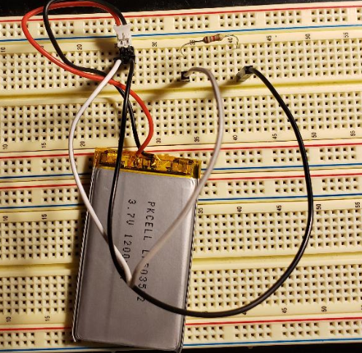

Figure 47. Connection of the main battery to a 2.1KΩ load.

In the figure above, since the output current is 200 mA, the expected battery usage until cut-off would be around 6 hours. This is only if the current drawn from the battery is 200 mA. If the maximum current draw is 500 mA, the battery will only last 2.4 hours.

The second option for power is the USB connection from an external power source. This will serve as a secondary option when the main battery is fully discharged at 3 Volts and needs charging. To verify that the USB connection from an external power source is output 5 to 6 Volts, a USB connector and an adapter will be used to plug into a wall outlet. The USB will be connected to a USB connector on a breadboard which will be in parallel with a resistor or load. Similar to the Figure above. A digital multimeter will be used to measure the output voltage across the resistor. The current will vary as it will depend on the resistor value.

### Charging

The test plan to charge the lithium-polymer battery will involve the integrated chip from Texas Instrument, the MCP73831/2. This IC is capable of charging our battery pack at 4.2 volts and at charging current of 500 mA. The since the IC is small in size and not easily testable on a breadboard with resistors and capacitors, a pre-assembled PCB design will be procured from Adafruit, a renowned hardware company that specializes in teaching and selling various electronics and kits.

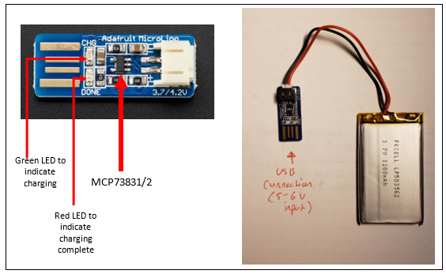

Figure 48. Charging IC for the Li-polymer battery.

The default charging current on this design is 100 mA, but can be modified to charge at 500 mA. With 500 mA, the expected fully charged battery is expected to be:



This will be tested when the battery discharged at the cutoff voltage around 3.0 V. The charging rate of 500 mA was chosen as recommended by the datasheet of the MCP73831/2.

The recommend charging rate for most batteries is around ½ C, which 500 mA is just 100 mA from ½ C. This will ensure the battery is charging at a minimal rate and securely. There is an option to charge the battery at 1 C but that would require more careful considerations on the charging circuit schematic designs highlighted in chapter 6.

### Temperature Sensor

To test the temperature, the Texas Instruments LM35 centigrade temperature will be used. The full datasheet is located in Appendix A-6. The LM35 was chosen as it is the most common temperature sensor for small to mid-level projects. The sensor will measure the temperature of the lasers and send an output voltage to an input pin of the MSP430 microcontroller.

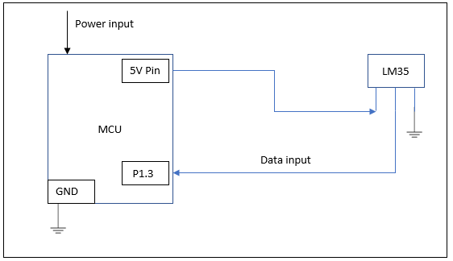

Figure 49. Connection of LM35 to the microcontroller.

A quick summary of the LM35 is given below:

* Linear +10-mV/°C Scale Factor
* Temperature range of -55 °C - 150°C
* Operates from 4 V to 30 V
* Less than 60- uA current drain
* 0.5°C ensured accuracy

In order for the MCU to analyze the data, the analog-to-digital converter or ADC (12 bit) built in the MSP430 will be set up to read the input data from the output pin of the temperature sensor. The microcontroller will have an internal reference voltage of 1.2 V that will used.

From Figure 49, the connections that will be made between the LM35 temperature sensor the and the microcontroller are shown. The output from the LM35 will be connected to the pin in port 1, pin 3. This pin has an analog function that can be used to read the values that come from the sensor.

### Cooling System

For the testing of the cooling system for the lasers and other electrical components, two 3.3/5 V fans specified in the parts selection summary will be utilized.

A power supply and breadboard equipment will help with the test procedures and analysis. The testing procedure will include supply both fans with 3.3 Volts and observing the air flow and operation. After the supplying 3.3 Volts, the fans will supplied 5 Volts and observation of operation will be noted.

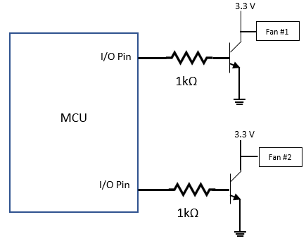

Figure 50. Simple configuration of the fan connection to microcontroller.

In the above figure, the both fans will be connected to the collector of two NPN BJT. The emitter pin will be grounded for both BJTs. The base pin will be connected to a 1K Ohm resistor to limit the current coming from the microcontroller.

When the temperature is measured from the temperature sensor and sent to the MCU, the MCU will active or send an output voltage to the BJTs. Once the threshold voltage is surpassed, the BJT will act as a short circuit an allow the fan to turn on from the 3.3 Volts.

### Microcontroller

The microcontroller is responsible for integration of all the individual parts of DABS. In addition to the system integration, the microcontroller will run the tests and calculations, under the instruction of the software. To establish a primary test and prototype, a microcontroller development kit will be used. The development kit is prepackaged and provides a convenient environment to conduct component tests on a breadboard. After these initial tests, and with the fully integrated PCB design, we will have a microcontroller chip soldered to the PCB to integrate the subsystems and coordinated the tests, on the final product.

### LED Source

The DABS light sources consist of two beams of two wavelengths. The green laser diode, a 532 nm laser achieved with a 808 nm to 1064 nm medium, calls for 3 - 3.7 V with an output of 40 mW. For our purposes, the polarization is not important, but the characterization testing must determine the drive current needed for lasing, the power output and any rate of change the power may incur over a 10 second run, and the spectrum of the power. Integration testing will determine how much of the spectrum is picked up by the photodetection diode, how much of the power is transmitted through the cuvette, and creating a program that will run each diode, one at a time, for 2-3 seconds during the most consistent period as determined by the Power vs Time data.

#### Characterization Testing

The characterization tests are designed to determine the light source drive current needed for lasing, the power output and any rate of change the power may incur over a 10 second run, and the wavelength spectrum. The specifications offered by the manufacturer can be different than the actual behaviors measured in the laboratory, so initial validation and characterization testing is planned to be completed before Senior Design II. The rest of the design will depend on specific intensity, wavelength, and power consumption values, so it will be crucial to complete any of the characterization that isn’t completed before the end of the semester over the winter break.

#### Green Diode

The Lights88 532 nm green diode claims a working current of less than 250 mA and no warm-up time. Because the accuracy of DABS measurements is dependent on small changes in the power output, it is crucial to characterize the laser beam. Divergency, while specified to be less than 1.5 mard, is unimportant for our measurements, as the measurement is dependent on a ratio of measurements from the same incident angle.

#### Drive Current

The drive current will be tested by securing the diode on an optical test board with the lasing end 5 inches from a CMOS power sensor. The diode will then be attached to a DC power supply and setting the current to 100 mA and slowly increasing the current until lasing occurs. This threshold current and the operating voltage will be recorded, and a ten second power reading will be recorded from the power sensor. The current will be increased in 20 to 50 mA increments, as determined appropriate given the rate of change, with the operating voltage and the ten second power readings recorded at each point. The result will be to have a series of Power vs Time graphs that will indicate if there is a specific drive current that gives the most stable power readings.

#### Power vs Time

The power output of a laser diode increases as the laser warms up. The manufacturer of the diode specifies that the laser diode should not be operated continuously for 3-5 seconds. Two readings from the photodetector will be taken within a minute of each other, and it will be important that the incident power from the beam be identical. After an ideal drive current is determined, four more ten-second Power vs Time readings will be recorded with varying time delays as shown in the following table. The slope of the Power vs Time graphs will determine the minimum amount of time necessary the DABS operator must allow between taking the blank reference reading and the sample reading.

|  |  |  |  |
| --- | --- | --- | --- |
| Run | Time (mm:ss) | Power vs Time | Slope |
| 1 | 00:00 – 00:10 | Graph | (D Power/Time) |
| 2 | 01:40 – 01:50 | Graph | (D Power/Time) |
| 3 | 02:50 – 03:00 | Graph | (D Power/Time) |
| 4 | 03:30 – 03:40 | Graph | (D Power/Time) |

Figure 51. Green Diode Power vs Time test table.

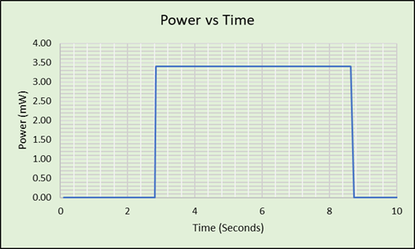

Figure 52. Green laser diode Power vs Time graph

The above Power vs Time graph is based from readings taken during verification testing of the green laser diode to ensure it worked and had sufficient output power. While lasing, the power output is relatively stable at 34 mW.

###### Emission Spectrum

The manufacturer specifications indicate an output spectrum of 532 nm ±10. To accurately determine the bilirubin absorbance at 450 nm, it is important that the photodetector diode is receiving most of the power from a specified wavelength. We have spoken to Dr. Patrick Likamwa and received permission to use an optical spectrometer in order to perform a spectral analysis. From a 5 inch distance to the spectrometer, the 532 nm laser diode will be run at the determined drive current to obtain an emission spectrum. From this spectrum, the transmitted power at 540 nm will be determined from the spectral bandwidth, as well as the peak wavelength.

Emission Spectra Characterization Testing Results

Emission spectra for the green 532 nm diode was taken on 11/20/2019 using an Ocean Optics USB2000+ Spectrometer. The central wavelength emitted was at 534 nm, with a 2 nm full-width-half-maximum value. The spectral bandwidth is sufficiently narrow for our calculations, and there is sufficient absorbance anticipated at 534 nm for our hemoglobin proxy betalains for this light source to be used in our calculations. The emission spectra are depicted in the following figure.

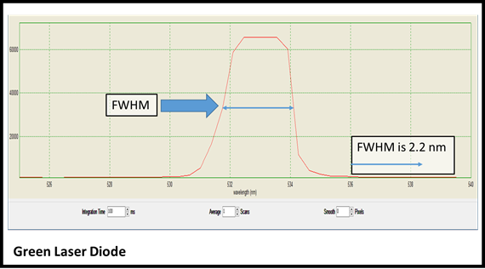

Figure 53. Emission spectra of green laser diode.

##### Blue LED Diode

LEDs emit photons through electron-hole recombination. As a result, we expect the blue LED will have a broader spectrum than the laser diode. The 5 mm blue LED from CO-RODE specifies an intensity of 7000-9000 millicandela (MCD), the standard measurement for LED intensity. The specified spectrum is 462-465 nm. The forward voltage is listed as 3 - 3.7 V and current is 20 mA. Testing is planned to determine the actual power output, spectral emission bandwidth, and to optimize the drive current.

###### Drive Current

Having a constant output at a constant wavelength is essential to making an accurate measurement. The drive current must be set at a constant to keep the LED output power constant, but if it is too high, it will produce heat which can cause the wavelength to shift. The optimum drive current will be characterizing by positioning the LED on an optical table with the 5 mm done 5 inches directly from the CMOS power sensor and attaching the diode ends to a DC voltage supply and increasing the current until an output power comparable to the power output by the green laser diode.

###### Power vs Time

The expectation is that temperature will have less of an effect on the power output on the LED. The bigger concern will be to determine any ramp-up time delays. If the LED takes time to reach full power, that delay must be determined so that readings can be taken when the LED is at full power. Once the drive current is determined, three 15-second Power vs Time measurements will be recorded. These will determine the maximum time delay for the LED to reach maximum power output at room temperature.

###### Emission Spectrum

The spectrum specified by CO-RODE is 462 – 465 nm. This is ideal in both the range and bandwidth, and testing will be done to verify this. The LED will be run by the DC power supply at the determined drive current, 5 inches from the spectrometer sensor. The lights in the lab will be dimmed for this reading to verify there is no stray light contributing to the measured emission spectra. The resulting LED emission spectrum will verify the peak wavelength contributing to the output power.

Emission Spectra Characterization Results

The emission spectra was recorded for the blue LED light source on November 20th using an Ocean Optics USB2000+ Spectrometer. The bandwidth was considerably larger than the specifications provided by the manufacturer. The full-width-half-maximum value was over 20 nm. This will be too broad to determine how much absorption of light in this entire range can be attributed to the absorption at 460 nm. This light source will continue to be used for testing and construction, but another light source, a 450 nm 30mW laser diode, has been ordered from aliexpress.com and will be delivered over the winter break.

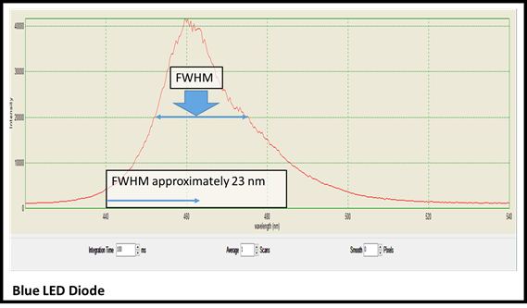

Figure 54. Emission Spectra of blue LED.

The above figure shows the emission spectra for the blue LED. It has a central peak wavelength at 460 nm, which is suitable for our readings. However, the FWHM value of 23 nm is too broad for the absorbance readings to accurately determine what amount of absorbance can be attributed to one specific wavelength.

#### Integration Testing

The lasers alone cannot provide a complete reading. Their interaction with other components will have to be accounted for in order for DABS to make an accurate measurement. As components arrive and are individually characterized, they will be tested with the laser diodes to ensure they are working together properly. Primarily, they will be tested with the cuvettes, the photodiode, with the power source, and with the controller.

##### Light Source vs Cuvette

The purchased cuvettes are made of an optical glass that is supposed to allow full transmission of wavelengths in the visible range. This will need to be verified with testing. The output power of each light source will be measured 5 inches from the power sensor with nothing else in the beam path. An empty cuvette will then be placed in the beam path and the power transmitted through the empty cuvette. If there is a significant (greater than 2%) drop in transmitted power, the emission spectra will be recorded for each light source with the cuvette in the beam path to see if the power is being unequally interfered on a specific wavelength, or if the entire spectrum is equally affected.

##### Light Source vs Photodiode

The photodiode will be capable of reading both wavelengths, but the sensitivity to each wavelength will differ. The power intensities for each light source must be recorded by the photodiode. This testing will take place within a chamber to prevent stray light from contributing to the light incident upon the photodiode. For the purposes of calibrating the light source intensity, the photodiode can be attached to an oscilloscope at this stage in the testing and does not require to be integrated with the amplifier, although that will need to be tested at a later time.

##### Light Source vs Power Source

The drive currents for each light source were determined during the characterization testing. The laser diode and the led will each need to be attached to the power source. An appropriate transistor circuit will be applied to ensure a constant current is applied to each when turned “on” to take a measurement. This will be a crucial and possibly time-consuming part of the integration process and will need to be started before the winter break in case any other components need to be designed or ordered. This will also be the time when wires and connectivity components are determined.

##### Light Source vs Microcontroller

The microcontroller will be programmed for the two stages of measurement: a blank reference reading, and the sample reading. At each stage, the controller will receive input from the user (“Blank Inserted”, “Sample Inserted”, e.g.) and trigger the power to each light source, one at a time, each for 2 seconds. Testing will be required to make sure the signal turns the laser diode on for 2 seconds, the off, and then the LED on for two seconds, then off so that there is no overlap. Simultaneous integration testing will be done with the microcontroller and the photodiode to make sure the two readings are taken during the last 1.5 seconds, or as necessary to account for any ramp-up time delays discovered in the laser diode characterization testing.

#### Light Source Testing Schedule and Equipment

Preliminary testing has been started on both laser diode and the LED to ensure that they work. Characterization testing will begin in the final two weeks of Senior Design way so that integration testing can begin over the winter break.

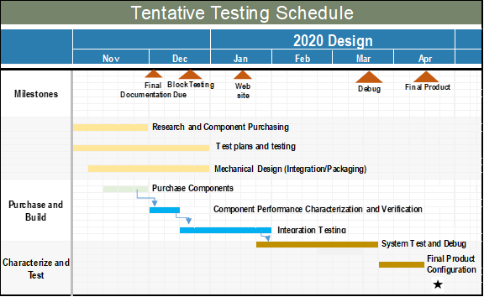

Table 22 Tentative Testing Schedule

The tentative testing schedule allows for whole system testing by the end of January. It requires integration testing to begin over the winter break. The team has weekly group meetings while school is in session and can meet additionally as needed to complete component integration testing.

Most components for testing are available in the CREOL Senior Design lab with the exception of the spectrometer. We have contacted Dr. Likamwa and will be able to use the spectrometer without any scheduling conflicts through the end of this semester. However, any measurements that require a spectrometer next semester will require coordinated scheduling, as there is a Laser Engineering laboratory that will be using the spectrometer most weeks.

All of the necessary equipment and components are listed in the below table. The cuvettes will take longer to arrive, but the light-containment box can be assembled using the manufacturer dimensions. There are no foreseen delays due to equipment availability.

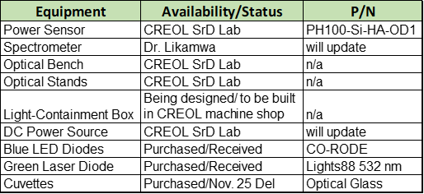

Table 23. Light Source Testing Equipment and Status

### Sample Input

The Beer-Lambert Law has two variables that can be altered: the molar extinction coefficient (e) and the concentration (c), given in mol/L. The ultimate goal is to insert a sample of unknown concentration, compute that concentration, and advise whether immediate medical attention is necessary. This necessitates a known e value. The molar extinction values for curcumin and betalains have been determined in other cited characterizations of the organic dyes, but differences in preparation and source (solvents, fresh juice extracts, or powders) result in varied e values at different wavelengths. These values will be determined for our purposes by creating standards of known concentrations.

#### Preparation and Characterization

For the purposes of accurate measurements, beetroot powder and turmeric powder will be used as the betalain and curcumin sources, respectively. Individual standards will be prepared for each. One mg will be weighed and mixed with 100 mL of methanol. This mixture will be protected from direct light and discarded after one hour of testing, as betalain and curcumin are both light-sensitive.

A spectral analysis will be taken of each sample with a spectrometer and a white LED transmission source. This will verify the absorbance profiles of our samples and provide the betalain absorbance ratio from 540 nm to 460 nm. This will be done with two additional concentrations, .5 mg per 100 mL and .1 mg per 100 mL, in order to verify the spectra are scalable to the concentrations and not the methanol solvent. These concentrations will be used for calibration during the integration testing.

#### Calibration and Integration Testing

When the DABS system is assembled for integration testing, the sample standards of known concentrations will be used to calibrate. The Beer-Lambert Law states that A=(I0/I). The absorbance (A) will be measured by measure the incident power (I0) of each beam, 460 nm and 540 nm, through a cuvette filled with pure methanol, and then the transmitted power of each beam through the standards (460 nm through the curcumin standard, and 460 nm and 540 nm through the betalain standard). The A value will be calculated for each standard using the equation A=e*l*c. Having defined A, the molar extinction coefficient, e, will be set for each wavelength.

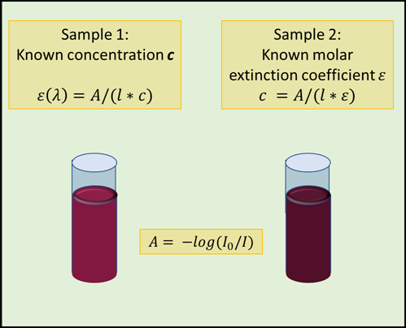

Figure 55. Known concentrations used to establish molar extinction coefficients.

Using the same method, the molar extinction coefficient will then be determined for a sample containing both curcumin and betalain. With a known e value for each wavelength, validation testing can begin on samples with unknown concentrations.

### Photodetector

#### Characterization Testing

Initial testing of the 3 photodetectors will be done using ambient light from the room under no biasing and then with the 532 nm laser diode and 460 nm LED sources under reverse biasing. A very rudimentary circuit including a DC source and a resistor will be enough to run the initial tests on each photodiode to verify that the device is indeed collecting light and responding in the manner that it was designed to be.

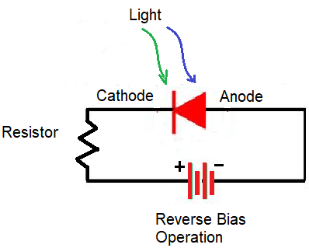

Figure 56 Test Circuit for Photodiode - Reverse Bias Operation

The rudimentary circuit depicted above, along with a multimeter and the 2 light sources is enough to test the initial data that needs to be collected from the photodiodes. The current generated from the photodiode is the measurement that needs to be taken under no bias operation and reverse bias operation. This circuit will be used to find the dark current of the photodiode under no bias and reverse bias conditions.

#### Dark Current

The dark current for each photodiode will be found by using a DC power supply from the senior design lab as the power source and a multimeter to measure the current readings across each photodiode. The photodiodes will initially be zero biased to verify that each device is sensitive enough to ambient light and will respond to small changes in light intensity. Then each photodiode will be reverse biased to an appropriate voltage between 3 to 5 volts and the dark current measurement will be taken again. To measure an accurate dark current, an opaque object, such as a hand or solid object, will be placed in front of the photosensitive area of each photodiode to block out all the light while the light containment box is unavailable. The photodiode that is needed for the DABS project needs to be sensitive to small changes in light intensity at power levels that are not significantly high, where the response rate of the detector is not as significant as the sensitivity. This means a relatively large difference between the dark current generated and photo generated current from the sources is necessary to have a good signal to noise ratio that will give accurate results.

|  |  |  |  |
| --- | --- | --- | --- |
|  | Dark Current of each Photodiode | | |
| Reverse Voltage | SFH 2430 | BPW21R | VEMD5510C |
| 0 V | N/A | 0.0012 mA | N/A |
| 3 V | N/A | 0.0012 mA | N/A |
| 4 V | N/A | 0.0012 mA | N/A |
| 5 V | N/A | 0.0013 mA | N/A |

Table 24. Dark Current of photodiodes.

#### Photogenerated Current

Once the dark current for each of the 3 photodiodes has been accurately calculated, the photo generated current for each of the photodiodes will be found under a constant reverse bias voltage. Multiple photo generated current measurements at incremental light intensities of about 5 mW of power will be taken using each of the light sources chosen for this project. The light source used will be placed on an optical stand so that it is stable, and the photodiode can be aligned properly to ensure that as much of the beam will hit the photosensitive area of the detector. A distance of 5 inches between the light source and the photodetector will also be constant to reduce inaccuracies in measurement due to dispersion. All the data collected will be tabulated to display a side by side comparison of the corresponding photo generated current for each of the 3 photodiodes with the light

|  |  |  |  |
| --- | --- | --- | --- |
|  | Photo Generated Current of Each Photodiode | | |
| Source Power | SFH 2430 | BPW21R | VEMD5510C |
| 20 mW | N/A | 0.34 mA | N/A |
| 25 mW | N/A | 0.35 mA | N/A |
| 30 mW | N/A | 0.36 mA | N/A |
| 35 mW | N/A | 0.38 mA | N/A |
| 40 mW | N/A | 0.40 mA | N/A |

Table 25. 532 nm Laser Diode measurements.

intensity introduced into the system. The results of the test should indicate a strong linear response between increasing light intensity and photo induced current, as well as having a high sensitivity to changes in light intensity which would match the datasheet specs.

|  |  |  |  |
| --- | --- | --- | --- |
|  | Photo Generated Current of Each Photodiode | | |
| Source Power | SFH 2430 | BPW21R | VEMD5510C |
| 20 mW | N/A | 0.16 mA | N/A |
| 25 mW | N/A | 0.18 mA | N/A |
| 30 mW | N/A | 0.21 mA | N/A |
| 35 mW | N/A | 0.25 mA | N/A |
| 40 mW | N/A | 0.25 mA | N/A |

Table 26. 460 nm LED measurements.

#### Photodiode vs Cuvette and Samples

A similar test will be performed but now instead of changing the input light intensity of the source, it will remain constant and we can simulate the absorption of light by using semitransparent materials such as plastics or water to measure the change in photo induced current. This will demonstrate how the photodiode responds to an object absorbing some of the incident light before reaching the sensor while the cuvettes and test samples are still unavailable for more precise testing.

|  |  |  |  |
| --- | --- | --- | --- |
|  | Photo Generated Current of Each Photodiode | | |
| Substance | SFH 2430 | BPW21R | VEMD5510C |
| Air | N/A | 0.36 mA | N/A |
| Empty Cuvette | N/A | 0.35 mA | N/A |
| Cuvette w/water | N/A | 0.35 mA | N/A |
| Cuvette w/turmeric | N/A | 0.35 mA | N/A |
| Cuvette w/beetroot powder | N/A | 0.25 mA | N/A |

Table 27. 532 nm Laser Diode measurements at mW.

Once the cuvettes, turmeric, and beetroot powder are acquired, the test previously mentioned will be repeated to verify if the photodiodes are able to detect a significant difference of intensity when there is a substance placed in the optical path of the beam. This will generate a new set of data that is more closely related to the actual application of the project that can then be manipulated to find the molar absorptivity of turmeric and beetroot.

|  |  |  |  |
| --- | --- | --- | --- |
|  | Photo Generated Current of Each Photodiode | | |
| Source Power | SFH 2430 | BPW21R | VEMD5510C |
| Air | N/A | mA | N/A |
| Empty Cuvette | N/A | mA | N/A |
| Cuvette w/water | N/A | mA | N/A |
| Cuvette w/turmeric | N/A | mA | N/A |
| Cuvette w/beetroot powder | N/A | mA | N/A |

Table 28. 460 nm LED measurements at mW.

The SFH 2430 and VEMD5510C photodiodes were unable to be used for testing, since they are surface mount photodiodes and the senior design lab does not have the necessary equipment for testing surface mount devices. The BPW21R looks more like a traditional diode with two leads protruding from the head of the device allowing testing to be done easily with a breadboard that is readily available from the senior design lab.

These initial measurements were taken without a light containment housing and performed under the room lighting in the lab. The test was done to confirm that the photodiode was indeed performing the way it was intended and can photo generate current when excited with the corresponding wavelengths. The test will have to be performed again with greater accuracy once the distances between the sources, cuvette, and detector are finalized and the components can be mounted and aligned correctly. This will result in greater accuracy and precision in the gathered data that will facilitate the testing for the final design.

If a method to test the surface mount devices is available during winter break, the other 2 photodiodes will be tested as well. If this is possible then all 3 photodiodes will be retested during the break to collect enough data to come to a defining conclusion as to which photodiode would work best for our application. By January the selection of the photodiode should be completed, so the project can continue to progress towards the next stages of its development.

#### Photodiode vs Integration Testing

At this point all the properties and characteristic testing of the photodiode has been completed, but as the other subsystems of the project and the housing for the design are being completed, the integration of all the components will require more testing. The photodiode will have to be retested once it has its amplifier circuit to verify that it is still generating a valid output inside the housing enclosure and can run efficiently using the power supply designed for the project, instead of the lab test equipment. This will be an iterative process, as each step where a subsystem is added the photodiode will have to be recalibrated and tested.

### Transimpedance Amplifier

The results of the photoconductor test will be used for the initial planning and simulation of th transimpedance amplifier circuit. Using electronic schematic capture and simulation program, the transimpedance amplifier will be designed to deliver the proper gain, such that the microcontroller can detect the voltage signal.

Once the circuit simulation is complete, the circuit will be built and tested, using a breadboard, to ensure we are able to obtain a real amplifier gain that was determined through calculations and simulation. When the physical circuit is designed to deliver the correct voltage value, the design can be converted into a PCB layout to be integrated into the final design.

The transimpedance amplifier circuit must be included because the microcontroller needs to be able to detect a voltage in order to convert the absorbance readings to a useful concentration value. The gain will be theoretically calculated, then the circuit can be simulated to attempt to verify the calculated values. Once we successful simulate the amplifier, we can build the amplifer on a breadboard and conduct the preliminary hardware tests. Once these three steps are complete we can verify that the microcontroller reads the appropriate voltage and then we can incorporate the design into the PCB.

### Touchscreen

#### Touch Response Output Voltage Range

In order to determine the operational voltage response range due to engaging the touch capabilities of the screen, we will be probing the output lines by means of a multimeter. Initially, the measurements will be taken by engaging each of the four corners on the screen and recording the reading for each particular corner. The maximum and minimum values observed from these measurements will serve as the initial bounds of the reading and we will also compare this to the datasheet values as a form of validation.

If the values differ from the datasheet considerably the next step would be the now probe by means of an oscilloscope. The intension is to swipe along the entire screen systematically beginning from the top left corner. The oscilloscope would be displaying the maximum and minimum measurements. With the time interval on the oscilloscope being set to accommodate for the time interval needed to swipe the screen, it will display the maximum and minimum voltage output of the touch response.

This information is important for configuring the analog voltage to a digital value within the microcontroller and receiving an accurate result. With knowledge of this operating maximum and minimum voltage the proper reference voltage can be used, therefore breaking up the steps in voltage more evenly and achieving a finer reading.

The analog ground pin of the module is also an important piece in this procedure since it also directly affects value reading. The testing of the analog ground will only be done if voltage testing of the touch response lines differs substantially from the values in the datasheet. If this testing does become necessary, further research will need to be done in order to determine a testing method.

#### Input Current Range

The current draw from within the two states are expected to change as to signifiy a decrease in power usage. The testing of these two phases are required to verify this expectation.

##### Active Mode

The display module takes in voltage from two separate, a five-volt node and a three-volt node. Since both these voltages take care of separate functions and draw power from the battery this one module is pulling power from two separate points. With that being the case, being aware of its power consumptions could be very crucial to the power-efficiency of the project as a whole if the current draw is relativity high.

In order to test the amount of current being drawn into the display both nodes will have to be probed individually. A multimeter will be attached in series with the voltage node and each node will be tested one at a time. They will be tested one after the other in order to avoid the possibility of one multimeter affecting the reading of another.

This testing will consist of probing continuously for a period of time and recording the current consumption periodically. The goal of testing of a period of time is to observe if there is change in current consumption over time. This probing technique will also be done with slight changes to the voltage nodes. The objective is to observe and test the current response while mimicking the change in voltage that is likely to occur due to the battery’s voltage output decreasing during operation or a spike in voltage due to being fully charged.

##### Low-Power mode

The testing of the current in low-power mode is to make sure that the intension of this state is met. As in, the current being drawn is reduce close to zero in order to create a more power efficient system and extend the duration of the battery. The testing will be identical to the testing for active mode with simply the change in state being the only difference.

## Software Test Environment

For the software test environment, several operating systems and applications are important in testing the software that will interface between the microcontroller and the end user. Below a three important software that will be used to test the project codes.

* Operating System:
  + Windows 10
* Application:
  + Code Composer IDE
* Compiler version:
  + v18.12.2.LTS

This project will designed using Microsoft Windows 10 operating system, and is designed to function using programs supported by this operating system. We used Texas Instruments Code Composer Studio to write, debug and test the code for the microcontroller.

## Software Specific Testing

Each module in the system that fulfills a feature requires some level of software in order to operate with the system as a whole. Testing that these modules all work will require individual testing followed by collaborative testing. Also, since many of the modules are maintained and developed by separate team members, the software for many of the components besides the microcontroller will be interfacing. Accordingly, this testing will be not only to test the validity of the software but also the compatibility of the hardware developed by other members.

This section includes testing of:

* LCD display communication and operation
* Touch response sensing and calibration
* Low-power mode (de)activation methods

### Display/SPI Communication

The graphical component of the project is broken up into two separate sub-components. Since it utilizes the Texas Instrument Graphics Library, our software but be able to integrate with the library as well as be able to carrying the interfaced data from the microcontroller to the display. An added layer between these two links is the driver needed in order to communicate with the needed registers interact with the display as well as where to retrieve data. The entangled interaction makes it such that testing certain aspects of them requires the utilization of others.

#### SPI Communication/Driver

The graphical portion of the display can only be interfaced through SPI. Data is translated from the microcontroller through to SPI data line into the display, where the display receives the information and interprets it into a pre-determined format.

Figure 57. Display being reset using command over SPI.

The testing of SPI data transfer starts off at the beginning of the process, with ability to translate data into binary. This is achieved by developing an algorithm for converting from decimal to binary then running it in the terminal and displaying the output conversions of a set of testcase numbers.

Following the conversion testing is testing that the data is received appropriately. This is done by implementing the template SPI driver provided by the manufacturer. Within it are variables that must be sent for our specific microcontroller that allow the driver to properly. The testing will be to implement the driver function that reset the display.

#### Graphical Driver

The manufacturer also includes a driver responsible for graphics which interacts with the SPI driver. It implements functions from the SPI driver with data from the graphics library. This graphics driver comes with constants holding the memory address of the register inside the display

In order to test the driver properly the SPI software is needed along with the graphics library. Once the serial communication software is established and verified through testing, the drivers functions can be used to verify the drivers as a whole. This simultaneously validates a portion of the driver testing along with further strengthen the SPI software since it is the medium of communication for the interaction. The validation of the rest of the drivers relies on utilization of the graphics library.

#### Graphics Library

The graphics library gives the ability to obtain the pixel data to draw objects without needing to develop the algorithm oneself. The driver software will take the data given to it from the graphics library and carry said date over SPI in order for the display to illustrate the data. Testing of the graphics library is essentially testing of the entire graphical display configuration since it incorporates and requires the use of every layer associated with interacting with the display.

Figure 58. Displaying text data along with shape objects sent to the display.

The testing of the graphical library is simultaneously confirming that the data being sent from the library is compatible with the screen, along with testing that the driver is configured to send this pixel data to the correct portion of the display responsible for displaying this data. The graphics library as well as the rest of the driver software is verified if the object display is as expected from the library.

### Touch Response/Coordination

The manufacturer provides a sample code that calibrates the touch response of the screen and that calibration will remain until the calibration code is run again. However, the code itself requires adjustments in order to be fully compatible with our microcontroller. Although the sample code cannot be fully used as is, it still makes a great tool for initial testing of the touch response code. The code is set to have the screen react for every touch it feels on any part of the screen and change the display on every response. The tests and confirms that the sample part of the code works properly and that the analog signals are at least operating correctly. The only remaining functionality is corresponding it touch response to a point(s) on the screen.

Figure 59. Calibration of screen for touchscreen.

In order for the touch response to be full operational there must be an algorithm on the microcontroller that scales the touch analog signals to their respective points on the display where the touch was initiated. The same code will be used for this testing since it is already provided with the appropriate unconditionality and only requires some simple adjustments. The sample code when fully operational is set to respond if and only if the touch response is found to be in the red circle on the display. And added benefit of the sample is that it does all four corners, which tests all the extremes. And it also has a menu screen following it that testing the responses in the center of the display.

### Low-power mode

#### Screen off and back on

Before anything else in the low-power mode testing, the display’s ability to actually lower into a low-power mode must be verified. If it does not have the capability of implementing this functionality then the low-power mode design will not work. The graphical display is the only component that needs this type of testing due to the fact that all other components are essentially in a form of hibernation by design.

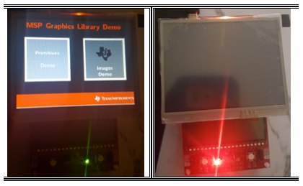

Figure 60. Side-by-side of PWM = 0 testing.

The idea behind the display’s sleep mode comes from the design of the backlight circuit shown in the datasheet. The design shows the circuit is powered by a AIC1896 module. Further research into this modules showed that the module shuts down if its provide PWM signal is set to 0. As such, that will be the goal of the low-power mode function with regards to the screen.

To test this approach a snippet of code will be added to a working sample code. The snippet will set the PWM output signal to 0 once the left button is pressed and the operation reverses once the button is pressed again. The test will prove positive if the screen turns on and off with each push of the button. Also, a debouncing approach will be taken for the button in order to reduce the likelihood of a observing a false response. And in order to visually confirm the intended state of the screen the red and green LEDs will be used. Green LED signifying that the screen should be active and red for the inactive state.

#### Touch response wake up

The procedure for utilizing the touch response of the screen for awaking the system from low-power mode involves taking advantage of the interrupt design that the touch procedure uses. The interrupt design is initially used because it makes the design such that there is no need of using extra power in order to activate the touch response. As in, there is no need to programmatically run a loop that is constantly checking force an input signal in order to be aware of if a signal was possibly sent.

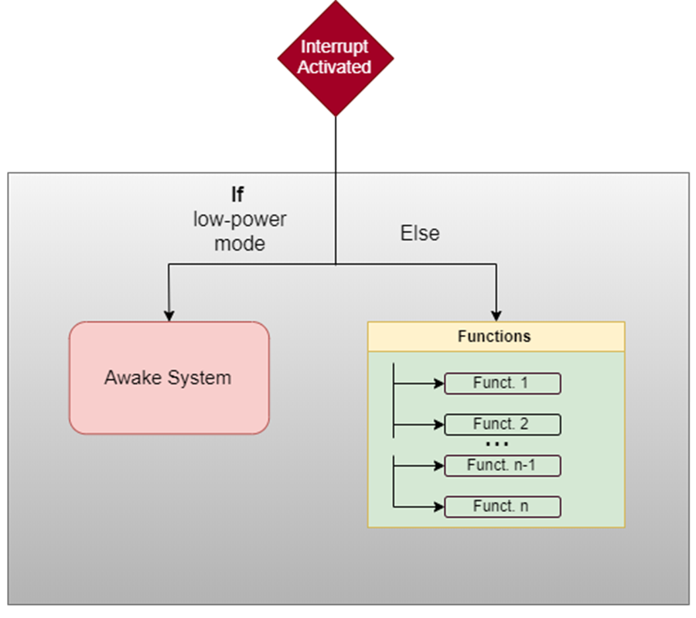

Figure 61. Process for ADC interrupt of touch signals.

Since the low-power mode design utilizes the PWM, it should only affect the backlight circuit of the display. Hence, the touch response circuit should not be affected if the circuit are indeed completely independent. With this being the case, the touchscreen should operation normally. And the only difference between its operation in the two states is that while in low-power mode the response for any analog signal inputted will be redirected to only awakening the system.

#### Sleep timer

The timer for the sleep mode will be implemented using one of the internal timers of the microcontroller. And to initiate the low-power mode functionality it will simply call a function that handles the entire operation and essentially contain the information mentioned Section *7.4.3.1*. Testing of this timer will consist of proving that activates a specific time duration after the last touch to the screen. As such, the updating of the countdown timer must to test such that it updates for every touch to the screen. Also, since the user will have the option to set a new timer duration besides the default setting, different durations must be tested. The set of durations will vary from both extremes to vary random times in between.

#### Sleep mode - Simulated button

The simulated button for sleep mode is implemented with the intent that the user intends to save power. It will be implementing the same function activated when the sleep timer is activated. Accordingly, testing this feature only entails confirming that the touch response algorithm can accurately detect when the simulated button is pressed. Since the intended procedure for the simulated button implements other sub-system of this project (i.e ADC conversions and touch response conversion algorithm), verifying the button will simply require the action of pressing the button. With that being the said, since the button will be in a corner its reliability comes into question. Testing the reliability will consist of pressing the button in various locations in its specified area. If the functionality works as intended above a satisfactory threshold rate then it shall be deemed reliable.

# Project Operation

This section will serve as the user manual and is designed to guide the user reliable measure the bilirubin content of a sample. While the project is intended to be able to accurately measure a blood sample, it will only be tested using a blood substitute. The substitute compound, derived from turmeric root and red beetroot, was chosen because of their homologous absorptive characteristics.

The end goal of this device is to provide the user with an at home, accurate read out of the concentration of bilirubin in the blood. The concentrations displayed will be compared to thresholds that can help determine the possible need to seek further medical advice or attention. As mentioned, this device will only provide a proof of concept, because we will not have the ability to conduct human testing (i.e., using real blood samples) due to strenuous IRB restrictions.

The DABS device would be categorized as a medical device; however, we will not be seeking any certifications by the FDA to regulate this device. We cannot, and will not, recommend anyone to use this device to test any real blood samples and should not substitute it for advice from a medical professional.

## General Information

The Direct Absorption Bilirubin Spectrometer is intended to deliver on the following goals:

1. An accurate display of the sample bilirubin concentration. The microcontroller receives a voltage signal that is converted to a useful concentration value (by the Beer-Lambert Law). The device should be able to interpret the concentration results in terms of safe, borderline, and unsafe concentrations levels. Again, this will be provided, by proof of concept, using solution known to have similar spectral absorption characteristics to that of hemoglobin and bilirubin.
2. The device should be able to notify the user, via display, whether to seek additional advice from a physician. Under threshold values will be considered safe, whereas a borderline or over threshold value will be considered grounds to seek further help.
3. The user interface should be set up in a way that allows easy operation for any user, regardless of technological savvy. The chosen display has touch screen capabilities, which will guide the user through the procedure.

## Safety Considerations

Review this information before use to ensure safe operations of DABS.

DABS was designed and built in a way to mitigate chances of any safety or health risks. Read and adhere to the following safety considerations before turning on and operating DABS:

1. Check the electrical connections for any loose, torn, or otherwise damaged cables. Do not operate if you suspect issues with these connections.
2. Ensure there are no bare or exposed wires, to mitigate potential electrical shock.
3. Do not operate this in or around water, or another liquid (apart from the solution loaded into the cuvette), to prevent damage of the device.
4. Ensure the device is fully enclosed before supply power to the lasers. Avoid looking directly at the laser, to mitigate any potential eye or vision damage.
5. Ensure the device is on a stable surface

## Device Calibration

The device will be calibrated to a blank sample, using the two light sources at 450 nm and 532 nm. This procedure serves to tare the measurements to ensure the utmost accuracy of the samples to be tested. Ensure the device has been calibrated before use.

Calibration of the device to a blank will ensure that the device will be more accurate. The blank serves as control sample for calibration purposes. Once calibration is complete, the measurement for a true sample will be more accurate and should display the correct concentration.

## Using the Spectrometer

DABS will follow a succinct set of instructions to reliably measure and display the overall sample bilirubin concentration.

1. Review the safety considerations, above, before operating the device.
2. Turn on the devices and allow the system to start up.
3. Follow the on-screen prompts. Starting with calibration and then for the sample of interest.
4. Ensure the laser is not powered on when loading the blank for calibration.
5. Load the blank cuvette sample to ensure proper calibration. Now, the laser can be powered on to illuminate the blank and provide the necessary calibration.
6. Ensure the laser is powered off before removing the blank and inserting the test sample.
7. Prepare sample and load into a new cuvette and push the on-screen button to initiate the test. Follow the prompts on the screen to illuminate the sample of interest to get the concentration values.
8. Upon receipt of test results, follow the guidelines as to the need to seek further medical attention.
   1. If the concentration falls below threshold, likely no further assistance needed. If you fear something is off, contact medical professional.
   2. If the concentration value is approaching the unsafe value, contact physician for advice.
   3. If the concentration is at or above the unsafe threshold, seek immediate medical advice and/or attention.

# Administrative Content

## Milestone Discussion

At the close of Senior Design I, the DABS project is on schedule. Much of the semester was spent researching, deciding, purchasing and validating individual components and preparing the project documentation. The steps going forward will consist of integration testing, integrating systems, building a working prototype and subsystem collaborations to determine if any redesigns are necessary to make sure there is a cohesive unit.

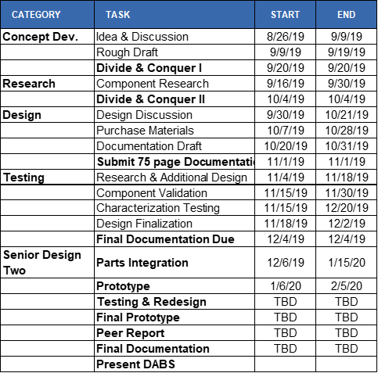

Table 29. Project milestones.

The current Project Milestone list includes all milestones and dates for Senior Design I. Other milestones have been projected for the following semester, but more milestones will be added, along with more accurate timeframes and deadlines, when Senior Design II begins on January 6. It is our current expectation that the first month will consist of integration testing, integrating systems, building a working prototype and subsystem collaborations to determine if any redesigns are necessary begin building the final product by mid-February. Validation testing will take up the majority of the latter half of the semester. Additional documentation and presentation requirements will be scheduled as those due dates are made available.

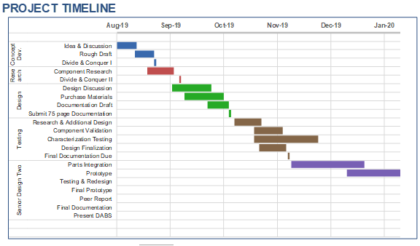

Figure 62. Milestone timeline calendar.

To date, all major milestones for Senior Design I have been met. Ample time for individual component testing has been budgeted, but any characterization testing that has not been completed by the end of Senior Design I will need to be completed over the winter break for the team to have five weeks to integrate parts and test the components together. With thorough integration testing, a working prototype should be completed relatively quickly, by mid-February, so that any major design or component changes can be made with enough lead time to order new parts and reintegrate. The timeline for the milestone elements are interdependent, so the time budget will have to be updated frequently, at the weekly team meetings, to reflect ongoing progress and to prioritize any impending assignment due dates.

At the conclusion of the the fall semester, we plan to perform design and testing for the first two weeks. In this time we will have the ability to focus more attention to the fine details of the project and get a good head start going into the second half of the project stage. We anticipate to finalize our PCD designs and submit them to be fabricated. We also hope to do prototype tests to ensure a smooth integration of the different electrical systems. With a good prototype design we will then be able to make little adjustments before constructing and testing the final design project.

## Budget and Finance Discussion

The bill of materials shall be used to keep track of the components, to be used, and the total cost of this project. The bill of materials is split into four subsystems: optical and transimpedance amplifier, power (including DC, charging, batteries), the processor and display, PCB, and temperature control. Tables 28 and 29 will show our anticipated bill of materials (may be updated/modified during the initial testing/prototyping process).

Since the DABS project is self-funded, we are going to try to keep this as low-cost as feasible. Looking at the similar devices, the prices range from about $1,700 to about $10,000. Our goal is to create a much more affordable, at home version of this expensive lab equipment. We initially estimated that DABS would cost approximately $650 and hope to stay below $1000 since this project is solely student funded.

|  |  |  |  |  |
| --- | --- | --- | --- | --- |
| **Subsystem** | **Item** | **Quantity** | **Vendor** | **Cost** |
| Optical and TIA | Green Laser Diode | 1 | Lights88 | $16 |
| Blue Laser Diode | 1 | AliExpress | $20 |
| Cuvettes | 4 | Adealink | $14 |
| Transimpedeance Amplifier OPA 170 | 1 | TI | $1.44 |
|
| Photodetector | 1 | Digikey | $24.00 |

Table 30. Bill of Materials Optical and TIA

|  |  |  |  |  |
| --- | --- | --- | --- | --- |
| **Subsystem** | **Item** | **Quantity** | **Vendor** | **Cost** |
| Power | Battery | 1 |  | $12 |
| Various Electrical Components (Resistors, capacitors, etc) |  | Digikey | ~$15 |

Table 31 Bill of Materials Power and Miscellanous Components

The parts that can be ordered through Texas Instruments (i.e., the integrated circuits, microcontrollers, etc) we are making an attempt to reduce overall costs by ordering samples. Texas Instruments allows customers to order a given number of samples, of each product (1+ copies of each item), for testing and educational purposes. This may not make a huge financial difference, but allows us to reduce cost if parts get damaged while we conduct tests.

|  |  |  |  |  |
| --- | --- | --- | --- | --- |
| **Subsystem** | **Item** | **Quantity** | **Vendor** | **Cost** |
| Processor & Display | MSP430FR6989 (Development Board) | 1 | DigiKey | $20 |
| MSP430 | 1 | TI.com | Free sample |
| LCD Display |  |  |  |
| **Subsystem** | **Item** | **Quantity** | **Vendor** | **Cost** |
| **PCB** | 2 Layer ($5 per in2) | 3 | OSH | TBD |
| **Subsystem** | **Item** | **Quantity** | **Vendor** | **Cost** |
| Temperature Control | Fan | 2 |  | $10 |
| Temperature Sensor | 1 | TI.com | Free sample |

Table 32. Bill of Materials MCU, Display, PCB and Temp Control

## Stretch goals

There are additional features that would be great additions to the project but have not been able to be implemented at this time. One of which being the ability to display locations of nearby hospitals and clinics to the user. This feature will be acquired by adding on GPS and Wi-Fi network modules and with the use of the GoogleAPI. The intention is that the API will use the position provided by the GPS and complete a hardcoded search of relevant clinics in the area. The added feature is useful in the case that the results of the sampling recommends medical attention.

An add-on to this feature would be also sending this information to a user-inputted phone number. The GoogleAPI also has feature where it is able to send messages through its servers.

At the conclusion of Senior Design 1 we plan to finish the designs and start a series of hardware testing, with the goal of having positive results going into Senior Design 2. The plan is to use the second semester to conduct full system tests and perform the adjustments that will guarantee us a successful project.

# References

1. “Sharing Battery Knowledge.” *Battery University*. Battery University, 04 Aug. 2016. Web. 07 Oct. 2019. <https://batteryuniversity.com/learn/article/sharing_battery_knowledge>.
2. “Secondary (Rechargeable) Batteries.” *Electropaedia*, Woodbank Communications Ltd, n.d. Web. 07 Oct. 2019. https://www.mpoweruk.com/
3. “WEBENCH® Power Designer. “ *WEBENCH® Power Designer* | *Overview* | *Design Resources* | *TI.com*, http://www.ti.com/design-resources/design-tools-simulation/webench-power-designer.htm.
4. M. McEwen and K. Reynolds, "Noninvasive detection of bilirubin using pulsatile absorption," Australasian physical & engineering sciences in medicine / supported by the Australasian College of Physical Scientists in Medicine and the Australasian Association of Physical Sciences in Medicine, vol. 29, pp. 78-83, 04/01 2006.
5. S. Meites and C. K. Hogg, "Direct Spectrophotometry of Total Serum Bilirubin in the Newborn," Clinical Chemistry, vol. 6, no. 5, pp. 421-428, 1960.
6. A. Westwood, "THE ANALYSIS OF BILIRUBIN IN SERUM," Annals of Clinical Biochemistry, vol. 28, pp. 119-130, Mar 1991.
7. P. Nagaraja, K. Avinash, A. Shivakumar, R. Dinesh, and A. K. Shrestha, "Simple and sensitive method for the quantification of total bilirubin in human serum using 3-methyl-2-benzothiazolinone hydrazone hydrochloride as a chromogenic probe," Spectrochimica Acta Part A: Molecular and Biomolecular Spectroscopy, vol. 77, no. 4, pp. 782-786, 2010/11/01/ 2010.
8. Y. Andreu, M. Ostra, C. Ubide, J. Galbán, S. de Marcos, and J. R. Castillo, "Study of a fluorometric-enzymatic method for bilirubin based on chemically modified bilirubin-oxidase and multivariate calibration," Talanta, vol. 57, no. 2, pp. 343-353, 2002/05/16/ 2002.
9. M. D. van Erk, A. J. Dam-Vervloet, F.-A. de Boer, M. F. Boomsma, H. v. Straaten, and N. Bosschaart, "How skin anatomy influences transcutaneous bilirubin determinations: an in vitro evaluation," Pediatric Research, vol. 86, no. 4, pp. 471-477, 2019/10/01 2019.
10. S. Meites and J. W. Traubert, "Use of Bilirubin Standards," Clinical Chemistry, vol. 11, no. 7, pp. 691-699, 1965.
11. Price, S. *The Peltier Effect and Thermoelectric Cooling*, http://ffden-2.phys.uaf.edu/212_spring2007.web.dir/sedona_price/phys_212_webproj_peltier.html.
12. “How Do Thermoelectric Coolers (TEC) Work?” *II-VI Marlow*, https://www.marlow.com/how-do-thermoelectric-coolers-tecs-work.
13. Kelechava, Brad. “ANSI C18.2M: Portable Rechargeable Cell and Batteries - Specifications and Safety - ANSI Blog.” *The ANSI Blog*, ANSI, 8 July 2019, https://blog.ansi.org/2017/10/ansi-c182m-portable-rechargeable-cell-batteries/#gref.
14. “1642 Standard for Lithium Batteries: Standards Catalog.” *UL*, UL LLC, 13 Mar. 2012, https://standardscatalog.ul.com/standards/en/standard_1642_5.
15. “BS EN 61960-3:2017.” *Welcome to the BSI Standards Shop*, BSI, 21 Nov. 2017, https://shop.bsigroup.com/ProductDetail/?pid=000000000030293674.
16. “BS EN 61429:1997, IEC 61429:1995.” *Welcome to the BSI Standards Shop*, BSI, 15 Sept. 1997, https://shop.bsigroup.com/ProductDetail?pid=000000000019979104.
17. “2054 Standard for Household and Commercial Batteries: Standards Catalog.” *UL*, UL LLC, 29 Nov. 2004, https://standardscatalog.ul.com/standards/en/standard_2054_2.
18. Adafruit Industries. “Adafruit Micro Lipo - USB LiIon/LiPoly Charger.” *Adafruit Industries Blog RSS*, Adafruit, https://www.adafruit.com/product/1304.
19. *Energia*. n.d. 01 November 2019. <https://energia.nu>.
20. "How can a screen sense touch? A basic understanding of touch panels." n.d. *EIZO.* 01 November 2019. <https://www.eizo.com/library/basics/basic_understanding_of_touch_panel/>.
21. I2C Info – I2C Bus, Interface and Protocol. n.d. https://i2c.info/
22. Keim, Robert. *Introduction to Capacitive Touch Sensing*. n.d. <https://www.allaboutcircuits.com/technical-articles/introduction-to-capacitive-touch-sensing/>.
23. Paonessa, Simon. "Reducing Signal Noise in Practice." n.d. <https://www.predig.com/sites/default/files/documents/whitepapers/Reducing_Signal_Noise.pdf>.
24. Peacock, Craig. 12 Arpil 2018. <https://www.beyondlogic.org/usbnutshell/usb1.shtml>.
25. —. *USB in a NutShell*. 12 April 2018. <https://www.beyondlogic.org/usbnutshell/usb2.shtml#Connectors>.
26. Pinkle, Carsten. *The Why and How of Differential Signaling*. n.d. <https://www.allaboutcircuits.com/technical-articles/the-why-and-how-of-differential-signaling/>.
27. *Serial Baud Rates Supported By NI-VISA*. 14 October 2019. <http://www.ni.com/product-documentation/54548/en/#toc2>.
28. Smith, Joshua R. *Communication*. Seattle, n.d. <https://courses.cs.washington.edu/courses/cse466/11au/calendar/07-comms-posted2.pdf>.
29. Gudino, Miguel. “Types of Switching DC to DC Converters.” *Arrow.com*, Arrow Electronics, 29 May 2019, https://www.arrow.com/en/research-and-events/articles/types-of-switching-dc-dc-converters.
30. Edgefx. “Types of Amplifiers and Their Circuits with Working.” *Edgefx Kits Official Blog*, 20 Nov. 2014, https://www.edgefxkits.com/blog/different-types-of-amplifiers/.
31. “Micro Lab Instruments, Ahmedabad - Manufacturer of Biochemistry Analyzer and Electrolyte Analyzer.” *Https://Www.microlab-India.com/*, IndaMART InterMESH Limited , https://www.microlab-india.com/.
32. “BiliChek System Non-Invasive Jaundice Assessment Device.” *Philips*, https://www.usa.philips.com/healthcare/product/HC989805644871/bilichek-system-non-invasive-jaundice-assessment-device.
33. “World's Largest Selection of Electronic Components Available for Immediate Shipment!®.” *DigiKey Electronics - Electronic Components Distributor*, Digi-Key Electronics, <https://www.digikey.com/>.
34. Baker, Bonnie. “Design Transimpedance Amplifiers for Precision Opto-Sensing”. DigiKey Electronics, ArticleLibrary. <https://www.digikey.com/en/articles/techzone/2017/jul/design-transimpedance-amplifiers-for-precision-opto-sensing>
35. Baker, Bonnie. “How to Design Stable Transimpedance Amplifiers for Automotive and Medical Systems”. DigiKey Electronics, ArticleLibrary. <https://www.digikey.com/en/articles/techzone/2017/jun/how-to-design-stable-transimpedance-amplifiers-automotive-medical-systems>
36. Green, Tim., Sernig, Pete., & Wells, Collin. Texas Instruments “Analog Engineer’s Circuit Cookbook: Amplifiers”. Pages 45-48.
37. Texas Istruments “MSP430FR6989: Description & Parametrics”. <http://www.ti.com/product/MSP430FR6989>.
38. “Arduino Due: Overview”. <https://store.arduino.cc/usa/due>
39. “CFR - Code of Federal Regulations Title 21.” *Accessdata.fda.gov*, FDA, 1 Apr.2019, <https://www.accessdata.fda.gov/scripts/cdrh/cfdocs/cfcfr/cfrsearch.cfm?cfrpart=640>.
40. *Spectroscopy: The Detector*, Opteks, <https://www.optecks.com/Portal/index.php/knowledge-center/spectroscopy-root/spect7>.

# Appendix A: Datasheets

1. MCP73831/2

<https://cdn.sparkfun.com/assets/learn_tutorials/6/9/5/MCP738312.pdf>

1. MCP73213

<http://ww1.microchip.com/downloads/en/devicedoc/20002190c.pdf>

1. TPS62743

<http://www.ti.com/lit/ds/symlink/tps62743.pdf>

1. TPS63806

<http://www.ti.com/lit/ds/symlink/tps63806.pdf>

1. Li-Polymer Battery Technology Specification

<https://cdn-shop.adafruit.com/product-files/258/C101-_Li-Polymer_503562_1200mAh_3.7V_with_PCM_APPROVED_8.18.pdf>

1. LM35 Temperature Sensor

<http://www.ti.com/lit/ds/symlink/lm35.pdf>

1. BPW21R photodiode

<http://www.vishay.com/docs/81519/bpw21r.pdf>

1. VEMD5510C photodiode

<http://www.vishay.com/docs/84354/vemd5510c.pdf>

1. SFH2430

<https://www.digikey.com/product-detail/en/osram-opto-semiconductors-inc/SFH-2430-Z/475-2579-1-ND/1228076>

# Appendix B: Permissions

Electropaedia (Quote):

**“**The contents of the web site are provided free of charge for educational purposes. The material is the copyright of Woodbank Communications Ltd however you may use extracts of the information published here but only if, in each instance, you prominently acknowledge the source and provide a link back to the Electropaedia web site at www.mpoweruk.com. We would also expect you to inform us about such use.

If you have questions or comments about the site please use the [Feedback Form](https://www.mpoweruk.com/feedback.htm) to contact us.

We welcome your comments.**”**

Curcumin Image Permission



Betalain Image Permission:

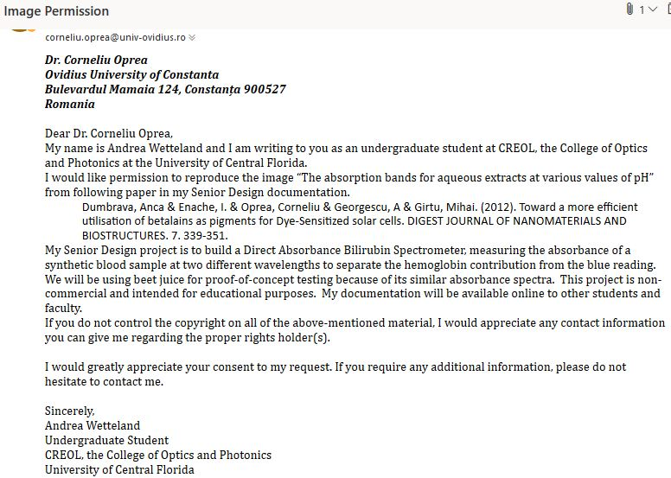

Battery University website:



Flinders University:

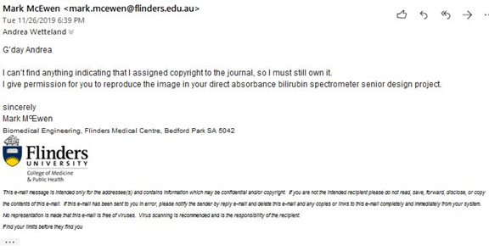

From TI’s terms of service section 4. Use Restrictions and Termination of Access to TI Services.

