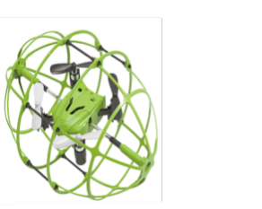 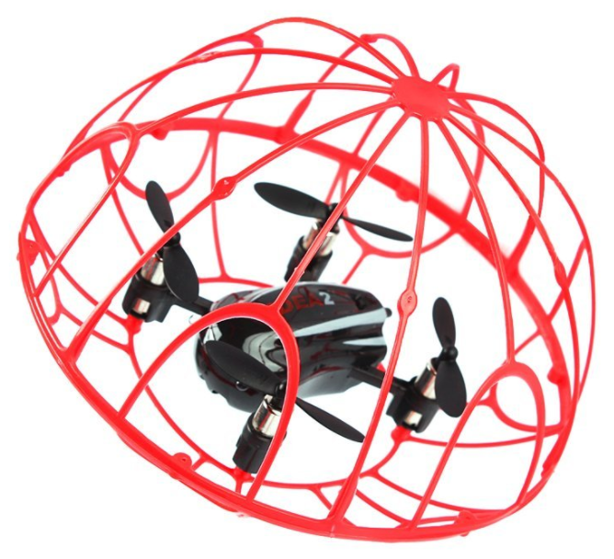￼



Group 28
Pamela Echevarria: EE
Branden Griffin: CpE
Jarryd Salas: EE
Joey Velez-Ginorio: CpE

Sponsor: Lockheed Martin
Contributors: Mechanical Engineering, Aerospace Engineering, Computer Science

Table of Contents

1 Executive Summary___________________________________________________________5
2 Project Description____________________________________________________________6
2.1 Motivation___________________________________________________________6
2.2 Goals and Objectives__________________________________________________6
2.3 Requirements Specification_____________________________________________7
2.4 House of Quality_____________________________________________________7
3 Background Research_________________________________________________________9
3.1 Similar Projects_____________________________________________________10
3.1.1 Obstacles Detection and Collision Avoidance______________________13
3.1.2 Raspberry Pi Model__________________________________________14
3.2 Relevant Technologies________________________________________________16
3.2.1 Relevant Technologies for Hardware_____________________________16
3.2.1.1 Microcontrollers_______________________________16
3.2.1.1.1 Architectures_________________________16
3.2.1.1.2 Microcontroller Comparison____________________18
3.2.1.1.3 ATmega328 Integration_________________19
3.2.1.1.4 Additional Computing Architectures _______20
3.2.1.1.5 Programming Languages_______________21
3.2.1.2 Battery and Power____________________________22
3.2.1.3 Quadcopter Kit Selection______________________________31
3.2.1.4 Flight Controllers______________________________32
3.2.1.4.1 Autopilot Flight Stacks________________________35
3.2.1.5 Cameras____________________________________36
3.2.1.6 Sensors_____________________________________41
3.2.1.7 Wireless Transmission_________________________44
3.2.1.8 LCD Screens________________________________49
3.2.2 Relevant Technologies for Software_____________________________49
3.2.2.1 Flight Controller Software_____________________________50
3.2.2.2 Convolutional Neural Networks__________________50
3.2.2.3 Support Vector Machines_______________________51
3.2.2.4 MCU Software_______________________________51
3.2.2.5 Google’s TensorFlow__________________________51
3.2.2.6 Berkeley’s Caffe______________________________52
3.2.2.7 Python’s Theano_____________________________53
3.3 Parts Selection Summary_____________________________________________53
4 Design Constraints and Standards______________________________________________56
4.1 Environmental and Competition Constraints______________________________56
4.2 Economic Constraints_______________________________________________57
4.3 Size and Structural Constraints________________________________________57
4.4 Time Constraints___________________________________________________58
4.5 Dependence Constraints_____________________________________________58
4.6 Testing Constraints_________________________________________________59
4.7 Programming Standards: C___________________________________________59
4.8 Safety Standards___________________________________________________60
4.9 PCB Standards____________________________________________________60
5 Hardware Design__________________________________________________________62
5.1 Power Distribution__________________________________________________63
5.2 Flight Controller Connections_________________________________________63
5.3 Printed Circuit Board (PCB)__________________________________________65
5.3.1 Printed Circuit Board (PCB) – Using Eagle Cad__________________68
5.3.2 Printed Circuit Board (PCB) – Flight Controller___________________72
5.3.3 Printed Circuit Board Sensor Connection_________________________73
5.3.4 Additional PCB Design Considerations__________________________76
5.3.4.1 Trace Width and Trace Spacing_______________________76
5.3.4.2 Isolate___________________________________________76
5.3.4.2 Annular Ring______________________________________77
5.3.4.4 Gerber File Generation______________________________77
5.3.4.5 Tenting__________________________________________77
5.3.4.6 Labeling_________________________________________78
5.3.4.7 Component Placement_____________________________78
5.3.4.8 Placement of Power, Ground, and Signal Traces_________78
5.3.4.9 Separation_______________________________________79
5.3.4.10 Heating Issues___________________________________80
5.4 ATmega328______________________________________________________81
5.4.1 ATmega328 to Pixhawk Connection___________________________81
5.4.2 ATmega328 to Sensors Connection___________________________82
5.4.3 ATmega328 to RunCam Connection___________________________82
5.4.4 Interfacing ATmega328 with Intel Compute Stick_________________82
5.4.5 ATmega328 USB Connection________________________________83
5.4.6 ATmega328 Pin Connection Summary_________________________83
5.5 Voltage Regulator_________________________________________________84
5.5.1 Linear Voltage Regulator____________________________________84
5.5.1.1 Switching Voltage Regulator__________________85
5.5.2 PCB Voltage Regulator____________________________________85
5.6 Printed Circuit Board Complete Design________________________________86
5.7 Optional Hardware Features________________________________________86
5.7.1 Electrostatic Discharge Protection____________________________86
5.7.2 Wireless Charging________________________________________88
5.7.3 Lidar___________________________________________________89
5.7.4 Bluetooth_______________________________________________89
5.7.5 4K Video Streaming_______________________________________90
5.7.6 Additional Motors_________________________________________90
5.7.7 Gimbal_________________________________________________91
6 Project Software Design Details_____________________________________________92
6.1 Software Functionality_____________________________________________92
6.1.1 Drone Central Command___________________________________93
6.1.2 Camera Feed and Transmission_____________________________94
6.1.3 Prey Tracking____________________________________________94
6.1.4 Collision Control__________________________________________94
6.1.5 Flight Control____________________________________________95
6.1.6 Ground Station Central Command____________________________97
6.1.7 Ground Station Video Feed__________________________________97
6.2 Algorithm Description______________________________________________98
6.2.1 Low-level Control_________________________________________98
6.2.2 Prey Tracking____________________________________________98
6.3 Software Functionality Flowcharts____________________________________99
6.3.1 Prey Drone Detection______________________________________100
6.3.2 Collision Avoidance_______________________________________100
6.4 Additional Software Features________________________________________101
6.4.1 Safety__________________________________________________101
6.5 Software Implementation Design_____________________________________102
6.5.1 Programming the Atmega328________________________________102
6.5.2 PCB to Pixhawk Communication______________________________103
6.5.2.1 MAVlink_________________________________________104
6.5.3 PCB to Camera Communication______________________________104
6.5.4 Camera Feed____________________________________________105
6.5.5 Software Variable and Function Breakdown_____________________105
6.5.5.1 Variables________________________________________105
6.5.5.2 Functions________________________________________106
6.6 Optional Software Features__________________________________________107
6.6.1 Alternative Modes of Control_________________________________108
6.6.1.1 Voice Control_____________________________________108
6.6.1.2 Gesture Control___________________________________109
7 Testing and Debugging_____________________________________________________111
7.1 Hardware Testing__________________________________________________111
7.1.1 Hardware Testing Procedure_________________________________111
7.1.2 Parts____________________________________________________114
7.2 Software Testing___________________________________________________116
7.2.1 Testing PCB to Pixhawk Communication________________________116
7.2.2 Testing Camera Feed_______________________________________117
7.2.3 Testing Individual Software Functions___________________________117
8 Administrative Content______________________________________________________119
8.1 Project Roles_____________________________________________________119
8.1.1 Mechanical Engineers______________________________________119
8.1.2 Aerospace Engineers_______________________________________120
8.1.3 Computer Science_________________________________________120
8.2 Project Milestones_________________________________________________121
8.3 Budget Analysis___________________________________________________122
8.4 Team Communications______________________________________________123
8.4.1 Cross-discipline Communication_______________________________123
8.4.2 CE/EE Group Communication_________________________________124
8.4.3 Alternative Communication Options____________________________124
9 Second Semester Findings__________________________________________________125
9.1 Hardware________________________________________________________125
9.1.1 Power Supply/Distribution______________________________________125
9.1.2 Final Hardware Component Selection_____________________________127
9.1.3 Printed Circuit Board (PCB)_____________________________________130
9.1.4 Sensors____________________________________________________133
9.2 Hardware/Software Integration_______________________________________136
9.3 Software________________________________________________________137
10 Appendices______________________________________________________________138
10.1 Works Cited______________________________________________________138
10.2 Permission Requests_______________________________________________141

List of Tables
Table 1. Microcontroller Chip Comparisons………………………………………………………….18
Table 2. Flight Controller Comparisons……………………………………………………………….35
Table 3. Sensors Comparison………………………………………………………………………….42
Table 4. Characteristics of the Sharp GP2Y0A02YK0F IR Sensor………………………………...44
Table 5. RC receiver Specification Comparisons…………………………………………………….49
Table 6. RC System……………………………………………………………………………………..65
Table 7. SRF02 Registers……………………………………………………………………………...74
Table 8. ATmega328 Pin Connections………………………………………………………………..83
Table 9. Milestones……………………………………………………………………………………..121
Table 10. Components and Their Estimated Costs…………………………………………………122
Table 11. Weight Analysis…………………………...…………………………………………………127
Table 12. As-Demonstrated Drone Bill of Materials…………………………………………………129
Table 13. USB to Serial Converter Comparison Chart...……………………………………………130
Table 14. Updated Sensor Selection……………….…………………………………………………134

List of Figures
Figure 1 – House of Quality……………………....….……...………………………………………………. 8
Figure 2 – Existing Quadcopter Design………….…………………………………………………………. 10
Figure 3 – Diagonal Arms Quadcopter Frame…………………………………………………………….. 11
Figure 4 – Quadcopter Structural Designs……………………....…………………………………………. 12
Figure 5 – Ultrasonic Sensor Functionality…...………………………………………..…………………... 13
Figure 6 – Ultrasonic Sensor Design Research…………....……………............................................... 14
Figure 7 – Pi-Quadcopter Design……………………………...……………............................................. 15
Figure 8 – Pi-Quadcopter Design Electronics………………....……………............................................ 15
Figure 9 – Battery Connections…………………….……….……………................................................. 28
Figure 10 – Switch Basics………………………………………………...……………............................... 28
Figure 11 – INSERT HERE………………………………..……………................................. x
Figure 12 – INSERT HERE………………………………..……………................................. x
Figure 13 – INSERT HERE………………………………..……………................................. x
Figure 14 – INSERT HERE………………………………..……………................................. x
Figure 15 – INSERT HERE………………………………..……………................................. x
Figure 16 – INSERT HERE………………………………..……………................................. x
Figure 17 – INSERT HERE………………………………..……………................................. x
Figure 18 – INSERT HERE………………………………..……………................................. x
Figure 19 – INSERT HERE………………………………..……………................................. x
Figure 20 – INSERT HERE………………………………..……………................................. x
Figure 20 – INSERT HERE………………………………..……………................................. x
Figure 21 – INSERT HERE………………………………..……………................................. x
Figure 22 – INSERT HERE………………………………..……………................................. x
Figure 23 – INSERT HERE………………………………..……………................................. x
Figure 24 – INSERT HERE………………………………..……………................................. x
Figure 25 – INSERT HERE………………………………..……………................................. x
Figure 26 – INSERT HERE………………………………..……………................................. x
Figure 27 – INSERT HERE………………………………..……………................................. x
Figure 28 – INSERT HERE………………………………..……………................................. x
Figure 29 – INSERT HERE………………………………..……………................................. x
Figure 30 – INSERT HERE………………………………..……………................................. x
Figure 31 – INSERT HERE………………………………..……………................................. x
Figure 32 – INSERT HERE………………………………..……………................................. x
Figure 33 – INSERT HERE………………………………..……………................................. x
Figure 34 – INSERT HERE………………………………..……………................................. x
Figure 35 – INSERT HERE………………………………..……………................................. x
Figure 36 – INSERT HERE………………………………..……………................................. x
Figure 37 – INSERT HERE………………………………..……………................................. x
Figure 38 – INSERT HERE………………………………..……………................................. x
Figure 39 – INSERT HERE………………………………..……………................................. x
Figure 40 – INSERT HERE………………………………..……………................................. x
Figure 41 – INSERT HERE………………………………..……………................................. x
Figure 42 – INSERT HERE………………………………..……………................................. x
Figure 43 – INSERT HERE………………………………..……………................................. x
Figure 44 – INSERT HERE………………………………..……………................................. x
Figure 45 – INSERT HERE………………………………..……………................................. x

Figure 11. RunCam Split 2…………............................................................................................40
Figure 12. Robot-Electronics: “CMUcam5 Pixy”..........................................................................40
Figure 13. Camera Connection……………………………………………………………………......41
Figure 14. Beam Pattern for SRF02 Ultrasonic Sensor………………………………………….....43
Figure 15. Course Layout……………………………………………………………………………...57
Figure 16. Hardware Control Diagram…………………………………………………………….....62
Figure 17. Pixhawk Flight Controller and Connection Diagram…………………………………...63
Figure 18. AdaFruit: “Arduino – Arduino Board Uno (EAGLE files and schematic posted)”.......70
Figure 19. Webench: “Design : 4756069/1 LM3478MMX/NOPB”...............................................71
Figure 20. Microcontroller Schematic Design……………………………………………………......72
Figure 21. SRF02 Ultrasonic Sensor Diagram……………………………………………………....73
Figure 22. SRF02 Command Table…………………………………………………………………...74
Figure 23. Sharp IR sensor voltage/distance graph…………………………………………….......75
Figure 24. Trace Overwriting……………………………………………………………………....…..76
Figure 25. PCB Drill Placement…………………………………………………………………...…..77
Figure 26. PCB Tenting…………………………………………………………………………….......78
Figure 27. Analog vs. Digital Lines……………………………………………………………………80
Figure 28. Ardupilot: Pozyx for Non-GPS Loiter……………………………………………………..81
Figure 29: Connection Visualization…………………………………………………………………..84
Figure 30. Adjustable Voltage Regulator………………………………………………………....…..85
Figure 31. Software Control Diagram………………………………………………………………....93
Figure 32. QGroundControl Software Fly-View……………………………………………...…..…..96
Figure 33. Target Tracking Coded Flowchart…………………………………………………....….100
Figure 34. Collision Avoidance Flowchart……………………………………………………….…..101
Figure 35. PCB to Pixhawk Communication……………………………………………………......104
Figure 36. Function and Variable Dependencies………………………………………………......107
Figure 37: RunCam Settings……………………………………………………………………....…113
Figure 38: Hardware Component Connections………………………………………………....….115
Figure 39: Actual Frame and Intel Stick……………………………………………………....…….116
Figure 40. Project Role Breakdown…………………………………………………………...…….119
Figure 41. Final Hardware Block Diagram………………………………………………………….125
Figure 42. Physical Layout of Robocopter………………………………………………………….128
Figure 43. Final PCB Schematic…....……………………………………………………………….131
Figure 44. Final PCB Layout………...……………………………………………………………….132
Figure 45. Manufactured PCB……….……………………………………………………………….133
Figure 46. Final Sensor Placement……….…………...…………………………………………….135

1. Executive Summary

The history of the human species is a story of conquering, fighting, and survival. Over time, wars have been fought with increasingly advanced technology. Some advances have been motivated by the pursuit for destructive power, but many others have taken inspiration from the desire to save lives. One such technology aimed at saving lives is the drone.

Drones reduce the need for pilots and foot soldiers in areas of combat, and as a result are highly beneficial in the quest to keep people alive. Perhaps just as importantly, drones can be used for monitoring dangerous areas without putting human scouts at risk. They can be remotely controlled by personnel operating computers connected to the drone. In fact, some drones are completely autonomous - that is, they function without human control. Such drones rely on computer programming algorithms.

Unfortunately, drone technology has proven to be difficulty to perfect. Complex computer systems are required in most cases, and as a result their cost can skyrocket. Autonomous drones in particular require exceptional electronics systems and programming functionality. Reducing the cost and implementation complexity, while maintaining functional integrity, is one of the big challenges in the development of drones today, and that is what this Robocopter project aims at tackling. In this case, the Robocopter will be designed to function autonomously.

This document will explore the various aspects of designing a Robocopter that meets our criteria of a cost effective and high performing drone solution. First, research and analysis of existing drones and copters will be presented. In addition, technological component research will be discussed, as part selection is critical to keeping the project cost manageable, while at the same time maintaining high performance. Comparisons will be made between potential components to weigh the benefits and cons of each. Design constraints and standards will also be mentioned, as they affect which parts will be appropriate to include in the design. Constraints will also guide where we focus our effort in the project and special considerations we must make when making certain design decisions, such as economic and time limitations. Keeping design standards in our minds will make sure we maintain quality while working within our design constraints.

Furthermore, the design process for our Robocopter will be elaborated on; both the hardware and software aspects of the Robocopter’s design will be analyzed. After the design is complete, testing will be performed on our design to ensure expected behavior and allow for possible improvements. Our project milestones and budget analysis will also be explored, in the administrative section of this document.

Finally, we will provide insight into the conclusions we arrive at in our research and design of attempting to build a cost effective, autonomous quadcopter - or as we have named in this project, Robocopter.

2. Project Description

Before researching, designing, or developing a project, it is important to consider what the heart of the project is - that is, what are our motivations and goals in creating it. This section will elaborate on this aspects of our Robocopter project.

2.1 Motivation

As mentioned in the executive summary, war is - unfortunately - rampant in the history of human civilization. Countless technologies have been developed for each offensive and defensive purposes, and sometimes for both. One of the more recent technological advancements, the drone, became popular after its inception in the late 20th century, and is increasingly employed in combat situations today. The underlying motivation behind this Robocopter project is ultimately to save lives. Rather than putting human lives at risk by having pilots enter dangerous areas, drones can be used. Unfortunately, drones can be complex and costly, so developing more efficient ones is an ongoing challenge. Our desire to develop a cost effective, high performing quadcopter drone is the driving force behind this Robocopter project.

Apart from the aforementioned military purposes, there are other applications for the technology we wish to explore with our Robocopter. Drones are being used more and more frequently for commercial and industrial purposes. Amazon, for example, has been exploring using autonomous drones to deliver shipments to their customers. The technology is not quite there yet for it to be practical on an everyday level, so much work is to be done in the field. Drones can also be used to autonomously explore or even investigate various regions - in the aftermath of the hurricane, they can be deployed to scout areas affected and relay back information about where the most immediate help is required. All of these applications for autonomous drone technology will be in the forefront of our mind when developing our Drone and its behavior.

To evaluate the effectiveness of our Robocopter, it will compete in a Lockheed Martin Sponsored competition. The Robocopter we develop will face off against other quadcopter drones developed by other Senior Design teams. The competition will evaluate our Robocopter’s effectiveness at maneuvering a designed course to track, intercept, and take down “prey” drones. Such a competition will simulate how effective our implemented design might be in real combat situations.

2.2 Goals and Objectives

The goal is to create a Robocopter for defense that is worthy of competing with those already designed in the market. In addition, another goal is to research and find the most efficient way of tracking and detecting prey drones, or other moving targets. For this Robocopter we are looking to make it as energy efficient as possible, and with smooth and controlled motions. The objective is to have an affordable and portable Robocopter that excels in detecting and engaging with enemies. Another goal we have for this Robocopter is to be weather resistant. The competition will take place outdoors and considering the unpredictable weather in Florida, it is imperative that the aircraft can withstand various weather conditions. Some of these conditions include - but aren’t limited to - rain, extreme heat (we must make sure that the copter doesn’t overheat), and strong winds (it must be able to withstand them and continue its course).
Ultimately we strive to design and implement a Robocopter worthy of competing and that will win in the competition. We are designing it to be able to get as many points as possible in the competition. Yet, most importantly, our intention is to build a Robocopter that has valuable technological elements that could later be adopted and implemented in other copters that could serve in preserving and protecting life. As we are a sponsored project, our goal is to add value to this company perhaps with something that they could use and implement later on. In addition we are going to ensure that we are setting a good example and representing the company well, make sure we represent their name in an outstanding manner.
2.3 Requirements Specification

The following is a list of requirements for the Robocopter:
- A camera or sensor for the Robocopter to detect prey drones around it.
- A tracking algorithm/mechanism for the Robocopter to lock onto the prey drones and attempt to intercept them.
- The ability to transmit the video from the camera to a ground station.
- The ground station must display the video from the Robocopter, as well as the tracking algorithm at work.
- Battery must be able to sustain flight for at least 10 minutes at a time.
- Size limit of 4×4×4 (ft).
- Must be able to re-track prey after collision with foreign objects.
- Must have a protective cage around it for when it collides.
- Must consume little enough power to efficiently run the UAV without overheating other components.
- Must be able to adjust tracking/locating of foreign object within 1 sec.
- System must have weatherproof protection on all electrical components.
- Components must not interfere with movement of quadcopter.
- Must have a way of monitoring battery usage/voltage.
- A ESC (Electronic Speed Controller) to control the motors.

2.4 House Of Quality
To maintain integrity between the marketing and engineering aspects of the project, a house of quality was created. The marketing requirements describe the functionality required by the customer, in this case Lockheed Martin, while the engineering requirements describe the technical aspects of the project. The following diagram is the House of Quality we have created for the Robocopter.
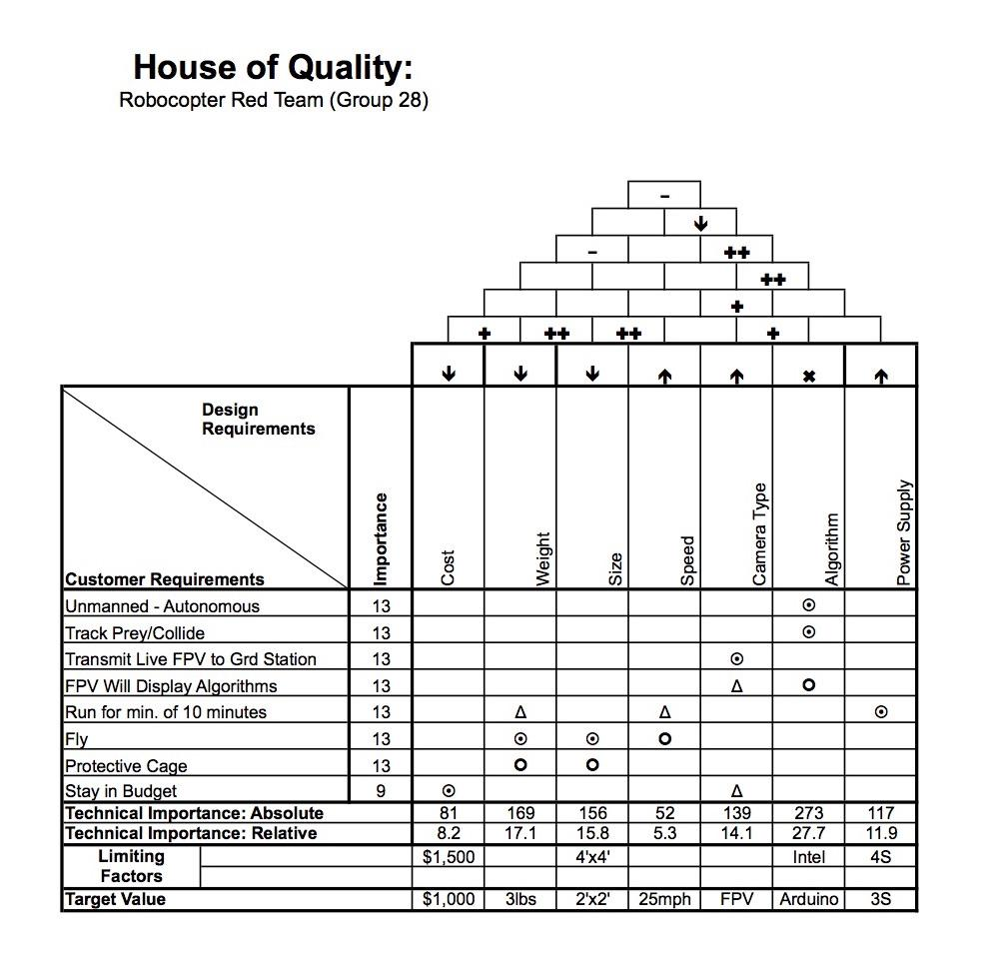
Figure 1. House of Quality (Diagram Provided by QFD Online)
An important note to make on the House of Quality is the emphasis on the algorithms and the flight of the Robocopter. The Robocopter will not be able to fly without correctly implemented algorithms that allow for autonomous behavior, nor will it be able to fly for an extended period of time without a strong battery and efficient circuitry/wiring. These aspects of the Robocopter design will be the most challenging and critical that we will be tackling.

3 Background Research

They key to a great, successful project is having a clear understanding of each requirement means and to achieve your goal. What makes this project particularly unique is that it is an autonomous or unmanned aerial vehicle. The interest and popularity for these type of vehicles has been around for many years now and each day, having these more commonly increases. The first question to ask when building an unmanned aerial vehicle is, what does autonomous really mean. The definition of autonomous as provided by dictionary.com is “navigated and maneuvered by a computer without a need for human control or intervention under a range of driving situations and conditions.” The definition then of automation also provided by dictionary.com is “the technique, method, or system of operating or controlling a process by highly automatic means, as by electronic devices, reducing human intervention to a minimum.”

What we can conclude from these two definitions is that we are designing a robot that does not need our help in any way to perform all of its capabilities, which means that we need to provide it with a way to interpret its surrounding conditions and translate this into a task that must be performed according to the conditions, using electrical components. We will accomplish this through a series of devices such as a flight controller to achieve a smooth flight and also a way to control other instruments such as the motors and propellers. Another extremely important component is the use of a PCB that will interpret all data received and send commands to all other devices to make sure the Robocopter performs well.

Now there are several different levels of automation in terms of cars but also aerial vehicles that we need to understand to ensure that we have a fully autonomous Robocopter. The level range from the Driver Assistance first level of automation where the vehicle can take over certain parts such as moving the vehicle around or actually propelling the vehicle forward/backwards, but never both at the same time. An example of this would be cruise control in a car. This goes to the last level which is full automation where the vehicle does not need any type of assistance from a human to do anything. In-between those levels there are others that are mainly autonomous but can request human assistance is needed or that just do need assistance for some features.

Focusing on our goal, to make a fully autonomous unmanned aerial vehicle, to design and build a successful drone that meets specific requirements, extensive research had to be done. There are many designs out on the market now that incorporate some form of autonomous flight, either being just autonomously stabilizing itself, or tracking a moving object to record video. Most autonomous copters out today allow their UAV to follow, track, and even record, but not attack. Some copters allow the user to carry a device whereas the drone can then track the device, follow, and record. Moreover, some drones can autonomously fly by tracking hand movements from user control. As well, different quadcopters will have different flight times or maximum speed. Therefore, by doing some extensive research on previous designs and builds, we are able to examine what components could be useful in our design based off our specific requirements, such as flight time, autonomous tracking, max speed etc.

3.1 Similar Projects

Before diving into the research of the various technologies that will be used in our Robocopter, we will first take a look at some similar projects that have been completed before. This approach will give us an overview of components and design choices to consider when we implement our own design. Fortunately, there are countless drone and quadcopter projects online constructed by both hobbyists and engineers, which will give us key insight into the part selection process. There are two main things that will be setting our project apart from existing quadcopter projects - first, ours will be autonomous, whereas as projects found online are almost always manually controlled. Second, our project will be using a custom designed PCB rather than an existing microcontroller. Still, exploring existing projects will steer us in the right direction.

One interesting quadcopter design was laid out by Jake Brown from www.mydronelab.com, and can be seen in Figure 2. His design is a very popular one, where there is a central hub for the electronics, and four arms extending out with a motor and propellor at the end of each.

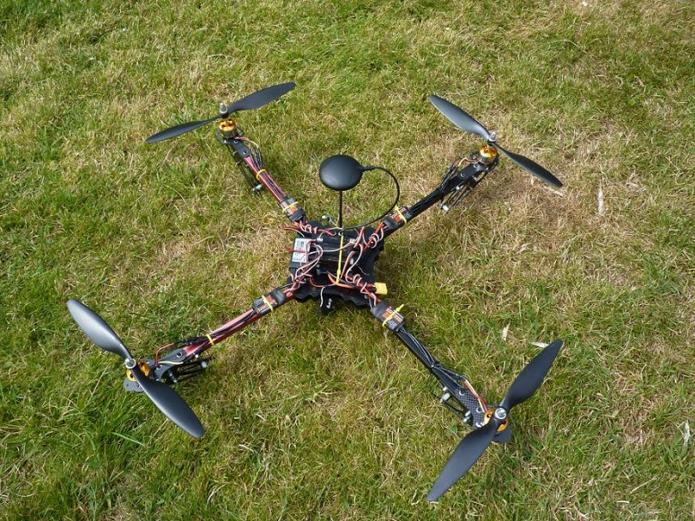
Figure 2. Existing Quadcopter design [4]

The design he has implemented utilizes an Arduino microcontroller to act as the processing unit for the quadcopter. We may use an Arduino based PCB, but we will be building it from scratch. We will complete further research on microprocessor selection later on. As for the other components used, there is a battery (which is essential for any drone project), rotors, propellers, IMU (inertial measurement unit), and RC controller. These are all parts we may want to implement in our design. The IMU, for example, measures information such as the quadcopter’s velocity and orientation - in unison with a flight controller, this could be very useful. Also, while our Robocopter will need to use custom programming to autonomously track and intercept prey drones, as well as fly around the course, there is the scenario where we may need to fly the Robocopter back to the ground for repair. In that case, or any emergency situation where we need to override the autonomous behavior, an RC controller and RC transmitter would need to be utilized in our design.

Another quadcopter project is described by skilledflyer.com. Their design uses the same frame as the previously described quadcopter project and can be seen in Figure 3.
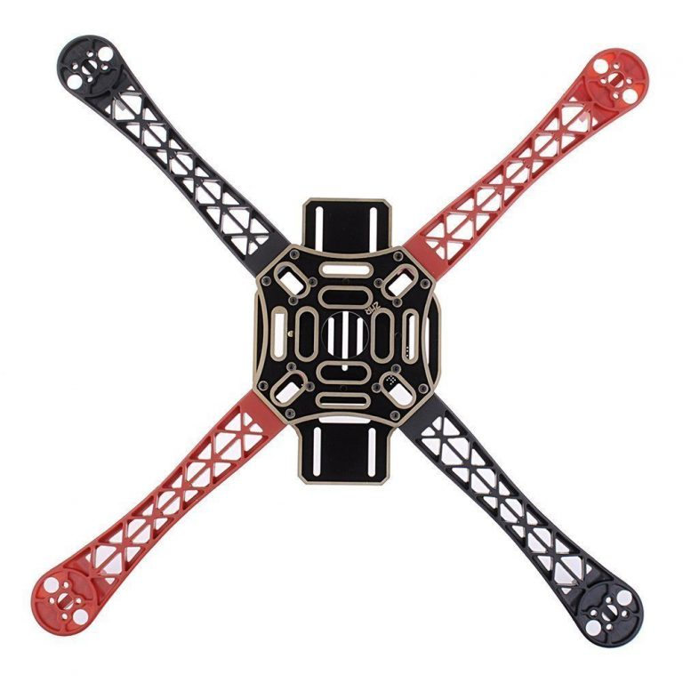
Figure 3. Diagonal Arms Quadcopter Frame [5]

The layout of their quadcopter is very similar to the previous project, but there are some differences in the components they choose to include in their design. For one, they elect to use four electronic speed controllers (ESC) between the flight controller and motors rather than using one large one. Choosing the ESC and IMU will be part of the research we complete later on. Additionally, rather than using an isolated flight controller in conjunction with a microcontroller, they simply utilize an Arduino microcontroller to act as a flight controller. Such a decision will be one we will have to face when choosing our components - that is, if we want to use an isolated flight controller. Using a designated flight controller would have both some benefits and cons. The nice thing about them would be that they are specifically designed to handle motor control and the overall movements of aircrafts. Also, it would save us from having to perform extra work on our PCB. On the downside, including an isolated flight controller would increase the weight of the Robocopter, requiring us to provide more battery life and thrust. Additionally, it would require more wiring and interfacing to use both a flight controller and a PCB instead of simply integrating the flight control software on the PCB itself. We will perform further analysis on which design choice we move forward with in later sections.

Additionally, there are other quadcopter structural designs that we could potentially base ours on. One of them has the electronics on a bridge between two arms, with a propellor at the ends of each arm. Figure 4 compares this design with the design discussed previously, from a top down perspective.

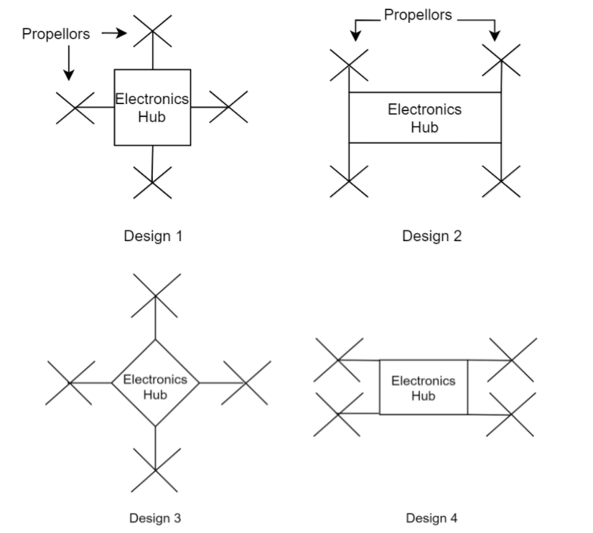
Figure 4. Quadcopter structural designs

Design 2 and 4 are intriguing because there is more support to the arms, however they have a critical downside: weight distribution. Design 1 and 3 are more balanced as far as weight is concerned, so calculating flight movements will be less challenging. With Design 2 and 4, we would have to account for the fact that the propellers aren’t evenly distributed in relation to the center of gravity of the aircraft. While some professionally made drones do use those designs, it is beyond the scope of what will be possible for this team in the allotted time span. One popular implementation of Design 2 that is worth looking at is the DJI Inspire.

Thus, we will be using a design closer to that of Design 1 and perhaps Design 3 for the structure of our Robocopter. With a project of this scope, any extra trouble we save ourselves will allow us to spend more time on improving the efficiency of our systems.

3.1.1 Obstacle Detection and Collision Avoidance

When dealing with obstacle detection and avoiding said obstacles, there are many different sensors that can be utilized. Figure 5 outlines the functionality flow for a typical ultrasonic sensor.

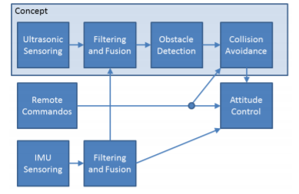
Figure 5. Ultrasonic Sensor Functionality

Figure 6 shows how a quadcopter design used multiple ultrasonic sensors to receive a full 360 degree coverage. The green section show each individual sensor angle of detection while the yellow section shows the overlap between sensors. Since the ultrasonic sensors used here have about a 30 degree angle detection, 12 sensors were used to get a full 360 detection radius. The SRF02 sensor was used because the low cost and high reliability as well as easy communication for several entrants. The ultrasonic sensor also was able to detect water and glass surfaces, where the possibility of infrared cannot. These ultrasonic sensors were pretty effective in detection however noise from the quadcopter rotations caused a slight problem with measurements. In this design, an IMU was used to measure the angular rate from the gyroscope to dismiss the incorrect measurements from the rotations.

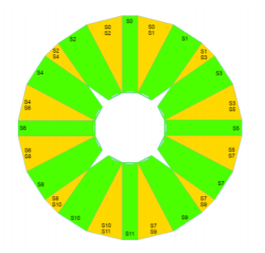
Figure 6 . Ultrasonic Sensor Design Research

3.1.2 Raspberry Pi Model

The next design examined is the Pi Quadcopter seen in the Figure 7 below. A raspberry microcontroller was used in place of a receiver, performing all the calculations for flight control then transmitting that to the flight controller. The Pi copter also used a flight controller that had a built in wifi chip that could be used to connect a device on the ground to the copter. The wifi network would allow the user to connect via an app and control the drone like a remote controller would. 30A electronic speed controllers were used because they must exceed the max draw of the motors which are being used. A 3S 3300 mAh battery was used to give the copter a good flight time based off the motors and components used. Some other useful components presented in this design, are the battery monitor and battery charger. The battery monitor is an interesting piece, when the battery is low, it will ring or flash to alert the user. When using Li-Po batteries it is best to keep the cells above 3V, so since this design used a 3S battery the monitor would warn the user when below 9V. This part of the design will most likely be useful in our design as we would like to monitor our battery life as well and make sure it is not being over drained.

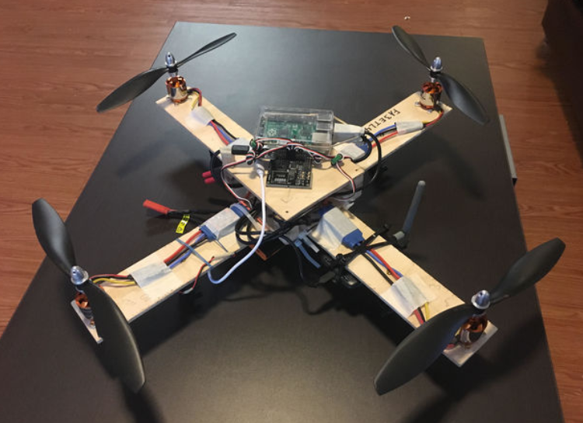
Figure 7. Pi-Quadcopter Design

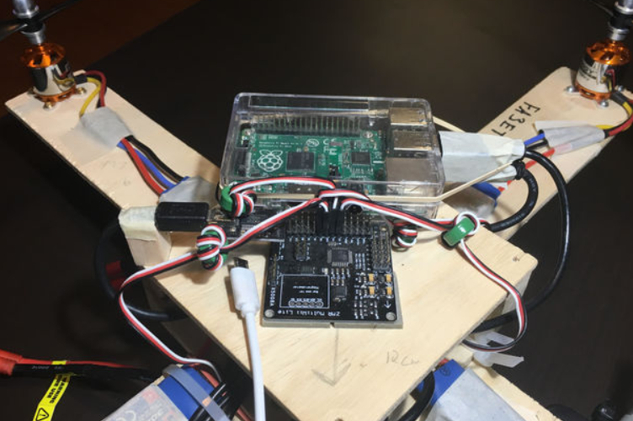
Figure 8. Pi-Quadcopter Design Electronics

3.2 Relevant Technologies

The following sections detail relevant technologies for the hardware and software systems on the Robocopter. We split the hardware and software into separate sections. The hardware section focuses on computing architectures, sensors, and peripherals on the Robocopter. The software section focuses on the research that went into low-level and high-level software systems like the prey tracking and image recognition systems. The descriptions include some systems that do not make it into the final design, but describe the advantages of disadvantages of the different technologies, and why they were or weren’t used in the final design.

3.2.1 Relevant Technologies for Hardware

There are several important hardware technologies we will be using in our Robocopter design that require extensive research. The microcontroller/microprocessor we integrate on our PCB will control the other hardware components and also low level movement of the Robocopter. The battery used will be critical to the length of time our Robocopter can remain in flight. The cameras we use for both tracking and environmental awareness purposes will also be important to how our Robocopter performs in the competition. The following sections will discuss the hardware components, the technology behind them, and our thought process for selecting the exact parts we will use in our actual design.

3.2.1.1 Microcontrollers

The Robocopter will require several hardware components such as a camera, flight controller, sensors, battery, electronic speed controllers, etc. To connect all these parts so that they can communicate with each other, a central unit will be necessary - that is where the PCB (printed circuit board) becomes relevant. The PCB that we design will act as the “brain” of the Robocopter. It will be composed of components that allow it to be programmed to not only interact with the other hardware pieces, but also ultimately utilize algorithms that will allow the Robocopter to fly and track other drone autonomously. As such, sufficient research will be necessary to develop the architecture of the PCB. This section will discuss different microcontroller architectures and programming languages that could potentially be utilized for the Robocopter.

3.2.1.1.1 Architectures

There are two major functions that must be completed by the software in our Robocopter. First, low level movement and control of the other hardware components. Second, the tracking algorithms and interception of the prey drones. For us - the ECE team - handling the former aspect will be the primary concern, while the CS members of our interdisciplinary team will be tackling a large portion of the tracking and interception. The CS team members will be using an Intel Compute Stick CS125 to complete their objective. However, it will be important for our ECE team to break down and analyze which microcontroller technology will be best suited for our software responsibility. In the end, we will have to interface the PCB with the Intel Compute Stick. being used by the CS team. Because of this, we will also need to be familiar with the technology behind an Intel Compute Stick regardless of the microcontroller we choose for our PCB.

There are several standout options for the processing unit on the PCB. Raspberry Pi, Arduino, MSP430, and Beaglebone were all considered. An indepth look at each of these options will now be performed to weigh their benefits and downfalls.

Raspberry Pi - The Raspberry Pi series is composed of several single-board computers with extensive capabilities when it comes to homemade robotic and electronic projects. Raspberry Pi boards contain a CPU, as well as RAM, input/output slots, and even USB connections. In other words, Raspberry Pi boards are essentially compact computers. In fact, they even run a simple operating system. While their complex structure would allow more advanced capabilities in the Robocopter, they would also pose the problem of being more difficult to implement. Because we will be constructing the PCB from the ground up, we will not be using a Raspberry Pi itself, but instead the SoC ( system on chip) found on a Raspberry Pi. The Raspberry Pi model most well suited for the Robocopter is the Raspberry Pi model B, which utilizes a BCM2837 SoC. For the PCB, we would be using the BCM2837 as the processing core. Unfortunately, after extended research, it was found that the BCM2837 cannot be purchased individually - only in bulk quantities, thus rendering this option unviable.

BeagleBone - Like the Raspberry Pi, BeagleBone are a series of single-board computers. The BeagleBone Black is one of the more modern and capable BeagleBone microcontrollers, and it utilizes the AM3358 SoC [97]. While the BeagleBone Black can run a full operating system like Debian Linux, the PCB for the Robocopter would only use the AM3358 chip itself.

MSP430 - The MSP430 series is a family of mixed signal microcontrollers. MSP430’s are known for their performance in low cost, low power projects [98]. There are extensive variations of MSP430 chips available, but two were considered for this project. The MSP430G2553 is a mixed signal microcontroller that provides decent processing speeds with a moderately low power requirement. The MSP430FG4618 is an ultra low power MCU with slightly slower processing speeds but with much more memory and many more output pins. It does require slightly more power than the MSP430G2553. All of these characteristics will be compared in a table later in this section.

Arduino - Another very interesting option for our PCB would be an Arduino based microcontroller. Arduino microcontrollers are used frequently for Robotic projects, including drones. Arduino, like the MSP430 series, does not run an operating system like BeagleBone and Raspberry Pi, but also does not provide quite the same capability. Arduino is much more barebones, and as such has lower power requirement [103]. The ATmega328 is a very capable Arduino based chip that will be considered for the PCB.
3.2.1.1.2 Microcontroller Comparison

There are several important features to consider when narrowing in on the microcontroller to be used on the PCB. Memory (both flash and RAM), CPU clock speed, operating voltage, I/O lines, power consumption, and even temperature range are all noteworthy characteristics to compare. Table 1 will compare these characteristics for the ATmega328, MSP430FG4618, MSP430G2553, AM3358, and BCM2837.

Microcontroller Chips

Feature | ATmega328 | AM3358  (BeagleBoneBlack) | MSP430FG4618 | MSP430G2553 | BCM2837  (Raspberry Pi Model B)
Memory | 32 KB Flash  2 KB Ram  1 KB EEPROM | 128 KB Ram  256 KB L2- Cache | 116 KB Flash  8KB Ram | 16 KB Flash  0.5 KB Ram | 1 GB Ram
CPU Speed (MHz) | ~20 | 600-1000 | 8 | 16 | ~1200
Operating Voltage (V) | 1.8 to 5.5 | 5 | 1.8 - 3.6 | 1.8 - 3.6 | 5
Temperature Range (C) | -40 to 85 | -40 to 105 | - 40 to 85 | -40 to 85 | -40 to 85
GPIO Lines | 23 | 65 | 80 | 24 | 40
Power Consumption | Active: .2 mA  Power-down: 0.1 µA  Power-saving: .75 µA | Active: 210- 460 mA | .4 mA  Standby: 1.3 µA | .33 mA  Standby: .7 µA | Active: ~1.34 A  Idle: 300 mA
Operating System | n/a | Android  Linux  Neutrino | n/a | n/a | Raspbian  Linux
Table 1. Microcontroller Chip Comparisons[70, 87, 98, 103]

After a quick glance at the microprocessor table, there are a few clear distinctions. The AM3358 and BCM2837 are far more powerful than the other chips, and can even run operating systems. The big downside to these chips is their power consumption. Both require 5V to function and their current draw is orders of magnitude larger than the other three chips. The ATmega328 finds itself in the middle of the group, with a respectable CPU speed, low power consumption, and decent memory size. It’s major drawback is that it has the lowest number of GPIO lines, but that shouldn’t cause any major problems, as it should still have enough for the Robocopter. Both MSP430 chips have extremely low power consumption and operating voltage, but are also slower.

Another problem we have discovered is that the AM3358, both MSP430 chips, and the BCM2837 are extremely difficult, if not impossible to acquire individually. For the most part, they can only be ordered in large bundles, or on a BeagleBone or Raspberry Pi itself. Fortunately, the ATmega328 is the most desireable chip for the Robocopter. It strikes a balance between capability and power consumption that makes it well suited for the Robocopter’s design. Having a lower power requirement will allow the Robocopter’s battery to be used in other places such as the camera and motors. Additionally, it has sufficient memory and processing speed so that the hardware on the Robocopter can be communicated with in a meaningful manner and there are no major hiccups in its performance.

Consequently, the microcontroller chip we will be moving forward with on our Robocopter’s PCB is the ATmega328. Being a mere 0.2 ounces in weight and 2 inches long[2], the chip will not occupy a large amount of space on the PCB and will not weigh down the Robocopter much at all. Given that, it will not pose any problems to the flight time or movement of the aircraft.

3.2.1.1.3 ATmega328 Integration

To construct a PCB with an ATmega328 integrated onto it, there are a few other things that must be considered. First, to have the ATmega328 installed on the motherboard, it must be placed in a socket. Further research has lead us to find that a 28 pin DIP socket adaptor will be suitable for the ATmega328’s placement on the PCB. Additionally, a crystal oscillator will be needed, as the chip uses that for its internal timing. We have found that a standard quartz 16 MHz quartz crystal oscillator will be sufficient.

To load software onto the ATmega328, a USB connection is required. Two options present themselves for this problem: the first is that the PCB design can include USB to serial communication conversion. There will be a USB port integrated on the PCB, and input from that port will go through the conversion mechanism, and then to the ATmega328. A more simple solution would be to purchase a USB to serial communication converter. This converter would be external to the PCB itself, and could be plugged into the PCB via I/O pins. As this option is more straightforward, simpler, and would save space on the PCB board, it will be the option that the team moves forward with.

When designing the PCB, it will be critical to find out how these components interact with the other parts of the circuit so that the design is effective and will be functional. Separate sections will discuss how the PCB will be designed to ensure that the ATmega328 is properly interfaced with each of the hardware components

3.2.1.1.4 Additional Computing Architectures Considered

There are several other computing architectures that have been used in similar projects before that we opted not to use in this project for several reasons. Below I will discuss these architectures and their advantages and disadvantages.

NVIDIA Jetson - The NVIDIA Jetson [68] is an embedded system that provides a platform for deploying compute-intensive systems that include applications for computer vision, robotics, and medicine. It provides support for CUDA, NVIDIA’s parallel programming language. And this architecture could be used as a standalone to train compute-intensive algorithms like the ones detailed for prey tracking.

The advantage to using the NVIDIA Jetson is that it has plenty of computing power, enough to train the CNNs used in prey tracking on its own, let alone the other tasks that the Robocopter must perform. This could save lots of time when developing the algorithm for prey tracking, as training a CNN on a regular computer may not be as efficient as utilizing the parallelizable architecture of the Jetson.

However, a disadvantage to the Jetson is certainly cost. A development kit for the Jetson costs around $560 dollars, and may actually be more than what we need for the project. Since we can train some of the more compute-intensive algorithms offline, the Robocopter itself may not need the compute-power on its own to train algorithms like a CNN. Ideally, a computer or cluster would train the network, and then the weights used for classification can be transferred over to a less-powerful embedded system. Another issue is learning to interface with Jetson and CUDA. Despite solving many computational problems, the architecture introduces software hurdles that may not be worth the benefit. Learning CUDA requires some knowledge about parallel programming, and getting the Jetson to interface with other embedded systems and the PCB may also require more testing than with other platforms specified earlier (Raspberry Pi, Arduino).

Intel Compute Stick - The Intel Compute Stick [69] is a device that turns any HDMI display into a fully functional computer; with it’s own operating system, same graphics, and wireless connectivity. It all fits into a portable stick, about 4.5 inches from end to end.

There are several advantages to using the compute stick. It has strong performance, with a choice of Intel Atom or an Intel Core M processor, containing up to 4GB of memory and 64GB of storage. It’s also incredibly portable, so that it wouldn’t interfere with the size requirements of the Robocopter. Another thing is that it’s easy to use. You simply insert it into an HDMI slot, and it works like any other computer. Compared to other embedded systems, the price is actually not that high depending on the specifications. Some can be bought for as low as $42 dollars. The compute stick has been used by other drone projects, however we opted against it for several reasons.

While the compute stick is relatively inexpensive, there is far fewer documentation on integrating compute sticks with the embedded system of our Robocopter than there is for something like a raspberry pi. Our goal for the hardware design was to ensure that we used components for which there was plenty of documentation to fall back on, in case our knowledge was limited in some specific domain. There is documentation on using the intel compute stick, just not as much. Another disadvantage is requiring an HDMI slot in the hardware design. Not necessarily too hard to implement, but it’s a requirement nonetheless that the PCB design would have to incorporate in order to support the device.

3.2.1.1.5 Programming Languages

ATmega328 - Just as important as the microcontroller is the language that will be used to control it. The ATmega328 is preloaded with the Arduino bootloader and as such will be able to use the language of a typical Arduino microcontroller. As the Arduino language is simply a subset of C/C++ functions, either language will be applicable.

C++ is object oriented, and thus more powerful overall than C, but for our portion of the project, C may be more suited. First, C is simpler and more straightforward. C++ has classes and other advanced features that would not be necessary for low level Robocopter control. Additionally, C is closer to assembly language than C++, which will make it easier for us to visualize what each piece of code is doing physically for the Robocopter. For example, C uses pointers and requires precise allocation of memory to be used. Being closely tied to the hardware also means that C will be more efficient than C++ in dealing with low level interactions. Consequently, for the software aspect of the Robocopter - that is, implementing low level control on the PCB - we will be utilizing the C language. For the Intel Stick that will be used by the CS team, separate considerations will be made.

Raspberry Pi - The raspberry pi [70] supports a wider array of languages than an Arduino, a feature that the computer science team was especially interested in. At time of writing, the final implementation language for high-level software design (like prey tracking, image recognition) has not been decided. However, the most likely languages to be used are object-oriented languages like Python, C++. which have extensive support for machine learning software systems.

Python and C++ are used extensively in research for computer vision, and there are user-friendly APIs available for software developers in need of image recognition software solutions: especially those using convolutional neural networks. Examples of these solutions are, Google’s TensorFlow (available in Python and C++) and Berkeley’s Caffe (C++).

Another consideration for programming languages are ones which can implement a fast software system, that is some languages may have speed advantages over others. Overall, C++ is regarded as a faster language but this tradeoff will have to be balanced over considerations of software usability and time to implementation.

3.2.1.2 Battery and Power

Most quadcopters and RC vehicles use what is a called a Lithium-Polymer Battery pack to supply power to the UAV. Lithium-Polymer batteries or best known as LiPo batteries are the best for these type of projects due to their characteristics of lightweight, high energy densities and higher more powerful discharge rates. This allows for extended flight time due to the reduction of the load on the aerial vehicle through a lighter battery pack and also through the increase in energy supply and higher discharge rates. What it means by higher discharge rates is that these batteries have a higher capacity or they supply more amps per hour thus making it last longer if the loads don’t draw more current than before. For this reason one of the factors to look for when choosing a battery to achieve a certain flight time is the battery’s capacity. The higher the capacity the more powerful it is and the longer it will last. Although there is a peak at which the capacity no longer contributes to the flight time but it only hinders it through extensive added weight to the copter. Yet, there is always a drawback to a product.

Although LiPo batteries are very good for these types of projects, they are also very dangerous if not properly taken care of. They could easily become damaged and perhaps even catch on fire. For this reason most shipping companies such as USPS, UPS, FedEx, and even airlines don’t allow for these battery packs to be shipped or carried with. It is definitely a safety hazard but there are many accessories and rules to help have a positive experience with LiPos. For example it is not recommended to discharge the battery all the way. This will quickly ruin the battery and it won’t have the lifespan that it could’ve. This Robocopter will have a voltage/current monitor to help prevent this and will make sure that the quadcopter returns to the initial ground position before the battery goes below 80% discharge. Yet, as we continue we will further discuss how to select the best battery for the Robocopter.

When selecting one of the most important components of the Robocopter, the battery pack, it is essential to take into consideration all of the elements that affect the performance of the quadcopter. In this case we need to take into consideration the motors that will be used, as these draw the most power. In turn, in order to know which would be the best motor for the copter, we must know or have an estimate of the overall weight of the robot. Although the the aerospace students in our group will be in charge of selecting the absolute best motor for our project, for now we will consider an estimated weight total of about 3.5lbs. This is taking into consideration that our flight controller is 15.8g, the body of the Robocopter usually averages around 500g, the PixyCam CMUCam5 that we will discuss later is 27g, also the Runcam Split FPV camera weighs 21g the average motor/propellor combination weighs around 200g in total, the ESCs are approximately 25g in total, the potential battery pack is 321g, among other components needed This gives us a total of about 1,384.8g or 3.05lbs. Yet I would round this total to expect a drone weighing around 3.5lbs. Yet a motor needs to be able to produce 50% more thrust than what the weight of drone would be. In this case our motors would need to produce around 3.175kg of thrust. If we divide this load between the four motors, this means that each needs to provide 793.8g of thrust. In this way we can assure that even if there are heavier than expected winds, we would still have a positive flying experience. After this analysis of the factors affecting the selection of the battery, then we can select a motor that would qualify.

After taking into consideration the thrust required we came to the conclusion that the EMAX RS2205 2600KV Motor is the best option combined with the Gemfan 5030 propellers that provide a thrust of 990g at 100% with a 4S LiPo battery. Despite that the selected battery is a 3S and not 4S which means that the thrust would be less, 990g is a big difference from what we actually need and thus the 3S battery pack should be more than enough especially since we truly overestimated the weight of the Robocopter. The motors have an efficiency of 2.82g/W, which is fairly good. The maximum current draw on these motors/propellor combinations with a 4S battery pack is about 21.7A. If we select our battery to be a 3600mAh 3S 30C battery, this means we can draw 3.6*30=108A. This equation comes from the 3600mAh or 3.6Ah and the capacity 30C. If each motor draws 21.7, then 21.7*4=86.8A in total. In order to avoid burning a motor even though we won’t be using the Robocopter at full throttle at all times, a 3600mAh 11.1V 3S 30C LiPo Battery pack will work well. This will allow for a current draw of 3.6*30=108A in total, which is perfect for the motors selected. Even though the analysis was done using a 4S LiPo, the 3S will work just as well and perhaps even better because the 3S will also have less weight which would possibly allow for more thrust to be provided.

After the thorough analysis this Robocopter will be powered by a single Turnigy LiPo battery pack that has a capacity of 3600mAh, provides 11.1 volts of power using three 3.7V cells and has a discharge capacity of 30C with a charge rate of 2C. In addition, this battery pack weighs 321g. Although it is slightly heavier than other batteries, it still should not sacrifice the weight limit we set previously. Despite that there are a number of different battery brands and all offer the same specifications, for some reason some brands tend to be much better than other. When selecting the battery we came across a few brands that were very good in terms of performance, lifespan of the battery, of course assuming that all good battery care practices were taken, and we came to the conclusion that for the price, weight and quality Turnigy was the best selection for this particular project. The reviews for this product were exceptional and it fit the requirements we needed for a power supply. Although the brand Gens Ace definitely came in first in terms of reliability and performance, they are a bit more pricy and the exact capacity preferred was not offered by this brand.

Considering that the battery is one of the most essential components of the Robocopter since without it, there is no drone, it is important to select a powerful power supply. When selecting a battery we must a few key parts in mind. Part of the requirements for this project is to have a flight time of at least 10 minutes which is the duration of the competition and the presentation. Thus after careful research we observed that a drone with a battery pack between 2000mAh and 3000mAh capacity, will usually have a run time of 10-20min. Since we are looking to double the required time and would like a run time of about 20min. The more capacity means the more run time but also the heavier. For this reason we chose a higher capacity in order to ensure the run time we need. Just to go over some terminology, mAh is milli Amperes per hour, S is meaning cells so if we have 3S, this signifies that there are three battery cells of 3.7 volts.

When selecting the voltage, we mainly focus on the motors and had to take into consideration which type of charger we were looking to use. If we apply the basic P=VI equation we can observe that the higher the voltage we choose, the lower current draw which could be favorable in order to better control the power for the Robocopter. Although most cameras and other components of the drone use only 5V, the motors truly draw the full 11.1V. In order to properly distribute the battery we will be implementing a power distribution board. The board we will be using will have some filtered regulated outputs in order to provide just 5V without needing a converter to other components such as the camera, any LCDs we may need, etc. This setup allows for a much neater and cleaner performance of the copter.

In addition the power distribution board has an input for power of XT60 terminal which fits perfectly with the selected battery since the output terminal for the battery pack is also XT60. XT60 terminal is one of the more popular ends and for this reason we also selected this battery. Although we could always change the terminal end, it would require unnecessary additional work, additional funds, and it would leave a lot of room for error. In this way we coordinated for both components to match and be able to connect without any hassles. Now in order to recharge our battery we chose a Universal charger by Tenergy which works for 3S battery pack for the 11.1V it supplies.

Although above we examined briefly a few characteristics of the quadcopter to decide what motor would be best, we didn’t truly go over what a motor is. As Google’s dictionary would define, a motor is “a machine, especially one powered by electricity or internal combustion, that supplies motive power for a vehicle or for some other device with moving parts.” The purpose of a motor is to convert electrical energy into mechanical energy to provide motion. This usually occurs through an electromagnetic field when current flows, typically found in a type of material such as copper wiring. Even though there are two main types of motors, direct current (DC) motors and alternating current (AC) motors, we will be focusing on a particular type of DC motor as this is what we will be using in this project. Under DC motors we have Brush, Brushless and Stepper motors. Brush motors are the more common type of motors and work through the switching current as an electrode or “brush” comes in contact with a commutator. The second type of motor is the stepper motor, which runs based on a pulsed power. Yet, for this project we will be using a brushless motor which operates when current switches through the use of a different switching element, for example a transistor. This is a bit more compact and simpler. The way a motor in general operates is that you have a metal in the center that will rotate along a certain axis. Then surrounding the center metal, there is are other opposing poles metals then when they begin rotating they start attracting and repelling. This in turn produces a magnetic field that with the help of a coiled conductive wire around the center metal will help in supplying power and mechanical energy. When selecting a motor one of the most important conditions to take into consideration is the overall weight of the Robocopter. Although when you are just starting it is difficult to know exactly how much the aerial vehicle will weigh you can start identifying some parts and getting a rough estimate. For this reason the weight is at least doubled when finding out how much thrust would be needed. This gives room for some error and also for any additional parts added towards the end.

In order to properly choose a motor we must know how to read the label on the motor. The first two numbers in the sequence represent the diameter of the motor. The second two digits tell you the motor or rotor height. The size of the motor is relative to the size of the quadcopter frame. When referring to the size of the frame it is actually signifying the distance between the motors that are across from each other. The size of the frame will also determine the dimensions of the propellers that would be needed to achieve flight. For this reason, the first four digits give us the dimensions of the motor. In between the first sequence of numbers and the second sequence, there is a letter, most likely a Q. But following the letter is another important set of numbers that represent the revolutions per volt. This number consists of anywhere from three to four digits and are followed by the letters kV meaning kilovolts.

Next, is the number of electromagnets in stator followed by the letter N, which we briefly went over earlier. And the last set of numbers is the number of permanent magnets in the rotors which is followed by the letter P. Next in the process of the selection is checking the performance. Different motors can promise the same thing but the performance is not the same. To know this, we must know for example the efficiency. Efficiency is described as the ratio of power out divided by the power in. We want to make sure we are not losing power in unnecessary ways such as copper loss or in other words power lost to heat, or Iron loss for example. A good way to measure the copper loss versus touching the motor after running it and see if it’s overheating which is not recommended because it could very well burn you, is to use the equation for copper loss. The equation is as follows,

- CP= I^2 x Rw

where Rw is the winding resistance of the copper inside the motor, I is the current through the copper and CP is the copper loss.

The bridge between the motor and the power supply is also a very important component to take a look at. Even though it is small and lightweight it plays a huge role in the performance of a quadcopter. The Electronic Speed Controller or also known as ESC is in charge of ensuring smooth power delivery to your motor. This is a circuit used to regulate the voltage actually reaching the motor, meaning how fast the motor will run, manages the direction of the motor and could also act as a brake or a way to stop the motor. Without this component the quadcopter would never leave the ground or at least not get very far. An electric speed controller consists of three wires, one that is connected to the power supply, in this case the power distribution board, the other connects to the motor and the last one connects to the flight controller. The ESC chosen must be compatible with the motors selected since just as we have different types of motors we also have different types of ESCs. There are brush ESCs and also brushless motors, whom offer higher performance and more power. The way that electronic speed controllers control the speed of a motor is by quickly powering on and off, in other words allowing for power to flow through or not. This is done through a fairly simple circuit that implements a MOSFET transistor as a switch. So when the MOSFET is switched to the on position, the current rises just as the magnetic field in the windings of the motor increases.

Now, when the MOSFET is switched to the off position, then the magnetic energy stored in those same windings from when it was one will have to be absorbed by the ESC. When selecting an electronic speed controller it is important to keep in mind making sure that you purchase the write ESC for the motor selected. When implementing the electronic speed controllers, we have two separate options. We can use four individual ESC’s that connects to the power distribution board and to the individual motors. This is the more common way of setting up a quadcopter, to use for ESCs. The benefit is that each is independent and that if one fails it does not affect the other motors and although you the aerial vehicle will still crash because there is an unbalanced system, at least it won’t be as brutal and you won’t risk the chance of damaging the other ESCs. The downside to this method is that you do add additional weight to the copter and if you are looking for a more lightweight racing drone this isn’t efficient. In addition, if you have a small frame that perhaps has short wings, then placing the ESCs on the wings where they are usually placed would be much harder. If you can’t comfortably fit the electronic speed controller on the wing, you might end up pressing on certain cables that could hinder the performance of the copter. The second option we have for adding an ESC is to use a 4-in-1 electronic speed controller. One of the more popular brands for the flight controller we are using is the Q Brain 4-in-1 ESC. The great thing about using this type of layout is that the ESC is more compact, weighs less than four individual ESCs and is very easy to use. The downside to setting up in this manner is that if one of the ESCs embedded goes out, the whole board stops working and now the motors don’t function and the crash is much more intense.

Another concept to keep in mind is that some of these 4-in-1 ESCs also act as a power distribution board even though you can also attach one to it. This is good if you have a very simple quadcopter but for this project a separate power distribution board would be necessary because the 4-in-1 ESC has limited ports and we would need much more for all the components. After weighing the pros and cons of each we have decided to stick to the traditional four individual and independent electronic speed controllers. We can provide more stability in this fashion and although certain components can go wrong with any type of configuration, using four seems to work very well considering it's used most commonly versus just one central ESC. The frame we will be using has already been selected to support the size of the ESCs on each leg and there should be no problem with that. In addition, all of the calculations have incorporated the weight of four ESCs and thus the Robocopter is prepared to handle that type of weight. SInce this isn’t a racing drone then the weight is not as much as a constraint.

Another component that is extremely important when setting up the battery supply across the Robocopter is using a Power Distribution Board. Yet, the Pixhawk Mini Flight Controller that we will be using brings a PDB. The power distribution board is an excellent and crucial component as it neatly distributes the power supply to all the components needing power. When you have just one power supply and so many components, you need a central station where all can draw power from. In addition, it makes sure the distributed power supplied at those nodes is exact and consistent. For example if you have an ESC connected at the 5V connection, then there will be a consistent 5V supplied at all time. There are some connections that are 5V and others that are 12V depending on what you are connecting.

The next piece that we need in supplying power to the Robocopter is a Power Module. The Power Module is in charge of monitoring the voltage and current running through the power source. It also monitors the battery life and will call for the Robocopter to come down from flying at a certain level of the battery. The flight controller selected for this project includes the whole package and is one of the reasons why we selected it in particular. The power distribution board that the flight controller includes also has a Power Module. In this case the power module provided should be sufficient but in case as it works well for batteries less than or equal to 4S, which is 14.8V. If we needed more power we could purchase the alternative Power Module that is compatible with the flight controller. That power module is the 10S Power Module, which could take up to 45V, a 10S LiPo. It is a great feature that the flight controller has even though at this time we won’t need to take advantage of that.

When mounting the battery onto the frame it is important to place it in the exact middle in order for the motors to have equal weight to handle, otherwise there will be a disbalance in the quadcopter and we could potentially burn out one of the motors. Below is an image that better displays the way everything should be connected.

PDB
ESC
ESC
ESC
ESC
M
M
M
M
FC
Camera
PCB
Battery
Battery
Intel
S
PM
Figure 9 – Battery Connections

Now to power on our Robocopter, we will need a switch. In order to avoid a disturbance in the electronics and possible failure from using one power source, especially such a powerful one, two batteries will be implemented. One battery will be for the motors and propellers alone and the other battery, a smaller one will power the electronics. Yet the Robocopter will still be powered on through one switch. This type of switch is called a double-pole double-throw or DPDT switch. This type of switch is a single actuator that controls two independent single-pole, single-throw (SPST) switch enabled circuits. Now the number of poles describes the number of circuits that the switch can control, while the number of throws describes the number of positions the switch’s poles can have. Since the double-pole double-throw consists of two single-pole single-throw, it is important to know what that is. A single-pole single-throw switch is the most simplest form of a switch and the most common as well. It either allows current to pass through the circuit and turn it on or it opens the circuit and turns it off. Below is an image of the circuit layout for the double-pole double-throw switch we will be using and the picture of it physically.
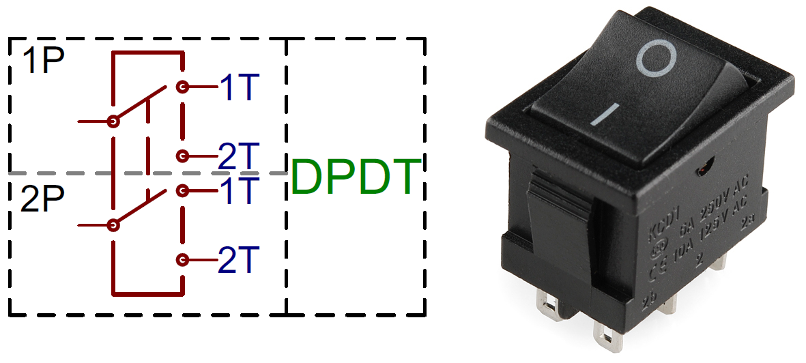
Figure 10. Switch Basics (from SparkFun)
The complexity of having two batteries is also charging the batteries. It would be much more convenient to charge just one battery, perhaps we could even set up a port to charge where removing the battery or moving cables around isn’t necessary. In addition, each battery and its usage is different so one may lose power before the other which means we would need two voltage and current regulators to keep track of the battery life of each. Typically the battery for the electronics would last longer as those components don’t drain as much power as the motors/propellers do. Yet, the benefits of using two batteries truly outweighs using just one. One battery would serve the purpose of powering the flight part of the quadcopter, for example the motors and perhaps even the flight controller, while the other battery takes care of the electronics, such as the printed circuit board, the camera, the sensors, and so on.

One of the major benefits is to reduce the noise and interference that such a high powered voltage and such high current draw from the motors could cause on the electronics. This could potentially have the electronics reboot and cause issues in the performance. Although a one cell battery should be sufficient for powering the electronics, a 2S LiPo makes it easier to connect to certain components such as the camera and the ATMega328 that require an input of 5V. A 2S LiPo pack provides 7.4V which through some circuit design we can bring down the voltage to 5V.

Now when it comes to selecting a switch there are thousands of options. For this project though it is important to keep in mind the size, weight and functionality constraints. It is important to select a switch that is easily accessible but not too accessible that it could bump into something during the flight and accidentally power off. In addition, the switch should have a reasonable size in comparison to the quadcopter. Also, should the switch be a standard one such as those that are pressed on one side or the other, should it be more of a knob you move up and down or should it be a single button switch. To begin, the switch that is more of a metal knob that you move up or down would be the last option since it usually extends out too much for a quadcopter this size. Then the next two options are a decision to make simply based on looks and preference. For this project I believe it would be preferable to use a button switch versus those that you flip to one side or the other. Mainly because it is flat so it doesn’t get in the way of anything else, it works based off of contact with a metal or not and usually they come with an LED which is always a good indicator of power on or off. Yet, when selecting one, looks aren’t everything. It is extremely important to select a quality switch capable of effectively powering on both power supplies without causing any issue where one doesn’t turn on or one burns out and situations of that nature.

When speaking about the power for the quadcopter it is also important to keep in mind the battery usage. It is recommended to not discharge the battery pack more than 80%. A battery voltage monitor is a good way to be notified of when the battery is running low. This monitor is connected to the balance plug of the LiPo battery. The way it works is that the moment any one cell of the pack drops below a set value, usually around 3.5V, a buzzer goes off in case the copter is in RC mode then you can know when to bring it back or if in autonomous mode, then the Robocopter is programmed to return to the original position. The downside to this is that voltage can easily fluctuate depending on changes in the load which could potentially set the buzzer off falsely. Yet, it is still a good estimate of the battery usage. Due to the downside described though it is recommended to also use a current sensor. This type of sensor measures and tracks the current consumption. Since the capacity of the battery is known in mAh and this is programmed along with a threshold to the sensor, then the quadcopter knows that once it falls below the threshold it must return. The suggested capacity usage is 80% of the capacity. So for example if you have a battery with a capacity of 4000mAh, the set limit would be when it reaches 800mAh left. After that point you could potentially be damaging the battery. The downside to this method alone is that the capacity or current draw resets anytime the power is disconnected and reconnected, so this would only work if the battery is fully charged. Otherwise the sensor would be reading it incorrectly. For this reason, it is recommended to use both sensors and collect data from both of them. With a set of conditions, the Robocopter can autonomously determine if it needs to land or not.

Yet in order to avoid using two separate sensors and having two communications a single power module will function as both. The purpose of a power module is to provide a stable power supply to the system and to monitor the battery’s voltage and current in order to send a signal when it is time to land the copter. Although a power module perhaps doesn’t make a noise, it won’t be necessary because it should autonomously return using the flight controller. In addition, those readings from the power module is best to display on the OSD or on-screen display that will also be showing the algorithms used for motion and tracking. To add just one more benefit, the Pixhawk Flight Controller selected for this project already comes with a compatible power module which would allow for the communication between the two to be superb.

One other consideration for the powering of the Robocopter we have discussed is the utilization of solar power. In theory, having a few small solar panels on the Robocopter providing passive power would be beneficial to the flight time of the Robocopter and eliminate the need for recharging. Unfortunately, we have found that there are limitations to solar technology that would make it less than ideal for us to implement. For one, solar panels of the strength needed to affect the flight time of the Robocopter can weigh several pounds - the weight alone would counteract the added power and likely not increase the flight time at all. Additionally, decent strength solar panels, 12V for example, can be quite sizeable in relation to the goal size of our Robocopter - some even being larger than a square foot. There would be no practical way for us to secure the solar panel on our Robocopter. Also, there is the issue of not known what the weather will be like on competition day. If it is cloudy or even rainy, any solar panels would be added weight with no benefit. Consequently, we will not be using solar charging on our Robocopter.

3.2.1.3 Quadcopter Kit Selection

In order to begin testing our parts in a timely manner, the process of selecting a practice quadcopter kit was necessary. Although it is known that the final quadcopter design will differ from the testing kit in terms of size, weight, material, motors and propellers used, and so on, it still gives a very good foundation for the parts already selected. The main parts that this kit would affect in comparison to the official design, is the battery, as we would need a battery that is adequate for the motors and ESC’s selected as well as minor changes in some of the coding where the information from the motors is needed for the motion of the Robocopter. After revising numerous options online, it came down to two very strong candidates. The first option is an LHI 220 Quadcopter Kit Full Carbon Frame Kit from Amazon. This kit contains 4 DX2205 2300KV Brushless Motors with the 5inch propellers, 4 Littlebee 20A Mini ESCs, an F3 Flight Controller Board Cleaflight 6DOF Standard, a 700TVL camera, a TS5828 FPV 5.8G 32CH and a frame. Although some of these parts we don’t need it is a good way to get a rough estimate about how much everything in total would weigh and also in case one of our parts doesn’t work we have a backup to continue testing other parts while we replace the one we truly want. The DX2205 2300KV Brushless Motors weigh 28g each and provide 660g of thrust each with a 3S LiPo battery. With an estimate that this entire kit weighs roughly 590g and if we add anything additional on our part then we can say that the in total the weight is around 600-620g. If we multiply this by 2, we obtain a weight of about 1240g which means we would need about 310g of thrust from each motor. Yet, since we know the copter will weigh more than this, since a rough estimate of our electronics is about 684g alone, then these motors give a good cushion to fall back on. In addition, the motors draw about 19.2A each maximum with a 3S LiPo battery. All this, for the price of $136.

The second option, a Hobbypower DIY F450 Quadcopter Kit, was also a good competitor. This kit includes the frame, an APM2.8 Flight Controller with the NEO-7M GPS, 4 920KV Brushless Motors with propellers and 4 Simonk 30A ESCs. These 920KV Brushless Motors weigh 55g each and provide about 860g of max thrust each. Although these motors are much more power and this kit brings everything we need there are a few reasons the first option was selected as the winner. The main reason is because although the motors provide more thrust, we truly don’t need that much and it is not worth risking the large increase in the weight of each motor which is almost about double the weight. In addition, the motors in the second option draw more current which could drain the battery faster or would require a more powerful but heavier battery. Lastly, the second kit doesn’t bring as many items as the first kit and costs more since it is priced at $139.40.

After selecting the quadcopter kit we will be using for testing purposes we had to select and appropriate battery as that is the one component it does not bring. Although for the final project it is possible that a larger battery is needed to achieve the desired flight time, for now we need a pack that will supply sufficient power to the components in order to test and achieve a certain flight time. Once for certain on the definite motors selected by the aerospace and mechanical team members, the battery will be adjusted for those particular motors and electronic speed controllers. For this kit, a Turnigy 3300mAh 3S 30C LiPo Battery Pack is chosen. This will supply around 99A of current and the motors need only about 80A, which would leave enough room for our electronic components at the moment as well. Once the switch is received and an appropriate battery for the electronics alone is selected, then it will all begin to come together, in a fashion more as the finished product.

Despite that we have selected a kit for testing purposes while the mechanical engineering and aerospace team members work on developing the best possible quadcopter frame and protective cage, the frame that will be used has already been selected. The final frame to be used is the Domybest HJ MWC X-Mode Alien Multicopter Quadcopter Frame Kit. This is an affordable frame that has the necessary dimensions in terms of the center space and the branches to fit the size of the electrical components. In addition it has a enough strength to support the entire weight of the Robocopter and it can handle up to 12 inch propellers. Although 12 inch may sound like a big number, in order to sustain and provide optimal performance most likely 12 inch propellers are necessary. The center lower plate can handle about 45 * 45mm flight control board or several boards of those dimensions stacked on top. The Pixhawk Mini flight controller has dimensions of 38x43x12mm and the GPS module included is of the dimensions 37x37x12mm. Which means that the centerpiece of the frame can firmly support these components. In addition it is long enough for the battery of 6.4 x 2.9 x 1.6 inches in dimensions. The frame also weighs roughly one pound and the estimated weight of the electronics is about 1.5 lbs which leaves the Robocopter at a total weight of 2.5 pounds without the protective cage. This is a powerful but lightweight design that is being implemented. When it comes to the protective cage it should not add too much weight as the material should be thin flexible and most materials that way should be a bit lighter. An option that has been discussed for the protective cage is to have a round or oval shape that in case the Robocopter were to drop to the floor or bump into an obstacle there could be some elasticity and buoyancy to help prevent a major shock to the copter causing parts to possibly shift around.

3.2.1.4 Flight Controllers

When selecting our flight controller, there were many parameters we wanted to examine in helping us choose the most efficient one for this design. Some of these parameters included power output, weight, size, and the cost. Also in determining our flight controller, one that is open source and allows us to add some peripherals, is best suited. The flight controller is almost like the brain of our quadcopter, it tells the electronic speed controllers how much rpm each motor should have in order to perform maneuvers, as well as stay stable hovering in place. In order for this to take place the flight controller usually comes equipped with accelerometers, gyrometers, magnetometers, and possibly an IMU of some sort. The accelerometer will measure the acceleration as well as some tilt of our copter. A gyroscope is a device that usually consists of a wheel or a disk that can spin rapidly about an axis that itself is free to alter in direction. This allows a measurement of tilt and direction to be taken which in our case can help stabilize the copter back to being horizontal. Not necessary, but useful is the IMU, which is made up of a combination of accelerometers, gyroscopes, magnetometers, and also has the capability of measuring the copters velocity, orientation, and the gravitational forces present.
Before deciding which flight controller to be chosen, a look at all the measurables and how their technology relates to this specific project.

Accelerometer - Like discussed before an accelerometer is a device that measures the changes in gravitational acceleration in whatever device it is installed in. These accelerometers can measure acceleration, tilt, and even vibration. The device at rest measures 1g which is the earth’s gravitational pull, 9.81 meters/second. There are two different types of measuring this change, one uses the piezoelectric effect which measures small voltage changes, the other measures the capacitance between two components. If sensing in multiple directions however, a multi-axis sensor must be designed within the accelerometer, or three linear accelerometers can give a good three dimension measurement. This technology is useful for a quadcopter project like this because an accelerometer can measure the orientation of the copter relative to the earth’s surface. By knowing the orientation of the copter, the flight controller will know when it needs to be stabilized and can send out signals to the ESC’s and motors.

Barometer - A barometer is a device that can measure atmospheric pressure. Usually a barometer is used in weather forecasting, but for this project is useful in our quadcopter stabilization. The barometer in this particular case will be used in the flight controller to measure the aircraft’s altitude. The good thing about the pressure sensors within the device are that they are very sensitive, therefore can read and detect change in the air pressure when our copter moves just a few inches.

Magnetometer - The most common definition of a magnetometer is that it is a tool or instrument that measures the magnetization of an element. It does this by looking at the Earth’s magnetic field and the local magnetic field and can determine the location of a magnetic force. The magnetometer is used in a drone because the accelerometer and gyroscope alone are not enough to know the direction the copter is facing. The accelerometer/gyroscope will give information and measurements based on the relative position to ground but the magnetometer will give us a location and direction relative to the world itself. This device also acts as a GPS kind of module.

Inertial Measurement Unit - Inertial measuring unit, also referred to as an IMU, is a measuring device comprised of all the previously discussed components and instruments. This device measures and reports the products force, angular rate, and also the magnetic field surrounding it. Likewise for this project, IMU’s are most commonly found in devices so that they can maneuver aircraft, UAV’s, satellites, etc. The inertial measurement unit most commonly contains one accelerometer, gyroscope, and magnetometer for each of the three vehicle axes, pitch, roll, and yaw. With these three measurements, the entirety of the aircraft’s position can be recorded. The use of IMU’s in unmanned aircraft’s like this one is almost essential for a stable and successful flight. In order to actually track the copter’s position the inertial measuring unit takes the measured data and uses a method known as dead reckoning. Dead reckoning is a process of calculating an element’s position by knowing the previous position as well as estimated speeds over an elapsed time.

In navigation purposes like the one the quadcopter will be using the inertial measurement unit will feed data into the processor which will then calculate altitude, velocity, position, etc. This calculation is done within the flight controller, and uses the information to make sure all systems and axes are stabilized during hovering and are adjusted when performing tasks. Likewise with any measuring devices, errors are bound to occur, especially when dealing with a flying object. In order to reduce these errors, multiple calibrations will need to be done with the flight controller and sensors to make sure they are both in sync.

Based on all these measurables, we narrowed it down to three possible flight controllers for autonomous flight. The 3DR Pixhawk autopilot has normal max power input of 4.8-5.4 V. The Pixhawk also is very small at about 1.7 x 0.5 x 1.5 inches and only weighing 5 ounces, making it very maintainable for our quadcopter to handle. This controller also comes equipped with many features including the multitude of sensors already equipped within it. A ST Micro L3GD20H 16 bit gyroscope, a ST Micro LSM303D 14 bit accelerometer/magnetometer, an Invensense MPU 6000 3-axis accelerometer/gyroscope, and a MEAS MS5611 barometer.

Another flight controller also researched was the APM 2.8 V2.8 ArduPilot UAV flight controller. The APM 2.8 is a complete open-source system that can be used to turn any aircraft into an autonomous vehicle. It differs from previous models of the APM, whereas there is no onboard compass. This is ideal for multicopters because in that case the compass should be placed as far as possible from the power and motor supply to avoid magnetic interference. This flight controller has some similar features as the Pixhawk, but also some deficiencies. With the ArduPilot the user can program GPS missions and waypoints before takeoff. As well as the Pixhawk, the ArduPilot has an accelerometer/gyro mpu-6000, as well as a barometric pressure sensor. However, the ArduPilot does not come equipped with the amount of reliable sensors compared to the Pixhawk autopilot, and of course the better the sensors the better the autonomous flight is. The flight controller also lacks the number of input/output pins and connections for this project where we will be connecting a printed circuit board and possible a raspberry pi for computative tasks. The ArduPilot also is a decent amount bigger being 2.78 x 1.77 x .53 inches big and weighing 31 grams.

The PIXFALCON is another flight controller more similar to the Pixhawk than ArduPilot, with compact size and features. The pixfalcon also comes equipped with multiple sensors, such as a ST Micro L3GD20H 16 bit gyroscope, a ST Micro LSM303D 14 bit accelerometer/magnetometer, an Invensense MPU 6000 3-axis accelerometer/gyroscope, and a MEAS MS5611 barometer. These are the same sensors as the Pixhawk, however the dimensions on the pixfalcon are 1.5 x 1.7 x .47 inches and weighing .56 ounces. Table 2 outlines these comparisons.

Feature | PIXHAWK Mini | PIXFALCON | APM 2.8 ArduPilot
Operating Voltage | 4.1-5.5 V | 4.1-5.5 V | 4.5-5.5 V
Max Input Voltage | 45V (10S LiPo) | 45V (10S LiPo) | N/A
Max Current | 90A | 90A | N/A
Sensors | Accel/Gyro/Mag, Accel/Gyro,Barometer, GPS | Gyro, Accel/Mag, Accel/Gyro, Barometer | 3-axis Gyro, 3-axis Accel, Altimeter, GPS
Open-Source | Yes | Yes | Yes
Weight | 15.8g | 15.8g | 31g
Dimensions | 1.50 x 1.69 x .49 in | 1.50 x 1.70 x .50 in | 2.78 x 1.77 x .53 in
Price | $139 |  | $70
Table 2. Flight Controller Comparisons

By examining all the measurables discussed above, the PIXHAWK Mini meets all the requirements needed to build a successful autonomous quadcopter. The Pixhawk mini runs on a 32-bit ARM Cortex M4 Processor which is powerful enough to compute any tracking algorithms needed. Three highly reliable sensors (Gyro/Accel/Mag) also come installed on the Pixhawk which will give us stable flight, easy maneuverability, and good recordings of our copters tilt, speed, etc. This flight controller also comes equipped with an abundant amount of connectivity options for peripherals such as UART, I2C, and CAN. This will be needed when connecting other components, microcontrollers, sensors, etc. Moreover, the Pixhawk includes a GPS module that will allow us to track the position of our quadcopter at all times. The size and weight of this flight controller (1.5x1.7x.5 in, 15.8g) are also sufficient enough to fit nicely on a drone that meets the requirement size of being less than 4x4x4 feet.

3.2.1.4.1 Autopilot Flight Stacks

Apart from the flight controller itself, another important consideration to be made is which autopilot software to use on the flight controller. The two prominent autopilot flight control stacks used for drone projects today are APM, or ArduPilot, and PX4. In general, Pixhawk flight controllers are able to utilize either firmware; however, the Pixhawk mini is optimized for PX4 [102]. Before settling on staying with PX4, a closer look will be taken into both autopilots to determine if that is a strong choice to make.

APM’s development began over a decade ago, and was originally intended to be highly compatible with Arduino boards, hence the name ArduPilot. Since then, it has been adopted for a wide variety of hardware setups. It has a large community of people that have used it in projects, and thus a large support base online. Due to its older nature, the further development of ArduPilot has slowed over time and is overall most well suited for simpler, older hardware.

PX4, on the other hand, is more modern and has more advanced capabilities. Its support of various peripherals and sensors is more extensive than APM’s, which would allow more freedom in choosing the sensors to be used by the Robocopter. PX4 also has a more developed functionality base, allowing for more advanced flight calculations and control, such as terrain estimation.

The gap in advanced feature capability between APM and PX4 may be vital to the Robocopter’s performance in the competition. PX4 would allow for more flight control and maneuverability, and also has greater support for modern hardware. It also has strong support for MAVlink, which is a message protocol that would allow for easier communication between the ATmega328 on the Robocoptor’s PCB and the Pixhawk mini itself. Such advantages may lead to greater performance by the Robocopter in the Lockheed Martin competition, and allow it to more efficiently maneuver to track and intercept prey drones. These considerations, along with the fact that the Pixhawk mini is built around PX4 hardware technology and thus optimized for PX4 software, make it clear that PX4 will be the more appropriate autopilot software to utilize on the Robocopter.

3.2.1.5 Cameras

The great aspect about this particular project is that it is very broad and allows for a very dynamic and creative project. For this project we have to big options when it comes to selecting how we will implement a camera. The first option is to use just one camera and implement image tracking using particular programming libraries and algorithms to detect the drone. Then, using for example a usb output, we can transmit the video using a wifi module that will be used to provide the first person view live stream to our ground station. The second option is to have two separate cameras. One camera will be used for image sensing and tracking while the other would particularly be for providing the first person view video. Both options are extremely good options and both have their pros and cons, which we will discuss further in detail below.

When considering the first option, we took into account the pros first. One of the benefits of using just one camera is that we will reduce the weight of the copter. One of the biggest factors in an aerial vehicle is weight as gravity is a huge enemy that it must fight against at all times. Even if it’s just a few grams of weight that we are saving, in the long run this could go a long way. If we have less weight and a powerful battery pack we could potentially extend the battery life of the Robocopter. Considering that a 10min runtime is a requirement for this project as the competition will be ten minutes long and we would not like to interrupt the session to have to replace a battery. Plus if we have to replace a battery, this means that we would also have to purchase another battery which little by little we could easily eat up our budget. As we mention budget, purchasing just one camera could, if we select correctly, help us save some funds and make sure we don’t run out. In regards to the battery life, since we need at least 10 minutes of runtime, we should plan for our battery to last anywhere from 15 to 20 minutes.

The second advantage is that we also save up space on our frame. If we have to cameras, we need to have a spot for both of the to fit in the front of the Robocopter. Although the cameras are fairly small, it would still be more components we need to add to hook the cameras on that would in the end also add more weight to the Robocopter. We are aiming to have the drone frame a size of 2’ x 2’ feet. Even though our limit is 4’ x 4’ x 4’, we truly don’t need that much space. We have taken a look at potential prey drones provided by our sponsor and they are very small, which means that we won’t be in a need of a huge Robocopter. In any case it would actually be favorable to have a smaller drone in order to be able move around and weave through obstacles much better. In addition, if we make the frame larger than 2’ x 2’, we risk having the protective cage that is required, be much larger than the limits. will be introducing two different types of camera. Lastly, the last pro, to utilizing just one camera is that it makes projecting the algorithms used on the first person view video projected at the ground station just slightly easier. If you have just one incoming video stream and you are already working with that image, than you can simply overlap an image with the corresponding analysis of the image.

Yet, the second alternative is also a great solution to meet all the necessary requirements. The second option is to have two cameras that in the end work together but each has its own function. One of the main advantages is that we can use a particular camera called the Pixy CMUcam5. This camera is a smart image sensor camera that you can easily train to search for a particular type of object. There is more information regarding this camera below. The great aspect about this, is that it makes the programming required just slightly more friendly. In addition, the way this works as a sensor is with this following analogy. Say for example you were blind, although humans have other senses such as hearing, touch, smell, and so on, would it ever be the same as if you could actually see what is in front of you? It wouldn’t be the same as seeing because otherwise your other senses leave a lot of room for error when describing how the object looks. In this case, it is in a way the same thing. Although we will have other sensors such as the infrared, the ultrasonic sensor, among others, it would be much more complex to identify the exact prey we are looking for. Despite that we could use the libraries and algorithms mentioned earlier to adapt a standard camera to do these types of tracking functions, the Pixy CMUcam5 facilitates the coding, as it is particularly designed to track. This could also make the detection a bit quicker than using a standard camera. Now when it comes to displaying the algorithms on top of the first person view video, we can program the two cameras to have compatible displays, so that they line up. Now, since the Pixy CMUcam5 does not have the capability of video out to where we could use wifi for FPV, then we would implement a second camera. The second camera we would choose for the first person view is designed and specific for first person view. Thus the latency with this camera when projecting the FPV is minimal, perhaps 24.6ms on average which is almost as saying that there is no delay. Then, we could simply connect this camera to the raspberry pi that would already be wifi enabled.

The first camera is the board camera Pixy CMUCam5 with smart vision sensor compatible with both Arduino and Raspberry Pi. The most interesting technology of this camera that convinced us that this is the camera we need, is that you can “teach” the camera which object(s) to look for. The camera does use 7 color detection in order to better detect the object but it can also look for similar shape, characteristics, etc. Although there are a number of sensors that will assist in avoiding obstacles, helping with the maneuver of the Robocopter, the best way to detect the predator drone will be through actually seeing it through the camera. Once the camera detects that this is what we are looking for, the software will instruct for the movement of the Robocopter towards the prey. In addition the Pixy CMUcam5 is lightweight with just 27g and is board embedded which facilitate its set up. There are a few downsides to it though, that thus, led us to add a secondary camera. Part of the requirements of this project is to provide a real time first person view video feed to a ground station through wifi. Yet, the Pixy CMUcam5 lacks the ability to transmit video out. In addition, the quality of the video is not the best for a larger projection such as on a monitor. For these unfortunate reasons we chose to look into a camera dedicated to providing FPV.

Originally for the second camera we were going to use the Runcam Eagle 2, a small 28mm x 26mm x 28mm, 18g FPV camera. Runcam is one of the top brands and one of the most commonly use in quads to provide first person view. For example with this particular camera it uses CMOS (complementary metal oxide semiconductor) image sensor technology to provide a much higher quality image than other FPV cameras. Although it is more common to use CCD (charge coupled device) technology, CMOS has it’s advantages when particularly using it for image capture in drones. Despite that both have a mechanism to capture light and convert that into electric charge that in the end will produce an electronic signal, they have some differences to make this happen. The biggest difference between both of them is that in a CCD sensor you usually have just one output spot that will allow for a the voltage conversion and thus produce an analog signal. As technology develops we have slowly moved to digital transmission of signals in order to reduce noise, allow computers to understand the information and also to improve the quality of the output. An example of this is radio stations. An analog radio broadcast such as AM (amplitude modulation) and FM (frequency modulation) is one produced using analog signals and there is often much interference in the sound. Yet if we listen to a digital radio broadcast such as Sirius XM (satellite radio) then we have a better quality of sound with very reduced noise. In the same way, the CMOS sensor tends to produce a faster and better quality image due to the digitization embedded in the conversion process. This occurs at each individual pixel, where the light is converted to charge then to voltage, next to what our group calls the “polishing stage” where amplification, noise reduction and electronic output signal occurs. With this, we produce an image much faster and with sharper image despite the lower uniformity compared to the CCD and thus reduce latency. For this reason this type of imagery has also been implemented in our smartphones today, as CMOS also allows for cameras embedded in chips and requiring less power. All of those factors play in, to provide a camera that ultimately will provide a quality real-time image to our FPV ground station. This camera provides an image resolution of 800TVL which is almost equivalent to 720p. This is not the best resolution as is say for example 1080p or 4K, but it is still a really good image that is more than enough for this project and at a more reasonable price. The main difference between those resolutions is when you zoom in the image. The lower the resolution the more pixelated it will look when zoomed but since we will not be zooming in, 800TVL will provide a sharp, clear image and the latency when transmitting to real-time FPV will be much less. In addition this camera has a wide range for input voltage beginning at 5V which allows us to stick with the original 11.1V battery selected earlier in the process.

Despite the large number of benefits of the Eagle 2 camera, the RunCam Split 2 has a lot more benefits. The RunCam Split 2 has the benefit that it has a chip that allows the camera to stream a first person view and also record HD video and store it in a micro SD card. The attached circuit board has an integrated secured SD card slot and it also comes with a removable wifi chip, which is convenient since we need to stream the FPV using wifi. The RunCam Split 2 weighs just 23g including the wifi module with a PCB of dimensions 35mmx35mm. This camera has a field of view (FOV) of 130° which provides almost 180°. In addition, if we need to go back to look at the video, we can have a 1080P resolution video. We can set the FPV to fit 16:9 screens automatically versus the 4:3 standard. The advantage of this is that the HD recording is set at a ratio of 16:9 and this way you have an actual view of what is being recorded. The main difference between the quality of standard definition such as TVL, what the FPV provides is that it has much less pixels than a high definition image. The reason standard videos are displayed at a smaller aspect ratio (4:3) is well one because there are a lot less pixels and if the image is zoomed in there would be a lot of pixelation. In you display an image with a lot more pixels, the image flows better, it looks more put together and you can have a clearer large image. Take for example a puzzle. If you have a puzzle with less pieces and you separate these pieces there would be a lot more space between each important section of the picture. But if you take a puzzle with four or five times the number of pieces for the same image and you give the same amount of space as the other one between each piece you will be able to see for one a large image and you won’t miss much of the picture in those cracks. In a similar way high definition better completes a picture and thus the display looks much improved. This particular has actually even been compared to the GoPro, which is one of the most popular and most used camera in drones. Despite its popularity and amazing video quality, HD cameras are not typically used to provide a first person view video in real time. The image quality is very good, but it is also a larger and heavier signal, which would create a bigger lag in the display. Even though this isn’t a GoPro camera, we still have the same lense that the GoPro uses, the RC25G. The RunCam Split 2 allows us to store up to 64GB of video with a 1080P resolution but we will actually use a standard FPV quality video which will still look sharp and gives a low latency. Since we must correlate with each discipline, if at a certain point we must compromise something and we have to give up a camera, the RunCam Split 2 is the ideal camera for our drone. Below we can see all of the components it is made up of. Figure 11 and Figure 12 are pictures of both cameras.

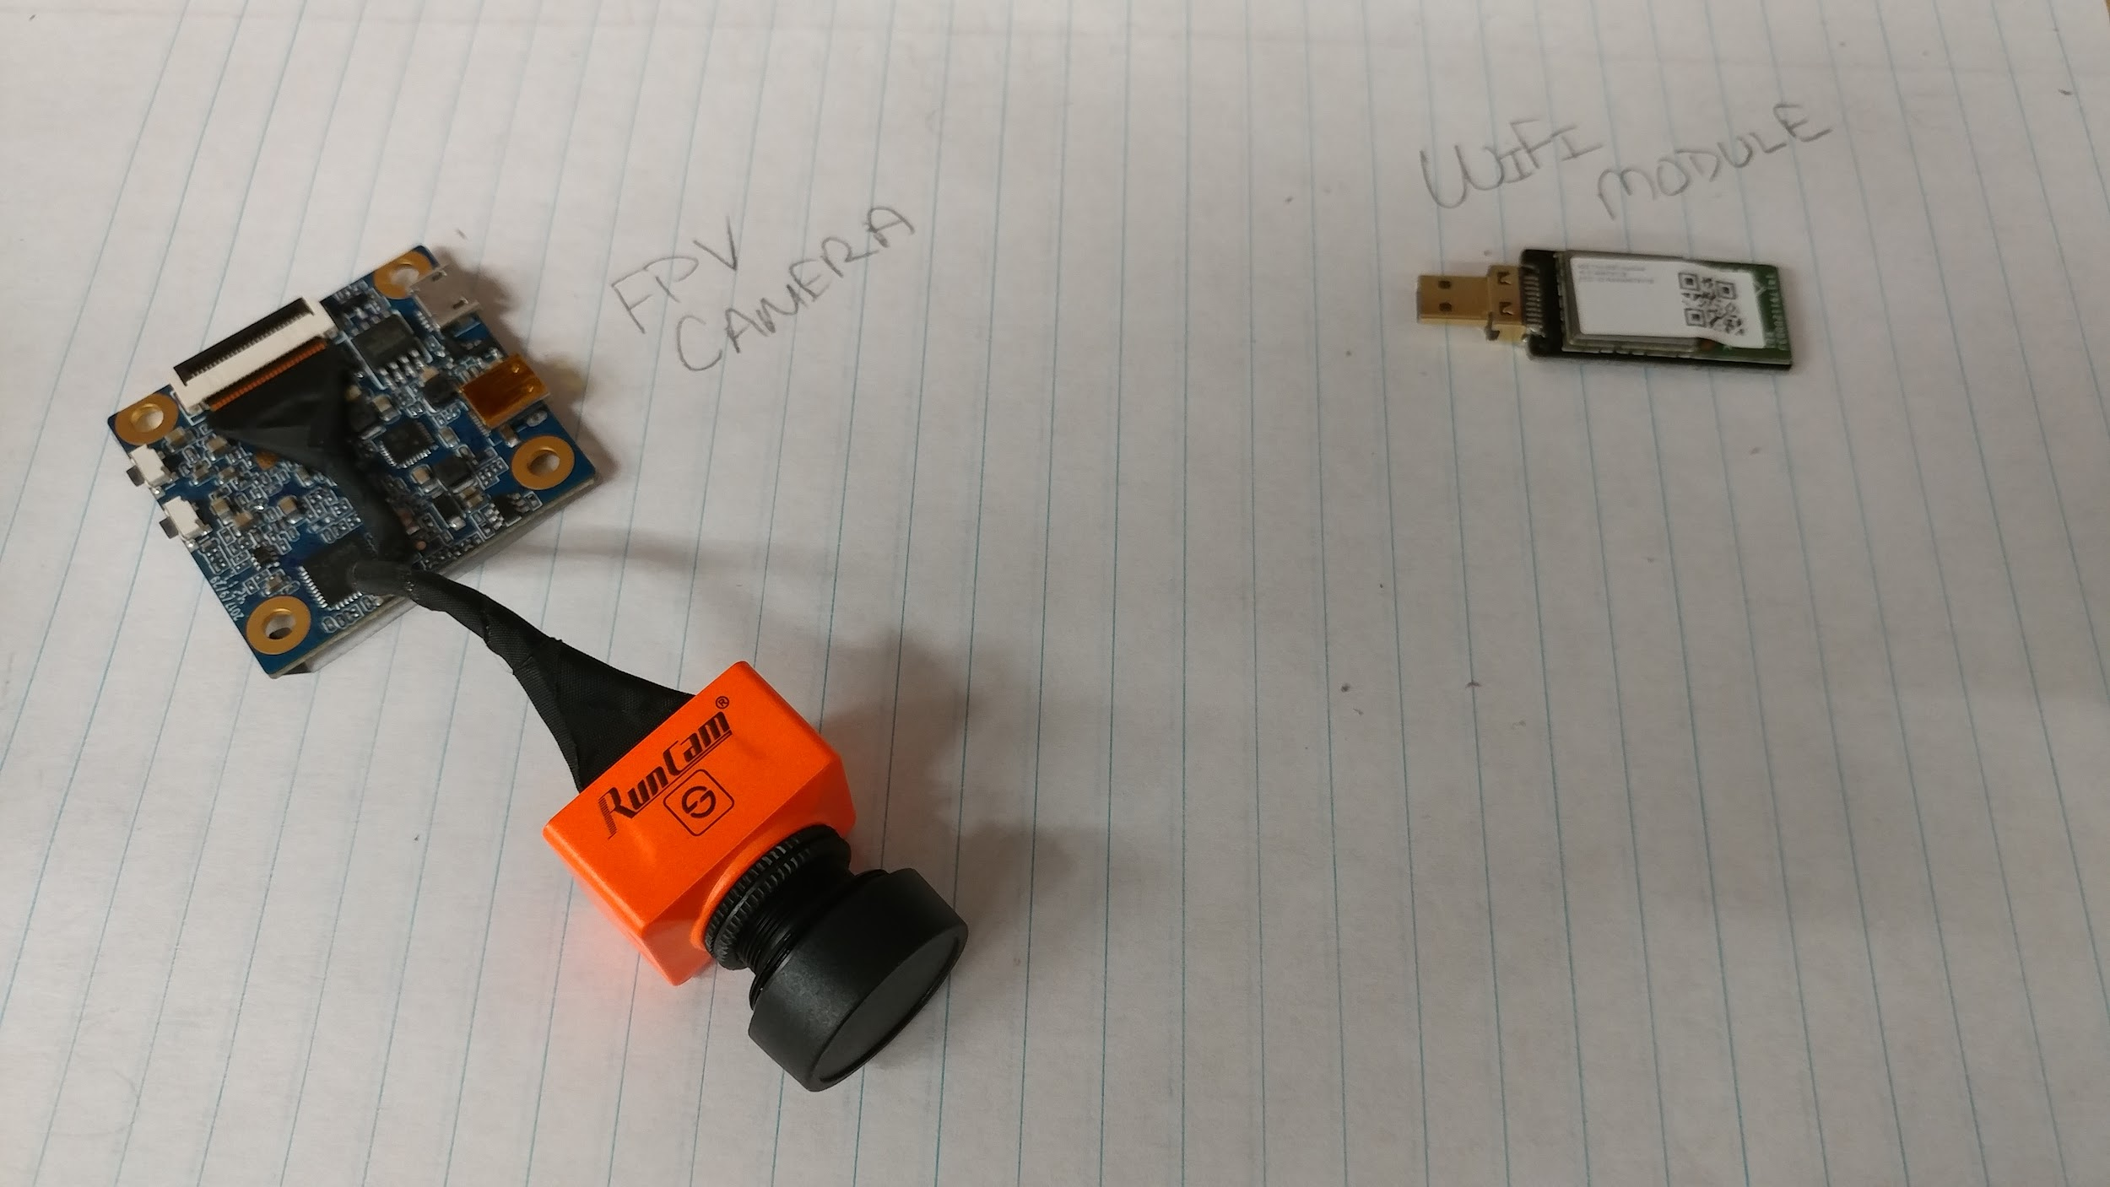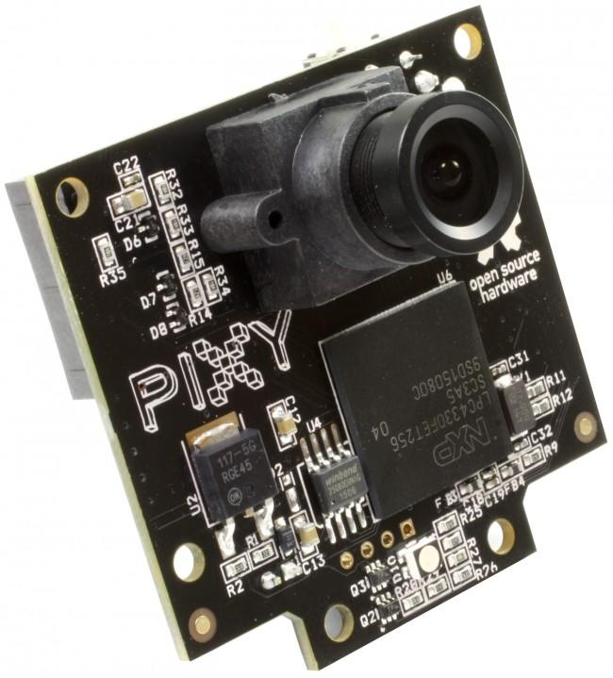
Figure 11. RunCam Split 2 Figure 12. Robot-Electronics: “CMUcam5 Pixy”

After careful consideration and discussions over the benefits of either decision, and as we spoke with our sponsor, it was decided to go with just one camera. The benefits of one camera as mentioned previously truly outweighed using two. The only thing drawing us to using two cameras was the benefits of the Pixy CMUcam5, yet it was considered by our counselors to not fit the purpose and needs of this project. The goal is for us to be able to achieve what the Pixy camera can do with our own technology, algorithms, thought process and and techniques. For this reason we did not wish to violate any rules that could put into question our credibility and our engineering abilities. Even though we won’t be using the Pixy CMUcam, we will be adapting the RunCam Split 2 to perform equally as well. The RunCam Split 2 is an awesome camera specifically made for FPV and it is rated one of the best. Its dual features truly draws our attention and makes it the ideal camera for the job. Its small size but powerful capabilities suits the drone well, almost as if it were made specifically for this project.

One of the best features of the RunCam Split 2 is that it has its own PCB that it is attached to. This is great because it has the necessary ports and keeps the camera small and lightweight. It also makes it more compact as we can easily stack the camera’s PCB on top of the quadcopters PCB. One of the ports that the camera has is a micro usb port, typically used to connect to a computer. Since we will be using an intel stick which will be doing all or most of the image sensing, it would act in some way as a computer just as a Raspberry Pi would. The Intel stick we will be using contains usb ports that you can connect certain devices to it just as you would connect a camera or flash drive to the usb port on your computer. This stick will be programmed to connect with the camera and detect the prey visually. Thus the intel stick would then be connected to the printed circuit board. This Intel Stick would then be in charge of communicating with the PCB and the built in ATMega328 that the code flashed onto the PCB will interpret and act on. The PCB is mainly in charge of the actual motion of the Robocopter and also of the obstacle avoidance. Another alternative, was to connect the camera and the intel stick to the PCB and have a trace that transmitted the signals and data between the two devices. Yet the image processing would be delayed slightly since the camera would send data to the PCB then the PCB would send this data to the Intel Stick for it to process and analyze and then send back the result or commands to the PCB. All the traveling of data is unnecessary and could cause delays that could potentially make a huge difference as to how soon we can reach the prey. It is important to always keep in mind that the competition is point based and the idea is to be able to avoid obstacles presented in the path as you make your way to attack the prey and actually be able to cause a collision. For this reason time is crucial in terms of the competition outcome. Below is an image of how these three components would be connected. Keep in mind that the Arduino Uno board displayed in the picture is only to give a visual representation of the connections but that board is actually to represent the unique PCB designed for this project.

Figure 13. Camera Connection

3.2.1.6 Sensors

Besides the sensors included on the flight controller, individual sensors will also be needed to help with obstacle avoidance. While the flight controller sensors are mainly for keeping the copter level and stable at all times the other needed sensors will need to detect when an obstacle is near and then send a signal to our microcontroller. The microcontroller will process this info and send signals to the flight controller letting it know how to maneuver to avoid the detected obstacles. The way this is done is by taking the analog signals for voltage and turning that into a digital output signal. Some possible sensors are lidar, ultrasonic, and infrared. These comparisons can be seen in Table 3.

Feature | SRF02/SRF05 | XL-MaxSonar | Sharp GP2Y0A02YK0F | Sharp GP2Y0A21YK0F
Sensor Type | Ultrasonic | Ultrasonic | Infrared | Infrared
Detection Distance | 0-14.76 ft | 20-25.1 ft | 7.87-59.06 in | 3.94-31.50 in
Response Time | N/A | 10 Hz reading rate | 38 ms | 39 ms
Operating Voltage | 0-5 V | 3.3-5.5 V | 4.5-5.5 V | 4.5-5.5V
Current Consumption | 4mA | 3.4mA | 33mA | 40mA
Weight | .32 oz | .32 oz | .17 oz
Dimensions | 1.81 x 1.1 x .75 in |  | 1.16 x 0.5 x .85 in | 1.16 x .52 x .53 in
Price | $7 | $40 | $9
Table 3. Sensors Comparison

Ultrasonic sensors are able to detect an obstacle by sending out sound waves then sensing when the sound waves bounce back to the sensor. The sound wave is sent out a certain frequency so that way it does not detect an unknown frequency bouncing back. By recording the time lapse from sound wave sent and received the calculation of the distance of the object is simple. Distance then equals the speed of sound times the time taken all divided by 2. Ultrasonic sensors can be very reliable if they are equipped with a way to reduce possible noise around the sensor. Since sound waves are being detected, if vibration or noise occurs around the sensor these waves can become distorted and possibly lost in air. Moreover, the shape of the obstacle being detected/targeted can also affect whether or not it is detected or not. For instance the shape of an obstacle can cause the sound waves to bounce away from the sensor instead of back to it, this is why multiple sensors may be needed. Also if the object is too small, not enough of the sound wave may be reflected back.

Like the ultrasonic sensors, the infrared sensors also are able to detect an obstacle by sending out a signal and recording the bounce back. For an infrared sensor, a select wavelength light is sent out and the intensity of the received light tells us how far the obstacle is from the sensor. For instance, the brighter, more intense light received back means the obstacle is closer. IR sensors can also detect thermal radiation changes, since most objects emit some form of thermal radiation, these sensors then can detect when an obstacle is present. However, one disadvantage of an IR sensor is that since it detects the variant temperature between objects, if the objects have a similar temperature range there could be inaccuracies.

The Ultrasonic SRF02 sensor listed above in the table is actually an ultrasonic sensor built onto a small footprint printed circuit board. It features both I2C and Serial interface, but for this design the I2C interface will most likely be used. One good feature is that the SRF02 can have 16 of them connected onto one single I2C bus, which in this particular case when 4-8 sensors are needed it is ideal. The SRF02 uses a single transducer for both transmission and reception which makes the minimum range higher than dual transducer sensors. The minimum range is about 17-18cm (7 inches). The SRF02 operates on +5 Vcc for I2C mode, which works with our design as well. The sensor allows a beam detection of up to 60 degrees for good detection. Any wider than -30 to 30 degrees the measured beam is very light if anything. The beam pattern can be seen below in Figure 13.

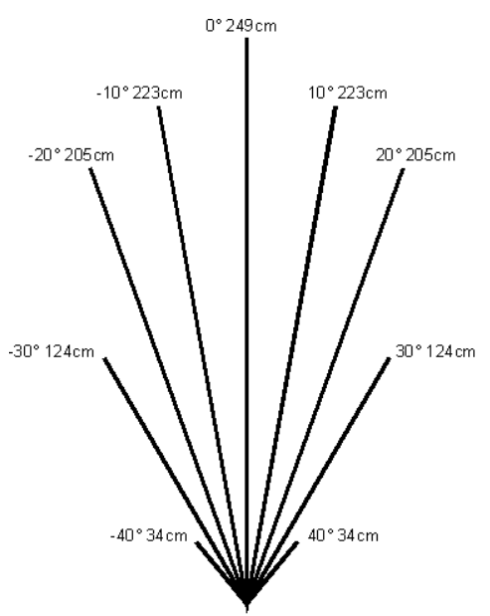
Figure 14. Beam Pattern for SRF02 Ultrasonic Sensor

The Sharp GP2Y0A02YK0F Infrared Distance Sensor listed in the table above measures distances 7.9-59.0 inches. The sensor is able to do this by using a reflected beam of infrared light. Using triangulation, the sensor can calculate the distance measured with little to no influence from operating time or environmental temperature. The device is analog so it outputs the voltage corresponding to the detected distance, thus being a proximity sensor. Some notes on this sensor and likewise infrared sensors, for one, the lens must be kept clean. Also it is recommended that a by-pass capacitor be placed between Vcc and GND. Moreover, the overall specs of the Sharp IR sensor fit right in with the rest of the quadcopter and PCB design. The operating voltage is 4.5-5.5 volts with other characteristics seen below in Table 4.

Parameter | Symbol | Min. | Typ. | Max. | Unit
Average Supply Current | Icc | ~ | 33 | 50 | mA
Measuring Distance Range | L | 20 | ~ | 150 | cm
Output Voltage | Vo | 0.25 | 0.4 | .55 | V
Output Voltage Differential | Change in Vo | 1.8 | 2.05 | 2.3 | V
Table 4. Characteristics of the Sharp GP2Y0A02YK0F IR Sensor

Furthermore, the Ultrasonic SRF02 sensor and Sharp IR sensor have their advantages and disadvantages. Moving forward, one of each sensor will be acquired and ran breadboard test on. These breadboard test will be to see if the sensor is accurate enough for detecting up to certain distances, as well as if the noise generated by the quadcopter effects the sensor significantly or not. From research done both sensors should be able to handle the noise and vibration so if the test come out good, most likely four of each sensor or some combination of the sensors will be used to help our copter avoid obstacles.

3.2.1.7 Wireless Transmission

Before we go into how we will use and implement wifi in our project, we must understand what wifi is and how it works. Wifi stands for Wireless Fidelity and it just another form of transferring information from one place to another. Yet, what makes it so unique is the speed at which this happens. The question arises when you know that wifi also uses radio frequencies to send signals from one point to another and wonder what makes it different then. Well the major difference is the frequency at which the signals are sent. Typically radio signals sent through antennas for things such as FM and AM radio or for speaking over the phone, are sent at a much slower rate, at around kilohertz or megahertz. When you tune your radio to say 100.3 radio station, you are actually tuning into frequency 100.3kHz station. Wifi on the other hand has a frequency in the gigahertz range, typically 2.4GHz to be exact although it could range from 2.4GHz to 5GHz. Now to better understand this number difference between these we’ll go over what these acronyms mean. Kilo is 10^3, Mega is 10^5 , and Giga is 10^9. So, if wifi sends signals containing information at a frequency of 2.4GHz, this means that it is sending 2.4x10^9 radio waves per second. Hertz is simply 1/seconds. There are a few specific 802.11 network models provided by IEEE for which wifi abides and the user can select from them, depending on the purpose and needs for it. For example if you have network 802.11a uses a frequency of 5GHz and the Orthogonal Frequency-Division Multiplexing (OFDM). The OFDM is a form of modulation with multicarriers. The way it works is that it divides the radio signals into smaller ones, more narrow band channels that thus allow for more data transfer and perhaps at a faster rate, while avoiding interference between signals. This is done by having a signal consist of a number of very close and evenly spaced modulated carriers. Even though the bottom of the sides of the carriers overlap, there is still no interference of the signal if the space between the top edge is the reciprocal of the period. With this type of network, it is possible to transmit up to 54MBits of data per second. The second type of network model is the 802.11b which has a frequency of 2.4GHz and only allows for data transmission of up to 11Mbits per second. This is a relatively low speed and low data transmission rate, for which reason it is not as popular. The third network rate is the 802.11g, that although it has a lower frequency, 2.4GHz, it implements the Orthogonal Frequency-Division Multiplexing layout and can thus still transmit up to 54Mbits of data per second. Lastly, the more power type of network is the 802.11n which can transmit up to 140Mbits of data per second using a frequency of 5GHz. Although we won’t need such powerful wireless transmission, we will be using router or modem to transmit. In order to accomplish this we must know how to set it up. In order to establish a wifi connection using a router, we must connect the router to the internet connection which is usually laid out as part of the building when it is constructed using an ethernet cable . Once this is set up we are able begin adding wifi devices to the wifi network provided by the router.

The ground station for this project will be provided to us, but we must provide a router for which the ground station and the Robocopter or the camera on the Robocopter can connect to. Typically wifi is the most common form of transmitting data and information today, but when it comes to providing a real-time first person view, using wifi will create a lag. With recent improved technology, the lag is not as noticeable but it still is present. In addition wifi tends to be very sensitive with the signal. If the signal is unable to transfer clearly then the connection simply drops. This could affect the presentation if there is any type of failure with the connection from both sides, the ground station and the drone. For this reason, typically in drones, we use analog broadcasting through a certain frequency. The downside to this method is that primarily you must purchase additional hardware and equipment such as a transmitter and a receiver in order to achieve this. With wifi, you could simply use any wifi enabled device such as cellphones, tablets, among others. Yet, for this project we are required to use wifi as our means of providing a first person view to the ground station and so we will focus on all the positive features of wifi that outweigh those relatively small downsides.

When selecting a wifi module it is important to keep in mind several factors that could hinder the signal such as obstacles, for example a wall, trees and so on, humidity, metal objects that could reflect the signal, among other factors. In addition it is important to keep in mind the distance between the Robocopter where the chip will be at and the router at the ground station. To begin, this project will take place outdoors on a square shaped 40ft x 40ft field. That means that the router would actually be a bit farther out than 40ft. This we need to select a wifi chip that can provide this type of range. In addition the competition will consist of other quadcopters and also obstacles that could contribute to a disturbance in the signal. There will be a total of about 8 obstacles spread out evenly in a diamond shaped layout. The note in our favor is that the Robocopter would be able to fly over the obstacles and possibly avoid any interruptions in the wifi signal. If unsure of the accuracy in the range stated by the maker there is an equation to double check the distance.
The equation is as follows,

(2) Distance (km) = 10(maximum path loss – 32.44 – 20log(f))/20

where the, maximum path loss = transmit power – receiver sensitivity + gains – losses – fade margin. Yet, considering that this arena is outdoors and the obstacles are not really buildings or trees or anything of that nature then the module we have selected, discussed below should do an excellent job.

Despite that the intel stick that we will be utilizing for this project, dedicated mainly to image processing, tracking and analysis, it was considered implementing a wifi to our PCB in order to have a backup in case one fails. Although it is decided not to have a separate wifi module since the Runcam Split already also brings a wifi module the Wifi-ESP8266 Module would have been a good alternative to provide wireless transmission of the first person view video at 2.4GHz. In particular the Esp8266 Esp-07 Module. The wifi chip is just at about 8.5g in weight and the dimensions are 16mm x 21.2mm x 3mm. Although if used on a breadboard, you would need a development board, it is one of the simpler wifi modules to implement in a PCB. Another benefit of this particular module is that it has much more GPIO pins in comparison to the Esp-01 module and is beneficial to connect multiple components to it if needed. The Esp-07 module has a n integrated low-power 32-bit MCU. Once on the printed circuit board, the wifi module runs on 3.3V of power. Since the power supply is of 11.1V, and the ATMega328 Chip is powered by 5V, then we will implement a voltage divider on the board using resistors. In order to obtain the 3.3V we are looking for. Using the equation, we can arbitrarily pick two resistor values where the voltage across R₂ is the voltage we are looking for as we would connect the wifi module’s input voltage pin, in parallel with this resistor. This would be implemented in the PCB design. On the contrary, the RunCam Split 2 camera can be powered by anywhere from 5V to 17V instead of 3.3V. For this case, it would connect the camera to the PCB at a pin where it also connects with the wifi module. We will see more of how everything will connect with the schematic of the printed circuit board.

One of the requirements for the video transmission is that we must use a router to where the computer can connect to. First we must know what a router is and its purpose. A router is what Linksys would call a “gatekeeper” to wireless connection. It transforms the internet connection transmitted through a wire and provide wireless internet. In order to provide live first person view wirelessly through a router it is important to setup a private network connection. To do so first connect the router to the internet provider using typically an ethernet cable. Next, using a web interface the default settings can be changed. At this step, a name is given to the new network that will be assigned to a channel. Considering that most people are setup on channel 6, it is recommended to use a different channel to avoid interference in the signal. After, a username and a password is also assigned to protect the connection making it a WPA or Wifi Protected Access.

Remote Control Transmitters & Receivers - Even though the quadcopter will mostly be in autonomous mode, there will be some instances when the drone must be controlled manually. A couple examples are when there is damage to the copter and it must be brought back for repairs. First, lets look at how a radio system works that way the right system can be chosen for this particular use. An RC radio system is made up of a transmitter and receiver that are connected together through a communication link only between the two of them. The transmitter is typically located on the device controlled by the vehicle operator while the receiver is mounted on the vehicle. By connecting the receiver to the flight controller, it is in turn connected to the electronic speed controllers and therefore motors. The way of communication between the transmitter and receiver is done through radio frequencies. The transmitter will encode a number of discrete channels within the frequency, so that each one can be used to send a value, such as a switch, control stick position, etc. The number of channels needed depends on the vehicle type. For a ground vehicle, only two channels are needed for movement, steering and throttle. For a aircraft like the quadcopter, at least four channels are needed for flight, roll, pitch, yaw, and thrust. However, some transmitters can provide up to 8 or 16 channels so other mechanisms can be controlled or different flight modes can be activated.

When selecting an RC system, the transmitter and receiver must be compatible with each other as well as compatible with the PX4 software and the flight controller hardware. The next thing to examine is the different receiver protocols, how they function, and can affect the flight of an aircraft. The most common radio control is PWM, pulse width modulation. The PWM is an analog signal where the length of the outputting pulse specifies the servo motor output or the throttle position. The PWM receiver can be messy though due to wiring so more and more drone users are using PPM or SBUS. PPM, pulse position modulation, is the next common radio control mode. PPM uses one wire where a series of PWM signals are sent one after another instead of on multiple wires but sent at the same time. This is an advantage for wiring purposes as only one signal wire is needed, however the disadvantage is the channel may have more and more noise. The next kind of radio control protocols discussed are serial protocols. The most common serial protocol is the S.BUS. The S.BUS is an inverted UART signal, which can support up to 18 channels using one signal cable. This can be useful if dealing with a vehicle with multiple modes or mechanisms.Another serial protocol is the Graupner HoTT SUMD, which is very similar to the S.BUS protocol. The advantages however are compared to the S.BUS, no signal inverter is needed for the UART signal, and compared to the PPM, the Graupner SUMD has better resolution and very little to no jitter/noise.

Before looking at which transmitters and receivers are compatible with all the components, let’s look at how the receiver will be connected to the flight controller. Depending on the type of receiver chosen will determine this. The PPM and S.BUS receivers must connect to the RC ground, power, and signal pins of the controller. The PWM receivers connect to the RCIN channel by a PPM encoder, meaning more components. Lastly the Spektrum and DSM receivers must connect to the SPKT/DSM input on the flight controller.

Some compatible receivers with PX4 and Pixhawk are:

- All Spektrum DSM RC receivers
- All Futaba S.BUS and S.BUS2 RC receivers
- All FrSky PPM and S.bus models
- Graupner HoTT
- All PPM models

Some compatible and popular transmitters are:

- FrSky Taranis PPM-Sum Compatible Transmitter
- Turnigy transmitters
- Futaba transmitters

Now to go into some detail on three to four specific transmitter/receiver combinations that could possibly be used for this quadcopter. The first one to be examined is the FrSky Taranis X9D Plus and Taranis QX7 RC transmitters, which are compatible with a variety of FrSky PPM-Sum and S.BUS receivers. The first thing that is noticed is that both transmitters are OpenTX, meaning open source firmware, which looks enticing for an autonomous project like this. One key advantage of the Taranis is that it can receive and display telemetry data directly from the flight controller and on-board sensors. Flight mode, GPS, current drawn, cell voltages, all can be displayed on this particular transmitter. Some extra features that are nice are the 2.4GHz frequency, audio speech outputs, vibration alerts, , receiver signal strength alerts, open source firmware, and high visibility LCD screen. The next possible transmitters/receivers are the Futaba’s. Some supported receivers for Pixhawk are Futaba/Ripmax R7008SB S.BUS 2, and the Futaba FASST S.BUS 2.4GHz Receiver R6303sB. The first receiver includes both standard PWM output ports as well as S.BUS output ports, which is nice. The R7008SB has a voltage range of 3.5 - 8.4 V, and a current drain of 75mA. It also is very small (.98 x 1.9 x .56 in) and lightweight (10.9g). The second receiver also allows both PWM and S.BUS outputs and operates at the same voltage range. However the R6303SB receiver is a little smaller (.89 x 1.47 x .37 in) and lighter (7.2g). Table 5 compares these dimensions.

Receiver | # of channels | Dimensions (mm x mm x mm) | Weight (g) | Operating Voltage (V) | Operating Current (mA)
FrSky X8R | 16 | 46.47 x 26.78 x 14.12 | 16.6 | 4-10 | 100 mA @5V
FrSky XSR | 16 | 26 x 19.2 x 5 | 3.8 | 4-10 | 100 mA @5V
Futaba R7008SB | 8-16 | 24.9 x 47.3 x 14.3 | 10.9 | 3.5-8.4 | 75 mA
Futaba R6303SB | 8-16 | 22.5 x 37.4 x 9.3 | 7.2 | 3.5-8.4 | 75 mA
Table 5. RC Receiver Specification Comparisons

Once all the research was done on both the Taranis and the Futaba transmitter/receiver combinations, it was found that the Taranis QX7 2.4 GHz transmitter and the X8R receiver were the best duo. There are many good possible combinations out there, and with an unlimited supply of money and resources, the best combination could be used. However, for this budget, this seems like the best route to go. Now to look at some specs for the particular transmitter/receiver to be purchased. The Taranis transmitter was discussed in good detail above, the XR8 receiver although can be examined more.

3.2.1.8 LCD Screens

One requirement for this project is that a First Person Video (FPV) be sent to a device at the ground station so that the judges and spectators can view how the quadcopter is tracking the prey. The couple options available here are either, buy an individual LCD screen just for the video to be transmitted on, or buy a telemetry/wifi set that will allow us to transmit a FPV directly to any device that has a usb connector. For example with the Pixhawk mini flight controller a 915 Mhz telemetry radio is suggested to connect a device and the copter controller. The radio allows us to view in-flight data, change missions on the go, and tune in realtime. It is also open source which is good for a project like this where things may need to be added or adjusted for our benefit.

3.2.2 Relevant Technologies for Software

There are several technologies we will be considering when we develop the software for the Robocopter. The PCB, flight controller, and Raspberry Pi will also utilize some of these techniques to increase the Robocopter’s performance. The following sections will discuss these technologies in more detail.

3.2.2.1 Flight Controller Software

The flight controller we are using has software that supports several requirements of our design. Foremost, it stabilizes the aircraft, but also lets us set up bounds on the regions in which the drone operates. This allows us to not worry about the drone moving outside the competition zone, and allows us to implement safety features that prevent the drone from moving out of a range where we can retrieve it from faults.

The software also provides data on the quadcopter, like altitude, orientation, etc. that the MCU can use to navigate towards targets. The flight controller software can be used to project that information into the ground control system’s display as well.

3.2.2.2 Convolutional Neural Networks

To target and track prey drones, an option for image recognition is a convolutional neural network (CNN) [71]. Many state of the art techniques in computer vision are built around the use of convolutional neural network. A CNN is a supervised learning algorithm that builds in invariance to rotations (through convolution) in order to excel on computer vision tasks.

The advantage to using a CNN is that once trained, it’s known for doing extremely well on object recognition tasks. For the Robocopter, it would have to distinguish between prey drones and fake drones, and other objects. This introduces an interesting dilemma (and potential downside to using CNNs).

CNNs require a lot of data to be trained effectively, and while there are many datasets available to achieve near state-of-the-art performance on object recognition tasks, there are far fewer datasets catered towards identifying real drones vs fake drones (a key software requirement for the prey tracking software system). This issue could be circumvented by the fact that we know that the fake drones, so another sensor could trigger that a target isn’t moving and override and object detection signal from the algorithm. Another way is to compile our own dataset for the task, but this option is less likely to be feasible within the time constraints of our project. Datasets for training convolutional neural networks typically consist of ten or hundreds of thousands of labeled image data. It’s important to note that other supervised learning techniques will suffer from similar problems (though CNNs are infamous for needing large amounts of data to train). However, CNNs in particular can be quite costly (in time and computing power) to train. Depending on the dataset, training a CNN from scratch could take days for each iteration, and many iterations may be needed in order to tune the network right correct parameters. For these reasons, it’s most likely that we would be using a pre-trained CNN for object recognition.

A great advantage to using CNNs are their wide software support by systems like Google’s TensorFlow and Berkeley’s Caffe API. These systems allow you to use pre-trained CNNs for image recognition tasks in just a few lines of code, and are compatible with the raspberry pi. In addition, these platforms allow you to build systems that build on CNNs as well, integrating other network architectures that may exist in other drone tracking projects in the research literature.

3.2.2.3 Support Vector Machines

A support vector machine (SVM) [72] is another supervised learning algorithm that could be used to detect prey drones. The key distinction between these and CNNs are that they take far fewer data to train, but also have become less prevalent in the recent computer vision literature (that is dominated by CNN-based architectures).

An advantage with SVMs are that they are generally simpler to work with, in that getting the SVM to start performing well requires less hyperparameter tuning than you would expect with a CNN. However, these difficulties are offset by the prevalence of software solutions available (Google’s TensorFlow and Berkeley’s Caffe) that avoid these issues by providing APIs to directly interface with pre-trained networks. There a number of other supervised learning algorithms that could also work, but the software solutions available for CNNs make these options less attractive as alternatives.

3.2.2.4 MCU Software

Another consideration we had for software was related to the research that went into the computing architecture. While most MCUs can be programmed with C or some derivative of the C programming language, there are some advantages to using specific MCUs. We ended up choosing an MCU that supports Arduino’s software platform, but below I’ll detail some alternatives and discuss reasons why we preferred the MCU we chose.

TI also has a range of chips that support its software to be programmed onto the MCU. These are architectures that showed up in our coursework. However, there is less documentation by hobbyists using these chips for drone projects than there are for arduino-based architecture. Because of this, there is also plenty of reference code available to re-use and adapt code for an arduino system. For these reasons we opted to use the Atmega chip.

3.2.2.5 Google’s TensorFlow

Mentioned in previous sections, this open-source software library merits a section of it’s own, because of it’s vast utility and standalone content. Originally created within Google Brain, and for internal use, Google decided to release the software as an open source library for data science, machine learning. It’s common use is in the development, use, and research of neural networks, like the CNN discussed in earlier sections.

However, TensorFlow [73] isn’t just a machine learning software library, instead it’s a computational graph library that happens to have machine learning software systems built on top of it. That is, the way you perform computations is by building and simulating graphs, with nodes and edges that encode the dependencies of computation. This is enticing for machine learning enthusiasts because it allows you to parallelize training for architectures like a CNN, in addition to saving computation. It saves computation because when a node in the graph’s value is computed, all the dependent nodes for that computation are known, and only those nodes are executed, instead of the entire graph of computation.

The library contains a plethora of algorithms pre-implemented for data science and machine learning. You can find all sorts of variants of neural network architectures: recurrent neural networks, convolutional neural networks, in addition to all the open-source code provided by researchers developing state-of-the-art techniques for computer vision using TensorFlow. This vast library is also supported with good documentation and a slew of tutorials that make the API accessible. This is important, since if the software development team isn’t specialized in machine learning, the API and tutorials allow an entry point for teams that need software solutions that TensorFlow can provide.

Other key advantages of TensorFlow are that it’s supported in Python and C++, both languages can be ran on a raspberry pi or similar architecture. And it’s compatible on multiple operating systems: Linux, macOS, Windows, and Android. Google also provides cloud computing resources for training some of the networks that may be built using TensorFlow. In addition, TensorFlow provides pre-trained networks as well if all you need is a pre-trained network for standard object-recognition tasks. All of these things make TensorFlow a versatile software solution for computer vision tasks related to this project.

3.2.2.6 Berkeley’s Caffe

Caffe [74] is another open-source software library catered for computer vision software systems. It was developed by the University of California, Berkeley’s AI research group (BAIR). Before the release of TensorFlow, Caffe was used frequently in the research community of computer vision. It’s still used today, but a slew of competing systems like TensorFlow have split the market for computer vision software solutions.

A downside to Caffe is that it’s support is in C++, and there isn’t as much user-friendly documentation on the API than there is for other libraries. Despite this, there is a substantial code-base for users to draw from, since Caffe has been used extensively in the research community.

Similar to TensorFlow, Caffe is a computational graph software. The way you set up computations is by building graphs, with nodes and edges that encode dependencies in computation. Machine learning researchers exploit this structure to effectively train networks. These types of computations allow you to implement optimized versions of back propagation, the algorithm used to train neural network based architectures. Though speed differences continue to decline, a nice property of Caffe is it’s speed.

Caffe is a good alternative to libraries like TensorFlow, however since it’s written in C++, it’s not as open to software developers looking for Python-based solutions for computer vision problems. For that reason, Theano (which will be discussed next) may work better as an alternative.

3.2.2.7 Python’s Theano

Theano [75] is a python library that allows you to perform and optimize computations with complex mathematical expressions that use large arrays efficiently. Some of it’s stable features I’ll detail below.

Theano has tight integration with Python numerical computing library, NumPy. This is advantageous for software developers already familiar with NumPy, making Theano easier to learn for them. In addition, this means Theano is integrated with a software library already known for its optimized architecture for scientific computing, making for faster and more efficient code. An example of this includes efficient symbolic differentiation, where Theano can perform derivatives on functions with one or many inputs.

Some computations in scientific computing can make for precision errors when the decimals are too low, or values get too high. Theano provides speed and stability optimizations to prevent this, for example: when computing log(1+x) when x is very small. These operations can occur frequently when doing machine learning and so this optimization is incredibly helpful. In addition, it takes the expertise requires down a notch for software developers interested in quickly developing a machine learning application, since this feature saves them from potential pitfalls that extensive study of theory may otherwise require.

Theano uses dynamic C code generation to make programs run faster. This is good because, in addition to being integrated with NumPy, the Theano code base ensures that machine learning systems developed with the library are also efficient. In order to compete with existing libraries for machine learning, features like this are helpful for competing with systems like Caffe, whose code bases are written in conventionally quicker languages like C++.

3.3 Parts Selection Summary

After performing extensive research on technologies that could be utilized for the Robocopter project, as well as various implementations of those technologies in similar projects, the team has come to an agreement on the parts that will be used. This section will summarize those selections, while the administrative portion of this document provides a table listing the weight and cost of each component.

Microcontroller - The PCB will contain a microcontroller unit that performs various tasks related to the communication between the hardware components of the Robocopter. The decision of which microcontroller to use revolves around the input/output capabilities, as well as processing capabilities that are required. The ATmega328 will be the microcontroller unit implemented on the PCB, as it has low power requirements and sufficient processing speed, memory and input/output pins.

Image Processing - While the ATmega328 will be utilized on the PCB to perform communication tasks between the various hardware components, it will not be used for the image processing. Instead, the CS members of the team will be interfacing an Intel Compute Stick with the FPV camera. The Intel Compute Stick will be able to perform advanced calculations required to process the video feed of the camera, and engage the tracking mechanism required to intercept the prey drones.

Camera - The FPV camera will be used for two purposes: first, it will be necessary so that the ground station can display the vision of the Robocopter. More importantly, however, it will be used for tracking purposes. The video feed from the FPV camera will be sent to the Compute Stick so tracking algorithms can be employed. The FPV camera chosen for this project is the RunCam Split 2. One major advantage of the RunCam Split 2 is that it is equipped with a wifi module that will allow the Robocopter to easily send the video feed to the ground station - such a feature will relieve the PCB of having to send video feed via a telemetry connection. Additionally, the RunCam Split 2 is a measly 21 grams - any reduction in weight possible will increase the flight time for the Robocopter.

Flight Controller - The flight controller will handle the specific actions required to adjust the motors and direct the Robocopter where it needs to go. The 3DR Pixhawk Mini was the flight controller the team decided on for the project, for a number of reasons. First, it is extremely small and lightweight, which will help the Robocopter’s flight time. Additionally, it supports the PX4 flight stack, which is extremely powerful and can communicate with the ATmega328 through MAVlink. The Pixhawk Mini also comes with a GPS module which will allow for accurate position tracking.

Sensors - Although the Pixhawk Mini has an internal measurement unit and GPS module, some additional sensors will be used to help guide the Robocopter. First, an SRF02 Ultrasonic range finder will be interfaced with the PCB to assist in collision avoidance. To provide extra collision avoidance capability, an AIMELIAE Infrared sensor will also be used. Both sensors are lightweight, affordable, and can be easily connected to an ATmega328. They will assist greatly in detecting if the Robocopter is approaching obstacles that it needs to avoid.

Battery - The battery may be the most vital component to ensuring the flight time of the Robocopter. There is an interesting tradeoff with batteries, and that is that the larger the battery, the more power it will be able to provide the components. However, the larger the battery, the more it weighs, which will in turn force the motors to use more power to keep the Robocopter aloft. The Turnigy 3300mAh, 11.1V LiPo battery was chosen after considering this tradeoff. Although the battery is relatively heavy at 241g, its 11.1V and 3300mAh will provide a strong, enduring power source for the components. Most of the hardware components require between 3V - 5V to operate, so 11.1V will be more than sufficient.

Prototyping frame - To begin testing the hardware connections and software of the Robocopter, a prototype kit will be necessary. The frame being developed by the MAE team will not be complete until midway through the Spring semester. THe LHI 220 quadcopter kit will be used to these testing purposes. It is a small quadcopter, but affordable and should be a similar frame design to the one being developed by the MAE team. At the very least, it will be useful for testing hardware connections.

4. Design Constraints and Standards

There are several constraints that must be considered when designing the Robocopter. They can range from environmental in nature, to economic and time related. A detailed examination of these constraints will be imperative to our success in creating the Robocopter. Constraints will be limiting factors on how we design our Robocopter, and what external requirements we will need to follow. Standards will outline how we work within those constraints while at the same time maintaining high levels of quality that are acceptable by the Engineering industry. The following sections will discuss these constraints and standards in further detail, and how they will be impacting the development of our Robocopter.

4.1 Environmental and Competition Constraints
One of the most important constraints we face when designing the Robocopter is the environmental aspect. The competition we will be competing in will be taking place in a bounded arena outdoors- as such, we will be facing unknown weather conditions. Given that the Robocopter will have to fly effectively, rain and wind could have a profound impact on its performance. Rain could knock the Robocopter around and make it more difficult for the Robocopter to ascend, but it could also potentially interfere with the electronics, sensors, and communication with the ground station. Consequently, we will have to prepare for such a scenario by encasing the electronic components. Additionally, strong winds could push the Robocopter around and inhibit its ability to move and track the prey drones. We will have to make sure the parts are secured safely on the Robocopter, and perform tests in similar conditions to ensure it can maneuver in increased winds. We will also likely perform test flights in rainy conditions to make sure the sensors will stick work properly, and that the Robocopter will be able to move properly and communicate with the ground station in the scenario that it is rainy on competition day. Apart from weather, another environmental constraint we face is our lack of knowledge regarding the obstacles that will be in place at the competition. Lockheed Martin has provided us with the following graphic, which describes the course layout at a high level.
However, we will not know what the obstacles actually are or how large they will be until the day of the competition. Regardless, we will have to ensure that our Robocopter can avoid various obstacles in its tracking efforts, and this will be done in the coding for the Robocopter’s movement. Also, we will have to include sensors on the Robocopter that will help it avoid running into obstacles. For example, an ultrasonic sensor would allow the Robocopter to determine how far away it is from a potential obstacle, and then relay that information to the PCB so that it can steer the aircraft away accordingly.
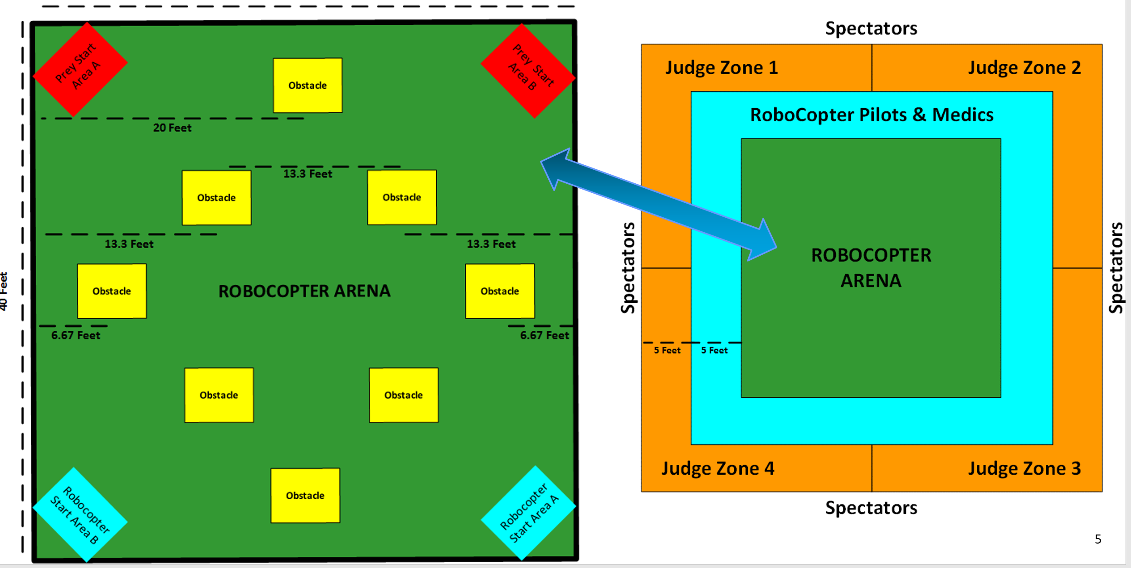
Figure 15. Course Layout

4.2 Economic Constraints

One of the main limits on how extensive and advanced the technology we use in the Robocopter can be is our budget. As the project is sponsored by Lockheed Martin, they are providing us with $1500 in funding. This is a sizeable budget for the scope of the project, but there are some things to consider: first, we will have to keep our expenses on prototyping parts to a minimum so we don’t occupy too much of the budget that will be necessary for operational design parts. Additionally, the electronic hardware aspect portion of the budget can only be so large, as the MAE on the team will need to purchase structural components such as the propellers, protective cage, etc. Balancing all of these constraints will be imperative to staying within the budget.

One other factor related to the economic constraints of the project is that to purchase the components, the process must go through the MAE department. The MAE department does not allow purchases from certain vendors such as hobbyking.com, Walmart, Target, etc. Such a policy may restrict the list of components that can be chosen, as less vendors are available. Fortunately, Amazon has an extensive inventory of electrical components, so a majority of the purchases will be through them.

4.3 Size and Structural Constraints

Another constraint we will be considering when designing the Robocopter is the size and structural limitations. Lockheed Martin requires that the Robocopter be within a size of 4ft x 4ft x 4ft. This should not pose too large of a problem, as that would be quite large for a copter. However, it does mean that we cannot have too excessive of a protective cage for the Robocopter, and cannot have any arms or other structural components sticking too far out. The size of the Robocopter also must be carefully considered when determining how to intercept the prey drones and avoid obstacles. The Robocopter must be large enough and sturdy enough that it can take down the prey drones without faltering in its own flight. However, it must not be too large such that obstacles become hard to avoid - not only because of the dimensions of the Robocopter, but also due to decreased mobility. Consequently, a careful balance must be found. Additionally, as we are designing the hardware/electrical side of the project, we will need to work with the MAE team members to ensure that our design fits with the body they are aiming to develop. We will need our components to be efficiently arranged and perhaps decently compact, so that they will sit nicely within the frame the MAE members develop. This constraint also means we will have to carefully monitor the weight of the components we choose, so that they do not weigh down the Robocopter too much in conjunction with the frame the MAE create. To ensure these constraints do not become a problem, we will simply have to be transparent with the MAE team and frequently work together with them to confirm the different aspects of the project are synchronized. One way we are doing this is having a full team meeting every tuesday to discuss our weekly objectives and progress within our respective project responsibilities. We also have a team conference call with Lockheed Martin every other Friday to go over concerns and questions that are relevant to the progression of the Robocopter.

4.4 Time Constraints

Aside from our economic constraints, perhaps our most imposing constraint is our time constraint. Many companies will spend years developing drones, aircrafts, and the technologies in them. We will not have that luxury, and instead have two semesters to design and fully realize our Robocopter. We will spend the entire first semester researching and designing the Robocopter, as well as testing the components that it will be composed of. The second semester will entail constructing the Robocopter and testing its overall functionality. Budgeting our time will be just as important as budgeting our funds. If we fall behind in the design process, we will have trouble catching up. Consequently, we will be laying out a schedule so we can meet weekly goals and keep the project moving forward. A table can be found in the administrative content portion of the document that outlines our weekly and monthly objectives.

4.5 Dependence Constraints

One constraint we are faced with that may not be apparent on first thought is that we are depending on multiple other teams to help us complete the project. As we are an interdisciplinary team, there are several components of the project we will be depending on other subteams for. The MAE (mechanical and aerospace engineers) on our team will be developing the frame and structure for the electronics to sit in. They are responsible for the protection of the electronic components and stability of the structure. The CS (computer science) members of the team will be developing the tracking algorithms for the Robocopter to detect and intercept prey drones. We will not have extensive input on these other elements of the Robocopter apart from making sure their designs can support ours. Without correctly functioning designs from the MAE and CS team, the Robocopter will not perform accurately regardless of how well designed our part is. We will be working closely with both teams to ensure transparency and staying on the same page regarding overall design goals. The end product will depend on all of our teams.

4.6 Testing Constraints

The ultimate goal for the Robocopter will be to perform well on the competition day. To do well in the competition, we are going to have to simulate the conditions the Robocopter will find itself in the best that we can. However, one condition that will be challenging to replicate will be the prey drones. We only have a vague idea of what the prey drones that will be used on competition day will be like. Lockheed Martin has displayed to use two potential drones that may be used. There will be several on competition day, and we will not know what their structure is or what their behavior will be like apart from the estimations we make based off of the preview drones we have been shown. For the most part, we only know that the drones will be relatively small. To tackle this constraint, we will be purchasing a few various quadcopter drones that we will use for testing purposes. We will try to simulate a decent variety of sizes and speeds with these to best prepare for the competition.

One other testing constraint we are faced with is that we won’t be able to accurately assess the performance of the Robocopter until it is largely complete in its construction. It will have to be able to maintain flight before we can test its tracking and intercepting abilities - and that is one more reason why we will be aiming to construct the Robocopter in a very timely manner.

4.7 Programming Standards : C
When writing software, there are certain standards to follow depending on the coding languages used. We will be using C to write the low level software on the Arduino based PCB for the Robocopter, so we will be following the current C standard, ISO/IEC 9899 - informally known as C11[6]. C11 specifies, according to the international standard, such things as the representation of C programs - including input and output data - the syntax and semantic rules for writing in the language, and the restrictions and constraints of the language.
It will be important to follow the standard for a variety of reasons. First, transparency - using standard syntax and formatting will allow us to debug the code easier in the testing stages, and will also make it easier for other people to read and understand what the code is doing. In the industry, maintaining code that other people will be able to read is important, especially in team projects. Additionally, using the guidelines of C11 will allow for more efficient code. Using verbose and excessively complex code could hinder the performance of the Robocopter. The calculations being performed on the PCB and Raspberry Pi will need to happen extremely quickly and at a consistent pace so that the Robocopter can move and intercept prey drones at an acceptable pace. Any deviation in the calculations that results in extended response time for the components of the Robocopter could result in its inability to effectively track and intercept the prey drones. Thus, following the syntax and representation specified by the standard will be key to ensuring high efficiency.
4.8 Safety Standards
Drones can be very dangerous, particularly when they are autonomous. Any malfunction that results in an unnecessary risk to human life could be catastrophic. For our Robocopter, we will be considering several design implementations that will minimize the risk of posing a threat to civilians. First, we will make sure our Robocopter has a manual override mechanism in the case that the autonomous software malfunctions. If the Robocopter’s programming ends up faulting we will need to have the ability to instantly take control of the aircraft with an RC controller and return it to a safe location. Another safety precaution we will take is limiting any protrusions from the Robocopter’s frame, so that in the case it were to go haywire, a direct hit on a person would not cause any harm. The Robocopter will not be very heavy, which will help this cause.
4.9 PCB Standards
The PCB will be the central hardware component of the Robocopter, so ensuring it is designed properly will be necessary for it to achieve acceptable levels of quality. The IPC, or Association of Connecting Electronics Industries, maintains standards regarding PCB design and development. The most important standard for us to follow in regards to the PCB is the IPC 2221, which outlines layout and printed circuit design. The construction of the PCB itself will be handled by an outside company, so our responsibility lies entirely within designing the layout of the PCB[7]. Following the IPC 2221 standard will be necessary for us to achieve a high quality PCB. Once we enter the industry and work on company projects, following IPC standards will be expected of us. All the employees of a company will need to follow them so that they remain on the same page and overall quality is maintained. Getting a jumpstart on learning to design within the guidelines of the standard now will not only ensure we create a high performing PCB for our Robocopter, but also that we learn the process for future purposes.
The software that will be implemented on the Robocopter will handle several tasks imperative to its success on competition day. The following sections will dive into the design details of how we are developing the software and utilizing it to operate the Robocopter.

One important note to make is that the prey tracking and collision control will largely be a responsibility of the CS team members, but Branden and Joey will be working with them in the process. The following chart provides a high level view of who will be working on each software aspect. There will be several algorithms in place on the PCB and Intel Compute Stick that ultimately determine the behavior of the Robocopter. The PCB will largely be performing the low level control of the Robocopter, while the Intel Stick utilized by the CS team members will be used for prey tracking. The following sections will explain each algorithm in further detail.

5. Hardware Design

In the beginning of the semester, an initial flowchart was created for the hardware design. This flowchart was to help us understand what different hardware components would be needed and how we felt they would interact with each other. The initial design however, would most likely change and may not resemble the final design at all. As well some of the assigned responsibilities between teammates might change slightly. Although some extra smaller components might be added to the final design, the key hardware components such as: battery, flight controller, PCB, camera, sensors, and wireless transmission will be included in the upcoming design aspects. Figure 15 outlines the hardware design of the Robocopter.
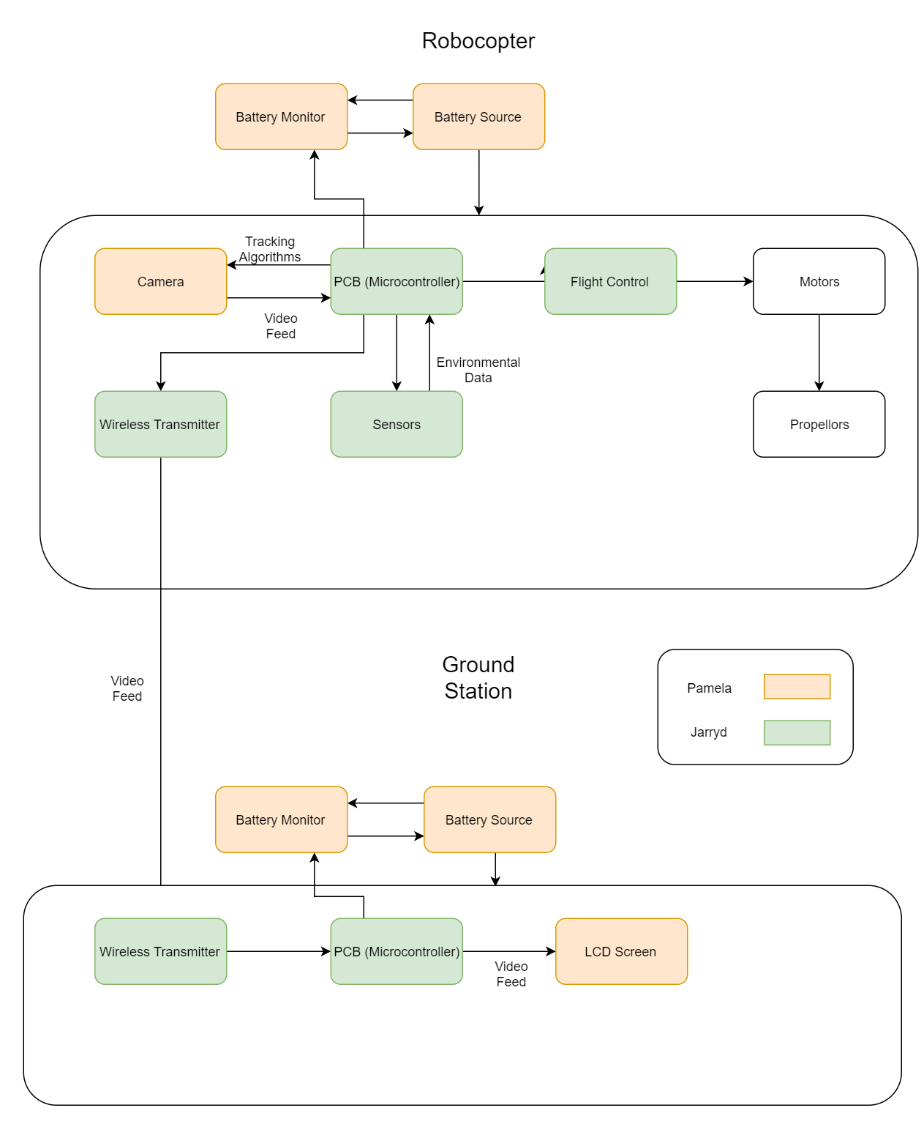
Figure 16. Hardware Control Diagram
5.1 Power Distribution
The Li-Po battery will be the main source of power for the overall copter. In order for this power to be distributed without frying smaller components, some measures are taken. First off the battery must power the flight controller, which will be used to power some smaller components. The flight controller’s operating voltage is 4.1-5.5 V while our battery is 11.1 V so the voltage must be stepped down. There are multiple ways to do this such as a voltage regulator circuit on the printed circuit board or a power module which does this for us. In our case we will use the power module provided by the flight controller to power the Pixhawk mini as well as smaller accessories. The power module outputs 5.3V at up to 2.25A which fits perfectly with the rest of our design. Since multiple components will need power the power module will be connected to the power distribution board included with the flight controller. Now the power distribution board will send power to the flight controller as well as the electronic speed controllers which will then power the motors. For the Pixhawk mini, the PM port is used as the connection terminal, the PM port will also read analog voltage and current measurements.
5.2 Flight Controller Connections
The flight controller doesn’t provide power to any other components but it does provide signals. For example the 8 channel pwm board, the GPS, telemetry set, and the external switch are all components that will be connected. The GPS will connect to the Pixhawk mini via a GPS&I2C port via a 6 pin cable. The GPS will also be placed as far away as possible from other electronics so interference can be reduced. The 915 Mhz telemetry radio will be connected to the flight controller through the telem port on the Pixhawk via a 6 pin cable as well. The connections can be seen below in Figure 16:

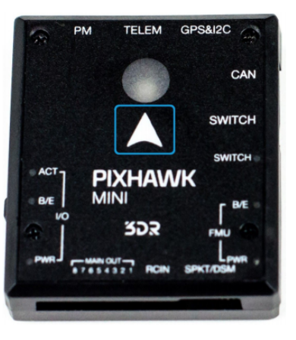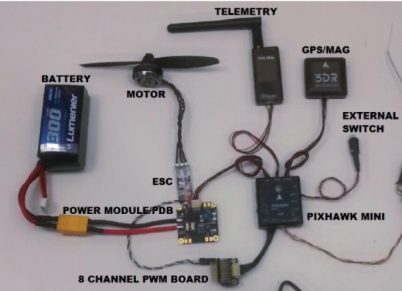
Figure 17. Pixhawk Flight Controller and Connection Diagram

Implementation/Testing - The first step in implementing the Pixhawk flight controller is placing it correctly on the quadcopter. The controller needs to be placed in the middle of the quadcopter and also oriented right with the north heading facing the top of the copter. Next is connecting all the peripheral components, such as the GPS+compass, the telemetry, power, etc. The flight controller comes with an included firmware that will run the flight controller known as QGroundControl. By connecting the Pixhawk mini to a desktop via usb, the firmware, the latest version of PX4, can be uploaded onto the controller. Once the firmware is uploaded, there are many little setups that need to be done before running our copter. QGroundControl needs to know what kind of aircraft will be used, so a quadcopter oriented in the X position is chosen. The Pixhawk mini comes with built in sensors such as the gyrometer, accelerometer, magnetometer, etc. These must be oriented at the starting position on the copter, therefore there’s a reference orientation. Next is the GPS, to calibrate this, the QGroundControl runs a program that tells the user to orientate the copter at certain positions so it can record all different positions the copter can be in.

The Pixhawk mini is very user friendly seeing as it allows different pre-programmed flight modes to be set. Some of these include, stabilized, position, and altitude modes. The stabilized mode makes the vehicle hard to flip, and levels out if sticks are released. The position mode will stop and hold the position against wind drift or whatever when the sticks are released. Lastly, the altitude mode will set a max rate at which the copter can climb and drop. Some other useful modes/switches are return to launch and mission mode. The return to launch mode will raise the copter to a safe height and return it to launch position, which is nice and will most likely be used as a safe or reset switch. The mission mode is a mode that just runs a pre-programmed mission set in QGroundControl, however, this will less likely to be used.

Implementation of RC System - Like discussed a little bit of before, the receiver will be connected directly to the flight controller. For this particular receiver, the FrSky X8R, it can be connected either by PWM or by S.BUS. The PWM output connection allows up to 8 standard servo outputs, while the S.BUS connection allows up to all 16 channels being used. The Table 6 below shows the different possible modes for the S.BUS connection.

In order for a transmitter and receiver to work together, they must first be bounded. A transmitter can be bound to multiple receivers however a receiver can only be bound to one transmitter module. This is an easy process of just simply turning on each module making sure they are in bind mode and running some small procedures. The process of binding will not have to be repeated unless one of the modules is replaced.

Mode | Telemetry | Failsafe and Model Match | Channel Output | F/S Button
1 (D8) | Yes | No | CH1-CH8 | Do not press
2 (D16) | No | Yes | CH1-CH8 | Press before power
3 (D16) | No | Yes | CH9-CH16 | Press before power
4 (D16) | Yes | Yes | CH9-CH16 | Press before power
5 (D16) | Yes | Yes | CH1-CH8 | Press before power
Table 6. RC System

Before each flight a range check should be done because reflections from nearby metal fences, buildings, trees, etc. can cause loss of signal. Without the object actually flying this test can be done by entering range check mode, then slowly move away from the aircraft while operating the controls to confirm signal transmission. One good thing about the FrSky X8R receiver chosen is the failsafe feature. When the control signal is lost for a certain period of time, all controls then move to a preset position.

5.3 Printed Circuit Board (PCB)

Before we discuss one of the most important components in any electrical or electronic device, the printed circuit board, we’ll go over the basics of what a circuit is. A circuit in essence is a path established for electricity to flow through in order to take advantage of the potential that voltage has. If electricity doesn’t flow, it doesn’t do anything, we need the voltage to flow from area of high potential to lower potential in order to provide some type of power. This is done through a circuit that contains conductive materials such as copper wire to stress for this to happen. Once we have this type of energy flowing throughout the circuit, with current, then we can introduce useful components such as switches, LEDs, and so on, to see the circuit perform something. Take for example the analogy of water. Let’s say you are floating on a body of water, and you need to go from one end to another in order to go to work or to get food or any reason is valid. Although the water has the potential to move it needs, one a clear route to take, and two some type of current or conduction. It needs an area with less current in order for it to then begin to move in that direction. Well a circuit works in a similar fashion. Now a printed circuit board brings all the electrical components needed for a device to function, to one central motherboard station. At this “station” copper traces transfer not only power but also signals. For this reason the printed circuit board is truly the brain of the device and one of the most important parts of any electronic.

Prior to the invention of circuit boards, tedious work of wiring everything took place. The downside to this is the fact that after a while, the wires begin to get old, rust, and eventually stop working. Although most electronic devices have a certain lifespan, the use of printed circuit boards has definitely extended the potential lifespan of said electronics. Today, before printing a circuit board, usually a lot of testing occurs on a breadboard because it is more customizable and from there you can determine how to design your circuit board. The printed circuit board allows for different components to be connected and for signal and power to flow between them. In this way it is much easier for several devices to communicate. For this project we will need a lot of physical devices located outside of the board to communicate efficiently to accomplish our task. We will need all of the sensors to correlate and to be on the same clock and for the camera to also send information effectively. If we are going to build a PCB we must also understand how it is made and what it consists of. We can think of a PCB for example as an Oreo. It has its center piece which for the printed circuit board it is called the substrate FR4. This layer is typically made of fiberglass, particularly the FR4, but in some cheaper products, you might have PCBs made from other materials such as phenolics or exposies. But for this project we want to make sure we have a quality Robocopter and thus will use fiberglass, even if it does cost a bit more. Then we have the outside layers such like an Oreo. The lid, consists of three thinner layers. The one closest to the center is the copper layer. On average you have about one ounce of copper per square foot on the circuit board. This layer is added through heat and this is where the wire traces are made and the circuit is actually imprinted on. The following layer going up is the solder mask layer. This layer is what seals the imprinted wires traces made on the copper layer. It protects the traces and also allows for the user to have a better soldering experience, where they don’t mess with the printed circuit but can add external component where they belong. Lastly, the silkscreen layer is the very top one and is the one that makes the board much user friendly. It’s the white writing that indicates important sections and labels all the connections. Without this layer, it would be extremely tedious to use the printed circuit board. With the image below we can better visualize the “oreo” layout of the printed circuit board, discussed above.

Today, there are a number of softwares that allow you to draw the schematic of the printed circuit board and simulate your design. Now selecting the right software could be the difference between a smooth process and nice experience or having a bumpy road. A few things important to consider when selecting a CAD software for designing are, how easy it is to use. When you are building a project as this one, there are a lot of aspects that go into it and it is unnecessary to spend additional time struggling with a software when there are others that are much more user-friendly. One criteria we used to determine if a certain software was a worthwhile one, that we would enjoy using, is by searching its popularity. Chances are that if many people are using this software, they must be content with it. Secondly, it is essential to check its features and capabilities. Before investing money and/or time on a particular software, we needed to make sure that it could do what we needed it to do. Otherwise, by the time we figured it out, it might have been a bit late. Lastly, we needed to verify what options we had for actually moving the board from the screen to a physical board.
Although there are a number of softwares for PCB schematics and designs not all are the best for this project. One of the options that was considered was DipTrace. This software is an excellent software for hobbyist looking to design a PCB. DipTrace has a free version limited by 300 pins maximum and 2 layers, which should be fine for simple projects and it isn’t expected for this project to require more. You could upgrade if you need to build a more complex design, which is good to know just in case we need it but we are going to be following the arduino uno layout so it should be as simple as possible. This software also has vendors it is partnered with for printing the board in several countries. This could be a pro or a con, because it could be good since this way it is unnecessary to be exporting files and risking some layouts to become damaged. The downside is that if you find another company you prefer to use perhaps at a cheaper price it might not be as easy. Yet, the vendor that DipTrace uses for the United States is called Bay Area Circuits and it is also an international company. This gives a good piece of mind since it shows that this is a stable and well known company. In addition, Bay Area Circuits has their own PCB design software called PCB Creator. This shows that this vendor is knowledgeable of the design process of the PCB and has compatible softwares. The EagleCad on the other hand which stand for Easy, Applicable, Graphical Layout Editor is a more complete software for PCB design, yet still affordable and designed for hobbyist. Although you could purchase a license that gives you 99 schematic sheets, 6 layers, and a 160mmx100mm routing area for $410, they also offer a free download for students which would be sufficient for our project. Since this software is much more widely used it does have pre-made libraries for some of the most popular boards such as Arduino, Raspberry Pi and BeagleBone. In addition it has features that allows for easy communication between the schematic and the PCB layout in order to keep things standard and avoid errors. It also has many links to different libraries already embedded that can help in the design process as well as an electrical check to make sure you have everything set. It is a good bridge between hobbyist and professional. The other two softwares we looked at are OrCad and PADS which are more on the professional spectrum. Although these have some really neat features such as OrCad has a PSpice circuit simulator which would be awesome for a testing purposes, we don’t need such an advanced software. The price difference is quite large as their licenses get into the thousand dollars and are a bit more complex to use. Although you could get a free version, all the add-ons are limited. Another downside is that all of the integrated softwares work independently and makes it more difficult to integrate everything. PADS is also very professional and has amazing 3D tool and models, but it is much more pricy. It definitely is a more complete software but it is not necessary for this particular project.

After careful research of the criteria mentioned earlier and the comparisons of the different softwares, we chose to use the EagleCAD software. It is a middle ground between hobbyist and professional. This is definitely a professional project as it is sponsored by a very well-known company but it is also a senior design project. In addition, Autodesk, the maker of EagleCAD is global company with locations all around the globe, in about 37 countries or more. If a company is not providing user-friendly and quality products, then it would not be global. We saw its participation in the different countries and the support is gives and receives to and from the users. This gives us a level of comfort in knowing that if at any point we need assistance we have a company that is ready to back us up and help. In addition this software has a number of features that truly allow us to effectively design our printed circuit board. For example, it includes PCB layouts and schematic editing tools, library contents for online libraries, 3D PCB design, complete components and also manufacturable parts, among many others. For building and testing it has features such as obstacle avoidance routing, modular design blocks and you can have multisheet schematics in case you need more complex PCBs. Although we plan to follow a very close example of the arduino layout, which would be provided by Arduino, it’s good to know we can count on a powerful software. We will definitely be making adjustments to our board to fit our specific needs, but we’ll have a guide in order to keep our parts compatible with the PCB. With all of this information regarding the software, we came to the conclusion that this would be the best tool to use to design our printed circuit board.

When actually designing the circuit board it is important to keep in mind the surface area and the weight. Believe it or not this could make a difference in the performance of the quadcopter. If we know the estimated weights of the materials that make up a printed circuit board we can design according in order to provide the most efficient circuit board. To estimate some of the weights we have that copper is about 8.23 g/cm^3, the FR-4 is approximately 1.9 g/cm^3, polyimide is around 1.42 g/cm^3, and acrylic close to 1.12 g/cm^3. So the key to manage the weight is to reduce the amount of copper used since it is the heaviest material. Of course, we need copper to make all the traces that allow for the flow of power and signal from one point to another but ww don’t need to overdo it. For example, if all the components needed fit on one side, then there is no need to also include another side of copper and circuit board to the panel. Obviously we want to provide a circuit board that can have safe traces, where they are big enough to carry the amount of current needed, but then we include just the exact required amount and that is it. The idea of the copter is to help reduce weight at all cost without sacrificing the efficiency and power of the Robocopter.

5.3.1 Printed Circuit Board (PCB) - Using Eagle Cad

Creating a printed circuit board is a two-step process. First you layout the schematic of the circuit using EagleCad’s schematic tool that works hand in hand with the PCB design tool, then you translate that into physical PCB parts. The first step, developing the schematic is critical because it is where you can catch any errors and debug the board before sending it out for fabrication. Lots of testing goes into play with this step, just as when we complete a lab for any circuit class we may have. For all labs we always have the design part of the lab, the simulation part and then the actual implementation of the designed circuit. So to get started with the schematic, when you first open up the software, on the left hand side there is a bar that will show a drop down menu for projects. Right click on the folder titled eagle and select the option for ‘Create New Project.’ Now a new project will be created which will be titled Robocopter for this case. If we right click the project, then we can select, ‘new’ and ‘schematic.’ From here we can begin adding parts to the workplace by using the ‘add’ tool and begin building the board. There is a way to search for parts but one must be careful to spell correctly, otherwise an asterisk should be used to search similar names. Although it is optional, it is recommended to also add a frame to keep everything looking neat and it also provides a label for the schematic. When you are ready to start connecting components together it is best to use the ‘Net’ tool and NOT the ‘Wire’ tool even though it makes more sense to use the wire tool. The “Net’ cursor does a much better job at connecting the dots where the ‘Wire’ mainly just draws a line. Although there are a lot of features and buttons that will be learned along the way, at least with those instructions we can start up a new project and a schematic for it.

Next we will transfer this schematic into a design that could become tangible when fabricated. In order to move this schematic to a related board just select the ‘Generate/Switch to Board’ command. Now what makes a printed circuit board unique and the most important part in its design is the layering. Of course for our project we will only implement one sheet of PCB, that “sheet” still has multiple layers that we must construct. Now when arranging the parts on the PCB we need to take into consideration that we must not overlap the components. One main reason for this because then it is much more difficult to select them and move them around if they are on top of each other. In addition this is not favorable because the components should have space to breathe and you don’t want to risk overlapping copper and possibly creating interference or short circuits. Also, it is best to try to maintain a clean and organized layout. This means that we should avoid overlapping or crisscrossing traces and paths. Lastly, keep in mind that although at times it is best to have a smaller board in order to accommodate to the frame of the quadcopter and also reduce cost, it is much better to have sufficient space between all your components to make routing easier.

After all components are connected and dimensions are set, we move to the next step, the routing section. This step is particularly unique as it could be compared to solving a puzzle. What routing means is that all the wires found in copper color must be given a position, whether up more or beneath another trace and so on while making sure not to overlap any signals. If two signals are following the same path we could run into some serious issues and finding the problem could be tedious, so it's best to do this part carefully and get it right on the first. When selecting the characteristics of the via, unless it is absolutely necessary, the default should work perfectly. Vias are small circles filled with copper that are found midway of a path in order to change direction of the path.

Another significant component of the software is the grid. This grid will assist in accurately measuring distances. The distance will include the angle of the direction and also the measured space between each component or turn. Although there is a feature that EagleCad offers that will help auto route your layout, it is not guaranteed that it will do the job well or the way you needed or expected. For this reason we will be performing our own routing. Of course SparkFun offers a large number of libraries and useful resources to assist in a smooth PCB designing process. Below we can see the schematic for the Arduino Uno that AdaFruit provides along with the Eagle files for the Arduino Uno Reference Design. Figure 17 depicts that design.

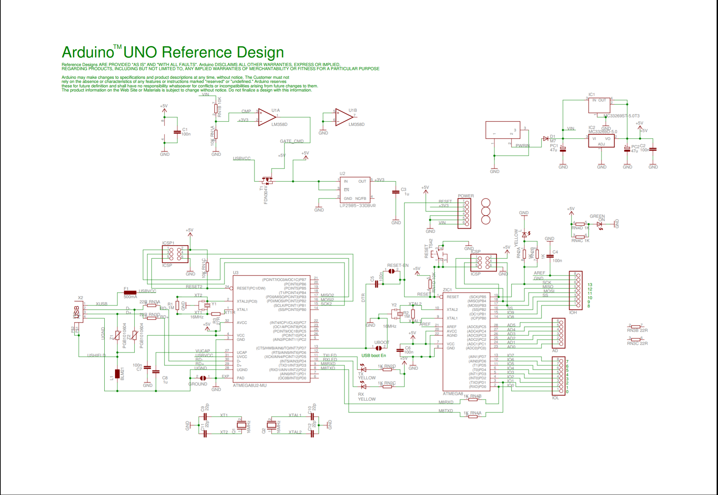
Figure 18. AdaFruit: “Arduino – Arduino Board Uno (EAGLE files and schematic posted)”

But before finalizing anything it is very important to test. To do this we will run two different tests. One can be accessed by clicking on the ‘RATSNEST’ icon. The second test can be found by downloading the guidelines provided by SparkFun and follow the testing requirements. Once everything passes the tests, then the design is ready for the finishing touches such as adding copper pours and generating Gerbers, but overall the PCB layout is complete. Despite that EagleCad offers a 3D feature, most of the design and implementation is done in 2D and for this reason it is extremely important to make sure that the routing is done efficiently and nothing is overlapping or running into each other.

Texas Instruments also offers a service called Webench that can help easily design and simulate a schematic for the power supply. The Webench software provides a full report based on the data you input it regarding the battery or power supply that will be used. It is simple to add loads or get a general idea of the schematics before adding all the loads the battery. It provides a comparison between different designs for you to be able to select the one that best suits the needs of that particular project. Editing the schematic provided if you want to customize or change something is permitted right on webench. Then you can run simulations, tests, see how it would look on the copper layer of the PCB and so much more. A full report is also produced with all of the individual parts listed and all of their information such as the specifications, price, maker, etc. It gives graphs with different test to show the pros and cons of the design and provides the overall analysis or statistical values for the schematic. Once satisfied with the schematic you can export the design to a file that is compatible with EagleCad. In this manner it is very easy to build off of it in EagleCad. Below is an image of the schematic produced for a design that provided the best efficiency at 92% at a reasonable price and it was a balanced design between all of its features. This schematic is based on input coming from the 3300mAh 3S 30C LiPo battery selected for testing. Figure 19, shown below, is the schematic that was produced.

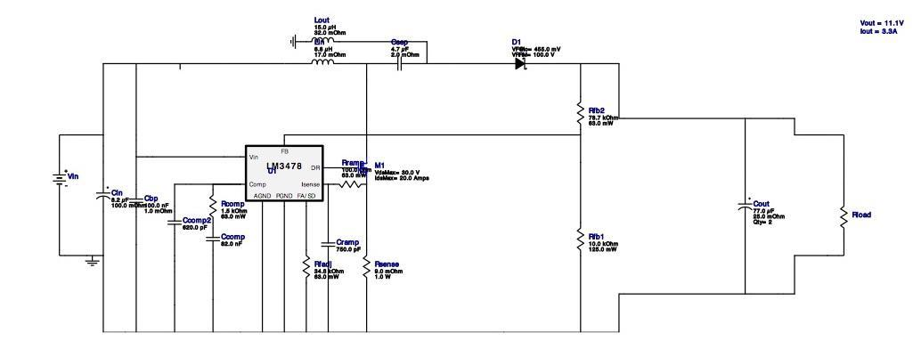
Figure 19. Webench: “Design : 4756069/1 LM3478MMX/NOPB”

In the process of designing all of the components in a schematic sheet for the printed circuit board it is good to start off with knowing what input ports are needed. We will definitely need a micro usb port in order to connect it to the computer to flash the code to it. Although it could serve as an input for power as well when using it on the quadcopter, since we will use a power distribution board it would be best to use wires soldered from one board to the other.

Next, since the Intel Stick that will be processing the images from the camera and contributing to the tracking of the prey, is an HDMI that must be plugged into an HDMI port, then it is crucial that this type of port is included. Although it is a bigger port to have that will take up some space, the Intel Stick is definitely going to be a large contributor and a very important aspect of the project. The great thing about the stick is that it is small, compact and efficient. It weighs just 59g and has dimensions of 111.76 x 38.1 x 12.7mm. It is also simple to use, you connect it to the computer and add all the coding prepared for it, then connect it to the PCB with the camera connected to it’s side USB ports and let the stick do its job. This is one of the main reasons why we selected this particular design versus say a Raspberry Pi, that although it is very powerful, it is a bit more complicated.
Figure 20 is the schematic for the microcontroller that we have developed. There are some adjustments that may need to be made, but it should fairly accurate.
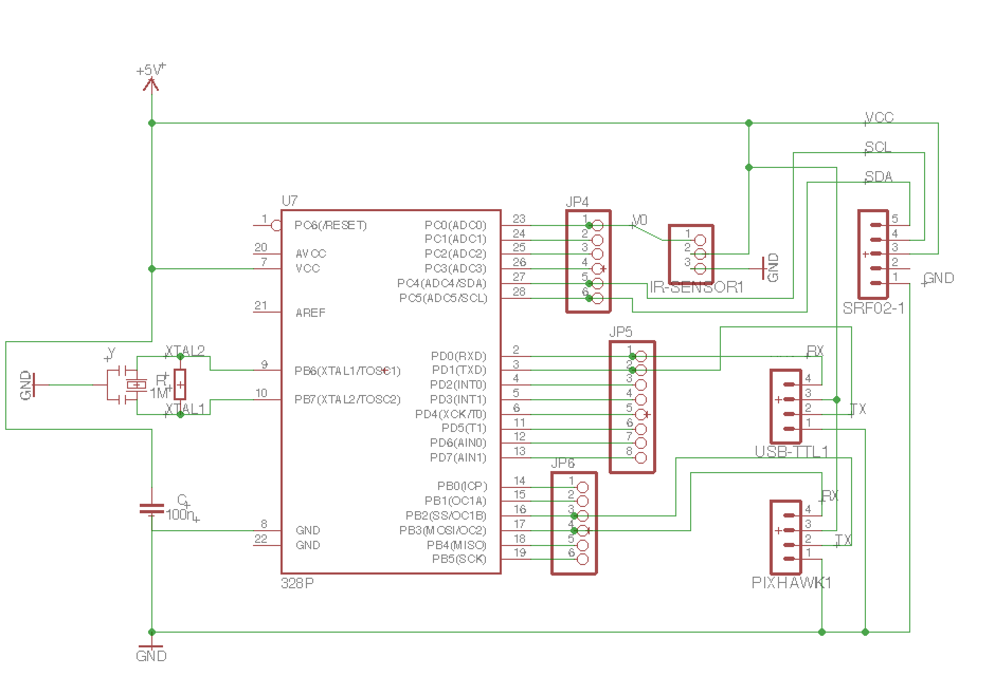
Figure 20. Microcontroller Schematic Design

5.3.2 Printed Circuit Board (PCB) - Flight Controller

One of the central components in the drone is the flight controller. Besides the printed circuit board, the flight controller would be the runner up for level of significance and large role in the performance of the quadcopter. The flight controller will have a lot of connections including the connection of the four motors through the ESCs, the power distribution board, and the printed circuit board. Although we will be making our own circuit board, we will be basing our design off the layout of the Arduino Uno and thus we will do some of our testing on an Arduino Uno board and must know the connections. This also will help in designing the ports, connections, and components required for our customized printed circuit board. The transmit exchange data (TXD) is connected to the port 11 on the arduino uno, the Receiver Exchange Data is connected to the port number 10. The ground is obviously connected to the ground.These three wires are also connected to the Telem 1 port on the flight controller. It is important to notice that the Pixhawk flight controller isn’t necessarily fully compatible with the arduino board as is the Pixhawk with a raspberry pi or something of that nature. But using the Mavlink-connection between the two components we can establish communication. Mavlink is a coding library that stands for Micro Air Vehicle Link. It is in charge of using programming language to establish communication with a small unmanned vehicle.

5.3.3 Printed Circuit Board Sensor Connection
For obstacle detection and avoidance, our quadcopter is going to be equipped with 4-6 ultrasonic srf02 sensors. These sensors will be placed on the wings most likely in order to get the best detection when an object is within a certain distance. Moreover, testing will need to be done to see how the placement of the sensors and noise generated from the propellers inherently affect each other. In order for the quadcopter to know what direction to move to avoid detected obstacles, the SRF02 sensors must be connected to a device that will compute sensor detection and turn that into flight controls. For instance if the front sensor has detected something then the flight control would tell the copter to move backwards. If the front and left sensors have detected an obstacle then move back and right, etc. The device connecting the sensor and computing this information will be the printed circuit board. Figure 21 is the SRF02 sensor.
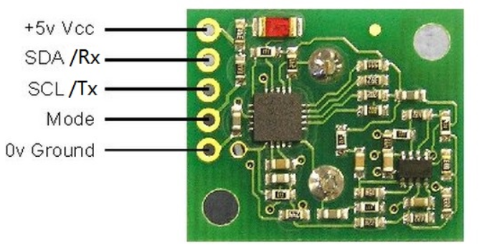
Figure 21. SRF02 Ultrasonic Sensor Diagram
The Vcc and ground are needed on any electrical component, then there is the SDA/Rx and SCL/Tx pins which are used for input/output. There are two ways that this ultrasonic sensor can be connected to a PCB or microcontroller, by I2C (Inter-Integrated Circuit) or UART serial interface. The good thing about both of these interfaces is that 16 sensors can be connected together on a single bus, allowing us to connect our desired 4-6 sensors.
The SRF02 sensors can be connected by I2C or UART. Our own printed circuit board that will be designed, one of, if not both of these interface connections will be implemented, depending on the scenario.
Testing SRF02 Ultrasonic Sensor - Like stated above there are two ways to have our sensors connected to the microcontroller, via I2C or Serial connection. In this part of the document, discussion on how to test the sensors using both connections will be done. The I2C utilizes the following registers seen in Table 7.

Location | Read | Write
0 | Software Revision | Command Register
1 | Unused (reads 0x80) | N/A
2 | Range High Byte | N/A
3 | Range Low Byte | N/A
4 | Autotune Minimum - High Byte | N/A
5 | Autotune Minimum - Low Byte | N/A
Table 7. SRF02 Registers
Location 0, as can be seen, will be used to start a ranging session, meaning read the data coming into the sensor. The good thing is that when ranging is taking place, the sensor will not respond to other commands occurring on the I2C bus. Location 2 and 3 will be used to read the incoming distance detected by the sonar, this will be in either inches, centimeters, or microseconds. There are also commands seen that will collect data without sending a burst out, this is the fake ranging mode.
Figure 22, shown below, lays out the different commands that can be used by SRF02.
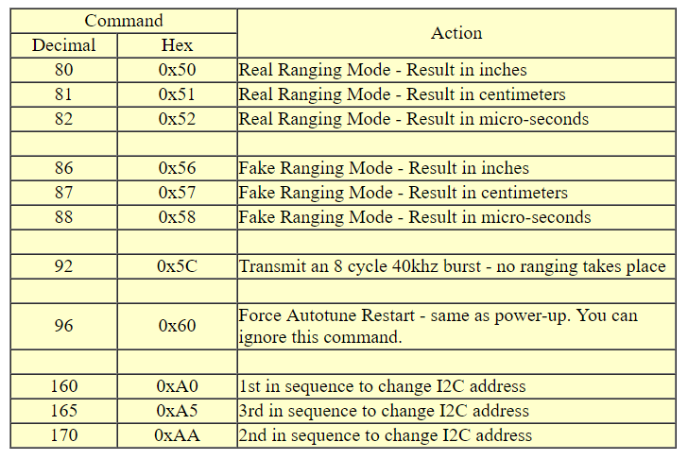
Figure 22. SRF02 Command Table
There are different ways to test this ultrasonic sensor, the first will be just a normal breadboard test. Using an Arduino Uno and a breadboard, testing will be done so that when an object is within a certain distance an LED being used will light up meaning detection occurred. This is a basic test just to make sure the SRF02 is working correctly. The next test can be to record different distances over a period of time of an object moving back and forth towards the sensor, this way a plot can be made of how effective the sensor can detect a moving object with respect to time.
The last few tests will need to be done with using an actual operating quadcopter. The sensors can be placed where desired and tests can be ran to see how well they are detecting with noise due to vibration or propellers. If the noise effects the detection process, most likely a filter of some sort will need to be used to filter out noise ranges produced by a flying quadcopter.
Testing Sharp GP2Y0A02YK0F Sensor - Like the SRF02 sensor, testing like stated above will need to be done on the Sharp IR sensor. Test will be done using an Arduino Uno and a breadboard as well. First is connecting the sensor to a breadboard, then connecting the breadboard to the arduino via jumper cables. The IR sensor has three connections, ground, power, and output. The ground and power connects to the arduino +5 volts and ground terminals, while the output pin connects to the analog pin of the board. The way to test this is uploading a program to the arduino that will plot a graph of volts versus distance. The closer the object the higher the voltage output is off the IR sensor. However, when connected to the analog pin, the arduino board uses built in analog/digital converters to convert the analog input into a byte between 0 and 1023. This value does not help us so it must be converted back to analog. By dividing 5 volts by 1024, it is seen that there are .0048828125 steps per value. Therefore whatever number is read from the sensor must be multiplied by this number to give us the voltage output. By looking at the datasheet of the sensor it can now be seen what distance the object is at related to the detected voltage. This graph can also be seen in Figure 23.
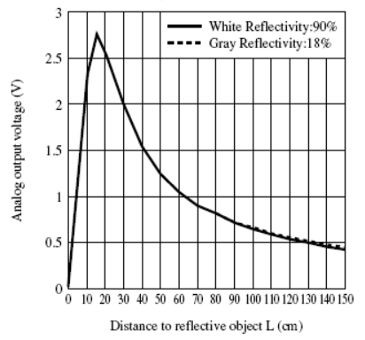
Figure 23. Sharp IR sensor voltage/distance graph
5.3.4 Additional PCB Design Considerations

There are specific design considerations that come into play when designing PCBs using ECAD software. These considerations range from being minor design choices, to important and critical design decisions. When designing a PCB, these considerations can have functional implications on the performance of the board, for example trace widths and trace spacing, isolates, annular rings, gerber file generation, tenting, labeling, component placement, placement of power and control lines, separation, and heating issues [80,81]. Below I will cover a range of these considerations that were used when designing the PCB.

5.3.4.1 Trace Width and Trace Spacing

While decreasing trace width may make it easier to design a smaller PCB, making the trace width too small can actually make the fabrication process more prone to faulty traces. In addition, you could get two traces that are touching each other, or almost touching (when 10 millimeters or less apart). These kinds of errors could lead to system failures and are especially important to consider. To avoid these problems it’s recommended to not go below 10 millimeter traces).

5.3.4.2 Isolate

Many projects often utilize ground or power planes for their grounding needs. However, this can be especially risky because the ground plane, when poured, can overwrite traces on the board, as can be seen in Figure 24.

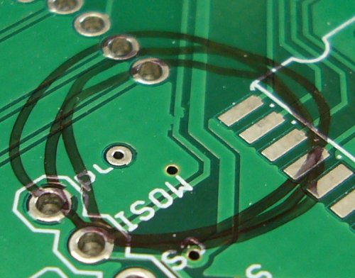
Figure 24. Trace Overwriting

In order to prevent this manufacturing concern, a good practice is to increase isolation on the traces from the ground. This can be changed in ECAD software by changing the properties of the board configuration. Often, ECAD software will default to 10 millimeters, 12 can be a safer number to adjust to.

5.3.4.3 Annular Ring

Another manufacturing issue that ECAD design should be aware of is that sometimes a sloppy drill hit can damage the vias or even break them and the trace that is connected through the vias. Often what can happen is that depending on the size of the drill holes, then the drill may not hit the center of the copper circles used for the vias, and in turn causing the break of via and trace. An example of a functional, but dangerous job of mis-centered drill holes on vias can be seen in Figure 25.

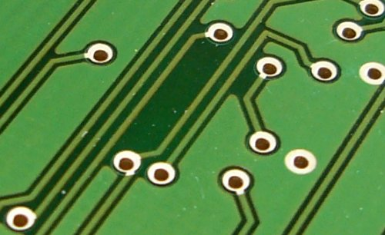
Figure 25. PCB Drill Placement

To remedy this however, there is a simple solution. The size of the annular ring around the vias can be increased. That way, if the drill is a bit off center, you don’t run the risk of the drill damaging the via and trace. If the default for the pads of the annular ring are 10 millimeters then setting them to 12 millimeters can be beneficial.

5.3.4.4 Gerber File Generation

Gerber files are the last step of the PCB design that can often be a pitfall for users of ECAD software. For example, EagleCad uses what’s called a CAM file to help create the gerber file. An easy solution to avoid this is to use open-sourced and reliable CAM files that have the settings necessary for functional gerber files. CAM files like those provided by SparkFun for EagleCad users, edits settings like mirroring on bottom layers, which can often cause issues with gerber file processing.

5.3.4.5 Tenting

Sometimes during manufacturing the vias can be exposed or potentially covered up by errors in placing the soldermask. Covering up the vias can prevent this error during manufacturing. It decreases the chance of silkscreen labels breaking, and even improves the overall aesthetic of the board. In order to tent (cover the vias), you can modify DRC rules in EagleCad. PCB design with or without tenting can be compared below in Figure 26.

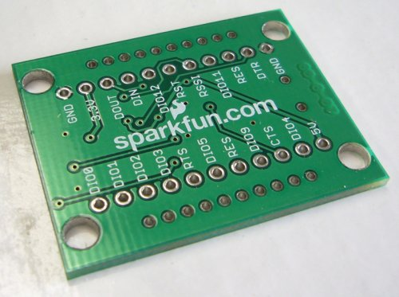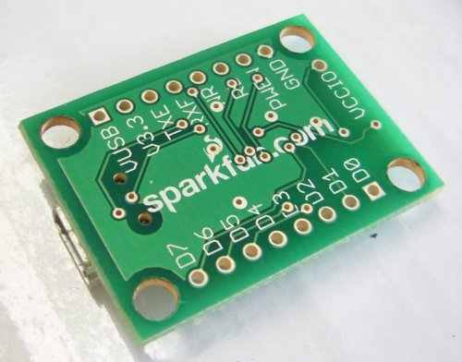
Figure 26. PCB Tenting

5.3.4.6 Labeling

Another design consideration to be discussed is labeling. Often it can be convenient to forgo the process of labeling, but labeling every button, switch, LED, pin and things like power connectors are important. If not done, it can be difficult to understand the hardware if the system is left alone for some time. Simple additions like labeling the power LED vs the status LED will add to the maintainability of the hardware.

5.3.4.7 Component Placement

Component placement is another important consideration for designing PCBs well. Depending on how components are placed, the board could be easy or more difficult to manufacture. Understanding good design principles for component placement can be critical to proper PCB design. Some of the guidelines that can be helpful to follow include orientation, placement, and organization. For orientation, simply make sure that similar components are oriented in similar directions. Doing this will help the soldering process be more efficient and subject to fewer errors. For placement, try not to have components on the solder side of the board, normally where there are things placed behind the plated components with a through-hole. For organization, surface mounted components should all be placed on the same side of the board. And all of the through-hole components should be on whatever is designated as the top side of the board. Doing this makes it so that there are fewer steps during the assembly process, and therefore less chance for error.

5.3.4.8 Placement of Power, Ground, and Signal Traces

Proper placement of the power, ground, and signal traces are also a vital aspect of PCB design. When orienting power and ground planes, these planes ought to be in the internal layers of the board, in addition to being symmetric and in the center. This helps the board not to bend. Power lines should be common rails for common power sources, and daisy-chaining the different power lines should be avoided. Also, it is helpful to make sure that the power traces are solid and wide.

To connect signal traces between components, it’s recommended to take the most direct path possible to a component, to avoid unnecessary overhead of traces on the board. As discussed before, defining appropriate widths for the signal traces is also helpful to ensure that the traces aren’t damaged during the manufacturing process.

5.3.4.9 Separation

It’s possible for large voltages from power rails and current spikes to interfere with electronics that operate at lower voltages and currents. This is an interference issue that can cause failures in systems like a robocopter if not handled properly. To avoid these issues there are a set of guidelines that one can follow when designing a PCB.

By keeping the power ground separate from a control ground on each supply stage, you can help avoid interference. If it’s essential to tie these together in the design, do it towards the end of a supply path to minimize the areas in which there could be potential interference. Placement of the ground layer in the middle is important because it reduces risk of a power circuit interfering and protects control signals in the process. You want to do something similar for the digital and analog ground signals as well. Capacitive coupling is another issue that needs to be dealt with. To help prevent capacitive coupling try to have analog grounds only crossed by analog lines, and digital ground crossed by digital lines.

Some of the areas more specifically that need targeted concern is the power distribution board which provides power to the motors. These motors require strong power signals that can easily disrupt the control of lower voltage components used to control things at the level of the microcontroller. Since the motors are constantly being provided signals causing the power line to be met with noise, it can project onto the control lines. These considerations are critical to the functionality of the robocopter and not addressing them in the ways addressed above could lead to failure in behavior. For example, false signals caused from noise in the power lines affecting control lines could mean that control signals could be mistakenly set off. In the worst case scenarios, control lines might be entirely disrupted and non-functional, which could affect a variety of functional properties in the behavior of the robocopter.

However, considering the design considerations for separation help ensure that the noise coming from power and control lines don’t interact as much as they possibly can. In effect, these considerations will preserve the functional requirements of the robocopter behavior and ensure that the requirements for the robocopter project are met while being less prone to error. The difference between analog and digital lines can be seen in Figure 27.

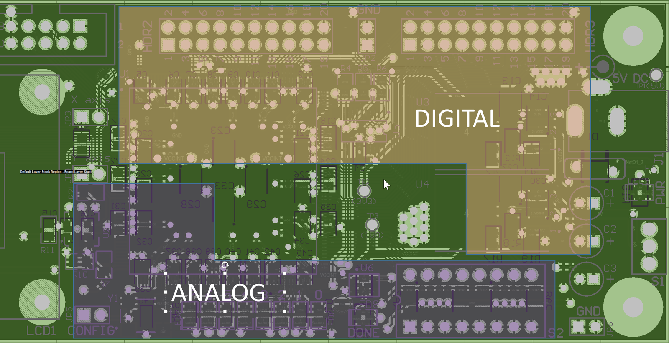
Figure 27. Analog vs. Digital Lines

5.3.4.10 Heating Issues

When heat dissipation isn’t taken into consideration, then post-manufacturing issues concerning heat can arise; damaging the board and its components. This could lead to failures in the robocopter project. In order to prevent these possibilities, some guidelines can be followed.

You want to immediately identify troublesome components, that are more at risk for damage due to heat. This can be done by checking thermal resistance ratings in the datasheet of each component. If it’s the case that a particular component is at special risk for heat damage, then adding thermal reliefs can help mitigate the effects. In addition, these components can be strategically placed to isolate them from potential heat sources.

Another form of thermal relief comes in the form of special thermal relief patterns that can be placed on a via or hole connected to ground or power planes. These help with heat sinking and improve the ability of the PCB to deter heat damage.

Ensuring that heating doesn’t become an issue is critical to the success of the overall robocopter design. This consideration, though last, is especially important. If necessary, heat sinks could be used to mitigate the issues with heat. However, it’s important that the heat ratings on critical components don’t get too hot that they become damaged through operation. Another consideration is to ensure that wear and tear during testing doesn’t wear down components that could break down during the competition. However, as discussed before, smart PCB design with regard to these heating issues can be heavily influential when ensuring that the PCB doesn’t put components at risk for heat faults. Connecting the Pixhawk to Arduino can be seen in Figure 28.
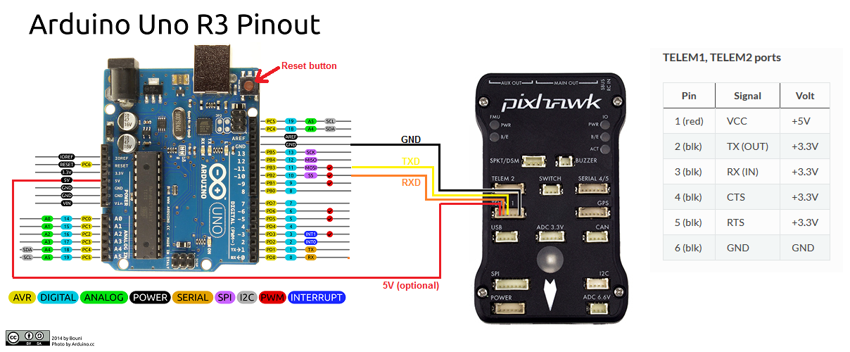
Figure 28. Ardupilot: Pozyx for Non-GPS Loiter

5.4 ATMega328 Connection Configuration

The ATmega328 chip is the main - and most important - component of our printed circuit board. The ATmega328 will be used to run programs that the CE/CS students design that will take in input from the ultrasonic sensors and turn that into flight control output. Before any programs can be uploaded onto the ATmega328 chip, the bootloader must be burned onto it. In order to burn the bootloader we will be using an Arduino board that will allow us to do this. The steps are as follows: upload ArduinoISP sketch onto the Arduino board, wire the board and MCU, and run the bootloader program. Once the bootloader is burned onto the ATmega328 chip it is ready for uploading programs. We then select the ATmega328 chip on the Arduino program and upload like normal. To then make use of the ATmega328 by communicating with other components, it will need to be interfaced with them through pin connections. The following sections will discuss how these connections will be made.

5.4.1 ATmega328 to Pixhawk Connection

The telemetry port on the Pixhawk mini can be utilized to establish communication with microcontrollers such as an ATmega328. The telemetry port on the Pixhawk has 4 connections: RX (input), TX (output), GND, and VCC [100]. The VCC can be used to send power to the PCB, although it is not entirely clear if this approach will be used yet. The plan is to use a separate battery for the PCB, but this design option will be considered if any problems are encountered during construction. The GND connection from the Pixhawk must connect to one of the GND pins of the ATmega328. The RX and TX connections of the Pixhawk require analog I/O, so the PWM pins of the ATmega328 should be utilized to limit the need for external analog to digital conversion. Thus, the RX of the Pixhawk will be connected to digital pin 10 of the ATmega328, otherwise known as PB2. PB2 provides a “Slave Select” feature so that the ATmega328 may choose to turn on or off the Pixhawk. The TX of the Pixhawk will be connected to digital pin 11, or PB3. PB3 is the “Master Out Slave In” digital port and can be used to receive data from the Pixhawk. A summary of these connections can be seen in figure 28.

5.4.2 ATmega328 to Sensors Connection

Along with the Pixhawk, there will be two sensors that need to be interfaced with the ATmega328: the SRF02 Ultrasonic sensor and the GP2Y0A02YK0F IR sensor.

The SRF02 sensor has two modes of operation, I2C mode and serial mode[103]. As this is not the only sensor being used, the I2C mode will be utilized so that the RX and TX pins of the ATmega328 are free. There are 4 connections that need to be made from the SRF02 sensor. It’s VCC pin needs to connect to the VCC pin of the ATmega328 so that the sensor can receive power. Additionally, the GND port needs to connect to one of the ATmega328’s GND pins. The SDA (RX) port of the SRF02 will connect with analog port 4 of the ATmega328, known as PC4. Also, the SCL (TX) port of the SRF02 will need to connect to analog port 5 of the ATmega328, which is PC5.

The IR sensor has only 3 connections that need to be made with the ATmega328[104]. Like the other components discussed, it has a VCC and GND that need to connect to the corresponding VCC and GND pins of the ATmega328. Its third connection is its output voltage connection, which will need to send information to the ATmega328 via analog port 0, PC0.

5.4.3 ATmega328 to RunCam Connection

The RunCam is interesting because it will not be sending video feed to the ATmega328. The RunCam will send its video feed to the Intel Compute Stick via micro-USB for image processing. However, the RunCam will still need some connections to the ATmega328. It’s VCC port will need to connect to the VCC of the ATmega328 so it can receive power, and will also need to be grounded by connecting the GND port.

5.4.4 Interfacing ATmega328 with Intel Compute Stick

The Intel Compute Stick will largely be communicating with the Runcam Split 2. However, it will still need to be connected to the PCB to receive power and also send directions to the ATmega328 about which direction the Robocopter must travel. The Compute Stick has an HDMI connection, which means an HDMI port will need to be included on the PCB. HDMI cables have 18 pins, but only a handful will be necessary to communicate with the ATmega328. Because the Compute Stick only needs to tell the Robocopter which direction to move in order to intercept the prey drone it is following, the data flow between it and the ATmega328 will not be extensive.

5.4.5 ATmega328 USB Connection

While it would be possible to include a USB port directly on the PCB, designing such a circuit would be unnecessarily challenging. A simpler solution is to use a USB to TTL adapter. The adapter chosen for the Robocopter has a FT232RL chipset, and 6 pins [105]. Only 4 of these pins will be necessary, and they are the RX, TX, 5V, and GND pins. The VCC and GND pins will connect to the VCC and GND of the ATmega328, as with the other parts. The RX of the adapter will connect to digital pin 0, that is PD0. The TX pin will connect to digital pin 1, or PD1. This USB adapter will allow for software to be loaded onto the ATmega328 from a computer.

5.4.6 ATmega328 Pin Connection Summary

Table 8 outlines what each pin of the ATmega328 will be connected to.

ATmega328 Pin | Device | Device Connection
PB2 | Pixhawk | RX
PB3 | Pixhawk | TX
PC0 | IR Sensor | V_{o}
PC4 | SRF02 Sensor | SDA
PC5 | SRF02 Sensor | SCL
PD0 | USB to TTL Adapter | RX
PD1 | USB to TTL Adapter | TX
Table 8: Pin Connections

Figure 29 provides a visual representation of these connections and can be seen below. SV1 will be one set of I/O ports and SV2 will be another. Additionally, the VCC and GND of each component will be connected as well, but to make the visualization simple to understand those connections are not shown.
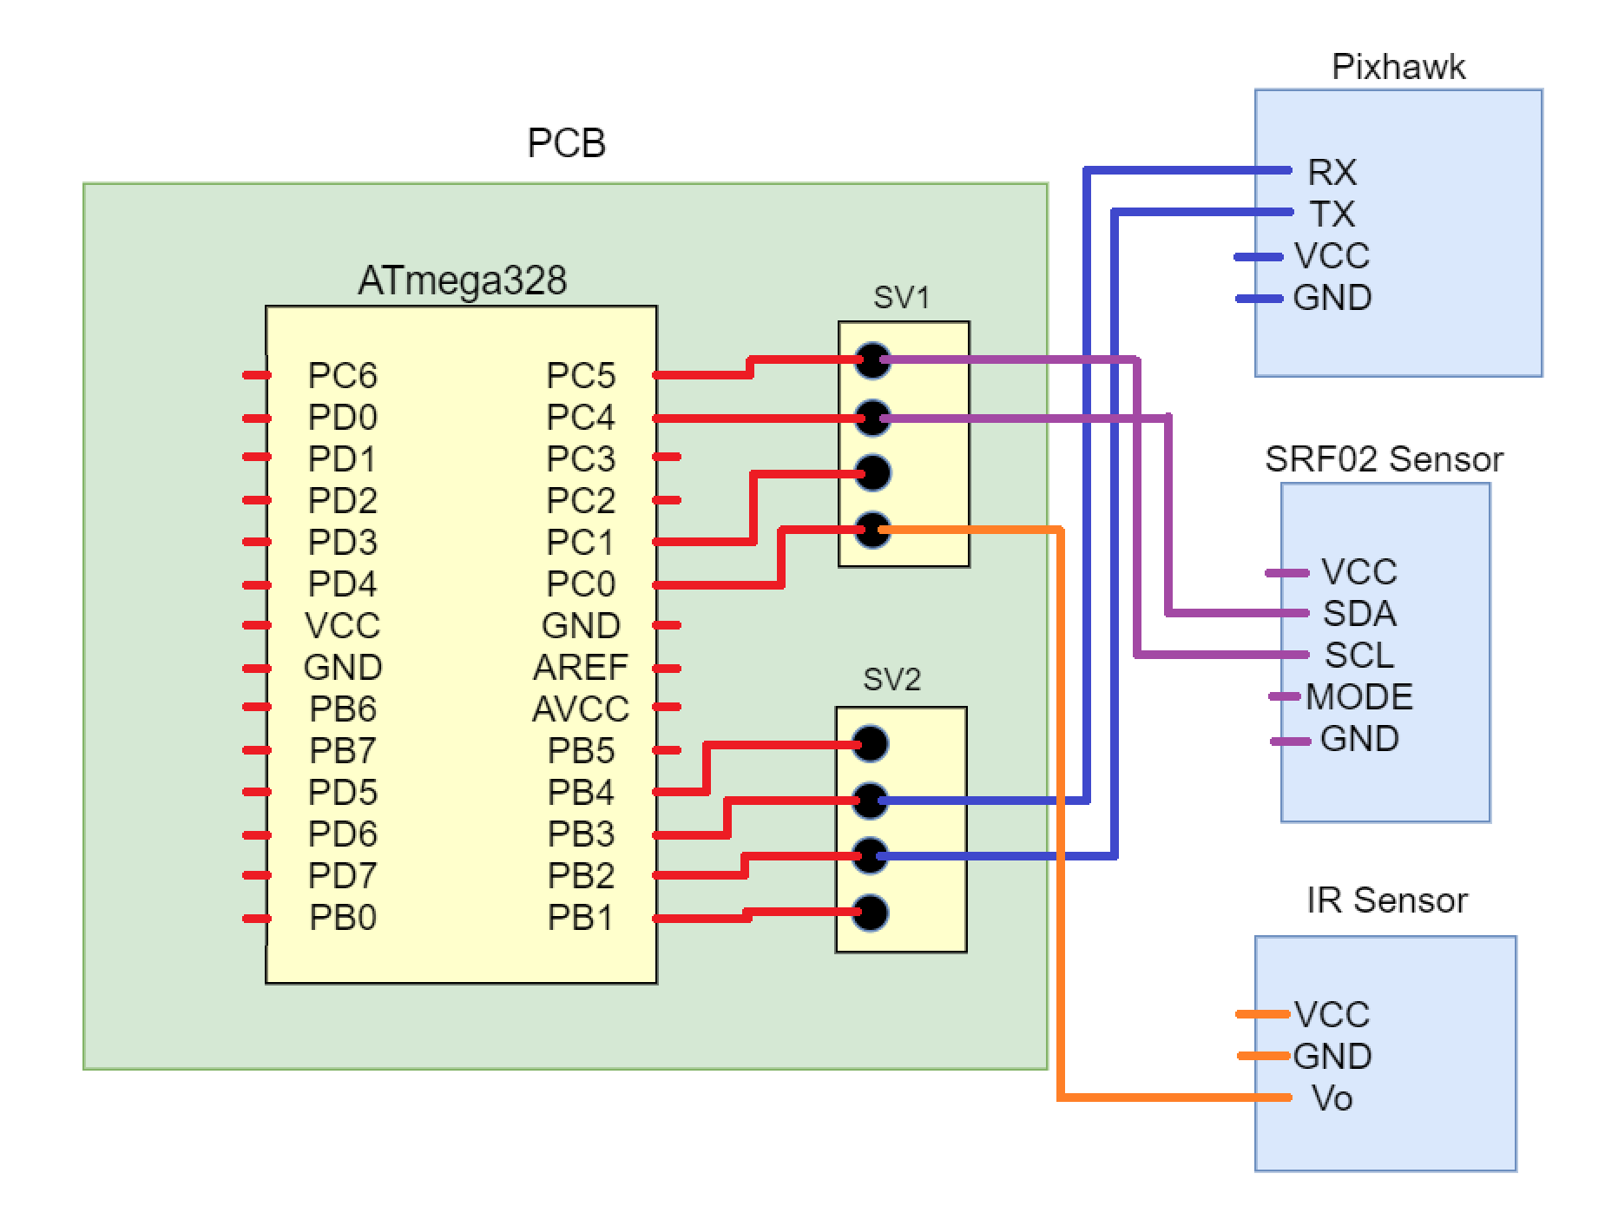
Figure 29: Connection Visualization

5.5 Voltage Regulator
Many circuit components are designed to operate at a certain voltage so there is no overkill or frying of the device. Since the main source of power provided is usually through one DC battery, a voltage regulator will be needed to step down the voltage to operate smaller components. A voltage regulator is also beneficial because regardless the varying input voltage or current pull from the load the output voltage remains constant.
5.5.1 Linear Voltage Regulator
The first voltage regulator examined as a possibility was the simple linear regulator. A linear regulator is composed of an op-amp and a n-channel transistor as well as some capacitors and resistors. There is two capacitors, one at the input and one at the output. The resistors are then connected in a way to the op amp to create a certain voltage at the output. This output voltage is regulated, non-changing, for a certain input voltage range.
5.5.1.1 Switching Voltage Regulator
While the linear regulator is a good option for keeping a certain voltage constant, a switching regulator is more efficient and has an adjustable output. If the difference between input and output is low the linear is more efficient but in our case where the difference is about 11.1 V to 5V then the switching regulator is far more efficient.
5.5.2 PCB Voltage Regulator
Figure 30 below shows the adjustable voltage regulator circuit that will be implemented on our PCB in order to get the 5V to run our atMega328 MCU. The reference voltage between the output and adjust pins is maintained at 1.25 V by the regulator.
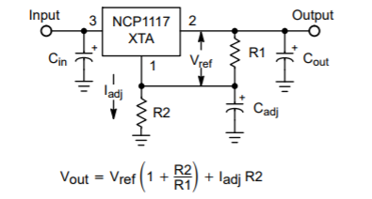
Figure 30. Adjustable Voltage Regulator
Some components needed in this circuit design are the input and output capacitors as well as the resistors used to adjust the output voltage. Input capacitors are crucial for regulator stability when the device is located within inches from the power source. This capacitor helps reduce noise and sensitivity generated from the power source. The output capacitor is used to compensate for any noise generated by the regulator. These capacitors also must be at minimum 4.7 micro-Farads but the most common value used is 10 micro-Farad. The capacitor can be made up of ceramic, aluminum electrolytic, or tantalum, as long as it meets the minimum capacitance over the temperature operating range of the circuit. However, for an adjustable circuit like such, there is a ripple associated with the output. This ripple depends on the ratio of the output voltage to the reference voltage, so as the output voltage increases so does the ripple, so a way to compensate must occur. By plugging in a bypass capacitor with a reactance lower than the resistance, R1, on the load side, the values loss due to ripple rejection can be restored. The adjustable capacitance value can be found by:
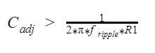
The output of the 5V adjustable regulator will then be connected to the input of a 3.3V regulator, this way any other components running at 3.3V can be powered.
5.6 Printed Circuit Board Complete Design
The above sections have discussed some broad hardware designs for the total project, as well as some more detailed designs that will be implemented on our printed circuit board. The most important component to any device, is the power supply. In order for all the designs to work for our printed circuit board, our 3S Li-Po battery pack must be able to connect to the PCB.
With power supplied to the printed circuit board, the previously discussed voltage regulator circuits will then step down the voltage to power the atMega328 chip that will act as our microcontroller. This power will also be used to supply the SRF02 sensors discussed as well.
The secondary components of our printed circuit board that are crucial are the interfaces. In order for the sensors and flight controller and any peripherals needed we must have sufficient interfaces to make these data connections. For our SRF02 sensors selected we need I2C interfaces, as well as digital PWM interfaces for TXD and RXD connections for the Pixhawk flight controller connection.
5.7 Optional Hardware Features

There are several hardware features which could have made it into the final design of the Robocopter. However, for various reasons, these features were not implemented into the final design. Several of these features will be detailed below, discussing their benefits and disadvantages to the design, and why ultimately they were not included in the final design.

5.7.1 Electrostatic Discharge Protection

Electrostatic discharge [76] is caused by a sudden flow of electricity, onset by the contact between two electrically charged objects. In many industrial applications, electrostatic discharge is something worth protecting against. These discharges can damage essential components to hardware design, like microchips. In order to prevent the loss of malfunction of components due to electrostatic discharge, there are ways to develop electronics that shields vulnerable components from electrostatic discharge. These components are at risk for electrostatic discharge during manufacturing, after manufacturing, and during shipping. Herein I will focus mostly on electrostatic discharge protection during manufacturing and transit, which most concerns our hardware design.
Grounding is essential to electrostatic discharge protection. There are microchips that can be used for electrostatic discharge protection that use the properties of grounding to divert dangerous discharges from harming sensitive components like an integrated circuit or microchip. These chips coupled with other electrostatic discharge prevention methods external to the hardware make for a safer build. Some of these include an electrostatic discharge protected area (EPA). These are often large manufacturing areas or smaller workbenches. These areas can take advantage of grounding properties to avoid discharge by wearing wrist straps meant to prevent electrostatic discharge. In addition to wrist straps, an EPA may include anti-static mats or conductive material on the floor that take charge away from the work area. These facilities may also include control of the humidity because humid environments promote the accumulation of electrostatic discharge.

Another concern is electrostatic discharge that occurs when the electronics are in transit, for example: moving the Robocopter to the competition area. In principle, it’s possible that an electrostatic discharge could knock out or damage specific components in the Robocopter if not handled correctly when transporting it. Often the way these challenges are addressed is by controlling surface resistance and volume resistivity of the packaging materials. For example, the Robocopter might be wrapped in a bad made from packaging that minimizes frictional charging due to rubbing between packaging and the Robocopter that could occur during transport. These are sometimes called anti static bags, which act like Faraday cages; shielding whatever is wrapped inside from electrostatic discharge.

In order to determine whether or not electrostatic discharge protection was necessary for our hardware design an option to explore would have been an electrostatic discharge simulator. These simulators are special circuits used to model environments in which an electrostatic discharge event could occur. However, this option was not explored. It would have added extra difficulties to hardware design, and electrostatic discharge protection is not an area of specialization the hardware designers are as familiar with. As I will explain why below, this ends up not being an issue for our hardware design.

During our manufacturing process we likely won’t have access to a facility with all the electrostatic discharge protection detailed above; the sort available at large hardware manufacturing facilities. However, as mentioned before, it was possible to bypass that limitation by integrating electrostatic discharge protections into the circuit design, possible by using special integrated circuits or clever design techniques for device input and output. After speaking with electrical engineers experienced with Robocopter projects however, we opted not to include the electrostatic discharge protection because it turned out to not be an issue for previous projects using similar hardware design constraints.

5.7.2 Wireless Charging

Wireless charging [77] was a low-priority hardware implementation feature that would have been added little practical benefit to our hardware design, and perhaps made it even more difficult. However, despite not making it into the final hardware design, it is a feature that, if more time was permitted, may have made it into the final design. Herein I will describe how wireless charging, also referred to as inductive charging, would have worked with the Robocopter project.

For wireless charging to work, induction coils create alternating electromagnetic fields from within a charging station. At the same time, another induction coil from the Robocopter would take power from the electromagnetic field generated by the charging station, and then convert it back into electric current that charges the battery onboard the Robocopter. Essentially these components create a transformer: a device that transfers energy between circuits using electromagnetic induction.

There are certain advantages to using inductive charging. One is protected connections, meaning that there isn’t corrosion when the electronics are enclosed, or kept away from water, or oxygen. Since there’s no need for a charging port, it’s possible to fully enclose the electronics of the Robocopter using inductive charging, meaning that short circuits due to insulation failure are less likely to occur. It also means that the durability of the Robocopter increases, since there’s less wear and tear on the charging port of the Robocopter, and the wire being used for the charging. This adds to the benefit of also making the Robocopter’s transport more convenient, since there are fewer cables to keep track of.

Despite these advantages, there are some looming disadvantages not yet discussed. For one, inductive charging is generally slower. Because of the lower efficiency inherent in electromagnetic induction vs wired charging, charging takes longer to happen. The slower charging rate, depending on how severe, could become a severe limitation in the prototyping and assessment of the Robocopter abilities, since more time would be spent just trying to charge the device. Another thing to consider is cost. Inductive charging and the hardware necessary to implement it are often more expensive, so this would have to be accounted for in the budget. Incompatible standards across inductive charging devices also make it difficult to design an inductive charging mechanism in the hardware. In addition, to add towards the discussion of inefficiency, this affects the battery as well. Since more heat is being distributed toward the battery, it could be damaged from excess exposure if precautions aren’t taken to prevent this.

Considering all these factors we ended up not including inductive charging in the final hardware implementation. Despite the advantages and disadvantages discussed, the ability to inductively charge the Robocopter would serve more as a luxury asset to the core functionality of the Robocopter and thus was a low-priority item given the time constraints of the project.

5.7.3 Lidar

A type of sensor that could have been used but was not, is the Lidar sensor [82]. Lidar uses either visible, near infrared or ultraviolet light to help image objects. This would have been integral in collision avoidance and object tracking and pursuit. It’s able to target many types of materials, like non-metallic objects including rocks, rain, and chemical compounds even like aerosol. The laser allows objects to be mapped with high resolution, in such a way that models of objects can be reconstructed from the data. It’s original development was used for atmospheric research and meteorology, where the intent was to map the earth and atmosphere. It is now a key feature of many modern technologies, including self-driving cars which utilize the data for collision avoidance.

The technology has been adapted for use with drones as well. Which is why it was considered for the current drone project. At one point, optical engineers were interested in providing a Lidar sensor for the project, which was ultimately rejected. Lidar may be too much information for what we need, and it would make it harder to interface with the processors and require more processing power because of the quality and number of data. In addition, Lidar can be more expensive than other sensor types that could be used for collision avoidance.

Ultimately, other sensors like infrared or ultrasonic and cameras were better suited for the task at hand with the robocopter competition. They cost less, and require fewer overhead in terms of cost and processing costs. If more resources were allocated to the project, including time and money, Lidar would have been a more attractive option to explore. State of the art Lidar sensors provide incredible data for tracking and its implementation in the right framework surely would have been helpful for the project. However, again as mentioned before this would have required resources that weren’t available in the current project. With these considerations in mind it was decided against using Lidar despite its benefits.

5.7.4 Bluetooth

For transmitting our data we opted to use WiFi over Bluetooth [83] for several reasons. Below I will compare the two technologies and show why it was ultimately chosen for WiFi to transmit and communicate between devices instead of Bluetooth.
Both Bluetooth and WiFi provide wireless communication between devices, but they differ in what they are specifically designed for and how they are generally used. Bluetooth is generally used to connect devices by forgoing the use of cables, whereas WiFi intends to connect devices to the internet (which in turn may be used to connect devices).

Bluetooth is a standard created for wireless technology that is used for exchanging information over small distances. This distance is typically less than 30 feet (which is why using it for the project would have been difficult). Technology like wireless headphones can take advantage of this technology to connect with mobile phones and computers (often in close proximity to the user) to wirelessly send audio data in order to play music. Its use in the drone would be for transmitting data to the ground station or to send information to the drone from the ground station controller. However, since the area of the competition is much larger than the less than 30 feet typical range, it would have made using it impossible for this project. However, other options for bluetooth receivers and transmitters are available that could have fixed this limitation. Yet those options would have cost more, as is the theme with many other optional measures not used in this project. In order to reserve cost for other components like the processors it was decided that introducing bluetooth would introduce more problems than it would solve. Hence, it was excluded as the wireless communication protocol for the project.

5.7.5 4K Video Streaming

When contemplating the resolution of video used for the ground station it was noted the potential for a 4K video stream. However, for several issues I will discuss below, this option was forgone for lower resolutions.

A higher resolution screen has its benefits. There’s more data to analyze, and the computer vision system would have more data to use against making false-positives when tracking and in pursuit (which, as discussed in later sections, leads to catastrophic system failures). The ground station would also have a much clearer video stream, because of the higher resolution. However, these benefits do not seem all that necessary when compared to the negative aspects of implementing a 4K video stream.

A more expensive camera, processor, and wireless transmission protocol device would be necessary to implement 4K video stream. The camera would need to be able to capture 4K resolution video streams, and interface with a processor that could handle that much data. Even if the video stream is in 4K it needs to have a good frame rate otherwise the video is unwatchable. This puts massive demands on the processors to process more information in order to control tracking, the video stream, and low-level control for pursuit. In addition, to send such a large amount of data over wireless transmission, the WiFi protocol and the hardware supporting it would need to ensure that a larger bandwidth was available to transmit more information in the same amount of time you would with less information and a smaller bandwidth. All these additions can be incredibly expensive as well. As mentioned before, 4K streaming requires performance increases on nearly every other system on the robocopter and would cause a spike in the hardware costs as well, just for one requirement (4K video stream on the ground station). In order to prevent unnecessary costs and difficulties, a lower resolution stream was decided on.

5.7.6 Additional Motors

One consideration for the robocopter was adding more motors. Currently only 4 motors are used. But for reasons discussed below, it can be seen that there are pros and cons to increasing the number of motors used. Ultimately, for these reasons, it was decided not to use additional motors.

Additional motors have the benefit of increasing thrust and maneuverability. This could be beneficial for many reasons. Increased speed could make it easier to catch prey, and could help when maneuvering to capture prey. In the case that prey are making quick movements and sudden changes in direction, the extra motors can help with the agility of the robocopter and in effect make it easier to score points in the competition.

However, the increased number of motors draw several disadvantages. Power is a huge concern. Given the constraints on size of the battery, providing enough power to the motors beyond the 4 on the current robocopter, is incredibly difficult. Since the robocopter needs to operate for a significant amount of time in order to score points in the competition, the extra motors drastically reduce the runtime capabilities of the drone. Of course, a higher capacity battery could use but the robocopter size is constrained to be 4x4 feet max. The larger number of motors also puts a larger processing burden on the flight controller which needs to regulate the actions of more motors, adding latency to the robocopter flight response when in pursuit of prey and navigation. Cost is also another factor, with more motors, the overall cost of motors will cost more. In addition, a stronger processor and flight controller also increase the price of the robocopter.

5.7.7 Gimbal

A gimbal can be used to prop a camera and drastically increase the stability of the camera feed. More precisely, it’s a pivoted support that lets an object rotate about a single axis. They can be used for compasses, stoves, and drink holders in cars (to prevent spills). In this case we could have used it with the camera producing the video feed and being used for tracking. There are several advantages and disadvantages to this which will be discussed below.

Benefits to the gimbal include a more stable video feed. This has drastic benefits on the software end. In future sections, the stability of the camera feed will be shown as paramount in the tracking systems of the robocopter. In order to fulfill a major requirement of the competition, the robocopter must be able to track and pursue prey drones. However, the computer vision algorithms underlying the tracking require that the images being projected and analyzed are stable and not incredibly blurry. Instability in the camera feed could mean that image files are corrupted or too blurred to be analyzed correctly. This leads to false-positive or false-negatives that drastically hinder the ability for the robocopter to fulfill requirements. A gimbal assists with camera stability and so would help prevent these issues.

However, a gimbal in practice would be quite difficult to implement. Because the camera direction would be stuck to one axis (if gimbal was optimized to keep the camera looking straight). But if the robocopter is approaching prey at an angle, then it wouldn’t want a camera feed looking directly forward (you want the feed to be an eye level view in this case). In order to circumvent this, extra software control would be necessary if a gimbal with axis control wanted to be implemented. For purposes of reducing cost and complexity, the robocopter doesn’t use this option to prevent extra processing costs on behalf of the processors.

6. Project Software Design Details

The software that will be implemented on the Robocopter will handle several tasks imperative to its success on competition day. The following sections will dive into the design details of how we are developing the software and utilizing it to operate the Robocopter.

6.1 Software Functionality

The software design of the Robocopter is equally as important as the hardware design. The coding the controls the PCB will determine the effectiveness of the Robocopter’s functionality. The software block diagram below gives an overview of how the software systems on the Robocopter will work. The software systems are organized by whether they pertain to the drone or the ground station, and whether they will be overseen by Branden or Joey. The next sections will provide more specifics about the software functionality of each block in the diagram and how it contributes to the whole system. One important note to make is that the prey tracking and collision control will largely be a responsibility of the CS team members, but Branden and Joey will be working with them in the process. The following chart, Figure 31, provides a high level view of who will be working on each software aspect.

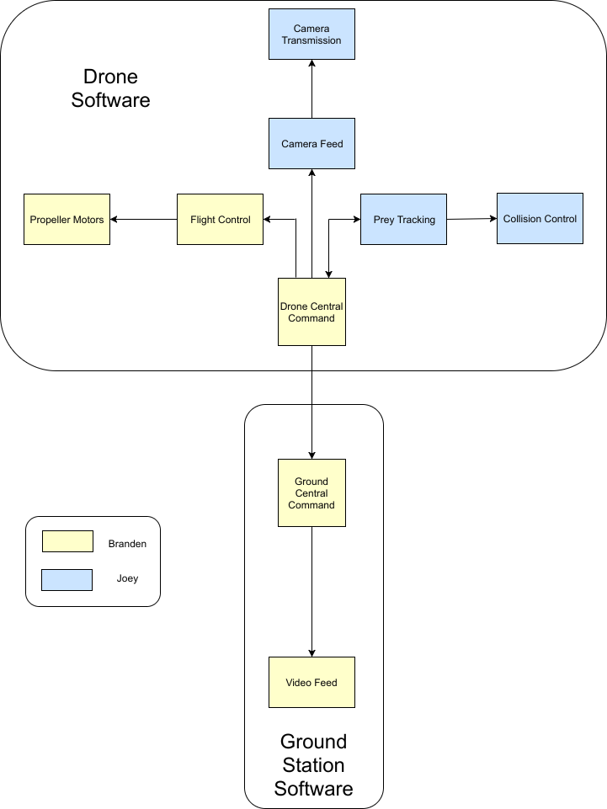
Figure 31. Software Control Diagram

6.1.1 Drone Central Command

The drone’s software system will have the equivalent of a central command. It takes in the inputs from different sensors, the flight controller, and camera transmission, in order to make decisions about how to control the motors to navigate or pursue a target. The main role of this block is to take in processes dealt with by other blocks, and use that information to conduct make decisions about low-level control on the drone. A secondary role of central command is to relay the information it receives from other software blocks to the ground station central command, like the camera feed and targeting visuals.

The functionality of this system is core to the entire project. Some of these problems will be explained in further detail in other sections, but things the drone central command needs to be wary of are several potential pitfalls. One includes Robocopter instability. If the Robocopter is unstable, then many systems will either go offline or be faulty. For example, an unstable Robocopter makes for an unstable camera feed, which affects prey tracking, messing up the video feed that is eventually sent to the ground station central command. In effect, instability of the Robocopter messes with most of the requirements of the project.

6.1.2 Camera Feed and Transmission

These blocks deal with formatting input from the camera in a way that can be processed by the computer vision algorithms that will be used in tracking and control. In addition, the transmission feed needs to go to the drone’s central command, where it can be forwarded onto the ground station.

6.1.3 Prey Tracking

The computer science team working with us will be responsible for most of the software functionality here. The plan is to use a convolutional neural network in order to identify whether or not there is a drone in sight. If a drone is in sight, then the algorithm should put a bounding box around it, and feed forward information to the drone’s central command that allow it to begin tracking the target drone.

A key feature of the functionality will be the ability to distinguish regular objects in the arena, from potential prey. One of the conditions for the competition is that there will be mock drones (that are just printed images of drones on paper), and the algorithm will need to avoid making false-positives; otherwise the Robocopter could end up tracking false prey.

6.1.4 Collision Control

This module takes in information what the prey tracking module and uses it to initiate a collision with a target. Another important role however, is to create controlled collisions, in such a way that the Robocopter can recover after collision. The current goal is for collisions to be from a top-down angle, such that we can push down on prey. Working with our aerospace and mechanical engineers, we hypothesize that a collision from this angle would be most effective in disabling a drone to earn more points (per rules of the competition, touching a drone is worth less than disabling one).

In order to create controlled collisions the module will have to rely on the material integrity of our crash shield, but also the ability to communicate with the flight controller to readily stabilize the drone after collision.

6.1.5 Flight Control

The flight controller will take in information about the orientation of the drone in order to stabilize its flight. It’s a key component of the drone, and its function is crucial for nearly every software system. I’ll specify those systems below.

For tracking, the flight control helps keep the Robocopter flight stable, which keeps the camera stable; a necessary requisite for our computer vision algorithms to work properly. The flight control ensures that the frames analyzes by our software for tracking have minimal blurring, which affect the algorithm’s performance negatively.

For collision control, the flight control plays a huge role in ensuring that the sudden shift in sensor data (on stability) can be used to restabilize the Robocopter. The competition does allow us to reset the Robocopter in the case that our Robocopter destabilizes after collision, however ideal functionality would give us the ability to collide with targets and resume normal operation soonafter.

QGroundControl - QGroundControl will be the software used with the Pixhawk mini flight controller to run autonomous missions, as well as stabilize the quadcopter. This software is also beneficial because it is open source which allows input to be taken into effect when flying autonomously. For example, during a mission plan it will allow other input to come in telling the copter to start maneuvering a different way if needed for obstacle avoidance or prey tracking.

The main view while flying the copter is the fly view which can be seen in Figure 32. This view can be switched between a map view or a video view, which is most likely what will be used with the camera we have connected. On the left side of the screen will be the fly tools: center map, map type, and zoom in/out. Center map is basically what it says which is centers the map around a point chosen by the user. The map type tool allows the feed to be switched between street, satellite, and hybrid mode, or if using a camera then video mode. To the right of the screen of fly view is the instrument panel. The instrument panel will show current information of the quadcopter. The panel includes different pages which open up to display more information regarding aspects of that page. For example there is the telemetry page, the vehicle health page, and the vibration clipping page. Moreover, the bottom of the view contains the guided bar, which allows the user to interact with the copter directly through the QGroundControl application. Some of these options are: takeoff, arm, disarm, change altitude, go to location, pause, and many more.

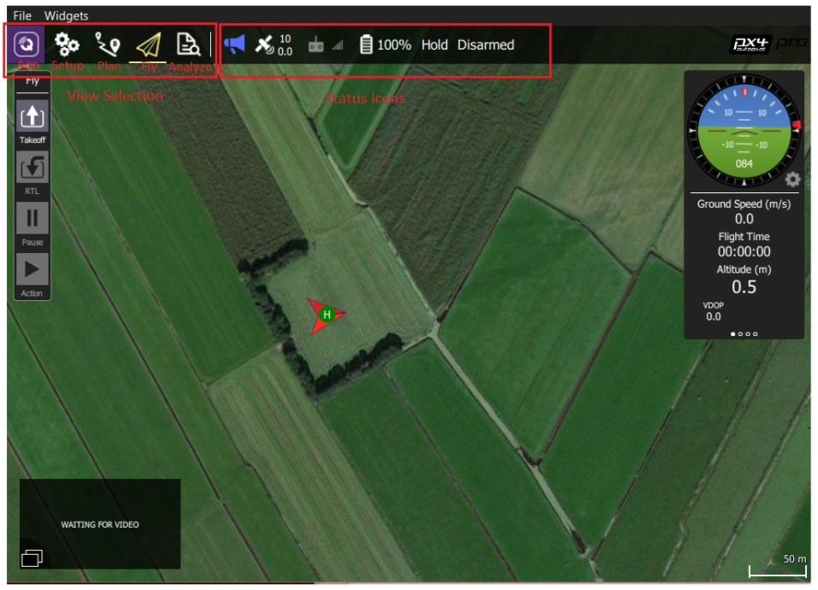
Figure 32. QGroundControl Software Fly-View

The next view examined is the plan view, which is used to plan autonomous missions. Seeing as our copter will rely on other components for tracking prey and avoiding obstacles, the missions planned here will be so the copter has a starting route to start navigating. Then when it has to leave the path or deviate, it can do so and return back to the mission afterwards. In plan view there are some tools provided by the software that are useful, on the left side the Plan Tools bar is provided. Tools included here are: add commands, survey, sync, center map, map type, and zoom in/out. The add commands tool can be useful as it allows a new mission command to be placed at a certain location on the map for when the copter reaches this location. The sync tool allows the user to communicate the missions to the copter through send, load, save, and remove options. The survey tool can also be beneficial seeing as it allows the quadcopter to survey a grid pattern of a certain area. This will be used more likely than flying a programmed path because the vehicle can be told to survey an area for example our competition area, then when it needs to deviate to attack prey drones it can but also staying within the area stated.

On the right side of this view is the mission command list. The list of mission commands are options that allow the user to edit the mission, the geofence, and even rally points. Like stated above, the survey option or also known as GeoFence is crucial to this particular project. The GeoFence will allow us to create a virtual fence around the area, our competition area, that the copter will be subject to stay within. If the copter goes outside the GeoFence boundaries a specific action can be programmed to be take, in our instance the copter will most likely be assigned to go back to its last position within the fenced in area, or go back to starting position. Within this feature there is a manual grid tool which is helpful in setting the grid pattern. This feature includes the availability of setting the grid angle, grid spacing, altitude, turnaround distance, and trigger distance. A surveying area can also be controlled with the camera connected.

6.1.6 Ground Station Central Command

The ground station is going to process the camera feed and tracking information based on our tracking algorithm. The computer science team will also be largely responsible for this portion, as the software incorporates data from their tracking algorithm and some graphical user interface design. Though this central command doesn’t require as intensive computing as the drone, it’s still a key software system on the project because it’s what the judges will use to evaluate our drone’s performance as well.

The objective for the software of the ground station is to consolidate all the information provided by the drone central command, into a video feed that meet all the software requirements for the ground station.

The ground station is a key requirement for the project and it’s success, though peripheral in ways to the Robocopter functionality, is just as important for the competition. The functionality of the software will require implementations that can account for several potential problems. One problem that could occur is that the connection between the ground station video feed and the drone’s central command could be lost. In the case that this happens, there needs to be a protocol in place for what to do to ensure reconnection, and if reconnection is not possible, how best to operate the Robocopter in a safe way. Another potential issue is that the camera feed on the Robocopter could be unstable, messing with the feed and tracking data displayed sent to central command. This becomes an issue for the video feed, which requires accurate information to display and fulfill the requirements accurately.

6.1.7 Ground Station Video Feed

The final output of the software system is the ground station video feed. After drone central command processes information and forwards it to ground station central command, it’s output into a video feed. The software system controlled the video feed needs to use the information from ground station central command to output a video that displays a stream from the drone, with visuals added on top to indicate tracking information coming from our tracking algorithm.

6.2 Algorithm Description

There will be several algorithms in place on the PCB and and Raspberry Pi that ultimately determine the behavior of the Robocopter. The PCB will largely be performing the low level control of the Robocopter, while the Intel Stick utilized by the CS team members will be used for prey tracking. The following sections will explain each algorithm in further detail.

6.2.1 Low-level control

The main algorithm used in the Robocopter is the feedback loop between the tracking system and low-level flight control systems: so that will be detailed below.

The drone starts in steady-state, where it’s simply roaming within the bounds of the competition’s zone, avoiding collisions with stationary objects. At all times, a camera feed is sent to a tracking algorithm based on a convolutional neural network (CNN) for object detection and classification. If the image sent to the CNN detects a drone, a bounding box is placed on the target. With the bounding box, the system then uses sensor data to get estimates as to the distance and location of the target. Communicating with the flight controller, the drone then attempts to maneuver towards the target for a controlled collision. Upon successful collision, the drone re stabilizes, and then goes back to the state state condition.

If at any point, the camera feed loses track of the target (or the target goes offscreen), the system will go into steady-state and start from the beginning of the loop if a target is spotted again.

6.2.2 Prey Tracking

The prey tracking algorithm will be based on the software technologies discussed in section 3, convolutional neural networks (CNNs). The goal for this system will be to identify target prey (drones). Doing so requires the system to prevent two main scenarios: avoiding false-negatives, and avoiding false-positives. Below I’ll discuss the situations leading to these scenarios to make clear the requirements of this system. They are important because failure to address these scenarios will lead to faulty performance of the Robocopter in the competition, and potentially dangerous situation that could disable the Robocopter

The fake drones used in the competition will be images of drones. A possible scenario is that these images are mislabeled as actual drones, and then the Robocopter will engage in a controlled collision with the image, which could be especially dangerous for the Robocopter if the image is against a hard surface. Another situation for false-positives is labeling something that is neither a drone or fake drone as an actual drone e.g. an obstacle. Similar to the situation before, this could lead to a dangerous collision, and should be avoided. To circumvent these issues the CNN based system needs to be trained on a carefully curated dataset to achieve good object-recognition performance, but also maintain some control blocks to ensure what is being tracked is indeed not just an image or obstacle.

Another possible situation is obtaining a false-negative. Here, an actual prey drone may not be labeled as prey, and so the Robocopter wouldn’t engage in a pursuit for controlled collision. This would be catastrophic because then the Robocopter would fail to obtain any points in the competition. The solution here, however, is similar to before. We will avoid this by testing and ensuring the dataset obtains a certain level of performance on object recognition to ensure this isn’t an issue. Another way that this could occur is through hardware failures. For example, if the flight control fails to stabilize the Robocopter enough for the camera to send steady feeds to the software system, then the images being analyzed may be too blurry or degenerate to be analyzed accurately. This problem may also result in false-positives.
If the false-positive and false-negatives are avoided, the general outline for the algorithm is as follows. The camera sends an image to the software system based on a CNN, it’s sent through the network, and the network either say yes or no to whether a prey is in the camera feed, and if so a bounding box around that prey is placed. If a bounding box is placed, the software system uses information from other sensors to get an estimate of the distance the prey is from the drone.

Once this is done, that information, along with the bounding box on the image is prepared to be sent to the ground control station. This software system also sends a control signal to low-level motor control to begin pursuit of prey. This system is a core to the project, and implements many of the requirements of the project, dealing with the ability to track prey and also have a ground control station that displays the necessary information, which comes from this software module.

6.3 Software Functionality Flowcharts

6.3.1 Prey Drone Detection
Figure 33 outlines the drone detection and tracking functionality.
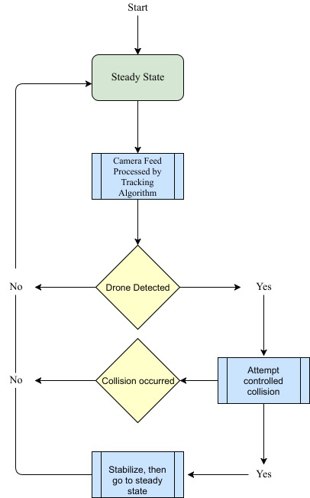
Figure 33. Target Tracking Coded Flowchart

6.3.2 Collision Avoidance

Collision avoidance is one of the main software requirements of the Robocopter. The process for how this will be accomplished from a software standpoint is outlined in Figure 34 below.
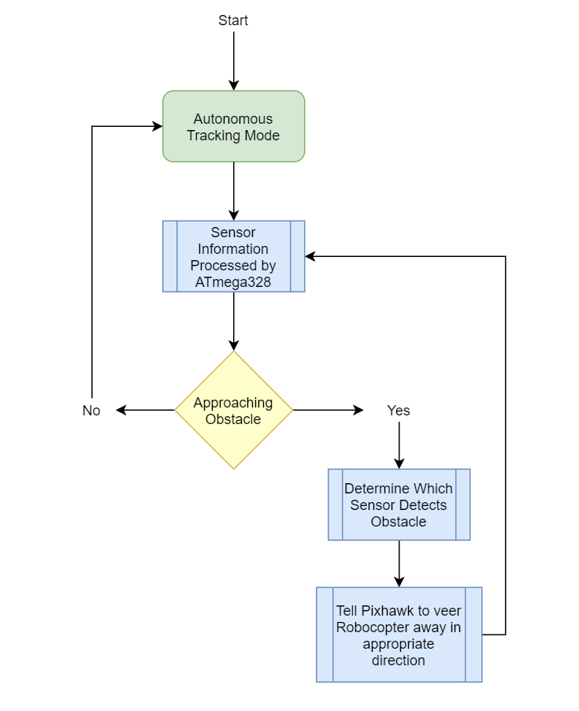
Figure 34 - Collision Avoidance Flowchart

6.4 Additional Software Features

6.4.1 Safety

Throughout the entire system there will be several software fail-safes meant to prevent catastrophic failure. Some of the software safety features are inherent to specific systems discussed before, and others are general control tests the system makes to ensure proper functionality.

A necessary software implementation is one for preventing the Robocopter from leaving an intended area. Parts of this requirement can be done through the flight controller software, which allows for setting bounds on the range in which the drone can operate. This is necessary, especially in testing to prevent losing the drone (which has occurred in previous years). In addition, this feature ensures that the Robocopter operates within range of the competition area. Ensuring that the Robocopter only operates in an intended area also makes for safer operation, because there is the potential that the Robocopter could cause damage to either people or property through faulty behavior occurring outside an intended area of activity.

This feature complements the previous one. Another feature that is needed is to have a reset state, which tells the Robocopter to return to a specific location if out of range or when in under any state where it’s lost signal with the control station. This ensures that in the case that the previous feature fails, that the drone is not lost. But also, this feature ensures that under failures that may occur as a result of the competition, that the drone understands that it should land and not remain hovering (where potentially we are unable to fix any issues).

Safety features peripheral to what was described in the prey tracking sections are how we prevent false-positives and negatives through the reinforcement of sensor data. False-positives and false-negatives could lead to dangerous collisions for the Robocopter. To prevent this, some failsafes are implemented. The sensor data we get will prevent the system from colliding with objects, so if fake prey are next to walls, they won’t be collided with. In addition, the prey tracking software also uses the fact that fake prey do not move at all, to identify true prey.

6.5 Software Implementation Design

The ATmega328 will be the heart of the PCB in the Robocopter, so the software written for the PCB will revolve around allowing the ATmega328 to effectively communicate with the other hardware components. The following sections will discuss how software will be written to accomplish this.

6.5.1 Programming the ATmega328

While testing a prototype Robocopter this semester and the beginning of next, an Arduino Uno equipped with an ATmega328 will be used in place of a PCB. Loading software or code onto an Arduino Uno is simple: first, the software package for Arduino Uno will be downloaded. Code for the Robocopter can be written in that software package. After doing so, the code is loaded onto the board via USB. At that point, the board is ready to use the code.

For the custom PCB with an ATmega328, the code will be loaded in a slightly different manner. Rather than using the designated Arduino software package, code will be developed using the Atmel Studio IDE. On Atmel studio, the ATmega328 can be selected as the chip being used, and then when code is written in the IDE, it will be ready to be loaded onto the chip. Again, the code will be loaded via USB, so the PCB that is designed will have a USB port integrated onto it. One work around to this, which will likely be used in the Robocopter’s design, is to utilize a USB to serial converter. Rather than having to design the usb to serial conversion on the PCB itself, a separate chip that performs this functionality can be purchased and plugged into the ports of the PCB.

6.5.2 PCB to Pixhawk Communication

The Pixhawk flight controller will be handling such things as each motor’s rotation and direction so that the Robocopter can fly correctly. For it to be able to do this, it will need to be interfaced with the PCB so that the ATmega328 can provide instructions as to which direction the Robocopter must move. Once those instructions are received, the Pixhawk will enact the appropriate fine motor controls to achieve that movement.
The first step in this process is the data collection from the sensors both on the Pixhawk, as well as the other peripheral sensors attached to the PCB. This information is relayed to the ATmega328 where appropriate movement decisions are made. For example, if a sensor detects that the Robocopter is close to an obstacle, the ATmega328 will interpret that information from the corresponding sensor, and make a decision about which direction the Robocopter needs to move. To accomplish this movement, the ATmega328 will communicate with the Pixhawk via a MAVlink, which will be discussed further later. Once the Pixhawk has instructions as to which direction the Robocopter should move, it will enact the appropriate adjustments to the orientation and thrust of the motors. Another important note to make is that this process will occur in conjunction with the prey tracking being performed by the Camera and Intel Compute Stick. The Camera will be providing information to the Compute Stick regarding prey movement, but not about the Robocopter’s location. Consequently, if a sensor detects the Robocopter approaching an obstacle at a rapid rate, there will need to be an interrupt to the Compute Stick’s instruction so that the ATmega328 can correct the path by communicating with the Pixhawk as described before. Once that process is complete, control of the Pixhawk will be returned to the Intel Compute Stick.

Figure 35 shown below depicts the relationship between the sensors, ATmega328, Pixhawk, and ESC (electronic speed controllers). Information flows from the sensors to the ATmega328, as a part of the obstacle avoidance functionality. The instructions that result from that data flows to the Pixhawk to determine flight path. The Pixhawk then tells the ESC to adjust the motors,
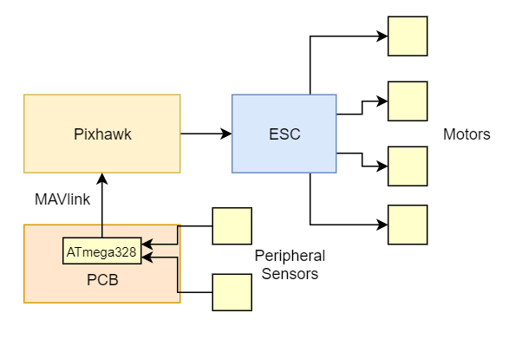
Figure 35 - PCB to Pixhawk Communication
6.5.2.1 MAVlink

For the ATmega328 to communicate with the Pixhawk, a specific message protocol is needed. In this case, that protocol is called MAVlink [98]. The serial communication channel of the ATmega328 will be utilized to establish communication with the Pixhawk through MAVlink messages. There is a library of MAVlink commands and messages that will be drawn from to direct the Pixhawk to perform different adjustments and movements.

6.5.3 PCB to Camera Communication

The Runcam Split 2 will be the camera used by the Robocopter to detect the movements of prey drones; it will need to be interfaced with the PCB to function properly. The software written for the PCB to talk to the Runcam will be pretty simple, as it will only need to inform the Runcam to turn on and start recording. Once the Runcam is recording, its video feed will be sent back to the PCB where the ATmega328 will direct the feed to the Intel Compute Stick. The Compute Stick will contain the tracking algorithms - largely written by the CS members of the team - that will be applied to the feed from the Runcam. For each unit of time of video processed by the Compute Stick, it will send instruction back to the ATmega328 regarding which direction the Robocopter needs to move to intercept the prey drone it is tracking. The ATmega328 will then relay that information to the Pixhawk to perform the exact movement adjustments required, in the process described in the previous section.

6.5.4 Camera Feed

One of the primary requirements outlined for the Robocopter is not only that it must track and intercept prey drones, but that it also sends a video feed from the camera of the tracking in action. The Runcam split 2 will be the camera used for tracking purposes, and fortunately, it has wifi functionality built into it. As the Runcam is recording video from the perspective of the Robocopter, it will be sending that feed through wifi to a ground station, which will be an app on a phone. The CS team will be performing minor adjustments to the video feed so that the tracking algorithms in work will appear on the feed. The phone app will display this video feed with the tracking algorithms in work so that an observer can visualize what the Robocopter is actually doing in its movements.

6.5.5 Software Variable and Function Breakdown

Now that the high level software functionality on the Robocopter has been examined, a more indepth look will be beneficial. The following sections will outline and describe the specific variables and functions that will be used to realize the required software functionality. The variables are conditions or characteristics that define the current state of the Robocopter, and the functions are procedures that initiate when certain variable conditions are met.

6.5.5.1 Variables

boolean sensor1Detect, sensor2Detect, sensor3Detect - each of the three peripheral sensors will have their own boolean variable. Each variable is set to false if the data being reported to the ATmega328 by each respective sensor is determined to be insufficient to require flight path alteration. If one of the sensors reports that the distance between the Robocopter and an obstacle is significant enough to warrant a change in path, the variable for that sensor is set to true.

boolean preyFound - this variable is a boolean that is initially set to false. When the trackingMode() function is running, the preyFound variable will be set to true if a prey is discovered. Once set to true, the targetIntercept() function takes control.

boolean collisionOccured - this variable is a boolean that keeps track of collisions. It is initialized to false, and can be set to true if a collision occurs during the running of the targetIntercept() function. If this variable is set to true, the collisionRecovery() function takes control.

boolean manualFlight - this boolean variable is also initialized to false. It is set to true if input from the RC controller is detected. Once set to true, the manualControl() function initiates. This variable is set back to false once flight is reset so that autonomous control resumes.

boolean flightInitiated - this boolean is false initially, and set to true at the completion of the flightInitiation(). The variable is set back to false after the completion of the manualControl() function. This is because flight must be reinitiated after manually controlling the Robocopter.

6.5.5.2 Functions

poweredOn() - This function will handle the startup of the Robocopter. When the switch is pressed to power on the Robocopter, this function will initiate all the hardware components. The camera will be activated, as well as the sensors, Pixhawk, etc.

sensorDetection(sensor#Detect) - This function will handle the scenario where a sensor detects that the Robocopter is rapidly approaching an obstacle. Depending on which sensor reports the information, the Robocopter will react accordingly. If an ultrasonic sensor in the front of the copter reports that it is closing in on an obstacle directly ahead, the function will tell the Pixhawk that it needs to adjust flight as to move backwards and thus avoid the obstacle. In other words, these function will initiate if one of the sensor#Detect booleans is set to true.

flightInitiation() - This function will take control after the poweredOn() function completes. Once all hardware is initialized, this function will tell the Pixhawk to adjust the motors so that the Robocopter lifts off the ground vertically to the desired tracking height initiation.

manualControl(manualFlight) - One of the features of the Robocopter is that it will be able to be controlled manually if need be. This function will activate if input from the RC controller is detected. It will stop the autonomous functionality of the Robocopter and allow the RC controller full control of the Pixhawk and the vehicle's movement.

trackingMode() - Apart from targetIntercept(), most of the flight of the Robocopter will be through this function. This function will begin after flightInitiation() has completed, and will direct the Robocopter to begin moving around to search for prey drones. The Intel Compute Stick will contain the algorithms to perform this function, and as such will be designed mostly by the CS team. While in this function, the Robocopter will follow predefined guidelines to autonomously fly through the competition course in search of prey drones.

targetIntercept(preyfound) - This function will initiate if preyfound is set to 1 - that is, if a prey is found while the Robocopter is in trackingMode(). If that condition is met, targetIntercept() will follow algorithms contained on the Intel Compute Stick to travel towards the prey drone it is locked onto. These instructions will direct the Pixhawk to move towards the prey drone until a collision is made.

collisionRecovery() - If the collisionOccured variable is set to true by the targetIntercept() function, this function will then take control. The role of this function is to stabilize the Robocopter after it has collided with a prey drone.

Figure 36, seen below, depicts the relationships between each function and the variables they depend on. The green boxes contain the function being performed at a given time, and the arrows flow towards the function that will take control if certain conditions are met. These conditions are shown next to the flow arrows.

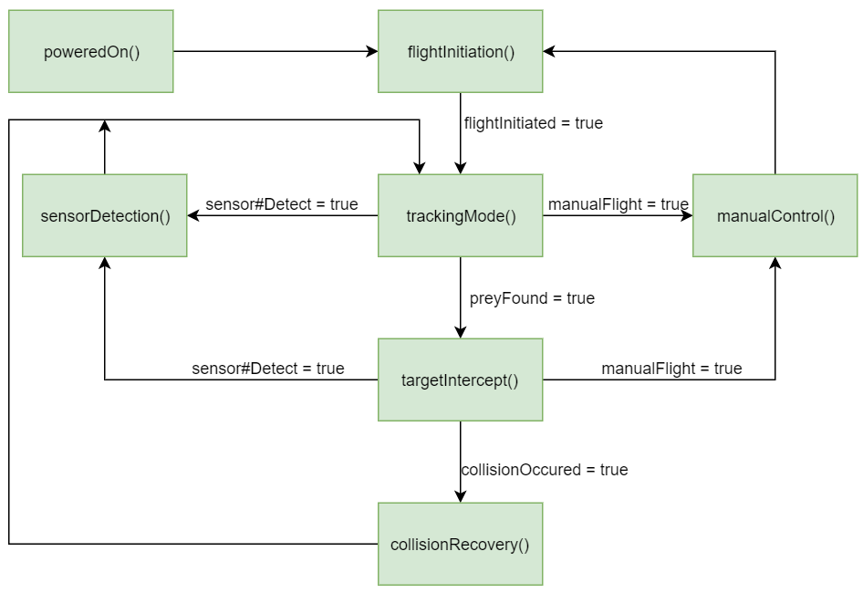
Figure 36 - Function and Variable Dependencies

6.6 Optional Software Features

There are several software features which could have made it into the final design of the Robocopter. However, for various reasons, these features were not implemented into the final design. Several of these features will be detailed below, discussing their benefits and disadvantages to the design, and why ultimately they were not included in the final design.

6.6.1 Alternative Modes of Control

For the Robocopter, there are some modes of control used. These include an automated control ability, where the movements of the Robocopter are determined by the on-board software on the Robocopter. There is also remote control abilities, that allow manual override of the automated control. However, two options for control modes that weren’t further explored in this iteration of the Robocopter, but were potential options, are voice and gesture control [78, 79]. There are some hardware features necessary to implement these, but I will largely focus on how these modes of control are implemented on the software side, with brief mention of the hardware necessary to support them.

6.6.1.1 Voice Control

Up until recently, state of the art in natural language processing didn’t offer performance like most smartphones have now on voice recognition tasks. This was onset by the application of neural networks towards the task of speech recognition, and subsequent adoption of this method by corporate artificial intelligence laboratories like Google and Microsoft. This helped further the adoption of smart control technologies operated largely through voice commands, like Google’s voice assistant, Microsoft’s voice assistant, Amazon’s Alexa, and Apple’s Siri.

This technology has been adapted for cars as well, a case study I will detail further; as it pertains to the sort of features that a Robocopter could potentially have. In cars, voice control has become a safety feature as well, because the hands-free control of different services provided by the car can now be handled hands free. This allows the driver to be more aware of the road and their driving, in addition to building a more efficient user interface. Some specific examples of this are with GPS systems, where you can ask the car to find a place to eat, or somewhere to find gas. In response, these systems will locate the nearest locations or allow you to choose from a set of options. Opting for this route means that the driver isn’t dangerously trying to drive and use their phone or GPS device at the same time.

With the Robocopter you could expect a slew of features aided by voice control. Nearly every control command could have a voice option, and it could be tied to either the ground station which routes signals to the drone or to the drone itself. I will detail some of these features below and how they could be beneficial to the project.

One feature is a voice-controlled startup. This has several benefits. For one, there is less mechanical wear and tear on the startup switch that might be used otherwise. Another benefit is convenience and response time. Implementing a feature like this means that the Robocopter could be started at a distance, and in doing so it increases the efficiency for which it takes to get the Robocopter functioning. Using manual switches, like mentioned before, would slow this process and also result in wear and tear of physical on and off switches on the Robocopter.
Other voice-control options include actions like recall, search, and reset. With recall, the user would speak to the ground station and the command would prompt the Robocopter to come back to the location of the ground station. For search, the Robocopter would be put into an active state, where it searches within a pre-specified bounded area for potential prey. For reset, the Robocopter goes back to its default state, especially useful for when you want to halt any active pursuit of prey or searching activity.

All in all, voice-control has several benefits however it also introduces many challenges. Foremost are the issues with implementation and stability of the voice recognition software. Despite advancements in speech recognition that now support many commercial applications like Amazon’s Alexa and Apple’s Siri, it’s clear that there are pitfalls. For example, in noisy environments it may be difficult to get commands across because of the mixture of other noise blocking out the signal the voice recognizer needs to detect. This could be especially disastrous towards the competition if voice-commands are what mandate whether or not the drone go into a search mode or if there is no other way to reset the drone in the case of some other software failure. Another disadvantage is in that it would also stretch our expertise thin, where the team has less experience on voice recognition applications. Foreseeing these difficulties, it was decided to forgo these features in lieu of manual and automatic controls, apart from voice-recognition.

6.6.1.2 Gesture Control

Gesture control is broader topic in computer science that deals with interpreting human gestures through the use of algorithms. Typically these motions can come from the body, and most commonly come from the face or hand. Technology like Microsoft’s Kinect uses computer vision techniques to track specific points on the body, in order to provide gesture recognition abilities. However, there are other gesture recognition products like the myo armband which is a device worn on someone’s forearm which lets people wirelessly control electronic devices using hand motions, without the need of a camera for gesture recognition like Microsoft’s Kinect. Something like the myo armband would have been a more appropriate gesture recognition tool for the Robocopter project.

Some major applications for gesture control has been in automotive sectors, consumer electronics, transit, gaming, smartphones, defence, home automation, and sign language interpretation. Similar to voice-control it enhances user experience and efficiency by cutting down on the time it takes to use specific devices. For example, a gesture to start my car or to turn off the lights in my room is a potentially useful tool to have available.

As I mentioned before, there are a number of different ways to go about gesture recognition and tracking, both on the hardware and software side. I will detail some quick mentions on the hardware, and then go into their software implementations. Some examples for gesture recognition are wired globes. For example, the sensors on the glove send back information, which is then used to determine if a specific gesture was performed. An early example of this was the DataGlobe, which could detect someone’s hand positions, their movements, and even subtler movements like finger bending. Fiber optics ran throughout the hand and light pulses were sent to detect when bending of fingers caused disruption in the signal. This information allowed the glove to recreate gestures digitally.

Another option is to use depth-aware cameras. One could imagine a depth-aware camera on the ground station constantly searching for gestures to relay to the Robocopter. There however would be more latency and potential inefficiencies with using this approach as opposed to something like a wired glove, since it brings in level of computer vision techniques required to analyze video feeds. Perhaps to mitigate this the use of stereo cameras could be done, which has been used in previous gesture recognition products, however the problems would likely still persist despite marginal improvements.

Mouse controlled gesture tracking is another option. The ground control station could have a platform for a mouse that the user could use to draw a gesture which would then be sent to the Robocopter to implement several different actions. Similar to the voice control option, these options could be used to more efficiently control the Robocopter by saving time that would be used if a manual control option was preferred.

Depending on the hardware used, the software implementation of the gesture control could be quite different. However, most rely on pointers provided by the hardware couched in a 3D coordinate system. Using this information there are a class of algorithms that generally describe the types used in gesture control systems. These are 3D model-based algorithms, skeletal-based algorithms, and appearance-based models. For 3D model-based algorithms, volumetric models are used, which are heavily used in computer animation applications. The downside however, is that this method is incredibly computationally expensive, especially for a real time analysis of the gesture control. For skeletal-based algorithms, intensive processing of 3d models are forgone in lieu of a virtual skeleton, where parts of someone’s body is mapped to a digital skeleton. The advantage of this method is that the algorithms work quicker because smaller numbers of parameters are being analyzed. Also, pattern matching becomes possible, against templates found in a database. Lastly, the key points let the program focus on distinct and specific parts of the skeleton. For appearance-based models, a spatial representation of the body is forgone, and instead 2D templates are used. For its simplicity, this method is often only employed for hand-gesture recognition.

For the Robocopter, we opted not to use gesture recognition despite its benefits with regards to usability because of the challenges inherent to getting some hardware and software integrated on top of the core requirements necessary for the competition. Ultimately, because of time requirements a compromise was made between usability and feasibility of the implementation with the expertise from the group.

7. Testing and Debugging

Testing will be critical to constructing our Robocopter and ensuring high performance, and will be broken into several stages. There will be two major aspects of testing we will complete: hardware testing, and software testing/debugging. The following sections will break down the processes we will be using to complete these aspects of our construction of the Robocopter, as well as any results we reach in doing so.

7.1 Hardware Testing

Before we can start construction of the Robocopter, we will be testing each of the hardware components that will be utilized. Testing of these components will be vital to confirming not only that they are working properly, but also outline what requirements each will have for being implemented correctly in unison.

7.1.1 Hardware Testing Procedure

One of the most important parts to be tested once all of the components ordered arrive and everything setup is the battery life. Although the required flight time is 10min and that does not mean that the battery cannot be changed out, it is preferable not to do that in order to reduce cost of having to purchase another battery. Besides the cost, it is not preferable since that means the competition would have to be paused and spend time changing out the battery which could also cause an error when reconnecting under the pressure and other factors. Also, since the battery cannot be discharged below a 80% of its capacity then the battery must be prepared to last at least 15-20 minutes in flight time. This way we make sure we don’t run below the threshold. From testing we will be able to determine the best solution in case it is not sufficient. If in case it is necessary to change the battery then most likely a higher capacity battery should be selected. This does increase the weight and there is a point where the larger capacity will not be of benefit anymore and would just become another load but if chosen right before that point then the higher capacity will increase the run time. What other drone hobbyist also implement is two smaller batteries in parallel that would produce a higher capacity but perhaps keep lower weight than a single one with high mAh. It is important to note that if using two batteries for the same components, they should be placed in parallel and not int series. In series you would simply make a battery with more cells, not necessarily more capacity and more. For example if you place two 2200mAh 3S LiPo batteries in series, then now you have a 6S battery but you are also supplying a lot more current that could perhaps burnout the motors and electrical components because it is beyond what they can handle.

Related to the battery life, is actually monitoring it. The power module will be in charge of performing voltage and current monitoring to know when the battery is running low and will require the quadcopter to return to the ground. Since in the early stages the system still will not be in autonomous mode and we simply want to test, we will use a buzzer that will notify when the battery has reached the 80% threshold. Then we can compare to when the power module detects this as well and double check that it is working properly. Although for the actual project a buzzer won’t be necessary since the battery monitor ratings will be displayed on the live first person view video and it can be tracked from there.

Secondly, the testing of the motors is super important before attempting to fly. It is necessary to make sure they are able to produce the thrust it says that it can and can lift the quadcopter to the necessary parameters. Although there are many ways to test this, two alternatives will be discussed. The first option is the one most would think of, and that is selecting different objects found around the house that have known weights and test them with increasing weight as you fly the copter in RC mode. The great thing about this option is that is very analytical and thorough. You can easily create data points and analyze the data that could help in the future for battery selection, in case a different motor is needed this can serve as a reference along with other benefits. The second way of testing the grams of thrust that the motors provide is by setting them up on the drone’s frame and placing the drone upside down on a balance. Then, with the RC controller you begin running the motors until you reach their maximum about and record the amount of grams the balance displayed. This is a good solution if you need a quick and easy way to test the amount of thrust produced. It might not be as accurate as the other method but it still works. It is the same as if you have a large sample with lots of data points you will obtain much more precise results and estimations versus if you have a very small sample with few data points. The percent error between the two could be substantial but it depends on the situation and the purpose that will determine if it is worth the risk. For this particular project, either way will work since everything is also being overestimated to give a decent cushion for error and changes in the design in the future.

Another component that is very important to test is the camera. In the beginning steps of testing, mainly what is being looked for is that the camera works, and the amount of latency that it has. In addition, this is the part where we would set up all the desired settings on the camera and verify that they work efficiently. So to test the camera alone, first we would connect it to the computer to set the settings to for example the 4:3 FOV ratio and to transmit the first person view video in real time through wifi enabling. Once the wifi is enabled and the app is downloaded on a cellular device then, that device can be connected to the camera’s wifi module. Through the application, the video would be displayed and simply moving your finger in and out of the frame can give a good estimate as what to expect in terms of the latency. That is mainly for basic testing. To test it a bit further it would be best to begin testing the wifi transmission of the video through a wireless router as will be needed for the final project. This can be done it two ways, one is using the wifi module that the camera already brings which is compatible or the wifi embedded in the Intel Stick to where the camera will be connected, can be used to transmit the video.

Considering that it is also necessary to add an on screen display or OSD that will provide the algorithms used to detect the prey and avoid obstacles as well as other readings such as altitude, battery life, and so on, then the best solution should be to use the wifi that the intel stick provides. This can be easily integrated in the programming and thus it is easier to have both displayed at the same time, with no lag and more accurately.

In this instance, for testing purposes since the Intel Stick is still not programmed with all the coding needed, we tested the camera using the wifi module the camera brings to where we paired connected a cellphone using the RunCam App to the module. We powered it on using a USB cable that was connected to a laptop. Although this is acceptable, we did notice that the camera and its board were getting a bit heated. Although the MacBook we were using has USB ports that supply 5V of power which is the maximum the USB port on the camera can take, it was a bit hot. This could potentially be that the current supply was too much, but the true reasons are unknown at the moment and we will continue testing for this purpose. Perhaps when the LiPo battery is used, it would be better. In addition, we will be using the vcc soldering pad on the camera’s board to power it on, where it can take up to 17V of power and this could reduce the heating. Despite that, we did have it on for over 10 minutes and no damage to the component was done which lets us know that this camera can still be used for the project. Figure 37 is a picture of the settings used to set it up that could also be affecting the temperature.
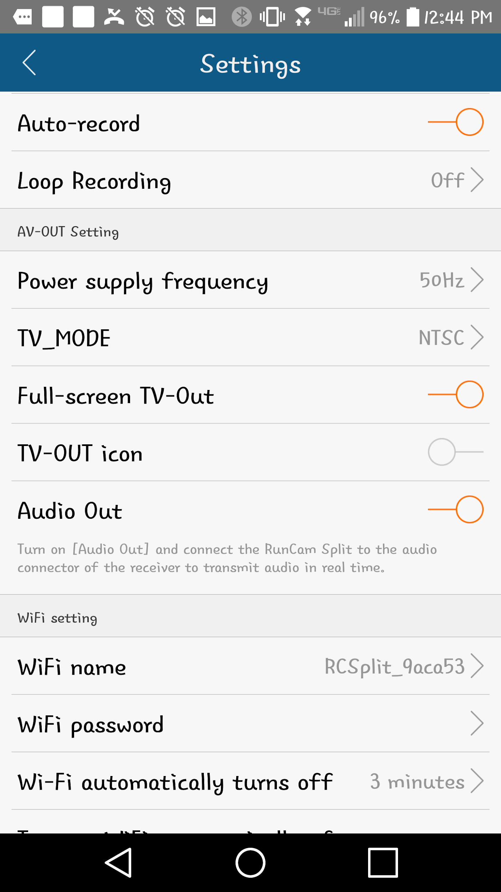
Figure 37: RunCam Settings

Now the latency was somewhat more than we expected. There is an obvious delay in the image. It is still in the millisecond range but if paying close attention to it, there is noticeable delay in the image. We attempted to change some of the setting above such as the TV_Mode and Audio Out in an attempt to reduce the amount of processing the camera has to do before sending the image out but there wasn’t much change. Our next testing attempt will be to use the intel stick’s wifi that perhaps is faster. This can only be accomplished once we have sufficient coding on the intel stick.

Part of this process will also be testing different design alternatives to the provided Arduino Uno schematic. The layout will be modified to suit our needs and simulated to see if the design theoretically works. This part of the testing is extremely important and so essential. It is better to burn something during simulation and be able to fix it before actually messing something up in the physical circuits. Since the official PCB design won’t be finalized until next semester, a breadboard with wires and all the physical components will be used for building the circuits and testing. Yet, the circuits physically built will follow strictly what came from a successful simulation. This is when the EagleCad software will be best taken advantage of. Although there has been a lot of work and careful research put into each aspect of this project by a strong and diverse team, the design won’t always turn out the way it was expected from what was learned through reading. Then with trial and error and testing through softwares and breadboards, the final outcome can be reached for a winning quality robocopter.

7.1.2 Parts

In order to be able to do some testing, first understanding the parts that are needed and how they go together is necessary. So far the necessary parts to begin testing have been ordered although it is known that there will be some additional components that perhaps will be needed later on. An example of this, is that since now the exact motors that will be implemented are known a more appropriate battery than what is currently being used for testing can be selected. Figure 38 is a picture labeling the main hardware components that will be used and have arrived already.

Yet, since this is a sponsored interdisciplinary project, there isn’t the same level of flexibility when it comes to ordering parts. For this reason the sensors have not arrived yet, even though they were ordered at the same time as everything else. The image also includes the way in which the components should be connected. How the power distribution board is connected to the battery through the power module which would then connect the Electronic Speed Controllers that are also connected to the motors and the Pixhawk Mini Flight Controller. Since there is still no PCB, then we will be using an Arduino Uno board powered by an ATMega328. Although there is a large possibility that the design deviates from this one where two batteries would be implemented, one for the electronics and another for the motors, first one battery would be tested to see the response and if we can save some of that weight that an additional battery adds.

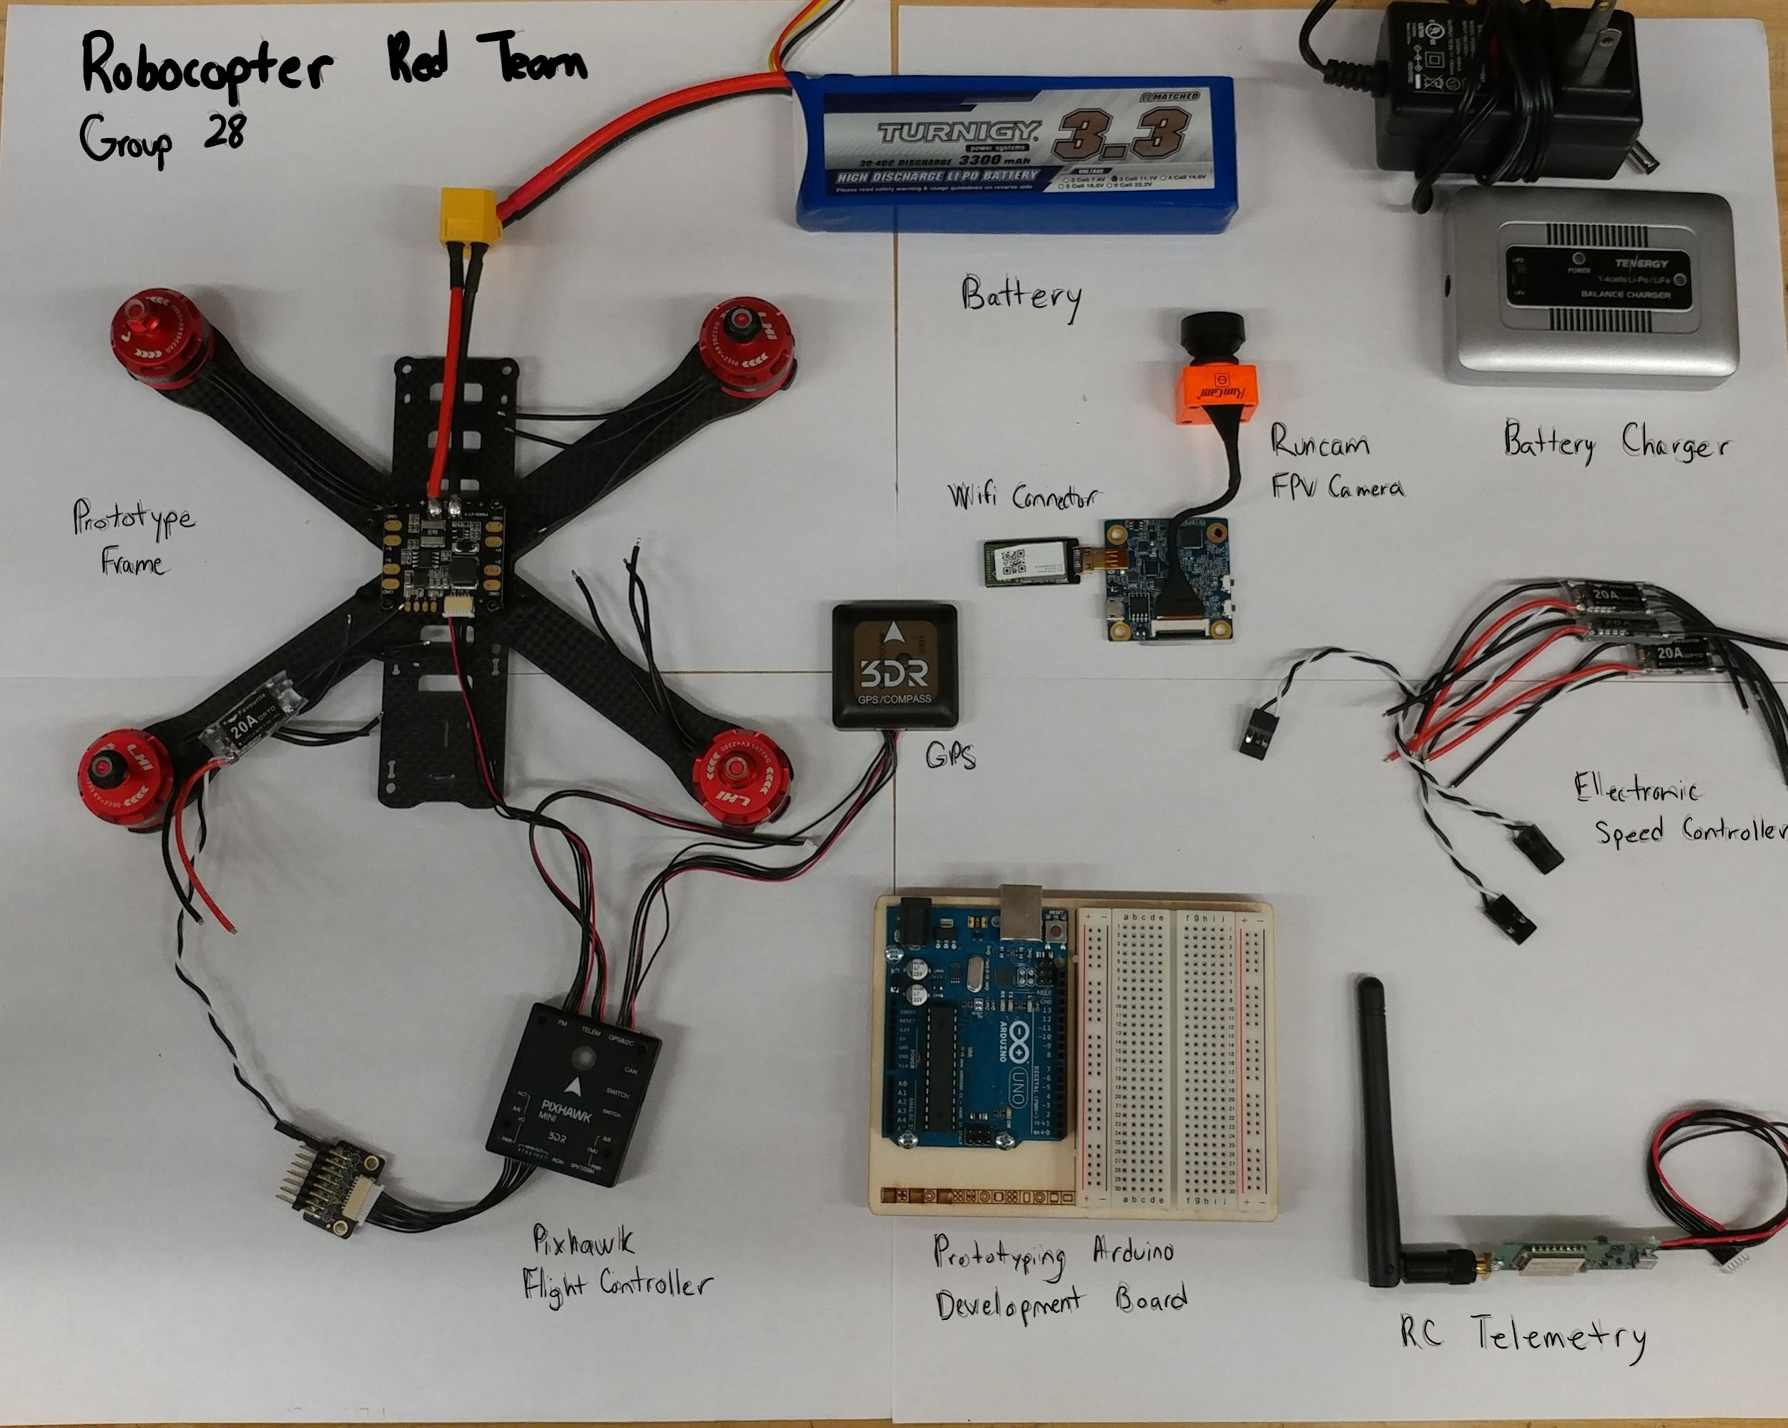
Figure 38: Hardware Component Connections

Next, Figure 39 displays the actual frame that will be used for the robocopter, which was ordered and has arrived and in addition the Intel Stick. At the moment since there is no code on the Intel Stick it has not been included in the diagram of connected parts.
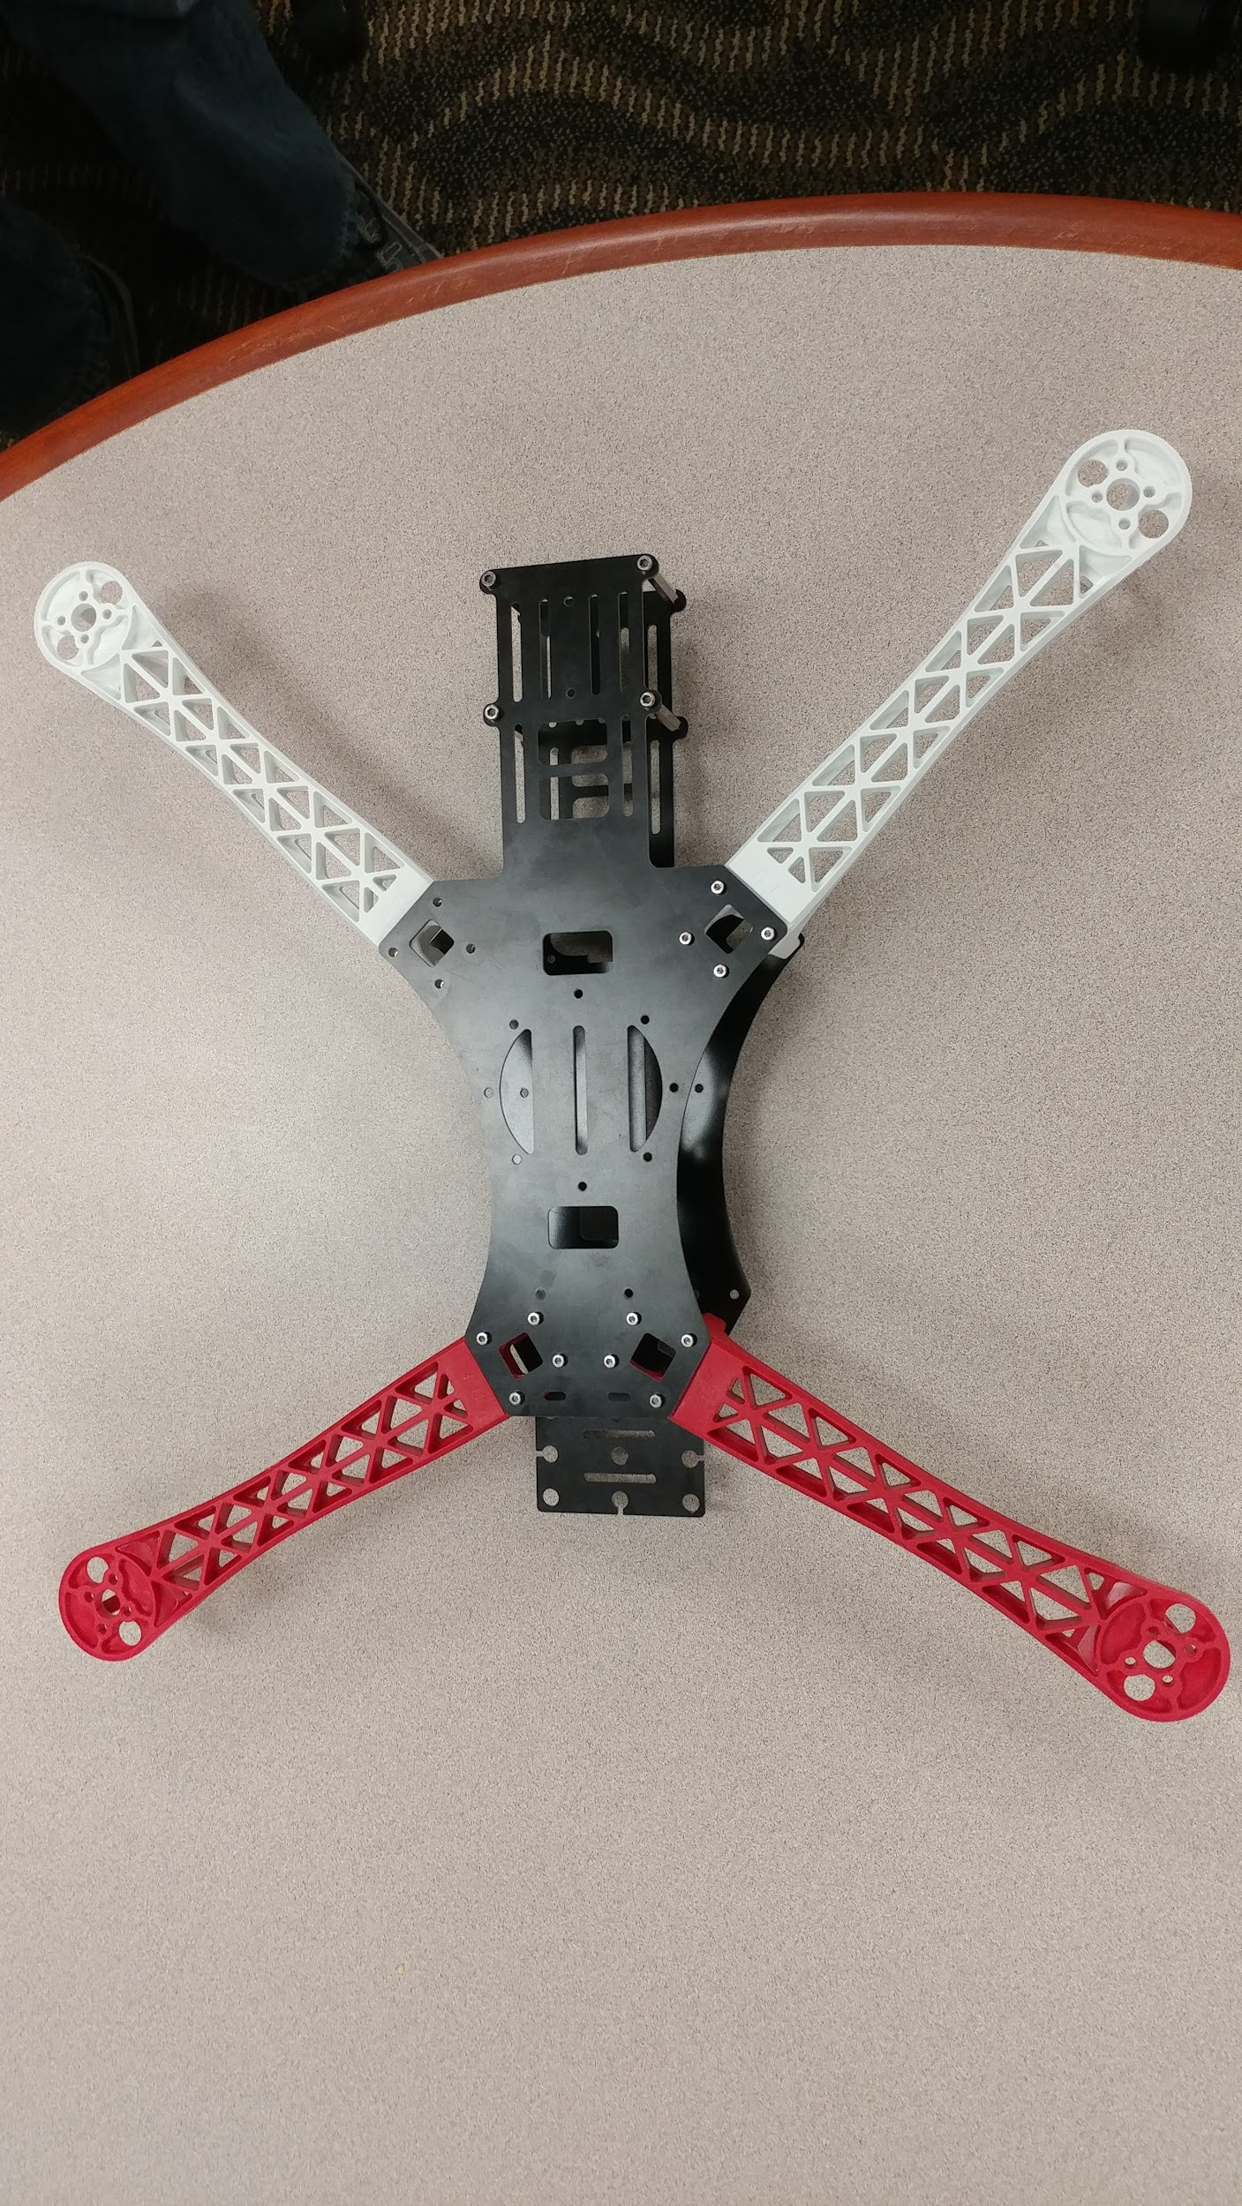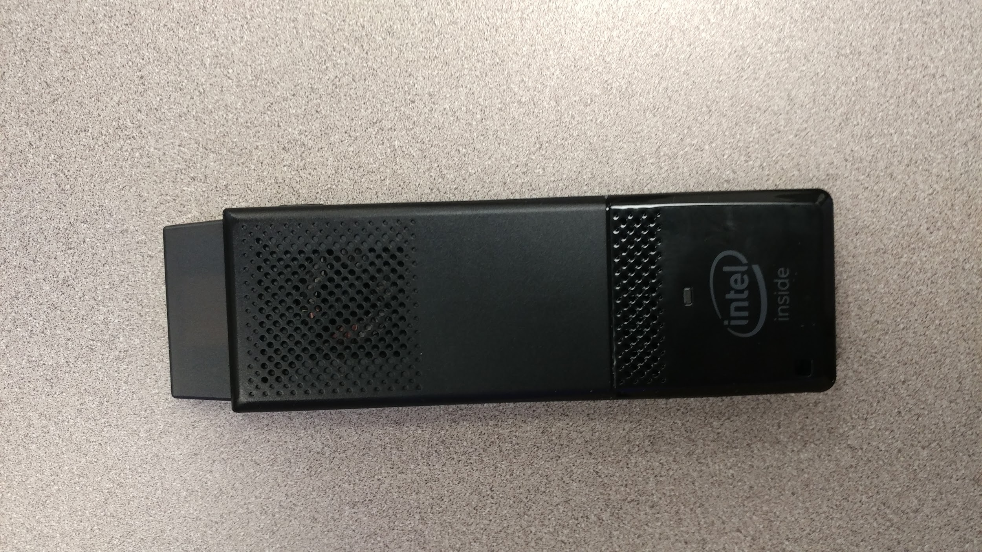
Figure 39: Actual Frame and Intel Stick

7.2 Software Testing

The programming for the Robocopter will be equally important as the hardware when it comes to its end performance, so making sure it works correctly is imperative. The different software components we will be testing include the interfacing of the Intel Compute Stick and PCB, the PCB’s control of the other components, and the ATmega328’s functional flow. Part of the testing will occur in Senior Design II, where we will be working on the control, movement, and tracking of the Robocopter in a more complete state. The testing being performed this semester will be on isolated sets of components - such as the battery -> PCB -> motors, etc. As our PCB will not be constructed until the Spring semester, we will be performing software testing and debugging using an Arduino Uno. Arduino Uno uses an ATmega328 chip, which will be the one integrated on the PCB - this will ensure accurate testing.

7.2.1 Testing PCB to Pixhawk Communication

The flight of the Robocopter will be handled by the Pixhawk in unison with the PCB. Testing this connection will be vital to the Robocopter’s movement. To test it, code will be loaded onto an Arduino Uno board that has an ATmega328. The Arduino board will be connected to the Pixhawk via the telemetry port on the Pixhawk. The code will contain instructions that will require the Pixhawk to adjust the speed of the motors as well as their direction. Several different variations of these instructions will be tested to confirm that the Pixhawk is receiving the instructions correctly, and making the corresponding adjustments to the motors.

7.2.2 Testing Camera Feed

Another major function of the Robocopter that will require testing is the Runcam camera and the feed it sends. It will be important to make sure that the Runcam is able to transmit the feed it records to both the PCB and to the ground station. Testing the latter will be relatively simple - the Runcam will be connected to the Arduino Uno test board which will be used to tell it when to turn on and start recording. It will also, of course, be connected to the battery source. Additionally, a phone will be equipped with an accompanying Runcam app designed to display the feed from the Runcam - this app will be connected to the wifi module of the Runcam itself. Once the Runcam is turned on and recording mode is engaged, its feed should be displayed on the app on the phone being used. This process will be tested several times to confirm that the feed is correctly being transmitted to the ground station (phone).

7.2.3 Testing Individual Software Functions

Apart from testing the overall functionality of the Robocopter, it is necessary to test each software function independently to make sure they work correctly. Some functions will only be fully testable once the Robocopter’s final frame is complete in the Spring semester. In the meantime, as much of their functionality will be tested as possible.

The poweredOn() function will be the simplest of functions to test. The procedure for testing this function will start by confirming that all hardware components are connected appropriately. Then, the overall power switch will be turned on. At this point, all hardware components should turn on and be in standby mode. If the camera, sensors, Pixhawk, and other components are all powered on and ready to use, the function is successful.

The flightInitiation() function will not be possible to test on the actual Robocopter until it is constructed in the Spring semester. To test it this semester, we will be attaching the hardware components to a prototype frame. After the poweredOn() function is complete, flightInitiation() will be ready to run. By activating another switch, the function will begin. The goal of the function is to lift the Robocopter into the air to prepare for prey tracking mode, so that is what will be confirmed to be working by the test. If the prototype drone, equipped with the operational hardware components, is turned on and able to lift off the ground to a neutral air position, the function is tested to be successful.

The sensorDetection() function should alter the flight path of the Robocopter if a sensor detects that the Robocopter is on course for collision with an obstacle. To test this function this semester, the hardware components will be attached to the prototype drone frame, as accurately as possible to how they will be attached for the final build. Because part of this function includes interrupting the prey tracking algorithm, it will not be possible to entirely test it this semester. Once the CS team has completed the tracking algorithms, sensorDetection() will be able to be tested properly. Part of the function can be tested now however. After powering on the Robocopter, the sensors should be active and ready to work. They will be actively reporting data to the ATmega328 for processing. By placing a hand in front of a sensor, and then moving the hand closer to that sensor, the function should eventually activate once a certain distance threshold is crossed. At that point, the Pixhawk should redirect the motors in a fashion that would reverse the flight of the Robocopter. As our initial test will not include flight, we will simply be confirming if the motors’ directions change.

manualControl() is another function that will require further testing once the Robocopter’s final frame is complete. For now, the function will be tested by allowing a user to control the Robocopter once the flightInitiation() function has completed. At that point, a user will be able to input directional instructions from an RC controller, and the Robocopter should move accordingly. If the Robocopter changes from the neutral position after flightInitation() to allowing movement from the RC controller, the function will be determined to be successful.

trackingMode() and targetIntercept() depend entirely on the tracking algorithms written by the CS team, so their functionality cannot be tested at this time. Once they have finished writing that software, the functions will be tested on the prototype Robocopter. To test the trackingMode() function, it will first be important to confirm that flightInitiation() has completed. At that point, trackingMode() will initiate. The Robocopter should then begin to move according to predetermined guidelines. If the Robocopter starts to move in a logical manner, and reports video feed to the ground station, the function works correctly. Once a prey drone is spotted, targetIntercept() should initiate. For testing purposes, the team will be purchasing a drone online to use as a prey drone. That prey drone will be flown in front of the Robocopter, and once the Robocopter spots it, targetIntercept() will engage. The Robocopter should then pursue the prey drone until it collides with it. If such functionality is achieved, then testing of the function will be successful.

Finally, collisionRecovery() must be tested. It will not be safe to test this function until a protective cage for the Robocopter is built, so that it does not fall apart upon collision. Once that is achieved, collisionRecovery() will be tested by colliding the Robocopter with test prey drones. If the Robocopter collides and is able to successfully stabilize itself back to trackingMode(), the function will be determined to work correctly.

Once each function has been tested to work independently, some final tests will be performed to confirm that they all work together. Starting from the poweredOn() function, each pathway through the function dependency chart will be tested to make sure the right functions take control at the right times, and that they work correctly when they are supposed to. Most of this testing procedure will be performed in the Spring semester when the construction of the actual operational Robocopter begins.
8. Administrative Content

The Robocopter will take considerable effort to realize, so scheduling, budgeting, and organization will be a primary focus for us. The following sections will break down the roles of each team within the interdisciplinary group, our milestones and scheduling objectives, and also our part selection with corresponding costs.

8.1 Project Roles

Given the interdisciplinary aspect of the project, it’s necessary to indicate all parties involved in the project; even though this report focuses on the contribution of the computer and electrical engineers.

Figure 40 is a pie chart detailing the number of team members from each of the disciplines and the what percent of the team they comprised: Aerospace Engineers (AE), Electrical Engineers (EE), Computer Engineers (CpE), Mechanical Engineers (ME), Computer Science (CS).

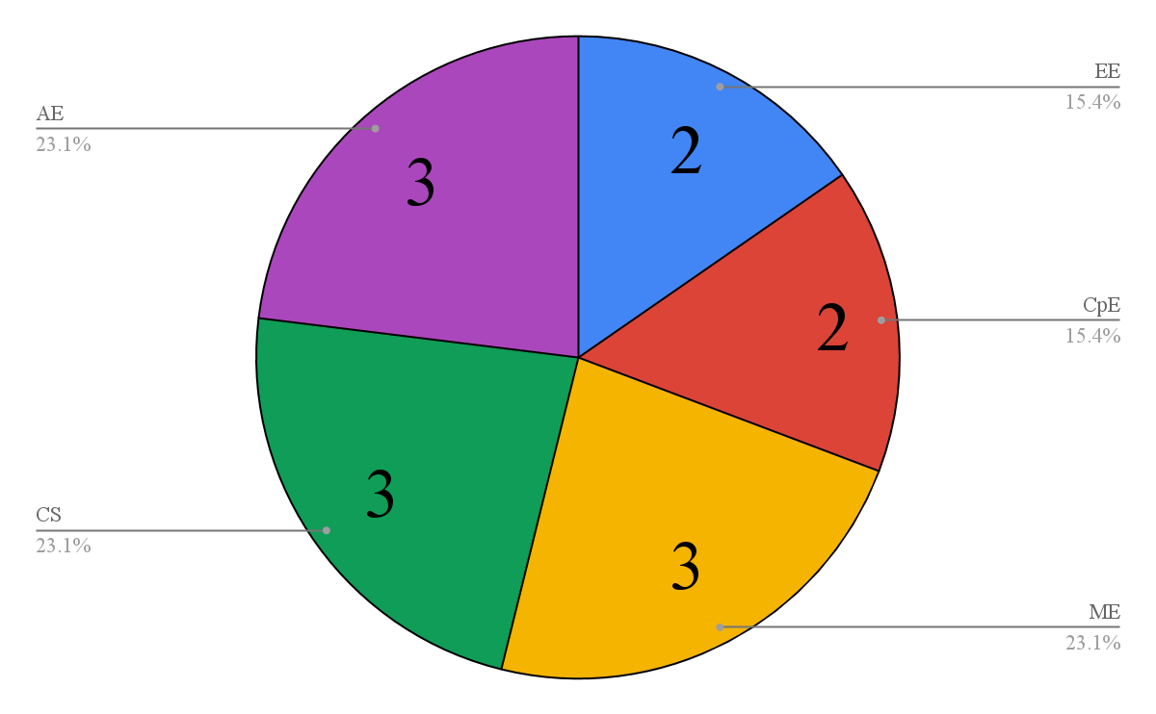
Figure 40. Project Role Breakdown

8.1.1 Mechanical Engineers

The mechanical engineers worked closely with the aerospace engineers on a design for the crash cage on our Robocopter. This involved stress analysis on whether the materials chosen for the cage could withstand collisions. Other considerations that mechanical engineers had were what kind of design we wanted for mounting our electronics, since they were largely responsible for 3D CAD design for 3D printed components.
8.1.2 Aerospace Engineers

The aerospace engineers helped the mechanical engineering team ensure that their requirements didn’t interfere with the ability of the Robocopter to fly e.g. choosing materials strong enough to sustain collisions but also light enough to promote flight. Their expertise helped in choosing motors powerful enough to sustain flight but also not so demanding as to require much larger power supplies. The aerospace team helps the electrical and mechanical engineers interface their requirements in a way that the drone can still operate.

8.1.3 Computer Science

The computer science team interfaced with the computer engineers to make sure their software could be supported on the hardware of the system. They were responsible for the tracking algorithm, and broadcasting a live video feed of the tracking data to the central ground station. In general, the computer engineers dealt with low-level control details of drone flight, while the computer science team dealt with more software intensive software requirements.

8.2 Project Milestones

Keeping on schedule will be key to our success, as there are quite a few steps in developing the Robocopter that are dependent upon each other’s completion. As of 12/4/2017, all parts (with a few exceptions) have been ordered, the circuit schematics for the microcontroller have been designed, and the project is now ready for PCB design and the beginning stages of construction. The first few weeks of the spring semester will be spent working on these aspects.

Table 9, show below, is a list of milestones we’ve set for the project, including short descriptions and a scheduled completion week for each.

Project Milestones
Number | Milestone | Scheduled Completion Week
1 | Procure draft parts list for CE/EE team | 9/4/17
2 | Meet with CS/AE/ME teams to get their draft parts list requirements | 9/11/17
3 | Run calculations on possible parts lists, to get information about speed, fly time, power consumption, etc. | 9/18/17
4 | Research components and technologies to narrow in on exact parts to be used | 10/23/17
5 | Devise final parts list that meets the demands of the CS/MAE teams. Then meet with those teams to order parts for testing. | 10/30/17
6 | Begin breadboard and microcontroller testing of relevant components. Begin designing PCB. | 11/13/17
7 | Finish testing | 11/20/17
8 | Order remaining components required for construction | 11/27/17
9 | Order PCB | 1/7/18
10 | Being constructing Robocopter | 1/7/18
11 | Begin integrating PCB into drone | 1/14/18
12 | Finalize construction of the drone | 2/12/18
13 | Hardware / Software Debug | 2/19/18 - END
Table 9. Milestones

8.3 Budget Analysis

Table 10 outlines the parts that will or have purchased for the construction of the Robocopter. Also included is the weight of each component, as that information will be vital for the MAE to design the frame and protective cage of the Robocopter.

Component | Quantity | Weight(g) | Vender | Estimated Cost
11.1V LiPo Battery | 1 | 250 | Amazon.com | $28.16
Battery Charger | 1 | 136 | Amazon.com | $23.50
RunCam FPV Camera | 1 | 21 | Amazon.com | $59.00
Pixhawk Mini Flight Controller | 1 | 38 | Amazon.com | $139.99
Power Module | 1 | 22.7 | Amazon.com | $37.99
Infrared Sensor | 2 | 5.57 | Amazon.com | $14.34
Ultrasonic Sensor | 1 | 4.6 | Amazon.com | $19.99
Wifi Telemetry | 1 | 2 | Amazon.com | $29.99
ATmega328 | 1 | 25 | Amazon.com | $7.97
Crystal Oscillator | 1 | 22.68 | Amazon.com | $7.77
ATmega328 Socket Adaptor | 1 | 90.72 | Amazon.com | $4.83
Prototyping Quadcopter Kit | 1 | n/a | Amazon.com | $136
Intel Compute Stick | 1 | 60.2 | Amazon.com | $126.51
USB to TTL Adapter | 1 | 17 | Amazon.com | $10.97
PCB | 1 | ~25 | --- | Not yet known
Total |  |  |  | $647.01
Table 10. Components and Their Estimated Costs

While the total budget as provided by Lockheed Martin is $2000, the cost of the Robocopter as presented on competition day must not exceed $1500. The remaining $500 is delegated to prototyping. The total budget for the ECE aspect of the Robocopter is displayed in Table 10 and will be slightly over $500. The remainder of the total budget will be used by the MAE members of our team to construct the frame/body of the Robocopter.

As of 12/4/2017, all parts have been ordered, and most have been acquired and used to begin prototype construction. The infrared and ultrasonic sensors, as well as the USB to TTL adapter are still in the process of being delivered to the team, and the PCB has not yet been ordered as must still be designed. The schematics that will be implemented on the PCB are largely done, apart from any adjustments that may be required upon further prototyping, but the order cost of the PCB should not be large. The electronic component budget total for the project so far is roughly $647, though a few more parts may be required if prototyping demands such.

The remainder of the $2000 budget will be delegated to the body of the Robocopter, which includes its frame, propellers, motors, and protective cage. The MAE members of the team estimate that this cost should not exceed the electrical component cost of the Robocopter by much, if at all. Consequently, the project is operating well within the budget provided by Lockheed Martin.

8.4 Team Communications

With such a large interdisciplinary team, communication was an important aspect to ensuring that systems developed across disciplines would work together. I will briefly address the way communication was set up between the different disciplines, including the communication strategies used specifically within the computer and electrical engineering group.

8.4.1 Cross-discipline Communication

In order to communicate with the different disciplines, a Facebook group was set up with all team members. This was the primary mode of communication for the team, with designated individuals who would be in charge of corresponding with Lockheed Martin over email. Using the facebook group, messages were sent out for meeting reminders but also to constantly clarify requirements that different disciplines were trying to implement that needed consultation from another discipline. For example, the mechanical engineers needed to chat with the hardware design specialists in order to know what kind of casing they would have to develop that could withstand an impact. At weekly meetings the groups would also convene to cooperate in similar ways in person.

8.4.2 CE/EE Group Communication

Within the CE/EE group, the primary means of communication was a Google Hangouts chatroom. Using this chat, meetings were set up and we coordinated how to best complete this report.

8.4.3 Alternative Communication Options

Some alternative communication tools may be helpful for groups in the future to use. Herein I will discuss them. Jira and Slack are both tools used extensively in software development projects. However, they would both also work well with the Robocopter project. Jira allows you to set tasks and issues for groups to complete, it’s an interface where everyone can track project progress. And slack is a group chat software that gives you the ability to host one team within one channel, but open up smaller channels that divide the chats between individual disciplines. This is convenient however, because depending if those sub-chats are public, the whole team can be involved in chats across disciplines, while still allowing each discipline to communicate individually.

9. Second Semester Updates

9.1 Hardware

9.1.1 Power Supply/Distribution

In the previous semester a very rough block diagram of the way all the hardware components would be connected and powered was presented. Initially it was thought to include a switch that would power both batteries, the battery used for avionics components and the battery used for the electronics. Yet, after selecting the official batteries that would be used, their connections were completely different as the Lipo has a XT90 connector and the power bank was a usb type-c connector. This would require a lot of extra time to be able to implement a switch and was not efficient for our purpose. Especially since each battery required a different type of charger and different periods of time for charging since the 10000mAh MultiStar Lipo Battery selected took about 10 hours to charge. For this reason a much more updated and the finalized block diagram design for the drone is shown below.

Battery 1
Flight Controller
Power Module
ESC
ESC
ESC
ESC
Motor
Motor
Motor
Motor
MCU
PDB
Camera
CPU
Battery 2
USB Hub
KEY:
=Data/Signal
=Power
IR (x3)
Figure 41. Finalized Hardware Block Diagram

The final battery selections for the drone were: Multistar 10,000mAh 4S Lipo battery pack for the avionics components and eeco 5,000mAh Power Bank. The lipo pack was selected in conjunction with the selection of the motors. The motors selected by the aerospace team were the Brushless T-Motor Navigator Series MN3110. Yet these motors nor battery could have been selected without a proper weight analysis first. As several options for motors and batteries were searched there was a constant update of a spreadsheet with all the components and weights. In the end, the following table was obtained for the total weight of the drone.

Part | Weight (g)
Frame | 347
Cage | 454
Motors | 80
Props (4) | 24
ESCs | 5
Battery 1 | 128
Battery 2 | 803
Camera | 159
Intel Stick | 59
Flight Controller | 68
PCB | 25
IR Sensor | 27
USB Hub | 28
Connector Adap | 18
Micro to C Adap | 6
Total: | 2486
MAX: | 2600
Table 11. Weight Analysis

Finally after determining from the specifications and data the manufacturer gives that those motors could give for 2600g of thrust per motor after considering the 2:1 ratio discussed earlier in the text; it was found that these were the exact motors needed. The motors were needed 9,379mAh if to be flown at 85% throttle for ten minutes with a 4S Lipo and 11 inch propellers. Yet since the drone would not be flying anywhere near 85% throttle at any point, then worrying about the 80% discharge rule discussed earlier in the text was not necessary. From there the ESC was selected which was pretty simple since the max current draw for the motors was known to be 21A. In this case you add 20% more as a good cushion which calculated to be a little over 25A and thus the final selection was an upgrade to the T-Motor 30A 2S-4S ESC. These are extremely lightweight and small which fit perfectly on the frame of the quadcopter. For these reasons the final combination selected fit perfectly all the requirements for power. Now in terms of the electronics, each component draws such little current that, the 5000mAh power bank was more than enough. After all the calculations it gave for about 80 minutes of battery life and the total of the competitions lasted for 20 minutes.

9.1.2 Final Hardware Component Selections

Below is the final drone setup and table with all the final hardware component selections, their cost and a total bill of materials for the finalized drone. Most of the components remained the same as those selected the previous semester except the motors, propellers and batteries as discussed in the previous section. In addition, there was a change in the camera selection due to the requirement that the live first person view video must be transmitted via wifi through a router. The setback with the previous RunCam selection is that it was great for FPV, yet it was set for only analog transmission and it needed to be able to transmit digitally. Thus the selection made by the computer science team whom were in charge primarily of the video transmission, was the Audson Webcam. The great features about this camera is that it is a webcam so it transmits video imagery digitally, the resolution is in 1080P, it was less expensive than the previous selection and it plugged right into the CPU (Intel Compute Stick) via usb just as you would connect any webcam to a computer.

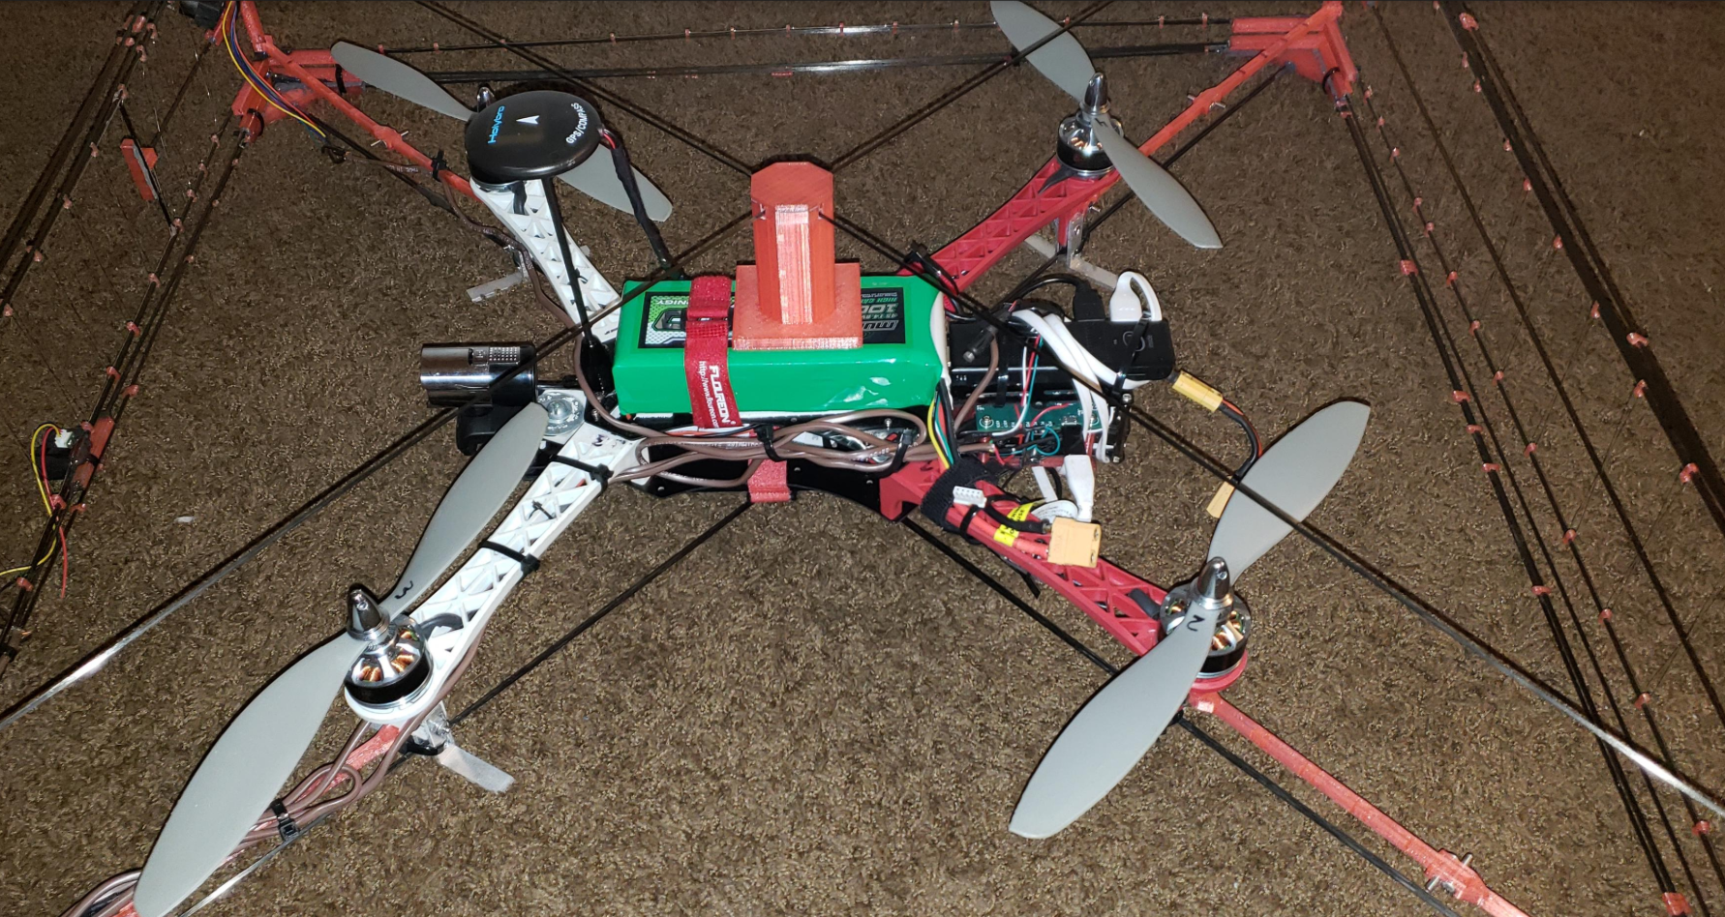
Figure 42. Physical Layout of Robocopter

Component | Quantity | Unit Cost | Cost
T-MOTOR MN3110 KV700 Motor | 4 | 48.85 | 195.4
RAYCorp 1147 11x4.7 Propellers | 1 | 13.99 | 13.99
3DR Pixhawk Mini Autopilot | 1 | 139.99 | 139.99
Holybro GPS | 1 | 50.00 | 5.00
Aimeliae GP2Y0A02YK0F IR Sensor | 1 | 7.17 | 7.17
DomyBest HJ MWC | 1 | 21.59 | 21.59
Frsky ACCST Taranus Q X7 RC Transmitter | 1 | 124.99 | 124.99
Frsky Taranis Compatible Receiver | 1 | 34.99 | 34.99
eeco 5000mAh Portable Charger | 1 | 15.99 | 15.99
XT60 Female to XT90 Male Adapter | 1 | 5.99 | 5.99
Multistar High Capacity 4S 10000mAh | 1 | 74.95 | 74.95
Intel Compute Stick CS125 | 1 | 126.51 | 126.51
T-Motor 30A BLHeli_S 2-4S FPV ESC | 4 | 14.99 | 59.96
Micro USB to USB C Adaptor | 1 | 5.99 | 5.99
3D Filament | 1 | 28.72 | 28.72
.080" x 48" Solid Round Carbon | 30 | 3.39 | 101.7
.106" x .035" x 48" Solid Flat Carbon | 20 | 2.99 | 59.8
Printed Circuit Board (PCB) | 1 | 51.13 | 51.13
IR Sensor | 2 | 24.95 | 49.9
Epoxy Structural Adhesive | 1 | 6.28 | 6.28
Vibration Damping Grommets | 1 | 11.34 | 11.34
Hex drive screw 6-32 thread 1/2 inch long | 1 | 3.72 | 3.72
Hex drive screw 6-32 thread 3/4 inch long | 1 | 4.41 | 4.41
Hex nut 6-32 thread | 1 | 3.4 | 3.4
Ausdom HD Camera | 1 | 26.66 | 26.66
Total Final Drone Cost: |  |  | $1224.57
Table 12: As-Demonstrated Drone Bill of Materials

9.1.3 Printed Circuit Board (PCB)

The printed circuit board had some modifications from the schematic presented the first semester. The design procedure began in an attempt to resemble an Arduino Uno but in a much simpler form as that was the board we would be using for testing purposes. In addition we would be using the Arduino Uno for testing as after much research it was determined that the best MCU for the project was the ATMega328 chip as discussed previously. That MCU is used in both the Arduino Uno and the Arduino Mini, both which were used for prototyping and testing. Yet, the Arduino Uno currently uses the ATMega8U2 as the chip for USB to serial conversion despite that it is an MCU alone also. For the purposes of this project a second MCU was not necessary but better yet a simpler usb to serial converter was preferable to incorporate a micro-b usb connector instead of the USB Type B connector that the Arduino uses which is too large for this project. In addition, the micro-b connector is much more widely used today and was a better option to have a number of cables accessible to us for testing. For this reason a couple options were researched and shown in a table below. Yet it was found that prior to Arduino using the ATMega8U2, they actually used the FT232R chip from FTDI which turns out to be a very popular usb to serial converter chip on many devices. Sparkfun had a number of breakout boards for this purpose with Eagle Reference designs included and additionally Arduino has a tutorial on how to setup and ATMega chip with a Sparkfun usb breakout board. Thus after researching and finding a lot more helpful documentation for the FT232R chip, the final selection was made.

Feature | FT232R | ATmega8U2 | CP2104
Power Consumption | 500mA | 500mA | 500mA
Operating Voltage | 3.3-5.25V | 2.7-5.5V | 4.0-5.25V
Data Transfer Rate | 300 baud-3 Mbaud | N/A | 300 baud-2 Mbaud
Open-Source | $4.50 | $2.29 | $1.65+
Table 13. USB to Serial Converter Comparison Chart

After the major components had been selected and the necessary research had been done to combine all the knowledge needed from each reference and datasheet, the final PCB schematic is shown below.

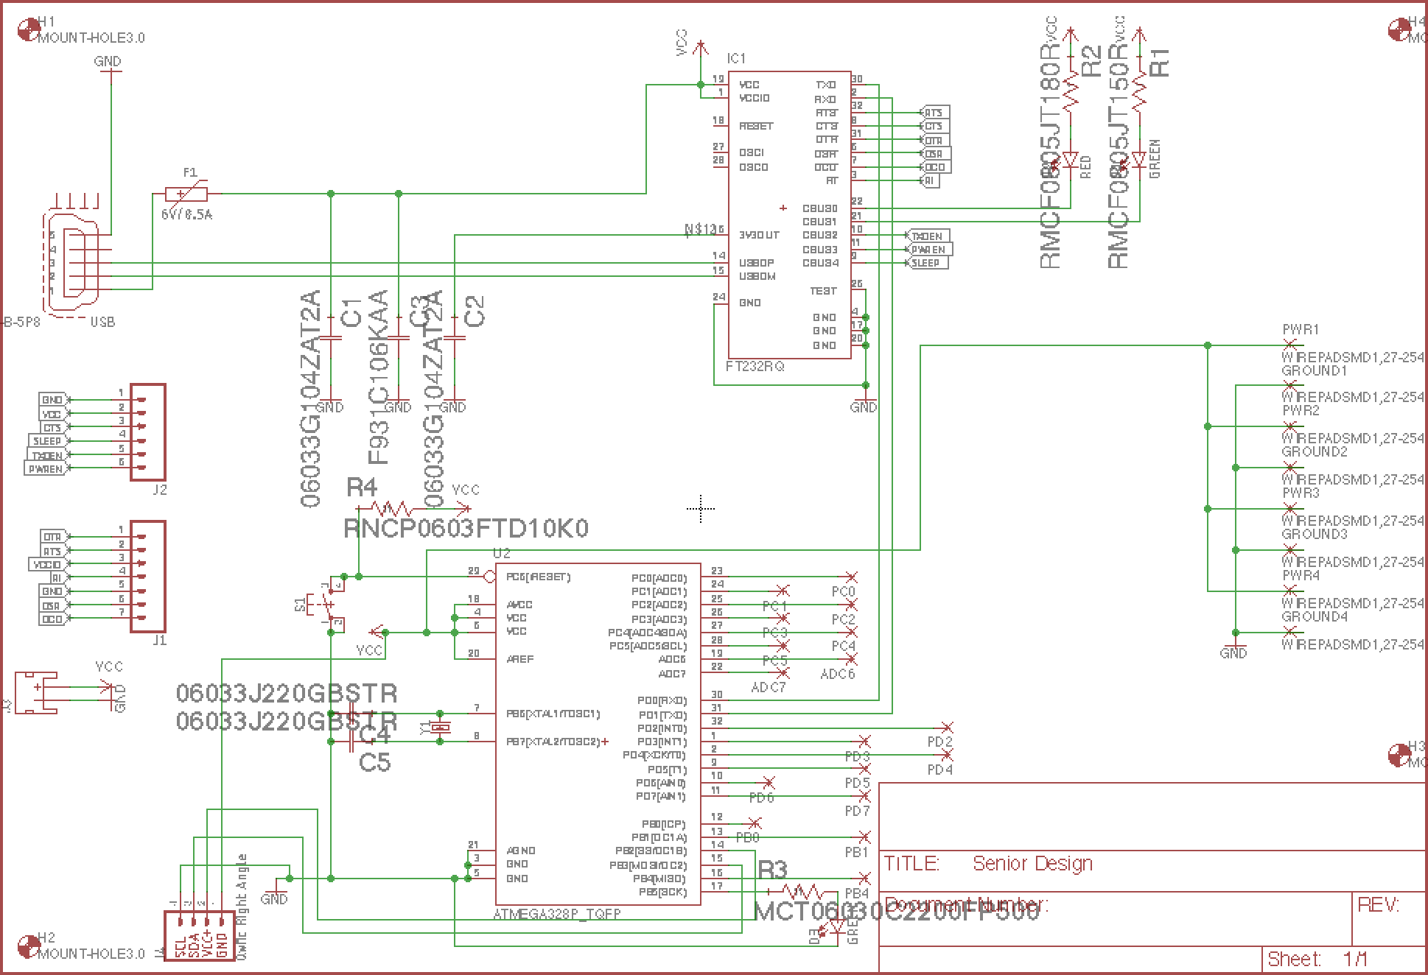
Figure 43. Final PCB Schematic

In this schematic a couple ports are also found. For example a port for the Pixhawk Mini Flight Controller is included in this design as the original setup had the PCB connected directly to the flight controller and just in case it is needed in the future. Most importantly there is a micro-b usb connector used to power and program the MCU. All other connections to the MCU were left as solder pads in order to better customize the board and the drone to have the ability to add more sensors or different sensors in the future if needed.

Lastly, simply all the resistor and capacitor values were selected. For example the ATMega328 chip has a 16MHz crystal oscillator at it’s XTAL1 and XTAL2 pins and each end of the crystal must have a 22pF capacitor that goes to ground this is standard. Then for each LED depending on the color of the LED and the specs the Ohm’s Law equation shown below was used to determine the series resistance needed. Vs is the voltage supplied which in this case is 5V. Then Vled is given in the specs of the particular LED as the forward voltage drop of the LED but typically for example a red LED has a forward voltage drop of 1.8V.

$R=\frac{V_{s}-V_{LED}}{I_{LED}}$ (2)

Lastly, in order to reset the MCU for programming a MOM switch was incorporated at the reset pin and a standard across all the references used, is that a 10kΩ pull-up resistor is needed to connect from the reset pin to VCC. The goal when selecting each component was to select the smallest packages for each as possible to minimize the final size of the PCB. For this reason surface mount components were the type primarily used on this board. Some were both surface mount and through-hole, but overall only SMD components were used. This way we could use much smaller parts and thus reduce the weight on the drone which was a top priority and is for any aerial vehicle. Below is the final PCB layout which gave dimensions of 64.16mm x 67.42mm.

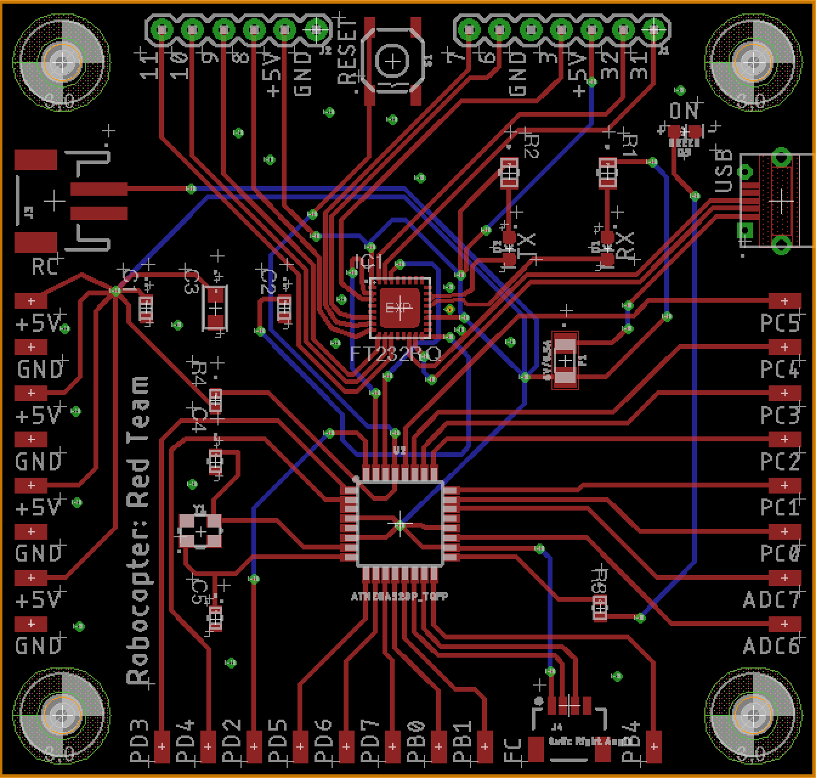
Figure 44. Final PCB Layout

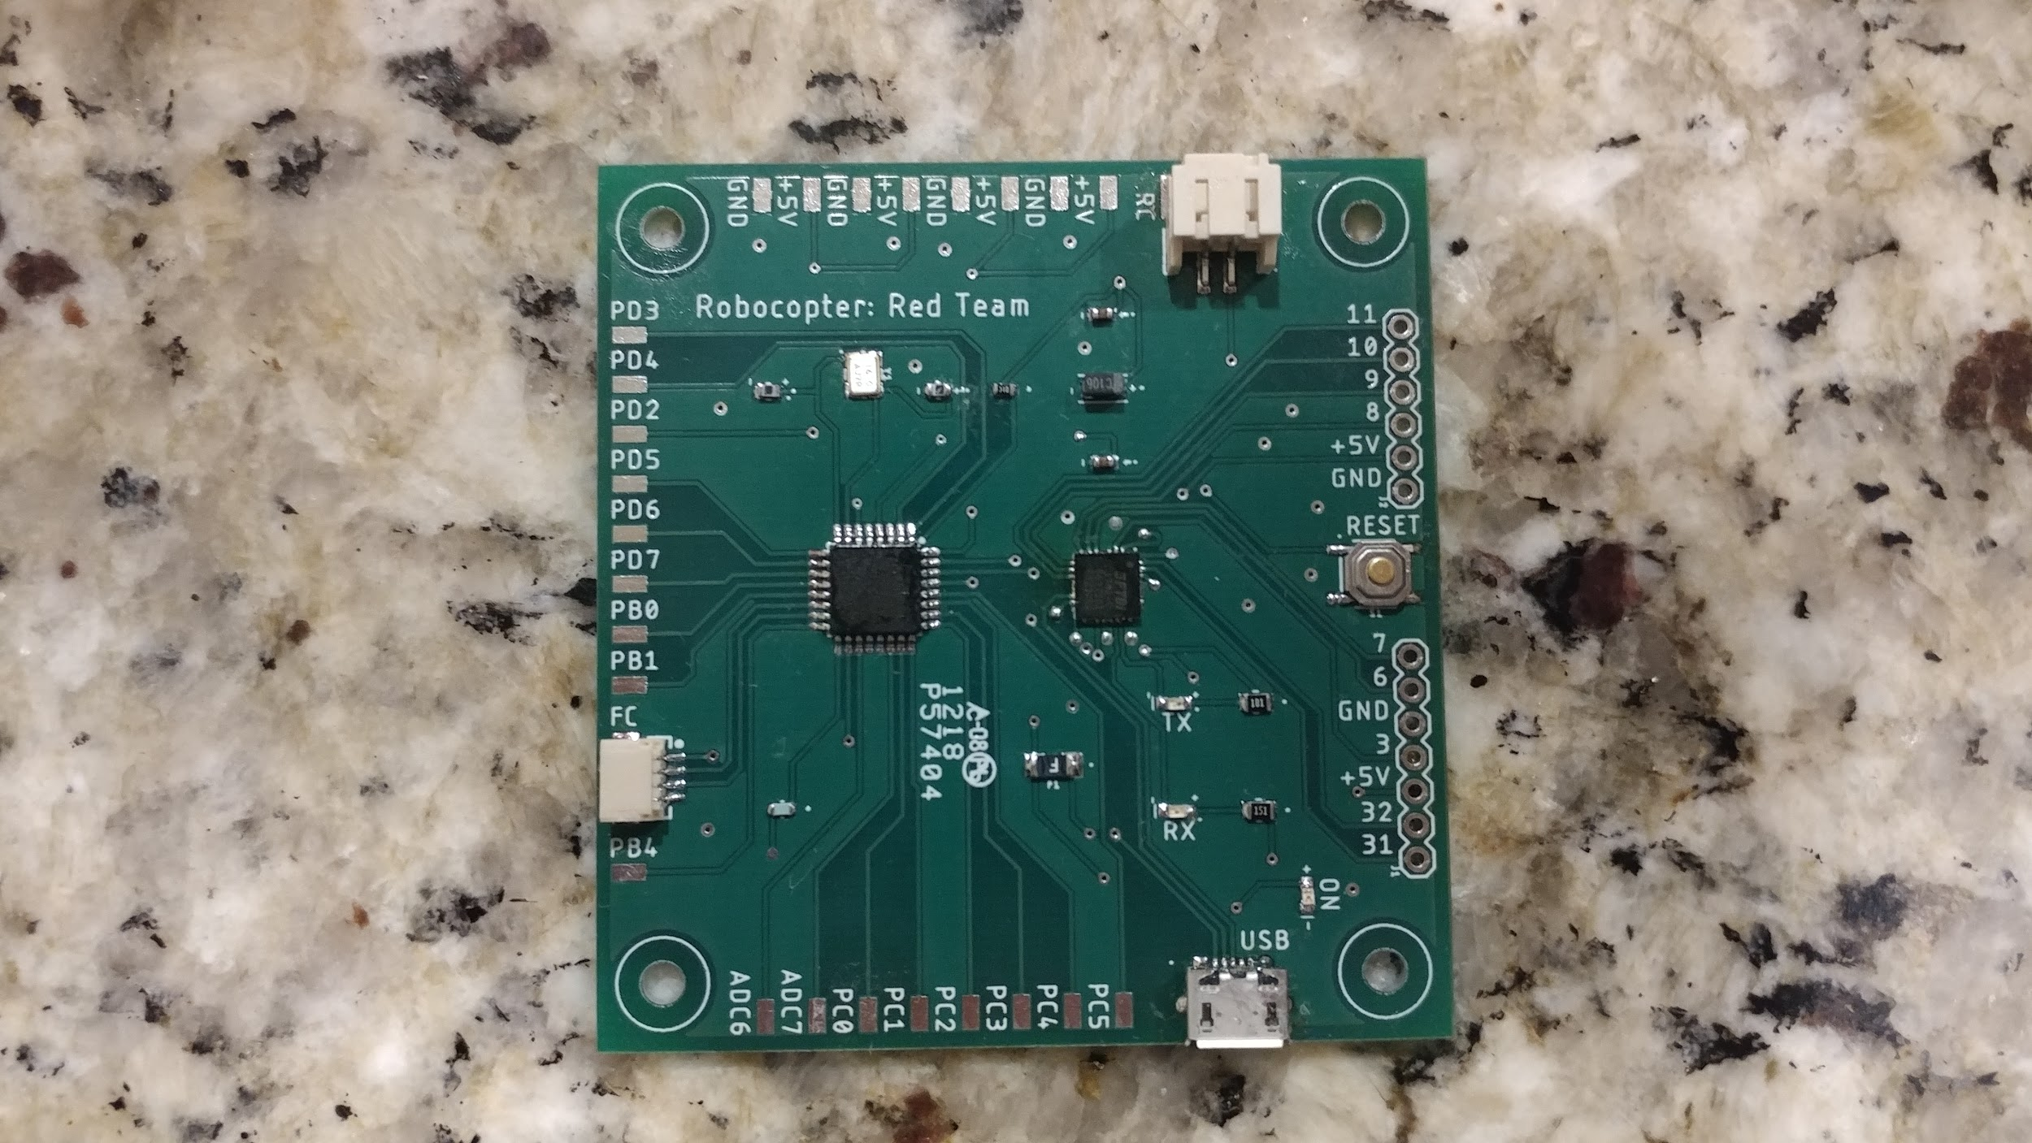
Figure 45. Manufactured PCB

9.1.4 Sensors

The original design concept involved using both ultrasonic and infrared sensors. However, after further testing it was concluded that the data from the ultrasonic sensors was not reliable at the distance we needed. We originally had the Sharp GP2Y0A02YK0F infrared sensors and had good detection at 3 feet up to around 4 feet so decided to get 2 more of these. Unable to find the same sensors we went with 2 similar infrared sensors the Sharp GP2Y0A710K0F and set the detection distance to match the original.

Feature | SRF02 | XL-MaxSonar | Sharp  GP2Y0A710KF | Sharp  GP2Y0A02YK0F | Sharp  GP2Y0A21yK0F
Sensor Type | Ultrasonic | Ultrasonic | Infrared | Infrared | Infrared
Detection  Distance | 0-14.76 ft | 20-25.1 ft | 3-15 ft | 0.65-4.92 ft | 0.32-2.63 ft
Operating  Voltage | 0-5V | 3.3-5.5V | 4.5-5.5V | 4.5-5.5V | 4.5-5.5V
Current  Consumption | 4 mA | 3.4 mA | 30 mA | 33 mA | 40 mA
Weight | 0.32 oz | 0.32 oz | 0.38 oz | 0.17 oz | 0.17 oz
Dimensions | 1.81x1.1x0.75 in | N/A | 2.28x0.69x0.88 in | 1.16x0.5x0.85 in | 1.16x0.52x0.53 in
Price | $7 | $40 | $25 | $9 | N/A
Table 14. Updated Sensor Selection

Next on figure 46 is shown the final design of the quadcopter as well as the location of the sensors.

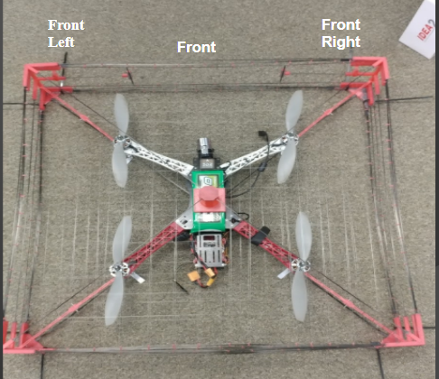
Figure 46. Final Sensor Placement

In retrospect more sensors could have been placed, for example one in the back and one on each side of the cage. Moreover for the sake of the competition we found three sensors would be sufficient enough to avoid the obstacles in the course.

9.2 Hardware/Software Integration

There were a few critical changes made to hardware/software integration side of the Robocopter once construction began. Originally, it was intended that the Pixhawk Mini would be receiving MAVLink commands directly from the MCU on the PCB. The Intel Compute Stick would be external to this, sending information only to the MCU, and allowing the MCU to make all flight path decisions. However, when prototyping and construction of the actual project began, some huge roadblocks made themselves apparent. First, there is no real support for tracking and detection algorithms in the documentation for MAVLink when it comes to an Arduino loaded chip, such as the ATmega328 being used in this project. The ATmega328 also proved to be short of enough memory to implement such tracking and detection algorithms. Finally, and perhaps most importantly, establishing a connection between the MCU and the Pixhawk presented tremendous difficulty. After a few weeks of attempting this setup, it was decided that we needed to rearrange our components. In the end, the Intel Compute Stick was connected directly to the Pixhawk Mini. The Compute Stick is able to run Python scripts that can send information directly through the USB connection of the Pixhawk. This method was found to be much simpler to implement. So in this setup, the PCB doesn’t communicate directly with the Pixhawk; instead, it sends sensor information to the Compute Stick, and the Python scripts running on the Compute Stick send MAVLink commands to the Pixhawk.

As far as the MCU/sensor integration is concerned, no monumental changes in design occured. In the final build of the Robocopter, three infrared sensors are mounted on the cage of the vehicle, with each having three connections to the MCU; VCC, GND, Vo. VCC and GND were soldered to the corresponding pads of the PCB, with the Vo of each sensor being soldered to an analog pin connection on the PCB. The Vo of each sensors sends information regarding any potential objects the sensor detects in front of it. Through trial and error testing, it was determined that the noise readings of the sensors was 300-350. When an object is within 2 meters of a sensor, the readings jump to the low 600s. As the object moves closer to the sensor, the readings continue to drop down towards 400 before they become unreliable. Thus, to avoid obstacles, the MCU was set to send an interrupt to the Intel Compute Stick whenever a reading of over 400 is detected. In such an instance, the Python scripts on the Compute Stick read the interrupt, and through MAVLink can tell the Pixhawk that the Robocopter needs to move the opposite direction to avoid hitting whatever obstacle was detected.

9.3 Software

Because of the changes to hardware/software integration, the software requirements for the MCU and CPU both changed. Originally it was intended for the MCU to issue out MAVLink commands and process sensor information. The MCU would receive directional commands from the CPU, which would be running video processing, in order to move the drone towards a target. However, the switch mandated that the MCU actually send interrupts to avoid collisions to the CPU, effectively reversing the order of command. In the end, this was tremendously helpful because MAVLink worked a lot easier using a Python library provided by DroneKit for issuing such commands. Otherwise, we were struggling with getting MAVLink commands to successfully send and receive using the MCU.

Communicating interrupts sparked a few software issues that had to be resolved, which weren’t covered in the senior design 1 document. When communicating interrupts from the MCU to the CPU, in practice, it turns out you want the CPU to send a flag to the MCU whenever it’s ready to receive interrupts. Otherwise, the MCU during take-off, if at all unstable, may trigger a premature interrupt, when the infrared sensors are pointing down to the ground during an unstable take-off. Having the MCU wait for a flag from the CPU, and then sending interrupts after solves this issue. Another interesting issue that arises is the speed at which interrupt flags are being sent and how quickly they’re being read on the end of the CPU. For example, you could send an interrupt flag (0 for no interrupt, 1 for interrupt) every cycle on the MCU at 9600 baud, but then the CPU would need to read a large number of bytes at a time during every serial port read in order to catch the interrupt without latency. In practice, this issue was solved by experimenting with different configurations of delays and read byte sizes on the MCU and CPU. In the end, we set the MCU to process a 100 millisecond delay after every interrupt flag was sent, and had the CPU read in 5 bytes of interrupt flags (1 flag = 1 byte) per serial port read. Using this setup we achieved a quick response time on the drone when receiving interrupts flagging it to stop upon detecting a collision.

10. Appendices

10.1 Works Cited

[1] https://elinux.org/RPi_Hardware
[2] http://www.microchip.com/wwwproducts/en/ATmega328
[3] https://www.arduino.cc/en/Main/FAQ#toc13
[4] http://mydronelab.com/blog/arduino-quadcopter.html
[5] https://skilledflyer.com/arduino-quadcopter-diy-project/
[6] http://www.open-std.org/jtc1/sc22/wg14/www/docs/n1570.pdf
[7] http://www.ipc.org/ContentPage.aspx?pageid=IPC-Free-Documents
[8] www.dronethusiast.com/ultimate-drone-battery-care/.
[9] http://www.robotshop.com/blog/en/make-uav-lesson-3-propulsion-14785
[10] http://www.referencedesigner.com/cal/battery_life_watt_hour_56.php
[11] http://rcfoamfighters.com/blog/?p=84
[12]https://www.genstattu.com/blog/best-lipo-battery-brand-choosing-your-lipo-brand/
[13] https://courses.engr.illinois.edu/ece445/getfile.asp?id=7329
[14] https://store.dji.com/product/mavic-intelligent-flight-battery
[15] https://oscarliang.com/emax-rs2205-2300kv-2600kv-motors/
[16] https://oscarliang.com/top-5-best-motors-mini-quad/
[17]http://www.dronetrest.com/t/brushless-motors-how-they-work-and-what-the-numbers-mean/564
[18] http://www.rohm.com/web/global/electronics-basics/motors/what-is-a-motor/
[19] http://erlerobotics.com/blog/product/electronic_speed_controller/
[20] https://www.elprocus.com/electronic-speed-control-esc-working-applications/
[21] https://hobbyking.com/en_us/emax-rs2205-motor-for-fpv-racing-kv2600-cw-shaft-rotation.html
[22] https://hobbyking.com/en_us/5045-three-blade-propeller-glass-fiber-nylon-1pair-org.html
[23] https://hobbyking.com/en_us/hobby-king-quadcopter-power-distribution-board.html
[24] https://oscarliang.com/how-to-choose-battery-for-quadcopter-multicopter/
[25] https://oscarliang.com/monitor-measure-battery-voltage-alarm-drone/
[26] http://www.droneybee.com/best-lipo-battery-brand/
[27] http://fpvlab.com/forums/archive/index.php/t-731.html
[28] http://www.droneybee.com/best-lipo-battery-charger/
[29] https://hobbyking.com/en_us/turnigy-4000mah-3s-30c-lipo-pack-xt-60.html
[30]
[31] https://www.amazon.com/Gens-ace-5000mAh-Battery-Traxxas/dp/B01JCSOJIY/ref=sr_1_1_sspa?ie=UTF8&qid=1510523164&sr=8-1-spons&keywords=Gens+Ace+3S+5000mAh+lipo&psc=1
[32] https://www.amazon.com/Turnigy-3300mAh-Lipo-Pack-XT-60/dp/B0778DHR57/ref=sr_1_1?ie=UTF8&qid=1510608945&sr=8-1&keywords=Turnigy+3300mAh+3S+30C+LiPo&dpID=41n%252BtgPWHwL&preST=_SX300_QL70_&dpSrc=srch
[33] https://www.amazon.com/Tenergy-TLP-4000-Universal-Charger-3-7V-14-8V/dp/B007MD54NQ
[34] https://www.amazon.com/Tenergy-Cells-Li-PO-Balance-Charger/dp/B004FGWY54
[35] http://www.tested.com/tech/502351-rc-battery-guide-basics-lithium-polymer-batteries/
[36] https://oscarliang.com/top-5-best-fpv-camera-mini-quad/
[37] http://shop.runcam.com/runcam-eagle-2/
[38] https://www.runcam.com/download/eagle2/Eagle2-manual.pdf
[39] https://oscarliang.com/runcam-split-camera/
[40] https://oscarliang.com/runcam-split-v2-camera/
[41] http://cmucam.org/projects/cmucam5
[42] http://www.teledynedalsa.com/imaging/knowledge-center/appnotes/ccd-vs-cmos/
[43] https://soltechsecurity.wordpress.com/2014/01/29/600tvl-720p-1080p-is-there-much-of-a-difference/
[44] https://newatlas.com/sae-autonomous-levels-definition-self-driving/49947/
[45] https://www.amazon.com/Pixy-CMUcam5-Smart-Vision-Sensor/dp/B00IUYUA80/ref=sr_1_1?ie=UTF8&qid=1508873229&sr=8-1&keywords=pixy+cmucam5
[46] http://shop.runcam.com/runcam-split-2/
[47] https://www.linksys.com/us/r/resource-center/wifi-router/
[48] https://computer.howstuffworks.com/build-private-wifi-network.htm
[49] https://openhomeautomation.net/choose-esp8266-module/
[50] https://www.mikrocontroller.net/attachment/338570/Ai-thinker_ESP-07_WIFI_Module-EN.pdf
[51] http://www.electronicdesign.com/communications/understanding-wireless-range-calculations
[52] https://www.scientificamerican.com/article/how-does-wi-fi-work/
[53] http://searchnetworking.techtarget.com/definition/orthogonal-frequency-division-multiplexing
[54] http://www.radio-electronics.com/info/rf-technology-design/ofdm/ofdm-basics-tutorial.php
[55] http://ccm.net/faq/298-what-is-wifi-and-how-does-it-work
[56] https://www.amazon.com/HiLetgo-ESP8266-Serial-Wireless-Module/dp/B00WG9HM7W/ref=sr_1_4?ie=UTF8&qid=1509156843&sr=8-4&keywords=ESP8266+esp-07+module
https://blog.adafruit.com/2010/09/27/arduino-arduinoboarduno-eagle-files-and-schematic-posted/
[57] https://www.sfcircuits.com/pcb-school/pcb-design-software-comparison-guide
[58] https://learn.sparkfun.com/tutorials/pcb-basics
[59] https://learn.sparkfun.com/tutorials/using-eagle-board-layout
[60] http://pcdandf.com/pcdesign/index.php/current-issue/243-flexperts/10228-the-flexperts-1508

[61] http://robot-electronics.co.uk/htm/srf02tech.htm
[62] http://www.mouser.com/ds/2/308/NCP1117-D-81326.pdf
[63] https://www.allaboutcircuits.com/technical-articles/understanding-arduino-uno-hardware-design/
[64] https://www.arduino.cc/en/Tutorial/ArduinoToBreadboard
[65] https://docs.px4.io/en/flight_controller/Pixhawk_mini.html
[66] http://luckylarry.co.uk/arduino-projects/arduino-using-a-sharp-ir-sensor-for-distance-calculation/
[67] https://www.dfrobot.com/wiki/index.php/SRF02_Ultrasonic_sensor_(SKU:SEN0005)
[68] http://www.nvidia.com/object/jetson-tk1-embedded-dev-kit.html
[69] https://www.intel.com/content/www/us/en/products/boards-kits/compute-stick.html
[70] https://www.raspberrypi.org/products/raspberry-pi-2-model-b/
[71] http://ufldl.stanford.edu/tutorial/supervised/ConvolutionalNeuralNetwork/
[72] http://web.mit.edu/6.034/wwwbob/svm.pdf
[73] https://www.tensorflow.org/
[74] http://caffe.berkeleyvision.org/
[75] http://deeplearning.net/software/theano/
[76] http://www.ecmweb.com/content/electrostatic-discharge-causes-effects-and-solutions
[77] https://powerbyproxi.com/wireless-charging/
[78] http://searchcrm.techtarget.com/definition/speech-recognition
[79] https://books.google.com/books?id=Pe7gG0LxEUIC&dq=pentland+cipolla+computer+vision+human+interaction&printsec=frontcover&source=bl&ots=O2q5ExL8PU&sig=FMhom_f4h9dqeib-6pSSpjbsB38&hl=en&ei=uzvsSbruBdqIsAaq5PCKBw&sa=X&oi=book_result&ct=result&resnum=1#v=onepage&q=pentland%20cipolla%20computer%20vision%20human%20interaction&f=false
[80] https://resources.altium.com/pcb-design-blog/top-pcb-design-guidelines-every-pcb-designer-needs-to-know
[81] https://www.sparkfun.com/tutorials/115
[82] https://en.wikipedia.org/wiki/Lidar
[83] https://www.techopedia.com/2/27881/networks/wireless/what-is-the-difference-between-bluetooth-and-wi-fi
[84] https://www.amazon.com/Hobbypower-Encoder-Pixhawk-Megapirate-Controller/dp/B00HCA40HA
[85] https://www.amazon.com/YKS-Telemetry-915Mhz-Pixhawk-Quadcopter/dp/B0196LF6PW/ref=pd_bxgy_21_img_3?_encoding=UTF8&psc=1&refRID=GYCJTQJ059Y2WEDZWT9Z
[86] https://www.amazon.com/Crius-External-Indicator-Pixhawk-Controller/dp/B00LAV9VLM/ref=pd_bxgy_21_img_2?_encoding=UTF8&psc=1&refRID=GYCJTQJ059Y2WEDZWT9Z
[87] https://beagleboard.org/black
[88] http://www.microchip.com/wwwproducts/en/ATMEGA16U2
[89] http://www.instructables.com/id/Adding-ICSP-header-to-your-ArduinoAVR-board/
[90] https://www.youtube.com/watch?v=1eB_mhuXXUc
[91] http://qgroundcontrol.org/mavlink/start
[92] https://medium.com/@Dronesmith/why-we-chose-px4-vs-apm-as-lucis-default-firmware-ea39f4514bef
[93] http://www.ti.com/design-tools/overview.html
[94] https://www.amazon.com/Hobbypower-Encoder-Pixhawk-Megapirate-Controller/dp/B00HCA40HA
[95]https://www.amazon.com/YKS-Telemetry-915Mhz-Pixhawk-Quadcopter/dp/B0196LF6PW/ref=pd_bxgy_21_img_3?_encoding=UTF8&psc=1&refRID=GYCJTQJ059Y2WEDZWT9Z
[96] https://www.amazon.com/Crius-External-Indicator-Pixhawk-Controller/dp/B00LAV9VLM/ref=pd_bxgy_21_img_2?_encoding=UTF8&psc=1&refRID=GYCJTQJ059Y2WEDZWT9Z
[97]http://www.instructables.com/id/Adding-ICSP-header-to-your-ArduinoAVR-board/
[98]http://qgroundcontrol.org/mavlink/start
[99]https://medium.com/@Dronesmith/why-we-chose-px4-vs-apm-as-lucis-default-firmware-ea39f4514bef
[100]https://docs.px4.io/en/flight_controller/pixhawk_mini.html
[101]https://www.arduino.cc/en/Reference/SPI
[102]https://www.amazon.com/USB-TTL-Adapter-Interface-Development/dp/B075N82CDL/ref=sr_1_7?ie=UTF8&qid=1512278873&sr=8-7&keywords=usb+to+ttl
[103] https://www.robot-electronics.co.uk/htm/srf02tech.htm
[104] https://www.sparkfun.com/datasheets/Sensors/Infrared/gp2y0a02yk_e.pdf
[105] https://www.amazon.com/USB-TTL-Adapter-Interface-Development/dp/B075N82CDL/ref=sr_1_7?s=electronics&ie=UTF8&qid=1512324357&sr=1-7&keywords=usb+to+ttl
[106] https://www.arduino.cc/en/Main/Standalone
[107] https://www.sparkfun.com/datasheets/Components/SMD/ATMega328.pdf
[108] https://cdn.sparkfun.com/datasheets/BreakoutBoards/DS_FT232R.pdf
[109] https://cdn.sparkfun.com/datasheets/BreakoutBoards/FT232R-Breakout_v37.pdf
[110] https://www.youtube.com/watch?v=1AXwjZoyNno&list=PL868B73617C6F6FAD
[111] http://blog.optimumdesign.com/through-hole-vs-surface-mount
[112] https://www.hobbypartz.com/02p-motor-821-mn3110-kv700.html
[113] https://www.amazon.com/Computer-Portable-Rotates-Network-Microphone/dp/B01HFFDFHW/ref=sr_1_23?ie=UTF8&qid=1519313018&sr=8-23&keywords=web+camera
[114] http://www.ohmslawcalculator.com/led-resistor-calculator
[115] http://led.linear1.org/1led.wiz
[116] https://www.newnex.com/usb-connector-type-guide
[117] https://www.silabs.com/documents/public/data-sheets/cp2104.pdf
[118] http://ww1.microchip.com/downloads/en/DeviceDoc/7799S.pdf
[119] https://learn.sparkfun.com/tutorials/light-emitting-diodes-leds

10.2 Picture Permission Requests:

1.
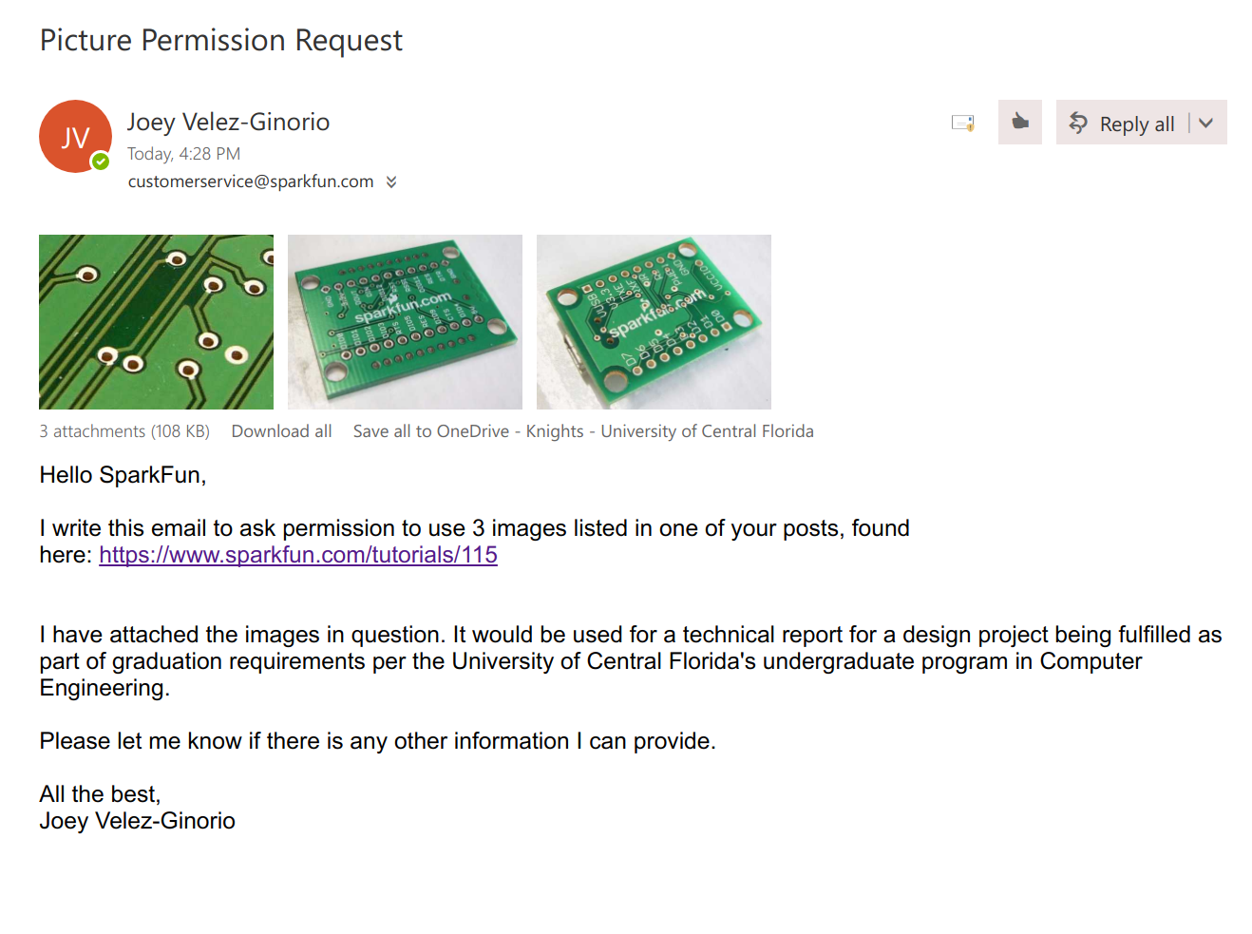

2.
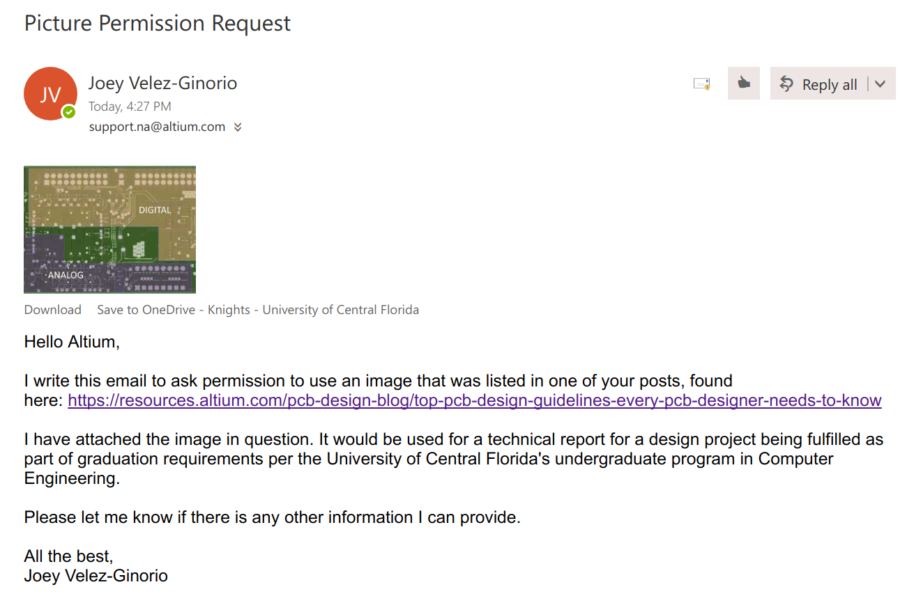

3.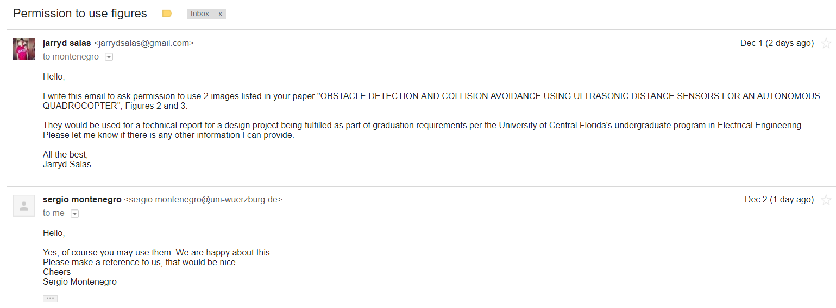
4.
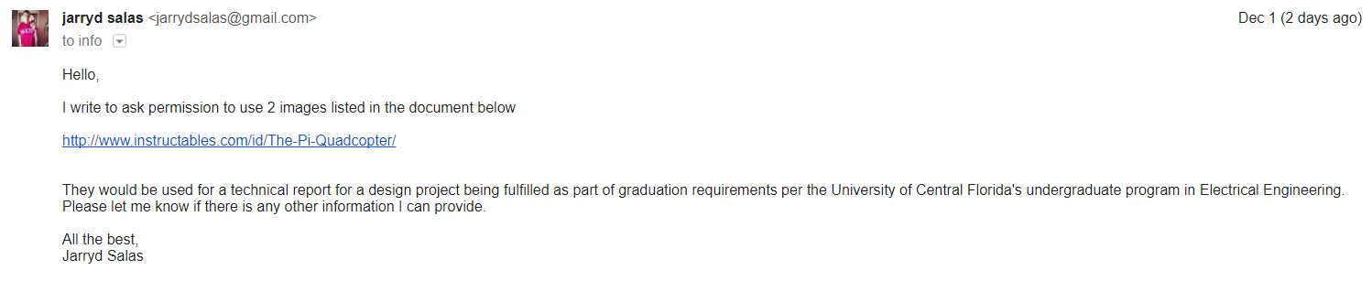
5.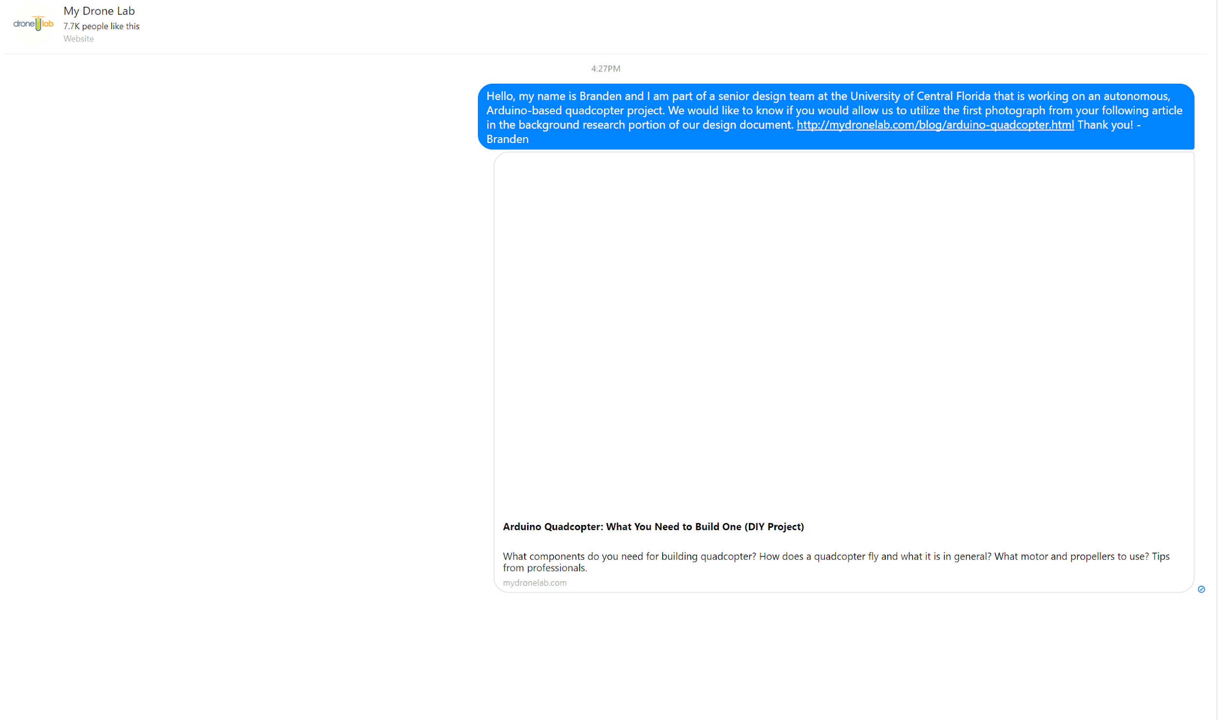
6.
7.
Letter to AdaFruit written on 12/02/17 at 3:04pm. Through their “contact us” link.

To AdaFruit

I reach out to you to request permission to use the schematic picture and use as a reference the design in the zip folder mentioned below and provided in the article "Arduino – ArduinoBoardUno (EAGLE files and schematic posted)" published on SEPTEMBER 27, 2010 AT 9:12 AM; with link https://blog.adafruit.com/2010/09/27/arduino-arduinoboarduno-eagle-files-and-schematic-posted/.

---EAGLE files: arduino-uno-reference-design.zip
---Schematic: arduino-uno-schematic.pdf

These mentioned above would be used as references and learning guides for a technical report being written for a design project. The senior design project is part of my graduation requirement for the University of Central Florida's undergraduate Electrical Engineering program.

Please let me know if any additional information is needed and if permission is granted to use these references in our report.

Regards,
Pamela



8.


9.
