**Senior Design**

*Arcadia Spider Robotic Hub*

A picture containing person, tree

Description generated with high confidence

*Department of Electrical Engineering and Computer Science*

*University of Central Florida*

*Dr. Lei Wei*

*Initial Project Document and Group Identification*

***Group 24***

Dries Kassabi Electrical Engineering

Steven Solis Photonic Science and Engineering

Angel Mandujano Electrical Engineering

Said Mourfik Electrical Engineering

Consultant Arcadia Spectacular

**Project Narrative**

Electronic Dance Music (EDM) has gained popularity in recent years, not only in the United States, but all over the world. What started as an underground scene in the 1980s, has evolved into a $6.2 billion global industry. Most of that money isn’t coming from record sales, but live music events where DJs/Producers play music in front of a live audience. Every March since 1999, the city of Miami hosts what is known globally as “the world’s biggest festival”, Ultra Music Festival. Annually capping off Miami Music Week, Ultra boasts lineups that put all other festivals to shame and attracts over 150,000 people over the span of the 3-day event.

One aspect of the festival that has grown dramatically over time is the quality of stage production. For many festival-goers, stage production can make or break an event. Indeed, the demand for production quality has gotten so great, Ultra has looked to outside independent companies to do it for them. One of these companies is Arcadia Spectacular, and they host their own exclusive stage called the “Arcadia Spider”. It is the only 360-degree stage at Ultra and hosts the lesser popular “underground” DJs that are part of Ultra’s “Resistance” brand. On top of that, the stage also has its own half-hour mini show called “The Arcadia Landing Show” that is exclusive to the Arcadia Spider and adds even more distinctiveness to their setup.

It was while witnessing this unique show that the idea came to mind to work with them for a Senior Design Project. We reached out to them through their website and sure enough, they were more than happy to have a group of eager engineering students work on designing an addition to their stage. After a lot of brainstorming and input from Arcadia, particularly their founder and director Pip Rush, we decided that our project would be an R2-D2 like robotic hub that would fit under the DJ booth located in the center of the stage.

When talking to Pip, he mentioned that he wanted something to go under the DJ booth to interact with the crowd in that area of the stage more. A robotic hub seemed to be a perfect option as it could house any special effects that we wanted and could easily fit under the DJ booth, accomplishing Pip’s desire for more crowd interaction. Furthermore, a robotic hub could be easily scaled for the constraints we would face in Senior Design. Although what we produce won’t be a full-scale product, our project would serve as a proof-of-concept prototype and prove the viability of the design for full-scale implementation.

**Goals and Objectives**

For our goals and objectives for this project, we will first outline what we envision for the full-scale version of the product, and then talk about how we will scale it down for our Senior Design project. First, the structure of the Arcadia Spider Robotic Hub (ASRH), can be envisioned as a half-sphere, where the flat part of the structure is attached to the bottom of the DJ booth. An extremely crude depiction of how our setup would like is shown in the figure below. It is a screenshot of a 3D model for the Arcadia Spider with cropped picture of R2-D2 pasted onto the model where the full-scale version of our project would actually go. This is only intended to give an early visual conception of our idea.

**A picture containing plane, sky

Description generated with high confidence**

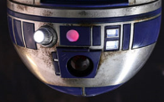

In the full-scale version, we envision the hub to have lasers, LEDs, and C02 blasters as its special effects, and have the capability to rotate 360° on the Yaw axis. The ASRH will also include a camera that can rotate 90° on the Pitch axis. Both the Pitch and Yaw motors of the ASRH can be either manually controlled, or put on an automated procedure. The laser/light show can also either be manually controlled or put on an automated procedure. The camera on the ASRH will serve two purposes: to capture footage, and be used for the robot vision aspect of the device. While the device is in operation, the user can command the ASRH to be in “lock-on” mode. In “lock-on” mode, the ASRH will look for an object of interest in the crowd, and follow that object in the crowd so that it stays relatively close to the center of the camera image. While in lock-on mode, the user can manually fire the C02 blasters, or activate “auto-fire” which would fire the C02 blasters.

For senior design, we will build a scaled-down prototype of the product. The size of the device will not exceed a diameter of 2 feet, a height of 1 foot, and a weight of 15 pounds. We will use a limited number of LEDs and lasers, and will substitute a small nerf gun or small C02 blaster in for a full-scale C02 blaster.

Essentially, our project will possess all the functionalities of the full-scale version, with scaled down hardware. Our goal is to create a working proof-of-concept prototype that demonstrates the viability of our design to be re-created as a full-scale product, given the proper resources.

**Block Diagrams**

Below is a series of block diagrams for our project. The first one labeled ‘Project Block Diagram’ outlines the main components of our project, and is color-coded to reflect which group member(s) are responsible for each particular component. The second diagram labeled ‘Software Block Diagram’ outlines a sketch of the software flow of the ASRH. The third diagram labeled “Hardware Block Diagram” outlines a sketch of how all the different hardware components are connected to each other.

Project Block Diagram

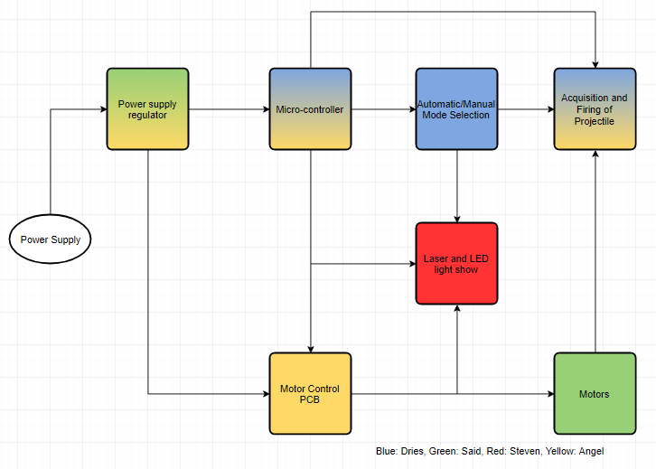

Software Block Diagram

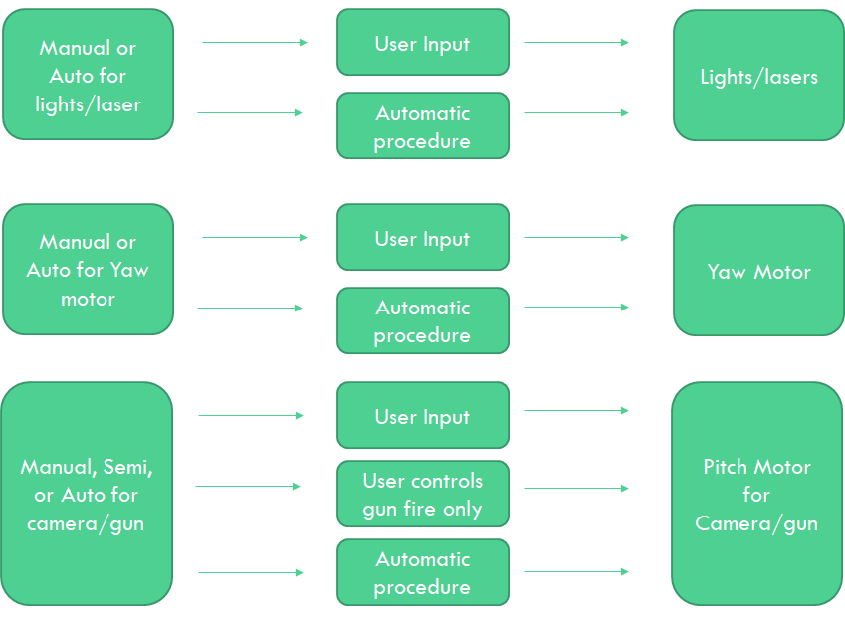

Hardware Block Diagram

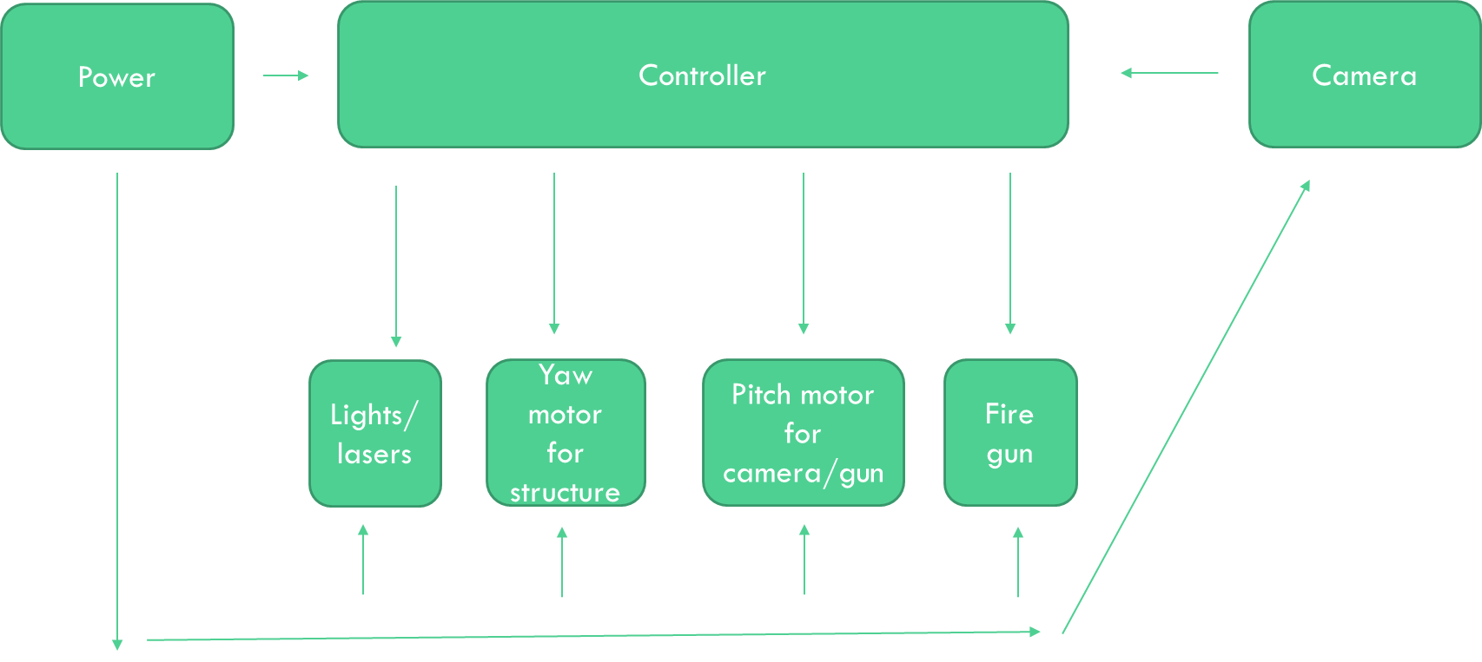

**Specifications**

Like any design, our project has certain specifications we plan to meet. Below is a list of specifications we have come up with for the ASRH.

* The ASRH structure shall be able to rotate 360° on the Yaw axis
* The ASRH camera and gun shall be able to rotate 75° on the Pitch axis
* The ASRH shall have multiple pre-programmed patterns for the laser/light show
* The ASRH shall be able to locate, track, and follow an object of interest
* The ASRH shall allow the user to choose between manual or automatic control for the following capabilities
  + Yaw motor rotation
  + Pitch motor rotation
  + Laser/Light show
  + Target Acquisition and Gun Firing

These specifications represent the core functionalities of our project, and will serve as a checklist of items for our team to complete.

**Timeline**

Below is a rough timeline of objectives for our project. It outlines planned start and end dates for various parts of our project and is subject to change.

**Engineering-Marketing Tradeoff Table**

We have come up with a list of both market and engineering requirements for our project. They are as follows:

Market Requirements

* Easy to Use
* Robust Response
* Aesthetic
* Captivating Light Show
* Low Power/ Efficient
* Automatic and Manual Control Options
* Low Cost

Engineering Requirements

* Simple User Interface
* Low Latency
* Quality S/W and H/W for light show
* Quality S/W and H/W for automatic and manual control modes
* < 50 Watts Power Consumption

Below is our tradeoff table corresponding to our market and engineering requirements.

Positive Correlation: ↑

Strong Positive Correlation: ↑↑

Negative Correlation: ↓

Strong Negative Correlation: ↓↓

Positive Polarity: +

Negative Polarity: -

Table 1: Tradeoff table

|  |  |  |  |  |  |  |  |  |
| --- | --- | --- | --- | --- | --- | --- | --- | --- |
|  |  | Simple UI | Latency | Reliability | Power Consumption | Autonomy | Cost | Weight |
|  |  | + | - | + | - | + | - | - |
| Easy to use | + | ↑↑ | ↓↓ | ↑ | ↓ | ↑↑ | ↓ |  |
| Robust Response | + | ↑ |  | ↑↑ | ↓ | ↑↑ | ↓ |  |
| Aesthetic | + | ↑ |  | ↑ |  |  | ↓ | ↓ |
| Captivating Light Show | + | ↓ | ↓↓ | ↓ | ↓↓ | ↑ | ↓ | ↓ |
| Power | - | ↑ |  | ↑ |  | ↓↓ | ↑↑ | ↓↓ |
| Runtime | + | ↓ |  | ↓ ↓ | ↓ ↓ |  | ↓↓ |  |
| Targets for Engineering Requirements |  | < 5 input controllers | < 1 seconds | >100 cycles before failure | <50 Watts | > 1 automatic systems | < $1000 | < 15 lbs |

**Budget**

Below is a table estimating our budget for this project. It is important to note that this is an extremely rough estimation as it is based on quick google searches and averages of prices we found for each particular component. It also does not account for individual electrical components we may have to use. In addition, some of the items in this list may not be used. For example, the Nerf SecretStrike and the C02 gun/canister are mutually exclusive; one of these items will be used, but not both.

|  |  |  |  |
| --- | --- | --- | --- |
| Component | Quantity | Unit Price | Total Price |
| Controller | 1 | $50 | $50 |
| Servo (Yaw) | 1 | $50 | $50 |
| Servo ( Pitch) | 1 | $20 | $20 |
| Servo ( Laser) | 1 | $40 | $40 |
| Servo (Gun) | 1 | $50 | $50 |
| Structure | 1 | $100 | $100 |
| LEDs | 2 | $20 | $40 |
| Laser/Optics | 2 | $20 | $40 |
| Nerf SecretStrike* | 1 | $10 | $10 |
| C02 gun/ canister* | 1 | $50 | $50 |
| PCB | 2 | $50 | $100 |
| Miscellaneous | 1 | S20 | $20 |
| Total Cost |  |  | $570 |

This project will be self-funded by all the group members. We plan to apply for the SoarTech scholarship that would give us up to $1000 if we win it. We feel good about our chances because of the robot vision/visual servoing aspect of our project aligns with their interests.