Arcadia Spider Robotic Hub – an Addition to the Arcadia Spider
Dries Kassabi, Angel Mandujano, Said Mourfik, and Steven Solis

Dept. of Electrical and Computer Engineering University of Central Florida, Orlando, Florida, 32816-2450

Abstract — The Arcadia Spider Robotic Hub is a proposed addition to Arcadia Spectacular’s Arcadia Spider. This project is a proof-of-concept prototype for the addition that features rotational capabilities on the pitch/yaw axis, a light show, and object detection/tracking capabilities all with automatic and manual control options. The purpose of this project is to demonstrate the Computer/Electrical Engineering design principles of such an addition, affirming the viability of the design for full-scale implementation.

Index Terms — Autonomous systems, computer vision, embedded software, intelligent robots, lighting control.

I. Introduction
Electronic Dance Music (EDM) has gained popularity in recent years, not only in the United States, but all over the world. What started as an underground scene in the 1980s, has evolved into a $7.1 billion global industry [1]. Most of that money isn’t coming from record sales, but live music events where DJs/Producers play music in front of a live audience. Every March since 1999, the city of Miami hosts what is known globally as “the world’s premier electronic music festival”, Ultra Music Festival. Annually capping off Miami Music Week, Ultra boasts lineups that put all other festivals to shame and attracts over 150,000 people over the span of the 3-day event.
One aspect of the festival that has grown dramatically over time is the quality of stage production. For many festival-goers, stage production can make or break an event. Indeed, the demand for production quality has gotten so great, Ultra has looked to outside independent companies to do it for them. One of these companies is the UK based Arcadia Spectacular, and they host their own exclusive stage called the “Arcadia Spider” shown in Figure 1. It is the only stage at Ultra that allows the crowd to gather under, and around it 360 degrees.
.

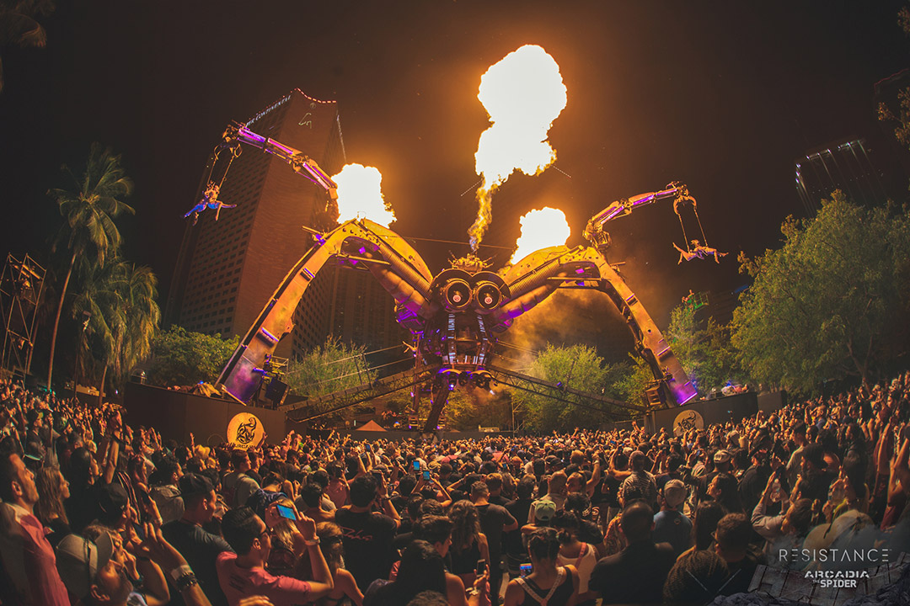
Figure 1: The Arcadia Spider at Ultra Music Festival
As impressive as the Arcadia Spider is with its pyrotechnics and robotics, that is not to say it cannot be improved. After getting in touch with Arcadia Spectacular’s founder and director, Pip Rush, he informed us of his desire to add features right underneath the DJ booth in the center of the Spider. The Spider, when standing far enough away to view it in its entirety, is quite spectacular from a visual effects standpoint. However, as one moves towards the center of the stage, those effects begin to lose their impact. Therefore, an addition to the Spider in that area of the stage makes logical sense.
Our idea is to add a self-contained, semi-autonomous, tele-operated robotic hub underneath the DJ booth that would house all the special effects. A full-scale implementation of this robotic hub, which we have dubbed the ‘Arcadia Spider Robotic Hub’ (ASRH) shown in Figure 2, would include lights, a CO2 blaster, and a camera. The lights and CO2 are special effects that are typically used at these type of shows, and the camera would serve as the ‘eye’ of the semi-autonomous ASRH, with the bonus of being able to capture footage of the dance floor.

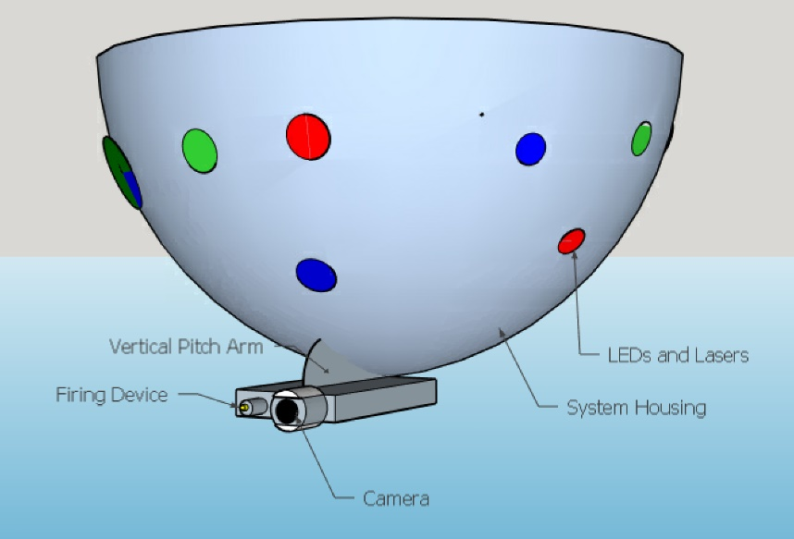
Figure 2 - Rough 3D Model Demonstrating the Concept of the ASRH
Because of the logistical challenges of working with a company from overseas and overall complexity of this undertaking, the goal of this project is not to make a stand-alone device to be added directly to the Spider. Instead, the goal of this project is to produce a proof-of-concept prototype that confirms the viability of the design for full-scale implementation. Essentially, all the key computer/electrical engineering design principles for such a device are demonstrated, but with less expensive parts and hardware more accessible to us. For example, instead of using a real CO2/cryo blaster, the use of a Nerf SecretStrike is employed to represent what would be a CO2/cryo blaster on a full-scale version.

II. Overall System Concept and Major components
Operation of the ASRH and its major components are best presented through a functional block diagram as shown in Figure 3. It is essentially made up of two independent subsystems: the light show, and the robotic hub itself which, are controlled by the Arduino Trinket and MSP430 respectively. Both the MSP430 and Trinket receive instructions from the Raspberry Pi, which is the medium for User input.
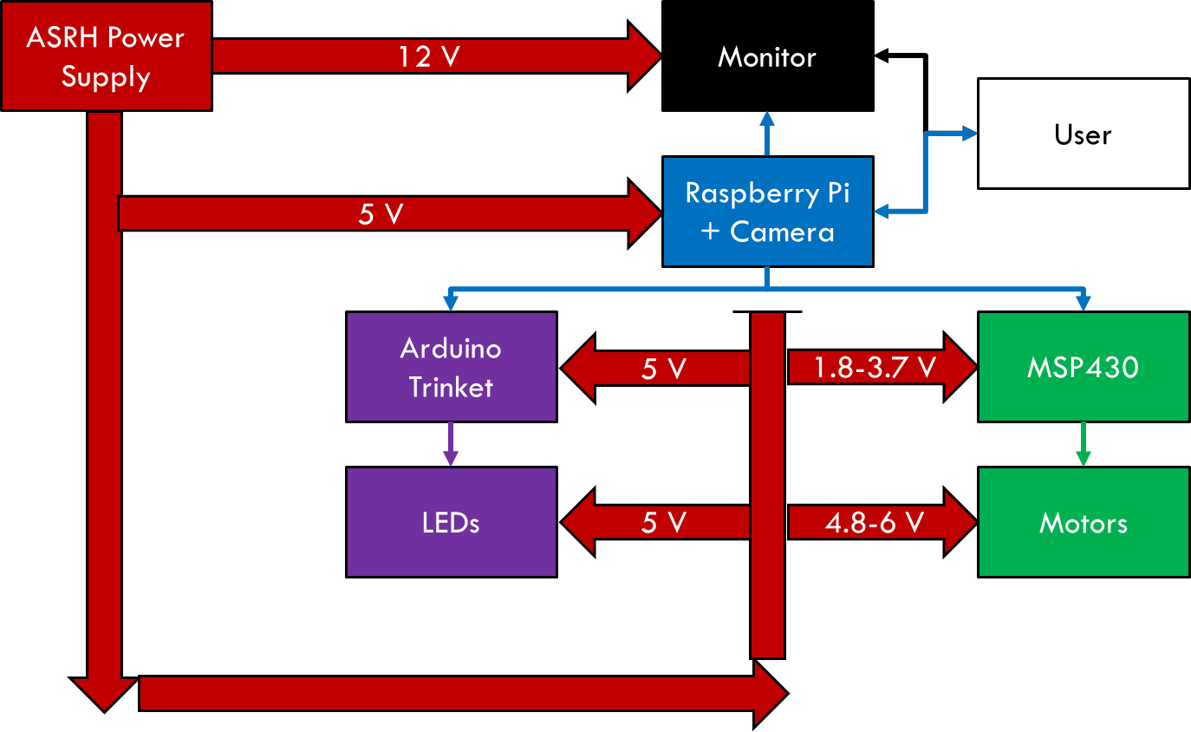
Figure 3 - ASRH Functional Block Diagram
A. ASRH Power Supply
All components of the ASRH receive power from one standard outlet. The design involves the use of an AC-DC converter in concert with voltage regulator circuits. Details on power considerations are given in Section IV.
B. Raspberry Pi + Camera/Monitor
The ASRH uses the combination of the Raspberry Pi 3 Model B along with the Raspberry Pi camera to achieve the following: 1) Display camera feed to a monitor, 2) Accept input from the User through an Xbox controller, 3) perform image processing in real time, and 4) interface with the Trinket and MSP430 to control the LEDs and motors. Details are given in Section III.

C. Trinket/LEDs
The Arduino Trinket acts as the brain that controls the LEDs on the outer surface of the ASRH. The Trinket receives input from the user via the Raspberry Pi and Xbox controller. Upon receiving these signals, the Trinket triggers a specific light sequence that is assigned to several buttons on the Xbox controller. The Trinket and LEDs may be powered by a 5V external battery pack for the convenience of easily removing the Trinket for reprogramming or it can be hard wired onto the ASRH power supply. Details are given in Section III.
D. MSP430
The MSP430 acts as an intermediary between the Raspberry Pi and the motors. Since the motors require precise PWM signals, their control was off-boarded to a separate processor. This design decision was made to avoid potential problems of precise PWM generation and computationally expensive image processing being run on the same chip. Details are given in Section III.
E. Motors
The ASRH uses 3 motors: one to rotate the ASRH on the Yaw axis, one to rotate the Nerf gun and camera on the Pitch axis, and one to fire the Nerf gun. Parallax Continuous Rotation Servos are the Pitch and Yaw motors, and one 9g Micro Servo is the Gun motor.

III. Software Detail
On the ASRH, there are 3 pieces of software running simultaneously: the software for the Raspberry Pi, the software for the MSP430, and the software for the Trinket.
A. Raspberry Pi (User Control and I/O)
One of the primary functions of the Raspberry Pi is to accept user input and send the appropriate signals to the MSP430 and Trinket.
To obtain input from the user, the ASRH utilizes a wireless Xbox controller connected to the Raspberry Pi. An open source Linux based driver named ‘xboxdrv’ in conjunction with an open source Python class called ‘xbox.py’ is used to interpret the inputs from the Xbox controller into something that is usable [3]. The main Python script on the ASRH imports ‘xbox.py’ and links the pressing of buttons on the Xbox controller to GPIO pins on the Raspberry Pi. It is these GPIO pins that connect to the MSP430 and Trinket. In addition, the user also controls what the ASRH detects and tracks. A picture of an Xbox controller with labeled buttons is given in Figure 4 and a summary of all ASRH commands is given in Table 1.

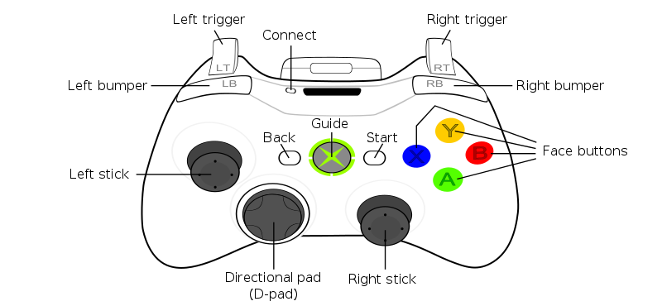
Figure 4 - Xbox Controller Diagram

Table 1 – ASRH Commands

Command | Xbox Button | Robot Description | Light Show Description
Green | A | Commands the ASRH to detect/track green | Initiates a green hue-based sequence when the ARSH tracks green
Red | B | Commands the ASRH to detect/track red | Initiates a red hue-based sequence when the ARSH tracks red
Blue | X | Commands the ASRH to detect/track blue | Initiates a blue hue-based sequence when the ARSH tracks blue
Yellow | Y | Commands the ASRH to detect/track yellow | Initiates a yellow hue-based sequence when the ARSH tracks yellow
Face | Back | Commands the ASRH to detect/track human faces | Initiates magenta hue-based sequence when the ARSH tracks faces
Up | Up on the D-pad | Commands Pitch motor to rotate upwards | Bright light sequence
Down | Down on the D-pad | Commands the Pitch motor to rotate downwards | Dim light sequence
Left | Left on the D-pad | Commands Yaw motor to rotate left | Initiates a cyan hue-based light sequence
Right | Right on the D-pad | Commands Yaw motor to rotate right | Initiates a raspberry hue-based light sequence
Speed Modifier 1 | Left bumper (LB) | Slows down manual control speed (effect increases when both modifiers are activated) | N/A
Speed Modifier 2 | Right bumper (RB) | Slows down manual control speed (effect increases when both modifiers are activated) | N/A
Lock-On | Left trigger (LT) | Commands ASRH to lock-on and aim at a target | Initiates a unique light sequence
Fire | Right trigger (RT) | Commands the Gun motor to fire the Nerf gun | Initiates a unique light sequence
Scan | This signal activates when no input is detected for an extended period | Commands the ASRH to slowly rotate on the Yaw axis | N/A
Scan Direction | Pressing down on the left or right stick (LS and RS) | Changes the direction of rotation while in scan mode | N/A
Shutdown | Start | Commands the MSP430 to break out of its loop, shutting down the servos | Lights turn off

B. Raspberry Pi (Computer Vision and Visual Servoing)
For the computer vision portion of the project, color tracking and face detection is implemented using OpenCV with Python 2.7. In addition, the ASRH features visual servoing when lock-on mode is activated, automatically commanding the motors to aim at a specified target depending on what tracking method is selected.
To implement color detection and tracking, the color space is changed from RGB (red, green, and blue) to HSV (hue, saturation, and value) space to have greater invariance to light levels in the frame being captured. RGB values cannot be used directly for color detection due to detected colors varying dramatically depending on the shade of the color as well as the lighting conditions. Once operating in HSV space, thresholds are used to detect for a specific color, which will then allow for tracking to be implemented. However, before color tracking can be done, filtering masks must be applied to the captured frame. The filtering masks make the detected object more discernable and clear out any noise that may have been captured. Afterwards, contours are drawn on the object of interest, as well as a centroid which designates the ‘target’ for visual servoing. When multiple objects of the same color are detected, the contour with the largest area is designated as the ‘target’. Red, green, blue, and yellow are the four colors that will be detected and tracked using this method. Implementation of detecting red is shown in Figure 5.
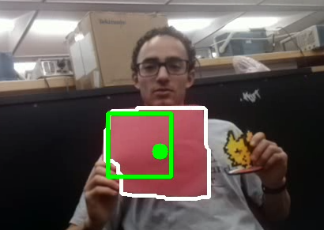
Figure 5 - Color Tracking on the ASRH
For face detection, Haar Cascades will be used to detect faces in the captured frame [2]. The reason for using Haar Cascades instead of other face detection algorithms is due to it being easy to implement as well as being an already included library in OpenCV with pre-trained classifiers for face detection. This method works by extracting Haar features that are either edge features, line features, or center-surrounded features. Once all the features are detected, the classifiers look for ones that will be useful while discarding the others. This process is done several times in each window of the captured frame until enough features are obtained that can give an accurate face detection with a low false positive rate. This method is able to detect multiple faces in the captured frame but will only track a maximum of five faces. This is to cut down on computational delays that occur when tracking multiple faces. Rectangles are drawn around each face; in the case of multiple detected faces, the one with the largest rectangle area is designated as the target. Implementation of face detection is shown in Figure 6.
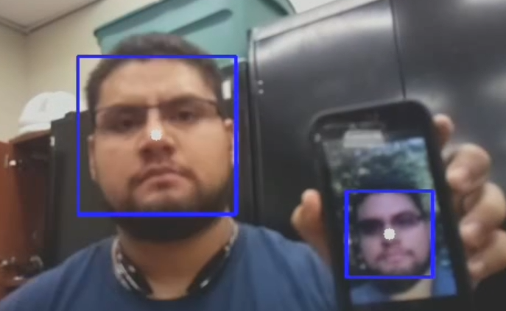
Figure 6 - Face Detection on the ASRH
To implement visual servoing, a small bounding box in the center of the image frame is configured as shown in Figure 5. When in lock-on mode, the ASRH automatically activates the Up, Down, Left, and Right commands to bring the target within the area of the bounding box.
C. MSP430 (Motor Control)
The code running on the ASRH’s MSP430 can be presented in terms of a series of functions. Figure 7 shows the flow of the program in terms of its functions and Table 2 gives a description of each function.
initClock();
initGPIO();
initTimer();

initSpeed();

speed();
pitch();
yaw();
gun();
Figure 7 – MSP430 Software Flow

Table 2 - MSP430 Functions
Function | Description
initClock(); | Initializes the Clock to 1 MHz
initTimer(); | Sets up timers to generate appropriate PWM signals for each motor
initGPIO(); | Initializes the GPIO pins that will be used
initSpeed(); | Initializes the ‘speed’ variable which controls how fast the ASRH rotates when manually controlled
speed(); | Updates the ‘speed’ variable based on whether the user is activating the speed modifiers.
pitch(); | Adjusts the PWM signal based on Raspberry Pi commands
yaw(); | Adjusts the PWM signal based on Raspberry Pi commands
gun(); | Adjusts the PWM signal based on Raspberry Pi commands
D. Trinket and LEDs
The primary function of the Arduino Trinket is to control the LEDs mounted to the exterior of the ASRH. The Trinket has its pins set up to receive 4 inputs and send out data to the LEDs. The inputs are the signals sent out by the Raspberry Pi and the output is sent to command a string of LEDs. The 16 possible I/O combinations of the 4 GPIO pins allows the ability to receive an input that is unique for each digital button on the Xbox controller as seen in Figure 4. The trinket is programmed using Arduino’s IDE that has a library of functions that allow us to precisely control each LED on the ASRH. When the Trinket receives input from its GPIO pins a certain light sequence is activated and will continue to perform in a loop unless the user activates another sequence.
While running, the Trinket sends the program data to the LED strand through the designated pin. The LEDs are linked in a chain from the output pin and the data is sent from one end to the other creating a string of lights. These linked LEDs have drivers in them that can process the information sent by the Trinket and convert it to a certain color and brightness. Each LED is controlled individually but the programs use patterns to reduce script size as well as providing a visual appeal so that the lights do not appear to be flashing with no purpose. The light sequences are representative of the actions that the ARSH is performing. For example, while tracking colors the hues of the LEDs will match those of the color being looked for by the camera. The lights can be powered from the same power source as the rest of the ASRH or a separate 5V source from the Trinket depending on how many lights placed in a string.

IV. Power considerations
The ASRH is designed in such a way so that one standard outlet can provide adequate power to all the different components. Table 3 outlines the power requirements for the ASRH.

Table 3 - ASRH Power Requirements
Component | Operating Voltage (V) | Maximum Current Draw (A)
7-Inch LCD Monitor | 12 | 0.5
Raspberry Pi+Camera | 5 | 2.5
Trinket+LEDs | 5 | 0.180
MSP430 | 1.8-3.7 | < 0.5
Parallax Servos | 4-6 | 2 x (0.140 ± 0.05)
9g Micro Servo | 4.8-6 | 0.700-0.800 (Stall)
A. Power Supply
To power the ASRH a 65W dual output AC to DC switching power supply, manufactured by MeanWell, called the RD-65A is used. Channel 1 outputs 5V and a rated current of 6A, channel 2 outputs 12V and a rated current of 3A. This power supply was chosen due to reliability and practicality reasons and would satisfies all the power requirements of each major component. Opting to buy an already manufactured power supply allowed us to focus on completing all feature requirements instead of designing and testing the power supply as well. The fact that it is a dual output power supply and able to handle up to 6A provides more options for powering all the components. The block diagram in Figure 5 shows the power configuration of the ASRH.
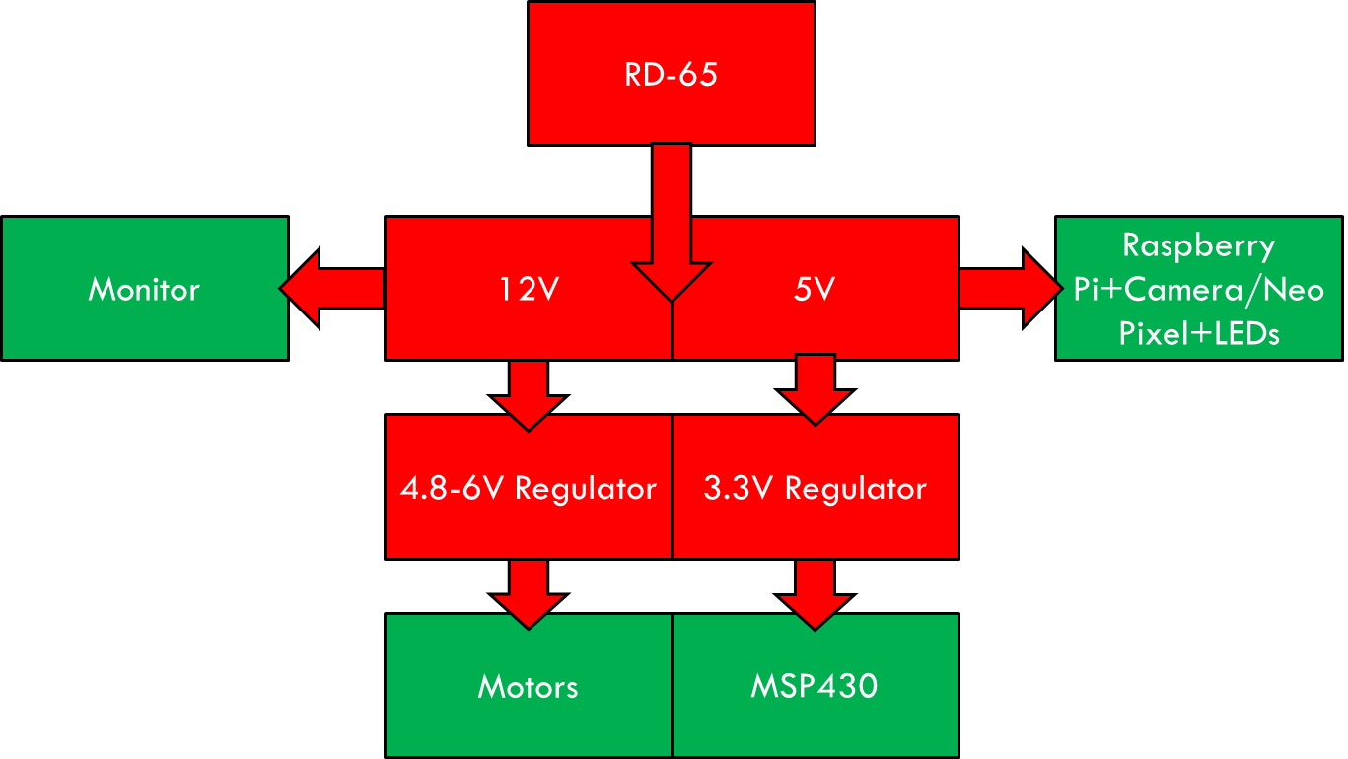
Figure 8 - ASRH Power Block Diagram
B. Voltage Regulator 1 (L4978)
To power the MSP430 and motors, it was necessary to step down the 5 and 12-volt outputs from the RD-65. To achieve high efficiency, a switching regulator posed a better option than a linear regulator.
Therefore, the L4978 adjustable switching regulator with a 2A limit was chosen. It has a high efficiency rating and is available in a dual in-line package (DIP package) for easy testing using breadboard. For the PCB design, the SOIC package is used instead of the DIP one. To achieve a 5.1 volt output needed to operate the three servos the values of R2 and R3 in Figure 9 were chosen to be 2.7 kΩ and 4.7 kΩ respectively. For an output of 3.3 volts, R2 is changed to be 0Ω and R3 is removed.
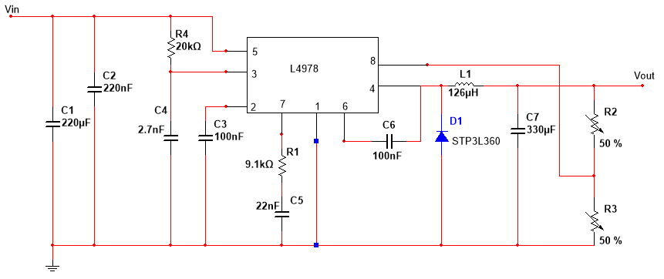
Figure 9 - L4978 Circuit Schematic
During testing the L4978, was found to be unable to sufficiently provide for all 3 motors at once. It was discovered that the servos interfered with each other’s incoming PWM signals when they were connected to the same regulator. To solve this, it was decided to implement 3 separate regulators, one for each servo. Even after changing the design, they still performed unreliably during testing. For backup purposes, a linear voltage regulator was designed in case further issues were discovered when using the L4978.

C. Voltage Regulator 2 (LM317)
Since the switching regulators were not always consistent, the LM317 linear voltage regulator was chosen as the backup option. The LM317 is an adjustable voltage regulator that allows us to choose the necessary output voltages for our servos and other components. The output voltages will be adjusted by changing R_{adj} using Equation 1 shown below.

$V_{o}= 1.25 (1 + R_{adj} / R1) + (C_{adj}× R2)$ (1)

For this circuit, R_{adj} will be set to 390 ohms and an input voltage of 5 V to provide 3.3 output voltages for MSP 430. To provide the 5.1 volts necessary for the three motors, R_{adj} will be set to 900 ohms and an input voltage of 12 volts will be used, with C_{adj} set to 10uF. Figure 10 shows the circuit diagram for the LM317 used.

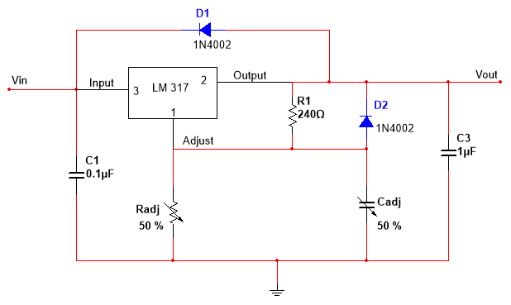
Figure 10 - LM317 Circuit Schematic

Another advantage of using LM317 is that it comes in two packages: a 3-pin TO-220 package that will allow for easy breadboard testing and a 3-pin SOT-223 surface mount package for PCB design

V. Printed Circuit Board Design
Because of the difficulties that occurred during development in terms of powering the ASRH, three different PCB configurations were made.
A. L4978 Configuration (2 boards, 4 regulators)
The initial plan was to use two separate PCBs, a power board and a signal board. For the power board, the main voltage regulator is the L4978, with a USB connection to power the Raspberry Pi and pin connections for the servos and other components. The servos each have their own L4978 switching regulator instead of sharing one for power. The reason for this was to minimize electrical noise that interfered with the PWM signals going to the servo when more than one servo was connected to the same regulator.
For the CPU board, the MSP430 and an L4978 switching regulator are on the same board. Because of the limited board space available on the free version of Eagle, this configuration required the use of two separate boards.

B. LM317 Configuration 1 (1 board, 4 regulators)
For this configuration, the LM317 linear regulators and the MSP430 were placed on the same board. This was accomplished thanks to the LM317 regulator needing less external components than the L4978. This PCB was sent for manufacturing before final testing of the LM317, so it was unknown if one regulator was sufficient for all 3 motors. Therefore, this configuration was designed with a regulator for each motor. The power section is separated from the signal section to reduce as much electrical noise interference as possible. The other advantage of using this PCB layout is that there is only one PCB instead of two separate PCBs like the L4978 configuration.
C. LM317 Configuration 2 (1 board, 2 regulators)
After obtaining parts to test the LM317 in the lab, it was found that using only one regulator was sufficient to power all 3 motors. To take advantage of this new information, one last ‘optimal’ board with only the necessary components was made. This configuration is a fraction of the size and uses a fraction of the components compared to the other 2 configurations.

VI. Structural/Mechanical Considerations (DRIES)
After completing all the electrical and computer engineering portions, a mechanical structure is necessary to complete the project. This section will explain how the ASRH is constructed to demonstrate its capabilities, covering the mechanical structure and internal wiring.
A. Mechanical Structure
The main ASRH structure is composed of 3 pieces of Styrofoam and is shown in Figure 11. The first two are 12-inch disks that serve as the base and rotating platform, and the third is a 12-inch hollow semicircle to serve as an outer covering or shroud. Styrofoam was chosen for its low cost, ability to be easily modified, and light weight. The Yaw motor is embedded into the base, followed by the rotating platform being mounted on top. The Pitch motor is then mounted onto a small piece of Styrofoam with electrical tape and mounted on top of the platform. The Gun motor is mounted onto the Nerf SecretStrike by electrical tape in a manner so that the rotating arm presses down on the trigger when activated. The Nerf gun is then attached to the Pitch motor. The camera is also attached to the Nerf gun by means of a taped piece of Styrofoam to which the camera is attached.

(a)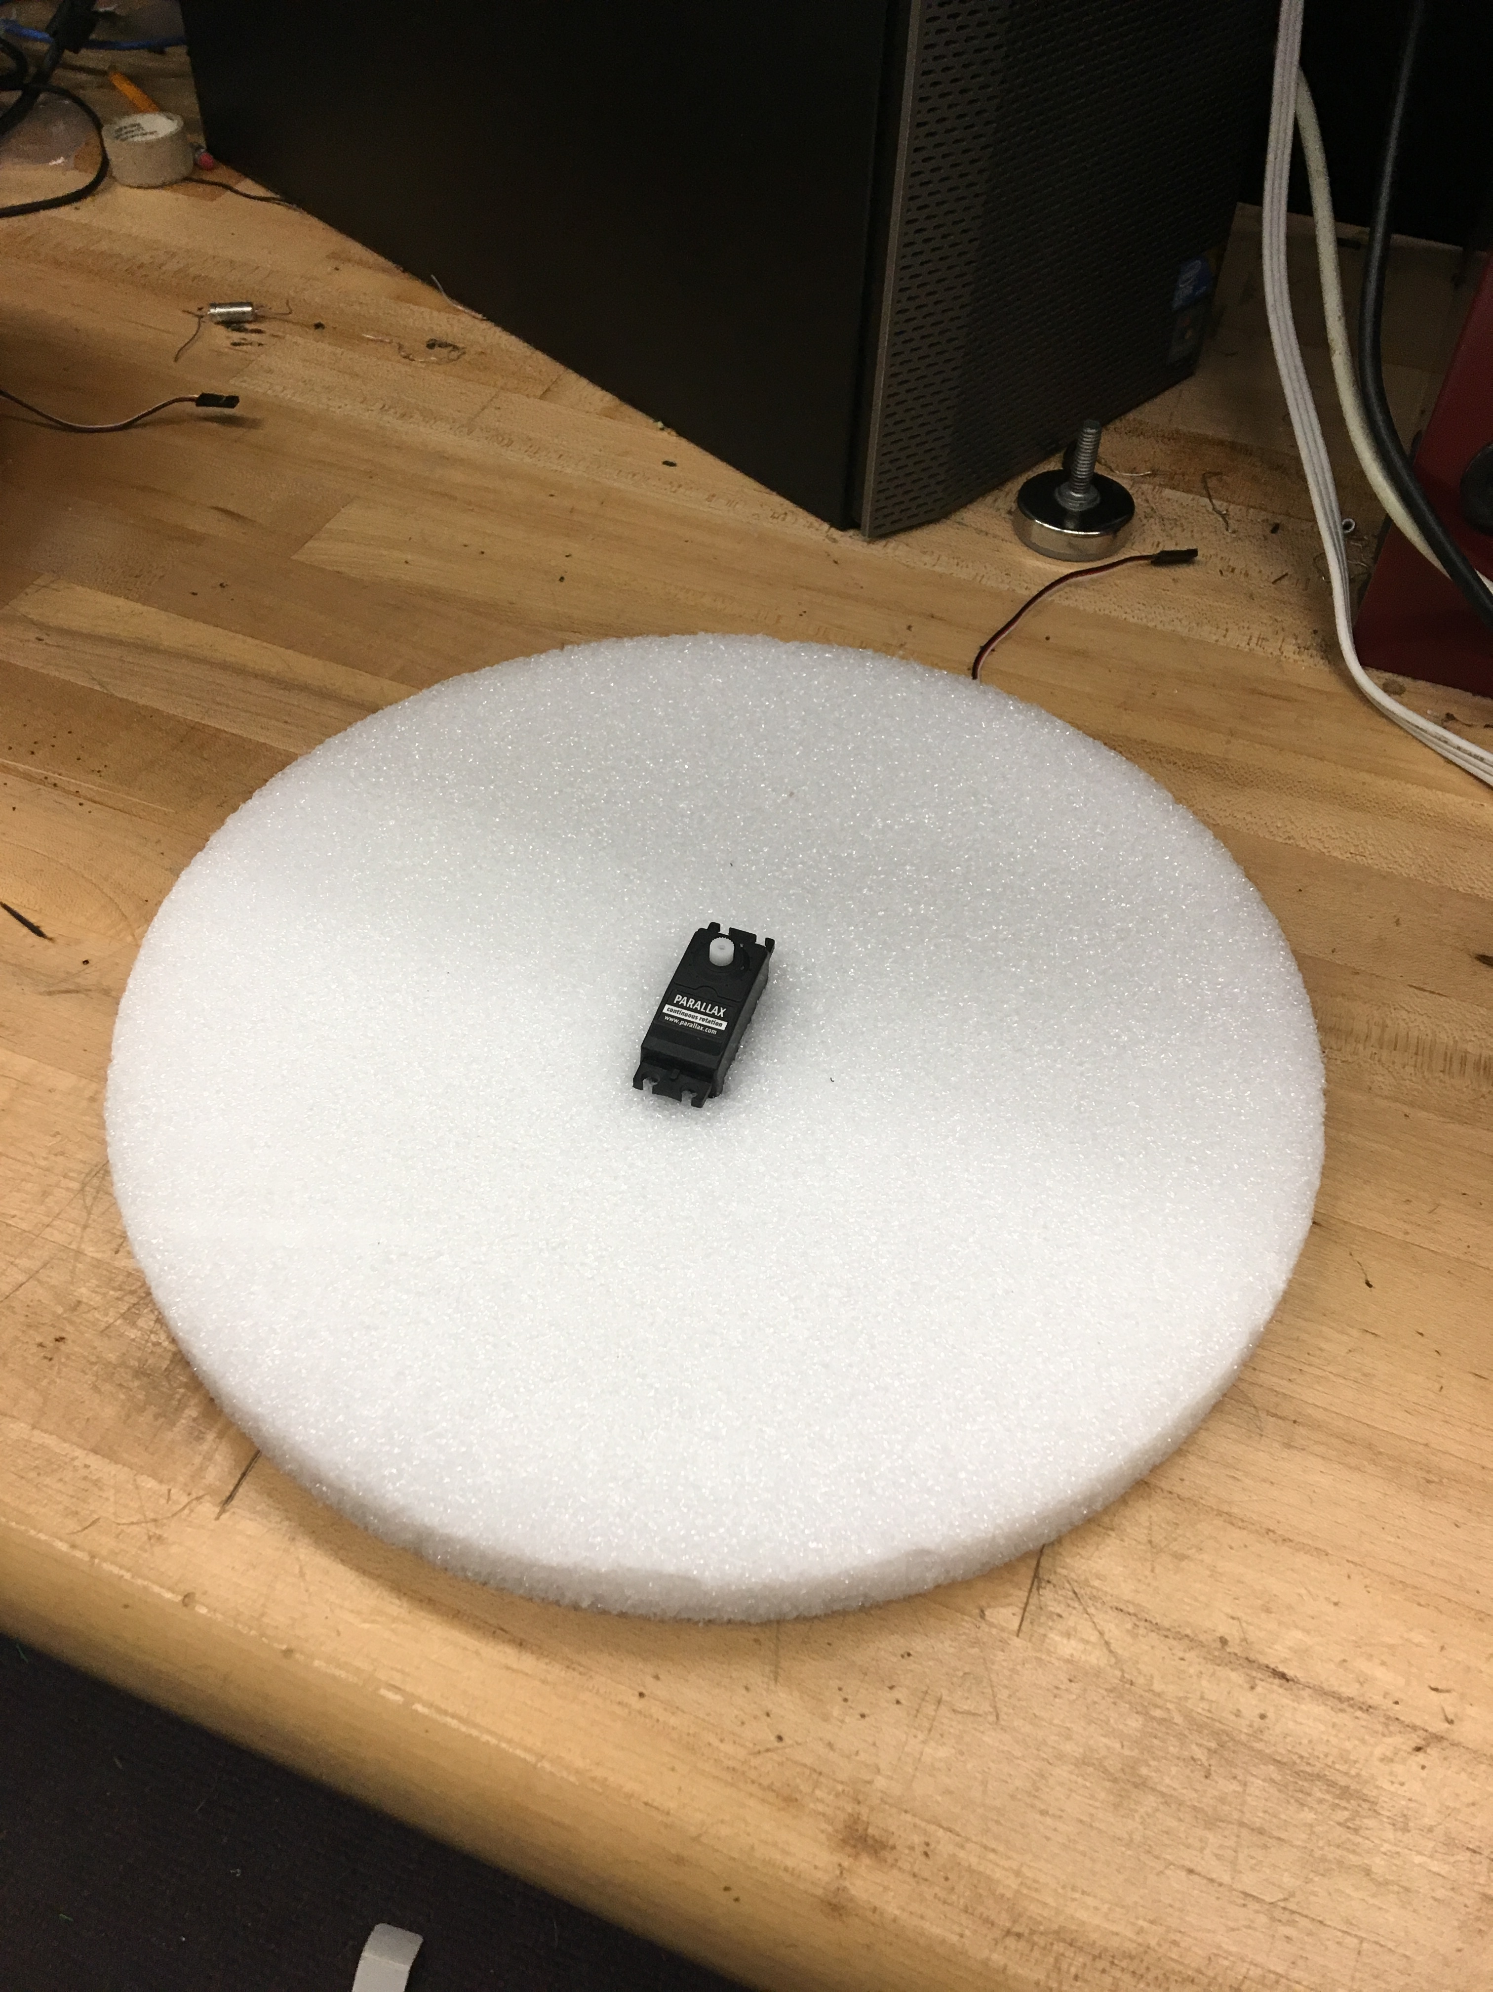 (b)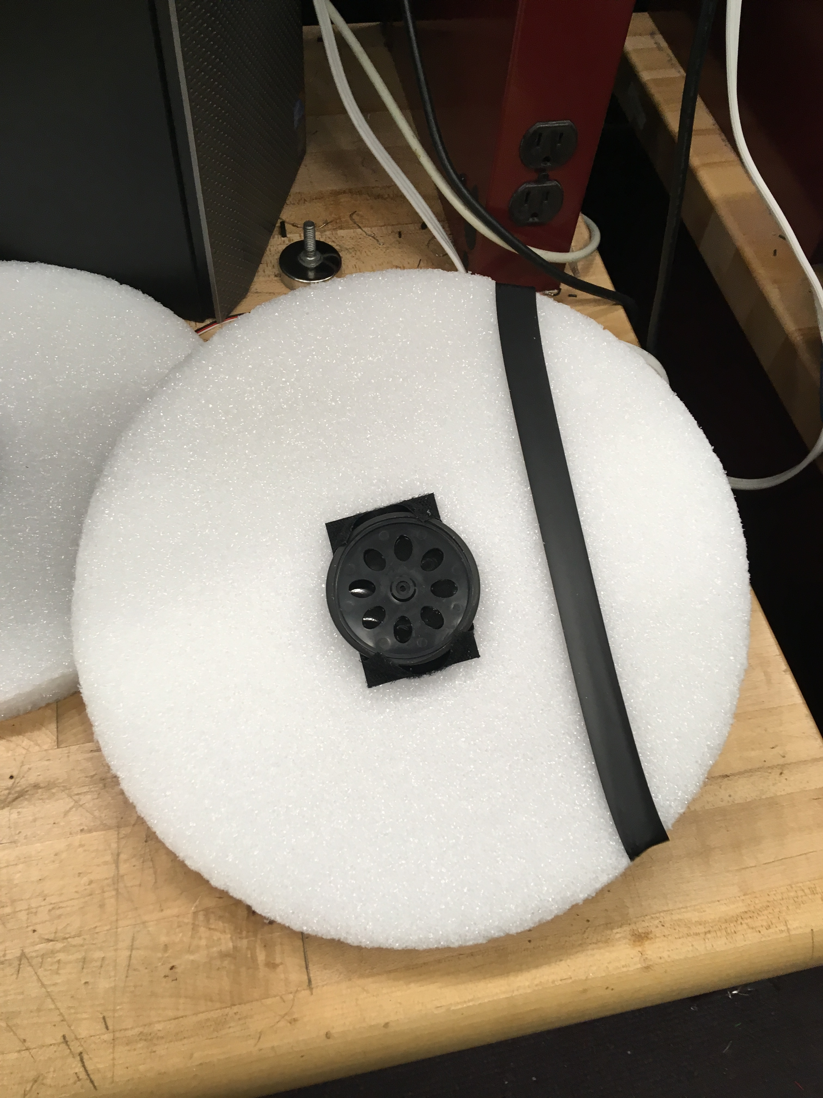(c) 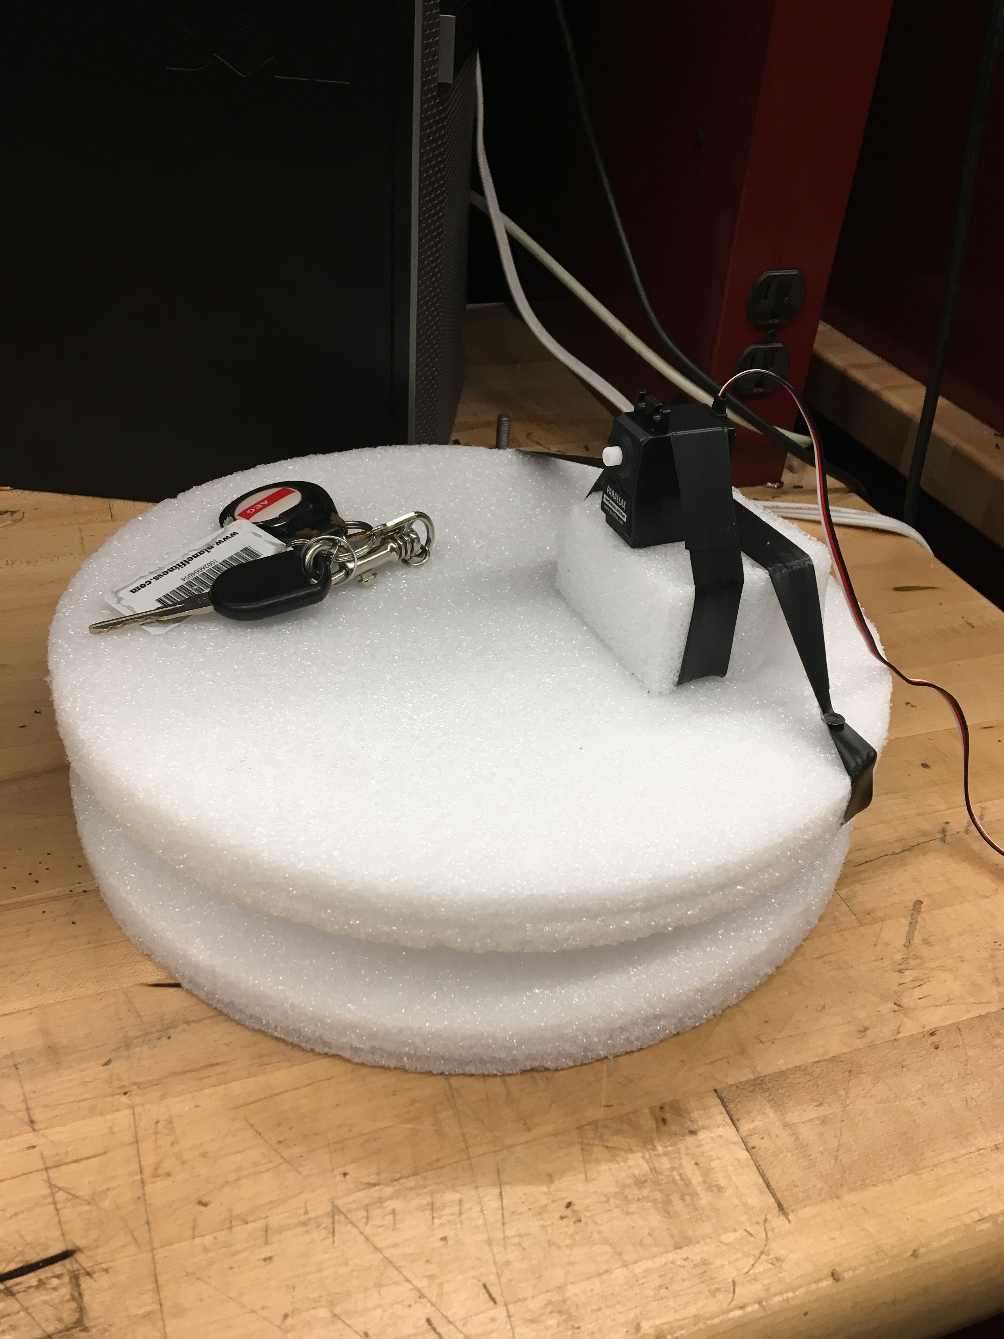
(d)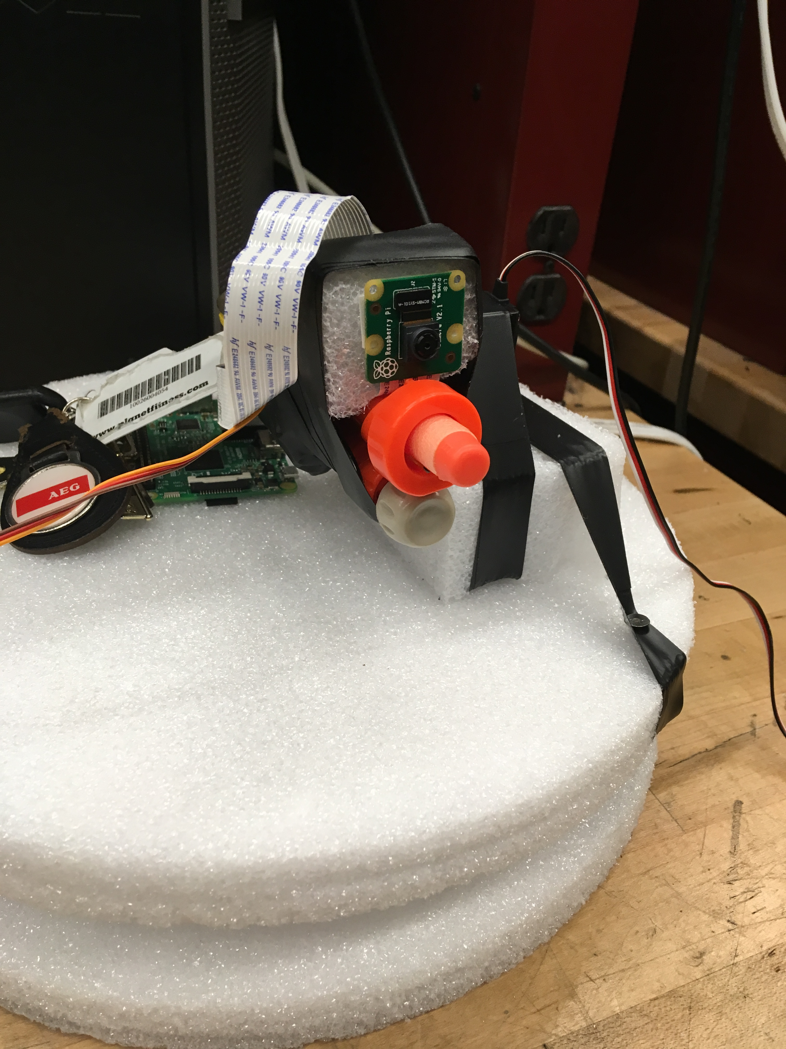(e)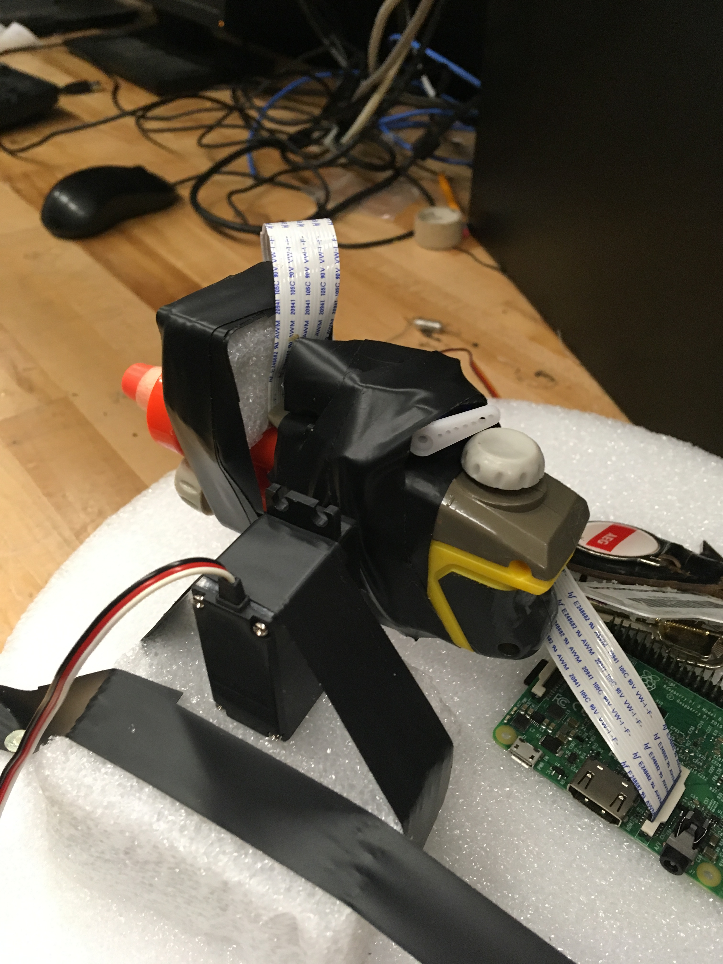(f)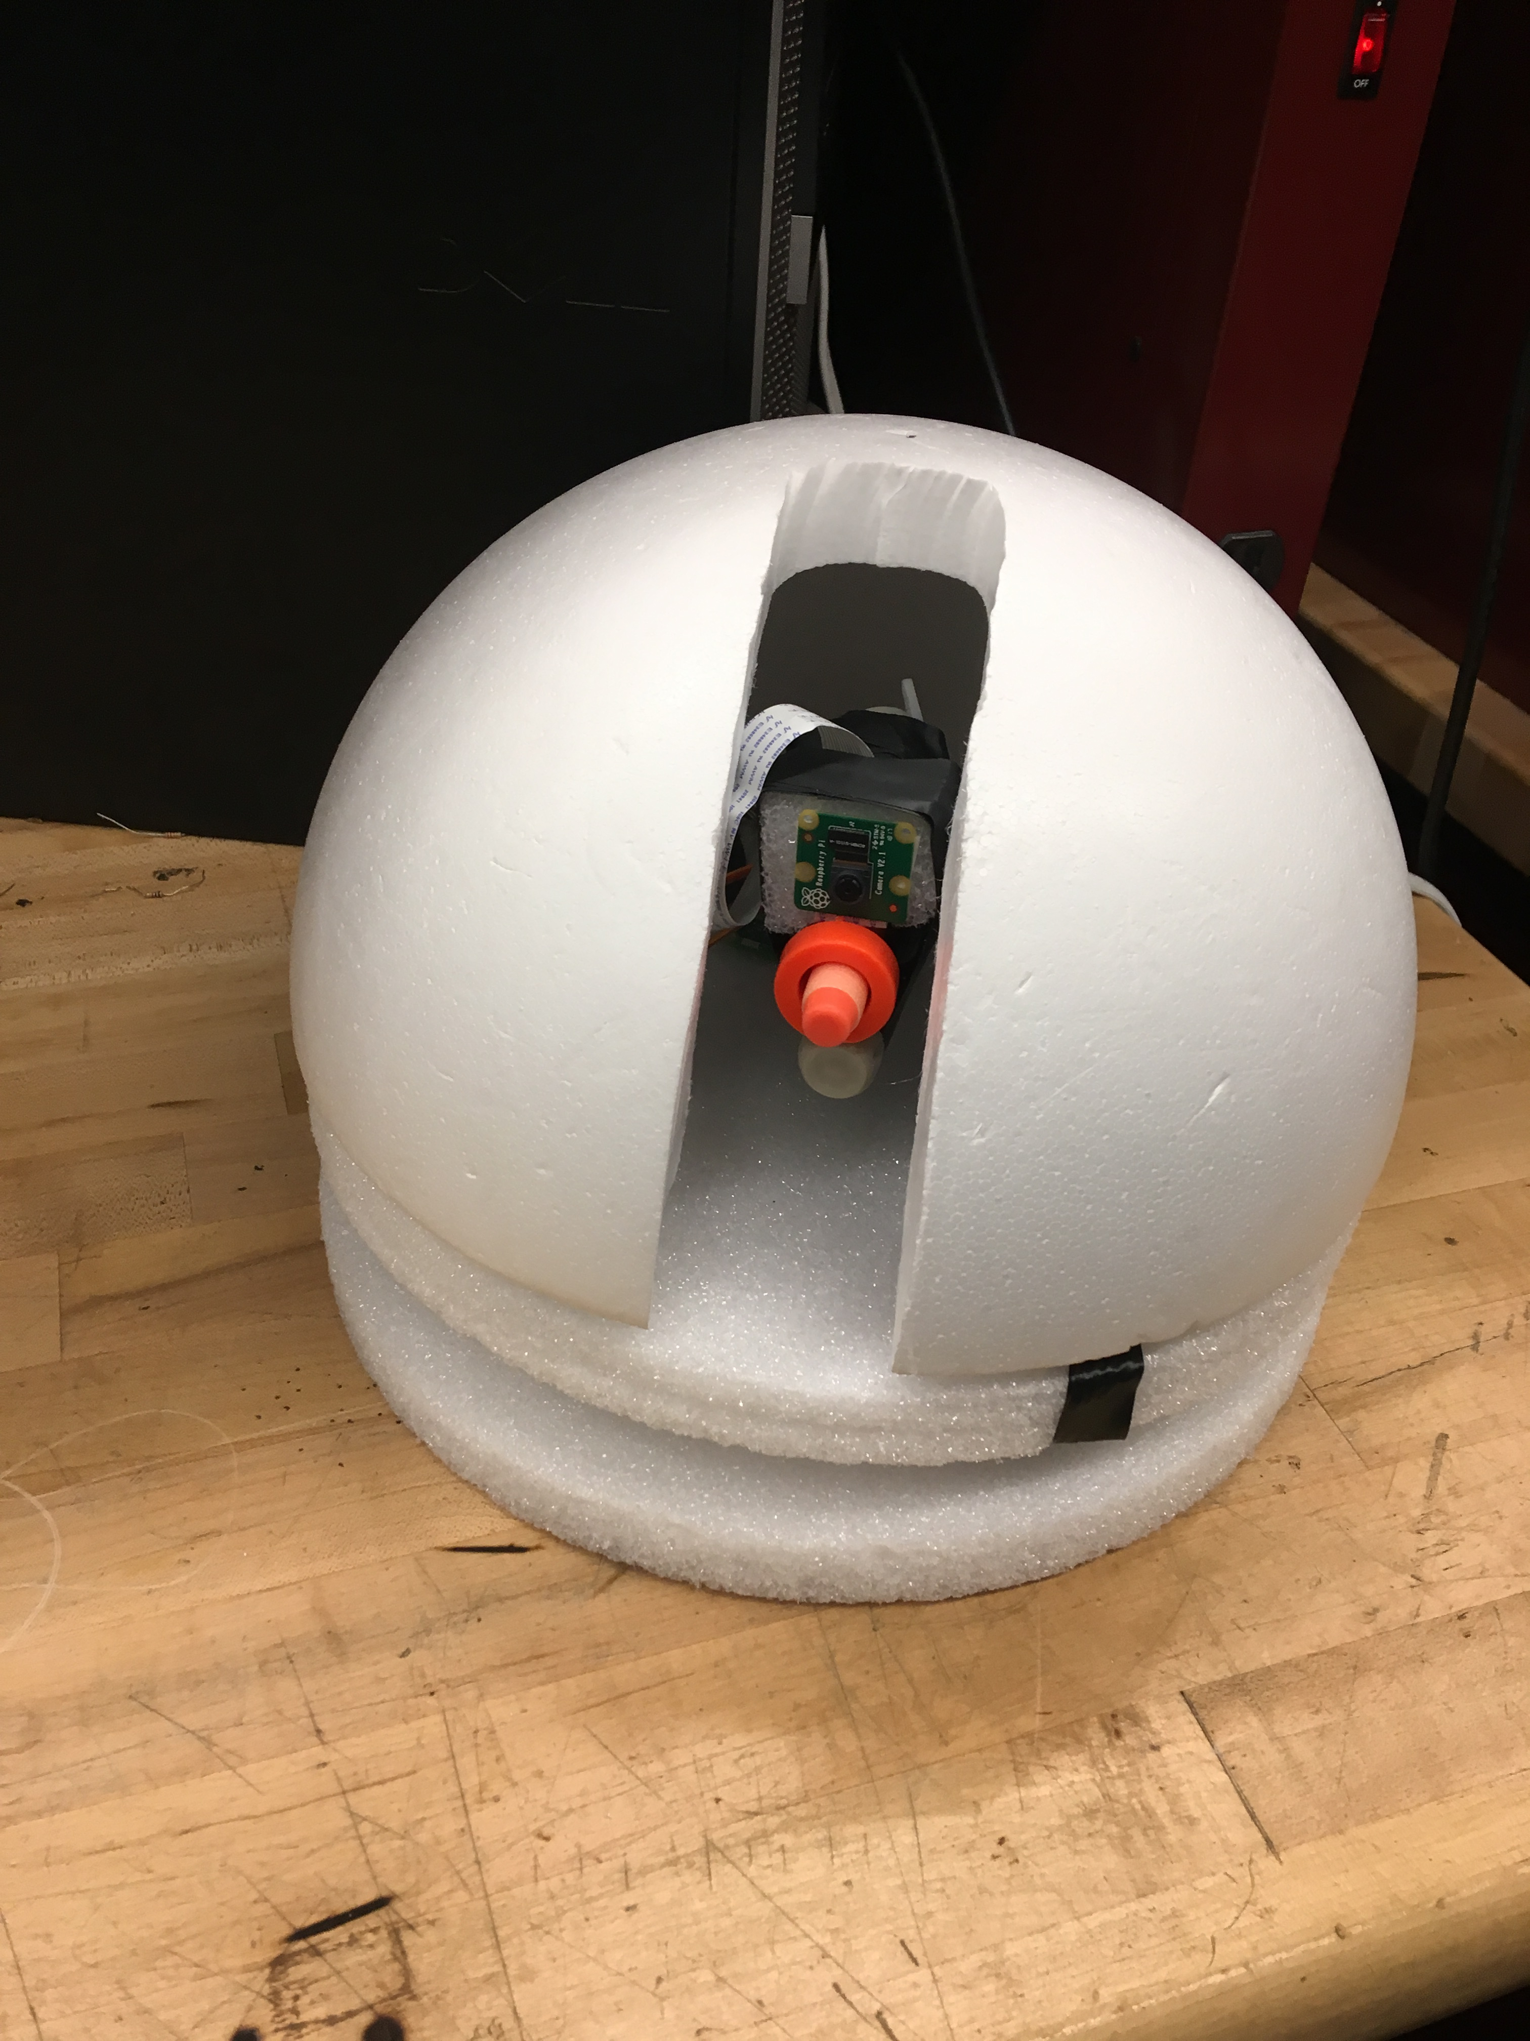
Figure 11 – ASRH Structure: (a) Base with Yaw motor (b) Platform (bottom view) (c) Platform on Base with Pitch Motor (d) Camera on Nerf gun (e) Servo on Nerf Gun (f) Shroud
B. Wiring
Figuring out how to wire everything was the greatest challenge from a structural/mechanical point of view. The main problem is that we had components on the rotating Platform that needed to connect to components outside of the Shroud. Usually, the problem of connecting rotating components to stationary components is easily solved using an electro-mechanical slip ring. However, this solution is not applicable to the ASRH for two main reasons: 1) The slip ring would need to enter the rotating Platform at its center of rotation, which was not possible due to the location of the yaw motor at the platform’s center. 2) Because of the types of signals we were dealing with, it was impossible to use a normal slip ring on the ASRH. Instead, we would need to use a customized slip ring that costs hundreds of dollars.
It was therefore decided to go with a different approach to solve this problem. Instead of a slip ring, long flexible wires are used that wrap around a 4-inch tart ring sitting in between the Base and Platform. This allows the ASRH to fully rotate on the Yaw axis while at the same time keeping most of the wires out of view, leaving the ASRH more aesthetically pleasing. This is implemented by cutting a small hole in the Platform to feed wires through. Ground, Power, and Signal for both the Pitch and Gun motor, the Raspberry Pi Camera Ribbon Cable, and instructions to the Trinket are the signals that will be fed through this hole in the platform.

VII. Concluding Remarks
In conclusion, this Senior Design Project is a proof-of-concept prototype for a possible addition to the Arcadia Spider. The ASRH successfully demonstrates the electrical and computer engineering design principles required for a full-scale implementation using cheaper parts and hardware. The difference between this project and an addition to the Arcadia Spider is simply a matter of scale.

VIII. Biography

Steven Solis will receive his Bachelor of Science in Photonics Science and Engineering in May of 2018 from the University of Central Florida. He plans to enter the workforce after graduation as well as pursue a masters in optics. Steven is currently a research assistant under Dr. Michael Chini at the University of Central Florida.

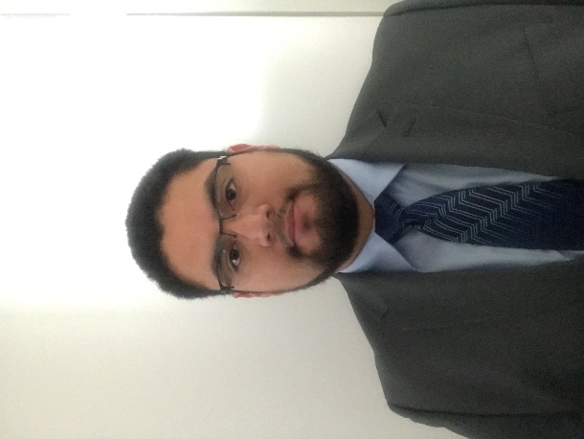
Angel Mandujano will receive his BSEE and minor in Intelligent Robotic Systems in May 2018. He plans to continue his education and enter graduate school for an MSEE in Signal Processing and Systems at UCF.
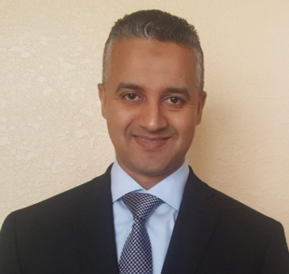
Said Mourfik will receive his Bachelor of Science in Electrical Engineering in May of 2018 from the University of Central Florida. He plans to continue education toward his master’s degree (digital signal processing). Said is currently an intern at Universal Orlando Creative team.

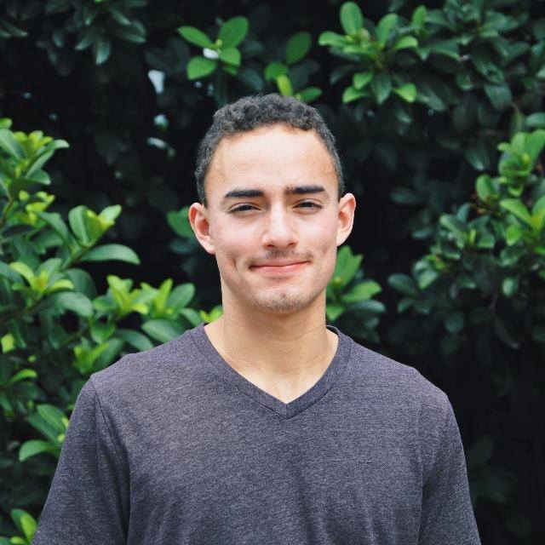
Dries Kassabi will receive his BSEE and minors in Math and Intelligent Robotic Systems in May 2018. He will assume a full-time role as a Testability/Reliability Engineer at Lockheed Martin after graduation. He plans to attend the University of Florida’s Outreach Engineering Management program where he will earn a M.S. in Industrial and Systems Engineering and an MBA while working. He hopes to one day earn his PhD in a technical field. His main interests are Intelligent Robotic Systems and Electromagnetics.

IX. References
[1] P. Rubinstein, “EDM Is Now Worth More Than Ever Before But It's Still Not Good Enough,” Your EDM, 26-May-2016. [Online]

[2] “OpenCV: Face Detection using Haar Cascades,” OpenCV. [Online]

[3] FRC4564, “FRC4564/Xbox,” GitHub. [Online]. /Xbox. [Accessed: 13-Apr-2018]

