# Solar Powered Flower Sculpture

Nickolas DeVito, Kelechi Ukachi-Lois, Mahaley Vann, and Kibwe Williamson

### Dept. of Electrical Engineering and Computer Science, University of Central Florida, Orlando, Florida, 32816-2450

### ***Abstract* — The purpose of this document is to outline the steps that were taken to design and realize our** S**olar** P**owered** F**lower** S**culpture p**roject. By reading commands sent from a compatible Android mobile application, the flower sculpture used segmented LED strips, embedded beneath the flower sculpture’s “petals”, to operate in a variety of modes. The sculpture can be chosen to act as a clock, (with LEDs operating as the hour and minute hands of a clock face), as well as a alarm/timer. Other modes allow the sculpture to work as an LWS lamp, or under a party mode that cycles through various light patterns at the user’s suggestion. Mobile commands are sent over a Bluetooth connection to an Arduino microcontroller. The sculpture uses solar cells as its source of renewable energy, and provides a lightweight, aesthetically pleasing presentation.

### ***Index Terms* —** B**luetooth, design for quality**,light emitting diode**s, microcontroller, mobile applicat**ions, solar power generation.

### I. Introduction

In today's society, not many people will stop to take the time into looking at the simple and beautiful things that life has to offer. Due to this, the thought of creating a project that not only appeals to society’s need for new technology but also incorporating and harvesting the simple and beautiful qualities of nature, is what led to the development of the Solar Powered Flower Sculpture.

This idea began with simply wanting to have a project that solely relied on the harvested energy provided by the sun, solar energy. With this, the consumer would be able to transport said product absolutely anywhere without the worry of providing an external power source. From here, the overall presentation of the project was to have an aesthetic design and led to choosing a flower. This flower design would be displayed by having the sculpture have twelve petals, of which, would be connected to a wooden base.

As previously discussed, the simple and beautiful things in life usually get overlooked, so to keep the interest of the consumer, the technological aspects and additions were discussed. For the electrical portion, NeoPixel digital red, green, blue, and white LEDs would be adhered to each individual flower petal on the sculpture. These LEDs would then receive coded displays from an internal microcontroller, the Arduino Nano, which would be stored within the wooden base of the sculpture. This Arduino Nano is then capable of transmitting these codes through an Android compatible application with Bluetooth.

With the addition of the Android application, it allows consumer interaction which would then allow the ability to continuously change and customize the sculpture. With this, the project successfully combines the beauty of nature with the drive to advance technology.

II. System Components

The following sections describe the selection of each subsystem and their function. Each was selected or designed to fulfill a specific function in the overall design. The later sections explain each system in more detail.

*A. Microcontroller*

The microcontroller is the brains of the system receiving and sending signal to Bluetooth shield. The microcontroller provides a grounding pin and a three volt pin for the Bluetooth shield. Either directly or through a pin extension module the microcontroller will need to be able to send out twelve pulse width modulation signals to the LED strips. The LEDS can be grounded through the Arduino’s ground but will get their voltage directly from the battery to prevent them from crashing the microcontroller due to voltage drop. The microcontroller will get its power directly from the battery. The microcontroller will have five volt and three volt pins limiting what can be directly hooked up to the controllers.

*B. LEDs*

The LEDs chosen were NeoPixel digital red, green, blue, and white LED strips. These certain LEDs are contained within a white flex PCB case holding 60 LEDs per meter. This certain LED strip contains white LEDs with a yellow phosphor on one half and then red, green, and blue LEDs on the other half of the strip. The difference between the NeoPixel and regular LEDs is that the NeoPixels are 5050-sized LEDs that contain an embedded microcontroller within the actual LED itself. This then allows each individual LED down the strip be controlled and programed separately. To run this certain LED strip, a constant five volts DC needs to be delivered from the Arduino Nano microcontroller throughout the whole LED strip.

*C. Photovoltaic Cells*

For this Solar Powered Flower Sculpture, the group decided to series stack multiple small high powered photovoltaic cells to achieve a large enough input to charge the rechargeable Nickel–Metal Hydride battery that supplies power to the Arduino Nano microcontroller. By doing this, the group could optimize the size the base of the Solar Powered Flower Sculpture since the photovoltaic cells would be small enough to be placed at the outskirts of the petals along the edges of the wooden base. These certain photovoltaic cells happen to be made from copper indium diselenide which has a dark glossy appearance, which is typically seen on the LED path lights. With this, the photovoltaic cells will blend into the base since the wooden base will be stained to a darker color, black cherry.

*D. Power Control*

To power the Solar Powered Flower Sculpture, a battery source will be in parallel with the photovoltaic cells and the Arduino Nano microcontroller. This is accomplished by the photovoltaic cells being connected to a charge controller which will then provide a constant charging source for the battery. The battery will then be connected to a switching regulator that will provide a constant regulated voltage source to the Arduino Nano microcontroller without saturating the microcontroller system. With this constant regulated voltage being provided from the switching regulator, the Arduino Nano microcontroller is then capable of constantly providing enough voltage to power the NeoPixel digital red, green, blue, and white LED strips and operate the program that is uploaded onto the Arduino Nano microcontroller. To correctly power the Solar Powered Flower Sculpture, a Nickel-Metal Hydride 9-volt rechargeable battery was selected.

*E. Wireless Module*

The wireless module is the pipeline between the Android application and the Arduino. The wireless module holds a vital role in enabling communication between both the Android application and the Arduino. Because, it is what enables the Android application and the Arduino to communicate. Without the wireless module, the Solar Powered Flower Sculpture would not be able to communicate with the Android application which is a required feature.

For this Solar Powered Flower Sculpture, the wireless module must be a duplex. Meaning that both parties will be able to receive and transmit messages. To achieve this, a Bluetooth module will used. The Arduino will be equipped with a Bluetooth module that has both a transceiver and receiver which will enable the Arduino to transmit and receive messages via Bluetooth communication. The Android application is intended to be run on a smartphone, which have Bluetooth built-in. Meaning that the Android application will be able to transmit and receive messages via Bluetooth communication..

The wireless Bluetooth module works physically with the Arduino microcontroller. The Bluetooth wireless module is to be physically connected to the Arduino microcontroller. The wireless Bluetooth module has four pins to be physically connected to the Arduino microcontroller. The pins that will be connected to the Arduino microcontroller are the transmitter pin, the receiver pin, the VCC pin, and the ground pin.

*F. Texas Instruments TLC5940*

To keep the size of the solar statue down we went with the smaller microcontroller the Arduino Nano. This gave us the small size we wanted but a major trade up was that it didn’t have enough pulse width modulation outputs for our project. This required that we include a LED driver to expand the number of pulse width modulation outputs available for the design. To expand the number of pulse width modulation outputs available for our project we used the TLC5940 from Texas Instrument. This gave us sixteen pulse width modulation channels to work with, without having to go with a bigger microcontroller. The TLC5940 is daisy chainable allowing us to make more elaborate displays by just adding another unit. The duty cycle is twelve bit and the limit control is six bit.

*G. Android Application*

The Android application is the tool designed to facilitate the user with the variety of functions the Solar Powered Flower Sculpture accomplishes. The Android application is designed to be user-friendly allowing for use by any user regardless of technical background. The Android application is designed for Android API level 23, Android 6.0 Marshmallow. This specific API level determines the level of compatibility with Android devices. As of March 2017 there are currently 34.1% of devices which run Android API level 23, Android 6.0 Marshmallow and above. According to the Android developer website[1]. Selecting this API level gives over a third of devices access compatibility to the Solar Powered Flower Sculpture Android application. As Android users update their devices and devices software, a greater proportion of user will have compatibility to the Android API level 23, Android 6.0. As a result, the Solar Powered Flower Sculpture Android application will be more compatible with Android devices as users update.

### III. System Concept

The device’s flow of operation is described in the following sections to give a full grasp of the project. The considerations for the multiple aspects of the design are explained. The issues that arose during the prototyping process and how they were resolved will also be explained in the following sections.

*A. Operation Overview*

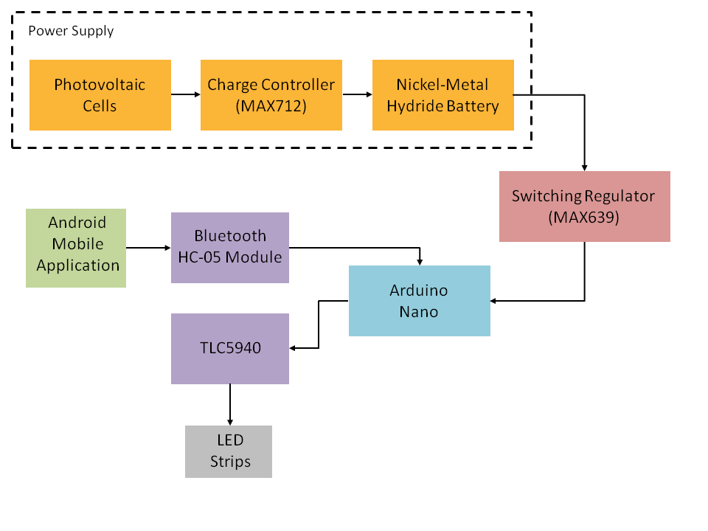

Fig. 1. The operation of the system as a whole is shown in the block diagram above.

The figure above shows the chain of power flow throughout the electrical components in the project. To begin, the project absorbs solar energy and converts it into an electrical current through the solar cells. This current is run through the charge controller, of which then stabilizes and allows for a regulated voltage to be delivered to the rest of the system. This regulated voltage is then what allows for the rechargeable Nickel–Metal Hydride battery to recharge after it drops past its minimum voltage for the system. These components make up the power supply used by other pieces of the system. The battery then sends its varying voltage through a switching regulator, which will regulate that voltage to a constant five volts, and then will supply power to the Arduino Nano microcontroller and its attachments. The Arduino Nano, in addition to the TLC5940 LED driver, is then what supplies power and commands to the NeoPixel digital LED strips. A Bluetooth module is also connected to the microcontroller, which communicates with the user via a mobile app. This interaction then alters the display in response to the user’s input.

*B. Software Flow Overview*

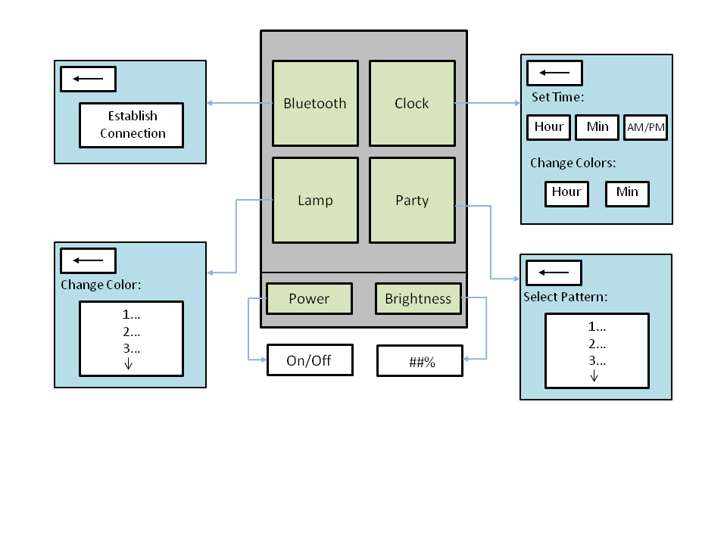

Fig. 2. The functional flow of the Android mobile application software component is shown in the diagram above.

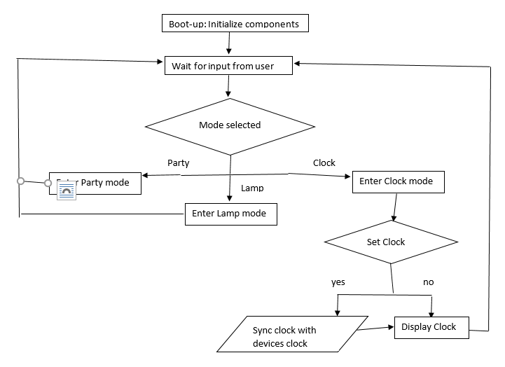

Fig. 3. Flowchart showing the transitional flow between the receive, decide and display states.

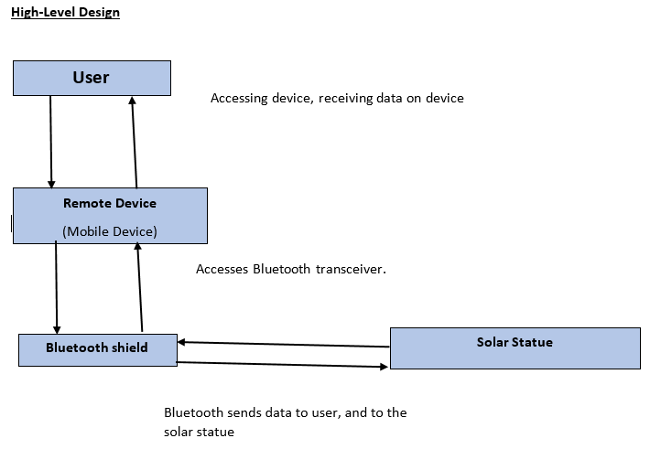

Fig. 4 Illustrates the flow of RFCOMM serial communication from user to solar statue.

The user selects between one of three modes. Selecting the clock executes functions that take the time from the users device and displays an analogous clock display of that time. Choosing the lamp mode turns on all the LEDs in a certain color and brightness. Selecting the party mode activates various kaleidoscope type display of colored lights on the display.

### IV. Hardware Detail

Further technical explanations behind choosing the main hardware components listed in section II. System Components will now be analyzed.

*A. Microcontroller*

The Solar Powered Flower Sculpture’s display has twelve petals which each have LEDs adhered to their surfaces. Due to this, a microcontroller needed to have twelve accessible input/output pins in order to communicate to the LEDs embedded microcontroller. Also, twelve separate input/output pins are needed to have pulse width modulation to control the brightness of the LEDS. Keeping the project cost efficient, the Arduino Nano was chosen. This microcontroller only has twenty-two digital input/output pins, of which only six have pulse width modulation functionality and does not meet the requirements. However, an LED driver was incorporated in the hardware schematic to extend the Arduino Nano’s pulse width modulation input/output pins. This additional component requires the designated connection to five of the Arduino Nano’s input/output pins. With the contribution of this component, any of the remaining input/output pins can be used to communicate the codes to the LEDs embedded microcontroller.

*B. LEDs*

As previously discussed, the LEDs chosen were Neopixel digital red, green, blue, and white. These specific LEDs fit our design aesthetic since they are built in strip form and can be adhered to the petals of the sculpture together without any extra wiring. These were ideal since they combine all four basic LED colors which would inherently allow for maximum coding possibilities.

To integrate these LEDs into the hardware design, each strip was cut to include nine individual LEDs. Each LED strip has three port connections, a red wire for power, a black wire for ground, and a green wire for digital communications. The red power wires are connected to the five volt pin on the Arduino Nano. The black wires are actually connected to the LED drivers pins since it is a common-cathode current sinker. With this in mind, these specific LED strips need a maximum of five volts and 80 mA per individual LEDs to have all LEDs on and at full brightness. To correct the Arduino Nano’s DC current per input/output pins of 40 mA, a resistor was added in series with the red power wire to increase the current from the Arduino Nano’s five volt pin. For communication to the LEDs embedded microcontroller, each individual green wire is connected to a digital or analog input/output pin on the Arduino Nano.

*C. Photovoltaic Cells*

The photovoltaic cells are the power cell for all of the electronic devices on the sculpture. Each individual photovoltaic cell are 60 mm by 60 mm and provide four and a half volts and 90 mA. To power the sculpture’s electronics as a whole, the nine volt rechargeable battery needs to retain enough voltage to power the Arduino Nano. In order to do this, as previously stated in section II, six series stacked photovoltaic cells will provide a maximum of 27 volts. These are firstly connected to a charge controller (MAX712) which allows for a regulated voltage to be supplied to the rechargeable battery[5]. This charge controller is capable of doing so as long as the photovoltaic cells as a whole series supply a minimum of six volts. In an effort to maximize solar power efficiency, each of the six photovoltaic cells will be distributed strategically around the sculpture to increase all day solar exposure.

### V. Software Detail

*A. Android Application*

The Solar Powered Flower Sculpture Android application requires Bluetooth capability and permission to access Bluetooth in order to properly function. In the event that the Android device lacks a Bluetooth adapter or refuses permission, the Solar Powered Flower Sculpture Android application will be unable to perform its duties due to a lack of the appropriate means. Android API level 23, Android 6.0 Marshmallow protocol requires users to be informed about the fact that the application will access Bluetooth during runtime. This means that the Solar Powered Flower Sculpture Android application must prompt the user before accessing Bluetooth. This gives the user the opportunity to prevent the application from accomplishing its intended purpose, allowing better security rights for the user. If the user fails to allow permissions the Solar Powered Flower Sculpture Android application will prevent the user from executing the desired code. Allowing permissions is a necessity for the Solar Powered Flower Sculpture Android application to effectively complete its required duties

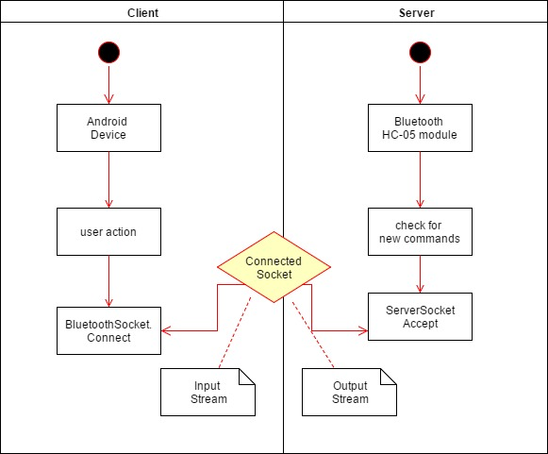

Fig. 5 Illustrates the flow of serial connection process

The design of the Solar Powered Flower Sculpture Android application gives users the ability to switch back and forth from multiple activities. All of these activities have the ability access the Bluetooth once the initiated communication has been established. In order to achieve this feat, the Solar Powered Flower Sculpture Android application harnesses the usefulness of Services. Services allow the android application to run the Bluetooth service in the background. This allows the Bluetooth connection to stay alive as the user navigates between different activities. Without using Services, the Solar Powered Flower Sculpture Android application would have to be extremely inefficiently. Since it would force the application to reconnect the Bluetooth connections every time the user switched between activities.

The Solar Powered Flower Sculpture Android application implements a connect thread, a connected thread and a handler to initiate and maintain the Bluetooth connection to the Bluetooth socket. Once connected, all information in the Bluetooth socket is handled by input streams and output streams. These input streams and output streams are used to beam bytes back and forth with the objective of facilitating successful communication with the android application and the Bluetooth device it is connected with. Data sent through is used to select, change, alter different settings of the Solar Powered Flower Sculpture[3].

The Solar Powered Flower Sculpture Android application is designed to limit and reduce the user’s need to interact with the Bluetooth settings manually. Besides the initial connection process, the Solar Powered Flower Sculpture Android application is designed to limit the need for unnecessary interaction with the technical aspects of Bluetooth. The graphical user interface of the Solar Powered Flower Sculpture Android application is intended to be as clear and straightforward as possible.

The graphical user interface has main five activities in total. The first being the home page which is used for navigation. Along with four other activities which include, Bluetooth, Party, Clock, and lamp.

The Bluetooth activity is used to select the appropriate device to connect with. The Bluetooth activity gives the user the ability to search for available Bluetooth devices and also generates a list of Bluetooth devices that have already been paired. Via onClickListeners, the activity allows user to click on the desired device and then simply click on the connect button to connect the systems.

The Clock activity is the activity which sets and customizes the clock display. The clock activity is a fragmented activity with three specific fragment tabs the first fragment tab is for setting the clock. This fragment activity can also adjust the colors of the both the hour hand and minute hand of the clock.

The Party activity is an activity which is used to select the desired pattern modes. With a total of ten unique patterns the user is able to scroll through a listview to select the desired pattern. Once selected the Solar Powered Flower Sculpture will emit the led pattern.

The Lamp activity is an activity to activate the lamp feature of the Solar Powered Flower Sculpture. The lamp mode is designed to be used as a lamp therefore the Solar Powered Flower Sculpture LEDs will be in a constant consistent state. The lamp mode offers a selection of both brightness and color.

Keeping the user in mind, the overall graphical user interface has been developed with a multitude of onClickListeners. These click listeners allow the user to select, navigate, through the Solar Powered Flower Sculpture Android application with little to no effort. The listeners are linked to buttons, seekbars, and spinners which give the user the ability to change settings with the push of a button or the slide of a thumb.

*B. Arduino Computation*

The Arduino Nano microcontroller used for this project relies on code written in C. The functions used by the Solar Powered Flower Sculpture operating modes are embedded into the microcontroller, and can be run based on the results of options provided to the user in the mobile application. Strings of receiving data carried from the Android app are translated into condition variables that, based on changes the user has made on their mobile device, determine which functions are running on the microcontroller[2]. This assumes a Bluetooth connection has already been established with the compatible device. Therefore, before the code determines which mode of operation will translate to the flower sculpture’s LEDs, the Arduino uses its attached Bluetooth module to become identifiable to the mobile device, and ensure a connection for receiving information once it has been confirmed by the user.

Before the Solar Powered Flower Sculpture can run its operating modes, certain initializations need to be made by the microcontroller. The pin values corresponding to each of the twelve LED strips need to be set before they can be modified by further doce instructions. Modifying these values in the Arduino code changes the color of the LEDs. Separate pin values are also set corresponding to the LED strip connections for TLC5940 pulse width modulation. Modifying these values in the code can change the brightness settings of the LED strips, and also allow for possible fading effects.

If the clock mode is selected on the mobile application, values will be read into the Arduino Nano relating to the time to be set, the colors of the hour and minute hands, and the brightness. A pre-installed Arduino package allows the microcontroller to have an actively running time function throughout the use of the structure. As time is selected by the user and transferred via Bluetooth, the hour and minute sections of the Arduino’s time function are modified, and its seconds value is set to zero. This allows the time to be readjusted at any time, and it will be maintained even if the mode of operation is changed from clock to something else. For assigning the hour and minute hand values to their respective LED strips, first color specified is determined, as separate functions of code exist for each of the color values. Then data is sent from the Arduino that will light all LEDs on the strip representing minutes, and some of the LEDs on the strip representing hour. As there are twelve LED strips representing the petals of the Solar Powered Flower Sculpture, minutes are assigned to the closest value of five to be displayed.

If the party mode is selected on the mobile application, the values read into the Arduino microcontroller will relate to the pattern selected and brightness. Each of the ten light cycle patterns are programmed into the Arduino Nano, and by having a condition variable specified from the application data, the desired pattern will run on a loop displaying to the LED strips. The patterns themselves are written by a combination of having selected color conditions turned on or off to each individual light, and a series of time statements for pauses between display effects. At any time, if a different pattern is selected and read in through the Bluetooth receiver, the current pattern will be interrupted and the new one will start.

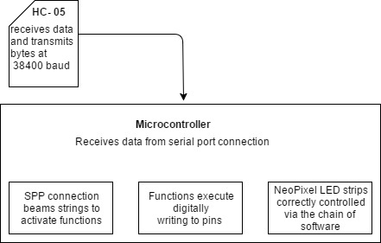

Fig. 6 As the HC-05 Bluetooth beams data to the microcontroller, the specific code procedure occurs. [4]

If the lamp mode is selected, the values will be transferred through the Arduino’s Bluetooth attachment, and will be used relating to the color and brightness settings of all LED strips. Cases are programmed into the microcontroller for all possible color values on the mobile app, and depending on which one is read in, the specified function will run on the structure. If at any time the color or brightness of the LEDs are changed by the user, the current case will end and the adjustments will be made to the structure.

|  |  |  |
| --- | --- | --- |
| LED | Arduino Nano | TLC5940 |
| 1 | D2 | OUT1 |
| 2 | D4 | OUT2 |
| 3 | D5 | OUT3 |
| 4 | D6 | OUT4 |
| 5 | D7 | OUT5 |
| 6 | D8 | OUT6 |
| 7 | A0 | OUT7 |
| 8 | A1 | OUT8 |
| 9 | A2 | OUT9 |
| 10 | A3 | OUT10 |
| 11 | A4 | OUT11 |
| 12 | A5 | OUT12 |

Fig. 7 LED initialization pins

VI. PCB Design

The printed circuit board for this sculpture project was designed using the Eagle program software. This software was chosen since it was similar to other schematic based softwares used while in the ECE major related classes. Despite having a vast library selection, a majority of the components used in the sculpture’s design had to be created from scratch.

Due to the photovoltaic cells and the NeoPixel digital LED strips needing to be through holes, it made the most sense to have the photovoltaic cells power and ground wires be located on the left side of the board, and then since the NeoPixel digital LED strips have three individual wires, power, communication and ground, these would be best designed in rows and columns on the lower right hand side of the board.

It was also made as a decision to implement the actual Arduino Nano microcontroller onto the printed circuit board with through holes instead of using the ATmega328 microchip. This proved to be the most cost efficient since the routing from the microchip to the input/output pins was already achieved.

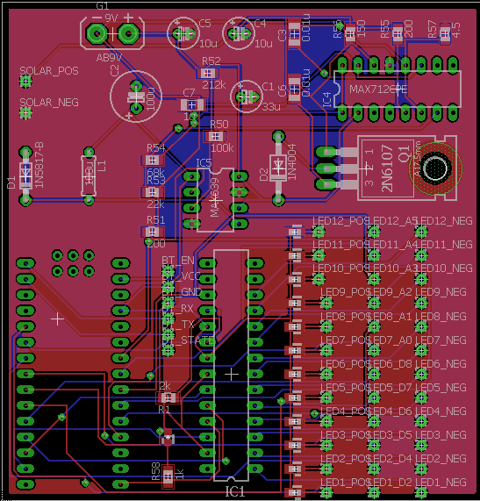

Fig. 8 Final printed circuit board layout

Also, despite the system running proficiently as a low powered system, this also meant having smaller solder mounted resistors and capacitors. With this in mind, most of the resistors and capacitors were lined up in even rows and columns to eliminate being all over the place.

VII. Conclusion

This document reflects the key points of our project and outlines its various functions. The Solar Powered Flower Sculpture was dual-semester long in production, where the first semester was research based and the second semester was implementation of the research and production of a physical scale model.

During the research phase, each member was able to learn a great deal about the components we were working with. We were able to demonstrate a great deal of competence about the components that was incorporated into our project, for each group member’s individual fields of expertise and responsibilities. Each member was also able to show an overall understanding of the entire scope of the project. Each member let their skills shine during the design phase, allowing us to put together a very detailed design. The detailed outline of the design and construction gave each member a sense of their responsibility and accountability for the project.

During the implementation and production phase, each group member was able to then showcase their developed skills when the project started to come together. The group also grew together in a sense that everyone would help each other in an effort to reach milestones and see progress. This part also gave insight into working on potential future engineering projects in the engineering and computer science fields.

### Acknowledgement

The group as a whole would like to extend gratitude towards the University of Central Florida’s College of Engineering and Computer Science, for giving us all of the resources to begin and finish our respective degrees and to become active participants in the engineering field.

We would also like to acknowledge all of our core and major class lectures and professors, who were the ones who made us all the more determined to prove to them that we could be successful engineers based on their teachings.

Lastly, we would like to graciously thank Dr. Douglas. Who seemed to always be able to find a component or spare part that then led to advancements in our project.

### References

[1] "Dashboards." Android Developers. N.p., n.d. Web. 05 Apr. 2017.

[2] Pmosconi. “Connect Arduino Arduino Uno to Android viz Bluetooth.” *Arduino*, <http://www.instructables.com/id/Connect-Arduino-Uno-to-Android-via-Bluetooth/>.

[3] Deyson. “How To: Create An Android App With Android Studio to Control LED.” *Instructables*, <http://www.instructables.com/id/Android-Bluetooth-Control-LED/>.

[4] “Datasheet Bluetooth to Serial Port Module HC05.” *Electronica 60 Norte*, <http://www.electronica60norte.com/mwfls/pdf/newBluetooth.pdf>.

[5] "Battery and Energy Technologies." *Nickel Cadmium NiCad Batteries*. N.p., n.d. Web. 10 Nov. 2016.

### Biography

**Nickolas Devito** is currently a senior at the University of Central Florida engaged in studying Computer Engineering, with a minor in Digital Media. His interests include interactive software design and development of embedded systems. His main focus on the project was programming the microcontroller, including LED implementation, and mobile application design.

**Kelechi Ukachi-Lois** is currently a senior computer engineering student at the University of Central Florida. Kelechi focused his technical elective studies on the computer programming side of computer engineering. With an expected graduation date of May 2017, Kelechi plans to exercise the discipline developed in computer engineering and apply it to other endeavors.



**Mahaley Vann** is currently a senior at the University of Central Florida. She will be graduating with her Bachelor’s in Electrical Engineering in the Spring Semester of 2017. After graduation, she will pursue job opportunities focused in renewable energy or control systems engineering. Being the solo electrical engineer in this project, her responsibilities included the hardware design for the printed circuit board, the power supply system, and the hardware wiring for the LEDs.



**Kibwe Williamson** is a student at the University of Central Florida studying Computer Engineering. He has been working for the last two terms as a research assistant as a rapid prototyper in the field of human factors. His interest includes synthetic biology and intends to pursue an advanced degree in biological engineering with a focus on synthetic biology. His focus on the project was mainly the interfacing the other components with the microcontroller and developing the software for the microcontroller.