**Senior Design 1**

*Solar-Powered Flower Sculpture that Illuminates with LED Interface to Tell Time*



*Department of Electrical Engineering and Computer Science*

*University of Central Florida*

*Dr. Lei Wei*

*Initial Project Document and Group Identification:*

*Divide and Conquer*

***Group 21***

Nickolas DeVito Computer Engineer [ndevito@knights.ucf.edu](mailto:ndevito@knights.ucf.edu)

Kibwe Williamson Computer Engineer k[williamson12@knights.ucf.edu](mailto:kwilliamson12@knights.ucf.edu)

Kelechi Ukachi-Lois Computer Engineer [kukachil@knights.ucf.edu](mailto:kukachil@knights.ucf.edu)

Mahaley Vann Electrical Engineer [mahaley.vann@knights.ucf.edu](mailto:mahaley.vann@knights.ucf.edu)

***Project Narrative***

As time marches onwards, renewable energy becomes increasingly vital to our society. Respecting the Earth and preserving its beauty for future generations is our responsibility. Therefore, building an electronic device that harvests renewable energy while simultaneously preserving and adding beauty to world is a highly appropriate project for an engineer. Naturally, this project will harvest natural, solar energy and add beauty via a sculpture.

The goal of this project is to bring renewable energy in an artistic design. By creating this sculpture people can enjoy access to the time of day without confining themselves inside or staring at an ordinary analog or digital clock. This sculpture will accomplish this by including a led interface to tell time (by the hour). This sculpture could also act as a night light once the sun went down.

An objective of this project is to draw attention and highlight the fact that structures can and should be built to harvest electricity without destroying the planet. Although this project is on a smaller scale, it shows that there are ways to keep the Earth beautiful while generating electricity.

The sculptures design is to be relatively small so that it can be portable. The idea is that the sculpture would be able to sit on a table and be taken on a camping trip or sit in someone’s backyard. The expected functionality is that it will absorb solar power in order to be able to illuminate the LED time telling interface.

The sculpture’s portability allows it to be used outdoors or indoors, as long as there is a sufficient source of sunlight to make use of its solar panels. Placed near a window, for example, the flower could easily sit by somebody’s desk, or act as a decorative addition to a gardener’s patio. Both situations would allow the owner of the sculpture to glance over for a look at the time, and the LED light source could act as a reading lamp of its own. Much like how a grandfather clock chimes a melody when the hour hand strikes, and a cuckoo-clock makes certain times of the day an event, the flower sculpture’s changing petals provides knowledge to the hours of the day, without being nearly as noisy as the previous examples. Rather, the LED petals change relaxingly, allowing people who wish to the visible change in time observe the phenomenon, without disturbing those that don’t.

***Motivation***

Our proposed project has many possible uses, depending on the type of person that may use it. Lovers of the outdoors would find great use for it as a portable light that tells the time and uses a flower design to represent their natural interests. Gardeners could take it with them outside to keep track of time while tending to flowers of their own, and those that prefer staying indoors can still place it nearby as a comforting memento. Some may be drawn to its artistic design, some may be attracted to its environmentally-friendly qualities, and others may appreciate its simplicity as a clock interface. Whoever uses our project, they will find something that appeals uniquely to them. As long as the sun powers it, our solar sculpture will enjoy long-lasting reusability, and hopefully bring happiness to people using it.

***Prototype Design***

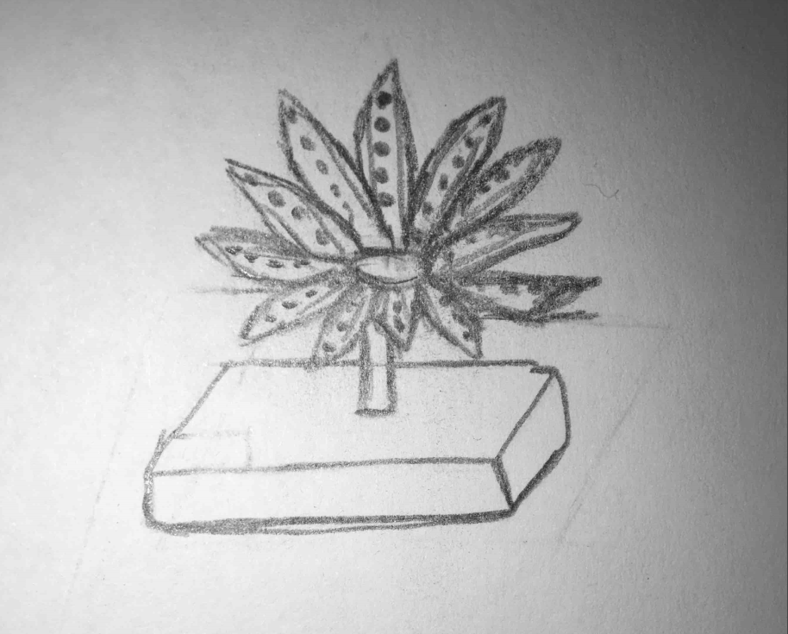

*subject to change

***Specification Requirements***

* Portable
  + Dimensions : no bigger than 3ft x 3ft x 3ft
  + Weight : under 40 lbs
* Solar Panels
  + Input Voltage : 15V – 45V
  + Output Voltage : 5V – 25V
* Microcontroller
  + Input / Output Voltage : 2.5 – 7.5 V
* LED Strips
  + Bright enough to be source of light
  + Bright enough to see a distance away
* Rechargeable batteries
  + Withstand running clock after charging

***Project Budget:***

* Raw Materials $100 - $200
* Rechargeable Batteries $25 - $35
* Solar Panels $30 - $50
* Microcontroller $25 - $40
* LED strip $7 - $40
* PCB $25 - $150
* Digital Clock $7 - $25

Total estimated budget: $219 - $500

This project will be funded completely by the group members.

***House of Quality***

Engineering/Marketing tradeoffs

Many, if not all engineering concepts are based on the ideal situation. However, this is not a perfect world. In our reality optimizing one area leads to flaws in others. In order to build more efficient designs it is necessary to take into account both the optimization and flaws that occur when constructing a design. Once a design has completed its requirements, the next step is to analyze the desired features and weigh them against their unwanted counterparts. Managing these tradeoffs is a major part of any design project.

↑ = Positive correlation

↑↑ = Strong positive correlation

↓ = Negative correlation

↓↓ = Strong negative correlation

+ = Positive polarity Increasing the Requirement

- = Negative Polarity Decreasing the Requirement

Engineering/Marketing Tradeoff Matrix

|  |  |  |  |  |  |  |  |  |
| --- | --- | --- | --- | --- | --- | --- | --- | --- |
|  | | Cost | Weight | Size | Durability | Brightness | Energy-Efficiency | Quality |
| - | - | - | + | + | + | + |
| Estimated Voltage from Solar | + | ↓↓ | ↓↓ | ↓↓ |  | ↑↑ | ↑↑ | ↑↑ |
| Brightness | + | ↓↓ | ↓ | ↓ |  |  | ↓ | ↑↑ |
| System Power | + | ↓↓ | ↓↓ | ↓↓ |  | ↑↑ | ↑↑ | ↑↑ |
| Microcontroller Performance | + | ↓↓ | ↓ | ↓ | ↑ |  | ↑ | ↑↑ |
| Size | - | ↓ | ↑ |  | ↓ | ↓ | ↓↓ | ↓↓ |
| Cost | - |  | ↓ | ↓ | ↓ | ↓↓ | ↓↓ | ↓↓ |

***Project Milestones***

|  |  |  |
| --- | --- | --- |
| **Senior Design 1 Fall 2016** | | |
| **Description** | **Duration** | **Dates** |
| Senior Design 1 Project Idea | 1 week | August 22 - 26 |
| Form Group / Project Idea | 1 week | August 29 - September 2 |
| Initial Project Document | 1 week | September 5 - 9 |
| Research / Begin Writing | 2 weeks | September 12 - 30 |
| Writing / Prototype Designing | 3 weeks | October 3 - 21 |
| Writing | 2 weeks | October 24 - November 4 |
| Table of Contents |  | November 4 |
| Writing | 1 week | November 7 - 11 |
| Initial Draft |  | November 11 |
| Code Development / PCB Design | 2 weeks | November 14 - 25 |
| Finish Document | 1 week | November 28 - December 2 |
| Review Document | 1 day | December 5 |
| Final Document |  | December 6 |

|  |  |  |
| --- | --- | --- |
| **Senior Design II Spring 2017** | | |
| **Description** | **Duration** | **Dates** |
| Test Components | TBA | TBA |
| Build Prototype | TBA | TBA |
| Testing & Redesign | TBA | TBA |
| Finalize Prototype | TBA | TBA |
| Peer Presentation | TBA | TBA |
| Final Report | TBA | TBA |
| Final Presentation | TBA | TBA |

***Potential add-ons***

If given adequate time, we would want to add on to our project specifications. To enhance our sculpture even more we would also like to give it charging capabilities. We would do this by adding one or more USB charging ports in the base. This would then allow our customers the ability to charge their electronic devices with renewable energy.

***Software Logic Flowchart***

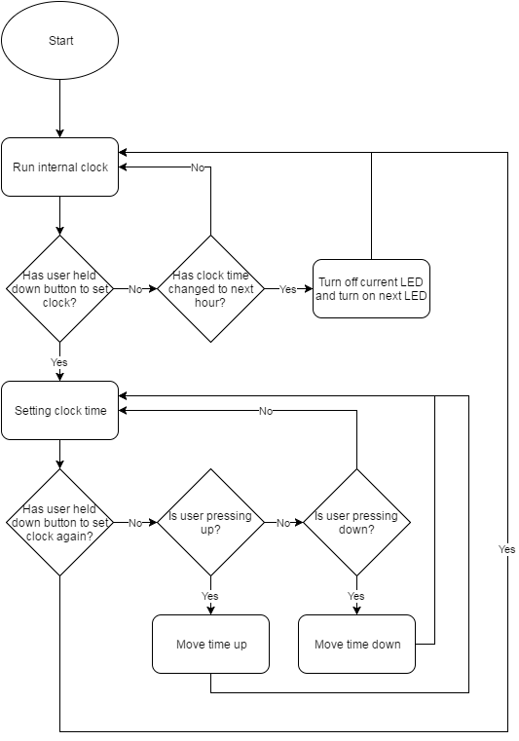

***Hardware Block Diagram***

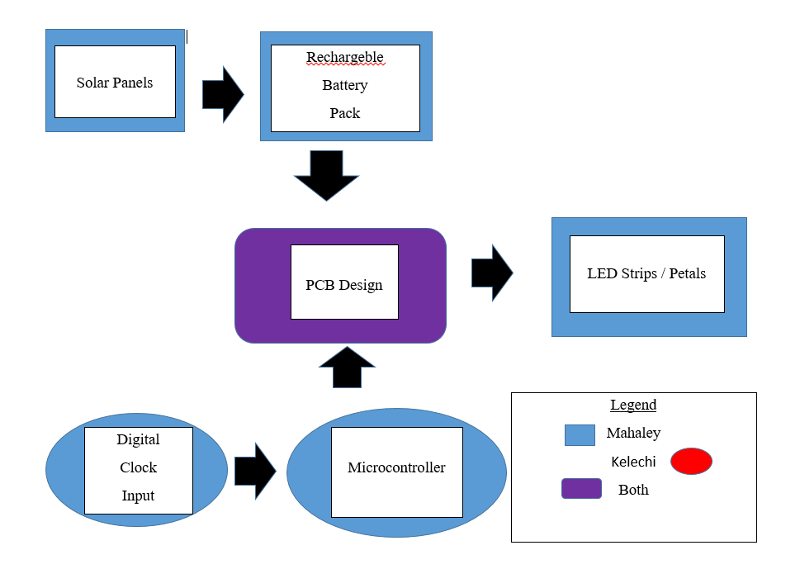

Microcontroller

Interface

Kibwe Williamson

Microcontroller

Software

Nickolas DeVito