**Initial Project and Group Identification**

**Divide and Conquer**

**Nerf-Enabled Battlebot with Automated Target Detection using Multiple Sensing**

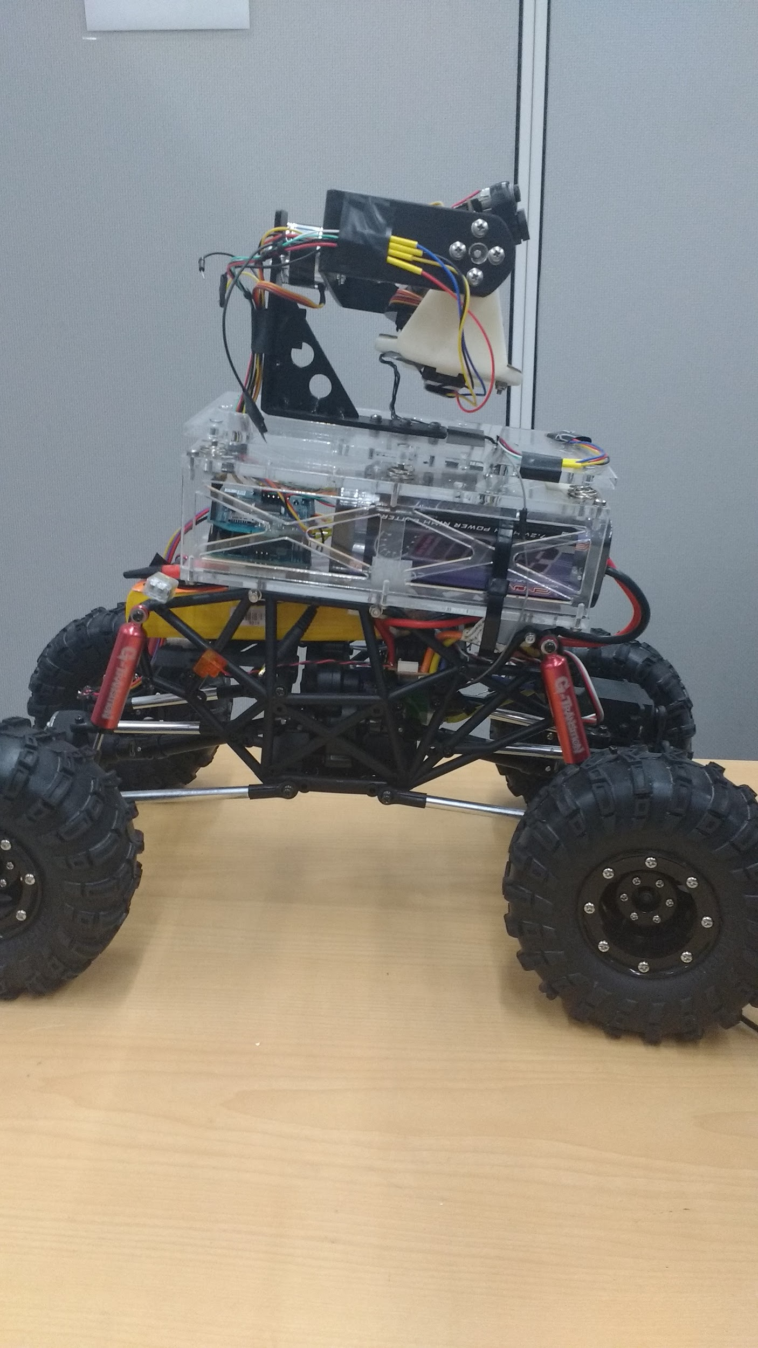

Department of Electrical Engineering and Computer Science

University of Central Florida

Dr. Lei Wei

Sponsor: Lockheed Martin

Senior Design I

Fall 2016

**Group 9**

|  |  |  |
| --- | --- | --- |
| Aaron Hoyt  Daniel Agudelo  Rafael Ramirez  Rachel Gremillion |  | Electrical Engineering  Computer Engineering  Computer Engineering  Computer Engineering |

**Narrative Description**

The purpose of this project is to design a manually remote-controlled ground robot with automated target detection, aiming, and firing capabilities using multiple sensing technologies to participate in the Lockheed Martin Nerf-Enabled BattleBot Competition.

The competition will take place against two other teams tasked with the same project (building a Nerf-enabled battle robot). The robot will be placed on a field with two primary course zones on opposite sides and a keep out zone in the middle. One of these primary course zones will be designated to the robot.

A point system is established where the team with the most points by the end of the battle competition is determined the winner. A team can earn points by demonstrating the following abilities with their robot:

* Shooting an enemy bot with a Nerf ball or Nerf dart
* Shooting designated target zones opposite of the field with a Nerf ball or Nerf dart
* Shooting designated target zones elsewhere on the field with a Nerf ball or Nerf dart

Points can be deducted if the robot leaves its designated zone and enters the keep out zone of the course.

This project will be developed in conjunction with a team of Mechanical Engineering students. The focus of this team (Group 9), as Electrical and Computer Engineers, will be the electrical powering of the system as well as providing the software algorithms for the automated target detection module and managing data transmission within the system. Further detail can be seen in Figure 1 and Figure 2.

The robot will combine two sensor modalities such as mid-wave infrared imagery and Lidar point clouds. With these two sensor technologies, the robot will be able to automatically detect its target, aim, and fire accurately a maximum of two Nerf weapon systems. If more than one weapon system is implemented, only one system will shoot Nerf balls while the other system will make use of Nerf darts. The weapon system(s) will be provided with cartridges containing Nerf ammo for the robot. This ammo will be reloaded into the robot automatically.

The user will be able to maneuver the robot manually by remote-control, but will have no control over any other portion of the robotic system such as the aiming and firing system as it will be automatic.

The automatic detection system will also provide feedback to the user wirelessly via a live video feed. This video feed will be highlighting automatically the objects that were detected as a selected target.

**Requirements Specifications**

|  |  |  |  |
| --- | --- | --- | --- |
| **Subsystem** | **Requirement**  **Specification** | **Engineering Clarification** | **Verification** |
| Size | 1 | Total robot dimensions shall not exceed 3ft x 3ft x 3ft. | Standard to battlebot competition. |
| Software Detection | 2 | Be able to automatically detect objects to a distance up to 45ft. | Standard to battlebot competition. |
|  | 2 | To be able to automatically detect and highlight three different targets. | Standard to battlebot competition. |
|  | 2 | Must be able to automatically determine the distance of three targets. | Simulating various targets at different ranges. |
|  | 2 | Be able to detect moving target. | Utilizing a sample robot for target acquisition. |
| Power | 3 | Power supply must be able to last a minimum of 25 minutes. | Using the system for two 10 minute rounds. |
|  | 3 | To be able to operate at 12V and draw a maximum of 3A. | Based on total power consumption of the system. |
| Mobility | 4 | Be able to remotely control the Battlebot. | Testing with the use of a remote control in each direction the Battlebot must turn. |
|  | 4 | Be able to track the distance it travels. | Measure the distance it moves. |
| Cost | 5 | As demonstrated cost can not exceed $1000. | Optimizing components under $1000 for the final build. This is based on Lockheed Martin’s budget requirements. |

**Table 1: Requirements Specifications**

**Budget and Financing**

This project has been sponsored by the company Lockheed Martin. They have allowed a maximum budget of $2,000, with the limitation that the final product be at a maximum as-demonstrated cost of $1,000. The estimations for this project can be seen in Table 2.

|  |  |  |  |
| --- | --- | --- | --- |
| **Item Name** | **Quantity** | **Cost** | **Total** |
| Microcontroller | 1 | $40 | $40 |
| Battery Power Supply | 1 | $30 | $30 |
| Cables, Wires and Connectors | 1 | $200 | $200 |
| Camera | 1 | $70 | $70 |
| Wireless Video Datalink | 1 | $150 | $150 |
| Chassis (Enclosure) | 1 | $30 | $30 |
| Distance Sensor | 2 | $170 | $340 |
| Encoder | 1 | $20 | $20 |
| Mechanic Dummy | 1 | $150 | $150 |
| Nerf Ball or Nerf Dart | 25 | $1 | $25 |
| Weapons System | 1 | $50 | $50 |
| PCB Components | 1 | $40 | $40 |
| **Grand Total** |  |  | $1,145 |

**Table 2: Budgeting**

**Engineering-Market Trade-Off Matrix**

All trade-offs considered in order to prevent an imbalance within the system are mapped in Table 3. Ideally, considering all positives and negatives will lead to a complete build that will satisfy all requirements listed above in Table 1.

**Legend**

↑ Positive Correlation

↑↑ Strong Positive Correlation

↓ Negative Correlation

↓↓ Strong Negative Correlation

+ Positive Polarity (Increasing requirement)

- Negative Polarity (Decreasing requirement)

|  |  |  |  |  |  |  |  |
| --- | --- | --- | --- | --- | --- | --- | --- |
|  | | **Range of Detection** | **Object Recognition**  **Accuracy** | **Fast Processor**  **(Clock Speed)** | **Memory** | **Dimensions** | **Cost** |
| **+** | **+** | **+** | **+** | **+** | **-** |
| **Detection Accuracy** | **+** | **↑↑** | **↑↑** | **↑↑** | **↑↑** | **↑↑** | **↓** |
| **Firing Accuracy** | **+** | **↑** | **↑** | **↑↑** | **↑↑** | **↑↑** | **↓** |
| **Low Power** | **+** |  |  | **↓** | **↓** | **↓** | **↑↑** |
| **Cost** | **-** | **↓↓** | **↓** | **↓↓** | **↑** |  | **↑↑** |
|  |  | $≈$ 45ft | $≈$ 51% | $≥$ 1GHz | $≥$ 512MB | 3 x 3 x 3 ft | $≤$ $1000 |

**Table 3: Engineering-Market Trade-Off Matrix**

**Project Milestones**

A clear breakdown of how we will budget our time for both the Fall and Spring semesters has been provided in Table 4 and Table 5. Individual roles have been assigned to various group members as well.

|  |  |  |  |  |  |
| --- | --- | --- | --- | --- | --- |
| **Fall 2016 - Senior Design I** | | | | | |
| **No.** | **Task** | **Start** | **End** | **Status** | **Responsible** |
| 1 | Research Project Ideas | 8/22/16 | 9/9/16 | Completed | Group 9 |
| 2 | Initial Project Idea | 9/1/16 | 9/9/16 | In Progress | Group 9 |
| 3 | Prepare Project Meeting Questions | 9/9/16 | 9/22/16 | Pending | Group 9 |
| 4 | Half Hour Meeting | 9/19/16 | 9/19/16 | Pending | Group 9 |
| 5 | Sponsor Meeting | 9/21/16 | 9/21/16 | Pending | Group 9 |
| 6 | Project Documentation Guidelines | - | 9/27/16 | Pending | Group 9 |
| 7 | Research and Project Development | 10/10/16 | 10/17/16 | Pending | Group 9 |
| 8 | Table of Contents | - | 11/4/16 | Pending | Group 9 |
| 9 | Draft Document | - | 11/11/16 | Pending | Group 9 |
| 10 | Group Progress/Milestone Check | 11/13/16 | 11/13/16 | Pending | Group 9 |
| 11 | Prepare Meeting Questions | 11/14/16 | 11/16/16 | Pending | Group 9 |
| 12 | Half Hour Meeting | 11/14/16 | 11/16/16 | Pending | Group 9 |
| 13 | Final Document | - | 12/6/16 | Pending | Group 9 |
| 14 | Order Components | - | 12/6/16 | Pending | Aaron Hoyt |

**Table 4: Fall Milestones**

|  |  |  |  |  |  |
| --- | --- | --- | --- | --- | --- |
| **Spring 2017 - Senior Design II** | | | | | |
| **No.** | **Task** | **Start** | **End** | **Status** | **Responsible** |
| 15 | Test Components | 1/9/17 | 1/15/17 | Pending | Rafael Ramirez |
| 16 | Build Prototype | 1/16/17 | 2/26/17 | Pending | Group 9 |
| 17 | Test Prototype | TBD | TBD | Pending | Daniel Agudelo |
| 18 | Make Necessary Changes | TBD | TBD | Pending | Rachel Gremillion |
| 19 | Finalize Project | TBD | TBD | Pending | Group 9 |
| 20 | Final Presentation | TBD | TBD | Pending | Group 9 |
| 21 | Final Report | TBD | TBD | Pending | Group 9 |
| 22 | Battlebots Competition | TBD | TBD | Pending | Group 9 |

**Table 5: Spring Milestones**

**Hardware Block Diagram**

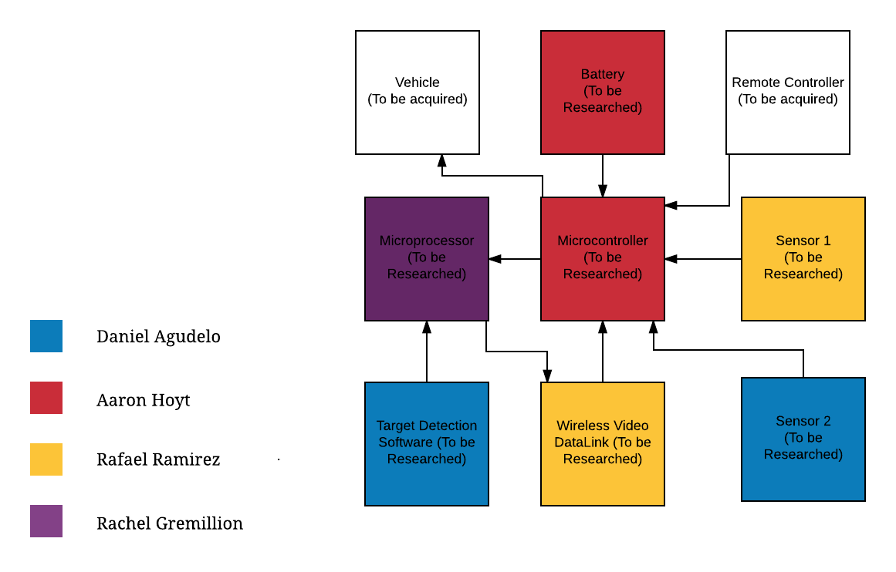**Figure 1: Hardware Block Diagram**

**Software Block Diagram**

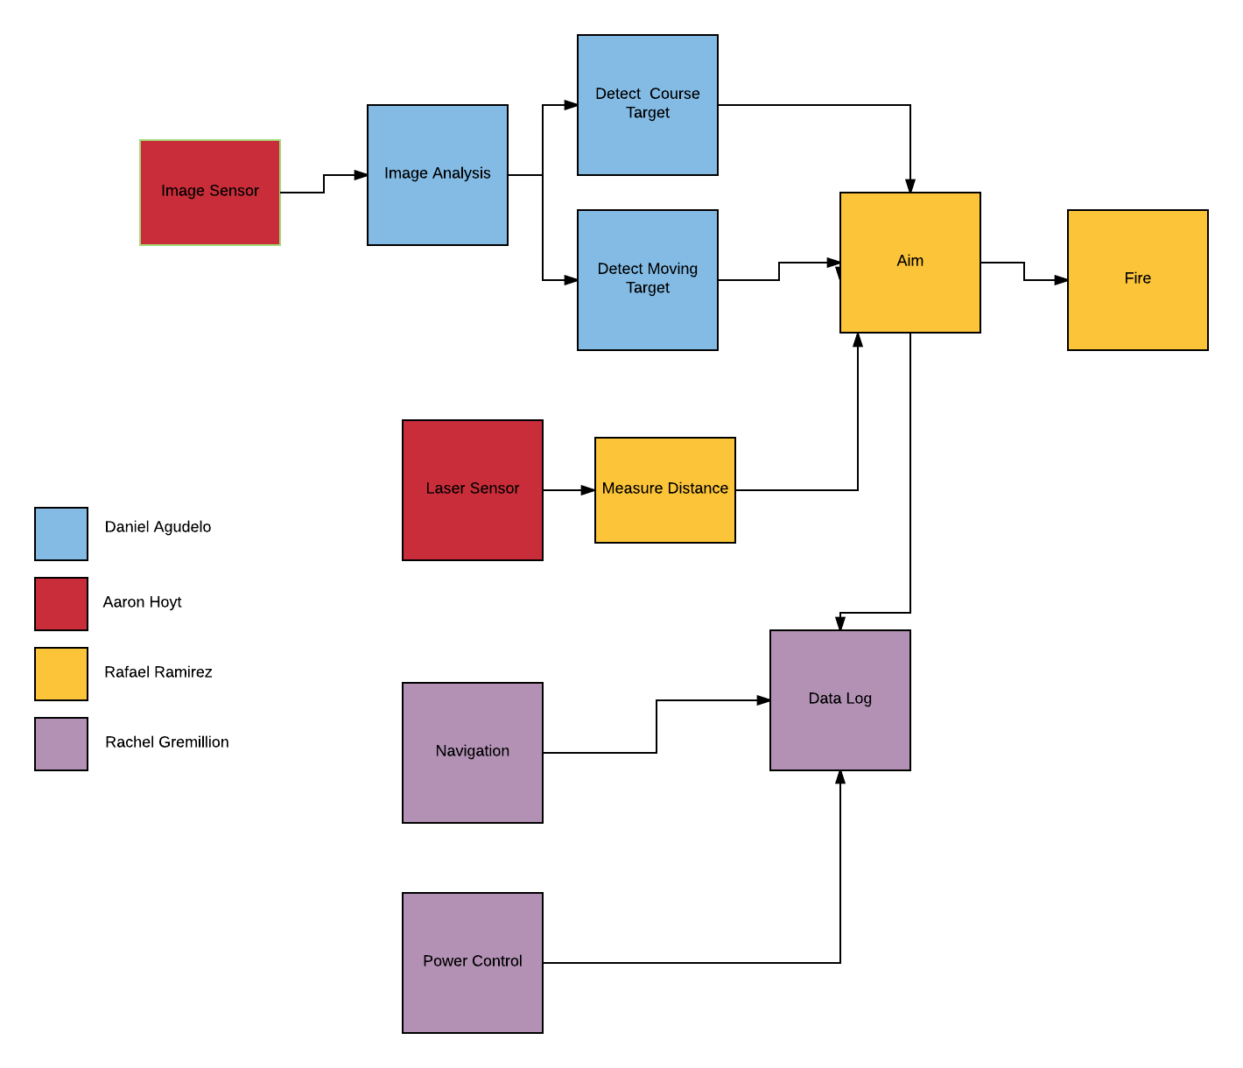

**Figure 2: Software Block Diagram**