Dancing Water Display:

An Audiovisual Spectrum Analyzer

Timothy Le, Esha Hassan, Katie Corini, and Joshua Fabian

Dept. of Electrical Engineering and Computer Science, University of Central Florida, Orlando, Florida, 32816-2450

***Abstract* – This document outlines the design approach and fundamental concepts used to create an audiovisual spectrum analyzer. This project involves processing audio signals filtered through a Fast Fourier Transform to power water pumps. The strength of the pumps depends on their corresponding frequency band, which will result in the physical representation of a spectrum analyzer. The paper focuses on the methodology to achieve this objective, a summary of schematics, and descriptions of hardware and software components.**

***Index Terms –* analog-digital conversion, Fast Fourier Transform, microprocessor, frequency, Bluetooth, LEDs, signal processing**

1. INTRODUCTION

The Dancing Water Display combines the concepts of water speakers and a spectrum analyzer. Water speakers are a USB-powered consumer product which consist of a speaker system and an equal number of water streams and LEDs that “dance” to music. Putting together this project involves a mixture of intricate hardware and software design and is intended to be a physical representation of a spectrum analyzer using an array of water pumps along with LEDs that flash to music. Each pump division will be set to a specific frequency range so that water is shot upward at variable heights. A key component of this device is a mobile application that can control the power, light, and pump settings via Bluetooth connection. This way, the user can customize a water and light show for any setting. The goal is to make the product as aesthetically pleasing as possible all the while combining signal processing with art.

1. SYSTEM COMPONENTS

To obtain a full grasp of the project, the following sections describe the selection of each major component and their function. The later sections explain each part in more depth with practical details.

1. *Water Pumps*

The main exhibit will be portrayed by the 16 water pumps, more specifically the Magicfly DC30A-1230. This decision was made based on the fact that it is extremely lightweight, has adequate flow rate, requires little power to operate, and its low cost.

1. *Microcontroller*

The microcontroller will be the brain of the spectrum analyzer since it contains all the software programming that the project requires. Between the MSP430 and the PIC32, the ideal choice was the PIC32. This is because the PIC contains a larger capacity of flash memory which was necessary for our project, higher SRAM, and more A/D converter channels.

1. *Light Emitting Diodes (LEDs)*

LEDs are going to be incorporated into the Dancing Water Display to create a visually appealing show for viewers. The goal is to have them flash accordingly to the beat of the music input that the device receives. The LEDs that were selected are the YSL-R547W2C-A13 because of their relatively low cost and bright output.

1. *LED Drivers*

Drivers will be used to provide a constant current source to light the LEDs. The STP08CP05 is an 8-bit shift register used to drive LEDs. It is low voltage, low current, and is able to receive signals from the microprocessor.

1. *Power*

The source of the power will be a wall outlet, which is expected to have an AC voltage of 115 volts. The power supply is intended to provide enough power to run the main circuit board and water pumps. An SP320-15 has been selected for the power supply. It contains an output voltage of 15 volts and an output current of 20 amps.

1. *Analog-to-Digital/Digital-to-Analog Converters*

The processor in the PIC32 already has a built-in analog-to-digital converter with 10-bit resolution and a 16-channel input. As for the digital-to-analog converters, 16 converters are compulsory, one for each water pump. This entails two DACs with 8 outputs each. The best choice to go with is the LTC1665 Micro-Power Octal 8-bit DAC, which will be used to send signals to the water pumps after the audio signal has been processed digitally.

1. *Current Drivers*

The current drivers are going to be used to amplify the signals they receive from the DACs. The drivers that were chosen to be assimilated into the project will be 16 OPA548T operational amplifiers, which have an input voltage between -0.5 and 5 volts and an output current of 5 amps, which is sufficient to run the water pumps.

1. *Bluetooth*

In order to allow communication between the MCU and the smartphone application, there needs to be wireless connectivity that has an effective range, throughput, low cost, and is reliable. Although WiFi has larger throughput, Bluetooth was the ideal choice because it is cheaper, easier to implement, and requires less infrastructure.

1. *Smartphone Application*

It was desired to have a user-friendly application available on at least one major smartphone brand, and Android seemed like the best choice. This way, the LED, power, and pump settings of the spectrum analyzer can be controlled wirelessly to allow customization.

1. *Wooden Box*

Particle board is being used to create a reservoir for the water and to build a power supply box. Additionally, a 2x4 will serve as a mounting board for the water pumps. The reservoir is painted black and leak-free.

1. *Acrylic Tank*

The acrylic tank is necessary to house the fountain so that water does not spill over. The dimensions are approximately 12 inches in height, just high enough for the water jets, and 33 x 3.5 inches, just long and narrow enough for the water pump array.

1. SYSTEM CONCEPT

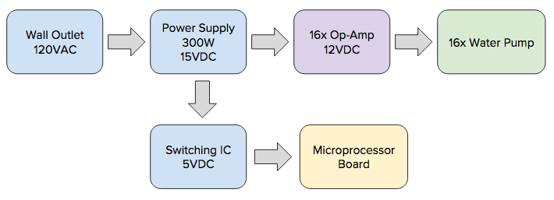To fully understand the system concept, the next sections go over the device’s flow of operation.

1. 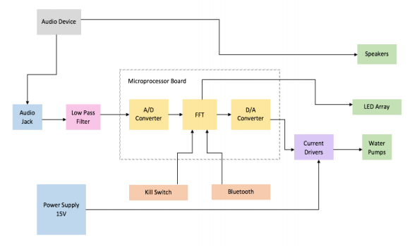*Operation Overview*

Fig. 1. The block diagram above shows how the system works as a whole and how each component interacts with each other.

1. *Fast Fourier Transform (FFT)*

A Fast Fourier Transform will be executed on the microcontroller. When the analog input signal is converted to a digital signal, the FFT is used to find the frequency magnitudes. Afterwards, the signal is converted back to analog and amplified to power the water pumps. The project will use the Decimation-in-Time Fast Fourier Transform, a quicker version of the Fourier Transform, to convert the music input from the time domain into the frequency domain. Once this process is completed, specific frequency ranges will be grouped together and the water pumps will receive their magnitude values, which will allow the display to act like a spectrum analyzer. The FFT works by decomposing an N point time domain signal into N time domain signals comprised of a single point. Ultimately, there will be 16 outputs for the DIT-FFT for the 16 water pumps.

1. *Power Flow*

The power flow requirements for the project were determined by the power required for the Magicfly water pumps. In total the water pumps would require 12VDC and about 5.6A without startup current. To be safe and to not have any problems with the water pumps, the current was increased to provide 20A. The amount of power required for this project would not allow it to be battery operated. The power will be taken from a 120VAC wall outlet and a 300W power supply with an output of 15VDC and 20A. From the power supply 15VDC will be sent to the 16 controlling op-amps to supply the power to the 16 water pumps. The power supply will also provide the necessary power to the microprocessor board. Figure 2 shows the flow diagram for the power system in the project.

Fig. 2. The diagram above represents the flow of power of the device.

1. HARDWARE DESIGN DETAILS

The following sections go into immense detail about each of the hardware system components.

1. *Water Pumps*

The water pumps for the display were chosen to be the Magicfly DC30A-1230. These are individually powerd water pumps that use DC voltage. This will allow each water pump to be controlled differently by the microprocessor to display the music frequency magnitude range. The max voltage rating is 12VDC and max current rating is 0.35A. The dimensions of the water pump is 51x34x42.7mm and the cost per pump is $10.99. These pumps were chosen due to their dimensions, power ratings, and cost. The small dimensions of the water pumps allows the display frame to be smaller in length than using different water pumps. 16 Magicfly water pumps will be used to display the audio frequency magnitudes in the water fountain.

1. *Input Audio Attenuator/Low Pass filter*

For the input, the design team used a line input electrical signal. For these signals, voltages have values ranging from +2 to -2 volts. Since the voltages may be negative, the design team had to level shift the signal voltage so that they are all positive values for the analyzer to process. In addition, the microcontroller only operates from 0-3.3V so the design team had to attenuate the shifted signal of 0-4V down to a maximum of 3.3V. This was done using the following circuit.

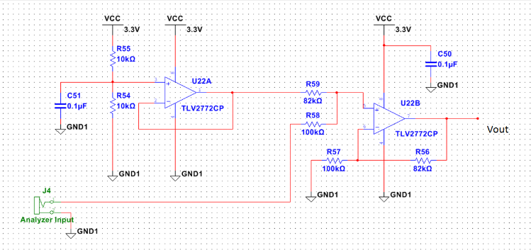

Fig. 3. The schematic above displays the circuit for the input audio attenuator and low pass filter.

The next part is the antialiasing filter to block out unnecessary frequencies. For our design, we set the cutoff frequency to 4kHz. This was chosen because around 10% of frequencies in music are above this frequency and we can neglect them. In addition, we are only analyzing the energy of the signal, so this cutoff will suffice. In order to emulate an ideal brick wall filter, we utilized an 8th order Elliptic filter which had the steepest rolloff rate of the other filters we analyzed. The design team used the MAX7404 filter.

1. *Analog-to-Digital Conversion*

In order for the audio signal to be displayed on a water pump, the signal must be converted from a continuous quantity to a discrete one. The design team utilized the internal ADC to the microcontroller to convert the signal. The ADC the design team used was a 10 bit, 16 channel Successive approximation register ADC. The design team sampled at 10 kHz, and high resolution is not required for the project. The output of the A/D converter is then Fast Fourier Transformed so that the signal can be displayed in the frequency domain.

1. 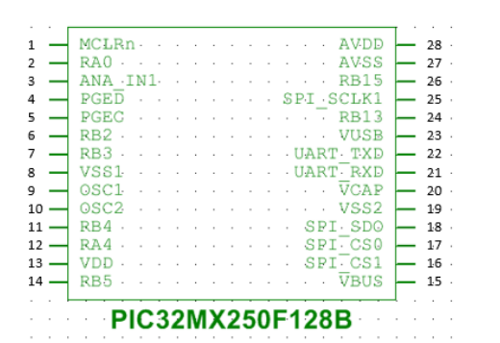*Microcontroller*

Fig. 4. The figure above shows the pinout for the PIC32 microcontroller.

The PIC32MV250F128B model of the PIC32 was chosen, which is a 28 pin DIP package. Pin 1, PinMCLRn, or the master clear pin, provides two functions: device reset, and device programming and debugging. This pin is attached to a reset switch to provide a device reset for our project. Pins RB1, RB3, and RB4 were designated to be the connection between the chip and the LED shift register. More specifically, RB2 is designated for the LED data, RB3 is the latch enable, which latches data into the output shift register, and RB4 is the LED shift register clock, which shifts at every rising edge of the internal clock. Finally, RA0, or pin 2 was programmed to contain an LED. The LED’s purpose is to always remain on when the chip is powered on. The LED will be placed on the board and serves as a visual aid when troubleshooting. Pins 4 and 5, or the PGED and PGEC pins, are used for in circuit serial programming (ICSP) and debugging purposes. These pins will be connected to a Programming Debug Header where the development kit for debugging will be connected to interface with the chip. A header was implemented so that the debugging port could be placed on an easy to access location on the PCB. Pins 8 and 19, or VSS and VSS2, are used as the ground references for logic and I/O pins. It must be connected at all times. As ground references, these pins will be connected to ground wires. Pin 27, or AVSS, is the ground reference for analog 52 modules, used for the internal A/D converter. This pin will be connected to a ground wire. Pins 9 and 10 (OSC1 and OSC2) are the oscillator crystal input and output, respectively. These are the external oscillator pins for the microchip. The oscillator serves as the internal clock of the chip, and its configuration and component values must be determined manually. Pin 13, or VDD, is the pin that connects to the positive power supply for peripheral logic and I/O pins. Pin 28, or AVDD, connects to the positive power supply for analog modules, such as the A/D converter. These pins are connected to the 3.3V power supply. Pins 16, 17, 18, and 25 were assigned to be the SPI outputs of the processor and consequently the input of the DAC. Thus, pins 16, 17, 18, and 25 were named SPI_CS1, SPI_CS2, and SPI_SD0, and SPI_SCLK1 respectively. SPI_SD0 connects to the data input of the DAC, meaning the audio signal will be the output of this pin. SPI_CS1 and SPI_CS2 are the select pins

1. *Light Emitting Diodes (LEDs)*

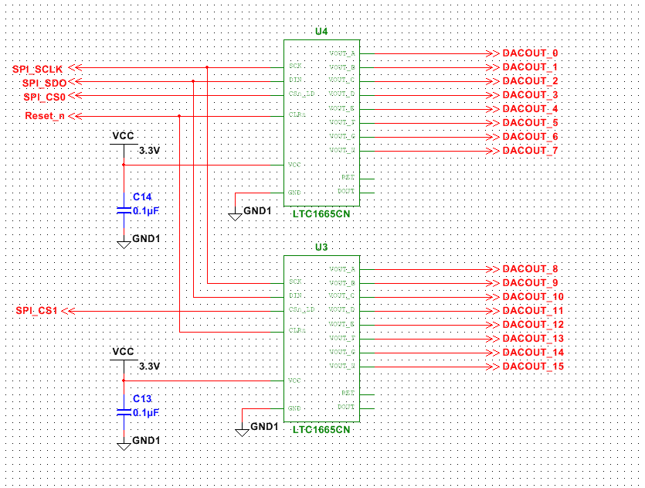The original plan was to have 16 RGB LEDs, one for each water pump, for a multicolor light show. The LEDs activate based on the musical beat of the audio signal. It was also expected to have a certain color flash to a specific frequency range. The current design entails six LEDs per pump, two of each color (red, blue, and green) in series with a 330 ohm resistor, totaling to 96 LEDs for the entire display. They will be mounted on top of the acrylic tank so that the lights shine down. All LEDs will be driven from the 15V power supply. Since they are driven by a 20 milliamp constant current source, the resistor will drop about 6.6 volts. The resistor will also dissipate approximately 132mW, which is suitable because the resistors are 250mW components. The LED forward voltage drop specification is 3.4 volts, meaning the total voltage drop across the two LEDs in series is 6.8 volts. The available voltage at the LED is 15 – 6.6 = 8.4 volts which is higher than the forward voltage of 6.8 volts that is needed to turn them on.

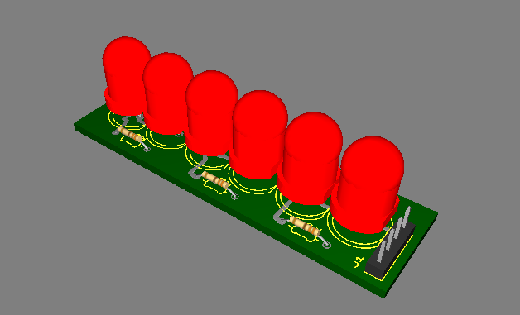

Fig. 5. The figure above portrays a 3D model of the LED strips.

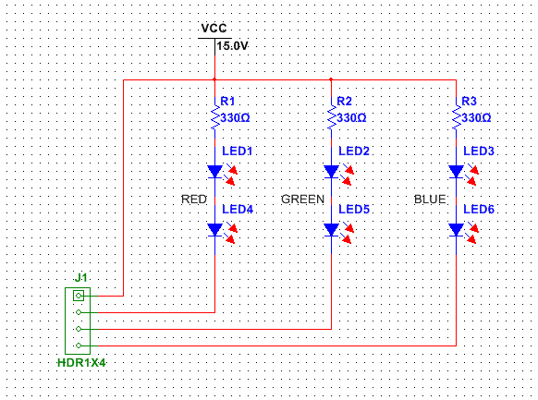

Fig. 6. The schematic above depicts the placement and wiring of the LEDs on each PCB strip.

1. *Digital-to-Analog Converters*

Once the audio signal has been digitally processed and converted to the frequency domain, the signal must be sent to the water pumps to display. In addition, there must be 16 separate outputs, each corresponding to a water pump. Each output is assigned to a specific frequency range, and they are all uniform. The signal must be converted back to analog to be effectively displayed on the pumps in continuous time, thus, requiring a Digital to Analog Converter. This device was required to have a functionality to produce 16 outputs, along with being able to function at low power so 16 converters are needed. In addition, the DAC must support SPI, since that is the format of the output of the audio signal from the processor. The team decided to use the Linear Technology LTC 1665 Micro-pwer Octal 8-bit DAC. Since this DAC has only 8 outputs, two of the chips needed to be daisy-chained to allow 16 independent channels.

Fig. 7. The figure above shows the schematic for the DACs.

The first DAC will convert the outputs 0-7 and the second will convert outputs 7 through 15, which are sent to each corresponding motor driver. The SPI CLK, Din, and CLR pins will all share the same input. The SCLK, Din, and CLR inputs will come from the PIC32 Pins 25, 18 and 1, respectively. The SCLK inputs are shared because the clocks must stay consistent to function properly between the two. The Din inputs must be the same because the two devices must have the same signal to analyze. The CLR inputs must be shared, because if the design team were to reset the device, it is efficient to only have one reset. The CS/LD pin is the select pin, and selects which device to use. Hence, the two inputs must be independent. Both supply voltages will be supplied by the 15V power source, regulated down to 3.3V. The design team attached a 0.1uF capacitor as a decoupling capacitor to stabilize the Vcc. This completes the design of the DAC process. The output is then sent to the next stage, which is the power op amp.

1. *Current Drivers*

Once the audio signal has been converted to the frequency domain in the processor, and consequently converted to an analog signal from the LTC1665, the analog voltages must now be sent to a voltage amplifier to power the water pumps. The design team decided to use the OPA548T Power op amp. Each power driver would power one of the water pumps. Thus, in the final design there will be 16 individual drivers, all identical.

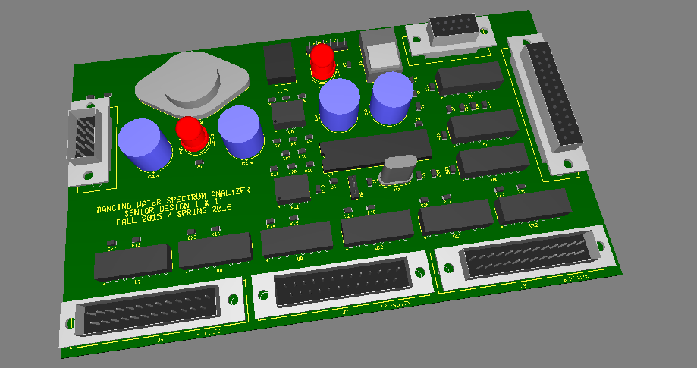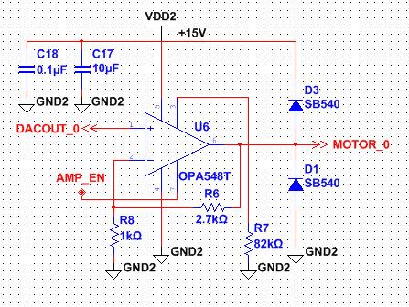 Fig. 8. The schematic above depicts the placement and wiring of the LEDs on each PCB strip.

Since there will be a positive gain for the drivers, the op amp configuration will be of the typical non-inverting type. Thus, the input to the positive terminal will be the output of the DAC corresponding to the proper water pump varying from 0-3.3V. The inverting terminal will be sent to the ground with a resistor to achieve the desired gain. The supply pins will be attached to the 15V power supply and will serve as the Vcc of the op amp. The required output voltage is 12V at the maximum input (3.3V) because that is the operating max voltage of the water pump. The resistor values were selected to fulfill the proper gain. The diodes in the schematic were utilized to prevent back emf from the motors themselves.

1. *Bluetooth*

For wireless interaction, a Bluetooth connection was implemented. Since the connection would only be used to facilitate control signals, only unidirectional support was needed. One part of this problem was solved by conveniently utilizing the built-in Bluetooth adapter of whichever device is running it. With that device acting as the sender, the spectrum analyzer acts as a receiver, achieved by using a USBT232B Bluetooth RS232 adapter from USConverters. The adapter plugs into the RS232 port on the PCB of the device. Once paired and connected with a smartphone, the adapter is ready to accept data.

1. *PCB Development*

The design team decided to use two PCBs for this project. One board would contain the low power components such as the microcontroller and DACs, while the second board contained primarily high power components and was strictly used for the power operational amplifiers. All of the connectors were placed at the edge of the board for easy access. The power op amps were placed next to each other in an orderly fashion and assigned to the right half of the circuit board. Every component that contained a decoupling capacitor had them placed as close to their corresponding components as possible. The linear regulator for the 3.3V power supply was placed so that it was far apart from the other components, as the regulator would dissipate the most heat. Heat sinks were required for the power op amps due to the fact that they dissipated a large amount of heat.

Fig. 9. The figure above shows a 3D model of the PCB containing the low power components.

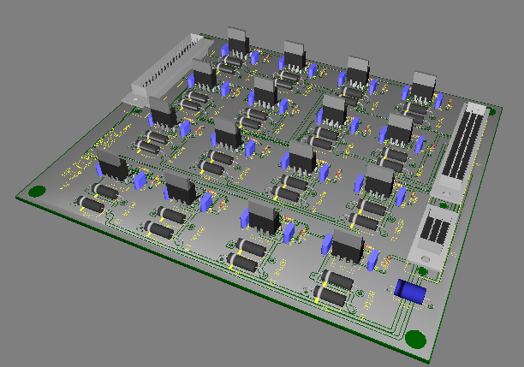

Fig. 10. The figure above shows a 3D model of the PCB containing the high power components.

1. *Power*

The power requirements for this project were determined by the amount of power required to run the 16 water pumps. The Magicfly DC30A-1230 was chosen as the water pump because of its low cost and power consumption. However having 16 Magicfly water pumps required a significant amount of power. Each Magicfly has a max current rating of 0.35A and a max voltage rating of 12V DC and the current totaled to 5.6A. When tested, the Magicfly has startup current of around 0.4A. To make sure all startup current is accounted for the group decided to increase the current supplied to the water pumps. So in total the voltage and current being supplied to the water pumps would be 15V and 20A. The 15V was chosen because the water pumps will be acquiring their power from the controlling op-amps that have a voltage range from 0-15V. These values will be more than enough to properly supply the system completely including the LEDs, and PCB boards. The power supply for the Dancing Water Display would require access to a wall outlet. The amount of power required for this project is too much for battery operation. After reviewing the power supply designs and comparing the cost of these designs for the parts and PCB boards, a prebuilt power supply was purchased. The chosen power supply was purchased from Astrodyne for $80 and plugs into a wall outlet with 120VAC and converts it to 15V DC and 20A.

1. SOFTWARE DESIGN DETAILS

The following sections go into detail about each of the software system components.

1. *Embedded Software*

The PIC32 microcontroller used in the project was coded in C. The most demanding task that the PIC32 must tackle is the conversion of an audio input signal from the time domain to the frequency domain. The signal is originally fed into a standard 3.5mm headphone jack as an analog signal before passing through an analog-to-digital converter. The digital signal then arrives at the PIC32 for processing. The PIC32 utilizes a Decimation-in-Time Fast Fourier Transform (DIT-FFT) algorithm to analyze the signal. It works by decomposing an N point time domain signal into N time domain signals each composed of a single point. The frequency spectra corresponding to each point is then calculated. Finally, the N spectra are synthesized into a single frequency spectrum. Choosing a DIT-FFT algorithm over a standard Fourier Transform cuts the computational complexity from order O(N2) to O(N log2 N). In this case, the PIC32 is performing calculations on a 512 point signal, for which the DIT-FFT is expected to perform over fifty times faster. Once 512 output values have been determined, they must be scaled down to 16 to match the number of water pumps in the display array. This is easily achieved by adding together each block of 32 adjacent frequencies to obtain a single number for that block, in a process known as linear frequency binning. Each number is then assigned to a water pump. The magnitude of the number determines the height of the stream of water that will be ejected from the corresponding pump. The PIC32 is also responsible for processing control signals that are being passed to it from the Bluetooth adapter. All of these signals consist simply of a single character that serves to identify which modification needs to be made. Changes can be made to the behavior of both the water pumps and the LEDs in the display. The water pumps can be set to a variety of predefined behaviors. For example, the “ramp up” mode causes the pumps on one end to shoot a short stream, scaling linearly to the other end where the pumps are shooting at maximum strength. The “constant” mode causes all 16 pumps to shoot at about half strength, and the “music” mode will match each pump’s strength to the DIT-FFT outputs. The LEDs can also be controlled. One mode that the user can select is “beat” mode, which will scale the brightness of the LEDs according to the audio signal. There are also three pre-defined flashing patterns that the user can choose from.

1. *Android Application*

In order to be an interactive exhibit, it was necessary to create some kind of control interface. Many factors were taken into consideration while the team was deciding what form this interface would take, including ease of use, ease of development, availability, and affordability. An Android application provided the best combination of these factors. Using an Android device’s built-in Bluetooth adapter, the application is able to detect the Bluetooth receiver on the spectrum analyzer, establish a connection to it, and send single-character control signals. These signals are fed into the MCU on the analyzer and used to modify the behavior of the display. In the final version, the application is able to control the height of the water from the pump array and the flashing pattern of the LEDs. When opened for the first time, the application will first check to see if the device has a compatible Bluetooth module and if it is enabled. If so, it will scan the list of devices that are paired with the phone. If it successfully identifies the Bluetooth adapter on the spectrum analyzer, it will display a message that it is ready to connect and waits for the user to initiate a connection by pressing the connect button on the main screen. When the connect button is pushed, the application opens a Bluetooth socket and attempts to establish an insecure RFCOMM connection.

1. *User Interface*

The main screen consists of three buttons and a status indicator. The “Connect” button and the status indicator is used to establish and monitor the application’s Bluetooth connection with the display. The “LED Settings” button takes the user to the second screen where they can apply an LED pattern. Radio buttons simplify the choosing process and an “Apply” button is used to send the chosen mode to the analyzer. The “Pump Settings” takes the user to the third screen to choose a mode for the pumps. Available options include ramp up, ramp down, constant, increment, decrement, disable, enable, and music mode, which matches the pump outputs to the spectral analysis of the audio input signal.

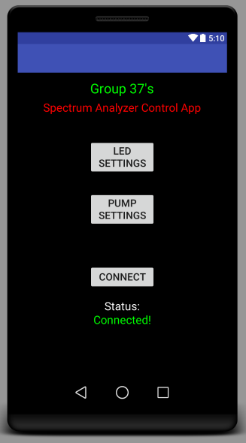

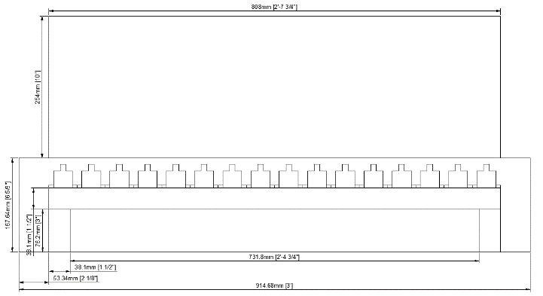

Fig. 11. The figure above shows what the user interface of the mobile application is expected to look like.

1. STRUCTURE DESIGN DETAILS

The next sections describe the planning and building of the mechanical aspect of the project.

1. *Water Reservoir*

The goal of the Dancing Water Display was to have a portable exhibit. The water reservoir for the display will house the 16 water pumps. The box was constructed out of particle board and 2x4s with dimensions of 37”x9.25”x6”. This provides adequate water and is large enough to contain the 16 water pumps. Rubber pond liner is used inside the reservoir to prevent water leakage. Figure 12 shows the initial concept for the water reservoir from the front view.

1. *Reservoir Lid*

A lid was built from particle board to cover the water reservoir and to act as a platform for the acrylic display. The dimensions of the lid are 38”x10.25”x1”. A one inch lip is used to hold the lid in place on the water reservoir like a shoe box lid. This will prevent any splattering water from coming out of the display. A small 3”x2” cut was made in the back middle of the lid to grant access to the wires for the 16 water pumps. The lid has a hole cut in the middle to allow the water fountain from the pumps in the reservoir to be seen. The dimensions of the cut out are 33.25”x3.75”. In order for the acrylic display to be secure on the top of the lid a rim was created with extra particle board. This rim is 0.5” from the hole and has extra particle board acting as a slip to hold the acrylic in place. Figure 13 shows the initial concept for the lid.

1. *Acrylic Display*

In order to view the water show, an acrylic tank was constructed as to prevent any water from the fountain from spilling. The dimensions of the acrylic tank are 33”x3.5”x12”. This tank will not have a bottom as the bottom will rest on the rim provided by the lid. It will have a top to prevent water from escaping the tank. Figure 11 shows the front of the initial concept for the acrylic display on top of the water reservoir. Figure 12 shows the side of the initial concept for the acrylic display on top of the water reservoir

Fig. 12. The figure above depicts the concept drawing for the display front view.

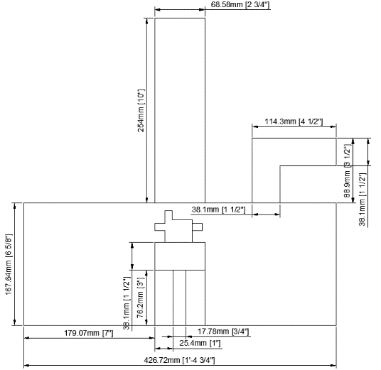

Fig. 13. The figure above depicts the concept drawing for the display side view.

1. *LED Box*

An LED box was created to house the LEDs on the top of the acrylic display. The dimensions of the LED box are 34”x4.5”x3”. The 16 LEDs circuit boards are mounted to the top inside of the box pointing down into the acrylic display. The LED box has two 1” platforms on either end to allow the box to rest on the top of the acrylic, acting like a Lego piece and has a 0.5” rim on the bottom that encases the acrylic display. A hole is cut on the back of the LED box to allow access to the LED wires.

1. *Water Pump Beam*

The 16 water pumps are mounted to a beam of wood in a row with dimensions of 26.5”x1.5”. The beam holding the water pumps is then mounted to the underside of the lid using two 3”x0.5” pieces of wood at either end to secure the water pumps in place while being submerged in the water reservoir.

1. CONCLUSION

Overall, putting together this project has been a challenging yet stimulating experience. The hardware, software, and mechanical aspects helped apply engineering concepts into a real world assignment. Several meetings took place to meticulously plan the project. ensure progress, and to test prototypes. The team was even able to meet their stretch goals regarding LED and pump settings.

1. BIOGRAPHIES

Timothy Le is currently studying Electrical Engineering at the University of Central Florida. He has been working the last two years at Lockheed Martin as a systems engineering intern and intends in the future to pursue a Masters in Electrical Engineering with a specialization in signal processing. His focus on the project was mainly hardware and PCB design.

Esha Hassan is a student at the University of Central Florida studying Electrical Engineering. Her interests include lighting and electronics and she is currently working on designing vehicle tail lights for OffsetSoul Intl, LLC. Her focus on the project was the LEDs and the display frame design and construction.

Katie Corini is a student at University of Central Florida studying Electrical Engineering and focusing on power electronics. She is currently a tutor of math and physics at Valencia College. Her focus on the project was the power supply design and display frame design and construction.

Joshua Fabian is a student at the University of Central Florida studying Computer Engineering. His interests include development of embedded systems and Android applications. His main contribution to the project was software design and development.

ACKNOWLEDGMENTS

The team thanks Dr. Richie for being a mentor, lecturer, and advisor throughout the year; Dr. Lei Wei for lecturing on engineering concepts and real world application as well as guidance for the senior design project; Boeing/Leidos for their generous funding; and UCF for their education which allowed this project to be completed.