9/15/15

Senior Design 1

**Dancing Water Spectrum Analyzer**

**A visual representation of music using a spectrum analyzer with water.**

**Group 37**

Joshua Fabian - Computer Engineering

Esha Hassan - Electrical Engineering

Tim Le - Electrical Engineering

Katie Corini - Electrical Engineering

**Project Description**

This project will be use a standard 3.5 mm headphone jack to input an audio signal into our custom spectrum analyzer. The analog signal is converted to a digital signal and a fast fourier transform is used to find the frequency magnitudes. The signal will be converted to analog again and the signal will be amplified to power the motors. The magnitudes will be used to determine how the water will react to the inputted signal. Each water jet will be assigned to a specific frequency band, and there will be around 16 water jets. The strength of the water jets will vary based on the strength of their corresponding frequency band. The result will be a physical representation of a spectrum analyzer. In addition, there will be an LED for each water jet to add color to the display. The power supply for the system will also be designed by the team.

**Project Motivation**

The motivation of this project is to gain an understanding of digital signal processing and power supply design, along with mechanical and aesthetic design.

**Goals and Objectives**

The goal of this project is to produce a visible representation of an audio input. The water display will be portable and of medium weight. The system will be user friendly and will feature a standard 3.5 mm audio jack for input.

**Project Function**

The function of this project is to provide an aesthetically pleasing water show following music.

**Requirement Specifications**

16 Water pumps

16 LEDs

1 Custom 16-chambered plexiglass fish tank

1 2-Gallon tank

1 Custom Designed Microprocessor

1 Custom Designed Power Supply

**Block Diagram and Drawing**

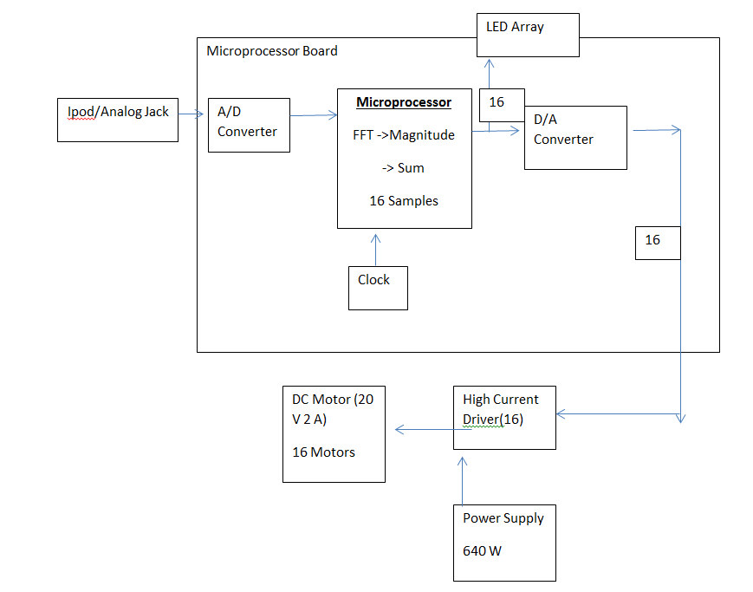

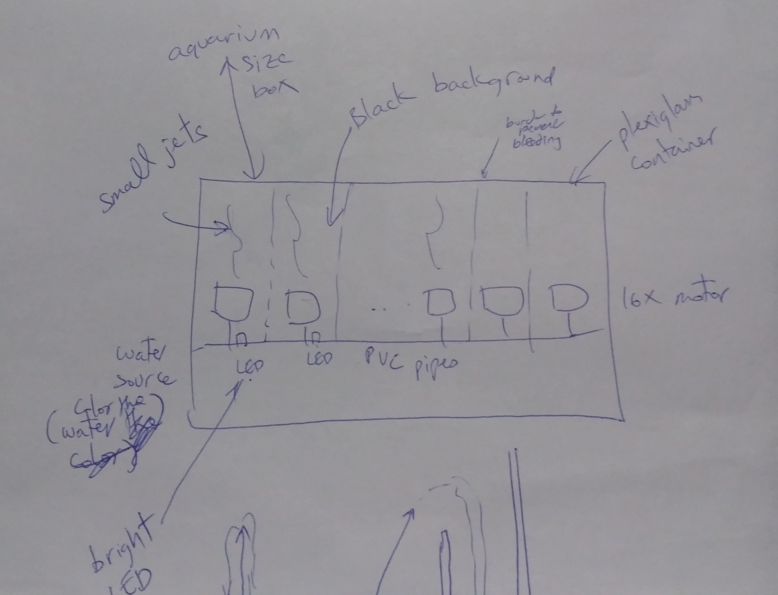

**Project Budget**

No sponsorships currently.

Self funded.

**Project Milestones**

**Semester 1:** Complete design and small prototype

**Semester 2:** Finished project