Head On

Initial Design Proposal

Group 12:

Amber Farrell, Cp.E.

Larry Herman, E.E.

Cristhian Marin, Cp.E.

Aurora Reinefeld, E.E.

**Narrative:**

In recent years, vehicles have incorporated sophisticated electronic systems in order to improve the safety, comfort, and overall enjoyment of the ride. Notable features seen in newer vehicles include built in navigation, projected speed, directions displayed on the windshield, omni­directional cameras for a 360 view of the vehicle, and proximity sensors to detect nearby obstacles. Meanwhile, the two wheeled counterpart, the motorcycle, continues to lack an implementation of these features that would make riding more comfortable and safer for riders.

Using our in helmet system, we hope to give riders easy access to data such as the proximity of potentially hazardous objects, details of the bike (e.g. cardinal direction, speed), and general details (e.g time).

**Marketing Analysis:**

Currently in the market is a similar product called “Skully AR­1”, which provides riders with a heads up display (HUD), rear view display, and GPS navigation; therefore, allowing the rider to “gain full situational awareness,” according to their website. Our product will have a similar premise by helping increase the situational awareness of the rider. However, rather than showing the rider an image of the road behind him or her, our system will simply display a symbol on the screen indicating what direction the potential hazards are coming from.

Another similar product is a previous senior design project, named “Helmet Tracking System”, which tracked the rider using GPS and sent out texts if he or she was in an accident. However, this system had no integrated display for the rider to interact with the system. Our product will allow the rider to be warned visually of the proximity of other vehicles, as well as display other useful information such as, speed, cardinal direction, and time. Hence, increasing the overall awareness of the bike and surroundings, and increasing the rider’s safety.

**Objectives:**

* Useable during charge
* Easy to understand interface
* Non­obstructive display
* Easy to read display
* Ability to sense obstacles approaching from all directions
* Accurate time displayed
* Accurate cardinal direction indicator
* Accurate speed measurement
* Dual charging methods
* Utilize solar power

**Requirement specifications:**

|  |  |
| --- | --- |
| Attribute | Value |
|  |  |
| Battery Life | Minimum 1 hour |
|  |  |
| Connectivity distance to onboard transponder | 15 feet |
|  |  |
| Sensor measurement frequency | 1.5 s |
|  |  |
| Number of sensors | 4 |
|  |  |
| Forward detection distance | Minimum of 15 feet |
|  |  |
| Lateral and rear detection distance | Minimum of 3 feet |
|  |  |

**Constraints:**

* 49 CFR 571.218
* Available surface area on helmet for solar cell placement.
* Minimum helmet visibility as dictated by Department of Transportation Standard 218.
* FCC regulations of wireless transmitter.

**Block Diagrams:**

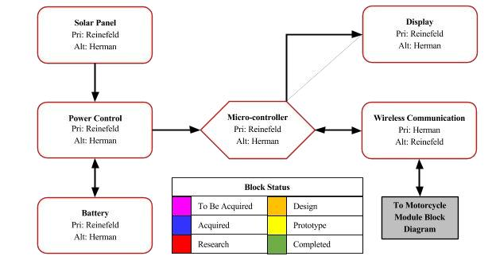

**Diagram 1: Helmet Module Hardware**

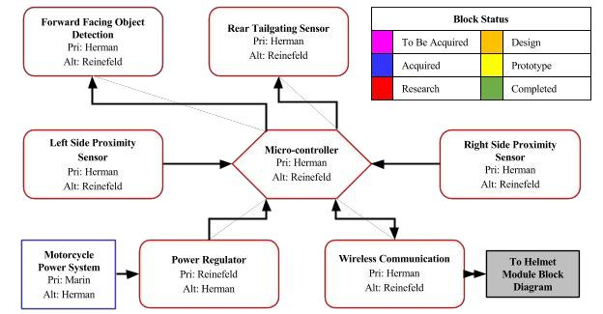

**Diagram 2: Motorcycle Module Hardware**

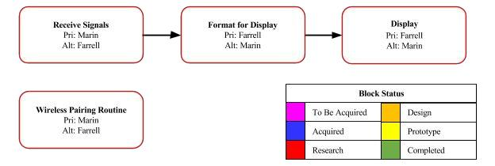

**Diagram 3: Helmet Module Software**

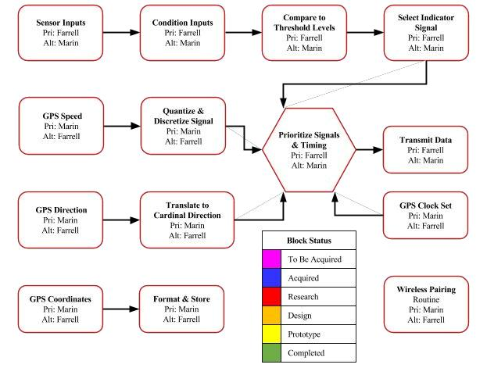

**Diagram 4: Motorcycle Module Software**

● Solar Cell Placement

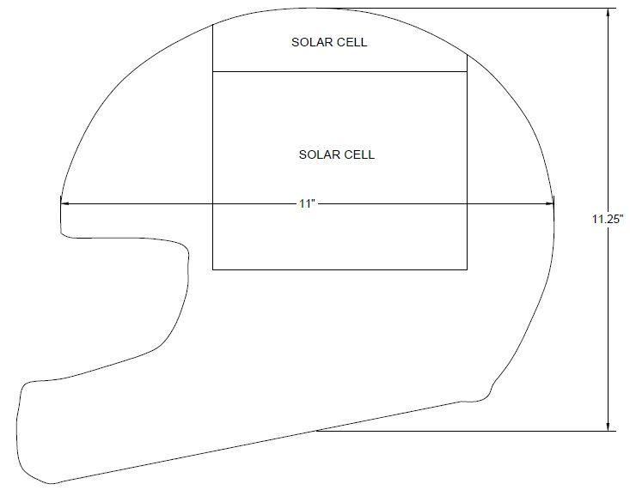

Image 1: Side View of Helmet

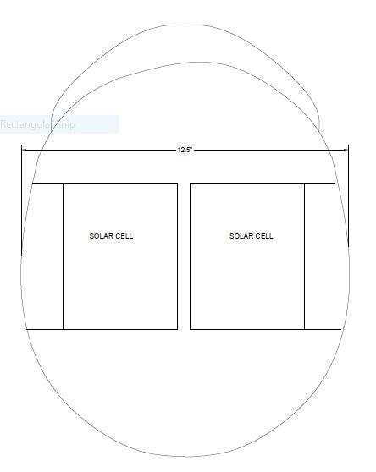

Image 2: Top View of Helmet

**Budget and Financing:**

|  |  |  |
| --- | --- | --- |
| **Parts** | **Quantity** | **Cost (each)** |
| Motorcycle for testing | 1 | Acquired |
| Motorcycle helmet | 1 | $50 |
| Printed circuit boards | 10 | $5 |
| Microcontrollers | 2 | $10 |
| GPS module | 1 | $50 |
| LCD display | 1 | $15 |
| Solar panels | 8 | $15 |
| Battery | 1 | $40 |
| Short range sensors | 3 | $10 |
| Long range sensor | 1 | $115 |
| Wireless modules | 4 | $9 |
| Power regulators | 4 | $15 |
| USB TTL board | 1 | $6 |
| **Total:** |  | $592 |

**Milestones:**

|  |  |
| --- | --- |
| Senior Design 1 | |
| Milestone | Deadline |
| Research possible project ideas | August 28, 2015 |
| Choose project topic | August 31, 2015 |
| Perform market analysis of similar products | September 9, 2015 |
| Develop list of possible features | September 9, 2015 |
| Research ways to implement the agreed upon features | September 11, 2015 |
| Submit project proposal document | September 15, 2015 |
| Propose idea to local companies for funding | September 22, 2015 |
| Research and obtain chip and compatible modules | September 30, 2015 |
| Design and obtain PCB for onboard motorcycle system | October 7, 2015 |
| Develop prototype with all modules transmitting and receiving data | October 31, 2015 |
| Finalize design of hardware and GUI | November 18, 2015 |
| Finish research paper | November 30, 2015 |

|  |  |
| --- | --- |
| Senior Design 2 | |
| Milestone | Deadline |
| Build and program final product | January 30, 2016 |
| Troubleshoot problems | February 29, 2016 |
| Test for accuracy and make necessary modifications | March 31, 2016 |
| Finish final documentation | April 15, 2016 |
| Ensure all requirements set in senior design are met | April 29, 2016 |