Smart Water Rockets (SWR) for Space Trek Space Camp at Kennedy Space Center
Gabriel Fernandez, Connor Philips, and Kyle Moran
College of Engineering and Computer Science, University of Central Florida, Orlando, FL 32826, USA
Abstract — The Smart Water Rocket system (SWR) will be an upgrade to the water rocket program currently in use by the Space Trek space camp program. The SWR aims to replace or upgrade three main components of the old system: launch data collection, post-launch data analysis, and launch experience. The SWR will improve this process by upgrading a few key steps in the procedure. The team has designed a new altimeter to work with an android device via Bluetooth to send all of the flight data post launch. To improve on the launch experience, the angle system will be automatized using a stepper motor.
I. INTRODUCTION TO CURRENT SYSTEM
Space Trek has three separate programs: near space exploration, robotics, and rocketry. The rocketry program, currently has several small faults. The program breaks the students into groups of three to five depending on the total class size. There are often more than one hundred students in a class resulting in upwards of twenty five individual rockets. Each rocket, at peak efficiency, takes 4 minutes to launch once the students are ready.
The launch angle is particularly difficult to set accurately. The current system uses a thumbscrew to hold the pad in place at the intended angle. This is inefficient because the screw is always either too tight to remove for the next launch or too loose to hold the rocket steady. It is incredibly dangerous for the rocket to fall and launch in the horizontal position. The full force of the rocket is directed horizontally and it becomes a torpedo like projectile. If it were to strike a guest or student there is a massive chance for injury.
To gather the flight data of the water rockets, Space Trek is currently utilizing a Jolly Logic AltimeterTwo which is inserted to the nose of the rocket. After the rocket has landed, the team needs to retrieve the rocket, open it and take out the AltimeterTwo to scroll through the data on an LCD screen. Currently this process is one of the most time consuming and inconvenient ways to obtain the flight data.
II. CUSTOM ALTIMETER AND ACCELEROMETER DESIGN
To handle all of the data within the altimeter an ATMega328P has been implemented as the main microcontroller. The purpose of the ATMega328p is to efficiently communicate and gather all of the data from the two sensors onboard. After it has successfully obtained the data and stored it, it will send the data by Bluetooth to our Android device. Utilizing the ATMega328P also gave access to the various Arduino libraries as well as I2C support for communication with the onboard sensors.
To further improve MCU performance in the altimeter, the standard 16 MHz operating speed of the ATMega328P was changed to 12MHz. By doing this, the MCU requires less power, which translates to a lower voltage operation of 3.3V and longer battery life.
The heart of any altimeter, in our case a pressure based altimeter, is the pressure sensor. Using the change in pressure obtained by the MCU the device is able to relate the change to altitude using the formula below (see Figure 1).
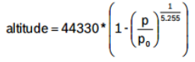
Figure 1: Pressure equation for altitude
Based on our initial research and price point, Bosch’s BMP180 was chosen as a great candidate. From Table 1 above the relative accuracy of the sensor was obtained. Given the end goal of our smart water rocket system, having a pressure sensor with just ±0.12 hPa fluctuations in the readings seemed perfect. The other concern, which is longevity, was also satisfied, since a ±1.0 hPa change per year is still within a reliable margin.
Parameter | Test Conditions | Typical | Max
Supply Voltage |  | 2.5V | 3.6V
Relative Accuracy | 950-1050 hPa | ±0.12 hPa
Absolute  Accuracy | 300-1100 hPa | -1.0 hPa | +2.0 hPa
Long Term Stability | 12 months | ±1.0 hPa
Table 1: All values taken from Bosch’s BMP180 datasheet.
In order to retain the same functionality as the AltimeterTwo, the rocket’s altimeter was also equipped with a triple axis accelerometer. By utilizing an accelerometer we are able to detect sudden movements in order to “start” our pressure readings as well as efficiently detect velocity and acceleration.
When looking at accelerometers the main constraint was compatibility with a 3.3V input and the ATMega328p. As it turns out, the amount of accelerometers that satisfied these constraints was ample. The finial accelerometer chosen was the ADXL345 by Texas Instruments. From Table 1-2 the accelerometer is able to sustain the intended voltage supply of 3.3V while maintaining good accuracy. Also, this accelerometer is incredibly light at just 20mg.
Parameter | Test Conditions | Typical | Max
Supply Voltage |  | 2.5V | 3.6V
Relative Accuracy | 950-1050 hPa | 128 LSB/g | 143 LSB/g
Weight |  | 20mg
Table 1: All values taken from the ADXL345 datasheet.
Power proved to be one of the most challenging aspects of the altimeter’s design. The initial design of the altimeter was based around using two coin cell batteries stacked together, but this would take too much space on the board and the batteries would be prone to “falling off” due to constant impact. When comparing the initial design to our main consumer reference, the AltimeterTwo, it was clear that we needed to provide a rechargeable battery. Not only was this a new design concept to the team, but also adds significantly more durability to the device.
Choosing the correct battery came down to voltage, cost and size. Based on the 3.3V requirement for the ATMega328P and every other component in the system a 3.7V Li-Po battery was chosen. Li-Po was chosen for its price and availability at the cost of weight. The size, in our case an 850mAh battery, was chosen to provide multiple hours of ON time. This battery provides a constant discharge rate of 2C (1.70A). Based on the initial tests the system draws around 1.00A which makes this battery more than enough for the rest of the system.
Since this new design includes a rechargeable battery, the device called for a battery manager. The MCP73831 by Microchip was chosen for its price, size and reverse discharge protection. The MCP73831 also includes integrated pass transistor and integrated current sensing, in 5-pin SOT-23 and thermally efficient 8-pin 2mm x 3mm DFN packages.
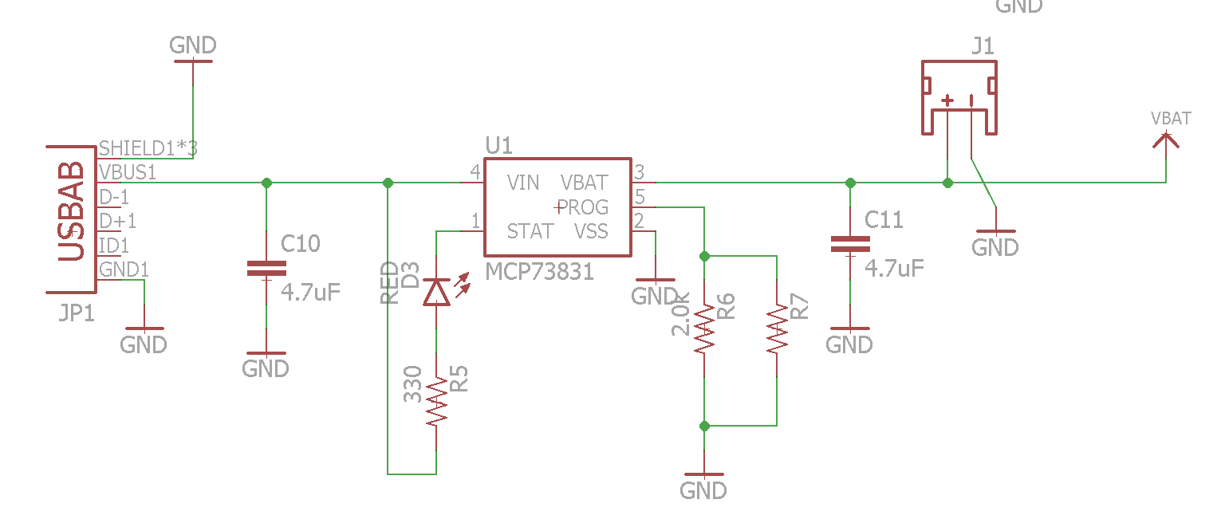
Figure 2: Battery management circuit schematic.
From the schematic above (see Figure 2) the power system of the device can be observed. Here the charging voltage source will be a micro-usb. This micro-usb port was designed strictly for charging the battery and no data transfer. Here, only three of the pins are being used. Two of them are grounded, while the VBus supplies the standard 5V input supplied by USB.
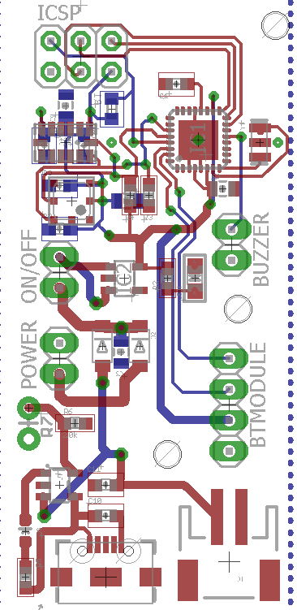
Figure 3: Final PCB Layout of the altimeter
The final aspect of the power system is the integration of a voltage regulator, or DC-DC converter. Since the Li-Po battery supplies a 3.7V output, a MIC5225 by Micro Chip was utilized to bring the voltage down to 3.3V. From here that same 3.3V output supplies the rest of the system.
The final PCB layout shown above (see Figure 3) was designed to stay as close as possible to the AltimeterTwo’s size. Based on the designed constraints requested by Space Trek, the Smart Water Rocket’s altimeter is only slightly over the width at 1 inch versus the AltimeterTwo’s 0.7 inches. Unlike the width, both the length and weight meet all of the requirements.
Given the size of this design and the difficulty of properly testing the hardware, the board was designed with many pins wired to physical headers on the board. The lines for ICSP (MISO, MOSI, 3.3V, GND, SCLK, RESET) were left open to install the Bootloader directly onto the ATMega328P. Additionally, four more headers were wired to the TX, RX, 3.3V and GND lines to provide serial communications.
As yet another physical header on the board, an extra battery port was created with a separate Schotzky diode to isolate it from the rechargeable battery system. This gave the Smart Water Rocket’s altimeter the ability to be easily powered by an external source other than the battery in case of any issues. Right after the Schotzky diodes and before the voltage regulator the tracks were opened with an ON/OFF header to provide a physical “ON/OFF switch” on-board. For the purposes of the final product, no physical switch is being used, just a jumper between the two headers.
III. SOFTWARE
The main goals of the altimeter are to use sensors to collect data on its height, velocity and acceleration and to transmit them back to the ground for immediate viewing. With many calculations per second it becomes important to be able to send that information to a larger storage device. On the launch pad there will be the mobile device that will receive the information from the microcontroller and convert the raw data into information that the students and instructors can use. The data from the sensors will be stored on the device and will have the ability to be accessed between launches by the instructors. Since this is a two part design it will be broken down into microcontroller design for the rocket module and mobile application for the mobile device on the launchpad.

A. Microcontroller Design for Rocket
Designing the microcontroller involves communicating with the sensors and to send all of that data to the mobile device through the Bluetooth module. Once the rocket has received a signal from the mobile device, it will transmit data on an infinite loop and it is up to the mobile application to determine when to stop the information coming from the microcontroller. The launch will be initiated by a button within the application and once it has landed another button will be used to let the rocket know it can stop transmitting data.
Each of the sensors has a set of libraries which makes it very straightforward to collect the data onto the microcontroller itself, once the data has been collected within the iteration of the loop, it must be written to the serial component which also controls the communication of the Bluetooth module. Every second it will send information regarding its height and acceleration in three axis to the serial communicator, which it used by the Bluetooth module that the app will be listening for an input stream of data.
The Bluetooth module will then take the serial communications and transmit that to the paired device, which will receive up to 256 bytes per transmission which will include the height, x acceleration and y acceleration, and z acceleration, from the pressure sensor and accelerometer respectively. The JY-MCU is the chosen Bluetooth device that operates at a standard baud rate of 57600 which is different than the standard 9600 baud rate of the hardware serial communications of the ATMega328P. Therefore the team utilized Arduino’s software serial library to create a custom TX and RX communication pins from a standard set of digital pins.
The height is measured from a pressure reading from the BMP180 pressure sensor by comparing its current pressure to the difference between the baseline pressure readings. This will calculate the height in meters that the rocket is currently at compared to the initialized point and a simple conversion will put it into feet for the team. Since the team’s sponsor uses US customary units, all SI units will need to be converted as such.
All of the acceleration readings from the ADXL345 accelerometer will allow our team to calculate the velocity at a given time which can be used to find the max velocity and the average velocity. Integrating the acceleration over a short period of time and adding the initial velocity to it can achieve this. It is also possible to take this integration a step further to calculate the distance that the rocket has traveled but due to the cost effective design of the ADXL345 there is simply far too much background noise to get an accurate enough reading.
Using these subsystems together will create an altimeter that will be able to automatically transmit the data of rocket’s trajectory directly to a mobile device for immediate viewing during and after the launch. Between the launches the students will be able to record their data without the hassle of retrieving the altimeter from within the nosecone and slowly scrolling through single line segments of data to record the information they need.

B. Mobile Application
Designing the mobile application requires a constant communication to the microcontroller, which will be done through Bluetooth by pairing the devices together. As long as the pairing remains intact the transmission of data will be accurate and reliable to give the instructors and students a real-time analysis of the flight of the rockets. Since the distance of the rocket can reach the limit of the range of the Bluetooth it is up to the application to be able to automatically repair with the device and manage to keep the stream of data intact.
Since our team is using designing the mobile application with the Android operating systems it comes fully equipped with many Bluetooth libraries to make connecting and transmitting data a smooth process. On the initialization of the application, it will make sure that Bluetooth is both powered on and has a device paired before attempting to read any data from the MCU in the rocket Any problems with a Bluetooth connection will prevent the user from starting a rocket launch and will wait for the connection to be established before continuing.
Once a connection has been established, the mobile application will then have a set of buttons to let it know that a launch is going to commence and it will begin reading data from the Bluetooth module. Another button will be used to let the mobile application know when the flight has landed and to stop listening for data. Any additional data for maxes will also be stored on the microcontroller and will be transmitted at the end of the launch just in case the connection was broken at the apex of the flight. Once the rocket has landed and the application has stopped reading in data, then it begin the process of converting raw data into useable data.
After the rocket has landed the MCU will cease transmitting data and the mobile application will summarize the results of the flight and printing the max values to the screen, including height, acceleration, velocity and distance. All of these values can be determined from the relative positions of the rocket given the time it took for each transmission.
IV. Launchpad Automation
Automation of the launchers has been a goal of Space Trek’s for a while since they began the water rocketry program
The launch pads are currently mounted to carts with two layers so that extra supplies (safety glasses, beakers, etc.) can be stored as well. The layers are separated by thick plastic with ventilation holes (see Figure 4). The sides are not enclosed; it is basically two plastic shelves stacked on top of each other. The carts work very well for this application and replacing them will add excess costs to the project so the carts will not be replaced.
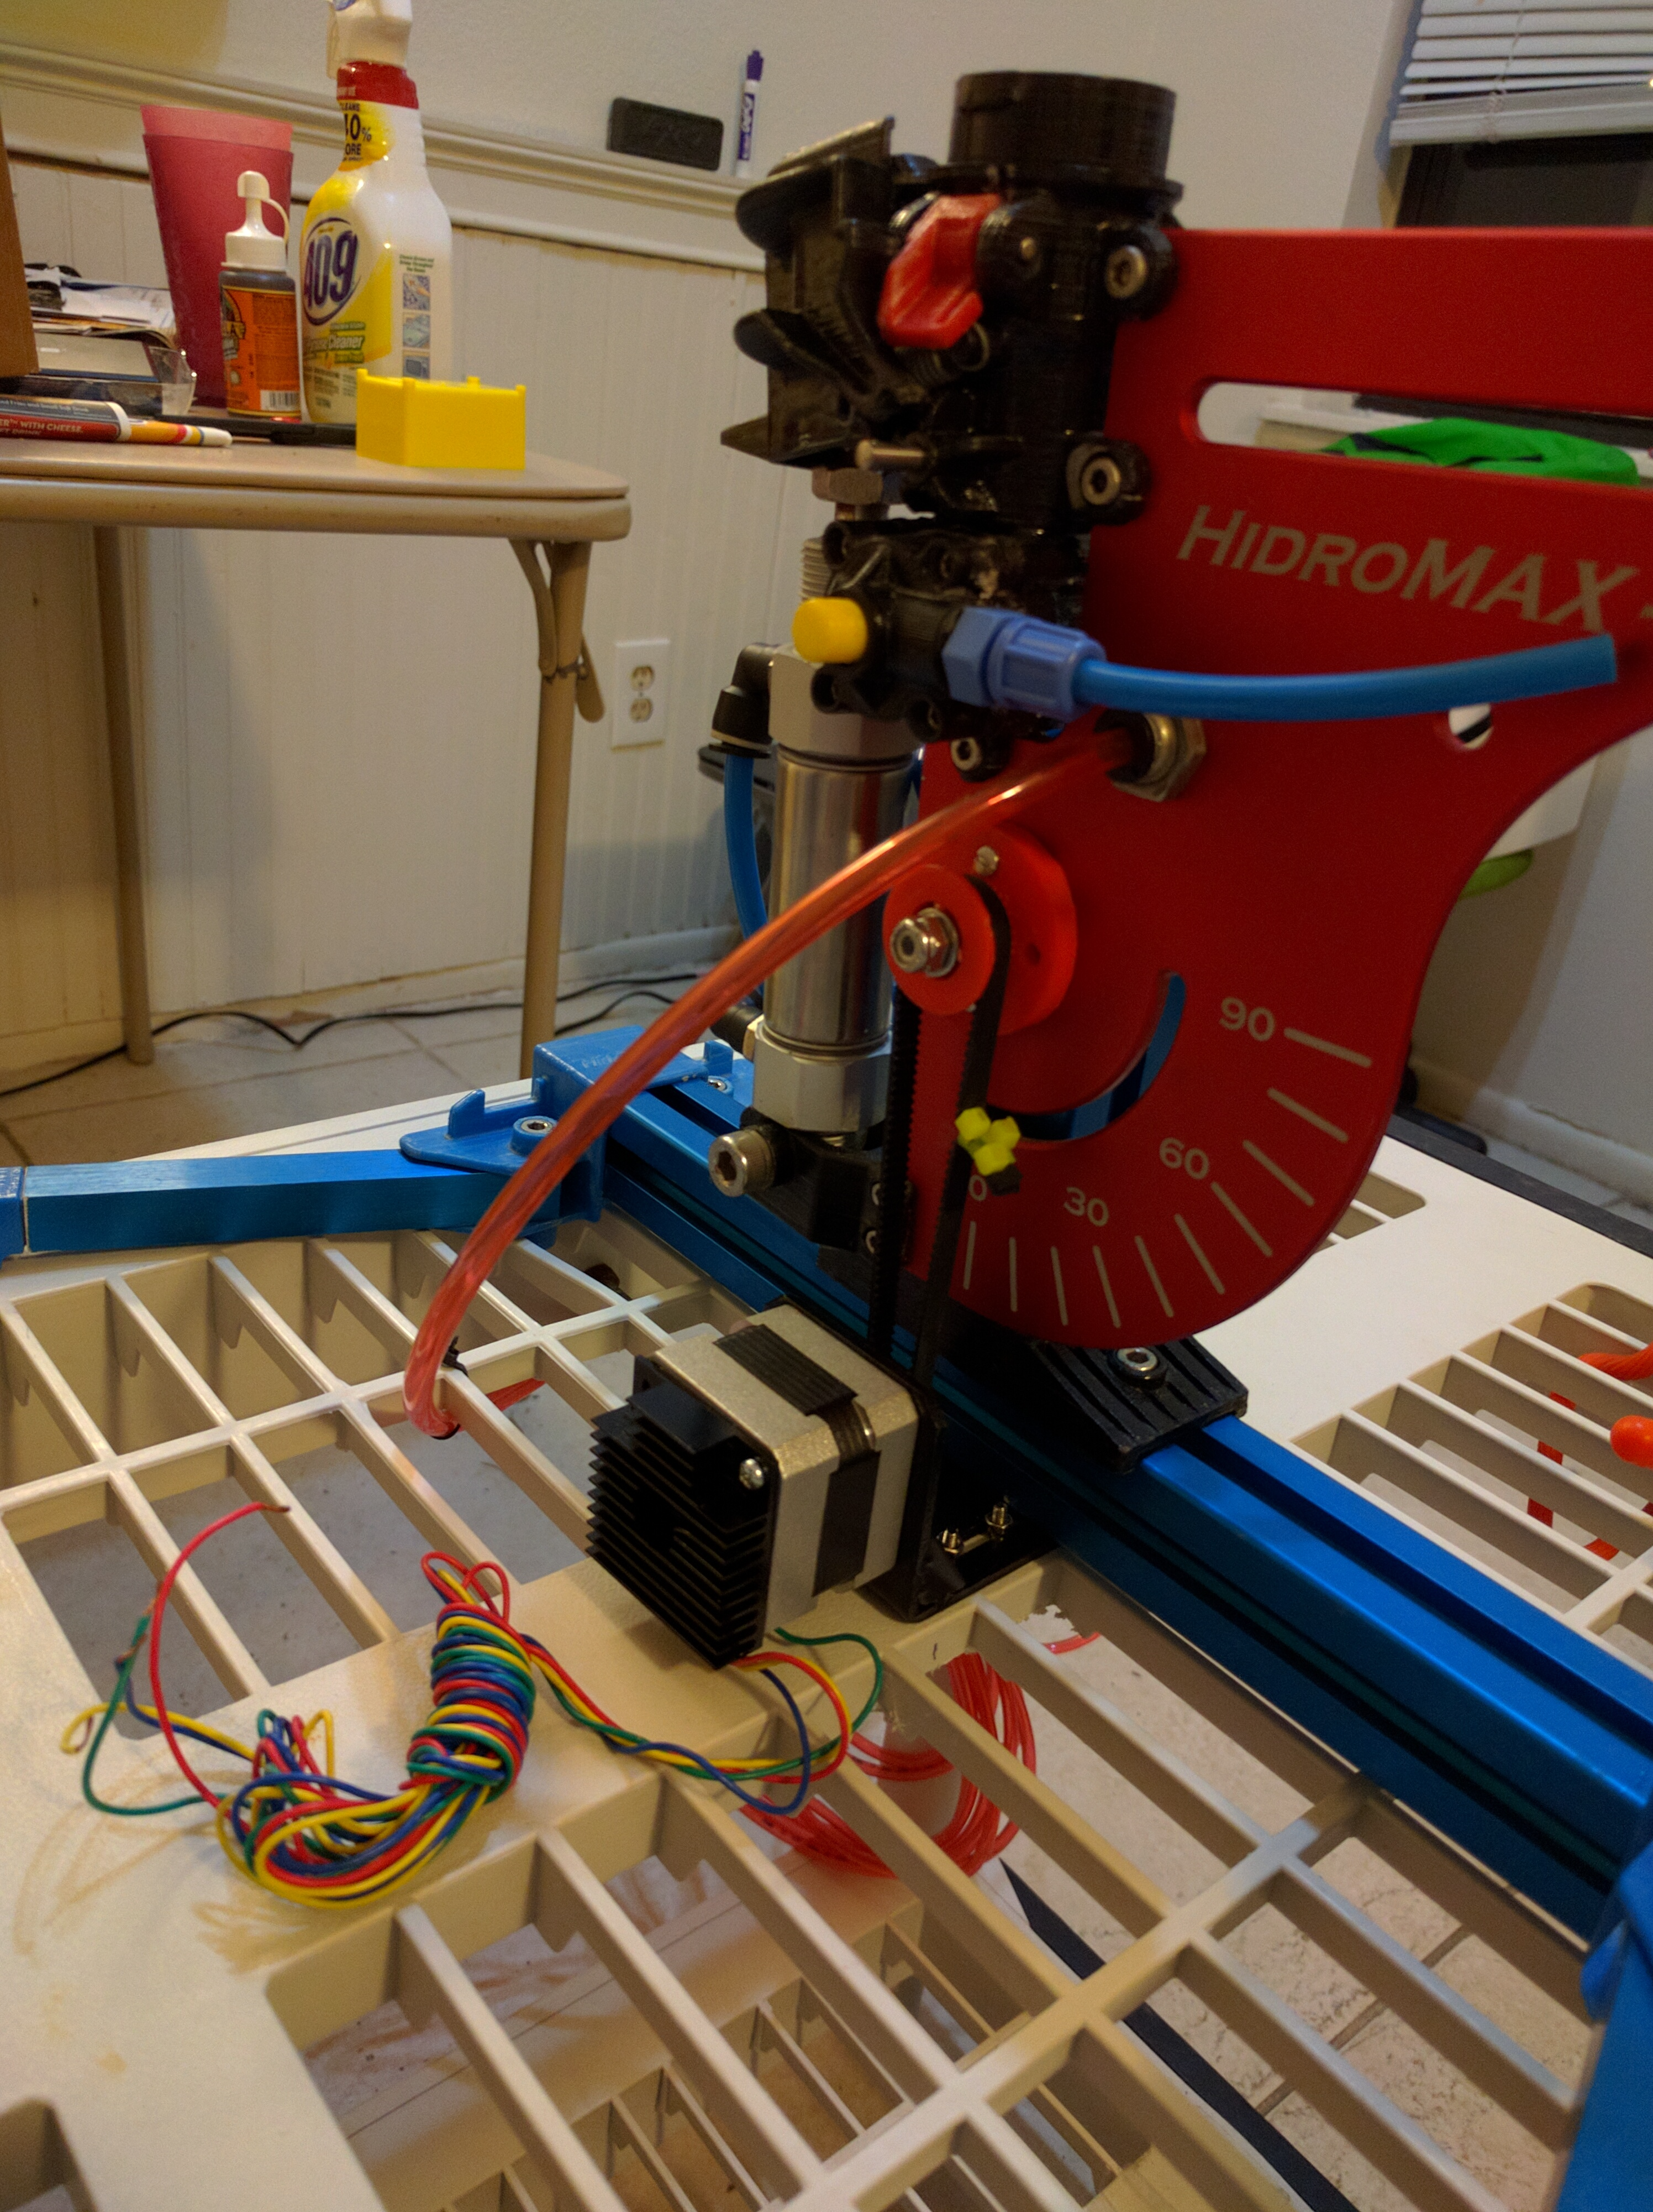
Figure 4: Launchpad and CanaKit Stepper Motor
A. Stepper Motors
Space Trek provided the team with the CanaKit Stepper Motor pictured above in order to automate the launcher. The stepper has 200 steps/revolution (1.8 step angle), 12V rated voltage, 0.33A rated current, and a holding torque of 2.3kg*cm.
The launch angle automation is controlled by a stepper motor because this type of motor is has the power, precision and price necessary for the SWR. Stepper motors use a series of gears and magnets to rotate to a set position and clamp down. The gear mechanism it uses gives the motor excellent holding stability and allows it to precisely move heavy loads. Figure 5 shows how the shaft rotates using magnets between different poles to control movement in two directions, also known as bidirectional movement.
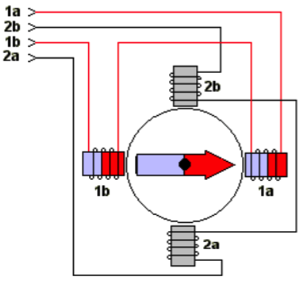
Figure 5: Conceptual Model of a Bipolar Stepper Motor
The launch pad stepper motors requires sufficient torque to move the weight of the rocket, after it has been fueled and pressurized, from a horizontal position to the desired launch angle. Once it has reached its position it must hold strong as the rocket is launched. These motors were chosen because they are simple to set up and sufficiently powerful for this application.
B. Launchpad Modification
In order to automate the Launchpad and successfully rotate the angle plate, the cart had to undergo several structural modifications. The final system design involved mounting the stepper motor directly underneath the axis at which the angle plate rotates. Fortunately the rocket launcher is mounted on the blue slider below so it can be moved to any position desired for mounting the stepper motor. The launcher is aligned with the middle column of the gray launch platform. From this point, the middle column is rectangular so it needed to be modified so that a mount could be fitted to the platform. The destination of the stepper motor was hollowed out from underneath using a dremel. Once the surface was made flat four holes were drilled and the motor mount was successfully placed in the desired position while still leaving room for adjustment once the final system was connected.
With the position of the motor in mind, came the idea for how to angle plate will be turned. The point at which the angle plate rotates currently is a bolt tightened through the angle plate against a stand, which is part of the blue sliding launcher mount. On this axis several changes were made in order to connect the stepper motor to the angle plate for automation. A timing belt and gears with setscrews were acquired for the stepper motor but only one gear was used. The metal gear was attached to the stepper motor shaft and then a new gear was designed in PROGRAM for the angle plate. Not only did the system need a larger gear to improve performance but it was designed to screw into the plate instead of trying to fuse the small surface of the metal gear to the platform and relying on the strength of glue or a small welding job.
V. Stepper Motor Circuit
In order to run the stepper motor an Arduino Uno is used to program and control the rotation of the launcher. Fortunately the SWR Team acquired an Adafruit Motor Shield V2.3 from Space Trek to drive the motors. Lastly an Adafruit Stackable Shield was acquired to wire a simple circuit for buttons to control the motors.
To control the stepper motor there are three buttons. The first button controls forward rotation of the stepper, which tilts the angle plate towards and horizontal position. A second button controls the backward rotation, which tilts the plate towards a vertical position. The final and third button alternates changes between different delays between steps. This function is so that Space Trek can have one speed that provides a single step per button press. Once a desired angle is reached this can be used to make minute adjustments. One or two more reduced delay modes can be used to increase the speed at which the motor steps and sufficiently rotate the launcher plate.
These buttons were not hard-wired to the system so that Space Trek can revise the design as necessary. In the future they will connect a Zigbee transceivers to both the stepper systems and to the cart that houses the rocket launch buttons so they can control the launches from a separate location.
To wire the circuit there is three female headers placed on top of the stackable shield with two ports for each button. Underneath the shield there a jumper wires and 10 kΩ resistors connected to each header. This conceals the rest of the circuit so only the necessary headers are in plain sight.
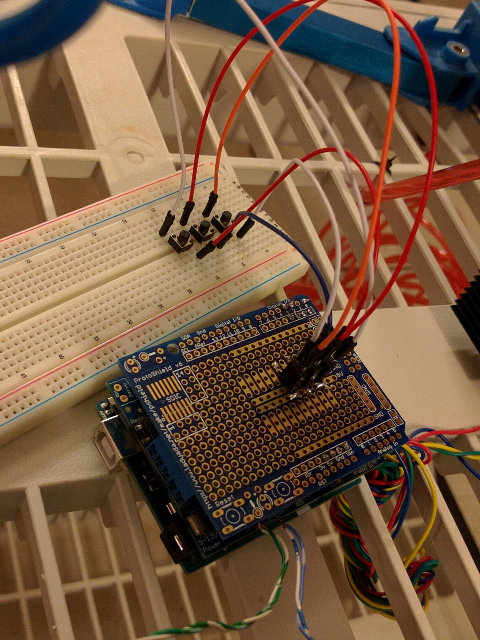
Finally to power the stepper system a Lead-Acid battery was acquired so because it is durable and reliable. The 12v pack is compliant with the rated voltage of the stepper. At 7Ah the battery has a sufficient cycle to last days powering multiple stepper motors which draw constant power for holding torque and adjust launch angles for multiple launches during busy Space Camp days.
VI. CONCLUSION
The project has given each person in our group valuable experience pertaining to the material that was outlined during the course. Proceeding through both semesters taught the team what it's like to work in a group and how to power through the obstacles that arise.
Overall, the design specifications that were requested became a reality and the final product worked as intended.
VII. SPONSOR
The Smart Water Rocket is a project inspired by the guys over at Space Trek. Their team works hard to provide valuable experiences to children by introducing to different STEM experiments.
The Smart Water Rocket team would like to thank the Space Trek team for all of their support and guidance throughout the course.
VIII. ACKNOWLEDGMENTS
The team would like to thank Dr. Lei Wei and Dr. Richie for lecturing and advising through the Senior Design courses. The team would also like to thank faculty members John Edison, Niels da Vitoria Lobo, and sponsor Ryan Elliott Elliott for taking the time to review the project demonstration.
Another big help to the team was EE graduate Edgar Alastre, providing guidance, experience, supplies and equipment. Also, a special thanks to Best Global Source for providing mounting solutions and testing equipment.
IX. REFERENCES
[1] https://www.sparkfun.com/pages/accel_gyro_guide
[2] http://www.dimensionengineering.com/info/accelerometers
[3] http://www.electroschematics.com/9798/reading-temperatures-i2carduino/
[4] http://www.homautomation.org/2014/04/03/best-ways-to-power-a-arduinoaccording-to-your-need/
[5] http://www.instructables.com/id/The-Ultimate-Altimeter-A-compactArduino-altimeter/
THE TEAM

Connor Phillips is a senior at the University of Central Florida. He is graduating with a Bachelor’s of Science in Electrical Engineering in May 2016. He hopes to work in the field of controls and eventually pursue a Masters degree.

Kyle Moran is a 23-year-old senior at the University of Central Florida. He is graduating with a Bachelor of Science in Computer Engineering in May 2016. He is currently looking for a job as a Software Developer. He plans to eventually pursue a Master’s Degree in Space Systems Design or Robotics.

Gabriel Fernandez is a senior at University of Central Florida graduating with a B.S.E.E. Originally from Puerto Rico, he moved to Orlando in order to obtain an E.E degree. He hopes to begin a career as a Process Systems Engineer or Sales Engineer.

