

**Table of Contents**

Project Description……………………………………………………..3

List of Requirements……………………………………………………4

Block Diagrams……………………………………………………………5

Estimated Project Budget……………………………………………6

Project Milestone for Both Semesters………………………...7

**Project Description:**

The focus of this project is to develop a flying drone and charging dock that supports wireless inductive and solar charging. The drone will be programmed to have a mission to follow its user for recording purposes. The user will be wearing a transmitter that the drone can track, which will work via radio transmissions or Bluetooth LE. The dock will be stationary and the drone will be capable of remembering where the dock is located such that it can return to its dock when its battery is low, or when it has finished its work (similar to the Roomba robotic vacuum cleaner). When the drone returns to its dock, it will essentially be operating by itself to properly orient and position itself for the inductive charging to work. If the drone is unable to reach its dock in time, it will land at its current location to prevent a crash.

The motivation behind this project stems from a shared interest in flying drones, and wanting to incorporate renewable energy. The idea of incorporating inductive charging started as the idea of creating a drone that was powered via induction alone, but there are legal and practical complications of that. The legal complication would stem from if the drone were to receive its power from the induction of a power line, it would essentially be theft from the power company. The practical complication comes from the fact that aside from rural areas, most power transmission lines are underground, thus isolating it from being used as a power source. Thus, the ethical solution is to construct a charging dock that will support the inductive charging, and power the dock by a solar panel in order to incorporate renewable energy.

Thus the goal of this project is to develop a compact, low cost drone with a corresponding charging dock. The charging dock will receive its power from a solar panel, and deliver the renewable energy via an inductive coil. A prebuilt flight controller will be used that can use open source software. The software will be modified to enable the drone to track and follow its user, then fly itself to the dock or land itself in the event of a low battery, lost transmission, or end of mission event. The drone will be able to accomplish this using any combination of object detection (optical), GPS, compass orientation, Bluetooth 4.0 Low Energy, or a form of radio transmission. The drone will also be able to land itself where it is, should it not be able to return to the charging dock, thus preventing a crash from a dead battery.

**List of Requirements and Specifications**

* 4W, 12V Solar panel
* 5V Wireless Receiver
* 12V input Wireless Transmitter
* Rechargeable Lithium Polymer (Li-Po)- 5200 mAh

**Constraints**

* Flight time – Varies with payload, temperature, flight altitudes, weather.
* Battery charge time – Varies with the distance between wireless receiver and wireless transmitter.

**Standards**

* Drone Flight below 400 ft.
* Weight of Drone below 55 lbs.

**Block Diagram Drone:**

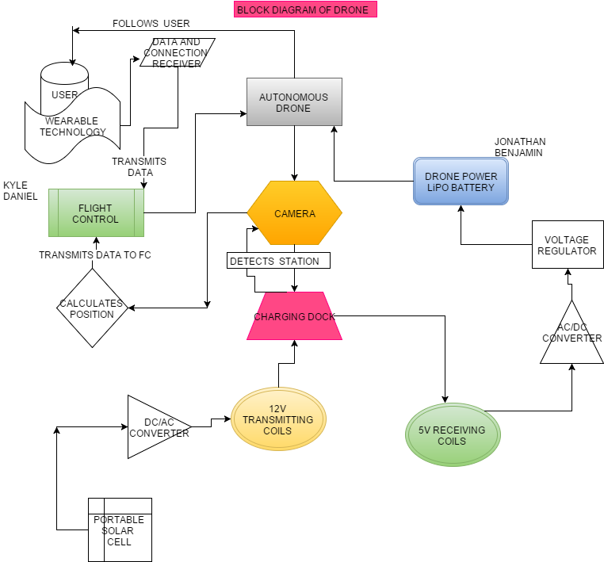

https://docs.google.com/drawings/d/skTvUURwzXfqWgUj39vF0mQ/image?w=85&h=67&rev=10&ac=1https://docs.google.com/drawings/d/s3xd82JfVrpahYPQRKeySrA/image?w=97&h=61&rev=29&ac=1  
https://docs.google.com/drawings/d/sO4JeQ4c0wPq02ibxlfUWTg/image?w=92&h=87&rev=1&ac=1https://docs.google.com/drawings/d/sFQhwmiUAv1STu4OukyyY0Q/image?w=89&h=77&rev=1&ac=1

**Estimated Project Budget:**

|  |  |
| --- | --- |
| Item | Cost |
| Microcontroller | $20.00 |
| PCB Manufacturing | $100.00 |
| Induction Coil | $10.00 |
| Document Printing | $50.00 |
| Camera | $50.00 |
| Servo | $10.00 |
| Propellers | $20.00 |
| DC Motors | $40.00 |
| Wiring | $10.00 |
| Controller | $20.00 |
| Solar Panels | $20.00 |
| Wireless Transmitter | $7.00 |
| Wireless Receiver | $7.00 |
| Accelerometer | $20.00 |
| Drone Frame | $30.00 |
| Materials (wood, plastic) | $50.00 |
| GPS | $50.00 |
| Altimeter | $15.00 |
| Misc. | $300.00 |
| **Total** | **$829.00** |

**Initial Project Milestone**

* **Research** - September – Late October
* **Design** – Late October – end of November
* **Prototype** – Mid December – Early March
* **Test** – Early March – End of April