Maze Navigating Robot

Group: 28

Ly Nguyen

Uyen Nguyen

Luke Ireland

We would like to do a project that maximizes our knowledge and skills.

The goal is to create a low-cost and energy-efficient robot that can navigate through a maze autonomously.

Specifications and Requirements:

* The robot should be able to rotate 360 degrees
* The robot should be able to determine where to turn
* It should be able to navigate through the maze 9 out of 10 times
* It should be able to detect and avoid walls
* Dimensions:
  + height: 5-10”
  + length: 10-15”
  + width: 7-12”
  + weight: less than 5 lbs.
* Wheels: 3 wheels, 3’’ diameter, 2 in front, 1 in rear
* Stepper or servo motor:
  + 2 for 2 front wheels
  + Speed: 0.10-0.20 sec/60°
  + Weight: 1 - 2 oz
  + 4.8 - 6 V
  + Torque: 100 - 150 oz-in
* Steering: This robot will use differential drive to steer itself
* Microcontroller:
  + 5V and 350 mA
  + enough A/D I/O ports for sensors
  + at least two output ports for motors
* Power regulation circuit:
  + Protect major components, i.e. microcontrollers, motors, sensors, battery pack, etc.
  + Switching regulator for motors
  + Linear regulator for sensors
  + Small capacitor to prevent high frequency disturbances
  + Large capacitor to prevent low frequency voltage disturbances
  + Use fuse to protect batteries
* Infrared sensors
  + Work in close range
  + Field Width: 3 or 4 sensors to cover an area of 180° in the front
  + Position the sensors so that signal emitted by one sensor cannot be read by another sensor
  + The wall should be made of material that will reflect the IR light
  + Low energy consumption
  + Able to work under indirect and direct sunlight
* Li-Ion Battery:
  + Operating temperatures: -10 to +50°C
  + Storage temperatures: 0 to +30°C
  + 3.7/cell
  + Rechargeable

**Block Diagram *TBA= To Be Acquired**

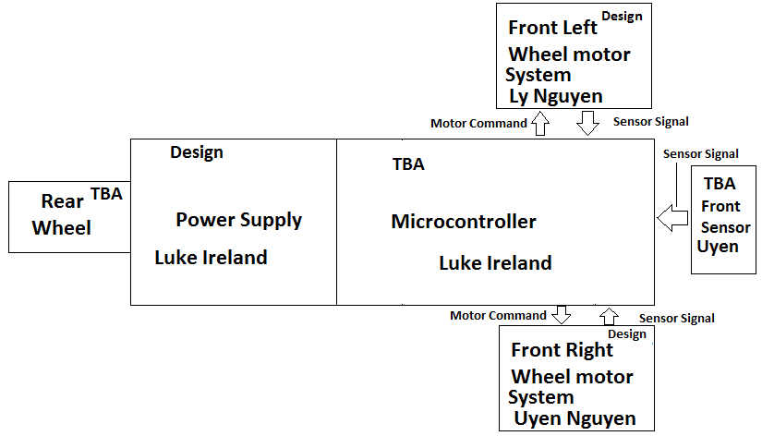

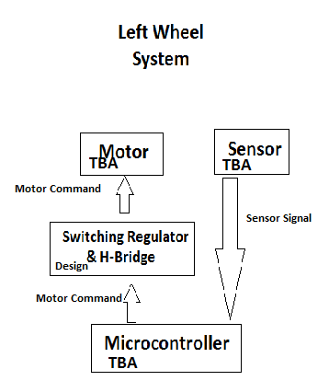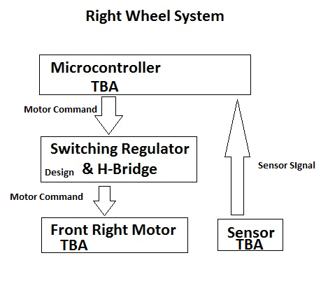

**Budget**

* Batteries: $30 - $45
* Microcontroller: $10-$30
* Chassis: $10-$20
* Sensors: $10-$20
* Motors: $30-$60 per wheel
* Other miscellaneous components: $20 - $50

Total: $150 - $300

**Project Milestone**

Senior Design I

* Week of Sept 8: Research sensors
* Week of Sept 15: Research microcontrollers
* Week of Sept 22: Research motors and other electronic parts
* Week of Sept 29: Design protective circuits
* Week of Oct 6: Design protective circuits & Power Supply
* Week of Oct 13: Design Power Supply
* Week of Oct 20: Simulate & capture schematics
* Week of Oct 27: Status Report
* Week of Nov 3: Purchase hardware components
* Week of Nov 10: Research Algorithms
* Week of Nov 17: Research & Choose Algorithm
* Week of Nov 24: Final Report

Holiday Break

* Write rough draft of algorithm

Senior Design II

* Week of Jan 12: Build Chassis, connect the motors to the chassis
* Week of Jan 19: Build protective circuits
* Week of Jan 26: Build power supply
* Week of Feb 2: Interface components and test connections
* Week of Feb 9: Test sensors, collect and graph data
* Week of Feb 16: Test and modify algorithm
* Week of Feb 23: Test and modify algorithm
* Week of Mar 2: Test and modify algorithm
* Week of Mar 9: Build maze for demonstration/ continue testing and modifying
* Week of Mar 16: Build maze for demonstration/ continue testing and modifying
* Week of Mar 23: Build maze for demonstration/ continue testing and modifying
* Week of Mar 30: Make sure the project is up to specs and working properly
* Week of April 6 - May 5: Improve and fix any problems